Enhancing Safety:
Family Violence Strategy for the Victorian Corrections system
2018-2021

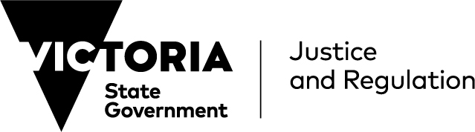
Contents
Contents 2
Commissioner’s foreword 3
Introduction 5
Where we have come from 7
Corrections Victoria Family Violence Strategy 2018–2021 9
Understanding the need for cultural responsivity when responding to family violence 9
Principles and objectives of this Strategy 11
Principle 1: Family violence and gender inequality are not tolerated 12
Principle 2: Victim survivors, vulnerable children and families are safe and supported to recover and thrive 14
Principle 3: Perpetrators are held to account, engaged and connected 16
Principle 4: Preventing and responding to family violence is systemic and enduring 18
How the Strategy will be implemented 19
Reference material 20
Commissioner’s foreword
Enhancing Safety: Family Violence Strategy for the Victorian Corrections system 2018-2021 will guide the way that the Victorian corrections system responds to family violence over the next four years. The Strategy recognises that prisoners and offenders are over-represented as victim survivors and perpetrators of family violence. We have an important role in reducing re-offending and supporting victim survivors of family violence.
This activity will not occur in isolation and continues a commitment Corrections Victoria originally demonstrated in 2015-16 through its first Family Violence Service Reform Strategy. It continues the work begun in response to the recommendations of the Royal Commission into Family Violence, which handed down its report in March 2016. It will complement and support Strengthening Connections: Women’s Policy for the Victorian Corrections system and the Kaka Wangity Wangin-Mirrie – Aboriginal Cultural Programs Suite, both of which highlight family violence as a key area of focus.
This Strategy will support the Victorian Government’s 10 year plan, Ending Family Violence: Victoria’s Plan for Change and the associated Family Violence Rolling Action Plans. It will be delivered in partnership with our colleagues in the Regional Service Network, privately operated prisons and Justice Health, and in close collaboration with other government and non-government organisations.
This Strategy recognises the particular complexity and challenge of the experience of family violence among Aboriginal prisoners and offenders. It will support the Indigenous Family Violence 10 Year Plan, Strong Culture, Strong Peoples and Strong Families: Towards a safer future for Indigenous families and communities and any future plans to support Aboriginal Victorians. This Strategy also recognises the different experience of family violence for culturally and linguistically diverse communities and affirms Corrections Victoria’s commitment to considering the needs of prisoners and offenders with culturally and linguistically diverse backgrounds, in the corrections system’s response to family violence.
The principles under which this Strategy’s programs and initiatives will be delivered reflect the high-level approach the Victorian corrections system will take to supporting victim survivors and holding perpetrators accountable for their behaviour. The accompanying Corrections Family Violence Action Plan, which will be reviewed and updated each year, outlines the specific programs and initiatives that will be delivered under the Strategy. The Evaluation Framework outlines how we will build a comprehensive understanding of the impact of our ongoing actions to address family violence.
This Strategy demonstrates how we will act on our unique opportunity to create long-term positive change through the way we work with perpetrators and support victim survivors of family violence, and how we will ensure that family violence is embedded as a consideration in our day-to-day work. The programs and initiatives implemented under this Strategy will contribute to the corrections system’s goal of enhancing community safety.
Attitudes that condone or normalise violence against women or family members remain too prevalent within our prisoner and offender groups. As part of this strategy we must redouble our efforts to create environments in which such attitudes are identified, challenged and not allowed to flourish.

Rod Wise
Acting Commissioner

LANGUAGE IN THIS STRATEGY
Family violence
Family violence is defined in section 5 of the Victorian Family Violence Protection Act 2008. It involves coercive and abusive behaviours by a perpetrator that are designed to intimidate, humiliate, undermine and isolate, resulting in fear and insecurity. It can include physical, sexual, psychological and emotional violence, and economic abuse and control. The act defines family broadly to include intimate partners, ex-partners, parents, children, siblings or extended family. This definition encompasses the variety of relationships and structures that can make up family units and kinship networks, and the range of ways family violence can be experienced, including through family-like or carer relationships and other interpersonal relationships, and across all genders and sexualities.
Under the Act, family violence also includes behaviour that causes a child to experience, witness or be exposed to the effects of family violence.
Family violence is more broadly defined for Aboriginal than non-Aboriginal people as ‘an issue focused around a wide range of physical, emotional, sexual, social, spiritual, cultural, psychological and economic abuses that occur within families, intimate relationships, extended families, kinship networks and communities’ (Department of Victorian Communities, 2003).
Family violence can also be experienced differently by culturally and linguistically diverse (CALD) communities. Social isolation and cultural attitudes can facilitate family violence, and particular forms of family violence—such as forced marriage and dowry-related abuse—can be experienced in some CALD communities (State of Victoria, 2016a).
Victim survivors and perpetrators
The term victim survivor has the same meaning as a ‘primary person’ as defined in the Family Violence Protection Act 2008. It is used to describe people who have experienced family violence, or are at risk of being subjected to family violence. We recognise that not every person who has experienced or is experiencing family violence identifies with this term. Family violence is only one part of a victim survivor’s life and it does not define who they are. Our use of this term acknowledges the strength and resilience shown by victim survivors who have experienced or currently live with family violence. Other terms that are used in the literature and practice to describe people who have experienced family violence include ‘victim’ and ‘affected family member’.
The term perpetrator is used to describe people who use family violence, whether or not they have been convicted of a family violence offence. A person who has used family violence may be subject to a police report and/or a civil notice or order to prohibit family violence, such as a family violence safety notice or family violence intervention order, in which they may be referred to as a ‘perpetrator’, ‘respondent’ or ‘other party’.
Corrections Victoria recognises that the majority of victim survivors of family violence are women and children, and the majority of perpetrators are men, but that men may also be victim survivors and women may also be perpetrators. Where possible, this strategy uses gender-neutral language to refer to victim survivors and perpetrators.
Prisoners and offenders
The term prisoner is used to describe people who are held in corrective services custody, whether sentenced or unsentenced (also referred to as remand).
The term offender is used to describe persons who are being managed by Community Correctional Services, including prisoners released onto parole and offenders subject to a supervised court order or reparation order.
Aboriginal and Torres Strait Islander people
Corrections Victoria uses the term Aboriginal to refer to Aboriginal and Torres Strait Islander people. The terms ‘Koori’, ‘Koorie’ and ‘Indigenous’ are retained in the names of programs and initiatives and, unless noted otherwise, are inclusive of all Aboriginal and Torres Strait Islander peoples.

Introduction
Key Statistics
- In the year ending 30 June 2017, there were 76,495 family incidents recorded by Victoria Police.
- The rate of reported family incidents (per 100,000 population) has been growing since 2008:
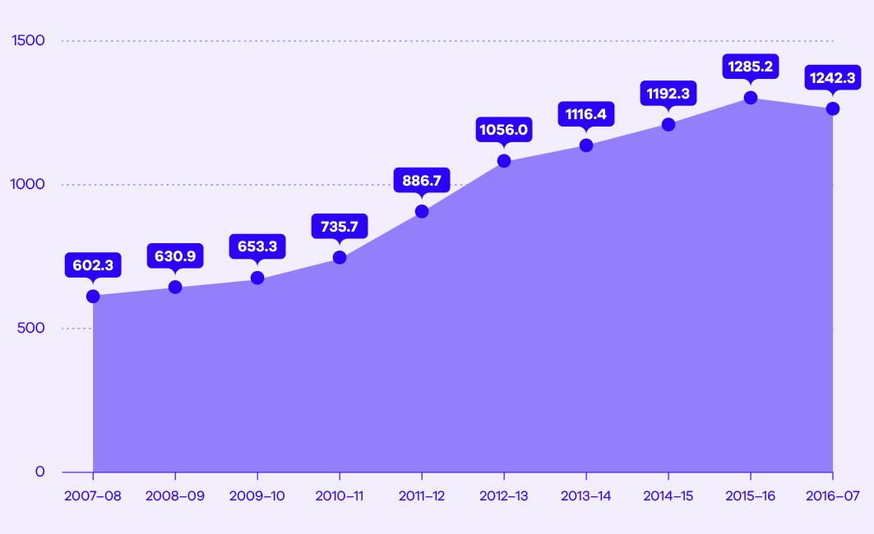
- Across Australia:
- one in six women and one in 16 men have experienced physical and/or sexual violence by a current or former partner since the age of 15
- almost one in four (23.0 per cent) women have experienced emotional abuse from a current or previous partner since the age of 15.
Sources: Crime Statistics Agency, 2017a; Australian Bureau of Statistics, 2017
As shown in the key statistics, the rate of family incidents reported to police increased by approximately 113 per cent between 2007-08 and 2015-16, but declined slightly from 2015-16 to 2016-17 (Crime Statistics Agency, 2017a). A substantial number of Australians have been a victim survivor of family violence at some point since the age of 15 (Australian Bureau of Statistics, 2017).

Key Statistics
In Victoria’s corrections system there were almost 21,000 prisoners and offenders on 31 December 2016. Two-thirds had a history of family violence as a perpetrator and/or a victim survivor in the previous decade:
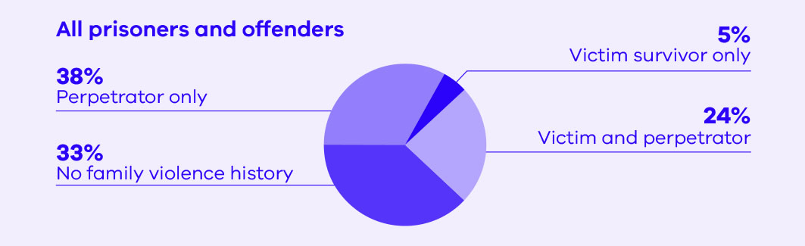
Source: Corrections Victoria 2017a; Crime Statistics Agency, 2017b
Prisoners and offenders in Victoria are disproportionately represented as both victim survivors and perpetrators of family violence. Of the nearly 21,000 prisoners and offenders managed by the Victorian corrections system, two-thirds had a history of family violence—as a victim survivor and/or perpetrator—in the last ten years (Corrections Victoria 2017a; Crime Statistics Agency, 2017b). Many prisoners and offenders also demonstrate entrenched attitudes that condone or normalise violence against women and other family members, and blame victim survivors (Department of Justice and Regulation, 2016). This demonstrates the significant need for programs to address family violence offending, as well as education and staff engagement to respond appropriately to attitudes that contribute to violence and abuse. The corrections system has a unique opportunity to create long-term positive behavioural and attitudinal change through the way in which it works with perpetrators and supports victim survivors of family violence to enhance community safety.

Where we have come from
The Victorian corrections system has made significant progress in its response to and management of family violence victim survivors and perpetrators. In 2015-16, Corrections Victoria launched its first Family Violence Service Reform Strategy. The Family Violence Service Reform Strategy 2015-16 sought to create an environment of change to prepare the corrections system for the reforms expected as a consequence of the Royal Commission into Family Violence (the Royal Commission). In doing so, it promoted a vision for Corrections Victoria to support a reduction in family violence incidents in the community by ensuring that perpetrators and victim survivors of family violence are better supported and serviced. It included 24 initiatives in five focus areas:
- identifying family violence perpetrators
- delivering targeted family violence programs and services to perpetrators
- supporting prisoners and offenders who are victim survivors of family violence
- creating an environment for cultural change
- working with other service systems.
The initiatives delivered as part of the Family Violence Service Reform Strategy 2015–16 included:
- introducing education and awareness campaigns for prisoners, offenders and corrections employees
- promoting regional family violence initiatives
- surveying prisoners’ experiences of, and attitudes towards, family violence
- expanding a number of programs for victim survivors and perpetrators
- training employees at the Dame Phyllis Frost Centre and Tarrengower Prison and within Community Correctional Services in the Family Violence Risk Assessment and Risk Management Framework (also known as the Common Risk Assessment Framework or CRAF)
- improving referral pathways to specialist family violence services under the Reintegration Pathway
- establishing a Specialist Family Violence Pathway to identify family violence perpetrators and target family violence-specific treatment needs.
Royal Commission Recommendations
Recommendation 183
Corrections Victoria review the current processes for identifying female offenders at risk of or with a history of family violence and respond through therapeutic interventions and education programs.
Recommendation 184
Corrections Victoria ensure that therapeutic interventions such as individual counselling and group-based programs such as Out of the Dark are available for all women in prison who have experienced family violence.
Recommendation 185
Corrections Victoria:
- Inform post-release support services if a prisoner has a history of family violence victimisation to ensure that post-release accommodation arrangements do not place the prisoner at increased risk
- Refer prisoners who have been victims of family violence to family violence services when they are being released. (State of Victoria, 2016a)

The Royal Commission into Family Violence delivered its findings in March 2016. Its 227 recommendations proposed a series of system improvements to enhance the family violence service system, finding that the system was not keeping victim survivors safe and there were a number of gaps and obstacles in the delivery of effective programs, laws and policies (State of Victoria, 2016b). The three specific recommendations relating to Corrections Victoria concerned women victim survivors in prison.
In developing this Strategy, Corrections Victoria is conscious that its focus needs to be on all victim survivors of family violence, regardless of gender and whether they are in prison or Community Correctional Services. Further, Corrections Victoria acknowledges its unique role in working towards behaviour change for perpetrators through program delivery, effective supervision and proactively addressing problematic attitudes and behaviour, including where they fall short of family violence.

Corrections Victoria Family Violence Strategy 2018–2021
In response to the findings of the Royal Commission, the Victorian Government developed a 10 year plan for change—Ending Family Violence: Victoria’s Plan for Change—which was launched in November 2016. Enhancing Safety: Family Violence Strategy for the Victorian Corrections system 2018-2021 (the Strategy) will support the delivery of Ending Family Violence: Victoria’s Plan for Change and its associated Family Violence Rolling Action Plan 2017–2020. It will also continue to support the initiatives delivered as a result of the Royal Commission recommendations.
The Strategy builds on the Corrections Victoria Family Violence Service Reform Strategy 2015–16 and continues the delivery of those initiatives, as well as introducing a number of new initiatives. The Strategy aims to ensure the Victorian corrections system responds appropriately to family violence in the way in which it supports victim survivors and holds perpetrators to account, and drives cultural change across the organisation.
Understanding the need for cultural responsivity when responding to family violence
Supporting Aboriginal prisoners and offenders
The Royal Commission highlighted that the experience of family violence may be more complex for Aboriginal people. This is in part due to the dispossession of land and culture, intergenerational grief and trauma, and child removal policies, as well as the unique make up of family and kinship structures in Aboriginal communities. Barriers to accessing assistance can also be greater, in part due to the mistrust Aboriginal people have in seeking assistance from government agencies, which is a result of experiences with past discriminatory government policies (State of Victoria, 2016a).
Aboriginal people are over-represented in the Victorian corrections system, and Aboriginal prisoners and offenders are also over-represented as victim survivors and perpetrators of family violence compared to the general prisoner and offender population. In Victoria’s corrections system there were almost 1,500 Aboriginal prisoners and offenders on 31 December 2016 (Corrections Victoria, 2017a). Their history of family violence over the previous decade shows 84 per cent of Aboriginal prisoners and offenders have a history of family violence—as a victim survivor and/or perpetrator—compared with 65 per cent of non-Aboriginal prisoner and offenders (Corrections Victoria, 2017a; Crime Statistics Agency, 2017b):
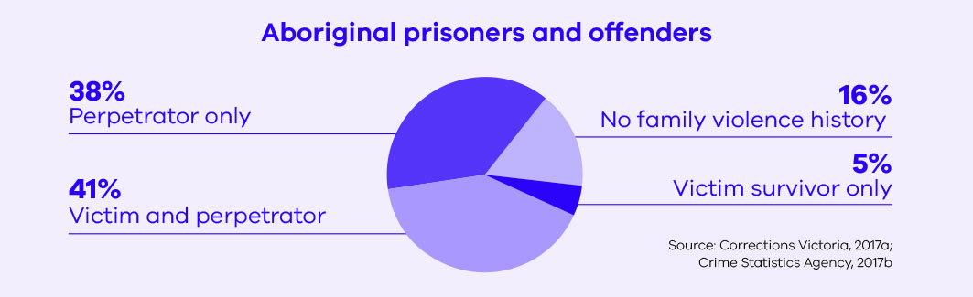
Corrections Victoria is committed to supporting Aboriginal prisoners and offenders, and ensuring that programs and initiatives delivered to Aboriginal prisoners and offenders who have experienced family violence are culturally responsive. As part of this commitment, the programs and initiatives delivered under this Strategy will align to the Koori Caucus Working Group on Family Violence Cultural Safety Principles to underpin responses to family violence:
- whole of family – whole of community
- culturally safe family violence system
- victims own the pathway to recovery
- perpetrators take responsibility for their actions.
Corrections Victoria aims to respond to family violence experienced by Aboriginal prisoners and offenders by:
- promoting and encouraging Aboriginal self-determination and community-led responses to family violence
- working in partnership with Aboriginal organisations to ensure they are supported through family violence legislative changes when providing a service for Corrections Victoria
- ensuring Corrections Victoria family violence initiatives align with the Indigenous Family Violence 10 Year Plan, Strong Culture, Strong Peoples and Strong Families: Towards a safer future for Indigenous families and communities and any future Aboriginal family violence strategies
- providing programs specific to the needs of Aboriginal perpetrators and victim survivors, with a focus on healing, cultural and family strengthening and behaviour change
- developing family violence supports and programs for Aboriginal prisoners and offenders, with a focus on intergenerational grief and trauma, healing and family strengthening
- providing education across the Victorian corrections system workforce about Aboriginal family violence, including an awareness of the holistic framework that focuses on prevention programs aimed at strengthening the factors that protect against family violence.

Supporting culturally and linguistically diverse prisoners and offenders
The Royal Commission highlighted that the experience of family violence may be different for members of CALD communities. There are additional barriers to seeking assistance for victim survivors from CALD communities, including social isolation, language difficulties and attitudes that may discourage reporting. These barriers to reporting, and limitations in data collection methods, mean that the prevalence of family violence in CALD communities is difficult to measure, although some data has suggested that people from CALD communities experience disproportionate levels of family violence. The form that family violence takes in CALD communities can also vary, and may include forced marriage, female genital mutilation and dowry-related abuse. Victim survivors in some CALD communities are also more likely to experience violence from their partner’s family (State of Victoria, 2016a).
Language barriers and attitudes about family violence can also be barriers to accessing appropriate programs for perpetrators from CALD communities. Mainstream Men’s Behaviour Change Programs are delivered in English and do not consider the cultural norms of CALD communities or deal with other issues that may be relevant, such as migration experiences and trauma (State of Victoria, 2016a).
The Victorian corrections system manages a number of prisoners and offenders from different CALD communities. Analysis of Victorian prisoner population data at 31 July 2017 indicates that, based on country of birth, the largest CALD group in the Victorian prison system is from South East Asia (Corrections Victoria, 2017b). In its provision of programs and services to victim survivors and perpetrators of family violence, Corrections Victoria is committed to considering the different experiences of family violence that prisoners and offenders from CALD communities may have.

Principles and objectives of this Strategy
As outlined in Figure 1, Enhancing Safety: Family Violence Strategy for the Victorian Corrections system 2018-2021 brings together the objectives of the Family Violence Service Reform Strategy 2015-16 and the broad principles identified in Ending Family Violence: Victoria’s Plan for Change. The overlay of cultural responsivity across all four principles highlights Corrections Victoria’s commitment to consider the needs of Aboriginal prisoners and offenders, and prisoners and offenders with CALD backgrounds, in all aspects of the corrections system’s response to family violence.
Figure 1: Family violence strategy principles and objectives
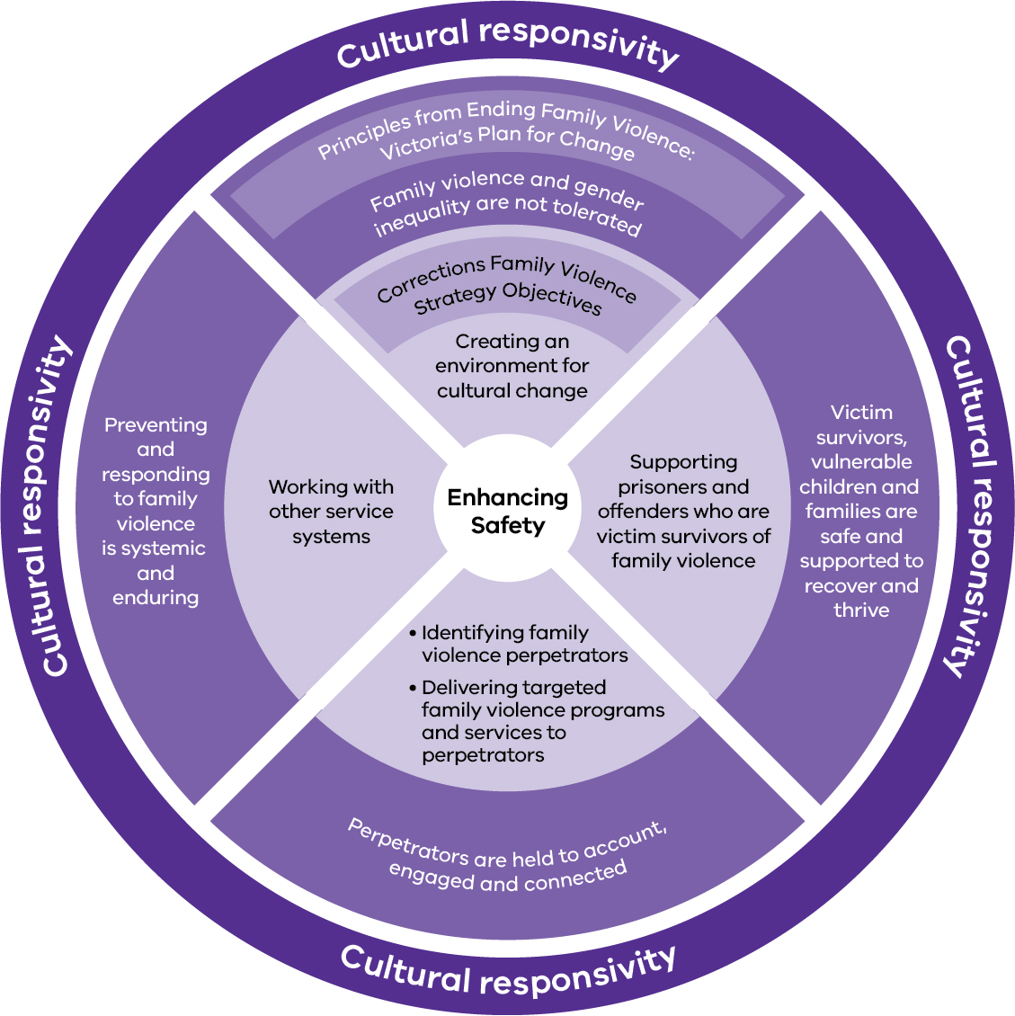

Principle 1
Family violence and gender inequality are not tolerated
Building on the Family Violence Service Reform Strategy 2015-16
This principle aligns to the Family Violence Service Reform Strategy 2015-16 objective of creating an environment for cultural change.
This principle builds on the achievements of the Family Violence Service Reform Strategy 2015-16 to ensure that family violence and gender inequality are not tolerated, by:
- actively working to improve Corrections Victoria’s understanding and awareness of family violence, and the impact of victimisation and perpetration, among prisoners and offenders
- ensuring access to programs or initiatives for prisoners and offenders to:
- hold perpetrators to account
- improve understanding of respectful relationships
- improve family linkages
- support family violence recovery and empowerment.
- equipping staff with the skills to respond appropriately to prisoner and offender behaviours and attitudes that are supportive of family violence and gender inequality
- promoting and integrating the Department of Justice and Regulation’s approach to gender equality within the corrections system.

Key Statistics
Corrections Victoria conducted a survey of prisoners’ experiences of, and attitudes towards, family violence in October 2015. This graph shows the degree to which female and male respondents agreed with particular statements relating to family violence.
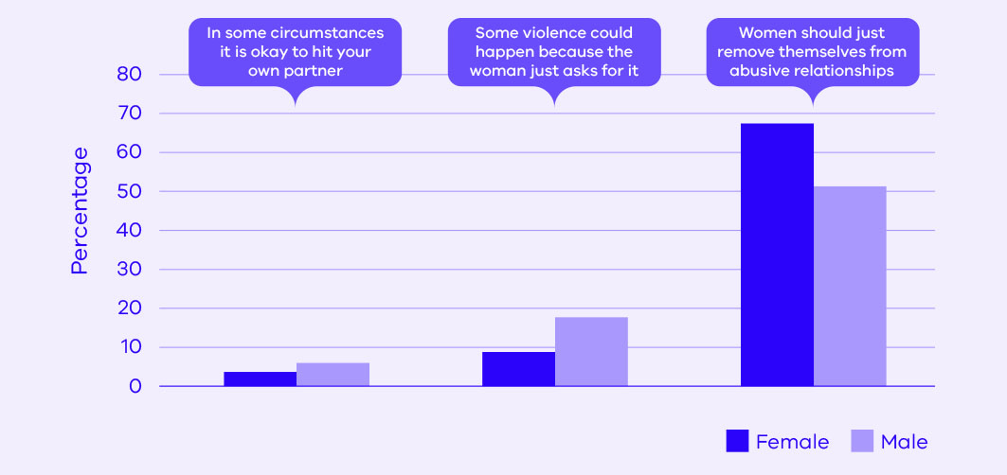
Source: Department of Justice and Regulation, 2016.
Research has shown that gender inequality is a key driver of violence against women. To prevent family violence, the attitudes and behaviours that foster and condone family violence must be challenged. The first Victorian Gender Equality Strategy, Safe and Strong, underpins initiatives to challenge gender inequality and work in this area will be guided by the Primary Prevention Strategy, Free from Violence: Victoria’s Strategy to prevent family violence and all forms of violence against women. As outlined in the Family Violence Rolling Action Plan 2017–2020, the Victorian Government is establishing a dedicated Prevention Agency to develop, support and coordinate prevention initiatives across the state.
Within Victoria’s corrections system, there is an opportunity to target prevention initiatives at prisoners and offenders who may be perpetrators and/or victim survivors of family violence. In some cases, those who are victim survivors of family violence may not recognise that they have experienced family violence or may be hesitant to talk about their experiences. Raising awareness of family violence is a critical way of encouraging those people to recognise and talk about their experiences. Similarly, awareness raising activities can prompt perpetrators who do not recognise their actions as family violence to reflect on their behaviour.
CASE STUDY
Dave has been in prison for a year after committing numerous burglaries. He has participated in the Respectful Relationships program, where he learned about the concept of healthy, respectful relationships and the behaviours that constitute family violence. While undertaking this program, Dave thought about his own childhood, where he and his mother would often have to stay with an aunt while Dave’s father ‘cooled off’ after his parents fought. Dave grew up terrified by his father’s rage. Dave never considered himself to be like his father, but as he continues to hear about different types of family violence, including non-physical violence, he begins to feel uncomfortable about his own behaviours.
Dave has a girlfriend outside prison who is also the mother of his 18 month old daughter. When they lived together, Dave used to check his girlfriend’s phone and emails and call her constantly to make sure she wasn’t seeing anyone else. His controlling behaviour caused many arguments between them during which Dave would often scream in his girlfriend’s face and threaten her with violence. Dave used to think that he knew where the line was because he wasn’t a ‘woman beater’, but now, as he continues to hear about emotional and psychological abuse and the harm they cause, this line is becoming blurred for him.
Dave is nearing the end of his non-parole period and had discussions with transition support workers about where he will live when he is released from prison. His girlfriend has said he cannot live with her and their daughter because of his past behaviours, so the transition support workers work with him to find housing in a location that allows him to see his daughter on a regular basis. Dave’s greatest wish is to live with his family again after missing them for so long, and he decides he will do whatever he can to be with his girlfriend and be a good father to his daughter. Upon his release from prison, Dave is referred to a Men’s Behaviour Change Program to encourage him to continue to learn about appropriate behaviour in a family context.
Note: This case study is a fictionalised depiction of the type of person who is managed in Victoria’s corrections system and is designed to illustrate the desired impact of programs and initiatives implemented under this Strategy. It includes a high-level representation of the support that an offender would receive in the corrections system, which in practice could involve multiple stages and support workers.

Principle 2
Victim survivors, vulnerable children and families are safe and supported to recover and thrive
Building on the Family Violence Service Reform Strategy 2015-16
This principle aligns to the Family Violence Service Reform Strategy 2015-16 objective of supporting prisoners and offenders who are victim survivors of family violence.
This principle builds on the achievements of the Family Violence Service Reform Strategy 2015-16 to ensure that victim survivors, vulnerable children and families are safer and supported to recover and thrive, by:
- improving the assessment of risk of family violence for victim survivors through enhanced intake and pre-and post-release processes and information sharing, and embedding family violence case management
- supporting the recovery of prisoners and offenders who are victim survivors of family violence through the provision of targeted programs and individualised support pre and post release
- minimising risk to families by preventing contact between prisoners who are perpetrators of family violence and their families, through the observation of conditions outlined in family violence intervention orders.

The service system in Victoria has not always made it easy for victim survivors and families to know what support is available or how they can obtain help. When people seek help they encounter a system that is difficult to navigate. They may also seek help from places that are not able to adequately understand their risks and needs or how best to support them.
Key statistics
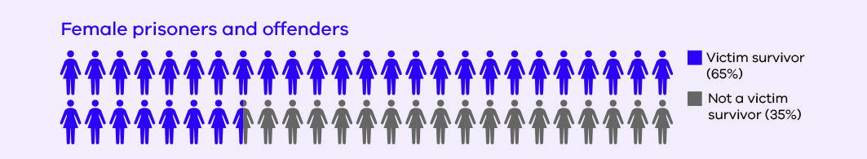
Total number of female prisoners and offenders at 31 December 2016: 2,928
Source: Corrections Victoria, 2017a Crime Statistics Agency, 2017b
As outlined in the Family Violence Rolling Action Plan 2017–2020, the Victorian Government is introducing reforms that focus on improving how victim survivors are kept safe and supported. These reforms focus not only on addressing demand pressures, but also on increasing the capacity and flexibility of child and family services and specialist family violence services to respond appropriately to people’s individual circumstances.
The role of Victoria’s corrections system in supporting victim survivors of family violence is two-fold. Through its programs and services, the Victorian corrections system aims to:
- reduce the harm to victim survivors of family violence in the community
- support prisoners and offenders who are victim survivors of family violence.
As outlined (Perpetrators are held to account, engaged and connected), a substantial percentage of prisoners and offenders within Victoria’s corrections system have a history of family violence perpetration. Corrections Victoria has a unique opportunity to intervene to change perpetrator behaviour and thereby reduce the harm to their families in the community.
Key statistics
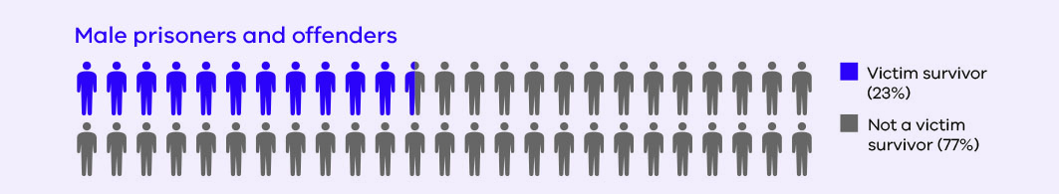
Total number of male prisoners and offenders at 31 December 2016: 17,886
Source: Corrections Victoria, 2017a Crime Statistics Agency, 2017b
Within Victoria’s corrections system there are a large number of prisoners and offenders with a history of family violence victimisation. In particular, the Royal Commission acknowledged the impact of trauma associated with family violence in the offending histories of women in prison, and the challenges that female victim survivors face on release from prison. A number of initiatives were introduced in response to the Royal Commission recommendations relating to women in prison - see (Where we have come from).
Almost a quarter of male prisoners and offenders, and two-thirds of female prisoners and offenders, have a history of family violence victimisation in the last 10 years (Corrections Victoria 2017a; Crime Statistics Agency, 2017b). Therefore, it is critical that Victoria’s corrections system offers the appropriate support to prisoners and offenders who are identified as victim survivors of family violence.

CASE STUDY
Kirra was pregnant with her second child when she was remanded into custody for a number of offences, including burglary, theft and offences committed while on bail. She gave birth to her son at a public hospital with the support of a Victorian Aboriginal Health Service case worker prior to her release. Her son was placed into kinship care when Kirra returned to prison.
Upon Kirra’s return to court, she received a sentence equal to the time already served on remand and was released.
Kirra returned to a dysfunctional and violent relationship with the father of her two sons. The relationship had previously been stressful because of daily fighting and his control over her, and there was an Intervention Order (IVO) in place against him. Although she was reunited with her recently-born son upon release from prison, he was subsequently removed by the Department of Health and Human Services due to family violence.
Within days of her release, Kirra was admitted to hospital with facial fractures and widespread bruising across her body. She will recover from her injuries, however, she has yet to make the decision to leave the situation of violence. A history of homelessness, substance abuse, low literacy skills, unemployment and financial hardship compound her difficult situation.
As Kirra was on remand during the time she spent in prison, she was unable to access the same level of post-release support as sentenced prisoners. In the future, additional post-release support will be available to prisoners on remand, like Kirra. They will receive additional support from reintegration service providers who can help them address their issues and refer them to an appropriate family violence service provider to assist with planning for release from prison to an environment safe from family violence.
Note: This case study is a fictionalised depiction of the type of person who is managed in Victoria’s corrections system and is designed to illustrate the desired impact of programs and initiatives implemented under this Strategy. It includes a high-level representation of the support that an offender would receive in the corrections system, which in practice could involve multiple stages and support workers.
Principle 3
Perpetrators are held to account, engaged and connected
Building on the Family Violence Service Reform Strategy 2015-16
This principle aligns to the Family Violence Service Reform Strategy 2015-16 objectives of:
- identifying perpetrators
- delivering targeted family violence programs and services to perpetrators.
This principle builds on the achievements of the Family Violence Service Reform Strategy 2015-16 to ensure that perpetrators are held to account, engaged and connected, by:
- identifying perpetrators of family violence on entry and throughout their correctional episode to ensure they are able to access appropriate programs and services throughout their time in the corrections system
- providing programs and services, based on research evidence, to hold perpetrators accountable for their behaviour, and facilitate and encourage behaviour change.

There is no single type of person who perpetrates family violence and so the system must provide more targeted, tailored responses to perpetrators, while keeping victim survivors and their risk of harm at the centre of focus. To end family violence, interventions must target the source—the person perpetrating the violence. There must be a coordinated and mutually reinforcing focus on the perpetrator across the service system, with the system and laws working together to hold perpetrators to account.
As outlined in the Family Violence Rolling Action Plan 2017–2020, the Victorian Government is focused on reducing the incidence of family violence by holding perpetrators to account for their actions. Since almost two-thirds of male prisoners and offenders, and just over half of female prisoners and offenders, have a history of family violence perpetration in the last 10 years (Corrections Victoria 2017a; Crime Statistics Agency, 2017b), Victoria’s corrections system has a unique opportunity to provide interventions to change perpetrator behaviour, given the existing expertise in the corrections workforce.

Key statistics
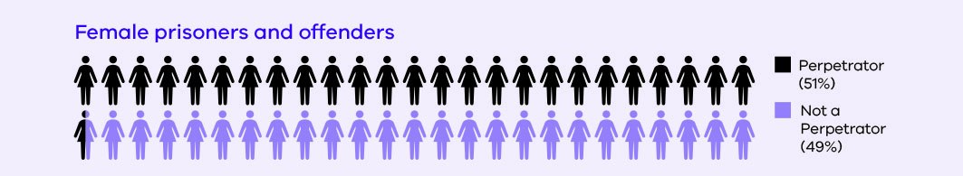
Total number of female prisoners and offenders at 31 December 2016: 2,928
Source: Corrections Victoria, 2017a Crime Statistics Agency, 2017b
The opportunity to engage with perpetrators is critical given the prevalence of family violence offending among prisoners and offenders, particularly those who represent the more serious and complex cases. The existing corrections programmatic framework and workforce provide a strong basis for developing, delivering and evaluating effective responses for perpetrators with complex needs, and integrating perpetrator interventions with family support and victim survivor services.
Key statistics
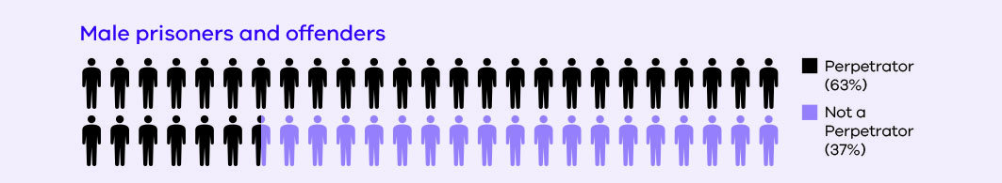
Total number of male prisoners and offenders at 31 December 2016: 17,886
Source: Corrections Victoria, 2017a Crime Statistics Agency, 2017b

CASE STUDY
Max, a 32 year old Vietnamese-Australian man, breached a Family Violence Intervention Order that resulted from a family violence incident involving his former partner. Due to the breach, Max received a 12-month Community Correction Order (CCO). An initial risk assessment carried out by his case manager determined Max to be at a high risk of general re-offending.
Three months into his CCO, Max consistently misses appointments with Community Correctional Services and has not attended any unpaid community work dates. Max was assessed and found suitable to participate in the Men’s Behaviour Change Program. His case manager is particularly concerned by his unwillingness to engage in the Program. In the few program sessions he attended, Max said he finds it difficult to relate to the other men in the program. His English is okay but he prefers to speak in Vietnamese, and he feels like all the other men in his group are different. He thinks they are just behaving badly whereas he is behaving in accordance with his culture.
Max’s case is reviewed by a Risk Review Panel where it is decided that the enforcement of his conditions will be sequenced in order for Max to focus on the Men’s Behaviour Change Program before starting his community work condition. To encourage Max to complete his CCO and address his offending behaviour, his case manager explores alternative culturally-specific programs he could attend instead of, or alongside, the Men’s Behaviour Change Program.
Since his case manager found a program that is a better fit for his needs, Max has improved his program attendance, and has also expressed an interest in a community work program close to his home. He is more engaged with his case manager, who has noted that Max is beginning to change his thinking and acknowledge his role as a perpetrator of family violence and the effect this may have had on his former partner.
Note: This case study is a fictionalised depiction of the type of person who is managed in Victoria’s corrections system and is designed to illustrate the desired impact of programs and initiatives implemented under this Strategy. It includes a high-level representation of the support that an offender would receive in the corrections system, which in practice could involve multiple stages and support workers.

Principle 4
Preventing and responding to family violence is systemic and enduring
Building on the Family Violence Service Reform Strategy 2015-16
This principle aligns to the Family Violence Service Reform Strategy 2015-16 objective of working with other service systems.
This principle builds on the achievements of the Family Violence Service Reform Strategy 2015-16 to ensure that preventing and responding to family violence is systemic and enduring, by:
- strengthening information sharing practices internally and with the broader family violence sector
- working with other departments and agencies to contribute to risk management and safety planning, and approaches to victim survivors and perpetrators that are consistent with the broader family violence system, with the objective of decreasing victimisation and reoffending
- providing guidance and tools to employees to increase their capability to support victim survivors and hold prisoner and offender perpetrators to account
- using technology to improve the identification and management of prisoners and offenders who are victim survivors or perpetrators of family violence
- working with the Department of Justice and Regulation’s Family Violence Principal Practitioner to identify opportunities to strengthen the response to family violence.

There is a need to transform the way in which we respond to family violence, and this transformation can only occur if reforms in this area are supported by strong foundations. This will require changes to the underlying structures that enable the system and services to function efficiently, including the workforce, information systems and funding arrangements.
As outlined in the Family Violence Rolling Action Plan 2017–2020, the Victorian Government has a number of key areas in its efforts to ensure that preventing and responding to family violence is systemic and enduring. These include the introduction of Support and Safety Hubs, the Central Information Point and a family violence information sharing scheme, and the redevelopment of the Family Violence Risk Assessment and Risk Management Framework (also known as the Common Risk Assessment Framework or CRAF).
As an organisation that manages, and holds information about, prisoners and offenders who may be perpetrators of family violence, it is critical that Corrections Victoria works closely with other departments, agencies and service providers to ensure effective risk assessment and management. Victoria’s corrections system has processes in place to share information under the Corrections Act 1986 and has developed strong working relationships with other agencies in the sector. However, there is an opportunity to build on these existing processes and relationships to share information with a wider group of organisations. Participation in the whole of government reforms, as a key holder of information, is vital for building these relationships.
Corrections Victoria also has an opportunity to implement initiatives within the corrections system to ensure that responses to family violence will be ongoing. Effective sharing of information within the corrections system, the alignment of risk assessment and management practices to the redeveloped Family Violence Risk Assessment and Risk Management Framework, and the provision of education and training to the corrections workforce are all areas of focus for this Strategy.

How the Strategy will be implemented
Corrections Victoria will work with our partners in the Regional Service Network, privately operated prisons, Justice Health, and across government and the family violence sector to implement Enhancing Safety: Family Violence Strategy for the Victorian Corrections system 2018-2021. The Strategy will support the delivery of initiatives for which Corrections Victoria shares responsibility with these partners, particularly in response to the recommendations of the Royal Commission into Family Violence.
The Strategy is complemented by a Family Violence Action Plan for the Victorian Corrections system, which details the initiatives to be delivered in the corrections system and how their delivery will be monitored. The Action Plan will be reviewed on an annual basis to ensure it reflects new areas of focus and subsequent initiatives developed over the four year period.
The Strategy is also accompanied by an Evaluation Framework that outlines how Corrections Victoria will provide evidence for the overall impact of the Strategy. The Evaluation Framework examines the impact of initiatives from the Family Violence Service Reform Strategy 2015-16 and initiatives in this Strategy, so that Corrections Victoria can gain a comprehensive understanding of the impact of its ongoing actions to address family violence.

Reference material
- Australian Bureau of Statistics (2017). Personal Safety, Australia, 2016, Catalogue No. 4906.0. Canberra: Australian Bureau of Statistics.
- Corrections Victoria (2017a). Monthly prisoner and offender statistics – 2016-17. Melbourne: Corrections Victoria. Available at: http://www.corrections.vic.gov.au/utility/publications+manuals+and+statistics/monthly+prisoner+and+offender+statistics [Accessed 15 January 2018].
- Corrections Victoria (2017b). Prisoner country of birth. Unpublished data analysis. Melbourne: Corrections Victoria.
- Crime Statistics Agency (2017a). Number of family incidents and rate per 100,000 population - July 2006 to June 2017. Unpublished data analysis. Melbourne: Crime Statistics Agency.
- Crime Statistics Agency (2017b). Family violence history of Corrections Victoria population (linkage of Corrections Victoria and Victoria Police data). Unpublished data analysis. Melbourne: Crime Statistics Agency.
- Department for Victorian Communities (2003). Victorian Indigenous Family Violence Task Force. Final Report. December 2003. Melbourne: The State of Victoria, Department for Victorian Communities.
- Department of Justice and Regulation (2016). Family Violence Prisoner Survey 2015: Summary Report. Melbourne: The State of Victoria, Department of Justice and Regulation.
- State of Victoria (2016a). Royal Commission into Family Violence: Report and recommendations, Vol. V, Parliamentary Paper No. 132 (2014-16).
- State of Victoria (2016a). Royal Commission into Family Violence: Summary and recommendations, Parliamentary Paper No. 132 (2014-16).

Acronyms Description
CALD Culturally and linguistically diverse
CCO Community Correction Order
CRAF Common Risk Assessment Framework (officially called the Family Violence Risk Assessment and Risk Management Framework)

Victims were recorded at least once by Victoria Police as an ‘affected family member’ on an L17 form, and perpetrators were recorded at least once as an ‘other party’ in the period from 1 July 2006 to 31 December 2016.

