Adult Parole Board Victoria
Annual Report 2017-18

Letter to the Minister 4
Introduction 5
Foreword from the Chairperson 5
Foreword from the Chief Administrative Officer 10
Key highlights for 2017-18 13
Members 14
Members appointed in 2017-18 15
Adult Parole Board members 2017-18 18
Operations and decision-making 21
Typical day for the Adult Parole Board 21
Sentencing and parole 23
The parole process 25
Parole data over the past 15 years 26
Key projects 32
Independent audit 32
Family violence 33
Legislation 33
Litigation 34
Stakeholder Collaboration and engagement 35
Increasing the community’s understanding of parole 35
Working collaboratively with stakeholders 36
Foreword from the DSOD Chairperson 39
History of the DSOD 40
DSOD Operations 41
Orders under the DSOD’s jurisdiction 42
Organisation and governance 44
Governance 44
Secretariat 44
Organisational chart 45
Privacy and information 46
Year at a glance 47
Financial report 50
Glossary 51

Published by the Adult Parole Board of Victoria
September 2018
This work, Adult Parole Board Annual Report 2017–18, is licensed under a Creative Commons Attribution 4.0 licence. You are free to re-use the work under that licence, on the condition that you credit the State of Victoria (Adult Parole Board) as author, indicate if changes were made and comply with the other licence terms. The licence does not apply to any branding, including the Victorian Government logo.
ISSN 2205-4863 (Print)
ISSN 2205-4871 (Online)
For further information, contact:
Chief Administrative Officer
Adult Parole Board of Victoria
Level 4, 444 Swanston Street, Carlton VIC 3053
DX 211768 Carlton
Telephone: (03) 9094 2111
Victorian country callers: 1300 766 946
Interpreter Service: Call 131 450 and ask for the Adult Parole Board
Facsimile: (03) 9094 2125
Email: apb.enquiries@justice.vic.gov.au
Internet: www.adultparoleboard.vic.gov.au
The information contained in this report was accurate as of September 2018.
Accessibility
If you would like to receive this publication in an alternative format, please telephone the Adult Parole Board on 03 9094 2111 or email apb.enquiries@justice.vic.gov.au.
This document is available in multiple formats on the internet at www.adultparoleboard.vic.gov.au

Letter to the Minister

The Hon Gayle Tierney MP
Minister for Corrections
Level 1, 2 Treasury Place
East Melbourne VIC 3002

Dear Minister
In accordance with the requirements of section 72(1) of the Corrections Act 1986, we are pleased to present this Annual Report of the performance and operations of the Adult Parole Board of Victoria for the 12 months from 1 July 2017 to 30 June 2018.

Yours sincerely

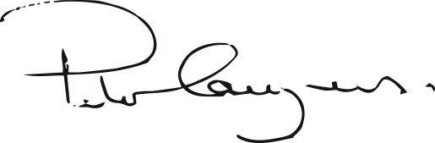
His Honour Peter Couzens
Chairperson

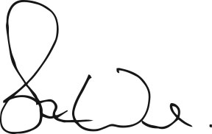
Stuart Ward
Chief Administrative Officer

Introduction
Foreword from the Chairperson
Five years after the tabling of the Review of the Parole System in Victoria conducted by former High Court Justice Ian Callinan AC, I can confidently assert that Victoria’s parole system has stabilised with significant benefits to both parolees and the Victorian community as a whole.
The following outcomes emerge from the reporting year’s statistics, which appear in full later in this report. They support the assertion contained in the opening paragraph.
- The Board received 1,680 parole applications, including re-parole, which was nine less than the preceding year. Only 114 eligible prisoners chose not to apply.
- The Board granted 803 parole orders, an increase of 46 from the previous year.
- The Board received 55 notices of detention from Victoria Police, one more than the preceding year but 143 fewer than 2014-15, a 72 per cent fall over three years.
- 156 parole orders were cancelled, 48 less than the preceding year representing a 24 per cent fall over the last two reporting years and an 80 per cent fall over the last five years (from 761 cancellations in 2013-14).
- 79 per cent of parolees successfully completed their parole and were discharged during the reporting year compared to 76 per cent in the previous year and 54 per cent in 2013-14.
- The number of persons convicted of serious violent offences or sex offences committed while on parole was four, one less than the previous year and 56 less than 2013-2014, a 93 per cent fall over five years.
- At the end of the reporting year, there were 858 prisoners on parole compared to 841 the previous year.
From the above, it is open to conclude the following:
- The vast majority of eligible prisoners, that is those who have been sentenced to a non-parole period, apply for parole. The claim made by critics that parole is too hard and that eligible prisoners are not bothering to apply is not borne out by the facts.
- The majority of applicants are granted parole but not to the same extent as was the case prior to the implementation of the reforms. The increase in the number of grants this year compared to the previous year and the increased number of parolees in the community at the end of the reporting year, however, strongly suggest that the decline in parole numbers has bottomed out and that they are now on the rise.
The combination of the following provides ample evidence of the benefits of the reformed parole system to both parolees and the Victorian community:
- the high proportion of parolees successfully completing their parole and being discharged at the end of their sentences
- the significant fall in the number of cancellations of parole
- the reduced number of notices of detention sent to the Board by Victoria Police
- the 93 per cent fall (from 60 to four) over the five years in prisoners being convicted of serious violent offences or sex offences committed while on parole.
As successful as the legislative and administrative reforms to the parole system have been, there is no room for over-confidence, complacency or meddling with the present strategies.
One should never forget that the risks posed by a prisoner’s re-entry to the community can never be eliminated, just reduced to an acceptable level so that the purpose of parole can be promoted and achieved whilst protecting the community from unacceptable risks.
DSOD (Detention and Supervision Order Division)
On 10 August 2005, the first Extended Supervision Order was made in the County Court under the Serious Sex Offender Monitoring Act 2005, the predecessor to the Serious Sex Offenders (Detention and Supervision) Act 2009.
On the same day, the Board convened its first sitting under the Act and determined appropriate instructions and directions for the order made by the court earlier that day.
Approximately 12 and a half years later on 19 February 2018, in the absence of His Honour Frank Shelton who was on leave, I presided over the final scheduled sitting of the Board’s DSOD in company with full-time member Stephen Farrow and community member Kieran Walshe. On 27 February 2018, the Board was formally divested of its jurisdiction under the Act and the Post Sentence Authority came into existence absorbing the Board’s previous jurisdiction.
The transition of the Board’s DSOD to the Authority was a major project involving, amongst other tasks, the migration of approximately 47,000 electronic records and the transfer of over 200 hardcopy files.
It was a complex project with significant time constraints. The fact that the project was successfully completed on time was a tribute to Project Manager Sonia Mosca, Project Officer Alison Slee and members of the Board’s Secretariat staff including Anita Lis, Tania Tesich, Fatima Ebrahim, Emma Hyde, and many others.
I wish to acknowledge and thank His Honour Frank Shelton, who served as Chairperson of the Division from January 2014, for his leadership and commitment to the work of the Division.
In addition, I wish to thank the judicial members who, from time to time, presided on the Division’s meetings in the absence of the Chairperson. I would also like to thank the Board’s full-time members and the community members assigned to the Division, for the manner in which they undertook the difficult but extremely important work of the Division, as well as members of the Board’s Secretariat who provided wonderful support for the Division, in particular Sarah Iavasile and Emma Hyde.
I would also like to thank and acknowledge the work of His Honour Ian Gray, Chairperson of the Post Sentence Authority, whom I worked closely with during the transition of the DSOD.
Membership
As with any other organisation, the strength of the Board depends largely on its leadership, membership and staff.
In terms of its membership, the Board has been extremely fortunate to have had appointed to it the following new members:
Full-time member
Colleen Bell
Judicial members
Retired Magistrate Her Honour
Jacinta Heffey
Reserve Magistrate Her Honour Catherine Lamble
Her Honour Michelle Hodgson
Community members
Kristy McKellar
Charlene Micallef
Chris Trotter
Heidi Tucker

As the report contains profiles of each of the new members, I shall refrain from commenting on them individually. Suffice to say that they are all exceptionally welcome additions to the Board’s membership due to their personal qualities, character, professional and life experiences, and their enthusiasm and commitment for the work of the Board.
The appointment of three new judicial members was especially welcome.
For a number of reasons, the Board can no longer expect to have sitting Supreme Court Justices or, with the one notable exception of Her Honour Judge Sue Pullen, County Court Judges amongst its membership.
The Board’s judicial membership includes six sitting magistrates. Due to the increasing workloads of the Magistrates’ Court of Victoria, however, their capacity to preside at Board meetings is extremely limited.
Similarly with reserve magistrates, the calls on them to sit in the Magistrates’ Court are such that their availability to sit at the Board is generally less than was originally anticipated.
The consequence of all this, combined with the increased number of sittings which are an important contribution to improved decision-making, is that in recent years an over reliance has developed on a very small number of judicial members, in particular His Honour Frank Shelton and His Honour Alan Spillane. This has caused the Board, from time to time, to experience difficulties listing matters in the event of illness, leave or otherwise.
The recent appointment of three new judicial members, especially Her Honour Jacinta Heffey and Her Honour Catherine Lamble, has done much to lessen this problem and for that the Board is most grateful.
The reality, however, is that sooner or later consideration will need to be given to broadening the base from which presiding members are drawn, for example, by extending the existing range of sitting or retired judicial officers to include experienced legal practitioners of, say, ten years or more standing. This approach would be consistent with many other jurisdictions, both within Australia and internationally, and would be an effective way of ensuring that at all times there is a sufficient number of presiding members to meet the Board’s needs and allow it to sit on each weekday, without diminishing its decision-making capability.
The Board took great pleasure in the induction of community member Aunty Pam Pederson to the Victorian Honour Roll of Women, joining her mother Lady Gladys Nicholls who was inducted in 2008.
Sadly the Board farewelled five members during the reporting year including Carmel Arthur, His Honour Robert Kumar OAM, Her Honour Kay Macpherson, Jim Parke and His Honour Louis Hill.
Carmel Arthur served as a community member of the Board for the maximum term of nine years, her term having expired on 29 December 2017.
Throughout her term, Carmel was a dedicated and highly respected member who served the Board with great distinction.
Carmel’s husband, Senior Constable Rodney Miller, was shot and killed in Cochranes Road Moorabbin on 16 August 1998 when on duty with Sergeant Gary Silk who was also shot and killed. Although a victim of crime herself, Carmel is a vocal and passionate supporter of parole.
Thankfully, Carmel’s service to the community will continue following her appointment as a full-time member of the Post Sentence Authority.
Reserve Magistrate His Honour Robert Kumar OAM served as a judicial member of the Board from 13 December 2011 until 29 June 2018 when his term expired. He decided not to seek reappointment due to the heavy demands placed on him to serve as a Reserve Magistrate.
His Honour’s many years of service to the law, especially as the Coordinating Magistrate at the Broadmeadows Magistrates’ Court, was recognised in the 2018 Australia Day Honours List when he was awarded Membership of the Order of Australia.
Her Honour Kay Macpherson served as a judicial member from 10 December 2013 to 1 August 2017. She sat regularly and was highly regarded by her colleagues. Unfortunately, due to the work commitments associated with her role as Coordinating Magistrate of the Children’s Court at Broadmeadows, she was unable to continue with the Board.
Jim Parke was a community member from 16 September 2014 to 15 September 2017. He was an active and valuable member of the Board.
I take this opportunity to again thank Carmel Arthur, His Honour Robert Kumar OAM, Her Honour Kay Macpherson, Jim Parke and His Honour Louis Hill for their years of service to the Adult Parole Board.
During the year, the Board has maintained its comprehensive and educational members’ seminar program with eminent speakers including The Hon. James Wood AO QC, Chairperson of the NSW State Parole Authority, who presented to the members at the Board seminar on 1 December 2017.

Community engagement
The Board has continued to take advantage of suitable opportunities to engage with the community with the aim of providing a better understanding of parole and, in particular, the role of the Board.
During Law Week 2018, for example, three opportunities arose which were enthusiastically accepted.
The first was an invitation for me to be interviewed by Jon Faine on his morning ABC 774 radio program. I was very pleased to accept the invitation and welcomed the opportunity to speak about the significant reforms that have occurred since 2013 and the success of these reforms.
The second was a visit to Deakin University in Geelong during which full-time member Colleen Bell and I presented to an interested and engaged audience of academics, students, lawyers and community members. This was a particularly successful and enjoyable occurrence. The event was hosted by Deakin Law School, and I would like to express my sincere thanks to Dr Marilyn McMahon, the Deputy Dean of Deakin Law School, and all her colleagues.
The third took place on 19 May 2018 in the County Court of Victoria. In a packed court, the Board’s presentation consisted of an explanation by me of parole and the role of the Board and a mock hearing conducted by a panel comprising of judicial member Her Honour Judge Sue Pullen, full-time
member Stephen Farrow and community member Kieran Walshe.
A most welcome addition to this year’s mock hearing was the participation of Senior Parole Officer Dylan Reynolds. Dylan was able to explain the role of an assigned Parole Officer in preparing a Parole Suitability Assessment, supervising a parolee in the community and reporting back to the Board any concerns with regards to compliance and increased risk.
I wish to acknowledge and thank Chief Judge His Honour Peter Kidd for agreeing to the Board’s participation and for Her Honour Judge Lisa Hannan and County Court staff for their enthusiastic support and assistance on the day.
This report details other occasions when either myself or other members took part in presentations about the Board and its role.
Collaboration
Throughout the reporting year, the Board was approached by representatives of like organisations and other interested parties to consult about parole and other related issues. These approaches reflect the enhanced reputation and standing of the Board, both nationally and internationally.
- In September 2017, Federal Court Judge Matthew Myers AM, the Commissioner for the Inquiry into Incarceration Rates of Aboriginal and Torres Strait Islander Peoples, and Mr Robert Cornall AO, the Acting President of the Australian Law Reform Commission, attended the Board’s premises to consult with myself, community member Aunty Pam Pederson, former Parole Officer Mr Peter Webster and Aboriginal Elders Uncle Kevin Coombs OAM and Uncle Glenn James OAM.
- Former Victoria Police Commissioner Ken Lay and former Supreme Court Justice the Honourable David Harper AM QC met with myself and Chief Administrative Officer (CAO) Stuart Ward at the Board’s premises in connection with their roles with the Independent Panel on Terrorism and Violent Extremism Prevention and Response Powers.
- The two Deputy Presidents of the Queensland Parole Board visited the Board for discussions with myself and CAO Stuart Ward in the aftermath of the Review of the Queensland Parole system, and the implementation of reforms.
- The Chairperson of the ACT Sentence Administration Board visited the Board and spoke with myself and CAO Stuart Ward.
- Following the United Kingdom (UK) Justice Secretary’s decision in early 2018 to commence a review of the England and Wales parole process, the Board was approached by members of the UK review team to discuss aspects of Victoria’s parole system, especially with regard to victims and reviews of decisions. Consequently, CAO Stuart Ward and I engaged in a lengthy telephone conference with members of the UK review team which was gratefully appreciated. We look forward to further discussions with our UK counterparts.
- CAO Stuart Ward and I were invited to deliver a presentation at the Association of Paroling Authority International’s conference at Lake Tahoe in Nevada, USA, in April 2018. Our presentation was entitled ’Crisis, Reform and Transformation, the journey of the Adult Parole Board’.
As the title suggests, our presentation followed the history of the Board from the troubled times of 2012 and 2013 through to the Callinan Review, the implementation of the recommendations of the review, and the successful transformation of the Board and the parole system as a whole with the positive outcomes that are touched upon in this year’s report.

Power to suspend parole
On 18 September 2017, I appeared before the Parliament of Victoria’s Law Reform, Road and Community Safety Committee’s Inquiry into Drug Law Reform in company with CAO Stuart Ward and full-time member Stephen Farrow to present and be questioned in respect of the Board’s earlier written submission.
In brief, the purpose of the Board’s written submission was to appraise the committee of the prevalence of illicit drug use as a contributor to the cancellation of parole and to recommend that the Board be given the power to suspend, as opposed to cancel, parole in appropriate cases where a parolee is found to have re-engaged in illicit drugs while on parole.
I’m pleased to say that the Committee adopted the Board’s submission in Recommendation 17 of its report which says as follows:
’As proposed by the Adult Parole Board, the Victorian Government provide the Adult Parole Board with the power to suspend parole for longer-term parolees who have been found to use illicit substances but whom have not reoffended. Suspension could be up to three months, and parolees offered treatment during that time. Following the period of suspension, the Board would assess whether they can continue on parole’.
The Board awaits the government’s response to the committee’s recommendation with great interest.
Finally, I wish to acknowledge and thank the membership, management and staff of the Adult Parole Board for their contributions to the work of the Board during the reporting year. They have been outstanding.
With one exception, I do not intend to name names for special mention for if I were to do so it may give the impression that the named person or persons is or are more important and more worthy of praise than others and that would not be the case.
The exception is the Board’s Chief Administrative Officer Stuart Ward who has continued to dedicate himself tirelessly, selflessly and expertly to the heavy demands of his role.
Stuart has been unflinching in his wish to transform the Board into a modern, innovative, progressive, effective and responsive organisation. With the support of the Board’s Executive and the management team, much has already been done to achieve that goal. He will not rest until more is done.

His Honour Peter Couzens
Chairperson
Adult Parole Board

Foreword from the Chief Administrative Officer
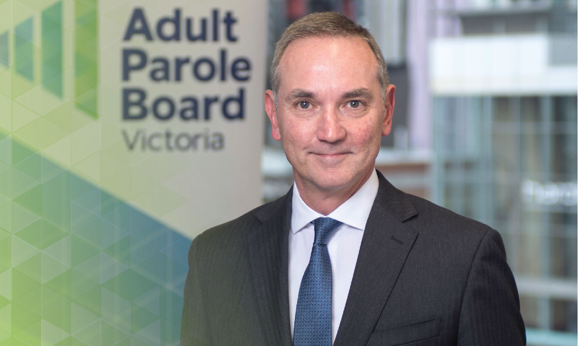
The 2017-18 Annual Report of the Adult Parole Board records how parole is an effective mechanism to manage the difficult but crucial task of transitioning prisoners into the community as they approach the end of their sentence, in a way that contributes to the safety of the Victorian community.
Data
It is pleasing to report that the 2017-18 data is consistent with the data reported in 2016-17. In simple terms, the story told is that:
- the overwhelming majority of eligible prisoners want, and apply for, parole
- the vast majority of parole applications proceed to a comprehensive assessment of the prisoner’s suitability for parole, assembling the information necessary to inform the Board’s decisions
- prisoners are likely to be granted parole if they behave in prison, satisfactorily complete required offender behaviour programs, and have suitable accommodation to reside at while on parole
- however, the Board will deny parole to prisoners when the risk to community safety and protection is too great
- a greater proportion of prisoners completed their parole period without it being cancelled than at any other time during which comparable records have been kept
- the rate of reoffending by prisoners on parole remains low – four people were convicted in 2017-18 on serious offences committed while on parole, and only 19 per cent of parole cancellations included any type of offending as a reason for the cancellation (including minor drug and traffic offending)
- most parole cancellations result from drug use, with the Board cancelling parole to prevent an escalation of risk and the possible commission of offences.
From the data, the community should have confidence that the Board exercises sound judgement about who is released on parole, the conditions imposed to monitor parole, and if and when to cancel parole. The data reflects the paramountcy of community safety and protection in the Board’s decisions.
It is timely in this report for the Board to present a longer term data analysis to understand the impact of the changes that have occurred from the years preceding 2012, through a period of unprecedented reform between 2013 and 2016, and the settling of the post-reform paradigm over the past two years. The analysis succinctly demonstrates the improvements made to the parole system over this time.
Membership
The Board is proud to introduce eight new members in this report, accounting for one quarter of its membership. The appointment of the new members has strengthened and refreshed the Board and ensured that its membership continues to reflect the diversity of the community. For the first time in its history, the member gender ratio is 50/50. The Board continues its emphasis on building and maintaining the knowledge of members, with the new members undertaking an extensive induction program and all members encouraged to attend monthly professional development seminars.
Practice development
The Board’s quest to be a best practice decision-making body has continued with significant steps taken to build on improvements already implemented.
- The divestment of the Board’s post sentence jurisdiction to the Post Sentence Authority in February 2018 allows the Board to concentrate its time and expertise on parole decisions.
The end of the Board’s Detention and Supervision Order Division (DSOD) provided an opportunity for the Board to schedule additional parole hearings in place of the weekly DSOD hearings. Apart from the benefit of spreading the parole case load across more hearings, this ensures there is a Board division convened on each weekday to consider urgent matters.
- The work on the Board’s case workflow system continues on schedule, with an important foundational phase of work successfully launched in October 2017. This priority project remains on track for the October 2018 deployment of the system envisaged by The Hon. Ian Callinan AC in his report on Victoria’s parole system.
The case workflow system will be named PRISM – Parole Records Integrated System of Management – recognising the array of component information that it orders.
Two significant advantages for the Board are worth highlighting. Firstly, PRISM will present information about prisoners from a number of separate IT systems through one central view, ensuring members can more easily access relevant information. Secondly, members will be able to securely access relevant offender files remotely to familiarise themselves with cases in advance of Board hearings.
These improvements will further reduce the risk of information management errors.
The Board continues its substantial resource commitment to this project with five staff dedicated to it, and the input of many other staff and members. The Board acknowledges the support of Corrections Victoria, and the work of the project team from Corrections Victoria Information Technology (CVIT).
- As a busy institution undertaking important work, the Board needs appropriate, modern accommodation. To that end, the Board welcomes the plans for it to move into purpose-designed premises in the second half of 2018. The Board will move to a building in Melbourne to be fully occupied by the Department of Justice and Regulation. The benefits for the Board will include better security, better meeting room capacity, better training spaces, better amenities, better offices for the Chairperson and Deputy Chairperson, better IT infrastructure, and a more flexible working environment.
- Complementing the re-location to new premises with improved physical security, the Board also welcomes the amendment of the Corrections Act 1986 to pave the way for improved security services to be present when prisoners on parole attend to be interviewed by the Board. Security officers will have the statutory power to give directions, use reasonable force to compel compliance with directions, and to arrest and detain a prisoner on parole if they have committed an indictable offence or their parole is cancelled.
- The Board completed the first stage of a new audit program to monitor its compliance with legislative requirements. This involved the development of a self-assessment tool and the completion of a self-assessment of key statutory requirements – providing reasons for decisions to cancel and revoke parole, the breach of parole process, the serious violent offender or sex offender hearing process, and the annual report requirements. Although the self-assessment was completed by Board staff in the reporting year, we await the report on the outcome of the assessment. In 2019, the Board will undertake the next stage of the program, an audit conducted by an external auditor. Going forward, self-assessments and external audits will occur on alternating years, embedding a regular discipline of accountability that is welcomed by the Board to identify practice improvement opportunities and give assurance of its compliance with the governing statutory framework.
Engagement
The Board continued to actively seek opportunities to engage with the community to drive positive messages about parole. This included initiating an event for Law Week in regional Victoria to supplement its mock parole hearing in Melbourne.
The Chairperson, His Honour Peter Couzens, and I had the honour of representing the Board to co-present at the international conference of the Association of Paroling Authorities International. It was with immense pride that we shared the Board’s journey of reform and recovery with senior representatives of parole agencies from across the world. It was with even greater pride that we returned home with the recognition of our international peers of the high standing of the Board and the Victorian parole system.
The Board’s standing is reinforced by the number of parole agencies and other bodies, from Australia and internationally, which have approached the Board during the year for input into how they might manage their own challenges. The Board always makes time to assist.
Acknowledgements
There is no doubt that the Board is setting and working to extremely high standards across all of its activities. During 2017-18 this was formally recognised by:
- a Special Commendation in the Justice Risk and Resilience Awards for the Board’s work in renovating its risk register and business continuity plan
- a Bronze Award for distinguished achievement in reporting for the Board’s 2016-17 Annual Report in the Australasian Reporting Awards.
The strong position of the Board recorded in this report is a testament to the diligence, commitment and integrity of its members and Secretariat. It is a privilege to work with such a positive and professional group toward our shared goal of enhancing the safety of the Victorian community.
The Chairperson, His Honour Peter Couzens, continues to promote and protect the Board through his strategic and wise leadership, and to be a strong and compelling advocate for the parole system. He is well supported by the Deputy Chairperson, His Honour Frank Shelton, and the full-time members.
The Board continues to foster and value effective and respectful working relationships with the many agencies with whom it interacts. Notably, the support that Corrections Victoria provides to the Board warrants particular recognition.

Stuart Ward
Chief Administrative Officer
Adult Parole Board

Key highlights for 2017-18
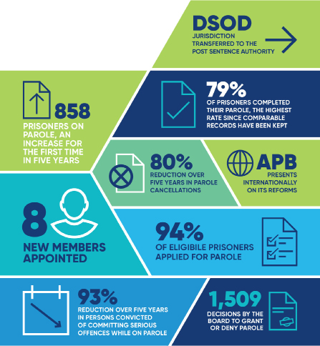

Members
The Board’s membership consists of members from a diverse range of backgrounds, both professionally and culturally, with rich and relevant experiences that they each bring to the Board.
The majority of members, some of whom have public profiles and are well-known within the community, have had, or continue to have, outstanding careers in a range of different fields.
Board panels normally comprise a presiding judicial member, a community member, and a full-time member.
The judicial members include current and retired County Court judges and current and retired magistrates.
The experience and backgrounds of the community members include:
- people who have been or have supported victims of crimes
- retired police officers
- an Aboriginal elder
- mental health service provision
- public administration
- journalism
- members of other decision-making Boards at tribunals, hospital administration, education, child protection, and members of the Sentencing Advisory Council
- the founder of Crime Stoppers.
The full-time members include lawyers and a forensic psychologist.
Member education – monthly seminar series
The Board has an established, comprehensive and educational seminar program as part of its professional development program to increase the knowledge of its members, and to promote consistency in the making of decisions. The program involves monthly seminars presented by experts and professionals who are leaders in their fields, biannual all-day seminars, and visits to prisons.
Each monthly seminar includes a ‘practice discussion’ during which the Chairperson and full-time members speak about Board practices to the members. The members also have an opportunity to contribute their perspective to the practices and operation of the Board.
The educational seminar program in 2017–18 included presentations on:
- the role of education in breaking the cycle of imprisonment
- the 2016-17 reporting year’s data and what it demonstrates
- the role of technology in sexual offending and social media
- forensic psychology and criminal profiling
- understanding female prisoners and challenges they face in prison and in the community
- the use and effects of drugs to understand urine analysis and screens
- how disciplinary incidents are managed within prisons
- challenges surrounding accommodation for prisoners applying for or on parole
- how information is received and processed by the Secretariat for the Board.
Two all-day seminars were also held during the reporting year in December 2017 and June 2018 with presentations on:
- the new case workflow system, with a demonstration by the project team
- the new Post Sentence Authority by His Honour Ian Gray, Chairperson of the Post Sentence Authority and Bree Oliver, Chief Administrative Officer of the Authority
- electronic monitoring
- the New South Wales parole system by The Hon. James Wood AO QC, Chair of the NSW State Parole Authority
- employment of prisoners on parole
- the role of the media.
The Board acknowledges the invaluable contribution of speakers who presented at the seminar series, many of whom have dedicated their lives to the management and treatment of offenders.
New members
The following members were appointed to the Board in 2017-18. More information about each member is available on pages 12 to 14 of this report.
Judicial members
- Her Honour Jacinta Heffey
- Her Honour Michelle Hodgson
- Her Honour Catherine Lamble
Community members
- Kristy McKellar
- Charlene Micallef
- Chris Trotter
- Heidi Tucker
Full-time member
- Colleen Bell
Member induction program
The Board developed an induction program for the eight members appointed in 2017-18. The induction program included information sessions where the new members learned about parole and the Board from members, the CAO, Corrections Victoria and Community Correctional Services. They received mentoring from other members, and they also had the opportunity to observe different Board hearings and visit prisons across Victoria.
Members appointed in 2017-18
Her Honour Jacinta Heffey
Judicial member
Her Honour Jacinta Heffey has over 30 years’ judicial experience, including sitting in the Magistrates’ Court, the Children’s Court and the Coroner’s Court. She was appointed as a magistrate in 1986, after 15 years of practice as a solicitor. She retired from the court in 2015. Her Honour recently said that, “If I needed any persuasion as to the benefits of the parole system, this has been overwhelmingly satisfied by my involvement on the Board”.
Her Honour Michelle Hodgson
Judicial member
Her Honour Michelle Hodgson was appointed as a magistrate in 2008 and currently sits on the Coroner’s Court. She was the Regional Coordinating Magistrate for the Grampians Region from 2013 to 2015. She has experience sitting in criminal and civil jurisdictions, as well as on the Children’s Court and the Victims of Crime Assistance Tribunal. Her Honour commenced her legal career as a solicitor in 1993, and signed the bar roll in 1998. For 18 months, she was in-house counsel in the Office of the Commonwealth Department of Public Prosecutions (DPP).
Her Honour Catherine Lamble
Judicial member
Her Honour Catherine Lamble has over 20 years’ judicial experience, including sitting in the Magistrates’ Court, the Children’s Court, and on the Victims of Crime Assistance Tribunal. She was appointed as a magistrate in 1995 and retired in early-2018. Prior to her appointment as a magistrate, she practiced as a solicitor for 16 years in private practice, as well as working for Victoria Legal Aid and the Victorian Aboriginal Legal Service.
Heidi Tucker
Community member
Heidi Tucker was appointed as the Chief Executive Officer of Anchor Inc in 2015. Anchor Inc is an independent not-for-profit organisation providing housing and support services for children, young persons, and families in the outer east region of Melbourne. Prior to Anchor Inc, she held senior management roles with Berry Street and Life Without Barriers. From 1990 to 2003, she held management positions with the NSW Department of Community Services and then the NSW Department of Juvenile Justice.
Kristy McKellar
Community member
Kristy McKellar has an academic background in social science and social work. She is a clinical professional with two decades of experience, including Community Correctional Services. Kristy is well-known in the family violence sector, both in Victoria and nationally. Kristy was named in the top 100 Women of Influence in Australia, named as the Agenda Setter of the Year for Australia and inducted into the Victorian Honour Roll of Women. Kristy sits on several state taskforces, boards, and holds many ambassador titles.
Charlene Micallef
Community member
Charlene Micallef is a social worker who works in palliative care service. Prior to this, Charlene was Manager, Victims Strategy and Services, at the Office of Public Prosecutions. This was a work group focused on assisting victims of crime and witnesses through the prosecution of indictable criminal cases, improving the victims’ experience through the criminal justice system and the system’s responsiveness to victims. Before this, Charlene worked with the Department of Justice and Regulation’s (DJR) Victims Support Agency and was a community representative on the DJR Sexual Assault Advisory Committee.
Chris Trotter
Community member
Professor Chris Trotter works in the Department of Social Work at Monash University and is Director of the Monash Criminal Justice Research Consortium. Prior to his appointment to Monash University, he worked for many years as a Community Corrections Officer and Regional Manager in Corrections Victoria. He has undertaken more than 30 research projects, published eight books and more than 100 papers predominantly on the subject of effective supervision of offenders. His book Working with Involuntary Clients, now in its third edition, is published in six different languages. He has recently been awarded Professor Emeritus for his outstanding achievements in research.
Colleen Bell
Full-time member appointed 2017-18
I began my legal career as an associate to the first female Supreme Court Judge, the Honourable Justice Rosemary Balmford AM. Upon Her Honour’s retirement from the bench, I became the associate to the Honourable Justice Katharine Williams. I’m fortunate to have been mentored by two such inspiring women early in my legal career. My judges worked across all divisions of the Supreme Court: criminal, common law and commercial, but it was the matters listed in the criminal division that truly captured my professional interest. It was my experience as a Judge’s associate that set me on a career path that ultimately led to my appointment on the Adult Parole Board.
During my time as an associate, I had the opportunity to observe the Board on an interview day at Port Phillip Prison. In those years, the Board’s Chairperson was a sitting Supreme Court Judge and the Board travelled across the state to interview prisoners in person, as part of the process to determine if a prisoner should receive parole. I recall the Board interviewed at least 30 prisoners that day and the experience definitely sparked my interest in, and admiration for, the work of the Board. I could not, however, foresee that I would be appointed as a full-time member of the Board some 15 years later.
After my Supreme Court associateships, I joined the Office of Public Prosecutions (OPP). During my 13 years as a solicitor at the OPP, I worked in general prosecutions, organised crime and the policy and specialised legal directorate. I was actively involved in former High Court Justice Ian Callinan AC’s review of the parole system following the murder of Jill Meagher by Adrian Bayley on 22 September 2012 and the Harper Review, which has recently led to the expansion of the serious sex offender legislation to include serious violent offenders, following the 17 March 2015 murder of Masa Vukotic by Sean Price. I also sat as the Director’s representative on the Detention and Supervision Order Review Board, an inter-agency board that makes recommendations to the Secretary to the Department of Justice and Regulation in respect of offenders who should be considered for post sentence supervision or detention. It was in this role that I had the opportunity to work closely with Corrections Victoria and I was able to appreciate the challenging and rewarding nature of the work undertaken by Corrections. I became very familiar with the use of risk assessment in the correctional environment and issues relating to sentence management.
My knowledge and experience seemed to be a natural fit with the operations of the Board and so, when a full-time member position at the Board became available, I expressed my interest.
I am particularly grateful for the opportunity to work with the Chairperson, His Honour Peter Couzens and the Deputy Chairperson, His Honour Frank Shelton, who lead the Board with integrity, compassion and an unwavering commitment to the rehabilitation and reintegration of offenders. I am also grateful to be working alongside such a skilled and insightful group of judicial, community and full-time members. There is a wealth of knowledge to be learned from them.
My new full-time member role allows me to combine my experience in criminal law with my fundamental interest in people. I believe the conditional release, monitoring and support that parole provides to offenders also has longer term benefits to the wider community in terms of reducing re-offence risk. I feel privileged to be part of the parole system and I look forward to making a positive contribution to the Board, to prisoners’ lives going forward, and to the community in general.
Carmel Arthur
Former community member, maximum term expired on 29 December 2017
For many years I believed that to be tough on crime, offenders needed to be locked-up and the keys thrown away. But then I accepted a role as a community member on the Adult Parole Board and subsequently became a far better educated and informed individual, more capable of appreciating the complexities confronting the criminal justice system.
My Board appointment came 10 years after the loss, in 1998, of my husband Rod Miller, a Victoria Police officer who was murdered while on duty. By 2008, I felt I had a mindset and a need to be authentically contributing to the community when the Adult Parole Board opportunity came my way.
Through my experience as a victim of crime, witnessing first-hand the way in which criminal justice responded to victims, I was motivated by a passion for changing the way victims were integrated into the criminal justice system through more engaging and inclusive methods.
Sitting on the Board was one such opportunity. It enabled me to develop an insight into the reality of what the system can deliver. Prison will not release model citizens, but it can influence an offender’s behaviour. Behaviour change of offenders is vital if they are to re-integrate within the community.
The development of my knowledge and education whilst on the Board led me to appreciate that parole is about managing risk and monitoring the way an offender behaves in the community. I had always considered parole to be a form of sentence discount. I now see it as an insurance policy for the community.
Releasing an offender from prison with just a bus ticket and no other support misses the opportunity for the community to monitor and influence their progress. To have no idea where they are going to go, or what they are going to do, leaves newly released offenders without monitoring and support which in turn heightens their risk of reoffending.
The breadth and gravity of the cases that the system deals with can be overwhelming, and the harm caused to victims can be devastating. For example, the 21-year-old man who had been a heroin addict for 11 years, because his parents let him “shoot up” from the age of 10 – who then engaged in a life that saw him commit copious armed robberies to feed the habit his parents helped to form. The trends that emerge can illuminate concerning developing problems in our community, which is why it is vital for departments and agencies to link up.
I came to realise that an essential part of our role was to connect with these offenders, to reinforce there was a better way and that, with effort, change is possible. Getting offenders on the right path is not only critical to public safety, it means that they can re-enter society and live a meaningful life. While many do go on to live meaningful and productive lives in the community, there are also those who struggle to adjust and who require ongoing and stringent monitoring and management. Not all offenders succeed. They return to prison, and their cycle starts again.
During my time, I saw significant reforms embedded to address serious deficiencies in both the funding and resources allocated to parole. Tragically, it took the murder of Jillian Meagher to bring about some of this change. It was the darkest period of the Board’s history, and resulted in “The Callinan Review”, whose recommendations would redefine the way parole is administered and monitored.
Additional resources were allocated to the management of offenders. Members now have access to real-time information on the status of an offender due to a significant investment in IT – which took the Board from archaic paper-based systems to electronic files. Caseloads have been significantly reduced. Gone are the days when it was accepted that you review over 100 cases in any one sitting. It was not sustainable and needed to change.
Most significantly is the requirement for departments and agencies to collaborate in a meaningful way to ensure information is shared across the system. Integrated service delivery is the keystone of success.
In the later years, I witnessed a willingness to put a face to the Board and a commitment to better engage with the community by being more open and transparent in the way decisions were made, and how offenders were monitored. This was essential to engendering confidence. It also gave due respect to our community - our most significant stakeholder.
My time on the Adult Parole Board was an absolute privilege, and I will continue to defend the need for parole and the benefits it delivers to the community. It was an honour to work with such an exceptional team of people, judges, community members, members of the legal profession and, most importantly, the staff of the Secretariat and Corrections Victoria –who are the unsung champions of our system. They work diligently, are committed beyond words and are tasked with managing some of the most complex people within our community. I will forever be in awe of their dedication and skill, as they work tirelessly to effect positive change.
Finally, I pay special thanks to former Chief Magistrate His Honour Darcy Dugan AM for his outstanding mentorship, The Hon. Justice Simon Whelan for his courageous leadership and His Honour Peter Couzens for his authentic leadership. The learning and growth that I was so privileged to gain over nine years was life-defining, and I will be forever grateful for the opportunity I was given.
Adult Parole Board members 2017-18
Chairperson
His Honour Peter Couzens
Retired Judge of the County Court, Retired President of the Children’s Court of Victoria
Appointed to the Board as Chairperson from 9 June 2015
Deputy Chairperson
His Honour Frank Shelton
Retired Judge of the County Court
Appointed to the Board as Deputy Chairperson from 17 December 2013
Full-time members
Stephen Farrow
Appointed to the Board from 11 November 2013
Dr David Curnow
Appointed to the Board from 18 May 2014
Nafsika Sahinidis
Appointed to the Board from 31 January 2017
Colleen Bell
Appointed to the Board from 19 December 2017
Judicial members
Her Honour Judge Susan Pullen
Judge of the County Court
Appointed to the Board from 6 November 2013
His Honour Robert Kumar OAM
Retired Deputy Chief Magistrate
Appointed to the Board from 13 December 2011
Ceased as a member on 29 June 2018
His Honour Gregory Connellan
Magistrate
Appointed to the Board from 10 December 2013
His Honour David Fanning
Magistrate
Appointed to the Board from 10 December 2013
His Honour Franz Holzer
State Coordinating Magistrate
Appointed to the Board from 10 December 2013
His Honour Gregory McNamara
Magistrate
Appointed to the Board from 10 December 2013
Her Honour Kay Macpherson
Magistrate
Appointed to the Board from 10 December 2013
Resigned from the Board on 1 August 2017
His Honour Ronald Saines
Magistrate
Appointed to the Board from 10 December 2013
His Honour John Doherty
Retired Magistrate
Appointed to the Board from 29 October 2014
His Honour Alan Spillane
Retired Magistrate
Appointed to the Board from 25 November 2013
His Honour Louis Hill
Retired Magistrate
Appointed to the Board from 10 December 2013
Ceased as a member on 9 December 2017
Her Honour Jacinta Heffey
Retired Magistrate
Appointed to the Board from 22 November 2017
Her Honour Michelle Hodgson
Magistrate
Appointed to the Board from 22 November 2017
Her Honour Catherine Lamble
Retired Magistrate
Appointed to the Board from 17 April 2018
Community members
Carmel Arthur
Victim of crime and campaigner for greater access to procedural justice for victims
Appointed to the Board from 2 December 2008
Maximum term expired on 29 December 2017
Kieran Walshe APM
Former Deputy Commissioner of Victoria Police
Appointed to the Board from 5 February 2013
Glenda Frost
Former President of Royal Victorian Association of Honorary Justices, experienced in company and tax law and accounting
Appointed to the Board from 17 December 2013
Peter Harvey
Former Detective Inspector of Victoria Police – Crime Department
Appointed to the Board from 17 December 2013
Pamela White
Retired public servant with extensive experience in human services
Appointed to the Board from 29 April 2014
Dr Patricia Mehegan
Member of the Mental Health Tribunal, cross-cultural consultant
Appointed to the Board from 16 September 2014
Claude Minisini
Chief Executive of a corporate issues management consultancy, former member of Victoria Police
Appointed to the Board from 16 September 2014
Cr Jim Parke
Councillor, City of Boroondara, and practising lawyer
Appointed to the Board from 16 September 2014
Ceased as a member on 15 September 2017
Aunty Pam Pedersen
Aboriginal community Elder from the Yorta Yorta nation, Elder representative for the Children’s Koori Court
Appointed to the Board from 16 September 2014
Geoff Wilkinson OAM
Retired senior crime journalist, member of the Sentencing Advisory Council, founder of Crime Stoppers Victoria
Appointed to the Board from 16 September 2014
Nicole Burns
Member of the Administrative Appeals Tribunal, Migration and Refugee Division, Department of Foreign Affairs and Trade (DFAT) consultant
Appointed to the Board from 23 September 2014
Rosemary Lever
Former Deputy Chancellor of RMIT University, former CEO of the Children’s Protection Society
Appointed to the Board from 23 September 2014
Mary Malone
A senior health administrator from South Australia and regional Victoria
Appointed to the Board from 23 September 2014
Kristy McKellar
Family Violence and Social Change Consultant, and survivor advocate
Appointed to the Board from 19 December 2017
Charlene Micallef
Former Manager of the Victims Strategy and Services Directorate at the Office of Public Prosecutions
Appointed to the Board from 19 December 2017
Chris Trotter
Professor in the Department of Social Work at Monash University and Director of the Monash Criminal Justice Research Consortium
Appointed to the Board from 19 December 2017
Heidi Tucker
Chief Executive Officer of Anchor Inc which provides housing and support services for children, young persons, and families in the outer east region of Melbourne.
Appointed to the Board from 19 December 2017
Secretary, Department of Justice and Regulation
Greg Wilson
Operations and decision-making

OPERATIONS AND DECISION-MAKING
TYPICAL DAY FOR THE ADULT PAROLE BOARD

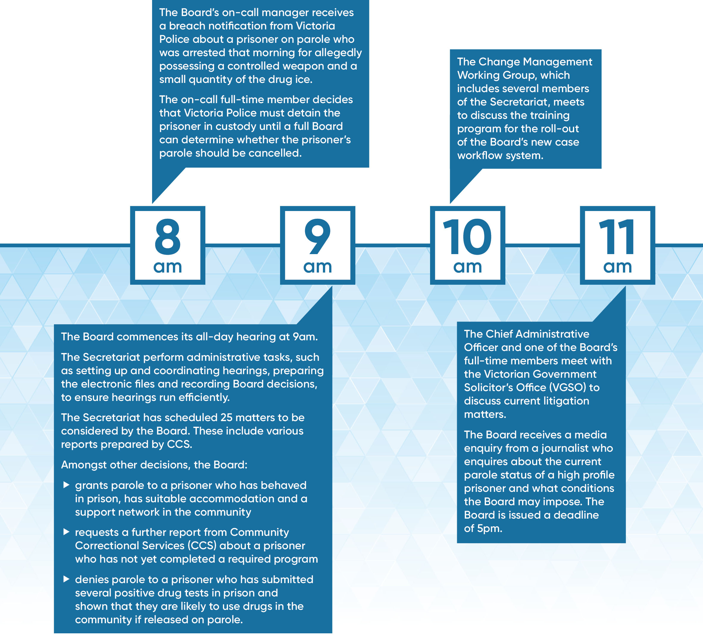

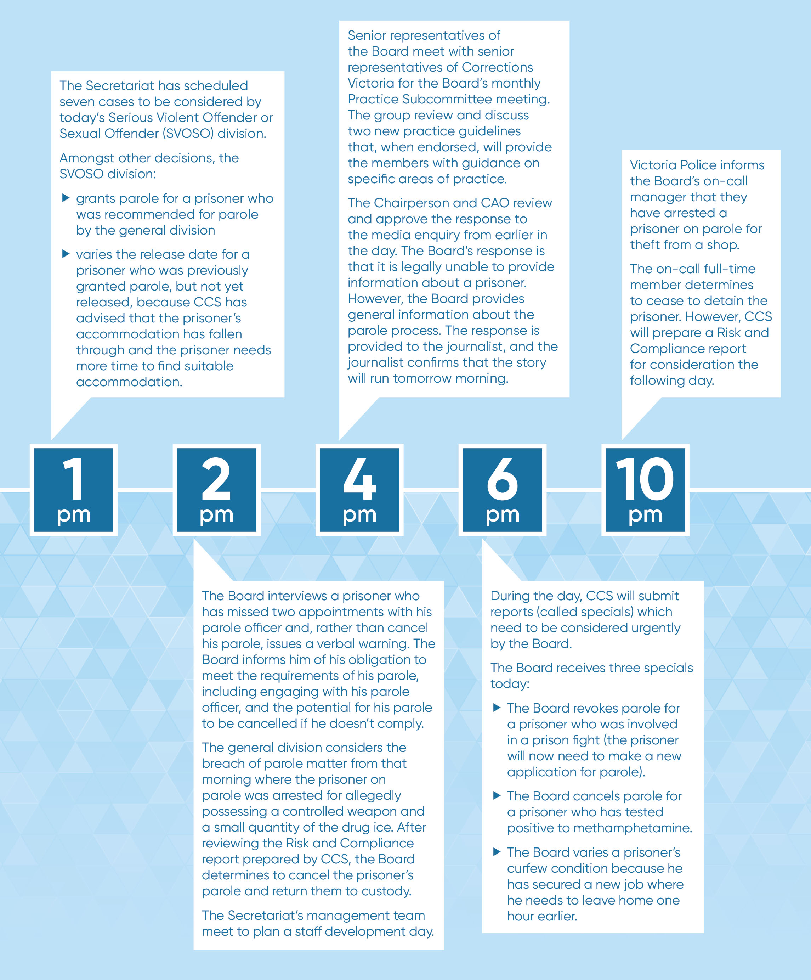

Sentencing and parole
Purpose of parole
The purpose of parole is to promote public safety by supervising and supporting the transition of offenders from prison back into the community in a way that seeks to minimise their risk of reoffending. The Board must treat the safety and protection of the community as its paramount consideration.
Sentencing
The courts have the sole responsibility for sentencing offenders. Only courts can impose a sentence and set a non-parole period as part of a sentence of imprisonment.
The Board has no role in the sentencing process and cannot change a sentence imposed by a court.
The Board’s role is not to decide whether the offender has been punished too much or not enough. The Board cannot decide to make the offender serve longer in prison to denounce their offence or to deter them or someone else from committing a similar offence. This is because those are sentencing considerations and are solely matters for the courts.
The Board’s role is to consider the risk of the prisoner’s transition back into the community.
Not all prison sentences include a non-parole period. In accordance with the Sentencing Act 1991, this depends on the length of the prison sentence.
A non-parole period must be at least six months less than the maximum term of the sentence. For example, if a court sentences a prisoner to five years’ imprisonment, the longest possible non-parole period is four and a half years, but it can be shorter.
More than 24 months | The sentencing court must set a non-parole period, unless the nature of the offence or the offender’s history would make parole inappropriate.
Between 12 and 24 months | The sentencing court is not required to, but may decide to, fix a non-parole period.
Less than 12 months | A non-parole period can not be set by the sentencing court, therefore parole is not possible.

Adult Parole Board
The Adult Parole Board is a decision-making authority which has jurisdiction over:
- prisoners for whom a court has ordered a prison sentence and has fixed a non-parole period (unless they are aged under 21 years or have been transferred from a youth justice centre)
- any prisoner under the age of 21 (unless the Board transfers them to a youth justice centre)
- young persons transferred by the Youth Parole Board from a youth justice centre to a prison.
The Corrections Act 1986 establishes the Adult Parole Board, its composition, functions, powers, and decision-making principles. The Board has additional functions outlined in the Children, Youth and Families Act 2005 and Sentencing Act 1991.
The Board does not have a case management function. It is not responsible for preparing prisoners for parole, or for supervising and managing them while they are on parole. It does not have an investigative function. Rather, it is a decision-making body that relies on information provided to it, primarily by Corrections Victoria, to make decisions in accordance with its statutory authority.
Board decisions
The main decisions made by the Board are to:
- determine if a parole application will proceed to the preparation of a Parole Suitability Assessment (this means that the Board requests a Parole Suitability Assessment from Corrections Victoria’s Community Correctional Services (CCS) to provide information upon which it can decide whether to grant, deny
or defer parole)
- defer the parole application
- grant parole
- deny parole
- revoke parole (this takes place after the Board has granted parole but before the prisoner has been released. For example, a positive drug test in prison may result in the Board revoking the prisoner’s parole before they are released)
- to impose discretionary conditions on a parole order
- vary parole conditions
- warn a prisoner on parole if their conduct has the potential to lead to their parole being cancelled
- cancel parole if there has been a breach (or suspected breach) of a parole condition, or if the risk to the safety and protection of the community has escalated.
If the prisoner’s sentence includes a non-parole period, the Board may order their release at any time after the expiry of that period.
Factors taken into account
In making decisions to grant parole, the Board carefully considers all relevant information with the paramount consideration being the safety and protection of the community.
Other matters that the Board takes into account include (but are not limited to):
- the sentence imposed by the court including any comments by the court about parole and rehabilitation
- psychiatric or psychological reports available to the court when it imposed the sentence
- victim impact statements provided to the sentencing court
- the nature and circumstances of the offence for which the prisoner is serving a sentence
- the prisoner’s criminal history, including performance on past parole orders or community-based orders
- a submission received from a victim of the prisoner
- the outcome of formal risk assessments conducted for the prisoner
- whether the prisoner has undertaken treatment or programs and, if so, formal reports of their performance
- psychiatric or psychological reports requested by the Board
- whether proposed accommodation is suitable and stable
- the prisoner’s behaviour in prison, including outcomes of random drug tests
- for serious offenders, the Board considers a detailed home assessment report about the suitability of proposed accommodation and intelligence held by Corrections Victoria and Victoria Police.
Parole conditions
The Board is required by law to impose 10 core parole conditions on every parole order. The Board may also impose discretionary conditions depending on a prisoner’s individual circumstances. If a prisoner breaches a condition, their parole may be cancelled and they may be returned to custody.
Core conditions
The ten core conditions are:
- You must not break any law.
- You must report to the community corrections centre specified in this Order within two clear working days after this Order comes into force.
- You must notify a community corrections officer of any change of address at least two clear working days before the change of address.
- You must notify a community corrections officer of any change of employment within at least two clear working days of the change of employment.
- You are under the supervision of a community corrections officer.
- You must report to, and receive visits from, a community corrections officer as and when directed by the community corrections officer.
- You must be available for an interview by a community corrections officer, the Regional Manager or the Adult Parole Board at the time and place as directed by the community corrections officer or the Regional Manager or Adult Parole Board.
- You must attend in person at a community corrections centre as directed in writing by a community corrections officer.
- You must not leave Victoria without the written permission of the Regional Manager.
- You must comply with any direction given by a community corrections officer or the Regional Manager or the Adult Parole Board that is necessary for a community corrections officer or the Regional Manager or the Adult Parole Board to give to ensure that you comply with this Order.
Discretionary conditions
Discretionary conditions may relate to:
- alcohol abstinence
- drug testing
- curfews
- residential restrictions
- geographical restrictions prohibiting entry into specified areas
- victim contact restrictions
- participation in rehabilitation programs
- community work
- electronic monitoring – both geographical and alcohol consumption.
Varying and revoking conditions
The Board can vary the conditions of a parole order at any time during the parole period. Conditions can be added to respond to changes in risk. Alternatively, conditions can be revoked if the prisoner has been performing well on parole for a long period. The Board’s primary consideration is always the safety and protection of the community.
THE PAROLE PROCESS
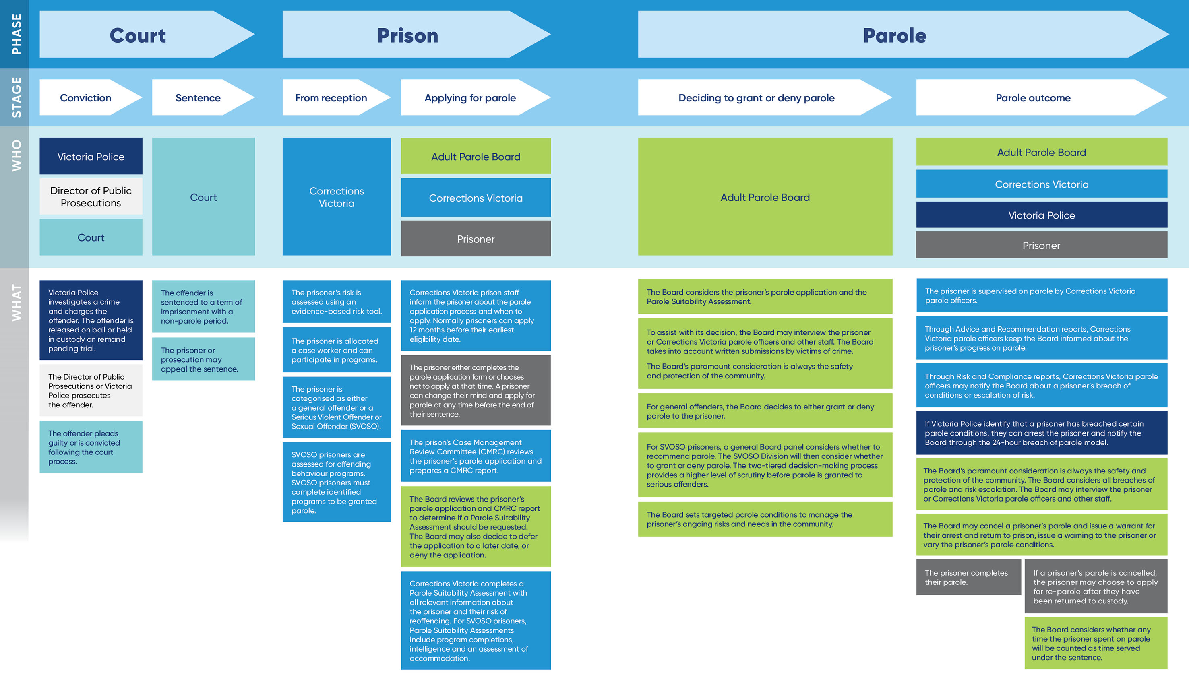

Parole data over the past 15 years
In the five years since 2013, the Victorian parole system has undergone greater change than at any other time in its sixty year history. Following three independent reviews of the adult parole system, there have been no fewer than ten Acts of Parliament reforming parole as well as many procedural and administrative changes.
After this intensive reform period, the Victorian adult parole system appears to be stabilising. That stabilisation brings with it the opportunity to examine the changes to the data before, during, and after the reform program, with a view to understanding the impact of the reforms.
Key data from the past 15 years is presented below. As depicted in Figure 1, this time span is sufficient to cover three periods:
- pre-reforms (from 2003 to 2012)
- reform period (2013 to 2016)
- post-reforms (2017 to 2018).
Figure 1 shows that the number of prisoners on parole, and the number of parole orders granted, denied and cancelled all remained consistent by both number and in comparison to each other between 2003-04 and 2010-11. During this time, approximately 90 per cent of decisions were to grant parole, and there were around twice the number of cancellations compared with denial decisions. It appears that the approach during this period may have been to release most prisoners on parole, and to actively use cancellation as a means of addressing breaches and risk.
Figure 1: Number of parole orders granted, denied, and cancelled, along with the number of prisoners on parole, from 2003-04 to 2017-18
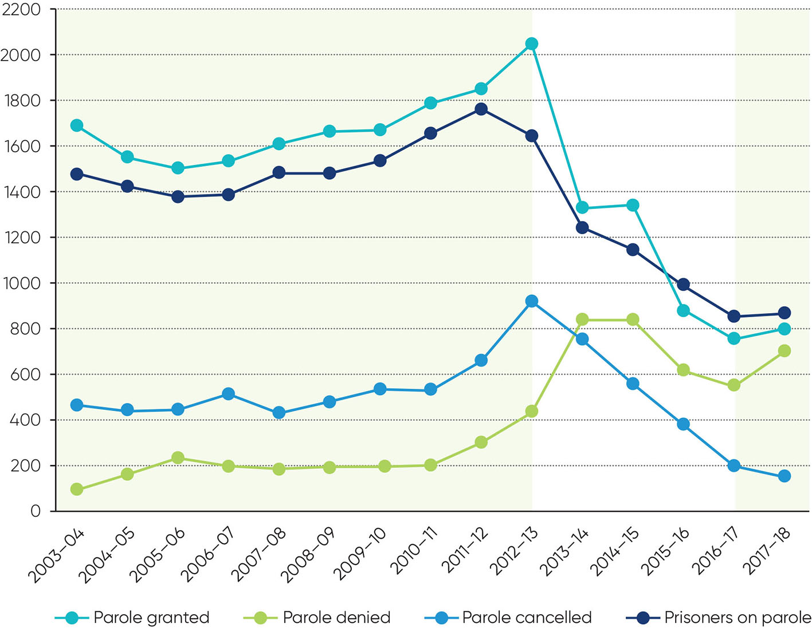
Towards the end of the pre-reform period, the decision-making approach began to change. The number of prisoners granted parole continued to increase, reflecting an increase in the number of prisoners eligible for parole. The numbers of cancellations and denials also increased, but at a faster rate, reflecting an increasing willingness to deny and cancel parole as concerns about the parole system emerged.
From 2012-13, there was a marked divergence in the data as the concerns about the parole system intensified and the reform program was resourced and commenced.
The number of parole orders granted fell dramatically, from a peak of 2,051 in 2012-13 to 757 in 2016-17 (a reduction of 63 per cent).
Corresponding to the decline in the number of parole orders granted, in 2012-13 the number of parole denials increased significantly. The number of denials has remained at a higher level since then, although it has fluctuated.
The change in the ratio between grants and denials can be seen starkly in Figure 2.
Figure 2: Comparison between decisions to grant and decisions to deny parole, from 2003-14 to 2017-18
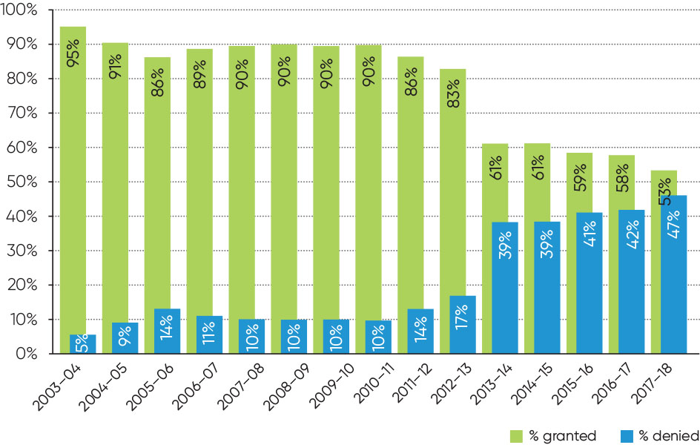

The number of parole cancellations increased in 2011-12 and 2012-13, in response to the steady increase in the number of prisoners on parole up to 2011-12, as well as the concerns that had emerged about the parole system. However, since 2012-13 there has been a steady decline in the number of cancellations. This mirrors the declines in the number of prisoners on parole and the number of parole orders granted, and reflects the increase in parole compliance and successful parole completions (Figure 3).
Figure 3: Comparison between the number of unsuccessful parole discharges and the proportion of parole orders completed from 2003-04 to 2017-185
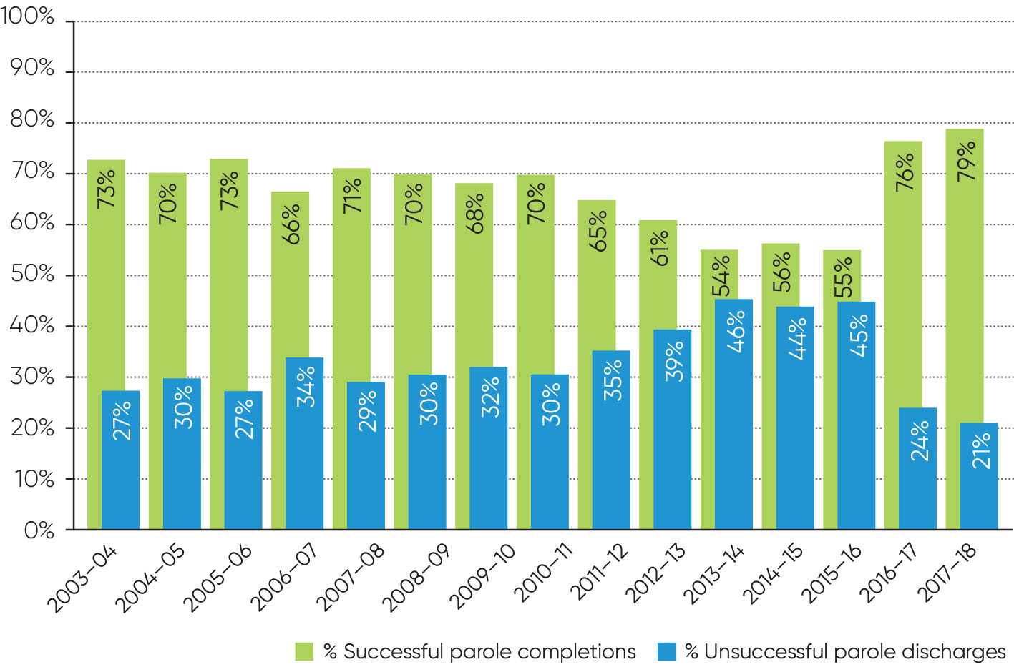

In the past two years (2016-17 and 2017-18), the data has become more stable as the reforms have become embedded into business as usual, and we are seeing a new post-reform paradigm. This post-reform period demonstrates:
- the steady decline in the number of prisoners on parole that commenced from 2011-12 has bottomed out with a small increase in 2017-18
- the decline in the number of parole orders granted that began from 2012-13 has also reversed, with an increase in 2017-18
- the ratio of parole orders granted and denied continues to run much closer than it did pre-reforms, following the abrupt adjustment that took place during the reform period
- the decrease in the number of parole cancellations during the reform period eased in 2017-18, but remains at a level that is significantly lower than the number of parole denials
- the proportion of parole orders completed has hit and stayed at record highs for the period in which comparable records have been kept.
Although there was a decrease in the number of prisoners on parole during the reform years, this downward trend has reversed and (subject to sentencing practices) it is likely that the number of prisoners on parole will continue to increase as the number of prisoners who are eligible for parole increases, and there continues to be a comparatively small number of prisoners whose parole is cancelled.
The post-reform data depicts a parole system that contributes to the enhancement of community safety. The parole system framework has improved in all aspects and is properly resourced, decisions about whether to grant, deny or cancel parole are better informed, and there is a strong emphasis on community protection and safety. This is leading to improved compliance on parole, with more prisoners completing their parole, along with better reintegration of prisoners on parole into the community.
Stage 1: The prisoner applies for parole
Eligible prisoners are not automatically considered for parole by the Board. Prisoners who have been sentenced by the court to a non-parole period must apply to the Board if they want to be considered for release on parole. This includes prisoners who have returned to custody following cancellation of their parole.
During 2017-18, the Board received 1,680 applications for parole. This is consistent with the number received in the previous year (1,689 applications received in 2016-17).
The Board was notified by Corrections Victoria of 114 prisoners who were eligible for parole but chose not to apply at their earliest opportunity. This represents six per cent of those who were eligible to apply in 2017-18, which is consistent with the previous two years in which this data has been reported (five per cent in 2016-17 and seven per cent in 2015-16).
Of the 1,680 applications received, 88 per cent (or 1,479) proceeded to the preparation of a Parole Suitability Assessment. Parole Officers from Corrections Victoria prepare Parole Suitability Assessments to inform the Board’s decisions. They are comprehensive reports compiling the information the Board needs to make decisions to either grant, deny or defer the prisoner’s parole application and to determine appropriate parole conditions. The preparation of the Parole Suitability Assessment does not mean that the prisoner will be granted parole.
Of the remaining 201 applications, 76 (or five per cent) were invalid, 59 (or four per cent) were deferred, 40 (or two per cent) were denied at the application stage, and 26 (or two per cent) had not been processed as at 30 June 2018. This is similar to the application outcomes since the application process commenced in 2015.
Figure 4: Proportion comparison of prisoners who applied for parole compared to those who chose not to apply at their earliest opportunity, from 2015-16 to 2017-18
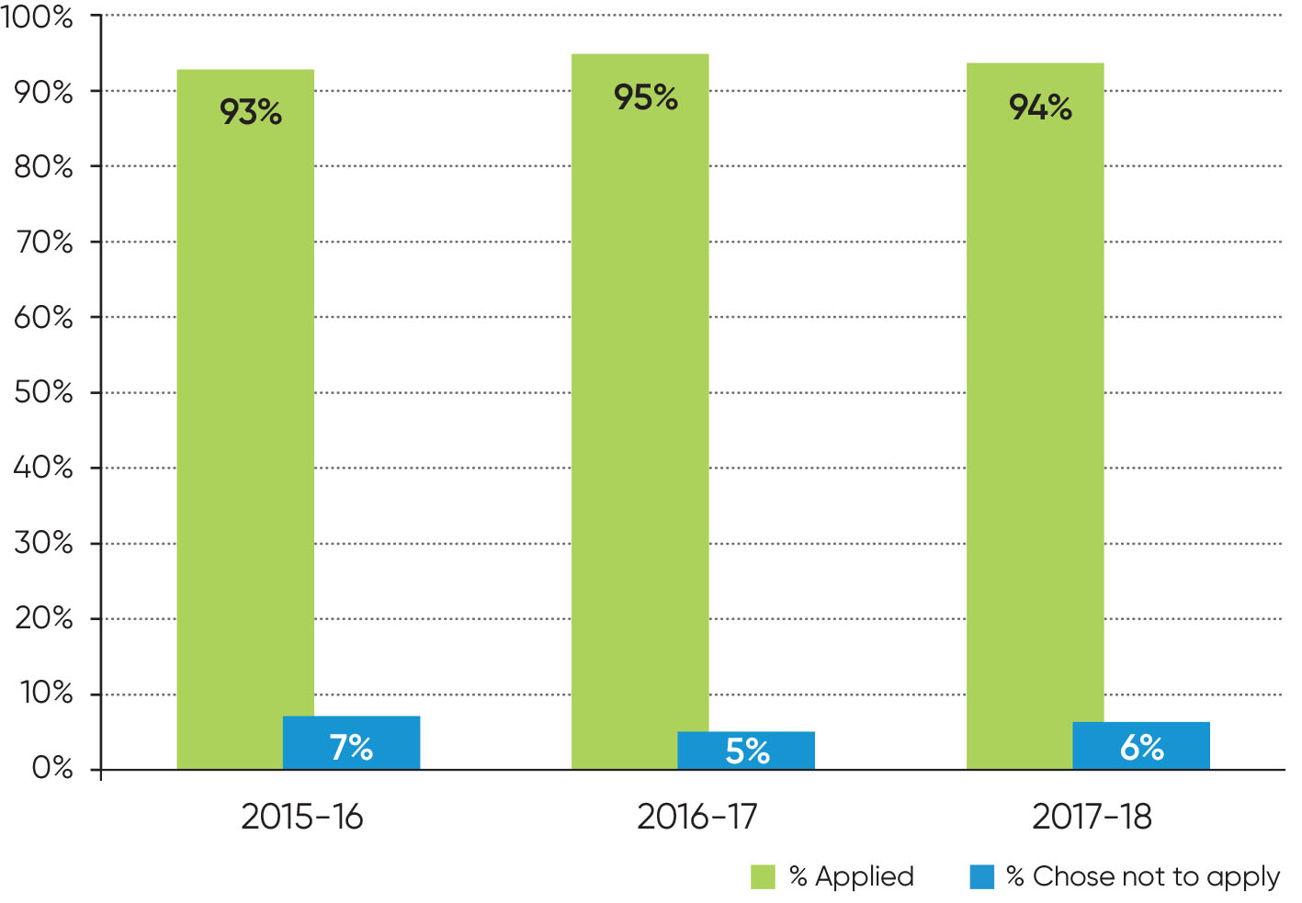
Figure 5: Processing of parole applications received from 2015-16 to 2017-18
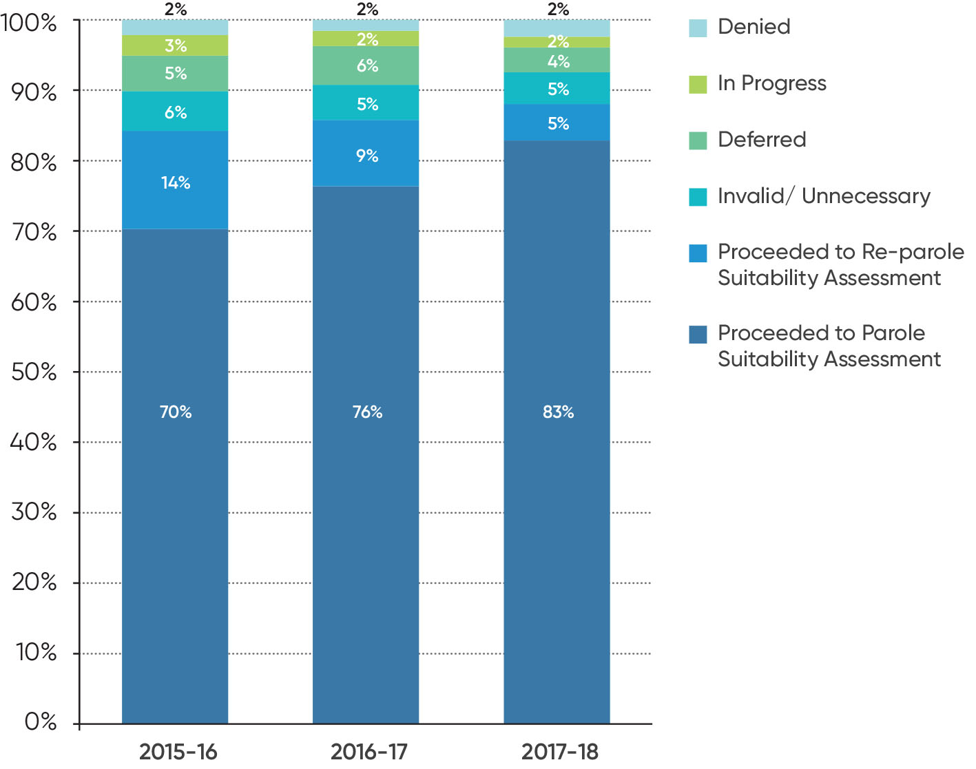

Stage 2: The Board decides to grant or deny parole
If the application proceeds, the Board will review the Parole Suitability Assessment which includes information about the prisoner’s background (including past offences and performance on previous parole orders or other supervised sentences in the community), the current offences and the circumstances in which the prisoner committed them, the prisoner’s behaviour in prison, any assessments and treatment conducted in prison, and what their plans are for release (such as accommodation and employment). The report analyses the prisoner’s risk factors and the extent to which they could be mitigated by parole conditions.
The Board may also receive further information, including submissions from victims of the prisoner’s offending, correspondence from the prisoner and their family or supporters, and information from police (such as whether there are any current or expired intervention orders relating to the prisoner). Once the Board has received all of the necessary information, it will decide whether to grant or deny parole.
In 2017-18, the Board made 1,509 decisions to grant or deny parole (some of these decisions were made in relation to applications that had been lodged in the previous reporting year). More than half of those decisions, 803 (or 53 per cent), were to grant parole, while 706 (or 47 per cent) were to deny parole.
In considering the ratio between granting and denying parole, it is important to note that the practice of the Board has been that if a prisoner applies for parole, but then before the application is finalised the prisoner decides that they no longer want parole and withdraws their application, the application is recorded as having been denied. In 2017-18, 242 denials were a result of the prisoner advising they no longer wanted parole (34 per cent of all denied decisions).
As part of its continuing agenda to improve data reporting to better reflect and understand parole outcomes, from next year the Board aims to separately report on parole applications that have been withdrawn by the prisoner, recording them as applications that have been withdrawn rather than denied. This will mean that comparison with previous years’ data will be impacted for a period of time.
Of the remaining 464 cases in which parole was denied, the most prevalent factor was an absence of suitable accommodation (one of the factors in 297 or 64 per cent of denials). As precarious or unsuitable accommodation can be a major risk factor for re-offending, the Board’s requirement to treat the safety and protection of the community as its paramount consideration means that the Board cannot grant parole in such cases.

Figure 6: Parole decisions from 2013-14 to 2017-18
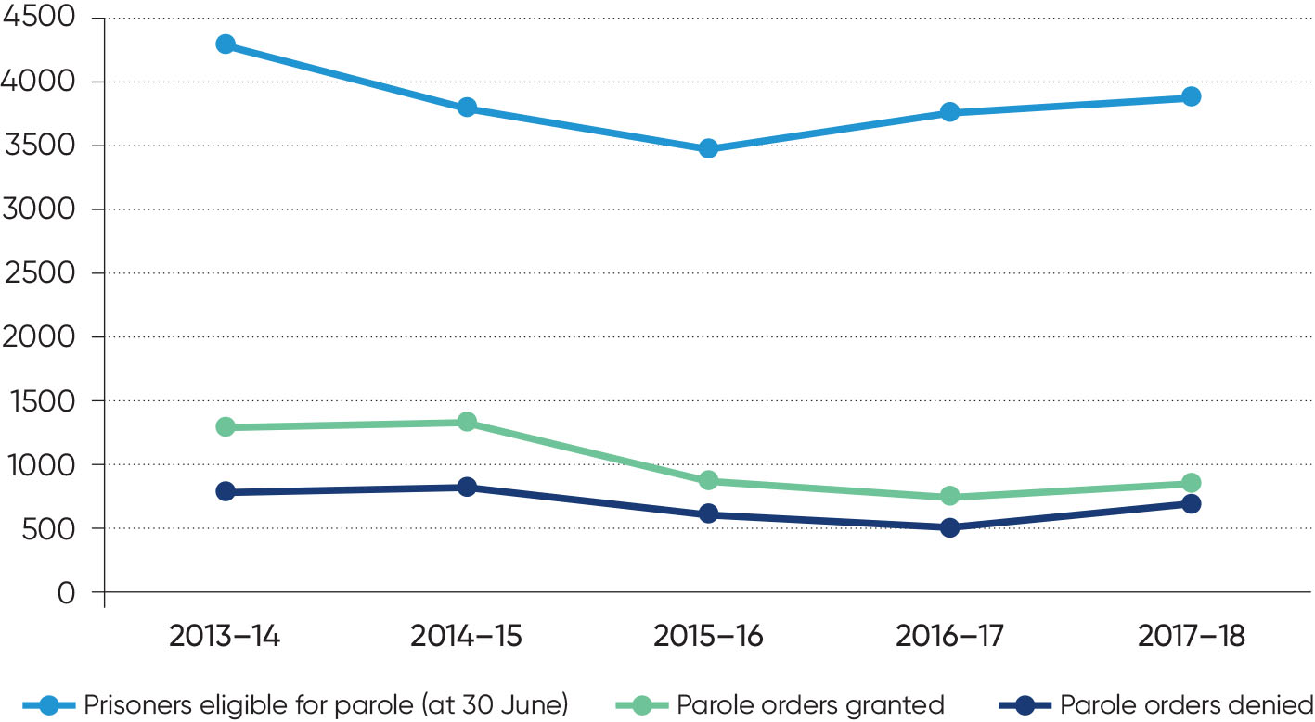

Stage 3: Parole outcomes
Parole completions
During 2017-18, 729 prisoners had their parole orders discharged by Corrections Victoria. Of these, 574 prisoners were discharged as successfully completing their parole order, resulting in a successful completion rate of 79 per cent.
The rate of successful completions is the highest it has been since comparable records have been kept dating back to 2000-01 (see Figure 3 on page 25).
Breach of parole
During 2017–18, Victoria Police notified the Board of 55 prisoners on parole who were arrested for suspected parole breaches. This is consistent with the number received in the previous year (54 notifications). The number of notifications has decreased from a high of 198 in 2014-15 (the year in which the breach of parole notification process commenced). The Board decided to cease detention for 13 of the 55 prisoners. Of the remaining 42 prisoners who were detained pending consideration by the Board, the Board cancelled parole for 26 prisoners and decided not to cancel parole for 16. The Board made the final decision about whether to cancel parole on the same day, or the next working day, in 96 per cent of notifications (64 per cent on the same day and 33 per cent on the next work day. Two cases were finalised two work days later.
Figure 7: Number of prisoners detained by the Board following notification of a suspected breach of parole by Victoria Police, from 2014-15 to 2017-18
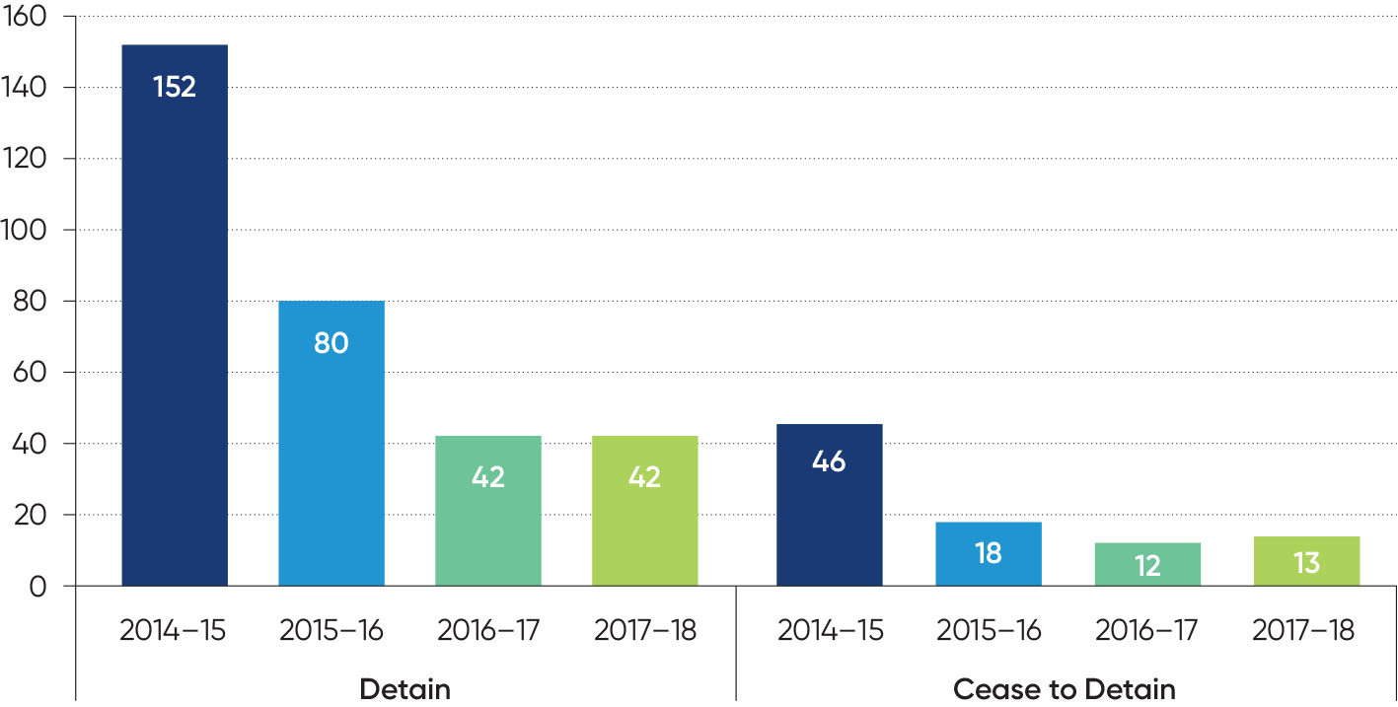
Cancellations
During 2017-18, the Board cancelled parole for 156 prisoners. This represents a 24 per cent reduction from 2016-17, and an 80 per cent reduction over the past five reporting years after a high of 761 cancellations in 2013-14.
The most common reason for the Board to cancel a prisoner’s parole was drug use (one of the factors in 67 per cent of all cancellations), and in particular the use of methylamphetamine (ice). In many cases, the Board considers that the use of drugs could present a significant risk of escalation to more serious offending.
Prisoners who were charged or found guilty of any further offending committed while on parole (including traffic related or drug offences) accounted for 30 (or 19 per cent) of cancellations in 2017-18.
Figure 8 shows the length of time that prisoners spent on parole before parole was cancelled. In 2017-18, 25 per cent of prisoners who had their parole cancelled had been on parole for one month or less. Another 25 per cent had been on parole for between one and three months. This means that half of the parole cancellations occurred within three months of release on parole (the median). Another 25 per cent were on parole for between three months and 7.8 months before parole was cancelled, and the final 25 per cent had been on parole for between 7.8 and 44.4 months prior to parole being cancelled.
Convictions on serious offences
In 2017-18, four persons were convicted on serious violent offences or sexual offences committed while on parole. This is slightly less than the previous year (five) and continues the substantial reduction from the first reporting year (60 in 2013-14). See Figure 9.
The 93 per cent decrease over the previous five years that this measure has been reported encapsulates the significant improvements to the parole system and community safety that are the result of the reforms that have been implemented. Although the aim is to reduce this figure further, it is not realistic to think that all serious offending can be prevented.
Reviews
During 2017-18, the Board received 16 requests from prisoners or their supporters and one request from Corrections Victoria to review Board decisions. The decisions reviewed were related to denials of parole and whether time to count could be granted toward a prisoner’s sentence following cancellation of parole.
This is a 47 per cent reduction in the number of requests for reviews received in 2016-17 (from 32 reviews received). The reduction is attributed to improved information being provided to prisoners by the Board along with Corrections Victoria surrounding the reasons behind
Board decisions.
Of the 17 requests for reviews received, the Board rejected eight due to there being no new information available when reviewing the decision. The Board accepted six requests for reviews based on additional information provided for the purpose of the review of decision. Of these, one prisoner’s application proceeded to a Re-parole Suitability Assessment, two prisoners were granted parole, one prisoner received time to count, one prisoner’s parole release date was brought forward and the Board requested a further report from CCS about another prisoner.
Three requests for reviews received during 2017-18 did not have an outcome as at 30 June 2018.
Figure 8: Number of months on parole at time of cancellation, from 2013-14 to 2017-18
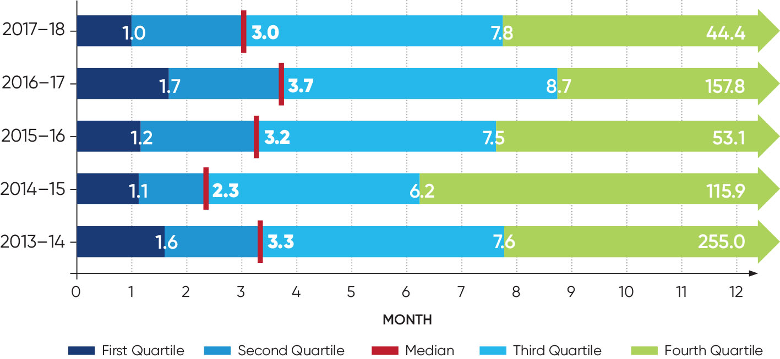

Figure 9: Number of persons convicted of a serious violent offence or sexual offence committed by them while on parole, from 2013-14 to 2017-18
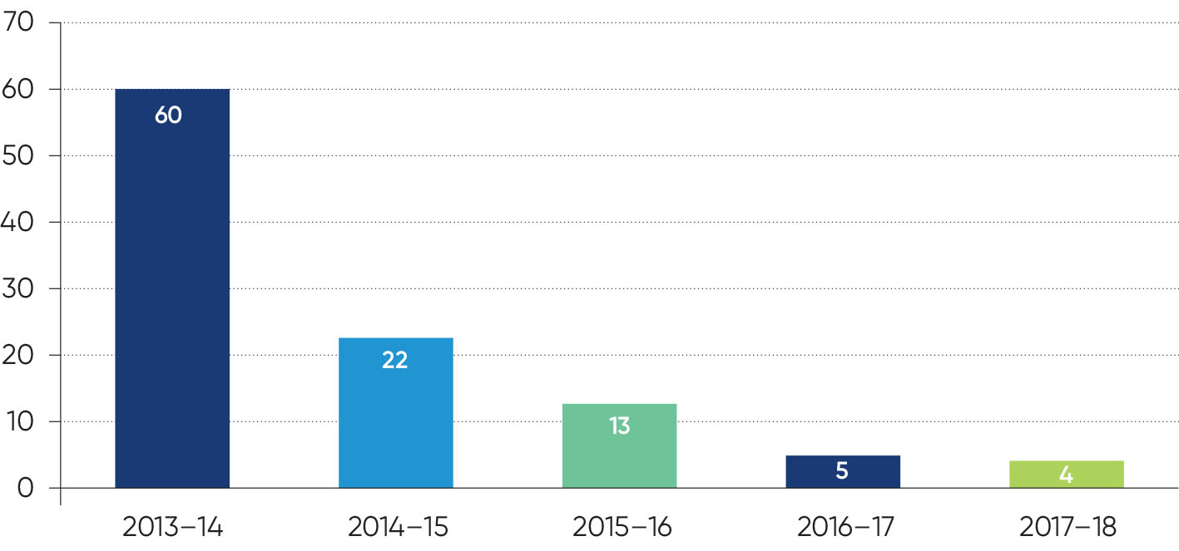

Key projects
Transition of DSOD to the Post Sentence Authority
During 2017-18, the Board worked closely with the Post Sentence Authority to transition its Detention and Supervision Order Division (DSOD) jurisdiction. The transition was a major six-month project – approximately 47,000 electronic records were transferred from the Board to the Authority, and more than 200 hardcopy files were transitioned. A range of governance strategies and operational frameworks were also prepared. The Board’s last day with jurisdiction for the DSOD was 26 February 2018 – the Authority was given jurisdiction from 27 February 2018.
The Minister for Corrections, the Hon. Gayle Tierney, spoke in the Parliament of Victoria on 7 March 2018 about the establishment of the Authority. She thanked the Board for discharging its DSOD responsibilities admirably.
Implementation of the Board’s case workflow system
The Board continues to work closely with Corrections Victoria on the development of its case workflow system.
Recommended by The Hon. Ian Callinan AC in his 2013 review of the Victorian parole system, the case workflow system will build on the digitisation of the Board’s files to meet the objectives of further reducing risk in decision-making and improving efficiency.
This priority project is on schedule to be implemented by October 2018. As part of the extensive foundation work that has been necessary, in October 2017 a significant phase of work was successfully launched in accordance with the project plan.
The system will be known as PRISM – Parole Records Integrated System of Management.
Supplementing the team of three staff from the Board’s Secretariat who have worked full time on the project since April 2017, two additional fixed term project roles were established in April 2018 to focus specifically on change management. The unwavering commitment of the Board to the project is evidenced by how it has managed to continue normal operations with five experienced staff devoted to the project.
The project is governed by a Corrections Victoria Project Control Group on which the Board is represented by the Chief Administrative Officer and General Manager, Practice Development. Within the Board, a Steering Committee chaired by the Chief Administrative Officer and including senior management and project officers from the Secretariat, a full-time member of the Board, and senior project staff from Corrections Victoria Information Technology meet on a fortnightly basis to provide direction and support to ensure the Board is meeting its responsibilities. A Change Working Group chaired by the General Manager, Operations commenced in early 2018 to plan the integration of the system into the operations of the Board when deployed in October 2018.
Independent audit
Following a recommendation made by the Sentencing Advisory Council in its 2012 Review of the Victorian Adult Parole System, the Minister for Corrections endorsed a program for a regular audit of the Board’s compliance with legislative requirements. Under this program, an external auditor will conduct a review on a biennial basis, and on the alternate years the Board will conduct a self-assessment. The first phase of the program commenced in 2018 with a self-assessment.
In 2017-18, the Justice Assurance and Review Office (JARO) tendered for and selected an auditor to work with the Board to develop a self-assessment tool and establish the self-assessment regime. The auditor will also compile a report following the self-assessment.
The provisions of the Corrections Act 1986 identified for the first self-assessment are:
- Section 74AAB – the Serious Violent Offender or Sexual Offender Parole division (SVOSO Division)
- Section 78C – procedures for and after notification of arrest for breach of parole by Victoria Police
- Section 74(8) – prisoners to be given a copy of a determination to revoke or cancel parole including the reasons
- Section 72(1) – the requirement to produce an Annual Report including specified information
The Board conducted the self-assessment in May and June of 2018. It is now waiting for the report to be prepared and to consider any recommendations contained in the report.
In accordance with the program, an external audit will be conducted in 2018-19.
The Board acknowledges the work, guidance and support of JARO.
Family violence
The Family Violence Information Sharing Scheme commenced on 26 February 2018 under the Family Violence Protection Amendment (Information Sharing) Act 2017. The scheme is one part of a suite of reforms from the Royal Commission into Family Violence. The Board is an information sharing entity (ISE) under the scheme. The Act permits a number of organisations, including the Board, to share current and historical family violence risk information with other listed organisations when necessary to manage a risk of family violence. The Board has implemented procedures to ensure it complies with the scheme.
Legislation
In the 2017-18 reporting year, the following major legislative amendments were made impacting on the powers, functions and operations of the Board.
- Following the government’s acceptance of the recommendations of the Harper Review of the post sentence scheme, the provisions of the Corrections Act 1986 under which the Board’s Detention and Supervision Order Division exercised power for part of the scheme as it then existed, and the provisions requiring the Board to report information relating to the post sentence scheme in its Annual Report, were repealed.
The repeal of these provisions was coordinated with the enactment of amendments to the Serious Sex Offenders (Detention and Supervision) Act 2009 establishing the Post Sentence Authority and giving it responsibility for functions including those previously exercised by the Detention and Supervision Order Division of the Board.
These changes took effect on
27 February 2018, and since then the Board has no statutory function with respect to the post sentence scheme.
The Serious Offenders Act 2018, enacted into law on 26 June 2018 (but to commence after the end of this reporting period) further develops the post sentence supervision and detention scheme, and replaces the Serious Sex Offenders (Detention and Supervision) Act 2009. Amongst other things, the Serious Offenders Act 2018:
expands the post sentence scheme to include some serious violent offences (in addition to serious sex offences)
introduces a new emergency detention order for short-term detention for up to seven days to contain a supervised offender’s escalating and imminent risk to the community.
- On 20 December 2017 Division 1B of Part 8 of the Corrections Act 1986 commenced operation, after it was inserted into the Act by the Corrections Legislation Further Amendment Act 2017.
The amendment establishes the foundation for improved security arrangements for the Board when it interviews prisoners on parole in person (when prisoners on parole attend the Board’s premises for an interview). Security officers will have power to search, seize items, supervise and escort, give directions, use reasonable force to compel obeyance with a direction, apply an instrument of restraint necessary to prevent injury, and to arrest a prisoner on parole if the security officer believes on reasonable grounds that they have committed an indictable offence or if the Board has cancelled the prisoner’s parole.
Although at the end of the reporting year the improved security arrangements have not been activated (discussions are continuing with Corrections Victoria about the implementation of the arrangements), the Board is pleased that the government responded to its concerns about security and welcomes the enactment of the provisions that provide a foundation for improved safety for its members and staff.
Litigation
The Board’s Risk and Audit Subcommittee is responsible for overseeing the risks associated with litigation.
During the reporting year, the Board was involved in two matters before the High Court of Australia which challenged the validity of legislative provisions regarding the eligibility for parole of prisoners Julian Knight and Craig Minogue. The defence of those matters was conducted by the State of Victoria. On 17 August 2017, the High Court rejected Mr Knight’s claim that Section 74AA of the Corrections Act 1986 was invalid because it interfered with the sentence imposed by the Supreme Court. On 20 June 2018, the High Court found that Section 74AAA of the Act did not apply to Mr Minogue.
The Board appears in, and gives evidence to, coronial inquiries and inquests. In 2017–18, this included producing evidence in relation to the Board’s involvement with the initial stages of coronial investigations into the deaths of Karen Chetcuti and Kai Hao. The coronial investigation in relation to the death of Michael Bekhazi, in which the Board provided a witness statement in May 2017, is still pending before the Coroner.
The Board is a defendant in a civil proceeding for damages in respect to a claim of false imprisonment when a prisoner’s parole was cancelled and they were extradited to Victoria to serve the balance of their Victorian sentence.
The Board is also involved in a number of proceedings being brought against the State of Victoria by families of victims who have been murdered by people on, or recently having completed, parole.

Stakeholder Collaboration and engagement
Increasing the community’s understanding of parole
Law Week 2018
The Adult Parole Board participated in Law Week for the third time with its mock hearing, ‘Parole, you decide’. However, for the first time, the Board also visited a regional location - Geelong - to educate the local community about parole.
Geelong information session
The Board approached Deakin Law School in early-2018 with an idea to run a parole information session in Geelong. The Board wanted to take the opportunity of Law Week to reach out and engage a regional community to educate them about parole and the Board. Deakin Law School agreed to host the event at the Deakin University Geelong Waterfront Campus on 16 May 2018.
The event was promoted through Geelong networks via Deakin Law School, the Geelong Law Association, and several community groups. On the day, there were nearly 50 people in the audience – approximately two-thirds were Deakin University students and one-third were legal practitioners and community members.
The Chairperson and a full-time member spoke about the purpose of parole, the process, who the Board members are, conditions, the breach of parole process, and much more. At its conclusion, most of the audience attended the refreshments and took the opportunity to speak with the Chairperson and full-time member, as well as senior Secretariat staff.
Every respondent to an event feedback form stated that the session had increased their knowledge about parole and the Board. One of the audience members was an ABC producer who spoke very positively about the event on radio on the morning of 19 May 2018.
The Board thanks Deakin Law School for hosting the event. Following its success, the Board will consider visiting other regional locations for Law Week in 2019.
‘Parole, you decide’
The Board ran its mock hearing at the County Court of Victoria in courtroom 4.2 on 19 May 2018. ‘Parole, you decide’ followed the story of a young prisoner who was sentenced by a court for an aggravated burglary, had served his non-parole period, and was now eligible to apply for parole.
The Chairperson facilitated the event, and the panel included a judicial member, community member and full-time member. A Secretariat staff member read the sentencing remarks, and a Senior Parole Officer from Reservoir Community Correctional Services informed the panel and audience about the Parole Suitability Assessment, and later the Risk and Compliance report.
The panel deliberated whether or not parole should be granted following an application by the prisoner, and the panel later deliberated on whether or not parole should be cancelled following notification by Victoria Police of a parole breach. The audience were given the option to indicate what they would decide if they were on the panel.
The audience learnt about the parole application process, the factors for consideration by the Board, and parole breaches and cancellations. Every respondent to a feedback form stated that the session had increased their knowledge about parole and the Board.
The Board thanks the County Court of Victoria for hosting ‘Parole, you decide’, as well as the Board members, Secretariat staff and stakeholders who contributed to the event.
Association of Paroling Authorities International (APAI) conference
The Board was invited by the Association of Paroling Authorities International (APAI) to present at the APAI conference in Nevada in late-April 2018. The Chairperson and Chief Administrative Officer attended the conference and presented the Board’s journey from the crisis in 2012-13 and through the extensive reform program. They spoke about the positive indicators – parole data, external evaluations and public commentary – which support the Board’s statement that it has transformed into a modern and efficient decision-making authority. The audience included delegates from the USA, Canada, England, Malaysia, New Zealand and Australia. The other Australian jurisdictions represented at the conference were New South Wales and Queensland.

External presentations to stakeholders
The Board presented to numerous groups in 2017-18 including the Victims Services Forum 2018, the Royal Victorian Association of Honourable Justices, the Leader’s Luncheon of the Hamilton Club, the Monash University Law Summer School, the University of Melbourne Masters of Criminology, Doctor of Psychology (Forensics) at Swinburne University of Technology, the ‘We all do it differently’ podcast, and the Council of Australiasian Tribunals Victoria Annual Conference. The Board also presented at events including the Association of Paroling Authorities International (APAI) conference and Victoria Law Foundation Law Week 2018.
Media engagement
The Chairperson completed media training through Mediability in 2017-18. This was a recommendation in the Board’s communications strategy which was endorsed by the Stakeholder Engagement Subcommittee.
The Board proactively took part in two media interviews during 2017-18 with the aim of educating the community about parole and the Board.
On 7 August 2017, Channel 9 news conducted an interview with the Chairperson and three community members and reported on the backgrounds and experiences of community members, why they joined the Board, and their role in Board hearings.
On 14 May 2018, at the beginning of Law Week, Jon Faine spoke with the Chairperson about parole on his morning ABC radio program.
On 30 June 2018, the Herald Sun reported that the Board was now less likely to grant parole for prisoners who were convicted of serious offences and liable for deportation on release. The Herald Sun editorial was supportive of the Board’s position and quoted the Board’s statement that ‘under Victorian law, the Board’s paramount consideration is the safety and protection of the community, including people within Victoria, in immigration centres, interstate and in other countries’.
Website
The Board’s first website was launched in 2016-17, and stakeholders continued to visit the website in 2017-18. Search terms relating to the Board generated high rankings in search engine results. At 30 June 2018, the five most popular pages, besides the homepage, were frequently asked questions, applying for parole, Board members, the parole process and Board decisions. During 2017-18, the website received nearly 45,000 page views. The Board will continue to identify opportunities to improve the website content, features, and search engine optimisation.
Working collaboratively with stakeholders
Consultations by external stakeholders
During 2017-18, a number of different jurisdictions within Victoria and around Australia consulted the Adult Parole Board to learn about its operations, practices and procedures, governance structure, as well as its experiences and lessons learned over the last few years. This is testament to the success of the implementation of the Victorian parole reform program since 2013, and the transformation of the Board into a modern, decision-making authority which is validated by the parole data contained in this report.
- The Board has taken numerous opportunities in the past few years to press for the power to suspend parole, as an alternative to cancellation, for prisoners who are serving lengthy parole periods and lapse into drug use. The Board was invited to prepare a submission for the Law Reform, Road and Community Safety Committee’s Inquiry into Drug Law Reform, and the Chairperson provided evidence to the committee on 18 September 2017. The committee adopted the Board’s position; in its final report, which was tabled in Parliament on 27 March 2018, the committee included a recommendation that the government provide the Board with a legislative power to suspend parole.
- The Australian Law Reform Commission conducted an inquiry into the overrepresentation of Aboriginal and Torres Strait Islander prisoners in Australia’s prisons. On 19 September 2017, the Commissioner of the inquiry and the Acting President attended the Board to meet with the Adult Parole Board Chairperson, three Aboriginal Elders and a former Aboriginal parole officer in order to discuss the issues.
- The Chairperson and Chief Administrative Officer met with a former Chief Commissioner of Police and a former Supreme Court of Appeal Justice who led the independent Expert Panel, established by the Victorian Government, on Terrorism and Violent Extremism Prevention and Response Powers to discuss parole issues related to terrorism.
- The two Deputy Presidents of the Parole Board Queensland, which is Queensland’s equivalent of the Adult Parole Board, visited the Board on 19 February 2018. They met with the Chairperson and Chief Administrative Officer, observed a parole hearing, and spoke with senior Secretariat staff about file management and meeting preparation processes.
- The Chairperson and Chief Administrative Officer spoke with the review team, based in the United Kingdom, who conducted the recent review of the operations of the Parole Board of England and Wales. The review team wanted to learn about victims, including how registered victims can make written submissions to the Board and are notified of parole decisions, how the Board provides its reasons for denying or cancelling parole, and the Board’s internal review processes.
The Board was also consulted by Victoria’s Youth Parole Board, the ACT Sentence Administration Board and the Administrative Appeals Tribunal (AAT) during 2017-18.
Corrections Victoria
The Board continues to foster a close, working relationship with Corrections Victoria that is collaborative, respectful and effective. The Secretariat, who support the Board on a daily basis and ensure that all matters are properly prepared and presented for Board consideration, comprise of Corrections Victoria staff.
The Board relies on the information it receives from Corrections Victoria parole officers, including Parole Suitability Assessments and risk evaluation reports, to make its decisions. The Board is regularly assisted by the attendance of parole officers at Board meetings to provide information and answer questions, including when the Board interviews a prisoner on parole.
Senior managers from Corrections Victoria are included as members on key governance committees including the Stakeholder Engagement Subcommittee, Practice Subcommittee, and Project Board. The Chairperson of the Board regularly communicates with the Commissioner for Corrections Victoria, and the Board’s Chief Administrative Officer meets on a fortnightly basis with the Corrections Victoria Deputy Commissioner, Offender Management.
Victims
The Chairperson was invited by the Department of Justice and Regulation’s Community Operations and Victims Support Agency to present on parole and the Board at the Victorian Victims Services Forum on 13 February 2018. In his presentation, he explained the purpose of parole, the parole process and the role of the Board, as well as how the Board may impose specific victim-related conditions, including no contact conditions, and the process for victims to make a submission to the Board. Victim support workers from across Victoria attended the forum.
The Board has been represented on the Victims of Crime Consultative Committee since its inception in 2012.
Victims Register
The Victims Register is managed by the Victims Support Agency. It is responsible for maintaining contact with victims of violent crime who have registered to receive information about an adult prisoner. A criminal act of violence includes offences such as assault, sexual assault offences, kidnapping and murder. The Victims Register will provide advice about the release of a prisoner on parole, including any conditions imposed that are relevant to the victim and any cancellation of parole.
The Board and the Victims Register work closely on a daily basis in relation to operational and policy issues. The Board provides information each day to the Victims Register about the management of prisoners (where appropriate) and victim-related conditions. The Victims Register is then able to provide victims of crime with timely, relevant and accurate information about the release of a prisoner on parole. In addition to daily contact, the Board and the Victims Register regularly meet to discuss other matters such as the implementation of local operating procedures, protocol and case specific matters.
During 2017–18, 80 prisoners with one or more registered victims were granted parole. For 98 registered victims, the Board informed the Victims Register of the date of release of the prisoner on parole. This enables compliance with the legislative requirement for the Victims Register to give the registered victims at least 14 days’ notice of the release unless the Board waives the notice period.
Victim submissions
Individuals included on the Victims Register have the right to send a written submission to the Board when the prisoner for whom they are registered is being considered for parole.
All submissions from victims are read by the Board and the issues and concerns raised are carefully considered as part of the decision-making process. Each submission is treated with strict confidence.
During 2017–18, 131 submissions were provided for the Board’s consideration of parole applications. In addition, four submissions were provided for consideration of supervision or detention order applications.
Victoria Police
The Board, Victoria Police and Corrections Victoria work collaboratively to give effect to section 78B of the Corrections Act 1986. Under this legislative provision, Victoria Police must consider detention of prisoners on parole suspected of having breached the prescribed conditions of their parole, including the condition that they must not break any law. The Board must be notified of the details of any alleged breach within 12 hours of the detention. In response, a Board member determines whether the circumstances warrant further detention pending consideration of cancellation of parole by the Board.
During 2017-18, a Corrections Victoria-led project to enhance information technology systems and improve the breach of parole notifications channel between Victoria Police and the Board was finalised.
During 2017–18, the Board received a total of 55 notifications from Victoria Police. Of those notifications, 42 prisoners were detained resulting in 26 cancellations of parole. The parole orders that were not cancelled may either have been varied to include more onerous parole conditions, or the prisoner may have been directed to attend a Board meeting to be interviewed.
The Board and Victoria Police have a memorandum of understanding for the exchange of information and cooperation.
Fugitive Task Force
The Fugitive Task Force is part of the Victoria Police State Anti-Gang Division and is responsible for the timely and safe arrest of offenders who have had their parole cancelled and a warrant issued for their arrest. The Board assists the Fugitive Task Force to ensure arrests occur swiftly by allowing full access to reports and documentation on an offender’s file.
The Fugitive Task Force also ensures the safe escort and security of offenders extradited back to Victoria for breach of parole from other states and territories in Australia.
The Board and the Fugitive Task Force have a memorandum of understanding that provides a shared agreement and understanding of the processes relating to the exchange of information and cooperation.
Melbourne North Police Station
The Board holds meetings on a daily basis at its office in Carlton, and is at times required to interview offenders either via prison video link or in person. When an offender is required to attend a Board meeting, the Board may decide to cancel their parole and issue a warrant for apprehension for their return to custody. If this occurs, Melbourne North Police assist the Board in executing the warrant at the hearing and safely return the offender to custody.
The Board and Melbourne North Police are parties to a protocol for shared responsibilities and communication.
Post Sentence Authority
During 2017-18, the Board worked closely with the new Post Sentence Authority to transition its Detention and Supervision Order Division function.
The Authority’s Chief Administrative Officer presented at the Board’s member education seminar in December 2017, as well as to Secretariat staff in April 2018, and the Authority’s Chairperson presented to members at the June 2018 seminar.
Prisoners
Improving communications with prisoners has continued to be a priority for the Board in 2017-18.
The Board’s Executive team and senior management visited several prisons across Victoria and spoke with groups of prisoner mentors to understand the experience of prisoners who are applying for parole.
The Board, in conjunction with Corrections Victoria, implemented a new process for correspondence to improve the efficiency and content of information provided to prisoners. The pilot which launched in 2016-17 was a success and was fully implemented in 2017-18. The new process is designed so that the most relevant body, either the Board or Corrections Victoria, for the correspondence can respond in a shorter time period.
During 2017-18, the Board participated in the Corrections Victoria-led review of the end-to-end parole application process. As a result, the Board’s decision of ‘proceed to parole planning’, which may imply that the prisoner has been granted parole, was changed to ‘proceed to a Parole Suitability Assessment’. This terminology change should help to reduce prisoners’ confusion about the current status of their application.
The Board reviewed and revised its letter to prisoners informing them that their parole application has proceeded to a Parole Suitability Assessment. The revised letter contains more information for prisoners that should clarify what a Parole Suitability Assessment is and what the next steps are.
The Board also introduced a new letter which will be sent to prisoners when Community Correctional Services has submitted the Parole Suitability Assessment to the Board. The purpose of this new letter is to keep prisoners informed during the application process.
The Board has enhanced its processes for considering requests for reviews of Board decisions. Each request for review will now be considered by the Chairperson and two full-time members. The Board will also inform the prisoner whether their request was accepted or rejected.
The Board also commenced work on a new brochure with comprehensive information about parole that it will make available for prisoners and their families. It is anticipated that the new brochure will be finalised in late-2018.
Foreword from the DSOD Chairperson
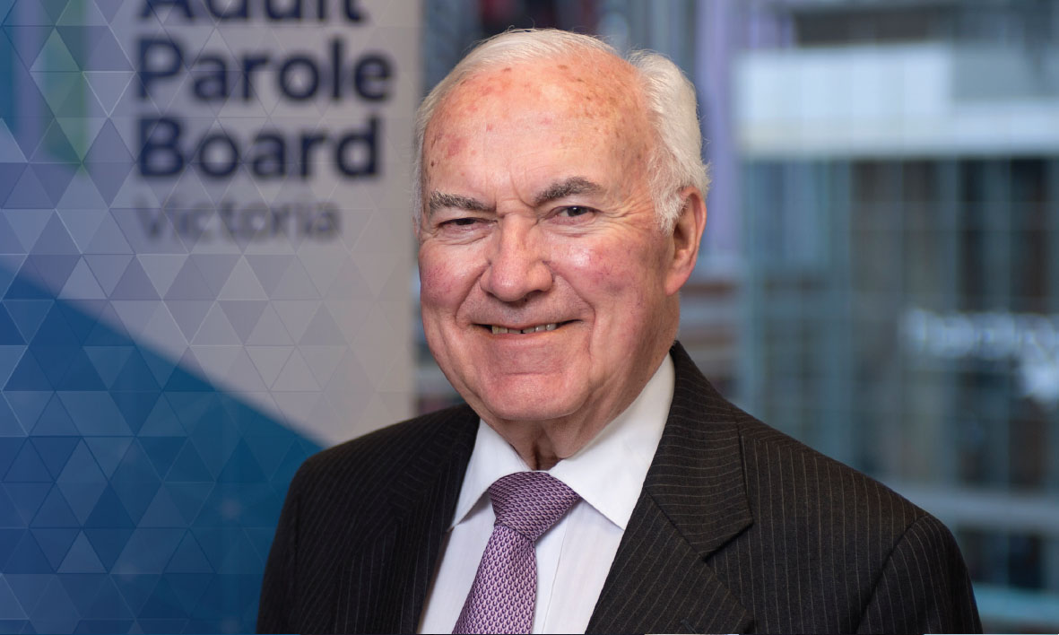
On 27 February 2018, the functions of the Detention and Supervision Order Division (DSOD) of the Adult Parole Board (Board) were transferred to the newly established statutory body, the Post Sentence Authority (Authority). And so, this is my last report to you as Chair of the DSOD.
I am pleased to advise that the transfer of duties occurred very smoothly and without a hitch. The operation of the detention and supervision regime was not interrupted in any way. Carmel Arthur, a well-respected community member of the Board and the DSOD whose nine year term on the Board expired in December last year, has been appointed as a full-time member of the Authority and thus provides a happy link between the two bodies.
The Authority is located, and will be located, in the same building as the Board and shares hearing room facilities. The relationship between the Board and the Authority is extremely cordial.
As at 26 February 2018 (the date immediately prior to the transition over to the Authority), three offenders were subject to detention orders made by the Supreme Court. There were 135 offenders subject to supervision orders (including interim supervision orders) compared with 133 offenders at 30 June last year. From 1 July 2017 to 26 February 2018, 25 offenders were directed by the Board to reside at a ‘residential facility’ – that is, at Corella Place or 228 Warrak Road, both located at Ararat or Emu Creek, adjoining Langi Kal Kal Prison.
It is the end of an era. The Board first became involved in the post sentence scheme in 2005 pursuant to the Serious Sex Offenders Monitoring Act 2005.
Subsequently, the operation of the scheme was pursuant to the Serious Sex Offenders (Detention & Supervision) Act 2009. For some years, the Board had been urging for its DSOD obligations to be undertaken by an independent, specialised body and this approach was recommended by the Harper Review leading to the establishment of the Authority.
In concluding this report, I sincerely thank:
- the DSOD transition project team of Sonia Mosca and Alison Slee for an excellent performance
- the staff of the APB for their assistance and support in the operation of the DSOD and the hand over to the Authority
- judicial members, full-time members and community members who sat on the DSOD.

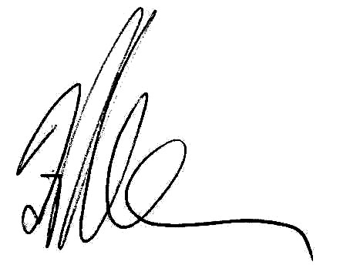
His Honour Frank Shelton
Chairperson of the Detention and Supervision Order Division
History of the DSOD
In March 2005, Victoria’s first post-sentence supervision scheme came into operation under the Serious Sex Offenders Monitoring Act 2005. The scheme applied only to people who had committed sexual offences against children. The Adult Parole Board was given responsibilities in relation to the management of those offenders on post-sentence supervision orders.
The following year, the government asked the Sentencing Advisory Council to report on possible extensions to the scheme. In its report, the Council considered the role of managing offenders on post sentence orders and stated that:
‘We recognise that some might consider that the Adult Parole Board could fulfil this role. Although we acknowledge the Board’s expertise and excellence in managing offenders on parole, we have serious concerns about the appropriateness of the Adult Parole Board carrying responsibilities for post-sentence management. In our view, the Adult Parole Board has a clearly defined and well-understood role in relation to offenders under sentence, and to extend this to encompass a post-sentence role risks detracting from the performance of its core functions. We further believe that this small group of offenders considered to present an ongoing and serious risk to the community would benefit from a specialist and more intensive model of management’.
The Board welcomed this recommendation in its 2007-08 Annual Report.
On 27 May 2008, the Act was amended to extend the scope of the scheme to people who had committed sex offences against adult victims. In the Board’s 2008-09 Annual Report, the Chairperson, The Hon. Justice Simon Whelan, re-iterated ‘the need for a specialist body to deal with these offenders’ on post-sentence orders.
These recommendations were adopted in part by the establishment in January 2010 of the Board’s Detention and Supervision Orders Division under the Serious Sex Offenders (Detention and Supervision) Act 2009. His Honour David Jones AM was the inaugural Chairperson of the DSOD from 1 January 2010 to 31 December 2012. His Honour Ross Betts was Chairperson from 1 January 2013 to 31 December 2013, and His Honour Frank Shelton was Chairperson from 1 January 2014 until 26 February 2018.
The review of the adult parole system in 2013 by Ian Callinan endorsed the recommendation of the Sentencing Advisory Council that there be a suitably resourced separate body to perform the functions of the DSOD.
In May 2015, the Minister for Corrections announced an independent review of the Serious Sex Offenders (Detention and Supervision) Act 2009. The Harper Review findings were tabled in Parliament in November 2015 and included the recommendation that the Board should no longer have a role in administering supervision and detention orders.
‘It is a responsibility which the Board has discharged admirably. The Panel nevertheless believes that the Board’s resources would be better employed if devoted to its core function and expertise which, of course, is to administer Victoria’s parole system. Both the Adult Parole Board and the Public Protection Authority would then have responsibility for that which each is best fitted to discharge’.
The Board welcomed this recommendation and its adoption by Parliament with the establishment of the Post Sentence Authority.
The Minister for Corrections, The Hon. Gayle Tierney, spoke in Parliament on 7 March 2018 about the establishment of the Authority. She thanked the Board for discharging its DSOD responsibilities admirably.
DSOD Operations
Jurisdiction of the DSOD until 26 February 2018
The Board’s DSOD had jurisdiction during 2017-18 from 1 July 2017 until 26 February 2018. Its DSOD jurisdiction ceased on 26 February 2018.
In this report, the Board reports on DSOD operations until 26 February 2018. The Board also reports on general post sentence scheme data in the 2017-18 reporting year. The Authority will separately report on its activities from 27 February 2018. This report will be the last occasion in which the Board reports on post sentence scheme data. From 2018-19, the Authority will be the only body reporting on the post sentence scheme.
In limited circumstances, courts can order an offender who has completed their sentence to be subject to post sentence detention or supervision. The power is currently limited to serious sex offenders who the courts determine will be an unacceptable risk of committing further sex offences after finishing their sentences.
The Supreme or County Court can impose a supervision order of up to 15 years, or an interim supervision order, on an application by the Secretary of the Department of Justice and Regulation. The power to impose orders is through the Serious Sex Offenders (Detention and Supervision) Act 2009. The court must be satisfied that the offender who has been convicted of serious sex offending poses an unacceptable risk of committing a serious sex offence after their sentence is finished if a supervision order is not made. Offenders subject to a supervision order are not undergoing a sentence and are not in custody. They reside in the community (including a number in residential facilities) but are subject to supervision.
When a supervision order is made, Corrections Victoria is responsible for supervising the offender.
Until 26 February 2018, the Board’s role, where authorised by the court making the order, was to provide direction on the administration of the conditions (e.g. accommodation or curfew) and on responses to breaches (e.g. issue a formal warning or recommend prosecution).
An eligible offender is defined in the Act as a person who is 18 years of age or over, has served a custodial sentence in respect to a relevant offence (which includes most sexual offences), and is serving a custodial sentence in Victoria for a specified serious sex offence at the time of application.
The Act enables the court to impose conditions on supervision orders. Conditions include:
- where the offender may live
- times when the offender must be
at home
- treatment or rehabilitation programs or activities that the offender must attend and participate in
- places or areas that the offender must not visit or may attend at specified times
- community activities the offender must not engage in
- persons or classes of person the offender must not have contact with
- forms of monitoring (including electronic monitoring) that the offender must comply with
- personal examinations by a medical expert which the offender must attend for the purpose of assisting the Board in determining the need for, or form of, any instruction and direction.
The Act established the DSOD within the Board. The functions of the DSOD under section 118 of the Act were to:
- monitor compliance with the supervision order and administer the conditions of the order
- give directions and instructions to an offender in accordance with any authorisation given to the Board under a supervision order
- make decisions to ensure the carrying into effect of the conditions of supervision orders
- make recommendations to the Secretary of the Department of Justice and Regulation in relation to applying to a court to review the conditions of supervision orders
- to review and monitor the progress of offenders on supervision orders.
The Act also empowers the Supreme Court to make a detention order of up to three years or an interim detention order. The Director of Public Prosecutions may apply to the Supreme Court for a detention order for an eligible serious sex offender. The court must be satisfied that the offender poses an unacceptable risk of committing a specified serious sex offence if a detention order is not made and that the offender is in the community. The Board is responsible for reviewing and monitoring offenders on detention orders. There were three offenders subject to detention orders as at 26 February 2018.
Corrections Victoria case manage offenders on detention and supervision orders, and, until 26 February 2018, provided the DSOD with reports and recommendations to facilitate their ongoing management.
On 27 June 2018, the Serious Offenders Act 2018 was passed in the Parliament of Victoria. It will replace the Serious Sex Offenders (Detention and Supervision) Act 2009 and expand the post sentence scheme to include certain serious violent offences, in addition to serious sex offences.
Membership of the division until 26 February 2018
As at 26 February 2018, there were eight judicial members, ten community members and three full-time members in the Detention and Supervision Order Division, including: His Honour Peter Couzens, His Honour Frank Shelton, Her Honour Judge Susan Pullen, His Honour Robert Kumar, His Honour David Fanning, His Honour Franz Holzer, His Honour Gregory MacNamara, His Honour Alan Spillane, Kieran Walshe, Glenda Frost, Peter Harvey, Pamela White, Dr Patricia Mehegan, Claude Minisini, Geoff Wilkinson, Nicole Burns, Rosemary Lever, Mary Malone, Stephen Farrow, Dr David Curnow and Nafsika Sahinidis.
A sitting of the DSOD consisted of the presiding member and two other members of the DSOD.
Operations of the division until 26 February 2018
The DSOD met weekly, as well as out of session for urgent cases. From 1 July 2017 to 26 February 2018, the DSOD sat on 83 days and heard 550 matters. Of these matters, 382 were scheduled and the remaining 168 were unscheduled to consider urgent matters.
Orders under the DSOD’s jurisdiction
During 2017-18, two detention orders and one interim detention order were made by the Supreme Court. The Supreme and County Courts made 11 interim supervision orders and 16 supervision orders against 19 persons.
Directions to reside at a residential facility
The court sets the conditions of a supervision order, including where the offender is required to reside. This may be in the community or at a residential facility. A residential facility is not a prison. The facilities are utilised for the purpose of housing offenders subject to supervision orders who are unable to source appropriate accommodation in the community, or who require a higher level of supervision or support than others.
Until 26 February 2018, the court could authorise the Board under section 20(1)(b) of the Serious Sex Offenders (Detention and Supervision) Act 2009 to direct an offender who is residing in the community to reside at a residential facility. From 1 July 2017 to 26 February 2018, the DSOD directed 25 offenders to reside in a residential facility.
As at 30 June 2018, there were 76 offenders subject to an interim supervision order or a supervision order requiring the offender to reside at a residential facility.
Emergency powers
The emergency powers contained in the Serious Sex Offenders (Detention and Supervision) Act 2009 permit the DSOD to give directions to manage an offender subject to a supervision order in a way that is inconsistent with, or not provided for, by the conditions of the order that were set by the court. From 1 July 2017 until 26 February 2018, the DSOD exercised these powers on one occasion.
Electronic monitoring
The court, in making interim supervision orders or supervision orders, is required to consider imposing condition(s) for electronic monitoring. Until 26 February 2018, the court could delegate authority to the DSOD to make such a direction for electronic monitoring. During 2017-18,
121 offenders on interim supervision orders or supervision orders were directed to comply with electronic monitoring.
As at 30 June 2018, a total of 93 offenders on interim supervision orders or supervision orders were subject to electronic monitoring (including those residing at a residential facility).
Breaches of supervision order
Section 160(1) of the Serious Sex Offenders (Detention and Supervision) Act 2009 states that an offender must not, without reasonable excuse, fail to comply with a condition of a supervision order (or interim supervision order). Breach proceedings may only be brought to the court by the Secretary of the Department of Justice and Regulation or a member of Victoria Police by filing a charge sheet. There is a maximum penalty of five years imprisonment for breach of a condition.
During 2017-18, the Secretary of the Department of Justice and Regulation, Victoria Police and the Office of Public Prosecutions initiated 30 breach proceedings.
Powers for police to enter premises
Section 158C of the Serious Sex Offenders (Detention and Supervision) Act 2009 gives police the power to enter premises at which a supervised offender resides, if the police officer reasonably suspects that the offender is present and that entry is reasonably necessary to monitor the offender’s compliance with a supervision order or interim supervision order. Section 171A gives Victoria Police the power to enter and search premises at which they reasonably suspect an offender to be present, using reasonable force if necessary, to arrest the offender for breaching a condition of a supervision order or interim supervision order. During 2017-18, the police did not exercise these powers.
 | 2017-18 |  | 2016-17 |  | 2015-16 |  | 2014-15 |  | 2013-14 | % change between 2016-17 and 2017-18
DETENTION AND SUPERVISION ORDERS
Number of sitting days of the Division (until 26 February) | 83 | 96 |  | 106 |  | 115 |  | 161 |  | -14%
Interim detention orders made (excludes renewals) | 1 | 0 |  | 0 |  | 0 |  | 0 |  | N/A
Detention orders made (excludes renewals) | 2 | 0 |  | 0 |  | 1 |  | 1 |  | N/A
Interim supervision orders made (excludes renewals) | 11 | 16 |  | 16 |  | 13 |  | 8 |  | -31%
Supervision orders made (excludes renewals) | 16 | 18 |  | 16 |  | 15 |  | 11 |  | -11%
Number of persons directed to reside in a residential facility (until 26 February) | 25¹ | 18 |  | 18 |  | 17 |  | 14 |  | 39%
Number of persons in respect of whom an emergency  power was exercised (until 26 February) | 1 | 3 |  | 2 |  | 0 |  | 2 |  | -67%
Number of persons required to comply with electronic monitoring | 1212 | 60 |  | 57 |  | 18 |  | 14 |  | 102%
Total number of persons subject to electronic monitoring at 30 June | 933 | 94 |  | 82 |  | 69 |  | 56 |  | -1%
Number of detention or supervision orders completed (including interim orders) | 104 | 11 |  | 9 |  | 6 |  | 0 |  | -9%
Number of persons on a detention order  (as at 26 February) | 3 | 2 |  | 2 |  | 2 |  | 1 |  | 50%
Number of persons on a supervision order  (as at 26 February) | 124 | 125 |  | 120 |  | 111 |  | 104 |  | -1%
Number of persons on an interim detention order  (as at 26 February) | 0 | 0 |  | 0 |  | 0 |  | 0 |  | N/A
Number of persons on an interim supervision order  (as at 26 February) | 11 | 8 |  | 7 |  | 5 |  | 4 |  | 38%
Number of times the exercise for powers of entry under sections 158C and 171A of the Act were reported to the Board | 0 | 2 |  | 0 |  | - |  | - |  | -100%

1. Inclusive of only those directed by the Board.
2. Data counting rules have changed from previous years. The 2017-18 figure reports on all persons required to wear an electronic monitoring device at any time during the reporting year. Previous years have reported on Supervision Orders made during the reporting year which included electronic monitoring conditions or directions.
3. Includes those residing at residential facilities.
4. Includes two supervision orders that were revoked.
Organisation and governance
Governance
The Board’s governance structure oversights the efficient and effective administration of the Board’s strategy, policy, and practice. All strategic decisions are made by the Executive based on the recommendations and advice of the four supporting subcommittees, with project advice provided by the Project Board.
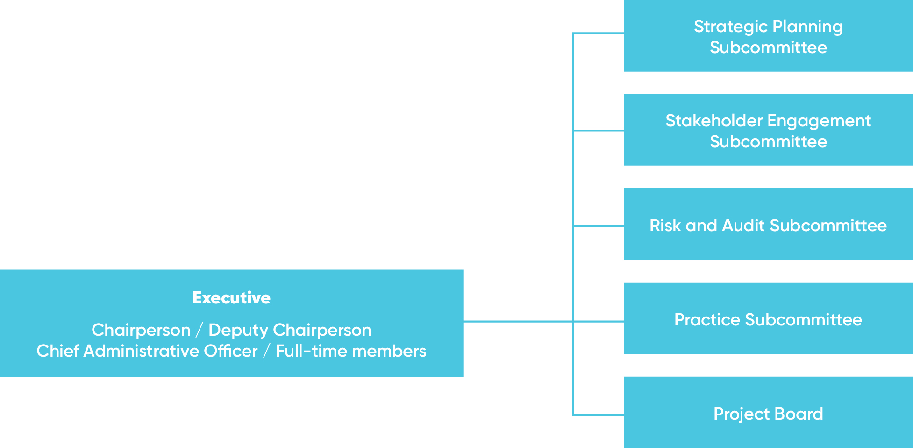
Secretariat
The Board is supported to undertake its functions by a Secretariat comprising of 30 ongoing Corrections Victoria staff (from the Department of Justice and Regulation).
The Secretariat is led by the Chief Administrative Officer, with the support of the senior management team of the General Manager, Operations and General Manager, Practice Development. The management team also comprises the Manager Operations, Manager Registry, Senior Communications Officer, Project Manager, and Senior IT Project Officer. This team is committed to ensuring that all aspects of the operations of the Board and Secretariat are working effectively and in a coordinated way. The team’s comradery, spirit of cooperation, and focus on a positive, professional and respectful culture, permeates the Secretariat, making it a rewarding and outstanding work environment.
The nature of the Board’s work, the significant projects that are being undertaken, the staff structure that was implemented in 2015, and a culture of encouraging and supporting staff, have provided many career development opportunities for staff. In addition to opportunities within the Board, a number of staff have been supported to take external secondment opportunities.
A significant change occurred at the senior management level, with the resignation of Pauline Bailey as General Manager, Operations, and the recruitment of Anita Lis to fill this dynamic and challenging role. After 15 years of extremely valuable service to the Board, Pauline resigned to take up another management position in Corrections Victoria. Her contribution to the Board was immense, particularly in recent years when she played a key part in managing the Board’s response to the changes and scrutiny. The Board is very fortunate to have recruited Anita into the role as she brings a wealth of experience from 17 years with Corrections Victoria, including most recently as General Manager, Electronic Monitoring Program.
The number of Board staff dedicated to the Case Workflow System Program increased during the reporting year. There are now five staff working exclusively on this priority project, with three involved in the design, development and testing of the system, and two focused on change management. Other senior staff including all members of the management team are also heavily involved. This resource commitment is a major challenge to manage, and the Board is grateful for the support of Corrections Victoria. All staff involved in the project have acquired valuable new skills, and the Board will benefit from the exponential growth in their professional capabilities beyond the duration of the project.
For six months the Board, with the support of Corrections Victoria, hosted an additional senior project manager, Sonia Mosca, to lead its approach to the transition of its post-sentence functions and repository of information and records to the new Post Sentence Authority, with the support of a project officer, Alison Slee, from within the Secretariat. This dedicated team meant that the project moved at a pace and in a way that gave optimum support to the successful establishment of the new post-sentence scheme.
Reflecting the importance of the pivotal role of the Senior Registry Officer, and in response to additional quality assurance tasks that have been introduced into the Registry team, a vacant VPS3 Meeting Coordinator position was recast as a second VPS3 Senior Registry Officer position and recruitment undertaken to fill it. This will enable the full breadth of the increased work load allocated to the Senior Registry Officers to be shared and managed between them.
Operational health and safety
The Board is committed to providing a safe and healthy workplace that is free from discrimination, harassment, bullying and workplace violence.
The Board’s health and safety representative monitors the occupational health and safety of staff and members. Any concern can be placed on the agenda of regular management team meetings, and a standing item is maintained on
the agenda for this purpose.
Equal employment opportunity employer
The Board is an equal employment opportunity employer. Appointments and promotions are based on merit, and staff receive the training and experience required to enhance their skills and abilities.
Organisational chart
Figure 11: Adult Parole Board Secretariat organisational chart
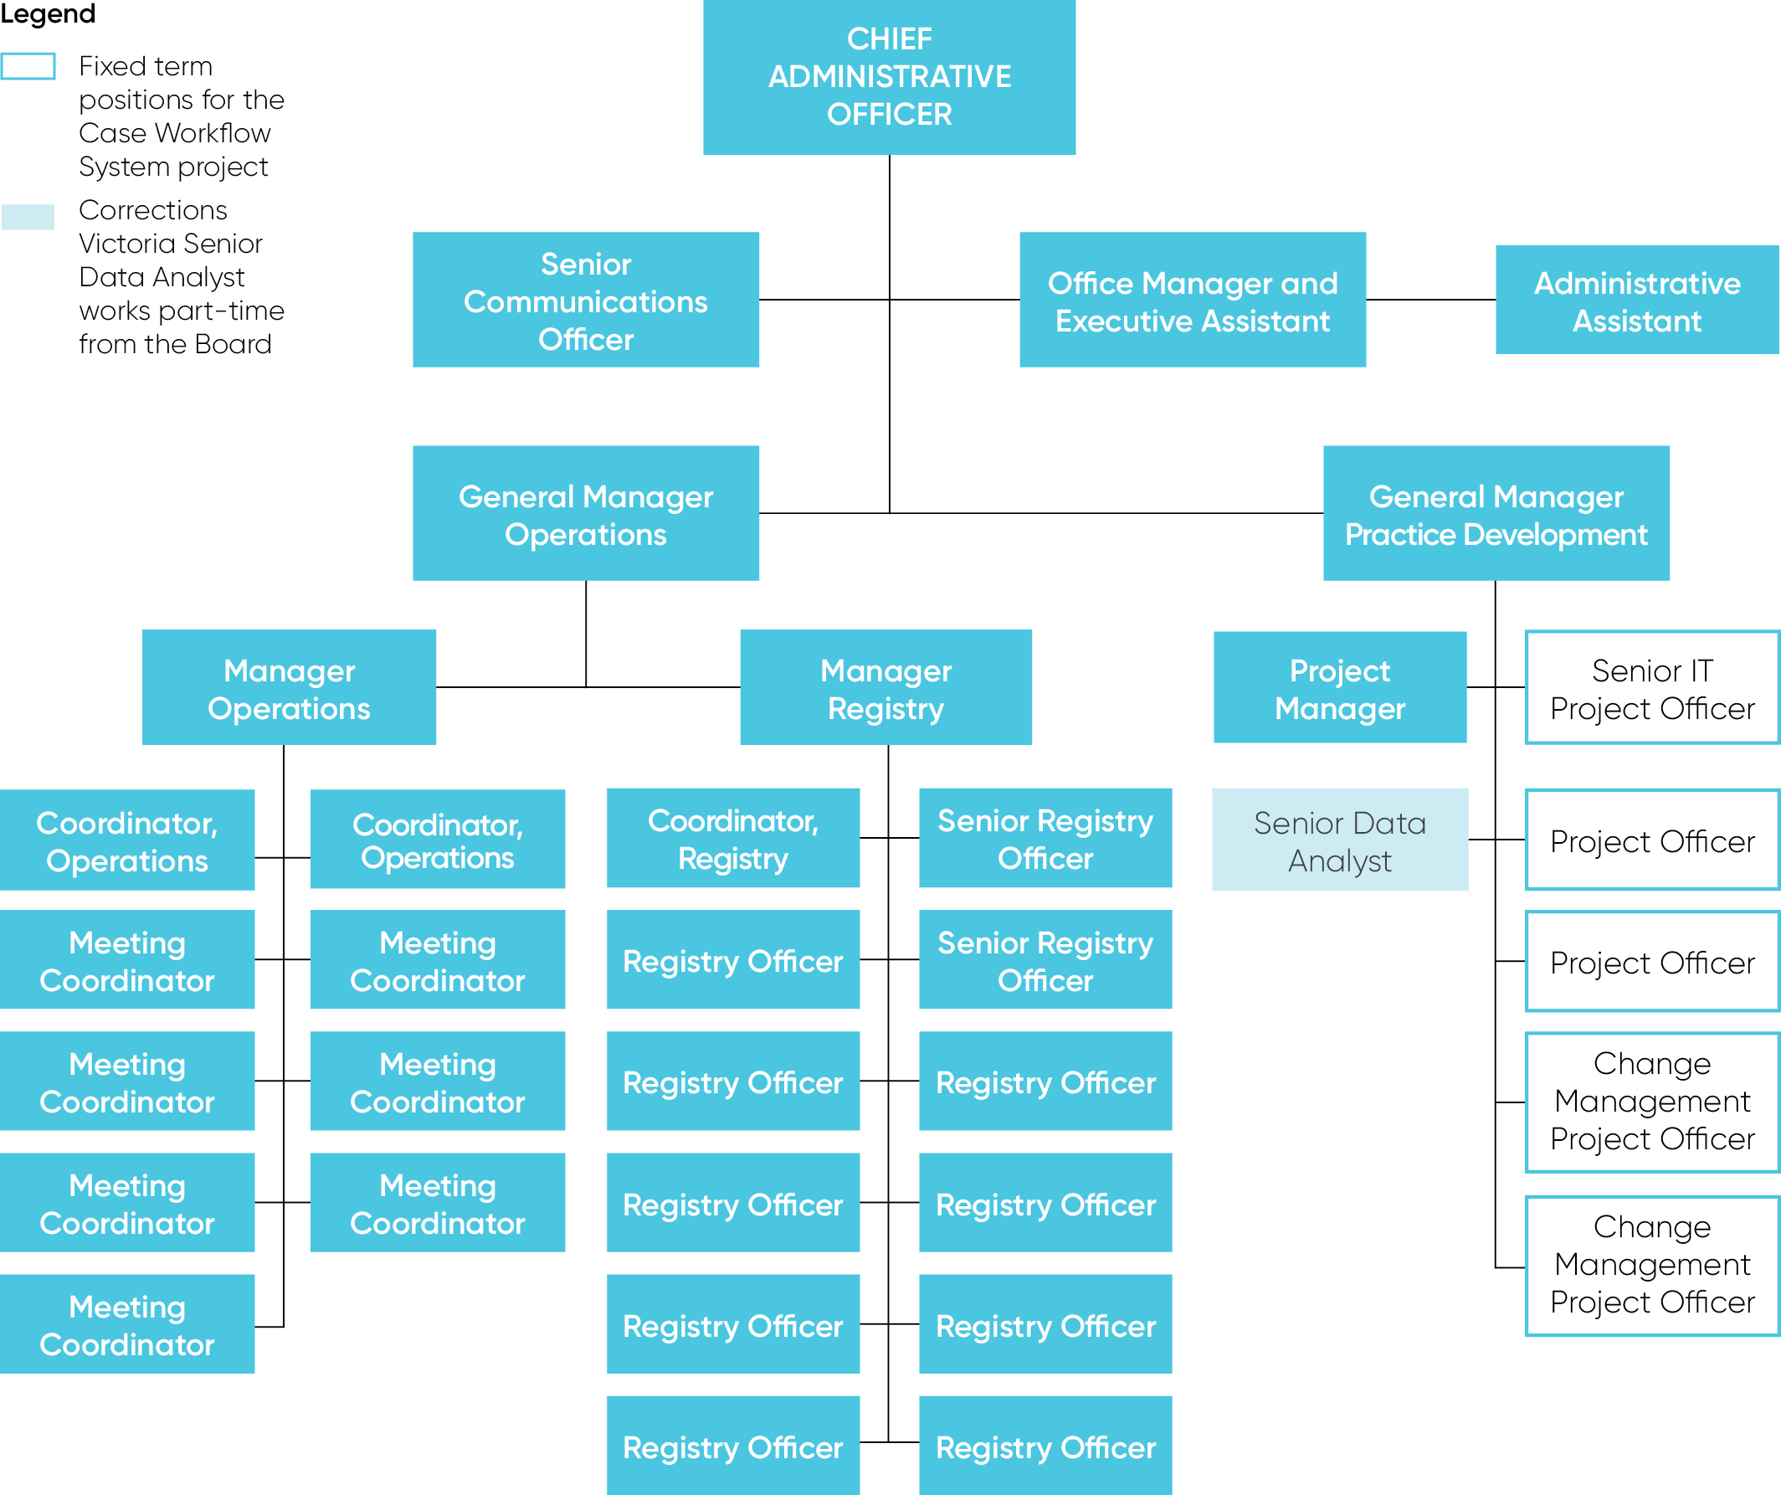
Privacy and information
Privacy and information
There are strict rules governing the release of information by the Adult Parole Board. The disclosure of ‘personal and confidential information’ is governed by Part 9E of the Corrections Act 1986 and the Privacy and Data Protection Act 2014. The Board is not subject to the Freedom of Information Act 1982.
It is an offence for Board members or staff to use or disclose personal or confidential information unless the disclosure is authorised: s.104ZZA of the Corrections Act 1986.
Information contained in an offender’s file is treated as confidential, and ensures that information can be provided to the Board with complete frankness by clinicians and intelligence. It also ensures that prisoners can speak to the Board without reservation.
Under the Corrections Act 1986:
- registered victims may be informed of an offender’s release date and certain victim-related conditions, but otherwise registered victims are not privy to information on an offender’s file (registered victim submissions are treated with strict confidentiality)
- there are limited circumstances, listed in s.104ZZ, where information given to the Board may be disclosed
- the disclosure of other ‘personal or confidential information’ is governed by s.104ZY which authorises disclosure of personal or confidential information for ‘official duties’ (defined under s.104ZX of the Act to include preparation for, conduct of or participation in, proceedings in any court or tribunal), law enforcement or in the specific circumstances stipulated under ss.104ZY(2).
Safety and protection of the community
Disclosure of personal and confidential information is authorised if a relevant person believes on reasonable grounds that the use or disclosure is necessary:
- to reduce the risk of a person committing a violent offence; or
- to lessen or prevent a threat to the life, health, safety or welfare of any person.
During 2017-18, the Board developed family violence information sharing protocols to ensure it complies with the Family Violence Information Sharing Scheme.

Year at a glance

 | 2017-18 | 2016-17 | 2015-16 | 2014-15 | 2013-14 | % change  between 2016-17  and 2017-18
Parole eligibility
Prisoners in custody (at 30 June) | 7,668 | 7,151 | 6,519 | 6,219 | 6,113 | 7%
Prisoners eligible for parole (at 30 June) | 3,846 | 3,727 | 3,463 | 3,765 | 4,244 | 3%
Prisoners on parole (at 30 June) | 858 | 841 | 981 | 1,138 | 1,233 | 2%
Parole applications (including applications for re-parole)
Total number received | 1,680 | 1,689 | 1,841 | 7431 | - | -1%
Total progressed to Parole or Re-parole Suitability Assessment | 1,479 | 1,449 | 1,551 | 6202 | - | 2%
Eligible prisoners who did not apply for parole | 114 | 91 | 142 | - | - | 25%
Board meetings
Total (Board and DSOD) meeting days3 | 294 | 268 | 272 | 295 | 266 | 10%
Prisoners interviewed at prison | 38 | 67 | 94 | 179 | 787 | -43%
Average matters considered per meeting day | 30 | 32 | 36 | - | - | -6%
Victim submissions
Submission from victims | 1314 | 161 | 164 | 124 | 126 | -19%
Parole orders5
Parole orders granted | 8036 | 757 | 883 | 1,341 | 1,313 | 6%
Parole orders denied | 7067 | 549 | 622 | 841 | 834 | 29%
Parole orders revoked8 | 41 | 39 | 42 | 70 | 111 | 5%
Parole order completions | 574 | 644 | 733 | 856 | 1,116 | -11%
Serious Violent Offender or Sexual Offender (SVOSO) Division
Total matters considered | 502⁹ | 542 | 617 | 750 | - | -7%
SVOSO orders granted | 318 | 321 | 383 | 598 | - | -1%
SVOSO orders denied10 | 31 | 18 | 19 | 9 | - | 72%
SVOSO orders revoked | 13 | 18 | 17 | 12 | - | -28%
Other outcomes11 | 150 | 185 | 198 | 131 | - | -19%
Breach of parole (detention)
Total notifications received | 55 | 54 | 98 | 198 | - | 2%
Total detained | 42 | 42 | 80 | 152 | - | 0%
*Total cancelled | 26 | 38 | 61 | 119 | - | -32%
*Total not cancelled | 16 | 4 | 19 | 33 | - | 300%
Total ceased to detain | 13 | 12 | 18 | 46 | - | 8%
Cancellation of orders12
Parole orders cancelled | 156 | 204 | 387 | 569 | 761 | -24%
Length of parole served prior to cancellation
* day of release to less than three months | 78 | 93 | 185 | 324 | 354 | -16%
* three to less than six months | 25 | 44 | 78 | 99 | 170 | -43%
* six to less than 12 months | 32 | 37 | 73 | 83 | 126 | -14%
* 12 months or more | 21 | 30 | 51 | 63 | 111 | -30%
Serious violent offence or sexual offence convictions
Total number persons convicted13 | 4 | 5 | 13 | 22 | 60 | -20%
Total number offences | 13 | 11 | 17 | 38 | 97 | 18%
Detention and supervision orders
Detention orders made by the Supreme Court (excludes renewals) | 2 | 0 | 0 | 1 | 1 | N/A
Interim supervision orders made by the Supreme and County Courts (excludes renewals) | 11 | 16 | 16 | 13 | 8 | -31%
Supervision orders made by the Supreme and County Courts (excludes renewals) | 15 | 18 | 16 | 15 | 11 | -17%
Reviews14
Requests for reviews | 1715 | 32 | 218 | 373 | 400 | -47%
Rejected | 816 | 24 | 147 | 344 | 363 | -67%
Accepted | 617 | 8 | 71 | 29 | 37 | -25%
Youth transfers
Transfers from prison to a youth justice centre | 1 | 4 | 1 | 2 | 3 | -75%
Transfers from a youth justice centre to prison18 | 18 | 17 | 13 | 15 | 20 | 6%
Interstate transfers
Parole orders transferred from Victoria | 19 | 19 | 20 | 24 | 27 | 0%
Parole orders transferred to Victoria | 33 | 34 | 32 | 39 | 28 | -3%
Members of the Board (at 30 June)
Judicial members | 13 | 13 | 16 | 17 | 17 | 0%
Full-time members | 4 | 319 | 4 | 4 | 4 | 33%
Community members | 15 | 13 | 16 | 17 | 8 | 15%
Departmental representatives | 1 | 1 | 1 | 1 | 1 | 0%
Total members | 33 | 30 | 37 | 39 | 30 | 10%
Staff of the Board (at 30 June)
Total employees | 3020 | 30 | 30 | 31 | 31 | 0%
Financial management
Funding | 5,547,700 | 5,356,300 | 5,294,500 | 5,550,800 | 4,394,000 | 4%
Expenditure | 5,406,124 | 4,919,098 | 4,893,401 | 5,129,911 | 4,802,382 | 10%

1 This data is from 1 March 2015 to 30 June 2015.
2 This data is from 1 March 2015 to 30 June 2015.
3 More than one division of the Board may sit on a meeting day. When this occurs, one meeting day is counted.
4 Excludes 4 victim submissions for offenders on supervision orders.
5 This includes SVOSO Division decisions.
6 The Board is required to report on the number of prisoners released on parole. The Board meets this requirement by reporting on the number of parole orders granted.
7 This includes denial decisions recorded when a prisoner withdraws their parole application. The Board denies parole in these circumstances to finalise the parole application. From 2018-19, the Board aims to record withdrawals separately from denials.
8 Parole orders are revoked when the Board reverses a decision to grant parole to a prisoner, prior to release on parole.
9 For ten matters it considered, the SVOSO Division made two decisions - an order to revoke parole and an order to deny parole.
10 These figures are the numbers of parole denial decisions made by the SVOSO division after another division of the Board recommended that parole be granted.
11 Other outcomes include parole variations, deferred cases, additional conditions or prisoners being considered on multiple occasions.
12 The Board is required to report on the number of persons returned to custody on cancellation of parole. The Board meets this requirement by reporting on the number of parole orders cancelled.
13 The Board is required to report on the number of persons convicted of a serious offence committed while on parole.
14 The Board is required to report on the number of requests it receives to review a Board decision, and the outcomes of the requests.
15 Not all requests for reviews received in 2017-18 had an outcome as at 30 June.
16 Reasons are reported on page 28.
17 Outcomes are reported on page 28.
18 This data was provided by the Youth Justice Centre and is indicative.
19 One full time member position was being advertised as at 30 June.
20 This total includes four vacant positions at 30 June 2018. The total does not include four additional fixed term positions for the case workflow system project. In addition to the four fixed term positions, one position from the Board’s Secretariat was dedicated full time to the case workflow system project. Of the 26 staff at 30 June 2018, 20 were female and six were male. Three of the additional four fixed term project positions were female, and one was male. The Secretariat is comprised of the following position levels: one STS7; two VPS6; four VPS5; four VPS4; nine VPS3; and ten VPS2.

Financial report
There are strict rules governing the release of information by the Adult Parole Board. The disclosure of ‘personal and confidential information’ is governed by Part 9E of the Corrections Act 1986 and the Privacy and Data Protection Act 2014. The Board is not subject to the Freedom of Information Act 1982.
Operating statement and financial summary 2013–14 to 2017–18
Funding and expenditure
The Board is funded by Corrections Victoria and its accounts are managed through the Department of Justice and Regulation.
 | 2017-18 | 2017-18  % of total expenditure | 2016-17 | 2015-16 | 2014-15 | 2013-14
Funding $
 | 5,547,700 |  | 5,356,300 | 5,294,500 | 5,550,800 | 4,394,000
Expenditure $
Salaries to staff | 3,186,824 | 59% | 2,926,812 | 2,867,646 | 2,765,123 | 2,323,347
Sessional member fees | 309,824 | 6% | 311,657 | 378,689 | 445,829 | 329,436
Salary related on-costs | 998,640 | 18% | 911,200 | 894,675 | 904,796 | 752,027
Operating expenses | 910,836 | 17% | 769,428 | 752,391 | 1,014,163 | 1,397,572
Total expenditures | 5,406,124 |  | 4,919,098 | 4,893,401 | 5,129,911 | 4,802,382

Audited accounts
The Board’s accounts are included in the accounts of Corrections Victoria, Department of Justice and Regulation. The audited accounts are published in the Department of Justice and Regulation Annual Report 2017–18.
Assets
The Board is not a body corporate and does not have power under its legislation to purchase, hold, or dispose of real and personal property.
Employee benefits
All employees of the Board are paid by Corrections Victoria. Consequently, the Board does not make payments directly in respect of employees’ superannuation, payroll tax and WorkCover.
Member remuneration
Remuneration of sessional members and the Board’s full-time members is fixed by the Governor in Council. Sitting judicial members are not remunerated for their work on the Board. Community members are remunerated at the rate of $547 per sitting day. Retired judicial members are remunerated at the rate of $632 per sitting day when acting as Chairperson of a division. These rates are set out in the Department of Premier and Cabinet’s Guidelines for the Appointment and Remuneration of Part-Time Non-Executive Directors of State Government Boards and Members of Statutory Bodies and Advisory Committees.

Glossary
Authority Post Sentence Authority
APB Adult Parole Board
Board Adult Parole Board
CCS Community Correctional Services
CV Corrections Victoria
DSOD Detention and Supervision Order Division
SVOSO Serious Violent Offences/Offenders or Sexual Offences/Offenders

Not including the Secretary of the Department of Justice and Regulation who does not actively participate as a member.
Under section 61(2)(f) of the Corrections Act 1986, the Secretary to the Department of Justice and Regulation is a member of the Board but does not have an active role in Board sittings.
Sentencing Advisory Council Review of the Victorian Adult Parole System (2012), Professor James Ogloff and the Office of Correctional Services Review Review of Parolee Reoffending by Way of Murder (2013) and Ian Callinan Review of the Parole System in Victoria (2013).
The comparison of the above timespans is helpful to demonstrate the changes that have occurred in parole decisions and outcomes over this extended period and a useful way of evaluating the impact of the reforms. In undertaking the comparison however, the Board is conscious that the very purpose of assessing the impact of reforms means that the Board and other parts of the parole system were operating in completely different environments, in areas such as the governing law, operations, and resources, in the pre-reform and post-reform periods.
Successful and unsuccessful completions are reported on the date Community Correctional Services (CCS) discharge parole orders. When a prisoner successfully completes their parole, CCS does multiple checks in order to confirm requirements have been met and then discharges the order. This is recorded as a successful completion. When a parole order is cancelled by the Board, CCS discharges the order as unsuccessful. Due to the timing of the CCS discharge process, there may be a slight difference between the number of cancellations and the number of unsuccessful discharges in a reporting period.
All references to ‘parole’ in this section of the report include re-parole (a subsequent period of parole after an initial parole order has been cancelled). The Board aims to report re-parole data separately from 2018-19, as there can be different issues affecting applications for re-parole which influence the outcomes. This is part of the Board’s continuing agenda to improve and analyse parole data.
The proportion is calculated from the total number of those that applied for parole and the total that reported as not wishing to apply for parole.
There can be multiple factors as to why a parole order was cancelled. Drug use was one of these factors.
These could have been in conjunction with other reasons.
This excludes those in custody with a condition to reside at a residential facility.
Sentencing Advisory Council, High Risk Offenders: Post-Sentence Supervision and Detention, Final Report (2007), para. 3.7.30.
Ian Callinan AC, Review of the Parole System in Victoria: Report (2013), p.97
Complex Adult Victim Sex Offender Management Review Panel, Advice on the legislative and governance models under the Serious Sex Offenders (Detention and Supervision) Act 2009 (Vic) (commonly referred to as the Harper Review report), p.xiv
These exclude any renewals made
As at 30 June 2018, there were four vacancies.

