Adult Parole Board Victoria
Annual Report 2016-17

Contents
Adult Parole Board Victoria Annual Report 2016-17 1
Introduction 4
Foreword from the Chairperson 4
Foreword from the Chief Administrative Officer 9
Celebrating 60 years 14
Perspectives on parole 17
MEMBERS 19
Adult Parole Board members 2016-17 23
Operations and decision-making 26
Sentencing and parole 26
The parole process 29
Key projects 34
Major legislative changes 34
Litigation 35
Stakeholder Collaboration and engagement 36
Increasing the community’s understanding of parole 36
Working collaboratively with stakeholders 38
Detention and Supervision Order Divison (DSOD) 40
Foreword from the DSOD Chairperson 40
Detention and Supervision Order Division operations 41
Orders under the division’s jurisdiction 42
Organisation and governance 45
Governance 45
Secretariat 45
Organisational chart 47
Privacy and information 47
Financial report 49
Year at a glance 50

The Hon Gayle Tierney MP
Minister for Corrections
Level 1, 2 Treasury Place
East Melbourne VIC 3002

Dear Minister
In accordance with the requirements of section 72(1) of the Corrections Act 1986, we are pleased to present this Annual Report of the performance and operations of the Adult Parole Board of Victoria for the 12 months from
1 July 2016 to 30 June 2017.

Yours sincerely
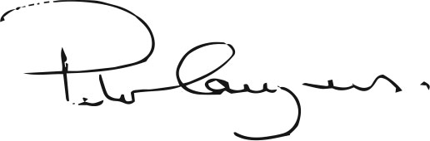
His Honour Peter Couzens
Chairperson

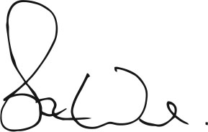
Stuart Ward
Chief Administrative Officer

Introduction

Foreword from the Chairperson
The third of July 2017 marked the 60th anniversary of the first sitting of the Adult Parole Board of Victoria.
To mark the occasion, I had the privilege of hosting a luncheon at the Board’s office at which five past Chairpersons of the Board were present. They were The Honourable Alastair Nicholson AO QC RFD, The Honourable Bernard Teague AO, The Honourable Justice Simon Whelan, The Honourable Elizabeth Curtain AM and The Honourable E.W. (Bill) Gillard QC.
It was an honour to be able to celebrate this historic occasion in the presence of such esteemed members of the judiciary, both past and present, each of whom served the Board with great distinction.
Later in the report you will be able to read more about the history of the Board and see photos of a truly memorable event.
The reporting year has provided further evidence that the parole system post-Callinan has improved and the community’s exposure to risk of harm from parolees has reduced.
In support of this claim I rely on the following statistics:
76 per cent of parolees successfully got through their parole and were discharged by Community Correctional Services during the reporting year.
Between 2013-14 and 2016-17, there has been a 92 per cent reduction in the number of persons convicted of serious violent or sexual offences committed by them while on parole in Victoria.

Table 1: The number of persons convicted of serious violent offences or sexual offences committed by them while on parole in Victoria
Year | Number of persons
2013–14 | 60
2014-15 | 22
2015-16 | 13
2016-17 | 5
In the reporting year 204 parolees had their parole cancelled and returned to custody. This was much fewer than the three preceding years.
Table 2: The number of parole orders cancelled by the Board
Year | Number of cancellations
2013–14 | 761
2014-15 | 569
2015-16 | 387
2016-17 | 204
Over 80 per cent of decisions to cancel parole involved a failure to comply with conditions, including illicit drug use, as opposed to alleged or actual reoffending.
Since 2014-15 when Victoria Police were given the power to arrest and detain parolees suspected of breaking their parole, there has been a 73 per cent reduction in the notifications of arrest and detention.
Table 3: The number of breach notifications that the Board received from Victoria Police
Year | Number of notifications
2014-15 | 198
2015-16 | 98
2016-17 | 54
There are many factors which have combined to bring about improvements to the parole system, one of which was highlighted in the report into the Queensland Parole System conducted by Mr Walter Sofronoff QC (now President of the Queensland Court of Appeal) during 2016.
In the course of conducting his review, Mr Sofronoff visited Victoria. He attended the Board and observed sittings of both the General and Serious Violent or Sexual Offender (SVOSO) Divisions and engaged in discussions with myself, Board members and management. He also spent time with representatives of Corrections Victoria.
His report, inter alia, was most complimentary of Corrections Victoria and, in particular, to efforts being made by their staff to better prepare prisoners for parole. To quote from the report, Mr Sofronoff said;
“The overarching philosophy of Corrections Victoria is to enhance community safety by ensuring the prisoners who are released on parole are well prepared and supported to succeed on parole. Corrections Victoria takes a lead role in working consistently with the prisoner throughout his or her incarceration to prepare the prisoner for parole.
“The model in Victoria appears to be the most likely to reduce inefficiency and improve community safety by adequately preparing prisoners for parole. It requires that preparation of a prisoner for parole begins when the prisoner is first received into custody and that there be proper case management and co-ordination of the treatment of the prisoner throughout his or her period of incarceration.”
I fully endorse Mr Sofronoff’s comments.
The better prepared a prisoner is for release into the community the better equipped the prisoner will be to comply with his or her conditions of parole and refrain from reoffending. It must not be inferred from my comments, however, that the system is perfect, it isn’t, or that no parolee will ever reoffend whilst on parole, for inevitably that will happen, from time to time, as risk can never be eliminated. What can be taken from my comments, however, is that the system has improved, as evidenced by the statistics referred to by me and that the likelihood of parolees reoffending has reduced, although not been eliminated.
Parole is a critical part of Victoria’s criminal justice system and yet there is widespread ignorance and misunderstanding throughout the community, including amongst the legal profession, about it. With that in mind the Board is committed to taking advantage of appropriate opportunities for its members, especially myself and the Board’s full-time members to speak publicly about parole so as to better inform and educate the community. Our goal is to persuade those who are prepared to listen, that as imperfect as the system may be, the community is safer if prisoners, especially violent offenders, are released conditionally on parole as opposed to being released unconditionally at the completion of their sentence.
During the reporting year, the Board engaged with the public, the legal profession and the judiciary, in the following ways:

Participation in Law Week
In conjunction with the Magistrates’ Court, the Board took part in a joint presentation during which a fictitious offender was sentenced to a non-parole period for violent offending. At the completion of the sentencing exercise, the Board convened two panels, the first to consider an application by the prisoner for parole, the second to consider a subsequent application to cancel. The first panel comprised judicial member, reserve Magistrate John Doherty, full-time member Mr Stephen Farrow and community member Ms Carmel Arthur. The second panel comprised judicial member Judge Susan Pullen, full-time
member Ms Nafsika Sahinidis and community member Mr Claude Minisini. The presentation was extremely realistic and provided the audience with a most valuable insight as to how the Parole Board goes about its decision-making.
Between the convening of the two panels, full-time member Dr David Curnow explained the arrest and detention powers contained in the Corrections Act 1986. Whilst community member Carmel Arthur, herself a victim, addressed the audience about the importance of parole.
The audience reaction to the presentation was positive and included comments such as:
- “Before today I opposed parole. Today I’ve changed my mind. Parole is control of the offender.”
- “I now know that parole protects the public (because of conditions, otherwise he would be released without any support).”
- “How different from the perception
in the press the Parole Board is.”
- “Parole is not automatically considered, it requires an application. Parole allows close monitoring if granted. Otherwise there is little in the way of supervision upon release.”

The judiciary and legal practitioners:
Presentations were delivered to:
- County Court Judges
- Members of the Law Institute of Victoria, Criminal Law sections
- Members of Victoria Legal Aid.

The media:
- Lindy Burns’ evening program on radio ABC 774
- Neil Mitchell’s morning program on radio 3AW
- Raf Epstein’s evening drive time program on radio ABC 774
- 3AW’s Sunday Morning program with Darren James, Nick McCallum and John Michael-Howson
- Community member Carmel Arthur was interviewed by John Silvester aka ‘Sly of the Underworld’ for an article which appeared in The Age.

Community groups:
I was privileged to present to the following community groups about parole:
- Melbourne Legacy
- The Glenferrie Rotary Club
- Full-time member Dr David Curnow presented to the Footscray Lion’s Club, La Trobe University third year psychology students and Swinburne University’s Doctor of Psychology students
- Full-time member Stephen Farrow presented to the Monash University’s Summer Law School.

The Adult Parole Board’s Website – www.adultparoleboard.vic.gov.au
The most significant initiative taken in terms of providing the community, including the legal profession and the judiciary, with information about the Adult Parole Board and the parole system in general, has been the development of the Board’s website www.adultparoleboard.vic.gov.au which was launched during the reporting year.
The website is the brainchild of the Board’s Chief Administrative Officer Stuart Ward. In conjunction with the Board’s Senior Communications Officer David Klotz, Stuart designed the website which I can confidently say sets the benchmark for similar websites around Australia.

Declining number of prisoners on parole
The number of parolees in the Victorian community continued to fall during the reporting year. As at 30 June 2017, there were 841 parolees in the community, down from 981 at the same time in the preceding year, a reduction of 14 per cent and an overall reduction of 49 per cent since 2012-13.
In last year’s report I commented on the declining number of parolees since 2011-12 and suggested various reasons why this had occurred. Rather than repeat myself in this year’s report, it is sufficient to say that the reasons to which I referred have continued to prevail.
There are signs, however, that the continual decline in parole numbers over the last few years will soon come to an end and that the number of parolees in the community will either bottom out or more likely start to increase. In the reporting year, for example, the number of prisoners
who are eligible for parole, that is prisoners who have been sentenced to a non-parole period, increased by 8 per cent over the previous year from 3,463 to 3,727.
I would expect this to continue, particularly bearing in mind the recent amendments to the Sentencing Act 1991 which limit the range of cases which may attract a combined term of imprisonment with a Community Corrections Order.

Detention and Supervision Order Division (DSOD)
During the reporting year the State Government announced that it would adopt the recommendations of the Harper Report – Complex Adult Victoria Sex Offender Management Review. Included amongst the recommendations is the establishment of a new post-sentence authority which will, in time, assume the Adult Parole Board’s Detention and Supervision Order Division.
Subject to the passage of relevant legislation, it is anticipated that the new authority will be established and operating in 2018.
The Adult Parole Board has long maintained that it should be divested of its jurisdiction under the Serious Sex Offenders (Detention and Supervision) Act 2009 and that it should be transferred to a separate specialist body. The Board, therefore, fully supports the Government’s initiative and will do all it can to ensure the smooth and effective transition of its jurisdiction to the new authority.
I extend my thanks to the Division’s Chairperson His Honour Frank Shelton, for his leadership of the Division throughout the reporting year and both acknowledge and thank him, the Division’s judicial members, the full-time members and appointed community members for their contributions and commitment to the work of the Division.

Membership
During the reporting year the Board farewelled two full-time members, Shivani Pillai and Raj Malhotra, three judicial members Jim Mornane, Peter Reardon and Frank Jones and three community members Kornelia Miles (nee Zimmer), Professor Bob Williams and Rudy Kirby.
On behalf of the Board I extend my sincere thanks and appreciation to each of them for their extremely valuable contributions to the work of the Board during their respective terms of office.
Shivani Pillai, Raj Malhotra and Jim Mornane are worthy of special mention.
Shivani served as a full-time member for a little under three years. In addition to her role as a sitting member, she was a member of the Board’s Executive, a member of various committees and the head of the Board’s professional development program. She resigned from the Board to return to the Victorian Bar to resume her career as a Barrister.
Raj Malhotra’s retirement followed his appointment as a Magistrate. His well-deserved appointment was not only a recognition of his personal and professional qualities but also of his years of service as a member of the Board.
In addition to being a sitting member, Raj was also a member of the Board’s Executive and a number of other committees.
Jim Mornane’s retirement as a judicial member brought to an end a long and distinguished career of public service in the law spanning about sixty years.
A former Assistant Victorian Government Solicitor and Magistrate, Jim joined the Board in 2014. He quickly became one of the most willing and active judicial members, highly respected for his work ethic, wisdom, decisiveness and good humour. The Board is poorer for his absence.
In January 2017 the Board welcomed to its team of full-time members Nafsika Sahinidis. Nafsika is a lawyer by profession whose career includes service in the Victorian Government Solicitor’s Office, the Corrections Victoria Legal Services Unit, the Victorian Building Authority and most recently Greyhound Racing Victoria.
Finally I wish to pay tribute to the men and women who have dedicated themselves so conscientiously and effectively to the difficult and at times stressful work of the Adult Parole Board. Whatever their age, whatever their status or individual role, they have committed themselves tirelessly to their individual tasks for the benefit of the Adult Parole Board and more broadly, the community.
Chief Administrative Officer Stuart Ward has continued to perform his role extraordinarily well. He is completely committed to the Board and dedicated to ensuring that it carries out its extremely important responsibilities efficiently and well. Together with his hardworking and united management team, he provides the Board with leadership of the highest quality.
His Honour Peter Couzens
Chairperson
Adult Parole Board

Myth
Victoria’s parole system is too tough; the conditions are too hard for prisoners.
Fact
76 per cent of eligible prisoners completed their parole in 2016-17. Of the minority that had parole cancelled, most were due to drug use (predominantly ice) on parole.

Foreword from the Chief Administrative Officer
The 2016-17 Annual Report is a record of a parole system working effectively and efficiently to enhance community safety.
The data reported shows that:
- Prisoners are engaging in the parole process, with the overwhelming majority of eligible prisoners applying for parole. The Board was notified of only 5 per cent of prisoners that chose not to apply at the earliest opportunity. Engaging with the parole process provides incentive to prisoners to prepare for parole, to behave in prison, and to participate in programs designed to address their offending behaviour.
- There is a well-informed and rigorous process for deciding whether to grant or deny parole to prisoners who apply, and the conditions attached to a parole order. The ratio of decisions to grant or deny parole including re-parole (58 per cent granted and 42 per cent denied) demonstrates that parole is achievable for most prisoners but that the paramount consideration is the safety and protection of the community.
- Compliance on parole is improving, as evidenced by the decrease in the number of breach of parole notifications the Board receives from Victoria Police (down 45 per cent from the previous year, and 73 per cent over three years) and the decrease in the number of parole orders cancelled (down 47 per cent from the previous year, and 78 per cent over five years).
- Working with Corrections Victoria
and Victoria Police, the Board responds quickly to escalation of risk of prisoners on parole to reduce the risk of serious reoffending. The majority of parole orders that were cancelled involved drug use (70 per cent) and only 18 per cent of cancellations involved the prisoner on parole being charged with an offence. The number of people convicted of committing serious offences while on parole has fallen by 92 per cent in the past four years.
- The parole system helps most prisoners who are released on parole to reintegrate into the community. The successful completion rate of 76 per cent is the highest it has been in eight years, up from 55 per cent in the previous year.
No parole system will ever eliminate reoffending by prisoners on parole. What the Board works hard to achieve is a reduction in the risk of reoffending.
The changes that have been made to the law, processes and resources for the parole system in recent years have settled and are working effectively. Monitoring of the reforms continues to ensure they are operating as expected.
The Board remains acutely aware that it must continue to strive to further improve its operations, governance and support for its members. It actively looks for opportunities to make positive changes. In 2016-17 this has included improvements as diverse as:
- Providing improved written reasons to prisoners for decisions to deny and revoke parole. This builds on work undertaken in 2015-16 to better articulate the reasons for decisions to cancel parole. Providing better reasons for adverse decisions not only helps prisoners understand and accept the issues of major concern to the Board, but it enables them to work toward addressing those issues to improve the prospects of future parole applications.
- Embedding into business as usual the process of considering ‘time to count’ after every parole cancellation. After every parole cancellation, the Board now considers whether any time spent on parole before it was cancelled counts as time served under the sentence and, if so, how much. Doing this after every cancellation ensures that all prisoners are treated equally.
- Improving processes to further reduce administrative errors in the formation of electronic files. The Board has been using electronic files in its meetings since 2014. Through an internal review and the successful pilot of proposed changes to its processes, the Secretariat has decreased the rate of errors made in the compilation of electronic files, while increasing efficiency and improving staff engagement with the process.
- Regularly monitoring the progress of persons subject to post-sentence detention orders. The Detention and Supervision Order Division of the Board has introduced arrangements to interview offenders on post-sentence detention orders at regular intervals, informed by reports from and attendance by senior officers from Corrections Victoria.
- Proactively reviewing post-sentence supervision order offenders by the Detention and Supervision Order Division of the Board.
- Updating the Board’s Business Continuity Plan and Risk Register.
- Developing and publishing Professional Standards for Members of the Adult Parole Board, in which members are guided on the expectations on them to uphold the Board’s integrity and public standing at the highest standard.
- Developing a members’ portal on the Board’s website to bring together resources to support Board members in an accessible and secure place.
The Board continues to work closely with Corrections Victoria to complete the case workflow system, with considerable progress being made. Additional resources have been made available by Corrections Victoria to the Board’s Secretariat to support this priority project. Other staff and Board members support the project as required, including through a Steering Committee the Board has established to oversight its participation in the project as business owner. The plan for the delivery of the case workflow system is being carefully managed under the governance of a Project Control Board.
The Board has also been actively involved in the preparatory work necessary to transfer the functions currently performed by its Detention and Supervision Order Division with regard to post-sentence detention and supervision orders, to a new post sentence authority in accordance with the recommendations of the Complex Adult Victim Sex Offender Management Review.
The Board acknowledges the challenge to better inform the community about what parole is, its purpose and benefits, how the parole system works, and the composition and jurisdiction of the Board. To that end, the Board developed its first Communications Strategy and moved quickly to implement priority activities. In addition to engaging directly with the public through numerous events, presentations and media interviews, the Chairperson and members of the Board have also presented to the judiciary and legal profession to dispel myths that have circulated about parole, some of which are included throughout this report.
A major step forward for the Board is the launch of its first website – www.adultparoleboard.vic.gov.au – in June 2017, containing easily accessible and understandable information about parole, including through an extensive use of videos. The website carries the new branding of the Board that was designed in 2016-17 to reflect its role and work in a contemporary style.
Improvements to the legislative framework, administrative processes, and resources have had a significant impact on improving the parole system. At least as important, though, is the hard work and commitment of the members and staff of the Board. Its performance rests on the diligence, courage, experience and diversity of its members, and the professionalism, resilience and flexibility of the Secretariat.
The Chairperson, His Honour Peter Couzens, provides positive, strong, and strategic leadership, and has injected his personality, integrity and values into all levels of the Board’s operations. He is ably supported by His Honour Frank Shelton, Deputy Chairperson and DSOD Chairperson, and the full-time members, Stephen Farrow, David Curnow and Nafsika Sahinidis. The Secretariat’s General Managers, Natasha Burhop and Pauline Bailey, and management team of Sarah Iavasile, Tania Tesich, David Klotz and Vanessa Los lead by example a motivated Secretariat that takes justifiable pride in its work.
The Board recognises the importance of working respectfully and in a coordinated way with other justice agencies. In particular, the Board has a close working relationship with, and is well supported by, Corrections Victoria. The common interest that the Board shares with Corrections Victoria to contribute to a safer community through the parole system is the prevailing theme in all our interactions.

Stuart Ward
Chief Administrative Officer
Adult Parole Board

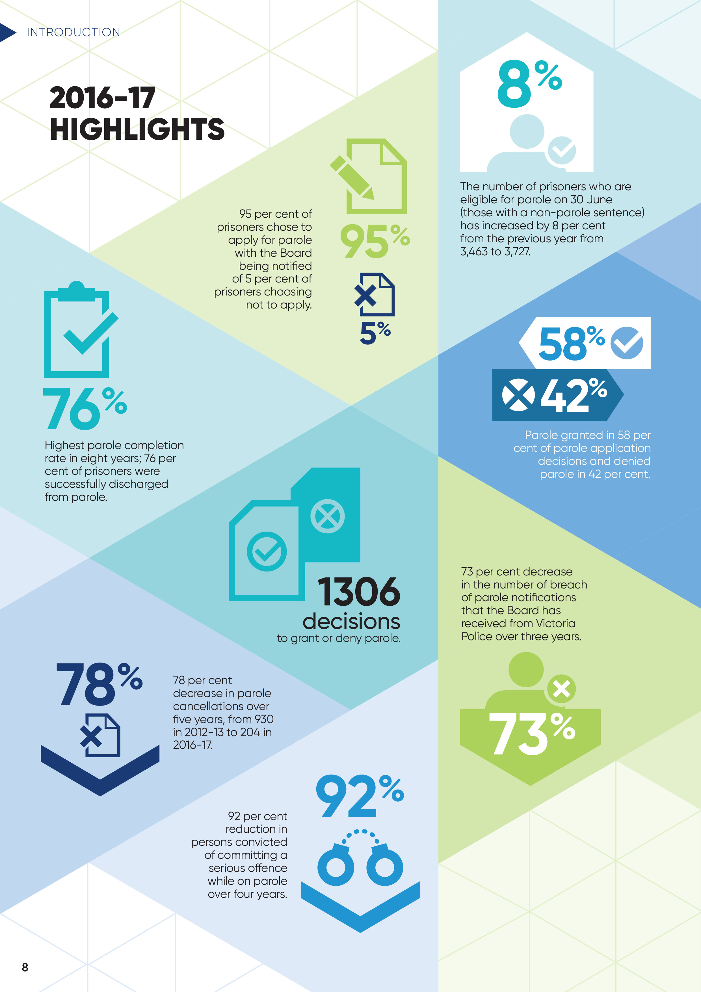
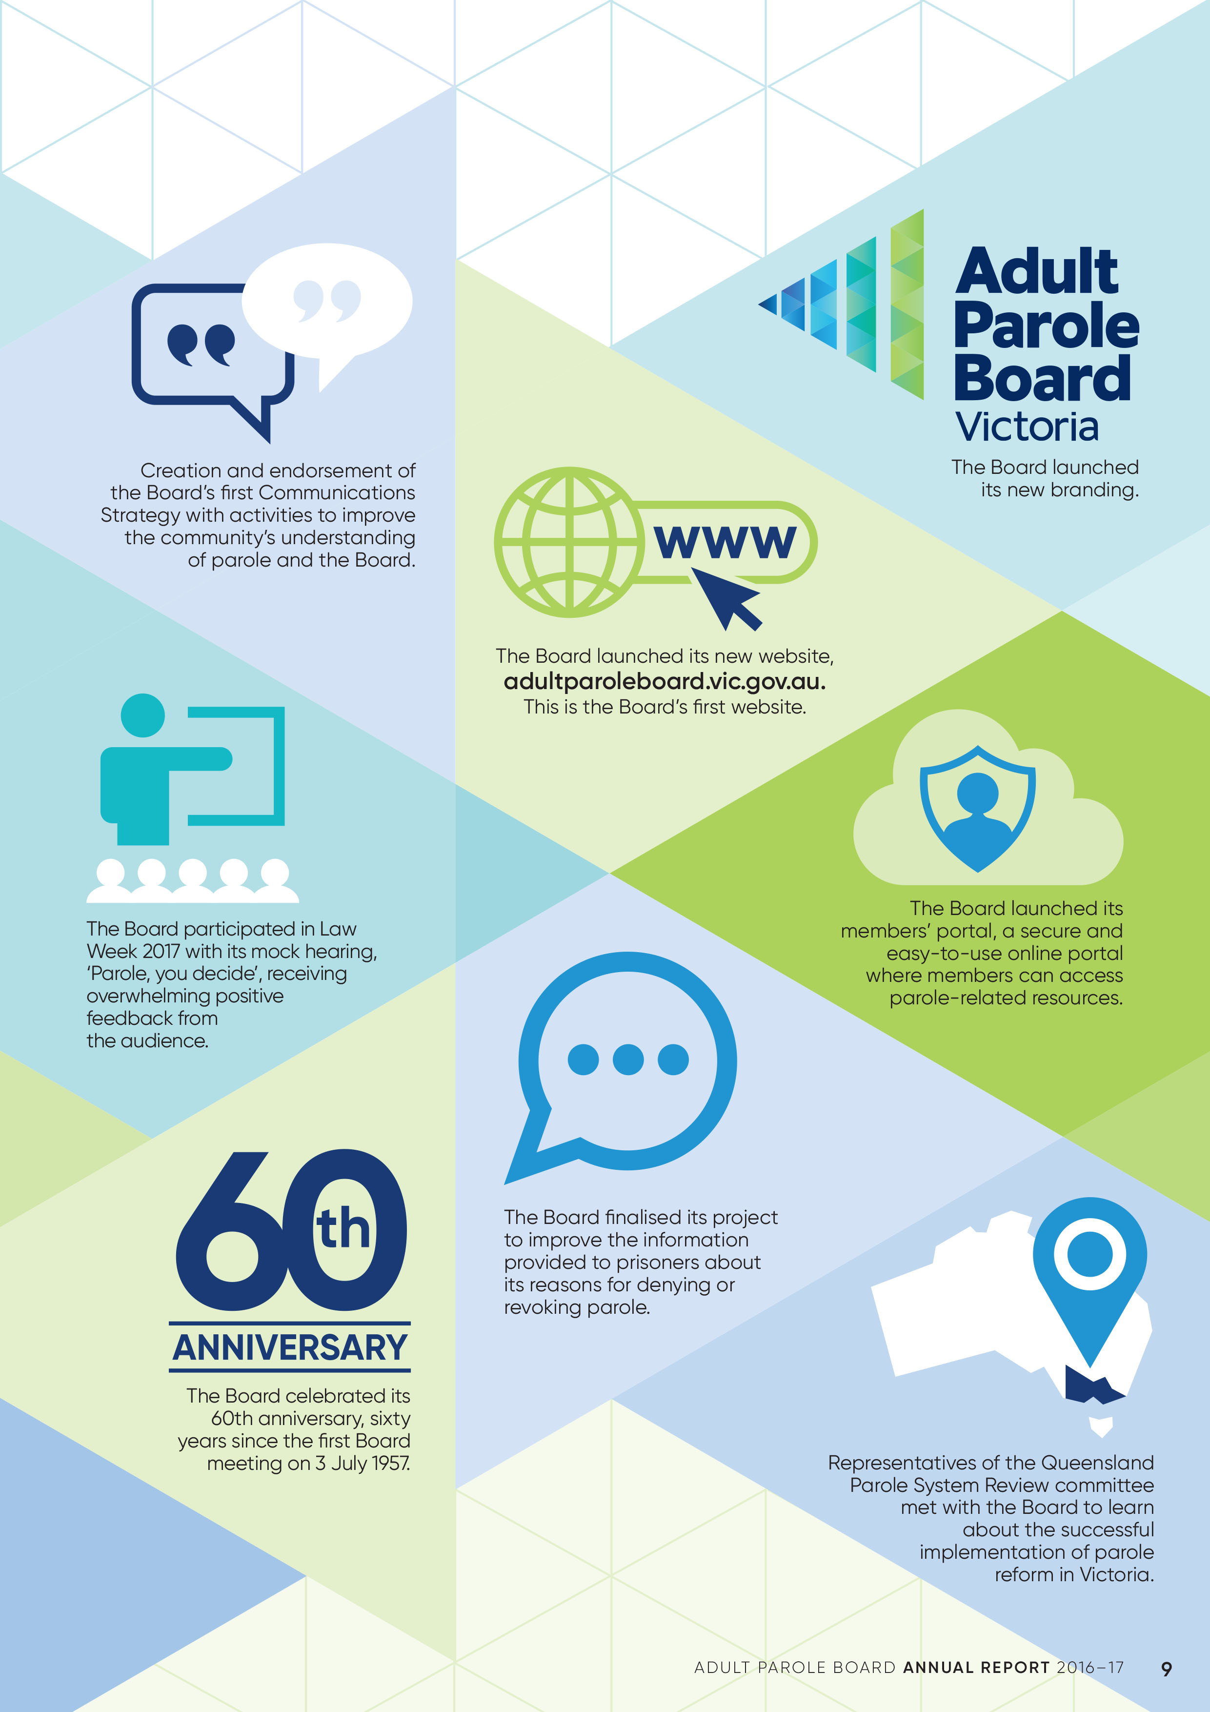

Celebrating 60 years
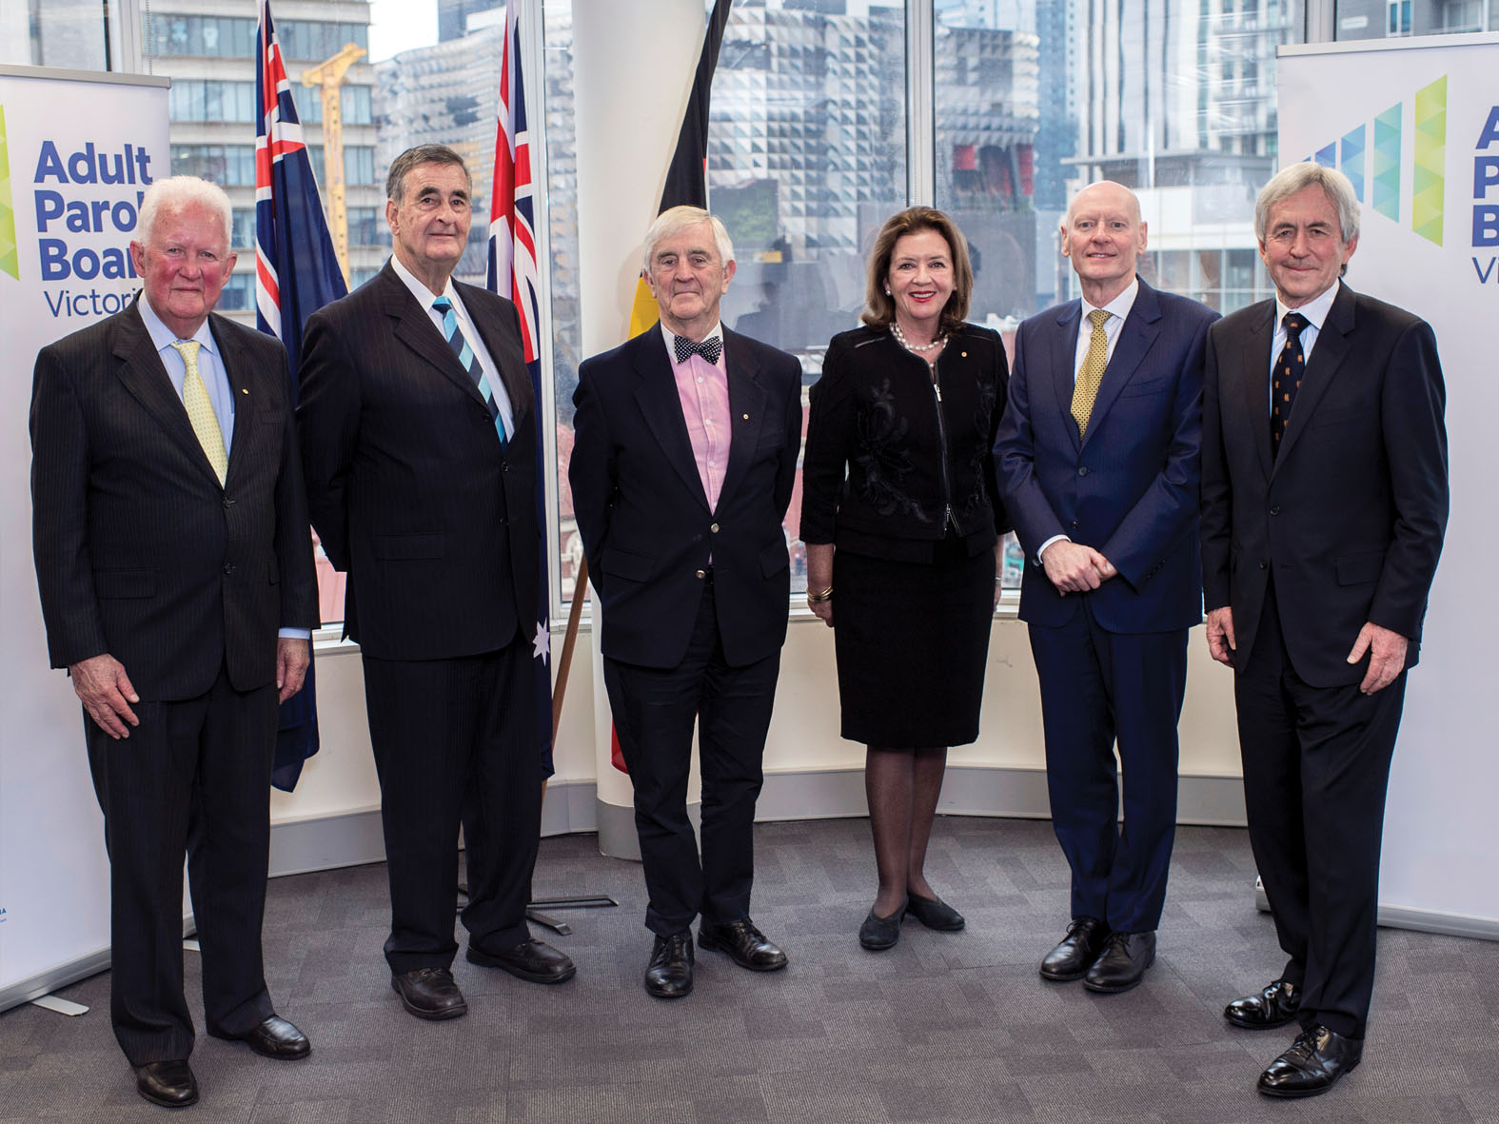
On 3 July 2017, the Adult Parole Board marked 60 years since its first meeting on 3 July 1957. Over the past 60 years, the Board has transformed into a modern and efficient decision-making authority.
The Board celebrated its 60th anniversary at its office in Carlton. Five former Chairpersons – including The Hon. Alastair Nicholson AO QC RFD, The Hon. Bernard Teague AO, The Hon. Justice Simon Whelan, The Hon. Elizabeth Curtain AM and The Hon. E. William Gillard QC – attended the celebration as honoured guests.
This was significant, as there have only been 10 Chairs over the past 60 years including:
The Hon. Sir John Barry – 1957 to 1969
The Hon. Sir John Starke QC – 1969 to 1985
The Hon. Alastair Nicholson AO QC RFD – 1985 to 1988
The Hon. Frank Vincent AO QC – 1988 to 2001
The Hon. Bernard Teague AO – 2001 to 2003 / 2007 to 2008
The Hon. Murray Kellam AO QC – 2003 to 2007
The Hon. Justice Simon Whelan – 2008 to 2013
The Hon. Elizabeth Curtain AM – 2013 to 2014
The Hon. E. William Gillard QC 2014 to 2015
His Hon. Peter Couzens – 2015 to present
The current Chairperson, His Hon. Peter Couzens, officiated the event. The Board’s longest serving staff members – Tonniette Santiano, Zoila Sosa, Helen Kostic, Pauline Bailey and Emma Hyde - presented each former Chair with a small 60th anniversary gift.

The Board through 60 years
1950s
- The first Board meeting was held in the Old Treasury Building in Spring Street on 3 July 1957.
- The Board was supported by six parole officers, who worked from a small building in Palmerston Street Carlton.
- There were separate Boards for male and female prisoners.
- A Supreme Court Judge, Justice J.V. Barry, was part-time Chairperson of both Boards. Four other members sat on the male Board and three women made up the female Board.
- The Board would meet once a week where it would consider approximately 15 to 20 cases.
- Most of the prisoners it considered were serving relatively short sentences (half of the prisoners had a possible parole period of one year or less).
1960s and ‘70s
- In the 1960s, the Board granted on average 15 parole orders a week (about 80 per cent of which were within a month of becoming eligible for parole) and denied parole in only one or two cases per week.
- Once on parole, prisoners were supervised by parole officers who were also responsible for supervising both adult and juvenile offenders on probation (an early form of community-based order).
- The parole officers had very high caseloads (the Board’s 1961-62 Annual Report notes caseloads of over 250 prisoners per parole officer).
- Automatic cancellation, when a prisoner was convicted of committing an offence on parole, was common. On average, there were around three a week. While the majority of offences were property-related, violent offences were also common.
- During the 1960s and 1970s, almost one prisoner each year would be cancelled after being convicted of committing a murder while on parole.
- In 1974, the first full-time member was appointed to the Board.
- Because of the very small number of female prisoners, the female Board sat only sporadically and the male and female Boards were merged into a single Board in 1974.
1980s and ‘90s
- The full membership continued to sit once a week until 1987, when the Board gained the capacity to sit as ‘divisions’ of at least three members. Each division was chaired by a serving Judge until 1991, when membership was broadened to include Magistrates and retired judicial officers.
- From 1984, new legislation made the Board responsible for a pre-release program which was separate from and in advance of parole. This program involved substantial numbers of prisoners, peaking at 467 in 1987. This program was abolished in 1992.
- The 1980s saw a broadening of role for the Board. The additional functions increased the volume and complexity of the Board’s work. They may also have contributed to public confusion about the nature and purpose of parole and the Board’s role.
- Offences relating to drugs became much more common. The Board introduced drug testing (urinalysis) as a condition in 1985. Drug testing and treatment quickly became common conditions.
- The 1980s and ‘90s saw an increase in the proportion of cancellations due to breach of conditions and a decrease in the proportion of cancellations due to further offending.
- During the first half of the Board’s existence, from 1957-1987, Victoria’s prison population and numbers on parole had fluctuated but had remained within a broadly stable range.
- During the second half of the Board’s history, Victoria’s prison population has dramatically increased. It more than doubled during the
past 30 years, increasing at a much faster rate than Victoria’s general population increased over that time.
- Compounding the Board’s workload was a development from the 1990s of the Board becoming increasingly involved in engaging with prisoners from an early stage in their prison sentence.
2000s
- In 2004, legislation made the Board responsible for a home detention scheme (eventually abolished in 2012), which was again separate from parole.
- In 2006, the Board was given further responsibility in relation to a post-sentence supervision scheme for offenders who had committed sexual offences against children.
- In 2008, that scheme was expanded to include offenders who had committed sexual offences against adults and was then replaced by the current Detention and Supervision Order scheme in 2010.
- By 2010, the Board still had just one full-time member. It was still chaired on a part-time basis by a serving Supreme Court Judge who had significant court-based responsibilities.
- The Board was now meeting three times per week. On average, the Board would consider over 50 matters per hearing day, although meetings often involved examining many more cases.
- The strains on the Board and on Community Correctional Services, who were responsible for supervising parolees, culminated in a series of high profile murders by parolees.
- During 2011 to 2013, the parole system was the subject of intense public scrutiny and debate. It was the subject of three independent reviews, which led to extensive legislative and administrative reforms to the Board and to the parole system.
The Board now
- The Board now has a full-time Chairperson and four full-time members, in addition to its diverse part-time membership of judicial and community members.
- There has been a significant increase in funding to the Board and Community Correctional Services.
- The Board now has much greater capacity to scrutinise cases before making a decision whether to release prisoners on parole.
- Once released, prisoners are monitored by specialist parole officers who have much smaller caseloads than at any other time in the history of parole in Victoria and are therefore capable of supporting and supervising more effectively.
- There has been a 92 per cent decrease over the past four years in the number of persons convicted of committing a serious offence while on parole.

Perspectives on parole

Courts
R v Liszczak and Phillips
[2017] VSC 103
“It is important to recognize the interplay between rehabilitation and protection of the community. If, as a community, we give up on the hope of rehabilitation for those who must return to the community at the completion of their total effective sentences, if we just deny them parole and then release them without any supervision or structures (as must occur on the current state of the law, bar some exceptions), then, while that has the effect of protecting the community for the duration of the potential parole period, it seems to me that that is just deferring to a later time a greater risk of reoffending, and thereby offers the community less protection in the longer run…while the decision whether – and, if so, when – they are released on parole will be affected by, among other things, the same or similar considerations, as well as the assessment of the Adult Parole Board, again, it should be a realistic option that they can be released on parole if their performance warrants it. My guess is that such an approach is more likely to redound to the benefit of the community in the longer term.”
The Hon. Justice Michael Croucher
Judge of the Supreme Court of Victoria

Victims
“The Victims Register enables victims of violent crime to receive specific information while the offender is under sentence, in prison or on parole, or subject to a post-sentence supervision order or detention order, and includes facilitating victim submissions made to the Adult Parole Board.
“Registered victims are often conflicted about receiving information. It can trigger the memory of the crime and the emotions of the loss of a loved one as a result of a violent crime, however the information also informs the registered person and may help them to feel more empowered, knowing the offender is, “still in prison”, or if released on parole, knowing the offender can’t come to the area where they live, or that police have powers to arrest the offender if they make contact with them.
“Writing a victim submission can also be conflicting, because for some it gives the registered person a voice, for others it triggers fear, and for most it does both. The feedback the Victims Register provides a victim after parole consideration is important because they want to feel heard and many victims struggle with the small amount of feedback provided. When the Victims Register gives timely and clear information, with patience and empathy about the circumstances, it goes a long way.
“Victims’ feedback is that they do not want any contact with the offender, even accidental. A common reaction is, “While time has helped, as it usually does with most things, we will never forgive or forget … I dread the prospect of meeting [the offender] in my local area”.”
Elizabeth Hall
Victims Register Coordinator
Community Operations and Victims Support Agency
Department of Justice and Regulation

Prisons
“Parole offers prisoners a path to an early release, conditional on good behaviour, and allows the Adult Parole Board to identify prisoners least likely to reoffend or become a threat to society and complete a successful period on parole. Those prisoners who do the most to earn parole in prison are also likely to work hard once outside prison walls to maintain their good behaviour, preventing coming back to prison. The opportunity of parole gives prisoners focus and something to aim for. This enables more engagement in offending behaviour programs and other developmental activities, which in turn supports a safer environment for both staff and prisoners.
“Parole can also be seen as an intermediate step between prison and release. Prisoners who spend years in prison can find adjusting to life on the outside difficult, making it more likely that they have difficulties reintegrating into society. Parole requires regular meetings with community corrections staff, and when paired with programs designed to help parolees get their lives back on track, it can be very successful.”
Scott Jacques
General Manager at Langi Kal Kal Prison

Prisoners
“In the early hours of the 1st of January 2015 I was involved in an alcohol fuelled fight that changed my life forever. During my time in prison I started to think about the circumstances of what happened on that night.
“I applied for parole while in prison by completing a parole application form, nominating an address to live on parole, and meeting with prison staff and my parole officer. The parole application process, while a little frustrating at times, was simple and straight forward.
“When I was released, the Board imposed conditions that were challenging, but I understood they were designed to assist my reintegration into the community. I was fortunate to have a very understanding employer, which meant I could attend parole appointments during work hours. My engagement with Community Correctional Services was also good, and I had a parole officer who treated me like a person, not a number.
“Throughout my period on parole I worked hard on my attitude towards alcohol, and the consequences of my drinking on my family, friends and myself. I also started to live life without alcohol for the first time in many years.
“I would recommend to other prisoners who are either applying for parole or are on parole to just stay out of trouble, keep their head down, and do what they’re told. I was lucky to have the support of my family and friends, and I know now that I have too much to live for to make the same mistakes again.”
Name withheld
Former prisoner of Victoria who completed a parole period

Community Correctional Services (CCS)
“Parole conditions are quite deliberately created for the combined purposes of minimising the risk of reoffending, and maximising a parolee’s prospects of furthering their rehabilitation whilst in the community. These conditions are related to prior offending and the identified areas of risk.
“My role is to not only ensure compliance with these conditions, but to assist and support parolees to affect positive change in their lives, with the hope that they can implement strategies to avoid high risk situations and learn how to deal with them if they arise.
“I am required to promptly inform the Adult Parole Board of any escalation of risk, and the evidence based practices relied upon to mitigate these risks. This occurs by way of comprehensive written reports and personal appearances. When the matter is urgent, issues are resolved within hours resulting in almost immediate action.
“My interaction with the Board is critical in supporting what is often a highly complex assessment of various factors. The high standard of this collaboration with the Board ensures that decisions can be made utilising the highest quality information available.”
Dylan Reynolds
Senior Parole Office at Reservoir CCS

Victoria Police
“We’ve had a legislative process in place for the past three years to notify the Board when we arrest a person on parole. We can contact the Board after hours, on weekends and public holidays. We then provide the Board with a summary of the parolee’s behaviour and offending, and a member of the Board quickly determines whether they should be detained in custody until a full Board panel can be convened to consider whether to cancel parole. Usually the decision about whether to cancel parole is made on the next working day. From our perspective, this arrangement works extremely well. It protects the public by quickly taking a parolee off the street if they are becoming an increasing risk. The Board is extremely responsive, decisive and conscious of protecting the community.”
Peter De Santo APM
Acting Assistant Commissioner Crime Command
Victoria Police

Myth
The parole system isn’t protecting the community because serious offences are committed by prisoners on parole.
Fact
The parole system cannot completely remove the risk of prisoners on parole committing serious offences. It can only reduce the risk. Prisoners released on parole, rather than at the end of their sentence, are subject to conditions and have supervision and support. If their risk of reoffending increases while they are on parole, the Board can cancel their parole and they can be returned to prison. As a result of reforms to the parole system, fewer prisoners on parole are committing serious offences (there has been a 92% reduction over the past 4 years), and more are completing parole.

MEMBERS

Diversity
The Board’s membership consists of members from a diverse range of backgrounds, both professionally and culturally, with rich and unique experiences that they each bring to the Board.
The majority of members, some of whom have public profiles and are well-known within the community, have had, or continue to have, impressive careers in a range of different fields.
Board panels comprise a judicial member, who is the presiding Chair, a community member, and a full-time member.
The judicial members include current and retired County Court Judges and current and retired Magistrates.
The experience and backgrounds of the community members include:
- people who have been victims of very serious crimes
- retired police officers
- an Aboriginal elder
- mental health service provision
- public administration
- journalism
- experience as members of other decision-making Boards at Tribunals, hospital administration, education, child protection, and members of the Sentencing Advisory Council
- the founder of Crime Stoppers.
The full-time members include lawyers and a forensic psychologist.

Members’ portal
The Board launched its members’ portal during 2016-17 to provide members with a secure and easy-to-use online portal where they can access resources including practice guidelines, videos of the monthly education seminars, the meeting roster, contact details of other members, and much more. The portal is accessible to members via the Board’s new website – adultparoleboard.vic.gov.au.

Professional Standards
As part of an ongoing commitment to maintaining the Board’s integrity, Professional Standards for Members have been developed to give practical and relevant guidance to Board members. The Standards include case studies of scenarios that members could be exposed to, with appropriate responses. The Standards have been published on the Board’s website.

Member education – monthly seminar series
The Board has an established comprehensive, educational seminar program as part of its professional development program to increase the knowledge of its members, and to promote consistency in the making of decisions. The program involves monthly seminars presented by experts and professionals who are leaders in their fields, biannual all-day seminars, and visits to prisons and correctional facilities.
Each monthly seminar includes a ‘practice discussion’ during which the Chairperson and full-time members provide essential updates regarding Board practices to the members. The members also have an opportunity to contribute their perspective to the practices and operation of the Board.
The educational seminar program in 2016–17 included presentations on:
- the use and effects of drugs to understand urine analysis and screens
- how intelligence is gathered and used by Corrections Victoria
- how to interview prisoners with an intellectual disability
- the previous reporting year’s data
- learning about prison industries
- understanding female prisoners and challenges they face in prison and in the community
- criminal youth gangs
- Forensicare community-based programs
- methods by prisoners to avoid urine testing.
Two all-day seminars were also held during the reporting year in December 2016 and June 2017 with presentations on:
- how Corrections Victoria manages prisoners with extremist views
- professional standards for members
- outcomes of the Harper Review
- Ravenhall Correctional Centre
- challenges facing offenders in the community.
The Board acknowledges the invaluable contribution of speakers to the seminar series, many of whom have dedicated their lives to the management and treatment
of offenders.

Member Profile

Nafsika Sahinidis
Full-time member, Appointed 2016-17
I have worked as a lawyer for 30 years, and regard the 10 years that I spent with Corrections Victoria as the most exciting of my career. During my time managing legal services at Corrections Victoria, I worked with the Board on several occasions and found the issues raised by the Board’s work to be very interesting.
I believe that full-time members perform an important role for the Board. In addition to the opportunity to elevate my skill-set, this was my main motivation to join the Board. I feel my extensive experience in managing a wide range of complex corrections and other public litigation has equipped me well for this role. Victoria was the second state in Australia to introduce a post-sentence supervision scheme for sex offenders in 2005, and I was responsible for the legal aspects of the introduction and implementation of this scheme. This was an important new reform that attempted to break the cycle of high risk paedophiles serving their sentences, only to be released into the community to reoffend against children.
Due to my background with Corrections Victoria, I was not surprised by the vast amount of quality information and reports available to assist the Board make its decisions. However, as a lawyer who is used to dealing with huge mountains of paper, I was impressed with the Board’s electronic files system and how information is easily accessible through an electronic system.
It’s a privilege for me to sit with and learn from the other members, people with such extraordinary and diverse careers, experiences, and backgrounds. I consider myself fortunate to have been given an opportunity to combine my interest in the corrections system with my passion for the application of the law in a decision-making role, which contrasts with my 30 years as a lawyer providing advice and recommendations.
Prisoners as a group pose some of the most difficult problems in our society. Many people seem to believe that the best solution for community safety should be to keep prisoners locked up behind prison doors. However, most prisoners will one day be released back into the community when their sentences expire. Therefore, with community safety the paramount consideration, the best solution is for prisoners to be reintegrated with the rigours of parole.
There is one particular case that resonated with me. A young person had performed well at school before falling into a methamphetamine addiction and being imprisoned for an aggravated burglary. He used his time in prison to complete his education and reconnect with his family and, as a member of the panel that granted him parole, I thought it was great to see that parole would assist his reintegration so he could continue on his path to success.
Nafsika Sahinidis was appointed to the Board as a full-time member from 31 January 2017. She’s had a legal career spanning 30 years including 10 years managing legal services at Corrections Victoria and 12 years working for the Victorian Government Solicitor’s Office.

Member Profile

His Honour James Mornane
Former Judicial Member
I sought appointment to the Board when coming to the end of a long legal career. I had extensive life experience and felt driven by the possibility of steering some prisoners away from crime.
I first became interested in the prison system back in the early ‘60s as a clerk to Magistrates acting in their capacity as visiting justices to prisons. In those days, visiting justices visited every prison in the State in order to give prisoners an opportunity to voice complaints. I visited every part of Pentridge Prison including the notorious H Division. Later on, as legal adviser to those who ran the prison system, I visited Jika Jika and drafted regulations affecting prisoners. Since then, vast changes have been made to the prison system. It has gone from one where prisons were highly disciplined institutions in which officers seemed to do a lot of yelling to places where the emphasis is now on rehabilitation and reintegration back into the community with relevant life skills.
Following the successful implementation of parole reforms over the past few years, the parole system and the Board have become much more effective and efficient. This is reflected in positive data and statistics outlined elsewhere in this annual report. The introduction of electronic files and the reduction of caseloads for each meeting has meant more time is given to reading and discussion before a decision is made.
When I first joined the Board, I was vexed by not being the sole decision maker. However, through vigorous discussion, I found joint decision-making would sometimes turn me around and change my view about a matter. Whenever this occurred, I am sure a wiser decision resulted.
Having acted as a Magistrate for 14 years, I have heard many horrible things. However, this did not prepare me for sitting on the Detention and Supervision Order Division of the Board where members have to deal with case after case of sexual offending. At times, I needed to work hard on myself to keep objectivity and act fairly and impartially to an offender whose crime revolted me.
I am committed to the concept of parole. I consider it foolhardy to straight-release prisoners into the community after they have served substantial sentences. Someone who is out of touch with the community is likely to find it all too hard. Unless they have hope, they may well throw up their hands and use substances to blot out pain and frustration. Prisoners on parole often have mental deficits and need to be monitored and also mentored in their struggle to give up old ways and adopt new ones. In this regard, I am singularly impressed with the dedication of Community Correctional Officers who assist parolees.
I am impressed with the calibre of my colleagues. Without exception, they are intelligent, hardworking and dedicated people who try desperately to make the system work whilst all too often exposed to ill-informed criticism. I would also like to express my appreciation to the wonderful administrative staff who so cheerfully and ably assisted me.
His Honour James Mornane was a member of the Board for three years until the end of April 2017. He commenced his career as a clerk of courts in 1960 and after obtaining a law degree joined the Crown Solicitor’s Office. He was appointed an Assistant Victorian Government Solicitor in 1993, a Magistrate in 1995, and sat on the bench until 2009 when he retired at 70 years old to do mediations.

Myth
The Board is faceless. The community does not know who makes parole decisions.
Fact
The complete list of Board members, including who they are and their professional backgrounds, is publicly available on the Board’s website and in this report. Members include Judges, Magistrates, diverse representatives of the community, and full-time members.

Adult Parole Board members 2016-17

Chairperson
His Honour Peter Couzens
Retired Judge of the County Court, President of the Children’s Court of Victoria
Appointed to the Board as Chairperson from 9 June 2015

Deputy Chairperson
His Honour Frank Shelton
Retired Judge of the County Court
Appointed to the Board as Deputy Chairperson from 17 December 2013
Appointed as Chairperson of the Detention and Supervision Order Division from 3 April 2014

Full-time members
Stephen Farrow
Appointed to the Board from 11 November 2013
Appointed as member of the Detention and Supervision Order Division from 11 November 2013
Raj Malhotra
Appointed to the Board from 2 December 2013
Appointed as member of the Detention and Supervision Order Division from 2 December 2013
Resigned from the Board on 28 February 2017 following
his appointment as a Magistrate by the Attorney-General of Victoria
Shivani Pillai
Appointed to the Board from 2 December 2013
Appointed as member of the Detention and Supervision Order Division from 2 December 2013
Resigned from the Board on 26 August 2016 to return to the Victorian Bar
Dr David Curnow
Appointed to the Board from 18 May 2014
Appointed as member of the Detention and Supervision Order Division from 18 May 2014
Nafsika Sahinidis
Appointed to the Board from 31 January 2017
Appointed as member of the Detention and Supervision Order Division from 30 January 2017

Judicial members
Her Honour Judge Susan Pullen
Judge of the County Court
Appointed to the Board from 6 November 2013
Appointed as member of the Detention and Supervision Order Division from 7 April 2014
His Honour Robert Kumar
Retired Deputy Chief Magistrate
Appointed to the Board from 13 December 2011
Appointed as member of the Detention and Supervision Order Division from 7 April 2014
His Honour Gregory Connellan
Magistrate
Appointed to the Board from 10 December 2013
His Honour David Fanning
Magistrate
Appointed to the Board from 10 December 2013
Appointed as member of the Detention and Supervision Order Division from 15 May 2014
His Honour Franz Holzer
State Coordinating Magistrate
Appointed to the Board from 10 December 2013
Appointed as member of the Detention and Supervision Order Division from 2 June 2016
His Honour Gregory MacNamara
Magistrate
Appointed to the Board from 10 December 2013
Appointed as member of the Detention and Supervision Order Division from 15 May 2014
Her Honour Kay Macpherson
Magistrate
Appointed to the Board from 10 December 2013
Appointed as member of the Detention and Supervision Order Division from 15 May 2014
His Honour Peter Reardon
Magistrate
Appointed to the Board from 10 December 2013
Resigned from the Board on 9 December 2016
His Honour Ronald Saines
Magistrate
Appointed to the Board from 10 December 2013
His Honour John Doherty
Retired Magistrate
Appointed to the Board from 29 October 2014
His Honour Alan Spillane
Retired Magistrate
Appointed to the Board from 25 November 2013
Appointed as member of the Detention and Supervision Order Division from 1 January 2014
His Honour Louis Hill
Retired Magistrate
Appointed to the Board from 10 December 2013
His Honour Francis Jones
Retired Magistrate
Appointed to the Board from 29 April 2014
Appointed as member of the Detention and Supervision Order Division from 15 May 2014
Resigned from the Board on 28 April 2017
His Honour James Mornane
Retired Magistrate
Appointed to the Board from 29 April 2014
Appointed as member of the Detention and Supervision Order Division from 15 May 2014
Resigned from the Board on 29 April 2017

Community members
Carmel Arthur
Victim of crime and campaigner for greater access to procedural justice for victims
Appointed to the Board from 2 December 2008
Appointed as member of the Detention and Supervision Order Division from 13 February 2014
Kieran Walshe APM
Former Deputy Commissioner of Victoria Police
Appointed to the Board from 5 February 2013
Appointed as member of the Detention and Supervision Order Division from 28 October 2013
Glenda Frost
President of Royal Victorian Association of Honorary Justices, experienced in company and tax law and accounting
Appointed to the Board from 17 December 2013
Appointed as member of the Detention and Supervision Order Division from 13 February 2014
Peter Harvey
Former Detective Inspector of Victoria Police – Crime Department
Appointed to the Board from 17 December 2013
Appointed as member of the Detention and Supervision Order Division from 13 February 2014
Rudolph Kirby
Descendant of the Wiradjuri, Yorta Yorta and Wamba Wamba nations, CEO of Mallee District Aboriginal Services
Appointed to the Board from 17 December 2013
Appointed as member of the Detention and Supervision Order Division from 13 February 2014
Resigned from the Board on 16 December 2016
Pamela White
Retired public servant with extensive experience in human services
Appointed to the Board from 29 April 2014
Appointed as member of the Detention and Supervision Order Division from 1 January 2015
Dr Patricia Mehegan
Member of the Mental Health Tribunal, cross-cultural consultant
Appointed to the Board from 16 September 2014
Appointed as member of the Detention and Supervision Order Division from 1 January 2015
Claude Minisini
Chief Executive of a corporate issues management consultancy, former member of Victoria Police
Appointed to the Board from 16 September 2014
Appointed as member of the Detention and Supervision Order Division from 1 January 2015
Cr Jim Parke
Councillor, City of Boroondara, and practising lawyer
Appointed to the Board from 16 September 2014
Appointed as member of the Detention and Supervision Order Division from 13 February 2014
Aunty Pam Pedersen
Aboriginal community Elder from the Yorta Yorta nation, Elder representative for the Children’s Koori Court
Appointed to the Board from 16 September 2014
Geoff Wilkinson OAM
Retired senior crime journalist, member of the Sentencing Advisory Council, founder of Crime Stoppers Victoria
Appointed to the Board from 16 September 2014
Appointed as member of the Detention and Supervision Order Division from 1 January 2015
Kornelia Miles (nee Zimmer)
Victim of crime and former member of the Victims of Crime Consultative Committee
Appointed to the Board from 16 September 2014
Resigned from the Board on 11 July 2016
Nicole Burns
Member of the Administrative Appeals Tribunal, Migration and Refugee Division, Department of Foreign Affairs and Trade (DFAT) consultant
Appointed to the Board from 23 September 2014
Appointed as member of the Detention and Supervision Order Division from 30 May 2016
Rosemary Lever
Former Deputy Chancellor of RMIT University, former CEO of the Children’s Protection Society
Appointed to the Board from 23 September 2014
Appointed as member of the Detention and Supervision Order Division from 1 January 2015
Mary Malone
A senior health administrator from South Australia and regional Victoria
Appointed to the Board from 23 September 2014
Appointed as member of the Detention and Supervision Order Division from 1 January 2015
Professor Charles (Bob) Williams
Emeritus professor of law at Monash University, retired member of Victorian Civil and Administrative Tribunal (VCAT)
Appointed to the Board from 23 September 2014
Resigned from the Board on 30 December 2016

Secretary, Department of Justice and Regulation
Greg Wilson

Myth
The Adult Parole Board lets prisoners out of prison early
Fact
Courts set sentences including the ‘non-parole’ period. The non-parole period is the minimum time that a prisoner must serve in prison. The Board cannot release a prisoner on parole before the end of the non-parole period. Parole does not reduce the sentence. If the Board decides to grant parole to a prisoner after they have served their non-parole period in prison, the prisoner is still under sentence in the community on conditions and with supervision until their sentence expires. If they don’t comply with the parole conditions, the Board can cancel parole and return them to prison.

Operations and decision-making

Sentencing and parole
The Adult Parole Board is a decision-making authority which has jurisdiction over:
- prisoners for whom a court has ordered a prison sentence and has fixed a non-parole period (unless they are aged under 21 years or have been transferred from a youth justice centre)
- any prisoner under the age of 21 (unless the Board transfers them to a youth justice centre)
- young persons transferred by the Youth Parole Board from a youth justice centre to a prison
- any serious sexual offender upon whom a court has imposed a supervision or detention order. These offenders are managed through the Board’s Detention and Supervision Order Division.
The Corrections Act 1986 establishes the Adult Parole Board, its composition, functions, powers, and decision-making principles. The Board has additional functions outlined in the Children, Youth and Families Act 2005, Serious Sex Offenders (Detention and Supervision) Act 2009 and Sentencing Act 1991.
The Board does not have a case management function. It is not responsible for preparing prisoners for parole, or for supervising and managing them while they are on parole. It does not have an investigative function. Rather, it is a decision-making body that relies on information provided to it, primarily by Corrections Victoria, to make decisions in accordance with its statutory authority.

Sentencing
The courts have the sole responsibility for sentencing offenders. Only courts can impose a sentence and set a non-parole period as part of a sentence of imprisonment.
The Board has no role in the sentencing process and cannot change a sentence imposed by a court.
The Board’s role is not to decide whether the offender has been punished too much or not enough. The Board cannot decide to make the offender serve longer in prison to denounce their offence or to deter them or someone else from committing a similar offence. This is because those are sentencing considerations and are solely matters for the courts.
The Board’s role is to consider the risk in of the prisoner’s transition back into the community.
Not all prison sentences include a non-parole period. In accordance with the Sentencing Act 1991, this depends on the length of the prison sentence.
A non-parole period must be at least six months less than the maximum term of the sentence. For example, if a court sentences a prisoner to five years’ imprisonment, the longest possible non-parole period is four and a half years, but it can be shorter.
The courts imposed an increased number of sentences with non-parole periods in 2016-17, and this has contributed to the 8 per cent increase to the number of prisoners eligible for parole in 2016-17 compared with 2015-16.
Sentence length | Non-parole period
More than 24 months | The sentencing court must set a non-parole period, unless the nature of the offence or the offender’s history would make parole inappropriate.
Between 12 and 24 months | The sentencing court is not required to, but may decide to, fix a non-parole period.
Less than 12 months | A non-parole period can not be set by the sentencing court, therefore parole is not possible.

Board decisions
The main decisions made by the Board are to:
- determine if a parole application will proceed to parole planning (this means that the Board requests a Parole Suitability Assessment from Corrections Victoria’s Community Correctional Services (CCS) to provide information upon which it can decide whether to grant, deny or defer parole)
- grant parole
- deny parole
- revoke parole (this takes place after the Board has granted parole but before the prisoner has been released. For example, a positive drug test in prison may result in the Board revoking the prisoner’s parole before they are released)
- defer the parole application
- to impose discretionary conditions on a parole order
- vary parole conditions
- warn a prisoner on parole if their conduct has the potential to lead to their parole being cancelled
- cancel parole if there has been a breach (or suspected breach) of a parole condition, or if the risk to the safety and protection of the community has escalated.
If the prisoner’s sentence includes a non-parole period, the Board may order their release at any time after the expiry of that period.

Factors for consideration
In making decisions to grant parole, the Board carefully considers all relevant information with the paramount consideration being the safety and protection of the community.
Other matters that the Board takes into account include (but are not limited to):
- the sentence imposed by the court including any comments by the court about parole and rehabilitation
- psychiatric or psychological reports available to the court when it imposed the sentence
- victim impact statements provided to the sentencing court
- the nature and circumstances of the offence for which the prisoner is serving a sentence
- the prisoner’s criminal history, including performance on past parole orders or community-based orders
- a submission received from a victim of the prisoner
- the outcome of formal risk assessments conducted for the prisoner
- whether the prisoner has undertaken treatment or programs and, if so, formal reports of their performance
- psychiatric or psychological reports requested by the Board
- suitable and stable accommodation arrangements
- the prisoner’s behaviour in prison, including outcomes of random drug tests
- for serious offenders, the Board considers a detailed home assessment report about the suitability of proposed accommodation and intelligence held by Corrections Victoria and Victoria Police.

Parole conditions
The Board is required by law to impose 10 core parole conditions on every parole order. The Board may also impose discretionary conditions depending on a prisoner’s individual circumstances. If a prisoner breaches a condition, their parole may be cancelled and they may be returned to custody.

Core conditions
The ten core conditions are:
1. You must not break any law.
2. You must report to the community corrections centre specified in this Order within two clear working days after this Order comes into force.
3. You must notify a community corrections officer of any change of address at least two clear working days before the change of address.
4. You must notify a community corrections officer of any change of employment within at least two clear working days of the change of employment.
5. You are under the supervision of a community corrections officer.
6. You must report to, and receive visits from, a community corrections officer as and when directed by the community corrections officer.
7. You must be available for an interview by a community corrections officer, the Regional Manager or the Adult Parole Board at the time and place as directed by the community corrections officer or the Regional Manager or Adult Parole Board.
8. You must attend in person at a community corrections centre as directed in writing by a community corrections officer.
9. You must not leave Victoria without the written permission of the Regional Manager.
10. You must comply with any direction given by a community corrections officer or the Regional Manager or the Adult Parole Board that is necessary for a community corrections officer or the Regional Manager or the Adult Parole Board to give to ensure that you comply with this Order.

Discretionary conditions
Discretionary conditions may relate to:
- alcohol abstinence
- drug testing
- curfews
- residential restrictions
- geographical restrictions prohibiting entry into specified areas
- victim contact restrictions
- participation in rehabilitation programs
- community work
- electronic monitoring – both geographical and alcohol consumption.

Varying and revoking conditions
The Board can vary the conditions of a parole order at any time during the parole period. Conditions can be added to respond to changes in risk. Alternatively, conditions can be revoked if the prisoner has been performing well on parole for a long period. The Board’s primary consideration is always the safety and protection of the community.

Myth
Prisoners ‘max out’ their sentence in prison rather than apply for parole.
Fact
95 per cent of eligible prisoners applied for parole at the earliest opportunity in 2016-17. Most prisoners are not put off by the application process and are willing to comply with parole conditions.

The parole process
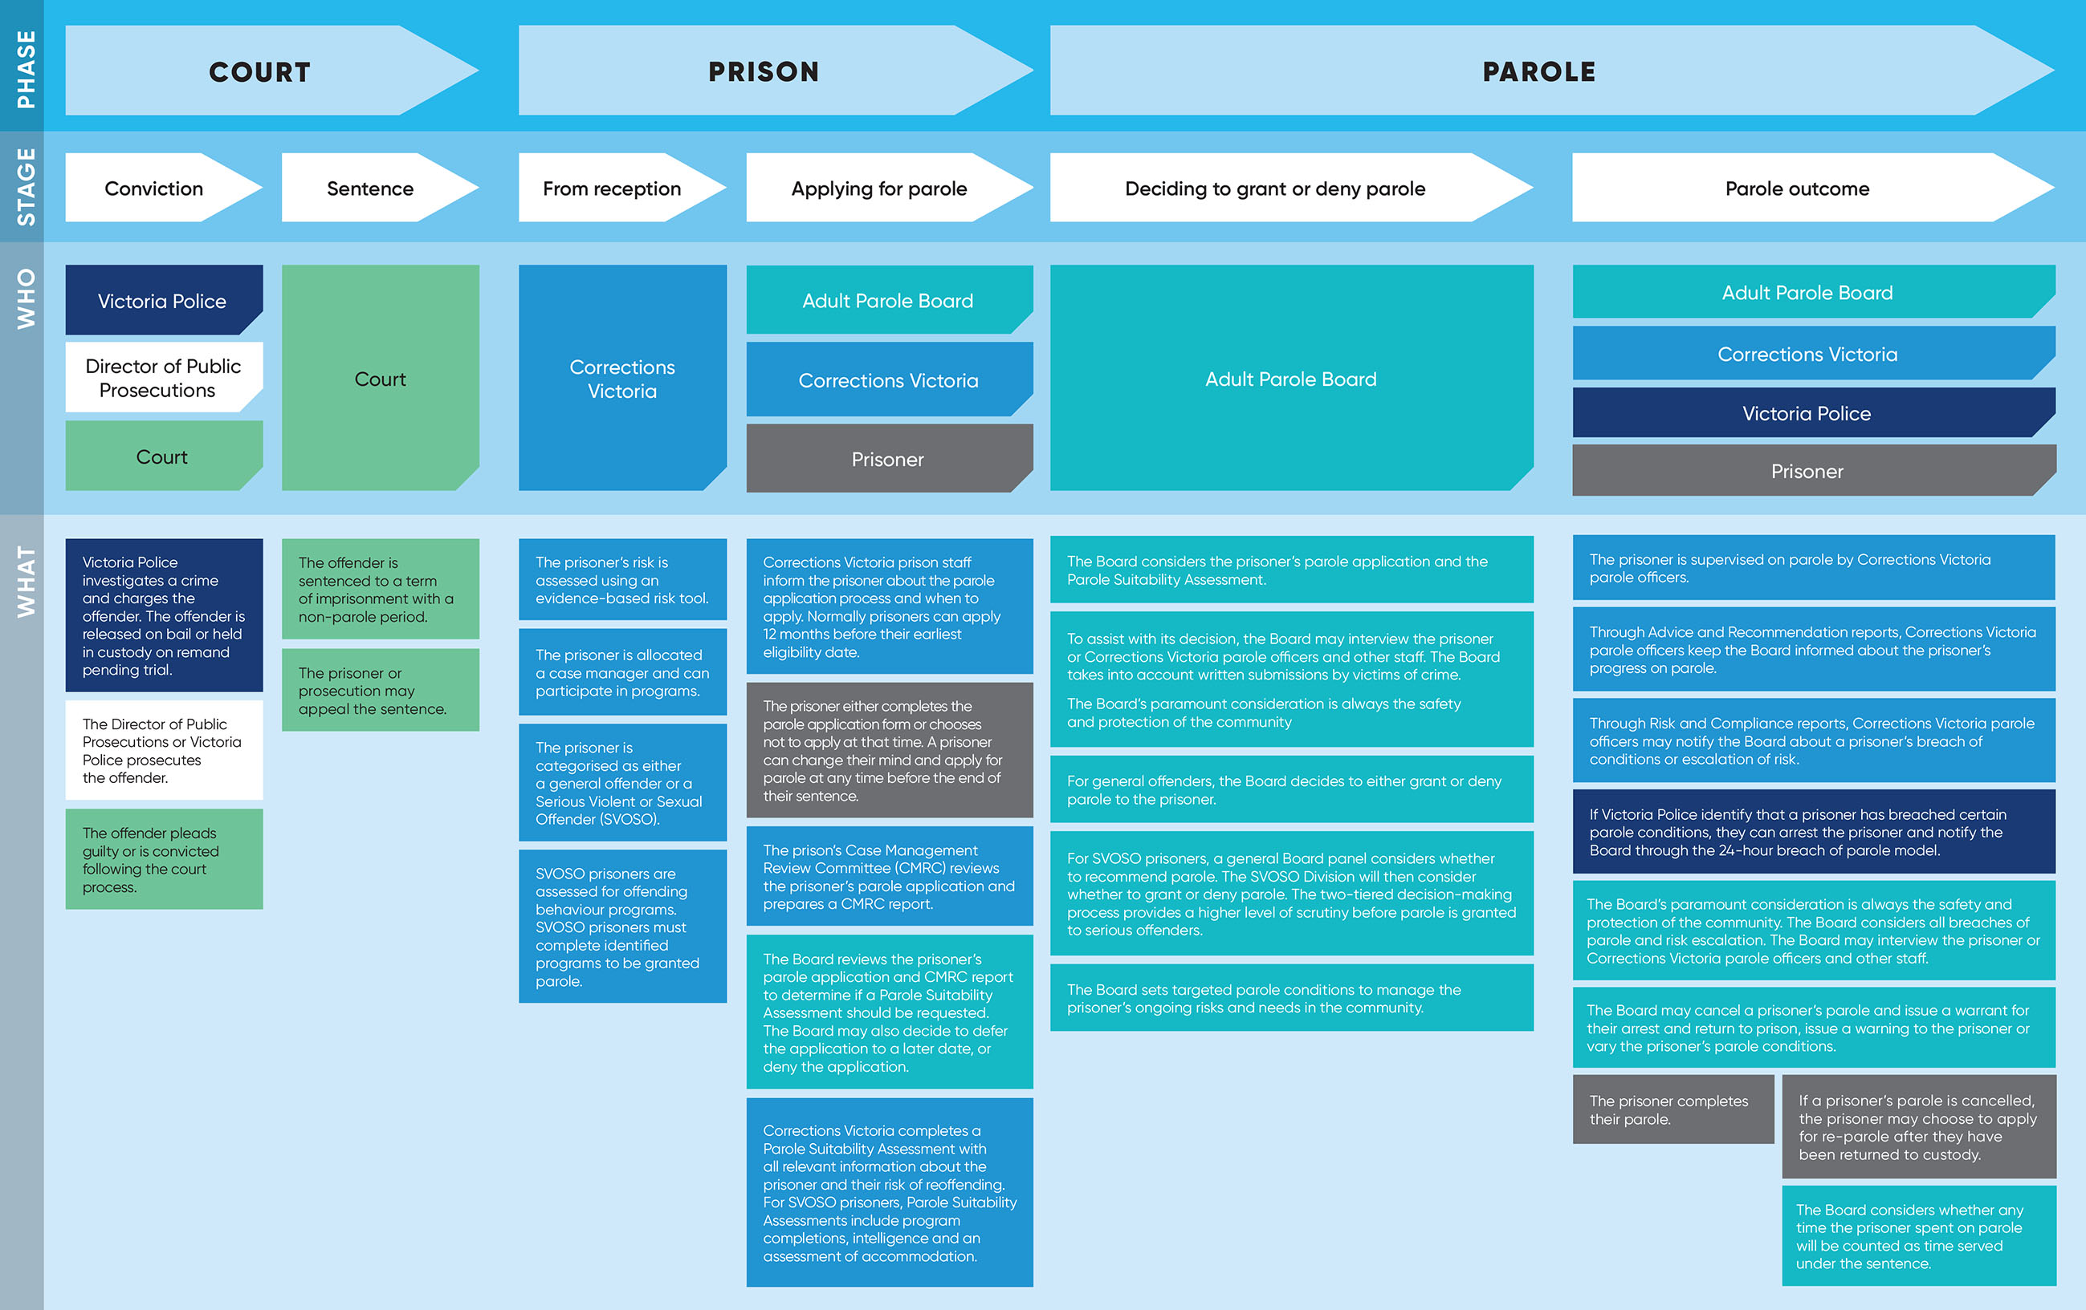

Stage 1 – The prisoner applies for parole
Prisoners are not automatically considered for parole by the Board. Eligible prisoners who wish to be considered for parole must apply. Eligible prisoners are prisoners who have been sentenced by the court to a non-parole period, inclusive of those who have been returned to custody following cancellation of their parole.
During 2016-17, the Board received 1,689 applications for parole (including re-parole applications), a decrease of 152 from the previous year.
Ninety-one prisoners advised that they did not wish to apply at the earliest opportunity, 51 less than 2015-16.
The ratio of prisoners that applied for parole was 95 per cent comparable to 5 per cent that chose not to apply for parole.
Of the 1,689 applications received,
85 per cent (or 1,449) proceeded to the preparation of a full Parole (or
Re-parole) Suitability Assessment report to the Board by Corrections Victoria. A Parole Suitability Assessment is a comprehensive report that assists the Board in its decision to grant, deny or defer the prisoner’s parole and to determine appropriate parole conditions. The preparation of the Parole
Suitability Assessment does not mean that the prisoner will be granted parole.
Of the remaining applications, 84 (or 5 per cent) were invalid, 93 (or 6 per cent) were deferred, 26 (or 2 per cent) were denied at the application stage, and 37 (or 2 per cent) had not been processed as at 30 June 2017. This is similar to the application outcomes in 2015-16.

Figure 1: The ratio of prisoners who applied for parole and those who did not apply
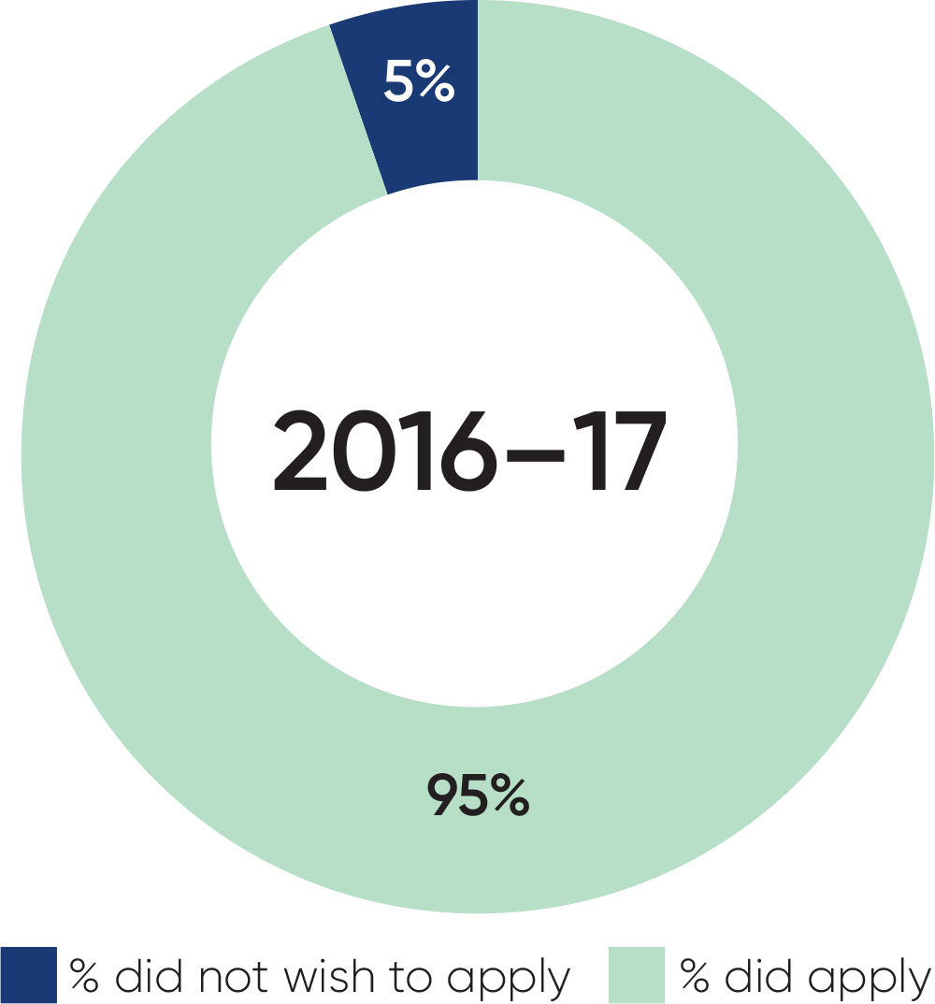

Figure 2: Processing of parole applications received 2015-16 – 2016-17
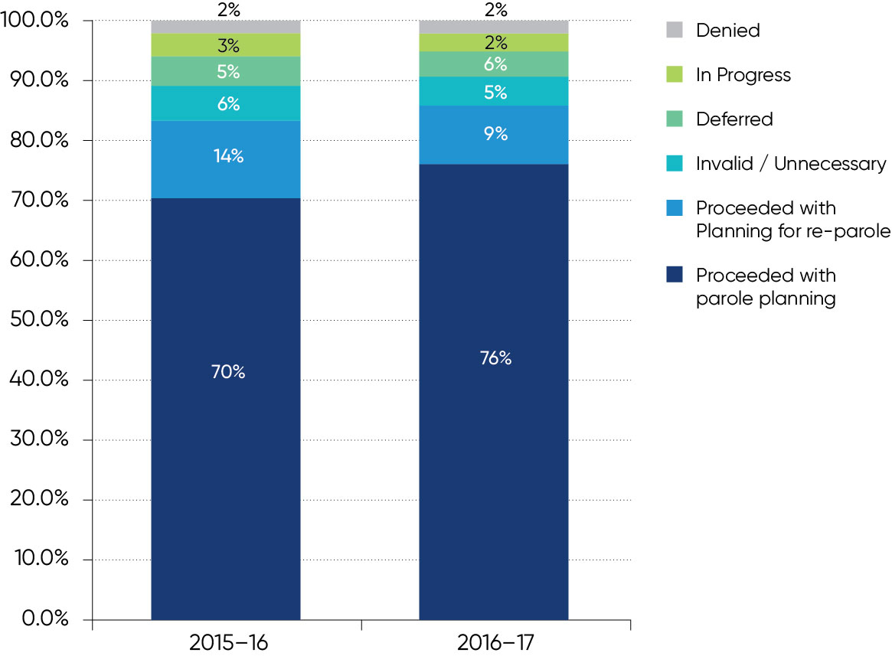

Stage 2 – The Board decides to grant or deny parole
For the applications that proceed, the Board receives comprehensive Parole Suitability Assessment reports provided by Corrections Victoria that analyse the prisoner’s background and offences, risk to the community if released, and the recommended parole conditions that could be imposed. When the Board has the information it requires to mitigate any risks, as well as relevant information including victim submissions, the Board will then determine whether the prisoner’s parole application should be granted (and which conditions will be imposed) or denied.
In 2016-17, the Board made 1,306 decisions to grant or deny parole (some of these decisions were made in relation to applications that had been lodged in the previous reporting year). In 2016-17, the Board granted parole for 757 prisoners (representing 58 per cent) and denied parole for 549 prisoners (representing 42 per cent). The majority of parole applications denied were due to the risk to the community being too great and this risk not being able to be mitigated adequately through conditions. For example, this could be that the prisoner does not have stable accommodation.
The ratio of prisoners granted or denied parole has remained reasonably consistent over the past four reporting years, with the Board granting on average 60 per cent and denying on average 40 per cent. In the four years prior to 2013-14, the Board was granting parole at an average of 87 per cent while denying parole at an average of 13 per cent.
This shift is attributable to the legislative and administrative changes to the parole system following the Callinan Review. Parole reforms, including the introduction of an electronic file system, reduced caseloads per meeting and more information available to the Board, means that Board panels now have more time and better information to carefully consider each decision to grant or deny parole with the community’s safety and protection as its paramount consideration.
The number of requests for a review of a Board decision by prisoners has reduced by 186 (or 85 per cent) since 2015-16. This can be attributed to improvements in communications with prisoners regarding why their parole was denied, revoked or cancelled, considering time to count after every parole cancellation, and prisoners being able to submit another application. The Board continues to improve the way it captures requests for reviews.
Figure 3: Parole decisions 2012-13 – 2016-17
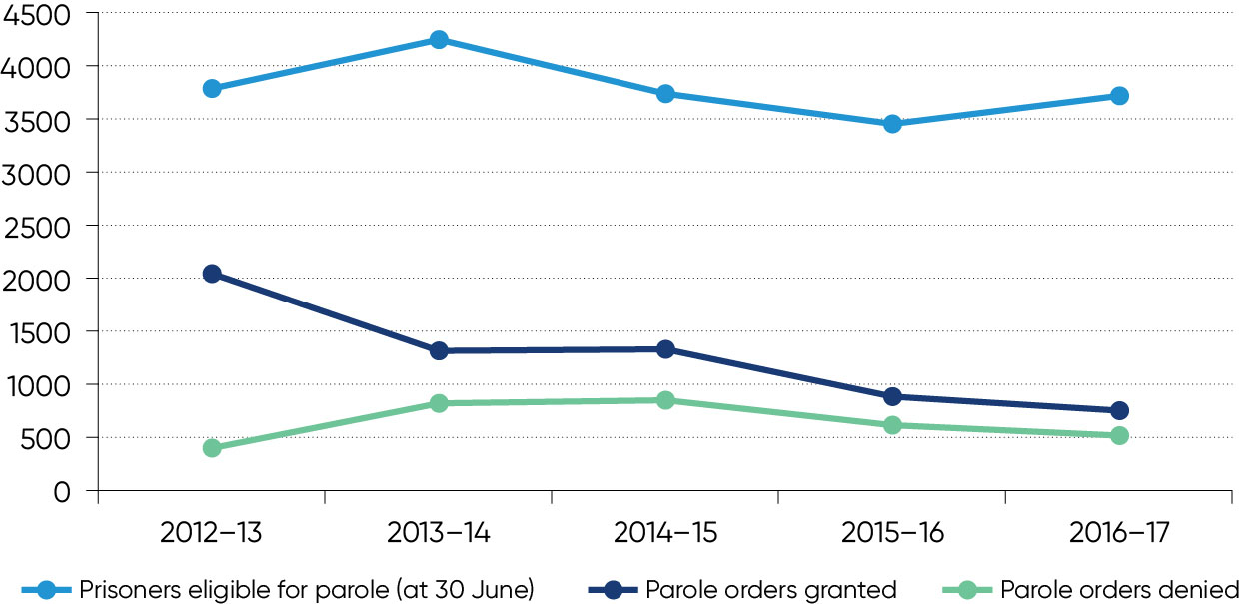
Figure 4: The ratio of prisoners granted or denied parole 2009-10 – 2016-17
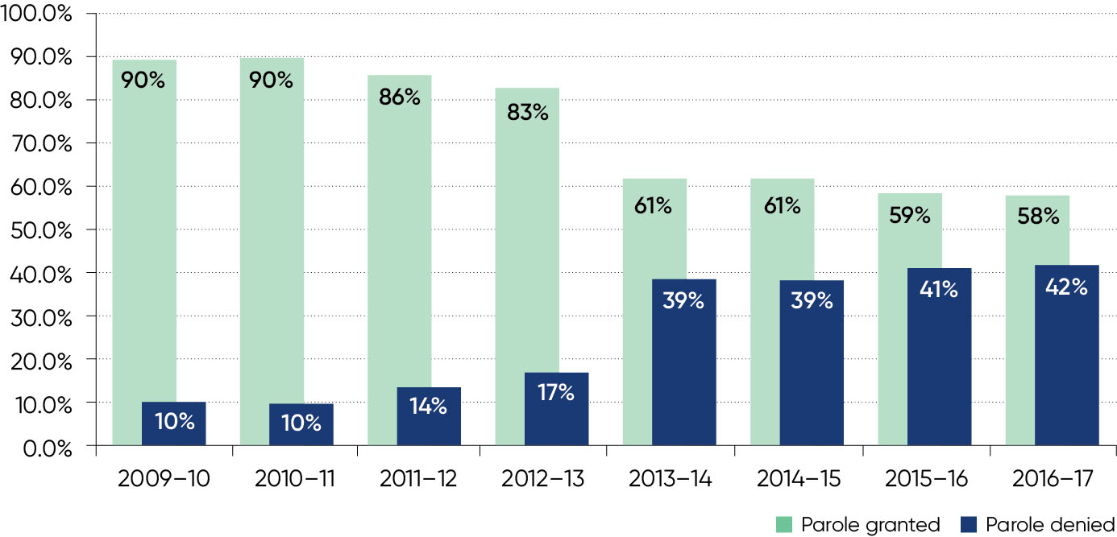
Figure 5: Number of prisoners on parole 2012-13 – 2016-17
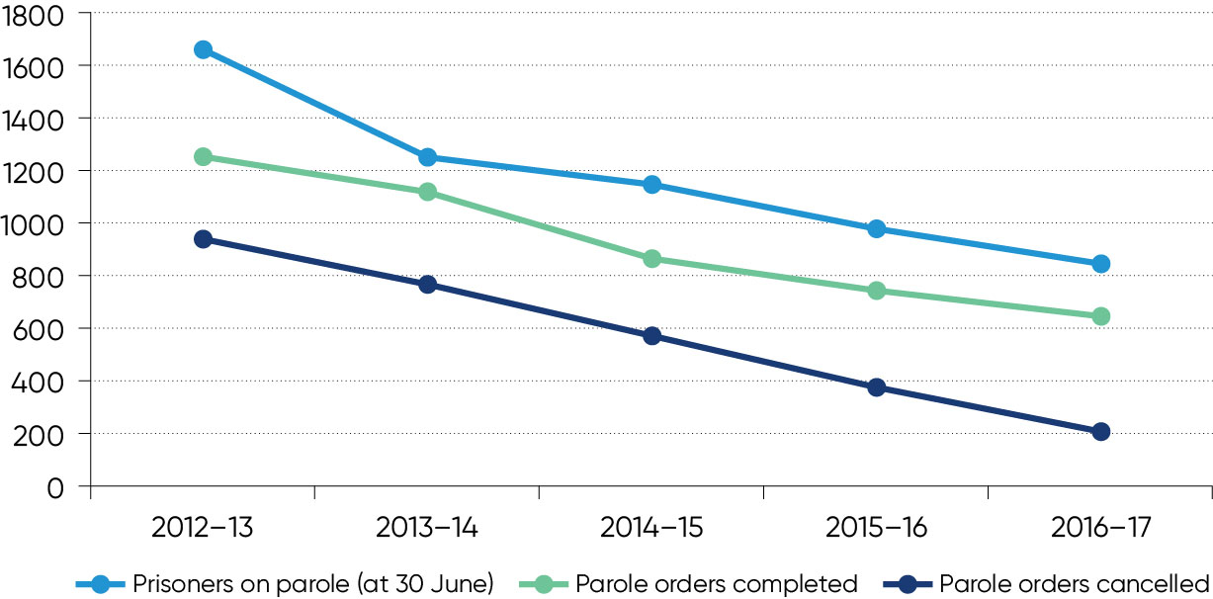

Stage 3 – Parole outcomes

Parole completions
During 2016-17, 644 (or 76 per cent) prisoners successfully completed their parole and their order was discharged by Corrections Victoria. This is the highest proportion of successful parole completions over the past eight reporting years.

Breach of parole
During 2016–17, Victoria Police notified the Board of 54 prisoners on parole who were arrested for suspected parole breaches. The number of breach notifications received by Victoria Police has reduced by 144 (or 73 per cent) over the past three years.
The Board decided to cease detention for 12 of the 54 prisoners. Of the remaining 42 prisoners, the Board cancelled 38 prisoners on parole, while the remaining four prisoners on parole were not cancelled. The Board made the final decision on the same working day, or the very next working day, in 100 per cent of notifications (70 per cent on the same working day and 30 per cent on the next work day).

Cancellations
During 2016-17, the Board made the decision to cancel parole for 204 prisoners. This represents a 47 per cent reduction from 2015-16, and a
78 per cent reduction over the past five reporting years.
The most common reason for the Board to cancel a prisoner’s parole was drug use (a reason in 70 per cent of all cancellations), and in particular the use of methylamphetamine (ice). In many cases, the Board considers that the use of drugs could present a significant risk of escalation to more serious offending.
Prisoners who were charged or found guilty of further offending committed while on parole accounted for 37 (or 18 per cent) of cancellations in 2016-17.
Over the past four years, there has been a 92 per cent reduction in the number of persons convicted of committing a serious violent or sexual offence while on parole.
Figure 6: Percentage of prisoners completing their parole 2009-10 – 2016-17
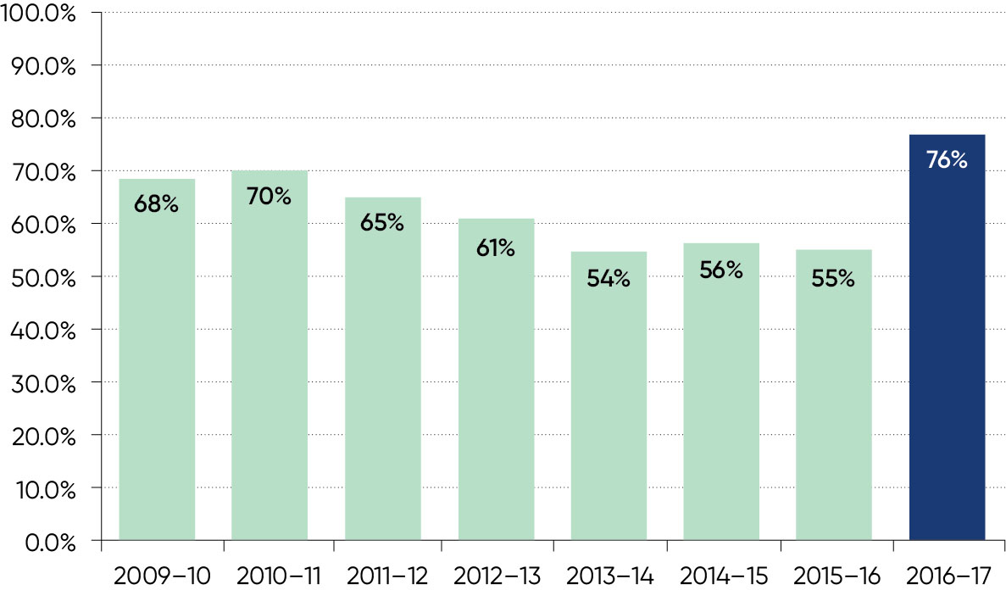
Figure 7: Number of prisoners detained by the Board following notification of a suspected breach of parole by Victoria Police 2014-15 – 2016-17
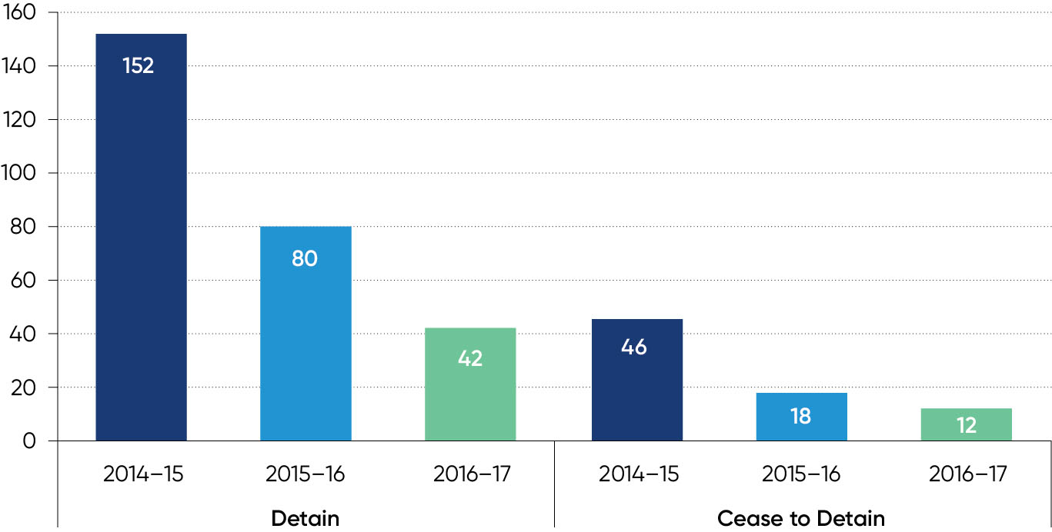

Figure 8: Number of persons convicted of a serious violent or sexual offence committed by them while on parole 2013-14 – 2016-17
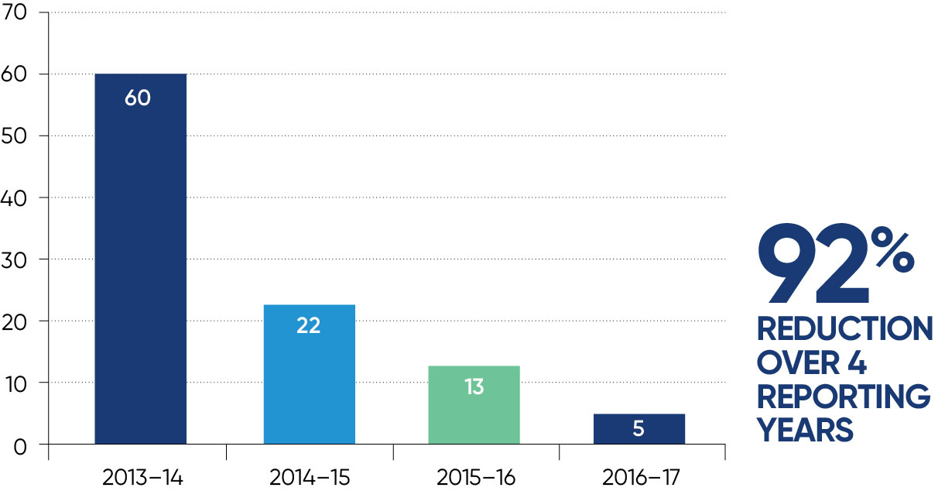
Figure 9 represents the length of time that prisoners spent on parole before their parole was cancelled. In 2016-17, 25 per cent of prisoners who had their parole cancelled had been on parole for 1.7 months or less. Another 25 per cent had been on parole for between 1.7 and 3.7 months. Half of the parole cancellations involved prisoners who had been on parole for 3.7 months or less (the median). Another 25 per cent had been on parole for between 3.7 months and 8.7 months when parole was cancelled, and the final 25 per cent had been on parole for between 8.7 and 157.8 months when parole was cancelled. The decline in time on parole before cancellation that occurred between 2012-13 and 2014-15 has reversed in the last two years. Improved compliance on parole is a contributing factor to the increase in the time spent on parole before cancellation.
Figure 9: Number of months on parole at time of cancellation
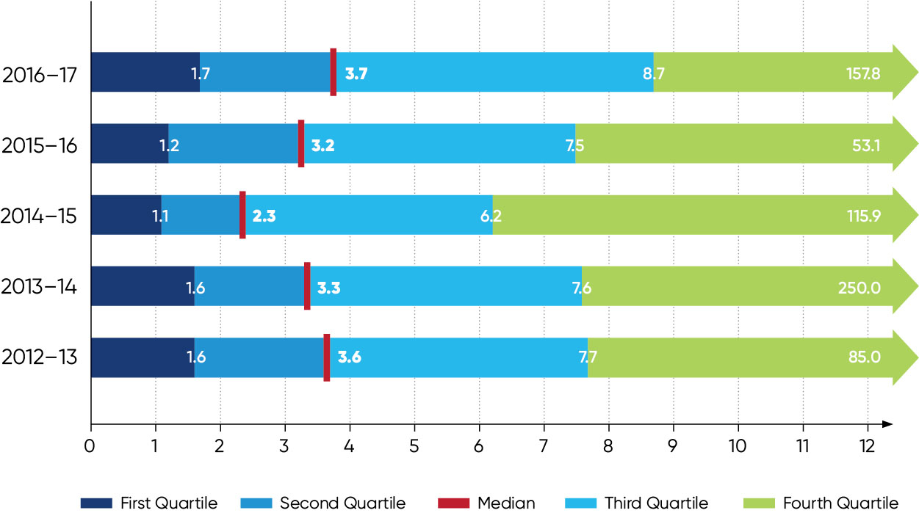

Myth
The Board cancels parole too quickly. It cancels parole for just missing an appointment.
Fact
The Board’s paramount consideration in considering whether to cancel parole is the safety and protection of the community. Parole is often cancelled for a combination of reasons, which can include missed appointments. Missed appointments may be important - they may be an indicator that the prisoner has relapsed into drug use and is avoiding drug testing. While unacceptable absences were a reason in 94 of the 204 cancellations in 2016-17, it was the sole reason in only 8 (4 per cent of cancellations).

Key projects
To continually improve the Board’s operations, a number of projects were undertaken during the reporting period. The Adult Parole Board’s Project Board provided project governance. Meeting regularly, the Project Board comprises Secretariat managers, the full-time Board member with portfolio responsibility for the projects, and senior staff from Corrections Victoria.
The key projects progressed during the reporting period are outlined below.
Time to count: This project was initiated through the Board’s Executive and saw it, in conjunction with Corrections Victoria, develop and implement procedures to consider whether to grant any, and if so how much, time to count against the sentence after every parole cancellation. The project moved into business as usual during the year.
Reasons for denial and revocation of parole: This project was initiated by the Board’s Executive to build on improvements it has previously made to the communication of reasons for decisions to cancel parole. It also aligned with improvements identified by Corrections Victoria in monitoring the effectiveness and operation of the parole system reforms. The aim of this project was to improve the communication of reasons for decisions to deny or revoke parole. The project was completed during 2016-17 and resulted in improved reasons given to every prisoner who, from the end of 2016, had their application for parole denied or had a parole order revoked. System improvements to automate processes will be implemented through the Adult Parole Board Case Workflow System Program.
Review of acquittal of recommendations in reports: The Board’s Executive initiated a project to review all relevant recommendations made in reports that have been written about the parole system, to ensure that the recommendations related to the Board are acquitted and the acquittal of the recommendations is properly recorded. This work will continue into the next reporting period.
Website: The Project Board provided governance over a project initiated through the Board’s Executive to create a dedicated website. This project resulted in the launch of the website in June 2017.
Branding: The Project Board provided governance for a project to re-brand the Board, initiated through the Board’s Executive. This project was completed in 2017 with the launch of the branding featured in this report.

Implementation of the Board’s case workflow system
The Board continues to work closely with Corrections Victoria in the implementation of the case workflow system.
The objectives of the case workflow system are to:
- reduce the risk of inaccurate Adult Parole Board decisions made due to inaccurate, untimely, incomplete and inaccessible information
- improve the efficiency of Adult Parole Board operations, where the efficiency dividend clearly represents a cost saving.
During 2016-17, funding was made available by Corrections Victoria for two additional fixed term positions for the Board to work on this Program. The Board has also established an internal Steering Committee to oversight the Board’s involvement in the project and to provide support for, and direction to, staff engaged in with the project.

Major legislative changes
During the reporting period, the following legislative amendments were made which impact on the powers and functions of the Board.
On 3 November 2016 amendments to the Corrections Act 1986 inserted a new section 104ZYA allowing information disclosure with other parole decision making bodies in other States and Territories.
On 14 December 2016 amendments to the Corrections Act 1986 inserted a new section 74AAA setting out the requirements for parole for prisoners sentenced to a term of imprisonment with a non-parole period for the murder of a police officer. This means that before the Board can release on parole a prisoner who has been convicted and sentenced for the murder of a police officer, the Board must be satisfied that the prisoner is in imminent danger of dying or is seriously incapacitated and, as a result, is not physically able to harm any person, and that the prisoner has demonstrated that they do not pose a risk to the community, and that the making of a parole order is justified.
Another amendment to the Corrections Act 1986 that took effect on
14 December 2016 was the introduction of section 74AABA which provides that the Board must not grant parole to a prisoner serving a sentence of imprisonment for murder, conspiracy to murder, accessory to murder or manslaughter unless the Board is satisfied, based on a report from Victoria Police, that the prisoner has satisfactorily cooperated to identify the location of the body or remains of the victim, or the place where the body or remains may be found. The prisoner’s cooperation can occur before or after they were sentenced for the offence.

Litigation
The Board’s Risk and Audit Subcommittee is responsible for overseeing the risks associated with litigation.
As at 30 June 2017, the Board was named in two matters pending before the High Court of Australia which challenge the validity of legislative provisions regarding the eligibility for parole of prisoners Julian Knight and Craig Minogue. The defence of those matters is being conducted by the State of Victoria. The High Court heard the application by Julian Knight on 28 March 2017 and reserved its decision. Craig Minogue’s application is in its early stages as a proceeding.
The Board appears in, and gives evidence to, coronial inquiries and inquests. In 2016–17, this included the coronial inquest into the death of Dermot O’Toole, and involvement with the initial stages of coronial investigations into the deaths of Karen Chetcuti and Michael Bekhazi.
The Board is also involved in the defence of a number of proceedings being brought against the State of Victoria by families of victims who have been murdered by people on, or recently having completed, parole.

Myth
Parole is a rubber stamp process.
Fact
The paramount consideration of the Adult Parole Board in deciding whether to grant parole is always the safety and protection of the community. In 2016-17, the Board denied parole in 42 per cent of applications, and granted parole in 58 per cent.

Stakeholder Collaboration and engagement

Increasing the community’s understanding of parole

The Board’s new website – adultparoleboard.vic.gov.au
The Board launched its new website on 28 June 2017. This is the Board’s first website.
The website features:
- clear and helpful information about parole and the Board
- videos of the Chairperson explaining the purpose of parole, parole processes, and Board membership
- videos of mock Parole Board hearings
- parole statistics
- an infographic of the parole process
- frequently asked questions about parole and the Board.
The website content has been written for a number of different audiences including the community, victims, prisoners’ families, Corrections Victoria, the legal profession, the judiciary, Victoria Police, the media, and more.
The Board consulted representatives of victims, Community Correctional Services and prisons to develop the content, and wishes to acknowledge these groups for their contribution.
The website will continue to be developed to ensure it is a primary resource for the Board’s stakeholders seeking information about parole in Victoria.

‘Parole, you decide’ at Law Week 2017
The Board participated in Law Week for the second time with a mock hearing ‘Parole, you decide’. The hearing followed the story of a young prisoner from sentencing to when he applied for parole and was on parole. ‘Parole, you decide’ was held in Court 1 of the Melbourne Magistrates’ Court on Saturday, 21 May 2017.
The first Board panel deliberated on whether or not parole should be granted following an application by the prisoner, and the second panel deliberated on whether or not parole should be cancelled following notification by Victoria Police of a parole breach. The audience were given the opportunity to voice their opinions about the decisions they would make if they were the Board.
It was facilitated by the Chairperson, and included two panels of three Board members, and a presentation on the parole breach notification and cancellation process by one of
the Board’s full-time members.
The audience learnt about the process that the Board goes through when evaluating a prisoner for parole, as well as the process for cancelling a prisoner’s parole. The audience also gained special access to the types of discussions which take place in closed Board meetings that the public are not normally privy to.
Every respondent to a ‘Parole, you decide’ feedback form stated that the event had increased their knowledge about the purpose of parole, the parole process, and the Board.
The ‘Parole, you decide’ footage from the Law Week 2016 event was published to the Board’s new website in June 2017.

‘Parole,you decide’ – audience feedback
“Parole allows close monitoring if granted. Otherwise, there is little in the way of supervision upon release.”
“The involvement, discussion, analysis and consideration is justice at its best. There is definitely a place for parole.”
“Before today, I opposed parole. Today, I’ve changed my mind. ‘Parole is control’ of the offender.”
“I now really understand the parole system.”

Media engagement
The Chairperson participated in several media interviews during 2016-17 with the aim of educating the community about parole and the Board.
These included:
- ‘Writs and Cures’ evening radio program on ABC 774
- Neil Mitchell’s morning radio program on 3AW
- Raf Epstein’s drive radio program on ABC 774
- Sunday Morning radio program with Darren James, Nick McCallum and John Michael-Howson on 3AW.

Foxtel documentary
The Chairperson was interviewed for a Foxtel documentary, called ‘Crimes That Shook Australia’, on the tragic case of the murder of Jill Meagher by Adrian Bayley in 2012. The Chairperson spoke about the suite of parole reforms that have been implemented since 2012. The documentary will air in 2018.

La Trobe University course on sentencing and corrections
The Chairperson was interviewed by La Trobe University for a course on sentencing and corrections. He spoke about the purpose of parole, the parole process and the diversity of the membership. These videos are available on the Board’s new website.
The feedback from the students was very positive. A number of students said that they had a negative view of parole and the Board prior to their engagement with the course. However, on reflection, they realised that they had a lack of understanding about the purpose of parole and the role of the Board.
For example, one student provided the following feedback about the course.
‘I have gained a much better understanding of parole and how it works in Victoria from the interview with the Chair of the Adult Parole Board. Before taking this subject I had little to no understanding of parole. A lot of what I knew about parole was through the media’.
Another student provided this feedback.
‘I can see now that the Adult Parole Board has to make a decision if an offender has been given a parole option at sentencing. They don’t always get it right but they make the decision based on the information they have at the time. I guess I hadn’t thought about all the successes they have because we only hear about the decisions where things go wrong’.

La Trobe University – student feedback
“At the beginning of the semester I could not understand why parole boards would allow offenders back into the community, though now I am aware that the decisions made are based on a lot of important information and in the best interests of both the offender and the community.”
“Before taking this subject I had little to no understanding of parole. A lot of what I knew about parole was through the media.”
“I guess I hadn’t thought about all the successes they have because we only hear about the decisions where things go wrong.”

Law Institute Journal
The Chairperson and Chief Administrative Officer (CAO) were both interviewed for the Law Institute Journal, which is published by the Law Institute of Victoria and has a vast readership including the judiciary and legal community. The Chairperson and CAO spoke about their extensive backgrounds in law and the improvements to the Board following the parole reforms.

External presentations to stakeholders
The Board presented to numerous groups in 2016-17 including County Court Judges, Law Institute of Victoria, the Office of Public Prosecutions, Victoria Legal Aid, Melbourne Legacy, La Trobe University, Swinburne University, Monash University, Mount Saint Joseph’s School, the Australian Psychology Society (at a session on Gang Related Violence), Footscray Lion’s Club and the Glenferrie Rotary Club. Several presentations were delivered to Corrections Victoria (CV), including the Chairperson presenting at the CV Stakeholder Forum, in order to improve understanding of the Board’s functions. The Board also presented at events including the Association of Paroling Authorities International (APAI) conference and Victoria Law Foundation Law Week 2017.

Association of Paroling Authorities International (APAI) conference
For the first time, Board representatives attended the annual conference of the Association of Paroling Authorities International (APAI) in April 2017. Joining over 200 delegates from 12 countries, including representatives from several other Australian jurisdictions, this was an opportunity to meet and hear from representatives of parole boards and authorities from across the world and to learn from global best practice. There are clear benefits for the Victorian Board from fostering the opportunity for dialogue and relationships with other jurisdictions.
The APAI has held annual conferences for over 30 years. Historically, most of its members have been based in the United States of America and Canada. The 2017 conference was held in Vancouver, Canada. The invitation to the Victorian Board was made as part of an agenda to extend the membership to make the organisation properly global. A resolution was passed at the conference to establish seven regional groups across the world as part of the Association’s governance structure. This will enable the regions to participate in the direction of the Association, including planning and running future conferences. The Board will be part of the Oceania group, with the other Australian states (NSW, SA and NT were represented at the conference), New Zealand (also represented at the conference) and some of the Pacific Islands.
The Board’s attendance confirmed that the issues it has faced and continues to face, including public scrutiny and criticism following high profile crimes committed by prisoners on parole, are common. Although there are many differences between the systems operating in different jurisdictions, in many respects the Victorian system now leads the way.

Working collaboratively with stakeholders

Corrections Victoria
The Board continues to foster a close, working relationship with Corrections Victoria that is collaborative, respectful and effective. The Secretariat, who support the Board on a daily basis and ensure that all matters are properly prepared and presented for Board consideration, comprise of Corrections Victoria staff.
The Board relies on the information it receives from Corrections Victoria parole officers, including Parole Suitability Assessments and risk evaluation reports, to make its decisions. The Board is regularly assisted by the attendance of parole officers at Board meetings to provide information and answer questions, including when the Board interviews a prisoner on parole.
Representatives of Community Correctional Services and prisons assisted the Board in the development of content for the Board’s new website to ensure that the information is relevant, accurate and helpful.
Senior managers from Corrections Victoria are included as members on key governance committees including the Stakeholder Engagement Subcommittee, Practice Subcommittee, and Project Board. The Chairperson of the Board regularly communicates with the Commissioner for Corrections Victoria, and the Board’s Chief Administrative Officer meets on a fortnightly basis with the Corrections Victoria Deputy Commissioner, Offender Management.

Victims
Representatives of the Victims Support Agency, within the Department of Justice and Regulation, assisted the Board in the development of content for the Board’s new website to ensure that the information is relevant, accurate and helpful.
The Board has been represented on the Victims of Crime Consultative Committee since its inception in 2012.

Victims Register
The Victims Register is managed by the Victims Support Agency. It is responsible for maintaining contact with victims of violent crime who have registered to receive information about an adult prisoner. A criminal act of violence includes offences such as assault, sexual assault offences, kidnapping and murder. The Victims Register will provide advice about the release of a prisoner on parole, including any conditions imposed that are relevant to the victim and any cancellation of parole.
The Board and the Victims Register work closely on a daily basis in relation to operational and policy issues. The Board provides information each day to the Victims Register about the management of prisoners (where appropriate) and victim-related conditions. The Victims Register is then able to provide victims of crime with timely, relevant and accurate information about the release of a prisoner on parole. In addition to daily contact, the Board and the Victims Register regularly meet to discuss other matters such as the implementation of local operating procedures, protocol and case specific matters.
During 2016–17, 59 prisoners with one or more registered victims were granted parole. For 69 registered victims, the Board informed the Victims Register of the date of release of the prisoner on parole to enable compliance with the legislative requirement for the Victims Register to give the registered victims at least 14 days’ notice of the release unless the Board waives the notice period.

Victim submissions
Individuals included on the Victims Register have the right to send a written submission to the Board when the prisoner for whom they are registered is being considered for parole.
All submissions from victims are read by the Board and the issues and concerns raised are carefully considered as part of the decision-making process. Each submission is treated with strict confidence.
During 2016–17, 161 submissions were provided for the Board’s consideration of parole applications. In addition, four submissions were provided for consideration of supervision order applications.
The Board commenced a practice of reviewing victim submissions to consider whether it would be beneficial for representatives of the Board to meet with the registered victim to explain parole processes and the Board’s role prior to the Board’s consideration of whether to grant or deny parole to the relevant prisoner.

Victoria Police
The Board, Victoria Police and Corrections Victoria work collaboratively to give effect to section 78B of the Corrections Act 1986. Under this legislative provision, Victoria Police must consider detention of prisoners on parole suspected of having breached the prescribed conditions of their parole, including the condition that they must not break any law. The Board must be notified of the details of any alleged breach within 12 hours of the detention. In response, a Board member determines whether the circumstances warrant further detention pending consideration of cancellation of parole by the Board.
During 2016–17, the Board received a total of 54 notifications from Victoria Police. Of those 54 notifications, 42 prisoners were detained resulting in 38 cancellations of parole. The parole orders that were not cancelled may either have been varied to include more onerous parole conditions, or the prisoner may have been directed to attend a Board meeting to be interviewed.
The Board and Victoria Police share a memorandum of understanding that provides a framework for shared responsibilities and communication relating to the processes relating to the exchange of information and cooperation.

Fugitive Task Force
The Fugitive Task Force is part of the Victoria Police State Anti-Gang Division and is responsible for the timely and safe arrest of offenders who have had their parole cancelled and a warrant issued for their arrest. The Board assists the Fugitive Task Force to ensure arrests occur swiftly by allowing full access to reports and documentation on an offender’s file.
The Fugitive Task Force also ensures the safe escort and security of offenders extradited back to Victoria for breach of parole from other states and territories in Australia.
The Board and the Fugitive Task Force have a memorandum of understanding that provides a shared agreement and understanding of the processes relating to the exchange of information and cooperation.

Melbourne North Police Station
The Board holds meetings on a daily basis at its office in Carlton, and is at times required to interview offenders either via prison video link or in person. When an offender is required to attend a Board meeting, the Board may decide to cancel their parole and issue a warrant for apprehension for their return to custody. If this occurs, Melbourne North Police assist the Board in executing the warrant at the hearing and safely return the offender to custody.
The Board and Melbourne North Police are parties to a protocol which provides a framework for shared responsibilities and communication.

Prisoners
Improving communication with prisoners has continued to be a priority for the Board in 2016-17.
The Board’s Executive team and senior management visited several prisons across Victoria and spoke with groups of prisoner mentors to understand the experience of prisoners who are applying for parole.
The Board’s project to improve the information provided to prisoners about its reasons for denying or revoking of parole was finalised. It is now providing clearly articulated reasons for every denial or revoke of parole, as well as every parole cancellation.
The Board launched its new website with information about parole and the Board, including how prisoners should prepare for parole while in prison and what’s expected of them on parole. This information, which was developed in consultation with representatives of Community Correctional Services and prisons, is written in a clear way to assist prisoners and their families.
The Board, in conjunction with Corrections Victoria, established and ran a pilot for a new process for correspondence to improve the efficiency and content of information provided to prisoners. The new process is designed so that the most relevant body, either the Board or Corrections Victoria, for the correspondence can respond in a shorter time period.

Detention and Supervision Order Divison (DSOD)
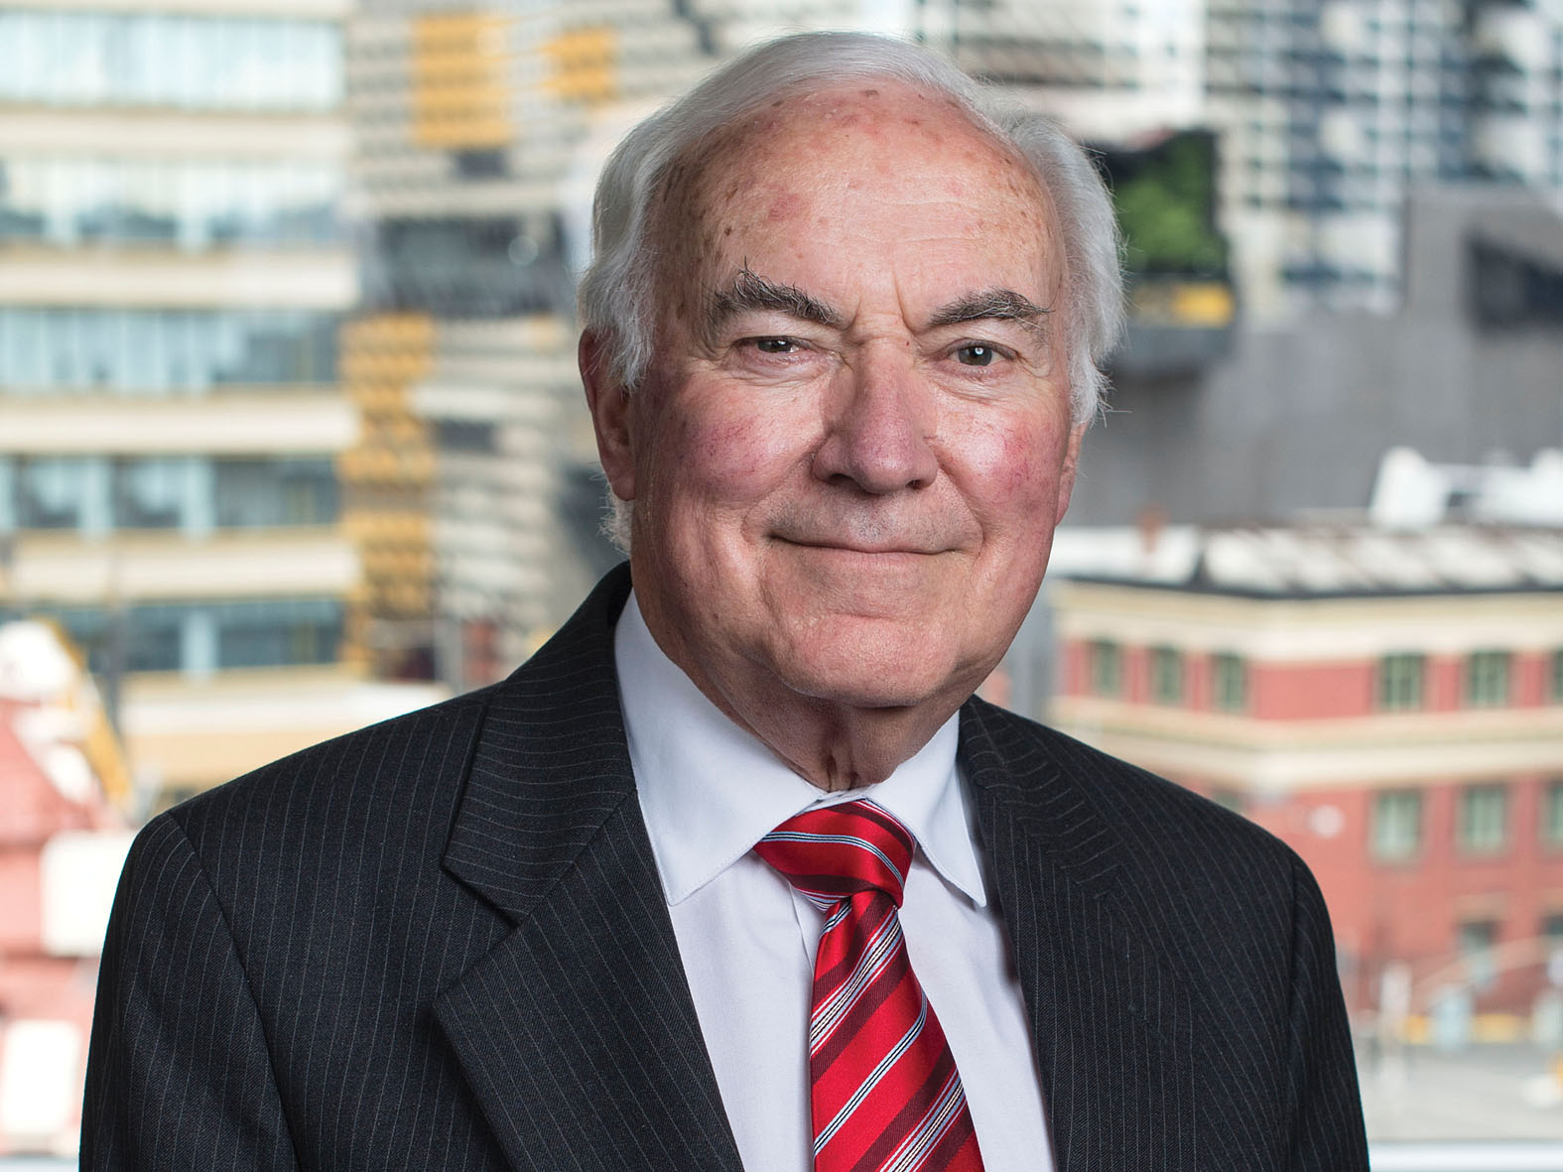

Foreword from the DSOD Chairperson
I am very pleased to pen this forward for the Detention and Supervision Order Division (DSOD) for the 12 month period to 30 June 2017.
It appears this will be the last report on DSOD for a full 12 month period. The Post Sentence Authority (PSA), recommended by the Harper Review, is anticipated to commence operation in 2018 which will include the transfer of DSOD functions to the new authority.
The DSOD welcomes the transfer of its functions to the proposed PSA. Over recent years the DSOD has strongly expressed the view that an independent specialised body should be established to take over the statutory duties performed by the DSOD. The DSOD will do all in its power to ensure that at the appropriate time, the transfer of these duties to the proposed PSA is seamless and that the operation of the supervision and detention regime is not interrupted in any way.
The number of Supervision Orders made in this reporting year has increased from 16 in 2015-16 to 18 in the reporting year. At 30 June 2017, 133 offenders were subject to Supervision Orders (including interim orders), compared with 127 offenders in the previous reporting year. Of these, 69 were required by the County Court or Adult Parole Board to reside at a ‘residential facility’. As at 30 June 2017, two offenders were subject to Detention Orders made by the Supreme Court.
The Sex Offender Management Branch of Corrections Victoria (SOMB) takes active steps in transitioning back into the community those who are suitable in residential facilities, an approach that the DSOD fully supports.
DSOD hearings are held each Monday morning. In addition, urgent matters are dealt with throughout the week. The number of matters dealt with by the DSOD has increased markedly in the reporting period, caused in part by an in depth review of all DSOD files prior to hand over to the proposed PSA.
The DSOD has been greatly assisted by the presence at its meetings of senior representatives of SOMB who can provide further information on the reports provided to the DSOD and, when required, provide advice on any updates to the reports.
Finally, I would like to take the opportunity to offer my sincere thanks to the Adult Parole Board members sitting on the DSOD who have so capably performed their role and to the staff of the Adult Parole Board for their dedicated assistance and support.
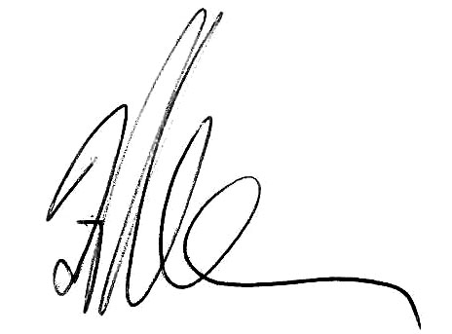
His Honour Frank Shelton
Chairperson of the Detention and Supervision Order Division

Detention and Supervision Order Division operations

Transition of the Board’s DSOD role to the new authority
The Board currently has a role in relation to the post-sentence supervision and detention scheme. However, the government has announced that it will make major changes to the scheme, including to establish a new body to perform a range of functions under the scheme. As a consequence of those changes, the Adult Parole Board will cease to have a role in relation to post sentence orders from 2018.

Jurisdiction of the division
In limited circumstances, courts can order an offender who has completed their sentence to be subject to post-sentence detention or supervision. The power is limited to serious sex offenders who the courts determine will be an unacceptable risk of committing further sex offences after finishing their sentences.
The Supreme or County Court can impose a supervision order of up to 15 years, or an interim supervision order, on an application by the Secretary of the Department of Justice and Regulation. The power to impose orders is through the Serious Sex Offenders (Detention and Supervision) Act 2009. The court must be satisfied that the offender who has been convicted of serious sex offending poses an unacceptable risk of committing a serious sex offence after their sentence is finished if a supervision order is not made. Offenders subject to a supervision order are not undergoing a sentence and are not in custody. They reside in the community (including a number in a residential facility) but are subject to supervision.
When a supervision order is made, Corrections Victoria is responsible for supervising the offender.
The Board’s role, where authorised by the court making the order, is to provide direction on the administration of the conditions (e.g. accommodation or curfew) and on responses to breaches (e.g. issue a formal warning or recommend prosecution).
An eligible offender is defined in the Act as a person who is 18 years of age or over, has served a custodial sentence in respect to a relevant offence (which includes most sexual offences), and is serving a custodial sentence in Victoria for a specified serious sex offence at the time of application.
The Act enables the court to impose conditions on supervision orders. Conditions include:
- where the offender may live
- times when the offender must be at home
- treatment or rehabilitation programs or activities that the offender must attend and participate in
- places or areas that the offender must not visit or may attend at specified times
- community activities the offender must not engage in
- persons or classes of person the offender must not have contact with
- forms of monitoring (including electronic monitoring) that the offender must comply with
- personal examinations by a medical expert which the offender must attend for the purpose of assisting the Board in determining the need for, or form of, any instruction and direction.
The Act established the Detention and Supervision Order Division within the Board. The functions of the division under section 118 of the Serious Sex Offenders (Detention and Supervision) Act 2009 are to:
- monitor compliance with the supervision order and administer the conditions of the order
- give directions and instructions to an offender in accordance with any authorisation given to the Adult Parole Board under a supervision order
- make decisions to ensure the carrying into effect of the conditions of supervision orders
- make recommendations to the Secretary of the Department of Justice and Regulation in relation to applying to a court to review the conditions of supervision orders
- to review and monitor the progress of offenders on supervision orders.
The Act also empowers the Supreme Court to make a detention order of up to three years or an interim detention order. The Director of Public Prosecutions may apply to the Supreme Court for a detention order for an eligible serious sex offender. The court must be satisfied that the offender poses an unacceptable risk of committing a specified serious sex offence if a detention order is not made and that the offender is in the community. The Board is responsible for reviewing and monitoring offenders on detention orders. There are two offenders subject to detention orders as at 30 June 2017.
Corrections Victoria case manage offenders on detention and supervision orders, and provide the Detention and Supervision Order Division with reports and recommendations to facilitate their ongoing management.

Membership of the division
As at 30 June 2017, there were nine judicial members, three full-time members and 12 community members in the Detention and Supervision Order Division.
A sitting of the division must consist of the presiding chair (who must be a judicial member) and two other members of the division.

Operations of the division
The Detention and Supervision Order Division meets weekly, as well as out of session for urgent cases.
During 2016–17, the division sat on 96 days and heard 540 matters. Of these matters, 479 were scheduled and the remaining 61 were unscheduled to consider urgent matters.
A representative from Corrections Victoria’s Sex Offender Management Branch attends each meeting of the division to provide an overview of each offender’s case to supplement the written reports. This ensures that the Board understands all aspects of the case, resulting in a better informed decision being made.

Orders under the division’s jurisdiction
The two detention orders made by the Supreme Court during previous reporting years remain in force and were renewed in 2016-17.
During 2016-17, the Supreme and County Courts made 16 interim supervision orders and 18 supervision orders against 24 persons. Additionally, the courts made seven interim supervision orders pending supervision order renewals and renewed 11 supervision orders. The courts also reviewed and confirmed 31 existing supervision orders.
During 2016–17:
- two supervision orders were revoked on review
- no supervision orders were revoked on appeal
- no application for a supervision order was refused
- no offenders subject to supervision orders were deported
- nine supervision orders were otherwise completed.
As at 30 June 2017, the division was responsible for the administration of 135 post-sentence orders, including two detention orders, 125 supervision orders and eight interim supervision orders.
At the same time last year, there was a total of 129 post-sentence orders. This indicates a 5 per cent increase in post-sentence orders over the past 12 months.

Directions to reside at a residential facility
The court sets the conditions of a supervision order, including where the offender is required to reside. This may be in the community or at a residential facility. A residential facility is not a prison. The facilities are utilised for the purpose of housing offenders subject to supervision orders who are unable to source appropriate accommodation in the community, or who require a higher level of supervision or support than others.
The court may authorise the Board under section 20(1)(b) of the Serious Sex Offenders (Detention and Supervision) Act 2009 to direct an offender who is residing in the community to reside at a residential facility. During 2016–17, the division directed 18 offenders to reside in a residential facility which is equal to the previous year.
As at 30 June 2017, there were 69 offenders subject to an interim supervision order or a supervision order requiring the offender to reside at a residential facility.

Emergency powers
The emergency powers contained in the Serious Sex Offenders (Detention and Supervision) Act 2009 permit the division to give directions to manage an offender subject to a supervision order in a way that is inconsistent with, or not provided for, by the conditions of the order that were set by the court. The division exercised these powers on three occasions in 2016–17.

Electronic monitoring
The court, in making interim supervision orders or supervision orders, is required to consider imposing condition(s) for compliance monitoring, including electronic monitoring. The court may delegate authority to the Detention and Supervision Order Division to make such a direction. In 2016–17, the court or the division directed 60 offenders on interim supervision orders or supervision orders to comply with electronic monitoring.
As at 30 June 2017, a total of 94 offenders on interim supervision orders or supervision orders were subject to electronic monitoring (including those residing at a residential facility). At the same time last year, there was a total of 82 supervision order offenders subject to electronic monitoring.

Breaches of supervision order
Section 160(1) of the Serious Sex Offenders (Detention and Supervision) Act 2009 states that an offender must not, without reasonable excuse, fail to comply with a condition of a supervision order (or interim supervision order). Breach proceedings may only be brought to the court by the Secretary of the Department of Justice and Regulation or a member of Victoria Police by filing a charge sheet. There is a maximum penalty of five years imprisonment for breach of a condition.
The Detention and Supervision Order Division has power to inquire into an alleged breach of a condition. The division relies on information from Corrections Victoria who are responsible for case managing the offenders.
The Serious Sex Offenders (Detention and Supervision) Act 2009 outlines the factors the division may consider in assessing the seriousness of the breach, such as whether the behaviour creates a risk to the safety of the community, is a repeated failure to comply with any condition, may increase the offender’s risk of committing a serious sex offence or is preparatory to a sex offence or seriously compromises the offender’s rehabilitation or treatment.
Depending on the seriousness of the alleged breach, the division may:
- take no action
- give a formal warning to the offender
- vary any directions that it has given to the offender under a condition of the order
- recommend that the Secretary of the Department of Justice and Regulation apply to the court to review the conditions of the supervision order
- recommend to the Secretary of the Department of Justice and Regulation to refer the matter to the Director of Public Prosecutions to consider whether or not to apply to the Supreme Court for a detention order in respect of the offender
- recommend that the Secretary bring proceedings in respect of the offence of breach of a supervision order.
During 2016-17, the Secretary of the Department of Justice and Regulation, Victoria Police and the Office of Public Prosecutions initiated 30 breach proceedings.
Thirty-one breach proceedings were completed or proven during 2016-17 which included a number of outstanding matters from 2015-16; seven breach proceedings were still pending at the conclusion of 2016-17.
Of the 31 breaches proven, eight offenders were breached for reoffending (eight times) and 22 offenders were breached for non-compliance with the conditions of their order (23 times).

Powers for police to enter premises
Section 158C of the Serious Sex Offenders (Detention and Supervision) Act 2009 gives police the power to enter premises at which a supervised offender resides, if the police officer reasonably suspects that the offender is present and that entry is reasonably necessary to monitor the offender’s compliance with a supervision order or interim supervision order. Section 171A gives Victoria Police the power to enter and search premises at which they reasonably suspect an offender to be present, using reasonable force if necessary, to arrest the offender for breaching a condition of a supervision order or interim supervision order. During 2016-17, the police exercised these powers on two occasions.

Table 4: Detention and supervision orders 2012-13 – 2016-17
 | 2016-17 | 2015-16 | 2014-15 | 2013-14 | 2012-13 | % change  between 2015-16  and 2016-17
DETENTION AND SUPERVISION ORDERS
Number of sittings of the Division | 96 | 106 | 115 | 161 | 127 | -9.4%
Interim detention orders made  (excluding renewals) | 0 | 0 | 0 | 0 | 0 | N/A
Detention orders made (excluding renewals) | 0 | 0 | 1 | 1 | 0 | N/A
Interim supervision orders made  (excluding renewals) | 16 | 16 | 13 | 8 | 8 | 0.0%
Supervision orders made (excluding renewals  and reviews) | 18 | 16 | 15 | 11 | 21 | 12.5%
Number of persons directed to reside in a residential facility | 18 | 18 | 17 | 14 | 12 | 0.0%
Number of persons in respect of whom an emergency power was exercised | 3 | 2 | 0 | 2 | 1 | 50.0%
Number of persons required to comply with electronic monitoring | 60 | 57 | 18 | 14 | 8 | 5.3%
Total number of persons subject to electronic monitoring (as at 30 June) | 941 | 82 | 69 | 56 | - | 14.6%
Number of detention or supervision orders completed (including interim orders) | 112 | 9 | 6 | 0 | 1 | 22.2%
Number of persons on a detention order  (as at 30 June) | 2 | 2 | 2 | 1 | - | 0.0%
Number of persons on a supervision order  (as at 30 June) | 125 | 120 | 111 | 104 | - | 4.2%
Number of persons on an interim detention order (as at 30 June) | 0 | 0 | 0 | 0 | 0 | N/A
Number of persons on an interim supervision order (as at 30 June) | 8 | 7 | 5 | 4 | - | 14.3%
Number of times the exercise for powers of entry under sections 158C and 171A of the Act were reported to the Board | 2 | 0 | - | - | - | N/A

1 This includes 69 persons at residential facilities.
2 Includes two that were revoked on review.

Organisation and governance

Governance
The Board’s governance structure oversights the efficient and effective administration of the Board’s strategy, policy, and practice. All strategic decisions are made by the Executive based on the recommendations and advice of the four supporting subcommittees, with project advice provided by the Project Board.
Figure 10: Adult Parole Board’s governance structure
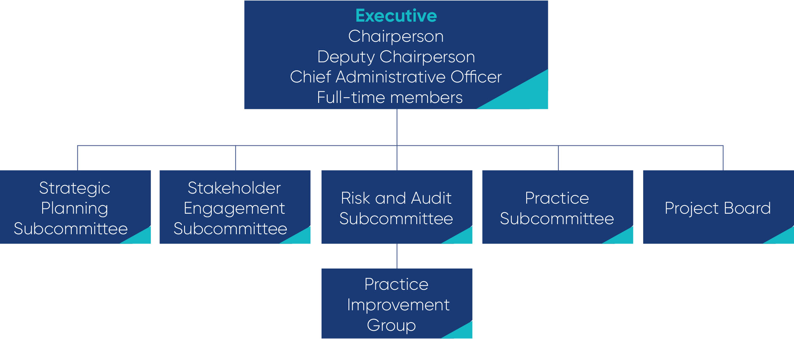

Secretariat
The Secretariat that supports the Board’s operation is comprised of 30 Department of Justice and Regulation staff (from Corrections Victoria).
The staff structure implemented in 2015-16 has proven to be very effective. It has delivered the benefits anticipated, including clarity of roles, consistency, flexibility, improved support lines for both staff and managers, opportunities for career development and progression, and good morale. The structure is now well settled.
Reflecting the importance, breadth and challenges of the Board’s Communications Strategy, the Senior Communications Officer role has been made ongoing. This effectively upgrades the Board’s capacity to deliver quality communications services.
During the reporting year, funding was provided by Corrections Victoria to employ two additional staff to work full time on the Adult Parole Board Case Workflow System Program. This brings the number of Secretariat staff working full time on this program to four, led by the General Manager Practice Development. In addition, other staff and members of the Board work on this program of work as required. This is a significant commitment for the Board, reflecting the importance of this Program, and the amount of work to be delivered.
The Secretariat’s management team comprises the Chief Administrative Officer, General Manager Practice Development, General Manager Operations, Manager Operations, Manager Registry, Project Manager, and Senior Communications Officer. This team meets fortnightly, and as required between meetings, to ensure that all aspects of the operations of the Board and Secretariat are working effectively and in a coordinated way. The strong comradery and cooperation amongst the management team, and their commitment to making the Board’s Secretariat an outstanding place to work, permeates the Secretariat.

Table 5: Adult Parole Board – non-executive workforce profile
VPS classification | 2016–17 |  |  | 2015–16 |  |  | 2014–15 |  |  | 2013–14 |  |  | 2012–13
 | Male | Female | Total | Male | Female | Total | Male | Female | Total | Male | Female | Total | Male | Female | Total
STS Grade 7 | 1 | 0 | 1 | 1 | 0 | 1 | 1 | 0 | 1 | 0 | 1 | 1 | 0 | 0 | 0
VPS Grade 6 | 0 | 2 | 2 | 0 | 2 | 2 | 0 | 2 | 2 | 0 | 2 | 2 | 1 | 0 | 1
VPS Grade 5 | 1 | 2 | 4¹ | 1 | 3 | 4 | 1 | 3 | 4 | 1 | 3 | 4 | 0 | 3 | 3
VPS Grade 4 | 0 | 4 | 4 | 0 | 4 | 4 | 0 | 1 | 1 | 0 | 1 | 1 | 0 | 0 | 0
VPS Grade 3 | 2 | 5 | 9² | 2 | 7 | 9 | 1 | 11 | 12 | 0 | 12 | 12 | 0 | 8 | 8
VPS Grade 2 | 2 | 6 | 10³ | 1 | 9 | 10 | 2 | 9 | 11 | 1 | 10 | 11 | 2 | 5 | 7
Total | 6 | 19 | 30⁴ | 5 | 25 | 30 | 5 | 26 | 31 | 2 | 29 | 31 | 3 | 16 | 19
1 This includes one vacant position at 30 June 2017.
2 This includes two vacant positions at 30 June 2017.
3 This includes two vacant positions at 30 June 2017.
4 The total includes five vacant positions at 30 June 2017. The total does not include two additional positions (one VPS5 female and one VPS4 female) for the case workflow project.

Operational health and safety
The Board is committed to providing a safe and healthy workplace that is free from discrimination, harassment, bullying and workplace violence.
The Board’s health and safety representative monitors the occupational health and safety of staff and members. Any issues of concern or requiring discussion can be put on the agenda of the meetings of the management team.

Equal employment opportunity employer
The Board is an equal employment opportunity employer. Appointments and promotions are based on merit, and staff receive the training and experience required to enhance their skills and abilities.

Organisational chart
Figure 11: Adult Parole Board Secretariat organisational chart
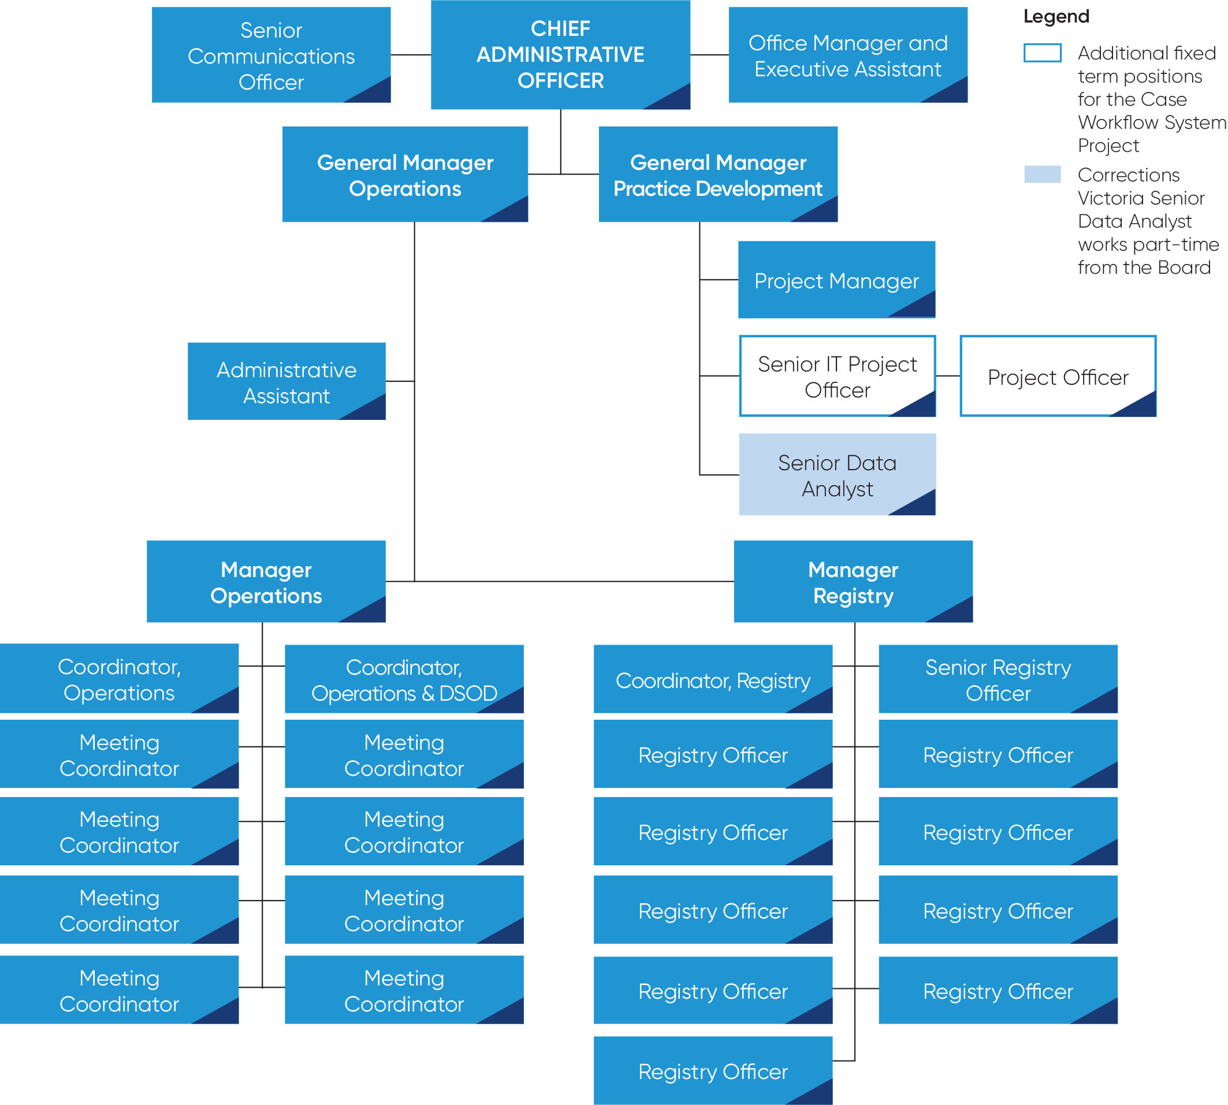

Privacy and information
There are strict rules governing the release of information by the Board. The disclosure of ‘personal and confidential information’ is governed by Part 9E of the Corrections Act 1986, Division 2 of the Serious Sex Offenders (Detention and Supervision) Act 2009 and the Privacy and Data Protection Act 2014. The Board is not subject to the Freedom of Information Act 1982.
‘Personal and confidential information’ is broadly defined under the Corrections Act 1986. Information contained in an offender’s file, including an offender’s release date, parole conditions, and Board decisions are regarded as confidential unless an exception applies under Part 9E, even if the request is made by or on behalf of an offender.
The strict nature of these provisions ensures that information can be provided to the Board with complete frankness by clinicians, intelligence and even anonymous sources. This enables the Board to be appraised of all relevant matters and to be best placed to assess any risks presented by an offender. The privacy provisions also serve to assure offenders that they can speak candidly and without reservation to the Board during interviews. This enables the Board to identify and address any risks presented by the offender which ultimately serves the paramount interest of community safety and protection.
The legal constraint on disclosure of information relating to offenders almost invariably means that the Board is unable to comment publicly in the media or in other forums about an offender’s parole status.
Under the Act registered victims may be informed of an offender’s release date and certain victim-related conditions, but otherwise registered victims are not privy to information on an offender’s file. Registered victim submissions are treated with strict confidentiality.
Exceptions to the non-disclosure of information given to the Board for the purpose of parole consideration such as Corrections Victoria reports, psychological or psychiatric reports, and intelligence are specified under s.104ZZ of the Corrections Act 1986. Disclosure of information given to the Board is authorised if the information’s use is reasonably necessary for:
a. the administration of Corrections legislation; or
b. the preparation for, conduct of or participation in:
- i criminal proceedings in any court; or
- ii proceedings before a tribunal; or
- iii an inquest or investigation held by a coroner; or
c. the relevant person believes on reasonable grounds that the use or disclosure is necessary:
- i to reduce the risk of a person committing a violent offence; or
- ii to lessen or prevent a threat to the life, health, safety or welfare of any person.
The disclosure of other ‘personal or confidential information’ is governed by s.104ZY of the Corrections Act 1986 which authorises disclosure of personal or confidential information if the use is reasonably necessary for the performance of ‘official duties’ (defined under s.104ZX of the Act to include preparation for, conduct of or participation in, proceedings in any court or tribunal), law enforcement or in the specific circumstances stipulated under ss.104ZY(2) applies.

Detention and supervision
The sharing of information in detention and supervision order matters is governed by sections 189, 191 and 192 of the Serious Sex Offenders (Detention and Supervision) Act 2009 which outlines the purposes of which disclosure is authorised.

Safety and protection of the community
In both jurisdictions disclosure of personal and confidential information is authorised if a relevant person believes on reasonable grounds that the use or disclosure is necessary:
i to reduce the risk of a person committing a violent offence; or
ii to lessen or prevent a threat to the life, health, safety or welfare of any person.
It is an offence for a relevant person to use or disclose personal or confidential information unless the disclosure is authorised: s.104ZZA of the Corrections Act 1986 and s.189(1A) of the Serious Sex Offenders (Detention and Supervision) Act 2009.

Myth
The Board should be telling the community when a prisoner is released on parole.
Fact
The Board is bound by laws that prevent it from disclosing information about prisoners who apply for and are on parole. This includes information about whether they have applied for parole and when they are released on parole.

Financial report
Operating statement and financial summary 2012–13 to 2016–17

Funding and expenditure
The Board is funded by Corrections Victoria and its accounts are managed through the Department of Justice and Regulation.
Table 6: Funding and expenditure
 | 2016-17 | 2016-17  % of total expenditure | 2015-16 | 2014-15 | 2013-14 | 2012-13
Funding $
 | 5,356,300 |  | 5,294,500 | 5,550,800 | 4,394,000 | 3,185,600
Expenditure $
Salaries to staff | 2,926,812 | 59% | 2,867,646 | 2,765,123 | 2,323,347 | 1,423,521
Sessional member fees | 311,657 | 6% | 378,689 | 445,829 | 329,436 | 303,189
Salary related on-costs | 911,200 | 19% | 894,675 | 904,796 | 752,027 | 596,876
Operating expenses | 769,428 | 16% | 752,391 | 1,014,163 | 1,397,572 | 746,994
Total expenditures | 4,919,098 |  | 4,893,401 | 5,129,911 | 4,802,382 | 3,070,580

Audited accounts
The Board’s accounts are audited as part of the accounts of Corrections Victoria, Department of Justice and Regulation. The accounts are published in the Department of Justice and Regulation Annual Report 2016–17.

Assets
The Board is not a body corporate and does not have power under its legislation to purchase, hold, or dispose of real and personal property.

Employee benefits
All employees of the Board are paid by Corrections Victoria. Consequently, the Board does not make payments directly in respect of employees’ superannuation, payroll tax and WorkCover.

Member remuneration
Remuneration of sessional members and the Board’s full-time members is fixed by the Governor in Council. Sitting judicial members are not remunerated for their work on the Board. Community members are remunerated at the rate of $536 per sitting day. Retired judicial members are remunerated at the rate of $620 per sitting day when acting as Chairperson of a division. These rates are set out in the Department of Premier and Cabinet’s Guidelines for the Appointment and Remuneration of Part-Time Non-Executive Directors of State Government Boards and Members of Statutory Bodies and Advisory Committees.

Year at a glance
Table 7: Adult Parole Board – summary of activities 2012-13 – 2016-17
 | 2016-17 | 2015-16 | 2014-15 | 2013-14 | 2012-13 | % change  between 2015-16  and 2016-17
Parole eligibility
Prisoners in custody (at 30 June) | 7,151 | 6,519 | 6,219 | 6,113 | 5,340 | 9.7%
Prisoners eligible for parole (at 30 June) | 3,727 | 3,463 | 3,765 | 4,244 | 3,785 | 7.6%
Prisoners on parole (at 30 June) | 841 | 981 | 1,138 | 1,233 | 1,646 | -14.3%
Parole applications (including applications for re-parole)
Total number received | 1,689 | 1,841 | 7431 | - | - | -8.3%
Total progressed to parole planning | 1,449 | 1,551 | 6202 | - | - | -6.6%
Eligible prisoners who did not apply for parole | 91 | 142 | - | - | - | -35.9%
Board meetings
Total (Board and DSOD) meeting days3 | 268 | 272 | 295 | 266 | 242 | -1.5%
Prisoners interviewed at prison | 67 | 94 | 179 | 787 | 1,899 | -28.7%
Average matters considered per meeting day | 32 | 36 | - | - | - | -11.1%
Victim submissions
Submission from victims | 1614 | 164 | 124 | 126 | 91 | -1.8%
Parole orders
Parole orders granted | 757 | 883 | 1,341 | 1,313 | 2,051 | -14.3%
Parole orders denied | 549 | 622 | 841 | 834 | 425 | -11.7%
Parole orders revoked5 | 39 | 42 | 70 | 111 | 42 | -7.1%
Parole order completions | 644 | 733 | 856 | 1,116 | 1,244 | -12.1%
Serious Violent or Sexual Offender Division
Total matters considered | 542 | 617 | 750 | - | - | -12.2%
SVoSO orders granted | 321 | 383 | 598 | - | - | -16.2%
SVoSO orders denied6 | 18 | 19 | 9 | - | - | -5.3%
SVoSO orders revoked | 18 | 17 | 12 | - | - | 5.9%
Other Outcomes7 | 185 | 198 | 131 | - | - | -6.6%
Breach of parole (detention)
Total notifications received | 54 | 98 | 198 | - | - | -44.9%
Total detained | 42 | 80 | 152 | - | - | -47.5%
*Total cancelled | 38 | 61 | 119 | - | - | -37.7%
*Total not cancelled | 4 | 19 | 33 | - | - | -78.9%
Total ceases to detain | 12 | 18 | 46 | - | - | -33.3%
Cancellation of orders
Parole orders cancelled | 204 | 387 | 569 | 761 | 930 | -47.3%
Length of parole served prior to cancellation
* day of release to less than three months | 93 | 185 | 324 | 354 | 414 | -49.7%
* three to less than six months | 44 | 78 | 99 | 170 | 227 | -43.6%
* six to less than 12 months | 37 | 73 | 83 | 126 | 173 | -49.3%
* 12 months or more | 30 | 51 | 63 | 111 | 116 | -41.2%
Serious violent or sexual offence convictions
Total number persons convicted | 5 | 13 | 22 | 60 | - | -61.5%
Total number offences | 11 | 17 | 38 | 97 | - | -35.3%
Detention and supervision orders
Detention orders made by the Supreme Court (excludes renewals) | 08 | 0 | 1 | 1 | 0 | N/A
Interim supervision orders made by the Supreme and County Courts (excludes renewals) | 16 | 16 | 13 | 8 | 8 | 0.0%
Supervision orders made by the Supreme and County Courts (excludes renewals) | 189 | 16 | 15 | 11 | 21 | 12.5%
Reviews
Requests for reviews | 3210 | 218 | 373 | 400 | 209 | -85.3%
Rejected | 24 | 147 | 344 | 363 | 149 | -83.7%
Accepted | 8 | 71 | 29 | 37 | 60 | -88.7%
Youth transfers
Transfers from prison to a youth justice centre | 4 | 1 | 2 | 3 | 8 | 300.0%
Transfers from a youth justice centre to prison | 1711 | 13 | 15 | 20 | 26 | 30.8%
Interstate transfers
Parole orders transferred from Victoria | 19 | 20 | 24 | 27 | 25 | -5.0%
Parole orders transferred to Victoria | 34 | 32 | 39 | 28 | 34 | 6.3%
Members of the Board (at 30 June)
Judicial members | 13 | 16 | 17 | 17 | 11 | -18.8%
Full-time members | 312 | 4 | 4 | 4 | 2 | -25.0%
Community members | 13 | 16 | 17 | 8 | 9 | -18.8%
Departmental representatives | 1 | 1 | 1 | 1 | 1 | 0.0%
Total members | 30 | 37 | 39 | 30 | 23 | -18.9%
Staff of the Board (at 30 June)
Total employees | 3013 | 30 | 31 | 31 | 19 | -10.0%
Financial management
Funding | 5,356,300 | 5,294,500 | 5,550,800 | 4,394,000 | 3,185,600 | 1.2%
Expenditure | 4,919,098 | 4,893,401 | 5,129,911 | 4,802,382 | 3,070,580 | 0.5%
1 This data is from 1 March 2015 to 30 June 2015.
2 This data is from 1 March 2015 to 30 June 2015.
3 More than one division of the Board may sit on a meeting day. When this occurs, one meeting day is counted.
4 Excludes 4 victim submissions for offenders on supervision orders.
5 Parole orders are revoked when the Board reverses a decision to grant parole to a prisoner, prior to release on parole.
6
These figures are the numbers of parole denial decisions made by the SVOSO division after another division of the Board recommended that parole be granted.
7 Other outcomes include parole variations, deferred cases, additional conditions or prisoners being considered on multiple occasions.
8 Two detention order renewals were made during the year.
9 There were 11 renewals and 31 reviews not included in this figure.
10 The reduction in 2016-17 can be attributed to improvements in communications with prisoners regarding why their parole was denied, revoked or cancelled, considering time to count after every parole cancellation, and prisoners being able to submit another application.
11 This data was provided by the Youth Justice Centre and is indicative.
12 One full time member position was being advertised as at 30 June.
13 The total includes five vacant positions at 30 June 2017. The total does not include two additional positions for the case workflow project.

Published by the Adult Parole Board of Victoria
September 2017
This work, Adult Parole Board Annual Report 2016–17, is licensed under a Creative Commons Attribution 4.0 licence. You are free to re-use the work under that licence, on the condition that you credit the State of Victoria (Adult Parole Board) as author, indicate if changes were made and comply with the other licence terms. The licence does not apply to any branding, including the Victorian Government logo.
ISSN 2205-4863 (Print)
ISSN 2205-4871 (Online)
For further information, contact:
Chief Administrative Officer
Adult Parole Board of Victoria
Level 4, 444 Swanston Street, Carlton VIC 3053
DX 211768 Carlton
Telephone: (03) 9094 2111
Victorian country callers: 1300 766 946
Interpreter Service: Call 131 450 and ask for the Adult Parole Board
Facsimile: (03) 9094 2125
Email: apb.enquiries@justice.vic.gov.au
Internet: www.adultparoleboard.vic.gov.au
The information contained in this report was accurate as of September 2017.
Accessibility
If you would like to receive this publication
in an alternative format, please telephone
the Adult Parole Board on 03 9094 2111 or
email apb.enquiries@justice.vic.gov.au.
This document is available in multiple formats on the internet at www.adultparoleboard.vic.gov.au

Under section 61(2)(f) of the Corrections Act 1986, the Secretary to the Department of Justice and Regulation is a member of the Board but does not have an active role in Board sittings.
There can be multiple reasons as to why a parole order was cancelled. Drug use was one of these reasons.
These could have been in conjunction with other reasons.

