Ravenhall Correctional Centre
Visitor information Brochure

Ravenhall Correctional Centre Contact Information
97 Riding Boundary Road
Ravenhall VIC 3023
Ph: 03 8363 6500

Visits Booking Phone and Times
Phone: (03) 8363 6500
9am - 4pm Wednesday & Thursday
9am – 12pm Friday

VISITS REGIME DURING NON-CONTACT PERIOD
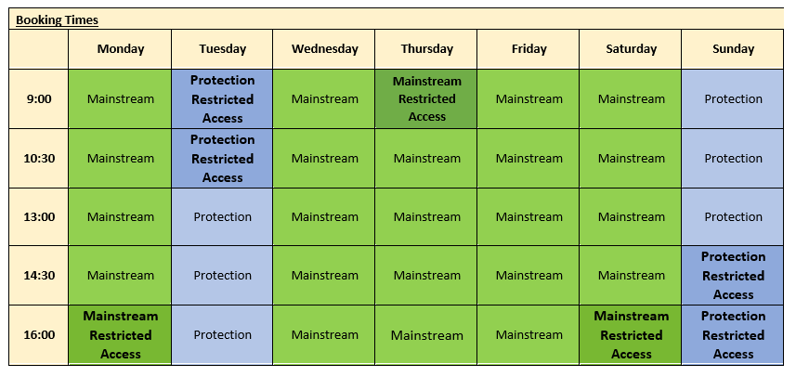

As of the 19th of April, the above schedule is our current contact schedule and can remain for non-contact periods. Current time slots to remain in place however current video visits scheduled for 30 minutes go to 1-hour sessions.
30 tablets available per session. 150 possible visits per day. Prisoners allowed to book 2 visits per week.

Mainstream visits occur Monday, Wednesday, Thursday, Friday and Saturday – as per current regime.
Protection visits occur on Tuesday and Sunday - as per current regime.

Currently we have 15 tablets set up on protection side, continue this and place 15 tablets on mainstream side for operation. 30 in total per session.

General Visiting Conditions
- To visit a prisoner, you must be on their approved list.
- Visitors should attend the centre at least 40 minutes prior to their appointment to allow time for processing.
- If a visitor arrives late, they will need to re-book their visit. Staff cannot guarantee this will be on the same day as original booking.

COVID Visiting Conditions
- You will be required to wear a mask on entry to Ravenhall for the entire duration of the visit.
- Visit canteen will be closed. No food or drink items will be permitted during visit.
- Playground will remain closed.
- A maximum of 2 people (2 adults or 1 adult and 1 child) will be permitted to visit due to social distancing requirements.
- You will be required to remain seated at all times and comply with social distancing requirements.
- Vending machines will not be available.
- Hand sanitiser will be available and you will be encouraged to practise safe hand hygiene.

Identification
Whenever you visit a prison, a total of 100 points of identification is required. If you do not have suitable identification, you will not be able to visit.

If you don't think you can meet these requirements, contact Corrections Victoria on 03 8684 6600.

Prisoner Property
Prisoner property needs to remain in your vehicle or, in the case of using public transport, stored in a locker until after the visit where it can then be retrieved and dropped off at the Mail Room in the Reception Area.

- 3 Pairs of briefs or boxer shorts
- 3 Pairs of socks
- 6 Standard size photographs per visit (no polaroids)
- 2 Pairs of white thermal underwear
- 1 Suit or dress pants, shoes, tie, belt and shirt (for court)

Please note the following:
- Acceptance of all items or property is at the discretion of RCC Staff
- All items must be new with tags and packaging intact. Items cannot have logos on them
Visitor Lockers
Visitor lockers are available for use. Lockers use a $1 coin for operation. Visitors must leave all valuables, phones, keys, etc in lockers whilst at the centre.

Prisoner Money
- Prisoners’ maximum monthly allowance is $190 per calendar month ($140 canteen and $50 for the prisoner phone).
- No cash or money orders will be accepted during COVID, EFT only.

Standards of Behaviour
Persons displaying disrespectful, aggressive or offensive behaviour will not be tolerated and failure to comply may lead to termination of the visit. Intoxicated persons, or persons under the influence of drugs will not be permitted entry.

Conditions of entry
All visitors will be searched on entry to a prison and after registering. Any vehicles entering the prison grounds may also be searched. Details of the search, including your vehicle’s registration number may be collected and recorded by prison authorities. A visitor may be monitored and recorded within the prison grounds including in carparks on prison property. Visitors should also expect that cameras may monitor public areas of prison facilities and that images may be recorded.

By law smoking on all prison grounds is not permitted. Smoking paraphernalia MUST be left in your vehicle glovebox.

Dress Standards
Listed below are examples of proper and improper attire. Suggestive clothing and see-through fabrics will not be allowed. Appropriate underclothing is required.
Standards expected from visitors attending Ravenhall Correctional Centre:
- • NO low cut or revealing skirts, tank tops, shirts, stretch pants or tights
- • NO see through or torn clothes
- • NO shorts, mini-skirts, hats, bandanas, sun visors or scarves (unless of religious significance)
- • NO tight, torn or revealing clothing
- • NO clothing with profane pictures or language
- • NO gang affiliated clothing
- • NO sunglasses, watches or excessive jewellery
- • NO thongs or slides. Shoes must be enclosed or be fastened with a heal strap.

Anyone failing to comply with this dress standard may be denied entry into the prison and have the booked visit cancelled.
