SEPARATION REGIMES
CORRECTIONS VICTORIA – SENTENCE MANAGEMENT DIVISION

SENTENCE MANAGEMENT MANUAL

This Commissioner’s Requirement describes the reasons and procedure for the separation of prisoners.
What

Separation regimes enable Corrections Victoria to ensure that prisoners are accommodated in appropriate environments to manage any risk that they pose to prison security, the community, themselves or any other person.

Why
The Corrections Act 1986, S 21 states:

(1) The Governor of a prison is responsible for the management, security and good order of the prison and the safe custody and welfare of the prisoners.

Corrections Regulations 2019, R 32 states:

(1) The Secretary may, in writing, order the separation of a prisoner from some or all other prisoners if the Secretary believes on reasonable grounds that the separation is necessary—
(a) for the safety and protection of the prisoner; or
(b) for the safety or welfare of any person; or
(c) for the management, good order or security of the prison.

(2) The amount of time a prisoner may be separated from other prisoners must not be longer than is necessary to achieve the purposes set out in subregulation (1)(a) or (b).

(5) Before making an order under subregulation (1) or (3) in relation to a prisoner, the Secretary must consider the following—
(a) any medical and psychiatric conditions of the prisoner;

When

Prisoners are separated when there is a reasonable belief that placement outside a separation regime will pose an unacceptable risk to prison security, the community, the prisoner or any other person.

Who

The Secretary has the power under R 32 to make separation decisions. Specific positions within Corrections Victoria have the authority to separate prisoners into separation regimes pursuant to delegations from the Secretary. These include, but are not limited to, positions within the Sentence Management Division (SMD) and prisons.
The SMD is responsible for reviewing all prisoners who are separated into separation regimes, for longer than seven days.

PM
3
Contents

1. Guiding principle
- Types of separation regimes
2.1 Placement in management or high security units
2.2 Medical/psychiatric observation
3. When is a separation order required?
4. Requesting separation
4.1 Prison management responsibilities
4.2 Sentence Management Division responsibilities
5. Ceasing separation
5.1 Ceasing separation prior to any review by a Sentence Management Panel

6. Review of separated prisoners

Schedules

Schedule PM3.1: Authority to separate a prisoner
Schedule PM3.2: SMO management risk assessment template (Centurion)
Schedule PM3.3: DPFC Management Regime Behavioural Expectations

Related Policy and Procedure

Charter of Human Rights and Responsibilities Act 2006
Corrections Act 1986
Corrections Regulations 2019
United Nations Standard Minimum Rules for the Treatment of Prisoners
Standard Guidelines for Corrections in Australia
Correctional Management Standards for Men’s Prisons in Victoria, 1.3
Correctional Management Standards for Women’s Prisons in Victoria, 1.2
SMM AC 2 - Sentence Management Panels
SMM PM 4 - Long Term Management Placement
SMM PM 5 - Incentive Based Regimes
SMM PM 5A – Incentive Based Regimes – Women’s System
SMM PM 6 - Intermediate Regimes

1. Guiding principle

Prisoners accommodated on a separation regime are managed under the least restrictive conditions consistent with the reasons for the separation and to the extent necessary to minimise the risk associated with that reason.

Staff, in carrying out their duties as described in this procedure, must comply with the provisions of the Charter of Human Rights and Responsibilities Act 2006 (‘the Charter’), ensuring that all prisoners are accorded appropriate human rights as defined by the Charter.

Section 38(1) of the Charter provides, ‘…it is unlawful for a public authority to act in a way that is incompatible with a human right or, in making a decision, to fail to give proper consideration to a relevant human right.’

Charter rights may be limited, but only to the extent that the limitation is reasonable and demonstrably justified. In determining, what is reasonable staff must take into account the nature of the right, the purpose of the limitation and whether there is another way of addressing the requirement which is less restrictive on the prisoner’s human rights.

While some rights will be restricted because a person is imprisoned, the fact that a person is deprived of liberty does not void all rights. The usual Charter tests for determining what is a reasonable limitation on rights will apply.

The Corrections Regulations must be interpreted in light of the Charter. This means that Charter rights must be considered when applying the Regulations. The Charter must therefore be considered whenever a prisoner is separated or reviewed.

In addition, when determining security ratings for prisoners less than 18 years of age, additional rights under the Charter and international law apply. In particular, the best interests of the child are a primary consideration.

2. Types of separation regimes

Corrections Victoria has developed a range of prison units and regimes within prisons and units to provide a range of security, supervision and support requirements. These include:

High security units
Management units and cells
Intermediate regimes
Medical and psychiatric observation

This procedure details the requirements for how prisoners are separated in management units, high security units and for medical and psychiatric observation. Staff should refer to the relevant procedure in relation to the placement of prisoners in intermediate regimes.

In addition to the above regimes, prison management (in accordance with powers available to prison management and officers under sections 20 to 22A of the Corrections Act 1986 have the ability to hold a prisoner in a cell or room to the extent necessary to provide for the safe custody and welfare of prisoners and the security of the prison. Such placements should not exceed 24 hours and justifications for such placements are to be recorded in the prisoner’s Individual Management File (IMF). Situations could include:

- to cool off following a minor altercation that does not require a disciplinary process
- awaiting transfer to another prison
- placement in a safe environment pending appropriate accommodation becoming available
- lock downs caused by staff shortages, security issues, industrial action, etc
- to enable urine samples to be taken in private
- as part of a behavioural management plan.

2.1 Placement in management or high security units

Prisoners may require separation into a high security or management unit or cell:

- following alleged involvement in an incident
- to serve loss of privileges received via a general manager’s disciplinary hearing
- following the receipt of information that they may not be safe
- following the receipt of information that a prisoner poses a risk to the security, good order or management of the prison.

2.2 Medical/psychiatric observation

Prison managers may separate a prisoner pending medical examination where such action is considered necessary. Prison managers must ensure that a prisoner separated for medical supervision is seen by a health professional as soon as possible and within 24 hours. Continuation of the separation is dependent on medical advice.

Any prisoner considered to be ‘at risk’ (i.e. the prisoner is considered to be at immediate or significant risk of suicide or self-harm) must be seen by an appropriate health professional within two hours. A continuation of the placement is subject to the advice of the health professional and decisions of a High Risk Assessment Team (HRAT) or a Risk Review Team (RRT) in accordance with Deputy Commissioner’s Instruction 1.02. Where a prisoner is separated after being assessed as being at high risk due to psychiatric or medical reasons, the prisoner will undergo further assessment before being released from separation.

3. When is a separation order required?

Prison management must complete a separation order in the following situations

To transfer a prisoner into a high security unit
To transfer a prisoner into a management unit or cell
To transfer a prisoner into a medical or psychiatric observation cell
When separating a prisoner in a cell for management reasons where the separation is expected to continue for longer than 24 hours

A separation order is not required in the following situations

Lock downs caused by staff shortages, security issues, industrial action etc
Confining a prisoner in a cell for a short period of time that doesn’t significantly impact on their out of cell hours
When a prisoner identified as a long term management prisoner is transferring between high security or management units

4. Requesting separation

Given the restrictive nature of high security units, management units or cells and observation regimes in placing prisoners in these environments, prison management must complete an ‘authority to separate a prisoner’ - schedule PM3.1, scan and email to DOJ-CV-DUTY DIRECTOR SEPARATIONS (dutydirectorseparations@justice.vic.gov.au) for endorsement by the SMD.

The following positions have the delegation to approve a prisoner’s separation:

- Commissioner, Corrections Victoria
- Deputy Commissioner, Operations
- Deputy Commissioner, Offender Management
- Assistant Commissioner, Sentence Management Division
- Duty Director
- General Manager, Major Offenders Unit
- General Manager, Sentence Management Operations
- Manager, Prisoner Intake and System Flow Unit, Sentence Management Operations
- Manager, Sentence Management Operations
- Manager, Major Offenders Unit
- General Manager of a prison (own location)
- Operations Manager of a prison (own location)
- Supervisor of a prison (own location)

During office hours prison staff should in the first instance contact the duty sentence management manager to discuss the circumstances, which have led to the request being made. A separation order is then completed by the location and forwarded to the SMD for endorsement. Unless the prisoner is serving loss of privileges because of a general manager’s disciplinary hearing the period of initial separation endorsed must not exceed seven days.

Outside office hours an initial request may be made verbally to the after-hours Corrections Victoria Duty Director, who will provide written advice to the SMD regarding the after-hours separations. Locations are still required to complete a separation order, which is forwarded to Sentence Management Operations (SMO). Based on the advice of the Duty Director, the SMO duty manager will endorse the separation order and return the endorsed copy to the originating prison location.

The separated prisoner must be advised of the reasons for the separation and a copy of the separation order must be given to the prisoner within 12 hours of separation. In the event that a prisoner declines to accept the copy of the order, an endorsement to that effect should be made on the order which is then to be placed on the prisoner’s IMF. The original (prison copy) of the ‘Authority to Separate a Prisoner’ and the faxed copy of the ‘Authority to Separate a Prisoner’ (signed and endorsed by Sentence Management Division) will be placed on the prisoner’s IMF. In addition, prison locations must keep copies centrally. Copies of the documents will be kept by SMD to provide an audit trail.

The prisoner’s new location must be entered into the Prison Information Management System (PIMS) or E*Justice on the same day, along with details of any incident that caused the separation. Where the incident or separation occurred after hours the PIMS entry should be made within 12 hours where practicable.

  - Prison management responsibilities

- Prison management must:

Consider any medical and psychiatric conditions of the prisoner. If the prisoner is under the age of 18, consider the best interest of the prisoner and the vulnerability of the prisoner (if reasonably practicable).
Contact SMD for endorsement of any separation during business hours or Duty Director for separations occurring after hours
Complete a separation order
Advise the prisoner of the reasons for separation (within 12 hours of initial separation) and provide a copy of the separation order
Forward a copy of the separation order to the SMD
Maintain a record of all separation orders completed at their location
Attach a copy of the separation order to the relevant section of the prisoners’ IMF
Regularly audit IMFs to ensure all documentation is contained in the files
Have a compliance framework to validate that the advisory visit and a copy of the separation order have been provided to the prisoner.

4.2 Sentence Management Division responsibilities

Consider any medical and psychiatric conditions of the prisoner. If the prisoner is under the age of 18, consider the best interest of the prisoner and the vulnerability of the prisoner (if reasonably practicable).
Review and endorse received separation orders
Forward a copy of the endorsed separation order to the location seeking the separation
Review all prisoners separated into high security and management unit or cells within 8 days of their separation (except if a prisoner is separated for a period of less than 7 days)
Maintain a record of all separation orders endorsed
Maintain a separations register recording details of the separation including: date of separation, date the order was received, completion of advisory check, whether a copy of the order has been given to the prisoner and date it was faxed back to the location
Notify the Chief Practitioner, Child Protection and Youth Justice, Department of Health and Human Services and Victorian Ombudsman if the prisoner separated is under the age of 18 years.

5. Ceasing separation

Separation ceases when

- a classification decision is made by a Sentence Management Panel (SMP), or
- an officer with a delegation from the Secretary authorises the suspension of separation, or
- the separation was made on the basis of a short term prisoner-management issue and the prisoner has been returned to their normal routine associating with other prisoners, prior to a Sentence Management review of the circumstances (refer 5.1), or
- any term imposed as a result of a Governor’s disciplinary hearing (section 53 of the Corrections Act 1986) has expired, or
- the separation was made after an assessment that a prisoner was at risk of self-harm, and the prisoner has been declared to be no longer at risk and returned to their normal routine associating with other prisoners, by a HRAT or RRT (refer 2.2).

5.1 Ceasing separation prior to any review by a Sentence Management Panel

The prison is to contact the relevant SMD portfolio manager or any senior SMD manager to inform them of the decision to cease separation and to seek verbal agreement.

The prison is to conduct a Case Management Review Committee (CMRC) meeting recommending reclassification. This reason then triggers an outcome of the meeting to the SMP. The text body should reflect the reasons for the initial separation and recommendations for clearance. The SMD portfolio holder will then respond, approving the recommendation of the CMRC.

Where a prisoner is separated for psychiatric reasons only and is later cleared, the HRAT process sets out a clear audit trail and therefore no CMRC meeting is required to reflect the transfer.

6. Review of separated prisoners

The SMD is responsible for ensuring that prisoners are reviewed with a frequency and process appropriate to their age, the restrictions and risks of their placement and security. In order to facilitate this, staff from the SMD, including representatives from the Major Offenders Unit, attend high-security and management units in Barwon, Ravenhall Correctional Centre, Port Phillip Prison, Metropolitan Remand Centre and the Dame Phyllis Frost Centre weekly.

In situations where prisoners are separated into high security or management unit or cells, Sentence Management staff must conduct a SMP that includes the prisoner and prison staff within eight days of the date they were separated (schedule PM3.2). Prisoners under the age of 18 must be reviewed weekly. This panel is to review the circumstances of the separation and consider the placement of the prisoner. The panel is responsible for determining whether ongoing separation or an alternative placement is required. Where the prisoner is accommodated in a country management unit the portfolio holder must either conduct the panel within this timeframe at the location, or conduct the panel by teleconference or videoconference. In addition, for prisoners separated on an observation regime, if the continuous period of separation exceeds seven days, they are required to be reviewed by a SMP within eight days of the date of initial separation. The SMP is required to consult with the relevant clinical and prison staff.

Separation review SMP must:

Make appropriate introductions and clearly explain the purpose of the interview
Ensure the prisoner understands the reason for their separation
Use interpreters when the prisoner has difficulties understanding English or has a hearing disability
Liaise with disability prison program staff regarding the placement of prisoners with a cognitive impairment
For Indigenous prisoners, offer for a support person to be present during the interview (AWO or ALO)
For female prisoners, discuss the Behavioural Management Document Schedule PM3.3
Classify the prisoner, including determination of future review dates
Update the prisoner risks and recommended actions as required
Consider any run out requests (or refer to the High Risk Management Advisory Panel)
Review the Incentive Based Regime
Ensure relevant separation documentation is contained in the prisoner’s IMF
Enter decision in PIMS using the appropriate risk assessment template
Forward a signed copy of the panel’s decision and all relevant documentation to the prison location

A SMP can only classify a prisoner to remain in a high security or management unit or cell for a period of up to 30 days. If a SMP believes that the prisoner poses a risk to prison security, the community, themselves or any other person if not accommodated in a high security or management unit, a long term management recommendation report must be approved within 30 days of the prisoner’s initial separation (refer to PM4 – Long Term Management Placement).

A long term management recommendation report is not required for those prisoners who have been cleared from management and classified to an alternate placement, however exceed 30 days in a high security or management unit or cell due to a lack of vacancies at their classified location. In these cases, Sentence Management must review the prisoner on a fortnightly basis, until transfer to their classified location occurs. These reviews will monitor the prisoner’s progress and assess their suitability to transfer to their classified location. Sentence Management will also continue to liaise with escort staff to expedite their transfer.

In completing reviews of separated prisoners the chairperson of the SMP must complete the risk assessment template (schedule PM3.2), which is recorded in PIMS and a signed copy forwarded to the prison location for attachment in the appropriate section of the prisoner’s IMF.

Schedules

The following schedules are attached:

Schedule PM3.1: Authority to separate a prisoner
Schedule PM3.2: SMO Management Risk Assessment Template (Centurion)
Schedule PM3.3: Behavioural Management Document (Female Prisoners)
Schedule PM3.1
AUTHORITY TO SEPARATE A PRISONER
Sections 20 and 56, Corrections Act 1986; Regulations 32, Corrections Regulations 2019

(1) REASON FOR SEPARATION
Prisoner’s Full Name |  | Prisoner’s CRN
Prison location |  | Current Accommodation

DESCRIPTION OF SITUATION LEADING TO THIS SEPARATION

IT IS NOW NECESSARY FOR THE ABOVE PRISONER TO BE SEPARATED FOR THE (tick one):

Safety of the prisoner |  | Safety of other persons |  | Management of the prison
Security of the prison |  | Good order of the prison |  | Loss of privileges

(SECTION 1) APPROVAL BY OPERATIONS MANAGER, MANAGER, SUPERVISOR OR OIC OF PRISON
Name (printed) | Signature | Title | Date & Time

(2) ADVISORY VISIT
□ Copy of order given to the prisoner and reasons of separation explained to the prisoner.

□ Copy of order NOT given to the prisoner. Reasons Why.

( SECTION 2) ENDORSE BY OPERATIONS MANAGER, MANAGER, SUPERVISOR OR OIC OF PRISON
Name (printed) | Signature | Date & Time
ON COMPLETION OF SECTION 1 & 2 PLEASE SCAN FORM AND EMAIL TO dutydirectorseparations@justice.vic.gov.au

(3) ENDORSEMENT BY SENTENCE MANAGEMENT DIVISION
(Section 3) Endorsement by Delegated Officer- Sentence Management Division
PERIOD OF SEPARATION | days |  | LOCATION IN WHICH TO BE SEPARATED

Comment
Name (printed) |  | Signature |  |  | Title | Date
□ Upon endorsement this form is to be faxed to the location requesting the separation and placed on prisoner’s IMF.

Schedule PM3.2
SMU Management Assessment Template

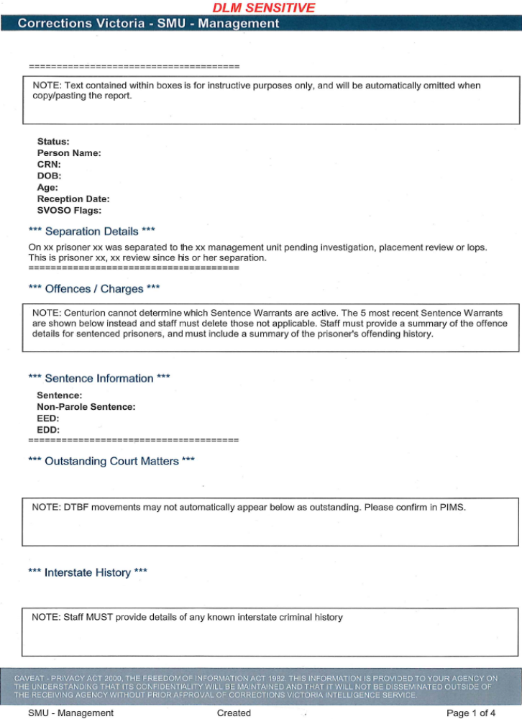

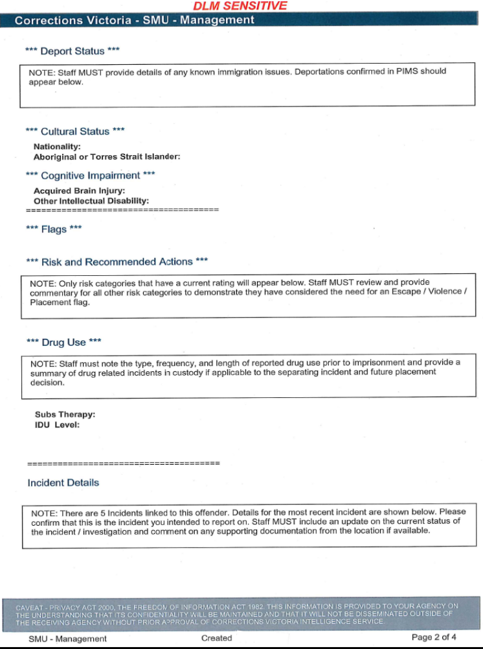

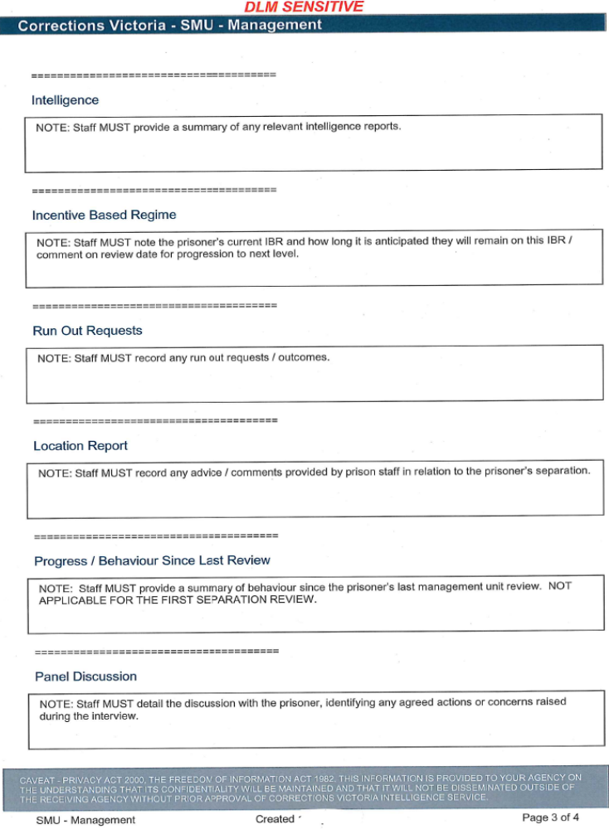

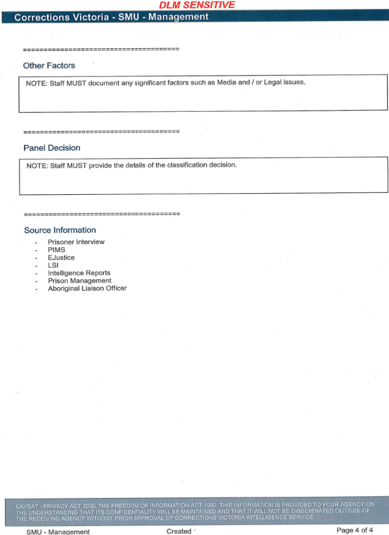
Schedule PM3.3



