**Report on Prohibited Drug Use and   
Contraband Seized in Victorian Prisons**

**2020-2021**

**Drugs in Victorian Prisons Report**

**August 2020**



Corrections Victoria

The System Performance Branch produces the Drugs in Victorian Prisons Report (DIVPR) each month to provide data pertaining to drug use – both illicit use and prescription misuse - and contraband seizures in Victorian prisons. The report is provided on a monthly basis, and is made available to selected stakeholders, such as the Assistant Commissioner Security and Intelligence Division, Deputy Commissioner Custodial Operations, General Manager Security and Emergency Services Group, General Manager Corrections Victoria Intelligence Unit, and Prison General Managers.

The report is designed to provide information for consideration of action, including the deployment of resources to detect and reduce drugs in Victorian prisons.

The DIVPR specifically compiles and presents data in the following areas:

* + - * drug test results for Random General and Targeted testing,
      * types of drugs identified through drug testing,
      * seizures of contraband from visitors and prisoners

The first section of the DIVPR provides a statewide overview of the above data, with the second section providing location specific data. In a bid to include details of all drug test results from the preceding month, compilation does not commence until after the 15th day of the following month. Information is provided by Prison Intelligence Units (seizures), the Drug Strategy Support Team (drug metabolite breakdowns), as well as the Monitoring, Standards and Reporting Unit (Random General – SDO8 data).

As of February 2019, Corrections Victoria amended its data reporting so that Methamphetamines (ie ICE) was reported separately to Amphetamines (a broader drug group). However, Amphetamines are present in the majority of ICE positives due to the way the drug is manufactured and how it metabolises within the body. As such, the number of Amphetamine positives may be overrepresented.

After a successful trial, Corrections Victoria has implemented saliva testing in the women’s prison system as part of its commitment to reducing the volume of strip searches conducted. Saliva testing has replaced most urine testing with an initial saliva test at the Dame Phyllis Frost Centre and Tarrengower Prison. Due to the need for confirmatory testing, any prisoner returning a positive result on a saliva test will be directed to complete a urine test. The saliva swabs are identical to those used by Victoria Police in roadside testing, but with additional testing for buprenorphine and methadone.

Due to the global COVID-19 pandemic, all personal visits to prisoners ceased from late March 2020. As a result, this no longer is an avenue for the introduction of contraband. However, we have seen an increase in the number of attempts by prisoners to introduce contraband through the mail and over the prison walls.

In addition, prisoners are currently required to be quarantined for 14 days upon reception into the prison system and are exempt from undertaking urinalysis testing during this time, for safety reasons.

**Table of Contents**

Statewide Overview 5

**Drug Test Results: 2020-2021** 5

**Targeted and Random General Overview** 6

**Graph of Targeted and Random General Drug Test Positives & Equivalents 2020-2021** 7

**Targeted and Random General Drug Test Positives & Equivalents: 2020-2021** 8

**Location Muster against Drug Tests Collected and % Positive** 9

Drugs Identified Through Drug Testing 10

**Positive Drug Test Results by Drug Type per Prison Location: August 2020** 10

**Graph of Positive Drug Test Results: Drug Type by Prison: August 2020** 11

**Year to Date Comparison - Current Financial Year and Previous Financial Years** 12

**Breakdown of Amphetamine & Opiate Drug Groups by Metabolite – 2020-2021** 13

**Positive by Location: YTD 2020-2021** 14

**Percentage Positive by Location: YTD 2020-2021** 15

Seizures of Contraband by Item Type 16

**Visitors – August 2020** 16

**Seizures of Contraband: Visitors - YTD 2020-2021** 17

**Graphs of Seizures of Contraband: Visitors – August 2020 & YTD 2020-2021** 18

**Seizures of Contraband: Prisoners – August 2020** 19

**Seizures of Contraband: Prisoners – YTD 2020-2021** 20

**Graphs of Seizures of Contraband: Prisoners – August 2020 & YTD 2020-2021** 21

LOCATION SPECIFIC RESULTS 22

**Barwon Prison** 23

**Melbourne Assessment Prison** 28

**Metropolitan Remand Centre** 33

**Port Phillip Prison** 38

**Dame Phyllis Frost Centre** 43

**Fulham Correctional Centre** 48

**Hopkins Correctional Centre** 53

**Karreenga (annex of Marngoneet)** 58

**Marngoneet Correctional Centre** 63

**Loddon Prison** 68

**Middleton (annex of Loddon)** 73

**Ravenhall Correctional Centre** 78

**Beechworth Correctional Centre** 83

**Dhurringile Prison** 88

**Langi Kal Kal Prison** 93

**Tarrengower Prison** 98

**Judy Lazarus Transition Centre** 103

## **Statewide Overview**

### **Drug Test Results: 2020-2021**

***Random General Positive Rate***

As at 15 September 2020, the number of Random General drug test samples collected in August was 862, of which 2.32% were positive.   
This is in comparison to the previous month, whereby 748 Random General tests were collected, of which 1.74% were positive.

* The following locations exceeded their Random General benchmark for the month of August 2020:
  + - Melbourne Assessment Prison, and
    - Middleton.
* The 2020-2021 Random General positive rate across all locations is 2.05%, with the following location exceeding their benchmark for the year:
  + - Melbourne Assessment Prison.

***Targeted Positive Rate***

The number of Targeted drug tests collected in August was 1,389 of which 4.39% were positive.

This is in comparison to the previous month, whereby 1,432 Targeted drug tests were collected, of which 7.33% were positive.

* The following locations had the highest Targeted positive rates for the month of August 2020:
  + - Hopkins Correctional Centre, and
    - Beechworth Correctional Centre.
* The 2020-2021 Targeted positive rate across all locations is 5.88%, with the following locations having the highest Targeted positive rates for the year:
  + - Hopkins Correctional Centre, and
    - Middleton.

Targeted testing is used by intelligence officers to identify and intervene in use, and a high positive rate may therefore indicate well directed intelligence.

***Note:*** *The Commissioner defines a Random General positive as positives, refusals, and unables found guilty at a GMDH, as well as interfered and adulterated results. Random General data is provided by the Monitoring, Standards and Reporting Unit, with adjustments reflected in the following reporting month. August data provided 15 September 2020.   
Targeted and Positive Results by Drug Type are retrieved from PIMS by the Monitoring, Standards and Reporting Unit. August data provided 16 September 2020.*

### **Targeted and Random General Overview**

|  |  |  |  |  |  |  |  |  |  |  |  |  |  |
| --- | --- | --- | --- | --- | --- | --- | --- | --- | --- | --- | --- | --- | --- |
| **TARGETED** | **Jul-20** | **Aug-20** | **Sep-20** | **Oct-20** | **Nov-20** | **Dec-20** | **Jan-21** | **Feb-21** | **Mar-21** | **Apr-21** | **May-21** | **Jun-21** | **YTD Av.** |
| **Barwon** | **9.43%** | **7.69%** |  |  |  |  |  |  |  |  |  |  | **8.77%** |
| **MAP** | **0.00%** | **0.00%** |  |  |  |  |  |  |  |  |  |  | **0.00%** |
| **MRC** | **4.88%** | **2.72%** |  |  |  |  |  |  |  |  |  |  | **3.86%** |
| **PPP** | **8.77%** | **6.02%** |  |  |  |  |  |  |  |  |  |  | **7.54%** |
| **DPFC** | **3.57%** | **6.45%** |  |  |  |  |  |  |  |  |  |  | **5.08%** |
| **Fulham** | **6.19%** | **1.11%** |  |  |  |  |  |  |  |  |  |  | **3.74%** |
| **Hopkins** | **11.11%** | **22.22%** |  |  |  |  |  |  |  |  |  |  | **16.67%** |
| **Karreenga** | **7.14%** | **0.00%** |  |  |  |  |  |  |  |  |  |  | **4.55%** |
| **Marngoneet** | **6.25%** | **2.63%** |  |  |  |  |  |  |  |  |  |  | **4.29%** |
| **Loddon** | **0.00%** | **5.88%** |  |  |  |  |  |  |  |  |  |  | **3.06%** |
| **Middleton** | **20.00%** | **6.90%** |  |  |  |  |  |  |  |  |  |  | **12.96%** |
| **Ravenhall** | **9.34%** | **4.15%** |  |  |  |  |  |  |  |  |  |  | **6.66%** |
| **Beechworth** | **7.14%** | **9.09%** |  |  |  |  |  |  |  |  |  |  | **8.51%** |
| **Dhurringile** | **1.85%** | **1.77%** |  |  |  |  |  |  |  |  |  |  | **1.81%** |
| **Langi Kal Kal** | **0.00%** | **0.00%** |  |  |  |  |  |  |  |  |  |  | **0.00%** |
| **Tarrengower** | **0.00%** | **0.00%** |  |  |  |  |  |  |  |  |  |  | **0.00%** |
| **JLTC** | **0.00%** | **0.00%** |  |  |  |  |  |  |  |  |  |  | **0.00%** |
| **Targeted % Positive** | **7.33%** | **4.39%** | **#N/A** | **#N/A** | **#N/A** | **#N/A** | **#N/A** | **#N/A** | **#N/A** | **#N/A** | **#N/A** | **#N/A** | **5.88%** |
|  |  |  |  |  |  |  |  |  |  |  |  |  |  |
| **RANDOM - Benchmark** | **Jul-20** | **Aug-20** | **Sep-20** | **Oct-20** | **Nov-20** | **Dec-20** | **Jan-21** | **Feb-21** | **Mar-21** | **Apr-21** | **May-21** | **Jun-21** | **YTD Av.** |
| **Barwon - 8.25%** | **4.65%** | **3.64%** |  |  |  |  |  |  |  |  |  |  | **4.08%** |
| **MAP - 8.00%** | **11.11%** | **9.09%** |  |  |  |  |  |  |  |  |  |  | **10.00%** |
| **MRC - 7.00%** | **0.00%** | **6.17%** |  |  |  |  |  |  |  |  |  |  | **3.29%** |
| **PPP** | **0.00%** | **4.00%** |  |  |  |  |  |  |  |  |  |  | **2.15%** |
| **DPFC – 6.00%** | **0.00%** | **0.00%** |  |  |  |  |  |  |  |  |  |  | **0.00%** |
| **Fulham** | **0.00%** | **0.00%** |  |  |  |  |  |  |  |  |  |  | **0.00%** |
| **Hopkins - 3.50%** | **3.45%** | **0.91%** |  |  |  |  |  |  |  |  |  |  | **2.03%** |
| **Karreenga - 3.50%** | **0.00%** | **0.00%** |  |  |  |  |  |  |  |  |  |  | **0.00%** |
| **Marngoneet – 7.00%** | **0.00%** | **4.41%** |  |  |  |  |  |  |  |  |  |  | **2.33%** |
| **Loddon - 5.00%** | **2.08%** | **0.00%** |  |  |  |  |  |  |  |  |  |  | **1.08%** |
| **Middleton - 4.00%** | **0.00%** | **6.06%** |  |  |  |  |  |  |  |  |  |  | **3.23%** |
| **Ravenhall** | **3.97%** | **2.63%** |  |  |  |  |  |  |  |  |  |  | **3.24%** |
| **Beechworth - 1.80%** | **0.00%** | **0.00%** |  |  |  |  |  |  |  |  |  |  | **0.00%** |
| **Dhurringile - 3.50%** | **3.57%** | **0.00%** |  |  |  |  |  |  |  |  |  |  | **1.85%** |
| **Langi Kal Kal - 1.50%** | **0.00%** | **0.00%** |  |  |  |  |  |  |  |  |  |  | **0.00%** |
| **Tarrengower - 1.50%** | **0.00%** | **0.00%** |  |  |  |  |  |  |  |  |  |  | **0.00%** |
| **JLTC - 3.50%** | **0.00%** | **0.00%** |  |  |  |  |  |  |  |  |  |  | **0.00%** |
| **Random % Positive** | **1.74%** | **2.32%** | **#N/A** | **#N/A** | **#N/A** | **#N/A** | **#N/A** | **#N/A** | **#N/A** | **#N/A** | **#N/A** | **#N/A** |  |
| **Random YTD % Positive** | **1.74%** | **2.05%** | **#N/A** | **#N/A** | **#N/A** | **#N/A** | **#N/A** | **#N/A** | **#N/A** | **#N/A** | **#N/A** | **#N/A** | **2.05%** |

### **Graph of Targeted and Random General Drug Test Positives & Equivalents 2020-2021**

### **Targeted and Random General Drug Test Positives & Equivalents: 2020-2021**

|  |  |  |  |  |  |  |  |  |  |  |  |  |  |  |
| --- | --- | --- | --- | --- | --- | --- | --- | --- | --- | --- | --- | --- | --- | --- |
| Corrections Victoria | **Jul-20** | **Aug-20** | **Sep-20** | **Oct-20** | **Nov-20** | **Dec-20** | **Jan-21** | **Feb-21** | **Mar-21** | **Apr-21** | **May-21** | **Jun-21** | YTD Average | YTD Totals |
| **Targeted - Tests Collected** | **1,432** | **1,386** |  |  |  |  |  |  |  |  |  |  | **1,409** | **2,818** |
| **Tested Positive** | **67** | **33** |  |  |  |  |  |  |  |  |  |  | **50** | **100** |
| **Refusal** | **11** | **9** |  |  |  |  |  |  |  |  |  |  | **10** | **20** |
| **Unable - Guilty** | **25** | **17** |  |  |  |  |  |  |  |  |  |  | **21** | **42** |
| **Interfered** | **1** | **2** |  |  |  |  |  |  |  |  |  |  | **2** | **3** |
| **Adulterated** | **1** | **0** |  |  |  |  |  |  |  |  |  |  | **1** | **1** |
| **Awaiting / Pending Results** | **0** | **3** |  |  |  |  |  |  |  |  |  |  | **2** | **3** |
| **Targeted - Effective Sample** | **1,432** | **1,389** |  |  |  |  |  |  |  |  |  |  | **1,411** | **2,821** |
| **Targeted % Positives and Equivalents** | **7.33%** | **4.39%** | **#N/A** | **#N/A** | **#N/A** | **#N/A** | **#N/A** | **#N/A** | **#N/A** | **#N/A** | **#N/A** | **#N/A** | **5.88%** | **5.88%** |
| **Random General - Tests Collected** | **739** | **845** |  |  |  |  |  |  |  |  |  |  | **792** | **1,584** |
| **Tested Positive** | **4** | **3** |  |  |  |  |  |  |  |  |  |  | **4** | **7** |
| **Refusal** | **2** | **10** |  |  |  |  |  |  |  |  |  |  | **6** | **12** |
| **Unable - Guilty** | **6** | **5** |  |  |  |  |  |  |  |  |  |  | **6** | **11** |
| **Interfered** | **0** | **0** |  |  |  |  |  |  |  |  |  |  | **0** | **0** |
| **No test - No Valid Reason** | **1** | **2** |  |  |  |  |  |  |  |  |  |  | **2** | **3** |
| **Adulterated** | **0** | **0** |  |  |  |  |  |  |  |  |  |  | **0** | **0** |
| **Awaiting / Pending Results** | **0** | **39** |  |  |  |  |  |  |  |  |  |  | **20** | **39** |
| **Random General - Effective Sample** | **748** | **862** |  |  |  |  |  |  |  |  |  |  | **805** | **1,610** |
| **SDO8 Positives & Equivalents** | **13** | **20** |  |  |  |  |  |  |  |  |  |  | **17** | **33** |
| **% Failures for SDO8 - Monthly** | **1.74%** | **2.32%** | **#N/A** | **#N/A** | **#N/A** | **#N/A** | **#N/A** | **#N/A** | **#N/A** | **#N/A** | **#N/A** | **#N/A** | **2.05%** |  |
| **% Failures for SDO8 - YTD** | **1.74%** | **2.05%** | **#N/A** | **#N/A** | **#N/A** | **#N/A** | **#N/A** | **#N/A** | **#N/A** | **#N/A** | **#N/A** | **#N/A** |  | **2.05%** |
| ***Random Objective 5.00%*** | ***5.00%*** | ***5.00%*** | ***5.00%*** | ***5.00%*** | ***5.00%*** | ***5.00%*** | ***5.00%*** | ***5.00%*** | ***5.00%*** | ***5.00%*** | ***5.00%*** | ***5.00%*** |  |  |

### **Location Muster against Drug Tests Collected and % Positive**

This data compares the number of Targeted and Random General tests collected and the percentage of the prison population tested for the month in comparison  
to the previous month.

It further provides the percentage of positives for both the Targeted and Random General urinalysis testing regimes.

|  |  |  |  |  |  |  |  |  |  |  |  |  |  |  |
| --- | --- | --- | --- | --- | --- | --- | --- | --- | --- | --- | --- | --- | --- | --- |
| **August 2020 - Location Muster Against Tests Collected  Targeted & Random General** | | | | | | | | | | **July 2020 - Location Muster Against Tests Collected  Targeted & Random General** | | | | |
|  |  | **Targeted** | | | | **Random General** | | | |  | **Targeted** | | **Random General** | |
| **Location** | **Average Monthly Muster** | **Targeted Tests Collected** | **% of Population** | **% Positive** | **No. of Tests YTD** | **Random General Tests Collected** | **% of Population** | **% Positive** | **No. of Tests YTD** | **Average Monthly Muster** | **Targeted Tests Collected** | **% Positive** | **Random General Tests Collected** | **% Positive** |
| **Barwon** | **356** | **65** | **18.26%** | **7.69%** | **171** | **53** | **14.89%** | **3.64%** | **96** | **365** | **106** | **9.43%** | **43** | **4.65%** |
| **MAP** | **166** | **0** | **0.00%** | **0.00%** | **5** | **10** | **6.02%** | **9.09%** | **18** | **156** | **5** | **0.00%** | **8** | **11.11%** |
| **MRC** | **710** | **147** | **20.70%** | **2.72%** | **311** | **76** | **10.70%** | **6.17%** | **147** | **692** | **164** | **4.88%** | **71** | **0.00%** |
| **PPP** | **858** | **249** | **29.02%** | **6.02%** | **557** | **49** | **5.71%** | **4.00%** | **92** | **827** | **308** | **8.77%** | **43** | **0.00%** |
| **DPFC** | **341** | **62** | **18.18%** | **6.45%** | **118** | **44** | **12.90%** | **0.00%** | **81** | **338** | **56** | **3.57%** | **37** | **0.00%** |
| **Fulham** | **668** | **90** | **13.47%** | **1.11%** | **187** | **62** | **9.28%** | **0.00%** | **118** | **708** | **97** | **6.19%** | **56** | **0.00%** |
| **Hopkins** | **730** | **9** | **1.23%** | **22.22%** | **18** | **110** | **15.07%** | **0.91%** | **195** | **745** | **9** | **11.11%** | **85** | **3.45%** |
| **Karreenga** | **236** | **8** | **3.39%** | **0.00%** | **22** | **31** | **13.14%** | **0.00%** | **63** | **240** | **14** | **7.14%** | **32** | **0.00%** |
| **Marngoneet** | **476** | **76** | **15.97%** | **2.63%** | **140** | **66** | **13.87%** | **4.41%** | **127** | **495** | **64** | **6.25%** | **61** | **0.00%** |
| **Loddon** | **356** | **51** | **14.33%** | **5.88%** | **98** | **45** | **12.64%** | **0.00%** | **92** | **376** | **47** | **0.00%** | **47** | **2.08%** |
| **Middleton** | **227** | **29** | **12.78%** | **6.90%** | **54** | **31** | **13.66%** | **6.06%** | **60** | **228** | **25** | **20.00%** | **29** | **0.00%** |
| **Ravenhall** | **1,064** | **434** | **40.79%** | **4.15%** | **841** | **148** | **13.91%** | **2.63%** | **269** | **1,071** | **407** | **9.34%** | **121** | **3.97%** |
| **Beechworth** | **173** | **33** | **19.08%** | **9.09%** | **47** | **29** | **16.76%** | **0.00%** | **53** | **182** | **14** | **7.14%** | **24** | **0.00%** |
| **Dhurringile** | **196** | **113** | **57.65%** | **1.77%** | **221** | **26** | **13.27%** | **0.00%** | **54** | **216** | **108** | **1.85%** | **28** | **3.57%** |
| **Langi Kal Kal** | **357** | **19** | **5.32%** | **0.00%** | **26** | **55** | **15.41%** | **0.00%** | **98** | **354** | **7** | **0.00%** | **43** | **0.00%** |
| **Tarrengower** | **54** | **4** | **7.41%** | **0.00%** | **5** | **6** | **11.11%** | **0.00%** | **13** | **57** | **1** | **0.00%** | **7** | **0.00%** |
| **JLTC** | **11** | **0** | **0.00%** | **0.00%** | **0** | **4** | **36.36%** | **0.00%** | **8** | **11** | **0** | **0.00%** | **4** | **0.00%** |
|  | **6,979** | **1,389** |  |  |  | **845** |  |  |  | **7,061** | **1,432** |  | **739** |  |

## **Drugs Identified Through Drug Testing**

### **Positive Drug Test Results by Drug Type per Prison Location: August 2020**



***ADP*, APS* & NOA* medication only included on standard testing panel for particular private prisons – remaining prisons can request inclusion***

***Ethanol** & Steroids** – tested upon request***

### **Graph of Positive Drug Test Results: Drug Type by Prison: August 2020**

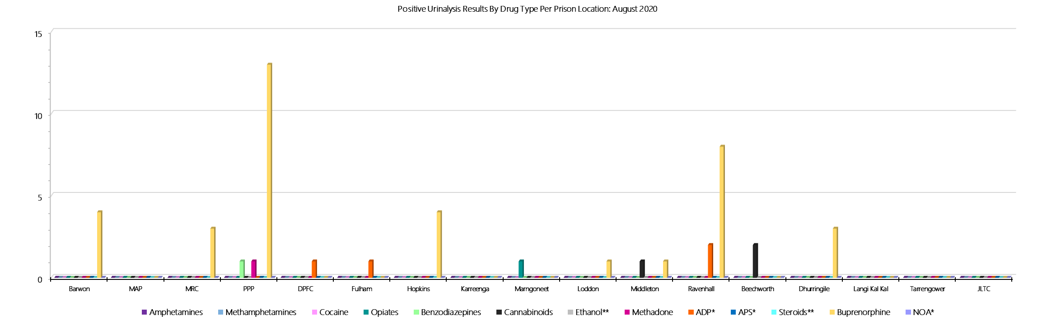

***ADP*, APS* & NOA* medication only included on standard testing panel for particular private prisons – remaining prisons can request inclusion***

***Ethanol** & Steroids** – tested upon request***

***Drugs Identified Through Drug Testing***

### **Year to Date Comparison - Current Financial Year and Previous Financial Years**



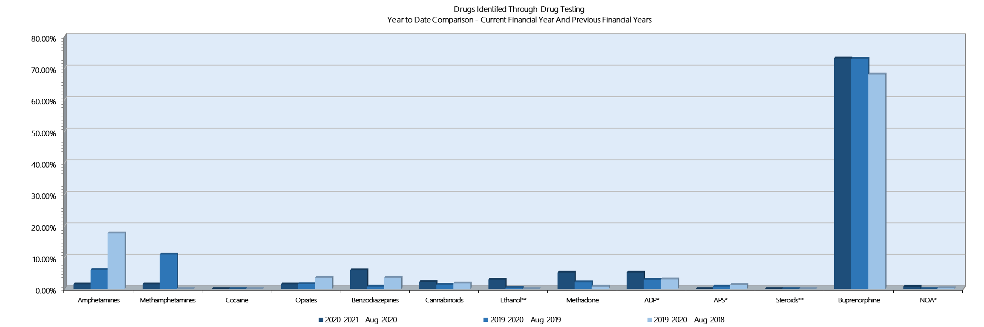

***ADP*, APS* & NOA* medication only included on standard testing panel for particular private prisons – remaining prisons can request inclusion***

***Ethanol** & Steroids** – tested upon request***

***Drugs Identified Through Testing***

### **Breakdown of Amphetamine & Opiate Drug Groups by Metabolite – 2020-2021**



*August data retrieved 16 September 2020. Results prepared in conjunction with Dorevitch pathology and in accordance with Australian testing methodology.*

***Drugs Identified Through Testing***

### **Positive by Location: YTD 2020-2021**



***Drugs Identified Through Testing:***

### **Percentage Positive by Location: YTD 2020-2021**



## **Seizures of Contraband by Item Type**

### **Visitors – August 2020**

|  |  |  |  |  |  |  |  |  |  |  |  |  |  |  |  |  |  |  |  |  |  |  |  |  |
| --- | --- | --- | --- | --- | --- | --- | --- | --- | --- | --- | --- | --- | --- | --- | --- | --- | --- | --- | --- | --- | --- | --- | --- | --- |
| **Visitors** | **GVM** | | **Powder & Crystal** | | **Synthetic (Suspected)** | | **Prescription Medication** | | **Buprenorphine** | | **Alcohol & Home Brew** | | **Syringes & Needles** | | **Smoking Paraphernalia** | | **Edged Weapons** | | **Electronic Devices** | | **Tools** | | **Other** | |
| **August 2020** | **Finds** | **Gms** | **Finds** | **Gms** | **Finds** | **Gms** | **Finds** | **Qty** | **Finds** | **Qty** | **Finds** | **Ltrs** | **Finds** | **Qty** | **Finds** | **Qty** | **Finds** | **Qty** | **Finds** | **Qty** | **Finds** | **Qty** | **Finds** | **Qty** |
| **Barwon** | **0** | **0.00** | **0** | **0.00** | **0** | **0.00** | **0** | **0.00** | **1** | **30.00** | **0** | **0.000** | **0** | **0** | **0** | **0** | **0** | **0** | **0** | **0** | **0** | **0** | **2** | **2** |
| **MAP** | **0** | **0.00** | **0** | **0.00** | **0** | **0.00** | **0** | **0.00** | **0** | **0.00** | **0** | **0.000** | **0** | **0** | **0** | **0** | **0** | **0** | **0** | **0** | **0** | **0** | **0** | **0** |
| **MRC** | **0** | **0.00** | **0** | **0.00** | **0** | **0.00** | **0** | **0.00** | **1** | **5.00** | **0** | **0.000** | **0** | **0** | **0** | **0** | **0** | **0** | **0** | **0** | **0** | **0** | **0** | **0** |
| **PPP** | **0** | **0.00** | **0** | **0.00** | **0** | **0.00** | **0** | **0.00** | **2** | **95.00** | **0** | **0.000** | **0** | **0** | **0** | **0** | **0** | **0** | **0** | **0** | **0** | **0** | **0** | **0** |
| **DPFC** | **0** | **0.00** | **0** | **0.00** | **0** | **0.00** | **0** | **0.00** | **0** | **0.00** | **0** | **0.000** | **0** | **0** | **0** | **0** | **0** | **0** | **0** | **0** | **0** | **0** | **0** | **0** |
| **Fulham** | **0** | **0.00** | **0** | **0.00** | **0** | **0.00** | **1** | **3.00** | **0** | **0.00** | **0** | **0.000** | **0** | **0** | **0** | **0** | **0** | **0** | **0** | **0** | **0** | **0** | **0** | **0** |
| **Hopkins** | **0** | **0.00** | **0** | **0.00** | **0** | **0.00** | **0** | **0.00** | **0** | **0.00** | **0** | **0.000** | **0** | **0** | **0** | **0** | **0** | **0** | **0** | **0** | **0** | **0** | **0** | **0** |
| **Karreenga** | **0** | **0.00** | **0** | **0.00** | **0** | **0.00** | **0** | **0.00** | **0** | **0.00** | **0** | **0.000** | **0** | **0** | **0** | **0** | **0** | **0** | **0** | **0** | **0** | **0** | **0** | **0** |
| **Marngoneet** | **0** | **0.00** | **0** | **0.00** | **0** | **0.00** | **0** | **0.00** | **0** | **0.00** | **0** | **0.000** | **0** | **0** | **0** | **0** | **0** | **0** | **0** | **0** | **0** | **0** | **0** | **0** |
| **Loddon** | **0** | **0.00** | **0** | **0.00** | **0** | **0.00** | **0** | **0.00** | **0** | **0.00** | **0** | **0.000** | **0** | **0** | **0** | **0** | **0** | **0** | **0** | **0** | **0** | **0** | **0** | **0** |
| **Middleton** | **0** | **0.00** | **0** | **0.00** | **0** | **0.00** | **0** | **0.00** | **0** | **0.00** | **0** | **0.000** | **0** | **0** | **0** | **0** | **0** | **0** | **0** | **0** | **0** | **0** | **0** | **0** |
| **Ravenhall** | **0** | **0.00** | **0** | **0.00** | **0** | **0.00** | **0** | **0.00** | **15** | **226.00** | **0** | **0.000** | **0** | **0** | **0** | **0** | **0** | **0** | **0** | **0** | **0** | **0** | **0** | **0** |
| **Beechworth** | **0** | **0.00** | **0** | **0.00** | **0** | **0.00** | **0** | **0.00** | **0** | **0.00** | **0** | **0.000** | **0** | **0** | **0** | **0** | **0** | **0** | **0** | **0** | **0** | **0** | **0** | **0** |
| **Dhurringile** | **0** | **0.00** | **0** | **0.00** | **0** | **0.00** | **0** | **0.00** | **0** | **0.00** | **0** | **0.000** | **0** | **0** | **0** | **0** | **0** | **0** | **0** | **0** | **0** | **0** | **0** | **0** |
| **Langi Kal Kal** | **0** | **0.00** | **0** | **0.00** | **0** | **0.00** | **0** | **0.00** | **0** | **0.00** | **0** | **0.000** | **0** | **0** | **0** | **0** | **0** | **0** | **0** | **0** | **0** | **0** | **0** | **0** |
| **Tarrengower** | **0** | **0.00** | **0** | **0.00** | **0** | **0.00** | **0** | **0.00** | **0** | **0.00** | **0** | **0.000** | **0** | **0** | **0** | **0** | **0** | **0** | **0** | **0** | **0** | **0** | **0** | **0** |
| **JLTC** | **0** | **0.00** | **0** | **0.00** | **0** | **0.00** | **0** | **0.00** | **0** | **0.00** | **0** | **0.000** | **0** | **0** | **0** | **0** | **0** | **0** | **0** | **0** | **0** | **0** | **0** | **0** |
| ***Current Month*** | **0** | **0.00** | **0** | **0.00** | **0** | **0.00** | **1** | **3.00** | **19** | **356.00** | **0** | **0.000** | **0** | **0** | **0** | **0** | **0** | **0** | **0** | **0** | **0** | **0** | **2** | **2** |
| ***Previous Month*** | **0** | **0.00** | **0** | **0.00** | **0** | **0.00** | **0** | **0.00** | **2** | **29.00** | **0** | **0.00** | **0** | **0.00** | **1** | **7** | **0** | **0** | **0** | **0** | **0** | **0** | **0** | **0** |

### **Seizures of Contraband: Visitors - YTD 2020-2021**

|  |  |  |  |  |  |  |  |  |  |  |  |  |  |  |  |  |  |  |  |  |  |  |  |  |
| --- | --- | --- | --- | --- | --- | --- | --- | --- | --- | --- | --- | --- | --- | --- | --- | --- | --- | --- | --- | --- | --- | --- | --- | --- |
| **Visitors** | **GVM** | | **Powder & Crystal** | | **Synthetic (Suspected)** | | **Prescription Medication** | | **Buprenorphine** | | **Alcohol & Home Brew** | | **Syringes & Needles** | | **Smoking Paraphernalia** | | **Edged Weapons** | | **Electronic Devices** | | **Tools** | | **Other** | |
| **2020-2021** | **Finds** | **Gms** | **Finds** | **Gms** | **Finds** | **Gms** | **Finds** | **Qty** | **Finds** | **Qty** | **Finds** | **Ltrs** | **Finds** | **Qty** | **Finds** | **Qty** | **Finds** | **Qty** | **Finds** | **Qty** | **Finds** | **Qty** | **Finds** | **Qty** |
| **Barwon** | **0** | **0** | **0** | **0** | **0** | **0** | **0** | **0** | **1** | **30** | **0** | **0** | **0** | **0** | **0** | **0** | **0** | **0** | **0** | **0** | **0** | **0** | **2** | **2** |
| **MAP** | **0** | **0** | **0** | **0** | **0** | **0** | **0** | **0** | **0** | **0** | **0** | **0** | **0** | **0** | **0** | **0** | **0** | **0** | **0** | **0** | **0** | **0** | **0** | **0** |
| **MRC** | **0** | **0** | **0** | **0** | **0** | **0** | **0** | **0** | **1** | **5** | **0** | **0** | **0** | **0** | **0** | **0** | **0** | **0** | **0** | **0** | **0** | **0** | **0** | **0** |
| **PPP** | **0** | **0** | **0** | **0** | **0** | **0** | **0** | **0** | **2** | **95** | **0** | **0** | **0** | **0** | **0** | **0** | **0** | **0** | **0** | **0** | **0** | **0** | **0** | **0** |
| **DPFC** | **0** | **0** | **0** | **0** | **0** | **0** | **0** | **0** | **0** | **0** | **0** | **0** | **0** | **0** | **0** | **0** | **0** | **0** | **0** | **0** | **0** | **0** | **0** | **0** |
| **Fulham** | **0** | **0** | **0** | **0** | **0** | **0** | **1** | **3** | **0** | **0** | **0** | **0** | **0** | **0** | **0** | **0** | **0** | **0** | **0** | **0** | **0** | **0** | **0** | **0** |
| **Hopkins** | **0** | **0** | **0** | **0** | **0** | **0** | **0** | **0** | **0** | **0** | **0** | **0** | **0** | **0** | **0** | **0** | **0** | **0** | **0** | **0** | **0** | **0** | **0** | **0** |
| **Karreenga** | **0** | **0** | **0** | **0** | **0** | **0** | **0** | **0** | **0** | **0** | **0** | **0** | **0** | **0** | **0** | **0** | **0** | **0** | **0** | **0** | **0** | **0** | **0** | **0** |
| **Marngoneet** | **0** | **0** | **0** | **0** | **0** | **0** | **0** | **0** | **0** | **0** | **0** | **0** | **0** | **0** | **0** | **0** | **0** | **0** | **0** | **0** | **0** | **0** | **0** | **0** |
| **Loddon** | **0** | **0** | **0** | **0** | **0** | **0** | **0** | **0** | **0** | **0** | **0** | **0** | **0** | **0** | **0** | **0** | **0** | **0** | **0** | **0** | **0** | **0** | **0** | **0** |
| **Middleton** | **0** | **0** | **0** | **0** | **0** | **0** | **0** | **0** | **1** | **1** | **0** | **0** | **0** | **0** | **0** | **0** | **0** | **0** | **0** | **0** | **0** | **0** | **0** | **0** |
| **Ravenhall** | **0** | **0** | **0** | **0** | **0** | **0** | **0** | **0** | **16** | **254** | **0** | **0** | **0** | **0** | **1** | **7** | **0** | **0** | **0** | **0** | **0** | **0** | **0** | **0** |
| **Beechworth** | **0** | **0** | **0** | **0** | **0** | **0** | **0** | **0** | **0** | **0** | **0** | **0** | **0** | **0** | **0** | **0** | **0** | **0** | **0** | **0** | **0** | **0** | **0** | **0** |
| **Dhurringile** | **0** | **0** | **0** | **0** | **0** | **0** | **0** | **0** | **0** | **0** | **0** | **0** | **0** | **0** | **0** | **0** | **0** | **0** | **0** | **0** | **0** | **0** | **0** | **0** |
| **Langi Kal Kal** | **0** | **0** | **0** | **0** | **0** | **0** | **0** | **0** | **0** | **0** | **0** | **0** | **0** | **0** | **0** | **0** | **0** | **0** | **0** | **0** | **0** | **0** | **0** | **0** |
| **Tarrengower** | **0** | **0** | **0** | **0** | **0** | **0** | **0** | **0** | **0** | **0** | **0** | **0** | **0** | **0** | **0** | **0** | **0** | **0** | **0** | **0** | **0** | **0** | **0** | **0** |
| **JLTC** | **0** | **0** | **0** | **0** | **0** | **0** | **0** | **0** | **0** | **0** | **0** | **0** | **0** | **0** | **0** | **0** | **0** | **0** | **0** | **0** | **0** | **0** | **0** | **0** |
| **YTD: August 20** | **0** | **0.00** | **0** | **0.00** | **0** | **0.00** | **1** | **3.00** | **21** | **385.00** | **0** | **0.000** | **0** | **0** | **1** | **7** | **0** | **0** | **0** | **0** | **0** | **0** | **2** | **2** |

### **Graphs of Seizures of Contraband: Visitors – August 2020 & YTD 2020-2021**

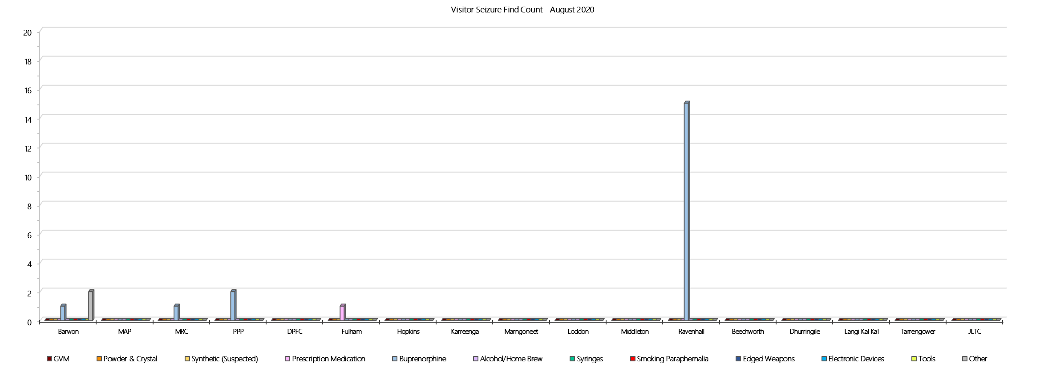

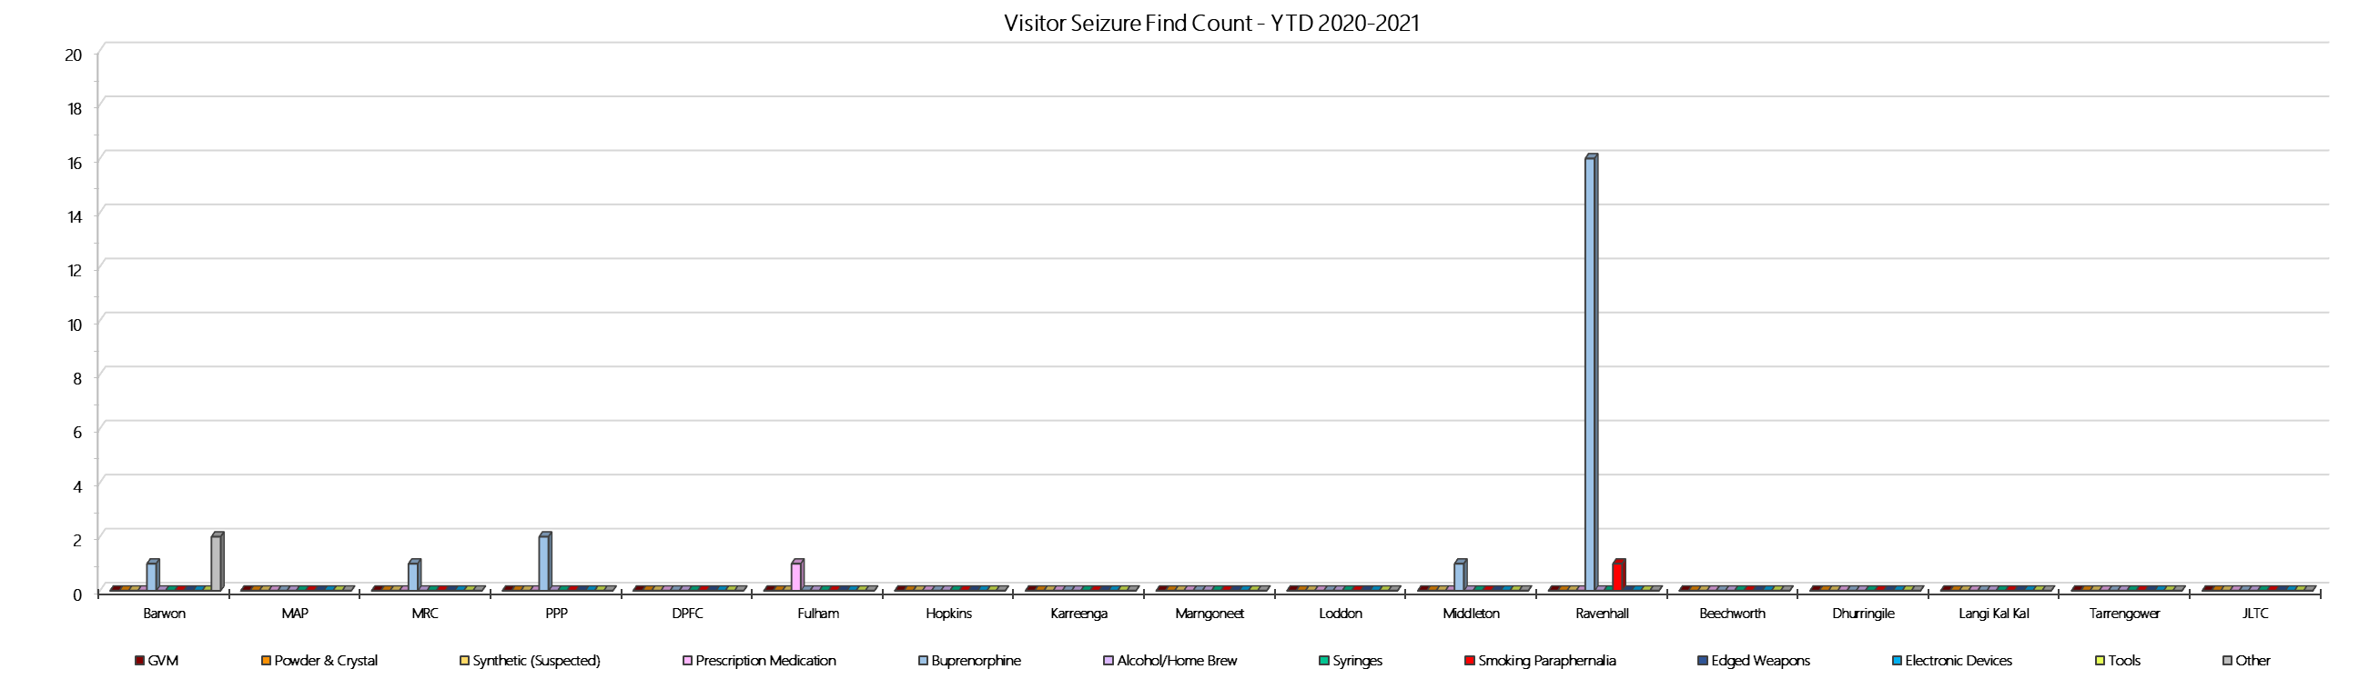

### **Seizures of Contraband: Prisoners – August 2020**

|  |  |  |  |  |  |  |  |  |  |  |  |  |  |  |  |  |  |  |  |  |  |  |  |  |
| --- | --- | --- | --- | --- | --- | --- | --- | --- | --- | --- | --- | --- | --- | --- | --- | --- | --- | --- | --- | --- | --- | --- | --- | --- |
| **Prisoners** | **GVM** | | **Powder & Crystal** | | **Synthetic (Suspected)** | | **Prescription Medication** | | **Buprenorphine** | | **Alcohol & Home Brew** | | **Syringes & Needles** | | **Smoking Paraphernalia** | | **Edged Weapons** | | **Electronic Devices** | | **Tools** | | **Other** | |
| **August 20** | **Finds** | **Gms** | **Finds** | **Gms** | **Finds** | **Gms** | **Finds** | **Qty** | **Finds** | **Qty** | **Finds** | **Ltrs** | **Finds** | **Qty** | **Finds** | **Qty** | **Finds** | **Qty** | **Finds** | **Qty** | **Finds** | **Qty** | **Finds** | **Qty** |
| **Barwon** | **0** | **0.00** | **0** | **0.00** | **0** | **0.00** | **1** | **0.05** | **8** | **15.60** | **8** | **42.500** | **1** | **1** | **0** | **0** | **10** | **12** | **5** | **9** | **3** | **5** | **10** | **29** |
| **MAP** | **0** | **0.00** | **1** | **2.63** | **0** | **0.00** | **0** | **0.00** | **0** | **0.00** | **0** | **0.000** | **0** | **0** | **0** | **0** | **0** | **0** | **0** | **0** | **0** | **0** | **0** | **0** |
| **MRC** | **1** | **0.50** | **1** | **0.50** | **0** | **0.00** | **9** | **10.00** | **3** | **1.25** | **1** | **2.000** | **1** | **1** | **5** | **15** | **2** | **2** | **2** | **2** | **0** | **0** | **9** | **16** |
| **PPP** | **0** | **0.00** | **0** | **0.00** | **0** | **0.00** | **12** | **34.00** | **14** | **0.00** | **2** | **0.000** | **3** | **0** | **1** | **1** | **9** | **9** | **0** | **0** | **2** | **2** | **9** | **19** |
| **DPFC** | **0** | **0.00** | **1** | **25.70** | **0** | **0.00** | **0** | **0.00** | **0** | **0.00** | **1** | **0.200** | **0** | **0** | **0** | **0** | **0** | **0** | **0** | **0** | **0** | **0** | **0** | **0** |
| **Fulham** | **0** | **0.00** | **0** | **0.00** | **0** | **0.00** | **7** | **19.25** | **0** | **0.00** | **3** | **3.000** | **1** | **3** | **11** | **16** | **2** | **2** | **2** | **2** | **4** | **6** | **2** | **4** |
| **Hopkins** | **0** | **0.00** | **0** | **0.00** | **0** | **0.00** | **4** | **13.00** | **0** | **0.00** | **0** | **0.000** | **0** | **0** | **3** | **3** | **7** | **9** | **0** | **0** | **0** | **0** | **5** | **6** |
| **Karreenga** | **0** | **0.00** | **0** | **0.00** | **0** | **0.00** | **1** | **0.80** | **1** | **0.60** | **0** | **0.000** | **0** | **0** | **1** | **1** | **0** | **0** | **0** | **0** | **0** | **0** | **1** | **1** |
| **Marngoneet** | **0** | **0.00** | **1** | **1.00** | **0** | **0.00** | **1** | **1.00** | **1** | **0.30** | **0** | **0.000** | **0** | **0** | **0** | **0** | **3** | **4** | **0** | **0** | **0** | **0** | **6** | **8** |
| **Loddon** | **0** | **0.00** | **0** | **0.00** | **0** | **0.00** | **0** | **0.00** | **1** | **1.00** | **2** | **10.000** | **0** | **0** | **3** | **3** | **2** | **3** | **0** | **0** | **0** | **0** | **1** | **1** |
| **Middleton** | **0** | **0.00** | **0** | **0.00** | **0** | **0.00** | **0** | **0.00** | **1** | **0.00** | **0** | **0.000** | **0** | **0** | **0** | **0** | **0** | **0** | **0** | **0** | **0** | **0** | **0** | **0** |
| **Ravenhall** | **0** | **0.00** | **0** | **0.00** | **0** | **0.00** | **3** | **4.60** | **4** | **5.80** | **6** | **9.000** | **1** | **1** | **0** | **0** | **10** | **10** | **0** | **0** | **6** | **21** | **3** | **3** |
| **Beechworth** | **1** | **0.01** | **0** | **0.00** | **0** | **0.00** | **0** | **0.00** | **0** | **0.00** | **0** | **0.000** | **0** | **0** | **2** | **2** | **0** | **0** | **0** | **0** | **0** | **0** | **0** | **0** |
| **Dhurringile** | **0** | **0.00** | **0** | **0.00** | **0** | **0.00** | **2** | **2.50** | **0** | **0.00** | **0** | **0.000** | **0** | **0** | **4** | **6** | **0** | **0** | **1** | **1** | **1** | **1** | **0** | **0** |
| **Langi Kal Kal** | **0** | **0.00** | **0** | **0.00** | **0** | **0.00** | **0** | **0.00** | **0** | **0.00** | **0** | **0.000** | **0** | **0** | **0** | **0** | **0** | **0** | **0** | **0** | **0** | **0** | **2** | **14** |
| **Tarrengower** | **0** | **0.00** | **0** | **0.00** | **0** | **0.00** | **0** | **0.00** | **0** | **0.00** | **0** | **0.000** | **0** | **0** | **0** | **0** | **0** | **0** | **0** | **0** | **0** | **0** | **0** | **0** |
| **JLTC** | **0** | **0.00** | **0** | **0.00** | **0** | **0.00** | **0** | **0.00** | **0** | **0.00** | **0** | **0.000** | **0** | **0** | **0** | **0** | **0** | **0** | **0** | **0** | **0** | **0** | **0** | **0** |
| **Current Month** | **2** | **0.51** | **4** | **29.83** | **0** | **0.00** | **40** | **85.20** | **33** | **24.55** | **23** | **66.700** | **7** | **6** | **30** | **47** | **45** | **51** | **10** | **14** | **16** | **35** | **48** | **101** |
| ***Previous Month*** | ***1*** | ***0.20*** | ***4*** | ***3.71*** | ***0*** | ***0.00*** | ***26*** | ***64.75*** | ***43*** | ***256.30*** | ***25*** | ***54.750*** | ***8*** | ***8*** | ***31*** | ***81*** | ***45*** | ***66*** | ***7*** | ***10*** | ***26*** | ***42*** | ***35*** | ***75*** |

### **Seizures of Contraband: Prisoners – YTD 2020-2021**

|  |  |  |  |  |  |  |  |  |  |  |  |  |  |  |  |  |  |  |  |  |  |  |  |  |
| --- | --- | --- | --- | --- | --- | --- | --- | --- | --- | --- | --- | --- | --- | --- | --- | --- | --- | --- | --- | --- | --- | --- | --- | --- |
| **Prisoners** | **GVM** | | **Powder & Crystal** | | **Synthetic (Suspected)** | | **Prescription Medication** | | **Buprenorphine** | | **Alcohol & Home Brew** | | **Syringes & Needles** | | **Smoking Paraphernalia** | | **Edged Weapons** | | **Electronic Devices** | | **Tools** | | **Other** | |
| **2020-2021** | **Finds** | **Gms** | **Finds** | **Gms** | **Finds** | **Gms** | **Finds** | **Qty** | **Finds** | **Qty** | **Finds** | **Ltrs** | **Finds** | **Qty** | **Finds** | **Qty** | **Finds** | **Qty** | **Finds** | **Qty** | **Finds** | **Qty** | **Finds** | **Qty** |
| **Barwon** | **0** | **0.00** | **0** | **0.00** | **0** | **0.00** | **4** | **7.05** | **15** | **101.10** | **18** | **64.250** | **5** | **5** | **1** | **1** | **21** | **27** | **5** | **9** | **10** | **17** | **21** | **51** |
| **MAP** | **0** | **0.00** | **1** | **2.63** | **0** | **0.00** | **0** | **0.00** | **0** | **0.00** | **0** | **0.000** | **0** | **0** | **0** | **0** | **1** | **1** | **0** | **0** | **1** | **1** | **4** | **6** |
| **MRC** | **2** | **0.70** | **1** | **0.50** | **0** | **0.00** | **10** | **11.00** | **6** | **5.25** | **1** | **2.000** | **1** | **1** | **6** | **16** | **3** | **6** | **3** | **3** | **1** | **3** | **14** | **24** |
| **PPP** | **0** | **0.00** | **1** | **1.00** | **0** | **0.00** | **19** | **43.00** | **32** | **138.70** | **6** | **9.000** | **6** | **3** | **7** | **8** | **20** | **21** | **3** | **4** | **8** | **9** | **15** | **30** |
| **DPFC** | **0** | **0.00** | **2** | **27.30** | **0** | **0.00** | **0** | **0.00** | **0** | **0.00** | **3** | **2.200** | **0** | **0** | **2** | **3** | **0** | **0** | **0** | **0** | **0** | **0** | **0** | **0** |
| **Fulham** | **0** | **0.00** | **0** | **0.00** | **0** | **0.00** | **11** | **22.75** | **1** | **5.50** | **6** | **7.000** | **1** | **3** | **19** | **41** | **5** | **8** | **2** | **2** | **9** | **13** | **5** | **11** |
| **Hopkins** | **0** | **0.00** | **1** | **0.11** | **0** | **0.00** | **4** | **13.00** | **0** | **0.00** | **0** | **0.000** | **1** | **1** | **3** | **3** | **8** | **10** | **0** | **0** | **0** | **0** | **5** | **6** |
| **Karreenga** | **0** | **0.00** | **0** | **0.00** | **0** | **0.00** | **3** | **4.80** | **3** | **1.20** | **0** | **0.000** | **0** | **0** | **1** | **1** | **2** | **2** | **0** | **0** | **0** | **0** | **2** | **2** |
| **Marngoneet** | **0** | **0.00** | **1** | **1.00** | **0** | **0.00** | **4** | **15.75** | **3** | **6.10** | **1** | **4.000** | **0** | **0** | **4** | **6** | **8** | **12** | **0** | **0** | **0** | **0** | **7** | **9** |
| **Loddon** | **0** | **0.00** | **0** | **0.00** | **0** | **0.00** | **0** | **0.00** | **1** | **1.00** | **4** | **17.000** | **0** | **0** | **4** | **4** | **2** | **3** | **0** | **0** | **0** | **0** | **1** | **1** |
| **Middleton** | **0** | **0.00** | **0** | **0.00** | **0** | **0.00** | **0** | **0.00** | **1** | **0.00** | **0** | **0.000** | **0** | **0** | **0** | **0** | **0** | **0** | **0** | **0** | **0** | **0** | **0** | **0** |
| **Ravenhall** | **0** | **0.00** | **1** | **1.00** | **0** | **0.00** | **9** | **30.10** | **13** | **21.80** | **9** | **16.000** | **1** | **1** | **5** | **34** | **19** | **26** | **3** | **5** | **11** | **32** | **5** | **5** |
| **Beechworth** | **1** | **0.01** | **0** | **0.00** | **0** | **0.00** | **0** | **0.00** | **0** | **0.00** | **0** | **0.000** | **0** | **0** | **4** | **4** | **0** | **0** | **0** | **0** | **1** | **1** | **0** | **0** |
| **Dhurringile** | **0** | **0.00** | **0** | **0.00** | **0** | **0.00** | **2** | **2.50** | **1** | **0.20** | **0** | **0.000** | **0** | **0** | **5** | **7** | **1** | **1** | **1** | **1** | **1** | **1** | **1** | **16** |
| **Langi Kal Kal** | **0** | **0.00** | **0** | **0.00** | **0** | **0.00** | **0** | **0.00** | **0** | **0.00** | **0** | **0.000** | **0** | **0** | **0** | **0** | **0** | **0** | **0** | **0** | **0** | **0** | **3** | **15** |
| **Tarrengower** | **0** | **0.00** | **0** | **0.00** | **0** | **0.00** | **0** | **0.00** | **0** | **0.00** | **0** | **0.000** | **0** | **0** | **0** | **0** | **0** | **0** | **0** | **0** | **0** | **0** | **0** | **0** |
| **JLTC** | **0** | **0.00** | **0** | **0.00** | **0** | **0.00** | **0** | **0.00** | **0** | **0.00** | **0** | **0.000** | **0** | **0** | **0** | **0** | **0** | **0** | **0** | **0** | **0** | **0** | **0** | **0** |
| **YTD: August 20** | **3** | **0.71** | **8** | **33.54** | **0** | **0.00** | **66** | **149.95** | **76** | **280.85** | **48** | **121.450** | **15** | **14** | **61** | **128** | **90** | **117** | **17** | **24** | **42** | **77** | **83** | **176** |

### **Graphs of Seizures of Contraband: Prisoners – August 2020 & YTD 2020-2021**

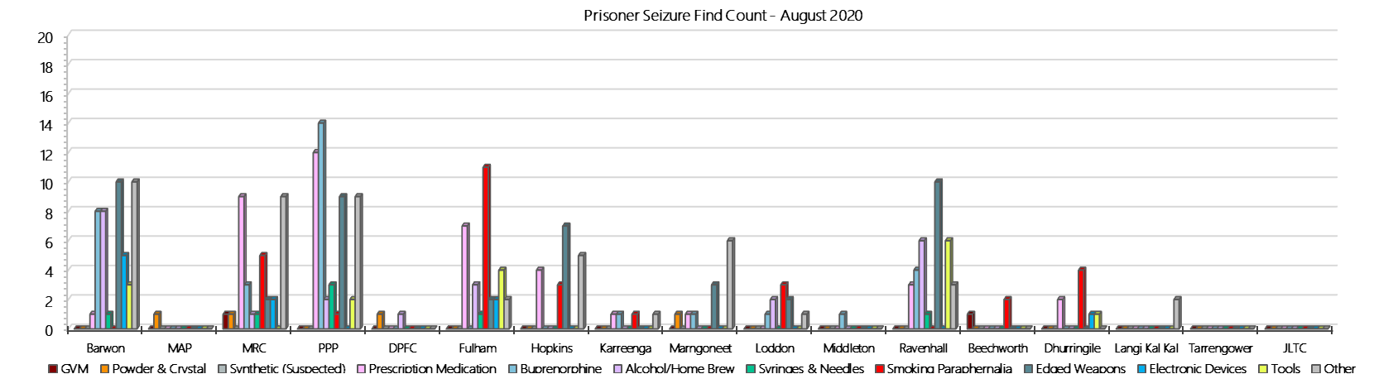

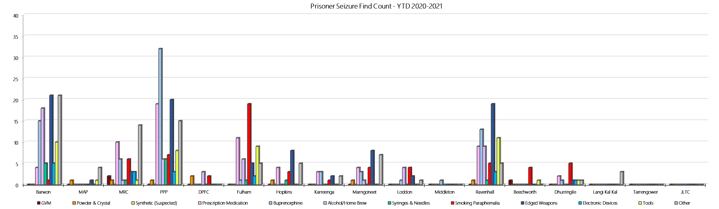

## **LOCATION SPECIFIC RESULTS**

### 

### **Barwon Prison**

***Targeted and Random General Drug Test Results: 2020-2021***

|  |  |  |  |  |  |  |  |  |  |  |  |  |  |  |
| --- | --- | --- | --- | --- | --- | --- | --- | --- | --- | --- | --- | --- | --- | --- |
| **Barwon** | **Jul-20** | **Aug-20** | **Sep-20** | **Oct-20** | **Nov-20** | **Dec-20** | **Jan-21** | **Feb-21** | **Mar-21** | **Apr-21** | **May-21** | **Jun-21** | **Average** | ***Totals*** |
| **Effective Sample - Targeted** | **106** | **65** |  |  |  |  |  |  |  |  |  |  | **86** | ***171*** |
| **Targeted Positives** | **5** | **2** |  |  |  |  |  |  |  |  |  |  | **4** | ***7*** |
| **Refusal** | **2** | **1** |  |  |  |  |  |  |  |  |  |  | **2** | ***3*** |
| **Unable** | **3** | **1** |  |  |  |  |  |  |  |  |  |  | **2** | ***4*** |
| **Interfered** | **0** | **1** |  |  |  |  |  |  |  |  |  |  | **1** | ***1*** |
| **Adulterated** | **0** | **0** |  |  |  |  |  |  |  |  |  |  | **0** | ***0*** |
| **Targeted % Tested Positive** | **9.43%** | **7.69%** | **#N/A** | **#N/A** | **#N/A** | **#N/A** | **#N/A** | **#N/A** | **#N/A** | **#N/A** | **#N/A** | **#N/A** | **8.77%** | ***8.77%*** |
| **Awaiting / Pending Results** | **0** | **0** |  |  |  |  |  |  |  |  |  |  | **0** | ***0*** |
| **Targeted Residual** | **0** | **0** |  |  |  |  |  |  |  |  |  |  | **0** | ***0*** |
| **Random tests collected** | **43** | **53** |  |  |  |  |  |  |  |  |  |  | **48** | ***96*** |
| **Tested Positive** | **2** | **0** |  |  |  |  |  |  |  |  |  |  | **1** | ***2*** |
| **Refusal (guilty)** | **0** | **2** |  |  |  |  |  |  |  |  |  |  | **1** | ***2*** |
| **Unable (not guilty)** | **0** | **0** |  |  |  |  |  |  |  |  |  |  | **0** | ***0*** |
| **Unable (guilty)** | **0** | **0** |  |  |  |  |  |  |  |  |  |  | **0** | ***0*** |
| **Interfered (guilty)** | **0** | **0** |  |  |  |  |  |  |  |  |  |  | **0** | ***0*** |
| **No test (valid reason)** | **1** | **0** |  |  |  |  |  |  |  |  |  |  | **1** | ***1*** |
| **No test (no valid reason)** | **0** | **0** |  |  |  |  |  |  |  |  |  |  | **0** | ***0*** |
| **Adulterated** | **0** | **0** |  |  |  |  |  |  |  |  |  |  | **0** | ***0*** |
| **Awaiting / Pending Results** | **0** | **0** |  |  |  |  |  |  |  |  |  |  | **0** | ***0*** |
| **Random Residual *(PIMS URAR030)*** | **0** | **0** |  |  |  |  |  |  |  |  |  |  | ***0*** | ***0*** |
| **Effective Sample - Random General** | **43** | **55** |  |  |  |  |  |  |  |  |  |  | **49** | **98** |
| **% Tested positive** | **4.65%** | **0.00%** |  |  |  |  |  |  |  |  |  |  | **2.33%** |  |
| **% Prisoner guilty, positive equivalents** | **0.00%** | **3.64%** |  |  |  |  |  |  |  |  |  |  | **1.82%** |  |
| **% Total prisoner fails** | **4.65%** | **3.64%** |  |  |  |  |  |  |  |  |  |  | **4.14%** |  |
| **% No test without valid reason** | **0.00%** | **0.00%** |  |  |  |  |  |  |  |  |  |  | **0.00%** |  |
| ***Random General Benchmark 8.25%*** | ***8.25%*** | ***8.25%*** | ***8.25%*** | ***8.25%*** | ***8.25%*** | ***8.25%*** | ***8.25%*** | ***8.25%*** | ***8.25%*** | ***8.25%*** | ***8.25%*** | ***8.25%*** | ***YTD*** |  |
| **% Failures for SDO** | **4.65%** | **3.64%** | **#N/A** | **#N/A** | **#N/A** | **#N/A** | **#N/A** | **#N/A** | **#N/A** | **#N/A** | **#N/A** | **#N/A** | **4.08%** |  |

***Barwon - Drugs Identified Through Testing by Drug Type: 2020-2021***

|  |  |  |  |  |  |  |  |  |  |  |  |  |  |  |
| --- | --- | --- | --- | --- | --- | --- | --- | --- | --- | --- | --- | --- | --- | --- |
| **Barwon** | ***Amphetamines*** | ***Methamphetamines*** | ***Cocaine*** | ***Opiates*** | ***Benzodiazepines*** | ***Cannabinoids*** | ***Ethanol\*\**** | ***Methadone*** | ***ADP\**** | ***APS\**** | ***Steroids\**** | ***Buprenorphine*** | ***NOA\**** | **Total** |
| **Jul-20** | **0** | **0** | **0** | **0** | **0** | **0** | **0** | **0** | **2** | **0** | **0** | **6** | **1** | **9** |
| **Aug-20** | **0** | **0** | **0** | **0** | **0** | **0** | **0** | **0** | **0** | **0** | **0** | **4** | **0** | **4** |
| **Sep-20** |  |  |  |  |  |  |  |  |  |  |  |  |  |  |
| **Oct-20** |  |  |  |  |  |  |  |  |  |  |  |  |  |  |
| **Nov-20** |  |  |  |  |  |  |  |  |  |  |  |  |  |  |
| **Dec-20** |  |  |  |  |  |  |  |  |  |  |  |  |  |  |
| **Jan-21** |  |  |  |  |  |  |  |  |  |  |  |  |  |  |
| **Feb-21** |  |  |  |  |  |  |  |  |  |  |  |  |  |  |
| **Mar-21** |  |  |  |  |  |  |  |  |  |  |  |  |  |  |
| **Apr-21** |  |  |  |  |  |  |  |  |  |  |  |  |  |  |
| **May-21** |  |  |  |  |  |  |  |  |  |  |  |  |  |  |
| **Jun-21** |  |  |  |  |  |  |  |  |  |  |  |  |  |  |
| **YTD** | **0** | **0** | **0** | **0** | **0** | **0** | **0** | **0** | **2** | **0** | **0** | **10** | **1** | **13** |
| ***All Prisons YTD*** | ***2*** | ***2*** | ***0*** | ***2*** | ***8*** | ***3*** | ***4*** | ***7*** | ***7*** | ***0*** | ***0*** | ***98*** | ***1*** | ***134*** |
| ***Barwon % of Total*** | ***0.00%*** | ***0.00%*** | ***0.00%*** | ***0.00%*** | ***0.00%*** | ***0.00%*** | ***0.00%*** | ***0.00%*** | ***28.57%*** | ***0.00%*** | ***0.00%*** | ***10.20%*** | ***100.00%*** | ***9.70%*** |

***Barwon Seizures of Contraband: Visitors & Prisoners: 2020-2021***

|  |  |  |  |  |  |  |  |  |  |  |  |  |  |  |  |  |  |  |  |  |  |  |  |  |
| --- | --- | --- | --- | --- | --- | --- | --- | --- | --- | --- | --- | --- | --- | --- | --- | --- | --- | --- | --- | --- | --- | --- | --- | --- |
| **Visitors** | **GVM** | | **Powder & Crystal** | | **Synthetic (Suspected)** | | **Prescription Medication** | | **Buprenorphine** | | **Alcohol/Home Brew** | | **Syringes & Needles** | | **Smoking Paraphernalia** | | **Edged Weapons** | | **Electronic Devices** | | **Tools** | | **Other** | |
| **Barwon** | **Finds** | **Gms** | **Finds** | **Gms** | **Finds** | **Gms** | **Finds** | **Qty** | **Finds** | **Qty** | **Finds** | **Ltrs** | **Finds** | **Qty** | **Finds** | **Qty** | **Finds** | **Qty** | **Finds** | **Qty** | **Finds** | **Qty** | **Finds** | **Qty** |
| **Jul-20** | **0** | **0.00** | **0** | **0.00** | **0** | **0.00** | **0** | **0.00** | **0** | **0.00** | **0** | **0.000** | **0** | **0** | **0** | **0** | **0** | **0** | **0** | **0** | **0** | **0** | **0** | **0** |
| **Aug-20** | **0** | **0.00** | **0** | **0.00** | **0** | **0.00** | **0** | **0.00** | **1** | **30.00** | **0** | **0.000** | **0** | **0** | **0** | **0** | **0** | **0** | **0** | **0** | **0** | **0** | **2** | **2** |
| **Sep-20** |  |  |  |  |  |  |  |  |  |  |  |  |  |  |  |  |  |  |  |  |  |  |  |  |
| **Oct-20** |  |  |  |  |  |  |  |  |  |  |  |  |  |  |  |  |  |  |  |  |  |  |  |  |
| **Nov-20** |  |  |  |  |  |  |  |  |  |  |  |  |  |  |  |  |  |  |  |  |  |  |  |  |
| **Dec-20** |  |  |  |  |  |  |  |  |  |  |  |  |  |  |  |  |  |  |  |  |  |  |  |  |
| **Jan-21** |  |  |  |  |  |  |  |  |  |  |  |  |  |  |  |  |  |  |  |  |  |  |  |  |
| **Feb-21** |  |  |  |  |  |  |  |  |  |  |  |  |  |  |  |  |  |  |  |  |  |  |  |  |
| **Mar-21** |  |  |  |  |  |  |  |  |  |  |  |  |  |  |  |  |  |  |  |  |  |  |  |  |
| **Apr-21** |  |  |  |  |  |  |  |  |  |  |  |  |  |  |  |  |  |  |  |  |  |  |  |  |
| **May-21** |  |  |  |  |  |  |  |  |  |  |  |  |  |  |  |  |  |  |  |  |  |  |  |  |
| **Jun-21** |  |  |  |  |  |  |  |  |  |  |  |  |  |  |  |  |  |  |  |  |  |  |  |  |
| **Total** | **0** | **0.00** | **0** | **0.00** | **0** | **0.00** | **0** | **0.00** | **1** | **30.00** | **0** | **0.000** | **0** | **0** | **0** | **0** | **0** | **0** | **0** | **0** | **0** | **0** | **2** | **2** |

|  |  |  |  |  |  |  |  |  |  |  |  |  |  |  |  |  |  |  |  |  |  |  |  |  |
| --- | --- | --- | --- | --- | --- | --- | --- | --- | --- | --- | --- | --- | --- | --- | --- | --- | --- | --- | --- | --- | --- | --- | --- | --- |
| **Prisoners** | **GVM** | | **Powder  & Crystal** | | **Synthetic  (Suspected)** | | **Prescription  Medication** | | **Buprenorphine** | | **Alcohol &  Home Brew** | | **Syringes & Needles** | | **Smoking  Paraphernalia** | | **Edged  Weapons** | | **Electronic  Devices** | | **Tools** | | **Other** | |
| **Barwon** | **Finds** | **Gms** | **Finds** | **Gms** | **Finds** | **Gms** | **Finds** | **Qty** | **Finds** | **Qty** | **Finds** | **Ltrs** | **Finds** | **Qty** | **Finds** | **Qty** | **Finds** | **Qty** | **Finds** | **Qty** | **Finds** | **Qty** | **Finds** | **Qty** |
| **Jul-20** | **0** | **0.00** | **0** | **0.00** | **0** | **0.00** | **3** | **7.00** | **7** | **85.50** | **10** | **21.750** | **4** | **4** | **1** | **1** | **11** | **15** | **0** | **0** | **7** | **12** | **11** | **22** |
| **Aug-20** | **0** | **0.00** | **0** | **0.00** | **0** | **0.00** | **1** | **0.05** | **8** | **15.60** | **8** | **42.500** | **1** | **1** | **0** | **0** | **10** | **12** | **5** | **9** | **3** | **5** | **10** | **29** |
| **Sep-20** |  |  |  |  |  |  |  |  |  |  |  |  |  |  |  |  |  |  |  |  |  |  |  |  |
| **Oct-20** |  |  |  |  |  |  |  |  |  |  |  |  |  |  |  |  |  |  |  |  |  |  |  |  |
| **Nov-20** |  |  |  |  |  |  |  |  |  |  |  |  |  |  |  |  |  |  |  |  |  |  |  |  |
| **Dec-20** |  |  |  |  |  |  |  |  |  |  |  |  |  |  |  |  |  |  |  |  |  |  |  |  |
| **Jan-21** |  |  |  |  |  |  |  |  |  |  |  |  |  |  |  |  |  |  |  |  |  |  |  |  |
| **Feb-21** |  |  |  |  |  |  |  |  |  |  |  |  |  |  |  |  |  |  |  |  |  |  |  |  |
| **Mar-21** |  |  |  |  |  |  |  |  |  |  |  |  |  |  |  |  |  |  |  |  |  |  |  |  |
| **Apr-21** |  |  |  |  |  |  |  |  |  |  |  |  |  |  |  |  |  |  |  |  |  |  |  |  |
| **May-21** |  |  |  |  |  |  |  |  |  |  |  |  |  |  |  |  |  |  |  |  |  |  |  |  |
| **Jun-21** |  |  |  |  |  |  |  |  |  |  |  |  |  |  |  |  |  |  |  |  |  |  |  |  |
| **Total** | **0** | **0.00** | **0** | **0.00** | **0** | **0.00** | **4** | **7.05** | **15** | **101.10** | **18** | **64.250** | **5** | **5** | **1** | **1** | **21** | **27** | **5** | **9** | **10** | **17** | **21** | **51** |

***Barwon Targeted and Random General Drug Test Positives & Equivalents: 2020-2021***

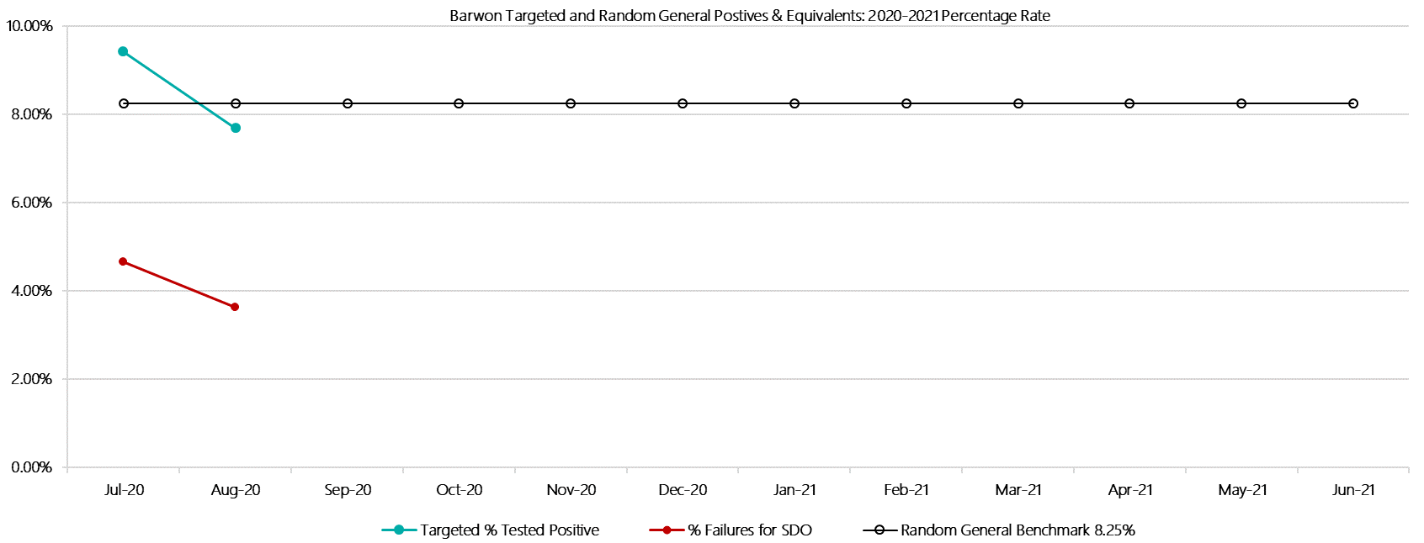

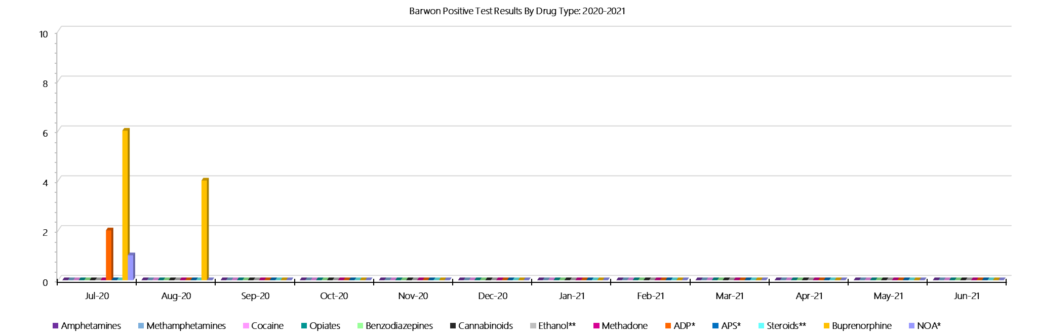***Barwon Positive Drug Test Results by Drug Type: 2020-2021***

***Barwon Count of Visitor Seizures Finds: 2020-2021***

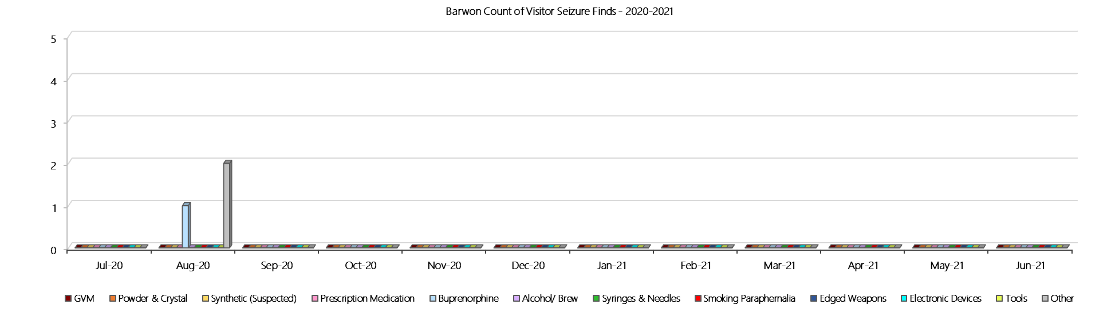

***Barwon Count of Prisoner Seizure Finds: 2020-2021***

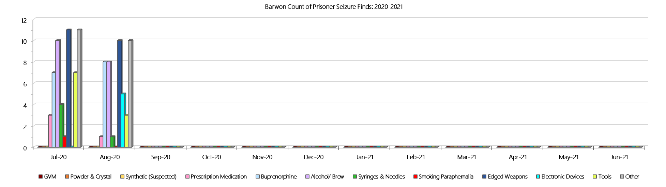

### **Melbourne Assessment Prison**

***Targeted and Random General Drug Test Results: 2020-2021***

|  |  |  |  |  |  |  |  |  |  |  |  |  |  |  |
| --- | --- | --- | --- | --- | --- | --- | --- | --- | --- | --- | --- | --- | --- | --- |
| **MAP** | **Jul-20** | **Aug-20** | **Sep-20** | **Oct-20** | **Nov-20** | **Dec-20** | **Jan-21** | **Feb-21** | **Mar-21** | **Apr-21** | **May-21** | **Jun-21** | **Average** | ***Totals*** |
| **Effective Sample - Targeted** | **5** | **0** |  |  |  |  |  |  |  |  |  |  | **3** | ***5*** |
| **Targeted Positives** | **0** | **0** |  |  |  |  |  |  |  |  |  |  | **0** | ***0*** |
| **Refusal** | **0** | **0** |  |  |  |  |  |  |  |  |  |  | **0** | ***0*** |
| **Unable** | **0** | **0** |  |  |  |  |  |  |  |  |  |  | **0** | ***0*** |
| **Interfered** | **0** | **0** |  |  |  |  |  |  |  |  |  |  | **0** | ***0*** |
| **Adulterated** | **0** | **0** |  |  |  |  |  |  |  |  |  |  | **0** | ***0*** |
| **Targeted % Tested Positive** | **0.00%** | **0.00%!** | **#N/A** | **#N/A** | **#N/A** | **#N/A** | **#N/A** | **#N/A** | **#N/A** | **#N/A** | **#N/A** | **#N/A** | **0.00%** | ***0.00%*** |
| **Awaiting / Pending Results** | **0** | **0** |  |  |  |  |  |  |  |  |  |  | **0** | ***0*** |
| **Targeted Residual** | **0** | **0** |  |  |  |  |  |  |  |  |  |  | **0** | ***0*** |
| **Random tests collected** | **8** | **10** |  |  |  |  |  |  |  |  |  |  | **9** | ***18*** |
| **Tested Positive** | **0** | **0** |  |  |  |  |  |  |  |  |  |  | **0** | ***0*** |
| **Refusal (guilty)** | **0** | **0** |  |  |  |  |  |  |  |  |  |  | **0** | ***0*** |
| **Unable (not guilty)** | **0** | **0** |  |  |  |  |  |  |  |  |  |  | **0** | ***0*** |
| **Unable (guilty)** | **0** | **0** |  |  |  |  |  |  |  |  |  |  | **0** | ***0*** |
| **Interfered (guilty)** | **0** | **0** |  |  |  |  |  |  |  |  |  |  | **0** | ***0*** |
| **No test (valid reason)** | **13** | **17** |  |  |  |  |  |  |  |  |  |  | **15** | ***30*** |
| **No test (no valid reason)** | **1** | **1** |  |  |  |  |  |  |  |  |  |  | **1** | ***2*** |
| **Adulterated** | **0** | **0** |  |  |  |  |  |  |  |  |  |  | **0** | ***0*** |
| **Awaiting / Pending Results** | **0** | **1** |  |  |  |  |  |  |  |  |  |  | **1** | ***1*** |
| **Random Residual *(PIMS URAR030)*** | **0** | **0** |  |  |  |  |  |  |  |  |  |  | ***0*** | ***0*** |
| **Effective Sample - Random General** | **9** | **11** |  |  |  |  |  |  |  |  |  |  | **10** | **20** |
| **% Tested positive** | **0.00%** | **0.00%** |  |  |  |  |  |  |  |  |  |  | **0.00%** |  |
| **% Prisoner guilty, positive equivalents** | **0.00%** | **0.00%** |  |  |  |  |  |  |  |  |  |  | **0.00%** |  |
| **% Total prisoner fails** | **0.00%** | **0.00%** |  |  |  |  |  |  |  |  |  |  | **0.00%** |  |
| **% No test without valid reason** | **11.11%** | **9.09%** |  |  |  |  |  |  |  |  |  |  | **10.10%** |  |
| ***Random General Benchmark 8.00%*** | ***8.00%*** | ***8.00%*** | ***8.00%*** | ***8.00%*** | ***8.00%*** | ***8.00%*** | ***8.00%*** | ***8.00%*** | ***8.00%*** | ***8.00%*** | ***8.00%*** | ***8.00%*** | ***YTD*** |  |
| **% Failures for SDO** | **11.11%** | **9.09%** | **#N/A** | **#N/A** | **#N/A** | **#N/A** | **#N/A** | **#N/A** | **#N/A** | **#N/A** | **#N/A** | **#N/A** | **10.00%** |  |

***Melbourne Assessment Prison - Drugs Identified Through Testing by Drug Type: 2020-2021***

|  |  |  |  |  |  |  |  |  |  |  |  |  |  |  |
| --- | --- | --- | --- | --- | --- | --- | --- | --- | --- | --- | --- | --- | --- | --- |
| **MAP** | ***Amphetamines*** | ***Methamphetamines*** | ***Cocaine*** | ***Opiates*** | ***Benzodiazepines*** | ***Cannabinoids*** | ***Ethanol\*\**** | ***Methadone*** | ***ADP\**** | ***APS\**** | ***Steroids\*\**** | ***Buprenorphine*** | ***NOA\**** | **Total** |
| **Jul-20** | **0** | **0** | **0** | **0** | **0** | **0** | **0** | **0** | **0** | **0** | **0** | **0** | **0** | **0** |
| **Aug-20** | **0** | **0** | **0** | **0** | **0** | **0** | **0** | **0** | **0** | **0** | **0** | **0** | **0** | **0** |
| **Sep-20** |  |  |  |  |  |  |  |  |  |  |  |  |  |  |
| **Oct-20** |  |  |  |  |  |  |  |  |  |  |  |  |  |  |
| **Nov-20** |  |  |  |  |  |  |  |  |  |  |  |  |  |  |
| **Dec-20** |  |  |  |  |  |  |  |  |  |  |  |  |  |  |
| **Jan-21** |  |  |  |  |  |  |  |  |  |  |  |  |  |  |
| **Feb-21** |  |  |  |  |  |  |  |  |  |  |  |  |  |  |
| **Mar-21** |  |  |  |  |  |  |  |  |  |  |  |  |  |  |
| **Apr-21** |  |  |  |  |  |  |  |  |  |  |  |  |  |  |
| **May-21** |  |  |  |  |  |  |  |  |  |  |  |  |  |  |
| **Jun-21** |  |  |  |  |  |  |  |  |  |  |  |  |  |  |
| **MAP YTD** | **0** | **0** | **0** | **0** | **0** | **0** | **0** | **0** | **0** | **0** | **0** | **0** | **0** | **0** |
| ***All Prisons YTD*** | ***2*** | ***2*** | ***0*** | ***2*** | ***8*** | ***3*** | ***4*** | ***7*** | ***7*** | ***0*** | ***0*** | ***98*** | ***1*** | ***134*** |
| ***MAP % of Total*** | ***0.00%*** | ***0.00%*** | ***0.00%*** | ***0.00%*** | ***0.00%*** | ***0.00%*** | ***0.00%*** | ***0.00%*** | ***0.00%*** | ***0.00%*** | ***0.00%*** | ***0.00%*** | ***0.00%*** | ***0.00%*** |

***Melbourne Assessment Prison Seizures of Contraband: Visitors & Prisoners: 2020-2021***

|  |  |  |  |  |  |  |  |  |  |  |  |  |  |  |  |  |  |  |  |  |  |  |  |  |
| --- | --- | --- | --- | --- | --- | --- | --- | --- | --- | --- | --- | --- | --- | --- | --- | --- | --- | --- | --- | --- | --- | --- | --- | --- |
| **Visitors** | **GVM** | | **Powder  & Crystal** | | **Synthetic  (Suspected)** | | **Prescription  Medication** | | **Buprenorphine** | | **Alcohol &  Home Brew** | | **Syringes & Needles** | | **Smoking  Paraphernalia** | | **Edged  Weapons** | | **Electronic  Devices** | | **Tools** | | **Other** | |
| **MAP** | **Finds** | **Gms** | **Finds** | **Gms** | **Finds** | **Gms** | **Finds** | **Qty** | **Finds** | **Qty** | **Finds** | **Ltrs** | **Finds** | **Qty** | **Finds** | **Qty** | **Finds** | **Qty** | **Finds** | **Qty** | **Finds** | **Qty** | **Finds** | **Qty** |
| **Jul-20** | **0** | **0.00** | **0** | **0.00** | **0** | **0.00** | **0** | **0.00** | **0** | **0.00** | **0** | **0.000** | **0** | **0** | **0** | **0** | **0** | **0** | **0** | **0** | **0** | **0** | **0** | **0** |
| **Aug-20** | **0** | **0.00** | **0** | **0.00** | **0** | **0.00** | **0** | **0.00** | **0** | **0.00** | **0** | **0.000** | **0** | **0** | **0** | **0** | **0** | **0** | **0** | **0** | **0** | **0** | **0** | **0** |
| **Sep-20** |  |  |  |  |  |  |  |  |  |  |  |  |  |  |  |  |  |  |  |  |  |  |  |  |
| **Oct-20** |  |  |  |  |  |  |  |  |  |  |  |  |  |  |  |  |  |  |  |  |  |  |  |  |
| **Nov-20** |  |  |  |  |  |  |  |  |  |  |  |  |  |  |  |  |  |  |  |  |  |  |  |  |
| **Dec-20** |  |  |  |  |  |  |  |  |  |  |  |  |  |  |  |  |  |  |  |  |  |  |  |  |
| **Jan-21** |  |  |  |  |  |  |  |  |  |  |  |  |  |  |  |  |  |  |  |  |  |  |  |  |
| **Feb-21** |  |  |  |  |  |  |  |  |  |  |  |  |  |  |  |  |  |  |  |  |  |  |  |  |
| **Mar-21** |  |  |  |  |  |  |  |  |  |  |  |  |  |  |  |  |  |  |  |  |  |  |  |  |
| **Apr-21** |  |  |  |  |  |  |  |  |  |  |  |  |  |  |  |  |  |  |  |  |  |  |  |  |
| **May-21** |  |  |  |  |  |  |  |  |  |  |  |  |  |  |  |  |  |  |  |  |  |  |  |  |
| **Jun-21** |  |  |  |  |  |  |  |  |  |  |  |  |  |  |  |  |  |  |  |  |  |  |  |  |
| **Total** | **0** | **0.00** | **0** | **0.00** | **0** | **0.00** | **0** | **0.00** | **0** | **0.00** | **0** | **0.000** | **0** | **0** | **0** | **0** | **0** | **0** | **0** | **0** | **0** | **0** | **0** | **0** |

|  |  |  |  |  |  |  |  |  |  |  |  |  |  |  |  |  |  |  |  |  |  |  |  |  |
| --- | --- | --- | --- | --- | --- | --- | --- | --- | --- | --- | --- | --- | --- | --- | --- | --- | --- | --- | --- | --- | --- | --- | --- | --- |
| **Prisoners** | **GVM** | | **Powder  & Crystal** | | **Synthetic  (Suspected)** | | **Prescription  Medication** | | **Buprenorphine** | | **Alcohol &  Home Brew** | | **Syringes & Needles** | | **Smoking  Paraphernalia** | | **Edged  Weapons** | | **Electronic  Devices** | | **Tools** | | **Other** | |
| **MAP** | **Finds** | **Gms** | **Finds** | **Gms** | **Finds** | **Gms** | **Finds** | **Qty** | **Finds** | **Qty** | **Finds** | **Ltrs** | **Finds** | **Qty** | **Finds** | **Qty** | **Finds** | **Qty** | **Finds** | **Qty** | **Finds** | **Qty** | **Finds** | **Qty** |
| **Jul-20** | **0** | **0.00** | **0** | **0.00** | **0** | **0.00** | **0** | **0.00** | **0** | **0.00** | **0** | **0.000** | **0** | **0** | **0** | **0** | **1** | **1** | **0** | **0** | **1** | **1** | **4** | **6** |
| **Aug-20** | **0** | **0.00** | **1** | **2.63** | **0** | **0.00** | **0** | **0.00** | **0** | **0.00** | **0** | **0.000** | **0** | **0** | **0** | **0** | **0** | **0** | **0** | **0** | **0** | **0** | **0** | **0** |
| **Sep-20** |  |  |  |  |  |  |  |  |  |  |  |  |  |  |  |  |  |  |  |  |  |  |  |  |
| **Oct-20** |  |  |  |  |  |  |  |  |  |  |  |  |  |  |  |  |  |  |  |  |  |  |  |  |
| **Nov-20** |  |  |  |  |  |  |  |  |  |  |  |  |  |  |  |  |  |  |  |  |  |  |  |  |
| **Dec-20** |  |  |  |  |  |  |  |  |  |  |  |  |  |  |  |  |  |  |  |  |  |  |  |  |
| **Jan-21** |  |  |  |  |  |  |  |  |  |  |  |  |  |  |  |  |  |  |  |  |  |  |  |  |
| **Feb-21** |  |  |  |  |  |  |  |  |  |  |  |  |  |  |  |  |  |  |  |  |  |  |  |  |
| **Mar-21** |  |  |  |  |  |  |  |  |  |  |  |  |  |  |  |  |  |  |  |  |  |  |  |  |
| **Apr-21** |  |  |  |  |  |  |  |  |  |  |  |  |  |  |  |  |  |  |  |  |  |  |  |  |
| **May-21** |  |  |  |  |  |  |  |  |  |  |  |  |  |  |  |  |  |  |  |  |  |  |  |  |
| **Jun-21** |  |  |  |  |  |  |  |  |  |  |  |  |  |  |  |  |  |  |  |  |  |  |  |  |
| **Total** | **0** | **0.00** | **1** | **2.63** | **0** | **0.00** | **0** | **0.00** | **0** | **0.00** | **0** | **0.000** | **0** | **0** | **0** | **0** | **1** | **1** | **0** | **0** | **1** | **1** | **4** | **6** |

***Melbourne Assessment Prison Targeted and Random General Urinalysis Positives & Equivalents: 2020-2021***

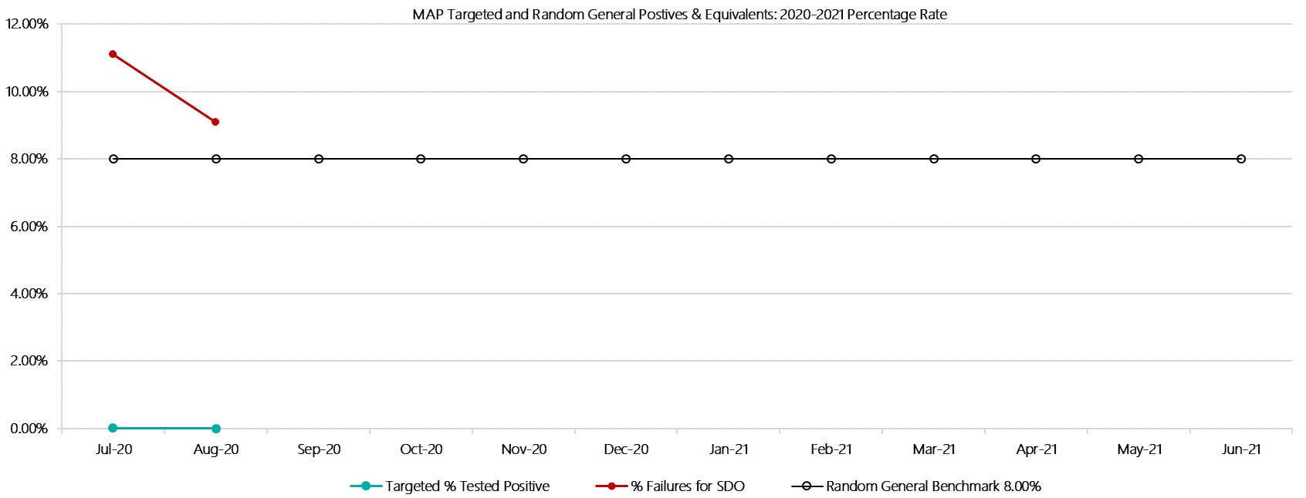

***Melbourne Assessment Prison Positive Test Results by Drug Type: 2020-2021***

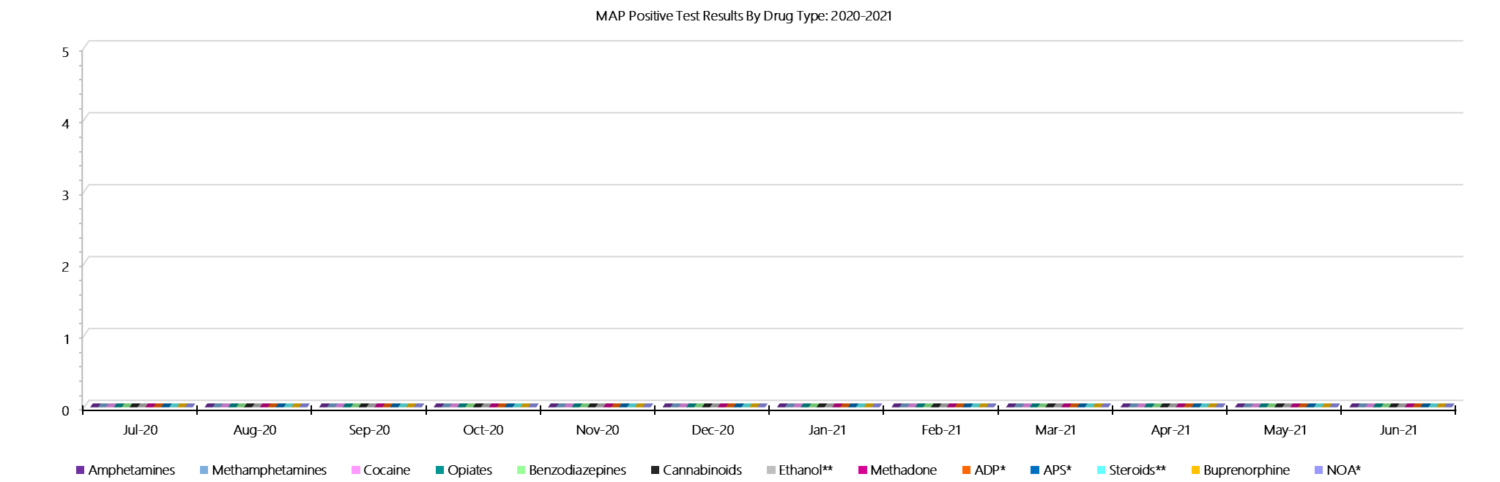

***Melbourne Assessment Prison Count of Visitor Seizures Finds: 2020-2021***

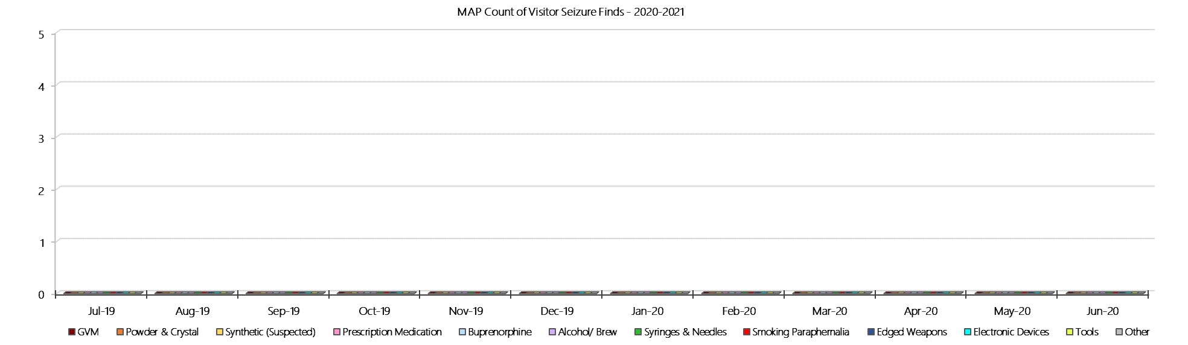

***Melbourne Assessment Prison Count of Prisoner Seizure Finds: 2020-2021***

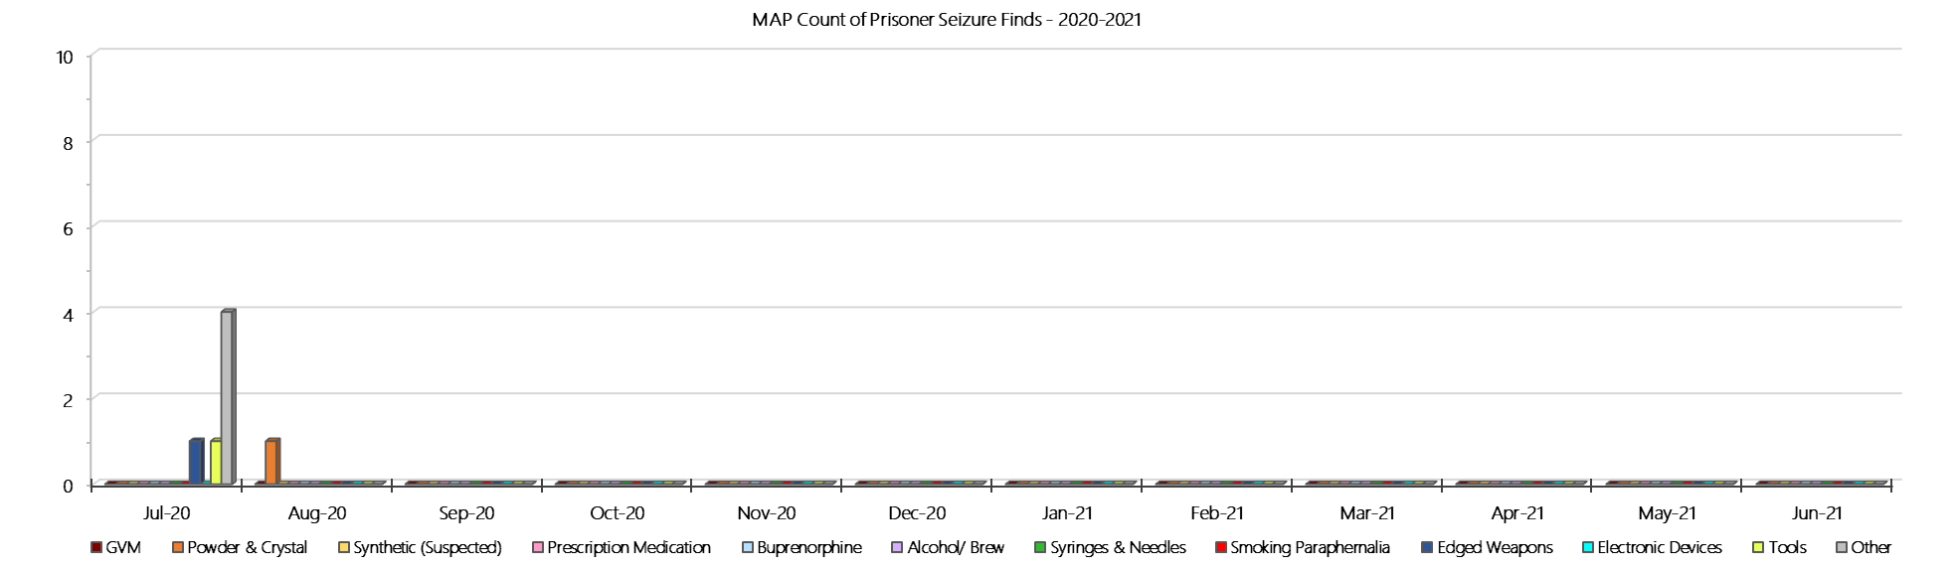

### **Metropolitan Remand Centre**

***Targeted and Random General Drug Test Results: 2020-2021***

|  |  |  |  |  |  |  |  |  |  |  |  |  |  |  |
| --- | --- | --- | --- | --- | --- | --- | --- | --- | --- | --- | --- | --- | --- | --- |
| **MRC** | **Jul-20** | **Aug-20** | **Sep-20** | **Oct-20** | **Nov-20** | **Dec-20** | **Jan-21** | **Feb-21** | **Mar-21** | **Apr-21** | **May-21** | **Jun-21** | **Average** | ***Totals*** |
| **Effective Sample - Targeted** | **164** | **147** |  |  |  |  |  |  |  |  |  |  | **156** | ***311*** |
| **Targeted Positives** | **7** | **3** |  |  |  |  |  |  |  |  |  |  | **5** | ***10*** |
| **Refusal** | **0** | **0** |  |  |  |  |  |  |  |  |  |  | **0** | ***0*** |
| **Unable** | **0** | **1** |  |  |  |  |  |  |  |  |  |  | **1** | ***1*** |
| **Interfered** | **0** | **0** |  |  |  |  |  |  |  |  |  |  | **0** | ***0*** |
| **Adulterated** | **1** | **0** |  |  |  |  |  |  |  |  |  |  | **1** | ***1*** |
| **Targeted % Tested Positive** | **4.88%** | **2.72%** | **#N/A** | **#N/A** | **#N/A** | **#N/A** | **#N/A** | **#N/A** | **#N/A** | **#N/A** | **#N/A** | **#N/A** | **3.86%** | ***3.86%*** |
| **Awaiting / Pending Results** | **0** | **0** |  |  |  |  |  |  |  |  |  |  | **0** | ***0*** |
| **Targeted Residual** | **0** | **0** |  |  |  |  |  |  |  |  |  |  | **0** | ***0*** |
| **Random tests collected** | **71** | **76** |  |  |  |  |  |  |  |  |  |  | **74** | ***147*** |
| **Tested Positive** | **0** | **0** |  |  |  |  |  |  |  |  |  |  | **0** | ***0*** |
| **Refusal (guilty)** | **0** | **3** |  |  |  |  |  |  |  |  |  |  | **2** | ***3*** |
| **Unable (not guilty)** | **0** | **1** |  |  |  |  |  |  |  |  |  |  | **1** | ***1*** |
| **Unable (guilty)** | **0** | **2** |  |  |  |  |  |  |  |  |  |  | **1** | ***2*** |
| **Interfered (guilty)** | **0** | **0** |  |  |  |  |  |  |  |  |  |  | **0** | ***0*** |
| **No test (valid reason)** | **15** | **28** |  |  |  |  |  |  |  |  |  |  | **22** | ***43*** |
| **No test (no valid reason)** | **0** | **0** |  |  |  |  |  |  |  |  |  |  | **0** | ***0*** |
| **Adulterated** | **0** | **0** |  |  |  |  |  |  |  |  |  |  | **0** | ***0*** |
| **Awaiting / Pending Results** | **0** | **0** |  |  |  |  |  |  |  |  |  |  | **0** | ***0*** |
| **Random Residual *(PIMS URAR030)*** | **0** | **0** |  |  |  |  |  |  |  |  |  |  | ***0*** | ***0*** |
| **Effective Sample - Random General** | **71** | **81** |  |  |  |  |  |  |  |  |  |  | **76** | **152** |
| **% Tested positive** | **0.00%** | **0.00%** |  |  |  |  |  |  |  |  |  |  | **0.00%** |  |
| **% Prisoner guilty, positive equivalents** | **0.00%** | **6.17%** |  |  |  |  |  |  |  |  |  |  | **3.09%** |  |
| **% Total prisoner fails** | **0.00%** | **6.17%** |  |  |  |  |  |  |  |  |  |  | **3.09%** |  |
| **% No test without valid reason** | **0.00%** | **0.00%** |  |  |  |  |  |  |  |  |  |  | **0.00%** |  |
| ***Random General Benchmark 7.00%*** | ***7.00%*** | ***7.00%*** | ***7.00%*** | ***7.00%*** | ***7.00%*** | ***7.00%*** | ***7.00%*** | ***7.00%*** | ***7.00%*** | ***7.00%*** | ***7.00%*** | ***7.00%*** | ***YTD*** |  |
| **% Failures for SDO** | **0.00%** | **6.17%** | **#N/A** | **#N/A** | **#N/A** | **#N/A** | **#N/A** | **#N/A** | **#N/A** | **#N/A** | **#N/A** | **#N/A** | **3.29%** |  |

***Metropolitan Remand Centre - Drugs Identified Through Testing by Drug Type: 2020-2021***

|  |  |  |  |  |  |  |  |  |  |  |  |  |  |  |
| --- | --- | --- | --- | --- | --- | --- | --- | --- | --- | --- | --- | --- | --- | --- |
| **MRC** | ***Amphetamines*** | ***Methamphetamines*** | ***Cocaine*** | ***Opiates*** | ***Benzodiazepines*** | ***Cannabinoids*** | ***Ethanol\*\**** | ***Methadone*** | ***ADP\**** | ***APS\**** | ***Steroids\*\**** | ***Buprenorphine*** | ***NOA\**** | **Total** |
| **Jul-20** | **0** | **0** | **0** | **0** | **0** | **0** | **0** | **0** | **0** | **0** | **0** | **7** | **0** | **7** |
| **Aug-20** | **0** | **0** | **0** | **0** | **0** | **0** | **0** | **0** | **0** | **0** | **0** | **3** | **0** | **3** |
| **Sep-20** |  |  |  |  |  |  |  |  |  |  |  |  |  |  |
| **Oct-20** |  |  |  |  |  |  |  |  |  |  |  |  |  |  |
| **Nov-20** |  |  |  |  |  |  |  |  |  |  |  |  |  |  |
| **Dec-20** |  |  |  |  |  |  |  |  |  |  |  |  |  |  |
| **Jan-21** |  |  |  |  |  |  |  |  |  |  |  |  |  |  |
| **Feb-21** |  |  |  |  |  |  |  |  |  |  |  |  |  |  |
| **Mar-21** |  |  |  |  |  |  |  |  |  |  |  |  |  |  |
| **Apr-21** |  |  |  |  |  |  |  |  |  |  |  |  |  |  |
| **May-21** |  |  |  |  |  |  |  |  |  |  |  |  |  |  |
| **Jun-21** |  |  |  |  |  |  |  |  |  |  |  |  |  |  |
| **MRC YTD** | **0** | **0** | **0** | **0** | **0** | **0** | **0** | **0** | **0** | **0** | **0** | **10** | **0** | **10** |
| ***All Prisons YTD*** | ***2*** | ***2*** | ***0*** | ***2*** | ***8*** | ***3*** | ***4*** | ***7*** | ***7*** | ***0*** | ***0*** | ***98*** | ***1*** | ***134*** |
| ***MRC % of Total*** | ***0.00%*** | ***0.00%*** | ***0.00%*** | ***0.00%*** | ***0.00%*** | ***0.00%*** | ***0.00%*** | ***0.00%*** | ***0.00%*** | ***0.00%*** | ***0.00%*** | ***10.20%*** | ***0.00%*** | ***7.46%*** |

***Metropolitan Remand Centre Seizures of Contraband: Visitors & Prisoners: 2020-2021***

|  |  |  |  |  |  |  |  |  |  |  |  |  |  |  |  |  |  |  |  |  |  |  |  |  |  |
| --- | --- | --- | --- | --- | --- | --- | --- | --- | --- | --- | --- | --- | --- | --- | --- | --- | --- | --- | --- | --- | --- | --- | --- | --- | --- |
| **Visitors** | **GVM** | | **Powder  & Crystal** | | **Synthetic  (Suspected)** | | **Prescription  Medication** | | **Buprenorphine** | | **Alcohol &  Home Brew** | | **Syringes & Needles** | | **Smoking  Paraphernalia** | | **Edged  Weapons** | | **Electronic  Devices** | | **Tools** | | **Other** | | |
| **MRC** | **Finds** | **Gms** | **Finds** | **Gms** | **Finds** | **Gms** | **Finds** | **Qty** | **Finds** | **Qty** | **Finds** | **Ltrs** | **Finds** | **Qty** | **Finds** | **Qty** | **Finds** | **Qty** | **Finds** | **Qty** | **Finds** | **Qty** | **Finds** | **Qty** |
| **Jul-20** | **0** | **0.00** | **0** | **0.00** | **0** | **0.00** | **0** | **0.00** | **0** | **0.00** | **0** | **0.000** | **0** | **0** | **0** | **0** | **0** | **0** | **0** | **0** | **0** | **0** | **0** | **0** | |
| **Aug-20** | **0** | **0.00** | **0** | **0.00** | **0** | **0.00** | **0** | **0.00** | **1** | **5.00** | **0** | **0.000** | **0** | **0** | **0** | **0** | **0** | **0** | **0** | **0** | **0** | **0** | **0** | **0** | |
| **Sep-20** |  |  |  |  |  |  |  |  |  |  |  |  |  |  |  |  |  |  |  |  |  |  |  |  | |
| **Oct-20** |  |  |  |  |  |  |  |  |  |  |  |  |  |  |  |  |  |  |  |  |  |  |  |  | |
| **Nov-20** |  |  |  |  |  |  |  |  |  |  |  |  |  |  |  |  |  |  |  |  |  |  |  |  | |
| **Dec-20** |  |  |  |  |  |  |  |  |  |  |  |  |  |  |  |  |  |  |  |  |  |  |  |  | |
| **Jan-21** |  |  |  |  |  |  |  |  |  |  |  |  |  |  |  |  |  |  |  |  |  |  |  |  | |
| **Feb-21** |  |  |  |  |  |  |  |  |  |  |  |  |  |  |  |  |  |  |  |  |  |  |  |  | |
| **Mar-21** |  |  |  |  |  |  |  |  |  |  |  |  |  |  |  |  |  |  |  |  |  |  |  |  | |
| **Apr-21** |  |  |  |  |  |  |  |  |  |  |  |  |  |  |  |  |  |  |  |  |  |  |  |  | |
| **May-21** |  |  |  |  |  |  |  |  |  |  |  |  |  |  |  |  |  |  |  |  |  |  |  |  | |
| **Jun-21** |  |  |  |  |  |  |  |  |  |  |  |  |  |  |  |  |  |  |  |  |  |  |  |  | |
| **Total** | **0** | **0.00** | **0** | **0.00** | **0** | **0.00** | **0** | **0.00** | **1** | **5.00** | **0** | **0.000** | **0** | **0** | **0** | **0** | **0** | **0** | **0** | **0** | **0** | **0** | **0** | **0** | |

|  |  |  |  |  |  |  |  |  |  |  |  |  |  |  |  |  |  |  |  |  |  |  |  |  |
| --- | --- | --- | --- | --- | --- | --- | --- | --- | --- | --- | --- | --- | --- | --- | --- | --- | --- | --- | --- | --- | --- | --- | --- | --- |
| **Prisoners** | **GVM** | | **Powder  & Crystal** | | **Synthetic  (Suspected)** | | **Prescription  Medication** | | **Buprenorphine** | | **Alcohol &  Home Brew** | | **Syringes & Needles** | | **Smoking  Paraphernalia** | | **Edged  Weapons** | | **Electronic  Devices** | | **Tools** | | **Other** | |
| **MRC** | **Finds** | **Gms** | **Finds** | **Gms** | **Finds** | **Gms** | **Finds** | **Qty** | **Finds** | **Qty** | **Finds** | **Ltrs** | **Finds** | **Qty** | **Finds** | **Qty** | **Finds** | **Qty** | **Finds** | **Qty** | **Finds** | **Qty** | **Finds** | **Qty** |
| **Jul-20** | **1** | **0.20** | **0** | **0.00** | **0** | **0.00** | **1** | **1.00** | **3** | **4.00** | **0** | **0.000** | **0** | **0** | **1** | **1** | **1** | **4** | **1** | **1** | **1** | **3** | **5** | **8** |
| **Aug-20** | **1** | **0.50** | **1** | **0.50** | **0** | **0.00** | **9** | **10.00** | **3** | **1.25** | **1** | **2.000** | **1** | **1** | **5** | **15** | **2** | **2** | **2** | **2** | **0** | **0** | **9** | **16** |
| **Sep-20** |  |  |  |  |  |  |  |  |  |  |  |  |  |  |  |  |  |  |  |  |  |  |  |  |
| **Oct-20** |  |  |  |  |  |  |  |  |  |  |  |  |  |  |  |  |  |  |  |  |  |  |  |  |
| **Nov-20** |  |  |  |  |  |  |  |  |  |  |  |  |  |  |  |  |  |  |  |  |  |  |  |  |
| **Dec-20** |  |  |  |  |  |  |  |  |  |  |  |  |  |  |  |  |  |  |  |  |  |  |  |  |
| **Jan-21** |  |  |  |  |  |  |  |  |  |  |  |  |  |  |  |  |  |  |  |  |  |  |  |  |
| **Feb-21** |  |  |  |  |  |  |  |  |  |  |  |  |  |  |  |  |  |  |  |  |  |  |  |  |
| **Mar-21** |  |  |  |  |  |  |  |  |  |  |  |  |  |  |  |  |  |  |  |  |  |  |  |  |
| **Apr-21** |  |  |  |  |  |  |  |  |  |  |  |  |  |  |  |  |  |  |  |  |  |  |  |  |
| **May-21** |  |  |  |  |  |  |  |  |  |  |  |  |  |  |  |  |  |  |  |  |  |  |  |  |
| **Jun-21** |  |  |  |  |  |  |  |  |  |  |  |  |  |  |  |  |  |  |  |  |  |  |  |  |
| **Total** | **2** | **0.70** | **1** | **0.50** | **0** | **0.00** | **10** | **11.00** | **6** | **5.25** | **1** | **2.000** | **1** | **1** | **6** | **16** | **3** | **6** | **3** | **3** | **1** | **3** | **14** | **24** |

***Metropolitan Remand Centre Targeted and Random General Drug Test Positives & Equivalents: 2020-2021  
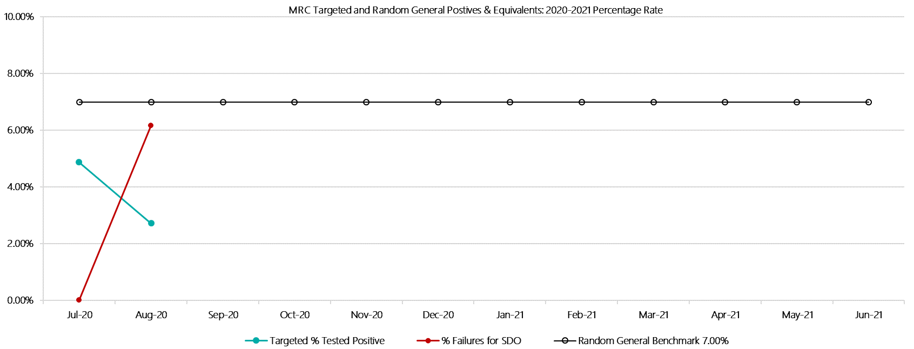***

***Metropolitan Remand Centre Positive Drug Test Results by Drug Type: 2020-2021***

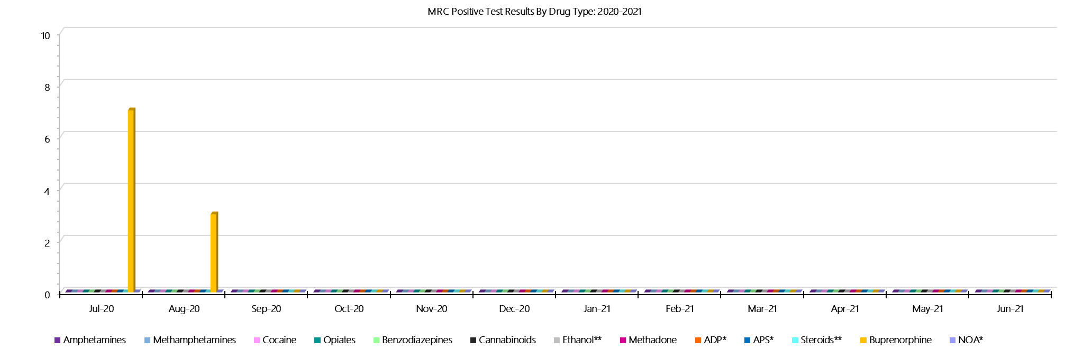

***Metropolitan Remand Centre Count of Visitor Seizures Finds: 2020-2021***

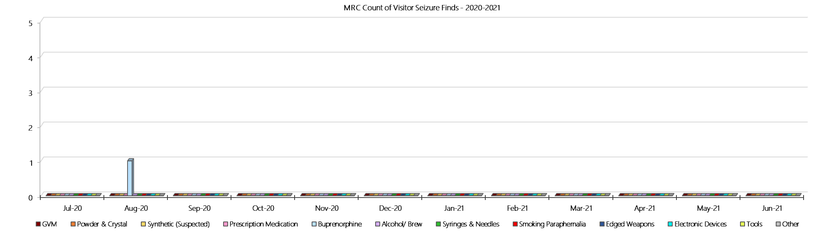

***Metropolitan Remand Centre Count of Prisoner Seizure Finds: 2020-2021***

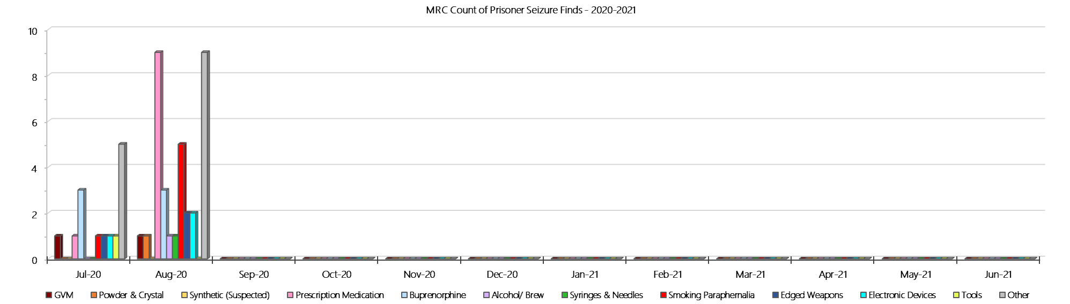

### **Port Phillip Prison**

***Targeted and Random General Drug Test Results: 2020-2021***

|  |  |  |  |  |  |  |  |  |  |  |  |  |  |  |
| --- | --- | --- | --- | --- | --- | --- | --- | --- | --- | --- | --- | --- | --- | --- |
| **Port Phillip Prison** | **Jul-20** | **Aug-20** | **Sep-20** | **Oct-20** | **Nov-20** | **Dec-20** | **Jan-21** | **Feb-21** | **Mar-21** | **Apr-21** | **May-21** | **Jun-21** | **Average** | ***Totals*** |
| **Effective Sample - Targeted** | **308** | **249** |  |  |  |  |  |  |  |  |  |  | **279** | ***557*** |
| **Targeted Positives** | **19** | **11** |  |  |  |  |  |  |  |  |  |  | **15** | ***30*** |
| **Refusal** | **5** | **3** |  |  |  |  |  |  |  |  |  |  | **4** | ***8*** |
| **Unable** | **3** | **1** |  |  |  |  |  |  |  |  |  |  | **2** | ***4*** |
| **Interfered** | **0** | **0** |  |  |  |  |  |  |  |  |  |  | **0** | ***0*** |
| **Adulterated** | **0** | **0** |  |  |  |  |  |  |  |  |  |  | **0** | ***0*** |
| **Targeted % Tested Positive** | **8.77%** | **6.02%** | **#N/A** | **#N/A** | **#N/A** | **#N/A** | **#N/A** | **#N/A** | **#N/A** | **#N/A** | **#N/A** | **#N/A** | **7.54%** | ***7.54%*** |
| **Awaiting / Pending Results** | **0** | **0** |  |  |  |  |  |  |  |  |  |  | **0** | ***0*** |
| **Targeted Residual** | **0** | **0** |  |  |  |  |  |  |  |  |  |  | **0** | ***0*** |
| **Random tests collected** | **43** | **49** |  |  |  |  |  |  |  |  |  |  | **46** | ***92*** |
| **Tested Positive** | **0** | **1** |  |  |  |  |  |  |  |  |  |  | **1** | ***1*** |
| **Refusal (guilty)** | **0** | **1** |  |  |  |  |  |  |  |  |  |  | **1** | ***1*** |
| **Unable (not guilty)** | **0** | **0** |  |  |  |  |  |  |  |  |  |  | **0** | ***0*** |
| **Unable (guilty)** | **0** | **0** |  |  |  |  |  |  |  |  |  |  | **0** | ***0*** |
| **Interfered (guilty)** | **0** | **0** |  |  |  |  |  |  |  |  |  |  | **0** | ***0*** |
| **No test (valid reason)** | **1** | **4** |  |  |  |  |  |  |  |  |  |  | **3** | ***5*** |
| **No test (no valid reason)** | **0** | **0** |  |  |  |  |  |  |  |  |  |  | **0** | ***0*** |
| **Adulterated** | **0** | **0** |  |  |  |  |  |  |  |  |  |  | **0** | ***0*** |
| **Awaiting / Pending Results** | **0** | **1** |  |  |  |  |  |  |  |  |  |  | **1** | ***1*** |
| **Random Residual *(PIMS URAR030)*** | **2** | **0** |  |  |  |  |  |  |  |  |  |  | ***1*** | ***2*** |
| **Effective Sample - Random General** | **43** | **50** |  |  |  |  |  |  |  |  |  |  | **47** | **93** |
| **% Tested positive** | **0.00%** | **2.00%** |  |  |  |  |  |  |  |  |  |  | **1.00%** |  |
| **% Prisoner guilty, positive equivalents** | **0.00%** | **2.00%** |  |  |  |  |  |  |  |  |  |  | **1.00%** |  |
| **% Total prisoner fails** | **0.00%** | **4.00%** |  |  |  |  |  |  |  |  |  |  | **2.00%** |  |
| **% No test without valid reason** | **0.00%** | **0.00%** |  |  |  |  |  |  |  |  |  |  | **0.00%** |  |
| **% Failures for SDO** | **0.00%** | **4.00%** | **#N/A** | **#N/A** | **#N/A** | **#N/A** | **#N/A** | **#N/A** | **#N/A** | **#N/A** | **#N/A** | **#N/A** | **2.15%** |  |

***Port Phillip Prison - Drugs Identified Through Testing by Drug Type: 2020-2021***

|  |  |  |  |  |  |  |  |  |  |  |  |  |  |  |
| --- | --- | --- | --- | --- | --- | --- | --- | --- | --- | --- | --- | --- | --- | --- |
| **PPP** | ***Amphetamines*** | ***Methamphetamines*** | ***Cocaine*** | ***Opiates*** | ***Benzodiazepines*** | ***Cannabinoids*** | ***Ethanol\*\**** | ***Methadone*** | ***ADP\**** | ***APS\**** | ***Steroids\*\**** | ***Buprenorphine*** | ***NOA\**** | **Total** |
| **Jul-20** | **0** | **0** | **0** | **0** | **0** | **0** | **0** | **5** | **0** | **0** | **0** | **18** | **0** | **23** |
| **Aug-20** | **0** | **0** | **0** | **0** | **1** | **0** | **0** | **1** | **0** | **0** | **0** | **13** | **0** | **15** |
| **Sep-20** |  |  |  |  |  |  |  |  |  |  |  |  |  |  |
| **Oct-20** |  |  |  |  |  |  |  |  |  |  |  |  |  |  |
| **Nov-20** |  |  |  |  |  |  |  |  |  |  |  |  |  |  |
| **Dec-20** |  |  |  |  |  |  |  |  |  |  |  |  |  |  |
| **Jan-21** |  |  |  |  |  |  |  |  |  |  |  |  |  |  |
| **Feb-21** |  |  |  |  |  |  |  |  |  |  |  |  |  |  |
| **Mar-21** |  |  |  |  |  |  |  |  |  |  |  |  |  |  |
| **Apr-21** |  |  |  |  |  |  |  |  |  |  |  |  |  |  |
| **May-21** |  |  |  |  |  |  |  |  |  |  |  |  |  |  |
| **Jun-21** |  |  |  |  |  |  |  |  |  |  |  |  |  |  |
| **PPP YTD** | **0** | **0** | **0** | **0** | **1** | **0** | **0** | **6** | **0** | **0** | **0** | **31** | **0** | **38** |
| ***All Prisons YTD*** | ***2*** | ***2*** | ***0*** | ***2*** | ***8*** | ***3*** | ***4*** | ***7*** | ***7*** | ***0*** | ***0*** | ***98*** | ***1*** | ***134*** |
| ***PPP % of Total*** | ***0.00%*** | ***0.00%*** | ***0.00%*** | ***0.00%*** | ***12.50%*** | ***0.00%*** | ***0.00%*** | ***85.71%*** | ***0.00%*** | ***0.00%*** | ***0.00%*** | ***31.63%*** | ***0.00%*** | ***28.36%*** |

***Port Phillip Prison Seizures of Contraband: Visitors & Prisoners: 2020-2021***

|  |  |  |  |  |  |  |  |  |  |  |  |  |  |  |  |  |  |  |  |  |  |  |  |  |  |
| --- | --- | --- | --- | --- | --- | --- | --- | --- | --- | --- | --- | --- | --- | --- | --- | --- | --- | --- | --- | --- | --- | --- | --- | --- | --- |
| **Visitors** | **GVM** | | **Powder  & Crystal** | | **Synthetic  (Suspected)** | | **Prescription  Medication** | | **Buprenorphine** | | **Alcohol &  Home Brew** | | **Syringes & Needles** | | **Smoking  Paraphernalia** | | **Edged  Weapons** | | **Electronic  Devices** | | **Tools** | | **Other** | | |
| **PPP** | **Finds** | **Gms** | **Finds** | **Gms** | **Finds** | **Gms** | **Finds** | **Qty** | **Finds** | **Qty** | **Finds** | **Ltrs** | **Finds** | **Qty** | **Finds** | **Qty** | **Finds** | **Qty** | **Finds** | **Qty** | **Finds** | **Qty** | **Finds** | **Qty** |
| **Jul-20** | **0** | **0.00** | **0** | **0.00** | **0** | **0.00** | **0** | **0.00** | **0** | **0.00** | **0** | **0.000** | **0** | **0** | **0** | **0** | **0** | **0** | **0** | **0** | **0** | **0** | **0** | **0** |
| **Aug-20** | **0** | **0.00** | **0** | **0.00** | **0** | **0.00** | **0** | **0.00** | **2** | **95.00** | **0** | **0.000** | **0** | **0** | **0** | **0** | **0** | **0** | **0** | **0** | **0** | **0** | **0** | **0** |
| **Sep-20** |  |  |  |  |  |  |  |  |  |  |  |  |  |  |  |  |  |  |  |  |  |  |  |  |
| **Oct-20** |  |  |  |  |  |  |  |  |  |  |  |  |  |  |  |  |  |  |  |  |  |  |  |  |
| **Nov-20** |  |  |  |  |  |  |  |  |  |  |  |  |  |  |  |  |  |  |  |  |  |  |  |  |
| **Dec-20** |  |  |  |  |  |  |  |  |  |  |  |  |  |  |  |  |  |  |  |  |  |  |  |  |
| **Jan-21** |  |  |  |  |  |  |  |  |  |  |  |  |  |  |  |  |  |  |  |  |  |  |  |  |
| **Feb-21** |  |  |  |  |  |  |  |  |  |  |  |  |  |  |  |  |  |  |  |  |  |  |  |  |
| **Mar-21** |  |  |  |  |  |  |  |  |  |  |  |  |  |  |  |  |  |  |  |  |  |  |  |  |
| **Apr-21** |  |  |  |  |  |  |  |  |  |  |  |  |  |  |  |  |  |  |  |  |  |  |  |  |
| **May-21** |  |  |  |  |  |  |  |  |  |  |  |  |  |  |  |  |  |  |  |  |  |  |  |  |
| **Jun-21** |  |  |  |  |  |  |  |  |  |  |  |  |  |  |  |  |  |  |  |  |  |  |  |  |
| **Total** | **0** | **0.00** | **0** | **0.00** | **0** | **0.00** | **0** | **0.00** | **2** | **95.00** | **0** | **0.000** | **0** | **0** | **0** | **0** | **0** | **0** | **0** | **0** | **0** | **0** | **0** | **0** |

|  |  |  |  |  |  |  |  |  |  |  |  |  |  |  |  |  |  |  |  |  |  |  |  |  |
| --- | --- | --- | --- | --- | --- | --- | --- | --- | --- | --- | --- | --- | --- | --- | --- | --- | --- | --- | --- | --- | --- | --- | --- | --- |
| **Prisoners** | **GVM** | | **Powder  & Crystal** | | **Synthetic  (Suspected)** | | **Prescription  Medication** | | **Buprenorphine** | | **Alcohol &  Home Brew** | | **Syringes & Needles** | | **Smoking  Paraphernalia** | | **Edged  Weapons** | | **Electronic  Devices** | | **Tools** | | **Other** | |
| **PPP** | **Finds** | **Gms** | **Finds** | **Gms** | **Finds** | **Gms** | **Finds** | **Qty** | **Finds** | **Qty** | **Finds** | **Ltrs** | **Finds** | **Qty** | **Finds** | **Qty** | **Finds** | **Qty** | **Finds** | **Qty** | **Finds** | **Qty** | **Finds** | **Qty** |
| **Jul-20** | **0** | **0.00** | **1** | **1.00** | **0** | **0.00** | **7** | **9.00** | **18** | **138.70** | **4** | **9.000** | **3** | **3** | **6** | **7** | **11** | **12** | **3** | **4** | **6** | **7** | **6** | **11** |
| **Aug-20** | **0** | **0.00** | **0** | **0.00** | **0** | **0.00** | **12** | **34.00** | **14** | **0.00** | **2** | **0.000** | **3** | **0** | **1** | **1** | **9** | **9** | **0** | **0** | **2** | **2** | **9** | **19** |
| **Sep-20** |  |  |  |  |  |  |  |  |  |  |  |  |  |  |  |  |  |  |  |  |  |  |  |  |
| **Oct-20** |  |  |  |  |  |  |  |  |  |  |  |  |  |  |  |  |  |  |  |  |  |  |  |  |
| **Nov-20** |  |  |  |  |  |  |  |  |  |  |  |  |  |  |  |  |  |  |  |  |  |  |  |  |
| **Dec-20** |  |  |  |  |  |  |  |  |  |  |  |  |  |  |  |  |  |  |  |  |  |  |  |  |
| **Jan-21** |  |  |  |  |  |  |  |  |  |  |  |  |  |  |  |  |  |  |  |  |  |  |  |  |
| **Feb-21** |  |  |  |  |  |  |  |  |  |  |  |  |  |  |  |  |  |  |  |  |  |  |  |  |
| **Mar-21** |  |  |  |  |  |  |  |  |  |  |  |  |  |  |  |  |  |  |  |  |  |  |  |  |
| **Apr-21** |  |  |  |  |  |  |  |  |  |  |  |  |  |  |  |  |  |  |  |  |  |  |  |  |
| **May-21** |  |  |  |  |  |  |  |  |  |  |  |  |  |  |  |  |  |  |  |  |  |  |  |  |
| **Jun-21** |  |  |  |  |  |  |  |  |  |  |  |  |  |  |  |  |  |  |  |  |  |  |  |  |
| **Total** | **0** | **0.00** | **1** | **1.00** | **0** | **0.00** | **19** | **43.00** | **32** | **138.70** | **6** | **9.000** | **6** | **3** | **7** | **8** | **20** | **21** | **3** | **4** | **8** | **9** | **15** | **30** |

***Port Phillip Prison Targeted and Random General Drug Test Positives & Equivalents: 2020-2021***

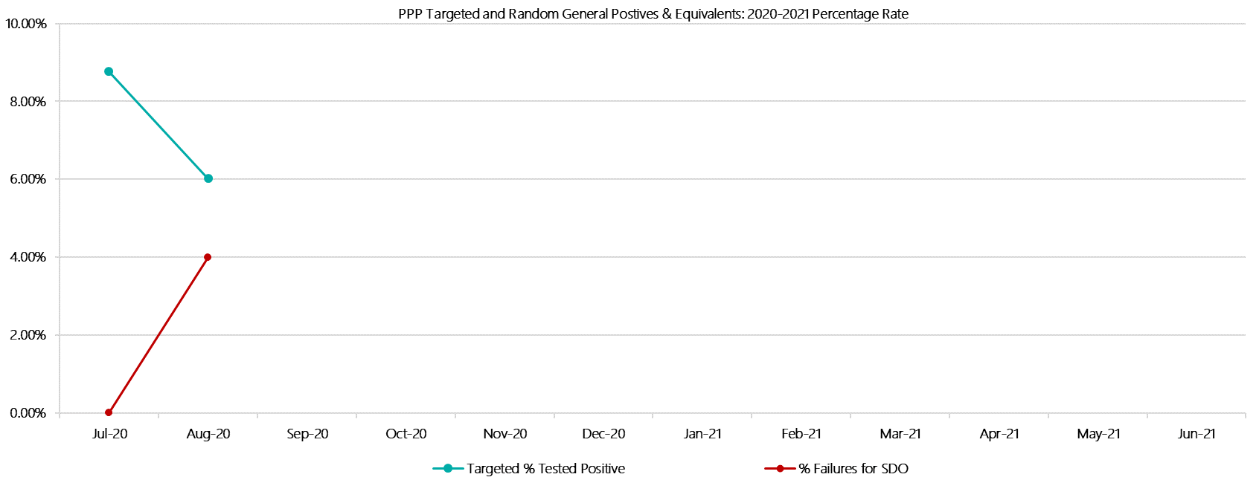

***Port Phillip Prison Positive Test Results by Drug Type: 2020-2021***

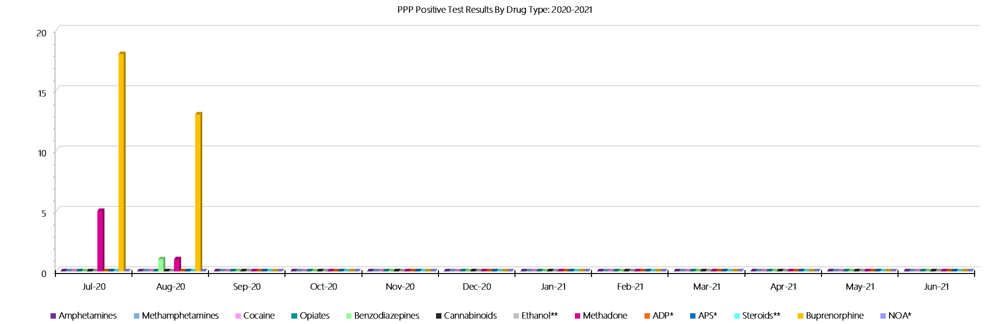

***Port Phillip Prison Count of Visitor Seizures Finds: 2020-2021***

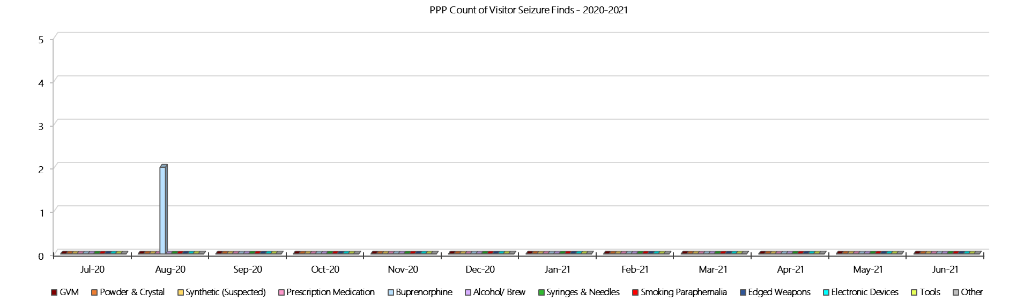

***Port Phillip Prison Count of Prisoner Seizure Finds: 2020-2021***

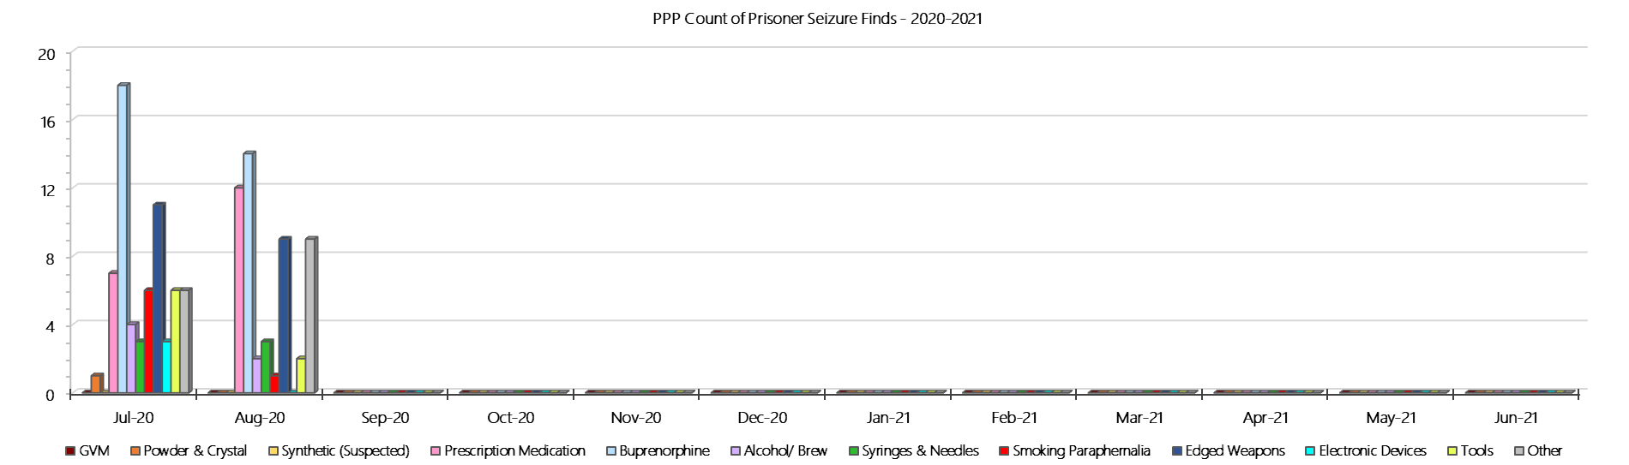

### **Dame Phyllis Frost Centre**

***Targeted and Random General Drug Test Results: 2020-2021***

|  |  |  |  |  |  |  |  |  |  |  |  |  |  |  |
| --- | --- | --- | --- | --- | --- | --- | --- | --- | --- | --- | --- | --- | --- | --- |
| **DPFC** | **Jul-20** | **Aug-20** | **Sep-20** | **Oct-20** | **Nov-20** | **Dec-20** | **Jan-21** | **Feb-21** | **Mar-21** | **Apr-21** | **May-21** | **Jun-21** | **Average** | ***Totals*** |
| **Effective Sample - Targeted** | **56** | **62** |  |  |  |  |  |  |  |  |  |  | **59** | ***118*** |
| **Targeted Positives** | **2** | **1** |  |  |  |  |  |  |  |  |  |  | **2** | ***3*** |
| **Refusal** | **0** | **1** |  |  |  |  |  |  |  |  |  |  | **1** | ***1*** |
| **Unable** | **0** | **2** |  |  |  |  |  |  |  |  |  |  | **1** | ***2*** |
| **Interfered** | **0** | **0** |  |  |  |  |  |  |  |  |  |  | **0** | ***0*** |
| **Adulterated** | **0** | **0** |  |  |  |  |  |  |  |  |  |  | **0** | ***0*** |
| **Targeted % Tested Positive** | **3.57%** | **6.45%** | **#N/A** | **#N/A** | **#N/A** | **#N/A** | **#N/A** | **#N/A** | **#N/A** | **#N/A** | **#N/A** | **#N/A** | **5.08%** | ***5.08%*** |
| **Awaiting / Pending Results** | **0** | **0** |  |  |  |  |  |  |  |  |  |  | **0** | ***0*** |
| **Targeted Residual** | **0** | **0** |  |  |  |  |  |  |  |  |  |  | **0** | ***0*** |
| **Random tests collected** | **37** | **44** |  |  |  |  |  |  |  |  |  |  | **41** | ***81*** |
| **Tested Positive** | **0** | **0** |  |  |  |  |  |  |  |  |  |  | **0** | ***0*** |
| **Refusal (guilty)** | **0** | **0** |  |  |  |  |  |  |  |  |  |  | **0** | ***0*** |
| **Unable (not guilty)** | **0** | **0** |  |  |  |  |  |  |  |  |  |  | **0** | ***0*** |
| **Unable (guilty)** | **0** | **0** |  |  |  |  |  |  |  |  |  |  | **0** | ***0*** |
| **Interfered (guilty)** | **0** | **0** |  |  |  |  |  |  |  |  |  |  | **0** | ***0*** |
| **No test (valid reason)** | **6** | **10** |  |  |  |  |  |  |  |  |  |  | **8** | ***16*** |
| **No test (no valid reason)** | **0** | **0** |  |  |  |  |  |  |  |  |  |  | **0** | ***0*** |
| **Adulterated** | **0** | **0** |  |  |  |  |  |  |  |  |  |  | **0** | ***0*** |
| **Awaiting / Pending Results** | **0** | **0** |  |  |  |  |  |  |  |  |  |  | **0** | ***0*** |
| **Random Residual *(PIMS URAR030)*** | **0** | **0** |  |  |  |  |  |  |  |  |  |  | ***0*** | ***0*** |
| **Effective Sample - Random General** | **37** | **44** |  |  |  |  |  |  |  |  |  |  | **41** | **81** |
| **% Tested positive** | **0.00%** | **0.00%** |  |  |  |  |  |  |  |  |  |  | **0.00%** |  |
| **% Prisoner guilty, positive equivalents** | **0.00%** | **0.00%** |  |  |  |  |  |  |  |  |  |  | **0.00%** |  |
| **% Total prisoner fails** | **0.00%** | **0.00%** |  |  |  |  |  |  |  |  |  |  | **0.00%** |  |
| **% No test without valid reason** | **0.00%** | **0.00%** |  |  |  |  |  |  |  |  |  |  | **0.00%** |  |
| ***Random General Benchmark 7.25%*** | ***6.00%*** | ***6.00%*** | ***6.00%*** | ***6.00%*** | ***6.00%*** | ***6.00%*** | ***6.00%*** | ***6.00%*** | ***6.00%*** | ***6.00%*** | ***6.00%*** | ***6.00%*** | ***YTD*** |  |
| **% Failures for SDO** | **0.00%** | **0.00%** | **#N/A** | **#N/A** | **#N/A** | **#N/A** | **#N/A** | **#N/A** | **#N/A** | **#N/A** | **#N/A** | **#N/A** | **0.00%** |  |

***Dame Phyllis Frost Centre - Drugs Identified Through Testing by Drug Type: 2020-2021***

|  |  |  |  |  |  |  |  |  |  |  |  |  |  |  |
| --- | --- | --- | --- | --- | --- | --- | --- | --- | --- | --- | --- | --- | --- | --- |
| **DPFC** | ***Amphetamines*** | ***Methamphetamines*** | ***Cocaine*** | ***Opiates*** | ***Benzodiazepines*** | ***Cannabinoids*** | ***Ethanol\*\**** | ***Methadone*** | ***ADP\**** | ***APS\**** | ***Steroids\*\**** | ***Buprenorphine*** | ***NOA\**** | **Total** |
| **Jul-20** | **0** | **0** | **0** | **1** | **1** | **0** | **0** | **0** | **0** | **0** | **0** | **0** | **0** | **2** |
| **Aug-20** | **0** | **0** | **0** | **0** | **0** | **0** | **0** | **0** | **1** | **0** | **0** | **0** | **0** | **1** |
| **Sep-20** |  |  |  |  |  |  |  |  |  |  |  |  |  |  |
| **Oct-20** |  |  |  |  |  |  |  |  |  |  |  |  |  |  |
| **Nov-20** |  |  |  |  |  |  |  |  |  |  |  |  |  |  |
| **Dec-20** |  |  |  |  |  |  |  |  |  |  |  |  |  |  |
| **Jan-21** |  |  |  |  |  |  |  |  |  |  |  |  |  |  |
| **Feb-21** |  |  |  |  |  |  |  |  |  |  |  |  |  |  |
| **Mar-21** |  |  |  |  |  |  |  |  |  |  |  |  |  |  |
| **Apr-21** |  |  |  |  |  |  |  |  |  |  |  |  |  |  |
| **May-21** |  |  |  |  |  |  |  |  |  |  |  |  |  |  |
| **Jun-21** |  |  |  |  |  |  |  |  |  |  |  |  |  |  |
| **DPFC YTD** | **0** | **0** | **0** | **1** | **1** | **0** | **0** | **0** | **1** | **0** | **0** | **0** | **0** | **3** |
| ***All Prisons YTD*** | ***2*** | ***2*** | ***0*** | ***2*** | ***8*** | ***3*** | ***4*** | ***7*** | ***7*** | ***0*** | ***0*** | ***98*** | ***1*** | ***134*** |
| ***DPFC % of Total*** | ***0.00%*** | ***0.00%*** | ***0.00%*** | ***50.00%*** | ***12.50%*** | ***0.00%*** | ***0.00%*** | ***0.00%*** | ***14.29%*** | ***0.00%*** | ***0.00%*** | ***0.00%*** | ***0.00%*** | ***2.24%*** |

***Dame Phyllis Frost Centre - Seizures of Contraband: Visitors & Prisoners: 2020-2021***

|  |  |  |  |  |  |  |  |  |  |  |  |  |  |  |  |  |  |  |  |  |  |  |  |  |  |  |
| --- | --- | --- | --- | --- | --- | --- | --- | --- | --- | --- | --- | --- | --- | --- | --- | --- | --- | --- | --- | --- | --- | --- | --- | --- | --- | --- |
| **Visitors** | **GVM** | | **Powder  & Crystal** | | **Synthetic  (Suspected)** | | **Prescription  Medication** | | **Buprenorphine** | | **Alcohol &  Home Brew** | | **Syringes & Needles** | | **Smoking  Paraphernalia** | | | **Edged  Weapons** | | **Electronic  Devices** | | **Tools** | | **Other** | | |
| **DPFC** | **Finds** | **Gms** | **Finds** | **Gms** | **Finds** | **Gms** | **Finds** | **Qty** | **Finds** | **Qty** | **Finds** | **Ltrs** | **Finds** | **Qty** | **Finds** | **Qty** | | **Finds** | **Qty** | **Finds** | **Qty** | **Finds** | **Qty** | **Finds** | **Qty** |
| **Jul-20** | **0** | **0.00** | **0** | **0.00** | **0** | **0.00** | **0** | **0.00** | **0** | **0.00** | **0** | **0.000** | **0** | **0** | **0** | | **0** | **0** | **0** | **0** | **0** | **0** | **0** | **0** | **0** |
| **Aug-20** | **0** | **0.00** | **0** | **0.00** | **0** | **0.00** | **0** | **0.00** | **0** | **0.00** | **0** | **0.000** | **0** | **0** | **0** | | **0** | **0** | **0** | **0** | **0** | **0** | **0** | **0** | **0** |
| **Sep-20** |  |  |  |  |  |  |  |  |  |  |  |  |  |  |  | |  |  |  |  |  |  |  |  |  |
| **Oct-20** |  |  |  |  |  |  |  |  |  |  |  |  |  |  |  | |  |  |  |  |  |  |  |  |  |
| **Nov-20** |  |  |  |  |  |  |  |  |  |  |  |  |  |  |  | |  |  |  |  |  |  |  |  |  |
| **Dec-20** |  |  |  |  |  |  |  |  |  |  |  |  |  |  |  | |  |  |  |  |  |  |  |  |  |
| **Jan-21** |  |  |  |  |  |  |  |  |  |  |  |  |  |  |  | |  |  |  |  |  |  |  |  |  |
| **Feb-21** |  |  |  |  |  |  |  |  |  |  |  |  |  |  |  | |  |  |  |  |  |  |  |  |  |
| **Mar-21** |  |  |  |  |  |  |  |  |  |  |  |  |  |  |  | |  |  |  |  |  |  |  |  |  |
| **Apr-21** |  |  |  |  |  |  |  |  |  |  |  |  |  |  |  | |  |  |  |  |  |  |  |  |  |
| **May-21** |  |  |  |  |  |  |  |  |  |  |  |  |  |  |  | |  |  |  |  |  |  |  |  |  |
| **Jun-21** |  |  |  |  |  |  |  |  |  |  |  |  |  |  |  | |  |  |  |  |  |  |  |  |  |
| **Total** | **0** | **0.00** | **0** | **0.00** | **0** | **0.00** | **0** | **0.00** | **0** | **0.00** | **0** | **0.000** | **0** | **0** | **0** | | **0** | **0** | **0** | **0** | **0** | **0** | **0** | **0** | **0** |

|  |  |  |  |  |  |  |  |  |  |  |  |  |  |  |  |  |  |  |  |  |  |  |  |  |  |
| --- | --- | --- | --- | --- | --- | --- | --- | --- | --- | --- | --- | --- | --- | --- | --- | --- | --- | --- | --- | --- | --- | --- | --- | --- | --- |
| **Prisoners** | **GVM** | | **Powder  & Crystal** | | **Synthetic  (Suspected)** | | **Prescription  Medication** | | **Buprenorphine** | | **Alcohol &  Home Brew** | | **Syringes & Needles** | | **Smoking  Paraphernalia** | | | **Edged  Weapons** | | **Electronic  Devices** | | **Tools** | | **Other** | |
| **DPFC** | **Finds** | **Gms** | **Finds** | **Gms** | **Finds** | **Gms** | **Finds** | **Qty** | **Finds** | **Qty** | **Finds** | **Ltrs** | **Finds** | **Qty** | **Finds** | **Qty** | | **Finds** | **Qty** | **Finds** | **Qty** | **Finds** | **Qty** | **Finds** | **Qty** |
| **Jul-20** | **0** | **0.00** | **1** | **1.60** | **0** | **0.00** | **0** | **0.00** | **0** | **0.00** | **2** | **2.000** | **0** | **0** | **2** | | **3** | **0** | **0** | **0** | **0** | **0** | **0** | **0** | **0** |
| **Aug-20** | **0** | **0.00** | **1** | **25.70** | **0** | **0.00** | **0** | **0.00** | **0** | **0.00** | **1** | **0.200** | **0** | **0** | **0** | | **0** | **0** | **0** | **0** | **0** | **0** | **0** | **0** | **0** |
| **Sep-20** |  |  |  |  |  |  |  |  |  |  |  |  |  |  |  | |  |  |  |  |  |  |  |  |  |
| **Oct-20** |  |  |  |  |  |  |  |  |  |  |  |  |  |  |  | |  |  |  |  |  |  |  |  |  |
| **Nov-20** |  |  |  |  |  |  |  |  |  |  |  |  |  |  |  | |  |  |  |  |  |  |  |  |  |
| **Dec-20** |  |  |  |  |  |  |  |  |  |  |  |  |  |  |  | |  |  |  |  |  |  |  |  |  |
| **Jan-21** |  |  |  |  |  |  |  |  |  |  |  |  |  |  |  | |  |  |  |  |  |  |  |  |  |
| **Feb-21** |  |  |  |  |  |  |  |  |  |  |  |  |  |  |  | |  |  |  |  |  |  |  |  |  |
| **Mar-21** |  |  |  |  |  |  |  |  |  |  |  |  |  |  |  | |  |  |  |  |  |  |  |  |  |
| **Apr-21** |  |  |  |  |  |  |  |  |  |  |  |  |  |  |  | |  |  |  |  |  |  |  |  |  |
| **May-21** |  |  |  |  |  |  |  |  |  |  |  |  |  |  |  | |  |  |  |  |  |  |  |  |  |
| **Jun-21** |  |  |  |  |  |  |  |  |  |  |  |  |  |  |  | |  |  |  |  |  |  |  |  |  |
| **Total** | **0** | **0.00** | **2** | **27.30** | **0** | **0.00** | **0** | **0.00** | **0** | **0.00** | **3** | **2.200** | **0** | **0** | **2** | | **3** | **0** | **0** | **0** | **0** | **0** | **0** | **0** | **0** |

***Dame Phyllis Frost Centre Targeted and Random General Drug Test Positives & Equivalents: 2020-2021***

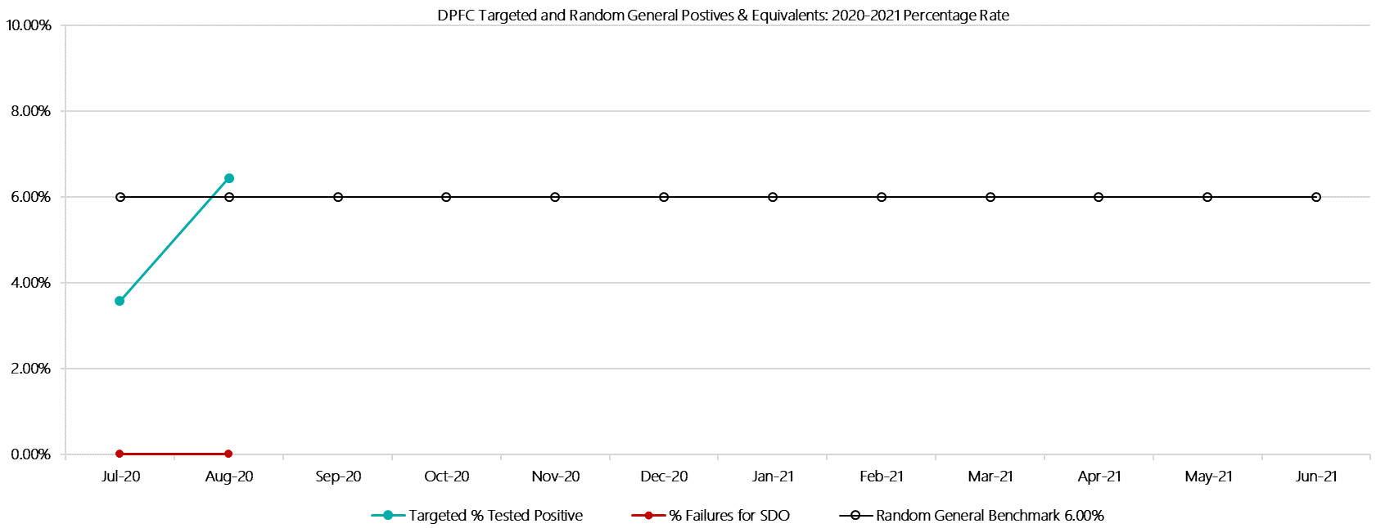

***Dame Phyllis Frost Centre Positive Test Results by Drug Type: 2020-2021  
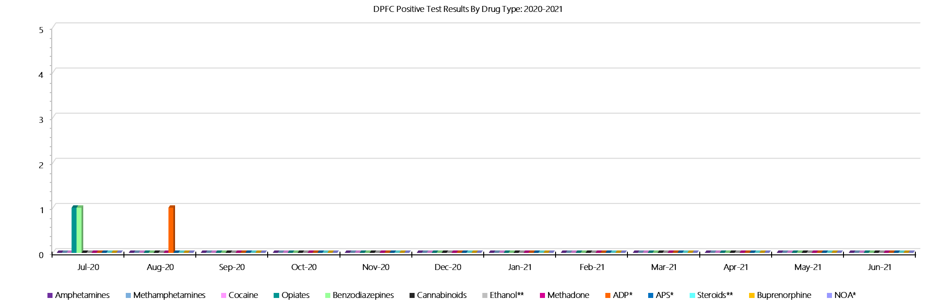***

***Dame Phyllis Frost Centre Count of Visitor Seizures Finds – 2020-2021***

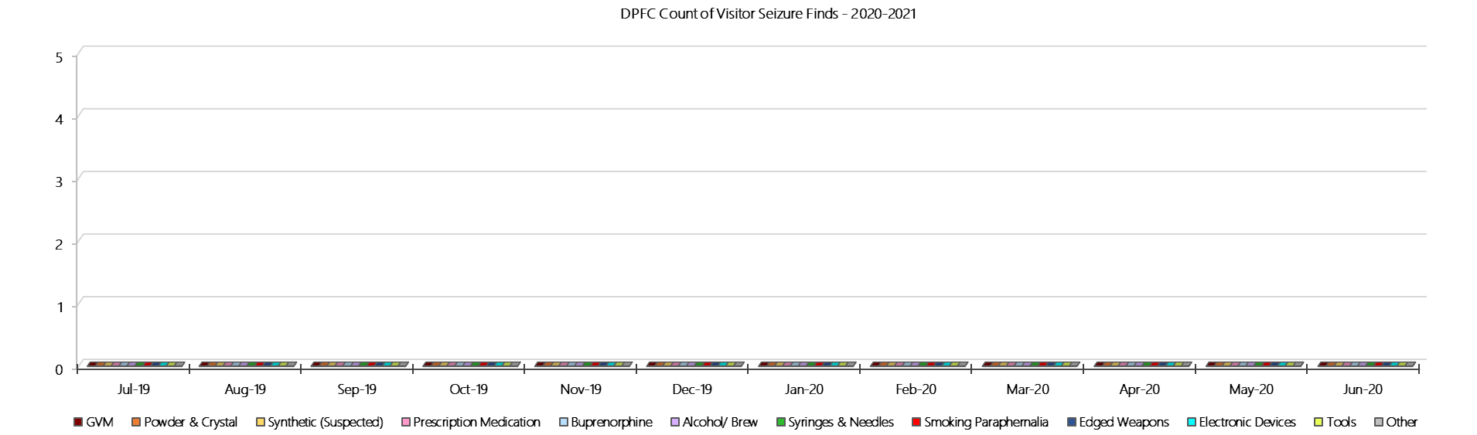

***DPFC Count of Prisoner Seizure Finds – 2020-2021***

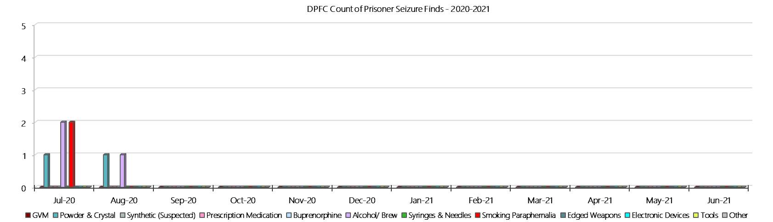

### **Fulham Correctional Centre**

***Targeted and Random General Drug Test Results: 2020-2021***

|  |  |  |  |  |  |  |  |  |  |  |  |  |  |  |
| --- | --- | --- | --- | --- | --- | --- | --- | --- | --- | --- | --- | --- | --- | --- |
| **Fulham** | **Jul-20** | **Aug-20** | **Sep-20** | **Oct-20** | **Nov-20** | **Dec-20** | **Jan-21** | **Feb-21** | **Mar-21** | **Apr-21** | **May-21** | **Jun-21** | **Average** | ***Totals*** |
| **Effective Sample - Targeted** | **97** | **90** |  |  |  |  |  |  |  |  |  |  | **94** | ***187*** |
| **Targeted Positives** | **4** | **1** |  |  |  |  |  |  |  |  |  |  | **3** | ***5*** |
| **Refusal** | **0** | **0** |  |  |  |  |  |  |  |  |  |  | **0** | ***0*** |
| **Unable** | **2** | **0** |  |  |  |  |  |  |  |  |  |  | **1** | ***2*** |
| **Interfered** | **0** | **0** |  |  |  |  |  |  |  |  |  |  | **0** | ***0*** |
| **Adulterated** | **0** | **0** |  |  |  |  |  |  |  |  |  |  | **0** | ***0*** |
| **Targeted % Tested Positive** | **6.19%** | **1.11%** | **#N/A** | **#N/A** | **#N/A** | **#N/A** | **#N/A** | **#N/A** | **#N/A** | **#N/A** | **#N/A** | **#N/A** | **3.74%** | ***3.74%*** |
| **Awaiting / Pending Results** | **0** | **0** |  |  |  |  |  |  |  |  |  |  | **0** | ***0*** |
| **Targeted Residual** | **0** | **0** |  |  |  |  |  |  |  |  |  |  | **0** | ***0*** |
| **Random tests collected** | **56** | **62** |  |  |  |  |  |  |  |  |  |  | **59** | ***118*** |
| **Tested Positive** | **0** | **0** |  |  |  |  |  |  |  |  |  |  | **0** | ***0*** |
| **Refusal (guilty)** | **0** | **0** |  |  |  |  |  |  |  |  |  |  | **0** | ***0*** |
| **Unable (not guilty)** | **0** | **0** |  |  |  |  |  |  |  |  |  |  | **0** | ***0*** |
| **Unable (guilty)** | **0** | **0** |  |  |  |  |  |  |  |  |  |  | **0** | ***0*** |
| **Interfered (guilty)** | **0** | **0** |  |  |  |  |  |  |  |  |  |  | **0** | ***0*** |
| **No test (valid reason)** | **0** | **2** |  |  |  |  |  |  |  |  |  |  | **1** | ***2*** |
| **No test (no valid reason)** | **0** | **0** |  |  |  |  |  |  |  |  |  |  | **0** | ***0*** |
| **Adulterated** | **0** | **0** |  |  |  |  |  |  |  |  |  |  | **0** | ***0*** |
| **Awaiting / Pending Results** | **0** | **2** |  |  |  |  |  |  |  |  |  |  | **1** | ***2*** |
| **Random Residual *(PIMS URAR030)*** | **0** | **0** |  |  |  |  |  |  |  |  |  |  | ***0*** | ***0*** |
| **Effective Sample - Random General** | **56** | **62** |  |  |  |  |  |  |  |  |  |  | **59** | **118** |
| **% Tested positive** | **0.00%** | **0.00%** |  |  |  |  |  |  |  |  |  |  | **0.00%** |  |
| **% Prisoner guilty, positive equivalents** | **0.00%** | **0.00%** |  |  |  |  |  |  |  |  |  |  | **0.00%** |  |
| **% Total prisoner fails** | **0.00%** | **0.00%** |  |  |  |  |  |  |  |  |  |  | **0.00%** |  |
| **% No test without valid reason** | **0.00%** | **0.00%** |  |  |  |  |  |  |  |  |  |  | **0.00%** |  |
| **% Failures for SDO** | **0.00%** | **0.00%** | **#N/A** | **#N/A** | **#N/A** | **#N/A** | **#N/A** | **#N/A** | **#N/A** | **#N/A** | **#N/A** | **#N/A** | **0.00%** |  |

***Fulham - Drugs Identified Through Testing by Drug Type: 2020-2021***

|  |  |  |  |  |  |  |  |  |  |  |  |  |  |  |
| --- | --- | --- | --- | --- | --- | --- | --- | --- | --- | --- | --- | --- | --- | --- |
| **Fulham** | ***Amphetamines*** | ***Methamphetamines*** | ***Cocaine*** | ***Opiates*** | ***Benzodiazepines*** | ***Cannabinoids*** | ***Ethanol\*\**** | ***Methadone*** | ***ADP\**** | ***APS\**** | ***Steroids\*\**** | ***Buprenorphine*** | ***NOA\**** | **Total** |
| **Jul-20** | **0** | **0** | **0** | **0** | **2** | **0** | **0** | **1** | **1** | **0** | **0** | **0** | **0** | **4** |
| **Aug-20** | **0** | **0** | **0** | **0** | **0** | **0** | **0** | **0** | **1** | **0** | **0** | **0** | **0** | **1** |
| **Sep-20** |  |  |  |  |  |  |  |  |  |  |  |  |  |  |
| **Oct-20** |  |  |  |  |  |  |  |  |  |  |  |  |  |  |
| **Nov-20** |  |  |  |  |  |  |  |  |  |  |  |  |  |  |
| **Dec-20** |  |  |  |  |  |  |  |  |  |  |  |  |  |  |
| **Jan-21** |  |  |  |  |  |  |  |  |  |  |  |  |  |  |
| **Feb-21** |  |  |  |  |  |  |  |  |  |  |  |  |  |  |
| **Mar-21** |  |  |  |  |  |  |  |  |  |  |  |  |  |  |
| **Apr-21** |  |  |  |  |  |  |  |  |  |  |  |  |  |  |
| **May-21** |  |  |  |  |  |  |  |  |  |  |  |  |  |  |
| **Jun-21** |  |  |  |  |  |  |  |  |  |  |  |  |  |  |
| **Fuham YTD** | **0** | **0** | **0** | **0** | **2** | **0** | **0** | **1** | **2** | **0** | **0** | **0** | **0** | **5** |
| ***All Prisons YTD*** | ***2*** | ***2*** | ***0*** | ***2*** | ***8*** | ***3*** | ***4*** | ***7*** | ***7*** | ***0*** | ***0*** | ***98*** | ***1*** | ***134*** |
| ***Fulham % of Total*** | ***0.00%*** | ***0.00%*** | ***0.00%*** | ***0.00%*** | ***25.00%*** | ***0.00%*** | ***0.00%*** | ***14.29%*** | ***28.57%*** | ***0.00%*** | ***0.00%*** | ***0.00%*** | ***0.00%*** | ***3.73%*** |

***Fulham Seizures of Contraband: Visitors & Prisoners: 2020-2021***

|  |  |  |  |  |  |  |  |  |  |  |  |  |  |  |  |  |  |  |  |  |  |  |  |  |
| --- | --- | --- | --- | --- | --- | --- | --- | --- | --- | --- | --- | --- | --- | --- | --- | --- | --- | --- | --- | --- | --- | --- | --- | --- |
| **Visitors** | **GVM** | | **Powder  & Crystal** | | **Synthetic  (Suspected)** | | **Prescription  Medication** | | **Buprenorphine** | | **Alcohol &  Home Brew** | | **Syringes & Needles** | | **Smoking  Paraphernalia** | | **Edged  Weapons** | | **Electronic  Devices** | | **Tools** | | **Other** | |
| **Fulham** | **Finds** | **Gms** | **Finds** | **Gms** | **Finds** | **Gms** | **Finds** | **Qty** | **Finds** | **Qty** | **Finds** | **Ltrs** | **Finds** | **Qty** | **Finds** | **Qty** | **Finds** | **Qty** | **Finds** | **Qty** | **Finds** | **Qty** | **Finds** | **Qty** |
| **Jul-20** | **0** | **0.00** | **0** | **0.00** | **0** | **0.00** | **0** | **0.00** | **0** | **0.00** | **0** | **0.000** | **0** | **0** | **0** | **0** | **0** | **0** | **0** | **0** | **0** | **0** | **0** | **0** |
| **Aug-20** | **0** | **0.00** | **0** | **0.00** | **0** | **0.00** | **1** | **3.00** | **0** | **0.00** | **0** | **0.000** | **0** | **0** | **0** | **0** | **0** | **0** | **0** | **0** | **0** | **0** | **0** | **0** |
| **Sep-20** |  |  |  |  |  |  |  |  |  |  |  |  |  |  |  |  |  |  |  |  |  |  |  |  |
| **Oct-20** |  |  |  |  |  |  |  |  |  |  |  |  |  |  |  |  |  |  |  |  |  |  |  |  |
| **Nov-20** |  |  |  |  |  |  |  |  |  |  |  |  |  |  |  |  |  |  |  |  |  |  |  |  |
| **Dec-20** |  |  |  |  |  |  |  |  |  |  |  |  |  |  |  |  |  |  |  |  |  |  |  |  |
| **Jan-21** |  |  |  |  |  |  |  |  |  |  |  |  |  |  |  |  |  |  |  |  |  |  |  |  |
| **Feb-21** |  |  |  |  |  |  |  |  |  |  |  |  |  |  |  |  |  |  |  |  |  |  |  |  |
| **Mar-21** |  |  |  |  |  |  |  |  |  |  |  |  |  |  |  |  |  |  |  |  |  |  |  |  |
| **Apr-21** |  |  |  |  |  |  |  |  |  |  |  |  |  |  |  |  |  |  |  |  |  |  |  |  |
| **May-21** |  |  |  |  |  |  |  |  |  |  |  |  |  |  |  |  |  |  |  |  |  |  |  |  |
| **Jun-21** |  |  |  |  |  |  |  |  |  |  |  |  |  |  |  |  |  |  |  |  |  |  |  |  |
| **Total** | **0** | **0.00** | **0** | **0.00** | **0** | **0.00** | **1** | **3.00** | **0** | **0.00** | **0** | **0.000** | **0** | **0** | **0** | **0** | **0** | **0** | **0** | **0** | **0** | **0** | **0** | **0** |

|  |  |  |  |  |  |  |  |  |  |  |  |  |  |  |  |  |  |  |  |  |  |  |  |  |  |  |
| --- | --- | --- | --- | --- | --- | --- | --- | --- | --- | --- | --- | --- | --- | --- | --- | --- | --- | --- | --- | --- | --- | --- | --- | --- | --- | --- |
| **Prisoners** | **GVM** | | **Powder  & Crystal** | | **Synthetic  (Suspected)** | | **Prescription  Medication** | | **Buprenorphine** | | **Alcohol &  Home Brew** | | **Syringes & Needles** | | **Smoking  Paraphernalia** | | | **Edged  Weapons** | | **Electronic  Devices** | | **Tools** | | **Other** | | |
| **Fulham** | **Finds** | **Gms** | **Finds** | **Gms** | **Finds** | **Gms** | **Finds** | **Qty** | **Finds** | **Qty** | **Finds** | **Ltrs** | **Finds** | **Qty** | **Finds** | **Qty** | | **Finds** | **Qty** | **Finds** | **Qty** | **Finds** | **Qty** | **Finds** | **Qty** |
| **Jul-20** | **0** | **0.00** | **0** | **0.00** | **0** | **0.00** | **4** | **3.50** | **1** | **5.50** | **3** | **4.000** | **0** | **0** | **8** | | **25** | **3** | **6** | **0** | **0** | **5** | **7** | **3** | **7** |
| **Aug-20** | **0** | **0.00** | **0** | **0.00** | **0** | **0.00** | **7** | **19.25** | **0** | **0.00** | **3** | **3.000** | **1** | **3** | **11** | | **16** | **2** | **2** | **2** | **2** | **4** | **6** | **2** | **4** |
| **Sep-20** |  |  |  |  |  |  |  |  |  |  |  |  |  |  |  | |  |  |  |  |  |  |  |  |  |
| **Oct-20** |  |  |  |  |  |  |  |  |  |  |  |  |  |  |  | |  |  |  |  |  |  |  |  |  |
| **Nov-20** |  |  |  |  |  |  |  |  |  |  |  |  |  |  |  | |  |  |  |  |  |  |  |  |  |
| **Dec-20** |  |  |  |  |  |  |  |  |  |  |  |  |  |  |  | |  |  |  |  |  |  |  |  |  |
| **Jan-21** |  |  |  |  |  |  |  |  |  |  |  |  |  |  |  | |  |  |  |  |  |  |  |  |  |
| **Feb-21** |  |  |  |  |  |  |  |  |  |  |  |  |  |  |  | |  |  |  |  |  |  |  |  |  |
| **Mar-21** |  |  |  |  |  |  |  |  |  |  |  |  |  |  |  | |  |  |  |  |  |  |  |  |  |
| **Apr-21** |  |  |  |  |  |  |  |  |  |  |  |  |  |  |  | |  |  |  |  |  |  |  |  |  |
| **May-21** |  |  |  |  |  |  |  |  |  |  |  |  |  |  |  | |  |  |  |  |  |  |  |  |  |
| **Jun-21** |  |  |  |  |  |  |  |  |  |  |  |  |  |  |  | |  |  |  |  |  |  |  |  |  |
| **Total** | **0** | **0.00** | **0** | **0.00** | **0** | **0.00** | **11** | **22.75** | **1** | **5.50** | **6** | **7.000** | **1** | **3** | **19** | | **41** | **5** | **8** | **2** | **2** | **9** | **13** | **5** | **11** |

***Fulham Targeted and Random General Drug Test Positives & Equivalents: 2020-2021***

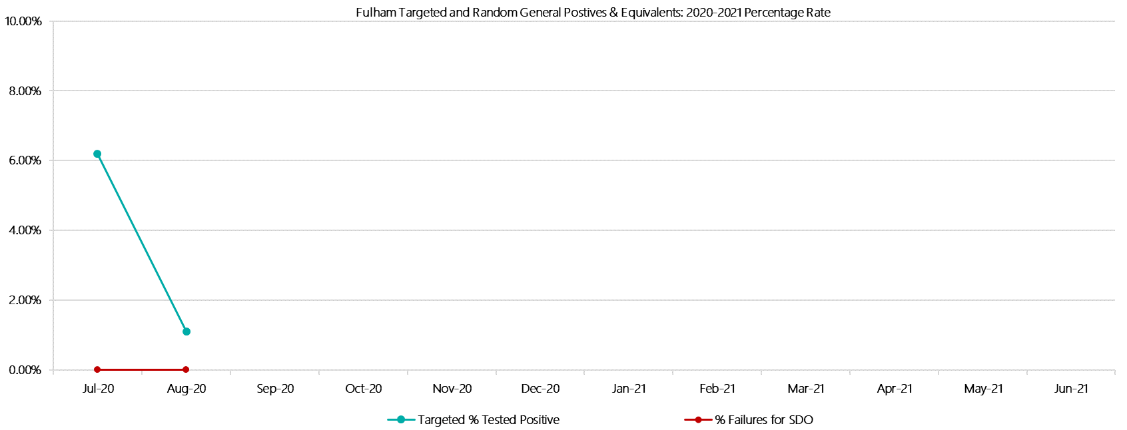

***Fulham Positive Test Results by Drug Type: 2020-2021***

**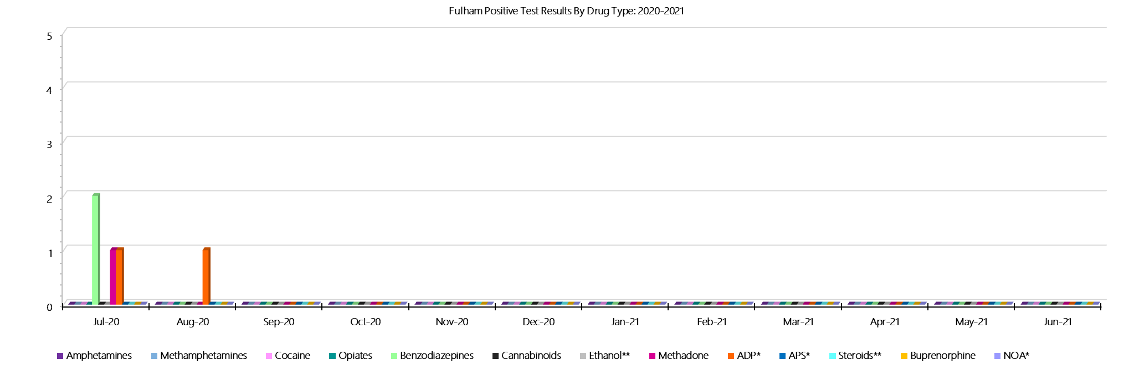*Fulham Count of Visitor Seizures Finds: 2020-2021***

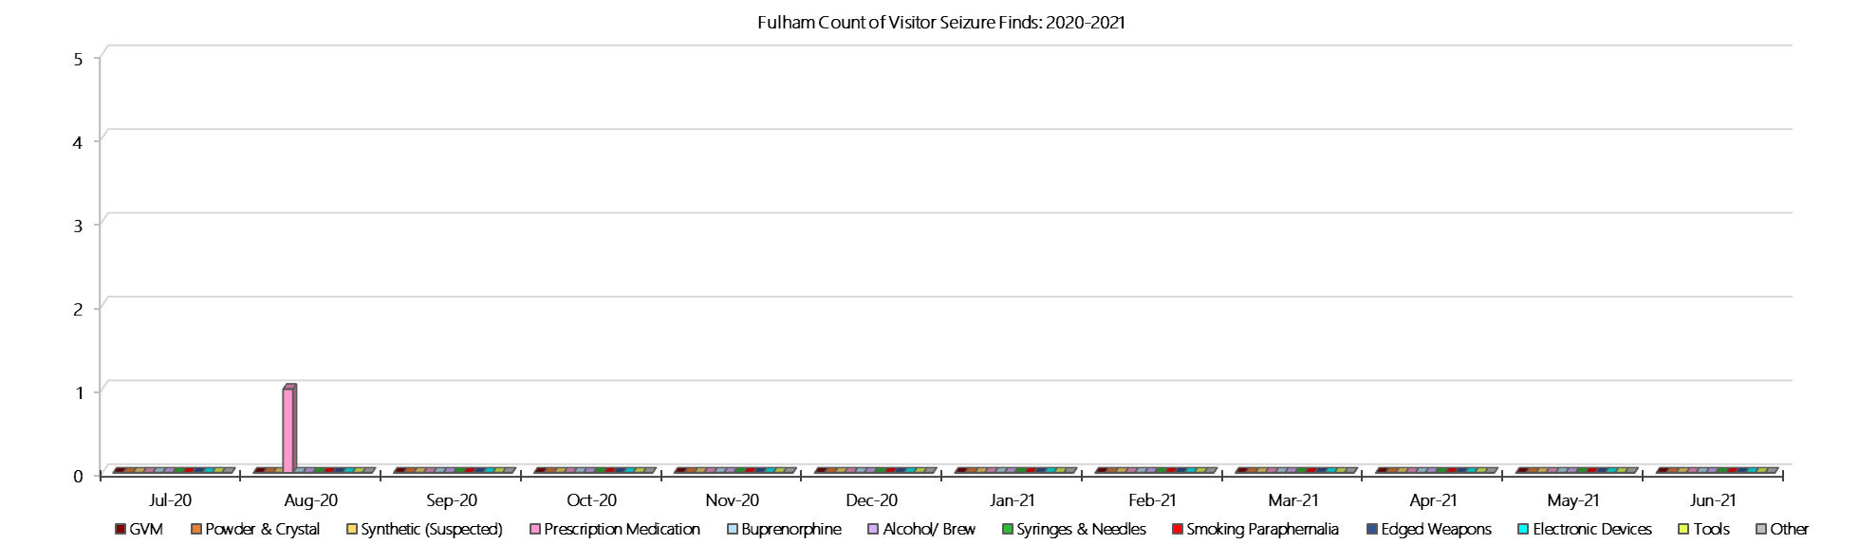

***Fulham Count of Prisoner Seizure Finds: 2020-2021***

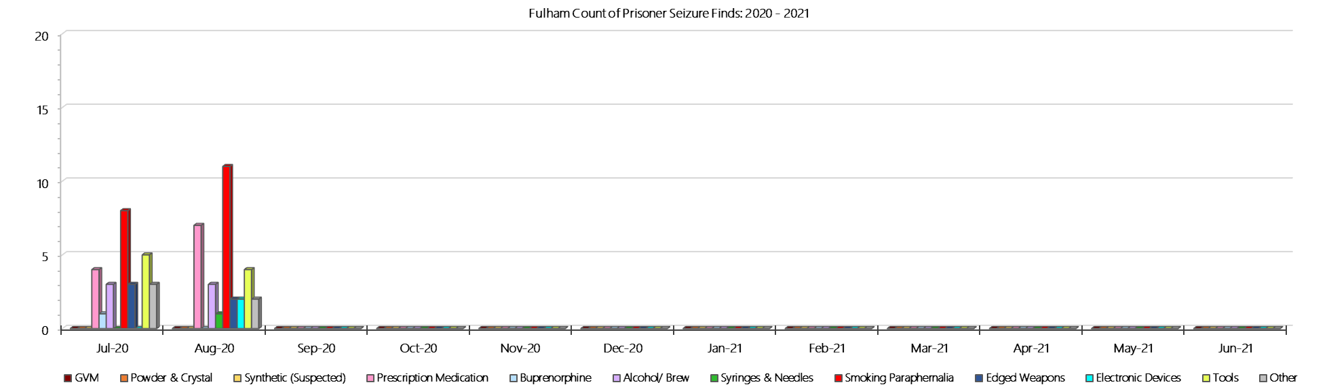

### **Hopkins Correctional Centre**

***Targeted and Random General Drug Test Results: 2020-2021***

|  |  |  |  |  |  |  |  |  |  |  |  |  |  |  |
| --- | --- | --- | --- | --- | --- | --- | --- | --- | --- | --- | --- | --- | --- | --- |
| **Hopkins** | **Jul-20** | **Aug-20** | **Sep-20** | **Oct-20** | **Nov-20** | **Dec-20** | **Jan-21** | **Feb-21** | **Mar-21** | **Apr-21** | **May-21** | **Jun-21** | **Average** | ***Totals*** |
| **Effective Sample - Targeted** | **9** | **9** |  |  |  |  |  |  |  |  |  |  | **9** | ***18*** |
| **Targeted Positives** | **0** | **2** |  |  |  |  |  |  |  |  |  |  | **1** | ***2*** |
| **Refusal** | **0** | **0** |  |  |  |  |  |  |  |  |  |  | **0** | ***0*** |
| **Unable** | **1** | **0** |  |  |  |  |  |  |  |  |  |  | **1** | ***1*** |
| **Interfered** | **0** | **0** |  |  |  |  |  |  |  |  |  |  | **0** | ***0*** |
| **Adulterated** | **0** | **0** |  |  |  |  |  |  |  |  |  |  | **0** | ***0*** |
| **Targeted % Tested Positive** | **11.11%** | **22.22%** | **#N/A** | **#N/A** | **#N/A** | **#N/A** | **#N/A** | **#N/A** | **#N/A** | **#N/A** | **#N/A** | **#N/A** | **16.67%** | ***16.67%*** |
| **Awaiting / Pending Results** | **0** | **0** |  |  |  |  |  |  |  |  |  |  | **0** | ***0*** |
| **Targeted Residual** | **0** | **0** |  |  |  |  |  |  |  |  |  |  | **0** | ***0*** |
| **Random tests collected** | **85** | **110** |  |  |  |  |  |  |  |  |  |  | **98** | ***195*** |
| **Tested Positive** | **1** | **1** |  |  |  |  |  |  |  |  |  |  | **1** | ***2*** |
| **Refusal (guilty)** | **0** | **0** |  |  |  |  |  |  |  |  |  |  | **0** | ***0*** |
| **Unable (not guilty)** | **0** | **1** |  |  |  |  |  |  |  |  |  |  | **1** | ***1*** |
| **Unable (guilty)** | **2** | **0** |  |  |  |  |  |  |  |  |  |  | **1** | ***2*** |
| **Interfered (guilty)** | **0** | **0** |  |  |  |  |  |  |  |  |  |  | **0** | ***0*** |
| **No test (valid reason)** | **5** | **1** |  |  |  |  |  |  |  |  |  |  | **3** | ***6*** |
| **No test (no valid reason)** | **0** | **0** |  |  |  |  |  |  |  |  |  |  | **0** | ***0*** |
| **Adulterated** | **0** | **0** |  |  |  |  |  |  |  |  |  |  | **0** | ***0*** |
| **Awaiting / Pending Results** | **0** | **0** |  |  |  |  |  |  |  |  |  |  | **0** | ***0*** |
| **Random Residual *(PIMS URAR030)*** | **0** | **0** |  |  |  |  |  |  |  |  |  |  | ***0*** | ***0*** |
| **Effective Sample - Random General** | **87** | **110** |  |  |  |  |  |  |  |  |  |  | **99** | **197** |
| **% Tested positive** | **1.15%** | **0.91%** |  |  |  |  |  |  |  |  |  |  | **1.03%** |  |
| **% Prisoner guilty, positive equivalents** | **2.30%** | **0.00%** |  |  |  |  |  |  |  |  |  |  | **1.15%** |  |
| **% Total prisoner fails** | **3.45%** | **0.91%** |  |  |  |  |  |  |  |  |  |  | **2.18%** |  |
| **% No test without valid reason** | **0.00%** | **0.00%** |  |  |  |  |  |  |  |  |  |  | **0.00%** |  |
| ***Random General Benchmark 3.50%*** | ***3.50%*** | ***3.50%*** | ***3.50%*** | ***3.50%*** | ***3.50%*** | ***3.50%*** | ***3.50%*** | ***3.50%*** | ***3.50%*** | ***3.50%*** | ***3.50%*** | ***3.50%*** | ***YTD*** |  |
| **% Failures for SDO** | **3.45%** | **0.91%** | **#N/A** | **#N/A** | **#N/A** | **#N/A** | **#N/A** | **#N/A** | **#N/A** | **#N/A** | **#N/A** | **#N/A** | **2.03%** |  |

***Hopkins - Drugs Identified Through Testing by Drug Type: 2020-2021***

|  |  |  |  |  |  |  |  |  |  |  |  |  |  |  |
| --- | --- | --- | --- | --- | --- | --- | --- | --- | --- | --- | --- | --- | --- | --- |
| **Hopkins** | ***Amphetamines*** | ***Methamphetamines*** | ***Cocaine*** | ***Opiates*** | ***Benzodiazepines*** | ***Cannabinoids*** | ***Ethanol\*\**** | ***Methadone*** | ***ADP\**** | ***APS\**** | ***Steroids\*\**** | ***Buprenorphine*** | ***NOA\**** | **Total** |
| **Jul-20** | **0** | **0** | **0** | **0** | **1** | **0** | **0** | **0** | **0** | **0** | **0** | **1** | **0** | **2** |
| **Aug-20** | **0** | **0** | **0** | **0** | **0** | **0** | **0** | **0** | **0** | **0** | **0** | **4** | **0** | **4** |
| **Sep-20** |  |  |  |  |  |  |  |  |  |  |  |  |  |  |
| **Oct-20** |  |  |  |  |  |  |  |  |  |  |  |  |  |  |
| **Nov-20** |  |  |  |  |  |  |  |  |  |  |  |  |  |  |
| **Dec-20** |  |  |  |  |  |  |  |  |  |  |  |  |  |  |
| **Jan-21** |  |  |  |  |  |  |  |  |  |  |  |  |  |  |
| **Feb-21** |  |  |  |  |  |  |  |  |  |  |  |  |  |  |
| **Mar-21** |  |  |  |  |  |  |  |  |  |  |  |  |  |  |
| **Apr-21** |  |  |  |  |  |  |  |  |  |  |  |  |  |  |
| **May-21** |  |  |  |  |  |  |  |  |  |  |  |  |  |  |
| **Jun-21** |  |  |  |  |  |  |  |  |  |  |  |  |  |  |
| **Hopkins YTD** | **0** | **0** | **0** | **0** | **1** | **0** | **0** | **0** | **0** | **0** | **0** | **5** | **0** | **6** |
| ***All Prisons YTD*** | ***2*** | ***2*** | ***0*** | ***2*** | ***8*** | ***3*** | ***4*** | ***7*** | ***7*** | ***0*** | ***0*** | ***98*** | ***1*** | ***134*** |
| ***Hopkins % of Total*** | ***0.00%*** | ***0.00%*** | ***0.00%*** | ***0.00%*** | ***12.50%*** | ***0.00%*** | ***0.00%*** | ***0.00%*** | ***0.00%*** | ***0.00%*** | ***0.00%*** | ***5.10%*** | ***0.00%*** | ***4.48%*** |

***Hopkins Seizures of Contraband: Visitors & Prisoners: 2020-2021***

|  |  |  |  |  |  |  |  |  |  |  |  |  |  |  |  |  |  |  |  |  |  |  |  |  |
| --- | --- | --- | --- | --- | --- | --- | --- | --- | --- | --- | --- | --- | --- | --- | --- | --- | --- | --- | --- | --- | --- | --- | --- | --- |
| **Visitors** | **GVM** | | **Powder  & Crystal** | | **Synthetic  (Suspected)** | | **Prescription  Medication** | | **Buprenorphine** | | **Alcohol &  Home Brew** | | **Syringes & Needles** | | **Smoking  Paraphernalia** | | **Edged  Weapons** | | **Electronic  Devices** | | **Tools** | | **Other** | |
| **Hopkins** | **Finds** | **Gms** | **Finds** | **Gms** | **Finds** | **Gms** | **Finds** | **Qty** | **Finds** | **Qty** | **Finds** | **Ltrs** | **Finds** | **Qty** | **Finds** | **Qty** | **Finds** | **Qty** | **Finds** | **Qty** | **Finds** | **Qty** | **Finds** | **Qty** |
| **Jul-20** | **0** | **0.00** | **0** | **0.00** | **0** | **0.00** | **0** | **0.00** | **0** | **0.00** | **0** | **0.000** | **0** | **0** | **0** | **0** | **0** | **0** | **0** | **0** | **0** | **0** | **0** | **0** |
| **Aug-20** | **0** | **0.00** | **0** | **0.00** | **0** | **0.00** | **0** | **0.00** | **0** | **0.00** | **0** | **0.000** | **0** | **0** | **0** | **0** | **0** | **0** | **0** | **0** | **0** | **0** | **0** | **0** |
| **Sep-20** |  |  |  |  |  |  |  |  |  |  |  |  |  |  |  |  |  |  |  |  |  |  |  |  |
| **Oct-20** |  |  |  |  |  |  |  |  |  |  |  |  |  |  |  |  |  |  |  |  |  |  |  |  |
| **Nov-20** |  |  |  |  |  |  |  |  |  |  |  |  |  |  |  |  |  |  |  |  |  |  |  |  |
| **Dec-20** |  |  |  |  |  |  |  |  |  |  |  |  |  |  |  |  |  |  |  |  |  |  |  |  |
| **Jan-21** |  |  |  |  |  |  |  |  |  |  |  |  |  |  |  |  |  |  |  |  |  |  |  |  |
| **Feb-21** |  |  |  |  |  |  |  |  |  |  |  |  |  |  |  |  |  |  |  |  |  |  |  |  |
| **Mar-21** |  |  |  |  |  |  |  |  |  |  |  |  |  |  |  |  |  |  |  |  |  |  |  |  |
| **Apr-21** |  |  |  |  |  |  |  |  |  |  |  |  |  |  |  |  |  |  |  |  |  |  |  |  |
| **May-21** |  |  |  |  |  |  |  |  |  |  |  |  |  |  |  |  |  |  |  |  |  |  |  |  |
| **Jun-21** |  |  |  |  |  |  |  |  |  |  |  |  |  |  |  |  |  |  |  |  |  |  |  |  |
| **Total** | **0** | **0.00** | **0** | **0.00** | **0** | **0.00** | **0** | **0.00** | **0** | **0.00** | **0** | **0.000** | **0** | **0** | **0** | **0** | **0** | **0** | **0** | **0** | **0** | **0** | **0** | **0** |

|  |  |  |  |  |  |  |  |  |  |  |  |  |  |  |  |  |  |  |  |  |  |  |  |  |  |
| --- | --- | --- | --- | --- | --- | --- | --- | --- | --- | --- | --- | --- | --- | --- | --- | --- | --- | --- | --- | --- | --- | --- | --- | --- | --- |
| **Prisoners** | **GVM** | | **Powder  & Crystal** | | **Synthetic  (Suspected)** | | **Prescription  Medication** | | **Buprenorphine** | | **Alcohol &  Home Brew** | | **Syringes & Needles** | | **Smoking  Paraphernalia** | | | **Edged  Weapons** | | **Electronic  Devices** | | **Tools** | | **Other** | |
| **Hopkins** | **Finds** | **Gms** | **Finds** | **Gms** | **Finds** | **Gms** | **Finds** | **Qty** | **Finds** | **Qty** | **Finds** | **Ltrs** | **Finds** | **Qty** | **Finds** | **Qty** | | **Finds** | **Qty** | **Finds** | **Qty** | **Finds** | **Qty** | **Finds** | **Qty** |
| **Jul-20** | **0** | **0.00** | **1** | **0.11** | **0** | **0.00** | **0** | **0.00** | **0** | **0.00** | **0** | **0.000** | **1** | **1** | **0** | | **0** | **1** | **1** | **0** | **0** | **0** | **0** | **0** | **0** |
| **Aug-20** | **0** | **0.00** | **0** | **0.00** | **0** | **0.00** | **4** | **13.00** | **0** | **0.00** | **0** | **0.000** | **0** | **0** | **3** | | **3** | **7** | **9** | **0** | **0** | **0** | **0** | **5** | **6** |
| **Sep-20** |  |  |  |  |  |  |  |  |  |  |  |  |  |  |  | |  |  |  |  |  |  |  |  |  |
| **Oct-20** |  |  |  |  |  |  |  |  |  |  |  |  |  |  |  | |  |  |  |  |  |  |  |  |  |
| **Nov-20** |  |  |  |  |  |  |  |  |  |  |  |  |  |  |  | |  |  |  |  |  |  |  |  |  |
| **Dec-20** |  |  |  |  |  |  |  |  |  |  |  |  |  |  |  | |  |  |  |  |  |  |  |  |  |
| **Jan-21** |  |  |  |  |  |  |  |  |  |  |  |  |  |  |  | |  |  |  |  |  |  |  |  |  |
| **Feb-21** |  |  |  |  |  |  |  |  |  |  |  |  |  |  |  | |  |  |  |  |  |  |  |  |  |
| **Mar-21** |  |  |  |  |  |  |  |  |  |  |  |  |  |  |  | |  |  |  |  |  |  |  |  |  |
| **Apr-21** |  |  |  |  |  |  |  |  |  |  |  |  |  |  |  | |  |  |  |  |  |  |  |  |  |
| **May-21** |  |  |  |  |  |  |  |  |  |  |  |  |  |  |  | |  |  |  |  |  |  |  |  |  |
| **Jun-21** |  |  |  |  |  |  |  |  |  |  |  |  |  |  |  | |  |  |  |  |  |  |  |  |  |
| **Total** | **0** | **0.00** | **1** | **0.11** | **0** | **0.00** | **4** | **13.00** | **0** | **0.00** | **0** | **0.000** | **1** | **1** | **3** | | **3** | **8** | **10** | **0** | **0** | **0** | **0** | **5** | **6** |

***Hopkins Targeted and Random General Drug Test Positives & Equivalents: 2020-2021***

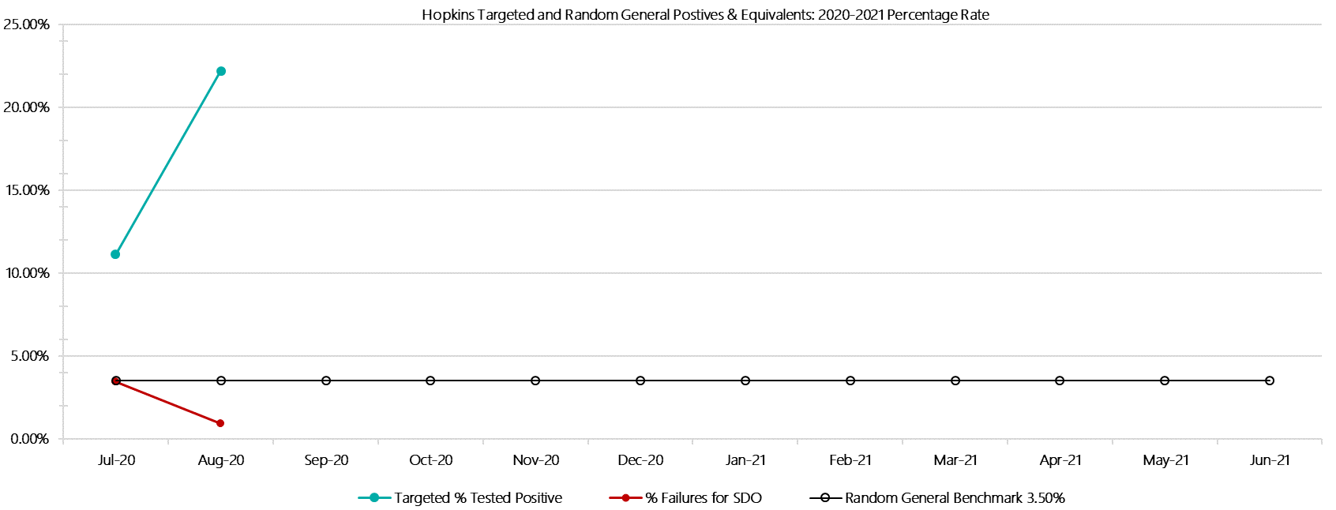

***Hopkins Positive Test Results by Drug Type: 2020-2021***

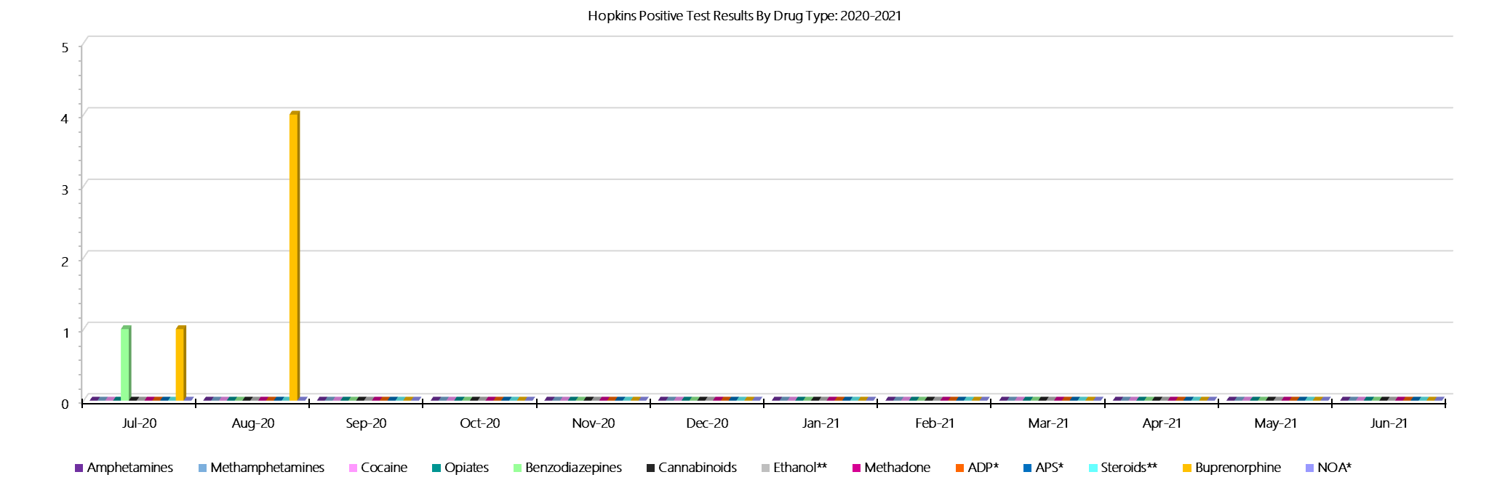

***Hopkins Count of Visitor Seizures Finds: 2020-2021***

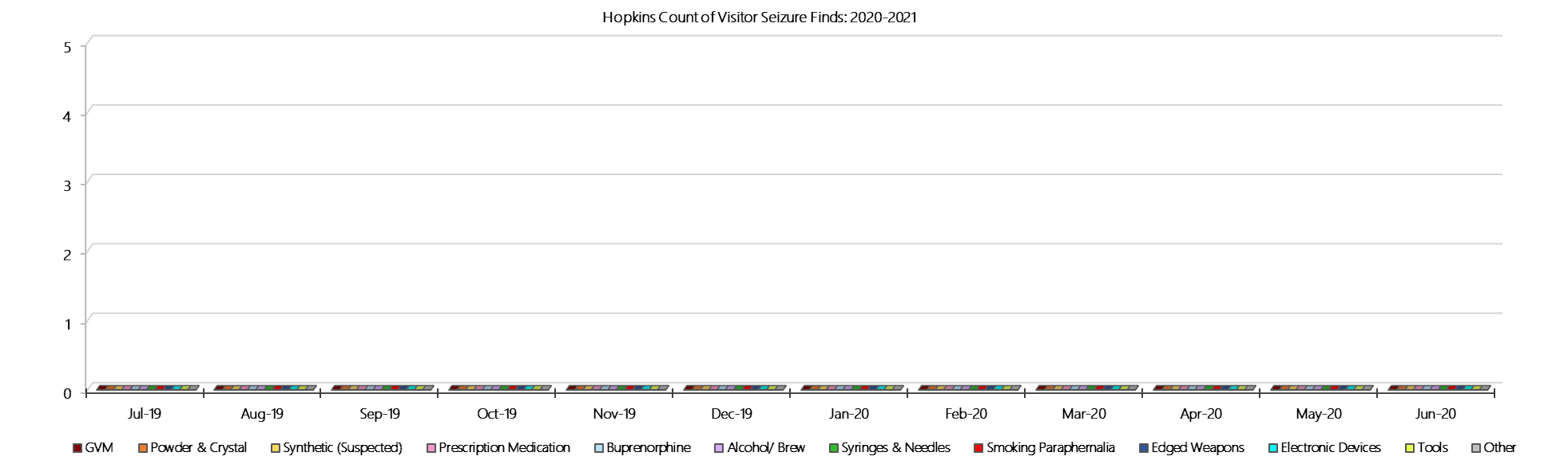

***Hopkins Count of Prisoner Seizure Finds: 2020-2021***

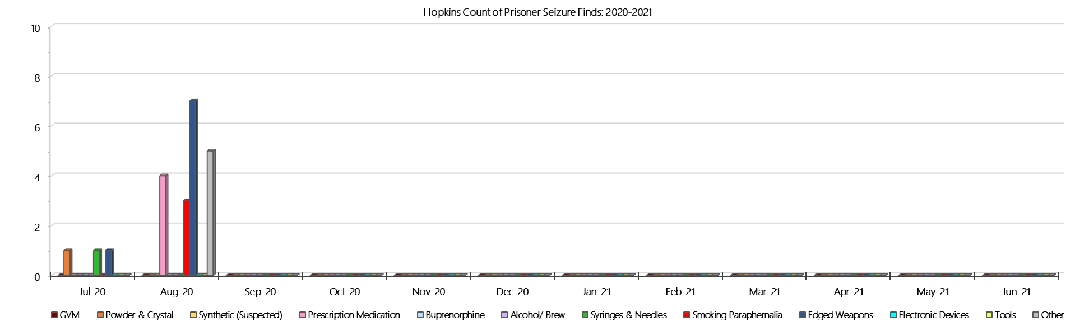

### **Karreenga (annex of Marngoneet)**

***Targeted and Random General Drug Test Results: 2020-21***

|  |  |  |  |  |  |  |  |  |  |  |  |  |  |  |
| --- | --- | --- | --- | --- | --- | --- | --- | --- | --- | --- | --- | --- | --- | --- |
| **Karreenga** | **Jul-20** | **Aug-20** | **Sep-20** | **Oct-20** | **Nov-20** | **Dec-20** | **Jan-21** | **Feb-21** | **Mar-21** | **Apr-21** | **May-21** | **Jun-21** | **Average** | ***Totals*** |
| **Effective Sample - Targeted** | **14** | **8** |  |  |  |  |  |  |  |  |  |  | **11** | ***22*** |
| **Targeted Positives** | **1** | **0** |  |  |  |  |  |  |  |  |  |  | **1** | ***1*** |
| **Refusal** | **0** | **0** |  |  |  |  |  |  |  |  |  |  | **0** | ***0*** |
| **Unable** | **0** | **0** |  |  |  |  |  |  |  |  |  |  | **0** | ***0*** |
| **Interfered** | **0** | **0** |  |  |  |  |  |  |  |  |  |  | **0** | ***0*** |
| **Adulterated** | **0** | **0** |  |  |  |  |  |  |  |  |  |  | **0** | ***0*** |
| **Targeted % Tested Positive** | **7.14%** | **0.00%** | **#N/A** | **#N/A** | **#N/A** | **#N/A** | **#N/A** | **#N/A** | **#N/A** | **#N/A** | **#N/A** | **#N/A** | **4.55%** | ***4.55%*** |
| **Awaiting / Pending Results** | **0** | **0** |  |  |  |  |  |  |  |  |  |  | **0** | ***0*** |
| **Targeted Residual** | **0** | **0** |  |  |  |  |  |  |  |  |  |  | **0** | ***0*** |
| **Random tests collected** | **32** | **31** |  |  |  |  |  |  |  |  |  |  | **32** | ***63*** |
| **Tested Positive** | **0** | **0** |  |  |  |  |  |  |  |  |  |  | **0** | ***0*** |
| **Refusal (guilty)** | **0** | **0** |  |  |  |  |  |  |  |  |  |  | **0** | ***0*** |
| **Unable (not guilty)** | **0** | **0** |  |  |  |  |  |  |  |  |  |  | **0** | ***0*** |
| **Unable (guilty)** | **0** | **0** |  |  |  |  |  |  |  |  |  |  | **0** | ***0*** |
| **Interfered (guilty)** | **0** | **0** |  |  |  |  |  |  |  |  |  |  | **0** | ***0*** |
| **No test (valid reason)** | **0** | **0** |  |  |  |  |  |  |  |  |  |  | **0** | ***0*** |
| **No test (no valid reason)** | **0** | **0** |  |  |  |  |  |  |  |  |  |  | **0** | ***0*** |
| **Adulterated** | **0** | **0** |  |  |  |  |  |  |  |  |  |  | **0** | ***0*** |
| **Awaiting / Pending Results** | **0** | **8** |  |  |  |  |  |  |  |  |  |  | **4** | ***8*** |
| **Random Residual *(PIMS URAR030)*** | **0** | **0** |  |  |  |  |  |  |  |  |  |  | ***0*** | ***0*** |
| **Effective Sample - Random General** | **32** | **31** |  |  |  |  |  |  |  |  |  |  | **32** | **63** |
| **% Tested positive** | **0.00%** | **0.00%** |  |  |  |  |  |  |  |  |  |  | **0.00%** |  |
| **% Prisoner guilty, positive equivalents** | **0.00%** | **0.00%** |  |  |  |  |  |  |  |  |  |  | **0.00%** |  |
| **% Total prisoner fails** | **0.00%** | **0.00%** |  |  |  |  |  |  |  |  |  |  | **0.00%** |  |
| **% No test without valid reason** | **0.00%** | **0.00%** |  |  |  |  |  |  |  |  |  |  | **0.00%** |  |
| ***Random General Benchmark 3.50%*** | ***3.50%*** | ***3.50%*** | ***3.50%*** | ***3.50%*** | ***3.50%*** | ***3.50%*** | ***3.50%*** | ***3.50%*** | ***3.50%*** | ***3.50%*** | ***3.50%*** | ***3.50%*** | ***YTD*** |  |
| **% Failures for SDO** | **0.00%** | **0.00%** | **#N/A** | **#N/A** | **#N/A** | **#N/A** | **#N/A** | **#N/A** | **#N/A** | **#N/A** | **#N/A** | **#N/A** | **0.00%** |  |

***Karreenga - Drugs Identified Through Testing by Drug Type: 2020-2021***

|  |  |  |  |  |  |  |  |  |  |  |  |  |  |  |
| --- | --- | --- | --- | --- | --- | --- | --- | --- | --- | --- | --- | --- | --- | --- |
| **Karreenga** | ***Amphetamines*** | ***Methamphetamines*** | ***Cocaine*** | ***Opiates*** | ***Benzodiazepines*** | ***Cannabinoids*** | ***Ethanol\*\**** | ***Methadone*** | ***ADP\**** | ***APS\**** | ***Steroids\*\**** | ***Buprenorphine*** | ***NOA\**** | **Total** |
| **Jul-20** | **0** | **0** | **0** | **0** | **0** | **0** | **0** | **0** | **0** | **0** | **0** | **1** | **0** | **1** |
| **Aug-20** | **0** | **0** | **0** | **0** | **0** | **0** | **0** | **0** | **0** | **0** | **0** | **0** | **0** | **0** |
| **Sep-20** |  |  |  |  |  |  |  |  |  |  |  |  |  |  |
| **Oct-20** |  |  |  |  |  |  |  |  |  |  |  |  |  |  |
| **Nov-20** |  |  |  |  |  |  |  |  |  |  |  |  |  |  |
| **Dec-20** |  |  |  |  |  |  |  |  |  |  |  |  |  |  |
| **Jan-21** |  |  |  |  |  |  |  |  |  |  |  |  |  |  |
| **Feb-21** |  |  |  |  |  |  |  |  |  |  |  |  |  |  |
| **Mar-21** |  |  |  |  |  |  |  |  |  |  |  |  |  |  |
| **Apr-21** |  |  |  |  |  |  |  |  |  |  |  |  |  |  |
| **May-21** |  |  |  |  |  |  |  |  |  |  |  |  |  |  |
| **Jun-21** |  |  |  |  |  |  |  |  |  |  |  |  |  |  |
| **Karreenga YTD** | **0** | **0** | **0** | **0** | **0** | **0** | **0** | **0** | **0** | **0** | **0** | **1** | **0** | **1** |
| ***All Prisons YTD*** | ***2*** | ***2*** | ***0*** | ***2*** | ***8*** | ***3*** | ***4*** | ***7*** | ***7*** | ***0*** | ***0*** | ***98*** | ***1*** | ***134*** |
| ***Karreenga % of Total*** | ***0.00%*** | ***0.00%*** | ***0.00%*** | ***0.00%*** | ***0.00%*** | ***0.00%*** | ***0.00%*** | ***0.00%*** | ***0.00%*** | ***0.00%*** | ***0.00%*** | ***1.02%*** | ***0.00%*** | ***0.75%*** |

***Karreenga Seizures of Contraband: Visitors & Prisoners: 2020-2021***

|  |  |  |  |  |  |  |  |  |  |  |  |  |  |  |  |  |  |  |  |  |  |  |  |  |
| --- | --- | --- | --- | --- | --- | --- | --- | --- | --- | --- | --- | --- | --- | --- | --- | --- | --- | --- | --- | --- | --- | --- | --- | --- |
| **Visitors** | **GVM** | | **Powder  & Crystal** | | **Synthetic  (Suspected)** | | **Prescription  Medication** | | **Buprenorphine** | | **Alcohol &  Home Brew** | | **Syringes & Needles** | | **Smoking  Paraphernalia** | | **Edged  Weapons** | | **Electronic  Devices** | | **Tools** | | **Other** | |
| **Karreenga** | **Finds** | **Gms** | **Finds** | **Gms** | **Finds** | **Gms** | **Finds** | **Qty** | **Finds** | **Qty** | **Finds** | **Ltrs** | **Finds** | **Qty** | **Finds** | **Qty** | **Finds** | **Qty** | **Finds** | **Qty** | **Finds** | **Qty** | **Finds** | **Qty** |
| **Jul-20** | **0** | **0.00** | **0** | **0.00** | **0** | **0.00** | **0** | **0.00** | **0** | **0.00** | **0** | **0.000** | **0** | **0** | **0** | **0** | **0** | **0** | **0** | **0** | **0** | **0** | **0** | **0** |
| **Aug-20** | **0** | **0.00** | **0** | **0.00** | **0** | **0.00** | **0** | **0.00** | **0** | **0.00** | **0** | **0.000** | **0** | **0** | **0** | **0** | **0** | **0** | **0** | **0** | **0** | **0** | **0** | **0** |
| **Sep-20** |  |  |  |  |  |  |  |  |  |  |  |  |  |  |  |  |  |  |  |  |  |  |  |  |
| **Oct-20** |  |  |  |  |  |  |  |  |  |  |  |  |  |  |  |  |  |  |  |  |  |  |  |  |
| **Nov-20** |  |  |  |  |  |  |  |  |  |  |  |  |  |  |  |  |  |  |  |  |  |  |  |  |
| **Dec-20** |  |  |  |  |  |  |  |  |  |  |  |  |  |  |  |  |  |  |  |  |  |  |  |  |
| **Jan-21** |  |  |  |  |  |  |  |  |  |  |  |  |  |  |  |  |  |  |  |  |  |  |  |  |
| **Feb-21** |  |  |  |  |  |  |  |  |  |  |  |  |  |  |  |  |  |  |  |  |  |  |  |  |
| **Mar-21** |  |  |  |  |  |  |  |  |  |  |  |  |  |  |  |  |  |  |  |  |  |  |  |  |
| **Apr-21** |  |  |  |  |  |  |  |  |  |  |  |  |  |  |  |  |  |  |  |  |  |  |  |  |
| **May-21** |  |  |  |  |  |  |  |  |  |  |  |  |  |  |  |  |  |  |  |  |  |  |  |  |
| **Jun-21** |  |  |  |  |  |  |  |  |  |  |  |  |  |  |  |  |  |  |  |  |  |  |  |  |
| **Total** | **0** | **0.00** | **0** | **0.00** | **0** | **0.00** | **0** | **0.00** | **0** | **0.00** | **0** | **0.000** | **0** | **0** | **0** | **0** | **0** | **0** | **0** | **0** | **0** | **0** | **0** | **0** |

|  |  |  |  |  |  |  |  |  |  |  |  |  |  |  |  |  |  |  |  |  |  |  |  |  |  |
| --- | --- | --- | --- | --- | --- | --- | --- | --- | --- | --- | --- | --- | --- | --- | --- | --- | --- | --- | --- | --- | --- | --- | --- | --- | --- |
| **Prisoners** | **GVM** | | **Powder  & Crystal** | | **Synthetic  (Suspected)** | | **Prescription  Medication** | | **Buprenorphine** | | **Alcohol &  Home Brew** | | **Syringes & Needles** | | **Smoking  Paraphernalia** | | | **Edged  Weapons** | | **Electronic  Devices** | | **Tools** | | **Other** | |
| **Karreenga** | **Finds** | **Gms** | **Finds** | **Gms** | **Finds** | **Gms** | **Finds** | **Qty** | **Finds** | **Qty** | **Finds** | **Ltrs** | **Finds** | **Qty** | **Finds** | **Qty** | | **Finds** | **Qty** | **Finds** | **Qty** | **Finds** | **Qty** | **Finds** | **Qty** |
| **Jul-20** | **0** | **0.00** | **0** | **0.00** | **0** | **0.00** | **2** | **4.00** | **2** | **0.60** | **0** | **0.000** | **0** | **0** | **0** | | **0** | **2** | **2** | **0** | **0** | **0** | **0** | **1** | **1** |
| **Aug-20** | **0** | **0.00** | **0** | **0.00** | **0** | **0.00** | **1** | **0.80** | **1** | **0.60** | **0** | **0.000** | **0** | **0** | **1** | | **1** | **0** | **0** | **0** | **0** | **0** | **0** | **1** | **1** |
| **Sep-20** |  |  |  |  |  |  |  |  |  |  |  |  |  |  |  | |  |  |  |  |  |  |  |  |  |
| **Oct-20** |  |  |  |  |  |  |  |  |  |  |  |  |  |  |  | |  |  |  |  |  |  |  |  |  |
| **Nov-20** |  |  |  |  |  |  |  |  |  |  |  |  |  |  |  | |  |  |  |  |  |  |  |  |  |
| **Dec-20** |  |  |  |  |  |  |  |  |  |  |  |  |  |  |  | |  |  |  |  |  |  |  |  |  |
| **Jan-21** |  |  |  |  |  |  |  |  |  |  |  |  |  |  |  | |  |  |  |  |  |  |  |  |  |
| **Feb-21** |  |  |  |  |  |  |  |  |  |  |  |  |  |  |  | |  |  |  |  |  |  |  |  |  |
| **Mar-21** |  |  |  |  |  |  |  |  |  |  |  |  |  |  |  | |  |  |  |  |  |  |  |  |  |
| **Apr-21** |  |  |  |  |  |  |  |  |  |  |  |  |  |  |  | |  |  |  |  |  |  |  |  |  |
| **May-21** |  |  |  |  |  |  |  |  |  |  |  |  |  |  |  | |  |  |  |  |  |  |  |  |  |
| **Jun-21** |  |  |  |  |  |  |  |  |  |  |  |  |  |  |  | |  |  |  |  |  |  |  |  |  |
| **Total** | **0** | **0.00** | **0** | **0.00** | **0** | **0.00** | **3** | **4.80** | **3** | **1.20** | **0** | **0.000** | **0** | **0** | **1** | | **1** | **2** | **2** | **0** | **0** | **0** | **0** | **2** | **2** |

***Karreenga Targeted and Random General Drug Test Positives & Equivalents: 2020-2021***

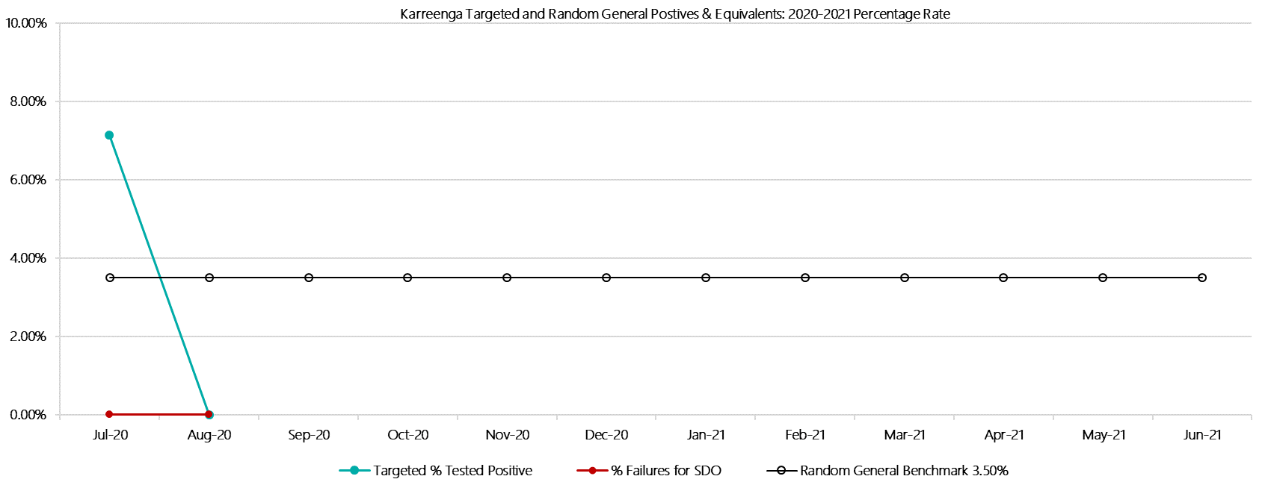

***Karreenga Positive Test Results by Drug Type: 2020-2021***

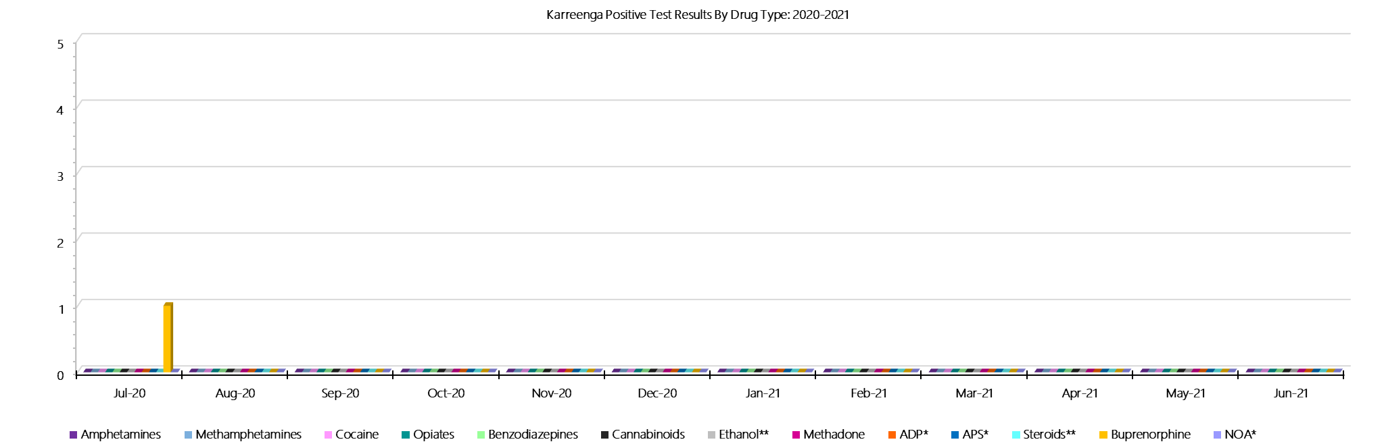

***Karreenga Count of Visitor Seizures Finds: 2020-2021***

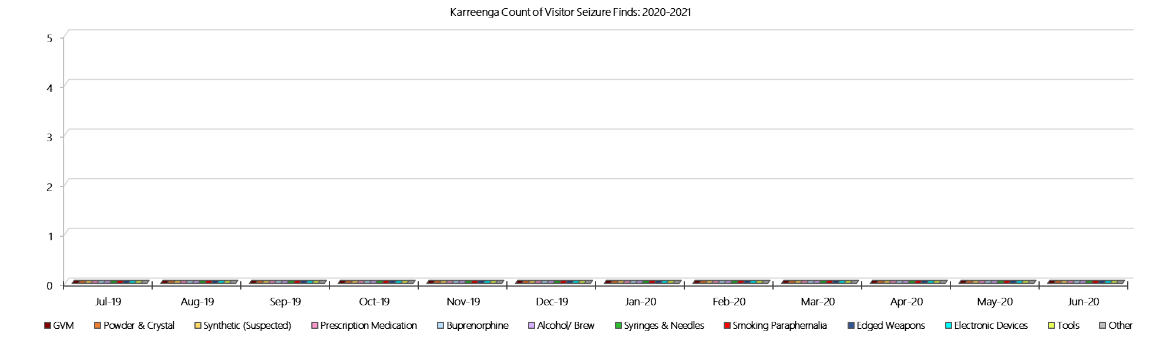

***Karreenga Count of Prisoner Seizure: 2020-2021***

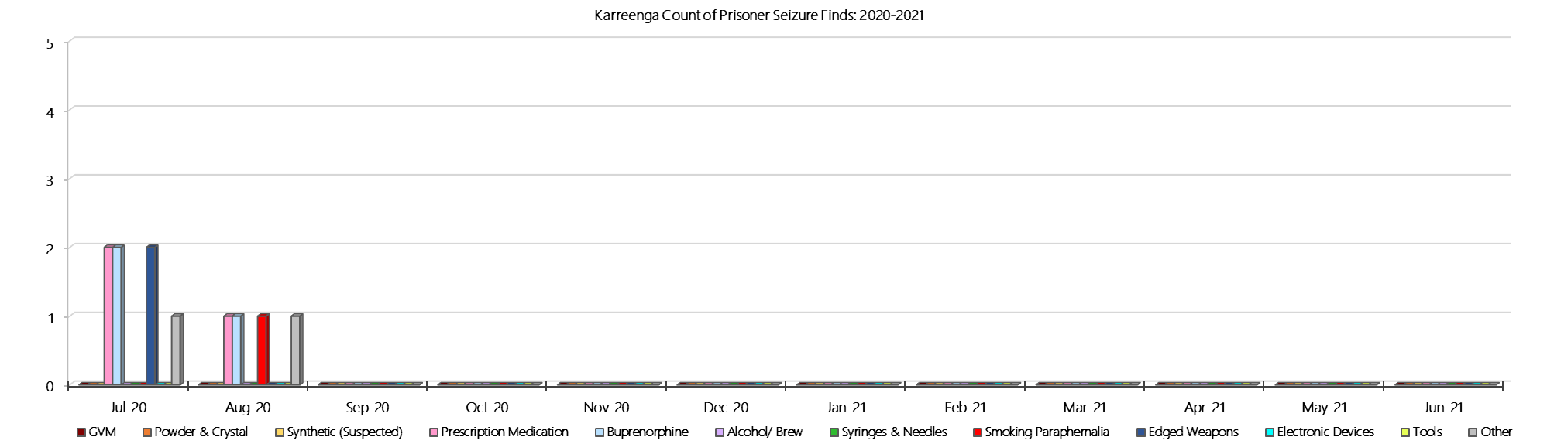

### **Marngoneet Correctional Centre**

***Targeted and Random General Drug Test Results: 2020-2021***

|  |  |  |  |  |  |  |  |  |  |  |  |  |  |  |
| --- | --- | --- | --- | --- | --- | --- | --- | --- | --- | --- | --- | --- | --- | --- |
| **Marngoneet** | **Jul-20** | **Aug-20** | **Sep-20** | **Oct-20** | **Nov-20** | **Dec-20** | **Jan-21** | **Feb-21** | **Mar-21** | **Apr-21** | **May-21** | **Jun-21** | **Average** | ***Totals*** |
| **Effective Sample - Targeted** | **64** | **76** |  |  |  |  |  |  |  |  |  |  | **70** | ***140*** |
| **Targeted Positives** | **0** | **0** |  |  |  |  |  |  |  |  |  |  | **0** | ***0*** |
| **Refusal** | **1** | **0** |  |  |  |  |  |  |  |  |  |  | **1** | ***1*** |
| **Unable** | **3** | **2** |  |  |  |  |  |  |  |  |  |  | **3** | ***5*** |
| **Interfered** | **0** | **0** |  |  |  |  |  |  |  |  |  |  | **0** | ***0*** |
| **Adulterated** | **0** | **0** |  |  |  |  |  |  |  |  |  |  | **0** | ***0*** |
| **Targeted % Tested Positive** | **6.25%** | **2.63%** | **#N/A** | **#N/A** | **#N/A** | **#N/A** | **#N/A** | **#N/A** | **#N/A** | **#N/A** | **#N/A** | **#N/A** | **4.29%** | ***4.29%*** |
| **Awaiting / Pending Results** | **0** | **1** |  |  |  |  |  |  |  |  |  |  | **1** | ***1*** |
| **Targeted Residual** | **0** | **0** |  |  |  |  |  |  |  |  |  |  | **0** | ***0*** |
| **Random tests collected** | **61** | **66** |  |  |  |  |  |  |  |  |  |  | **64** | ***127*** |
| **Tested Positive** | **0** | **1** |  |  |  |  |  |  |  |  |  |  | **1** | ***1*** |
| **Refusal (guilty)** | **0** | **1** |  |  |  |  |  |  |  |  |  |  | **1** | ***1*** |
| **Unable (not guilty)** | **0** | **0** |  |  |  |  |  |  |  |  |  |  | **0** | ***0*** |
| **Unable (guilty)** | **0** | **1** |  |  |  |  |  |  |  |  |  |  | **1** | ***1*** |
| **Interfered (guilty)** | **0** | **0** |  |  |  |  |  |  |  |  |  |  | **0** | ***0*** |
| **No test (valid reason)** | **1** | **2** |  |  |  |  |  |  |  |  |  |  | **2** | ***3*** |
| **No test (no valid reason)** | **0** | **0** |  |  |  |  |  |  |  |  |  |  | **0** | ***0*** |
| **Adulterated** | **0** | **0** |  |  |  |  |  |  |  |  |  |  | **0** | ***0*** |
| **Awaiting / Pending Results** | **0** | **5** |  |  |  |  |  |  |  |  |  |  | **3** | ***5*** |
| **Random Residual *(PIMS URAR030)*** | **0** | **0** |  |  |  |  |  |  |  |  |  |  | ***0*** | ***0*** |
| **Effective Sample - Random General** | **61** | **68** |  |  |  |  |  |  |  |  |  |  | **65** | **129** |
| **% Tested positive** | **0.00%** | **1.47%** |  |  |  |  |  |  |  |  |  |  | **0.74%** |  |
| **% Prisoner guilty, positive equivalents** | **0.00%** | **2.94%** |  |  |  |  |  |  |  |  |  |  | **1.47%** |  |
| **% Total prisoner fails** | **0.00%** | **4.41%** |  |  |  |  |  |  |  |  |  |  | **2.21%** |  |
| **% No test without valid reason** | **0.00%** | **0.00%** |  |  |  |  |  |  |  |  |  |  | **0.00%** |  |
| ***Random General Benchmark 6.50%*** | ***7.00%*** | ***7.00%*** | ***7.00%*** | ***7.00%*** | ***7.00%*** | ***7.00%*** | ***7.00%*** | ***7.00%*** | ***7.00%*** | ***7.00%*** | ***7.00%*** | ***7.00%*** | ***YTD*** |  |
| **% Failures for SDO** | **0.00%** | **4.41%** | **#N/A** | **#N/A** | **#N/A** | **#N/A** | **#N/A** | **#N/A** | **#N/A** | **#N/A** | **#N/A** | **#N/A** | **2.33%** |  |

***Marngoneet - Drugs Identified Through Testing by Drug Type: 2020-2021***

|  |  |  |  |  |  |  |  |  |  |  |  |  |  |  |
| --- | --- | --- | --- | --- | --- | --- | --- | --- | --- | --- | --- | --- | --- | --- |
| **Marngoneet** | ***Amphetamines*** | ***Methamphetamines*** | ***Cocaine*** | ***Opiates*** | ***Benzodiazepines*** | ***Cannabinoids*** | ***Ethanol\*\**** | ***Methadone*** | ***ADP\**** | ***APS\**** | ***Steroids\*\**** | ***Buprenorphine*** | ***NOA\**** | **Total** |
| **Jul-20** | **0** | **0** | **0** | **0** | **2** | **0** | **0** | **0** | **0** | **0** | **0** | **1** | **0** | **3** |
| **Aug-20** | **0** | **0** | **0** | **1** | **0** | **0** | **0** | **0** | **0** | **0** | **0** | **0** | **0** | **1** |
| **Sep-20** |  |  |  |  |  |  |  |  |  |  |  |  |  |  |
| **Oct-20** |  |  |  |  |  |  |  |  |  |  |  |  |  |  |
| **Nov-20** |  |  |  |  |  |  |  |  |  |  |  |  |  |  |
| **Dec-20** |  |  |  |  |  |  |  |  |  |  |  |  |  |  |
| **Jan-21** |  |  |  |  |  |  |  |  |  |  |  |  |  |  |
| **Feb-21** |  |  |  |  |  |  |  |  |  |  |  |  |  |  |
| **Mar-21** |  |  |  |  |  |  |  |  |  |  |  |  |  |  |
| **Apr-21** |  |  |  |  |  |  |  |  |  |  |  |  |  |  |
| **May-21** |  |  |  |  |  |  |  |  |  |  |  |  |  |  |
| **Jun-21** |  |  |  |  |  |  |  |  |  |  |  |  |  |  |
| **Marngoneet YTD** | **0** | **0** | **0** | **1** | **2** | **0** | **0** | **0** | **0** | **0** | **0** | **1** | **0** | **4** |
| ***All Prisons YTD*** | ***2*** | ***2*** | ***0*** | ***2*** | ***8*** | ***3*** | ***4*** | ***7*** | ***7*** | ***0*** | ***0*** | ***98*** | ***1*** | ***134*** |
| ***Marngoneet % of Total*** | ***0.00%*** | ***0.00%*** | ***0.00%*** | ***50.00%*** | ***25.00%*** | ***0.00%*** | ***0.00%*** | ***0.00%*** | ***0.00%*** | ***0.00%*** | ***0.00%*** | ***1.02%*** | ***0.00%*** | ***2.99%*** |

***Marngoneet Seizures of Contraband: Visitors & Prisoners: 2020-2021***

|  |  |  |  |  |  |  |  |  |  |  |  |  |  |  |  |  |  |  |  |  |  |  |  |  |
| --- | --- | --- | --- | --- | --- | --- | --- | --- | --- | --- | --- | --- | --- | --- | --- | --- | --- | --- | --- | --- | --- | --- | --- | --- |
| **Visitors** | **GVM** | | **Powder  & Crystal** | | **Synthetic  (Suspected)** | | **Prescription  Medication** | | **Buprenorphine** | | **Alcohol &  Home Brew** | | **Syringes & Needles** | | **Smoking  Paraphernalia** | | **Edged  Weapons** | | **Electronic  Devices** | | **Tools** | | **Other** | |
| **MCC** | **Finds** | **Gms** | **Finds** | **Gms** | **Finds** | **Gms** | **Finds** | **Qty** | **Finds** | **Qty** | **Finds** | **Ltrs** | **Finds** | **Qty** | **Finds** | **Qty** | **Finds** | **Qty** | **Finds** | **Qty** | **Finds** | **Qty** | **Finds** | **Qty** |
| **Jul-20** | **0** | **0.00** | **0** | **0.00** | **0** | **0.00** | **0** | **0.00** | **0** | **0.00** | **0** | **0.000** | **0** | **0** | **0** | **0** | **0** | **0** | **0** | **0** | **0** | **0** | **0** | **0** |
| **Aug-20** | **0** | **0.00** | **0** | **0.00** | **0** | **0.00** | **0** | **0.00** | **0** | **0.00** | **0** | **0.000** | **0** | **0** | **0** | **0** | **0** | **0** | **0** | **0** | **0** | **0** | **0** | **0** |
| **Sep-20** |  |  |  |  |  |  |  |  |  |  |  |  |  |  |  |  |  |  |  |  |  |  |  |  |
| **Oct-20** |  |  |  |  |  |  |  |  |  |  |  |  |  |  |  |  |  |  |  |  |  |  |  |  |
| **Nov-20** |  |  |  |  |  |  |  |  |  |  |  |  |  |  |  |  |  |  |  |  |  |  |  |  |
| **Dec-20** |  |  |  |  |  |  |  |  |  |  |  |  |  |  |  |  |  |  |  |  |  |  |  |  |
| **Jan-21** |  |  |  |  |  |  |  |  |  |  |  |  |  |  |  |  |  |  |  |  |  |  |  |  |
| **Feb-21** |  |  |  |  |  |  |  |  |  |  |  |  |  |  |  |  |  |  |  |  |  |  |  |  |
| **Mar-21** |  |  |  |  |  |  |  |  |  |  |  |  |  |  |  |  |  |  |  |  |  |  |  |  |
| **Apr-21** |  |  |  |  |  |  |  |  |  |  |  |  |  |  |  |  |  |  |  |  |  |  |  |  |
| **May-21** |  |  |  |  |  |  |  |  |  |  |  |  |  |  |  |  |  |  |  |  |  |  |  |  |
| **Jun-21** |  |  |  |  |  |  |  |  |  |  |  |  |  |  |  |  |  |  |  |  |  |  |  |  |
| **Total** | **0** | **0.00** | **0** | **0.00** | **0** | **0.00** | **0** | **0.00** | **0** | **0.00** | **0** | **0.000** | **0** | **0** | **0** | **0** | **0** | **0** | **0** | **0** | **0** | **0** | **0** | **0** |

|  |  |  |  |  |  |  |  |  |  |  |  |  |  |  |  |  |  |  |  |  |  |  |  |  |  |
| --- | --- | --- | --- | --- | --- | --- | --- | --- | --- | --- | --- | --- | --- | --- | --- | --- | --- | --- | --- | --- | --- | --- | --- | --- | --- |
| **Prisoners** | **GVM** | | **Powder  & Crystal** | | **Synthetic  (Suspected)** | | **Prescription  Medication** | | **Buprenorphine** | | **Alcohol &  Home Brew** | | **Syringes & Needles** | | **Smoking  Paraphernalia** | | | **Edged  Weapons** | | **Electronic  Devices** | | **Tools** | | **Other** | |
| **MCC** | **Finds** | **Gms** | **Finds** | **Gms** | **Finds** | **Gms** | **Finds** | **Qty** | **Finds** | **Qty** | **Finds** | **Ltrs** | **Finds** | **Qty** | **Finds** | **Qty** | | **Finds** | **Qty** | **Finds** | **Qty** | **Finds** | **Qty** | **Finds** | **Qty** |
| **Jul-20** | **0** | **0.00** | **0** | **0.00** | **0** | **0.00** | **3** | **14.75** | **2** | **5.80** | **1** | **4.000** | **0** | **0** | **4** | | **6** | **5** | **8** | **0** | **0** | **0** | **0** | **1** | **1** |
| **Aug-20** | **0** | **0.00** | **1** | **1.00** | **0** | **0.00** | **1** | **1.00** | **1** | **0.30** | **0** | **0.000** | **0** | **0** | **0** | | **0** | **3** | **4** | **0** | **0** | **0** | **0** | **6** | **8** |
| **Sep-20** |  |  |  |  |  |  |  |  |  |  |  |  |  |  |  | |  |  |  |  |  |  |  |  |  |
| **Oct-20** |  |  |  |  |  |  |  |  |  |  |  |  |  |  |  | |  |  |  |  |  |  |  |  |  |
| **Nov-20** |  |  |  |  |  |  |  |  |  |  |  |  |  |  |  | |  |  |  |  |  |  |  |  |  |
| **Dec-20** |  |  |  |  |  |  |  |  |  |  |  |  |  |  |  | |  |  |  |  |  |  |  |  |  |
| **Jan-21** |  |  |  |  |  |  |  |  |  |  |  |  |  |  |  | |  |  |  |  |  |  |  |  |  |
| **Feb-21** |  |  |  |  |  |  |  |  |  |  |  |  |  |  |  | |  |  |  |  |  |  |  |  |  |
| **Mar-21** |  |  |  |  |  |  |  |  |  |  |  |  |  |  |  | |  |  |  |  |  |  |  |  |  |
| **Apr-21** |  |  |  |  |  |  |  |  |  |  |  |  |  |  |  | |  |  |  |  |  |  |  |  |  |
| **May-21** |  |  |  |  |  |  |  |  |  |  |  |  |  |  |  | |  |  |  |  |  |  |  |  |  |
| **Jun-21** |  |  |  |  |  |  |  |  |  |  |  |  |  |  |  | |  |  |  |  |  |  |  |  |  |
| **Total** | **0** | **0.00** | **1** | **1.00** | **0** | **0.00** | **4** | **15.75** | **3** | **6.10** | **1** | **4.000** | **0** | **0** | **4** | | **6** | **8** | **12** | **0** | **0** | **0** | **0** | **7** | **9** |

***Marngoneet Targeted and Random General Drug Test Positives & Equivalents: 2020-2021***

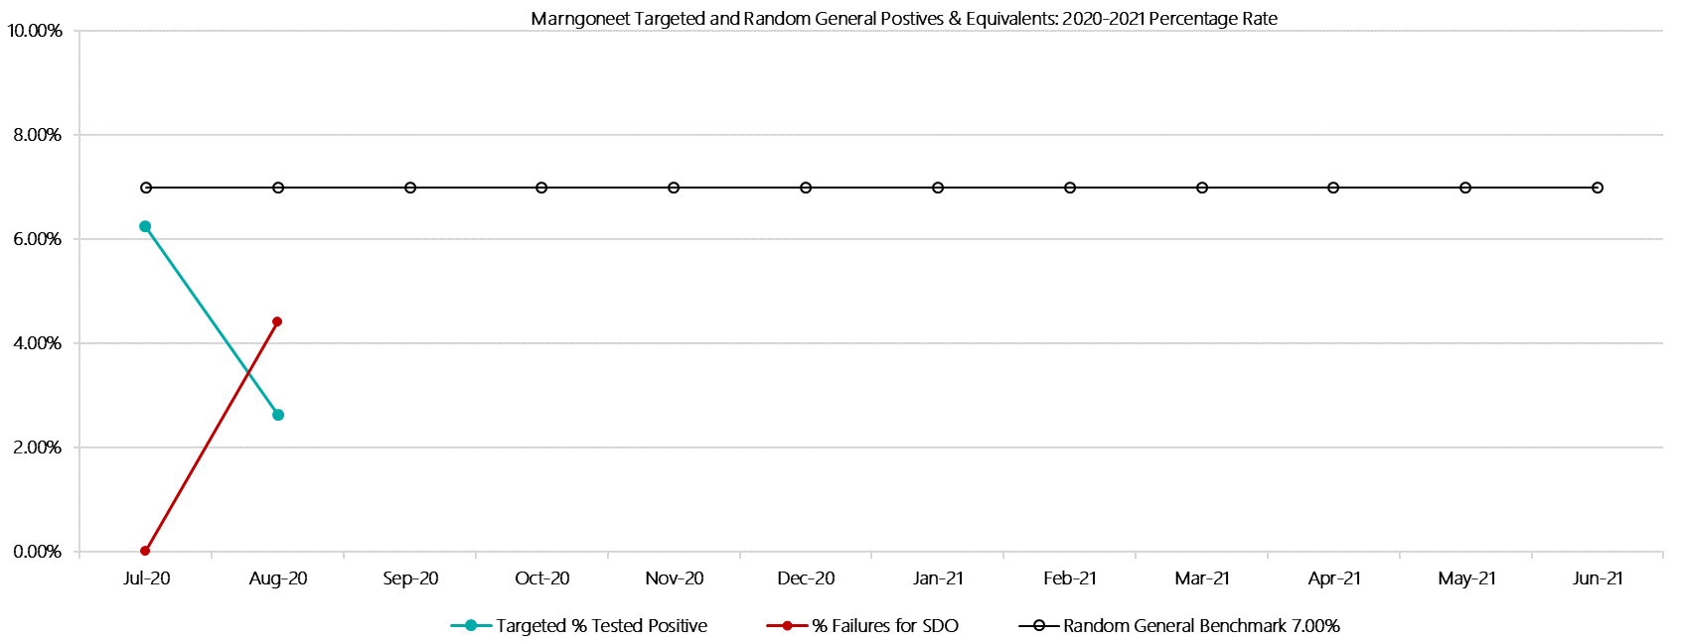

***Marngoneet Positive Test Results by Drug Type: 2020-2021***

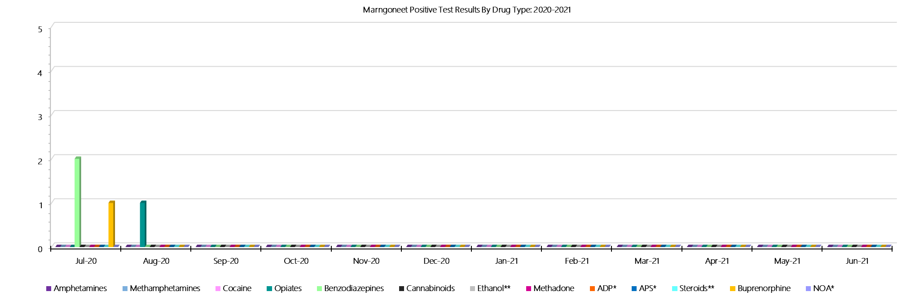

***Marngoneet Count of Visitor Seizures Finds: 2020-2021***

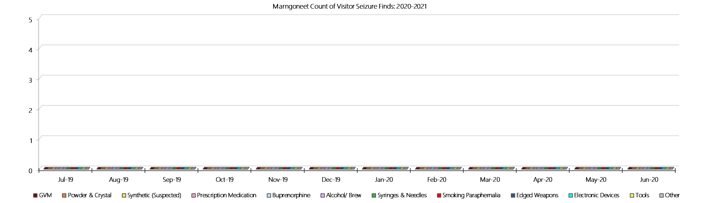

***Marngoneet Count of Prisoner Seizure Finds: 2020-2021***

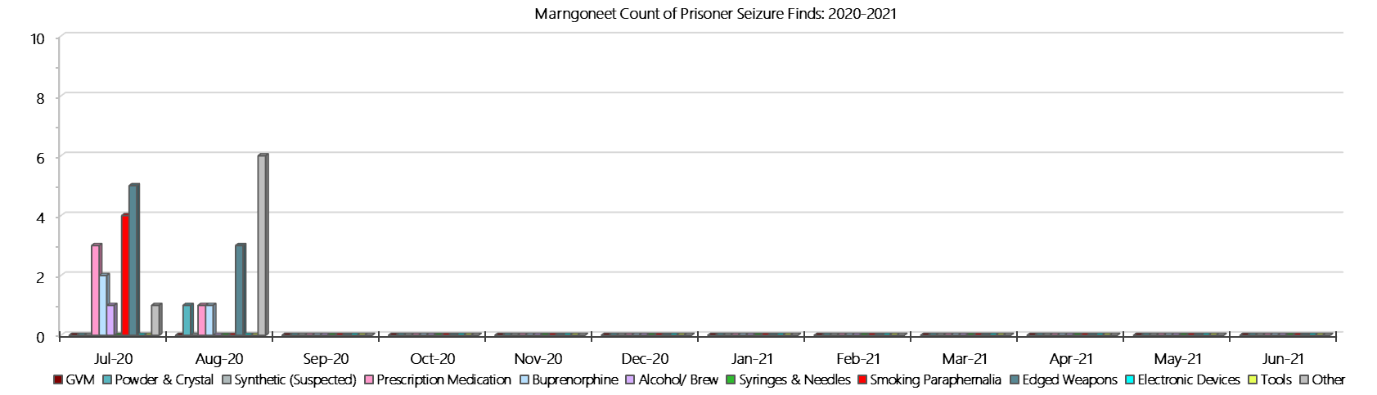

### **Loddon Prison**

***Targeted and Random General Drug Test Results: 2020-2021***

|  |  |  |  |  |  |  |  |  |  |  |  |  |  |  |
| --- | --- | --- | --- | --- | --- | --- | --- | --- | --- | --- | --- | --- | --- | --- |
| **Loddon** | **Jul-20** | **Aug-20** | **Sep-20** | **Oct-20** | **Nov-20** | **Dec-20** | **Jan-21** | **Feb-21** | **Mar-21** | **Apr-21** | **May-21** | **Jun-21** | **Average** | ***Totals*** |
| **Effective Sample - Targeted** | **47** | **51** |  |  |  |  |  |  |  |  |  |  | **49** | ***98*** |
| **Targeted Positives** | **0** | **1** |  |  |  |  |  |  |  |  |  |  | **1** | ***1*** |
| **Refusal** | **0** | **1** |  |  |  |  |  |  |  |  |  |  | **1** | ***1*** |
| **Unable** | **0** | **1** |  |  |  |  |  |  |  |  |  |  | **1** | ***1*** |
| **Interfered** | **0** | **0** |  |  |  |  |  |  |  |  |  |  | **0** | ***0*** |
| **Adulterated** | **0** | **0** |  |  |  |  |  |  |  |  |  |  | **0** | ***0*** |
| **Targeted % Tested Positive** | **0.00%** | **5.88%** | **#N/A** | **#N/A** | **#N/A** | **#N/A** | **#N/A** | **#N/A** | **#N/A** | **#N/A** | **#N/A** | **#N/A** | **3.06%** | ***3.06%*** |
| **Awaiting / Pending Results** | **0** | **0** |  |  |  |  |  |  |  |  |  |  | **0** | ***0*** |
| **Targeted Residual** | **0** | **0** |  |  |  |  |  |  |  |  |  |  | **0** | ***0*** |
| **Random tests collected** | **47** | **45** |  |  |  |  |  |  |  |  |  |  | **46** | ***92*** |
| **Tested Positive** | **0** | **0** |  |  |  |  |  |  |  |  |  |  | **0** | ***0*** |
| **Refusal (guilty)** | **1** | **0** |  |  |  |  |  |  |  |  |  |  | **1** | ***1*** |
| **Unable (not guilty)** | **0** | **0** |  |  |  |  |  |  |  |  |  |  | **0** | ***0*** |
| **Unable (guilty)** | **0** | **0** |  |  |  |  |  |  |  |  |  |  | **0** | ***0*** |
| **Interfered (guilty)** | **0** | **0** |  |  |  |  |  |  |  |  |  |  | **0** | ***0*** |
| **No test (valid reason)** | **0** | **0** |  |  |  |  |  |  |  |  |  |  | **0** | ***0*** |
| **No test (no valid reason)** | **0** | **0** |  |  |  |  |  |  |  |  |  |  | **0** | ***0*** |
| **Adulterated** | **0** | **0** |  |  |  |  |  |  |  |  |  |  | **0** | ***0*** |
| **Awaiting / Pending Results** | **0** | **11** |  |  |  |  |  |  |  |  |  |  | **6** | ***11*** |
| **Random Residual *(PIMS URAR030)*** | **0** | **0** |  |  |  |  |  |  |  |  |  |  | ***0*** | ***0*** |
| **Effective Sample - Random General** | **48** | **45** |  |  |  |  |  |  |  |  |  |  | **47** | **93** |
| **% Tested positive** | **0.00%** | **0.00%** |  |  |  |  |  |  |  |  |  |  | **0.00%** |  |
| **% Prisoner guilty, positive equivalents** | **2.08%** | **0.00%** |  |  |  |  |  |  |  |  |  |  | **1.04%** |  |
| **% Total prisoner fails** | **2.08%** | **0.00%** |  |  |  |  |  |  |  |  |  |  | **1.04%** |  |
| **% No test without valid reason** | **0.00%** | **0.00%** |  |  |  |  |  |  |  |  |  |  | **0.00%** |  |
| ***Random General Benchmark 5.00%*** | ***5.00%*** | ***5.00%*** | ***5.00%*** | ***5.00%*** | ***5.00%*** | ***5.00%*** | ***5.00%*** | ***5.00%*** | ***5.00%*** | ***5.00%*** | ***5.00%*** | ***5.00%*** | ***YTD*** |  |
| **% Failures for SDO** | **2.08%** | **0.00%** | **#N/A** | **#N/A** | **#N/A** | **#N/A** | **#N/A** | **#N/A** | **#N/A** | **#N/A** | **#N/A** | **#N/A** | **1.08%** |  |

***Loddon - Drugs Identified Through Testing by Drug Type: 2020-2021***

|  |  |  |  |  |  |  |  |  |  |  |  |  |  |  |
| --- | --- | --- | --- | --- | --- | --- | --- | --- | --- | --- | --- | --- | --- | --- |
| **Loddon** | ***Amphetamines*** | ***Methamphetamines*** | ***Cocaine*** | ***Opiates*** | ***Benzodiazepines*** | ***Cannabinoids*** | ***Ethanol\*\**** | ***Methadone*** | ***ADP\**** | ***APS\**** | ***Steroids\*\**** | ***Buprenorphine*** | ***NOA\**** | **Total** |
| **Jul-20** | **0** | **0** | **0** | **0** | **0** | **0** | **0** | **0** | **0** | **0** | **0** | **0** | **0** | **0** |
| **Aug-20** | **0** | **0** | **0** | **0** | **0** | **0** | **0** | **0** | **0** | **0** | **0** | **1** | **0** | **1** |
| **Sep-20** |  |  |  |  |  |  |  |  |  |  |  |  |  |  |
| **Oct-20** |  |  |  |  |  |  |  |  |  |  |  |  |  |  |
| **Nov-20** |  |  |  |  |  |  |  |  |  |  |  |  |  |  |
| **Dec-20** |  |  |  |  |  |  |  |  |  |  |  |  |  |  |
| **Jan-21** |  |  |  |  |  |  |  |  |  |  |  |  |  |  |
| **Feb-21** |  |  |  |  |  |  |  |  |  |  |  |  |  |  |
| **Mar-21** |  |  |  |  |  |  |  |  |  |  |  |  |  |  |
| **Apr-21** |  |  |  |  |  |  |  |  |  |  |  |  |  |  |
| **May-21** |  |  |  |  |  |  |  |  |  |  |  |  |  |  |
| **Jun-21** |  |  |  |  |  |  |  |  |  |  |  |  |  |  |
| **Loddon YTD** | **0** | **0** | **0** | **0** | **0** | **0** | **0** | **0** | **0** | **0** | **0** | **1** | **0** | **1** |
| ***All Prisons YTD*** | ***2*** | ***2*** | ***0*** | ***2*** | ***8*** | ***3*** | ***4*** | ***7*** | ***7*** | ***0*** | ***0*** | ***98*** | ***1*** | ***134*** |
| ***Loddon % of Total*** | ***0.00%*** | ***0.00%*** | ***0.00%*** | ***0.00%*** | ***0.00%*** | ***0.00%*** | ***0.00%*** | ***0.00%*** | ***0.00%*** | ***0.00%*** | ***0.00%*** | ***1.02%*** | ***0.00%*** | ***0.75%*** |

***Loddon Seizures of Contraband: Visitors & Prisoners: 2020-2021***

|  |  |  |  |  |  |  |  |  |  |  |  |  |  |  |  |  |  |  |  |  |  |  |  |  |  |  |
| --- | --- | --- | --- | --- | --- | --- | --- | --- | --- | --- | --- | --- | --- | --- | --- | --- | --- | --- | --- | --- | --- | --- | --- | --- | --- | --- |
| **Visitors** | **GVM** | | **Powder  & Crystal** | | **Synthetic  (Suspected)** | | **Prescription  Medication** | | **Buprenorphine** | | **Alcohol &  Home Brew** | | **Syringes & Needles** | | **Smoking  Paraphernalia** | | | **Edged  Weapons** | | **Electronic  Devices** | | **Tools** | | **Other** | | |
| **Loddon** | **Finds** | **Gms** | **Finds** | **Gms** | **Finds** | **Gms** | **Finds** | **Qty** | **Finds** | **Qty** | **Finds** | **Ltrs** | **Finds** | **Qty** | **Finds** | **Qty** | | **Finds** | **Qty** | **Finds** | **Qty** | **Finds** | **Qty** | **Finds** | **Qty** |
| **Jul-20** | **0** | **0.00** | **0** | **0.00** | **0** | **0.00** | **0** | **0.00** | **0** | **0.00** | **0** | **0.000** | **0** | **0** | **0** | | **0** | **0** | **0** | **0** | **0** | **0** | **0** | **0** | **0** |
| **Aug-20** | **0** | **0.00** | **0** | **0.00** | **0** | **0.00** | **0** | **0.00** | **0** | **0.00** | **0** | **0.000** | **0** | **0** | **0** | | **0** | **0** | **0** | **0** | **0** | **0** | **0** | **0** | **0** |
| **Sep-20** |  |  |  |  |  |  |  |  |  |  |  |  |  |  |  | |  |  |  |  |  |  |  |  |  |
| **Oct-20** |  |  |  |  |  |  |  |  |  |  |  |  |  |  |  | |  |  |  |  |  |  |  |  |  |
| **Nov-20** |  |  |  |  |  |  |  |  |  |  |  |  |  |  |  | |  |  |  |  |  |  |  |  |  |
| **Dec-20** |  |  |  |  |  |  |  |  |  |  |  |  |  |  |  | |  |  |  |  |  |  |  |  |  |
| **Jan-21** |  |  |  |  |  |  |  |  |  |  |  |  |  |  |  | |  |  |  |  |  |  |  |  |  |
| **Feb-21** |  |  |  |  |  |  |  |  |  |  |  |  |  |  |  | |  |  |  |  |  |  |  |  |  |
| **Mar-21** |  |  |  |  |  |  |  |  |  |  |  |  |  |  |  | |  |  |  |  |  |  |  |  |  |
| **Apr-21** |  |  |  |  |  |  |  |  |  |  |  |  |  |  |  | |  |  |  |  |  |  |  |  |  |
| **May-21** |  |  |  |  |  |  |  |  |  |  |  |  |  |  |  | |  |  |  |  |  |  |  |  |  |
| **Jun-21** |  |  |  |  |  |  |  |  |  |  |  |  |  |  |  | |  |  |  |  |  |  |  |  |  |
| **Total** | **0** | **0.00** | **0** | **0.00** | **0** | **0.00** | **0** | **0.00** | **0** | **0.00** | **0** | **0.000** | **0** | **0** | **0** | | **0** | **0** | **0** | **0** | **0** | **0** | **0** | **0** | **0** |

|  |  |  |  |  |  |  |  |  |  |  |  |  |  |  |  |  |  |  |  |  |  |  |  |  |  |  |
| --- | --- | --- | --- | --- | --- | --- | --- | --- | --- | --- | --- | --- | --- | --- | --- | --- | --- | --- | --- | --- | --- | --- | --- | --- | --- | --- |
| **Prisoners** | **GVM** | | **Powder  & Crystal** | | **Synthetic  (Suspected)** | | **Prescription  Medication** | | **Buprenorphine** | | **Alcohol &  Home Brew** | | **Syringes & Needles** | | **Smoking  Paraphernalia** | | | **Edged  Weapons** | | **Electronic  Devices** | | **Tools** | | **Other** | | |
| **Loddon** | **Finds** | **Gms** | **Finds** | **Gms** | **Finds** | **Gms** | **Finds** | **Qty** | **Finds** | **Qty** | **Finds** | **Ltrs** | **Finds** | **Qty** | **Finds** | **Qty** | | **Finds** | **Qty** | **Finds** | **Qty** | **Finds** | **Qty** | **Finds** | **Qty** |
| **Jul-20** | **0** | **0.00** | **0** | **0.00** | **0** | **0.00** | **0** | **0.00** | **0** | **0.00** | **2** | **7.000** | **0** | **0** | **1** | | **1** | **0** | **0** | **0** | **0** | **0** | **0** | **0** | **0** |
| **Aug-20** | **0** | **0.00** | **0** | **0.00** | **0** | **0.00** | **0** | **0.00** | **1** | **1.00** | **2** | **10.000** | **0** | **0** | **3** | | **3** | **2** | **3** | **0** | **0** | **0** | **0** | **1** | **1** |
| **Sep-20** |  |  |  |  |  |  |  |  |  |  |  |  |  |  |  | |  |  |  |  |  |  |  |  |  |
| **Oct-20** |  |  |  |  |  |  |  |  |  |  |  |  |  |  |  | |  |  |  |  |  |  |  |  |  |
| **Nov-20** |  |  |  |  |  |  |  |  |  |  |  |  |  |  |  | |  |  |  |  |  |  |  |  |  |
| **Dec-20** |  |  |  |  |  |  |  |  |  |  |  |  |  |  |  | |  |  |  |  |  |  |  |  |  |
| **Jan-21** |  |  |  |  |  |  |  |  |  |  |  |  |  |  |  | |  |  |  |  |  |  |  |  |  |
| **Feb-21** |  |  |  |  |  |  |  |  |  |  |  |  |  |  |  | |  |  |  |  |  |  |  |  |  |
| **Mar-21** |  |  |  |  |  |  |  |  |  |  |  |  |  |  |  | |  |  |  |  |  |  |  |  |  |
| **Apr-21** |  |  |  |  |  |  |  |  |  |  |  |  |  |  |  | |  |  |  |  |  |  |  |  |  |
| **May-21** |  |  |  |  |  |  |  |  |  |  |  |  |  |  |  | |  |  |  |  |  |  |  |  |  |
| **Jun-21** |  |  |  |  |  |  |  |  |  |  |  |  |  |  |  | |  |  |  |  |  |  |  |  |  |
| **Total** | **0** | **0.00** | **0** | **0.00** | **0** | **0.00** | **0** | **0.00** | **1** | **1.00** | **4** | **17.000** | **0** | **0** | **4** | | **4** | **2** | **3** | **0** | **0** | **0** | **0** | **1** | **1** |

***Loddon Targeted and Random General Drug Test Positives & Equivalents: 2020-2021***

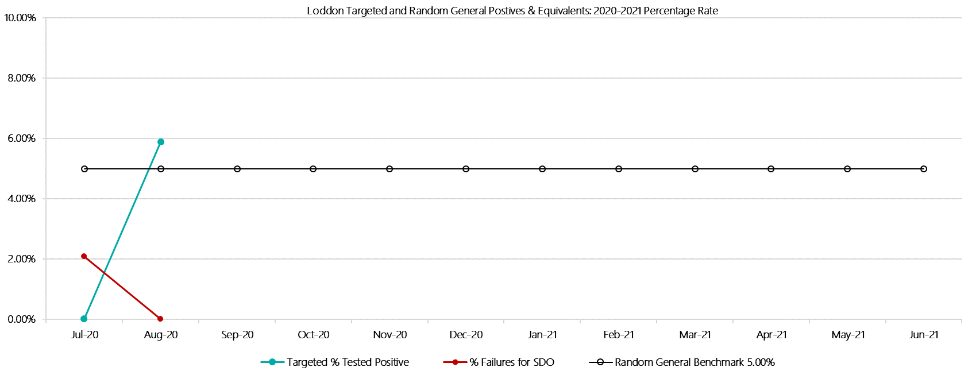

***Loddon Positive Test Results by Drug Type: 2020-2021***

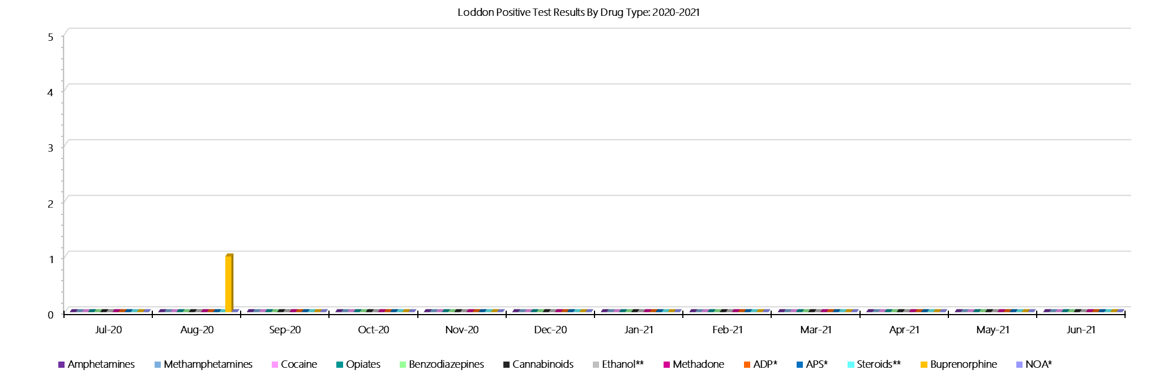

***Loddon Count of Visitor Seizures Finds: 2020-2021***

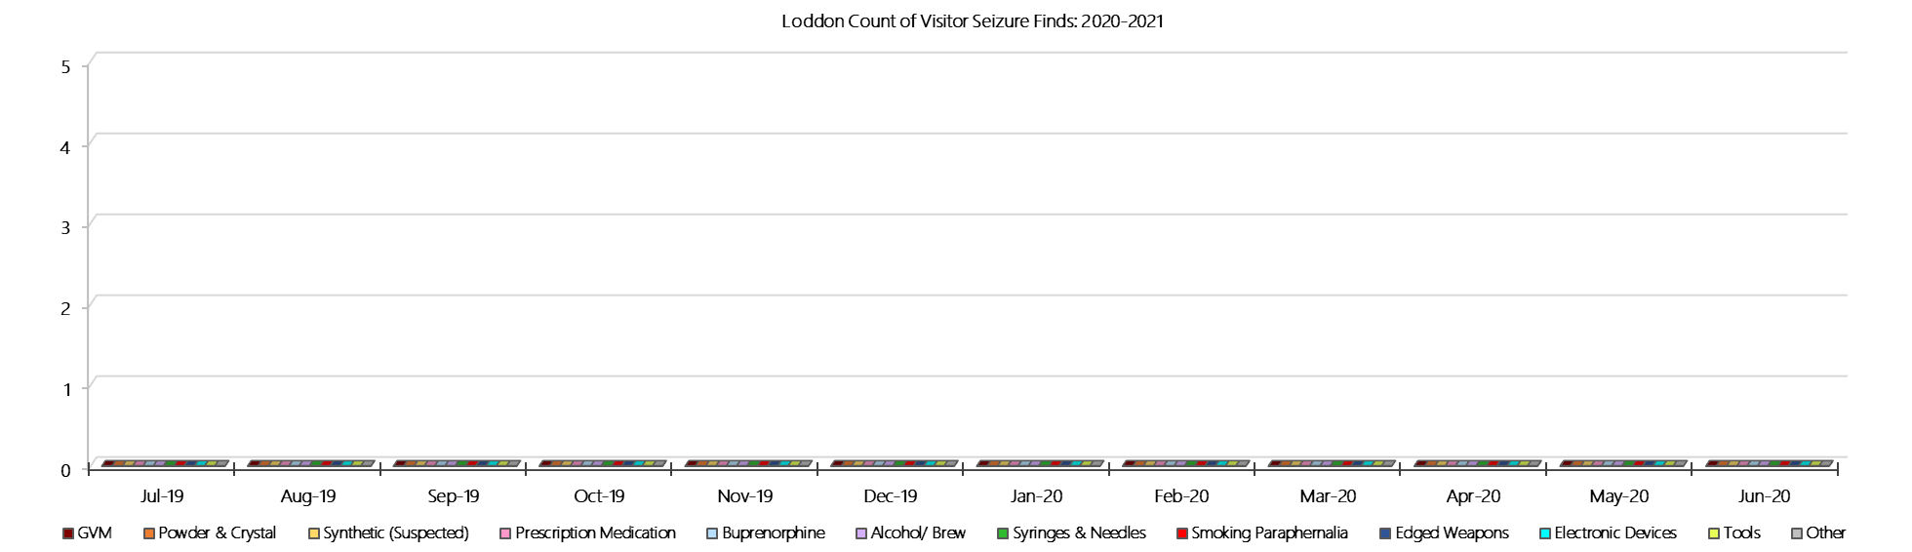

***Loddon Count of Prisoner Seizure Finds: 2020-2021***

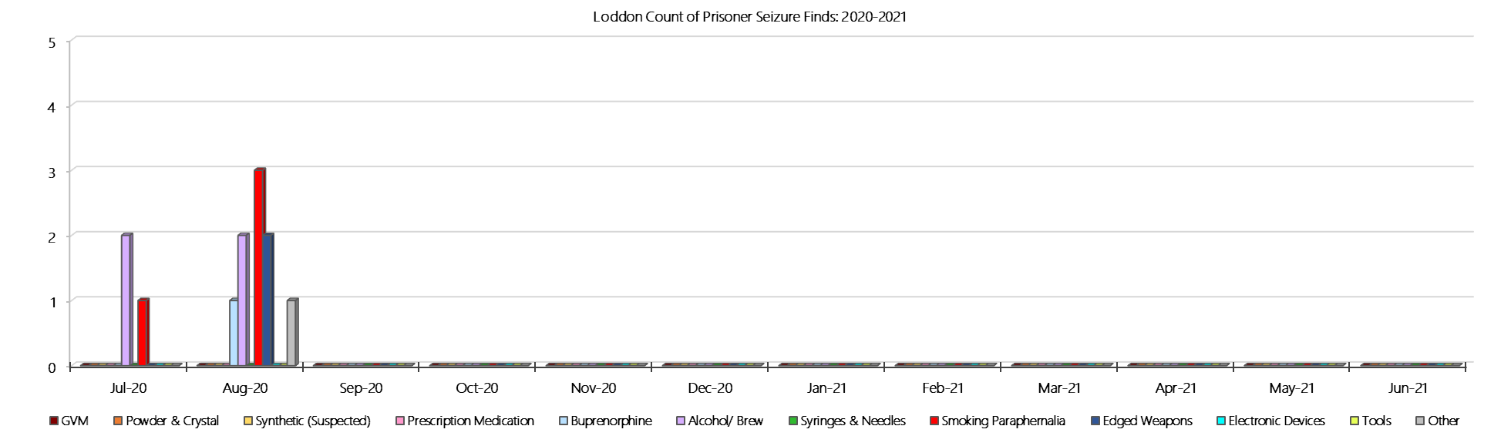

### **Middleton (annex of Loddon)**

***Targeted and Random General Drug Test Results: 2020-2021***

|  |  |  |  |  |  |  |  |  |  |  |  |  |  |  |
| --- | --- | --- | --- | --- | --- | --- | --- | --- | --- | --- | --- | --- | --- | --- |
| **Middleton** | **Jul-20** | **Aug-20** | **Sep-20** | **Oct-20** | **Nov-20** | **Dec-20** | **Jan-21** | **Feb-21** | **Mar-21** | **Apr-21** | **May-21** | **Jun-21** | **Average** | ***Totals*** |
| **Effective Sample - Targeted** | **25** | **29** |  |  |  |  |  |  |  |  |  |  | **27** | ***54*** |
| **Targeted Positives** | **4** | **0** |  |  |  |  |  |  |  |  |  |  | **2** | ***4*** |
| **Refusal** | **0** | **0** |  |  |  |  |  |  |  |  |  |  | **0** | ***0*** |
| **Unable** | **1** | **2** |  |  |  |  |  |  |  |  |  |  | **2** | ***3*** |
| **Interfered** | **0** | **0** |  |  |  |  |  |  |  |  |  |  | **0** | ***0*** |
| **Adulterated** | **0** | **0** |  |  |  |  |  |  |  |  |  |  | **0** | ***0*** |
| **Targeted % Tested Positive** | **20.00%** | **6.90%** | **#N/A** | **#N/A** | **#N/A** | **#N/A** | **#N/A** | **#N/A** | **#N/A** | **#N/A** | **#N/A** | **#N/A** | **12.96%** | ***12.96%*** |
| **Awaiting / Pending Results** | **0** | **1** |  |  |  |  |  |  |  |  |  |  | **1** | ***1*** |
| **Targeted Residual** | **0** | **0** |  |  |  |  |  |  |  |  |  |  | **0** | ***0*** |
| **Random tests collected** | **29** | **31** |  |  |  |  |  |  |  |  |  |  | **30** | ***60*** |
| **Tested Positive** | **0** | **0** |  |  |  |  |  |  |  |  |  |  | **0** | ***0*** |
| **Refusal (guilty)** | **0** | **1** |  |  |  |  |  |  |  |  |  |  | **1** | ***1*** |
| **Unable (not guilty)** | **0** | **0** |  |  |  |  |  |  |  |  |  |  | **0** | ***0*** |
| **Unable (guilty)** | **0** | **1** |  |  |  |  |  |  |  |  |  |  | **1** | ***1*** |
| **Interfered (guilty)** | **0** | **0** |  |  |  |  |  |  |  |  |  |  | **0** | ***0*** |
| **No test (valid reason)** | **0** | **0** |  |  |  |  |  |  |  |  |  |  | **0** | ***0*** |
| **No test (no valid reason)** | **0** | **0** |  |  |  |  |  |  |  |  |  |  | **0** | ***0*** |
| **Adulterated** | **0** | **0** |  |  |  |  |  |  |  |  |  |  | **0** | ***0*** |
| **Awaiting / Pending Results** | **0** | **3** |  |  |  |  |  |  |  |  |  |  | **2** | ***3*** |
| **Random Residual *(PIMS URAR030)*** | **0** | **0** |  |  |  |  |  |  |  |  |  |  | ***0*** | ***0*** |
| **Effective Sample - Random General** | **29** | **33** |  |  |  |  |  |  |  |  |  |  | **31** | **62** |
| **% Tested positive** | **0.00%** | **0.00%** |  |  |  |  |  |  |  |  |  |  | **0.00%** |  |
| **% Prisoner guilty, positive equivalents** | **0.00%** | **6.06%** |  |  |  |  |  |  |  |  |  |  | **3.03%** |  |
| **% Total prisoner fails** | **0.00%** | **6.06%** |  |  |  |  |  |  |  |  |  |  | **3.03%** |  |
| **% No test without valid reason** | **0.00%** | **0.00%** |  |  |  |  |  |  |  |  |  |  | **0.00%** |  |
| ***Random General Benchmark 4.00%*** | ***4.00%*** | ***4.00%*** | ***4.00%*** | ***4.00%*** | ***4.00%*** | ***4.00%*** | ***4.00%*** | ***4.00%*** | ***4.00%*** | ***4.00%*** | ***4.00%*** | ***4.00%*** | ***YTD*** |  |
| **% Failures for SDO** | **0.00%** | **6.06%** | **#N/A** | **#N/A** | **#N/A** | **#N/A** | **#N/A** | **#N/A** | **#N/A** | **#N/A** | **#N/A** | **#N/A** | **3.23%** |  |

***Middleton - Drugs Identified Through Testing by Drug Type: 2020-2021***

|  |  |  |  |  |  |  |  |  |  |  |  |  |  |  |  |
| --- | --- | --- | --- | --- | --- | --- | --- | --- | --- | --- | --- | --- | --- | --- | --- |
| **Middleton** | ***Amphetamines*** | | ***Methamphetamines*** | ***Cocaine*** | ***Opiates*** | ***Benzodiazepines*** | ***Cannabinoids*** | ***Ethanol\*\**** | ***Methadone*** | ***ADP\**** | ***APS\**** | ***Steroids\*\**** | ***Buprenorphine*** | ***NOA\**** | **Total** |
| **Jul-20** | **0** | | **0** | **0** | **0** | **0** | **0** | **4** | **0** | **0** | **0** | **0** | **0** | **0** | **4** |
| **Aug-20** | **0** | | **0** | **0** | **0** | **0** | **1** | **0** | **0** | **0** | **0** | **0** | **1** | **0** | **2** |
| **Sep-20** |  | |  |  |  |  |  |  |  |  |  |  |  |  |  |
| **Oct-20** |  | |  |  |  |  |  |  |  |  |  |  |  |  |  |
| **Nov-20** |  | |  |  |  |  |  |  |  |  |  |  |  |  |  |
| **Dec-20** |  | |  |  |  |  |  |  |  |  |  |  |  |  |  |
| **Jan-21** |  | |  |  |  |  |  |  |  |  |  |  |  |  |  |
| **Feb-21** |  | |  |  |  |  |  |  |  |  |  |  |  |  |  |
| **Mar-21** |  | |  |  |  |  |  |  |  |  |  |  |  |  |  |
| **Apr-21** |  | |  |  |  |  |  |  |  |  |  |  |  |  |  |
| **May-21** |  | |  |  |  |  |  |  |  |  |  |  |  |  |  |
| **Jun-21** |  | |  |  |  |  |  |  |  |  |  |  |  |  |  |
| **Middleton YTD** | | **0** | **0** | **0** | **0** | **0** | **1** | **4** | **0** | **0** | **0** | **0** | **1** | **0** | **6** |
| ***All Prisons YTD*** | | ***2*** | ***2*** | ***0*** | ***2*** | ***8*** | ***3*** | ***4*** | ***7*** | ***7*** | ***0*** | ***0*** | ***98*** | ***1*** | ***134*** |
| ***Middleton % of Total*** | | ***0.00%*** | ***0.00%*** | ***0.00%*** | ***0.00%*** | ***0.00%*** | ***33.33%*** | ***100.00%*** | ***0.00%*** | ***0.00%*** | ***0.00%*** | ***0.00%*** | ***1.02%*** | ***0.00%*** | ***4.48%*** |

***Middleton Seizures of Contraband: Visitors & Prisoners: 2020-2021***

|  |  |  |  |  |  |  |  |  |  |  |  |  |  |  |  |  |  |  |  |  |  |  |  |  |
| --- | --- | --- | --- | --- | --- | --- | --- | --- | --- | --- | --- | --- | --- | --- | --- | --- | --- | --- | --- | --- | --- | --- | --- | --- |
| **Visitors** | **GVM** | | **Powder  & Crystal** | | **Synthetic  (Suspected)** | | **Prescription  Medication** | | **Buprenorphine** | | **Alcohol &  Home Brew** | | **Syringes & Needles** | | **Smoking  Paraphernalia** | | **Edged  Weapons** | | **Electronic  Devices** | | **Tools** | | **Other** | |
| **Middleton** | **Finds** | **Gms** | **Finds** | **Gms** | **Finds** | **Gms** | **Finds** | **Qty** | **Finds** | **Qty** | **Finds** | **Ltrs** | **Finds** | **Qty** | **Finds** | **Qty** | **Finds** | **Qty** | **Finds** | **Qty** | **Finds** | **Qty** | **Finds** | **Qty** |
| **Jul-20** | **0** | **0.00** | **0** | **0.00** | **0** | **0.00** | **0** | **0.00** | **1** | **1.00** | **0** | **0.000** | **0** | **0** | **0** | **0** | **0** | **0** | **0** | **0** | **0** | **0** | **0** | **0** |
| **Aug-20** | **0** | **0.00** | **0** | **0.00** | **0** | **0.00** | **0** | **0.00** | **0** | **0.00** | **0** | **0.000** | **0** | **0** | **0** | **0** | **0** | **0** | **0** | **0** | **0** | **0** | **0** | **0** |
| **Sep-20** |  |  |  |  |  |  |  |  |  |  |  |  |  |  |  |  |  |  |  |  |  |  |  |  |
| **Oct-20** |  |  |  |  |  |  |  |  |  |  |  |  |  |  |  |  |  |  |  |  |  |  |  |  |
| **Nov-20** |  |  |  |  |  |  |  |  |  |  |  |  |  |  |  |  |  |  |  |  |  |  |  |  |
| **Dec-20** |  |  |  |  |  |  |  |  |  |  |  |  |  |  |  |  |  |  |  |  |  |  |  |  |
| **Jan-21** |  |  |  |  |  |  |  |  |  |  |  |  |  |  |  |  |  |  |  |  |  |  |  |  |
| **Feb-21** |  |  |  |  |  |  |  |  |  |  |  |  |  |  |  |  |  |  |  |  |  |  |  |  |
| **Mar-21** |  |  |  |  |  |  |  |  |  |  |  |  |  |  |  |  |  |  |  |  |  |  |  |  |
| **Apr-21** |  |  |  |  |  |  |  |  |  |  |  |  |  |  |  |  |  |  |  |  |  |  |  |  |
| **May-21** |  |  |  |  |  |  |  |  |  |  |  |  |  |  |  |  |  |  |  |  |  |  |  |  |
| **Jun-21** |  |  |  |  |  |  |  |  |  |  |  |  |  |  |  |  |  |  |  |  |  |  |  |  |
| **Total** | **0** | **0.00** | **0** | **0.00** | **0** | **0.00** | **0** | **0.00** | **1** | **1.00** | **0** | **0.000** | **0** | **0** | **0** | **0** | **0** | **0** | **0** | **0** | **0** | **0** | **0** | **0** |

|  |  |  |  |  |  |  |  |  |  |  |  |  |  |  |  |  |  |  |  |  |  |  |  |  |  |
| --- | --- | --- | --- | --- | --- | --- | --- | --- | --- | --- | --- | --- | --- | --- | --- | --- | --- | --- | --- | --- | --- | --- | --- | --- | --- |
| **Prisoners** | **GVM** | | **Powder  & Crystal** | | **Synthetic  (Suspected)** | | **Prescription  Medication** | | **Buprenorphine** | | **Alcohol &  Home Brew** | | **Syringes & Needles** | | **Smoking  Paraphernalia** | | | **Edged  Weapons** | | **Electronic  Devices** | | **Tools** | | **Other** | |
| **Middleton** | **Finds** | **Gms** | **Finds** | **Gms** | **Finds** | **Gms** | **Finds** | **Qty** | **Finds** | **Qty** | **Finds** | **Ltrs** | **Finds** | **Qty** | **Finds** | **Qty** | | **Finds** | **Qty** | **Finds** | **Qty** | **Finds** | **Qty** | **Finds** | **Qty** |
| **Jul-20** | **0** | **0.00** | **0** | **0.00** | **0** | **0.00** | **0** | **0.00** | **0** | **0.00** | **0** | **0.000** | **0** | **0** | **0** | | **0** | **0** | **0** | **0** | **0** | **0** | **0** | **0** | **0** |
| **Aug-20** | **0** | **0.00** | **0** | **0.00** | **0** | **0.00** | **0** | **0.00** | **1** | **0.00** | **0** | **0.000** | **0** | **0** | **0** | | **0** | **0** | **0** | **0** | **0** | **0** | **0** | **0** | **0** |
| **Sep-20** |  |  |  |  |  |  |  |  |  |  |  |  |  |  |  | |  |  |  |  |  |  |  |  |  |
| **Oct-20** |  |  |  |  |  |  |  |  |  |  |  |  |  |  |  | |  |  |  |  |  |  |  |  |  |
| **Nov-20** |  |  |  |  |  |  |  |  |  |  |  |  |  |  |  | |  |  |  |  |  |  |  |  |  |
| **Dec-20** |  |  |  |  |  |  |  |  |  |  |  |  |  |  |  | |  |  |  |  |  |  |  |  |  |
| **Jan-21** |  |  |  |  |  |  |  |  |  |  |  |  |  |  |  | |  |  |  |  |  |  |  |  |  |
| **Feb-21** |  |  |  |  |  |  |  |  |  |  |  |  |  |  |  | |  |  |  |  |  |  |  |  |  |
| **Mar-21** |  |  |  |  |  |  |  |  |  |  |  |  |  |  |  | |  |  |  |  |  |  |  |  |  |
| **Apr-21** |  |  |  |  |  |  |  |  |  |  |  |  |  |  |  | |  |  |  |  |  |  |  |  |  |
| **May-21** |  |  |  |  |  |  |  |  |  |  |  |  |  |  |  | |  |  |  |  |  |  |  |  |  |
| **Jun-21** |  |  |  |  |  |  |  |  |  |  |  |  |  |  |  | |  |  |  |  |  |  |  |  |  |
| **Total** | **0** | **0.00** | **0** | **0.00** | **0** | **0.00** | **0** | **0.00** | **1** | **0.00** | **0** | **0.000** | **0** | **0** | **0** | | **0** | **0** | **0** | **0** | **0** | **0** | **0** | **0** | **0** |

***Middleton Targeted and Random General Drug Test Positives & Equivalents: 2020-2021***

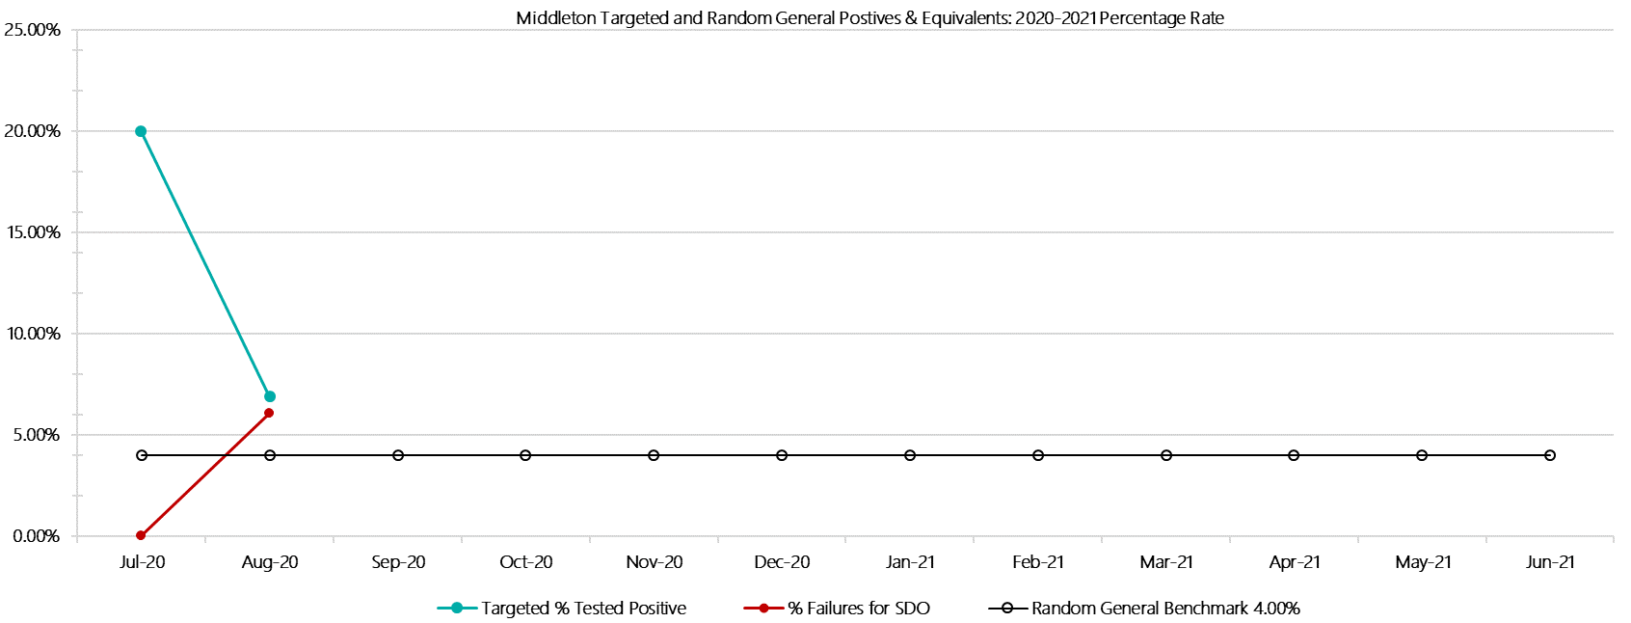

***Middleton Positive Test Results by Drug Type: 2020-2021***

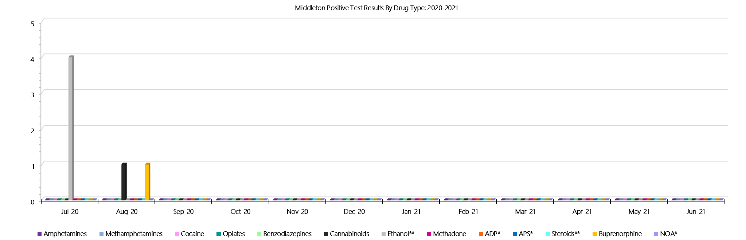

***Middleton Count of Visitor Seizures Finds: 2020-2021***

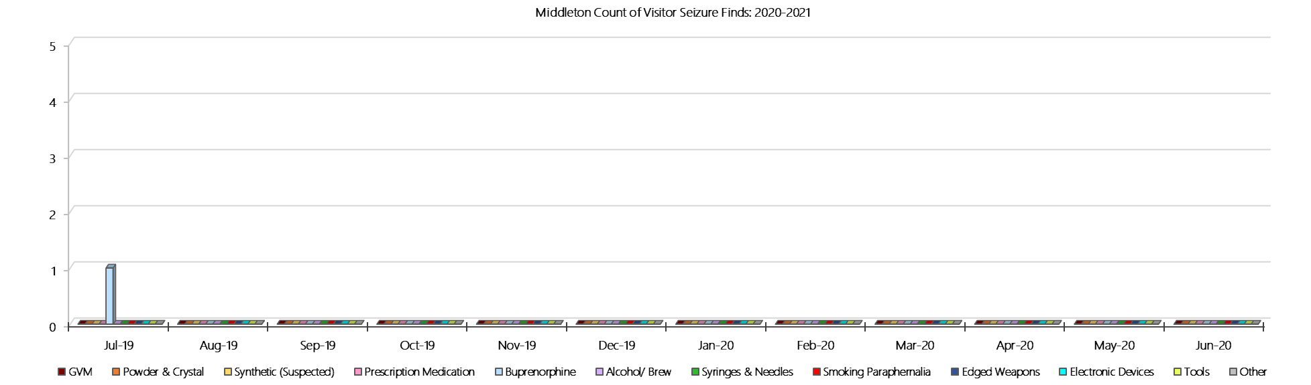

***Middleton Count of Prisoner Seizure Finds: 2020-2021***

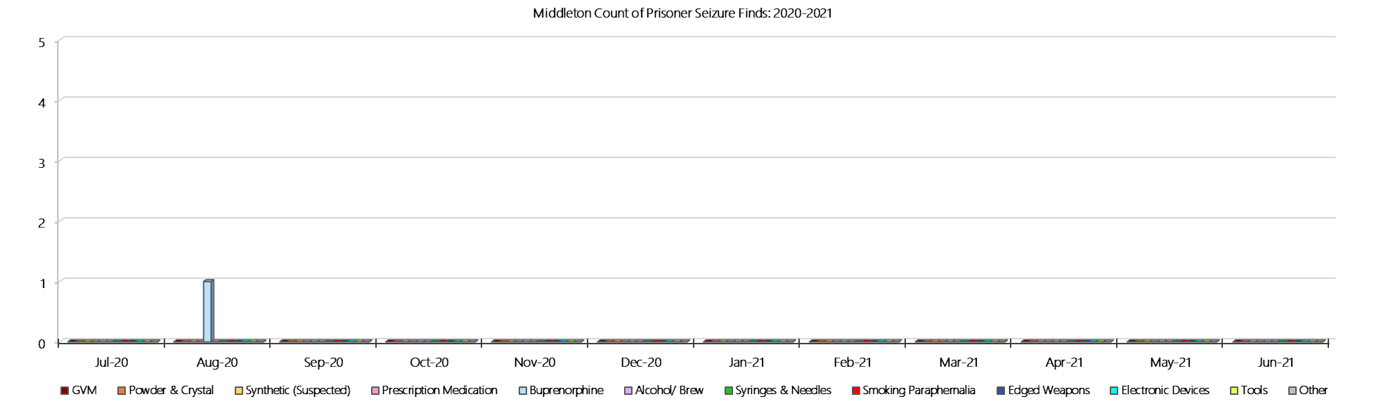

### **Ravenhall Correctional Centre**

***Targeted and Random General Drug Test Results: 2020-2021***

|  |  |  |  |  |  |  |  |  |  |  |  |  |  |  |
| --- | --- | --- | --- | --- | --- | --- | --- | --- | --- | --- | --- | --- | --- | --- |
| **Ravenhall** | **Jul-20** | **Aug-20** | **Sep-20** | **Oct-20** | **Nov-20** | **Dec-20** | **Jan-21** | **Feb-21** | **Mar-21** | **Apr-21** | **May-21** | **Jun-21** | **Average** | ***Totals*** |
| **Effective Sample - Targeted** | **407** | **434** |  |  |  |  |  |  |  |  |  |  | **421** | ***841*** |
| **Targeted Positives** | **23** | **8** |  |  |  |  |  |  |  |  |  |  | **16** | ***31*** |
| **Refusal** | **2** | **2** |  |  |  |  |  |  |  |  |  |  | **2** | ***4*** |
| **Unable** | **12** | **7** |  |  |  |  |  |  |  |  |  |  | **10** | ***19*** |
| **Interfered** | **1** | **1** |  |  |  |  |  |  |  |  |  |  | **1** | ***2*** |
| **Adulterated** | **0** | **0** |  |  |  |  |  |  |  |  |  |  | **0** | ***0*** |
| **Targeted % Tested Positive** | **9.34%** | **4.15%** | **#N/A** | **#N/A** | **#N/A** | **#N/A** | **#N/A** | **#N/A** | **#N/A** | **#N/A** | **#N/A** | **#N/A** | **6.66%** | ***6.66%*** |
| **Awaiting / Pending Results** | **0** | **0** |  |  |  |  |  |  |  |  |  |  | **0** | ***0*** |
| **Targeted Residual** | **1** | **0** |  |  |  |  |  |  |  |  |  |  | **1** | ***1*** |
| **Random tests collected** | **121** | **148** |  |  |  |  |  |  |  |  |  |  | **135** | ***269*** |
| **Tested Positive** | **0** | **0** |  |  |  |  |  |  |  |  |  |  | **0** | ***0*** |
| **Refusal (guilty)** | **1** | **2** |  |  |  |  |  |  |  |  |  |  | **2** | ***3*** |
| **Unable (not guilty)** | **1** | **0** |  |  |  |  |  |  |  |  |  |  | **1** | ***1*** |
| **Unable (guilty)** | **4** | **1** |  |  |  |  |  |  |  |  |  |  | **3** | ***5*** |
| **Interfered (guilty)** | **0** | **0** |  |  |  |  |  |  |  |  |  |  | **0** | ***0*** |
| **No test (valid reason)** | **3** | **10** |  |  |  |  |  |  |  |  |  |  | **7** | ***13*** |
| **No test (no valid reason)** | **0** | **1** |  |  |  |  |  |  |  |  |  |  | **1** | ***1*** |
| **Adulterated** | **0** | **0** |  |  |  |  |  |  |  |  |  |  | **0** | ***0*** |
| **Awaiting / Pending Results** | **0** | **0** |  |  |  |  |  |  |  |  |  |  | **0** | ***0*** |
| **Random Residual *(PIMS URAR030)*** | **0** | **0** |  |  |  |  |  |  |  |  |  |  | ***0*** | ***0*** |
| **Effective Sample - Random General** | **126** | **152** |  |  |  |  |  |  |  |  |  |  | **139** | **278** |
| **% Tested positive** | **0.00%** | **0.00%** |  |  |  |  |  |  |  |  |  |  | **0.00%** |  |
| **% Prisoner guilty, positive equivalents** | **3.97%** | **1.97%** |  |  |  |  |  |  |  |  |  |  | **2.97%** |  |
| **% Total prisoner fails** | **3.97%** | **1.97%** |  |  |  |  |  |  |  |  |  |  | **2.97%** |  |
| **% No test without valid reason** | **0.00%** | **0.66%** |  |  |  |  |  |  |  |  |  |  | **0.33%** |  |
| **% Failures for SDO** | **3.97%** | **2.63%** | **#N/A** | **#N/A** | **#N/A** | **#N/A** | **#N/A** | **#N/A** | **#N/A** | **#N/A** | **#N/A** | **#N/A** | **3.24%** |  |

***Ravenhall - Drugs Identified Through Testing by Drug Type: 2020-2021***

|  |  |  |  |  |  |  |  |  |  |  |  |  |  |  |  |
| --- | --- | --- | --- | --- | --- | --- | --- | --- | --- | --- | --- | --- | --- | --- | --- |
| **Ravenhall** | ***Amphetamines*** | | ***Methamphetamines*** | ***Cocaine*** | ***Opiates*** | ***Benzodiazepines*** | ***Cannabinoids*** | ***Ethanol\*\**** | ***Methadone*** | ***ADP\**** | ***APS\**** | ***Steroids\*\**** | ***Buprenorphine*** | ***NOA\**** | **Total** |
| **Jul-20** | **2** | | **2** | **0** | **0** | **1** | **0** | **0** | **0** | **0** | **0** | **0** | **23** | **0** | **28** |
| **Aug-20** | **0** | | **0** | **0** | **0** | **0** | **0** | **0** | **0** | **2** | **0** | **0** | **8** | **0** | **10** |
| **Sep-20** |  | |  |  |  |  |  |  |  |  |  |  |  |  |  |
| **Oct-20** |  | |  |  |  |  |  |  |  |  |  |  |  |  |  |
| **Nov-20** |  | |  |  |  |  |  |  |  |  |  |  |  |  |  |
| **Dec-20** |  | |  |  |  |  |  |  |  |  |  |  |  |  |  |
| **Jan-21** |  | |  |  |  |  |  |  |  |  |  |  |  |  |  |
| **Feb-21** |  | |  |  |  |  |  |  |  |  |  |  |  |  |  |
| **Mar-21** |  | |  |  |  |  |  |  |  |  |  |  |  |  |  |
| **Apr-21** |  | |  |  |  |  |  |  |  |  |  |  |  |  |  |
| **May-21** |  | |  |  |  |  |  |  |  |  |  |  |  |  |  |
| **Jun-21** |  | |  |  |  |  |  |  |  |  |  |  |  |  |  |
| **Ravenhall YTD** | | **2** | **2** | **0** | **0** | **1** | **0** | **0** | **0** | **2** | **0** | **0** | **31** | **0** | **38** |
| ***All Prisons YTD*** | | ***2*** | ***2*** | ***0*** | ***2*** | ***8*** | ***3*** | ***4*** | ***7*** | ***7*** | ***0*** | ***0*** | ***98*** | ***1*** | ***134*** |
| ***Ravenhall % of Total*** | | ***100.00%*** | ***100.00%*** | ***0.00%*** | ***0.00%*** | ***12.50%*** | ***0.00%*** | ***0.00%*** | ***0.00%*** | ***28.57%*** | ***0.00%*** | ***0.00%*** | ***31.63%*** | ***0.00%*** | ***28.36%*** |

***Ravenhall Seizures of Contraband: Visitors & Prisoners: 2020-2021***

|  |  |  |  |  |  |  |  |  |  |  |  |  |  |  |  |  |  |  |  |  |  |  |  |  |
| --- | --- | --- | --- | --- | --- | --- | --- | --- | --- | --- | --- | --- | --- | --- | --- | --- | --- | --- | --- | --- | --- | --- | --- | --- |
| **Visitors** | **GVM** | | **Powder  & Crystal** | | **Synthetic  (Suspected)** | | **Prescription  Medication** | | **Buprenorphine** | | **Alcohol &  Home Brew** | | **Syringes & Needles** | | **Smoking  Paraphernalia** | | **Edged  Weapons** | | **Electronic  Devices** | | **Tools** | | **Other** | |
| **Ravenhall** | **Find** | **Gms** | **Finds** | **Gms** | **Finds** | **Gms** | **Finds** | **Qty** | **Finds** | **Qty** | **Finds** | **Ltrs** | **Finds** | **Qty** | **Finds** | **Qty** | **Finds** | **Qty** | **Finds** | **Qty** | **Finds** | **Qty** | **Finds** | **Qty** |
| **Jul-20** | **0** | **0.00** | **0** | **0.00** | **0** | **0.00** | **0** | **0.00** | **1** | **28.00** | **0** | **0.000** | **0** | **0** | **1** | **7** | **0** | **0** | **0** | **0** | **0** | **0** | **0** | **0** |
| **Aug-20** | **0** | **0.00** | **0** | **0.00** | **0** | **0.00** | **0** | **0.00** | **15** | **226.00** | **0** | **0.000** | **0** | **0** | **0** | **0** | **0** | **0** | **0** | **0** | **0** | **0** | **0** | **0** |
| **Sep-20** |  |  |  |  |  |  |  |  |  |  |  |  |  |  |  |  |  |  |  |  |  |  |  |  |
| **Oct-20** |  |  |  |  |  |  |  |  |  |  |  |  |  |  |  |  |  |  |  |  |  |  |  |  |
| **Nov-20** |  |  |  |  |  |  |  |  |  |  |  |  |  |  |  |  |  |  |  |  |  |  |  |  |
| **Dec-20** |  |  |  |  |  |  |  |  |  |  |  |  |  |  |  |  |  |  |  |  |  |  |  |  |
| **Jan-21** |  |  |  |  |  |  |  |  |  |  |  |  |  |  |  |  |  |  |  |  |  |  |  |  |
| **Feb-21** |  |  |  |  |  |  |  |  |  |  |  |  |  |  |  |  |  |  |  |  |  |  |  |  |
| **Mar-21** |  |  |  |  |  |  |  |  |  |  |  |  |  |  |  |  |  |  |  |  |  |  |  |  |
| **Apr-21** |  |  |  |  |  |  |  |  |  |  |  |  |  |  |  |  |  |  |  |  |  |  |  |  |
| **May-21** |  |  |  |  |  |  |  |  |  |  |  |  |  |  |  |  |  |  |  |  |  |  |  |  |
| **Jun-21** |  |  |  |  |  |  |  |  |  |  |  |  |  |  |  |  |  |  |  |  |  |  |  |  |
| **Total** | **0** | **0.00** | **0** | **0.00** | **0** | **0.00** | **0** | **0.00** | **16** | **254.00** | **0** | **0.000** | **0** | **0** | **1** | **7** | **0** | **0** | **0** | **0** | **0** | **0** | **0** | **0** |

|  |  |  |  |  |  |  |  |  |  |  |  |  |  |  |  |  |  |  |  |  |  |  |  |  |  |  |
| --- | --- | --- | --- | --- | --- | --- | --- | --- | --- | --- | --- | --- | --- | --- | --- | --- | --- | --- | --- | --- | --- | --- | --- | --- | --- | --- |
| **Prisoners** | **GVM** | | **Powder  & Crystal** | | **Synthetic  (Suspected)** | | **Prescription  Medication** | | **Buprenorphine** | | **Alcohol &  Home Brew** | | **Syringes & Needles** | | **Smoking  Paraphernalia** | | | **Edged  Weapons** | | **Electronic  Devices** | | **Tools** | | **Other** | | |
| **Ravenhall** | **Finds** | **Gms** | **Finds** | **Gms** | **Finds** | **Gms** | **Finds** | **Qty** | **Finds** | **Qty** | **Finds** | **Ltrs** | **Finds** | **Qty** | **Finds** | **Qty** | | **Finds** | **Qty** | **Finds** | **Qty** | **Finds** | **Qty** | **Finds** | **Qty** |
| **Jul-20** | **0** | **0.00** | **1** | **1.00** | **0** | **0.00** | **6** | **25.50** | **9** | **16.00** | **3** | **7.000** | **0** | **0** | **5** | | **34** | **9** | **16** | **3** | **5** | **5** | **11** | **2** | **2** |
| **Aug-20** | **0** | **0.00** | **0** | **0.00** | **0** | **0.00** | **3** | **4.60** | **4** | **5.80** | **6** | **9.000** | **1** | **1** | **0** | | **0** | **10** | **10** | **0** | **0** | **6** | **21** | **3** | **3** |
| **Sep-20** |  |  |  |  |  |  |  |  |  |  |  |  |  |  |  | |  |  |  |  |  |  |  |  |  |
| **Oct-20** |  |  |  |  |  |  |  |  |  |  |  |  |  |  |  | |  |  |  |  |  |  |  |  |  |
| **Nov-20** |  |  |  |  |  |  |  |  |  |  |  |  |  |  |  | |  |  |  |  |  |  |  |  |  |
| **Dec-20** |  |  |  |  |  |  |  |  |  |  |  |  |  |  |  | |  |  |  |  |  |  |  |  |  |
| **Jan-21** |  |  |  |  |  |  |  |  |  |  |  |  |  |  |  | |  |  |  |  |  |  |  |  |  |
| **Feb-21** |  |  |  |  |  |  |  |  |  |  |  |  |  |  |  | |  |  |  |  |  |  |  |  |  |
| **Mar-21** |  |  |  |  |  |  |  |  |  |  |  |  |  |  |  | |  |  |  |  |  |  |  |  |  |
| **Apr-21** |  |  |  |  |  |  |  |  |  |  |  |  |  |  |  | |  |  |  |  |  |  |  |  |  |
| **May-21** |  |  |  |  |  |  |  |  |  |  |  |  |  |  |  | |  |  |  |  |  |  |  |  |  |
| **Jun-21** |  |  |  |  |  |  |  |  |  |  |  |  |  |  |  | |  |  |  |  |  |  |  |  |  |
| **Total** | **0** | **0.00** | **1** | **1.00** | **0** | **0.00** | **9** | **30.10** | **13** | **21.80** | **9** | **16.000** | **1** | **1** | **5** | | **34** | **19** | **26** | **3** | **5** | **11** | **32** | **5** | **5** |

***Ravenhall Targeted and Random General Drug Test Positives & Equivalents: 2020-2021***

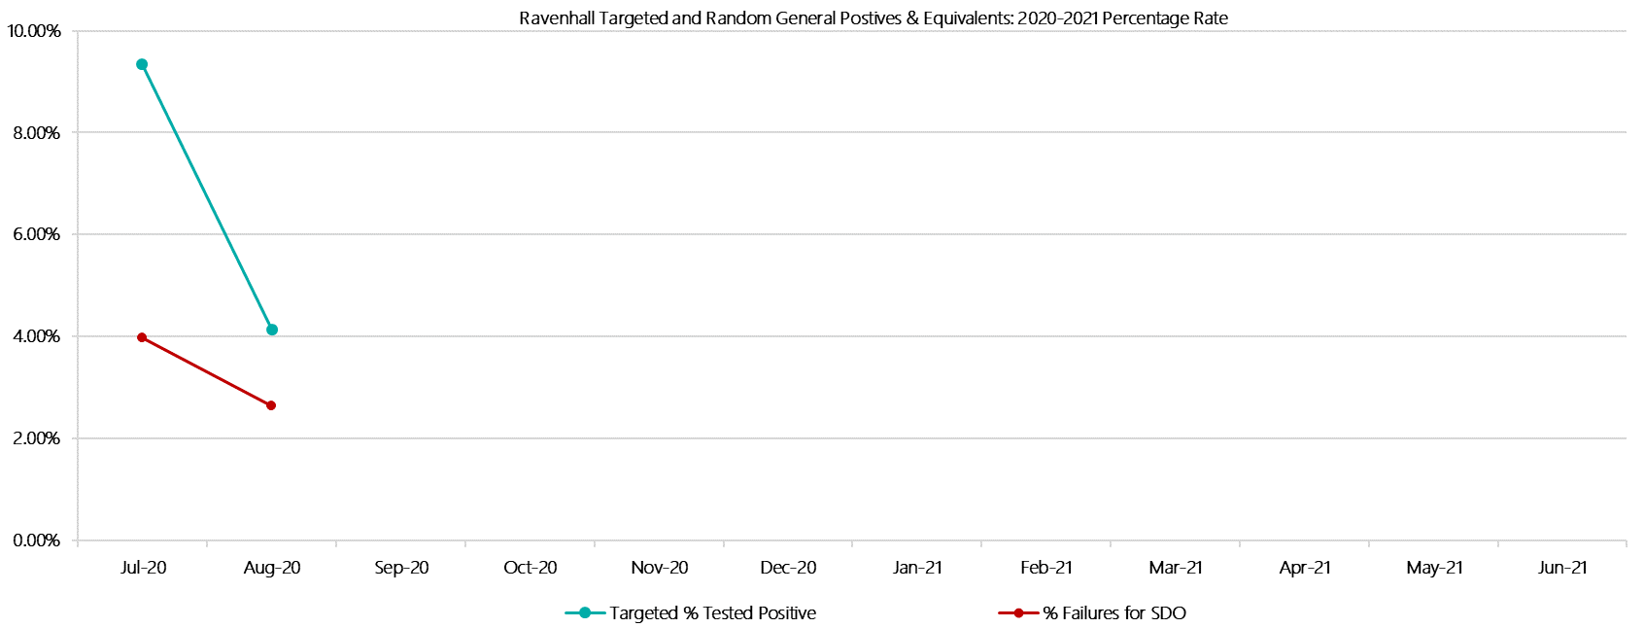

***Ravenhall Positive Test Results by Drug Type: 2020-2021***

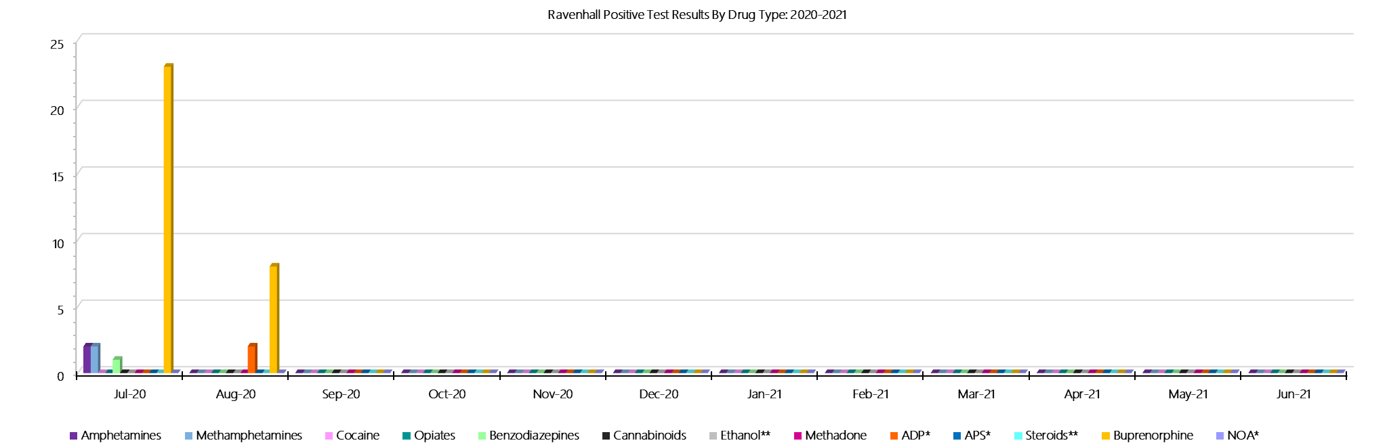

***Ravenhall Count of Visitor Seizures Finds: 2020-2021***

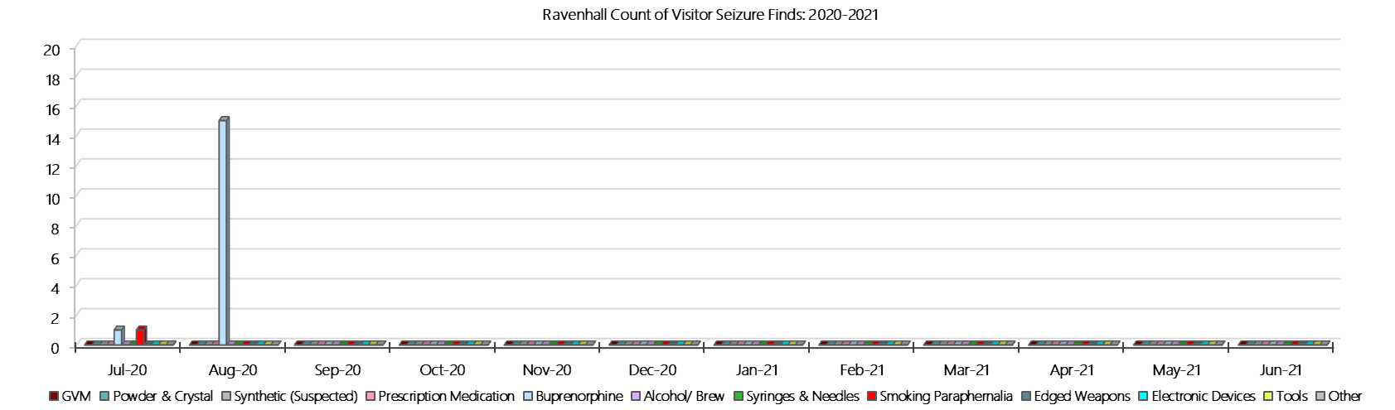

***Ravenhall Count of Prisoner Seizure Finds: 2020-2021***

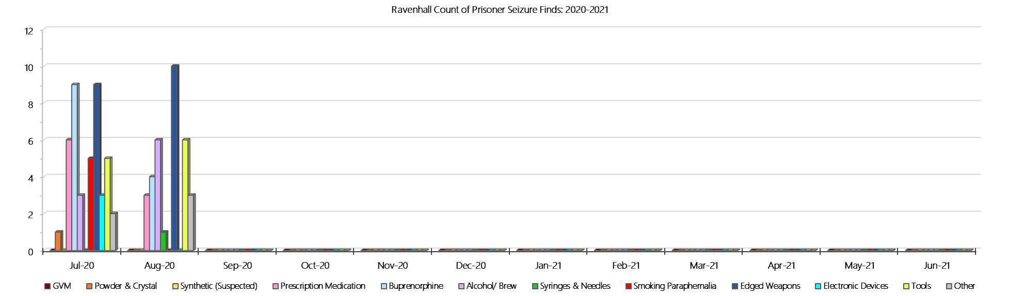

### **Beechworth Correctional Centre**

***Targeted and Random General Drug Test Results: 2020-2021***

|  |  |  |  |  |  |  |  |  |  |  |  |  |  |  |
| --- | --- | --- | --- | --- | --- | --- | --- | --- | --- | --- | --- | --- | --- | --- |
| **Beechworth** | **Jul-20** | **Aug-20** | **Sep-20** | **Oct-20** | **Nov-20** | **Dec-20** | **Jan-21** | **Feb-21** | **Mar-21** | **Apr-21** | **May-21** | **Jun-21** | **Average** | ***Totals*** |
| **Effective Sample - Targeted** | **14** | **33** |  |  |  |  |  |  |  |  |  |  | **24** | ***47*** |
| **Targeted Positives** | **1** | **2** |  |  |  |  |  |  |  |  |  |  | **2** | ***3*** |
| **Refusal** | **0** | **1** |  |  |  |  |  |  |  |  |  |  | **1** | ***1*** |
| **Unable** | **0** | **0** |  |  |  |  |  |  |  |  |  |  | **0** | ***0*** |
| **Interfered** | **0** | **0** |  |  |  |  |  |  |  |  |  |  | **0** | ***0*** |
| **Adulterated** | **0** | **0** |  |  |  |  |  |  |  |  |  |  | **0** | ***0*** |
| **Targeted % Tested Positive** | **7.14%** | **9.09%** | **#N/A** | **#N/A** | **#N/A** | **#N/A** | **#N/A** | **#N/A** | **#N/A** | **#N/A** | **#N/A** | **#N/A** | **8.51%** | ***8.51%*** |
| **Awaiting / Pending Results** | **0** | **0** |  |  |  |  |  |  |  |  |  |  | **0** | ***0*** |
| **Targeted Residual** | **0** | **0** |  |  |  |  |  |  |  |  |  |  | **0** | ***0*** |
| **Random tests collected** | **24** | **29** |  |  |  |  |  |  |  |  |  |  | **27** | ***53*** |
| **Tested Positive** | **0** | **0** |  |  |  |  |  |  |  |  |  |  | **0** | ***0*** |
| **Refusal (guilty)** | **0** | **0** |  |  |  |  |  |  |  |  |  |  | **0** | ***0*** |
| **Unable (not guilty)** | **0** | **0** |  |  |  |  |  |  |  |  |  |  | **0** | ***0*** |
| **Unable (guilty)** | **0** | **0** |  |  |  |  |  |  |  |  |  |  | **0** | ***0*** |
| **Interfered (guilty)** | **0** | **0** |  |  |  |  |  |  |  |  |  |  | **0** | ***0*** |
| **No test (valid reason)** | **0** | **1** |  |  |  |  |  |  |  |  |  |  | **1** | ***1*** |
| **No test (no valid reason)** | **0** | **0** |  |  |  |  |  |  |  |  |  |  | **0** | ***0*** |
| **Adulterated** | **0** | **0** |  |  |  |  |  |  |  |  |  |  | **0** | ***0*** |
| **Awaiting / Pending Results** | **0** | **0** |  |  |  |  |  |  |  |  |  |  | **0** | ***0*** |
| **Random Residual *(PIMS URAR030)*** | **0** | **0** |  |  |  |  |  |  |  |  |  |  | ***0*** | ***0*** |
| **Effective Sample - Random General** | **24** | **29** |  |  |  |  |  |  |  |  |  |  | **27** | **53** |
| **% Tested positive** | **0.00%** | **0.00%** |  |  |  |  |  |  |  |  |  |  | **0.00%** |  |
| **% Prisoner guilty, positive equivalents** | **0.00%** | **0.00%** |  |  |  |  |  |  |  |  |  |  | **0.00%** |  |
| **% Total prisoner fails** | **0.00%** | **0.00%** |  |  |  |  |  |  |  |  |  |  | **0.00%** |  |
| **% No test without valid reason** | **0.00%** | **0.00%** |  |  |  |  |  |  |  |  |  |  | **0.00%** |  |
| ***Random General Benchmark 1.80%*** | ***1.80%*** | ***1.80%*** | ***1.80%*** | ***1.80%*** | ***1.80%*** | ***1.80%*** | ***1.80%*** | ***1.80%*** | ***1.80%*** | ***1.80%*** | ***1.80%*** | ***1.80%*** | ***YTD*** |  |
| **% Failures for SDO** | **0.00%** | **0.00%** | **#N/A** | **#N/A** | **#N/A** | **#N/A** | **#N/A** | **#N/A** | **#N/A** | **#N/A** | **#N/A** | **#N/A** | **0.00%** |  |

***Beechworth - Drugs Identified Through Testing by Drug Type: 2020-2021***

|  |  |  |  |  |  |  |  |  |  |  |  |  |  |  |
| --- | --- | --- | --- | --- | --- | --- | --- | --- | --- | --- | --- | --- | --- | --- |
| **Beechworth** | ***Amphetamines*** | ***Methamphetamines*** | ***Cocaine*** | ***Opiates*** | ***Benzodiazepines*** | ***Cannabinoids*** | ***Ethanol\*\**** | ***Methadone*** | ***ADP\**** | ***APS\**** | ***Steroids\*\**** | ***Buprenorphine*** | ***NOA\**** | **Total** |
| **Jul-20** | **0** | **0** | **0** | **0** | **0** | **0** | **0** | **0** | **0** | **0** | **0** | **1** | **0** | **1** |
| **Aug-20** | **0** | **0** | **0** | **0** | **0** | **2** | **0** | **0** | **0** | **0** | **0** | **0** | **0** | **2** |
| **Sep-20** |  |  |  |  |  |  |  |  |  |  |  |  |  |  |
| **Oct-20** |  |  |  |  |  |  |  |  |  |  |  |  |  |  |
| **Nov-20** |  |  |  |  |  |  |  |  |  |  |  |  |  |  |
| **Dec-20** |  |  |  |  |  |  |  |  |  |  |  |  |  |  |
| **Jan-21** |  |  |  |  |  |  |  |  |  |  |  |  |  |  |
| **Feb-21** |  |  |  |  |  |  |  |  |  |  |  |  |  |  |
| **Mar-21** |  |  |  |  |  |  |  |  |  |  |  |  |  |  |
| **Apr-21** |  |  |  |  |  |  |  |  |  |  |  |  |  |  |
| **May-21** |  |  |  |  |  |  |  |  |  |  |  |  |  |  |
| **Jun-21** |  |  |  |  |  |  |  |  |  |  |  |  |  |  |
| **BeechworthYTD** | **0** | **0** | **0** | **0** | **0** | **2** | **0** | **0** | **0** | **0** | **0** | **1** | **0** | **3** |
| ***All Prisons YTD*** | ***2*** | ***2*** | ***0*** | ***2*** | ***8*** | ***3*** | ***4*** | ***7*** | ***7*** | ***0*** | ***0*** | ***98*** | ***1*** | ***134*** |
| ***Beechworth % of Total*** | ***0.00%*** | ***0.00%*** | ***0.00%*** | ***0.00%*** | ***0.00%*** | ***66.67%*** | ***0.00%*** | ***0.00%*** | ***0.00%*** | ***0.00%*** | ***0.00%*** | ***1.02%*** | ***0.00%*** | ***2.24%*** |

***Beechworth Seizures of Contraband: Visitors & Prisoners: 2020-2021***

|  |  |  |  |  |  |  |  |  |  |  |  |  |  |  |  |  |  |  |  |  |  |  |  |  |  |
| --- | --- | --- | --- | --- | --- | --- | --- | --- | --- | --- | --- | --- | --- | --- | --- | --- | --- | --- | --- | --- | --- | --- | --- | --- | --- |
| **Visitors** | **GVM** | | **Powder  & Crystal** | | **Synthetic  (Suspected)** | | **Prescription  Medication** | | **Buprenorphine** | | **Alcohol &  Home Brew** | | **Syringes & Needles** | | **Smoking  Paraphernalia** | | **Edged  Weapons** | | **Electronic  Devices** | | **Tools** | | **Other** | | |
| **BCC** | **Finds** | **Gms** | **Finds** | **Gms** | **Finds** | **Gms** | **Finds** | **Qty** | **Finds** | **Qty** | **Finds** | **Ltrs** | **Finds** | **Qty** | **Finds** | **Qty** | **Finds** | **Qty** | **Finds** | **Qty** | **Finds** | **Qty** | **Finds** | **Qty** |
| **Jul-20** | **0** | **0.00** | **0** | **0.00** | **0** | **0.00** | **0** | **0.00** | **0** | **0.00** | **0** | **0.000** | **0** | **0** | **0** | **0** | **0** | **0** | **0** | **0** | **0** | **0** | **0** | **0** |
| **Aug-20** | **0** | **0.00** | **0** | **0.00** | **0** | **0.00** | **0** | **0.00** | **0** | **0.00** | **0** | **0.000** | **0** | **0** | **0** | **0** | **0** | **0** | **0** | **0** | **0** | **0** | **0** | **0** |
| **Sep-20** |  |  |  |  |  |  |  |  |  |  |  |  |  |  |  |  |  |  |  |  |  |  |  |  |
| **Oct-20** |  |  |  |  |  |  |  |  |  |  |  |  |  |  |  |  |  |  |  |  |  |  |  |  |
| **Nov-20** |  |  |  |  |  |  |  |  |  |  |  |  |  |  |  |  |  |  |  |  |  |  |  |  |
| **Dec-20** |  |  |  |  |  |  |  |  |  |  |  |  |  |  |  |  |  |  |  |  |  |  |  |  |
| **Jan-21** |  |  |  |  |  |  |  |  |  |  |  |  |  |  |  |  |  |  |  |  |  |  |  |  |
| **Feb-21** |  |  |  |  |  |  |  |  |  |  |  |  |  |  |  |  |  |  |  |  |  |  |  |  |
| **Mar-21** |  |  |  |  |  |  |  |  |  |  |  |  |  |  |  |  |  |  |  |  |  |  |  |  |
| **Apr-21** |  |  |  |  |  |  |  |  |  |  |  |  |  |  |  |  |  |  |  |  |  |  |  |  |
| **May-21** |  |  |  |  |  |  |  |  |  |  |  |  |  |  |  |  |  |  |  |  |  |  |  |  |
| **Jun-21** |  |  |  |  |  |  |  |  |  |  |  |  |  |  |  |  |  |  |  |  |  |  |  |  |
| **Total** | **0** | **0.00** | **0** | **0.00** | **0** | **0.00** | **0** | **0.00** | **0** | **0.00** | **0** | **0.000** | **0** | **0** | **0** | **0** | **0** | **0** | **0** | **0** | **0** | **0** | **0** | **0** |

|  |  |  |  |  |  |  |  |  |  |  |  |  |  |  |  |  |  |  |  |  |  |  |  |  |  |
| --- | --- | --- | --- | --- | --- | --- | --- | --- | --- | --- | --- | --- | --- | --- | --- | --- | --- | --- | --- | --- | --- | --- | --- | --- | --- |
| **Prisoners** | **GVM** | | **Powder  & Crystal** | | **Synthetic  (Suspected)** | | **Prescription  Medication** | | **Buprenorphine** | | **Alcohol &  Home Brew** | | **Syringes & Needles** | | **Smoking  Paraphernalia** | | | **Edged  Weapons** | | **Electronic  Devices** | | **Tools** | | **Other** | |
| **BCC** | **Finds** | **Gms** | **Finds** | **Gms** | **Finds** | **Gms** | **Finds** | **Qty** | **Finds** | **Qty** | **Finds** | **Ltrs** | **Finds** | **Qty** | **Finds** | **Qty** | | **Finds** | **Qty** | **Finds** | **Qty** | **Finds** | **Qty** | **Finds** | **Qty** |
| **Jul-20** | **0** | **0.00** | **0** | **0.00** | **0** | **0.00** | **0** | **0.00** | **0** | **0.00** | **0** | **0.000** | **0** | **0** | **2** | | **2** | **0** | **0** | **0** | **0** | **1** | **1** | **0** | **0** |
| **Aug-20** | **1** | **0.01** | **0** | **0.00** | **0** | **0.00** | **0** | **0.00** | **0** | **0.00** | **0** | **0.000** | **0** | **0** | **2** | | **2** | **0** | **0** | **0** | **0** | **0** | **0** | **0** | **0** |
| **Sep-20** |  |  |  |  |  |  |  |  |  |  |  |  |  |  |  | |  |  |  |  |  |  |  |  |  |
| **Oct-20** |  |  |  |  |  |  |  |  |  |  |  |  |  |  |  | |  |  |  |  |  |  |  |  |  |
| **Nov-20** |  |  |  |  |  |  |  |  |  |  |  |  |  |  |  | |  |  |  |  |  |  |  |  |  |
| **Dec-20** |  |  |  |  |  |  |  |  |  |  |  |  |  |  |  | |  |  |  |  |  |  |  |  |  |
| **Jan-21** |  |  |  |  |  |  |  |  |  |  |  |  |  |  |  | |  |  |  |  |  |  |  |  |  |
| **Feb-21** |  |  |  |  |  |  |  |  |  |  |  |  |  |  |  | |  |  |  |  |  |  |  |  |  |
| **Mar-21** |  |  |  |  |  |  |  |  |  |  |  |  |  |  |  | |  |  |  |  |  |  |  |  |  |
| **Apr-21** |  |  |  |  |  |  |  |  |  |  |  |  |  |  |  | |  |  |  |  |  |  |  |  |  |
| **May-21** |  |  |  |  |  |  |  |  |  |  |  |  |  |  |  | |  |  |  |  |  |  |  |  |  |
| **Jun-21** |  |  |  |  |  |  |  |  |  |  |  |  |  |  |  | |  |  |  |  |  |  |  |  |  |
| **Total** | **1** | **0.01** | **0** | **0.00** | **0** | **0.00** | **0** | **0.00** | **0** | **0** | **0** | **0.000** | **0** | **0** | **4** | | **4** | **0** | **0** | **0** | **0** | **1** | **1** | **0** | **0** |

***Beechworth Targeted and Random General Drug Test Positives & Equivalents: 2020-2021***

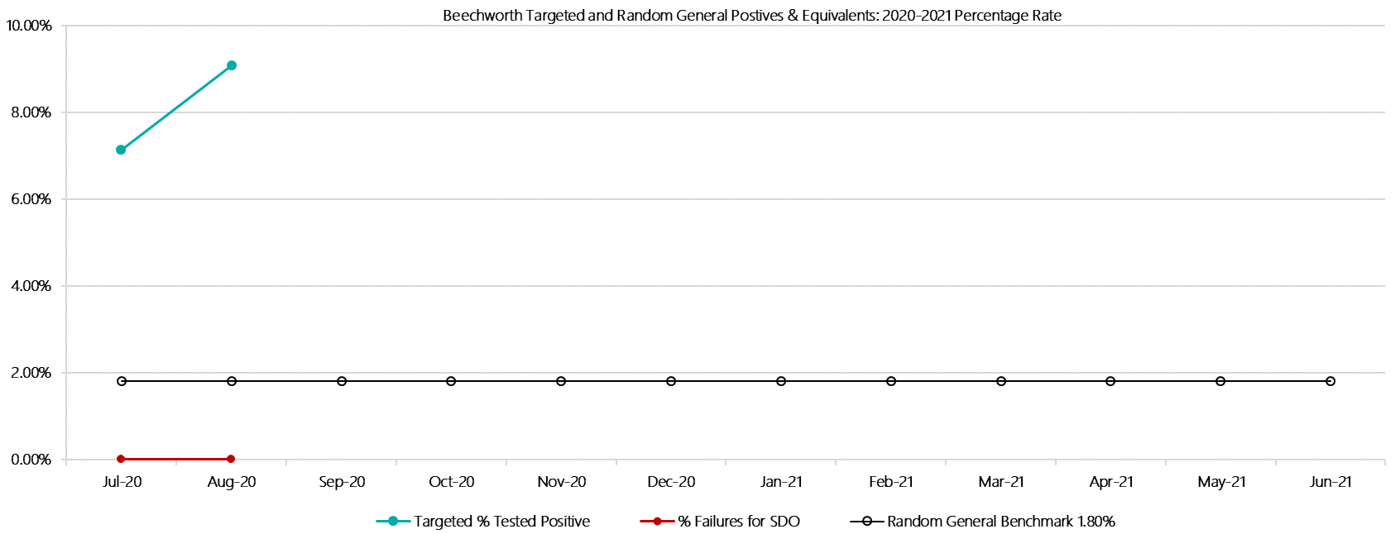

***Beechworth Positive Test Results by Drug Type: 2020-2021***

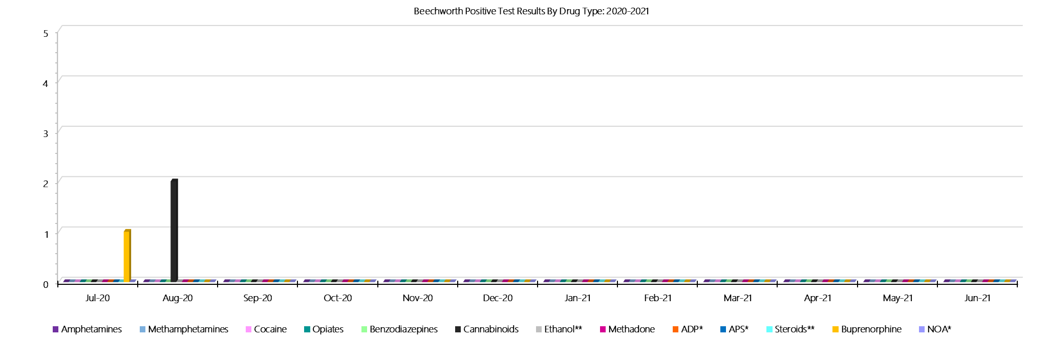

***Beechworth Count of Visitor Seizures Finds: 2020-2021***

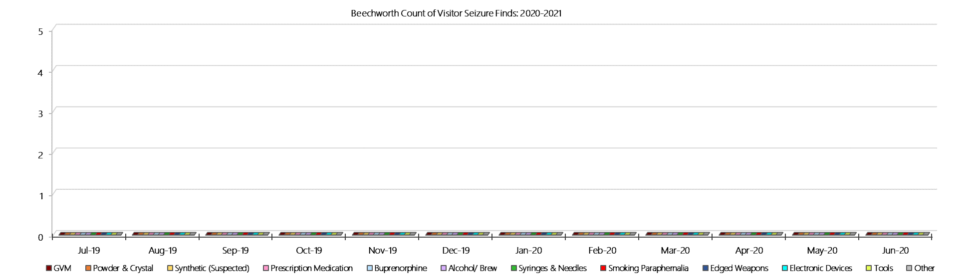

***Beechworth Count of Prisoner Seizure Finds: 2020-2021***

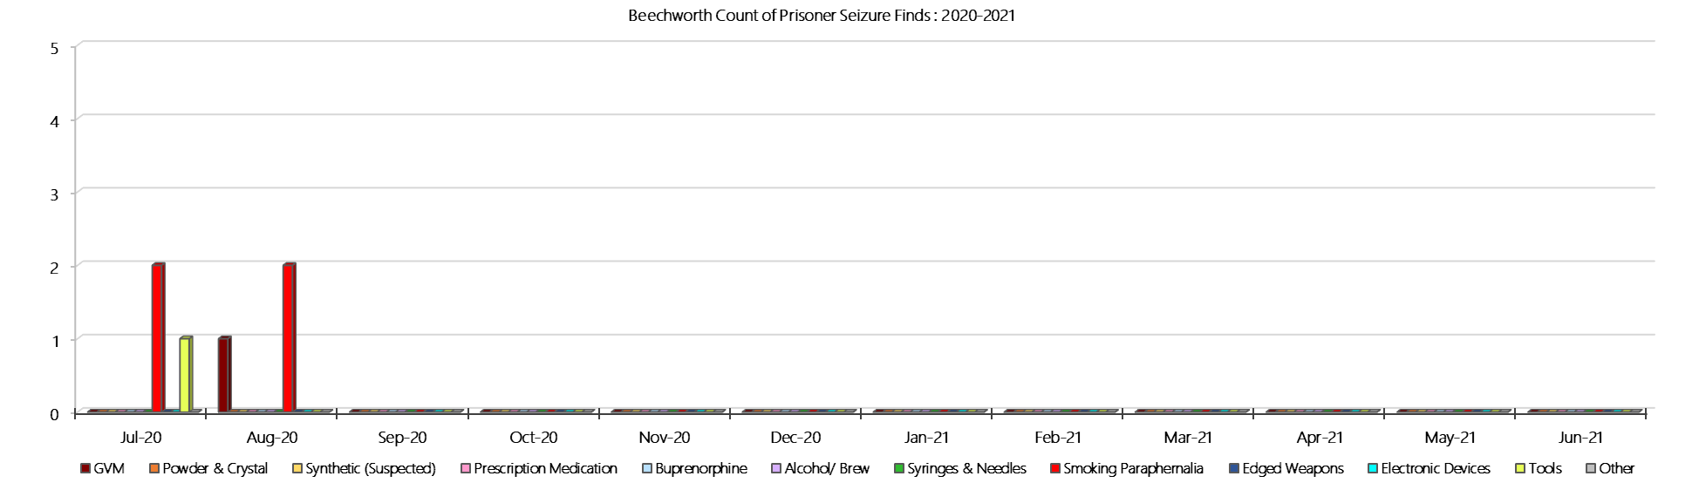

### **Dhurringile Prison**

***Targeted and Random General Drug Test Results: 2020-2021***

|  |  |  |  |  |  |  |  |  |  |  |  |  |  |  |
| --- | --- | --- | --- | --- | --- | --- | --- | --- | --- | --- | --- | --- | --- | --- |
| **Dhurringile** | **Jul-20** | **Aug-20** | **Sep-20** | **Oct-20** | **Nov-20** | **Dec-20** | **Jan-21** | **Feb-21** | **Mar-21** | **Apr-21** | **May-21** | **Jun-21** | **Average** | ***Totals*** |
| **Effective Sample - Targeted** | **108** | **113** |  |  |  |  |  |  |  |  |  |  | **111** | ***221*** |
| **Targeted Positives** | **1** | **2** |  |  |  |  |  |  |  |  |  |  | **2** | ***3*** |
| **Refusal** | **1** | **0** |  |  |  |  |  |  |  |  |  |  | **1** | ***1*** |
| **Unable** | **0** | **0** |  |  |  |  |  |  |  |  |  |  | **0** | ***0*** |
| **Interfered** | **0** | **0** |  |  |  |  |  |  |  |  |  |  | **0** | ***0*** |
| **Adulterated** | **0** | **0** |  |  |  |  |  |  |  |  |  |  | **0** | ***0*** |
| **Targeted % Tested Positive** | **1.85%** | **1.77%** | **#N/A** | **#N/A** | **#N/A** | **#N/A** | **#N/A** | **#N/A** | **#N/A** | **#N/A** | **#N/A** | **#N/A** | **1.81%** | ***1.81%*** |
| **Awaiting / Pending Results** | **0** | **0** |  |  |  |  |  |  |  |  |  |  | **0** | ***0*** |
| **Targeted Residual** | **0** | **0** |  |  |  |  |  |  |  |  |  |  | **0** | ***0*** |
| **Random tests collected** | **28** | **26** |  |  |  |  |  |  |  |  |  |  | **27** | ***54*** |
| **Tested Positive** | **1** | **0** |  |  |  |  |  |  |  |  |  |  | **1** | ***1*** |
| **Refusal (guilty)** | **0** | **0** |  |  |  |  |  |  |  |  |  |  | **0** | ***0*** |
| **Unable (not guilty)** | **0** | **0** |  |  |  |  |  |  |  |  |  |  | **0** | ***0*** |
| **Unable (guilty)** | **0** | **0** |  |  |  |  |  |  |  |  |  |  | **0** | ***0*** |
| **Interfered (guilty)** | **0** | **0** |  |  |  |  |  |  |  |  |  |  | **0** | ***0*** |
| **No test (valid reason)** | **0** | **0** |  |  |  |  |  |  |  |  |  |  | **0** | ***0*** |
| **No test (no valid reason)** | **0** | **0** |  |  |  |  |  |  |  |  |  |  | **0** | ***0*** |
| **Adulterated** | **0** | **0** |  |  |  |  |  |  |  |  |  |  | **0** | ***0*** |
| **Awaiting / Pending Results** | **0** | **6** |  |  |  |  |  |  |  |  |  |  | **3** | ***6*** |
| **Random Residual *(PIMS URAR030)*** | **0** | **0** |  |  |  |  |  |  |  |  |  |  | ***0*** | ***0*** |
| **Effective Sample - Random General** | **28** | **26** |  |  |  |  |  |  |  |  |  |  | **27** | **54** |
| **% Tested positive** | **3.57%** | **0.00%** |  |  |  |  |  |  |  |  |  |  | **1.79%** |  |
| **% Prisoner guilty, positive equivalents** | **0.00%** | **0.00%** |  |  |  |  |  |  |  |  |  |  | **0.00%** |  |
| **% Total prisoner fails** | **3.57%** | **0.00%** |  |  |  |  |  |  |  |  |  |  | **1.79%** |  |
| **% No test without valid reason** | **0.00%** | **0.00%** |  |  |  |  |  |  |  |  |  |  | **0.00%** |  |
| ***Random General Benchmark 3.50%*** | ***3.50%*** | ***3.50%*** | ***3.50%*** | ***3.50%*** | ***3.50%*** | ***3.50%*** | ***3.50%*** | ***3.50%*** | ***3.50%*** | ***3.50%*** | ***3.50%*** | ***3.50%*** | ***YTD*** |  |
| **% Failures for SDO** | **3.57%** | **0.00%** | **#N/A** | **#N/A** | **#N/A** | **#N/A** | **#N/A** | **#N/A** | **#N/A** | **#N/A** | **#N/A** | **#N/A** | **1.85%** |  |

***Dhurringile - Drugs Identified Through Testing by Drug Type: 2020-2021***

|  |  |  |  |  |  |  |  |  |  |  |  |  |  |  |
| --- | --- | --- | --- | --- | --- | --- | --- | --- | --- | --- | --- | --- | --- | --- |
| **Dhurringile** | ***Amphetamines*** | ***Methamphetamines*** | ***Cocaine*** | ***Opiates*** | ***Benzodiazepines*** | ***Cannabinoids*** | ***Ethanol\*\**** | ***Methadone*** | ***ADP\**** | ***APS\**** | ***Steroids\*\**** | ***Buprenorphine*** | ***NOA\**** | **Total** |
| **Jul-20** | **0** | **0** | **0** | **0** | **0** | **0** | **0** | **0** | **0** | **0** | **0** | **3** | **0** | **3** |
| **Aug-20** | **0** | **0** | **0** | **0** | **0** | **0** | **0** | **0** | **0** | **0** | **0** | **3** | **0** | **3** |
| **Sep-20** |  |  |  |  |  |  |  |  |  |  |  |  |  |  |
| **Oct-20** |  |  |  |  |  |  |  |  |  |  |  |  |  |  |
| **Nov-20** |  |  |  |  |  |  |  |  |  |  |  |  |  |  |
| **Dec-20** |  |  |  |  |  |  |  |  |  |  |  |  |  |  |
| **Jan-21** |  |  |  |  |  |  |  |  |  |  |  |  |  |  |
| **Feb-21** |  |  |  |  |  |  |  |  |  |  |  |  |  |  |
| **Mar-21** |  |  |  |  |  |  |  |  |  |  |  |  |  |  |
| **Apr-21** |  |  |  |  |  |  |  |  |  |  |  |  |  |  |
| **May-21** |  |  |  |  |  |  |  |  |  |  |  |  |  |  |
| **Jun-21** |  |  |  |  |  |  |  |  |  |  |  |  |  |  |
| **Dhurringile YTD** | **0** | **0** | **0** | **0** | **0** | **0** | **0** | **0** | **0** | **0** | **0** | **6** | **0** | **6** |
| ***All Prisons YTD*** | ***2*** | ***2*** | ***0*** | ***2*** | ***8*** | ***3*** | ***4*** | ***7*** | ***7*** | ***0*** | ***0*** | ***98*** | ***1*** | ***134*** |
| ***Dhurringile % of Total*** | ***0.00%*** | ***0.00%*** | ***0.00%*** | ***0.00%*** | ***0.00%*** | ***0.00%*** | ***0.00%*** | ***0.00%*** | ***0.00%*** | ***0.00%*** | ***0.00%*** | ***6.12%*** | ***0.00%*** | ***4.48%*** |

***Dhurringile Seizures of Contraband: Visitors & Prisoners: 2020-2021***

|  |  |  |  |  |  |  |  |  |  |  |  |  |  |  |  |  |  |  |  |  |  |  |  |  |  |
| --- | --- | --- | --- | --- | --- | --- | --- | --- | --- | --- | --- | --- | --- | --- | --- | --- | --- | --- | --- | --- | --- | --- | --- | --- | --- |
| **Visitors** | **GVM** | | **Powder  & Crystal** | | **Synthetic  (Suspected)** | | **Prescription  Medication** | | **Buprenorphine** | | **Alcohol &  Home Brew** | | **Syringes & Needles** | | **Smoking  Paraphernalia** | | **Edged  Weapons** | | **Electronic  Devices** | | **Tools** | | **Other** | | |
| **D’gile** | **Finds** | **Gms** | **Finds** | **Gms** | **Finds** | **Gms** | **Finds** | **Qty** | **Finds** | **Qty** | **Finds** | **Ltrs** | **Finds** | **Qty** | **Finds** | **Qty** | **Finds** | **Qty** | **Finds** | **Qty** | **Finds** | **Qty** | **Finds** | **Qty** |
| **Jul-20** | **0** | **0.00** | **0** | **0.00** | **0** | **0.00** | **0** | **0.00** | **0** | **0.00** | **0** | **0.000** | **0** | **0** | **0** | **0** | **0** | **0** | **0** | **0** | **0** | **0** | **0** | **0** |
| **Aug-20** | **0** | **0.00** | **0** | **0.00** | **0** | **0.00** | **0** | **0.00** | **0** | **0.00** | **0** | **0.000** | **0** | **0** | **0** | **0** | **0** | **0** | **0** | **0** | **0** | **0** | **0** | **0** |
| **Sep-20** |  |  |  |  |  |  |  |  |  |  |  |  |  |  |  |  |  |  |  |  |  |  |  |  |
| **Oct-20** |  |  |  |  |  |  |  |  |  |  |  |  |  |  |  |  |  |  |  |  |  |  |  |  |
| **Nov-20** |  |  |  |  |  |  |  |  |  |  |  |  |  |  |  |  |  |  |  |  |  |  |  |  |
| **Dec-20** |  |  |  |  |  |  |  |  |  |  |  |  |  |  |  |  |  |  |  |  |  |  |  |  |
| **Jan-21** |  |  |  |  |  |  |  |  |  |  |  |  |  |  |  |  |  |  |  |  |  |  |  |  |
| **Feb-21** |  |  |  |  |  |  |  |  |  |  |  |  |  |  |  |  |  |  |  |  |  |  |  |  |
| **Mar-21** |  |  |  |  |  |  |  |  |  |  |  |  |  |  |  |  |  |  |  |  |  |  |  |  |
| **Apr-21** |  |  |  |  |  |  |  |  |  |  |  |  |  |  |  |  |  |  |  |  |  |  |  |  |
| **May-21** |  |  |  |  |  |  |  |  |  |  |  |  |  |  |  |  |  |  |  |  |  |  |  |  |
| **Jun-21** |  |  |  |  |  |  |  |  |  |  |  |  |  |  |  |  |  |  |  |  |  |  |  |  |
| **Total** | **0** | **0.00** | **0** | **0.00** | **0** | **0.00** | **0** | **0.00** | **0** | **0.00** | **0** | **0.000** | **0** | **0** | **0** | **0** | **0** | **0** | **0** | **0** | **0** | **0** | **0** | **0** |

|  |  |  |  |  |  |  |  |  |  |  |  |  |  |  |  |  |  |  |  |  |  |  |  |  |  |
| --- | --- | --- | --- | --- | --- | --- | --- | --- | --- | --- | --- | --- | --- | --- | --- | --- | --- | --- | --- | --- | --- | --- | --- | --- | --- |
| **Prisoners** | **GVM** | | **Powder  & Crystal** | | **Synthetic  (Suspected)** | | **Prescription  Medication** | | **Buprenorphine** | | **Alcohol &  Home Brew** | | **Syringes & Needles** | | **Smoking  Paraphernalia** | | | **Edged  Weapons** | | **Electronic  Devices** | | **Tools** | | **Other** | |
| **D’gile** | **Finds** | **Gms** | **Finds** | **Gms** | **Finds** | **Gms** | **Finds** | **Qty** | **Finds** | **Qty** | **Finds** | **Ltrs** | **Finds** | **Qty** | **Finds** | **Qty** | | **Finds** | **Qty** | **Finds** | **Qty** | **Finds** | **Qty** | **Finds** | **Qty** |
| **Jul-20** | **0** | **0.00** | **0** | **0.00** | **0** | **0.00** | **0** | **0.00** | **1** | **0.20** | **0** | **0.000** | **0** | **0** | **1** | | **1** | **1** | **1** | **0** | **0** | **0** | **0** | **1** | **16** |
| **Aug-20** | **0** | **0.00** | **0** | **0.00** | **0** | **0.00** | **2** | **2.50** | **0** | **0.00** | **0** | **0.000** | **0** | **0** | **4** | | **6** | **0** | **0** | **1** | **1** | **1** | **1** | **0** | **0** |
| **Sep-20** |  |  |  |  |  |  |  |  |  |  |  |  |  |  |  | |  |  |  |  |  |  |  |  |  |
| **Oct-20** |  |  |  |  |  |  |  |  |  |  |  |  |  |  |  | |  |  |  |  |  |  |  |  |  |
| **Nov-20** |  |  |  |  |  |  |  |  |  |  |  |  |  |  |  | |  |  |  |  |  |  |  |  |  |
| **Dec-20** |  |  |  |  |  |  |  |  |  |  |  |  |  |  |  | |  |  |  |  |  |  |  |  |  |
| **Jan-21** |  |  |  |  |  |  |  |  |  |  |  |  |  |  |  | |  |  |  |  |  |  |  |  |  |
| **Feb-21** |  |  |  |  |  |  |  |  |  |  |  |  |  |  |  | |  |  |  |  |  |  |  |  |  |
| **Mar-21** |  |  |  |  |  |  |  |  |  |  |  |  |  |  |  | |  |  |  |  |  |  |  |  |  |
| **Apr-21** |  |  |  |  |  |  |  |  |  |  |  |  |  |  |  | |  |  |  |  |  |  |  |  |  |
| **May-21** |  |  |  |  |  |  |  |  |  |  |  |  |  |  |  | |  |  |  |  |  |  |  |  |  |
| **Jun-21** |  |  |  |  |  |  |  |  |  |  |  |  |  |  |  | |  |  |  |  |  |  |  |  |  |
| **Total** | **0** | **0.00** | **0** | **0.00** | **0** | **0.00** | **2** | **2.50** | **1** | **0.20** | **0** | **0.000** | **0** | **0** | **5** | | **7** | **1** | **1** | **1** | **1** | **1** | **1** | **1** | **16** |

***Dhurringile Targeted and Random General Drug Test Positives & Equivalents: 2020-2021***

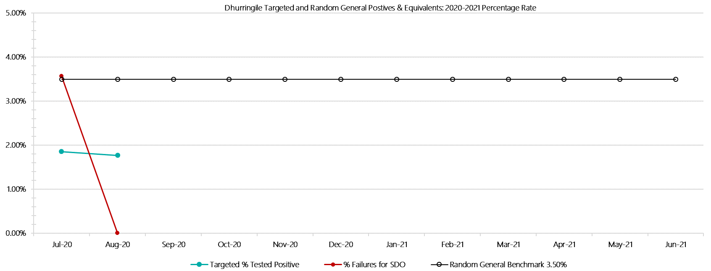

***Dhurringile Positive Test Results by Drug Type: 2020-2021***

**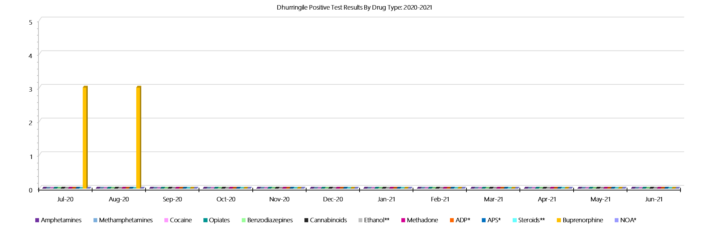*Dhurringile Count of Visitor Seizures Finds: 2020-2021***

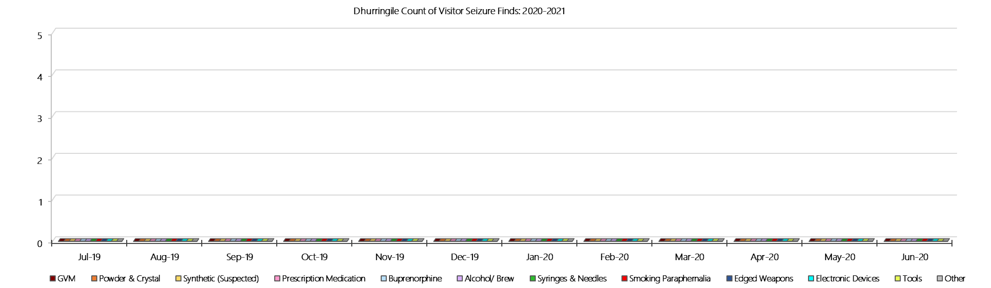

***Dhurringile Count of Prisoner Seizure Finds: 2020-2021***

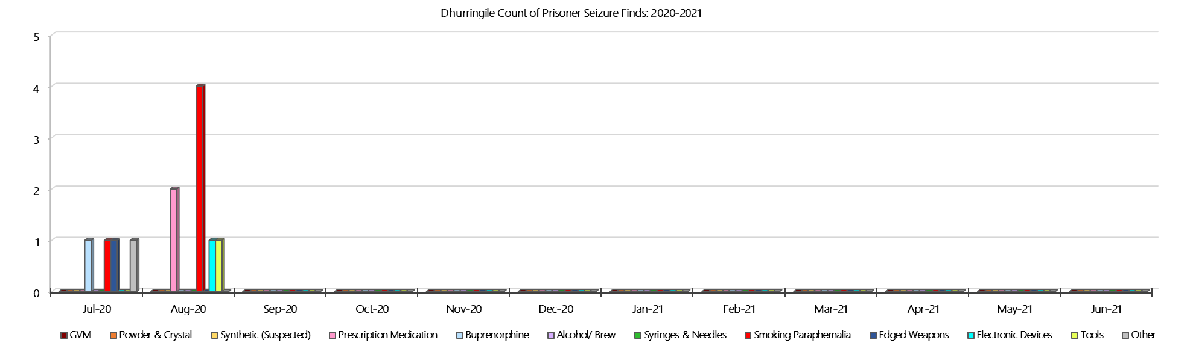

### **Langi Kal Kal Prison**

***Targeted and Random General Drug Test Results: 2020-2021***

|  |  |  |  |  |  |  |  |  |  |  |  |  |  |  |
| --- | --- | --- | --- | --- | --- | --- | --- | --- | --- | --- | --- | --- | --- | --- |
| **Langi Kal Kal** | **Jul-20** | **Aug-20** | **Sep-20** | **Oct-20** | **Nov-20** | **Dec-20** | **Jan-21** | **Feb-21** | **Mar-21** | **Apr-21** | **May-21** | **Jun-21** | **Average** | ***Totals*** |
| **Effective Sample - Targeted** | **7** | **19** |  |  |  |  |  |  |  |  |  |  | **13** | ***26*** |
| **Targeted Positives** | **0** | **0** |  |  |  |  |  |  |  |  |  |  | **0** | ***0*** |
| **Refusal** | **0** | **0** |  |  |  |  |  |  |  |  |  |  | **0** | ***0*** |
| **Unable** | **0** | **0** |  |  |  |  |  |  |  |  |  |  | **0** | ***0*** |
| **Interfered** | **0** | **0** |  |  |  |  |  |  |  |  |  |  | **0** | ***0*** |
| **Adulterated** | **0** | **0** |  |  |  |  |  |  |  |  |  |  | **0** | ***0*** |
| **Targeted % Tested Positive** | **0.00%** | **0.00%** | **#N/A** | **#N/A** | **#N/A** | **#N/A** | **#N/A** | **#N/A** | **#N/A** | **#N/A** | **#N/A** | **#N/A** | **0.00%** | ***0.00%*** |
| **Awaiting / Pending Results** | **0** | **1** |  |  |  |  |  |  |  |  |  |  | **1** | ***1*** |
| **Targeted Residual** | **0** | **0** |  |  |  |  |  |  |  |  |  |  | **0** | ***0*** |
| **Random tests collected** | **43** | **55** |  |  |  |  |  |  |  |  |  |  | **49** | ***98*** |
| **Tested Positive** | **0** | **0** |  |  |  |  |  |  |  |  |  |  | **0** | ***0*** |
| **Refusal (guilty)** | **0** | **0** |  |  |  |  |  |  |  |  |  |  | **0** | ***0*** |
| **Unable (not guilty)** | **0** | **0** |  |  |  |  |  |  |  |  |  |  | **0** | ***0*** |
| **Unable (guilty)** | **0** | **0** |  |  |  |  |  |  |  |  |  |  | **0** | ***0*** |
| **Interfered (guilty)** | **0** | **0** |  |  |  |  |  |  |  |  |  |  | **0** | ***0*** |
| **No test (valid reason)** | **1** | **0** |  |  |  |  |  |  |  |  |  |  | **1** | ***1*** |
| **No test (no valid reason)** | **0** | **0** |  |  |  |  |  |  |  |  |  |  | **0** | ***0*** |
| **Adulterated** | **0** | **0** |  |  |  |  |  |  |  |  |  |  | **0** | ***0*** |
| **Awaiting / Pending Results** | **0** | **1** |  |  |  |  |  |  |  |  |  |  | **1** | ***1*** |
| **Random Residual *(PIMS URAR030)*** | **0** | **0** |  |  |  |  |  |  |  |  |  |  | ***0*** | ***0*** |
| **Effective Sample - Random General** | **43** | **55** |  |  |  |  |  |  |  |  |  |  | **49** | **98** |
| **% Tested positive** | **0.00%** | **0.00%** |  |  |  |  |  |  |  |  |  |  | **0.00%** |  |
| **% Prisoner guilty, positive equivalents** | **0.00%** | **0.00%** |  |  |  |  |  |  |  |  |  |  | **0.00%** |  |
| **% Total prisoner fails** | **0.00%** | **0.00%** |  |  |  |  |  |  |  |  |  |  | **0.00%** |  |
| **% No test without valid reason** | **0.00%** | **0.00%** |  |  |  |  |  |  |  |  |  |  | **0.00%** |  |
| ***Random General Benchmark 1.50%*** | ***1.50%*** | ***1.50%*** | ***1.50%*** | ***1.50%*** | ***1.50%*** | ***1.50%*** | ***1.50%*** | ***1.50%*** | ***1.50%*** | ***1.50%*** | ***1.50%*** | ***1.50%*** | ***YTD*** |  |
| **% Failures for SDO** | **0.00%** | **0.00%** | **#N/A** | **#N/A** | **#N/A** | **#N/A** | **#N/A** | **#N/A** | **#N/A** | **#N/A** | **#N/A** | **#N/A** | **0.00%** |  |

***Langi Kal Kal - Drugs Identified Through Testing by Drug Type: 2020-2021***

|  |  |  |  |  |  |  |  |  |  |  |  |  |  |  |
| --- | --- | --- | --- | --- | --- | --- | --- | --- | --- | --- | --- | --- | --- | --- |
| **Langi Kal Kal** | ***Amphetamines*** | ***Methamphetamines*** | ***Cocaine*** | ***Opiates*** | ***Benzodiazepines*** | ***Cannabinoids*** | ***Ethanol\*\**** | ***Methadone*** | ***ADP\**** | ***APS\**** | ***Steroids\*\**** | ***Buprenorphine*** | ***NOA\**** | **Total** |
| **Jul-20** | **0** | **0** | **0** | **0** | **0** | **0** | **0** | **0** | **0** | **0** | **0** | **0** | **0** | **0** |
| **Aug-20** | **0** | **0** | **0** | **0** | **0** | **0** | **0** | **0** | **0** | **0** | **0** | **0** | **0** | **0** |
| **Sep-20** |  |  |  |  |  |  |  |  |  |  |  |  |  |  |
| **Oct-20** |  |  |  |  |  |  |  |  |  |  |  |  |  |  |
| **Nov-20** |  |  |  |  |  |  |  |  |  |  |  |  |  |  |
| **Dec-20** |  |  |  |  |  |  |  |  |  |  |  |  |  |  |
| **Jan-21** |  |  |  |  |  |  |  |  |  |  |  |  |  |  |
| **Feb-21** |  |  |  |  |  |  |  |  |  |  |  |  |  |  |
| **Mar-21** |  |  |  |  |  |  |  |  |  |  |  |  |  |  |
| **Apr-21** |  |  |  |  |  |  |  |  |  |  |  |  |  |  |
| **May-21** |  |  |  |  |  |  |  |  |  |  |  |  |  |  |
| **Jun-21** |  |  |  |  |  |  |  |  |  |  |  |  |  |  |
| **Langi Kal Kal YTD** | **0** | **0** | **0** | **0** | **0** | **0** | **0** | **0** | **0** | **0** | **0** | **0** | **0** | **0** |
| ***All Prisons YTD*** | ***2*** | ***2*** | ***0*** | ***2*** | ***8*** | ***3*** | ***4*** | ***7*** | ***7*** | ***0*** | ***0*** | ***98*** | ***1*** | ***134*** |
| ***Langi Kal Kal % of Total*** | ***0.00%*** | ***0.00%*** | ***0.00%*** | ***0.00%*** | ***0.00%*** | ***0.00%*** | ***0.00%*** | ***0.00%*** | ***0.00%*** | ***0.00%*** | ***0.00%*** | ***0.00%*** | ***0.00%*** | ***0.00%*** |

***Langi Kal Kal Seizures of Contraband: Visitors & Prisoners: 2020-2021***

|  |  |  |  |  |  |  |  |  |  |  |  |  |  |  |  |  |  |  |  |  |  |  |  |  |
| --- | --- | --- | --- | --- | --- | --- | --- | --- | --- | --- | --- | --- | --- | --- | --- | --- | --- | --- | --- | --- | --- | --- | --- | --- |
| **Visitors** | **GVM** | | **Powder  & Crystal** | | **Synthetic  (Suspected)** | | **Prescription  Medication** | | **Buprenorphine** | | **Alcohol &  Home Brew** | | **Syringes & Needles** | | **Smoking  Paraphernalia** | | **Edged  Weapons** | | **Electronic  Devices** | | **Tools** | | **Other** | |
| **LKK** | **Finds** | **Gms** | **Finds** | **Gms** | **Finds** | **Gms** | **Finds** | **Qty** | **Finds** | **Qty** | **Finds** | **Ltrs** | **Finds** | **Qty** | **Finds** | **Qty** | **Finds** | **Qty** | **Finds** | **Qty** | **Finds** | **Qty** | **Finds** | **Qty** |
| **Jul-20** | **0** | **0.00** | **0** | **0.00** | **0** | **0.00** | **0** | **0.00** | **0** | **0.00** | **0** | **0.000** | **0** | **0** | **0** | **0** | **0** | **0** | **0** | **0** | **0** | **0** | **0** | **0** |
| **Aug-20** | **0** | **0.00** | **0** | **0.00** | **0** | **0.00** | **0** | **0.00** | **0** | **0.00** | **0** | **0.000** | **0** | **0** | **0** | **0** | **0** | **0** | **0** | **0** | **0** | **0** | **0** | **0** |
| **Sep-20** |  |  |  |  |  |  |  |  |  |  |  |  |  |  |  |  |  |  |  |  |  |  |  |  |
| **Oct-20** |  |  |  |  |  |  |  |  |  |  |  |  |  |  |  |  |  |  |  |  |  |  |  |  |
| **Nov-20** |  |  |  |  |  |  |  |  |  |  |  |  |  |  |  |  |  |  |  |  |  |  |  |  |
| **Dec-20** |  |  |  |  |  |  |  |  |  |  |  |  |  |  |  |  |  |  |  |  |  |  |  |  |
| **Jan-21** |  |  |  |  |  |  |  |  |  |  |  |  |  |  |  |  |  |  |  |  |  |  |  |  |
| **Feb-21** |  |  |  |  |  |  |  |  |  |  |  |  |  |  |  |  |  |  |  |  |  |  |  |  |
| **Mar-21** |  |  |  |  |  |  |  |  |  |  |  |  |  |  |  |  |  |  |  |  |  |  |  |  |
| **Apr-21** |  |  |  |  |  |  |  |  |  |  |  |  |  |  |  |  |  |  |  |  |  |  |  |  |
| **May-21** |  |  |  |  |  |  |  |  |  |  |  |  |  |  |  |  |  |  |  |  |  |  |  |  |
| **Jun-21** |  |  |  |  |  |  |  |  |  |  |  |  |  |  |  |  |  |  |  |  |  |  |  |  |
| **Total** | **0** | **0.00** | **0** | **0.00** | **0** | **0.00** | **0** | **0.00** | **0** | **0.00** | **0** | **0.000** | **0** | **0** | **0** | **0** | **0** | **0** | **0** | **0** | **0** | **0** | **0** | **0** |

|  |  |  |  |  |  |  |  |  |  |  |  |  |  |  |  |  |  |  |  |  |  |  |  |  |  |
| --- | --- | --- | --- | --- | --- | --- | --- | --- | --- | --- | --- | --- | --- | --- | --- | --- | --- | --- | --- | --- | --- | --- | --- | --- | --- |
| **Prisoners** | **GVM** | | **Powder  & Crystal** | | **Synthetic  (Suspected)** | | **Prescription  Medication** | | **Buprenorphine** | | **Alcohol &  Home Brew** | | **Syringes & Needles** | | **Smoking  Paraphernalia** | | | **Edged  Weapons** | | **Electronic  Devices** | | **Tools** | | **Other** | |
| **LKK** | **Finds** | **Gms** | **Finds** | **Gms** | **Finds** | **Gms** | **Finds** | **Qty** | **Finds** | **Qty** | **Finds** | **Ltrs** | **Finds** | **Qty** | **Finds** | **Qty** | | **Finds** | **Qty** | **Finds** | **Qty** | **Finds** | **Qty** | **Finds** | **Qty** |
| **Jul-20** | **0** | **0.00** | **0** | **0.00** | **0** | **0.00** | **0** | **0.00** | **0** | **0.00** | **0** | **0.000** | **0** | **0** | **0** | | **0** | **0** | **0** | **0** | **0** | **0** | **0** | **1** | **1** |
| **Aug-20** | **0** | **0.00** | **0** | **0.00** | **0** | **0.00** | **0** | **0.00** | **0** | **0.00** | **0** | **0.000** | **0** | **0** | **0** | | **0** | **0** | **0** | **0** | **0** | **0** | **0** | **2** | **14** |
| **Sep-20** |  |  |  |  |  |  |  |  |  |  |  |  |  |  |  | |  |  |  |  |  |  |  |  |  |
| **Oct-20** |  |  |  |  |  |  |  |  |  |  |  |  |  |  |  | |  |  |  |  |  |  |  |  |  |
| **Nov-20** |  |  |  |  |  |  |  |  |  |  |  |  |  |  |  | |  |  |  |  |  |  |  |  |  |
| **Dec-20** |  |  |  |  |  |  |  |  |  |  |  |  |  |  |  | |  |  |  |  |  |  |  |  |  |
| **Jan-21** |  |  |  |  |  |  |  |  |  |  |  |  |  |  |  | |  |  |  |  |  |  |  |  |  |
| **Feb-21** |  |  |  |  |  |  |  |  |  |  |  |  |  |  |  | |  |  |  |  |  |  |  |  |  |
| **Mar-21** |  |  |  |  |  |  |  |  |  |  |  |  |  |  |  | |  |  |  |  |  |  |  |  |  |
| **Apr-21** |  |  |  |  |  |  |  |  |  |  |  |  |  |  |  | |  |  |  |  |  |  |  |  |  |
| **May-21** |  |  |  |  |  |  |  |  |  |  |  |  |  |  |  | |  |  |  |  |  |  |  |  |  |
| **Jun-21** |  |  |  |  |  |  |  |  |  |  |  |  |  |  |  | |  |  |  |  |  |  |  |  |  |
| **Total** | **0** | **0.00** | **0** | **0.00** | **0** | **0.00** | **0** | **0.00** | **0** | **0.00** | **0** | **0.000** | **0** | **0** | **0** | | **0** | **0** | **0** | **0** | **0** | **0** | **0** | **3** | **15** |

***Langi Kal Kal Targeted and Random General Drug Test Positives & Equivalents: 2020-2021***

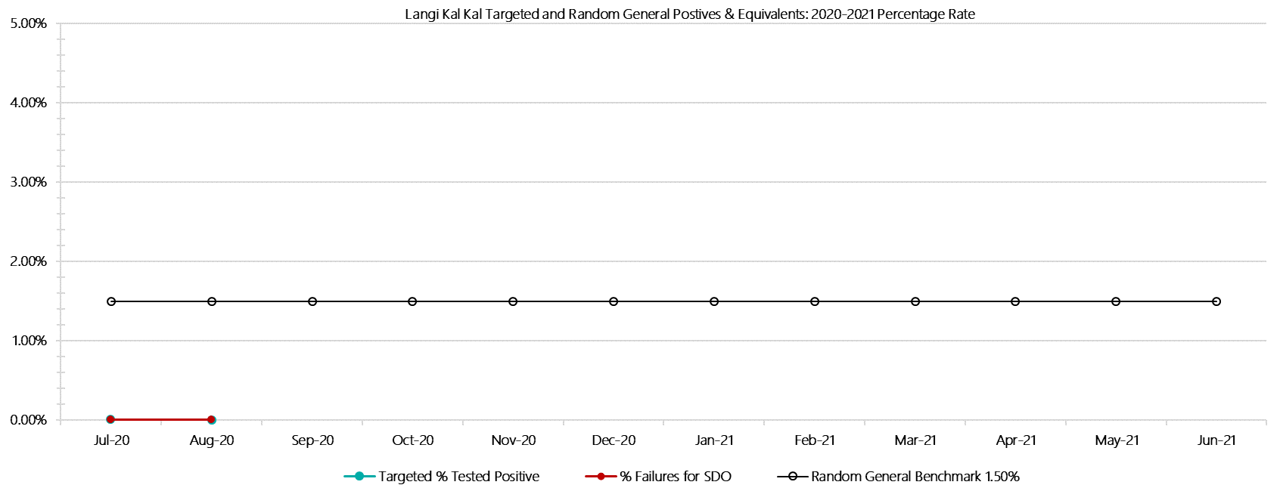

***Langi Kal Kal Positive Test Results by Drug Type: 2020-2021***

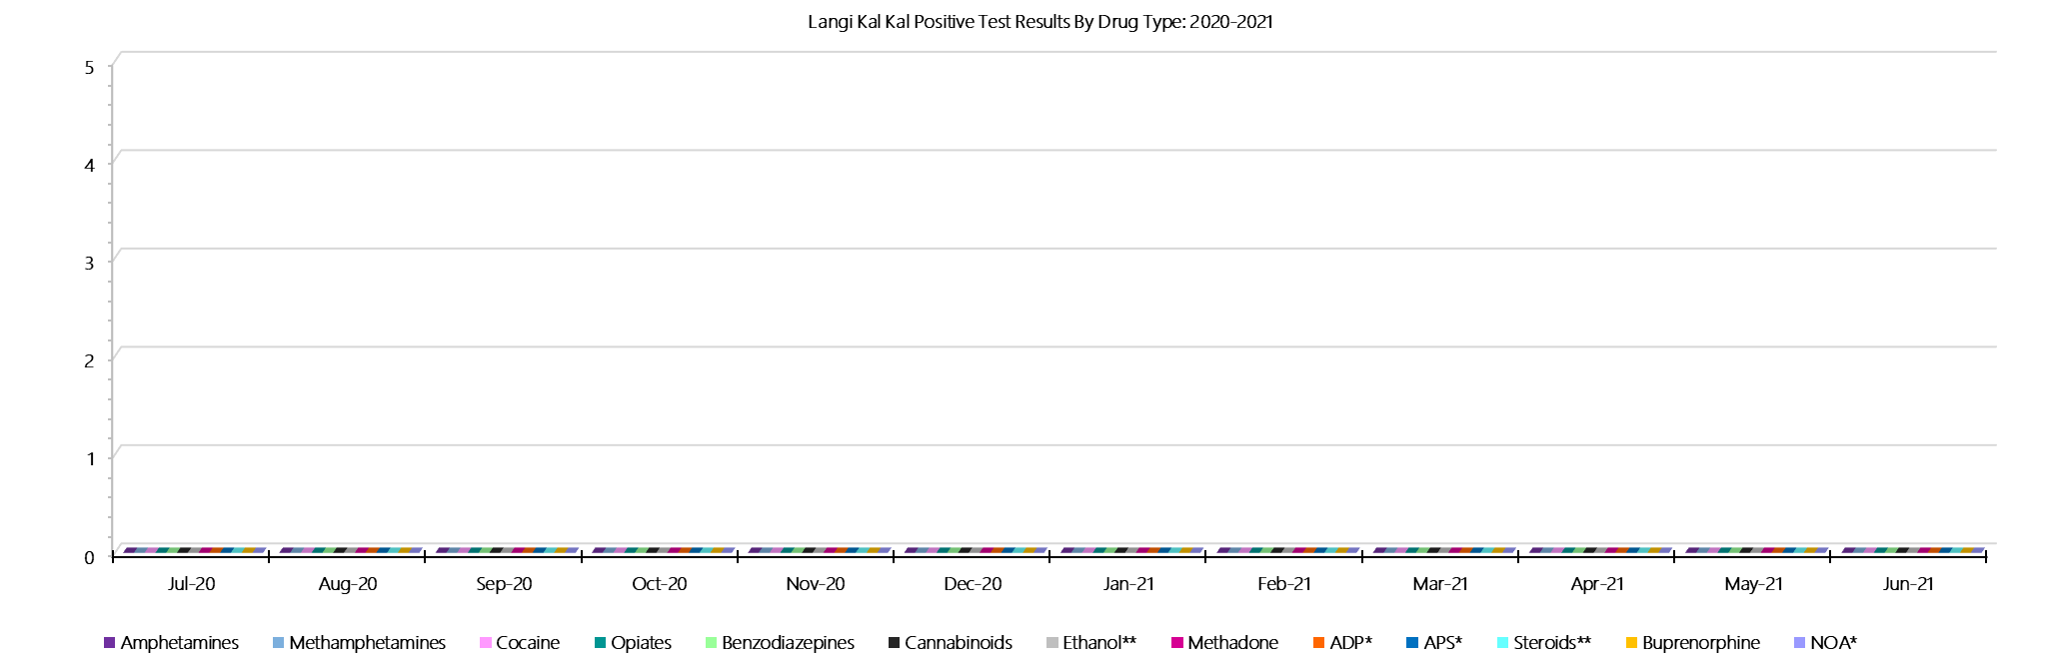

***Langi Kal Kal Count of Visitor Seizures Finds: 2020-2021***

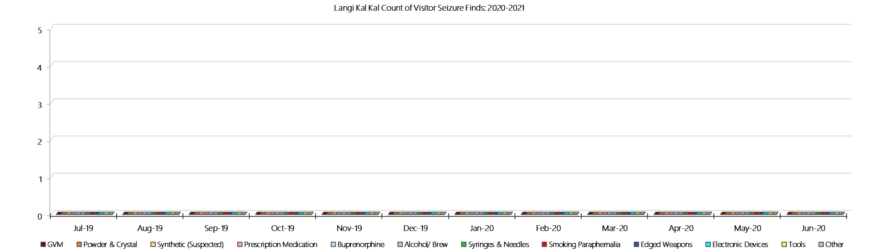

***Langi Kal Kal Count of Prisoner Seizure Finds: 2020-2021***

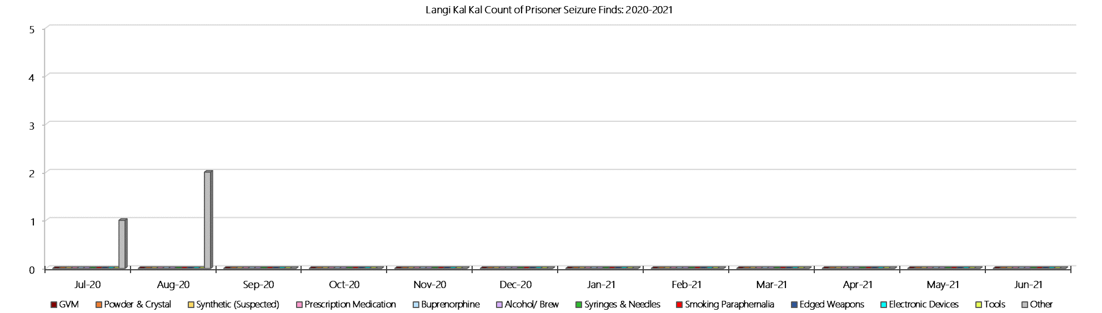

### **Tarrengower Prison**

***Targeted and Random General Drug Test Results: 2020-2021***

|  |  |  |  |  |  |  |  |  |  |  |  |  |  |  |
| --- | --- | --- | --- | --- | --- | --- | --- | --- | --- | --- | --- | --- | --- | --- |
| **Tarrengower** | **Jul-20** | **Aug-20** | **Sep-20** | **Oct-20** | **Nov-20** | **Dec-20** | **Jan-21** | **Feb-21** | **Mar-21** | **Apr-21** | **May-21** | **Jun-21** | **Average** | ***Totals*** |
| **Effective Sample - Targeted** | **1** | **4** |  |  |  |  |  |  |  |  |  |  | **3** | ***5*** |
| **Targeted Positives** | **0** | **0** |  |  |  |  |  |  |  |  |  |  | **0** | ***0*** |
| **Refusal** | **0** | **0** |  |  |  |  |  |  |  |  |  |  | **0** | ***0*** |
| **Unable** | **0** | **0** |  |  |  |  |  |  |  |  |  |  | **0** | ***0*** |
| **Interfered** | **0** | **0** |  |  |  |  |  |  |  |  |  |  | **0** | ***0*** |
| **Adulterated** | **0** | **0** |  |  |  |  |  |  |  |  |  |  | **0** | ***0*** |
| **Targeted % Tested Positive** | **0.00%** | **0.00%** | **#N/A** | **#N/A** | **#N/A** | **#N/A** | **#N/A** | **#N/A** | **#N/A** | **#N/A** | **#N/A** | **#N/A** | **0.00%** | ***0.00%*** |
| **Awaiting / Pending Results** | **0** | **0** |  |  |  |  |  |  |  |  |  |  | **0** | ***0*** |
| **Targeted Residual** | **0** | **0** |  |  |  |  |  |  |  |  |  |  | **0** | ***0*** |
| **Random tests collected** | **7** | **6** |  |  |  |  |  |  |  |  |  |  | **7** | ***13*** |
| **Tested Positive** | **0** | **0** |  |  |  |  |  |  |  |  |  |  | **0** | ***0*** |
| **Refusal (guilty)** | **0** | **0** |  |  |  |  |  |  |  |  |  |  | **0** | ***0*** |
| **Unable (not guilty)** | **0** | **0** |  |  |  |  |  |  |  |  |  |  | **0** | ***0*** |
| **Unable (guilty)** | **0** | **0** |  |  |  |  |  |  |  |  |  |  | **0** | ***0*** |
| **Interfered (guilty)** | **0** | **0** |  |  |  |  |  |  |  |  |  |  | **0** | ***0*** |
| **No test (valid reason)** | **1** | **4** |  |  |  |  |  |  |  |  |  |  | **3** | ***5*** |
| **No test (no valid reason)** | **0** | **0** |  |  |  |  |  |  |  |  |  |  | **0** | ***0*** |
| **Adulterated** | **0** | **0** |  |  |  |  |  |  |  |  |  |  | **0** | ***0*** |
| **Awaiting / Pending Results** | **0** | **0** |  |  |  |  |  |  |  |  |  |  | **0** | ***0*** |
| **Random Residual *(PIMS URAR030)*** | **0** | **0** |  |  |  |  |  |  |  |  |  |  | ***0*** | ***0*** |
| **Effective Sample - Random General** | **7** | **6** |  |  |  |  |  |  |  |  |  |  | **7** | **13** |
| **% Tested positive** | **0.00%** | **0.00%** |  |  |  |  |  |  |  |  |  |  | **0.00%** |  |
| **% Prisoner guilty, positive equivalents** | **0.00%** | **0.00%** |  |  |  |  |  |  |  |  |  |  | **0.00%** |  |
| **% Total prisoner fails** | **0.00%** | **0.00%** |  |  |  |  |  |  |  |  |  |  | **0.00%** |  |
| **% No test without valid reason** | **0.00%** | **0.00%** |  |  |  |  |  |  |  |  |  |  | **0.00%** |  |
| ***Random General Benchmark 1.50%*** | ***1.50%*** | ***1.50%*** | ***1.50%*** | ***1.50%*** | ***1.50%*** | ***1.50%*** | ***1.50%*** | ***1.50%*** | ***1.50%*** | ***1.50%*** | ***1.50%*** | ***1.50%*** | ***YTD*** |  |
| **% Failures for SDO** | **0.00%** | **0.00%** | **#N/A** | **#N/A** | **#N/A** | **#N/A** | **#N/A** | **#N/A** | **#N/A** | **#N/A** | **#N/A** | **#N/A** | **0.00%** |  |

***Tarrengower - Drugs Identified Through Testing by Drug Type: 2020-2021***

|  |  |  |  |  |  |  |  |  |  |  |  |  |  |  |
| --- | --- | --- | --- | --- | --- | --- | --- | --- | --- | --- | --- | --- | --- | --- |
| **Tarrengower** | ***Amphetamines*** | ***Methamphetamines*** | ***Cocaine*** | ***Opiates*** | ***Benzodiazepines*** | ***Cannabinoids*** | ***Ethanol\*\**** | ***Methadone*** | ***ADP\**** | ***APS\**** | ***Steroids\*\**** | ***Buprenorphine*** | ***NOA\**** | **Total** |
| **Jul-20** | **0** | **0** | **0** | **0** | **0** | **0** | **0** | **0** | **0** | **0** | **0** | **0** | **0** | **0** |
| **Aug-20** | **0** | **0** | **0** | **0** | **0** | **0** | **0** | **0** | **0** | **0** | **0** | **0** | **0** | **0** |
| **Sep-20** |  |  |  |  |  |  |  |  |  |  |  |  |  |  |
| **Oct-20** |  |  |  |  |  |  |  |  |  |  |  |  |  |  |
| **Nov-20** |  |  |  |  |  |  |  |  |  |  |  |  |  |  |
| **Dec-20** |  |  |  |  |  |  |  |  |  |  |  |  |  |  |
| **Jan-21** |  |  |  |  |  |  |  |  |  |  |  |  |  |  |
| **Feb-21** |  |  |  |  |  |  |  |  |  |  |  |  |  |  |
| **Mar-21** |  |  |  |  |  |  |  |  |  |  |  |  |  |  |
| **Apr-21** |  |  |  |  |  |  |  |  |  |  |  |  |  |  |
| **May-21** |  |  |  |  |  |  |  |  |  |  |  |  |  |  |
| **Jun-21** |  |  |  |  |  |  |  |  |  |  |  |  |  |  |
| **Tarrengower YTD** | **0** | **0** | **0** | **0** | **0** | **0** | **0** | **0** | **0** | **0** | **0** | **0** | **0** | **0** |
| ***All Prisons YTD*** | ***2*** | ***2*** | ***0*** | ***2*** | ***8*** | ***3*** | ***4*** | ***7*** | ***7*** | ***0*** | ***0*** | ***98*** | ***1*** | ***134*** |
| ***Tarrengower % of Total*** | ***0.00%*** | ***0.00%*** | ***0.00%*** | ***0.00%*** | ***0.00%*** | ***0.00%*** | ***0.00%*** | ***0.00%*** | ***0.00%*** | ***0.00%*** | ***0.00%*** | ***0.00%*** | ***0.00%*** | ***0.00%*** |

***Tarrengower Seizures of Contraband: Visitors & Prisoners: 2020-2021***

|  |  |  |  |  |  |  |  |  |  |  |  |  |  |  |  |  |  |  |  |  |  |  |  |  |
| --- | --- | --- | --- | --- | --- | --- | --- | --- | --- | --- | --- | --- | --- | --- | --- | --- | --- | --- | --- | --- | --- | --- | --- | --- |
| **Visitors** | **GVM** | | **Powder  & Crystal** | | **Synthetic  (Suspected)** | | **Prescription  Medication** | | **Buprenorphine** | | **Alcohol &  Home Brew** | | **Syringes** | | **Smoking  Paraphernalia** | | **Edged  Weapons** | | **Electronic  Devices** | | **Tools** | | **Other** | |
| **T’gower** | **Finds** | **Gms** | **Finds** | **Gms** | **Finds** | **Gms** | **Finds** | **Qty** | **Finds** | **Qty** | **Finds** | **Ltrs** | **Finds** | **Qty** | **Finds** | **Qty** | **Finds** | **Qty** | **Finds** | **Qty** | **Finds** | **Qty** | **Finds** | **Qty** |
| **Jul-20** | **0** | **0.00** | **0** | **0.00** | **0** | **0.00** | **0** | **0.00** | **0** | **0.00** | **0** | **0.000** | **0** | **0** | **0** | **0** | **0** | **0** | **0** | **0** | **0** | **0** | **0** | **0** |
| **Aug-20** | **0** | **0.00** | **0** | **0.00** | **0** | **0.00** | **0** | **0.00** | **0** | **0.00** | **0** | **0.000** | **0** | **0** | **0** | **0** | **0** | **0** | **0** | **0** | **0** | **0** | **0** | **0** |
| **Sep-20** |  |  |  |  |  |  |  |  |  |  |  |  |  |  |  |  |  |  |  |  |  |  |  |  |
| **Oct-20** |  |  |  |  |  |  |  |  |  |  |  |  |  |  |  |  |  |  |  |  |  |  |  |  |
| **Nov-20** |  |  |  |  |  |  |  |  |  |  |  |  |  |  |  |  |  |  |  |  |  |  |  |  |
| **Dec-20** |  |  |  |  |  |  |  |  |  |  |  |  |  |  |  |  |  |  |  |  |  |  |  |  |
| **Jan-21** |  |  |  |  |  |  |  |  |  |  |  |  |  |  |  |  |  |  |  |  |  |  |  |  |
| **Feb-21** |  |  |  |  |  |  |  |  |  |  |  |  |  |  |  |  |  |  |  |  |  |  |  |  |
| **Mar-21** |  |  |  |  |  |  |  |  |  |  |  |  |  |  |  |  |  |  |  |  |  |  |  |  |
| **Apr-21** |  |  |  |  |  |  |  |  |  |  |  |  |  |  |  |  |  |  |  |  |  |  |  |  |
| **May-21** |  |  |  |  |  |  |  |  |  |  |  |  |  |  |  |  |  |  |  |  |  |  |  |  |
| **Jun-21** |  |  |  |  |  |  |  |  |  |  |  |  |  |  |  |  |  |  |  |  |  |  |  |  |
| **Total** | **0** | **0.00** | **0** | **0.00** | **0** | **0.00** | **0** | **0.00** | **0** | **0.00** | **0** | **0.000** | **0** | **0** | **0** | **0** | **0** | **0** | **0** | **0** | **0** | **0** | **0** | **0** |

|  |  |  |  |  |  |  |  |  |  |  |  |  |  |  |  |  |  |  |  |  |  |  |  |  |  |
| --- | --- | --- | --- | --- | --- | --- | --- | --- | --- | --- | --- | --- | --- | --- | --- | --- | --- | --- | --- | --- | --- | --- | --- | --- | --- |
| **Prisoners** | **GVM** | | **Powder  & Crystal** | | **Synthetic  (Suspected)** | | **Prescription  Medication** | | **Buprenorphine** | | **Alcohol &  Home Brew** | | **Syringes** | | **Smoking  Paraphernalia** | | | **Edged  Weapons** | | **Electronic  Devices** | | **Tools** | | **Other** | |
| **T’gower** | **Finds** | **Gms** | **Finds** | **Gms** | **Finds** | **Gms** | **Finds** | **Qty** | **Finds** | **Qty** | **Finds** | **Ltrs** | **Finds** | **Qty** | **Finds** | **Qty** | | **Finds** | **Qty** | **Finds** | **Qty** | **Finds** | **Qty** | **Finds** | **Qty** |
| **Jul-20** | **0** | **0.00** | **0** | **0.00** | **0** | **0.00** | **0** | **0.00** | **0** | **0.00** | **0** | **0.000** | **0** | **0** | **0** | | **0** | **0** | **0** | **0** | **0** | **0** | **0** | **0** | **0** |
| **Aug-20** | **0** | **0.00** | **0** | **0.00** | **0** | **0.00** | **0** | **0.00** | **0** | **0.00** | **0** | **0.000** | **0** | **0** | **0** | | **0** | **0** | **0** | **0** | **0** | **0** | **0** | **0** | **0** |
| **Sep-20** |  |  |  |  |  |  |  |  |  |  |  |  |  |  |  | |  |  |  |  |  |  |  |  |  |
| **Oct-20** |  |  |  |  |  |  |  |  |  |  |  |  |  |  |  | |  |  |  |  |  |  |  |  |  |
| **Nov-20** |  |  |  |  |  |  |  |  |  |  |  |  |  |  |  | |  |  |  |  |  |  |  |  |  |
| **Dec-20** |  |  |  |  |  |  |  |  |  |  |  |  |  |  |  | |  |  |  |  |  |  |  |  |  |
| **Jan-21** |  |  |  |  |  |  |  |  |  |  |  |  |  |  |  | |  |  |  |  |  |  |  |  |  |
| **Feb-21** |  |  |  |  |  |  |  |  |  |  |  |  |  |  |  | |  |  |  |  |  |  |  |  |  |
| **Mar-21** |  |  |  |  |  |  |  |  |  |  |  |  |  |  |  | |  |  |  |  |  |  |  |  |  |
| **Apr-21** |  |  |  |  |  |  |  |  |  |  |  |  |  |  |  | |  |  |  |  |  |  |  |  |  |
| **May-21** |  |  |  |  |  |  |  |  |  |  |  |  |  |  |  | |  |  |  |  |  |  |  |  |  |
| **Jun-21** |  |  |  |  |  |  |  |  |  |  |  |  |  |  |  | |  |  |  |  |  |  |  |  |  |
| **Total** | **0** | **0.00** | **0** | **0.00** | **0** | **0.00** | **0** | **0.00** | **0** | **0.00** | **0** | **0.000** | **0** | **0** | **0** | | **0** | **0** | **0** | **0** | **0** | **0** | **0** | **0** | **0** |

***Tarrengower Targeted and Random General Drug Test Positives & Equivalents: 2020-2021***

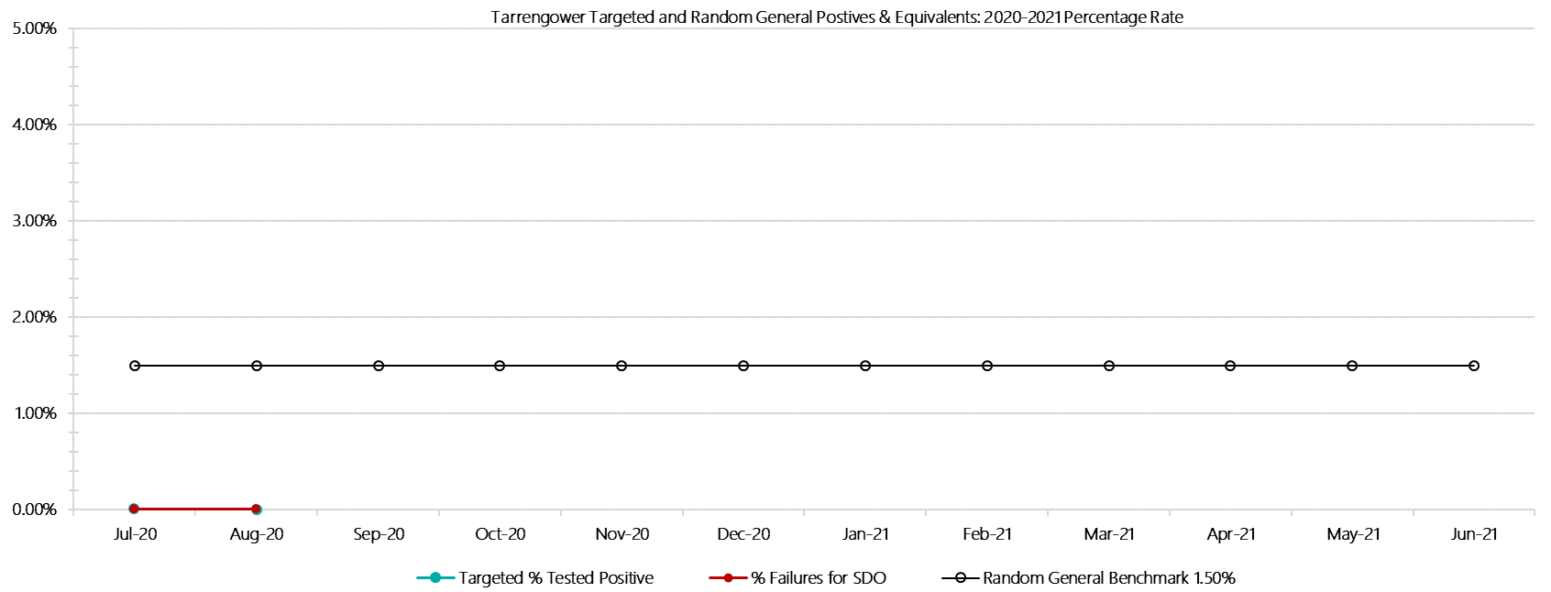

***Tarrengower Positive Test Results by Drug Type: 2020-2021***

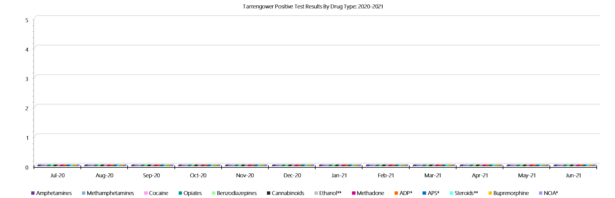

***Tarrengower Count of Visitor Seizures Finds: 2020-2021***

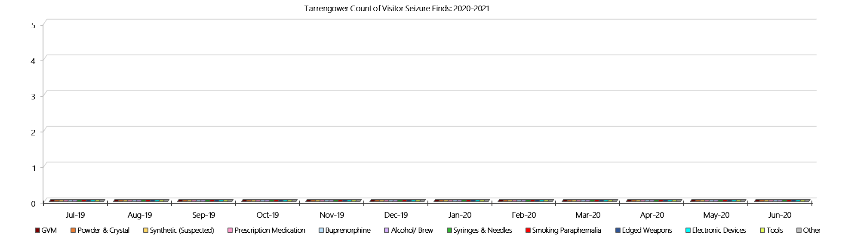

***Tarrengower Count of Prisoner Seizure Finds: 2020-2021***

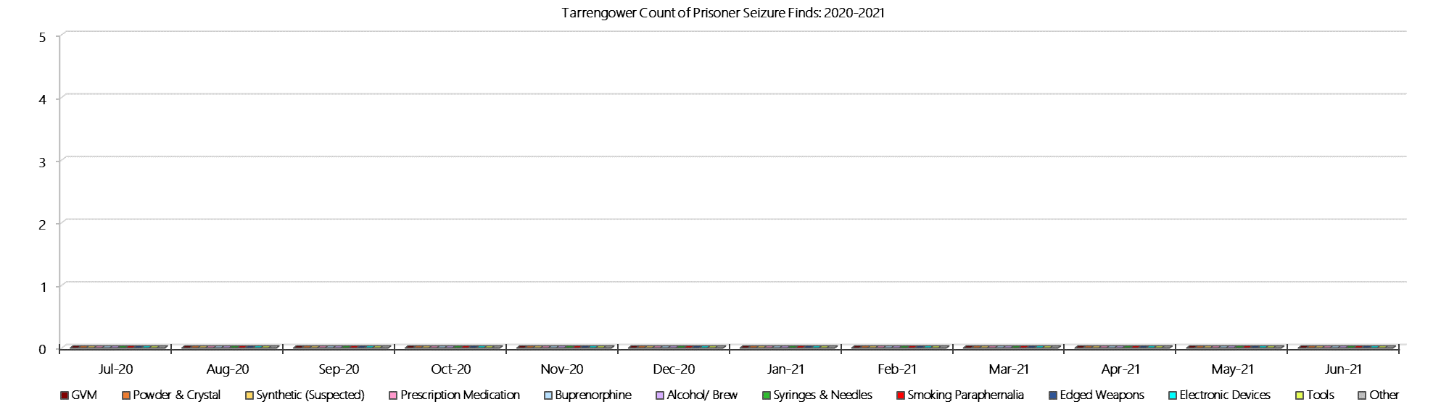

### **Judy Lazarus Transition Centre**

***Targeted and Random General Drug Test Results: 2020-2021***

|  |  |  |  |  |  |  |  |  |  |  |  |  |  |  |
| --- | --- | --- | --- | --- | --- | --- | --- | --- | --- | --- | --- | --- | --- | --- |
| **JLTC** | **Jul-20** | **Aug-20** | **Sep-20** | **Oct-20** | **Nov-20** | **Dec-20** | **Jan-21** | **Feb-21** | **Mar-21** | **Apr-21** | **May-21** | **Jun-21** | **Average** | ***Totals*** |
| **Effective Sample - Targeted** | **0** | **0** |  |  |  |  |  |  |  |  |  |  | **0** | ***0*** |
| **Targeted Positives** | **0** | **0** |  |  |  |  |  |  |  |  |  |  | **0** | ***0*** |
| **Refusal** | **0** | **0** |  |  |  |  |  |  |  |  |  |  | **0** | ***0*** |
| **Unable** | **0** | **0** |  |  |  |  |  |  |  |  |  |  | **0** | ***0*** |
| **Interfered** | **0** | **0** |  |  |  |  |  |  |  |  |  |  | **0** | ***0*** |
| **Adulterated** | **0** | **0** |  |  |  |  |  |  |  |  |  |  | **0** | ***0*** |
| **Targeted % Tested Positive** | **0.00%** | **0.00%** | **#N/A** | **#N/A** | **#N/A** | **#N/A** | **#N/A** | **#N/A** | **#N/A** | **#N/A** | **#N/A** | **#N/A** | **0.00%** | ***0.00%*** |
| **Awaiting / Pending Results** | **0** | **0** |  |  |  |  |  |  |  |  |  |  | **0** | ***0*** |
| **Targeted Residual** | **0** | **0** |  |  |  |  |  |  |  |  |  |  | **0** | ***0*** |
| **Random tests collected** | **4** | **4** |  |  |  |  |  |  |  |  |  |  | **4** | ***8*** |
| **Tested Positive** | **0** | **0** |  |  |  |  |  |  |  |  |  |  | **0** | ***0*** |
| **Refusal (guilty)** | **0** | **0** |  |  |  |  |  |  |  |  |  |  | **0** | ***0*** |
| **Unable (not guilty)** | **0** | **0** |  |  |  |  |  |  |  |  |  |  | **0** | ***0*** |
| **Unable (guilty)** | **0** | **0** |  |  |  |  |  |  |  |  |  |  | **0** | ***0*** |
| **Interfered (guilty)** | **0** | **0** |  |  |  |  |  |  |  |  |  |  | **0** | ***0*** |
| **No test (valid reason)** | **0** | **0** |  |  |  |  |  |  |  |  |  |  | **0** | ***0*** |
| **No test (no valid reason)** | **0** | **0** |  |  |  |  |  |  |  |  |  |  | **0** | ***0*** |
| **Adulterated** | **0** | **0** |  |  |  |  |  |  |  |  |  |  | **0** | ***0*** |
| **Awaiting / Pending Results** | **0** | **1** |  |  |  |  |  |  |  |  |  |  | **1** | ***1*** |
| **Random Residual *(PIMS URAR030)*** | **0** | **0** |  |  |  |  |  |  |  |  |  |  | ***0*** | ***0*** |
| **Effective Sample - Random General** | **4** | **4** |  |  |  |  |  |  |  |  |  |  | **4** | **8** |
| **% Tested positive** | **0.00%** | **0.00%** |  |  |  |  |  |  |  |  |  |  | **0.00%** |  |
| **% Prisoner guilty, positive equivalents** | **0.00%** | **0.00%** |  |  |  |  |  |  |  |  |  |  | **0.00%** |  |
| **% Total prisoner fails** | **0.00%** | **0.00%** |  |  |  |  |  |  |  |  |  |  | **0.00%** |  |
| **% No test without valid reason** | **0.00%** | **0.00%** |  |  |  |  |  |  |  |  |  |  | **0.00%** |  |
| ***Random General Benchmark 3.50%*** | ***3.50%*** | ***3.50%*** | ***3.50%*** | ***3.50%*** | ***3.50%*** | ***3.50%*** | ***3.50%*** | ***3.50%*** | ***3.50%*** | ***3.50%*** | ***3.50%*** | ***3.50%*** | ***YTD*** |  |
| **% Failures for SDO** | **0.00%** | **0.00%** | **#N/A** | **#N/A** | **#N/A** | **#N/A** | **#N/A** | **#N/A** | **#N/A** | **#N/A** | **#N/A** | **#N/A** | **0.00%** |  |

***JLTC - Drugs Identified Through Testing by Drug Type: 2020-2021***

|  |  |  |  |  |  |  |  |  |  |  |  |  |  |  |
| --- | --- | --- | --- | --- | --- | --- | --- | --- | --- | --- | --- | --- | --- | --- |
| **JLTC** | ***Amphetamines*** | ***Methamphetamines*** | ***Cocaine*** | ***Opiates*** | ***Benzodiazepines*** | ***Cannabinoids*** | ***Ethanol\*\**** | ***Methadone*** | ***ADP\**** | ***APS\**** | ***Steroids\*\**** | ***Buprenorphine*** | ***NOA\**** | **Total** |
| **Jul-20** | **0** | **0** | **0** | **0** | **0** | **0** | **0** | **0** | **0** | **0** | **0** | **0** | **0** | **0** |
| **Aug-20** | **0** | **0** | **0** | **0** | **0** | **0** | **0** | **0** | **0** | **0** | **0** | **0** | **0** | **0** |
| **Sep-20** |  |  |  |  |  |  |  |  |  |  |  |  |  |  |
| **Oct-20** |  |  |  |  |  |  |  |  |  |  |  |  |  |  |
| **Nov-20** |  |  |  |  |  |  |  |  |  |  |  |  |  |  |
| **Dec-20** |  |  |  |  |  |  |  |  |  |  |  |  |  |  |
| **Jan-21** |  |  |  |  |  |  |  |  |  |  |  |  |  |  |
| **Feb-21** |  |  |  |  |  |  |  |  |  |  |  |  |  |  |
| **Mar-21** |  |  |  |  |  |  |  |  |  |  |  |  |  |  |
| **Apr-21** |  |  |  |  |  |  |  |  |  |  |  |  |  |  |
| **May-21** |  |  |  |  |  |  |  |  |  |  |  |  |  |  |
| **Jun-21** |  |  |  |  |  |  |  |  |  |  |  |  |  |  |
| **JLTC YTD** | **0** | **0** | **0** | **0** | **0** | **0** | **0** | **0** | **0** | **0** | **0** | **0** | **0** | **0** |
| ***All Prisons YTD*** | ***2*** | ***2*** | ***0*** | ***2*** | ***8*** | ***3*** | ***4*** | ***7*** | ***7*** | ***0*** | ***0*** | ***98*** | ***1*** | ***134*** |
| ***JLTC % of Total*** | ***0.00%*** | ***0.00%*** | ***0.00%*** | ***0.00%*** | ***0.00%*** | ***0.00%*** | ***0.00%*** | ***0.00%*** | ***0.00%*** | ***0.00%*** | ***0.00%*** | ***0.00%*** | ***0.00%*** | ***0.00%*** |

***JLTC Seizures of Contraband: Visitors & Prisoners: 2020-2021***

|  |  |  |  |  |  |  |  |  |  |  |  |  |  |  |  |  |  |  |  |  |  |  |  |  |
| --- | --- | --- | --- | --- | --- | --- | --- | --- | --- | --- | --- | --- | --- | --- | --- | --- | --- | --- | --- | --- | --- | --- | --- | --- |
| **Visitors** | **GVM** | | **Powder  & Crystal** | | **Synthetic  (Suspected)** | | **Prescription  Medication** | | **Buprenorphine** | | **Alcohol &  Home Brew** | | **Syringes** | | **Smoking  Paraphernalia** | | **Edged  Weapons** | | **Electronic  Devices** | | **Tools** | | **Other** | |
| **JLTC** | **Finds** | **Gms** | **Finds** | **Gms** | **Finds** | **Gms** | **Finds** | **Qty** | **Finds** | **Qty** | **Finds** | **Ltrs** | **Finds** | **Qty** | **Finds** | **Qty** | **Finds** | **Qty** | **Finds** | **Qty** | **Finds** | **Qty** | **Finds** | **Qty** |
| **Jul-20** | **0** | **0.00** | **0** | **0.00** | **0** | **0.00** | **0** | **0.00** | **0** | **0.00** | **0** | **0.000** | **0** | **0** | **0** | **0** | **0** | **0** | **0** | **0** | **0** | **0** | **0** | **0** |
| **Aug-20** | **0** | **0.00** | **0** | **0.00** | **0** | **0.00** | **0** | **0.00** | **0** | **0.00** | **0** | **0.000** | **0** | **0** | **0** | **0** | **0** | **0** | **0** | **0** | **0** | **0** | **0** | **0** |
| **Sep-20** |  |  |  |  |  |  |  |  |  |  |  |  |  |  |  |  |  |  |  |  |  |  |  |  |
| **Oct-20** |  |  |  |  |  |  |  |  |  |  |  |  |  |  |  |  |  |  |  |  |  |  |  |  |
| **Nov-20** |  |  |  |  |  |  |  |  |  |  |  |  |  |  |  |  |  |  |  |  |  |  |  |  |
| **Dec-20** |  |  |  |  |  |  |  |  |  |  |  |  |  |  |  |  |  |  |  |  |  |  |  |  |
| **Jan-21** |  |  |  |  |  |  |  |  |  |  |  |  |  |  |  |  |  |  |  |  |  |  |  |  |
| **Feb-21** |  |  |  |  |  |  |  |  |  |  |  |  |  |  |  |  |  |  |  |  |  |  |  |  |
| **Mar-21** |  |  |  |  |  |  |  |  |  |  |  |  |  |  |  |  |  |  |  |  |  |  |  |  |
| **Apr-21** |  |  |  |  |  |  |  |  |  |  |  |  |  |  |  |  |  |  |  |  |  |  |  |  |
| **May-21** |  |  |  |  |  |  |  |  |  |  |  |  |  |  |  |  |  |  |  |  |  |  |  |  |
| **Jun-21** |  |  |  |  |  |  |  |  |  |  |  |  |  |  |  |  |  |  |  |  |  |  |  |  |
| **Total** | **0** | **0.00** | **0** | **0.00** | **0** | **0.00** | **0** | **0.00** | **0** | **0.00** | **0** | **0.000** | **0** | **0** | **0** | **0** | **0** | **0** | **0** | **0** | **0** | **0** | **0** | **0** |

|  |  |  |  |  |  |  |  |  |  |  |  |  |  |  |  |  |  |  |  |  |  |  |  |  |  |  |
| --- | --- | --- | --- | --- | --- | --- | --- | --- | --- | --- | --- | --- | --- | --- | --- | --- | --- | --- | --- | --- | --- | --- | --- | --- | --- | --- |
| **Prisoners** | **GVM** | | **Powder  & Crystal** | | **Synthetic  (Suspected)** | | **Prescription  Medication** | | | **Buprenorphine** | | **Alcohol &  Home Brew** | | **Syringes** | | **Smoking  Paraphernalia** | | | **Edged  Weapons** | | **Electronic  Devices** | | **Tools** | | **Other** | |
| **JLTC** | **Finds** | **Gms** | **Finds** | **Gms** | **Finds** | **Gms** | **Finds** | **Qty** | | **Finds** | **Qty** | **Finds** | **Ltrs** | **Finds** | **Qty** | **Finds** | **Qty** | | **Finds** | **Qty** | **Finds** | **Qty** | **Finds** | **Qty** | **Finds** | **Qty** |
| **Jul-20** | **0** | **0.00** | **0** | **0.00** | **0** | **0.00** | **0** | | **0.00** | **0** | **0.00** | **0** | **0.000** | **0** | **0** | **0** | | **0** | **0** | **0** | **0** | **0** | **0** | **0** | **0** | **0** |
| **Aug-20** | **0** | **0.00** | **0** | **0.00** | **0** | **0.00** | **0** | | **0.00** | **0** | **0.00** | **0** | **0.000** | **0** | **0** | **0** | | **0** | **0** | **0** | **0** | **0** | **0** | **0** | **0** | **0** |
| **Sep-20** |  |  |  |  |  |  |  | |  |  |  |  |  |  |  |  | |  |  |  |  |  |  |  |  |  |
| **Oct-20** |  |  |  |  |  |  |  | |  |  |  |  |  |  |  |  | |  |  |  |  |  |  |  |  |  |
| **Nov-20** |  |  |  |  |  |  |  | |  |  |  |  |  |  |  |  | |  |  |  |  |  |  |  |  |  |
| **Dec-20** |  |  |  |  |  |  |  | |  |  |  |  |  |  |  |  | |  |  |  |  |  |  |  |  |  |
| **Jan-21** |  |  |  |  |  |  |  | |  |  |  |  |  |  |  |  | |  |  |  |  |  |  |  |  |  |
| **Feb-21** |  |  |  |  |  |  |  | |  |  |  |  |  |  |  |  | |  |  |  |  |  |  |  |  |  |
| **Mar-21** |  |  |  |  |  |  |  | |  |  |  |  |  |  |  |  | |  |  |  |  |  |  |  |  |  |
| **Apr-21** |  |  |  |  |  |  |  | |  |  |  |  |  |  |  |  | |  |  |  |  |  |  |  |  |  |
| **May-21** |  |  |  |  |  |  |  | |  |  |  |  |  |  |  |  | |  |  |  |  |  |  |  |  |  |
| **Jun-21** |  |  |  |  |  |  |  | |  |  |  |  |  |  |  |  | |  |  |  |  |  |  |  |  |  |
| **Total** | **0** | **0.00** | **0** | **0.00** | **0** | **0.00** | **0** | | **0.00** | **0** | **0.00** | **0** | **0.000** | **0** | **0** | **0** | | **0** | **0** | **0** | **0** | **0** | **0** | **0** | **0** | **0** |

***JLTC Targeted and Random General Drug Test Positives & Equivalents: 2020-2021***

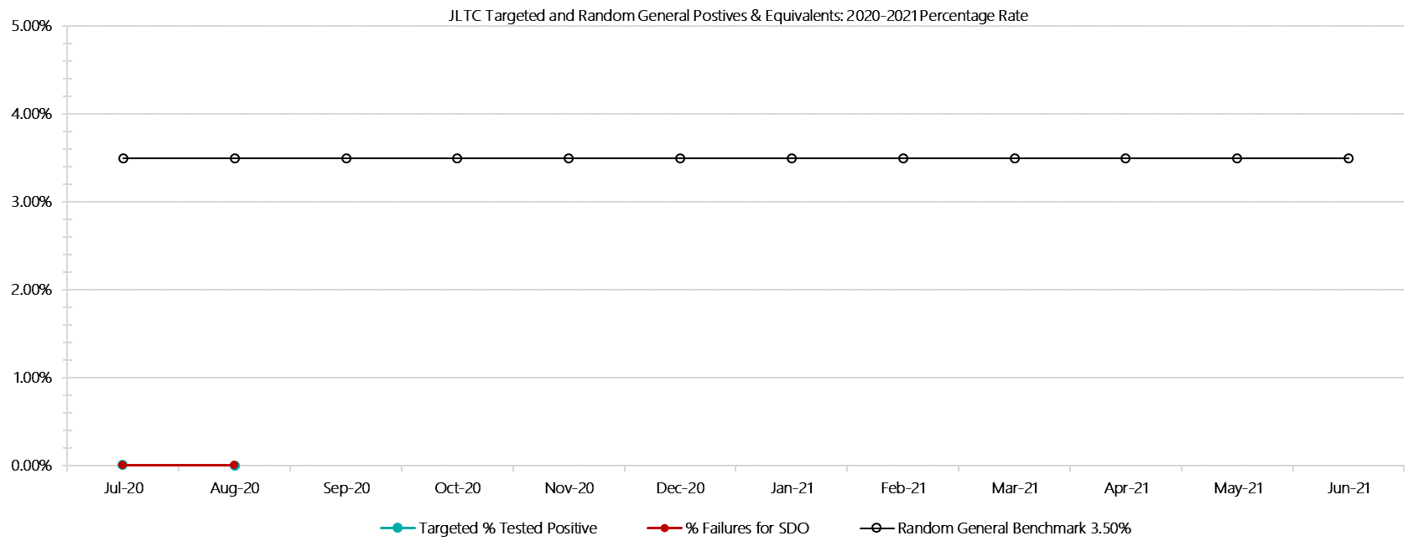

***JLTC Positive Test Results by Drug Type: 2020-2021***

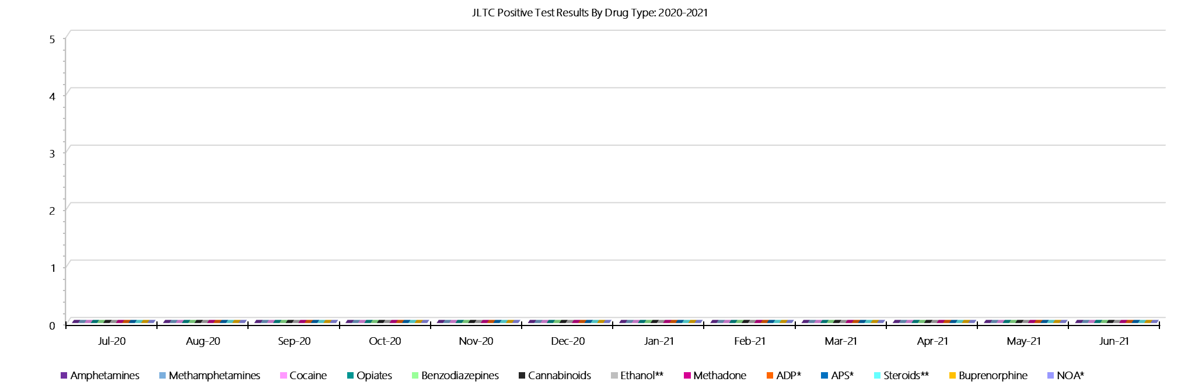

***JLTC Count of Visitor Seizures Finds: 2020-2021***

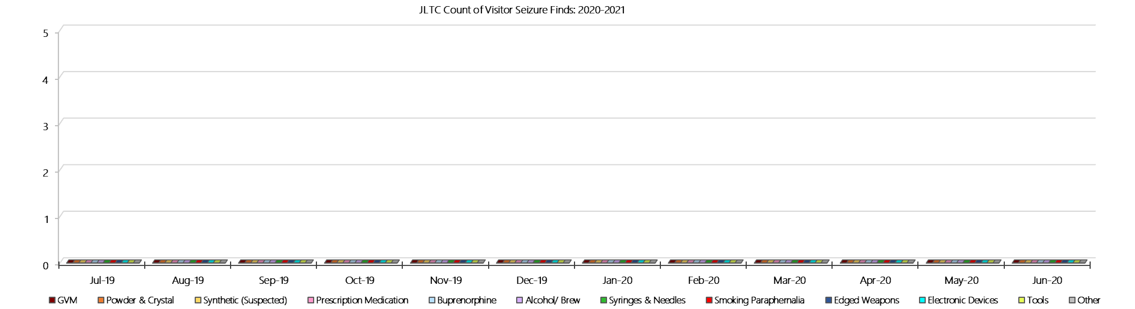

***JLTC Count of Prisoner Seizure Finds: 2020-2021***

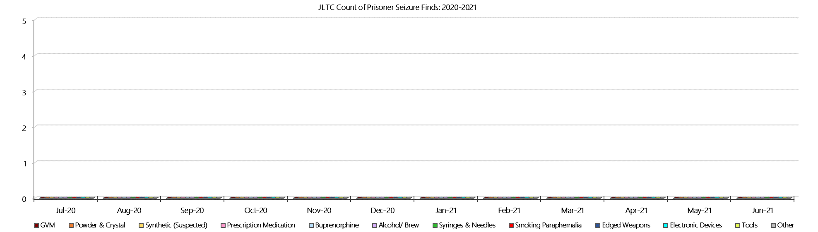

**- PAGE LEFT BLANK INTENTIONALLY -**