**Report on Prohibited Drug Use and   
Contraband Seized in Victorian Prisons**

**2019 - 2020**

**Drugs in Victorian Prisons Report**

**March 2020**



Corrections Victoria

The System Performance Branch produces the Drugs in Victorian Prisons Report (DIVPR) each month to provide data pertaining to drug use – both illicit use and prescription misuse - and contraband seizures in Victorian prisons. The report is provided on a monthly basis, and is made available to selected stakeholders, such as the Assistant Commissioner Security and Intelligence Division, Deputy Commissioner Operations, General Manager Security and Emergency Services Group, General Manager Corrections Victoria Intelligence Unit, and Prison General Managers and Regional Directors. The report is designed to provide information for consideration of action, including the deployment of resources to detect and reduce drugs in Victorian prisons.

The DIVPR specifically compiles and presents data in the following areas:

* + - * drug test results for Random General and Targeted testing,
      * types of drugs identified through drug testing,
      * seizures of contraband from visitors and prisoners

The first section of the DIVPR provides a statewide overview of the above data, with the second section providing location specific data. In a bid to include details of all drug test results from the preceding month, compilation does not commence until after the 15th day of the following month. Information is provided by Prison Intelligence Units (seizures), the Drug Strategy Support Team (drug metabolite breakdowns), as well as the Monitoring, Standards and Reporting Unit (Random General – SDO8 data).

There has been an amendment to the seizure category of “Syringes”, which has been renamed to “Syringes & Needles”, to capture needles modified for drug use.

As part of the commitment to reducing the volume of strip searches in the women's prisons, Corrections Victoria has implemented a 12-month trial of saliva testing, which commenced in March 2019. The trial has replaced the majority of urine testing with an initial saliva test at Dame Phyllis Frost Centre and Tarrengower Prison. Due to the need for confirmatory testing, any prisoner returning a positive result on a saliva swab will be directed to complete a urine test.

As of February 2019, Corrections Victoria amended its data reporting process relating to the types of drugs detected within the prison system to more efficiently report on Methamphetamines. Whilst the number of Methamphetamine positives is accurate, the number of Amphetamine positives may be over represented. This is due to Methamphetamine positives coming from the drug 'ICE' and Amphetamines also being present in the majority of these positives due to the way the drug is manufactured and how it metabolises within the body.

**Table of Contents**

**Drug Test Results: 2019-2020** 6

**Targeted and Random General Drug Test Positives & Equivalents: 2019-2020** 8

**Location Muster against Drug Tests Collected and % Positive** 11

Drugs Identified Through Drug Testing 12

**Positive Drug Test Results by Drug Type per Prison Location: March 2020** 12

**Graph of Positive Drug Test Results: Drug Type by Prison: March 2020** 13

**Year to Date Comparison - Current Financial Year and Previous Financial Years** 14

**Breakdown of Amphetamine & Opiate Drug Groups by Metabolite – 2019-2020** 15

**Positive by Location: YTD 2019-2020** 16

**Percentage Positive by Location: YTD 2019-2020** 17

**Graphs of Seizures of Contraband: Visitors – March 2020 & YTD 2019-2020** 19

**Graphs of Seizures of Contraband: Prisoners – March 2020 & YTD 2019-2020** 21

LOCATION SPECIFIC RESULTS 24

**Barwon Prison** 25

**Melbourne Assessment Prison** 30

**Metropolitan Remand Centre** 35

**Port Phillip Prison** 40

**Dame Phyllis Frost Centre** 45

**Fulham Correctional Centre** 50

**Hopkins Correctional Centre** 55

**Karreenga (annex of Marngoneet)** 60

**Marngoneet Correctional Centre** 65

**Loddon Prison** 70

**Middleton (annex of Loddon)** 75

**Ravenhall Correctional Centre** 80

**Beechworth Correctional Centre** 85

**Dhurringile Prison** 90

**Langi Kal Kal Prison** 95

**Tarrengower Prison** 100

**Judy Lazarus Transition Centre** 105

**Statewide Overview**

### **Drug Test Results: 2019-2020**

***Random General Positive Rate***

As at 28 April 2020, the number of Random General drug test samples collected in March was 1,067, of which 5.25% were positive.   
This is in comparison to the previous month, whereby 869 Random General tests were collected, of which 5.41% were positive.

* The following locations exceeded their Random General benchmark for the month of March 2020:
  + - Barwon Prison,
    - Karreenga,
    - Metropolitan Remand Centre,
    - Loddon Prison,
    - Port Phillip Prison, and
    - Ravenhall Correctional Centre.
* The 2019-2020 Random General positive rate across all locations is 4.89%, with the following locations exceeding their benchmark for the year:
  + - Barwon Prison,
    - Loddon Prison, and
    - Metropolitan Remand Centre.

***Targeted Positive Rate***

The number of Targeted drug tests collected in March was 1,576 of which 11.17% were positive.

This is in comparison to the previous month, whereby 1,680 Targeted drug tests were collected, of which 10.30% were positive.

* The following locations had the highest Targeted positive rates for the month of March 2020:
  + - Barwon Prison,
    - Hopkins Correctional Centre, and
    - Margoneet Correctional Centre.

The 2019-2020 Targeted positive rate for all locations 10.49%, with the following locations having the highest Targeted positive rates for the year:

* + - Barwon Prison,
    - Hopkins Correctional Centre, and
    - Metropolitan Remand Centre.

Targeted testing is used by intelligence officers to identify and intervene in use, and a high positive rate may therefore indicate well directed intelligence.

***Note:*** *The Commissioner defines a Random General positive as positives, refusals, and unables found guilty at a GMDH, as well as interfered and adulterated results. Random General data is provided by the Monitoring, Standards and Reporting Unit, with adjustments reflected in the following reporting month. March data provided 28 Aprill 2020.   
Targeted and Positive Results by Drug Type are retrieved from PIMS by the System Performance Branch. March data provided 28 April 2020.*

 ***Graph of Targeted and Random General Drug Test Positives & Equivalents 2019-2020***

### 

### **Targeted and Random General Drug Test Positives & Equivalents: 2019-2020**

|  |  |  |  |  |  |  |  |  |  |  |  |  |  |  |
| --- | --- | --- | --- | --- | --- | --- | --- | --- | --- | --- | --- | --- | --- | --- |
| Corrections Victoria | Jul-19 | Aug-19 | Sep-19 | Oct-19 | Nov-19 | Dec-19 | Jan-20 | Feb-20 | Mar-20 | Apr-20 | May-20 | Jun-20 | YTD Average | YTD Totals |
| **Targeted - Tests Collected** | **1,858** | **1,780** | **1,714** | **1,915** | **1,798** | **1,774** | **1,827** | **1,676** | **1,571** |  |  |  | **1,768** | **15,913** |
| **Tested Positive** | **127** | **148** | **122** | **159** | **163** | **155** | **169** | **130** | **142** |  |  |  | **146** | **1,315** |
| **Refusal** | **13** | **12** | **20** | **15** | **20** | **29** | **17** | **13** | **15** |  |  |  | **17** | **154** |
| **Unable - Guilty** | **12** | **16** | **10** | **22** | **19** | **39** | **12** | **24** | **17** |  |  |  | **19** | **171** |
| **Interfered** | **1** | **0** | **0** | **0** | **0** | **3** | **1** | **2** | **2** |  |  |  | **1** | **9** |
| **Adulterated** | **2** | **1** | **3** | **4** | **0** | **1** | **6** | **4** | **0** |  |  |  | **2** | **21** |
| **Awaiting / Pending Results** | **0** | **0** | **0** | **0** | **0** | **0** | **0** | **4** | **5** |  |  |  | **1** | **9** |
| **Targeted - Effective Sample** | **1,858** | **1,780** | **1,714** | **1,915** | **1,798** | **1,774** | **1,827** | **1,680** | **1,576** |  |  |  | **1,769** | **15,922** |
| **Targeted % Positives and Equivalents** | **8.34%** | **9.94%** | **9.04%** | **10.44%** | **11.23%** | **12.80%** | **11.22%** | **10.30%** | **11.17%** | **#N/A** | **#N/A** | **#N/A** | **10.49%** | **10.49%** |
| **Random General - Tests Collected** | **1,056** | **857** | **1,054** | **852** | **852** | **1,054** | **870** | **854** | **1,050** |  |  |  | **944** | **8,499** |
| **Tested Positive** | **37** | **33** | **31** | **34** | **36** | **37** | **34** | **32** | **39** |  |  |  | **35** | **313** |
| **Refusal** | **7** | **4** | **5** | **2** | **3** | **2** | **2** | **6** | **7** |  |  |  | **4** | **38** |
| **Unable - Guilty** | **9** | **5** | **9** | **3** | **3** | **8** | **6** | **8** | **8** |  |  |  | **7** | **59** |
| **Interfered** | **0** | **0** | **0** | **0** | **0** | **0** | **0** | **0** | **0** |  |  |  | **0** | **0** |
| **No test - No Valid Reason** | **1** | **1** | **2** | **0** | **0** | **0** | **0** | **1** | **2** |  |  |  | **1** | **7** |
| **Adulterated** | **0** | **1** | **0** | **2** | **0** | **0** | **1** | **0** | **0** |  |  |  | **0** | **4** |
| **Awaiting / Pending Results** | **0** | **0** | **0** | **0** | **0** | **0** | **1** | **0** | **14** |  |  |  | **2** | **15** |
| **Random General - Effective Sample** | **1,073** | **867** | **1,070** | **857** | **858** | **1,064** | **878** | **869** | **1,067** |  |  |  | **956** | **8,603** |
| **SDO8 Positives & Equivalents** | **54** | **44** | **47** | **41** | **42** | **47** | **43** | **47** | **56** | **0** | **0** | **0** | **35** | **421** |
| **% Failures for SDO8 - Monthly** | **5.03%** | **5.07%** | **4.39%** | **4.78%** | **4.90%** | **4.42%** | **4.90%** | **5.41%** | **5.25%** | **#N/A** | **#N/A** | **#N/A** | **3.67%** |  |
| **% Failures for SDO8 - YTD** | **5.03%** | **5.05%** | **4.82%** | **4.81%** | **4.83%** | **4.75%** | **4.77%** | **4.84%** | **4.89%** | **#N/A** | **#N/A** | **#N/A** |  | **4.89%** |
| ***Random Objective 5.00%*** | ***5.00%*** | ***5.00%*** | ***5.00%*** | ***5.00%*** | ***5.00%*** | ***5.00%*** | ***5.00%*** | ***5.00%*** | ***5.00%*** | ***5.00%*** | ***5.00%*** | ***5.00%*** |  |  |

### **Location Muster against Drug Tests Collected and % Positive**

This data compares the number of Targeted and Random General tests collected and the percentage of the prison population tested for the month in comparison  
to the previous month.

It further provides the percentage of positives for both the Targeted and Random General urinalysis testing regimes.

|  |  |  |  |  |  |  |  |  |  |  |  |  |  |  |
| --- | --- | --- | --- | --- | --- | --- | --- | --- | --- | --- | --- | --- | --- | --- |
| **March 2020 - Location Muster Against Tests Collected  Targeted & Random General** | | | | | | | | | | **February 2020 - Location Muster Against Tests Collected  Targeted & Random General** | | | | |
|  |  | **Targeted** | | | | **Random General** | | | |  | **Targeted** | | **Random General** | |
| **Location** | **Average Monthly Muster** | **Targeted Tests Collected** | **% of Population** | **% Positive** | **No. of Tests YTD** | **Random General Tests Collected** | **% of Population** | **% Positive** | **No. of Tests YTD** | **Average Monthly Muster** | **Targeted Tests Collected** | **% Positive** | **Random General Tests Collected** | **% Positive** |
| **Barwon** | **422** | **61** | **14.46%** | **18.03%** | **1,002** | **59** | **13.99%** | **14.29%** | **464** | **407** | **93** | **22.58%** | **45** | **14.29%** |
| **MAP** | **261** | **37** | **14.19%** | **8.11%** | **617** | **29** | **11.12%** | **3.33%** | **229** | **254** | **72** | **12.50%** | **22** | **12.00%** |
| **MRC** | **922** | **151** | **16.38%** | **15.89%** | **1,377** | **129** | **13.99%** | **9.92%** | **1,018** | **916** | **125** | **12.00%** | **105** | **9.43%** |
| **PPP** | **1,050** | **216** | **20.56%** | **12.50%** | **2,535** | **64** | **6.09%** | **12.12%** | **506** | **1,029** | **232** | **7.76%** | **51** | **3.92%** |
| **DPFC** | **456** | **139** | **30.51%** | **9.35%** | **1,105** | **68** | **14.92%** | **1.47%** | **575** | **470** | **127** | **1.57%** | **57** | **0.00%** |
| **Fulham** | **861** | **194** | **22.54%** | **13.40%** | **1,806** | **78** | **9.06%** | **5.13%** | **604** | **861** | **186** | **16.13%** | **62** | **4.84%** |
| **Hopkins** | **759** | **15** | **1.98%** | **20.00%** | **177** | **106** | **13.97%** | **1.85%** | **885** | **750** | **9** | **0.00%** | **92** | **2.15%** |
| **Karreenga** | **262** | **19** | **7.26%** | **0.00%** | **273** | **37** | **14.14%** | **5.13%** | **330** | **265** | **28** | **28.57%** | **31** | **0.00%** |
| **Marngoneet** | **520** | **96** | **18.45%** | **23.96%** | **831** | **76** | **14.61%** | **1.32%** | **614** | **534** | **101** | **13.86%** | **62** | **12.31%** |
| **Loddon** | **403** | **72** | **17.86%** | **8.33%** | **644** | **57** | **14.14%** | **5.17%** | **475** | **385** | **83** | **9.64%** | **47** | **6.38%** |
| **Middleton** | **233** | **45** | **19.31%** | **8.89%** | **426** | **38** | **16.31%** | **0.00%** | **302** | **235** | **48** | **4.17%** | **31** | **0.00%** |
| **Ravenhall** | **1,223** | **304** | **24.85%** | **10.20%** | **3,560** | **177** | **14.47%** | **6.67%** | **1,420** | **1,228** | **384** | **9.64%** | **141** | **6.25%** |
| **Beechworth** | **170** | **36** | **21.13%** | **5.56%** | **341** | **28** | **16.43%** | **0.00%** | **222** | **169** | **56** | **10.71%** | **24** | **0.00%** |
| **Dhurringile** | **213** | **165** | **77.36%** | **1.82%** | **991** | **34** | **15.94%** | **0.00%** | **289** | **208** | **101** | **1.98%** | **28** | **0.00%** |
| **Langi Kal Kal** | **359** | **18** | **5.02%** | **0.00%** | **199** | **55** | **15.33%** | **0.00%** | **449** | **359** | **32** | **0.00%** | **44** | **0.00%** |
| **Tarrengower** | **49** | **8** | **16.24%** | **0.00%** | **26** | **10** | **20.30%** | **0.00%** | **78** | **55** | **1** | **0.00%** | **8** | **0.00%** |
| **JLTC** | **22** | **0** | **0.00%** | **0.00%** | **12** | **5** | **23.07%** | **0.00%** | **39** | **19** | **2** | **50.00%** | **4** | **0.00%** |
|  | **8,185** | **1,576** |  |  |  | **1,050** |  |  |  | **8,144** | **1,680** |  | **854** |  |

## **Drugs Identified Through Drug Testing**

### **Positive Drug Test Results by Drug Type per Prison Location: March 2020**



***ADP*, APS* & NOA* medication only included on standard testing panel for particular private prisons – remaining prisons can request inclusion***

***Ethanol** & Steroids** – tested upon request***

### **Graph of Positive Drug Test Results: Drug Type by Prison: March 2020**

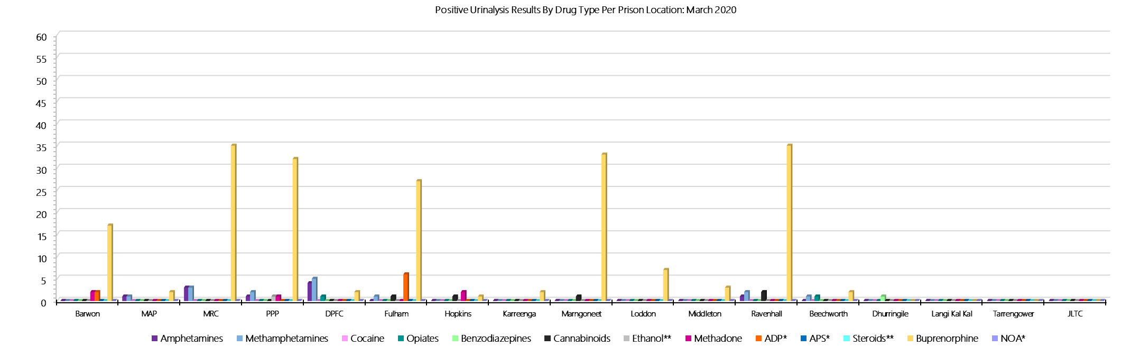

***ADP*, APS* & NOA* medication only included on standard testing panel for particular private prisons – remaining prisons can request inclusion***

***Ethanol** & Steroids** – tested upon request***

***Drugs Identified Through Drug Testing***

### **Year to Date Comparison - Current Financial Year and Previous Financial Years**

### 



***ADP*, APS* & NOA* medication only included on standard testing panel for particular private prisons – remaining prisons can request inclusion***

***Ethanol** & Steroids** – tested upon request***

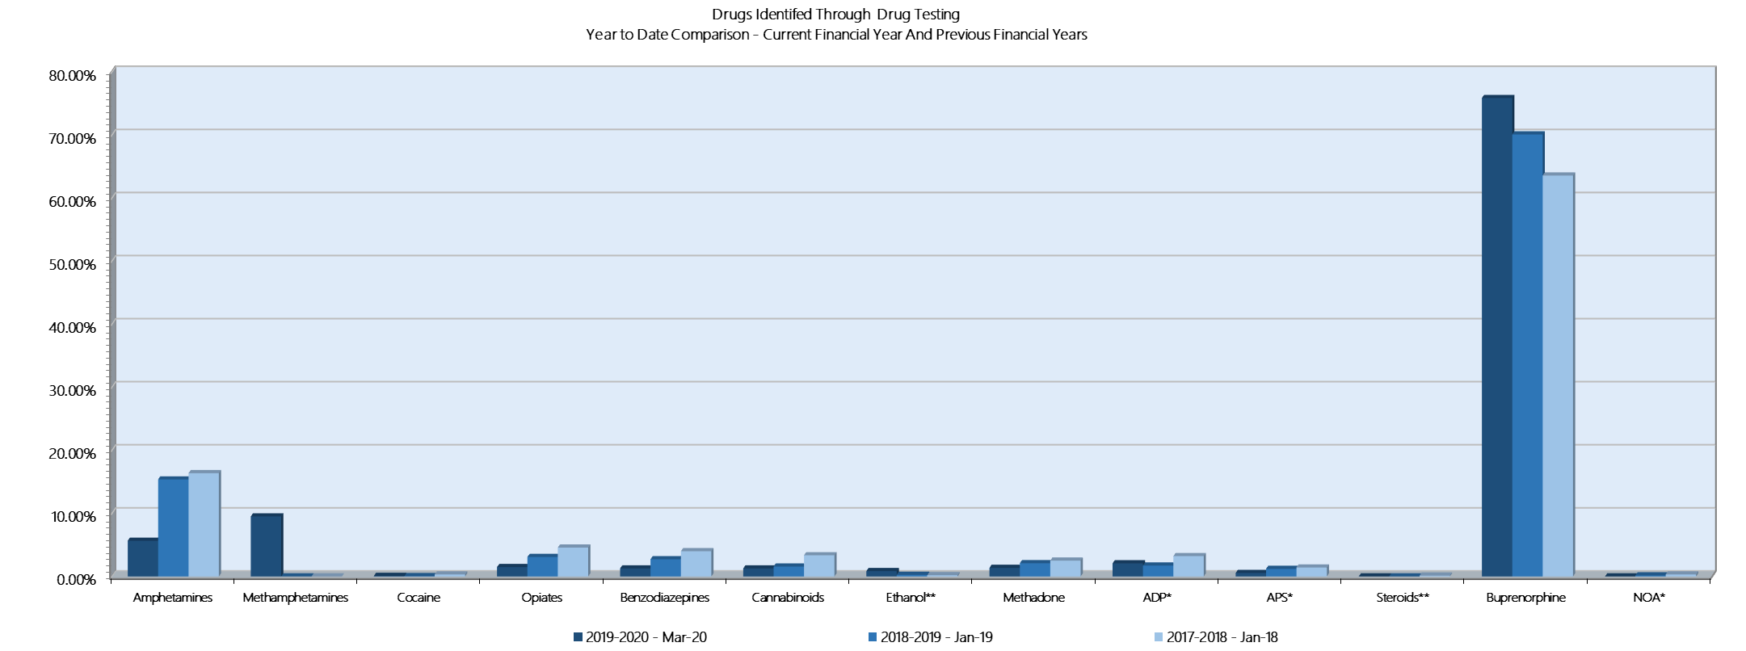

***Drugs Identified Through Testing***

### **Breakdown of Amphetamine & Opiate Drug Groups by Metabolite – 2019-2020**





*March data retrieved 29 April 2020. Results prepared in conjunction with Dorevitch pathology and in accordance with Australian testing methodology.*

***Drugs Identified Through Testing***

### **Positive by Location: YTD 2019-2020**



***Drugs Identified Through Testing:***

### **Percentage Positive by Location: YTD 2019-2020**



***S*eizures of Contraband by Item Type**

### **Visitors – March 2020**

|  |  |  |  |  |  |  |  |  |  |  |  |  |  |  |  |  |  |  |  |  |  |  |  |  |
| --- | --- | --- | --- | --- | --- | --- | --- | --- | --- | --- | --- | --- | --- | --- | --- | --- | --- | --- | --- | --- | --- | --- | --- | --- |
| **Visitors** | **GVM** | | **Powder & Crystal** | | **Synthetic (Suspected)** | | **Prescription Medication** | | **Buprenorphine** | | **Alcohol & Home Brew** | | **Syringes & Needles** | | **Smoking Paraphernalia** | | **Edged Weapons** | | **Electronic Devices** | | **Tools** | | **Other** | |
| **March 2020** | **Finds** | **Gms** | **Finds** | **Gms** | **Finds** | **Gms** | **Finds** | **Qty** | **Finds** | **Qty** | **Finds** | **Ltrs** | **Finds** | **Qty** | **Finds** | **Qty** | **Finds** | **Qty** | **Finds** | **Qty** | **Finds** | **Qty** | **Finds** | **Qty** |
| **Barwon** | **0** | **0.00** | **0** | **0.00** | **0** | **0.00** | **0** | **0.00** | **0** | **0.00** | **0** | **0.000** | **0** | **0** | **0** | **0** | **0** | **0** | **0** | **0** | **0** | **0** | **0** | **0** |
| **MAP** | **0** | **0.00** | **0** | **0.00** | **0** | **0.00** | **0** | **0.00** | **0** | **0.00** | **0** | **0.000** | **0** | **0** | **0** | **0** | **0** | **0** | **0** | **0** | **0** | **0** | **0** | **0** |
| **MRC** | **2** | **4.10** | **3** | **0.95** | **1** | **1.00** | **1** | **7.00** | **0** | **0.00** | **0** | **0.000** | **1** | **1** | **1** | **3** | **2** | **2** | **0** | **0** | **1** | **3** | **0** | **0** |
| **PPP** | **5** | **14.97** | **4** | **5.10** | **0** | **0.00** | **0** | **0.00** | **0** | **0.00** | **0** | **0.000** | **2** | **12** | **4** | **7** | **0** | **0** | **0** | **0** | **0** | **0** | **1** | **5** |
| **DPFC** | **0** | **0.00** | **1** | **1.30** | **0** | **0.00** | **1** | **7.00** | **0** | **0.00** | **0** | **0.000** | **0** | **0** | **1** | **1** | **0** | **0** | **0** | **0** | **0** | **0** | **0** | **0** |
| **Fulham** | **0** | **0.00** | **0** | **0.00** | **0** | **0.00** | **1** | **6.00** | **0** | **0.00** | **0** | **0.000** | **0** | **0** | **1** | **1** | **0** | **0** | **0** | **0** | **0** | **0** | **1** | **12** |
| **Hopkins** | **0** | **0.00** | **0** | **0.00** | **0** | **0.00** | **0** | **0.00** | **0** | **0.00** | **0** | **0.000** | **0** | **0** | **0** | **0** | **0** | **0** | **0** | **0** | **0** | **0** | **0** | **0** |
| **Karreenga** | **0** | **0.00** | **0** | **0.00** | **0** | **0.00** | **0** | **0.00** | **0** | **0.00** | **0** | **0.000** | **0** | **0** | **0** | **0** | **0** | **0** | **0** | **0** | **0** | **0** | **0** | **0** |
| **Marngoneet** | **0** | **0.00** | **0** | **0.00** | **0** | **0.00** | **0** | **0.00** | **0** | **0.00** | **0** | **0.000** | **0** | **0** | **0** | **0** | **0** | **0** | **0** | **0** | **0** | **0** | **0** | **0** |
| **Loddon** | **0** | **0.00** | **0** | **0.00** | **0** | **0.00** | **0** | **0.00** | **0** | **0.00** | **0** | **0.000** | **0** | **0** | **1** | **1** | **0** | **0** | **0** | **0** | **0** | **0** | **0** | **0** |
| **Middleton** | **0** | **0.00** | **0** | **0.00** | **0** | **0.00** | **0** | **0.00** | **0** | **0.00** | **0** | **0.000** | **0** | **0** | **0** | **0** | **0** | **0** | **0** | **0** | **0** | **0** | **0** | **0** |
| **Ravenhall** | **0** | **0.00** | **0** | **0.00** | **0** | **0.00** | **0** | **0.00** | **0** | **0.00** | **0** | **0.000** | **0** | **0** | **4** | **9** | **0** | **0** | **0** | **0** | **0** | **0** | **0** | **0** |
| **Beechworth** | **0** | **0.00** | **0** | **0.00** | **0** | **0.00** | **0** | **0.00** | **0** | **0.00** | **0** | **0.000** | **0** | **0** | **0** | **0** | **0** | **0** | **0** | **0** | **0** | **0** | **0** | **0** |
| **Dhurringile** | **0** | **0.00** | **0** | **0.00** | **0** | **0.00** | **0** | **0.00** | **0** | **0.00** | **0** | **0.000** | **0** | **0** | **0** | **0** | **0** | **0** | **0** | **0** | **0** | **0** | **0** | **0** |
| **Langi Kal Kal** | **0** | **0.00** | **0** | **0.00** | **0** | **0.00** | **0** | **0.00** | **0** | **0.00** | **0** | **0.000** | **0** | **0** | **0** | **0** | **0** | **0** | **0** | **0** | **0** | **0** | **0** | **0** |
| **Tarrengower** | **0** | **0.00** | **0** | **0.00** | **0** | **0.00** | **0** | **0.00** | **0** | **0.00** | **0** | **0.000** | **0** | **0** | **0** | **0** | **0** | **0** | **0** | **0** | **0** | **0** | **0** | **0** |
| **JLTC** | **0** | **0.00** | **0** | **0.00** | **0** | **0.00** | **0** | **0.00** | **0** | **0.00** | **0** | **0.000** | **0** | **0** | **0** | **0** | **0** | **0** | **0** | **0** | **0** | **0** | **0** | **0** |
| ***Current Month*** | **7** | **19.07** | **8** | **7.35** | **1** | **1.00** | **3** | **20.00** | **0** | **0.00** | **0** | **0.000** | **3** | **13** | **12** | **22** | **2** | **2** | **0** | **0** | **1** | **3** | **2** | **17** |
| ***Previous Month*** | ***6*** | ***49.89*** | ***13*** | ***48.98*** | ***1*** | ***57.17*** | ***5*** | ***25.50*** | ***6*** | ***144.61*** | ***0*** | ***0.000*** | ***6*** | ***16*** | ***8*** | ***20*** | ***1*** | ***1*** | ***2*** | ***4*** | ***1*** | ***1*** | ***5*** | ***9*** |

***Seizures of Contraband: Visitors - YTD 2019-2020***

|  |  |  |  |  |  |  |  |  |  |  |  |  |  |  |  |  |  |  |  |  |  |  |  |  |
| --- | --- | --- | --- | --- | --- | --- | --- | --- | --- | --- | --- | --- | --- | --- | --- | --- | --- | --- | --- | --- | --- | --- | --- | --- |
| **Visitors** | **GVM** | | **Powder & Crystal** | | **Synthetic (Suspected)** | | **Prescription Medication** | | **Buprenorphine** | | **Alcohol & Home Brew** | | **Syringes & Needles** | | **Smoking Paraphernalia** | | **Edged Weapons** | | **Electronic Devices** | | **Tools** | | **Other** | |
| **2019-2020** | **Finds** | **Gms** | **Finds** | **Gms** | **Finds** | **Gms** | **Finds** | **Qty** | **Finds** | **Qty** | **Finds** | **Ltrs** | **Finds** | **Qty** | **Finds** | **Qty** | **Finds** | **Qty** | **Finds** | **Qty** | **Finds** | **Qty** | **Finds** | **Qty** |
| **Barwon** | **2** | **17.40** | **2** | **3.10** | **0** | **0.00** | **2** | **5.00** | **2** | **69.00** | **0** | **0.000** | **2** | **4** | **2** | **3** | **0** | **0** | **0** | **0** | **0** | **0** | **0** | **0** |
| **MAP** | **0** | **0.00** | **0** | **0.00** | **0** | **0.00** | **0** | **0.00** | **0** | **0.00** | **0** | **0.000** | **0** | **0** | **0** | **0** | **0** | **0** | **0** | **0** | **0** | **0** | **0** | **0** |
| **MRC** | **11** | **24.53** | **22** | **63.37** | **2** | **58.17** | **8** | **50.00** | **4** | **5.71** | **1** | **0.660** | **6** | **21** | **19** | **34** | **10** | **23** | **2** | **4** | **10** | **17** | **15** | **30** |
| **PPP** | **8** | **51.13** | **14** | **51.95** | **0** | **0.00** | **1** | **2.00** | **7** | **330.00** | **0** | **0.000** | **10** | **35** | **10** | **25** | **2** | **2** | **0** | **0** | **0** | **0** | **2** | **6** |
| **DPFC** | **0** | **0.00** | **1** | **1.30** | **0** | **0.00** | **3** | **15.00** | **0** | **0.00** | **0** | **0.000** | **0** | **0** | **1** | **1** | **0** | **0** | **1** | **1** | **0** | **0** | **0** | **0** |
| **Fulham** | **0** | **0.00** | **0** | **0.00** | **0** | **0.00** | **1** | **6.00** | **0** | **0.00** | **0** | **0.000** | **2** | **3** | **11** | **20** | **0** | **0** | **0** | **0** | **0** | **0** | **5** | **24** |
| **Hopkins** | **1** | **1.12** | **2** | **1.89** | **0** | **0.00** | **0** | **0.00** | **0** | **0.00** | **0** | **0.000** | **0** | **0** | **3** | **3** | **0** | **0** | **1** | **1** | **0** | **0** | **0** | **0** |
| **Karreenga** | **0** | **0.00** | **1** | **1.20** | **0** | **0.00** | **0** | **0.00** | **0** | **0.00** | **0** | **0.000** | **0** | **0** | **1** | **1** | **0** | **0** | **0** | **0** | **0** | **0** | **0** | **0** |
| **Marngoneet** | **0** | **0.00** | **0** | **0.00** | **0** | **0.00** | **0** | **0.00** | **0** | **0.00** | **0** | **0.000** | **0** | **0** | **3** | **6** | **1** | **1** | **0** | **0** | **0** | **0** | **2** | **4** |
| **Loddon** | **1** | **1.00** | **1** | **1.30** | **0** | **0.00** | **0** | **0.00** | **4** | **165.50** | **0** | **0.000** | **1** | **1** | **6** | **46** | **0** | **0** | **0** | **0** | **0** | **0** | **0** | **0** |
| **Middleton** | **0** | **0.00** | **1** | **5.00** | **0** | **0.00** | **0** | **0.00** | **0** | **0.00** | **0** | **0.000** | **0** | **0** | **0** | **0** | **1** | **1** | **0** | **0** | **0** | **0** | **1** | **1** |
| **Ravenhall** | **19** | **131.98** | **27** | **51.24** | **0** | **0.00** | **12** | **80.50** | **4** | **22.00** | **0** | **0.000** | **7** | **14** | **32** | **96** | **5** | **5** | **1** | **1** | **3** | **17** | **4** | **36** |
| **Beechworth** | **0** | **0.00** | **0** | **0.00** | **0** | **0.00** | **0** | **0.00** | **0** | **0.00** | **0** | **0.000** | **0** | **0** | **0** | **0** | **0** | **0** | **0** | **0** | **0** | **0** | **0** | **0** |
| **Dhurringile** | **0** | **0.00** | **1** | **3.00** | **0** | **0.00** | **0** | **0.00** | **1** | **2.50** | **2** | **3.375** | **0** | **0** | **2** | **2** | **0** | **0** | **0** | **0** | **0** | **0** | **2** | **4** |
| **Langi Kal Kal** | **0** | **0.00** | **0** | **0.00** | **0** | **0.00** | **0** | **0.00** | **0** | **0.00** | **0** | **0.000** | **0** | **0** | **0** | **0** | **0** | **0** | **0** | **0** | **0** | **0** | **0** | **0** |
| **Tarrengower** | **0** | **0.00** | **0** | **0.00** | **0** | **0.00** | **0** | **0.00** | **0** | **0.00** | **0** | **0.000** | **0** | **0** | **0** | **0** | **0** | **0** | **0** | **0** | **0** | **0** | **1** | **1** |
| **JLTC** | **0** | **0.00** | **0** | **0.00** | **0** | **0.00** | **0** | **0.00** | **0** | **0.00** | **0** | **0.000** | **0** | **0** | **0** | **0** | **0** | **0** | **0** | **0** | **0** | **0** | **0** | **0** |
| **YTD: March 20** | **42** | **227.16** | **72** | **183.35** | **2** | **58.17** | **27** | **158.50** | **22** | **594.71** | **3** | **4.035** | **28** | **78** | **90** | **237** | **19** | **32** | **5** | **7** | **13** | **34** | **32** | **106** |

### **Graphs of Seizures of Contraband: Visitors – March 2020 & YTD 2019-2020**

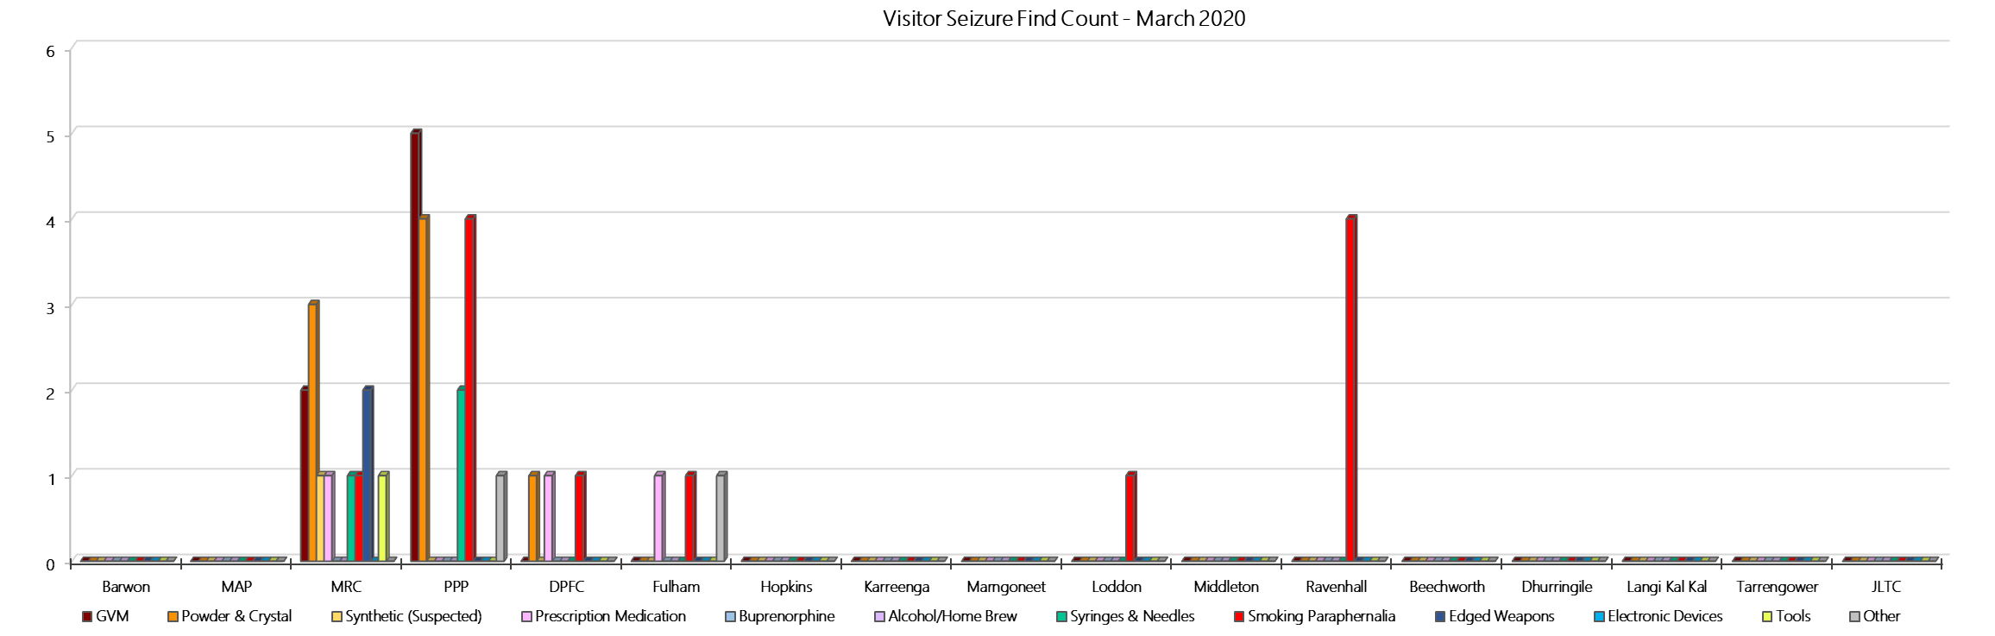

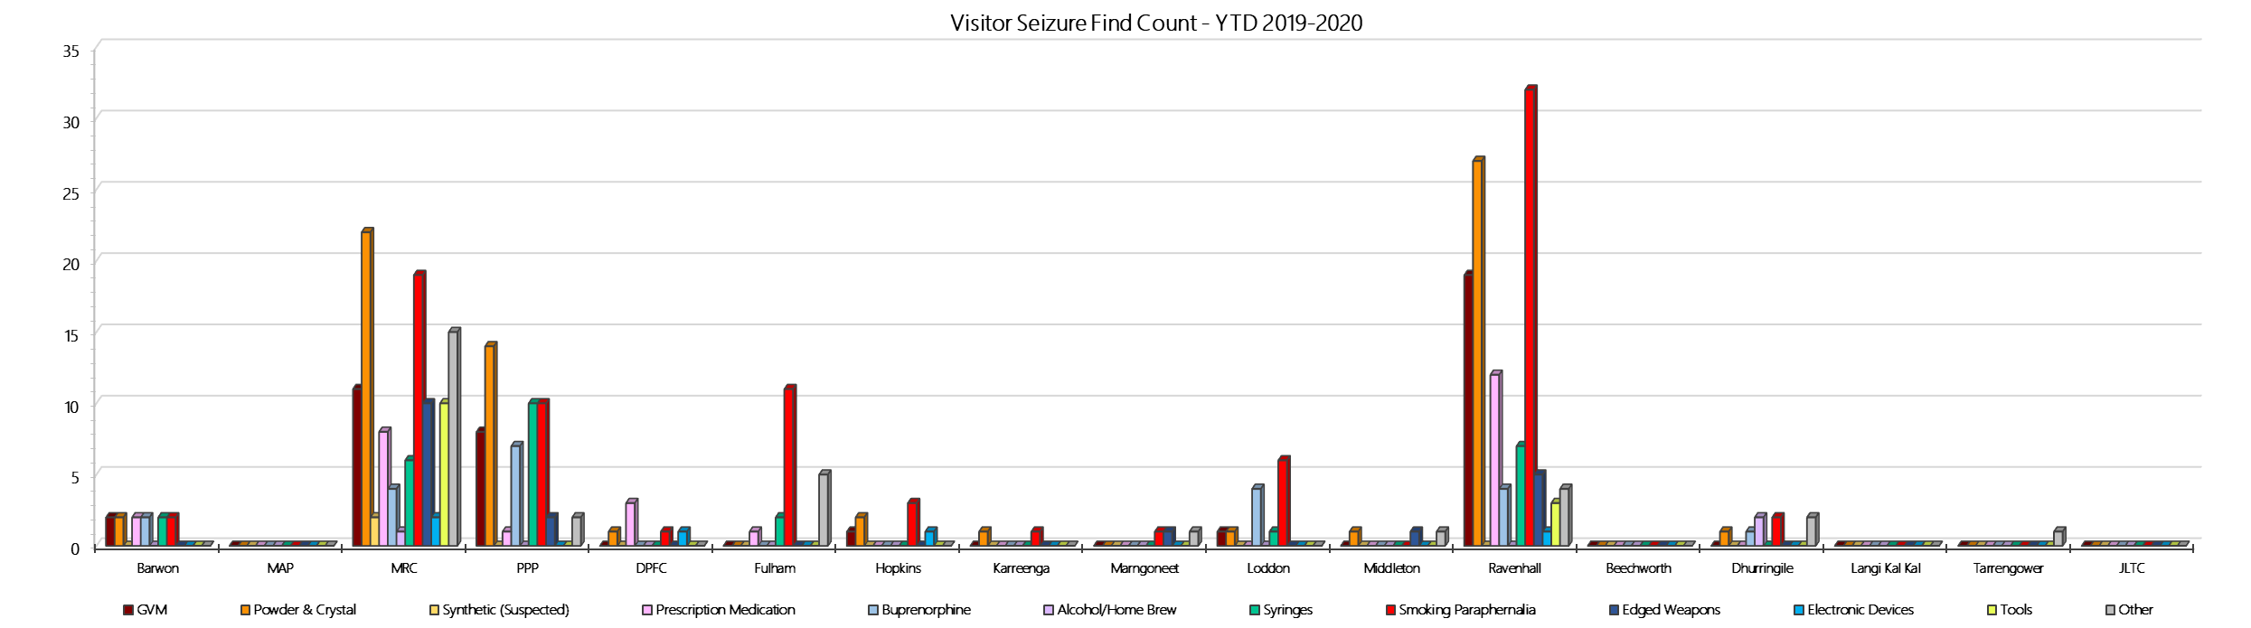

***Seizures of Contraband: Prisoners – March 2020***

|  |  |  |  |  |  |  |  |  |  |  |  |  |  |  |  |  |  |  |  |  |  |  |  |  |
| --- | --- | --- | --- | --- | --- | --- | --- | --- | --- | --- | --- | --- | --- | --- | --- | --- | --- | --- | --- | --- | --- | --- | --- | --- |
| **Prisoners** | **GVM** | | **Powder & Crystal** | | **Synthetic (Suspected)** | | **Prescription Medication** | | **Buprenorphine** | | **Alcohol & Home Brew** | | **Syringes & Needles** | | **Smoking Paraphernalia** | | **Edged Weapons** | | **Electronic Devices** | | **Tools** | | **Other** | |
| **March 20** | **Finds** | **Gms** | **Finds** | **Gms** | **Finds** | **Gms** | **Finds** | **Qty** | **Finds** | **Qty** | **Finds** | **Ltrs** | **Finds** | **Qty** | **Finds** | **Qty** | **Finds** | **Qty** | **Finds** | **Qty** | **Finds** | **Qty** | **Finds** | **Qty** |
| **Barwon** | **0** | **0.00** | **2** | **0.50** | **0** | **0.00** | **7** | **33.10** | **8** | **19.00** | **3** | **28.250** | **1** | **2** | **4** | **9** | **7** | **13** | **3** | **5** | **4** | **11** | **8** | **15** |
| **MAP** | **0** | **0.00** | **2** | **0.30** | **0** | **0.00** | **4** | **11.00** | **5** | **0.00** | **0** | **0.000** | **2** | **2** | **2** | **2** | **1** | **1** | **0** | **0** | **4** | **4** | **1** | **1** |
| **MRC** | **0** | **0.00** | **1** | **1.00** | **0** | **0.00** | **6** | **15.00** | **14** | **25.50** | **2** | **3.000** | **4** | **4** | **1** | **5** | **2** | **2** | **0** | **0** | **6** | **14** | **7** | **11** |
| **PPP** | **0** | **0.00** | **0** | **0.00** | **0** | **0.00** | **7** | **21.50** | **11** | **50.60** | **9** | **35.000** | **3** | **5** | **5** | **6** | **13** | **13** | **0** | **0** | **0** | **0** | **8** | **8** |
| **DPFC** | **0** | **0** | **0** | **0** | **0** | **0** | **1** | **0.5** | **3** | **22** | **0** | **0** | **2** | **6** | **4** | **5** | **2** | **2** | **0** | **0** | **0** | **0** | **1** | **1** |
| **Fulham** | **0** | **0** | **0** | **0** | **0** | **0** | **5** | **16.5** | **9** | **83.6** | **3** | **3** | **7** | **16** | **43** | **78** | **4** | **4** | **3** | **5** | **16** | **31** | **9** | **22** |
| **Hopkins** | **0** | **0.00** | **0** | **0.00** | **0** | **0.00** | **2** | **1.50** | **3** | **68.10** | **0** | **0.000** | **1** | **1** | **5** | **19** | **0** | **0** | **0** | **0** | **0** | **0** | **2** | **12** |
| **Karreenga** | **0** | **0.00** | **1** | **2.43** | **0** | **0.00** | **2** | **6.00** | **0** | **0.00** | **0** | **0.000** | **0** | **0** | **0** | **0** | **0** | **0** | **0** | **0** | **0** | **0** | **0** | **0** |
| **Marngoneet** | **0** | **0.00** | **0** | **0.00** | **0** | **0.00** | **7** | **12.50** | **2** | **0.55** | **2** | **2.500** | **0** | **0** | **3** | **3** | **3** | **4** | **1** | **1** | **1** | **1** | **4** | **10** |
| **Loddon** | **0** | **0.00** | **0** | **0.00** | **0** | **0.00** | **0** | **0.00** | **5** | **1.00** | **0** | **0.000** | **0** | **0** | **8** | **17** | **3** | **3** | **1** | **1** | **3** | **5** | **4** | **6** |
| **Middleton** | **0** | **0.00** | **0** | **0.00** | **0** | **0.00** | **0** | **0.00** | **0** | **0.00** | **0** | **0.000** | **0** | **0** | **0** | **0** | **0** | **0** | **0** | **0** | **1** | **1** | **0** | **0** |
| **Ravenhall** | **0** | **0.00** | **0** | **0.00** | **0** | **0.00** | **1** | **1.50** | **11** | **33.00** | **1** | **1.000** | **3** | **3** | **2** | **2** | **8** | **13** | **1** | **2** | **2** | **2** | **1** | **1** |
| **Beechworth** | **0** | **0.00** | **0** | **0.00** | **0** | **0.00** | **1** | **4.00** | **0** | **0.00** | **1** | **0.100** | **0** | **0** | **3** | **4** | **0** | **0** | **0** | **0** | **2** | **2** | **1** | **1** |
| **Dhurringile** | **2** | **52.10** | **1** | **0.50** | **0** | **0.00** | **0** | **0.00** | **0** | **0.00** | **1** | **0.100** | **1** | **3** | **5** | **30** | **0** | **0** | **0** | **0** | **3** | **5** | **0** | **0** |
| **Langi Kal Kal** | **0** | **0.00** | **0.00** | **0.00** | **0.00** | **0.00** | **0.00** | **0.00** | **0.00** | **0.00** | **0.00** | **0.00** | **0.00** | **0.00** | **0.00** | **0.00** | **0.00** | **0.00** | **0.00** | **0.00** | **0.00** | **0.00** | **0.00** | **0.00** |
| **Tarrengower** | **0** | **0.00** | **0.00** | **0.00** | **0.00** | **0.00** | **0.00** | **0.00** | **0.00** | **0.00** | **0.00** | **0.00** | **0.00** | **0.00** | **0.00** | **0.00** | **0.00** | **0.00** | **0.00** | **0.00** | **0.00** | **0.00** | **0.00** | **0.00** |
| **JLTC** | **0** | **0.00** | **0** | **0.00** | **0** | **0.00** | **0** | **0.00** | **0** | **0.00** | **0** | **0.000** | **0** | **0** | **0** | **0** | **0** | **0** | **0** | **0** | **0** | **0** | **0** | **0** |
| **Current Month** | **2** | **52.10** | **7** | **4.73** | **0** | **0.00** | **43** | **123.10** | **71** | **303.35** | **22** | **72.950** | **24** | **42** | **85** | **180** | **43** | **55** | **9** | **14** | **42** | **76** | **46** | **88** |
| ***Previous Month*** | ***1*** | ***5.54*** | ***12*** | ***9.16*** | ***0*** | ***0.00*** | ***58*** | ***246.10*** | ***81*** | ***228.73*** | ***34*** | ***72.890*** | ***13*** | ***13*** | ***70*** | ***134*** | ***50*** | ***55*** | ***8*** | ***9*** | ***19*** | ***30*** | ***51*** | ***108*** |

***Seizures of Contraband: Prisoners – YTD 2019-2020***

|  |  |  |  |  |  |  |  |  |  |  |  |  |  |  |  |  |  |  |  |  |  |  |  |  |
| --- | --- | --- | --- | --- | --- | --- | --- | --- | --- | --- | --- | --- | --- | --- | --- | --- | --- | --- | --- | --- | --- | --- | --- | --- |
| **Prisoners** | **GVM** | | **Powder & Crystal** | | **Synthetic (Suspected)** | | **Prescription Medication** | | **Buprenorphine** | | **Alcohol & Home Brew** | | **Syringes & Needles** | | **Smoking Paraphernalia** | | **Edged Weapons** | | **Electronic Devices** | | **Tools** | | **Other** | |
| **2019-2020** | **Finds** | **Gms** | **Finds** | **Gms** | **Finds** | **Gms** | **Finds** | **Qty** | **Finds** | **Qty** | **Finds** | **Ltrs** | **Finds** | **Qty** | **Finds** | **Qty** | **Finds** | **Qty** | **Finds** | **Qty** | **Finds** | **Qty** | **Finds** | **Qty** |
| **Barwon** | **1** | **0.10** | **9** | **19.60** | **0** | **0.00** | **41** | **170.85** | **61** | **95.85** | **35** | **124.750** | **12** | **14** | **20** | **45** | **76** | **129** | **6** | **9** | **22** | **49** | **49** | **98** |
| **MAP** | **8** | **38.80** | **10** | **3.94** | **0** | **0.00** | **32** | **173.25** | **41** | **268.73** | **1** | **0.500** | **17** | **20** | **26** | **43** | **10** | **11** | **9** | **11** | **14** | **15** | **21** | **115** |
| **MRC** | **6** | **8.54** | **19** | **42.38** | **1** | **0.50** | **87** | **310.75** | **141** | **195.09** | **30** | **103.500** | **31** | **36** | **70** | **132** | **75** | **88** | **5** | **8** | **59** | **145** | **95** | **123** |
| **PPP** | **0** | **0.00** | **4** | **7.30** | **0** | **0.00** | **59** | **195.50** | **100** | **490.15** | **26** | **105.700** | **21** | **39** | **22** | **39** | **106** | **140** | **3** | **2** | **24** | **45** | **96** | **166** |
| **DPFC** | **2** | **6.00** | **18** | **69.00** | **0** | **0.00** | **16** | **26.25** | **10** | **33.30** | **7** | **17.200** | **21** | **104** | **28** | **73** | **7** | **9** | **3** | **3** | **3** | **3** | **10** | **10** |
| **Fulham** | **1** | **0.20** | **6** | **8.20** | **0** | **0.00** | **73** | **163.35** | **69** | **155.30** | **34** | **48.000** | **17** | **29** | **234** | **516** | **43** | **51** | **15** | **21** | **83** | **170** | **63** | **97** |
| **Hopkins** | **0** | **0.00** | **3** | **0.66** | **0** | **0.00** | **9** | **19.00** | **26** | **102.10** | **0** | **0.000** | **10** | **10** | **34** | **137** | **11** | **12** | **2** | **2** | **3** | **7** | **7** | **17** |
| **Karreenga** | **0** | **0.00** | **4** | **8.93** | **0** | **0.00** | **20** | **81.00** | **16** | **7.30** | **5** | **15.000** | **7** | **7** | **9** | **14** | **8** | **10** | **0** | **0** | **3** | **5** | **17** | **84** |
| **Marngoneet** | **1** | **1.88** | **6** | **24.47** | **0** | **0.00** | **39** | **235.00** | **52** | **226.75** | **31** | **158.040** | **7** | **11** | **15** | **24** | **14** | **18** | **6** | **6** | **6** | **6** | **35** | **58** |
| **Loddon** | **1** | **7.20** | **2** | **5.00** | **0** | **0.00** | **5** | **69.00** | **37** | **181.90** | **16** | **40.000** | **2** | **2** | **40** | **68** | **24** | **26** | **6** | **6** | **5** | **12** | **22** | **78** |
| **Middleton** | **0** | **0.00** | **0** | **0.00** | **0** | **0.00** | **4** | **17.50** | **8** | **4.00** | **3** | **17.000** | **1** | **1** | **15** | **23** | **5** | **6** | **6** | **14** | **2** | **2** | **2** | **4** |
| **Ravenhall** | **1** | **3.76** | **8** | **7.02** | **0** | **0.00** | **65** | **636.75** | **79** | **276.30** | **52** | **100.220** | **17** | **20** | **91** | **447** | **120** | **206** | **6** | **7** | **43** | **141** | **53** | **144** |
| **Beechworth** | **0** | **0.00** | **0** | **0.00** | **0** | **0.00** | **2** | **28.00** | **0** | **0.00** | **1** | **0.100** | **0** | **0** | **8** | **13** | **0** | **0** | **1** | **1** | **3** | **3** | **7** | **11** |
| **Dhurringile** | **5** | **72.90** | **2** | **2.50** | **0** | **0.00** | **2** | **3.00** | **2** | **0.20** | **4** | **4.850** | **5** | **30** | **40** | **110** | **4** | **5** | **1** | **1** | **12** | **19** | **2** | **2** |
| **Langi Kal Kal** | **0** | **0.00** | **0** | **0.00** | **0** | **0.00** | **2** | **3.00** | **1** | **8.00** | **0** | **0.000** | **0** | **0** | **1** | **17** | **3** | **4** | **0** | **0** | **2** | **2** | **8** | **15** |
| **Tarrengower** | **0** | **0.00** | **0** | **0.00** | **0** | **0.00** | **2** | **5.00** | **0** | **0.00** | **0** | **0.000** | **0** | **0** | **2** | **2** | **0** | **0** | **0** | **0** | **0** | **0** | **2** | **1** |
| **JLTC** | **0** | **0.00** | **0** | **0.00** | **0** | **0.00** | **2** | **24.00** | **1** | **2.00** | **0** | **0.000** | **0** | **0** | **3** | **7** | **0** | **0** | **0** | **0** | **1** | **2** | **2** | **2** |
| **YTD: March 20** | **26** | **139.38** | **91** | **199.00** | **1** | **0.50** | **460** | **2161.20** | **644** | **2046.97** | **245** | **734.860** | **168** | **323** | **658** | **1,710** | **506** | **715** | **69** | **91** | **285** | **626** | **491** | **1025** |

### **Graphs of Seizures of Contraband: Prisoners – March 2020 & YTD 2019-2020**

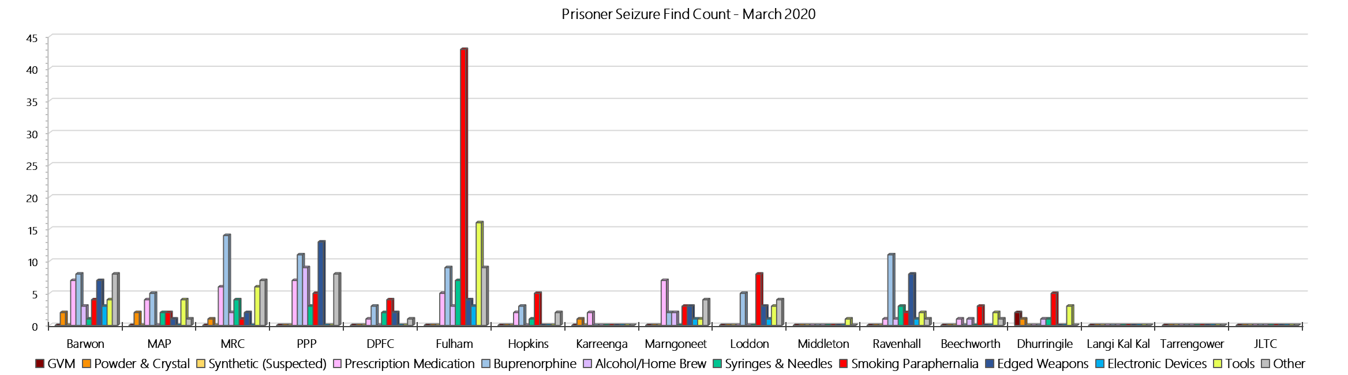

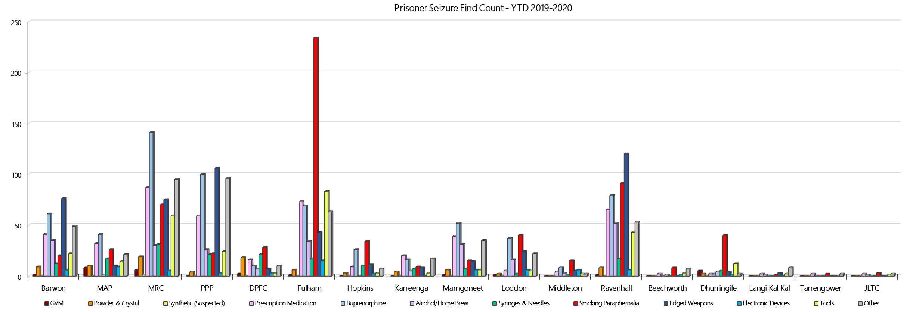

## **LOCATION SPECIFIC RESULTS**

### **Barwon Prison**

***Targeted and Random General Drug Test Results: 2019-2020***

|  |  |  |  |  |  |  |  |  |  |  |  |  |  |  |
| --- | --- | --- | --- | --- | --- | --- | --- | --- | --- | --- | --- | --- | --- | --- |
| **Barwon** | **Jul-19** | **Aug-19** | **Sep-19** | **Oct-19** | **Nov-19** | **Dec-19** | **Jan-20** | **Feb-20** | **Mar-20** | **Apr-20** | **May-20** | **Jun-20** | **Average** | ***Totals*** |
| **Effective Sample - Targeted** | **149** | **163** | **106** | **131** | **103** | **70** | **126** | **93** | **61** |  |  |  | **111** | ***1002*** |
| **Targeted Positives** | **19** | **18** | **15** | **18** | **8** | **6** | **15** | **16** | **8** |  |  |  | **14** | ***123*** |
| **Refusal** | **0** | **4** | **2** | **2** | **7** | **8** | **4** | **1** | **1** |  |  |  | **3** | ***29*** |
| **Unable** | **2** | **2** | **0** | **1** | **0** | **0** | **2** | **2** | **1** |  |  |  | **1** | ***10*** |
| **Interfered** | **0** | **0** | **0** | **0** | **0** | **2** | **0** | **0** | **1** |  |  |  | **0** | ***3*** |
| **Adulterated** | **1** | **0** | **0** | **2** | **0** | **0** | **0** | **2** | **0** |  |  |  | **1** | ***5*** |
| **Targeted % Tested Positive** | **14.77%** | **14.72%** | **16.04%** | **17.56%** | **14.56%** | **22.86%** | **16.67%** | **22.58%** | **18.03%** | **#N/A** | **#N/A** | **#N/A** | **16.97%** | ***16.97%*** |
| **Awaiting / Pending Results** | **0** | **0** | **0** | **0** | **0** | **0** | **0** | **0** | **0** |  |  |  | **0** | ***0*** |
| **Targeted Residual** | **1** | **1** | **0** | **0** | **0** | **0** | **0** | **0** | **1** |  |  |  | **0** | ***3*** |
| **Random tests collected** | **54** | **45** | **59** | **48** | **48** | **58** | **48** | **45** | **59** |  |  |  | **52** | ***464*** |
| **Tested Positive** | **3** | **2** | **4** | **6** | **2** | **6** | **1** | **3** | **5** |  |  |  | **4** | ***32*** |
| **Refusal (guilty)** | **4** | **1** | **0** | **0** | **0** | **1** | **1** | **3** | **1** |  |  |  | **1** | ***11*** |
| **Unable (not guilty)** | **0** | **0** | **0** | **0** | **0** | **0** | **0** | **0** | **0** |  |  |  | **0** | ***0*** |
| **Unable (guilty)** | **0** | **0** | **1** | **0** | **0** | **2** | **1** | **1** | **3** |  |  |  | **1** | ***8*** |
| **Interfered (guilty)** | **0** | **0** | **0** | **0** | **0** | **0** | **0** | **0** | **0** |  |  |  | **0** | ***0*** |
| **No test (valid reason)** | **2** | **2** | **1** | **3** | **0** | **1** | **1** | **2** | **2** |  |  |  | **2** | ***14*** |
| **No test (no valid reason)** | **1** | **0** | **0** | **0** | **0** | **0** | **0** | **0** | **0** |  |  |  | **0** | ***1*** |
| **Adulterated** | **0** | **1** | **0** | **1** | **0** | **0** | **0** | **0** | **0** |  |  |  | **0** | ***2*** |
| **Awaiting / Pending Results** | **0** | **0** | **0** | **0** | **0** | **0** | **0** | **0** | **0** |  |  |  | **0** | ***0*** |
| **Random Residual *(PIMS URAR030)*** | **0** | **0** | **0** | **1** | **0** | **0** | **0** | **0** | **0** |  |  |  | ***0.111111*** | ***1*** |
| **Effective Sample - Random General** | **59** | **46** | **60** | **48** | **48** | **61** | **50** | **49** | **63** |  |  |  | **54** | **484** |
| **% Tested positive** | **5.08%** | **4.35%** | **6.67%** | **12.50%** | **4.17%** | **9.84%** | **2.00%** | **6.12%** | **7.94%** |  |  |  | **6.52%** |  |
| **% Prisoner guilty, positive equivalents** | **6.78%** | **4.35%** | **1.67%** | **2.08%** | **0.00%** | **4.92%** | **4.00%** | **8.16%** | **6.35%** |  |  |  | **4.26%** |  |
| **% Total prisoner fails** | **11.86%** | **6.52%** | **8.33%** | **12.50%** | **4.17%** | **14.75%** | **6.00%** | **14.29%** | **14.29%** |  |  |  | **10.30%** |  |
| **% No test without valid reason** | **1.69%** | **0.00%** | **0.00%** | **0.00%** | **0.00%** | **0.00%** | **0.00%** | **0.00%** | **0.00%** |  |  |  | **0.19%** |  |
| ***Random General Benchmark 8.00%*** | ***8.00%*** | ***8.00%*** | ***8.00%*** | ***8.00%*** | ***8.00%*** | ***8.00%*** | ***8.00%*** | ***8.00%*** | ***8.00%*** | ***8.00%*** | ***8.00%*** | ***8.00%*** | ***YTD*** |  |
| **% Failures for SDO** | **13.56%** | **8.70%** | **8.33%** | **14.58%** | **4.17%** | **14.75%** | **6.00%** | **14.29%** | **14.29%** | **#N/A** | **#N/A** | **#N/A** | **11.16%** |  |

***Barwon - Drugs Identified Through Testing by Drug Type: 2019-2020***

|  |  |  |  |  |  |  |  |  |  |  |  |  |  |  |
| --- | --- | --- | --- | --- | --- | --- | --- | --- | --- | --- | --- | --- | --- | --- |
| **Barwon** | ***Amphetamines*** | ***Methamphetamines*** | ***Cocaine*** | ***Opiates*** | ***Benzodiazepines*** | ***Cannabinoids*** | ***Ethanol\*\**** | ***Methadone*** | ***ADP\**** | ***APS\**** | ***Steroids\*\**** | ***Buprenorphine*** | ***NOA\**** | **Total** |
| **Jul-19** | **0** | **0** | **0** | **0** | **0** | **0** | **0** | **0** | **0** | **0** | **0** | **29** | **0** | **29** |
| **Aug-19** | **0** | **0** | **0** | **0** | **0** | **0** | **0** | **0** | **4** | **1** | **0** | **20** | **0** | **25** |
| **Sep-19** | **2** | **3** | **0** | **0** | **0** | **0** | **0** | **0** | **0** | **0** | **0** | **22** | **0** | **27** |
| **Oct-19** | **1** | **1** | **0** | **0** | **1** | **1** | **0** | **0** | **0** | **1** | **0** | **32** | **0** | **37** |
| **Nov-19** | **0** | **0** | **0** | **0** | **0** | **0** | **0** | **0** | **0** | **0** | **0** | **10** | **0** | **10** |
| **Dec-19** | **0** | **0** | **0** | **0** | **0** | **0** | **0** | **2** | **0** | **0** | **0** | **19** | **0** | **21** |
| **Jan-20** | **0** | **0** | **0** | **1** | **0** | **0** | **0** | **2** | **0** | **0** | **0** | **24** | **0** | **27** |
| **Feb-20** | **0** | **0** | **0** | **0** | **0** | **0** | **0** | **1** | **0** | **0** | **0** | **30** | **0** | **31** |
| **Mar-20** | **0** | **0** | **0** | **0** | **0** | **0** | **0** | **2** | **2** | **0** | **0** | **17** | **0** | **21** |
| **Apr-20** |  |  |  |  |  |  |  |  |  |  |  |  |  |  |
| **May-20** |  |  |  |  |  |  |  |  |  |  |  |  |  |  |
| **Jun-20** |  |  |  |  |  |  |  |  |  |  |  |  |  |  |
| **YTD** | **3** | **4** | **0** | **1** | **1** | **1** | **0** | **7** | **6** | **2** | **0** | **203** | **0** | **228** |
| ***All Prisons YTD*** | ***133*** | ***224*** | ***2*** | ***35*** | ***30*** | ***30*** | ***20*** | ***32*** | ***49*** | ***13*** | ***0*** | ***1785*** | ***0*** | ***2353*** |
| ***Barwon % of Total*** | ***2.26%*** | ***1.79%*** | ***0.00%*** | ***2.86%*** | ***3.33%*** | ***3.33%*** | ***0.00%*** | ***21.88%*** | ***12.24%*** | ***15.38%*** | ***0.00%*** | ***11.37%*** | ***0.00%*** | ***9.69%*** |

***Barwon Seizures of Contraband: Visitors & Prisoners: 2019-2020***

|  |  |  |  |  |  |  |  |  |  |  |  |  |  |  |  |  |  |  |  |  |  |  |  |  |
| --- | --- | --- | --- | --- | --- | --- | --- | --- | --- | --- | --- | --- | --- | --- | --- | --- | --- | --- | --- | --- | --- | --- | --- | --- |
| **Visitors** | **GVM** | | **Powder & Crystal** | | **Synthetic (Suspected)** | | **Prescription Medication** | | **Buprenorphine** | | **Alcohol/Home Brew** | | **Syringes & Needles** | | **Smoking Paraphernalia** | | **Edged Weapons** | | **Electronic Devices** | | **Tools** | | **Other** | |
| **Barwon** | **Finds** | **Gms** | **Finds** | **Gms** | **Finds** | **Gms** | **Finds** | **Qty** | **Finds** | **Qty** | **Finds** | **Ltrs** | **Finds** | **Qty** | **Finds** | **Qty** | **Finds** | **Qty** | **Finds** | **Qty** | **Finds** | **Qty** | **Finds** | **Qty** |
| **Jul-19** | **0** | **0.00** | **0** | **0.00** | **0** | **0.00** | **0** | **0.00** | **0** | **0.00** | **0** | **0.000** | **0** | **0** | **0** | **0** | **0** | **0** | **0** | **0** | **0** | **0** | **0** | **0** |
| **Aug-19** | **1** | **16.50** | **0** | **0.00** | **0** | **0.00** | **0** | **0.00** | **0** | **0.00** | **0** | **0.000** | **0** | **0** | **0** | **0** | **0** | **0** | **0** | **0** | **0** | **0** | **0** | **0** |
| **Sep-19** | **0** | **0.00** | **1** | **3.00** | **0** | **0.00** | **1** | **3.00** | **0** | **0.00** | **0** | **0.000** | **0** | **0** | **1** | **1** | **0** | **0** | **0** | **0** | **0** | **0** | **0** | **0** |
| **Oct-19** | **0** | **0.00** | **0** | **0.00** | **0** | **0.00** | **0** | **0.00** | **0** | **0.00** | **0** | **0.000** | **0** | **0** | **0** | **0** | **0** | **0** | **0** | **0** | **0** | **0** | **0** | **0** |
| **Nov-19** | **1** | **0.90** | **1** | **0.10** | **0** | **0.00** | **0** | **0.00** | **0** | **0.00** | **0** | **0.000** | **2** | **4** | **1** | **2** | **0** | **0** | **0** | **0** | **0** | **0** | **0** | **0** |
| **Dec-19** | **0** | **0.00** | **0** | **0.00** | **0** | **0.00** | **0** | **0.00** | **0** | **0.00** | **0** | **0.000** | **0** | **0** | **0** | **0** | **0** | **0** | **0** | **0** | **0** | **0** | **0** | **0** |
| **Jan-20** | **0** | **0.00** | **0** | **0.00** | **0** | **0.00** | **0** | **0.00** | **1** | **53.00** | **0** | **0.000** | **0** | **0** | **0** | **0** | **0** | **0** | **0** | **0** | **0** | **0** | **0** | **0** |
| **Feb-20** | **0** | **0.00** | **0** | **0.00** | **0** | **0.00** | **1** | **2.00** | **1** | **16.00** | **0** | **0.000** | **0** | **0** | **0** | **0** | **0** | **0** | **0** | **0** | **0** | **0** | **0** | **0** |
| **Mar-20** | **0** | **0.00** | **0** | **0.00** | **0** | **0.00** | **0** | **0.00** | **0** | **0.00** | **0** | **0.000** | **0** | **0** | **0** | **0** | **0** | **0** | **0** | **0** | **0** | **0** | **0** | **0** |
| **Apr-20** |  |  |  |  |  |  |  |  |  |  |  |  |  |  |  |  |  |  |  |  |  |  |  |  |
| **May-20** |  |  |  |  |  |  |  |  |  |  |  |  |  |  |  |  |  |  |  |  |  |  |  |  |
| **Jun-20** |  |  |  |  |  |  |  |  |  |  |  |  |  |  |  |  |  |  |  |  |  |  |  |  |
| **Total** | **2** | **17.40** | **2** | **3.10** | **0** | **0.00** | **2** | **5.00** | **2** | **69.00** | **0** | **0.000** | **2** | **4** | **2** | **3** | **0** | **0** | **0** | **0** | **0** | **0** | **0** | **0** |

|  |  |  |  |  |  |  |  |  |  |  |  |  |  |  |  |  |  |  |  |  |  |  |  |  |
| --- | --- | --- | --- | --- | --- | --- | --- | --- | --- | --- | --- | --- | --- | --- | --- | --- | --- | --- | --- | --- | --- | --- | --- | --- |
| **Prisoners** | **GVM** | | **Powder  & Crystal** | | **Synthetic  (Suspected)** | | **Prescription  Medication** | | **Buprenorphine** | | **Alcohol &  Home Brew** | | **Syringes & Needles** | | **Smoking  Paraphernalia** | | **Edged  Weapons** | | **Electronic  Devices** | | **Tools** | | **Other** | |
| **Barwon** | **Finds** | **Gms** | **Finds** | **Gms** | **Finds** | **Gms** | **Finds** | **Qty** | **Finds** | **Qty** | **Finds** | **Ltrs** | **Finds** | **Qty** | **Finds** | **Qty** | **Finds** | **Qty** | **Finds** | **Qty** | **Finds** | **Qty** | **Finds** | **Qty** |
| **Jul-19** | **0** | **0.00** | **1** | **11.80** | **0** | **0.00** | **2** | **7.50** | **5** | **12.90** | **0** | **0.000** | **1** | **1** | **0** | **0** | **11** | **13** | **0** | **0** | **2** | **4** | **3** | **4** |
| **Aug-19** | **0** | **0.00** | **1** | **1.40** | **0** | **0.00** | **6** | **31.25** | **11** | **10.90** | **13** | **35.250** | **2** | **2** | **1** | **3** | **6** | **11** | **0** | **0** | **2** | **3** | **1** | **1** |
| **Sep-19** | **0** | **0.00** | **0** | **0.00** | **0** | **0.00** | **2** | **2.90** | **8** | **15.00** | **4** | **22.000** | **0** | **0** | **1** | **1** | **12** | **27** | **1** | **1** | **3** | **4** | **6** | **9** |
| **Oct-19** | **0** | **0.00** | **3** | **0.60** | **0** | **0.00** | **6** | **31.00** | **8** | **9.00** | **2** | **5.000** | **1** | **1** | **7** | **10** | **13** | **24** | **1** | **2** | **2** | **4** | **4** | **25** |
| **Nov-19** | **0** | **0.00** | **2** | **5.30** | **0** | **0.00** | **4** | **26.50** | **4** | **4.50** | **6** | **12.500** | **1** | **1** | **3** | **18** | **6** | **13** | **0** | **0** | **2** | **2** | **5** | **7** |
| **Dec-19** | **1** | **0.10** | **0** | **0.00** | **0** | **0.00** | **6** | **14.10** | **6** | **4.50** | **6** | **17.750** | **3** | **3** | **2** | **2** | **11** | **18** | **0** | **0** | **3** | **15** | **4** | **9** |
| **Jan-20** | **0** | **0.00** | **0** | **0.00** | **0** | **0.00** | **3** | **4.50** | **6** | **13.05** | **1** | **4.000** | **3** | **4** | **1** | **1** | **2** | **2** | **0** | **0** | **2** | **4** | **5** | **10** |
| **Feb-20** | **0** | **0.00** | **0** | **0.00** | **0** | **0.00** | **5** | **20.00** | **5** | **7.00** | **0** | **0.000** | **0** | **0** | **1** | **1** | **8** | **8** | **1** | **1** | **2** | **2** | **13** | **18** |
| **Mar-20** | **0** | **0.00** | **2** | **0.50** | **0** | **0.00** | **7** | **33.10** | **8** | **19.00** | **3** | **28.250** | **1** | **2** | **4** | **9** | **7** | **13** | **3** | **5** | **4** | **11** | **8** | **15** |
| **Apr-20** |  |  |  |  |  |  |  |  |  |  |  |  |  |  |  |  |  |  |  |  |  |  |  |  |
| **May-20** |  |  |  |  |  |  |  |  |  |  |  |  |  |  |  |  |  |  |  |  |  |  |  |  |
| **Jun-20** |  |  |  |  |  |  |  |  |  |  |  |  |  |  |  |  |  |  |  |  |  |  |  |  |
| **Total** | **1** | **0.10** | **9** | **19.60** | **0** | **0.00** | **41** | **170.85** | **61** | **95.85** | **35** | **124.750** | **12** | **14** | **20** | **45** | **76** | **129** | **6** | **9** | **22** | **49** | **49** | **98** |

***Barwon Targeted and Random General Drug Test Positives & Equivalents: 2019-2020***

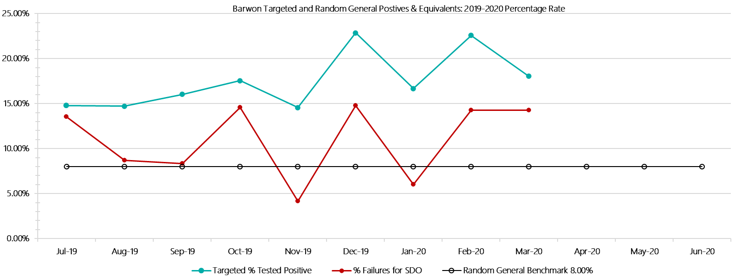

***Barwon Positive Drug Test Results by Drug Type: 2019-2020***

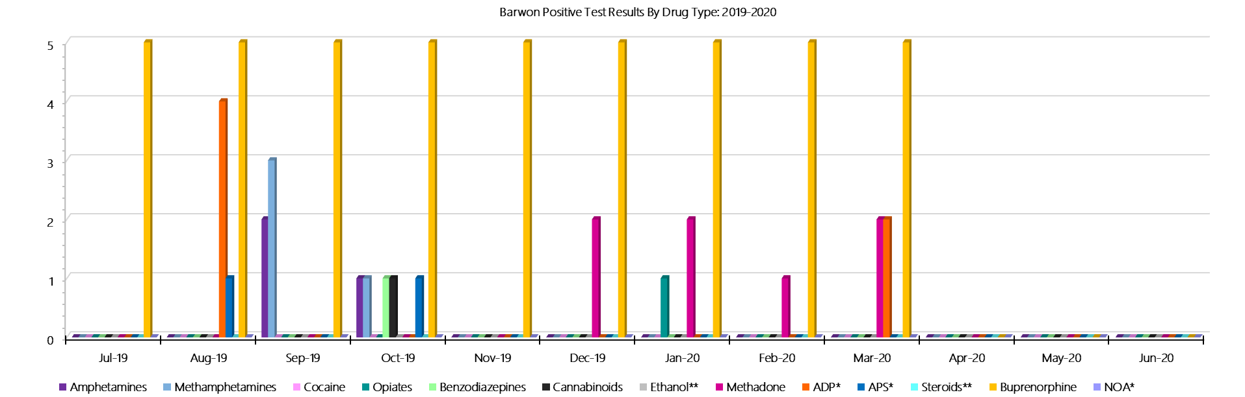

***Barwon Count of Visitor Seizures Finds: 2019-2020***

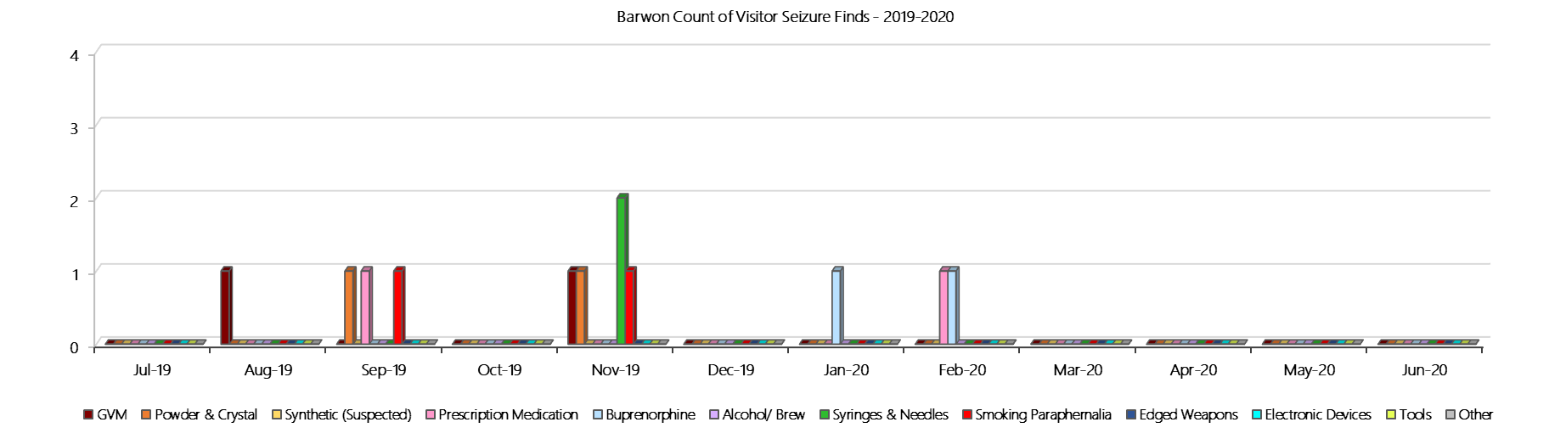

***Barwon Count of Prisoner Seizure Finds: 2019-2020***

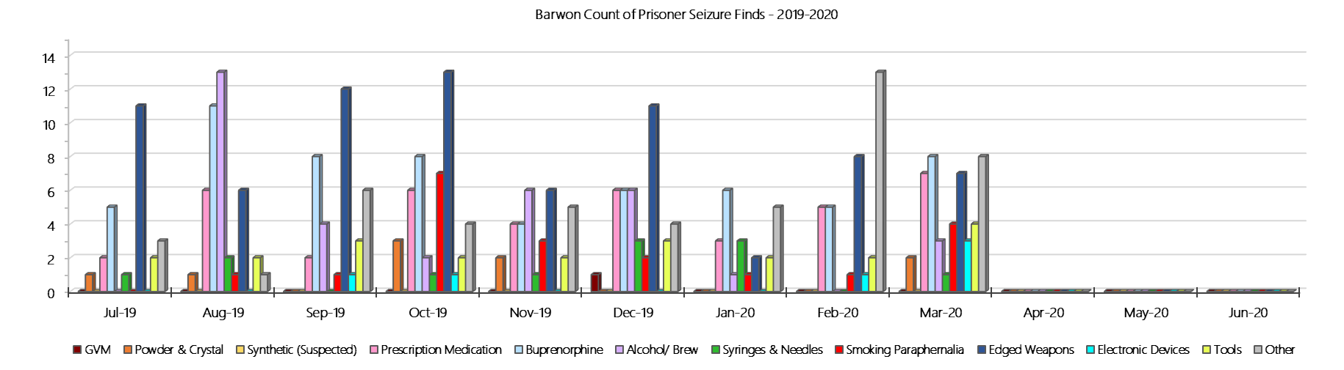

### **Melbourne Assessment Prison**

***Targeted and Random General Drug Test Results: 2019-2020***

|  |  |  |  |  |  |  |  |  |  |  |  |  |  |  |
| --- | --- | --- | --- | --- | --- | --- | --- | --- | --- | --- | --- | --- | --- | --- |
| **MAP** | **Jul-19** | **Aug-19** | **Sep-19** | **Oct-19** | **Nov-19** | **Dec-19** | **Jan-20** | **Feb-20** | **Mar-20** | **Apr-20** | **May-20** | **Jun-20** | **Average** | ***Totals*** |
| **Effective Sample - Targeted** | **85** | **90** | **63** | **74** | **71** | **57** | **68** | **72** | **37** |  |  |  | **69** | ***617*** |
| **Targeted Positives** | **3** | **4** | **2** | **4** | **2** | **7** | **3** | **6** | **2** |  |  |  | **4** | ***33*** |
| **Refusal** | **2** | **1** | **2** | **1** | **0** | **3** | **0** | **1** | **0** |  |  |  | **1** | ***10*** |
| **Unable** | **1** | **2** | **0** | **1** | **2** | **4** | **0** | **2** | **1** |  |  |  | **1** | ***13*** |
| **Interfered** | **0** | **0** | **0** | **0** | **0** | **0** | **0** | **0** | **0** |  |  |  | **0** | ***0*** |
| **Adulterated** | **0** | **0** | **0** | **1** | **0** | **0** | **0** | **0** | **0** |  |  |  | **0** | ***1*** |
| **Targeted % Tested Positive** | **7.06%** | **7.78%** | **6.35%** | **9.46%** | **5.63%** | **24.56%** | **4.41%** | **12.50%** | **8.11%** | **#N/A** | **#N/A** | **#N/A** | **9.24%** | ***9.24%*** |
| **Awaiting / Pending Results** | **0** | **0** | **0** | **0** | **0** | **0** | **0** | **0** | **1** |  |  |  | **0** | ***1*** |
| **Targeted Residual** | **0** | **0** | **0** | **0** | **0** | **0** | **0** | **0** | **0** |  |  |  | **0** | ***0*** |
| **Random tests collected** | **29** | **18** | **31** | **20** | **24** | **31** | **25** | **22** | **29** |  |  |  | **25** | ***229*** |
| **Tested Positive** | **0** | **0** | **1** | **1** | **0** | **0** | **0** | **0** | **0** |  |  |  | **0** | ***2*** |
| **Refusal (guilty)** | **0** | **1** | **1** | **1** | **0** | **1** | **0** | **2** | **1** |  |  |  | **1** | ***7*** |
| **Unable (not guilty)** | **0** | **0** | **0** | **0** | **0** | **0** | **0** | **0** | **0** |  |  |  | **0** | ***0*** |
| **Unable (guilty)** | **1** | **0** | **0** | **0** | **0** | **1** | **0** | **1** | **0** |  |  |  | **0** | ***3*** |
| **Interfered (guilty)** | **0** | **0** | **0** | **0** | **0** | **0** | **0** | **0** | **0** |  |  |  | **0** | ***0*** |
| **No test (valid reason)** | **5** | **9** | **4** | **7** | **8** | **9** | **5** | **9** | **13** |  |  |  | **8** | ***69*** |
| **No test (no valid reason)** | **0** | **0** | **0** | **0** | **0** | **0** | **0** | **0** | **0** |  |  |  | **0** | ***0*** |
| **Adulterated** | **0** | **0** | **0** | **0** | **0** | **0** | **0** | **0** | **0** |  |  |  | **0** | ***0*** |
| **Awaiting / Pending Results** | **0** | **0** | **0** | **0** | **0** | **0** | **0** | **0** | **0** |  |  |  | **0** | ***0*** |
| **Random Residual *(PIMS URAR030)*** | **0** | **0** | **1** | **0** | **0** | **0** | **0** | **0** | **0** |  |  |  | ***0.111111*** | ***1*** |
| **Effective Sample - Random General** | **30** | **19** | **32** | **21** | **24** | **33** | **25** | **25** | **30** |  |  |  | **27** | **239** |
| **% Tested positive** | **0.00%** | **0.00%** | **3.13%** | **4.76%** | **0.00%** | **0.00%** | **0.00%** | **0.00%** | **0.00%** |  |  |  | **0.88%** |  |
| **% Prisoner guilty, positive equivalents** | **3.33%** | **5.26%** | **3.13%** | **4.76%** | **0.00%** | **6.06%** | **0.00%** | **12.00%** | **3.33%** |  |  |  | **4.21%** |  |
| **% Total prisoner fails** | **3.33%** | **5.26%** | **6.25%** | **9.52%** | **0.00%** | **6.06%** | **0.00%** | **12.00%** | **3.33%** |  |  |  | **5.08%** |  |
| **% No test without valid reason** | **0.00%** | **0.00%** | **0.00%** | **0.00%** | **0.00%** | **0.00%** | **0.00%** | **0.00%** | **0.00%** |  |  |  | **0.00%** |  |
| ***Random General Benchmark 8.00%*** | ***8.00%*** | ***8.00%*** | ***8.00%*** | ***8.00%*** | ***8.00%*** | ***8.00%*** | ***8.00%*** | ***8.00%*** | ***8.00%*** | ***8.00%*** | ***8.00%*** | ***8.00%*** | ***YTD*** |  |
| **% Failures for SDO** | **3.33%** | **5.26%** | **6.25%** | **9.52%** | **0.00%** | **6.06%** | **0.00%** | **12.00%** | **3.33%** | **#N/A** | **#N/A** | **#N/A** | **5.02%** |  |

***Melbourne Assessment Prison - Drugs Identified Through Testing by Drug Type: 2019-2020***

|  |  |  |  |  |  |  |  |  |  |  |  |  |  |  |
| --- | --- | --- | --- | --- | --- | --- | --- | --- | --- | --- | --- | --- | --- | --- |
| **MAP** | ***Amphetamines*** | ***Methamphetamines*** | ***Cocaine*** | ***Opiates*** | ***Benzodiazepines*** | ***Cannabinoids*** | ***Ethanol\*\**** | ***Methadone*** | ***ADP\**** | ***APS\**** | ***Steroids\*\**** | ***Buprenorphine*** | ***NOA\**** | **Total** |
| **Jul-19** | **1** | **1** | **0** | **0** | **0** | **0** | **0** | **0** | **0** | **0** | **0** | **2** | **0** | **4** |
| **Aug-19** | **1** | **2** | **0** | **2** | **0** | **0** | **0** | **0** | **0** | **0** | **0** | **0** | **0** | **5** |
| **Sep-19** | **0** | **0** | **0** | **0** | **1** | **0** | **0** | **0** | **0** | **0** | **0** | **2** | **0** | **3** |
| **Oct-19** | **0** | **0** | **0** | **0** | **1** | **0** | **0** | **0** | **0** | **0** | **0** | **4** | **0** | **5** |
| **Nov-19** | **1** | **1** | **0** | **0** | **0** | **0** | **0** | **0** | **0** | **0** | **0** | **3** | **0** | **5** |
| **Dec-19** | **1** | **2** | **0** | **0** | **3** | **1** | **0** | **0** | **0** | **0** | **0** | **3** | **0** | **10** |
| **Jan-20** | **0** | **1** | **0** | **0** | **0** | **0** | **0** | **0** | **0** | **0** | **0** | **2** | **0** | **3** |
| **Feb-20** | **2** | **5** | **0** | **1** | **0** | **1** | **0** | **0** | **0** | **0** | **0** | **2** | **0** | **11** |
| **Mar-20** | **1** | **1** | **0** | **0** | **0** | **0** | **0** | **0** | **0** | **0** | **0** | **2** | **0** | **4** |
| **Apr-20** |  |  |  |  |  |  |  |  |  |  |  |  |  |  |
| **May-20** |  |  |  |  |  |  |  |  |  |  |  |  |  |  |
| **Jun-20** |  |  |  |  |  |  |  |  |  |  |  |  |  |  |
| **MAP YTD** | **7** | **13** | **0** | **3** | **5** | **2** | **0** | **0** | **0** | **0** | **0** | **20** | **0** | **50** |
| ***All Prisons YTD*** | ***133*** | ***224*** | ***2*** | ***35*** | ***30*** | ***30*** | ***20*** | ***32*** | ***49*** | ***13*** | ***0*** | ***1785*** | ***0*** | ***2353*** |
| ***MAP % of Total*** | ***5.26%*** | ***5.80%*** | ***0.00%*** | ***8.57%*** | ***16.67%*** | ***6.67%*** | ***0.00%*** | ***0.00%*** | ***0.00%*** | ***0.00%*** | ***0.00%*** | ***1.12%*** | ***0.00%*** | ***2.12%*** |

***Melbourne Assessment Prison Seizures of Contraband: Visitors & Prisoners: 2019-2020***

|  |  |  |  |  |  |  |  |  |  |  |  |  |  |  |  |  |  |  |  |  |  |  |  |  |
| --- | --- | --- | --- | --- | --- | --- | --- | --- | --- | --- | --- | --- | --- | --- | --- | --- | --- | --- | --- | --- | --- | --- | --- | --- |
| **Visitors** | **GVM** | | **Powder  & Crystal** | | **Synthetic  (Suspected)** | | **Prescription  Medication** | | **Buprenorphine** | | **Alcohol &  Home Brew** | | **Syringes & Needles** | | **Smoking  Paraphernalia** | | **Edged  Weapons** | | **Electronic  Devices** | | **Tools** | | **Other** | |
| **MAP** | **Finds** | **Gms** | **Finds** | **Gms** | **Finds** | **Gms** | **Finds** | **Qty** | **Finds** | **Qty** | **Finds** | **Ltrs** | **Finds** | **Qty** | **Finds** | **Qty** | **Finds** | **Qty** | **Finds** | **Qty** | **Finds** | **Qty** | **Finds** | **Qty** |
| **Jul-19** | **0** | **0.00** | **0** | **0.00** | **0** | **0.00** | **0** | **0.00** | **0** | **0.00** | **0** | **0.000** | **0** | **0** | **0** | **0** | **0** | **0** | **0** | **0** | **0** | **0** | **0** | **0** |
| **Aug-19** | **0** | **0.00** | **0** | **0.00** | **0** | **0.00** | **0** | **0.00** | **0** | **0.00** | **0** | **0.000** | **0** | **0** | **0** | **0** | **0** | **0** | **0** | **0** | **0** | **0** | **0** | **0** |
| **Sep-19** | **0** | **0.00** | **0** | **0.00** | **0** | **0.00** | **0** | **0.00** | **0** | **0.00** | **0** | **0.000** | **0** | **0** | **0** | **0** | **0** | **0** | **0** | **0** | **0** | **0** | **0** | **0** |
| **Oct-19** | **0** | **0.00** | **0** | **0.00** | **0** | **0.00** | **0** | **0.00** | **0** | **0.00** | **0** | **0.000** | **0** | **0** | **0** | **0** | **0** | **0** | **0** | **0** | **0** | **0** | **0** | **0** |
| **Nov-19** | **0** | **0.00** | **0** | **0.00** | **0** | **0.00** | **0** | **0.00** | **0** | **0.00** | **0** | **0.000** | **0** | **0** | **0** | **0** | **0** | **0** | **0** | **0** | **0** | **0** | **0** | **0** |
| **Dec-19** | **0** | **0.00** | **0** | **0.00** | **0** | **0.00** | **0** | **0.00** | **0** | **0.00** | **0** | **0.000** | **0** | **0** | **0** | **0** | **0** | **0** | **0** | **0** | **0** | **0** | **0** | **0** |
| **Jan-20** | **0** | **0.00** | **0** | **0.00** | **0** | **0.00** | **0** | **0.00** | **0** | **0.00** | **0** | **0.000** | **0** | **0** | **0** | **0** | **0** | **0** | **0** | **0** | **0** | **0** | **0** | **0** |
| **Feb-20** | **0** | **0.00** | **0** | **0.00** | **0** | **0.00** | **0** | **0.00** | **0** | **0.00** | **0** | **0.000** | **0** | **0** | **0** | **0** | **0** | **0** | **0** | **0** | **0** | **0** | **0** | **0** |
| **Mar-20** | **0** | **0.00** | **0** | **0.00** | **0** | **0.00** | **0** | **0.00** | **0** | **0.00** | **0** | **0.000** | **0** | **0** | **0** | **0** | **0** | **0** | **0** | **0** | **0** | **0** | **0** | **0** |
| **Apr-20** |  |  |  |  |  |  |  |  |  |  |  |  |  |  |  |  |  |  |  |  |  |  |  |  |
| **May-20** |  |  |  |  |  |  |  |  |  |  |  |  |  |  |  |  |  |  |  |  |  |  |  |  |
| **Jun-20** |  |  |  |  |  |  |  |  |  |  |  |  |  |  |  |  |  |  |  |  |  |  |  |  |
| **Total** | **0** | **0.00** | **0** | **0.00** | **0** | **0.00** | **0** | **0.00** | **0** | **0.00** | **0** | **0.000** | **0** | **0** | **0** | **0** | **0** | **0** | **0** | **0** | **0** | **0** | **0** | **0** |

|  |  |  |  |  |  |  |  |  |  |  |  |  |  |  |  |  |  |  |  |  |  |  |  |  |
| --- | --- | --- | --- | --- | --- | --- | --- | --- | --- | --- | --- | --- | --- | --- | --- | --- | --- | --- | --- | --- | --- | --- | --- | --- |
| **Prisoners** | **GVM** | | **Powder  & Crystal** | | **Synthetic  (Suspected)** | | **Prescription  Medication** | | **Buprenorphine** | | **Alcohol &  Home Brew** | | **Syringes & Needles** | | **Smoking  Paraphernalia** | | **Edged  Weapons** | | **Electronic  Devices** | | **Tools** | | **Other** | |
| **MAP** | **Finds** | **Gms** | **Finds** | **Gms** | **Finds** | **Gms** | **Finds** | **Qty** | **Finds** | **Qty** | **Finds** | **Ltrs** | **Finds** | **Qty** | **Finds** | **Qty** | **Finds** | **Qty** | **Finds** | **Qty** | **Finds** | **Qty** | **Finds** | **Qty** |
| **Jul-19** | **2** | **12.40** | **0** | **0.00** | **0** | **0.00** | **4** | **38.00** | **3** | **26.10** | **0** | **0.000** | **3** | **6** | **3** | **4** | **0** | **0** | **1** | **1** | **1** | **1** | **0** | **0** |
| **Aug-19** | **0** | **0.00** | **1** | **0.30** | **0** | **0.00** | **3** | **4.25** | **2** | **18.00** | **0** | **0.000** | **0** | **0** | **2** | **7** | **2** | **3** | **1** | **1** | **0** | **0** | **6** | **18** |
| **Sep-19** | **3** | **12.80** | **1** | **0.10** | **0** | **0.00** | **3** | **6.00** | **3** | **6.50** | **0** | **0.000** | **3** | **3** | **8** | **11** | **1** | **1** | **2** | **2** | **5** | **5** | **3** | **5** |
| **Oct-19** | **1** | **3.90** | **2** | **0.77** | **0** | **0.00** | **1** | **20.00** | **8** | **52.00** | **1** | **0.500** | **3** | **3** | **3** | **4** | **0** | **0** | **0** | **0** | **0** | **0** | **0** | **0** |
| **Nov-19** | **0** | **0.00** | **0** | **0.00** | **0** | **0.00** | **4** | **6.00** | **1** | **1.00** | **0** | **0.000** | **1** | **1** | **0** | **0** | **0** | **0** | **1** | **1** | **0** | **0** | **0** | **0** |
| **Dec-19** | **1** | **8.30** | **1** | **0.10** | **0** | **0.00** | **1** | **0.50** | **3** | **12.20** | **0** | **0.000** | **1** | **1** | **0** | **0** | **1** | **1** | **1** | **1** | **1** | **1** | **5** | **35** |
| **Jan-20** | **1** | **1.40** | **0** | **0.00** | **0** | **0.00** | **4** | **39.00** | **4** | **1.80** | **0** | **0.000** | **2** | **2** | **5** | **12** | **3** | **3** | **1** | **2** | **2** | **3** | **3** | **53** |
| **Feb-20** | **0** | **0.00** | **3** | **2.37** | **0** | **0.00** | **8** | **48.50** | **12** | **151.13** | **0** | **0.000** | **2** | **2** | **3** | **3** | **2** | **2** | **2** | **3** | **1** | **1** | **3** | **3** |
| **Mar-20** | **0** | **0.00** | **2** | **0.30** | **0** | **0.00** | **4** | **11.00** | **5** | **0.00** | **0** | **0.000** | **2** | **2** | **2** | **2** | **1** | **1** | **0** | **0** | **4** | **4** | **1** | **1** |
| **Apr-20** |  |  |  |  |  |  |  |  |  |  |  |  |  |  |  |  |  |  |  |  |  |  |  |  |
| **May-20** |  |  |  |  |  |  |  |  |  |  |  |  |  |  |  |  |  |  |  |  |  |  |  |  |
| **Jun-20** |  |  |  |  |  |  |  |  |  |  |  |  |  |  |  |  |  |  |  |  |  |  |  |  |
| **Total** | **8** | **38.80** | **10** | **3.94** | **0** | **0.00** | **32** | **173.25** | **41** | **268.73** | **1** | **0.500** | **17** | **20** | **26** | **43** | **10** | **11** | **9** | **11** | **14** | **15** | **21** | **115** |

***Melbourne Assessment Prison Targeted and Random General Urinalysis Positives & Equivalents: 2019-2020***

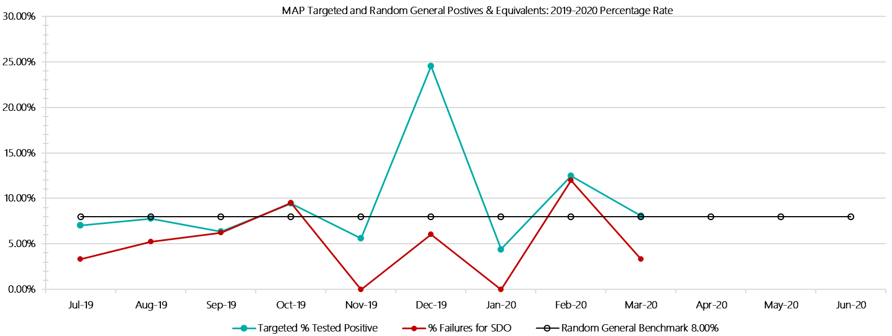

***Melbourne Assessment Prison Positive Test Results by Drug Type: 2019-2020***

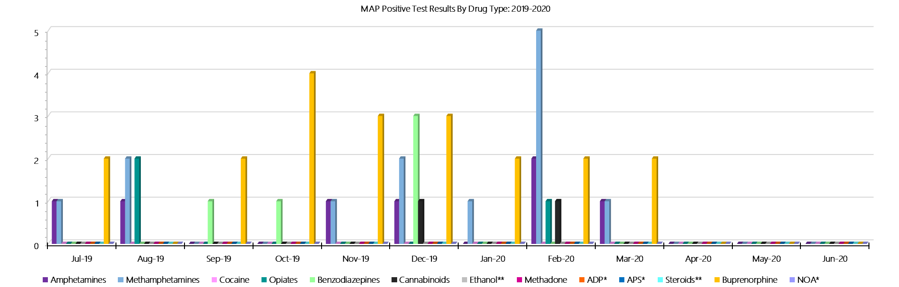

***Melbourne Assessment Prison Count of Visitor Seizures Finds: 2019-2020***

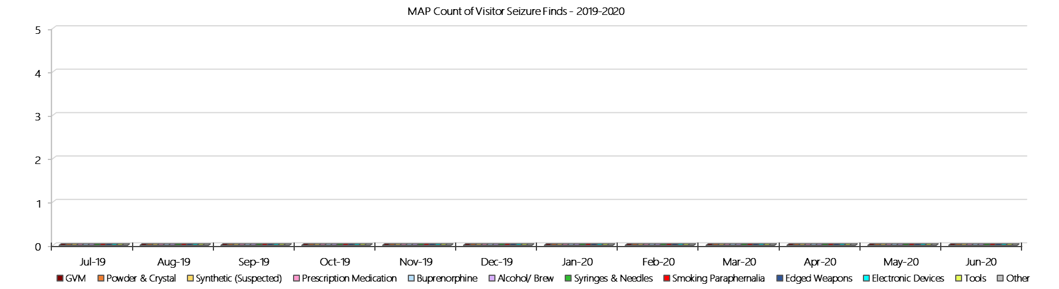

***Melbourne Assessment Prison Count of Prisoner Seizure Finds: 2019-2020***

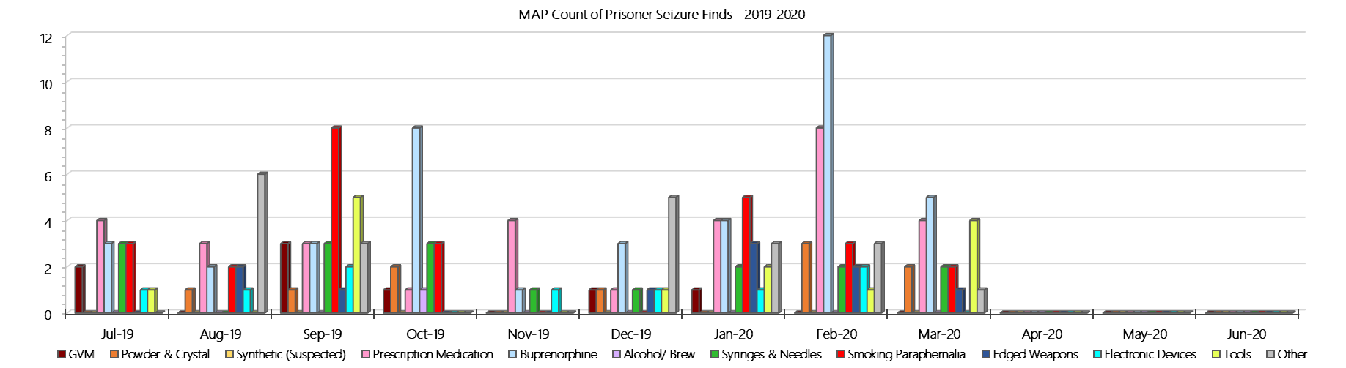

### **Metropolitan Remand Centre**

***Targeted and Random General Drug Test Results: 2019-2020***

|  |  |  |  |  |  |  |  |  |  |  |  |  |  |  |
| --- | --- | --- | --- | --- | --- | --- | --- | --- | --- | --- | --- | --- | --- | --- |
| **MRC** | **Jul-19** | **Aug-19** | **Sep-19** | **Oct-19** | **Nov-19** | **Dec-19** | **Jan-20** | **Feb-20** | **Mar-20** | **Apr-20** | **May-20** | **Jun-20** | **Average** | ***Totals*** |
| **Effective Sample - Targeted** | **161** | **137** | **151** | **151** | **183** | **167** | **151** | **125** | **151** |  |  |  | **153** | ***1377*** |
| **Targeted Positives** | **13** | **27** | **13** | **25** | **23** | **28** | **25** | **13** | **20** |  |  |  | **21** | ***187*** |
| **Refusal** | **0** | **1** | **4** | **0** | **2** | **2** | **1** | **1** | **2** |  |  |  | **1** | ***13*** |
| **Unable** | **1** | **1** | **0** | **1** | **3** | **2** | **0** | **0** | **1** |  |  |  | **1** | ***9*** |
| **Interfered** | **0** | **0** | **0** | **0** | **0** | **0** | **0** | **0** | **1** |  |  |  | **0** | ***1*** |
| **Adulterated** | **0** | **0** | **0** | **0** | **0** | **0** | **0** | **1** | **0** |  |  |  | **0** | ***1*** |
| **Targeted % Tested Positive** | **8.70%** | **21.17%** | **11.26%** | **17.22%** | **15.30%** | **19.16%** | **17.22%** | **12.00%** | **15.89%** | **#N/A** | **#N/A** | **#N/A** | **15.32%** | ***15.32%*** |
| **Awaiting / Pending Results** | **0** | **0** | **0** | **0** | **0** | **0** | **0** | **0** | **1** |  |  |  | **0** | ***1*** |
| **Targeted Residual** | **1** | **6** | **0** | **0** | **0** | **0** | **0** | **1** | **1** |  |  |  | **1** | ***9*** |
| **Random tests collected** | **128** | **104** | **124** | **97** | **98** | **127** | **106** | **105** | **129** |  |  |  | **113** | ***1018*** |
| **Tested Positive** | **14** | **13** | **8** | **6** | **8** | **8** | **16** | **9** | **11** |  |  |  | **10** | ***93*** |
| **Refusal (guilty)** | **0** | **2** | **0** | **1** | **2** | **0** | **0** | **0** | **0** |  |  |  | **1** | ***5*** |
| **Unable (not guilty)** | **0** | **0** | **1** | **0** | **0** | **0** | **0** | **0** | **0** |  |  |  | **0** | ***1*** |
| **Unable (guilty)** | **5** | **1** | **2** | **1** | **2** | **1** | **1** | **1** | **1** |  |  |  | **2** | ***15*** |
| **Interfered (guilty)** | **0** | **0** | **0** | **0** | **0** | **0** | **0** | **0** | **0** |  |  |  | **0** | ***0*** |
| **No test (valid reason)** | **7** | **3** | **7** | **9** | **6** | **5** | **4** | **6** | **8** |  |  |  | **6** | ***55*** |
| **No test (no valid reason)** | **0** | **1** | **0** | **0** | **0** | **0** | **0** | **0** | **1** |  |  |  | **0** | ***2*** |
| **Adulterated** | **0** | **0** | **0** | **0** | **0** | **0** | **0** | **0** | **0** |  |  |  | **0** | ***0*** |
| **Awaiting / Pending Results** | **0** | **0** | **0** | **0** | **0** | **0** | **1** | **0** | **2** |  |  |  | **0** | ***3*** |
| **Random Residual *(PIMS URAR030)*** | **0** | **1** | **0** | **0** | **1** | **4** | **0** | **0** | **0** |  |  |  | ***0.666667*** | ***6*** |
| **Effective Sample - Random General** | **133** | **108** | **126** | **99** | **102** | **128** | **107** | **106** | **131** |  |  |  | **116** | **1040** |
| **% Tested positive** | **10.53%** | **12.04%** | **6.35%** | **6.06%** | **7.84%** | **6.25%** | **14.95%** | **8.49%** | **8.40%** |  |  |  | **8.99%** |  |
| **% Prisoner guilty, positive equivalents** | **3.76%** | **2.78%** | **1.59%** | **2.02%** | **3.92%** | **0.78%** | **0.93%** | **0.94%** | **0.76%** |  |  |  | **1.94%** |  |
| **% Total prisoner fails** | **14.29%** | **14.81%** | **7.94%** | **8.08%** | **11.76%** | **7.03%** | **15.89%** | **9.43%** | **9.16%** |  |  |  | **10.93%** |  |
| **% No test without valid reason** | **0.00%** | **0.93%** | **0.00%** | **0.00%** | **0.00%** | **0.00%** | **0.00%** | **0.00%** | **0.76%** |  |  |  | **0.19%** |  |
| ***Random General Benchmark 7.00%*** | ***7.00%*** | ***7.00%*** | ***7.00%*** | ***7.00%*** | ***7.00%*** | ***7.00%*** | ***7.00%*** | ***7.00%*** | ***7.00%*** | ***7.00%*** | ***7.00%*** | ***7.00%*** | ***YTD*** |  |
| **% Failures for SDO** | **14.29%** | **15.74%** | **7.94%** | **8.08%** | **11.76%** | **7.03%** | **15.89%** | **9.43%** | **9.92%** | **#N/A** | **#N/A** | **#N/A** | **11.06%** |  |

***Metropolitan Remand Centre - Drugs Identified Through Testing by Drug Type: 2019-2020***

|  |  |  |  |  |  |  |  |  |  |  |  |  |  |  |
| --- | --- | --- | --- | --- | --- | --- | --- | --- | --- | --- | --- | --- | --- | --- |
| **MRC** | ***Amphetamines*** | ***Methamphetamines*** | ***Cocaine*** | ***Opiates*** | ***Benzodiazepines*** | ***Cannabinoids*** | ***Ethanol\*\**** | ***Methadone*** | ***ADP\**** | ***APS\**** | ***Steroids\*\**** | ***Buprenorphine*** | ***NOA\**** | **Total** |
| **Jul-19** | **1** | **6** | **0** | **2** | **0** | **0** | **0** | **0** | **0** | **0** | **0** | **27** | **0** | **36** |
| **Aug-19** | **2** | **5** | **0** | **1** | **1** | **1** | **0** | **0** | **0** | **0** | **0** | **44** | **0** | **54** |
| **Sep-19** | **2** | **2** | **0** | **0** | **0** | **0** | **0** | **0** | **0** | **0** | **0** | **25** | **0** | **29** |
| **Oct-19** | **3** | **6** | **0** | **1** | **0** | **0** | **0** | **1** | **0** | **0** | **0** | **32** | **0** | **43** |
| **Nov-19** | **0** | **3** | **0** | **2** | **0** | **1** | **0** | **0** | **0** | **0** | **0** | **30** | **0** | **36** |
| **Dec-19** | **4** | **7** | **0** | **0** | **0** | **0** | **0** | **0** | **0** | **0** | **0** | **37** | **0** | **48** |
| **Jan-20** | **0** | **0** | **0** | **0** | **1** | **0** | **0** | **0** | **0** | **0** | **0** | **55** | **0** | **56** |
| **Feb-20** | **3** | **6** | **0** | **0** | **1** | **0** | **0** | **0** | **0** | **0** | **0** | **25** | **0** | **35** |
| **Mar-20** | **3** | **3** | **0** | **0** | **0** | **0** | **0** | **0** | **0** | **0** | **0** | **35** | **0** | **41** |
| **Apr-20** |  |  |  |  |  |  |  |  |  |  |  |  |  |  |
| **May-20** |  |  |  |  |  |  |  |  |  |  |  |  |  |  |
| **Jun-20** |  |  |  |  |  |  |  |  |  |  |  |  |  |  |
| **MRC YTD** | **18** | **38** | **0** | **6** | **3** | **2** | **0** | **1** | **0** | **0** | **0** | **310** | **0** | **378** |
| ***All Prisons YTD*** | ***133*** | ***224*** | ***2*** | ***35*** | ***30*** | ***30*** | ***20*** | ***32*** | ***49*** | ***13*** | ***0*** | ***1785*** | ***0*** | ***2353*** |
| ***MRC % of Total*** | ***13.53%*** | ***16.96%*** | ***0.00%*** | ***17.14%*** | ***10.00%*** | ***6.67%*** | ***0.00%*** | ***3.13%*** | ***0.00%*** | ***0.00%*** | ***0.00%*** | ***17.37%*** | ***0.00%*** | ***16.06%*** |

***Metropolitan Remand Centre Seizures of Contraband: Visitors & Prisoners: 2019-2020***

|  |  |  |  |  |  |  |  |  |  |  |  |  |  |  |  |  |  |  |  |  |  |  |  |  |  |
| --- | --- | --- | --- | --- | --- | --- | --- | --- | --- | --- | --- | --- | --- | --- | --- | --- | --- | --- | --- | --- | --- | --- | --- | --- | --- |
| **Visitors** | **GVM** | | **Powder  & Crystal** | | **Synthetic  (Suspected)** | | **Prescription  Medication** | | **Buprenorphine** | | **Alcohol &  Home Brew** | | **Syringes & Needles** | | **Smoking  Paraphernalia** | | **Edged  Weapons** | | **Electronic  Devices** | | **Tools** | | **Other** | | |
| **MRC** | **Finds** | **Gms** | **Finds** | **Gms** | **Finds** | **Gms** | **Finds** | **Qty** | **Finds** | **Qty** | **Finds** | **Ltrs** | **Finds** | **Qty** | **Finds** | **Qty** | **Finds** | **Qty** | **Finds** | **Qty** | **Finds** | **Qty** | **Finds** | **Qty** |
| **Jul-19** | **0** | **0.00** | **1** | **1.00** | **0** | **0.00** | **1** | **3.00** | **2** | **3.10** | **0** | **0.000** | **2** | **11** | **4** | **5** | **1** | **3** | **0** | **0** | **2** | **3** | **4** | **7** | |
| **Aug-19** | **1** | **0.50** | **0** | **0.00** | **0** | **0.00** | **1** | **9.00** | **0** | **0.00** | **1** | **0.660** | **0** | **0** | **3** | **7** | **3** | **12** | **0** | **0** | **1** | **3** | **0** | **0** | |
| **Sep-19** | **1** | **0.01** | **0** | **0.00** | **0** | **0.00** | **0** | **0.00** | **0** | **0.00** | **0** | **0.000** | **0** | **0** | **0** | **0** | **0** | **0** | **0** | **0** | **0** | **0** | **1** | **5** | |
| **Oct-19** | **1** | **4.75** | **1** | **5.14** | **0** | **0.00** | **0** | **0.00** | **1** | **1.00** | **0** | **0.000** | **0** | **0** | **1** | **2** | **0** | **0** | **1** | **1** | **1** | **1** | **1** | **4** | |
| **Nov-19** | **0** | **0.00** | **8** | **9.78** | **0** | **0.00** | **0** | **0.00** | **0** | **0.00** | **0** | **0.000** | **1** | **4** | **3** | **4** | **3** | **5** | **0** | **0** | **2** | **4** | **2** | **2** | |
| **Dec-19** | **3** | **3.53** | **1** | **5.00** | **0** | **0.00** | **1** | **5.00** | **0** | **0.00** | **0** | **0.000** | **0** | **0** | **1** | **3** | **0** | **0** | **0** | **0** | **0** | **0** | **2** | **2** | |
| **Jan-20** | **3** | **11.64** | **5** | **23.45** | **0** | **0.00** | **4** | **26.00** | **0** | **0.00** | **0** | **0.000** | **1** | **3** | **4** | **6** | **1** | **1** | **0** | **0** | **2** | **2** | **3** | **8** | |
| **Feb-20** | **0** | **0.00** | **3** | **18.05** | **1** | **57.17** | **0** | **0.00** | **1** | **1.61** | **0** | **0.000** | **1** | **2** | **2** | **4** | **0** | **0** | **1** | **3** | **1** | **1** | **2** | **2** | |
| **Mar-20** | **2** | **4.10** | **3** | **0.95** | **1** | **1.00** | **1** | **7.00** | **0** | **0.00** | **0** | **0.000** | **1** | **1** | **1** | **3** | **2** | **2** | **0** | **0** | **1** | **3** | **0** | **0** | |
| **Apr-20** |  |  |  |  |  |  |  |  |  |  |  |  |  |  |  |  |  |  |  |  |  |  |  |  | |
| **May-20** |  |  |  |  |  |  |  |  |  |  |  |  |  |  |  |  |  |  |  |  |  |  |  |  | |
| **Jun-20** |  |  |  |  |  |  |  |  |  |  |  |  |  |  |  |  |  |  |  |  |  |  |  |  | |
| **Total** | **11** | **24.53** | **22** | **63.37** | **2** | **58.17** | **8** | **50.00** | **4** | **5.71** | **1** | **0.660** | **6** | **21** | **19** | **34** | **10** | **23** | **2** | **4** | **10** | **17** | **15** | **30** | |

|  |  |  |  |  |  |  |  |  |  |  |  |  |  |  |  |  |  |  |  |  |  |  |  |  |
| --- | --- | --- | --- | --- | --- | --- | --- | --- | --- | --- | --- | --- | --- | --- | --- | --- | --- | --- | --- | --- | --- | --- | --- | --- |
| **Prisoners** | **GVM** | | **Powder  & Crystal** | | **Synthetic  (Suspected)** | | **Prescription  Medication** | | **Buprenorphine** | | **Alcohol &  Home Brew** | | **Syringes & Needles** | | **Smoking  Paraphernalia** | | **Edged  Weapons** | | **Electronic  Devices** | | **Tools** | | **Other** | |
| **MRC** | **Finds** | **Gms** | **Finds** | **Gms** | **Finds** | **Gms** | **Finds** | **Qty** | **Finds** | **Qty** | **Finds** | **Ltrs** | **Finds** | **Qty** | **Finds** | **Qty** | **Finds** | **Qty** | **Finds** | **Qty** | **Finds** | **Qty** | **Finds** | **Qty** |
| **Jul-19** | **2** | **0.20** | **1** | **1.00** | **1** | **0.50** | **8** | **19.00** | **17** | **0.40** | **0** | **0.000** | **2** | **2** | **9** | **18** | **17** | **23** | **1** | **1** | **3** | **5** | **12** | **15** |
| **Aug-19** | **2** | **1.00** | **2** | **1.20** | **0** | **0.00** | **11** | **59.50** | **29** | **36.96** | **2** | **7.500** | **10** | **10** | **13** | **30** | **15** | **19** | **0** | **0** | **7** | **14** | **9** | **9** |
| **Sep-19** | **0** | **0.00** | **2** | **1.10** | **0** | **0.00** | **9** | **81.50** | **15** | **30.00** | **0** | **0.000** | **2** | **2** | **7** | **11** | **10** | **10** | **0** | **0** | **6** | **11** | **21** | **32** |
| **Oct-19** | **1** | **1.80** | **2** | **1.00** | **0** | **0.00** | **14** | **29.50** | **5** | **4.60** | **3** | **51.000** | **3** | **3** | **13** | **23** | **9** | **10** | **1** | **1** | **11** | **23** | **26** | **32** |
| **Nov-19** | **0** | **0.00** | **3** | **30.38** | **0** | **0.00** | **13** | **75.00** | **9** | **4.77** | **10** | **15.000** | **3** | **8** | **9** | **14** | **3** | **4** | **1** | **1** | **11** | **36** | **7** | **9** |
| **Dec-19** | **0** | **0.00** | **3** | **1.70** | **0** | **0.00** | **6** | **6.00** | **10** | **27.75** | **8** | **19.000** | **2** | **2** | **3** | **6** | **6** | **6** | **2** | **5** | **7** | **26** | **3** | **5** |
| **Jan-20** | **0** | **0.00** | **2** | **2.00** | **0** | **0.00** | **10** | **13.75** | **27** | **33.11** | **3** | **4.000** | **2** | **2** | **7** | **15** | **6** | **6** | **0** | **0** | **2** | **2** | **6** | **6** |
| **Feb-20** | **1** | **5.54** | **3** | **3.00** | **0** | **0.00** | **10** | **11.50** | **15** | **32.00** | **2** | **4.000** | **3** | **3** | **8** | **10** | **7** | **8** | **0** | **0** | **6** | **14** | **4** | **4** |
| **Mar-20** | **0** | **0.00** | **1** | **1.00** | **0** | **0.00** | **6** | **15.00** | **14** | **25.50** | **2** | **3.000** | **4** | **4** | **1** | **5** | **2** | **2** | **0** | **0** | **6** | **14** | **7** | **11** |
| **Apr-20** |  |  |  |  |  |  |  |  |  |  |  |  |  |  |  |  |  |  |  |  |  |  |  |  |
| **May-20** |  |  |  |  |  |  |  |  |  |  |  |  |  |  |  |  |  |  |  |  |  |  |  |  |
| **Jun-20** |  |  |  |  |  |  |  |  |  |  |  |  |  |  |  |  |  |  |  |  |  |  |  |  |
| **Total** | **6** | **8.54** | **19** | **42.38** | **1** | **0.50** | **87** | **310.75** | **141** | **195.09** | **30** | **103.500** | **31** | **36** | **70** | **132** | **75** | **88** | **5** | **8** | **59** | **145** | **95** | **123** |

***Metropolitan Remand Centre Targeted and Random General Drug Test Positives & Equivalents: 2019-2020  
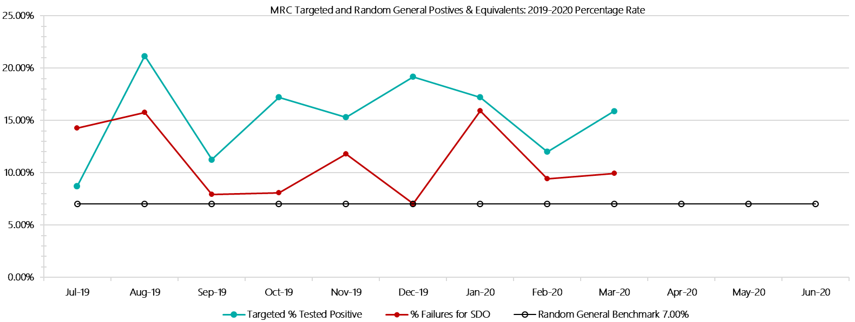***

***Metropolitan Remand Centre Positive Drug Test Results by Drug Type: 2019-2020***

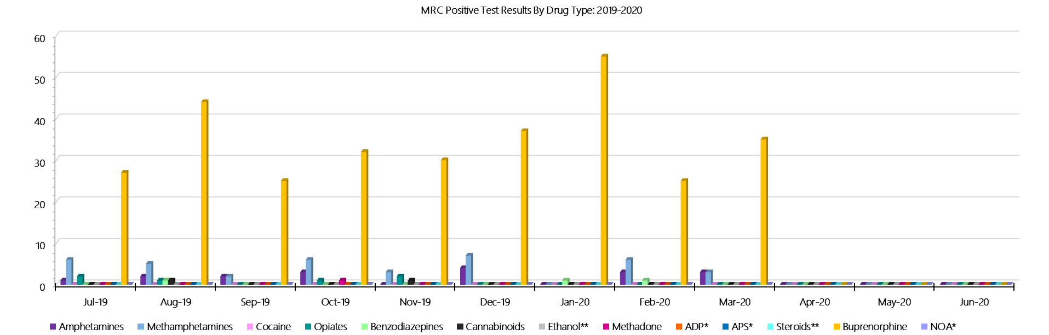

***Metropolitan Remand Centre Count of Visitor Seizures Finds: 2019-2020***

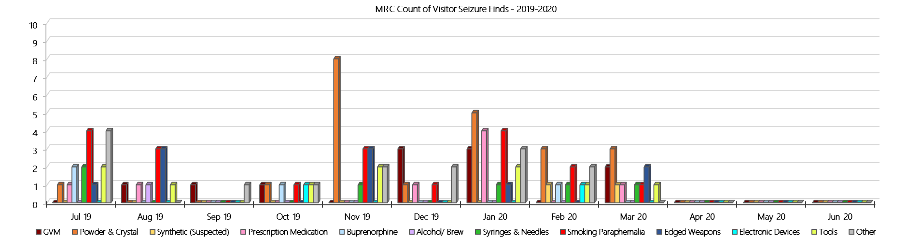

***Metropolitan Remand Centre Count of Prisoner Seizure Finds: 2019-2020***

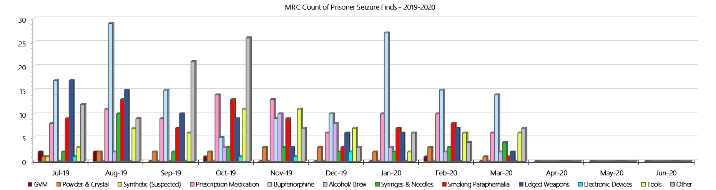

### **Port Phillip Prison**

***Targeted and Random General Drug Test Results: 2019-2020***

|  |  |  |  |  |  |  |  |  |  |  |  |  |  |  |
| --- | --- | --- | --- | --- | --- | --- | --- | --- | --- | --- | --- | --- | --- | --- |
| **Port Phillip Prison** | **Jul-19** | **Aug-19** | **Sep-19** | **Oct-19** | **Nov-19** | **Dec-19** | **Jan-20** | **Feb-19** | **Mar-20** | **Apr-20** | **May-20** | **Jun-20** | **Average** | ***Totals*** |
| **Effective Sample - Targeted** | **311** | **292** | **262** | **342** | **310** | **263** | **307** | **232** | **216** |  |  |  | **282** | ***2535*** |
| **Targeted Positives** | **28** | **34** | **33** | **21** | **35** | **20** | **32** | **15** | **21** |  |  |  | **27** | ***239*** |
| **Refusal** | **3** | **4** | **7** | **7** | **4** | **7** | **6** | **1** | **6** |  |  |  | **5** | ***45*** |
| **Unable** | **0** | **1** | **1** | **1** | **2** | **3** | **4** | **1** | **0** |  |  |  | **1** | ***13*** |
| **Interfered** | **0** | **0** | **0** | **0** | **0** | **0** | **0** | **0** | **0** |  |  |  | **0** | ***0*** |
| **Adulterated** | **0** | **1** | **2** | **1** | **0** | **0** | **2** | **1** | **0** |  |  |  | **1** | ***7*** |
| **Targeted % Tested Positive** | **9.97%** | **13.70%** | **16.41%** | **8.77%** | **13.23%** | **11.41%** | **14.33%** | **7.76%** | **12.50%** | **#N/A** | **#N/A** | **#N/A** | **11.99%** | ***11.99%*** |
| **Awaiting / Pending Results** | **0** | **0** | **0** | **0** | **0** | **0** | **0** | **0** | **0** |  |  |  | **0** | ***0*** |
| **Targeted Residual** | **4** | **1** | **4** | **1** | **1** | **1** | **0** | **0** | **0** |  |  |  | **1** | ***12*** |
| **Random tests collected** | **63** | **53** | **61** | **51** | **51** | **62** | **50** | **51** | **64** |  |  |  | **56** | ***506*** |
| **Tested Positive** | **3** | **5** | **4** | **1** | **4** | **5** | **3** | **2** | **6** |  |  |  | **4** | ***33*** |
| **Refusal (guilty)** | **1** | **0** | **0** | **0** | **0** | **0** | **0** | **0** | **0** |  |  |  | **0** | ***1*** |
| **Unable (not guilty)** | **1** | **1** | **1** | **0** | **0** | **0** | **0** | **1** | **0** |  |  |  | **0** | ***4*** |
| **Unable (guilty)** | **0** | **0** | **0** | **0** | **1** | **0** | **0** | **0** | **1** |  |  |  | **0** | ***2*** |
| **Interfered (guilty)** | **0** | **0** | **0** | **0** | **0** | **0** | **0** | **0** | **0** |  |  |  | **0** | ***0*** |
| **No test (valid reason)** | **3** | **1** | **3** | **1** | **0** | **3** | **4** | **1** | **2** |  |  |  | **2** | ***18*** |
| **No test (no valid reason)** | **0** | **0** | **0** | **0** | **0** | **0** | **0** | **0** | **1** |  |  |  | **0** | ***1*** |
| **Adulterated** | **0** | **0** | **0** | **0** | **0** | **0** | **0** | **0** | **0** |  |  |  | **0** | ***0*** |
| **Awaiting / Pending Results** | **0** | **0** | **0** | **0** | **0** | **0** | **0** | **0** | **1** |  |  |  | **0** | ***1*** |
| **Random Residual *(PIMS URAR030)*** | **0** | **0** | **0** | **0** | **1** | **0** | **0** | **0** | **1** |  |  |  | ***0.222222*** | ***2*** |
| **Effective Sample - Random General** | **64** | **53** | **61** | **51** | **52** | **62** | **50** | **51** | **66** |  |  |  | **57** | **510** |
| **% Tested positive** | **4.69%** | **9.43%** | **6.56%** | **1.96%** | **7.69%** | **8.06%** | **6.00%** | **3.92%** | **9.09%** |  |  |  | **6.38%** |  |
| **% Prisoner guilty, positive equivalents** | **1.56%** | **0.00%** | **0.00%** | **0.00%** | **1.92%** | **0.00%** | **0.00%** | **0.00%** | **1.52%** |  |  |  | **0.56%** |  |
| **% Total prisoner fails** | **6.25%** | **9.43%** | **6.56%** | **1.96%** | **9.62%** | **8.06%** | **6.00%** | **3.92%** | **10.61%** |  |  |  | **6.93%** |  |
| **% No test without valid reason** | **0.00%** | **0.00%** | **0.00%** | **0.00%** | **0.00%** | **0.00%** | **0.00%** | **0.00%** | **1.52%** |  |  |  | **0.17%** |  |
| **% Failures for SDO** | **6.25%** | **9.43%** | **6.56%** | **1.96%** | **9.62%** | **8.06%** | **6.00%** | **3.92%** | **12.12%** | **#N/A** | **#N/A** | **#N/A** | **7.25%** |  |

***Port Phillip Prison - Drugs Identified Through Testing by Drug Type: 2019-2020***

|  |  |  |  |  |  |  |  |  |  |  |  |  |  |  |
| --- | --- | --- | --- | --- | --- | --- | --- | --- | --- | --- | --- | --- | --- | --- |
| **PPP** | ***Amphetamines*** | ***Methamphetamines*** | ***Cocaine*** | ***Opiates*** | ***Benzodiazepines*** | ***Cannabinoids*** | ***Ethanol\*\**** | ***Methadone*** | ***ADP\**** | ***APS\**** | ***Steroids\*\**** | ***Buprenorphine*** | ***NOA\**** | **Total** |
| **Jul-19** | **2** | **2** | **0** | **0** | **0** | **0** | **0** | **5** | **0** | **0** | **0** | **36** | **0** | **45** |
| **Aug-19** | **4** | **5** | **0** | **0** | **0** | **0** | **0** | **4** | **0** | **0** | **0** | **39** | **0** | **52** |
| **Sep-19** | **6** | **11** | **0** | **0** | **0** | **0** | **0** | **2** | **0** | **0** | **0** | **39** | **0** | **58** |
| **Oct-19** | **0** | **1** | **0** | **0** | **0** | **0** | **0** | **0** | **0** | **0** | **0** | **26** | **0** | **27** |
| **Nov-19** | **1** | **2** | **0** | **1** | **1** | **0** | **0** | **0** | **0** | **0** | **0** | **40** | **0** | **45** |
| **Dec-19** | **3** | **5** | **0** | **0** | **1** | **1** | **0** | **1** | **0** | **0** | **0** | **32** | **0** | **43** |
| **Jan-20** | **0** | **0** | **0** | **0** | **0** | **0** | **2** | **1** | **0** | **0** | **0** | **40** | **0** | **43** |
| **Feb-20** | **0** | **0** | **0** | **0** | **0** | **0** | **0** | **1** | **0** | **0** | **0** | **26** | **0** | **27** |
| **Mar-20** | **1** | **2** | **0** | **0** | **0** | **0** | **1** | **1** | **0** | **0** | **0** | **32** | **0** | **37** |
| **Apr-20** |  |  |  |  |  |  |  |  |  |  |  |  |  |  |
| **May-20** |  |  |  |  |  |  |  |  |  |  |  |  |  |  |
| **Jun-20** |  |  |  |  |  |  |  |  |  |  |  |  |  |  |
| **PPP YTD** | **17** | **28** | **0** | **1** | **2** | **1** | **3** | **15** | **0** | **0** | **0** | **310** | **0** | **377** |
| ***All Prisons YTD*** | ***133*** | ***224*** | ***2*** | ***35*** | ***30*** | ***30*** | ***20*** | ***32*** | ***49*** | ***13*** | ***0*** | ***1785*** | ***0*** | ***2353*** |
| ***PPP % of Total*** | ***12.78%*** | ***12.50%*** | ***0.00%*** | ***2.86%*** | ***6.67%*** | ***3.33%*** | ***15.00%*** | ***46.88%*** | ***0.00%*** | ***0.00%*** | ***0.00%*** | ***17.37%*** | ***0.00%*** | ***16.02%*** |

***Port Phillip Prison Seizures of Contraband: Visitors & Prisoners: 2019-2020***

|  |  |  |  |  |  |  |  |  |  |  |  |  |  |  |  |  |  |  |  |  |  |  |  |  |  |
| --- | --- | --- | --- | --- | --- | --- | --- | --- | --- | --- | --- | --- | --- | --- | --- | --- | --- | --- | --- | --- | --- | --- | --- | --- | --- |
| **Visitors** | **GVM** | | **Powder  & Crystal** | | **Synthetic  (Suspected)** | | **Prescription  Medication** | | **Buprenorphine** | | **Alcohol &  Home Brew** | | **Syringes & Needles** | | **Smoking  Paraphernalia** | | **Edged  Weapons** | | **Electronic  Devices** | | **Tools** | | **Other** | | |
| **PPP** | **Finds** | **Gms** | **Finds** | **Gms** | **Finds** | **Gms** | **Finds** | **Qty** | **Finds** | **Qty** | **Finds** | **Ltrs** | **Finds** | **Qty** | **Finds** | **Qty** | **Finds** | **Qty** | **Finds** | **Qty** | **Finds** | **Qty** | **Finds** | **Qty** |
| **Jul-19** | **0** | **0.00** | **1** | **2.00** | **0** | **0.00** | **0** | **0.00** | **3** | **158.00** | **0** | **0.000** | **1** | **4** | **0** | **0** | **0** | **0** | **0** | **0** | **0** | **0** | **0** | **0** |
| **Aug-19** | **1** | **22.00** | **1** | **18.43** | **0** | **0.00** | **0** | **0.00** | **1** | **94.00** | **0** | **0.000** | **1** | **3** | **0** | **0** | **1** | **1** | **0** | **0** | **0** | **0** | **0** | **0** |
| **Sep-19** | **0** | **0.00** | **0** | **0.00** | **0** | **0.00** | **0** | **0.00** | **0** | **0.00** | **0** | **0.000** | **0** | **0** | **0** | **0** | **0** | **0** | **0** | **0** | **0** | **0** | **0** | **0** |
| **Oct-19** | **0** | **0.00** | **0** | **0.00** | **0** | **0.00** | **1** | **2.00** | **0** | **0.00** | **0** | **0.000** | **2** | **5** | **3** | **7** | **0** | **0** | **0** | **0** | **0** | **0** | **0** | **0** |
| **Nov-19** | **0** | **0.00** | **0** | **0.00** | **0** | **0.00** | **0** | **0.00** | **0** | **0.00** | **0** | **0.000** | **0** | **0** | **0** | **0** | **0** | **0** | **0** | **0** | **0** | **0** | **0** | **0** |
| **Dec-19** | **0** | **0.00** | **0** | **0.00** | **0** | **0.00** | **0** | **0.00** | **0** | **0.00** | **0** | **0.000** | **0** | **0** | **0** | **0** | **0** | **0** | **0** | **0** | **0** | **0** | **0** | **0** |
| **Jan-20** | **0** | **0.00** | **2** | **2.61** | **0** | **0.00** | **0** | **0.00** | **1** | **18.00** | **0** | **0.000** | **0** | **0** | **1** | **8** | **0** | **0** | **0** | **0** | **0** | **0** | **0** | **0** |
| **Feb-20** | **2** | **14.16** | **6** | **23.81** | **0** | **0.00** | **0** | **0.00** | **2** | **60.00** | **0** | **0.000** | **4** | **11** | **2** | **3** | **1** | **1** | **0** | **0** | **0** | **0** | **1** | **1** |
| **Mar-20** | **5** | **14.97** | **4** | **5.10** | **0** | **0.00** | **0** | **0.00** | **0** | **0.00** | **0** | **0.000** | **2** | **12** | **4** | **7** | **0** | **0** | **0** | **0** | **0** | **0** | **1** | **5** |
| **Apr-20** |  |  |  |  |  |  |  |  |  |  |  |  |  |  |  |  |  |  |  |  |  |  |  |  |
| **May-20** |  |  |  |  |  |  |  |  |  |  |  |  |  |  |  |  |  |  |  |  |  |  |  |  |
| **Jun-20** |  |  |  |  |  |  |  |  |  |  |  |  |  |  |  |  |  |  |  |  |  |  |  |  |
| **Total** | **8** | **51.13** | **14** | **51.95** | **0** | **0.00** | **1** | **2.00** | **7** | **330.00** | **0** | **0.000** | **10** | **35** | **10** | **25** | **2** | **2** | **0** | **0** | **0** | **0** | **2** | **6** |

|  |  |  |  |  |  |  |  |  |  |  |  |  |  |  |  |  |  |  |  |  |  |  |  |  |
| --- | --- | --- | --- | --- | --- | --- | --- | --- | --- | --- | --- | --- | --- | --- | --- | --- | --- | --- | --- | --- | --- | --- | --- | --- |
| **Prisoners** | **GVM** | | **Powder  & Crystal** | | **Synthetic  (Suspected)** | | **Prescription  Medication** | | **Buprenorphine** | | **Alcohol &  Home Brew** | | **Syringes & Needles** | | **Smoking  Paraphernalia** | | **Edged  Weapons** | | **Electronic  Devices** | | **Tools** | | **Other** | |
| **PPP** | **Finds** | **Gms** | **Finds** | **Gms** | **Finds** | **Gms** | **Finds** | **Qty** | **Finds** | **Qty** | **Finds** | **Ltrs** | **Finds** | **Qty** | **Finds** | **Qty** | **Finds** | **Qty** | **Finds** | **Qty** | **Finds** | **Qty** | **Finds** | **Qty** |
| **Jul-19** | **0** | **0.00** | **0** | **0.00** | **0** | **0.00** | **9** | **29.50** | **9** | **34.30** | **0** | **0.000** | **2** | **2** | **5** | **7** | **14** | **15** | **0** | **0** | **3** | **3** | **11** | **16** |
| **Aug-19** | **0** | **0.00** | **0** | **1.00** | **0** | **0.00** | **0** | **5.00** | **6** | **21.20** | **0** | **0.000** | **0** | **0** | **0** | **6** | **1** | **12** | **0** | **0** | **0** | **17** | **7** | **24** |
| **Sep-19** | **0** | **0.00** | **2** | **4.00** | **0** | **0.00** | **5** | **15.50** | **12** | **33.30** | **1** | **3.000** | **8** | **8** | **5** | **5** | **23** | **27** | **0** | **0** | **8** | **8** | **27** | **40** |
| **Oct-19** | **0** | **0.00** | **0** | **0.00** | **0** | **0.00** | **9** | **37.50** | **14** | **50.95** | **0** | **0.000** | **1** | **3** | **4** | **5** | **16** | **17** | **0** | **0** | **9** | **11** | **11** | **11** |
| **Nov-19** | **0** | **0.00** | **1** | **1.00** | **0** | **0.00** | **9** | **15.50** | **15** | **59.50** | **4** | **16.000** | **2** | **2** | **2** | **2** | **13** | **16** | **2** | **0** | **2** | **4** | **8** | **8** |
| **Dec-19** | **0** | **0.00** | **0** | **0.00** | **0** | **0.00** | **3** | **6.00** | **18** | **203.00** | **8** | **13.500** | **3** | **14** | **1** | **1** | **11** | **11** | **1** | **2** | **0** | **0** | **13** | **23** |
| **Jan-20** | **0** | **0.00** | **1** | **1.30** | **0** | **0.00** | **12** | **26.00** | **16** | **36.00** | **6** | **11.000** | **4** | **4** | **2** | **3** | **12** | **12** | **0** | **0** | **1** | **1** | **8** | **8** |
| **Feb-20** | **0** | **0.00** | **0** | **0.00** | **0** | **0.00** | **12** | **39.00** | **10** | **1.30** | **7** | **27.200** | **1** | **1** | **3** | **4** | **16** | **17** | **0** | **0** | **1** | **1** | **11** | **28** |
| **Mar-20** | **0** | **0.00** | **0** | **0.00** | **0** | **0.00** | **0** | **21.50** | **0** | **50.60** | **0** | **35.000** | **0** | **5** | **0** | **6** | **0** | **13** | **0** | **0** | **0** | **0** | **0** | **8** |
| **Apr-20** |  |  |  |  |  |  |  |  |  |  |  |  |  |  |  |  |  |  |  |  |  |  |  |  |
| **May-20** |  |  |  |  |  |  |  |  |  |  |  |  |  |  |  |  |  |  |  |  |  |  |  |  |
| **Jun-20** |  |  |  |  |  |  |  |  |  |  |  |  |  |  |  |  |  |  |  |  |  |  |  |  |
| **Total** | **0** | **0.00** | **4** | **7.30** | **0** | **0.00** | **59** | **195.50** | **100** | **490.15** | **26** | **105.700** | **21** | **39** | **22** | **39** | **106** | **140** | **3** | **2** | **24** | **45** | **96** | **166** |

***Port Phillip Prison Targeted and Random General Drug Test Positives & Equivalents: 2019-2020***

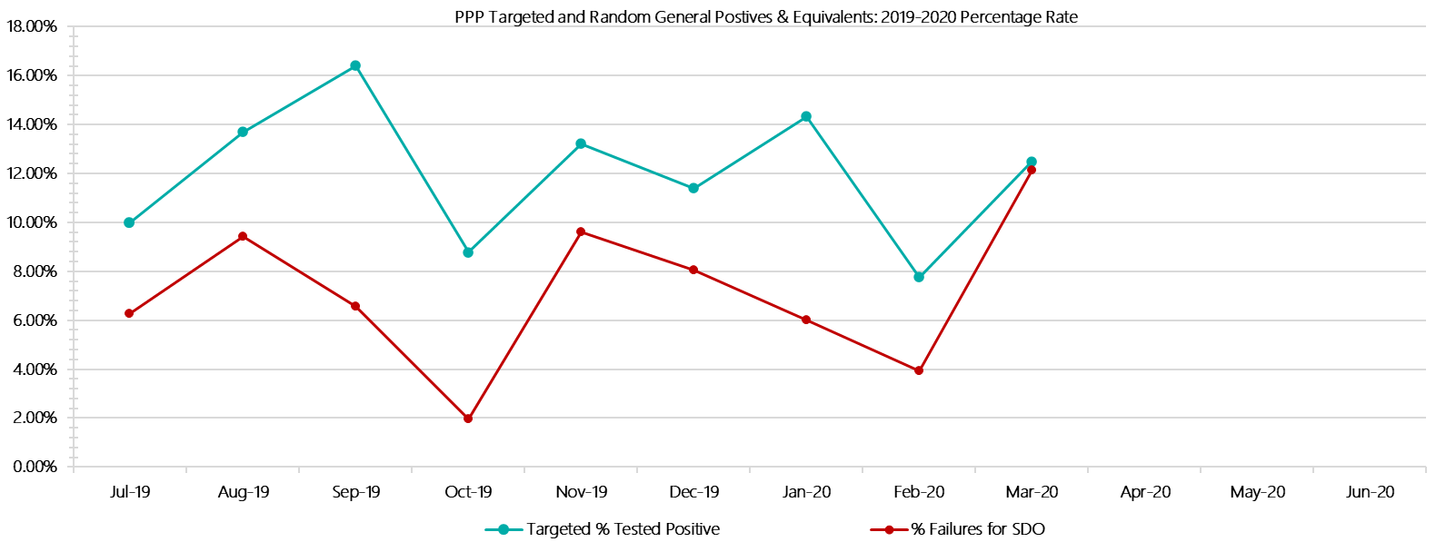

***Port Phillip Prison Positive Test Results by Drug Type: 2019-2020***

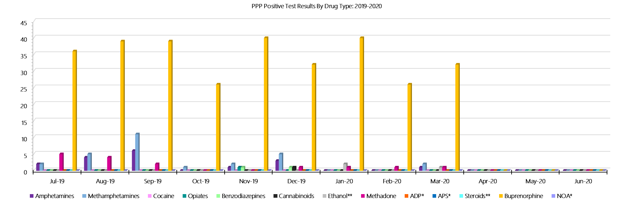

***Port Phillip Prison Count of Visitor Seizures Finds: 2019-2020***

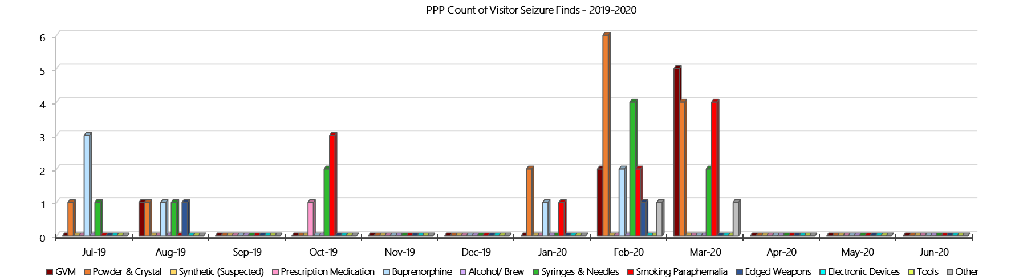

***Port Phillip Prison Count of Prisoner Seizure Finds: 2019-2020***

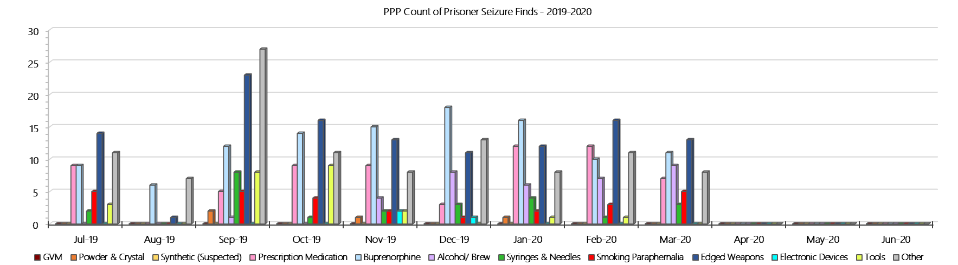

### **Dame Phyllis Frost Centre**

***Targeted and Random General Drug Test Results: 2019-2020***

|  |  |  |  |  |  |  |  |  |  |  |  |  |  |  |
| --- | --- | --- | --- | --- | --- | --- | --- | --- | --- | --- | --- | --- | --- | --- |
| **DPFC** | **Jul-19** | **Aug-19** | **Sep-19** | **Oct-19** | **Nov-19** | **Dec-19** | **Jan-20** | **Feb-20** | **Mar-20** | **Apr-20** | **May-20** | **Jun-20** | **Average** | ***Totals*** |
| **Effective Sample - Targeted** | **55** | **90** | **112** | **125** | **160** | **134** | **163** | **127** | **139** |  |  |  | **123** | ***1105*** |
| **Targeted Positives** | **5** | **3** | **2** | **12** | **11** | **14** | **9** | **1** | **8** |  |  |  | **7** | ***65*** |
| **Refusal** | **3** | **1** | **2** | **1** | **3** | **6** | **4** | **1** | **5** |  |  |  | **3** | ***26*** |
| **Unable** | **2** | **0** | **1** | **2** | **2** | **1** | **1** | **0** | **0** |  |  |  | **1** | ***9*** |
| **Interfered** | **0** | **0** | **0** | **0** | **0** | **0** | **0** | **0** | **0** |  |  |  | **0** | ***0*** |
| **Adulterated** | **0** | **0** | **0** | **0** | **0** | **0** | **1** | **0** | **0** |  |  |  | **0** | ***1*** |
| **Targeted % Tested Positive** | **18.18%** | **4.44%** | **4.46%** | **12.00%** | **10.00%** | **15.67%** | **9.20%** | **1.57%** | **9.35%** | **#N/A** | **#N/A** | **#N/A** | **9.14%** | ***9.14%*** |
| **Awaiting / Pending Results** | **0** | **0** | **0** | **0** | **0** | **0** | **0** | **2** | **2** |  |  |  | **0** | ***4*** |
| **Targeted Residual** | **0** | **1** | **0** | **0** | **1** | **0** | **1** | **0** | **1** |  |  |  | **0** | ***4*** |
| **Random tests collected** | **77** | **60** | **70** | **59** | **58** | **68** | **58** | **57** | **68** |  |  |  | **64** | ***575*** |
| **Tested Positive** | **0** | **0** | **0** | **2** | **0** | **0** | **0** | **0** | **1** |  |  |  | **0** | ***3*** |
| **Refusal (guilty)** | **0** | **0** | **1** | **0** | **0** | **0** | **0** | **0** | **0** |  |  |  | **0** | ***1*** |
| **Unable (not guilty)** | **0** | **0** | **0** | **0** | **0** | **0** | **0** | **0** | **0** |  |  |  | **0** | ***0*** |
| **Unable (guilty)** | **0** | **0** | **0** | **0** | **0** | **0** | **0** | **0** | **0** |  |  |  | **0** | ***0*** |
| **Interfered (guilty)** | **0** | **0** | **0** | **0** | **0** | **0** | **0** | **0** | **0** |  |  |  | **0** | ***0*** |
| **No test (valid reason)** | **2** | **2** | **5** | **0** | **1** | **2** | **0** | **1** | **3** |  |  |  | **2** | ***16*** |
| **No test (no valid reason)** | **0** | **0** | **0** | **0** | **0** | **0** | **0** | **0** | **0** |  |  |  | **0** | ***0*** |
| **Adulterated** | **0** | **0** | **0** | **0** | **0** | **0** | **0** | **0** | **0** |  |  |  | **0** | ***0*** |
| **Awaiting / Pending Results** | **0** | **0** | **0** | **0** | **0** | **0** | **0** | **0** | **0** |  |  |  | **0** | ***0*** |
| **Random Residual *(PIMS URAR030)*** | **0** | **0** | **0** | **0** | **0** | **0** | **0** | **0** | **0** |  |  |  | ***0*** | ***0*** |
| **Effective Sample - Random General** | **77** | **60** | **71** | **59** | **58** | **68** | **58** | **57** | **68** |  |  |  | **64** | **576** |
| **% Tested positive** | **0.00%** | **0.00%** | **0.00%** | **3.39%** | **0.00%** | **0.00%** | **0.00%** | **0.00%** | **1.47%** |  |  |  | **0.54%** |  |
| **% Prisoner guilty, positive equivalents** | **0.00%** | **0.00%** | **1.41%** | **0.00%** | **0.00%** | **0.00%** | **0.00%** | **0.00%** | **0.00%** |  |  |  | **0.16%** |  |
| **% Total prisoner fails** | **0.00%** | **0.00%** | **1.41%** | **3.39%** | **0.00%** | **0.00%** | **0.00%** | **0.00%** | **1.47%** |  |  |  | **0.70%** |  |
| **% No test without valid reason** | **0.00%** | **0.00%** | **0.00%** | **0.00%** | **0.00%** | **0.00%** | **0.00%** | **0.00%** | **0.00%** |  |  |  | **0.00%** |  |
| ***Random General Benchmark 7.25%*** | ***7.25%*** | ***7.25%*** | ***7.25%*** | ***7.25%*** | ***7.25%*** | ***7.25%*** | ***7.25%*** | ***7.25%*** | ***7.25%*** | ***7.25%*** | ***7.25%*** | ***7.25%*** | ***YTD*** |  |
| **% Failures for SDO** | **0.00%** | **0.00%** | **1.41%** | **3.39%** | **0.00%** | **0.00%** | **0.00%** | **0.00%** | **1.47%** | **#N/A** | **#N/A** | **#N/A** | **0.69%** |  |

***Dame Phyllis Frost Centre - Drugs Identified Through Testing by Drug Type: 2019-2020***

|  |  |  |  |  |  |  |  |  |  |  |  |  |  |  |
| --- | --- | --- | --- | --- | --- | --- | --- | --- | --- | --- | --- | --- | --- | --- |
| **DPFC** | ***Amphetamines*** | ***Methamphetamines*** | ***Cocaine*** | ***Opiates*** | ***Benzodiazepines*** | ***Cannabinoids*** | ***Ethanol\*\**** | ***Methadone*** | ***ADP\**** | ***APS\**** | ***Steroids\*\**** | ***Buprenorphine*** | ***NOA\**** | **Total** |
| **Jul-19** | **4** | **4** | **0** | **0** | **0** | **0** | **0** | **0** | **0** | **0** | **0** | **3** | **0** | **11** |
| **Aug-19** | **2** | **2** | **0** | **0** | **0** | **0** | **0** | **0** | **0** | **0** | **0** | **2** | **0** | **6** |
| **Sep-19** | **0** | **0** | **0** | **1** | **0** | **1** | **0** | **0** | **0** | **0** | **0** | **0** | **0** | **2** |
| **Oct-19** | **8** | **13** | **0** | **0** | **0** | **0** | **0** | **0** | **0** | **1** | **0** | **1** | **0** | **23** |
| **Nov-19** | **3** | **4** | **0** | **0** | **0** | **0** | **0** | **0** | **1** | **0** | **0** | **7** | **0** | **15** |
| **Dec-19** | **4** | **6** | **0** | **6** | **1** | **0** | **0** | **0** | **0** | **0** | **0** | **4** | **0** | **21** |
| **Jan-20** | **1** | **2** | **1** | **5** | **2** | **0** | **0** | **0** | **1** | **0** | **0** | **0** | **0** | **12** |
| **Feb-20** | **0** | **0** | **0** | **0** | **0** | **0** | **0** | **0** | **0** | **0** | **0** | **1** | **0** | **1** |
| **Mar-20** | **4** | **5** | **0** | **1** | **0** | **0** | **0** | **0** | **0** | **0** | **0** | **2** | **0** | **12** |
| **Apr-20** |  |  |  |  |  |  |  |  |  |  |  |  |  |  |
| **May-20** |  |  |  |  |  |  |  |  |  |  |  |  |  |  |
| **Jun-20** |  |  |  |  |  |  |  |  |  |  |  |  |  |  |
| **DPFC YTD** | **26** | **36** | **1** | **13** | **3** | **1** | **0** | **0** | **2** | **1** | **0** | **20** | **0** | **103** |
| ***All Prisons YTD*** | ***133*** | ***224*** | ***2*** | ***35*** | ***30*** | ***30*** | ***20*** | ***32*** | ***49*** | ***13*** | ***0*** | ***1785*** | ***0*** | ***2353*** |
| ***DPFC % of Total*** | ***19.55%*** | ***16.07%*** | ***50.00%*** | ***37.14%*** | ***10.00%*** | ***3.33%*** | ***0.00%*** | ***0.00%*** | ***4.08%*** | ***7.69%*** | ***0.00%*** | ***1.12%*** | ***0.00%*** | ***4.38%*** |

***Dame Phyllis Frost Centre - Seizures of Contraband: Visitors & Prisoners: 2019-2020***

|  |  |  |  |  |  |  |  |  |  |  |  |  |  |  |  |  |  |  |  |  |  |  |  |  |  |  |
| --- | --- | --- | --- | --- | --- | --- | --- | --- | --- | --- | --- | --- | --- | --- | --- | --- | --- | --- | --- | --- | --- | --- | --- | --- | --- | --- |
| **Visitors** | **GVM** | | **Powder  & Crystal** | | **Synthetic  (Suspected)** | | **Prescription  Medication** | | **Buprenorphine** | | **Alcohol &  Home Brew** | | **Syringes & Needles** | | **Smoking  Paraphernalia** | | | **Edged  Weapons** | | **Electronic  Devices** | | **Tools** | | **Other** | | |
| **DPFC** | **Finds** | **Gms** | **Finds** | **Gms** | **Finds** | **Gms** | **Finds** | **Qty** | **Finds** | **Qty** | **Finds** | **Ltrs** | **Finds** | **Qty** | **Finds** | **Qty** | | **Finds** | **Qty** | **Finds** | **Qty** | **Finds** | **Qty** | **Finds** | **Qty** |
| **Jul-19** | **0** | **0.00** | **0** | **0.00** | **0** | **0.00** | **0** | **0.00** | **0** | **0.00** | **0** | **0.000** | **0** | **0** | **0** | | **0** | **0** | **0** | **0** | **0** | **0** | **0** | **0** | **0** |
| **Aug-19** | **0** | **0.00** | **0** | **0.00** | **0** | **0.00** | **0** | **0.00** | **0** | **0.00** | **0** | **0.000** | **0** | **0** | **0** | | **0** | **0** | **0** | **0** | **0** | **0** | **0** | **0** | **0** |
| **Sep-19** | **0** | **0.00** | **0** | **0.00** | **0** | **0.00** | **0** | **0.00** | **0** | **0.00** | **0** | **0.000** | **0** | **0** | **0** | | **0** | **0** | **0** | **0** | **0** | **0** | **0** | **0** | **0** |
| **Oct-19** | **0** | **0.00** | **0** | **0.00** | **0** | **0.00** | **0** | **0.00** | **0** | **0.00** | **0** | **0.000** | **0** | **0** | **0** | | **0** | **0** | **0** | **1** | **1** | **0** | **0** | **0** | **0** |
| **Nov-19** | **0** | **0.00** | **0** | **0.00** | **0** | **0.00** | **0** | **0.00** | **0** | **0.00** | **0** | **0.000** | **0** | **0** | **0** | | **0** | **0** | **0** | **0** | **0** | **0** | **0** | **0** | **0** |
| **Dec-19** | **0** | **0.00** | **0** | **0.00** | **0** | **0.00** | **0** | **0.00** | **0** | **0.00** | **0** | **0.000** | **0** | **0** | **0** | | **0** | **0** | **0** | **0** | **0** | **0** | **0** | **0** | **0** |
| **Jan-20** | **0** | **0.00** | **0** | **0.00** | **0** | **0.00** | **1** | **4.00** | **0** | **0.00** | **0** | **0.000** | **0** | **0** | **0** | | **0** | **0** | **0** | **0** | **0** | **0** | **0** | **0** | **0** |
| **Feb-20** | **0** | **0.00** | **0** | **0.00** | **0** | **0.00** | **0** | **0.00** | **0** | **0.00** | **0** | **0.000** | **0** | **0** | **0** | | **0** | **0** | **0** | **0** | **0** | **0** | **0** | **0** | **0** |
| **Mar-20** | **0** | **0.00** | **1** | **1.30** | **0** | **0.00** | **1** | **7.00** | **0** | **0.00** | **0** | **0.000** | **0** | **0** | **1** | | **1** | **0** | **0** | **0** | **0** | **0** | **0** | **0** | **0** |
| **Apr-20** |  |  |  |  |  |  |  |  |  |  |  |  |  |  |  | |  |  |  |  |  |  |  |  |  |
| **May-20** |  |  |  |  |  |  |  |  |  |  |  |  |  |  |  | |  |  |  |  |  |  |  |  |  |
| **Jun-20** |  |  |  |  |  |  |  |  |  |  |  |  |  |  |  | |  |  |  |  |  |  |  |  |  |
| **Total** | **0** | **0.00** | **1** | **1.30** | **0** | **0.00** | **2** | **11.00** | **0** | **0.00** | **0** | **0.000** | **0** | **0** | **1** | | **1** | **0** | **0** | **1** | **1** | **0** | **0** | **0** | **0** |

|  |  |  |  |  |  |  |  |  |  |  |  |  |  |  |  |  |  |  |  |  |  |  |  |  |  |
| --- | --- | --- | --- | --- | --- | --- | --- | --- | --- | --- | --- | --- | --- | --- | --- | --- | --- | --- | --- | --- | --- | --- | --- | --- | --- |
| **Prisoners** | **GVM** | | **Powder  & Crystal** | | **Synthetic  (Suspected)** | | **Prescription  Medication** | | **Buprenorphine** | | **Alcohol &  Home Brew** | | **Syringes & Needles** | | **Smoking  Paraphernalia** | | | **Edged  Weapons** | | **Electronic  Devices** | | **Tools** | | **Other** | |
| **DPFC** | **Finds** | **Gms** | **Finds** | **Gms** | **Finds** | **Gms** | **Finds** | **Qty** | **Finds** | **Qty** | **Finds** | **Ltrs** | **Finds** | **Qty** | **Finds** | **Qty** | | **Finds** | **Qty** | **Finds** | **Qty** | **Finds** | **Qty** | **Finds** | **Qty** |
| **Jul-19** | **0** | **0.00** | **1** | **2.10** | **0** | **0.00** | **2** | **7.00** | **1** | **1.00** | **1** | **1.000** | **2** | **31** | **3** | | **3** | **0** | **0** | **0** | **0** | **0** | **0** | **0** | **0** |
| **Aug-19** | **0** | **0.00** | **1** | **1.00** | **0** | **0.00** | **0** | **0.00** | **1** | **1.00** | **1** | **0.600** | **3** | **6** | **2** | | **6** | **1** | **1** | **1** | **1** | **0** | **0** | **3** | **3** |
| **Sep-19** | **1** | **0.90** | **2** | **0.30** | **0** | **0.00** | **5** | **11.50** | **2** | **7.00** | **1** | **1.000** | **8** | **55** | **2** | | **3** | **0** | **0** | **1** | **1** | **0** | **0** | **2** | **2** |
| **Oct-19** | **0** | **0.00** | **4** | **11.60** | **0** | **0.00** | **4** | **2.75** | **0** | **0.00** | **1** | **2.600** | **3** | **3** | **2** | | **2** | **0** | **0** | **1** | **1** | **0** | **0** | **0** | **0** |
| **Nov-19** | **0** | **0.00** | **2** | **1.10** | **0** | **0.00** | **2** | **1.50** | **1** | **1.00** | **1** | **10.000** | **1** | **1** | **6** | | **20** | **0** | **0** | **0** | **0** | **2** | **2** | **0** | **0** |
| **Dec-19** | **1** | **5.10** | **4** | **16.70** | **0** | **0.00** | **1** | **2.00** | **1** | **1.00** | **2** | **2.000** | **0** | **0** | **6** | | **30** | **2** | **4** | **0** | **0** | **1** | **1** | **0** | **0** |
| **Jan-20** | **0** | **0.00** | **3** | **35.20** | **0** | **0.00** | **0** | **0.00** | **0** | **0.00** | **0** | **0.000** | **1** | **1** | **2** | | **2** | **0** | **0** | **0** | **0** | **0** | **0** | **4** | **4** |
| **Feb-20** | **0** | **0.00** | **1** | **1.00** | **0** | **0.00** | **1** | **1.00** | **1** | **0.30** | **0** | **0.000** | **1** | **1** | **1** | | **2** | **2** | **2** | **0** | **0** | **0** | **0** | **0** | **0** |
| **Mar-20** | **0** | **0.00** | **0** | **0.00** | **0** | **0.00** | **1** | **0.50** | **3** | **22.00** | **0** | **0.000** | **2** | **6** | **4** | | **5** | **2** | **2** | **0** | **0** | **0** | **0** | **1** | **1** |
| **Apr-20** |  |  |  |  |  |  |  |  |  |  |  |  |  |  |  | |  |  |  |  |  |  |  |  |  |
| **May-20** |  |  |  |  |  |  |  |  |  |  |  |  |  |  |  | |  |  |  |  |  |  |  |  |  |
| **Jun-20** |  |  |  |  |  |  |  |  |  |  |  |  |  |  |  | |  |  |  |  |  |  |  |  |  |
| **Total** | **2** | **6.00** | **18** | **69.00** | **0** | **0.00** | **15** | **25.75** | **7** | **11.30** | **7** | **17.200** | **19** | **98** | **24** | | **68** | **5** | **7** | **3** | **3** | **3** | **3** | **9** | **9** |

***Dame Phyllis Frost Centre Targeted and Random General Drug Test Positives & Equivalents – 2019-2020***

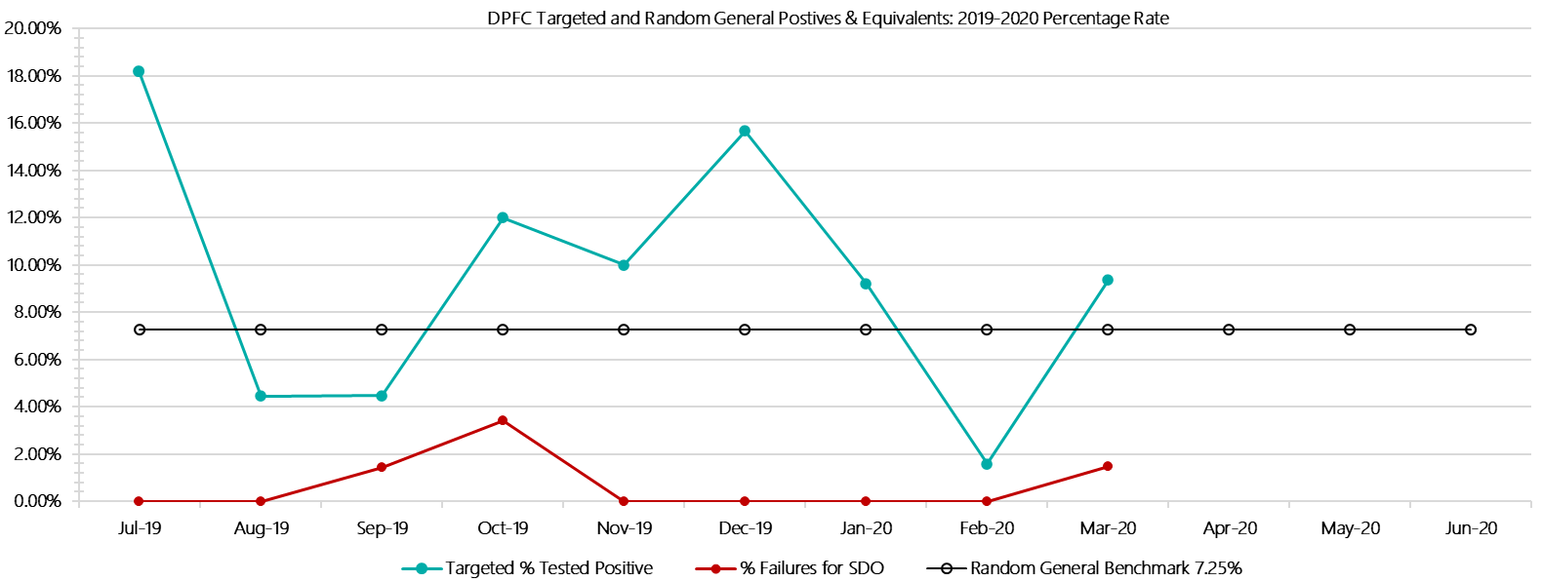

***Dame Phyllis Frost Centre Positive Test Results by Drug Type – 2019-2020  
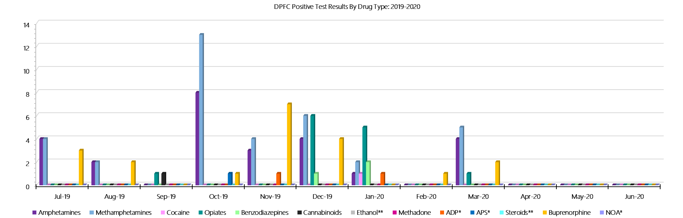***

***Dame Phyllis Frost Centre Count of Visitor Seizures Finds – 2019-2020***

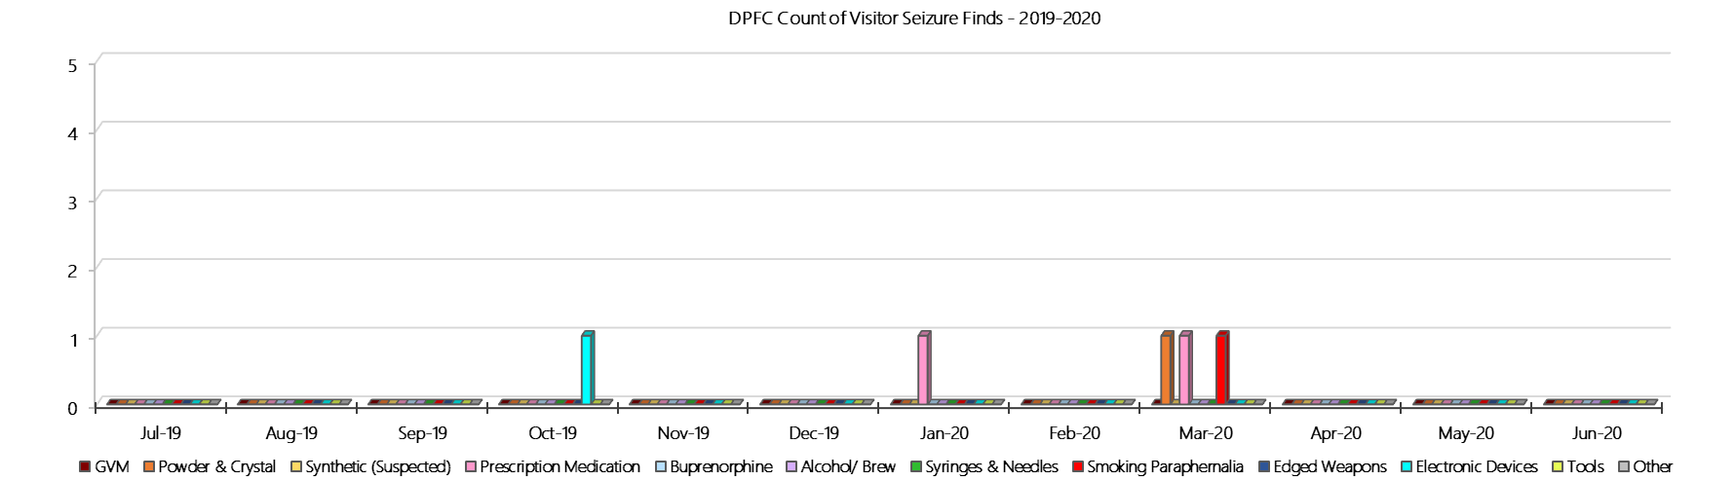

***DPFC Count of Prisoner Seizure Finds – 2019-2020***

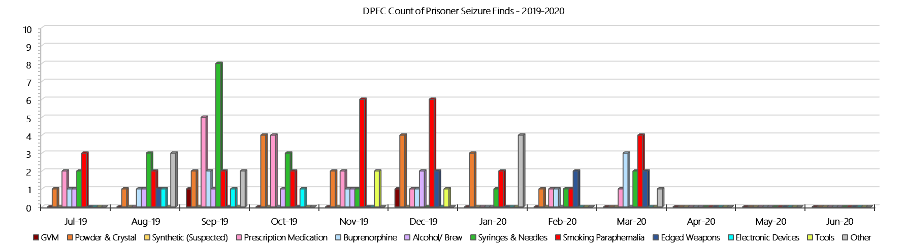

### **Fulham Correctional Centre**

***Targeted and Random General Drug Test Results: 2019-2020***

|  |  |  |  |  |  |  |  |  |  |  |  |  |  |  |
| --- | --- | --- | --- | --- | --- | --- | --- | --- | --- | --- | --- | --- | --- | --- |
| **Fulham** | **Jul-19** | **Aug-19** | **Sep-19** | **Oct-19** | **Nov-19** | **Dec-19** | **Jan-20** | **Feb-20** | **Mar-20** | **Apr-20** | **May-20** | **Jun-20** | **Average** | ***Totals*** |
| **Effective Sample - Targeted** | **224** | **204** | **204** | **197** | **193** | **198** | **206** | **186** | **194** |  |  |  | **201** | ***1806*** |
| **Targeted Positives** | **22** | **18** | **10** | **27** | **18** | **20** | **24** | **21** | **23** |  |  |  | **20** | ***183*** |
| **Refusal** | **0** | **0** | **0** | **0** | **0** | **0** | **1** | **2** | **0** |  |  |  | **0** | ***3*** |
| **Unable** | **0** | **3** | **3** | **0** | **2** | **4** | **2** | **7** | **3** |  |  |  | **3** | ***24*** |
| **Interfered** | **0** | **0** | **0** | **0** | **0** | **0** | **1** | **0** | **0** |  |  |  | **0** | ***1*** |
| **Adulterated** | **0** | **0** | **0** | **0** | **0** | **0** | **1** | **0** | **0** |  |  |  | **0** | ***1*** |
| **Targeted % Tested Positive** | **9.82%** | **10.29%** | **6.37%** | **13.71%** | **10.36%** | **12.12%** | **14.08%** | **16.13%** | **13.40%** | **#N/A** | **#N/A** | **#N/A** | **11.74%** | ***11.74%*** |
| **Awaiting / Pending Results** | **0** | **0** | **0** | **0** | **0** | **0** | **0** | **0** | **0** |  |  |  | **0** | ***0*** |
| **Targeted Residual** | **1** | **2** | **2** | **1** | **3** | **5** | **0** | **1** | **4** |  |  |  | **2** | ***19*** |
| **Random tests collected** | **76** | **61** | **73** | **57** | **60** | **74** | **63** | **62** | **78** |  |  |  | **67** | ***604*** |
| **Tested Positive** | **0** | **0** | **1** | **0** | **5** | **2** | **3** | **3** | **4** |  |  |  | **2** | ***18*** |
| **Refusal (guilty)** | **0** | **0** | **0** | **0** | **0** | **0** | **0** | **0** | **0** |  |  |  | **0** | ***0*** |
| **Unable (not guilty)** | **0** | **0** | **0** | **1** | **0** | **0** | **0** | **0** | **0** |  |  |  | **0** | ***1*** |
| **Unable (guilty)** | **0** | **0** | **1** | **0** | **0** | **1** | **1** | **0** | **0** |  |  |  | **0** | ***3*** |
| **Interfered (guilty)** | **0** | **0** | **0** | **0** | **0** | **0** | **0** | **0** | **0** |  |  |  | **0** | ***0*** |
| **No test (valid reason)** | **4** | **2** | **2** | **2** | **0** | **0** | **0** | **1** | **2** |  |  |  | **1** | ***13*** |
| **No test (no valid reason)** | **0** | **0** | **0** | **0** | **0** | **0** | **0** | **0** | **0** |  |  |  | **0** | ***0*** |
| **Adulterated** | **0** | **0** | **0** | **0** | **0** | **0** | **0** | **0** | **0** |  |  |  | **0** | ***0*** |
| **Awaiting / Pending Results** | **0** | **0** | **0** | **0** | **0** | **0** | **0** | **0** | **0** |  |  |  | **0** | ***0*** |
| **Random Residual *(PIMS URAR030)*** | **0** | **0** | **0** | **0** | **0** | **0** | **0** | **0** | **0** |  |  |  | ***0*** | ***0*** |
| **Effective Sample - Random General** | **76** | **61** | **74** | **57** | **60** | **75** | **64** | **62** | **78** |  |  |  | **67** | **607** |
| **% Tested positive** | **0.00%** | **0.00%** | **1.35%** | **0.00%** | **8.33%** | **2.67%** | **4.69%** | **4.84%** | **5.13%** |  |  |  | **3.00%** |  |
| **% Prisoner guilty, positive equivalents** | **0.00%** | **0.00%** | **1.35%** | **0.00%** | **0.00%** | **1.33%** | **1.56%** | **0.00%** | **0.00%** |  |  |  | **0.47%** |  |
| **% Total prisoner fails** | **0.00%** | **0.00%** | **2.70%** | **0.00%** | **8.33%** | **4.00%** | **6.25%** | **4.84%** | **5.13%** |  |  |  | **3.47%** |  |
| **% No test without valid reason** | **0.00%** | **0.00%** | **0.00%** | **0.00%** | **0.00%** | **0.00%** | **0.00%** | **0.00%** | **0.00%** |  |  |  | **0.00%** |  |
| **% Failures for SDO** | **0.00%** | **0.00%** | **2.70%** | **0.00%** | **8.33%** | **4.00%** | **6.25%** | **4.84%** | **5.13%** | **#N/A** | **#N/A** | **#N/A** | **3.46%** |  |

***Fulham - Drugs Identified Through Testing by Drug Type: 2019-2020***

|  |  |  |  |  |  |  |  |  |  |  |  |  |  |  |
| --- | --- | --- | --- | --- | --- | --- | --- | --- | --- | --- | --- | --- | --- | --- |
| **Fulham** | ***Amphetamines*** | ***Methamphetamines*** | ***Cocaine*** | ***Opiates*** | ***Benzodiazepines*** | ***Cannabinoids*** | ***Ethanol\*\**** | ***Methadone*** | ***ADP\**** | ***APS\**** | ***Steroids\*\**** | ***Buprenorphine*** | ***NOA\**** | **Total** |
| **Jul-19** | **0** | **0** | **0** | **2** | **0** | **1** | **0** | **1** | **3** | **1** | **0** | **17** | **0** | **25** |
| **Aug-19** | **2** | **3** | **0** | **0** | **0** | **0** | **0** | **0** | **6** | **2** | **0** | **11** | **0** | **24** |
| **Sep-19** | **0** | **0** | **0** | **3** | **1** | **0** | **0** | **0** | **1** | **0** | **0** | **6** | **0** | **11** |
| **Oct-19** | **0** | **0** | **0** | **0** | **1** | **0** | **0** | **1** | **5** | **2** | **0** | **24** | **0** | **33** |
| **Nov-19** | **0** | **0** | **0** | **2** | **2** | **0** | **0** | **0** | **5** | **0** | **0** | **20** | **0** | **29** |
| **Dec-19** | **0** | **3** | **0** | **0** | **0** | **0** | **0** | **0** | **2** | **3** | **0** | **15** | **0** | **23** |
| **Jan-20** | **6** | **9** | **0** | **0** | **0** | **0** | **0** | **0** | **2** | **1** | **0** | **22** | **0** | **40** |
| **Feb-20** | **0** | **1** | **0** | **0** | **0** | **0** | **0** | **0** | **7** | **1** | **0** | **20** | **0** | **29** |
| **Mar-20** | **0** | **1** | **0** | **0** | **0** | **1** | **0** | **0** | **6** | **0** | **0** | **27** | **0** | **35** |
| **Apr-20** |  |  |  |  |  |  |  |  |  |  |  |  |  |  |
| **May-20** |  |  |  |  |  |  |  |  |  |  |  |  |  |  |
| **Jun-20** |  |  |  |  |  |  |  |  |  |  |  |  |  |  |
| **Fuham YTD** | **8** | **17** | **0** | **7** | **4** | **2** | **0** | **2** | **37** | **10** | **0** | **162** | **0** | **249** |
| ***All Prisons YTD*** | ***133*** | ***224*** | ***2*** | ***35*** | ***30*** | ***30*** | ***20*** | ***32*** | ***49*** | ***13*** | ***0*** | ***1785*** | ***0*** | ***2353*** |
| ***Fulham % of Total*** | ***6.02%*** | ***7.59%*** | ***0.00%*** | ***20.00%*** | ***13.33%*** | ***6.67%*** | ***0.00%*** | ***6.25%*** | ***75.51%*** | ***76.92%*** | ***0.00%*** | ***9.08%*** | ***0.00%*** | ***10.58%*** |

***Fulham Seizures of Contraband: Visitors & Prisoners: 2019-2020***

|  |  |  |  |  |  |  |  |  |  |  |  |  |  |  |  |  |  |  |  |  |  |  |  |  |
| --- | --- | --- | --- | --- | --- | --- | --- | --- | --- | --- | --- | --- | --- | --- | --- | --- | --- | --- | --- | --- | --- | --- | --- | --- |
| **Visitors** | **GVM** | | **Powder  & Crystal** | | **Synthetic  (Suspected)** | | **Prescription  Medication** | | **Buprenorphine** | | **Alcohol &  Home Brew** | | **Syringes & Needles** | | **Smoking  Paraphernalia** | | **Edged  Weapons** | | **Electronic  Devices** | | **Tools** | | **Other** | |
| **Fulham** | **Finds** | **Gms** | **Finds** | **Gms** | **Finds** | **Gms** | **Finds** | **Qty** | **Finds** | **Qty** | **Finds** | **Ltrs** | **Finds** | **Qty** | **Finds** | **Qty** | **Finds** | **Qty** | **Finds** | **Qty** | **Finds** | **Qty** | **Finds** | **Qty** |
| **Jul-19** | **0** | **0.00** | **0** | **0.00** | **0** | **0.00** | **0** | **0.00** | **0** | **0.00** | **0** | **0.000** | **0** | **0** | **1** | **4** | **0** | **0** | **0** | **0** | **0** | **0** | **0** | **0** |
| **Aug-19** | **0** | **0** | **0** | **0** | **0** | **0** | **0** | **0** | **0** | **0** | **0** | **0** | **1** | **1** | **2** | **2** | **0** | **0** | **0** | **0** | **0** | **0** | **2** | **10** |
| **Sep-19** | **0** | **0.00** | **0** | **0.00** | **0** | **0.00** | **0** | **0.00** | **0** | **0.00** | **0** | **0.000** | **0** | **0** | **0** | **0** | **0** | **0** | **0** | **0** | **0** | **0** | **0** | **0** |
| **Oct-19** | **0** | **0.00** | **0** | **0.00** | **0** | **0.00** | **0** | **0.00** | **0** | **0.00** | **0** | **0.000** | **0** | **0** | **2** | **4** | **0** | **0** | **0** | **0** | **0** | **0** | **0** | **0** |
| **Nov-19** | **0** | **0.00** | **0** | **0.00** | **0** | **0.00** | **0** | **0.00** | **0** | **0.00** | **0** | **0.000** | **0** | **0** | **0** | **0** | **0** | **0** | **0** | **0** | **0** | **0** | **1** | **1** |
| **Dec-19** | **0** | **0.00** | **0** | **0.00** | **0** | **0.00** | **0** | **0.00** | **0** | **0.00** | **0** | **0.000** | **0** | **0** | **2** | **4** | **0** | **0** | **0** | **0** | **0** | **0** | **0** | **0** |
| **Jan-20** | **0** | **0.00** | **0** | **0.00** | **0** | **0.00** | **0** | **0.00** | **0** | **0.00** | **0** | **0.000** | **1** | **2** | **2** | **4** | **0** | **0** | **0** | **0** | **0** | **0** | **0** | **0** |
| **Feb-20** | **0** | **0.00** | **0** | **0.00** | **0** | **0.00** | **0** | **0.00** | **0** | **0.00** | **0** | **0.000** | **0** | **0** | **1** | **1** | **0** | **0** | **0** | **0** | **0** | **0** | **1** | **1** |
| **Mar-20** | **0** | **0.00** | **0** | **0.00** | **0** | **0.00** | **1** | **6.00** | **0** | **0.00** | **0** | **0.000** | **0** | **0** | **1** | **1** | **0** | **0** | **0** | **0** | **0** | **0** | **1** | **12** |
| **Apr-20** |  |  |  |  |  |  |  |  |  |  |  |  |  |  |  |  |  |  |  |  |  |  |  |  |
| **May-20** |  |  |  |  |  |  |  |  |  |  |  |  |  |  |  |  |  |  |  |  |  |  |  |  |
| **Jun-20** |  |  |  |  |  |  |  |  |  |  |  |  |  |  |  |  |  |  |  |  |  |  |  |  |
| **Total** | **0** | **0.00** | **0** | **0.00** | **0** | **0.00** | **1** | **6.00** | **0** | **0.00** | **0** | **0.000** | **2** | **3** | **11** | **20** | **0** | **0** | **0** | **0** | **0** | **0** | **5** | **24** |

|  |  |  |  |  |  |  |  |  |  |  |  |  |  |  |  |  |  |  |  |  |  |  |  |  |  |  |
| --- | --- | --- | --- | --- | --- | --- | --- | --- | --- | --- | --- | --- | --- | --- | --- | --- | --- | --- | --- | --- | --- | --- | --- | --- | --- | --- |
| **Prisoners** | **GVM** | | **Powder  & Crystal** | | **Synthetic  (Suspected)** | | **Prescription  Medication** | | **Buprenorphine** | | **Alcohol &  Home Brew** | | **Syringes & Needles** | | **Smoking  Paraphernalia** | | | **Edged  Weapons** | | **Electronic  Devices** | | **Tools** | | **Other** | | |
| **Fulham** | **Finds** | **Gms** | **Finds** | **Gms** | **Finds** | **Gms** | **Finds** | **Qty** | **Finds** | **Qty** | **Finds** | **Ltrs** | **Finds** | **Qty** | **Finds** | **Qty** | | **Finds** | **Qty** | **Finds** | **Qty** | **Finds** | **Qty** | **Finds** | **Qty** |
| **Jul-19** | **0** | **0.00** | **1** | **0.01** | **0** | **0.00** | **7** | **21.50** | **7** | **4.00** | **2** | **2.000** | **2** | **2** | **20** | | **103** | **2** | **3** | **3** | **3** | **3** | **4** | **6** | **7** |
| **Aug-19** | **0** | **0.00** | **2** | **1.50** | **0** | **0.00** | **6** | **6.00** | **4** | **20.80** | **3** | **3.600** | **1** | **1** | **20** | | **31** | **2** | **2** | **2** | **4** | **5** | **11** | **12** | **13** |
| **Sep-19** | **0** | **0.00** | **0** | **0.00** | **0** | **0.00** | **11** | **29.75** | **9** | **4.80** | **4** | **4.500** | **1** | **3** | **21** | | **31** | **12** | **16** | **1** | **3** | **5** | **20** | **1** | **1** |
| **Oct-19** | **1** | **0.20** | **0** | **0.00** | **0** | **0.00** | **6** | **12.00** | **5** | **3.30** | **2** | **1.200** | **1** | **1** | **30** | | **87** | **8** | **10** | **0** | **0** | **10** | **21** | **6** | **7** |
| **Nov-19** | **0** | **0.00** | **0** | **0.00** | **0** | **0.00** | **8** | **14.50** | **10** | **4.40** | **3** | **7.000** | **1** | **1** | **38** | | **63** | **5** | **6** | **2** | **2** | **14** | **34** | **7** | **7** |
| **Dec-19** | **0** | **0.00** | **0** | **0.00** | **0** | **0.00** | **9** | **13.50** | **10** | **0.00** | **2** | **2.000** | **2** | **3** | **25** | | **58** | **2** | **2** | **3** | **3** | **13** | **31** | **11** | **15** |
| **Jan-20** | **0** | **0.00** | **0** | **0.00** | **0** | **0.00** | **0** | **0.00** | **0** | **0.00** | **0** | **0.000** | **1** | **2** | **2** | | **4** | **0** | **0** | **0** | **0** | **0** | **0** | **0** | **0** |
| **Feb-20** | **0** | **0.00** | **1** | **1.69** | **0** | **0.00** | **12** | **34.60** | **5** | **18.00** | **8** | **14.200** | **2** | **2** | **20** | | **31** | **5** | **5** | **0** | **0** | **8** | **9** | **6** | **12** |
| **Mar-20** | **0** | **0.00** | **0** | **0.00** | **0** | **0.00** | **5** | **16.50** | **9** | **83.60** | **3** | **3.000** | **7** | **16** | **43** | | **78** | **4** | **4** | **3** | **5** | **16** | **31** | **9** | **22** |
| **Apr-20** |  |  |  |  |  |  |  |  |  |  |  |  |  |  |  | |  |  |  |  |  |  |  |  |  |
| **May-20** |  |  |  |  |  |  |  |  |  |  |  |  |  |  |  | |  |  |  |  |  |  |  |  |  |
| **Jun-20** |  |  |  |  |  |  |  |  |  |  |  |  |  |  |  | |  |  |  |  |  |  |  |  |  |
| **Total** | **1** | **0.20** | **6** | **8.20** | **0** | **0.00** | **73** | **163.35** | **69** | **155.30** | **34** | **48.000** | **17** | **29** | **234** | | **516** | **43** | **51** | **15** | **21** | **83** | **170** | **63** | **97** |

***Fulham Targeted and Random General Drug Test Positives & Equivalents: 2019-2020***

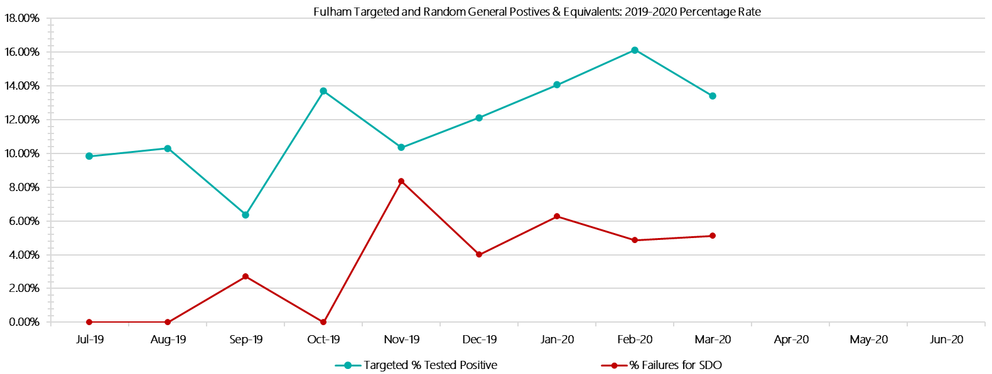

***Fulham Positive Test Results by Drug Type: 2019-2020***

**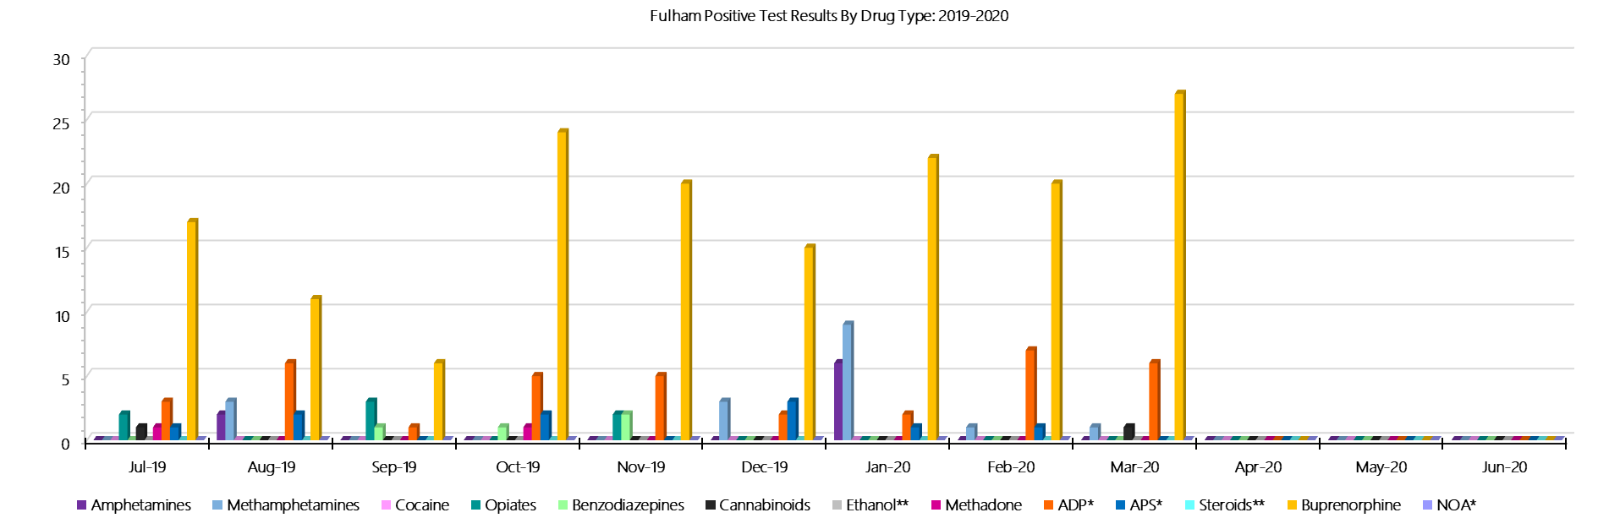*Fulham Count of Visitor Seizures Finds: 2019-2020***

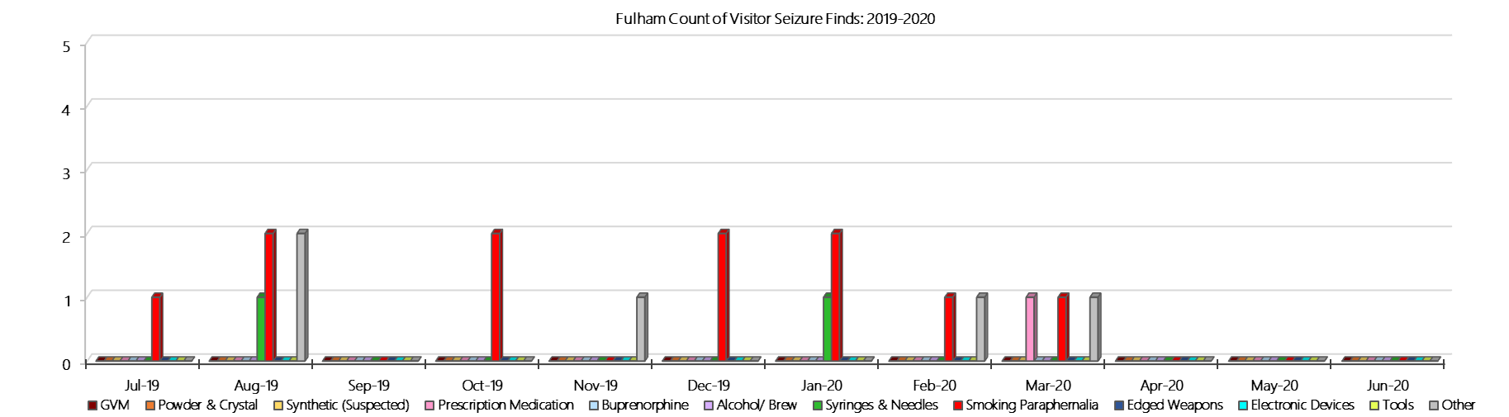

***Fulham Count of Prisoner Seizure Finds: 2019-2020***

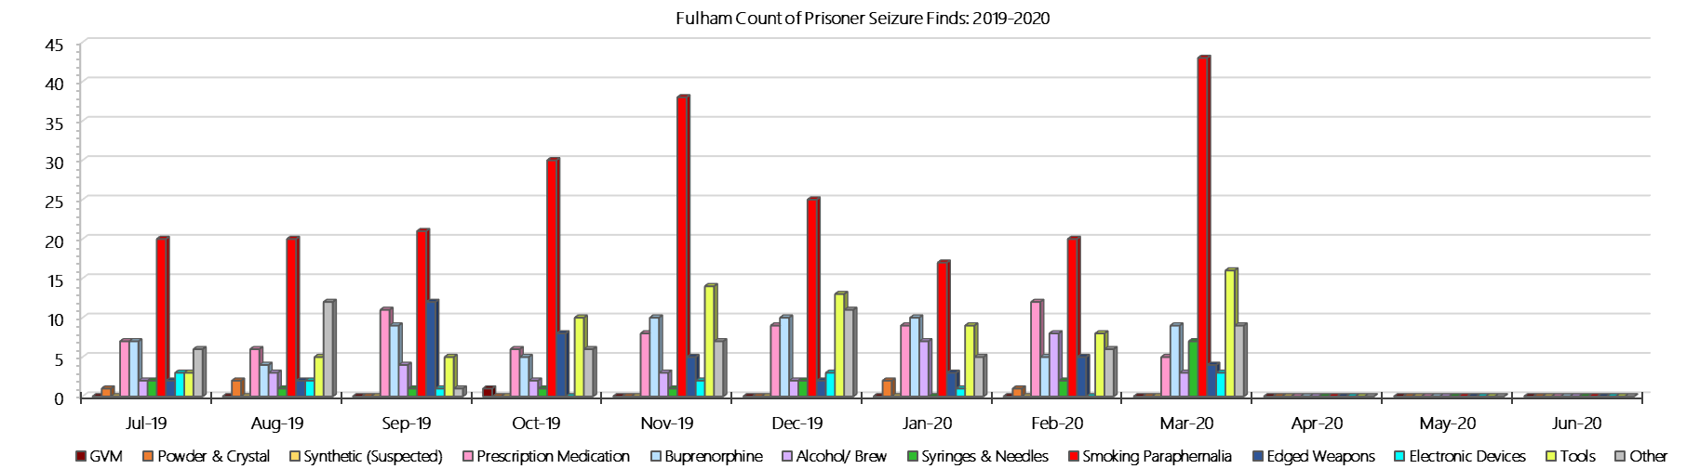

### **Hopkins Correctional Centre**

***Targeted and Random General Drug Test Results: 2019-2020***

|  |  |  |  |  |  |  |  |  |  |  |  |  |  |  |
| --- | --- | --- | --- | --- | --- | --- | --- | --- | --- | --- | --- | --- | --- | --- |
| **Hopkins** | **Jul-19** | **Aug-19** | **Sep-19** | **Oct-19** | **Nov-19** | **Dec-19** | **Jan-20** | **Feb-20** | **Mar-20** | **Apr-20** | **May-20** | **Jun-20** | **Average** | ***Totals*** |
| **Effective Sample - Targeted** | **22** | **7** | **13** | **16** | **31** | **28** | **36** | **9** | **15** |  |  |  | **20** | ***177*** |
| **Targeted Positives** | **2** | **1** | **0** | **2** | **6** | **4** | **4** | **0** | **3** |  |  |  | **2** | ***22*** |
| **Refusal** | **1** | **0** | **0** | **0** | **2** | **0** | **0** | **0** | **0** |  |  |  | **0** | ***3*** |
| **Unable** | **0** | **0** | **0** | **1** | **1** | **2** | **0** | **0** | **0** |  |  |  | **0** | ***4*** |
| **Interfered** | **0** | **0** | **0** | **0** | **0** | **0** | **0** | **0** | **0** |  |  |  | **0** | ***0*** |
| **Adulterated** | **0** | **0** | **0** | **0** | **0** | **0** | **0** | **0** | **0** |  |  |  | **0** | ***0*** |
| **Targeted % Tested Positive** | **13.64%** | **14.29%** | **0.00%** | **18.75%** | **29.03%** | **21.43%** | **11.11%** | **0.00%** | **20.00%** | **#N/A** | **#N/A** | **#N/A** | **16.38%** | ***16.38%*** |
| **Awaiting / Pending Results** | **0** | **0** | **0** | **0** | **0** | **0** | **0** | **0** | **0** |  |  |  | **0** | ***0*** |
| **Targeted Residual** | **0** | **0** | **0** | **0** | **0** | **1** | **0** | **0** | **0** |  |  |  | **0** | ***1*** |
| **Random tests collected** | **107** | **85** | **108** | **91** | **91** | **111** | **94** | **92** | **106** |  |  |  | **98** | ***885*** |
| **Tested Positive** | **2** | **1** | **2** | **5** | **2** | **1** | **1** | **1** | **0** |  |  |  | **2** | ***15*** |
| **Refusal (guilty)** | **0** | **0** | **0** | **0** | **0** | **0** | **0** | **0** | **2** |  |  |  | **0** | ***2*** |
| **Unable (not guilty)** | **0** | **0** | **0** | **1** | **1** | **0** | **0** | **0** | **0** |  |  |  | **0** | ***2*** |
| **Unable (guilty)** | **0** | **0** | **2** | **0** | **0** | **0** | **1** | **0** | **0** |  |  |  | **0** | ***3*** |
| **Interfered (guilty)** | **0** | **0** | **0** | **0** | **0** | **0** | **0** | **0** | **0** |  |  |  | **0** | ***0*** |
| **No test (valid reason)** | **0** | **0** | **0** | **0** | **1** | **4** | **0** | **0** | **2** |  |  |  | **1** | ***7*** |
| **No test (no valid reason)** | **0** | **0** | **0** | **0** | **0** | **0** | **0** | **1** | **0** |  |  |  | **0** | ***1*** |
| **Adulterated** | **0** | **0** | **0** | **0** | **0** | **0** | **0** | **0** | **0** |  |  |  | **0** | ***0*** |
| **Awaiting / Pending Results** | **0** | **0** | **0** | **0** | **0** | **0** | **0** | **0** | **5** |  |  |  | **1** | ***5*** |
| **Random Residual *(PIMS URAR030)*** | **0** | **0** | **0** | **0** | **0** | **0** | **0** | **0** | **0** |  |  |  | ***0*** | ***0*** |
| **Effective Sample - Random General** | **107** | **85** | **110** | **91** | **91** | **111** | **95** | **93** | **108** |  |  |  | **99** | **891** |
| **% Tested positive** | **1.87%** | **1.18%** | **1.82%** | **5.49%** | **2.20%** | **0.90%** | **1.05%** | **1.08%** | **0.00%** |  |  |  | **1.73%** |  |
| **% Prisoner guilty, positive equivalents** | **0.00%** | **0.00%** | **1.82%** | **0.00%** | **0.00%** | **0.00%** | **1.05%** | **0.00%** | **1.85%** |  |  |  | **0.52%** |  |
| **% Total prisoner fails** | **1.87%** | **1.18%** | **3.64%** | **5.49%** | **2.20%** | **0.90%** | **2.11%** | **1.08%** | **1.85%** |  |  |  | **2.26%** |  |
| **% No test without valid reason** | **0.00%** | **0.00%** | **0.00%** | **0.00%** | **0.00%** | **0.00%** | **0.00%** | **1.08%** | **0.00%** |  |  |  | **0.12%** |  |
| ***Random General Benchmark 3.50%*** | ***3.50%*** | ***3.50%*** | ***3.50%*** | ***3.50%*** | ***3.50%*** | ***3.50%*** | ***3.50%*** | ***3.50%*** | ***3.50%*** | ***3.50%*** | ***3.50%*** | ***3.50%*** | ***YTD*** |  |
| **% Failures for SDO** | **1.87%** | **1.18%** | **3.64%** | **5.49%** | **2.20%** | **0.90%** | **2.11%** | **2.15%** | **1.85%** | **#N/A** | **#N/A** | **#N/A** | **2.36%** |  |

***Hopkins - Drugs Identified Through Testing by Drug Type: 2019-2020***

|  |  |  |  |  |  |  |  |  |  |  |  |  |  |  |
| --- | --- | --- | --- | --- | --- | --- | --- | --- | --- | --- | --- | --- | --- | --- |
| **Hopkins** | ***Amphetamines*** | ***Methamphetamines*** | ***Cocaine*** | ***Opiates*** | ***Benzodiazepines*** | ***Cannabinoids*** | ***Ethanol\*\**** | ***Methadone*** | ***ADP\**** | ***APS\**** | ***Steroids\*\**** | ***Buprenorphine*** | ***NOA\**** | **Total** |
| **Jul-19** | **0** | **0** | **0** | **0** | **0** | **0** | **0** | **0** | **0** | **0** | **0** | **3** | **0** | **3** |
| **Aug-19** | **0** | **0** | **0** | **0** | **0** | **0** | **0** | **0** | **0** | **0** | **0** | **4** | **0** | **4** |
| **Sep-19** | **0** | **0** | **0** | **0** | **0** | **0** | **0** | **0** | **0** | **0** | **0** | **2** | **0** | **2** |
| **Oct-19** | **0** | **0** | **0** | **0** | **0** | **0** | **0** | **0** | **0** | **0** | **0** | **10** | **0** | **10** |
| **Nov-19** | **0** | **1** | **0** | **0** | **1** | **0** | **0** | **0** | **0** | **0** | **0** | **7** | **0** | **9** |
| **Dec-19** | **3** | **3** | **0** | **0** | **0** | **0** | **0** | **0** | **0** | **0** | **0** | **3** | **0** | **9** |
| **Jan-20** | **0** | **0** | **0** | **0** | **0** | **0** | **0** | **0** | **0** | **0** | **0** | **6** | **0** | **6** |
| **Feb-20** | **0** | **0** | **0** | **0** | **0** | **0** | **0** | **0** | **0** | **0** | **0** | **2** | **0** | **2** |
| **Mar-20** | **0** | **0** | **0** | **0** | **0** | **1** | **0** | **2** | **0** | **0** | **0** | **1** | **0** | **4** |
| **Apr-20** |  |  |  |  |  |  |  |  |  |  |  |  |  |  |
| **May-20** |  |  |  |  |  |  |  |  |  |  |  |  |  |  |
| **Jun-20** |  |  |  |  |  |  |  |  |  |  |  |  |  |  |
| **Hopkins YTD** | **3** | **4** | **0** | **0** | **1** | **1** | **0** | **2** | **0** | **0** | **0** | **38** | **0** | **49** |
| ***All Prisons YTD*** | ***133*** | ***224*** | ***2*** | ***35*** | ***30*** | ***30*** | ***20*** | ***32*** | ***49*** | ***13*** | ***0*** | ***1785*** | ***0*** | ***2353*** |
| ***Hopkins % of Total*** | ***2.26%*** | ***1.79%*** | ***0.00%*** | ***0.00%*** | ***3.33%*** | ***3.33%*** | ***0.00%*** | ***6.25%*** | ***0.00%*** | ***0.00%*** | ***0.00%*** | ***2.13%*** | ***0.00%*** | ***2.08%*** |

***Hopkins Seizures of Contraband: Visitors & Prisoners: 2019-2020***

|  |  |  |  |  |  |  |  |  |  |  |  |  |  |  |  |  |  |  |  |  |  |  |  |  |
| --- | --- | --- | --- | --- | --- | --- | --- | --- | --- | --- | --- | --- | --- | --- | --- | --- | --- | --- | --- | --- | --- | --- | --- | --- |
| **Visitors** | **GVM** | | **Powder  & Crystal** | | **Synthetic  (Suspected)** | | **Prescription  Medication** | | **Buprenorphine** | | **Alcohol &  Home Brew** | | **Syringes & Needles** | | **Smoking  Paraphernalia** | | **Edged  Weapons** | | **Electronic  Devices** | | **Tools** | | **Other** | |
| **Hopkins** | **Finds** | **Gms** | **Finds** | **Gms** | **Finds** | **Gms** | **Finds** | **Qty** | **Finds** | **Qty** | **Finds** | **Ltrs** | **Finds** | **Qty** | **Finds** | **Qty** | **Finds** | **Qty** | **Finds** | **Qty** | **Finds** | **Qty** | **Finds** | **Qty** |
| **Jul-19** | **0** | **0.00** | **0** | **0.00** | **0** | **0.00** | **0** | **0.00** | **0** | **0.00** | **0** | **0.000** | **0** | **0** | **0** | **0** | **0** | **0** | **0** | **0** | **0** | **0** | **0** | **0** |
| **Aug-19** | **0** | **0.00** | **0** | **0.00** | **0** | **0.00** | **0** | **0.00** | **0** | **0.00** | **0** | **0.000** | **0** | **0** | **0** | **0** | **0** | **0** | **0** | **0** | **0** | **0** | **0** | **0** |
| **Sep-19** | **1** | **1.12** | **0** | **0.00** | **0** | **0.00** | **0** | **0.00** | **0** | **0.00** | **0** | **0.000** | **0** | **0** | **0** | **0** | **0** | **0** | **0** | **0** | **0** | **0** | **0** | **0** |
| **Oct-19** | **0** | **0.00** | **1** | **1.20** | **0** | **0.00** | **0** | **0.00** | **0** | **0.00** | **0** | **0.000** | **0** | **0** | **1** | **1** | **0** | **0** | **0** | **0** | **0** | **0** | **0** | **0** |
| **Nov-19** | **0** | **0.00** | **0** | **0.00** | **0** | **0.00** | **0** | **0.00** | **0** | **0.00** | **0** | **0.000** | **0** | **0** | **0** | **0** | **0** | **0** | **0** | **0** | **0** | **0** | **0** | **0** |
| **Dec-19** | **0** | **0.00** | **1** | **0.69** | **0** | **0.00** | **0** | **0.00** | **0** | **0.00** | **0** | **0.000** | **0** | **0** | **1** | **1** | **0** | **0** | **0** | **0** | **0** | **0** | **0** | **0** |
| **Jan-20** | **0** | **0.00** | **0** | **0.00** | **0** | **0.00** | **0** | **0.00** | **0** | **0.00** | **0** | **0.000** | **0** | **0** | **0** | **0** | **0** | **0** | **0** | **0** | **0** | **0** | **0** | **0** |
| **Feb-20** | **0** | **0.00** | **0** | **0.00** | **0** | **0.00** | **0** | **0.00** | **0** | **0.00** | **0** | **0.000** | **0** | **0** | **1** | **1** | **0** | **0** | **1** | **1** | **0** | **0** | **0** | **0** |
| **Mar-20** | **0** | **0.00** | **0** | **0.00** | **0** | **0.00** | **0** | **0.00** | **0** | **0.00** | **0** | **0.000** | **0** | **0** | **0** | **0** | **0** | **0** | **0** | **0** | **0** | **0** | **0** | **0** |
| **Apr-20** |  |  |  |  |  |  |  |  |  |  |  |  |  |  |  |  |  |  |  |  |  |  |  |  |
| **May-20** |  |  |  |  |  |  |  |  |  |  |  |  |  |  |  |  |  |  |  |  |  |  |  |  |
| **Jun-20** |  |  |  |  |  |  |  |  |  |  |  |  |  |  |  |  |  |  |  |  |  |  |  |  |
| **Total** | **1** | **1.12** | **2** | **1.89** | **0** | **0.00** | **0** | **0.00** | **0** | **0.00** | **0** | **0.000** | **0** | **0** | **3** | **3** | **0** | **0** | **1** | **1** | **0** | **0** | **0** | **0** |

|  |  |  |  |  |  |  |  |  |  |  |  |  |  |  |  |  |  |  |  |  |  |  |  |  |  |
| --- | --- | --- | --- | --- | --- | --- | --- | --- | --- | --- | --- | --- | --- | --- | --- | --- | --- | --- | --- | --- | --- | --- | --- | --- | --- |
| **Prisoners** | **GVM** | | **Powder  & Crystal** | | **Synthetic  (Suspected)** | | **Prescription  Medication** | | **Buprenorphine** | | **Alcohol &  Home Brew** | | **Syringes & Needles** | | **Smoking  Paraphernalia** | | | **Edged  Weapons** | | **Electronic  Devices** | | **Tools** | | **Other** | |
| **Hopkins** | **Finds** | **Gms** | **Finds** | **Gms** | **Finds** | **Gms** | **Finds** | **Qty** | **Finds** | **Qty** | **Finds** | **Ltrs** | **Finds** | **Qty** | **Finds** | **Qty** | | **Finds** | **Qty** | **Finds** | **Qty** | **Finds** | **Qty** | **Finds** | **Qty** |
| **Jul-19** | **0** | **0.00** | **0** | **0.00** | **0** | **0.00** | **0** | **0.00** | **2** | **0.30** | **0** | **0.000** | **3** | **3** | **2** | | **10** | **0** | **0** | **0** | **0** | **0** | **0** | **1** | **1** |
| **Aug-19** | **0** | **0.00** | **0** | **0.00** | **0** | **0.00** | **0** | **0.00** | **9** | **17.00** | **0** | **0.000** | **1** | **1** | **9** | | **21** | **2** | **2** | **0** | **0** | **0** | **0** | **0** | **0** |
| **Sep-19** | **0** | **0.00** | **0** | **0.00** | **0** | **0.00** | **0** | **0.00** | **3** | **0.40** | **0** | **0.000** | **0** | **0** | **3** | | **3** | **2** | **2** | **0** | **0** | **0** | **0** | **0** | **0** |
| **Oct-19** | **0** | **0.00** | **0** | **0.00** | **0** | **0.00** | **0** | **0.00** | **1** | **0.30** | **0** | **0.000** | **0** | **0** | **3** | | **5** | **1** | **1** | **1** | **1** | **1** | **1** | **2** | **2** |
| **Nov-19** | **0** | **0.00** | **0** | **0.00** | **0** | **0.00** | **2** | **5.50** | **0** | **0.00** | **0** | **0.000** | **2** | **2** | **2** | | **4** | **1** | **1** | **0** | **0** | **2** | **6** | **0** | **0** |
| **Dec-19** | **0** | **0.00** | **0** | **0.00** | **0** | **0.00** | **0** | **0.00** | **0** | **0.00** | **0** | **0.000** | **1** | **1** | **1** | | **1** | **1** | **1** | **0** | **0** | **0** | **0** | **0** | **0** |
| **Jan-20** | **0** | **0.00** | **0** | **0.00** | **0** | **0.00** | **3** | **6.00** | **7** | **15.00** | **0** | **0.000** | **2** | **2** | **5** | | **31** | **2** | **2** | **1** | **1** | **0** | **0** | **1** | **1** |
| **Feb-20** | **0** | **0.00** | **3** | **0.66** | **0** | **0.00** | **2** | **6.00** | **1** | **1.00** | **0** | **0.000** | **0** | **0** | **4** | | **43** | **2** | **3** | **0** | **0** | **0** | **0** | **1** | **1** |
| **Mar-20** | **0** | **0.00** | **0** | **0.00** | **0** | **0.00** | **2** | **1.50** | **3** | **68.10** | **0** | **0.000** | **1** | **1** | **5** | | **19** | **0** | **0** | **0** | **0** | **0** | **0** | **2** | **12** |
| **Apr-20** |  |  |  |  |  |  |  |  |  |  |  |  |  |  |  | |  |  |  |  |  |  |  |  |  |
| **May-20** |  |  |  |  |  |  |  |  |  |  |  |  |  |  |  | |  |  |  |  |  |  |  |  |  |
| **Jun-20** |  |  |  |  |  |  |  |  |  |  |  |  |  |  |  | |  |  |  |  |  |  |  |  |  |
| **Total** | **0** | **0.00** | **3** | **0.66** | **0** | **0.00** | **9** | **19.00** | **26** | **102.10** | **0** | **0.000** | **10** | **10** | **34** | | **137** | **11** | **12** | **2** | **2** | **3** | **7** | **7** | **17** |

***Hopkins Targeted and Random General Drug Test Positives & Equivalents: 2019-2020***

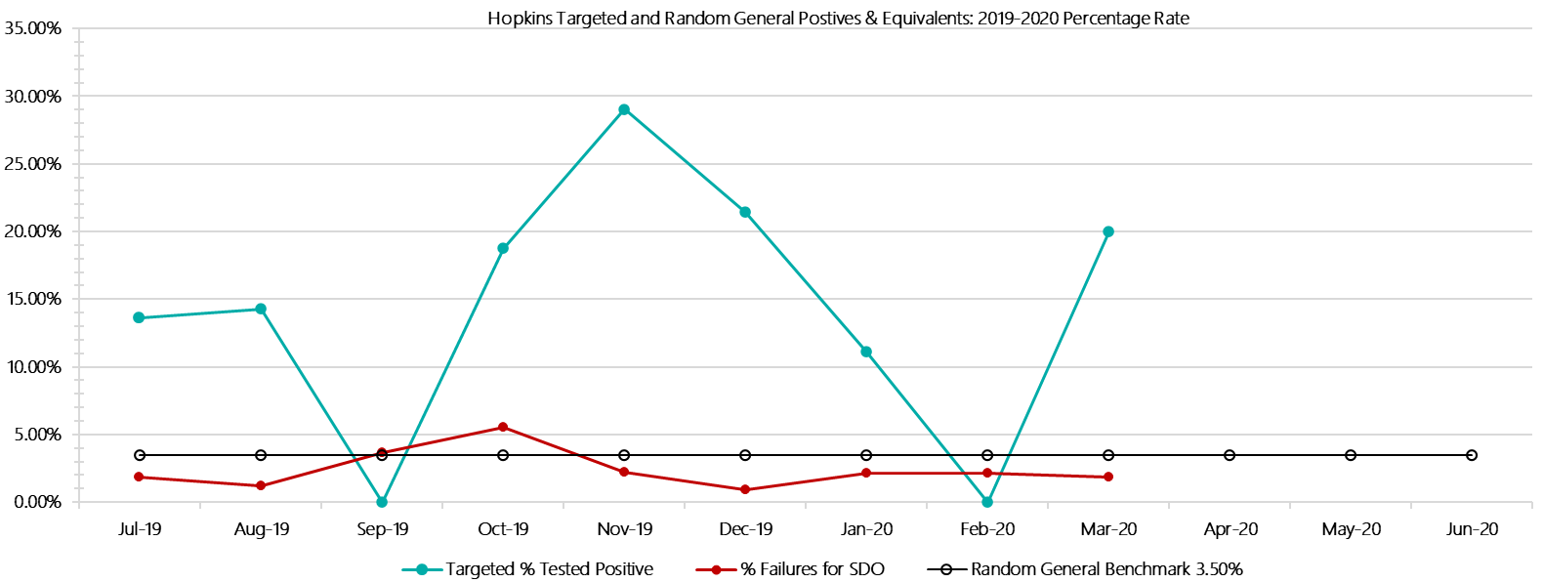

***Hopkins Positive Test Results by Drug Type: 2019-2020***

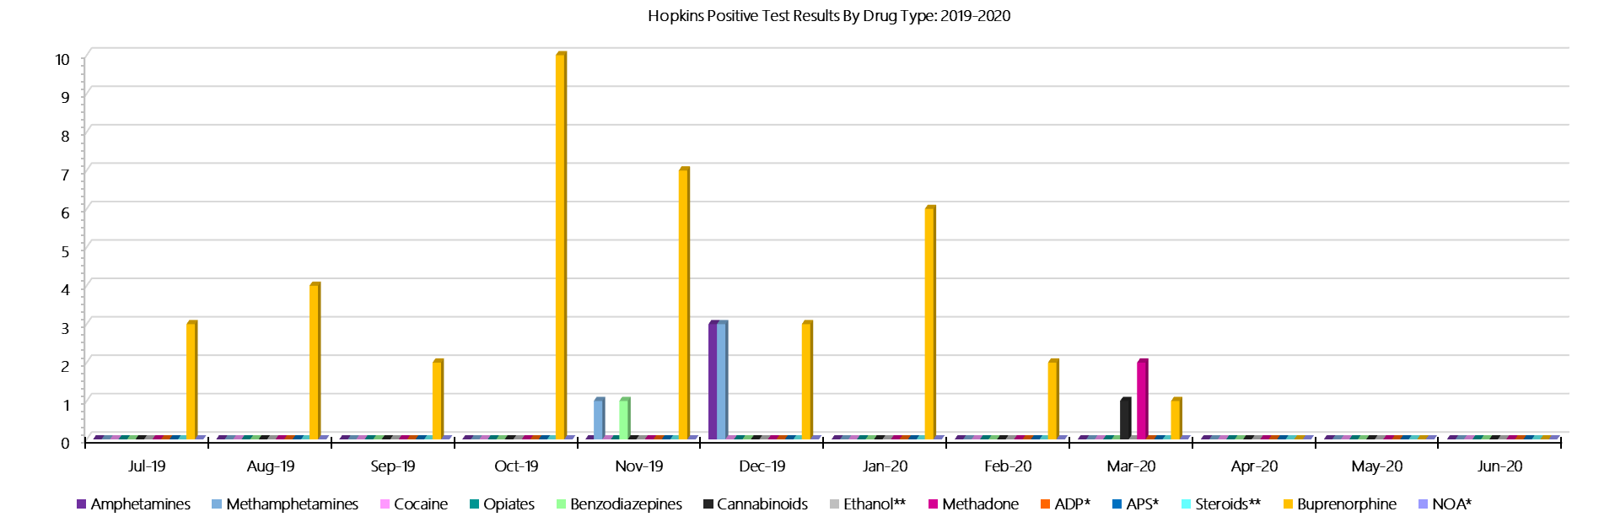

***Hopkins Count of Visitor Seizures Finds: 2019-2020***

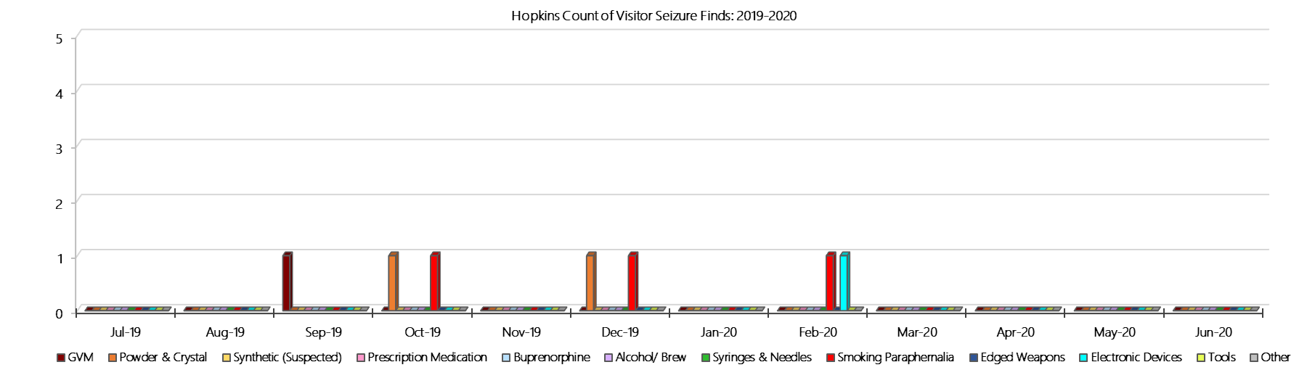

***Hopkins Count of Prisoner Seizure Finds: 2019-2020***

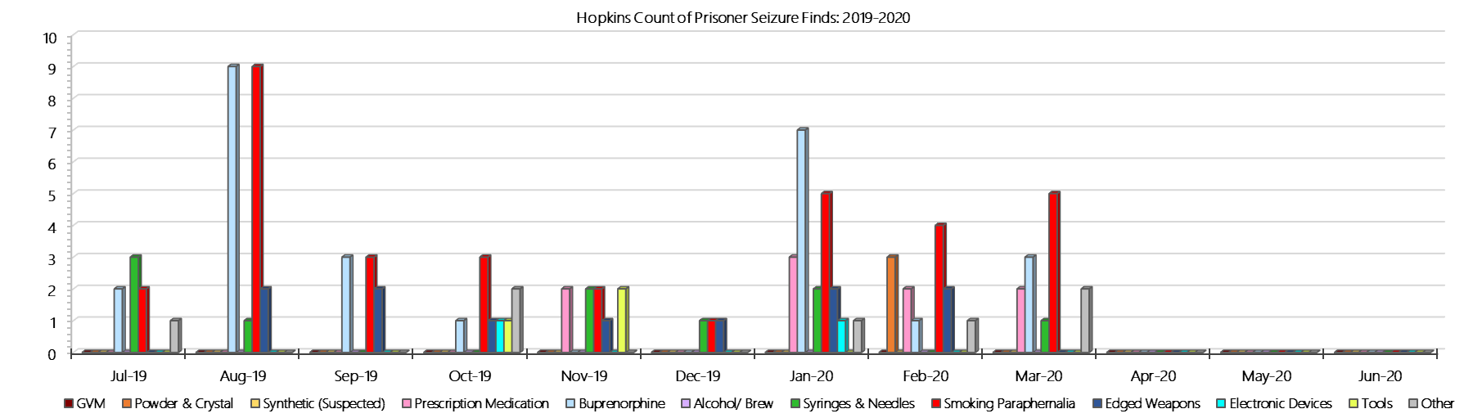

### **Karreenga (annex of Marngoneet)**

***Targeted and Random General Drug Test Results: 2019-2020***

|  |  |  |  |  |  |  |  |  |  |  |  |  |  |  |
| --- | --- | --- | --- | --- | --- | --- | --- | --- | --- | --- | --- | --- | --- | --- |
| **Karreenga** | **Jul-19** | **Aug-19** | **Sep-19** | **Oct-19** | **Nov-19** | **Dec-19** | **Jan-20** | **Feb-20** | **Mar-20** | **Apr-20** | **May-20** | **Jun-20** | **Average** | ***Totals*** |
| **Effective Sample - Targeted** | **44** | **41** | **23** | **34** | **24** | **27** | **33** | **28** | **19** |  |  |  | **30** | ***273*** |
| **Targeted Positives** | **4** | **3** | **3** | **3** | **3** | **0** | **0** | **1** | **0** |  |  |  | **2** | ***17*** |
| **Refusal** | **0** | **0** | **0** | **0** | **0** | **0** | **0** | **5** | **0** |  |  |  | **1** | ***5*** |
| **Unable** | **0** | **1** | **0** | **2** | **0** | **1** | **2** | **2** | **0** |  |  |  | **1** | ***8*** |
| **Interfered** | **1** | **0** | **0** | **0** | **0** | **0** | **0** | **0** | **0** |  |  |  | **0** | ***1*** |
| **Adulterated** | **0** | **0** | **0** | **0** | **0** | **0** | **0** | **0** | **0** |  |  |  | **0** | ***0*** |
| **Targeted % Tested Positive** | **11.36%** | **9.76%** | **13.04%** | **14.71%** | **12.50%** | **3.70%** | **6.06%** | **28.57%** | **0.00%** | **#N/A** | **#N/A** | **#N/A** | **11.36%** | ***11.36%*** |
| **Awaiting / Pending Results** | **0** | **0** | **0** | **0** | **0** | **0** | **0** | **0** | **0** |  |  |  | **0** | ***0*** |
| **Targeted Residual** | **0** | **1** | **0** | **0** | **0** | **0** | **0** | **0** | **0** |  |  |  | **0** | ***1*** |
| **Random tests collected** | **42** | **34** | **43** | **36** | **36** | **40** | **31** | **31** | **37** |  |  |  | **37** | ***330*** |
| **Tested Positive** | **0** | **2** | **0** | **0** | **0** | **1** | **0** | **0** | **0** |  |  |  | **0** | ***3*** |
| **Refusal (guilty)** | **0** | **0** | **0** | **0** | **0** | **0** | **0** | **0** | **0** |  |  |  | **0** | ***0*** |
| **Unable (not guilty)** | **0** | **0** | **0** | **0** | **0** | **0** | **0** | **0** | **0** |  |  |  | **0** | ***0*** |
| **Unable (guilty)** | **2** | **1** | **0** | **0** | **0** | **0** | **1** | **0** | **2** |  |  |  | **1** | ***6*** |
| **Interfered (guilty)** | **0** | **0** | **0** | **0** | **0** | **0** | **0** | **0** | **0** |  |  |  | **0** | ***0*** |
| **No test (valid reason)** | **1** | **1** | **2** | **0** | **0** | **3** | **0** | **3** | **0** |  |  |  | **1** | ***10*** |
| **No test (no valid reason)** | **0** | **0** | **0** | **0** | **0** | **0** | **0** | **0** | **0** |  |  |  | **0** | ***0*** |
| **Adulterated** | **0** | **0** | **0** | **0** | **0** | **0** | **0** | **0** | **0** |  |  |  | **0** | ***0*** |
| **Awaiting / Pending Results** | **0** | **0** | **0** | **0** | **0** | **0** | **0** | **0** | **1** |  |  |  | **0** | ***1*** |
| **Random Residual *(PIMS URAR030)*** | **0** | **0** | **0** | **0** | **0** | **0** | **0** | **0** | **0** |  |  |  | ***0*** | ***0*** |
| **Effective Sample - Random General** | **44** | **35** | **43** | **36** | **36** | **40** | **32** | **31** | **39** |  |  |  | **37** | **336** |
| **% Tested positive** | **0.00%** | **5.71%** | **0.00%** | **0.00%** | **0.00%** | **2.50%** | **0.00%** | **0.00%** | **0.00%** |  |  |  | **0.91%** |  |
| **% Prisoner guilty, positive equivalents** | **4.55%** | **2.86%** | **0.00%** | **0.00%** | **0.00%** | **0.00%** | **3.13%** | **0.00%** | **5.13%** |  |  |  | **1.74%** |  |
| **% Total prisoner fails** | **4.55%** | **8.57%** | **0.00%** | **0.00%** | **0.00%** | **2.50%** | **3.13%** | **0.00%** | **5.13%** |  |  |  | **2.65%** |  |
| **% No test without valid reason** | **0.00%** | **0.00%** | **0.00%** | **0.00%** | **0.00%** | **0.00%** | **0.00%** | **0.00%** | **0.00%** |  |  |  | **0.00%** |  |
| ***Random General Benchmark 3.50%*** | ***3.50%*** | ***3.50%*** | ***3.50%*** | ***3.50%*** | ***3.50%*** | ***3.50%*** | ***3.50%*** | ***3.50%*** | ***3.50%*** | ***3.50%*** | ***3.50%*** | ***3.50%*** | ***YTD*** |  |
| **% Failures for SDO** | **4.55%** | **8.57%** | **0.00%** | **0.00%** | **0.00%** | **2.50%** | **3.13%** | **0.00%** | **5.13%** | **#N/A** | **#N/A** | **#N/A** | **2.68%** |  |

***Karreenga - Drugs Identified Through Testing by Drug Type: 2019-2020***

|  |  |  |  |  |  |  |  |  |  |  |  |  |  |  |
| --- | --- | --- | --- | --- | --- | --- | --- | --- | --- | --- | --- | --- | --- | --- |
| **Karreenga** | ***Amphetamines*** | ***Methamphetamines*** | ***Cocaine*** | ***Opiates*** | ***Benzodiazepines*** | ***Cannabinoids*** | ***Ethanol\*\**** | ***Methadone*** | ***ADP\**** | ***APS\**** | ***Steroids\*\**** | ***Buprenorphine*** | ***NOA\**** | **Total** |
| **Jul-19** | **0** | **0** | **0** | **0** | **0** | **0** | **0** | **0** | **0** | **0** | **0** | **7** | **0** | **7** |
| **Aug-19** | **0** | **0** | **0** | **0** | **0** | **0** | **0** | **0** | **0** | **0** | **0** | **7** | **0** | **7** |
| **Sep-19** | **0** | **0** | **0** | **0** | **0** | **0** | **0** | **0** | **0** | **0** | **0** | **4** | **0** | **4** |
| **Oct-19** | **0** | **0** | **0** | **0** | **0** | **0** | **0** | **0** | **0** | **0** | **0** | **5** | **0** | **5** |
| **Nov-19** | **0** | **0** | **0** | **0** | **0** | **0** | **0** | **0** | **0** | **0** | **0** | **4** | **0** | **4** |
| **Dec-19** | **0** | **1** | **0** | **0** | **0** | **0** | **0** | **0** | **0** | **0** | **0** | **2** | **0** | **3** |
| **Jan-20** | **0** | **0** | **0** | **0** | **0** | **0** | **0** | **0** | **0** | **0** | **0** | **3** | **0** | **3** |
| **Feb-20** | **1** | **1** | **0** | **0** | **0** | **0** | **0** | **0** | **0** | **0** | **0** | **1** | **0** | **3** |
| **Mar-20** | **0** | **0** | **0** | **0** | **0** | **0** | **0** | **0** | **0** | **0** | **0** | **2** | **0** | **2** |
| **Apr-20** |  |  |  |  |  |  |  |  |  |  |  |  |  |  |
| **May-20** |  |  |  |  |  |  |  |  |  |  |  |  |  |  |
| **Jun-20** |  |  |  |  |  |  |  |  |  |  |  |  |  |  |
| **Karreenga YTD** | **1** | **2** | **0** | **0** | **0** | **0** | **0** | **0** | **0** | **0** | **0** | **35** | **0** | **38** |
| ***All Prisons YTD*** | ***133*** | ***224*** | ***2*** | ***35*** | ***30*** | ***30*** | ***20*** | ***32*** | ***49*** | ***13*** | ***0*** | ***1785*** | ***0*** | ***2353*** |
| ***Karreenga % of Total*** | ***0.75%*** | ***0.89%*** | ***0.00%*** | ***0.00%*** | ***0.00%*** | ***0.00%*** | ***0.00%*** | ***0.00%*** | ***0.00%*** | ***0.00%*** | ***0.00%*** | ***1.96%*** | ***0.00%*** | ***1.61%*** |

***Karreenga Seizures of Contraband: Visitors & Prisoners: 2019-2020***

|  |  |  |  |  |  |  |  |  |  |  |  |  |  |  |  |  |  |  |  |  |  |  |  |  |
| --- | --- | --- | --- | --- | --- | --- | --- | --- | --- | --- | --- | --- | --- | --- | --- | --- | --- | --- | --- | --- | --- | --- | --- | --- |
| **Visitors** | **GVM** | | **Powder  & Crystal** | | **Synthetic  (Suspected)** | | **Prescription  Medication** | | **Buprenorphine** | | **Alcohol &  Home Brew** | | **Syringes & Needles** | | **Smoking  Paraphernalia** | | **Edged  Weapons** | | **Electronic  Devices** | | **Tools** | | **Other** | |
| **Karreenga** | **Finds** | **Gms** | **Finds** | **Gms** | **Finds** | **Gms** | **Finds** | **Qty** | **Finds** | **Qty** | **Finds** | **Ltrs** | **Finds** | **Qty** | **Finds** | **Qty** | **Finds** | **Qty** | **Finds** | **Qty** | **Finds** | **Qty** | **Finds** | **Qty** |
| **Jul-19** | **0** | **0.00** | **0** | **0.00** | **0** | **0.00** | **0** | **0.00** | **0** | **0.00** | **0** | **0.000** | **0** | **0** | **0** | **0** | **0** | **0** | **0** | **0** | **0** | **0** | **0** | **0** |
| **Aug-19** | **0** | **0.00** | **0** | **0.00** | **0** | **0.00** | **0** | **0.00** | **0** | **0.00** | **0** | **0.000** | **0** | **0** | **0** | **0** | **0** | **0** | **0** | **0** | **0** | **0** | **0** | **0** |
| **Sep-19** | **0** | **0.00** | **0** | **0.00** | **0** | **0.00** | **0** | **0.00** | **0** | **0.00** | **0** | **0.000** | **0** | **0** | **0** | **0** | **0** | **0** | **0** | **0** | **0** | **0** | **0** | **0** |
| **Oct-19** | **0** | **0.00** | **1** | **1.20** | **0** | **0.00** | **0** | **0.00** | **0** | **0.00** | **0** | **0.000** | **0** | **0** | **1** | **1** | **0** | **0** | **0** | **0** | **0** | **0** | **0** | **0** |
| **Nov-19** | **0** | **0.00** | **0** | **0.00** | **0** | **0.00** | **0** | **0.00** | **0** | **0.00** | **0** | **0.000** | **0** | **0** | **0** | **0** | **0** | **0** | **0** | **0** | **0** | **0** | **0** | **0** |
| **Dec-19** | **0** | **0.00** | **0** | **0.00** | **0** | **0.00** | **0** | **0.00** | **0** | **0.00** | **0** | **0.000** | **0** | **0** | **0** | **0** | **0** | **0** | **0** | **0** | **0** | **0** | **0** | **0** |
| **Jan-20** | **0** | **0.00** | **0** | **0.00** | **0** | **0.00** | **0** | **0.00** | **0** | **0.00** | **0** | **0.000** | **0** | **0** | **0** | **0** | **0** | **0** | **0** | **0** | **0** | **0** | **0** | **0** |
| **Feb-20** | **0** | **0.00** | **0** | **0.00** | **0** | **0.00** | **0** | **0.00** | **0** | **0.00** | **0** | **0.000** | **0** | **0** | **0** | **0** | **0** | **0** | **0** | **0** | **0** | **0** | **0** | **0** |
| **Mar-20** | **0** | **0.00** | **0** | **0.00** | **0** | **0.00** | **0** | **0.00** | **0** | **0.00** | **0** | **0.000** | **0** | **0** | **0** | **0** | **0** | **0** | **0** | **0** | **0** | **0** | **0** | **0** |
| **Apr-20** |  |  |  |  |  |  |  |  |  |  |  |  |  |  |  |  |  |  |  |  |  |  |  |  |
| **May-20** |  |  |  |  |  |  |  |  |  |  |  |  |  |  |  |  |  |  |  |  |  |  |  |  |
| **Jun-20** |  |  |  |  |  |  |  |  |  |  |  |  |  |  |  |  |  |  |  |  |  |  |  |  |
| **Total** | **0** | **0.00** | **1** | **1.20** | **0** | **0.00** | **0** | **0.00** | **0** | **0.00** | **0** | **0.000** | **0** | **0** | **1** | **1** | **0** | **0** | **0** | **0** | **0** | **0** | **0** | **0** |

|  |  |  |  |  |  |  |  |  |  |  |  |  |  |  |  |  |  |  |  |  |  |  |  |  |  |
| --- | --- | --- | --- | --- | --- | --- | --- | --- | --- | --- | --- | --- | --- | --- | --- | --- | --- | --- | --- | --- | --- | --- | --- | --- | --- |
| **Prisoners** | **GVM** | | **Powder  & Crystal** | | **Synthetic  (Suspected)** | | **Prescription  Medication** | | **Buprenorphine** | | **Alcohol &  Home Brew** | | **Syringes & Needles** | | **Smoking  Paraphernalia** | | | **Edged  Weapons** | | **Electronic  Devices** | | **Tools** | | **Other** | |
| **Karreenga** | **Finds** | **Gms** | **Finds** | **Gms** | **Finds** | **Gms** | **Finds** | **Qty** | **Finds** | **Qty** | **Finds** | **Ltrs** | **Finds** | **Qty** | **Finds** | **Qty** | | **Finds** | **Qty** | **Finds** | **Qty** | **Finds** | **Qty** | **Finds** | **Qty** |
| **Jul-19** | **0** | **0.00** | **0** | **0.00** | **0** | **0.00** | **5** | **20.00** | **1** | **1.00** | **0** | **0.000** | **1** | **1** | **1** | | **1** | **0** | **0** | **0** | **0** | **0** | **0** | **5** | **15** |
| **Aug-19** | **0** | **0.00** | **1** | **0.10** | **0** | **0.00** | **1** | **1.00** | **1** | **0.10** | **0** | **0.000** | **1** | **1** | **2** | | **4** | **3** | **3** | **0** | **0** | **1** | **1** | **2** | **6** |
| **Sep-19** | **0** | **0.00** | **0** | **0.00** | **0** | **0.00** | **1** | **1.00** | **2** | **0.20** | **1** | **1.000** | **1** | **1** | **1** | | **2** | **0** | **0** | **0** | **0** | **0** | **0** | **1** | **1** |
| **Oct-19** | **0** | **0.00** | **0** | **0.00** | **0** | **0.00** | **1** | **27.00** | **3** | **1.00** | **1** | **5.000** | **0** | **0** | **0** | | **0** | **1** | **1** | **0** | **0** | **0** | **0** | **1** | **1** |
| **Nov-19** | **0** | **0.00** | **1** | **3.80** | **0** | **0.00** | **5** | **18.00** | **2** | **0.20** | **1** | **4.000** | **1** | **1** | **0** | | **0** | **1** | **1** | **0** | **0** | **0** | **0** | **2** | **6** |
| **Dec-19** | **0** | **0.00** | **0** | **0.00** | **0** | **0.00** | **0** | **0.00** | **1** | **0.10** | **1** | **2.000** | **1** | **1** | **1** | | **1** | **2** | **4** | **0** | **0** | **1** | **1** | **1** | **1** |
| **Jan-20** | **0** | **0.00** | **1** | **2.60** | **0** | **0.00** | **3** | **6.00** | **3** | **4.30** | **0** | **0.000** | **0** | **0** | **1** | | **1** | **0** | **0** | **0** | **0** | **0** | **0** | **3** | **52** |
| **Feb-20** | **0** | **0.00** | **0** | **0.00** | **0** | **0.00** | **2** | **2.00** | **3** | **0.40** | **1** | **3.000** | **2** | **2** | **3** | | **5** | **1** | **1** | **0** | **0** | **1** | **3** | **2** | **2** |
| **Mar-20** | **0** | **0.00** | **1** | **2.43** | **0** | **0.00** | **2** | **6.00** | **0** | **0.00** | **0** | **0.000** | **0** | **0** | **0** | | **0** | **0** | **0** | **0** | **0** | **0** | **0** | **0** | **0** |
| **Apr-20** |  |  |  |  |  |  |  |  |  |  |  |  |  |  |  | |  |  |  |  |  |  |  |  |  |
| **May-20** |  |  |  |  |  |  |  |  |  |  |  |  |  |  |  | |  |  |  |  |  |  |  |  |  |
| **Jun-20** |  |  |  |  |  |  |  |  |  |  |  |  |  |  |  | |  |  |  |  |  |  |  |  |  |
| **Total** | **0** | **0.00** | **4** | **8.93** | **0** | **0.00** | **20** | **81.00** | **16** | **7.30** | **5** | **15.000** | **7** | **7** | **9** | | **14** | **8** | **10** | **0** | **0** | **3** | **5** | **17** | **84** |

***Karreenga Targeted and Random General Drug Test Positives & Equivalents: 2019-2020***

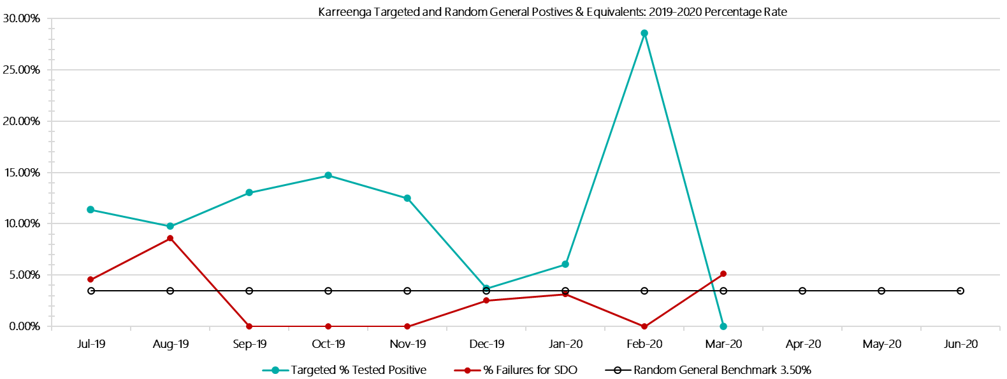

***Karreenga Positive Test Results by Drug Type: 2019-2020***

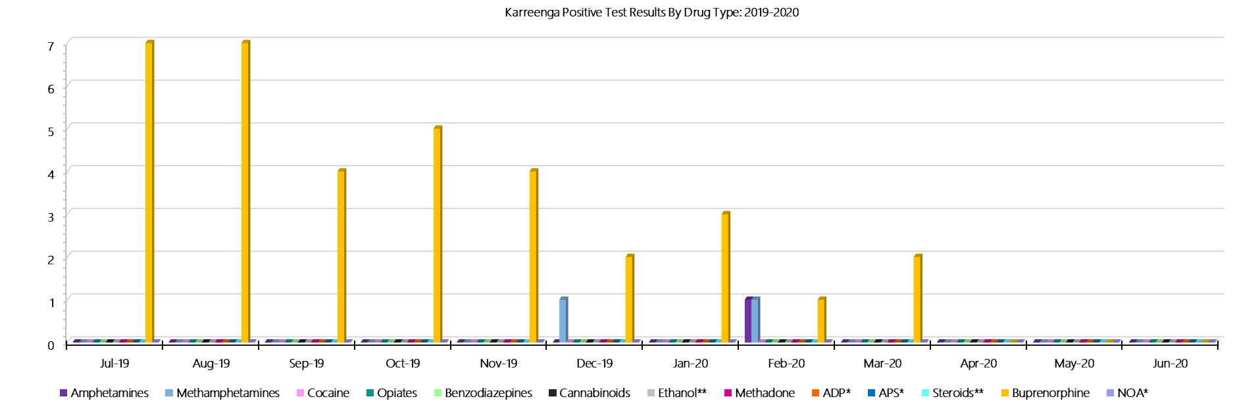

***Karreenga Count of Visitor Seizures Finds: 2019-2020***

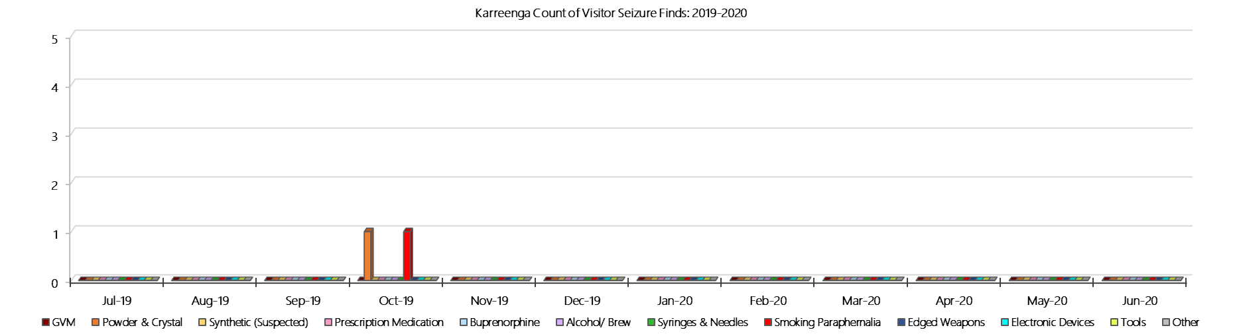

***Karreenga Count of Prisoner Seizure: 2019-2020***

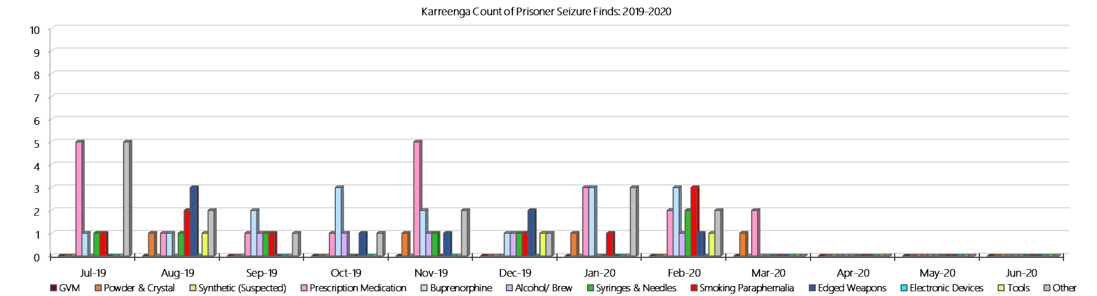

### **Marngoneet Correctional Centre**

***Targeted and Random General Drug Test Results: 2019-2020***

|  |  |  |  |  |  |  |  |  |  |  |  |  |  |  |
| --- | --- | --- | --- | --- | --- | --- | --- | --- | --- | --- | --- | --- | --- | --- |
| **Marngoneet** | **Jul-19** | **Aug-19** | **Sep-19** | **Oct-19** | **Nov-19** | **Dec-19** | **Jan-20** | **Feb-20** | **Mar-20** | **Apr-20** | **May-20** | **Jun-20** | **Average** | ***Totals*** |
| **Effective Sample - Targeted** | **105** | **65** | **67** | **109** | **107** | **100** | **81** | **101** | **96** |  |  |  | **92** | ***831*** |
| **Targeted Positives** | **1** | **2** | **9** | **19** | **12** | **17** | **10** | **10** | **20** |  |  |  | **11** | ***100*** |
| **Refusal** | **1** | **1** | **0** | **1** | **0** | **1** | **0** | **0** | **0** |  |  |  | **0** | ***4*** |
| **Unable** | **1** | **0** | **0** | **4** | **3** | **6** | **0** | **4** | **3** |  |  |  | **2** | ***21*** |
| **Interfered** | **0** | **0** | **0** | **0** | **0** | **0** | **0** | **0** | **0** |  |  |  | **0** | ***0*** |
| **Adulterated** | **0** | **0** | **0** | **0** | **0** | **0** | **0** | **0** | **0** |  |  |  | **0** | ***0*** |
| **Targeted % Tested Positive** | **2.86%** | **4.62%** | **13.43%** | **22.02%** | **14.02%** | **24.00%** | **12.35%** | **13.86%** | **23.96%** | **#N/A** | **#N/A** | **#N/A** | **15.04%** | ***15.04%*** |
| **Awaiting / Pending Results** | **0** | **0** | **0** | **0** | **0** | **0** | **0** | **1** | **0** |  |  |  | **0** | ***1*** |
| **Targeted Residual** | **0** | **1** | **0** | **0** | **0** | **2** | **0** | **0** | **1** |  |  |  | **0** | ***4*** |
| **Random tests collected** | **76** | **61** | **76** | **59** | **63** | **76** | **65** | **62** | **76** |  |  |  | **68** | ***614*** |
| **Tested Positive** | **1** | **2** | **3** | **4** | **3** | **4** | **3** | **5** | **1** |  |  |  | **3** | ***26*** |
| **Refusal (guilty)** | **1** | **0** | **1** | **0** | **0** | **0** | **0** | **0** | **0** |  |  |  | **0** | ***2*** |
| **Unable (not guilty)** | **0** | **0** | **0** | **0** | **0** | **0** | **0** | **0** | **0** |  |  |  | **0** | ***0*** |
| **Unable (guilty)** | **1** | **3** | **2** | **2** | **0** | **0** | **0** | **3** | **0** |  |  |  | **1** | ***11*** |
| **Interfered (guilty)** | **0** | **0** | **0** | **0** | **0** | **0** | **0** | **0** | **0** |  |  |  | **0** | ***0*** |
| **No test (valid reason)** | **2** | **1** | **1** | **2** | **1** | **4** | **1** | **1** | **3** |  |  |  | **2** | ***16*** |
| **No test (no valid reason)** | **0** | **0** | **0** | **0** | **0** | **0** | **0** | **0** | **0** |  |  |  | **0** | ***0*** |
| **Adulterated** | **0** | **0** | **0** | **1** | **0** | **0** | **0** | **0** | **0** |  |  |  | **0** | ***1*** |
| **Awaiting / Pending Results** | **0** | **0** | **0** | **0** | **0** | **0** | **0** | **0** | **2** |  |  |  | **0** | ***2*** |
| **Random Residual *(PIMS URAR030)*** | **0** | **0** | **1** | **0** | **0** | **0** | **0** | **0** | **0** |  |  |  | ***0.111111*** | ***1*** |
| **Effective Sample - Random General** | **78** | **64** | **79** | **61** | **63** | **76** | **65** | **65** | **76** |  |  |  | **70** | **627** |
| **% Tested positive** | **1.28%** | **3.13%** | **3.80%** | **6.56%** | **4.76%** | **5.26%** | **4.62%** | **7.69%** | **1.32%** |  |  |  | **4.27%** |  |
| **% Prisoner guilty, positive equivalents** | **2.56%** | **4.69%** | **3.80%** | **4.92%** | **0.00%** | **0.00%** | **0.00%** | **4.62%** | **0.00%** |  |  |  | **2.29%** |  |
| **% Total prisoner fails** | **3.85%** | **7.81%** | **7.59%** | **9.84%** | **4.76%** | **5.26%** | **4.62%** | **12.31%** | **1.32%** |  |  |  | **6.37%** |  |
| **% No test without valid reason** | **0.00%** | **0.00%** | **0.00%** | **0.00%** | **0.00%** | **0.00%** | **0.00%** | **0.00%** | **0.00%** |  |  |  | **0.00%** |  |
| ***Random General Benchmark 6.50%*** | ***6.50%*** | ***6.50%*** | ***6.50%*** | ***6.50%*** | ***6.50%*** | ***6.50%*** | ***6.50%*** | ***6.50%*** | ***6.50%*** | ***6.50%*** | ***6.50%*** | ***6.50%*** | ***YTD*** |  |
| **% Failures for SDO** | **3.85%** | **7.81%** | **7.59%** | **11.48%** | **4.76%** | **5.26%** | **4.62%** | **12.31%** | **1.32%** | **#N/A** | **#N/A** | **#N/A** | **6.38%** |  |

***Marngoneet - Drugs Identified Through Testing by Drug Type: 2019-2020***

|  |  |  |  |  |  |  |  |  |  |  |  |  |  |  |
| --- | --- | --- | --- | --- | --- | --- | --- | --- | --- | --- | --- | --- | --- | --- |
| **Marngoneet** | ***Amphetamines*** | ***Methamphetamines*** | ***Cocaine*** | ***Opiates*** | ***Benzodiazepines*** | ***Cannabinoids*** | ***Ethanol\*\**** | ***Methadone*** | ***ADP\**** | ***APS\**** | ***Steroids\*\**** | ***Buprenorphine*** | ***NOA\**** | **Total** |
| **Jul-19** | **0** | **1** | **0** | **0** | **0** | **1** | **2** | **0** | **0** | **0** | **0** | **6** | **0** | **10** |
| **Aug-19** | **0** | **0** | **0** | **0** | **0** | **1** | **0** | **1** | **0** | **0** | **0** | **15** | **0** | **17** |
| **Sep-19** | **4** | **5** | **0** | **0** | **0** | **0** | **2** | **0** | **0** | **0** | **0** | **18** | **0** | **29** |
| **Oct-19** | **4** | **6** | **0** | **0** | **0** | **0** | **0** | **0** | **1** | **0** | **0** | **31** | **0** | **42** |
| **Nov-19** | **1** | **1** | **0** | **0** | **2** | **0** | **6** | **6** | **0** | **0** | **0** | **23** | **0** | **39** |
| **Dec-19** | **1** | **1** | **0** | **0** | **0** | **1** | **0** | **0** | **0** | **0** | **0** | **32** | **0** | **35** |
| **Jan-20** | **0** | **0** | **0** | **0** | **0** | **0** | **0** | **0** | **0** | **0** | **0** | **24** | **0** | **24** |
| **Feb-20** | **0** | **0** | **0** | **0** | **0** | **1** | **0** | **0** | **0** | **0** | **0** | **22** | **0** | **23** |
| **Mar-20** | **0** | **0** | **0** | **0** | **0** | **1** | **0** | **0** | **0** | **0** | **0** | **33** | **0** | **34** |
| **Apr-20** |  |  |  |  |  |  |  |  |  |  |  |  |  |  |
| **May-20** |  |  |  |  |  |  |  |  |  |  |  |  |  |  |
| **Jun-20** |  |  |  |  |  |  |  |  |  |  |  |  |  |  |
| **Marngoneet YTD** | **10** | **14** | **0** | **0** | **2** | **5** | **10** | **7** | **1** | **0** | **0** | **204** | **0** | **253** |
| ***All Prisons YTD*** | ***133*** | ***224*** | ***2*** | ***35*** | ***30*** | ***30*** | ***20*** | ***32*** | ***49*** | ***13*** | ***0*** | ***1785*** | ***0*** | ***2353*** |
| ***Marngoneet % of Total*** | ***7.52%*** | ***6.25%*** | ***0.00%*** | ***0.00%*** | ***6.67%*** | ***16.67%*** | ***50.00%*** | ***21.88%*** | ***2.04%*** | ***0.00%*** | ***0.00%*** | ***11.43%*** | ***0.00%*** | ***10.75%*** |

***Marngoneet Seizures of Contraband: Visitors & Prisoners: 2019-2020***

|  |  |  |  |  |  |  |  |  |  |  |  |  |  |  |  |  |  |  |  |  |  |  |  |  |
| --- | --- | --- | --- | --- | --- | --- | --- | --- | --- | --- | --- | --- | --- | --- | --- | --- | --- | --- | --- | --- | --- | --- | --- | --- |
| **Visitors** | **GVM** | | **Powder  & Crystal** | | **Synthetic  (Suspected)** | | **Prescription  Medication** | | **Buprenorphine** | | **Alcohol &  Home Brew** | | **Syringes & Needles** | | **Smoking  Paraphernalia** | | **Edged  Weapons** | | **Electronic  Devices** | | **Tools** | | **Other** | |
| **MCC** | **Finds** | **Gms** | **Finds** | **Gms** | **Finds** | **Gms** | **Finds** | **Qty** | **Finds** | **Qty** | **Finds** | **Ltrs** | **Finds** | **Qty** | **Finds** | **Qty** | **Finds** | **Qty** | **Finds** | **Qty** | **Finds** | **Qty** | **Finds** | **Qty** |
| **Jul-19** | **0** | **0.00** | **0** | **0.00** | **0** | **0.00** | **0** | **0.00** | **0** | **0.00** | **0** | **0.000** | **0** | **0** | **1** | **1** | **0** | **0** | **0** | **0** | **0** | **0** | **1** | **2** |
| **Aug-19** | **0** | **0.00** | **0** | **0.00** | **0** | **0.00** | **0** | **0.00** | **0** | **0.00** | **0** | **0.000** | **0** | **0** | **0** | **0** | **0** | **0** | **0** | **0** | **0** | **0** | **0** | **0** |
| **Sep-19** | **0** | **0.00** | **0** | **0.00** | **0** | **0.00** | **0** | **0.00** | **0** | **0.00** | **0** | **0.000** | **0** | **0** | **0** | **0** | **0** | **0** | **0** | **0** | **0** | **0** | **0** | **0** |
| **Oct-19** | **0** | **0.00** | **0** | **0.00** | **0** | **0.00** | **0** | **0.00** | **0** | **0.00** | **0** | **0.000** | **0** | **0** | **0** | **0** | **0** | **0** | **0** | **0** | **0** | **0** | **0** | **0** |
| **Nov-19** | **0** | **0.00** | **0** | **0.00** | **0** | **0.00** | **0** | **0.00** | **0** | **0.00** | **0** | **0.000** | **0** | **0** | **1** | **3** | **0** | **0** | **0** | **0** | **0** | **0** | **0** | **0** |
| **Dec-19** | **0** | **0.00** | **0** | **0.00** | **0** | **0.00** | **0** | **0.00** | **0** | **0.00** | **0** | **0.000** | **0** | **0** | **1** | **2** | **1** | **1** | **0** | **0** | **0** | **0** | **1** | **2** |
| **Jan-20** | **0** | **0.00** | **0** | **0.00** | **0** | **0.00** | **0** | **0.00** | **0** | **0.00** | **0** | **0.000** | **0** | **0** | **0** | **0** | **0** | **0** | **0** | **0** | **0** | **0** | **0** | **0** |
| **Feb-20** | **0** | **0.00** | **0** | **0.00** | **0** | **0.00** | **0** | **0.00** | **0** | **0.00** | **0** | **0.000** | **0** | **0** | **0** | **0** | **0** | **0** | **0** | **0** | **0** | **0** | **0** | **0** |
| **Mar-20** | **0** | **0.00** | **0** | **0.00** | **0** | **0.00** | **0** | **0.00** | **0** | **0.00** | **0** | **0.000** | **0** | **0** | **0** | **0** | **0** | **0** | **0** | **0** | **0** | **0** | **0** | **0** |
| **Apr-20** |  |  |  |  |  |  |  |  |  |  |  |  |  |  |  |  |  |  |  |  |  |  |  |  |
| **May-20** |  |  |  |  |  |  |  |  |  |  |  |  |  |  |  |  |  |  |  |  |  |  |  |  |
| **Jun-20** |  |  |  |  |  |  |  |  |  |  |  |  |  |  |  |  |  |  |  |  |  |  |  |  |
| **Total** | **0** | **0.00** | **0** | **0.00** | **0** | **0.00** | **0** | **0.00** | **0** | **0.00** | **0** | **0.000** | **0** | **0** | **3** | **6** | **1** | **1** | **0** | **0** | **0** | **0** | **2** | **4** |

|  |  |  |  |  |  |  |  |  |  |  |  |  |  |  |  |  |  |  |  |  |  |  |  |  |  |
| --- | --- | --- | --- | --- | --- | --- | --- | --- | --- | --- | --- | --- | --- | --- | --- | --- | --- | --- | --- | --- | --- | --- | --- | --- | --- |
| **Prisoners** | **GVM** | | **Powder  & Crystal** | | **Synthetic  (Suspected)** | | **Prescription  Medication** | | **Buprenorphine** | | **Alcohol &  Home Brew** | | **Syringes & Needles** | | **Smoking  Paraphernalia** | | | **Edged  Weapons** | | **Electronic  Devices** | | **Tools** | | **Other** | |
| **MCC** | **Finds** | **Gms** | **Finds** | **Gms** | **Finds** | **Gms** | **Finds** | **Qty** | **Finds** | **Qty** | **Finds** | **Ltrs** | **Finds** | **Qty** | **Finds** | **Qty** | | **Finds** | **Qty** | **Finds** | **Qty** | **Finds** | **Qty** | **Finds** | **Qty** |
| **Jul-19** | **0** | **0.00** | **0** | **0.00** | **0** | **0.00** | **7** | **10.50** | **5** | **2.40** | **6** | **68.000** | **0** | **0** | **1** | | **1** | **1** | **1** | **2** | **2** | **0** | **0** | **6** | **11** |
| **Aug-19** | **0** | **0.00** | **0** | **0.00** | **0** | **0.00** | **2** | **2.50** | **5** | **11.10** | **4** | **12.000** | **1** | **1** | **2** | | **7** | **1** | **1** | **1** | **1** | **1** | **1** | **2** | **8** |
| **Sep-19** | **0** | **0.00** | **2** | **4.40** | **0** | **0.00** | **3** | **3.00** | **4** | **109.50** | **4** | **11.250** | **2** | **2** | **2** | | **5** | **2** | **2** | **1** | **1** | **0** | **0** | **3** | **3** |
| **Oct-19** | **0** | **0.00** | **3** | **20.06** | **0** | **0.00** | **6** | **137.50** | **8** | **42.10** | **5** | **47.000** | **1** | **2** | **0** | | **0** | **1** | **1** | **0** | **0** | **0** | **0** | **2** | **5** |
| **Nov-19** | **0** | **0.00** | **0** | **0.00** | **0** | **0.00** | **4** | **5.50** | **4** | **24.10** | **1** | **2.000** | **0** | **0** | **3** | | **4** | **1** | **2** | **1** | **1** | **3** | **3** | **7** | **7** |
| **Dec-19** | **1** | **1.88** | **1** | **0.01** | **0** | **0.00** | **5** | **20.00** | **8** | **29.40** | **3** | **10.000** | **2** | **5** | **2** | | **2** | **4** | **6** | **0** | **0** | **1** | **1** | **5** | **7** |
| **Jan-20** | **0** | **0.00** | **0** | **0.00** | **0** | **0.00** | **3** | **41.00** | **4** | **1.00** | **1** | **0.800** | **1** | **1** | **0** | | **0** | **1** | **1** | **0** | **0** | **0** | **0** | **5** | **6** |
| **Feb-20** | **0** | **0.00** | **0** | **0.00** | **0** | **0.00** | **2** | **2.50** | **12** | **6.60** | **5** | **4.490** | **0** | **0** | **2** | | **2** | **0** | **0** | **0** | **0** | **0** | **0** | **1** | **1** |
| **Mar-20** | **0** | **0.00** | **0** | **0.00** | **0** | **0.00** | **7** | **12.50** | **2** | **0.55** | **2** | **2.500** | **0** | **0** | **3** | | **3** | **3** | **4** | **1** | **1** | **1** | **1** | **4** | **10** |
| **Apr-20** |  |  |  |  |  |  |  |  |  |  |  |  |  |  |  | |  |  |  |  |  |  |  |  |  |
| **May-20** |  |  |  |  |  |  |  |  |  |  |  |  |  |  |  | |  |  |  |  |  |  |  |  |  |
| **Jun-20** |  |  |  |  |  |  |  |  |  |  |  |  |  |  |  | |  |  |  |  |  |  |  |  |  |
| **Total** | **1** | **1.88** | **6** | **24.47** | **0** | **0.00** | **39** | **235.00** | **52** | **226.75** | **31** | **158.040** | **7** | **11** | **15** | | **24** | **14** | **18** | **6** | **6** | **6** | **6** | **35** | **58** |

***Marngoneet Targeted and Random General Drug Test Positives & Equivalents: 2019-2020***

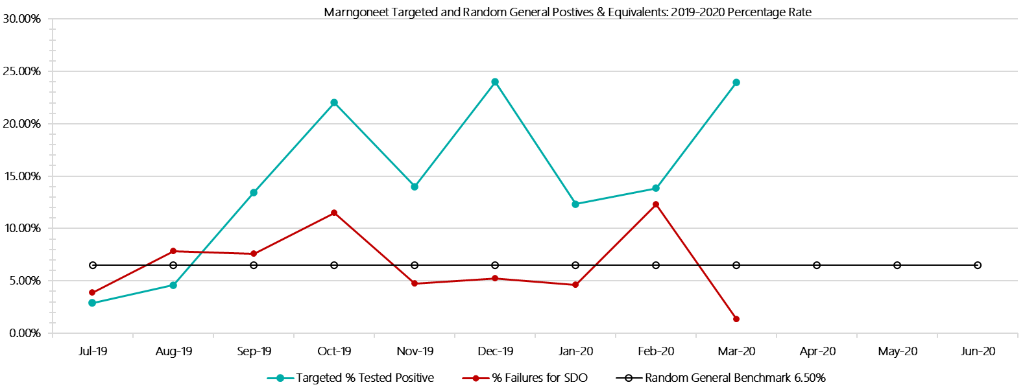

***Marngoneet Positive Test Results by Drug Type: 2019-2020***

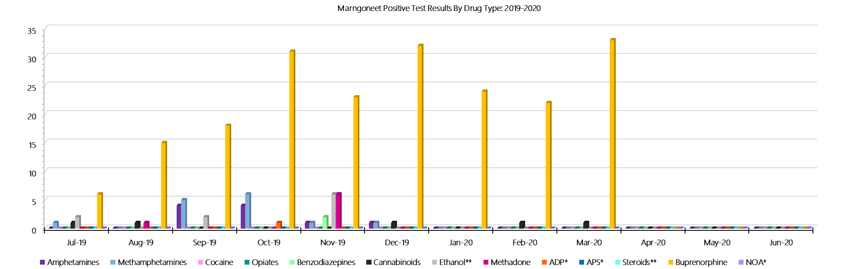

***Marngoneet Count of Visitor Seizures Finds: 2019-2020***

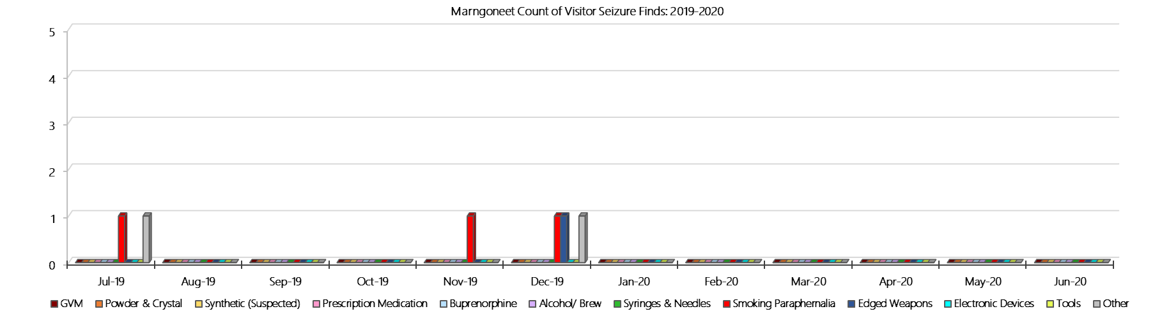

***Marngoneet Count of Prisoner Seizure Finds: 2019-2020***

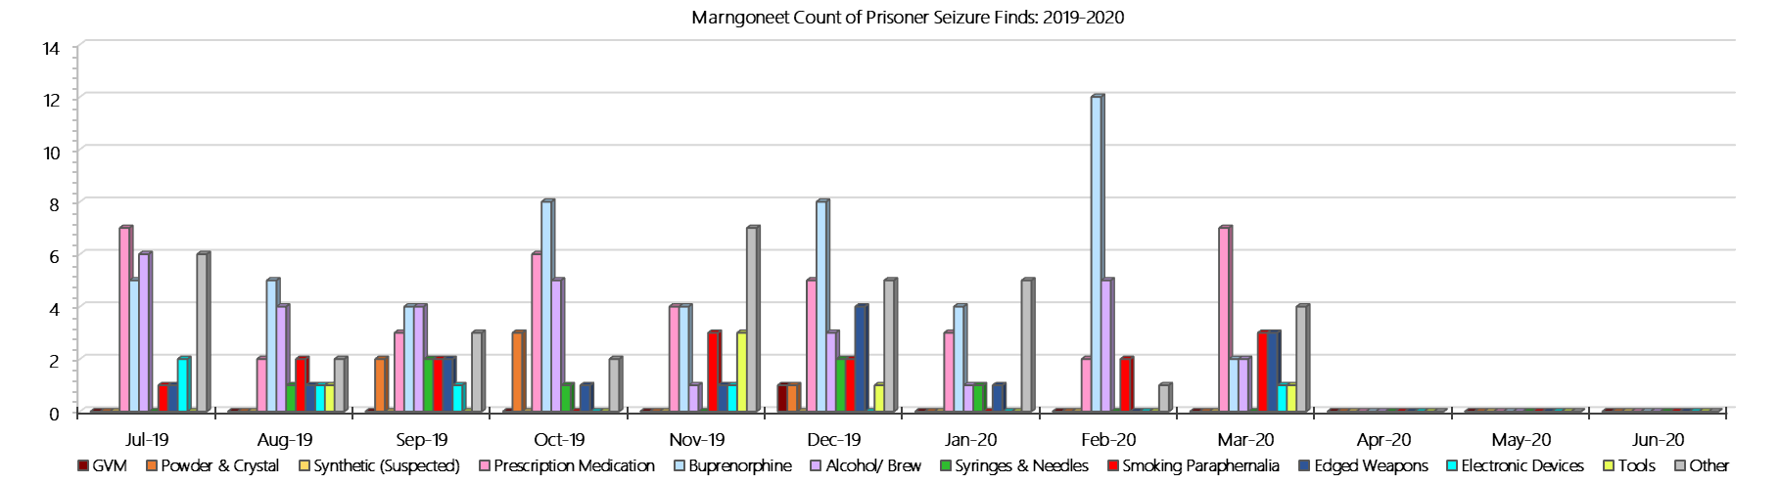

### **Loddon Prison**

***Targeted and Random General Drug Test Results: 2019-2020***

|  |  |  |  |  |  |  |  |  |  |  |  |  |  |  |
| --- | --- | --- | --- | --- | --- | --- | --- | --- | --- | --- | --- | --- | --- | --- |
| **Loddon** | **Jul-19** | **Aug-19** | **Sep-19** | **Oct-19** | **Nov-19** | **Dec-19** | **Jan-20** | **Feb-20** | **Mar-20** | **Apr-20** | **May-20** | **Jun-20** | **Average** | ***Totals*** |
| **Effective Sample - Targeted** | **82** | **73** | **72** | **65** | **59** | **72** | **66** | **83** | **72** |  |  |  | **72** | ***644*** |
| **Targeted Positives** | **8** | **5** | **12** | **3** | **6** | **6** | **10** | **6** | **5** |  |  |  | **7** | ***61*** |
| **Refusal** | **0** | **0** | **0** | **0** | **1** | **0** | **0** | **0** | **0** |  |  |  | **0** | ***1*** |
| **Unable** | **0** | **0** | **0** | **0** | **0** | **2** | **0** | **1** | **1** |  |  |  | **0** | ***4*** |
| **Interfered** | **0** | **0** | **0** | **0** | **0** | **0** | **0** | **1** | **0** |  |  |  | **0** | ***1*** |
| **Adulterated** | **1** | **0** | **0** | **0** | **0** | **0** | **0** | **0** | **0** |  |  |  | **0** | ***1*** |
| **Targeted % Tested Positive** | **10.98%** | **6.85%** | **16.67%** | **4.62%** | **11.86%** | **11.11%** | **15.15%** | **9.64%** | **8.33%** | **#N/A** | **#N/A** | **#N/A** | **10.56%** | ***10.56%*** |
| **Awaiting / Pending Results** | **0** | **0** | **0** | **0** | **0** | **0** | **0** | **0** | **0** |  |  |  | **0** | ***0*** |
| **Targeted Residual** | **6** | **4** | **2** | **0** | **0** | **1** | **0** | **0** | **1** |  |  |  | **2** | ***14*** |
| **Random tests collected** | **60** | **48** | **60** | **49** | **47** | **58** | **49** | **47** | **57** |  |  |  | **53** | ***475*** |
| **Tested Positive** | **5** | **3** | **6** | **3** | **3** | **3** | **0** | **3** | **2** |  |  |  | **3** | ***28*** |
| **Refusal (guilty)** | **0** | **0** | **0** | **0** | **0** | **0** | **0** | **0** | **1** |  |  |  | **0** | ***1*** |
| **Unable (not guilty)** | **0** | **0** | **0** | **0** | **0** | **0** | **0** | **0** | **0** |  |  |  | **0** | ***0*** |
| **Unable (guilty)** | **0** | **0** | **0** | **0** | **0** | **1** | **0** | **0** | **0** |  |  |  | **0** | ***1*** |
| **Interfered (guilty)** | **0** | **0** | **0** | **0** | **0** | **0** | **0** | **0** | **0** |  |  |  | **0** | ***0*** |
| **No test (valid reason)** | **2** | **0** | **2** | **0** | **1** | **1** | **2** | **1** | **2** |  |  |  | **1** | ***11*** |
| **No test (no valid reason)** | **0** | **0** | **0** | **0** | **0** | **0** | **0** | **0** | **0** |  |  |  | **0** | ***0*** |
| **Adulterated** | **0** | **0** | **0** | **0** | **0** | **0** | **0** | **0** | **0** |  |  |  | **0** | ***0*** |
| **Awaiting / Pending Results** | **0** | **0** | **0** | **0** | **0** | **0** | **0** | **0** | **2** |  |  |  | **0** | ***2*** |
| **Random Residual *(PIMS URAR030)*** | **0** | **0** | **0** | **0** | **0** | **0** | **0** | **0** | **0** |  |  |  | ***0*** | ***0*** |
| **Effective Sample - Random General** | **60** | **48** | **60** | **49** | **47** | **59** | **49** | **47** | **58** |  |  |  | **53** | **477** |
| **% Tested positive** | **8.33%** | **6.25%** | **10.00%** | **6.12%** | **6.38%** | **5.08%** | **0.00%** | **6.38%** | **3.45%** |  |  |  | **5.78%** |  |
| **% Prisoner guilty, positive equivalents** | **0.00%** | **0.00%** | **0.00%** | **0.00%** | **0.00%** | **1.69%** | **0.00%** | **0.00%** | **1.72%** |  |  |  | **0.38%** |  |
| **% Total prisoner fails** | **8.33%** | **6.25%** | **10.00%** | **6.12%** | **6.38%** | **6.78%** | **0.00%** | **6.38%** | **5.17%** |  |  |  | **6.16%** |  |
| **% No test without valid reason** | **0.00%** | **0.00%** | **0.00%** | **0.00%** | **0.00%** | **0.00%** | **0.00%** | **0.00%** | **0.00%** |  |  |  | **0.00%** |  |
| ***Random General Benchmark 5.00%*** | ***5.00%*** | ***5.00%*** | ***5.00%*** | ***5.00%*** | ***5.00%*** | ***5.00%*** | ***5.00%*** | ***5.00%*** | ***5.00%*** | ***5.00%*** | ***5.00%*** | ***5.00%*** | ***YTD*** |  |
| **% Failures for SDO** | **8.33%** | **6.25%** | **10.00%** | **6.12%** | **6.38%** | **6.78%** | **0.00%** | **6.38%** | **5.17%** | **#N/A** | **#N/A** | **#N/A** | **6.29%** |  |

***Loddon - Drugs Identified Through Testing by Drug Type: 2019-2020***

|  |  |  |  |  |  |  |  |  |  |  |  |  |  |  |
| --- | --- | --- | --- | --- | --- | --- | --- | --- | --- | --- | --- | --- | --- | --- |
| **Loddon** | ***Amphetamines*** | ***Methamphetamines*** | ***Cocaine*** | ***Opiates*** | ***Benzodiazepines*** | ***Cannabinoids*** | ***Ethanol\*\**** | ***Methadone*** | ***ADP\**** | ***APS\**** | ***Steroids\*\**** | ***Buprenorphine*** | ***NOA\**** | **Total** |
| **Jul-19** | **2** | **3** | **0** | **0** | **0** | **0** | **0** | **0** | **0** | **0** | **0** | **19** | **0** | **24** |
| **Aug-19** | **0** | **0** | **0** | **0** | **0** | **0** | **0** | **0** | **0** | **0** | **0** | **15** | **0** | **15** |
| **Sep-19** | **1** | **0** | **0** | **0** | **0** | **0** | **0** | **0** | **0** | **0** | **0** | **21** | **0** | **22** |
| **Oct-19** | **0** | **0** | **0** | **1** | **0** | **0** | **0** | **0** | **0** | **0** | **0** | **10** | **0** | **11** |
| **Nov-19** | **0** | **0** | **0** | **0** | **0** | **0** | **0** | **0** | **0** | **0** | **0** | **14** | **0** | **14** |
| **Dec-19** | **0** | **0** | **0** | **0** | **0** | **0** | **5** | **0** | **0** | **0** | **0** | **16** | **0** | **21** |
| **Jan-20** | **0** | **0** | **0** | **0** | **0** | **0** | **0** | **0** | **0** | **0** | **0** | **13** | **0** | **13** |
| **Feb-20** | **0** | **1** | **0** | **0** | **0** | **1** | **0** | **0** | **0** | **0** | **0** | **14** | **0** | **16** |
| **Mar-20** | **0** | **0** | **0** | **0** | **0** | **0** | **0** | **0** | **0** | **0** | **0** | **7** | **0** | **7** |
| **Apr-20** |  |  |  |  |  |  |  |  |  |  |  |  |  |  |
| **May-20** |  |  |  |  |  |  |  |  |  |  |  |  |  |  |
| **Jun-20** |  |  |  |  |  |  |  |  |  |  |  |  |  |  |
| **Loddon YTD** | **3** | **4** | **0** | **1** | **0** | **1** | **5** | **0** | **0** | **0** | **0** | **129** | **0** | **143** |
| ***All Prisons YTD*** | ***133*** | ***224*** | ***2*** | ***35*** | ***30*** | ***30*** | ***20*** | ***32*** | ***49*** | ***13*** | ***0*** | ***1785*** | ***0*** | ***2353*** |
| ***Loddon % of Total*** | ***2.26%*** | ***1.79%*** | ***0.00%*** | ***2.86%*** | ***0.00%*** | ***3.33%*** | ***25.00%*** | ***0.00%*** | ***0.00%*** | ***0.00%*** | ***0.00%*** | ***7.23%*** | ***0.00%*** | ***6.08%*** |

***Loddon Seizures of Contraband: Visitors & Prisoners: 2019-2020***

|  |  |  |  |  |  |  |  |  |  |  |  |  |  |  |  |  |  |  |  |  |  |  |  |  |  |  |
| --- | --- | --- | --- | --- | --- | --- | --- | --- | --- | --- | --- | --- | --- | --- | --- | --- | --- | --- | --- | --- | --- | --- | --- | --- | --- | --- |
| **Visitors** | **GVM** | | **Powder  & Crystal** | | **Synthetic  (Suspected)** | | **Prescription  Medication** | | **Buprenorphine** | | **Alcohol &  Home Brew** | | **Syringes & Needles** | | **Smoking  Paraphernalia** | | | **Edged  Weapons** | | **Electronic  Devices** | | **Tools** | | **Other** | | |
| **Loddon** | **Finds** | **Gms** | **Finds** | **Gms** | **Finds** | **Gms** | **Finds** | **Qty** | **Finds** | **Qty** | **Finds** | **Ltrs** | **Finds** | **Qty** | **Finds** | **Qty** | | **Finds** | **Qty** | **Finds** | **Qty** | **Finds** | **Qty** | **Finds** | **Qty** |
| **Jul-19** | **0** | **0.00** | **0** | **0.00** | **0** | **0.00** | **0** | **0.00** | **0** | **0.00** | **0** | **0.000** | **0** | **0** | **0** | | **0** | **0** | **0** | **0** | **0** | **0** | **0** | **0** | **0** |
| **Aug-19** | **0** | **0.00** | **0** | **0.00** | **0** | **0.00** | **0** | **0.00** | **0** | **0.00** | **0** | **0.000** | **0** | **0** | **0** | | **0** | **0** | **0** | **0** | **0** | **0** | **0** | **0** | **0** |
| **Sep-19** | **0** | **0.00** | **1** | **1.30** | **0** | **0.00** | **0** | **0.00** | **0** | **0.00** | **0** | **0.000** | **0** | **0** | **0** | | **0** | **0** | **0** | **0** | **0** | **0** | **0** | **0** | **0** |
| **Oct-19** | **0** | **0.00** | **0** | **0.00** | **0** | **0.00** | **0** | **0.00** | **0** | **0.00** | **0** | **0.000** | **0** | **0** | **1** | | **6** | **0** | **0** | **0** | **0** | **0** | **0** | **0** | **0** |
| **Nov-19** | **0** | **0.00** | **0** | **0.00** | **0** | **0.00** | **0** | **0.00** | **2** | **89.50** | **0** | **0.000** | **0** | **0** | **2** | | **30** | **0** | **0** | **0** | **0** | **0** | **0** | **0** | **0** |
| **Dec-19** | **1** | **1.00** | **0** | **0.00** | **0** | **0.00** | **0** | **0.00** | **0** | **0.00** | **0** | **0.000** | **0** | **0** | **0** | | **0** | **0** | **0** | **0** | **0** | **0** | **0** | **0** | **0** |
| **Jan-20** | **0** | **0.00** | **0** | **0.00** | **0** | **0.00** | **0** | **0.00** | **1** | **11.00** | **0** | **0.000** | **1** | **1** | **2** | | **9** | **0** | **0** | **0** | **0** | **0** | **0** | **0** | **0** |
| **Feb-20** | **0** | **0.00** | **0** | **0.00** | **0** | **0.00** | **0** | **0.00** | **1** | **65.00** | **0** | **0.000** | **0** | **0** | **0** | | **0** | **0** | **0** | **0** | **0** | **0** | **0** | **0** | **0** |
| **Mar-20** | **0** | **0.00** | **0** | **0.00** | **0** | **0.00** | **0** | **0.00** | **0** | **0.00** | **0** | **0.000** | **0** | **0** | **1** | | **1** | **0** | **0** | **0** | **0** | **0** | **0** | **0** | **0** |
| **Apr-20** |  |  |  |  |  |  |  |  |  |  |  |  |  |  |  | |  |  |  |  |  |  |  |  |  |
| **May-20** |  |  |  |  |  |  |  |  |  |  |  |  |  |  |  | |  |  |  |  |  |  |  |  |  |
| **Jun-20** |  |  |  |  |  |  |  |  |  |  |  |  |  |  |  | |  |  |  |  |  |  |  |  |  |
| **Total** | **1** | **1.00** | **1** | **1.30** | **0** | **0.00** | **0** | **0.00** | **4** | **165.50** | **0** | **0.000** | **1** | **1** | **6** | | **46** | **0** | **0** | **0** | **0** | **0** | **0** | **0** | **0** |

|  |  |  |  |  |  |  |  |  |  |  |  |  |  |  |  |  |  |  |  |  |  |  |  |  |  |  |
| --- | --- | --- | --- | --- | --- | --- | --- | --- | --- | --- | --- | --- | --- | --- | --- | --- | --- | --- | --- | --- | --- | --- | --- | --- | --- | --- |
| **Prisoners** | **GVM** | | **Powder  & Crystal** | | **Synthetic  (Suspected)** | | **Prescription  Medication** | | **Buprenorphine** | | **Alcohol &  Home Brew** | | **Syringes & Needles** | | **Smoking  Paraphernalia** | | | **Edged  Weapons** | | **Electronic  Devices** | | **Tools** | | **Other** | | |
| **Loddon** | **Finds** | **Gms** | **Finds** | **Gms** | **Finds** | **Gms** | **Finds** | **Qty** | **Finds** | **Qty** | **Finds** | **Ltrs** | **Finds** | **Qty** | **Finds** | **Qty** | | **Finds** | **Qty** | **Finds** | **Qty** | **Finds** | **Qty** | **Finds** | **Qty** |
| **Jul-19** | **0** | **0.00** | **0** | **0.00** | **0** | **0.00** | **2** | **39.00** | **8** | **9.60** | **0** | **0.000** | **0** | **0** | **3** | | **5** | **2** | **2** | **0** | **0** | **1** | **2** | **2** | **4** |
| **Aug-19** | **0** | **0.00** | **2** | **5.00** | **0** | **0.00** | **0** | **0.00** | **7** | **162.00** | **4** | **6.000** | **1** | **1** | **4** | | **4** | **0** | **0** | **1** | **1** | **1** | **5** | **2** | **19** |
| **Sep-19** | **1** | **7.20** | **0** | **0.00** | **0** | **0.00** | **1** | **1.00** | **3** | **9.30** | **1** | **2.000** | **0** | **0** | **5** | | **10** | **1** | **1** | **0** | **0** | **0** | **0** | **0** | **0** |
| **Oct-19** | **0** | **0.00** | **0** | **0.00** | **0** | **0.00** | **0** | **0.00** | **1** | **0.00** | **2** | **8.000** | **0** | **0** | **2** | | **2** | **3** | **4** | **1** | **1** | **0** | **0** | **0** | **0** |
| **Nov-19** | **0** | **0.00** | **0** | **0.00** | **0** | **0.00** | **1** | **28.00** | **2** | **0.00** | **1** | **8.000** | **0** | **0** | **1** | | **2** | **2** | **3** | **0** | **0** | **0** | **0** | **0** | **0** |
| **Dec-19** | **0** | **0.00** | **0** | **0.00** | **0** | **0.00** | **1** | **1.00** | **2** | **0.00** | **3** | **6.000** | **0** | **0** | **2** | | **3** | **7** | **7** | **1** | **1** | **0** | **0** | **1** | **1** |
| **Jan-20** | **0** | **0.00** | **0** | **0.00** | **0** | **0.00** | **0** | **0.00** | **4** | **0.00** | **1** | **2.000** | **0** | **0** | **4** | | **13** | **3** | **3** | **0** | **0** | **0** | **0** | **7** | **13** |
| **Feb-20** | **0** | **0.00** | **0** | **0.00** | **0** | **0.00** | **0** | **0.00** | **5** | **0.00** | **4** | **8.000** | **1** | **1** | **11** | | **12** | **3** | **3** | **2** | **2** | **0** | **0** | **6** | **35** |
| **Mar-20** | **0** | **0.00** | **0** | **0.00** | **0** | **0.00** | **0** | **0.00** | **5** | **1.00** | **0** | **0.000** | **0** | **0** | **8** | | **17** | **3** | **3** | **1** | **1** | **3** | **5** | **4** | **6** |
| **Apr-20** |  |  |  |  |  |  |  |  |  |  |  |  |  |  |  | |  |  |  |  |  |  |  |  |  |
| **May-20** |  |  |  |  |  |  |  |  |  |  |  |  |  |  |  | |  |  |  |  |  |  |  |  |  |
| **Jun-20** |  |  |  |  |  |  |  |  |  |  |  |  |  |  |  | |  |  |  |  |  |  |  |  |  |
| **Total** | **1** | **7.20** | **2** | **5.00** | **0** | **0.00** | **5** | **69.00** | **37** | **181.90** | **16** | **40.000** | **2** | **2** | **40** | | **68** | **24** | **26** | **6** | **6** | **5** | **12** | **22** | **78** |

***Loddon Targeted and Random General Drug Test Positives & Equivalents: 2019-2020***

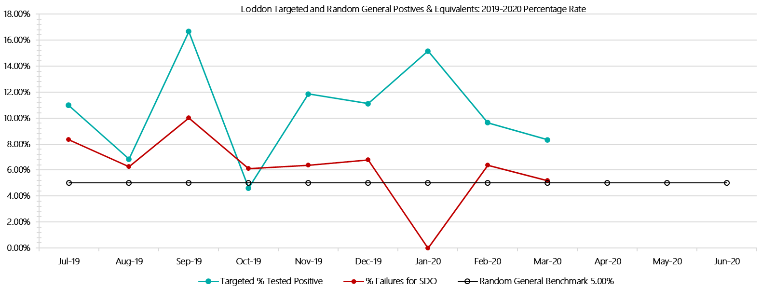

***Loddon Positive Test Results by Drug Type: 2019-2020***

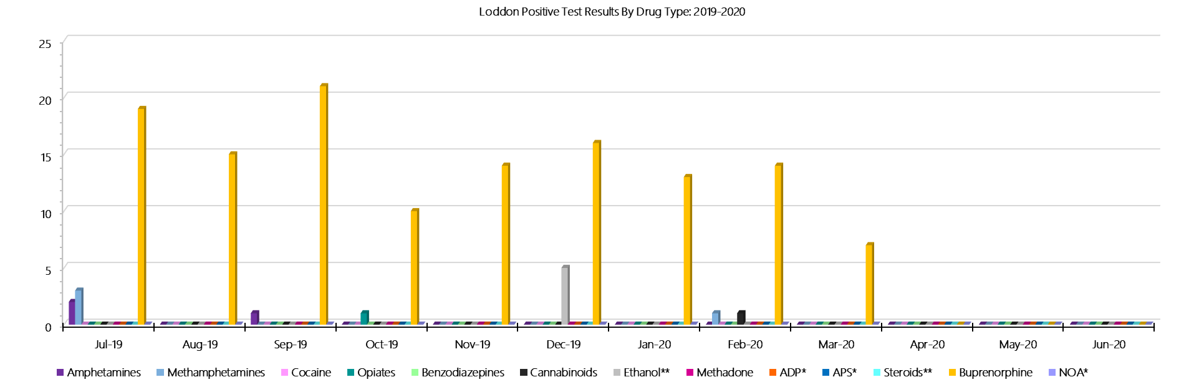

***Loddon Count of Visitor Seizures Finds: 2019-2020***

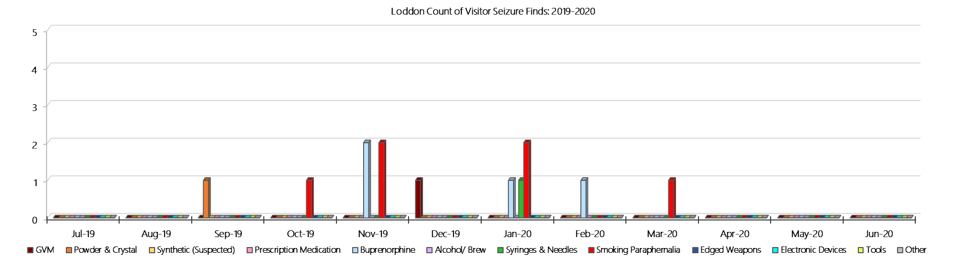

***Loddon Count of Prisoner Seizure Finds: 2019-2020***

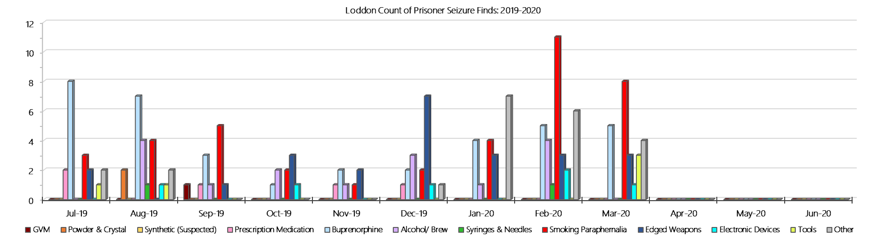

### **Middleton (annex of Loddon)**

***Targeted and Random General Drug Test Results: 2019-2020***

|  |  |  |  |  |  |  |  |  |  |  |  |  |  |  |
| --- | --- | --- | --- | --- | --- | --- | --- | --- | --- | --- | --- | --- | --- | --- |
| **Middleton** | **Jul-19** | **Aug-19** | **Sep-19** | **Oct-19** | **Nov-19** | **Dec-19** | **Jan-20** | **Feb-20** | **Mar-20** | **Apr-20** | **May-20** | **Jun-20** | **Average** | ***Totals*** |
| **Effective Sample - Targeted** | **36** | **43** | **54** | **49** | **50** | **51** | **50** | **48** | **45** |  |  |  | **47** | ***426*** |
| **Targeted Positives** | **2** | **5** | **3** | **2** | **4** | **2** | **0** | **2** | **2** |  |  |  | **2** | ***22*** |
| **Refusal** | **0** | **0** | **0** | **0** | **0** | **0** | **0** | **0** | **1** |  |  |  | **0** | ***1*** |
| **Unable** | **0** | **1** | **0** | **1** | **0** | **0** | **0** | **0** | **1** |  |  |  | **0** | ***3*** |
| **Interfered** | **0** | **0** | **0** | **0** | **0** | **1** | **0** | **0** | **0** |  |  |  | **0** | ***1*** |
| **Adulterated** | **0** | **0** | **0** | **0** | **0** | **0** | **0** | **0** | **0** |  |  |  | **0** | ***0*** |
| **Targeted % Tested Positive** | **5.56%** | **13.95%** | **5.56%** | **6.12%** | **8.00%** | **5.88%** | **0.00%** | **4.17%** | **8.89%** | **#N/A** | **#N/A** | **#N/A** | **6.34%** | ***6.34%*** |
| **Awaiting / Pending Results** | **0** | **0** | **0** | **0** | **0** | **0** | **0** | **0** | **0** |  |  |  | **0** | ***0*** |
| **Targeted Residual** | **0** | **0** | **0** | **1** | **0** | **0** | **0** | **1** | **1** |  |  |  | **0** | ***3*** |
| **Random tests collected** | **39** | **32** | **38** | **27** | **30** | **36** | **31** | **31** | **38** |  |  |  | **34** | ***302*** |
| **Tested Positive** | **0** | **1** | **1** | **0** | **0** | **0** | **0** | **0** | **0** |  |  |  | **0** | ***2*** |
| **Refusal (guilty)** | **0** | **0** | **0** | **0** | **0** | **0** | **0** | **0** | **0** |  |  |  | **0** | ***0*** |
| **Unable (not guilty)** | **0** | **0** | **0** | **0** | **0** | **0** | **0** | **0** | **0** |  |  |  | **0** | ***0*** |
| **Unable (guilty)** | **0** | **0** | **0** | **0** | **0** | **0** | **0** | **0** | **0** |  |  |  | **0** | ***0*** |
| **Interfered (guilty)** | **0** | **0** | **0** | **0** | **0** | **0** | **0** | **0** | **0** |  |  |  | **0** | ***0*** |
| **No test (valid reason)** | **1** | **0** | **2** | **1** | **0** | **1** | **0** | **1** | **0** |  |  |  | **1** | ***6*** |
| **No test (no valid reason)** | **0** | **0** | **0** | **0** | **0** | **0** | **0** | **0** | **0** |  |  |  | **0** | ***0*** |
| **Adulterated** | **0** | **0** | **0** | **0** | **0** | **0** | **0** | **0** | **0** |  |  |  | **0** | ***0*** |
| **Awaiting / Pending Results** | **0** | **0** | **0** | **0** | **0** | **0** | **0** | **0** | **0** |  |  |  | **0** | ***0*** |
| **Random Residual *(PIMS URAR030)*** | **0** | **0** | **0** | **0** | **0** | **0** | **0** | **0** | **0** |  |  |  | ***0*** | ***0*** |
| **Effective Sample - Random General** | **39** | **32** | **38** | **27** | **30** | **36** | **31** | **31** | **38** |  |  |  | **34** | **302** |
| **% Tested positive** | **0.00%** | **3.13%** | **2.63%** | **0.00%** | **0.00%** | **0.00%** | **0.00%** | **0.00%** | **0.00%** |  |  |  | **0.64%** |  |
| **% Prisoner guilty, positive equivalents** | **0.00%** | **0.00%** | **0.00%** | **0.00%** | **0.00%** | **0.00%** | **0.00%** | **0.00%** | **0.00%** |  |  |  | **0.00%** |  |
| **% Total prisoner fails** | **0.00%** | **3.13%** | **2.63%** | **0.00%** | **0.00%** | **0.00%** | **0.00%** | **0.00%** | **0.00%** |  |  |  | **0.64%** |  |
| **% No test without valid reason** | **0.00%** | **0.00%** | **0.00%** | **0.00%** | **0.00%** | **0.00%** | **0.00%** | **0.00%** | **0.00%** |  |  |  | **0.00%** |  |
| ***Random General Benchmark 4.00%*** | ***4.00%*** | ***4.00%*** | ***4.00%*** | ***4.00%*** | ***4.00%*** | ***4.00%*** | ***4.00%*** | ***4.00%*** | ***4.00%*** | ***4.00%*** | ***4.00%*** | ***4.00%*** | ***YTD*** |  |
| **% Failures for SDO** | **0.00%** | **3.13%** | **2.63%** | **0.00%** | **0.00%** | **0.00%** | **0.00%** | **0.00%** | **0.00%** | **#N/A** | **#N/A** | **#N/A** | **0.66%** |  |

***Middleton - Drugs Identified Through Testing by Drug Type: 2019-2020***

|  |  |  |  |  |  |  |  |  |  |  |  |  |  |  |  |
| --- | --- | --- | --- | --- | --- | --- | --- | --- | --- | --- | --- | --- | --- | --- | --- |
| **Middleton** | ***Amphetamines*** | | ***Methamphetamines*** | ***Cocaine*** | ***Opiates*** | ***Benzodiazepines*** | ***Cannabinoids*** | ***Ethanol\*\**** | ***Methadone*** | ***ADP\**** | ***APS\**** | ***Steroids\*\**** | ***Buprenorphine*** | ***NOA\**** | **Total** |
| **Jul-19** | **1** | | **2** | **0** | **0** | **0** | **0** | **0** | **0** | **0** | **0** | **0** | **3** | **0** | **6** |
| **Aug-19** | **2** | | **2** | **0** | **0** | **0** | **0** | **0** | **0** | **0** | **0** | **0** | **8** | **0** | **12** |
| **Sep-19** | **0** | | **0** | **0** | **0** | **0** | **0** | **0** | **0** | **0** | **0** | **0** | **6** | **0** | **6** |
| **Oct-19** | **0** | | **0** | **0** | **0** | **0** | **0** | **0** | **0** | **0** | **0** | **0** | **5** | **0** | **5** |
| **Nov-19** | **0** | | **0** | **0** | **0** | **0** | **1** | **0** | **0** | **0** | **0** | **0** | **3** | **0** | **4** |
| **Dec-19** | **0** | | **0** | **0** | **0** | **0** | **0** | **0** | **0** | **0** | **0** | **0** | **2** | **0** | **2** |
| **Jan-20** | **0** | | **0** | **0** | **0** | **0** | **0** | **0** | **0** | **0** | **0** | **0** | **0** | **0** | **0** |
| **Feb-20** | **0** | | **0** | **0** | **0** | **0** | **0** | **0** | **0** | **0** | **0** | **0** | **2** | **0** | **2** |
| **Mar-20** | **0** | | **0** | **0** | **0** | **0** | **0** | **0** | **0** | **0** | **0** | **0** | **3** | **0** | **3** |
| **Apr-20** |  | |  |  |  |  |  |  |  |  |  |  |  |  |  |
| **May-20** |  | |  |  |  |  |  |  |  |  |  |  |  |  |  |
| **Jun-20** |  | |  |  |  |  |  |  |  |  |  |  |  |  |  |
| **Middleton YTD** | | **3** | **4** | **0** | **0** | **0** | **1** | **0** | **0** | **0** | **0** | **0** | **32** | **0** | **40** |
| ***All Prisons YTD*** | | ***133*** | ***224*** | ***2*** | ***35*** | ***30*** | ***30*** | ***20*** | ***32*** | ***49*** | ***13*** | ***0*** | ***1785*** | ***0*** | ***2353*** |
| ***Middleton % of Total*** | | ***2.26%*** | ***1.79%*** | ***0.00%*** | ***0.00%*** | ***0.00%*** | ***3.33%*** | ***0.00%*** | ***0.00%*** | ***0.00%*** | ***0.00%*** | ***0.00%*** | ***1.79%*** | ***0.00%*** | ***1.70%*** |

***Middleton Seizures of Contraband: Visitors & Prisoners: 2019-2020***

|  |  |  |  |  |  |  |  |  |  |  |  |  |  |  |  |  |  |  |  |  |  |  |  |  |
| --- | --- | --- | --- | --- | --- | --- | --- | --- | --- | --- | --- | --- | --- | --- | --- | --- | --- | --- | --- | --- | --- | --- | --- | --- |
| **Visitors** | **GVM** | | **Powder  & Crystal** | | **Synthetic  (Suspected)** | | **Prescription  Medication** | | **Buprenorphine** | | **Alcohol &  Home Brew** | | **Syringes & Needles** | | **Smoking  Paraphernalia** | | **Edged  Weapons** | | **Electronic  Devices** | | **Tools** | | **Other** | |
| **Middleton** | **Finds** | **Gms** | **Finds** | **Gms** | **Finds** | **Gms** | **Finds** | **Qty** | **Finds** | **Qty** | **Finds** | **Ltrs** | **Finds** | **Qty** | **Finds** | **Qty** | **Finds** | **Qty** | **Finds** | **Qty** | **Finds** | **Qty** | **Finds** | **Qty** |
| **Jul-19** | **0** | **0.00** | **0** | **0.00** | **0** | **0.00** | **0** | **0.00** | **0** | **0.00** | **0** | **0.000** | **0** | **0** | **0** | **0** | **0** | **0** | **0** | **0** | **0** | **0** | **0** | **0** |
| **Aug-19** | **0** | **0.00** | **1** | **5.00** | **0** | **0.00** | **0** | **0.00** | **0** | **0.00** | **0** | **0.000** | **0** | **0** | **0** | **0** | **0** | **0** | **0** | **0** | **0** | **0** | **1** | **1** |
| **Sep-19** | **0** | **0.00** | **0** | **0.00** | **0** | **0.00** | **0** | **0.00** | **0** | **0.00** | **0** | **0.000** | **0** | **0** | **0** | **0** | **0** | **0** | **0** | **0** | **0** | **0** | **0** | **0** |
| **Oct-19** | **0** | **0.00** | **0** | **0.00** | **0** | **0.00** | **0** | **0.00** | **0** | **0.00** | **0** | **0.000** | **0** | **0** | **0** | **0** | **0** | **0** | **0** | **0** | **0** | **0** | **0** | **0** |
| **Nov-19** | **0** | **0.00** | **0** | **0.00** | **0** | **0.00** | **0** | **0.00** | **0** | **0.00** | **0** | **0.000** | **0** | **0** | **0** | **0** | **0** | **0** | **0** | **0** | **0** | **0** | **0** | **0** |
| **Dec-19** | **0** | **0.00** | **0** | **0.00** | **0** | **0.00** | **0** | **0.00** | **0** | **0.00** | **0** | **0.000** | **0** | **0** | **0** | **0** | **1** | **1** | **0** | **0** | **0** | **0** | **0** | **0** |
| **Jan-20** | **0** | **0.00** | **0** | **0.00** | **0** | **0.00** | **0** | **0.00** | **0** | **0.00** | **0** | **0.000** | **0** | **0** | **0** | **0** | **0** | **0** | **0** | **0** | **0** | **0** | **0** | **0** |
| **Feb-20** | **0** | **0.00** | **0** | **0.00** | **0** | **0.00** | **0** | **0.00** | **0** | **0.00** | **0** | **0.000** | **0** | **0** | **0** | **0** | **0** | **0** | **0** | **0** | **0** | **0** | **0** | **0** |
| **Mar-20** | **0** | **0.00** | **0** | **0.00** | **0** | **0.00** | **0** | **0.00** | **0** | **0.00** | **0** | **0.000** | **0** | **0** | **0** | **0** | **0** | **0** | **0** | **0** | **0** | **0** | **0** | **0** |
| **Apr-20** |  |  |  |  |  |  |  |  |  |  |  |  |  |  |  |  |  |  |  |  |  |  |  |  |
| **May-20** |  |  |  |  |  |  |  |  |  |  |  |  |  |  |  |  |  |  |  |  |  |  |  |  |
| **Jun-20** |  |  |  |  |  |  |  |  |  |  |  |  |  |  |  |  |  |  |  |  |  |  |  |  |
| **Total** | **0** | **0.00** | **1** | **5.00** | **0** | **0.00** | **0** | **0.00** | **0** | **0.00** | **0** | **0.000** | **0** | **0** | **0** | **0** | **1** | **1** | **0** | **0** | **0** | **0** | **1** | **1** |

|  |  |  |  |  |  |  |  |  |  |  |  |  |  |  |  |  |  |  |  |  |  |  |  |  |  |
| --- | --- | --- | --- | --- | --- | --- | --- | --- | --- | --- | --- | --- | --- | --- | --- | --- | --- | --- | --- | --- | --- | --- | --- | --- | --- |
| **Prisoners** | **GVM** | | **Powder  & Crystal** | | **Synthetic  (Suspected)** | | **Prescription  Medication** | | **Buprenorphine** | | **Alcohol &  Home Brew** | | **Syringes & Needles** | | **Smoking  Paraphernalia** | | | **Edged  Weapons** | | **Electronic  Devices** | | **Tools** | | **Other** | |
| **Middleton** | **Finds** | **Gms** | **Finds** | **Gms** | **Finds** | **Gms** | **Finds** | **Qty** | **Finds** | **Qty** | **Finds** | **Ltrs** | **Finds** | **Qty** | **Finds** | **Qty** | | **Finds** | **Qty** | **Finds** | **Qty** | **Finds** | **Qty** | **Finds** | **Qty** |
| **Jul-19** | **0** | **0.00** | **0** | **0.00** | **0** | **0.00** | **0** | **0.00** | **0** | **0.00** | **0** | **0.000** | **0** | **0** | **1** | | **1** | **1** | **1** | **1** | **1** | **0** | **0** | **0** | **0** |
| **Aug-19** | **0** | **0.00** | **0** | **0.00** | **0** | **0.00** | **0** | **0.00** | **3** | **4.00** | **0** | **0.000** | **0** | **0** | **2** | | **3** | **0** | **0** | **1** | **8** | **0** | **0** | **1** | **1** |
| **Sep-19** | **0** | **0.00** | **0** | **0.00** | **0** | **0.00** | **2** | **1.50** | **1** | **0.00** | **0** | **0.000** | **0** | **0** | **2** | | **3** | **0** | **0** | **1** | **2** | **0** | **0** | **0** | **0** |
| **Oct-19** | **0** | **0.00** | **0** | **0.00** | **0** | **0.00** | **0** | **0.00** | **1** | **0.00** | **0** | **0.000** | **0** | **0** | **2** | | **3** | **1** | **1** | **1** | **1** | **0** | **0** | **0** | **0** |
| **Nov-19** | **0** | **0.00** | **0** | **0.00** | **0** | **0.00** | **0** | **0.00** | **1** | **0.00** | **0** | **0.000** | **1** | **1** | **3** | | **8** | **1** | **1** | **0** | **0** | **0** | **0** | **0** | **0** |
| **Dec-19** | **0** | **0.00** | **0** | **0.00** | **0** | **0.00** | **2** | **16.00** | **0** | **0.00** | **2** | **16.000** | **0** | **0** | **3** | | **3** | **0** | **0** | **1** | **1** | **0** | **0** | **1** | **3** |
| **Jan-20** | **0** | **0.00** | **0** | **0.00** | **0** | **0.00** | **0** | **0.00** | **0** | **0.00** | **1** | **1.000** | **0** | **0** | **0** | | **0** | **0** | **0** | **0** | **0** | **1** | **1** | **0** | **0** |
| **Feb-20** | **0** | **0.00** | **0** | **0.00** | **0** | **0.00** | **0** | **0.00** | **2** | **0.00** | **0** | **0.000** | **0** | **0** | **2** | | **2** | **2** | **3** | **1** | **1** | **0** | **0** | **0** | **0** |
| **Mar-20** | **0** | **0.00** | **0** | **0.00** | **0** | **0.00** | **0** | **0.00** | **0** | **0.00** | **0** | **0.000** | **0** | **0** | **0** | | **0** | **0** | **0** | **0** | **0** | **1** | **1** | **0** | **0** |
| **Apr-20** |  |  |  |  |  |  |  |  |  |  |  |  |  |  |  | |  |  |  |  |  |  |  |  |  |
| **May-20** |  |  |  |  |  |  |  |  |  |  |  |  |  |  |  | |  |  |  |  |  |  |  |  |  |
| **Jun-20** |  |  |  |  |  |  |  |  |  |  |  |  |  |  |  | |  |  |  |  |  |  |  |  |  |
| **Total** | **0** | **0.00** | **0** | **0.00** | **0** | **0.00** | **4** | **17.50** | **8** | **4.00** | **3** | **17.000** | **1** | **1** | **15** | | **23** | **5** | **6** | **6** | **14** | **2** | **2** | **2** | **4** |

***Middleton Targeted and Random General Drug Test Positives & Equivalents: 2019-2020***

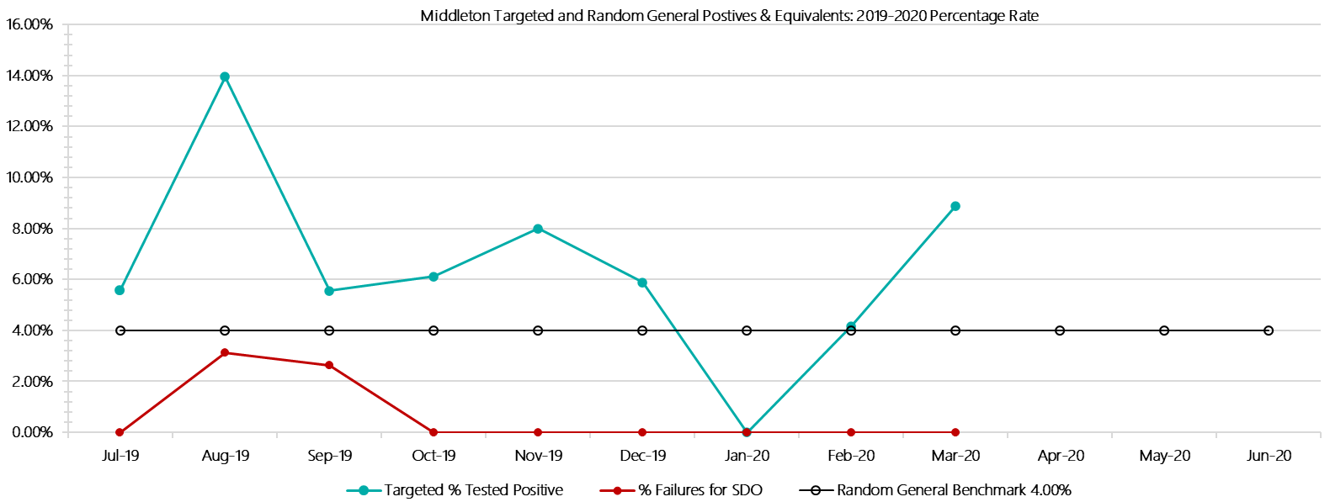

***Middleton Positive Test Results by Drug Type: 2019-2020***

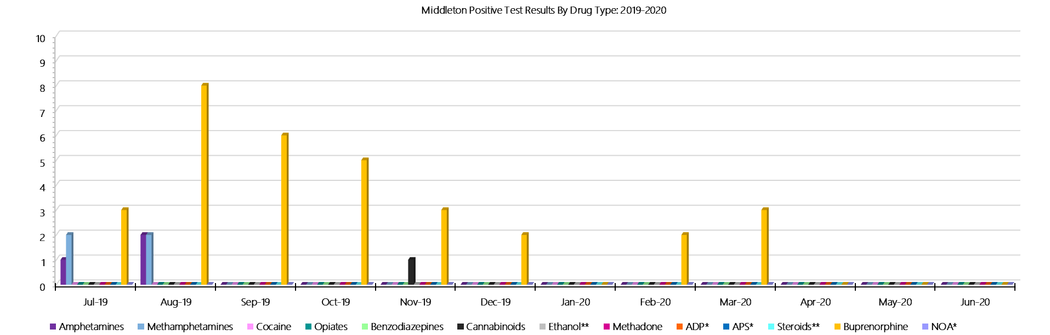

***Middleton Count of Visitor Seizures Finds: 2019-2020***

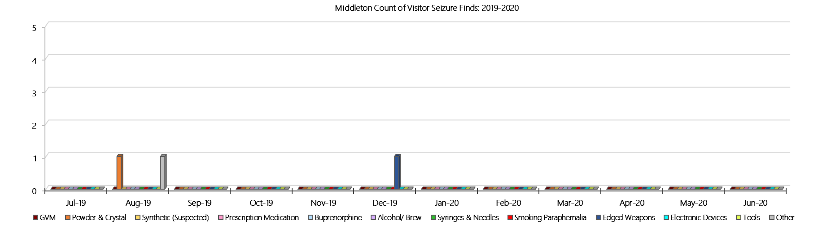

***Middleton Count of Prisoner Seizure Finds: 2019-2020***

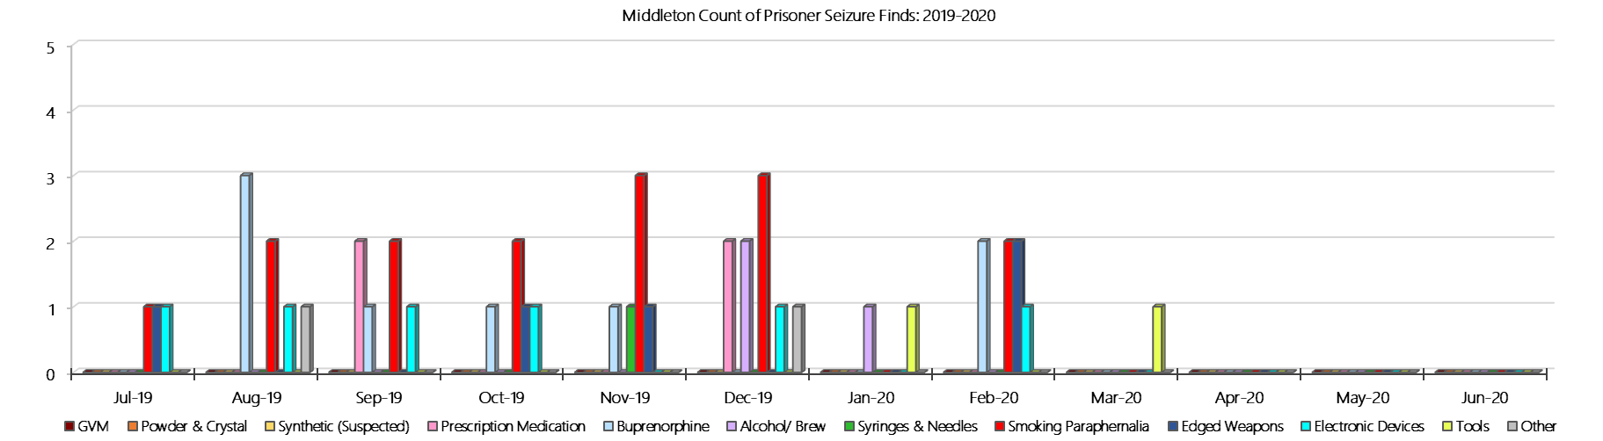

### **Ravenhall Correctional Centre**

***Targeted and Random General Drug Test Results: 2019-2020***

|  |  |  |  |  |  |  |  |  |  |  |  |  |  |  |
| --- | --- | --- | --- | --- | --- | --- | --- | --- | --- | --- | --- | --- | --- | --- |
| **Ravenhall** | **Jul-19** | **Aug-19** | **Sep-19** | **Oct-19** | **Nov-19** | **Dec-19** | **Jan-20** | **Feb-20** | **Mar-20** | **Apr-20** | **May-20** | **Jun-20** | **Average** | ***Totals*** |
| **Effective Sample - Targeted** | **375** | **426** | **400** | **444** | **411** | **414** | **402** | **384** | **304** |  |  |  | **396** | ***3560*** |
| **Targeted Positives** | **15** | **27** | **16** | **20** | **33** | **29** | **34** | **31** | **27** |  |  |  | **26** | ***232*** |
| **Refusal** | **1** | **0** | **3** | **3** | **1** | **2** | **1** | **1** | **0** |  |  |  | **1** | ***12*** |
| **Unable** | **5** | **4** | **5** | **8** | **4** | **14** | **1** | **4** | **4** |  |  |  | **5** | ***49*** |
| **Interfered** | **0** | **0** | **0** | **0** | **0** | **0** | **0** | **1** | **0** |  |  |  | **0** | ***1*** |
| **Adulterated** | **0** | **0** | **1** | **0** | **0** | **1** | **2** | **0** | **0** |  |  |  | **0** | ***4*** |
| **Targeted % Tested Positive** | **5.60%** | **7.28%** | **6.25%** | **6.98%** | **9.25%** | **11.11%** | **9.45%** | **9.64%** | **10.20%** | **#N/A** | **#N/A** | **#N/A** | **8.37%** | ***8.37%*** |
| **Awaiting / Pending Results** | **0** | **0** | **0** | **0** | **0** | **0** | **0** | **0** | **0** |  |  |  | **0** | ***0*** |
| **Targeted Residual** | **1** | **1** | **3** | **1** | **1** | **1** | **1** | **0** | **2** |  |  |  | **1** | ***11*** |
| **Random tests collected** | **174** | **146** | **173** | **147** | **139** | **179** | **144** | **141** | **177** |  |  |  | **158** | ***1420*** |
| **Tested Positive** | **8** | **4** | **1** | **4** | **8** | **6** | **7** | **6** | **9** |  |  |  | **6** | ***53*** |
| **Refusal (guilty)** | **1** | **0** | **2** | **0** | **1** | **0** | **0** | **1** | **2** |  |  |  | **1** | ***7*** |
| **Unable (not guilty)** | **0** | **0** | **0** | **0** | **0** | **0** | **0** | **1** | **0** |  |  |  | **0** | ***1*** |
| **Unable (guilty)** | **0** | **0** | **1** | **0** | **0** | **0** | **1** | **2** | **1** |  |  |  | **1** | ***5*** |
| **Interfered (guilty)** | **0** | **0** | **0** | **0** | **0** | **0** | **0** | **0** | **0** |  |  |  | **0** | ***0*** |
| **No test (valid reason)** | **7** | **2** | **5** | **1** | **7** | **5** | **4** | **4** | **5** |  |  |  | **4** | ***40*** |
| **No test (no valid reason)** | **0** | **0** | **2** | **0** | **0** | **0** | **0** | **0** | **0** |  |  |  | **0** | ***2*** |
| **Adulterated** | **0** | **0** | **0** | **0** | **0** | **0** | **1** | **0** | **0** |  |  |  | **0** | ***1*** |
| **Awaiting / Pending Results** | **0** | **0** | **0** | **0** | **0** | **0** | **0** | **0** | **0** |  |  |  | **0** | ***0*** |
| **Random Residual *(PIMS URAR030)*** | **0** | **0** | **0** | **1** | **1** | **0** | **1** | **0** | **1** |  |  |  | ***0.444444*** | ***4*** |
| **Effective Sample - Random General** | **175** | **146** | **178** | **147** | **140** | **179** | **145** | **144** | **180** |  |  |  | **159** | **1434** |
| **% Tested positive** | **4.57%** | **2.74%** | **0.56%** | **2.72%** | **5.71%** | **3.35%** | **4.83%** | **4.17%** | **5.00%** |  |  |  | **3.74%** |  |
| **% Prisoner guilty, positive equivalents** | **0.57%** | **0.00%** | **1.69%** | **0.00%** | **0.71%** | **0.00%** | **1.38%** | **2.08%** | **1.67%** |  |  |  | **0.90%** |  |
| **% Total prisoner fails** | **5.14%** | **2.74%** | **2.25%** | **2.72%** | **6.43%** | **3.35%** | **5.52%** | **6.25%** | **6.67%** |  |  |  | **4.56%** |  |
| **% No test without valid reason** | **0.00%** | **0.00%** | **1.12%** | **0.00%** | **0.00%** | **0.00%** | **0.00%** | **0.00%** | **0.00%** |  |  |  | **0.12%** |  |
| **% Failures for SDO** | **5.14%** | **2.74%** | **3.37%** | **2.72%** | **6.43%** | **3.35%** | **6.21%** | **6.25%** | **6.67%** | **#N/A** | **#N/A** | **#N/A** | **4.74%** |  |

***Ravenhall - Drugs Identified Through Testing by Drug Type: 2019-2020***

|  |  |  |  |  |  |  |  |  |  |  |  |  |  |  |  |
| --- | --- | --- | --- | --- | --- | --- | --- | --- | --- | --- | --- | --- | --- | --- | --- |
| **Ravenhall** | ***Amphetamines*** | | ***Methamphetamines*** | ***Cocaine*** | ***Opiates*** | ***Benzodiazepines*** | ***Cannabinoids*** | ***Ethanol\*\**** | ***Methadone*** | ***ADP\**** | ***APS\**** | ***Steroids\*\**** | ***Buprenorphine*** | ***NOA\**** | **Total** |
| **Jul-19** | **2** | | **5** | **0** | **0** | **0** | **1** | **0** | **0** | **0** | **0** | **0** | **28** | **0** | **36** |
| **Aug-19** | **2** | | **9** | **0** | **0** | **3** | **1** | **0** | **0** | **1** | **0** | **0** | **22** | **0** | **38** |
| **Sep-19** | **3** | | **3** | **0** | **0** | **1** | **2** | **0** | **0** | **0** | **0** | **0** | **16** | **0** | **25** |
| **Oct-19** | **7** | | **8** | **0** | **0** | **0** | **4** | **0** | **1** | **0** | **0** | **0** | **21** | **0** | **41** |
| **Nov-19** | **5** | | **8** | **0** | **0** | **0** | **0** | **0** | **0** | **0** | **0** | **0** | **43** | **0** | **56** |
| **Dec-19** | **4** | | **7** | **0** | **0** | **1** | **2** | **1** | **0** | **0** | **0** | **0** | **37** | **0** | **52** |
| **Jan-20** | **0** | | **0** | **0** | **0** | **0** | **0** | **0** | **0** | **0** | **0** | **0** | **51** | **0** | **51** |
| **Feb-20** | **2** | | **6** | **0** | **0** | **2** | **1** | **1** | **0** | **1** | **0** | **0** | **36** | **0** | **49** |
| **Mar-20** | **1** | | **2** | **0** | **0** | **0** | **2** | **0** | **0** | **0** | **0** | **0** | **35** | **0** | **40** |
| **Apr-20** |  | |  |  |  |  |  |  |  |  |  |  |  |  |  |
| **May-20** |  | |  |  |  |  |  |  |  |  |  |  |  |  |  |
| **Jun-20** |  | |  |  |  |  |  |  |  |  |  |  |  |  |  |
| **Ravenhall YTD** | | **26** | **48** | **0** | **0** | **7** | **13** | **2** | **1** | **2** | **0** | **0** | **289** | **0** | **388** |
| ***All Prisons YTD*** | | ***133*** | ***224*** | ***2*** | ***35*** | ***30*** | ***30*** | ***20*** | ***32*** | ***49*** | ***13*** | ***0*** | ***1785*** | ***0*** | ***2353*** |
| ***Ravenhall % of Total*** | | ***19.55%*** | ***21.43%*** | ***0.00%*** | ***0.00%*** | ***23.33%*** | ***43.33%*** | ***10.00%*** | ***3.13%*** | ***4.08%*** | ***0.00%*** | ***0.00%*** | ***16.19%*** | ***0.00%*** | ***16.49%*** |

***Ravenhall Seizures of Contraband: Visitors & Prisoners: 2019-2020***

|  |  |  |  |  |  |  |  |  |  |  |  |  |  |  |  |  |  |  |  |  |  |  |  |  |
| --- | --- | --- | --- | --- | --- | --- | --- | --- | --- | --- | --- | --- | --- | --- | --- | --- | --- | --- | --- | --- | --- | --- | --- | --- |
| **Visitors** | **GVM** | | **Powder  & Crystal** | | **Synthetic  (Suspected)** | | **Prescription  Medication** | | **Buprenorphine** | | **Alcohol &  Home Brew** | | **Syringes & Needles** | | **Smoking  Paraphernalia** | | **Edged  Weapons** | | **Electronic  Devices** | | **Tools** | | **Other** | |
| **Ravenhall** | **Find** | **Gms** | **Finds** | **Gms** | **Finds** | **Gms** | **Finds** | **Qty** | **Finds** | **Qty** | **Finds** | **Ltrs** | **Finds** | **Qty** | **Finds** | **Qty** | **Finds** | **Qty** | **Finds** | **Qty** | **Finds** | **Qty** | **Finds** | **Qty** |
| **Jul-19** | **2** | **22.09** | **2** | **2.62** | **0** | **0.00** | **2** | **8.00** | **1** | **5.00** | **0** | **0.000** | **0** | **0** | **3** | **12** | **2** | **2** | **0** | **0** | **1** | **6** | **0** | **0** |
| **Aug-19** | **2** | **6.50** | **3** | **25.81** | **0** | **0.00** | **3** | **30.00** | **0** | **0.00** | **0** | **0.000** | **1** | **1** | **5** | **8** | **1** | **1** | **0** | **0** | **1** | **10** | **1** | **1** |
| **Sep-19** | **3** | **10.00** | **6** | **7.45** | **0** | **0.00** | **2** | **7.00** | **1** | **7.00** | **0** | **0.000** | **1** | **3** | **5** | **12** | **1** | **1** | **1** | **1** | **0** | **0** | **1** | **15** |
| **Oct-19** | **2** | **35.40** | **3** | **1.84** | **0** | **0.00** | **0** | **0.00** | **0** | **0.00** | **0** | **0.000** | **1** | **2** | **1** | **1** | **1** | **1** | **0** | **0** | **0** | **0** | **0** | **0** |
| **Nov-19** | **3** | **14.80** | **3** | **0.74** | **0** | **0.00** | **0** | **0.00** | **0** | **0.00** | **0** | **0.000** | **0** | **0** | **5** | **7** | **0** | **0** | **0** | **0** | **0** | **0** | **0** | **0** |
| **Dec-19** | **2** | **7.46** | **5** | **4.54** | **0** | **0.00** | **1** | **3.00** | **1** | **8.00** | **0** | **0.000** | **2** | **3** | **2** | **2** | **0** | **0** | **0** | **0** | **1** | **1** | **1** | **15** |
| **Jan-20** | **1** | **0.00** | **1** | **1.12** | **0** | **0.00** | **1** | **13.00** | **0** | **0.00** | **0** | **0.000** | **1** | **2** | **5** | **34** | **0** | **0** | **0** | **0** | **0** | **0** | **0** | **0** |
| **Feb-20** | **4** | **35.73** | **4** | **7.12** | **0** | **0.00** | **3** | **19.50** | **1** | **2.00** | **0** | **0.000** | **1** | **3** | **2** | **11** | **0** | **0** | **0** | **0** | **0** | **0** | **1** | **5** |
| **Mar-20** | **0** | **0.00** | **0** | **0.00** | **0** | **0.00** | **0** | **0.00** | **0** | **0.00** | **0** | **0.000** | **0** | **0** | **4** | **9** | **0** | **0** | **0** | **0** | **0** | **0** | **0** | **0** |
| **Apr-20** |  |  |  |  |  |  |  |  |  |  |  |  |  |  |  |  |  |  |  |  |  |  |  |  |
| **May-20** |  |  |  |  |  |  |  |  |  |  |  |  |  |  |  |  |  |  |  |  |  |  |  |  |
| **Jun-20** |  |  |  |  |  |  |  |  |  |  |  |  |  |  |  |  |  |  |  |  |  |  |  |  |
| **Total** | **19** | **131.98** | **27** | **51.24** | **0** | **0.00** | **12** | **80.50** | **4** | **22.00** | **0** | **0.000** | **7** | **14** | **32** | **96** | **5** | **5** | **1** | **1** | **3** | **17** | **4** | **36** |

|  |  |  |  |  |  |  |  |  |  |  |  |  |  |  |  |  |  |  |  |  |  |  |  |  |  |  |
| --- | --- | --- | --- | --- | --- | --- | --- | --- | --- | --- | --- | --- | --- | --- | --- | --- | --- | --- | --- | --- | --- | --- | --- | --- | --- | --- |
| **Prisoners** | **GVM** | | **Powder  & Crystal** | | **Synthetic  (Suspected)** | | **Prescription  Medication** | | **Buprenorphine** | | **Alcohol &  Home Brew** | | **Syringes & Needles** | | **Smoking  Paraphernalia** | | | **Edged  Weapons** | | **Electronic  Devices** | | **Tools** | | **Other** | | |
| **Ravenhall** | **Finds** | **Gms** | **Finds** | **Gms** | **Finds** | **Gms** | **Finds** | **Qty** | **Finds** | **Qty** | **Finds** | **Ltrs** | **Finds** | **Qty** | **Finds** | **Qty** | | **Finds** | **Qty** | **Finds** | **Qty** | **Finds** | **Qty** | **Finds** | **Qty** |
| **Jul-19** | **1** | **3.76** | **0** | **0.00** | **0** | **0.00** | **15** | **192.00** | **11** | **15.00** | **1** | **1.000** | **0** | **0** | **12** | | **16** | **19** | **37** | **0** | **0** | **8** | **35** | **8** | **30** |
| **Aug-19** | **0** | **0.00** | **0** | **0.00** | **0** | **0.00** | **9** | **25.00** | **4** | **2.30** | **4** | **9.400** | **0** | **0** | **15** | | **47** | **11** | **27** | **1** | **1** | **6** | **13** | **8** | **26** |
| **Sep-19** | **0** | **0.00** | **2** | **3.00** | **0** | **0.00** | **8** | **25.00** | **7** | **11.00** | **11** | **20.500** | **4** | **4** | **14** | | **36** | **16** | **27** | **3** | **3** | **7** | **26** | **5** | **13** |
| **Oct-19** | **0** | **0.00** | **0** | **0.00** | **0** | **0.00** | **7** | **22.75** | **3** | **4.00** | **6** | **5.400** | **2** | **3** | **11** | | **47** | **18** | **26** | **0** | **0** | **12** | **50** | **14** | **29** |
| **Nov-19** | **0** | **0.00** | **2** | **0.02** | **0** | **0.00** | **6** | **11.50** | **5** | **5.00** | **5** | **5.920** | **3** | **4** | **11** | | **229** | **27** | **40** | **0** | **0** | **3** | **4** | **12** | **18** |
| **Dec-19** | **0** | **0.00** | **0** | **0.00** | **0** | **0.00** | **10** | **233.50** | **12** | **51.00** | **10** | **32.000** | **3** | **4** | **8** | | **29** | **10** | **14** | **0** | **0** | **5** | **11** | **3** | **3** |
| **Jan-20** | **0** | **0.00** | **3** | **3.56** | **0** | **0.00** | **6** | **45.50** | **16** | **144.00** | **7** | **13.000** | **1** | **1** | **12** | | **31** | **9** | **19** | **0** | **0** | **0** | **0** | **1** | **22.5** |
| **Feb-20** | **0** | **0.00** | **1** | **0.44** | **0** | **0.00** | **3** | **80.00** | **10** | **11.00** | **7** | **12.000** | **1** | **1** | **6** | | **10** | **2** | **3** | **1** | **1** | **0** | **0** | **1** | **1** |
| **Mar-20** | **0** | **0.00** | **0** | **0.00** | **0** | **0.00** | **1** | **1.50** | **11** | **33.00** | **1** | **1.000** | **3** | **3** | **2** | | **2** | **8** | **13** | **1** | **2** | **2** | **2** | **1** | **1** |
| **Apr-20** |  |  |  |  |  |  |  |  |  |  |  |  |  |  |  | |  |  |  |  |  |  |  |  |  |
| **May-20** |  |  |  |  |  |  |  |  |  |  |  |  |  |  |  | |  |  |  |  |  |  |  |  |  |
| **Jun-20** |  |  |  |  |  |  |  |  |  |  |  |  |  |  |  | |  |  |  |  |  |  |  |  |  |
| **Total** | **1** | **3.76** | **8** | **7.02** | **0** | **0.00** | **65** | **636.75** | **79** | **276.30** | **52** | **100.220** | **17** | **20** | **91** | | **447** | **120** | **206** | **6** | **7** | **43** | **141** | **53** | **143.5** |

***Ravenhall Targeted and Random General Drug Test Positives & Equivalents: 2019-2020***

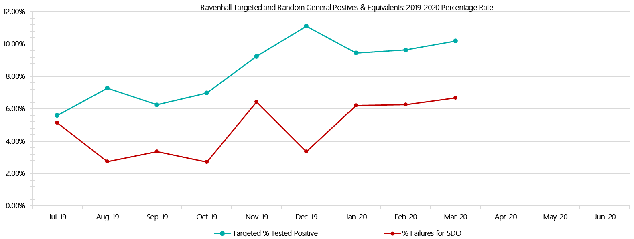

***Ravenhall Positive Test Results by Drug Type: 2019-2020***

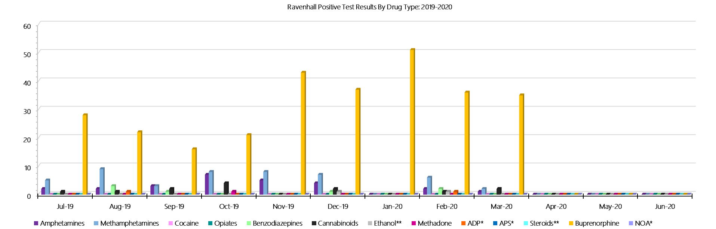

***Ravenhall Count of Visitor Seizures Finds: 2019-2020***

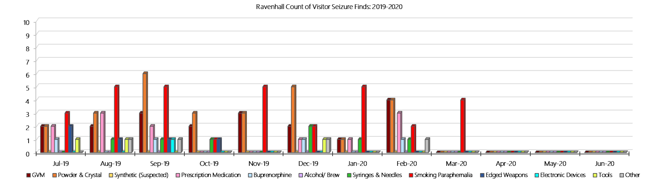

***Ravenhall Count of Prisoner Seizure Finds: 2019-2020***

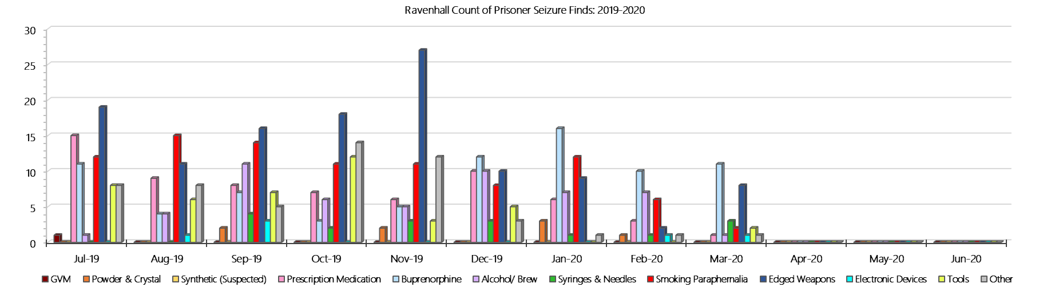

### **Beechworth Correctional Centre**

***Targeted and Random General Drug Test Results: 2019-2020***

|  |  |  |  |  |  |  |  |  |  |  |  |  |  |  |
| --- | --- | --- | --- | --- | --- | --- | --- | --- | --- | --- | --- | --- | --- | --- |
| **Beechworth** | **Jul-19** | **Aug-19** | **Sep-19** | **Oct-19** | **Nov-19** | **Dec-19** | **Jan-20** | **Feb-20** | **Mar-20** | **Apr-20** | **May-20** | **Jun-20** | **Average** | ***Totals*** |
| **Effective Sample - Targeted** | **43** | **35** | **38** | **50** | **20** | **42** | **21** | **56** | **36** |  |  |  | **38** | ***341*** |
| **Targeted Positives** | **0** | **0** | **1** | **0** | **0** | **1** | **0** | **6** | **2** |  |  |  | **1** | ***10*** |
| **Refusal** | **0** | **0** | **0** | **0** | **0** | **0** | **0** | **0** | **0** |  |  |  | **0** | ***0*** |
| **Unable** | **0** | **0** | **0** | **0** | **0** | **0** | **0** | **0** | **0** |  |  |  | **0** | ***0*** |
| **Interfered** | **0** | **0** | **0** | **0** | **0** | **0** | **0** | **0** | **0** |  |  |  | **0** | ***0*** |
| **Adulterated** | **0** | **0** | **0** | **0** | **0** | **0** | **0** | **0** | **0** |  |  |  | **0** | ***0*** |
| **Targeted % Tested Positive** | **0.00%** | **0.00%** | **2.63%** | **0.00%** | **0.00%** | **2.38%** | **0.00%** | **10.71%** | **5.56%** | **#N/A** | **#N/A** | **#N/A** | **2.93%** | ***2.93%*** |
| **Awaiting / Pending Results** | **0** | **0** | **0** | **0** | **0** | **0** | **0** | **0** | **0** |  |  |  | **0** | ***0*** |
| **Targeted Residual** | **0** | **0** | **0** | **0** | **0** | **0** | **0** | **3** | **0** |  |  |  | **0** | ***3*** |
| **Random tests collected** | **28** | **24** | **29** | **24** | **24** | **29** | **12** | **24** | **28** |  |  |  | **25** | ***222*** |
| **Tested Positive** | **0** | **0** | **0** | **0** | **0** | **0** | **0** | **0** | **0** |  |  |  | **0** | ***0*** |
| **Refusal (guilty)** | **0** | **0** | **0** | **0** | **0** | **0** | **0** | **0** | **0** |  |  |  | **0** | ***0*** |
| **Unable (not guilty)** | **0** | **0** | **0** | **0** | **0** | **0** | **0** | **0** | **0** |  |  |  | **0** | ***0*** |
| **Unable (guilty)** | **0** | **0** | **0** | **0** | **0** | **1** | **0** | **0** | **0** |  |  |  | **0** | ***1*** |
| **Interfered (guilty)** | **0** | **0** | **0** | **0** | **0** | **0** | **0** | **0** | **0** |  |  |  | **0** | ***0*** |
| **No test (valid reason)** | **0** | **0** | **0** | **0** | **0** | **0** | **0** | **0** | **0** |  |  |  | **0** | ***0*** |
| **No test (no valid reason)** | **0** | **0** | **0** | **0** | **0** | **0** | **0** | **0** | **0** |  |  |  | **0** | ***0*** |
| **Adulterated** | **0** | **0** | **0** | **0** | **0** | **0** | **0** | **0** | **0** |  |  |  | **0** | ***0*** |
| **Awaiting / Pending Results** | **0** | **0** | **0** | **0** | **0** | **0** | **0** | **0** | **0** |  |  |  | **0** | ***0*** |
| **Random Residual *(PIMS URAR030)*** | **0** | **0** | **0** | **0** | **0** | **0** | **0** | **0** | **0** |  |  |  | ***0*** | ***0*** |
| **Effective Sample - Random General** | **28** | **24** | **29** | **24** | **24** | **30** | **12** | **24** | **28** |  |  |  | **25** | **223** |
| **% Tested positive** | **0.00%** | **0.00%** | **0.00%** | **0.00%** | **0.00%** | **0.00%** | **0.00%** | **0.00%** | **0.00%** |  |  |  | **0.00%** |  |
| **% Prisoner guilty, positive equivalents** | **0.00%** | **0.00%** | **0.00%** | **0.00%** | **0.00%** | **3.33%** | **0.00%** | **0.00%** | **0.00%** |  |  |  | **0.37%** |  |
| **% Total prisoner fails** | **0.00%** | **0.00%** | **0.00%** | **0.00%** | **0.00%** | **3.33%** | **0.00%** | **0.00%** | **0.00%** |  |  |  | **0.37%** |  |
| **% No test without valid reason** | **0.00%** | **0.00%** | **0.00%** | **0.00%** | **0.00%** | **0.00%** | **0.00%** | **0.00%** | **0.00%** |  |  |  | **0.00%** |  |
| ***Random General Benchmark 1.80%*** | ***1.80%*** | ***1.80%*** | ***1.80%*** | ***1.80%*** | ***1.80%*** | ***1.80%*** | ***1.80%*** | ***1.80%*** | ***1.80%*** | ***1.80%*** | ***1.80%*** | ***1.80%*** | ***YTD*** |  |
| **% Failures for SDO** | **0.00%** | **0.00%** | **0.00%** | **0.00%** | **0.00%** | **3.33%** | **0.00%** | **0.00%** | **0.00%** | **#N/A** | **#N/A** | **#N/A** | **0.45%** |  |

***Beechworth - Drugs Identified Through Testing by Drug Type: 2019-2020***

|  |  |  |  |  |  |  |  |  |  |  |  |  |  |  |
| --- | --- | --- | --- | --- | --- | --- | --- | --- | --- | --- | --- | --- | --- | --- |
| **Beechworth** | ***Amphetamines*** | ***Methamphetamines*** | ***Cocaine*** | ***Opiates*** | ***Benzodiazepines*** | ***Cannabinoids*** | ***Ethanol\*\**** | ***Methadone*** | ***ADP\**** | ***APS\**** | ***Steroids\*\**** | ***Buprenorphine*** | ***NOA\**** | **Total** |
| **Jul-19** | **0** | **0** | **0** | **0** | **0** | **0** | **0** | **0** | **0** | **0** | **0** | **0** | **0** | **0** |
| **Aug-19** | **0** | **1** | **0** | **0** | **0** | **0** | **0** | **0** | **0** | **0** | **0** | **0** | **0** | **1** |
| **Sep-19** | **1** | **1** | **0** | **0** | **0** | **0** | **0** | **0** | **0** | **0** | **0** | **1** | **0** | **3** |
| **Oct-19** | **0** | **0** | **0** | **0** | **0** | **0** | **0** | **0** | **0** | **0** | **0** | **0** | **0** | **0** |
| **Nov-19** | **0** | **0** | **0** | **0** | **0** | **0** | **0** | **0** | **0** | **0** | **0** | **0** | **0** | **0** |
| **Dec-19** | **0** | **0** | **0** | **0** | **0** | **0** | **0** | **0** | **0** | **0** | **0** | **1** | **0** | **1** |
| **Jan-20** | **0** | **0** | **0** | **0** | **0** | **0** | **0** | **0** | **0** | **0** | **0** | **2** | **0** | **2** |
| **Feb-20** | **4** | **5** | **0** | **0** | **0** | **0** | **0** | **0** | **0** | **0** | **0** | **4** | **0** | **13** |
| **Mar-20** | **0** | **1** | **0** | **1** | **0** | **0** | **0** | **0** | **0** | **0** | **0** | **2** | **0** | **4** |
| **Apr-20** |  |  |  |  |  |  |  |  |  |  |  |  |  |  |
| **May-20** |  |  |  |  |  |  |  |  |  |  |  |  |  |  |
| **Jun-20** |  |  |  |  |  |  |  |  |  |  |  |  |  |  |
| **BeechworthYTD** | **5** | **8** | **0** | **1** | **0** | **0** | **0** | **0** | **0** | **0** | **0** | **10** | **0** | **24** |
| ***All Prisons YTD*** | ***133*** | ***224*** | ***2*** | ***35*** | ***30*** | ***30*** | ***20*** | ***32*** | ***49*** | ***13*** | ***0*** | ***1785*** | ***0*** | ***2353*** |
| ***Beechworth % of Total*** | ***3.76%*** | ***3.57%*** | ***0.00%*** | ***2.86%*** | ***0.00%*** | ***0.00%*** | ***0.00%*** | ***0.00%*** | ***0.00%*** | ***0.00%*** | ***0.00%*** | ***0.56%*** | ***0.00%*** | ***1.02%*** |

***Beechworth Seizures of Contraband: Visitors & Prisoners: 2019-2020***

|  |  |  |  |  |  |  |  |  |  |  |  |  |  |  |  |  |  |  |  |  |  |  |  |  |  |
| --- | --- | --- | --- | --- | --- | --- | --- | --- | --- | --- | --- | --- | --- | --- | --- | --- | --- | --- | --- | --- | --- | --- | --- | --- | --- |
| **Visitors** | **GVM** | | **Powder  & Crystal** | | **Synthetic  (Suspected)** | | **Prescription  Medication** | | **Buprenorphine** | | **Alcohol &  Home Brew** | | **Syringes & Needles** | | **Smoking  Paraphernalia** | | **Edged  Weapons** | | **Electronic  Devices** | | **Tools** | | **Other** | | |
| **BCC** | **Finds** | **Gms** | **Finds** | **Gms** | **Finds** | **Gms** | **Finds** | **Qty** | **Finds** | **Qty** | **Finds** | **Ltrs** | **Finds** | **Qty** | **Finds** | **Qty** | **Finds** | **Qty** | **Finds** | **Qty** | **Finds** | **Qty** | **Finds** | **Qty** |
| **Jul-19** | **0** | **0.00** | **0** | **0.00** | **0** | **0.00** | **0** | **0.00** | **0** | **0.00** | **0** | **0.000** | **0** | **0** | **0** | **0** | **0** | **0** | **0** | **0** | **0** | **0** | **0** | **0** |
| **Aug-19** | **0** | **0.00** | **0** | **0.00** | **0** | **0.00** | **0** | **0.00** | **0** | **0.00** | **0** | **0.000** | **0** | **0** | **0** | **0** | **0** | **0** | **0** | **0** | **0** | **0** | **0** | **0** |
| **Sep-19** | **0** | **0.00** | **0** | **0.00** | **0** | **0.00** | **0** | **0.00** | **0** | **0.00** | **0** | **0.000** | **0** | **0** | **0** | **0** | **0** | **0** | **0** | **0** | **0** | **0** | **0** | **0** |
| **Oct-19** | **0** | **0.00** | **0** | **0.00** | **0** | **0.00** | **0** | **0.00** | **0** | **0.00** | **0** | **0.000** | **0** | **0** | **0** | **0** | **0** | **0** | **0** | **0** | **0** | **0** | **0** | **0** |
| **Nov-19** | **0** | **0.00** | **0** | **0.00** | **0** | **0.00** | **0** | **0.00** | **0** | **0.00** | **0** | **0.000** | **0** | **0** | **0** | **0** | **0** | **0** | **0** | **0** | **0** | **0** | **0** | **0** |
| **Dec-19** | **0** | **0.00** | **0** | **0.00** | **0** | **0.00** | **0** | **0.00** | **0** | **0.00** | **0** | **0.000** | **0** | **0** | **0** | **0** | **0** | **0** | **0** | **0** | **0** | **0** | **0** | **0** |
| **Jan-20** | **0** | **0.00** | **0** | **0.00** | **0** | **0.00** | **0** | **0.00** | **0** | **0.00** | **0** | **0.000** | **0** | **0** | **0** | **0** | **0** | **0** | **0** | **0** | **0** | **0** | **0** | **0** |
| **Feb-20** | **0** | **0.00** | **0** | **0.00** | **0** | **0.00** | **0** | **0.00** | **0** | **0.00** | **0** | **0.000** | **0** | **0** | **0** | **0** | **0** | **0** | **0** | **0** | **0** | **0** | **0** | **0** |
| **Mar-20** | **0** | **0.00** | **0** | **0.00** | **0** | **0.00** | **0** | **0.00** | **0** | **0.00** | **0** | **0.000** | **0** | **0** | **0** | **0** | **0** | **0** | **0** | **0** | **0** | **0** | **0** | **0** |
| **Apr-20** |  |  |  |  |  |  |  |  |  |  |  |  |  |  |  |  |  |  |  |  |  |  |  |  |
| **May-20** |  |  |  |  |  |  |  |  |  |  |  |  |  |  |  |  |  |  |  |  |  |  |  |  |
| **Jun-20** |  |  |  |  |  |  |  |  |  |  |  |  |  |  |  |  |  |  |  |  |  |  |  |  |
| **Total** | **0** | **0.00** | **0** | **0.00** | **0** | **0.00** | **0** | **0.00** | **0** | **0.00** | **0** | **0.000** | **0** | **0** | **0** | **0** | **0** | **0** | **0** | **0** | **0** | **0** | **0** | **0** |

|  |  |  |  |  |  |  |  |  |  |  |  |  |  |  |  |  |  |  |  |  |  |  |  |  |  |
| --- | --- | --- | --- | --- | --- | --- | --- | --- | --- | --- | --- | --- | --- | --- | --- | --- | --- | --- | --- | --- | --- | --- | --- | --- | --- |
| **Prisoners** | **GVM** | | **Powder  & Crystal** | | **Synthetic  (Suspected)** | | **Prescription  Medication** | | **Buprenorphine** | | **Alcohol &  Home Brew** | | **Syringes & Needles** | | **Smoking  Paraphernalia** | | | **Edged  Weapons** | | **Electronic  Devices** | | **Tools** | | **Other** | |
| **BCC** | **Finds** | **Gms** | **Finds** | **Gms** | **Finds** | **Gms** | **Finds** | **Qty** | **Finds** | **Qty** | **Finds** | **Ltrs** | **Finds** | **Qty** | **Finds** | **Qty** | | **Finds** | **Qty** | **Finds** | **Qty** | **Finds** | **Qty** | **Finds** | **Qty** |
| **Jul-19** | **0** | **0.00** | **0** | **0.00** | **0** | **0.00** | **0** | **0.00** | **0** | **0.00** | **0** | **0.000** | **0** | **0** | **0** | | **0** | **0** | **0** | **0** | **0** | **0** | **0** | **2** | **6** |
| **Aug-19** | **0** | **0.00** | **0** | **0.00** | **0** | **0.00** | **0** | **0.00** | **0** | **0.00** | **0** | **0.000** | **0** | **0** | **1** | | **2** | **0** | **0** | **1** | **1** | **0** | **0** | **0** | **0** |
| **Sep-19** | **0** | **0.00** | **0** | **0.00** | **0** | **0.00** | **0** | **0.00** | **0** | **0.00** | **0** | **0.000** | **0** | **0** | **0** | | **0** | **0** | **0** | **0** | **0** | **0** | **0** | **0** | **0** |
| **Oct-19** | **0** | **0.00** | **0** | **0.00** | **0** | **0.00** | **0** | **0.00** | **0** | **0.00** | **0** | **0.000** | **0** | **0** | **2** | | **3** | **0** | **0** | **0** | **0** | **1** | **1** | **0** | **0** |
| **Nov-19** | **0** | **0.00** | **0** | **0.00** | **0** | **0.00** | **0** | **0.00** | **0** | **0.00** | **0** | **0.000** | **0** | **0** | **0** | | **0** | **0** | **0** | **0** | **0** | **0** | **0** | **3** | **3** |
| **Dec-19** | **0** | **0.00** | **0** | **0.00** | **0** | **0.00** | **1** | **24.00** | **0** | **0.00** | **0** | **0.000** | **0** | **0** | **0** | | **0** | **0** | **0** | **0** | **0** | **0** | **0** | **1** | **1** |
| **Jan-20** | **0** | **0.00** | **0** | **0.00** | **0** | **0.00** | **0** | **0.00** | **0** | **0.00** | **0** | **0.000** | **0** | **0** | **0** | | **0** | **0** | **0** | **0** | **0** | **0** | **0** | **0** | **0** |
| **Feb-20** | **0** | **0.00** | **0** | **0.00** | **0** | **0.00** | **0** | **0.00** | **0** | **0.00** | **0** | **0.000** | **0** | **0** | **2** | | **4** | **0** | **0** | **0** | **0** | **0** | **0** | **0** | **0** |
| **Mar-20** | **0** | **0.00** | **0** | **0.00** | **0** | **0.00** | **1** | **4.00** | **0** | **0.00** | **1** | **0.100** | **0** | **0** | **3** | | **4** | **0** | **0** | **0** | **0** | **2** | **2** | **1** | **1** |
| **Apr-20** |  |  |  |  |  |  |  |  |  |  |  |  |  |  |  | |  |  |  |  |  |  |  |  |  |
| **May-20** |  |  |  |  |  |  |  |  |  |  |  |  |  |  |  | |  |  |  |  |  |  |  |  |  |
| **Jun-20** |  |  |  |  |  |  |  |  |  |  |  |  |  |  |  | |  |  |  |  |  |  |  |  |  |
| **Total** | **0** | **0.00** | **0** | **0.00** | **0** | **0.00** | **2** | **28.00** | **0** | **0** | **1** | **0.100** | **0** | **0** | **8** | | **13** | **0** | **0** | **1** | **1** | **3** | **3** | **7** | **11** |

***Beechworth Targeted and Random General Drug Test Positives & Equivalents: 2019-2020***

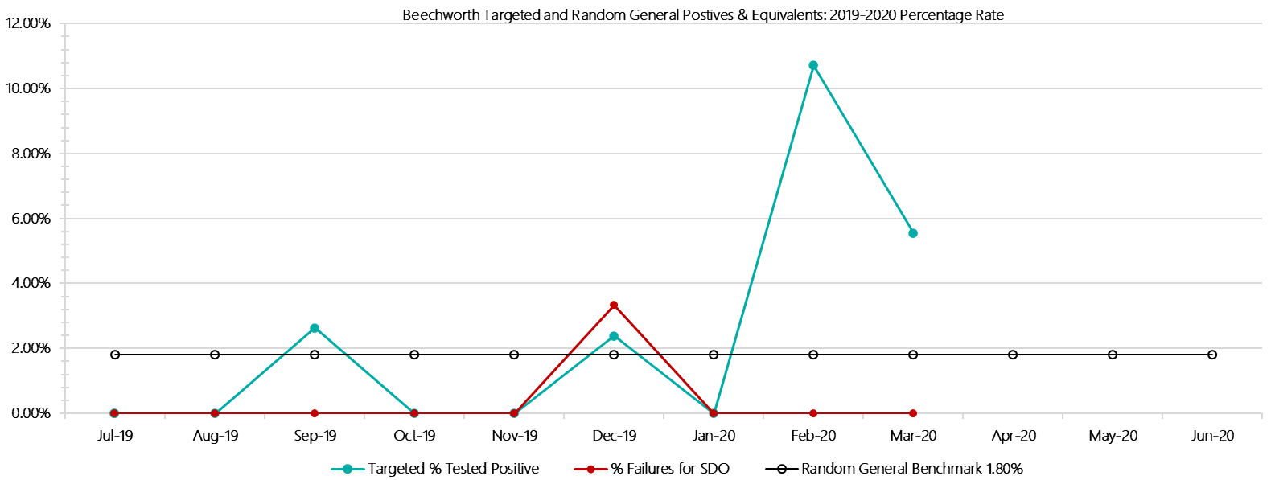

***Beechworth Positive Test Results by Drug Type: 2019-2020***

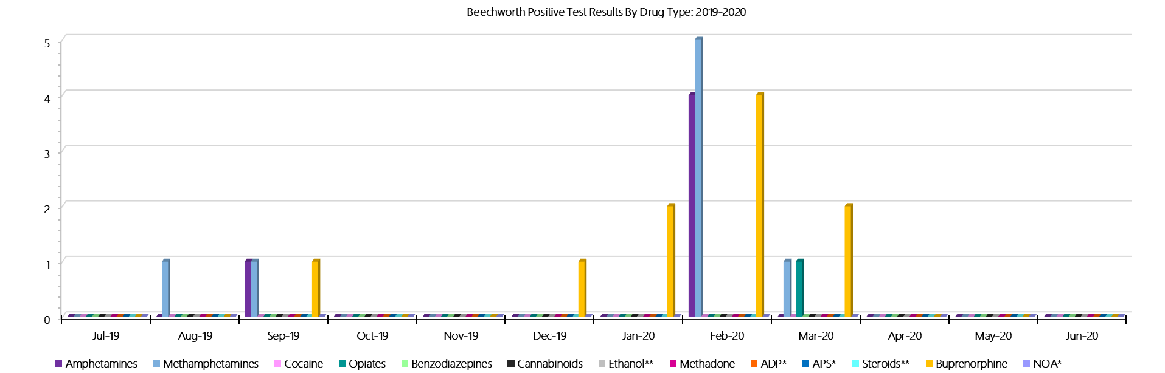

***Beechworth Count of Visitor Seizures Finds: 2019-2020***

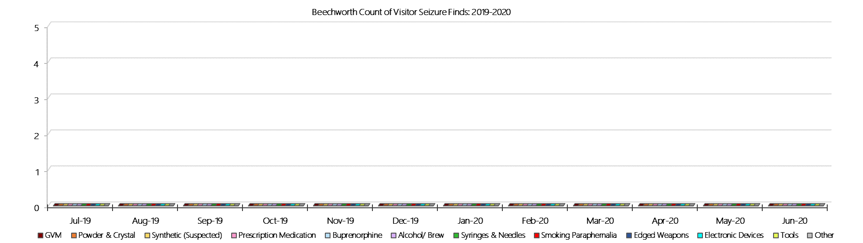

***Beechworth Count of Prisoner Seizure Finds: 2019-2020***

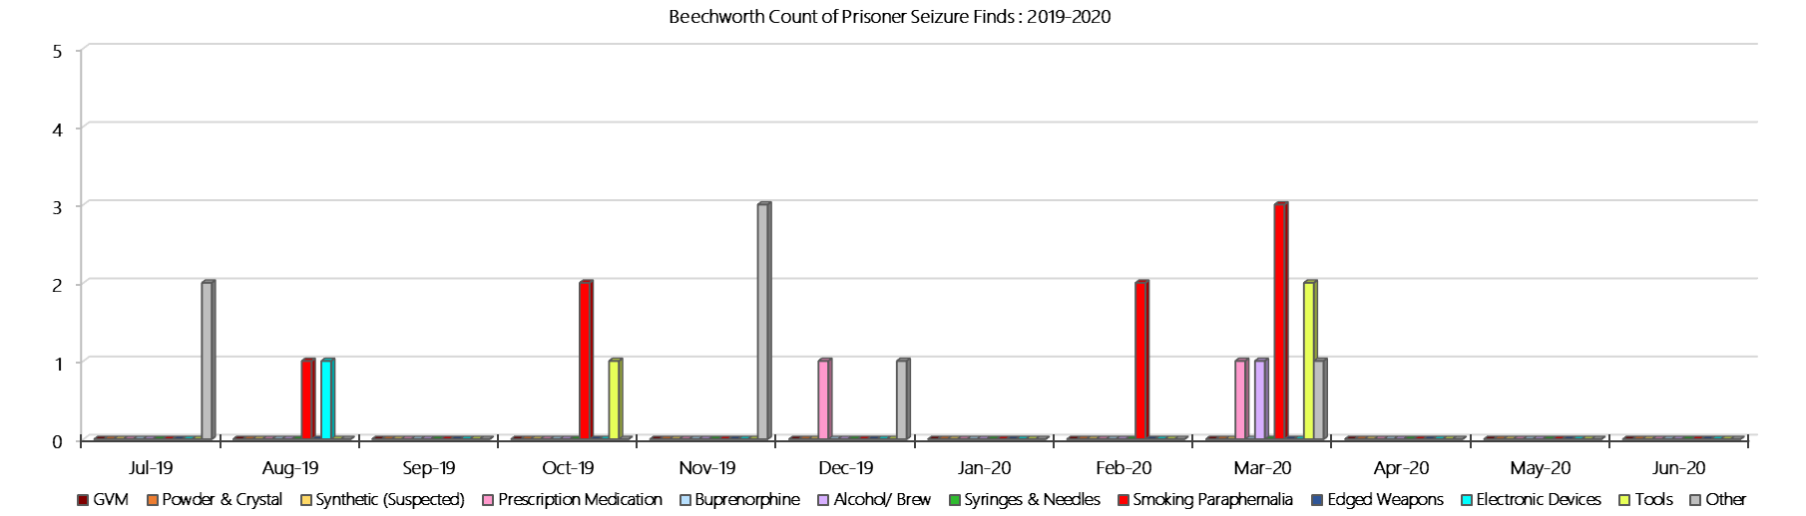

### **Dhurringile Prison**

***Targeted and Random General Drug Test Results: 2019-2020***

|  |  |  |  |  |  |  |  |  |  |  |  |  |  |  |
| --- | --- | --- | --- | --- | --- | --- | --- | --- | --- | --- | --- | --- | --- | --- |
| **Dhurringile** | **Jul-19** | **Aug-19** | **Sep-19** | **Oct-19** | **Nov-19** | **Dec-19** | **Jan-20** | **Feb-20** | **Mar-20** | **Apr-20** | **May-20** | **Jun-20** | **Average** | ***Totals*** |
| **Effective Sample - Targeted** | **130** | **90** | **117** | **116** | **64** | **120** | **88** | **101** | **165** |  |  |  | **110** | ***991*** |
| **Targeted Positives** | **5** | **1** | **3** | **3** | **1** | **1** | **2** | **1** | **1** |  |  |  | **2** | ***18*** |
| **Refusal** | **2** | **0** | **0** | **0** | **0** | **0** | **0** | **0** | **0** |  |  |  | **0** | ***2*** |
| **Unable** | **0** | **1** | **0** | **0** | **0** | **0** | **0** | **1** | **2** |  |  |  | **0** | ***4*** |
| **Interfered** | **0** | **0** | **0** | **0** | **0** | **0** | **0** | **0** | **0** |  |  |  | **0** | ***0*** |
| **Adulterated** | **0** | **0** | **0** | **0** | **0** | **0** | **0** | **0** | **0** |  |  |  | **0** | ***0*** |
| **Targeted % Tested Positive** | **5.38%** | **2.22%** | **2.56%** | **2.59%** | **1.56%** | **0.83%** | **2.27%** | **1.98%** | **1.82%** | **#N/A** | **#N/A** | **#N/A** | **2.42%** | ***2.42%*** |
| **Awaiting / Pending Results** | **0** | **0** | **0** | **0** | **0** | **0** | **0** | **1** | **1** |  |  |  | **0** | ***2*** |
| **Targeted Residual** | **1** | **0** | **1** | **0** | **0** | **0** | **0** | **0** | **0** |  |  |  | **0** | ***2*** |
| **Random tests collected** | **34** | **28** | **35** | **28** | **28** | **35** | **39** | **28** | **34** |  |  |  | **32** | ***289*** |
| **Tested Positive** | **1** | **0** | **0** | **1** | **1** | **1** | **0** | **0** | **0** |  |  |  | **0** | ***4*** |
| **Refusal (guilty)** | **0** | **0** | **0** | **0** | **0** | **0** | **0** | **0** | **0** |  |  |  | **0** | ***0*** |
| **Unable (not guilty)** | **0** | **0** | **0** | **0** | **0** | **0** | **0** | **0** | **0** |  |  |  | **0** | ***0*** |
| **Unable (guilty)** | **0** | **0** | **0** | **0** | **0** | **1** | **0** | **0** | **0** |  |  |  | **0** | ***1*** |
| **Interfered (guilty)** | **0** | **0** | **0** | **0** | **0** | **0** | **0** | **0** | **0** |  |  |  | **0** | ***0*** |
| **No test (valid reason)** | **0** | **0** | **0** | **0** | **0** | **0** | **0** | **0** | **1** |  |  |  | **0** | ***1*** |
| **No test (no valid reason)** | **0** | **0** | **0** | **0** | **0** | **0** | **0** | **0** | **0** |  |  |  | **0** | ***0*** |
| **Adulterated** | **0** | **0** | **0** | **0** | **0** | **0** | **0** | **0** | **0** |  |  |  | **0** | ***0*** |
| **Awaiting / Pending Results** | **0** | **0** | **0** | **0** | **0** | **0** | **0** | **0** | **1** |  |  |  | **0** | ***1*** |
| **Random Residual *(PIMS URAR030)*** | **0** | **0** | **0** | **0** | **0** | **0** | **0** | **0** | **0** |  |  |  | ***0*** | ***0*** |
| **Effective Sample - Random General** | **34** | **28** | **35** | **28** | **28** | **36** | **39** | **28** | **34** |  |  |  | **32** | **290** |
| **% Tested positive** | **2.94%** | **0.00%** | **0.00%** | **3.57%** | **3.57%** | **2.78%** | **0.00%** | **0.00%** | **0.00%** |  |  |  | **1.43%** |  |
| **% Prisoner guilty, positive equivalents** | **0.00%** | **0.00%** | **0.00%** | **0.00%** | **0.00%** | **2.78%** | **0.00%** | **0.00%** | **0.00%** |  |  |  | **0.31%** |  |
| **% Total prisoner fails** | **2.94%** | **0.00%** | **0.00%** | **3.57%** | **3.57%** | **5.56%** | **0.00%** | **0.00%** | **0.00%** |  |  |  | **1.74%** |  |
| **% No test without valid reason** | **0.00%** | **0.00%** | **0.00%** | **0.00%** | **0.00%** | **0.00%** | **0.00%** | **0.00%** | **0.00%** |  |  |  | **0.00%** |  |
| ***Random General Benchmark 3.50%*** | ***3.50%*** | ***3.50%*** | ***3.50%*** | ***3.50%*** | ***3.50%*** | ***3.50%*** | ***3.50%*** | ***3.50%*** | ***3.50%*** | ***3.50%*** | ***3.50%*** | ***3.50%*** | ***YTD*** |  |
| **% Failures for SDO** | **2.94%** | **0.00%** | **0.00%** | **3.57%** | **3.57%** | **5.56%** | **0.00%** | **0.00%** | **0.00%** | **#N/A** | **#N/A** | **#N/A** | **1.72%** |  |

***Dhurringile - Drugs Identified Through Testing by Drug Type: 2019-2020***

|  |  |  |  |  |  |  |  |  |  |  |  |  |  |  |
| --- | --- | --- | --- | --- | --- | --- | --- | --- | --- | --- | --- | --- | --- | --- |
| **Dhurringile** | ***Amphetamines*** | ***Methamphetamines*** | ***Cocaine*** | ***Opiates*** | ***Benzodiazepines*** | ***Cannabinoids*** | ***Ethanol\*\**** | ***Methadone*** | ***ADP\**** | ***APS\**** | ***Steroids\*\**** | ***Buprenorphine*** | ***NOA\**** | **Total** |
| **Jul-19** | **2** | **3** | **0** | **1** | **0** | **0** | **0** | **0** | **0** | **0** | **0** | **3** | **0** | **9** |
| **Aug-19** | **0** | **0** | **0** | **0** | **0** | **0** | **0** | **0** | **0** | **0** | **0** | **1** | **0** | **1** |
| **Sep-19** | **0** | **0** | **0** | **0** | **0** | **0** | **0** | **0** | **0** | **0** | **0** | **3** | **0** | **3** |
| **Oct-19** | **0** | **0** | **0** | **0** | **1** | **0** | **0** | **0** | **0** | **0** | **0** | **3** | **0** | **4** |
| **Nov-19** | **0** | **0** | **0** | **0** | **0** | **0** | **0** | **0** | **0** | **0** | **0** | **3** | **0** | **3** |
| **Dec-19** | **0** | **0** | **0** | **0** | **0** | **0** | **0** | **0** | **0** | **0** | **0** | **3** | **0** | **3** |
| **Jan-20** | **0** | **0** | **0** | **0** | **0** | **0** | **0** | **0** | **0** | **0** | **0** | **2** | **0** | **2** |
| **Feb-20** | **0** | **0** | **0** | **0** | **0** | **0** | **0** | **0** | **0** | **0** | **0** | **1** | **0** | **1** |
| **Mar-20** | **0** | **0** | **0** | **0** | **1** | **0** | **0** | **0** | **0** | **0** | **0** | **0** | **0** | **1** |
| **Apr-20** |  |  |  |  |  |  |  |  |  |  |  |  |  |  |
| **May-20** |  |  |  |  |  |  |  |  |  |  |  |  |  |  |
| **Jun-20** |  |  |  |  |  |  |  |  |  |  |  |  |  |  |
| **Dhurringile YTD** | **2** | **3** | **0** | **1** | **2** | **0** | **0** | **0** | **0** | **0** | **0** | **19** | **0** | **27** |
| ***All Prisons YTD*** | ***133*** | ***224*** | ***2*** | ***35*** | ***30*** | ***30*** | ***20*** | ***32*** | ***49*** | ***13*** | ***0*** | ***1785*** | ***0*** | ***2353*** |
| ***Dhurringile % of Total*** | ***1.50%*** | ***1.34%*** | ***0.00%*** | ***2.86%*** | ***6.67%*** | ***0.00%*** | ***0.00%*** | ***0.00%*** | ***0.00%*** | ***0.00%*** | ***0.00%*** | ***1.06%*** | ***0.00%*** | ***1.15%*** |

***Dhurringile Seizures of Contraband: Visitors & Prisoners: 2019-2020***

|  |  |  |  |  |  |  |  |  |  |  |  |  |  |  |  |  |  |  |  |  |  |  |  |  |  |
| --- | --- | --- | --- | --- | --- | --- | --- | --- | --- | --- | --- | --- | --- | --- | --- | --- | --- | --- | --- | --- | --- | --- | --- | --- | --- |
| **Visitors** | **GVM** | | **Powder  & Crystal** | | **Synthetic  (Suspected)** | | **Prescription  Medication** | | **Buprenorphine** | | **Alcohol &  Home Brew** | | **Syringes & Needles** | | **Smoking  Paraphernalia** | | **Edged  Weapons** | | **Electronic  Devices** | | **Tools** | | **Other** | | |
| **D’gile** | **Finds** | **Gms** | **Finds** | **Gms** | **Finds** | **Gms** | **Finds** | **Qty** | **Finds** | **Qty** | **Finds** | **Ltrs** | **Finds** | **Qty** | **Finds** | **Qty** | **Finds** | **Qty** | **Finds** | **Qty** | **Finds** | **Qty** | **Finds** | **Qty** |
| **Jul-19** | **0** | **0.00** | **0** | **0.00** | **0** | **0.00** | **0** | **0.00** | **0** | **0.00** | **0** | **0.000** | **0** | **0** | **0** | **0** | **0** | **0** | **0** | **0** | **0** | **0** | **0** | **0** |
| **Aug-19** | **0** | **0.00** | **0** | **0.00** | **0** | **0.00** | **0** | **0.00** | **0** | **0.00** | **0** | **0.000** | **0** | **0** | **0** | **0** | **0** | **0** | **0** | **0** | **0** | **0** | **0** | **0** |
| **Sep-19** | **0** | **0.00** | **0** | **0.00** | **0** | **0.00** | **0** | **0.00** | **0** | **0.00** | **0** | **0.000** | **0** | **0** | **0** | **0** | **0** | **0** | **0** | **0** | **0** | **0** | **0** | **0** |
| **Oct-19** | **0** | **0.00** | **0** | **0.00** | **0** | **0.00** | **0** | **0.00** | **1** | **2.50** | **0** | **0.000** | **0** | **0** | **1** | **1** | **0** | **0** | **0** | **0** | **0** | **0** | **0** | **0** |
| **Nov-19** | **0** | **0.00** | **1** | **3.00** | **0** | **0.00** | **0** | **0.00** | **0** | **0.00** | **2** | **3.375** | **0** | **0** | **1** | **1** | **0** | **0** | **0** | **0** | **0** | **0** | **2** | **4** |
| **Dec-19** | **0** | **0.00** | **0** | **0.00** | **0** | **0.00** | **0** | **0.00** | **0** | **0.00** | **0** | **0.000** | **0** | **0** | **0** | **0** | **0** | **0** | **0** | **0** | **0** | **0** | **0** | **0** |
| **Jan-20** | **0** | **0.00** | **0** | **0.00** | **0** | **0.00** | **0** | **0.00** | **0** | **0.00** | **0** | **0.000** | **0** | **0** | **0** | **0** | **0** | **0** | **0** | **0** | **0** | **0** | **0** | **0** |
| **Feb-20** | **0** | **0.00** | **0** | **0.00** | **0** | **0.00** | **0** | **0.00** | **0** | **0.00** | **0** | **0.000** | **0** | **0** | **0** | **0** | **0** | **0** | **0** | **0** | **0** | **0** | **0** | **0** |
| **Mar-20** | **0** | **0.00** | **0** | **0.00** | **0** | **0.00** | **0** | **0.00** | **0** | **0.00** | **0** | **0.000** | **0** | **0** | **0** | **0** | **0** | **0** | **0** | **0** | **0** | **0** | **0** | **0** |
| **Apr-20** |  |  |  |  |  |  |  |  |  |  |  |  |  |  |  |  |  |  |  |  |  |  |  |  |
| **May-20** |  |  |  |  |  |  |  |  |  |  |  |  |  |  |  |  |  |  |  |  |  |  |  |  |
| **Jun-20** |  |  |  |  |  |  |  |  |  |  |  |  |  |  |  |  |  |  |  |  |  |  |  |  |
| **Total** | **0** | **0.00** | **1** | **3.00** | **0** | **0.00** | **0** | **0.00** | **1** | **2.50** | **2** | **3.375** | **0** | **0** | **2** | **2** | **0** | **0** | **0** | **0** | **0** | **0** | **2** | **4** |

|  |  |  |  |  |  |  |  |  |  |  |  |  |  |  |  |  |  |  |  |  |  |  |  |  |  |
| --- | --- | --- | --- | --- | --- | --- | --- | --- | --- | --- | --- | --- | --- | --- | --- | --- | --- | --- | --- | --- | --- | --- | --- | --- | --- |
| **Prisoners** | **GVM** | | **Powder  & Crystal** | | **Synthetic  (Suspected)** | | **Prescription  Medication** | | **Buprenorphine** | | **Alcohol &  Home Brew** | | **Syringes & Needles** | | **Smoking  Paraphernalia** | | | **Edged  Weapons** | | **Electronic  Devices** | | **Tools** | | **Other** | |
| **D’gile** | **Finds** | **Gms** | **Finds** | **Gms** | **Finds** | **Gms** | **Finds** | **Qty** | **Finds** | **Qty** | **Finds** | **Ltrs** | **Finds** | **Qty** | **Finds** | **Qty** | | **Finds** | **Qty** | **Finds** | **Qty** | **Finds** | **Qty** | **Finds** | **Qty** |
| **Jul-19** | **0** | **0.00** | **0** | **0.00** | **0** | **0.00** | **0** | **0.00** | **0** | **0.00** | **1** | **3.000** | **3** | **3** | **4** | | **8** | **1** | **1** | **0** | **0** | **1** | **4** | **1** | **1** |
| **Aug-19** | **0** | **0.00** | **0** | **0.00** | **0** | **0.00** | **0** | **0.00** | **0** | **0.00** | **0** | **0.000** | **0** | **0** | **4** | | **14** | **0** | **0** | **0** | **0** | **0** | **0** | **0** | **0** |
| **Sep-19** | **0** | **0.00** | **0** | **0.00** | **0** | **0.00** | **0** | **0.00** | **1** | **0.10** | **1** | **0.750** | **0** | **0** | **3** | | **4** | **2** | **2** | **0** | **0** | **1** | **1** | **0** | **0** |
| **Oct-19** | **1** | **18.70** | **0** | **0.00** | **0** | **0.00** | **1** | **1.00** | **1** | **0.10** | **1** | **1.000** | **1** | **24** | **5** | | **6** | **0** | **0** | **0** | **0** | **4** | **4** | **0** | **0** |
| **Nov-19** | **2** | **2.10** | **0** | **0.00** | **0** | **0.00** | **0** | **0.00** | **0** | **0.00** | **0** | **0.000** | **0** | **0** | **8** | | **17** | **1** | **2** | **0** | **0** | **2** | **4** | **0** | **0** |
| **Dec-19** | **0** | **0.00** | **0** | **0.00** | **0** | **0.00** | **0** | **0.00** | **0** | **0.00** | **0** | **0.000** | **0** | **0** | **4** | | **6** | **0** | **0** | **0** | **0** | **1** | **1** | **0** | **0** |
| **Jan-20** | **0** | **0.00** | **1** | **2.00** | **0** | **0.00** | **1** | **2.00** | **0** | **0.00** | **0** | **0.000** | **0** | **0** | **3** | | **20** | **0** | **0** | **0** | **0** | **0** | **0** | **0** | **0** |
| **Feb-20** | **0** | **0.00** | **0** | **0.00** | **0** | **0.00** | **0** | **0.00** | **0** | **0.00** | **0** | **0.000** | **0** | **0** | **4** | | **5** | **0** | **0** | **1** | **1** | **0** | **0** | **1** | **1** |
| **Mar-20** | **2** | **52.10** | **1** | **0.50** | **0** | **0.00** | **0** | **0.00** | **0** | **0.00** | **1** | **0.100** | **1** | **3** | **5** | | **30** | **0** | **0** | **0** | **0** | **3** | **5** | **0** | **0** |
| **Apr-20** |  |  |  |  |  |  |  |  |  |  |  |  |  |  |  | |  |  |  |  |  |  |  |  |  |
| **May-20** |  |  |  |  |  |  |  |  |  |  |  |  |  |  |  | |  |  |  |  |  |  |  |  |  |
| **Jun-20** |  |  |  |  |  |  |  |  |  |  |  |  |  |  |  | |  |  |  |  |  |  |  |  |  |
| **Total** | **5** | **72.90** | **2** | **2.50** | **0** | **0.00** | **2** | **3.00** | **2** | **0.20** | **4** | **4.850** | **5** | **30** | **40** | | **110** | **4** | **5** | **1** | **1** | **12** | **19** | **2** | **2** |

***Dhurringile Targeted and Random General Drug Test Positives & Equivalents: 2019-2020***

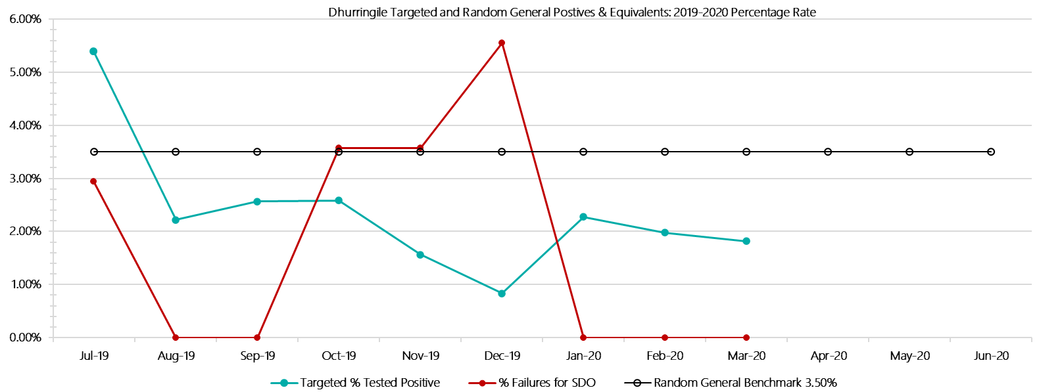

***Dhurringile Positive Test Results by Drug Type: 2019-2020***

**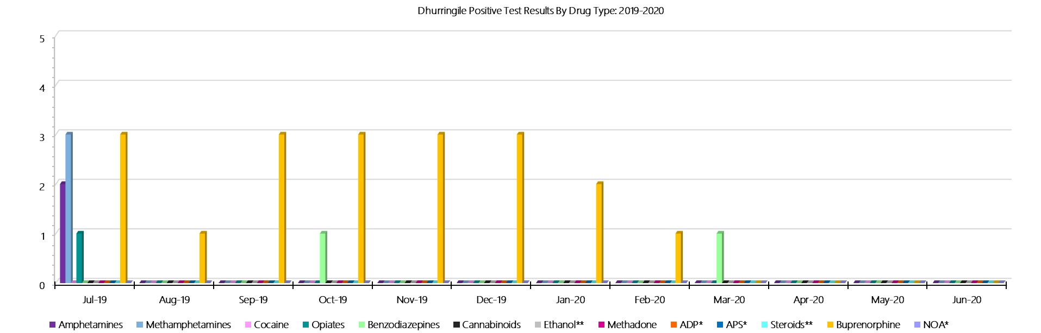*Dhurringile Count of Visitor Seizures Finds: 2019-2020***

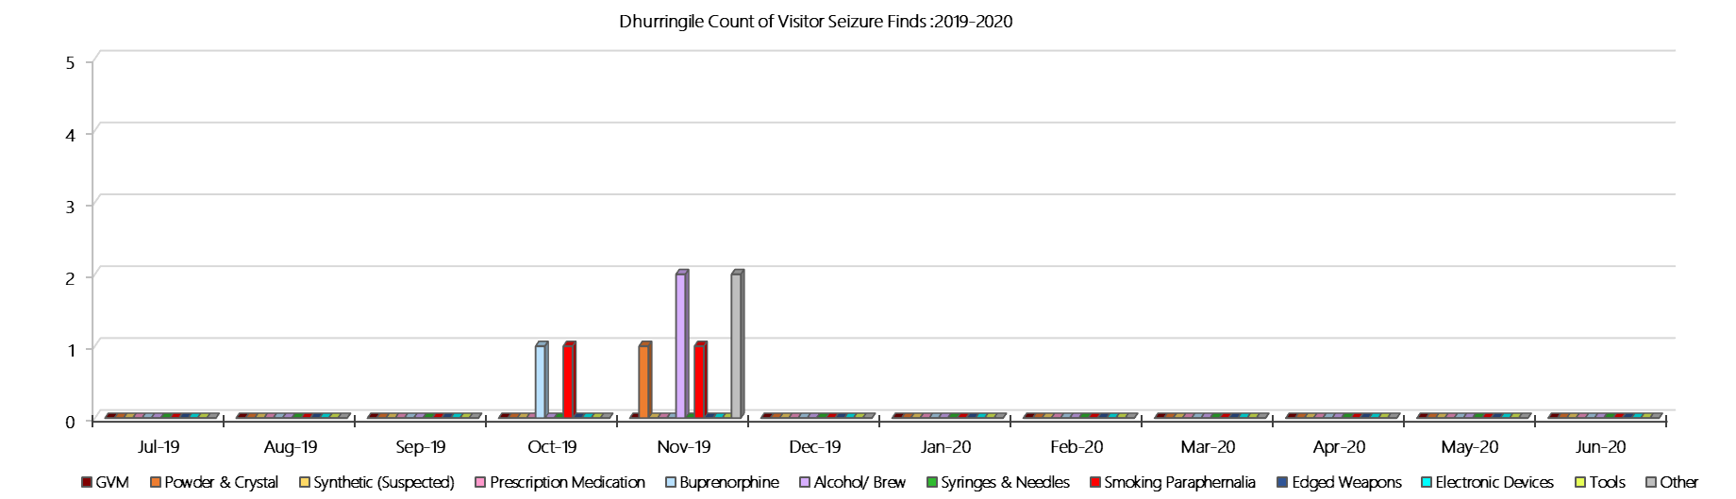

***Dhurringile Count of Prisoner Seizure Finds: 2019-2020***

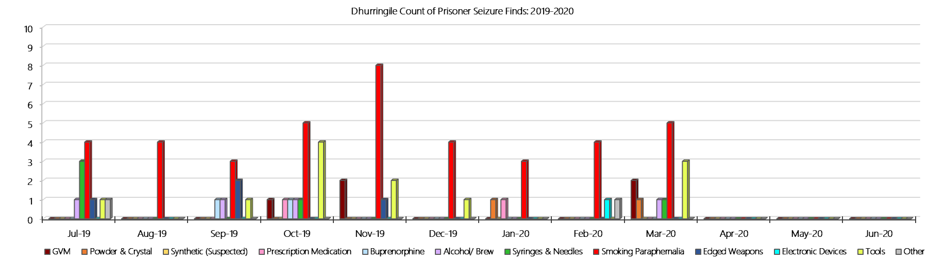

### **Langi Kal Kal Prison**

***Targeted and Random General Drug Test Results: 2019-2020***

|  |  |  |  |  |  |  |  |  |  |  |  |  |  |  |
| --- | --- | --- | --- | --- | --- | --- | --- | --- | --- | --- | --- | --- | --- | --- |
| **Langi Kal Kal** | **Jul-19** | **Aug-19** | **Sep-19** | **Oct-19** | **Nov-19** | **Dec-19** | **Jan-20** | **Feb-20** | **Mar-20** | **Apr-20** | **May-20** | **Jun-20** | **Average** | ***Totals*** |
| **Effective Sample - Targeted** | **28** | **20** | **27** | **11** | **9** | **28** | **26** | **32** | **18** |  |  |  | **22** | ***199*** |
| **Targeted Positives** | **0** | **0** | **0** | **0** | **0** | **0** | **1** | **0** | **0** |  |  |  | **0** | ***1*** |
| **Refusal** | **0** | **0** | **0** | **0** | **0** | **0** | **0** | **0** | **0** |  |  |  | **0** | ***0*** |
| **Unable** | **0** | **0** | **0** | **0** | **0** | **0** | **0** | **0** | **0** |  |  |  | **0** | ***0*** |
| **Interfered** | **0** | **0** | **0** | **0** | **0** | **0** | **0** | **0** | **0** |  |  |  | **0** | ***0*** |
| **Adulterated** | **0** | **0** | **0** | **0** | **0** | **0** | **0** | **0** | **0** |  |  |  | **0** | ***0*** |
| **Targeted % Tested Positive** | **0.00%** | **0.00%** | **0.00%** | **0.00%** | **0.00%** | **0.00%** | **3.85%** | **0.00%** | **0.00%** | **#N/A** | **#N/A** | **#N/A** | **0.50%** | ***0.50%*** |
| **Awaiting / Pending Results** | **0** | **0** | **0** | **0** | **0** | **0** | **0** | **0** | **0** |  |  |  | **0** | ***0*** |
| **Targeted Residual** | **0** | **0** | **0** | **0** | **0** | **0** | **0** | **0** | **0** |  |  |  | **0** | ***0*** |
| **Random tests collected** | **55** | **46** | **59** | **48** | **44** | **55** | **43** | **44** | **55** |  |  |  | **50** | ***449*** |
| **Tested Positive** | **0** | **0** | **0** | **0** | **0** | **0** | **0** | **0** | **0** |  |  |  | **0** | ***0*** |
| **Refusal (guilty)** | **0** | **0** | **0** | **0** | **0** | **0** | **1** | **0** | **0** |  |  |  | **0** | ***1*** |
| **Unable (not guilty)** | **0** | **0** | **0** | **0** | **0** | **0** | **0** | **0** | **0** |  |  |  | **0** | ***0*** |
| **Unable (guilty)** | **0** | **0** | **0** | **0** | **0** | **0** | **0** | **0** | **0** |  |  |  | **0** | ***0*** |
| **Interfered (guilty)** | **0** | **0** | **0** | **0** | **0** | **0** | **0** | **0** | **0** |  |  |  | **0** | ***0*** |
| **No test (valid reason)** | **0** | **0** | **1** | **0** | **0** | **0** | **0** | **0** | **0** |  |  |  | **0** | ***1*** |
| **No test (no valid reason)** | **0** | **0** | **0** | **0** | **0** | **0** | **0** | **0** | **0** |  |  |  | **0** | ***0*** |
| **Adulterated** | **0** | **0** | **0** | **0** | **0** | **0** | **0** | **0** | **0** |  |  |  | **0** | ***0*** |
| **Awaiting / Pending Results** | **0** | **0** | **0** | **0** | **0** | **0** | **0** | **0** | **0** |  |  |  | **0** | ***0*** |
| **Random Residual *(PIMS URAR030)*** | **0** | **0** | **0** | **0** | **0** | **0** | **0** | **0** | **0** |  |  |  | ***0*** | ***0*** |
| **Effective Sample - Random General** | **55** | **46** | **59** | **48** | **44** | **55** | **44** | **44** | **55** |  |  |  | **50** | **450** |
| **% Tested positive** | **0.00%** | **0.00%** | **0.00%** | **0.00%** | **0.00%** | **0.00%** | **0.00%** | **0.00%** | **0.00%** |  |  |  | **0.00%** |  |
| **% Prisoner guilty, positive equivalents** | **0.00%** | **0.00%** | **0.00%** | **0.00%** | **0.00%** | **0.00%** | **2.27%** | **0.00%** | **0.00%** |  |  |  | **0.25%** |  |
| **% Total prisoner fails** | **0.00%** | **0.00%** | **0.00%** | **0.00%** | **0.00%** | **0.00%** | **2.27%** | **0.00%** | **0.00%** |  |  |  | **0.25%** |  |
| **% No test without valid reason** | **0.00%** | **0.00%** | **0.00%** | **0.00%** | **0.00%** | **0.00%** | **0.00%** | **0.00%** | **0.00%** |  |  |  | **0.00%** |  |
| ***Random General Benchmark 1.50%*** | ***1.50%*** | ***1.50%*** | ***1.50%*** | ***1.50%*** | ***1.50%*** | ***1.50%*** | ***1.50%*** | ***1.50%*** | ***1.50%*** | ***1.50%*** | ***1.50%*** | ***1.50%*** | ***YTD*** |  |
| **% Failures for SDO** | **0.00%** | **0.00%** | **0.00%** | **0.00%** | **0.00%** | **0.00%** | **2.27%** | **0.00%** | **0.00%** | **#N/A** | **#N/A** | **#N/A** | **0.22%** |  |

***Langi Kal Kal - Drugs Identified Through Testing by Drug Type: 2019-2020***

|  |  |  |  |  |  |  |  |  |  |  |  |  |  |  |
| --- | --- | --- | --- | --- | --- | --- | --- | --- | --- | --- | --- | --- | --- | --- |
| **Langi Kal Kal** | ***Amphetamines*** | ***Methamphetamines*** | ***Cocaine*** | ***Opiates*** | ***Benzodiazepines*** | ***Cannabinoids*** | ***Ethanol\*\**** | ***Methadone*** | ***ADP\**** | ***APS\**** | ***Steroids\*\**** | ***Buprenorphine*** | ***NOA\**** | **Total** |
| **Jul-19** | **0** | **0** | **0** | **0** | **0** | **0** | **0** | **0** | **0** | **0** | **0** | **0** | **0** | **0** |
| **Aug-19** | **0** | **0** | **0** | **0** | **0** | **0** | **0** | **0** | **0** | **0** | **0** | **0** | **0** | **0** |
| **Sep-19** | **0** | **0** | **0** | **0** | **0** | **0** | **0** | **0** | **0** | **0** | **0** | **1** | **0** | **1** |
| **Oct-19** | **0** | **0** | **0** | **0** | **0** | **0** | **0** | **0** | **0** | **0** | **0** | **0** | **0** | **0** |
| **Nov-19** | **0** | **0** | **0** | **0** | **0** | **0** | **0** | **0** | **0** | **0** | **0** | **0** | **0** | **0** |
| **Dec-19** | **0** | **0** | **0** | **0** | **0** | **0** | **0** | **0** | **0** | **0** | **0** | **0** | **0** | **0** |
| **Jan-20** | **0** | **0** | **0** | **0** | **0** | **0** | **0** | **0** | **0** | **0** | **0** | **1** | **0** | **1** |
| **Feb-20** | **0** | **0** | **0** | **0** | **0** | **0** | **0** | **0** | **0** | **0** | **0** | **0** | **0** | **0** |
| **Mar-20** | **0** | **0** | **0** | **0** | **0** | **0** | **0** | **0** | **0** | **0** | **0** | **0** | **0** | **0** |
| **Apr-20** |  |  |  |  |  |  |  |  |  |  |  |  |  |  |
| **May-20** |  |  |  |  |  |  |  |  |  |  |  |  |  |  |
| **Jun-20** |  |  |  |  |  |  |  |  |  |  |  |  |  |  |
| **Langi Kal Kal YTD** | **0** | **0** | **0** | **0** | **0** | **0** | **0** | **0** | **0** | **0** | **0** | **2** | **0** | **2** |
| ***All Prisons YTD*** | ***133*** | ***224*** | ***2*** | ***35*** | ***30*** | ***30*** | ***20*** | ***32*** | ***49*** | ***13*** | ***0*** | ***1785*** | ***0*** | ***2353*** |
| ***Langi Kal Kal % of Total*** | ***0.00%*** | ***0.00%*** | ***0.00%*** | ***0.00%*** | ***0.00%*** | ***0.00%*** | ***0.00%*** | ***0.00%*** | ***0.00%*** | ***0.00%*** | ***0.00%*** | ***0.11%*** | ***0.00%*** | ***0.08%*** |

***Langi Kal Kal Seizures of Contraband: Visitors & Prisoners: 2019-2020***

|  |  |  |  |  |  |  |  |  |  |  |  |  |  |  |  |  |  |  |  |  |  |  |  |  |
| --- | --- | --- | --- | --- | --- | --- | --- | --- | --- | --- | --- | --- | --- | --- | --- | --- | --- | --- | --- | --- | --- | --- | --- | --- |
| **Visitors** | **GVM** | | **Powder  & Crystal** | | **Synthetic  (Suspected)** | | **Prescription  Medication** | | **Buprenorphine** | | **Alcohol &  Home Brew** | | **Syringes & Needles** | | **Smoking  Paraphernalia** | | **Edged  Weapons** | | **Electronic  Devices** | | **Tools** | | **Other** | |
| **LKK** | **Finds** | **Gms** | **Finds** | **Gms** | **Finds** | **Gms** | **Finds** | **Qty** | **Finds** | **Qty** | **Finds** | **Ltrs** | **Finds** | **Qty** | **Finds** | **Qty** | **Finds** | **Qty** | **Finds** | **Qty** | **Finds** | **Qty** | **Finds** | **Qty** |
| **Jul-19** | **0** | **0.00** | **0** | **0.00** | **0** | **0.00** | **0** | **0.00** | **0** | **0.00** | **0** | **0.000** | **0** | **0** | **0** | **0** | **0** | **0** | **0** | **0** | **0** | **0** | **0** | **0** |
| **Aug-19** | **0** | **0.00** | **0** | **0.00** | **0** | **0.00** | **0** | **0.00** | **0** | **0.00** | **0** | **0.000** | **0** | **0** | **0** | **0** | **0** | **0** | **0** | **0** | **0** | **0** | **0** | **0** |
| **Sep-19** | **0** | **0.00** | **0** | **0.00** | **0** | **0.00** | **0** | **0.00** | **0** | **0.00** | **0** | **0.000** | **0** | **0** | **0** | **0** | **0** | **0** | **0** | **0** | **0** | **0** | **0** | **0** |
| **Oct-19** | **0** | **0.00** | **0** | **0.00** | **0** | **0.00** | **0** | **0.00** | **0** | **0.00** | **0** | **0.000** | **0** | **0** | **0** | **0** | **0** | **0** | **0** | **0** | **0** | **0** | **0** | **0** |
| **Nov-19** | **0** | **0.00** | **0** | **0.00** | **0** | **0.00** | **0** | **0.00** | **0** | **0.00** | **0** | **0.000** | **0** | **0** | **0** | **0** | **0** | **0** | **0** | **0** | **0** | **0** | **0** | **0** |
| **Dec-19** | **0** | **0.00** | **0** | **0.00** | **0** | **0.00** | **0** | **0.00** | **0** | **0.00** | **0** | **0.000** | **0** | **0** | **0** | **0** | **0** | **0** | **0** | **0** | **0** | **0** | **0** | **0** |
| **Jan-20** | **0** | **0.00** | **0** | **0.00** | **0** | **0.00** | **0** | **0.00** | **0** | **0.00** | **0** | **0.000** | **0** | **0** | **0** | **0** | **0** | **0** | **0** | **0** | **0** | **0** | **0** | **0** |
| **Feb-20** | **0** | **0.00** | **0** | **0.00** | **0** | **0.00** | **0** | **0.00** | **0** | **0.00** | **0** | **0.000** | **0** | **0** | **0** | **0** | **0** | **0** | **0** | **0** | **0** | **0** | **0** | **0** |
| **Mar-20** | **0** | **0.00** | **0** | **0.00** | **0** | **0.00** | **0** | **0.00** | **0** | **0.00** | **0** | **0.000** | **0** | **0** | **0** | **0** | **0** | **0** | **0** | **0** | **0** | **0** | **0** | **0** |
| **Apr-20** |  |  |  |  |  |  |  |  |  |  |  |  |  |  |  |  |  |  |  |  |  |  |  |  |
| **May-20** |  |  |  |  |  |  |  |  |  |  |  |  |  |  |  |  |  |  |  |  |  |  |  |  |
| **Jun-20** |  |  |  |  |  |  |  |  |  |  |  |  |  |  |  |  |  |  |  |  |  |  |  |  |
| **Total** | **0** | **0.00** | **0** | **0.00** | **0** | **0.00** | **0** | **0.00** | **0** | **0.00** | **0** | **0.000** | **0** | **0** | **0** | **0** | **0** | **0** | **0** | **0** | **0** | **0** | **0** | **0** |

|  |  |  |  |  |  |  |  |  |  |  |  |  |  |  |  |  |  |  |  |  |  |  |  |  |  |
| --- | --- | --- | --- | --- | --- | --- | --- | --- | --- | --- | --- | --- | --- | --- | --- | --- | --- | --- | --- | --- | --- | --- | --- | --- | --- |
| **Prisoners** | **GVM** | | **Powder  & Crystal** | | **Synthetic  (Suspected)** | | **Prescription  Medication** | | **Buprenorphine** | | **Alcohol &  Home Brew** | | **Syringes & Needles** | | **Smoking  Paraphernalia** | | | **Edged  Weapons** | | **Electronic  Devices** | | **Tools** | | **Other** | |
| **LKK** | **Finds** | **Gms** | **Finds** | **Gms** | **Finds** | **Gms** | **Finds** | **Qty** | **Finds** | **Qty** | **Finds** | **Ltrs** | **Finds** | **Qty** | **Finds** | **Qty** | | **Finds** | **Qty** | **Finds** | **Qty** | **Finds** | **Qty** | **Finds** | **Qty** |
| **Jul-19** | **0** | **0.00** | **0** | **0.00** | **0** | **0.00** | **0** | **0.00** | **0** | **0.00** | **0** | **0.000** | **0** | **0** | **0** | | **0** | **1** | **2** | **0** | **0** | **1** | **1** | **1** | **1** |
| **Aug-19** | **0** | **0.00** | **0** | **0.00** | **0** | **0.00** | **0** | **0.00** | **0** | **0.00** | **0** | **0.000** | **0** | **0** | **0** | | **0** | **0** | **0** | **0** | **0** | **0** | **0** | **0** | **0** |
| **Sep-19** | **0** | **0.00** | **0** | **0.00** | **0** | **0.00** | **0** | **0.00** | **0** | **0.00** | **0** | **0.000** | **0** | **0** | **0** | | **0** | **0** | **0** | **0** | **0** | **0** | **0** | **1** | **1** |
| **Oct-19** | **0** | **0.00** | **0** | **0.00** | **0** | **0.00** | **0** | **0.00** | **0** | **0.00** | **0** | **0.000** | **0** | **0** | **0** | | **0** | **1** | **1** | **0** | **0** | **0** | **0** | **0** | **0** |
| **Nov-19** | **0** | **0.00** | **0** | **0.00** | **0** | **0.00** | **0** | **0.00** | **0** | **0.00** | **0** | **0.000** | **0** | **0** | **0** | | **0** | **1** | **1** | **0** | **0** | **1** | **1** | **0** | **0** |
| **Dec-19** | **0** | **0.00** | **0** | **0.00** | **0** | **0.00** | **1** | **2.00** | **0** | **0.00** | **0** | **0.000** | **0** | **0** | **0** | | **0** | **0** | **0** | **0** | **0** | **0** | **0** | **0** | **0** |
| **Jan-20** | **0** | **0.00** | **0** | **0.00** | **0** | **0.00** | **0** | **0.00** | **1** | **8.00** | **0** | **0.000** | **0** | **0** | **1** | | **17** | **0** | **0** | **0** | **0** | **0** | **0** | **4** | **11** |
| **Feb-20** | **0** | **0.00** | **0** | **0.00** | **0** | **0.00** | **1** | **1.00** | **0** | **0.00** | **0** | **0.000** | **0** | **0** | **0** | | **0** | **0** | **0** | **0** | **0** | **0** | **0** | **2** | **2** |
| **Mar-20** | **0** | **0.00** | **0** | **0.00** | **0** | **0.00** | **0** | **0.00** | **0** | **0.00** | **0** | **0.000** | **0** | **0** | **0** | | **0** | **0** | **0** | **0** | **0** | **0** | **0** | **0** | **0** |
| **Apr-20** |  |  |  |  |  |  |  |  |  |  |  |  |  |  |  | |  |  |  |  |  |  |  |  |  |
| **May-20** |  |  |  |  |  |  |  |  |  |  |  |  |  |  |  | |  |  |  |  |  |  |  |  |  |
| **Jun-20** |  |  |  |  |  |  |  |  |  |  |  |  |  |  |  | |  |  |  |  |  |  |  |  |  |
| **Total** | **0** | **0.00** | **0** | **0.00** | **0** | **0.00** | **2** | **3.00** | **1** | **8.00** | **0** | **0.000** | **0** | **0** | **1** | | **17** | **3** | **4** | **0** | **0** | **2** | **2** | **8** | **15** |

***Langi Kal Kal Targeted and Random General Drug Test Positives & Equivalents: 2019-2020***

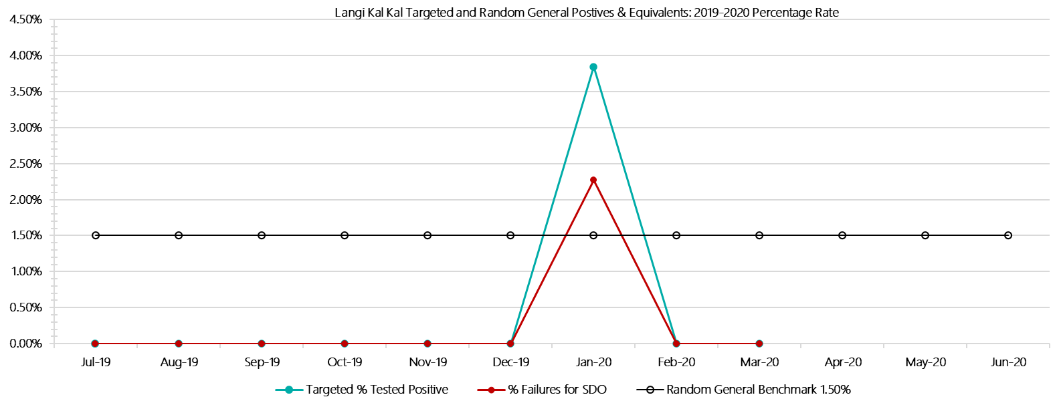

***Langi Kal Kal Positive Test Results by Drug Type: 2019-2020***

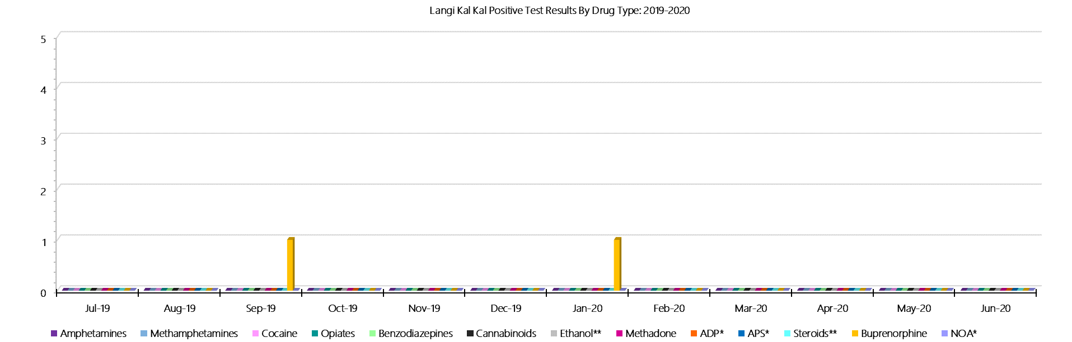

***Langi Kal Kal Count of Visitor Seizures Finds: 2019-2020***

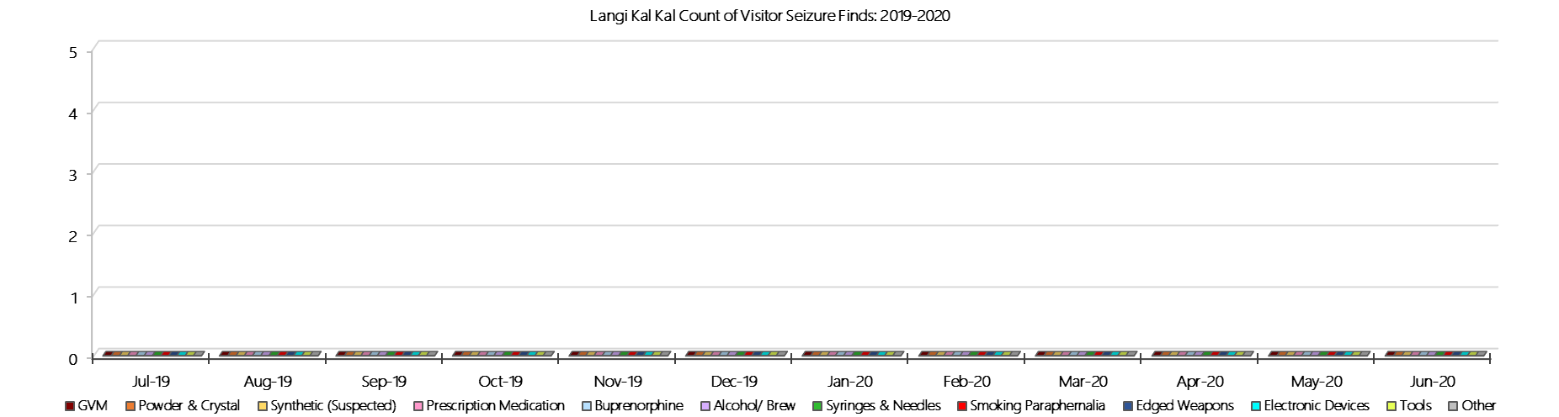

***Langi Kal Kal Count of Prisoner Seizure Finds: 2019-2020***

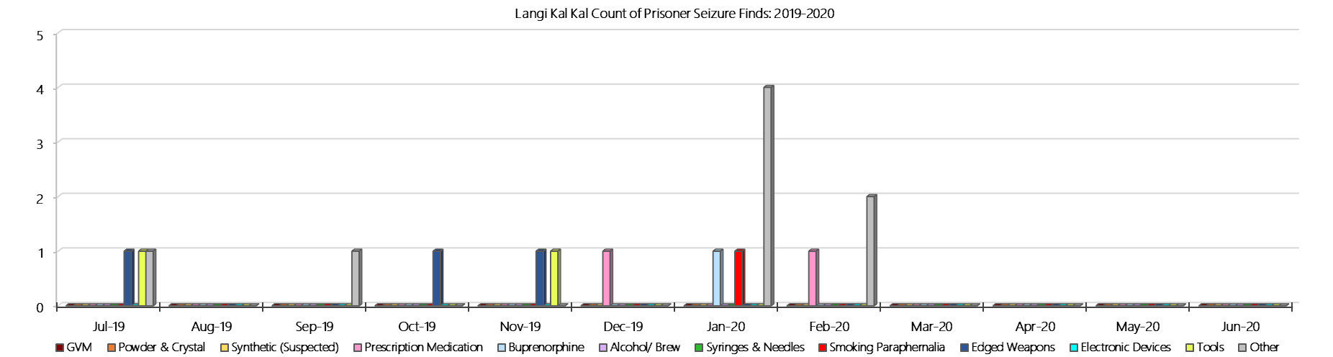

### **Tarrengower Prison**

***Targeted and Random General Drug Test Results: 2018-2019***

|  |  |  |  |  |  |  |  |  |  |  |  |  |  |  |
| --- | --- | --- | --- | --- | --- | --- | --- | --- | --- | --- | --- | --- | --- | --- |
| **Tarrengower** | **Jul-19** | **Aug-19** | **Sep-19** | **Oct-19** | **Nov-19** | **Dec-19** | **Jan-20** | **Feb-20** | **Mar-20** | **Apr-20** | **May-20** | **Jun-20** | **Average** | ***Totals*** |
| **Effective Sample - Targeted** | **7** | **3** | **3** | **1** | **1** | **1** | **1** | **1** | **8** |  |  |  | **3** | ***26*** |
| **Targeted Positives** | **0** | **0** | **0** | **0** | **1** | **0** | **0** | **0** | **0** |  |  |  | **0** | ***1*** |
| **Refusal** | **0** | **0** | **0** | **0** | **0** | **0** | **0** | **0** | **0** |  |  |  | **0** | ***0*** |
| **Unable** | **0** | **0** | **0** | **0** | **0** | **0** | **0** | **0** | **0** |  |  |  | **0** | ***0*** |
| **Interfered** | **0** | **0** | **0** | **0** | **0** | **0** | **0** | **0** | **0** |  |  |  | **0** | ***0*** |
| **Adulterated** | **0** | **0** | **0** | **0** | **0** | **0** | **0** | **0** | **0** |  |  |  | **0** | ***0*** |
| **Targeted % Tested Positive** | **0.00%** | **0.00%** | **0.00%** | **0.00%** | **100.00%** | **0.00%** | **0.00%** | **0.00%** | **0.00%** | **#N/A** | **#N/A** | **#N/A** | **3.85%** | ***3.85%*** |
| **Awaiting / Pending Results** | **0** | **0** | **0** | **0** | **0** | **0** | **0** | **0** | **0** |  |  |  | **0** | ***0*** |
| **Targeted Residual** | **0** | **0** | **0** | **0** | **0** | **0** | **0** | **0** | **0** |  |  |  | **0** | ***0*** |
| **Random tests collected** | **10** | **8** | **10** | **7** | **7** | **10** | **8** | **8** | **10** |  |  |  | **9** | ***78*** |
| **Tested Positive** | **0** | **0** | **0** | **0** | **0** | **0** | **0** | **0** | **0** |  |  |  | **0** | ***0*** |
| **Refusal (guilty)** | **0** | **0** | **0** | **0** | **0** | **0** | **0** | **0** | **0** |  |  |  | **0** | ***0*** |
| **Unable (not guilty)** | **0** | **0** | **0** | **0** | **0** | **0** | **0** | **0** | **0** |  |  |  | **0** | ***0*** |
| **Unable (guilty)** | **0** | **0** | **0** | **0** | **0** | **0** | **0** | **0** | **0** |  |  |  | **0** | ***0*** |
| **Interfered (guilty)** | **0** | **0** | **0** | **0** | **0** | **0** | **0** | **0** | **0** |  |  |  | **0** | ***0*** |
| **No test (valid reason)** | **0** | **0** | **0** | **1** | **1** | **0** | **0** | **0** | **0** |  |  |  | **0** | ***2*** |
| **No test (no valid reason)** | **0** | **0** | **0** | **0** | **0** | **0** | **0** | **0** | **0** |  |  |  | **0** | ***0*** |
| **Adulterated** | **0** | **0** | **0** | **0** | **0** | **0** | **0** | **0** | **0** |  |  |  | **0** | ***0*** |
| **Awaiting / Pending Results** | **0** | **0** | **0** | **0** | **0** | **0** | **0** | **0** | **0** |  |  |  | **0** | ***0*** |
| **Random Residual *(PIMS URAR030)*** | **0** | **0** | **0** | **0** | **0** | **0** | **0** | **0** | **0** |  |  |  | ***0*** | ***0*** |
| **Effective Sample - Random General** | **10** | **8** | **10** | **7** | **7** | **10** | **8** | **8** | **10** |  |  |  | **9** | **78** |
| **% Tested positive** | **0.00%** | **0.00%** | **0.00%** | **0.00%** | **0.00%** | **0.00%** | **0.00%** | **0.00%** | **0.00%** |  |  |  | **0.00%** |  |
| **% Prisoner guilty, positive equivalents** | **0.00%** | **0.00%** | **0.00%** | **0.00%** | **0.00%** | **0.00%** | **0.00%** | **0.00%** | **0.00%** |  |  |  | **0.00%** |  |
| **% Total prisoner fails** | **0.00%** | **0.00%** | **0.00%** | **0.00%** | **0.00%** | **0.00%** | **0.00%** | **0.00%** | **0.00%** |  |  |  | **0.00%** |  |
| **% No test without valid reason** | **0.00%** | **0.00%** | **0.00%** | **0.00%** | **0.00%** | **0.00%** | **0.00%** | **0.00%** | **0.00%** |  |  |  | **0.00%** |  |
| ***Random General Benchmark 1.50%*** | ***1.50%*** | ***1.50%*** | ***1.50%*** | ***1.50%*** | ***1.50%*** | ***1.50%*** | ***1.50%*** | ***1.50%*** | ***1.50%*** | ***1.50%*** | ***1.50%*** | ***1.50%*** | ***YTD*** |  |
| **% Failures for SDO** | **0.00%** | **0.00%** | **0.00%** | **0.00%** | **0.00%** | **0.00%** | **0.00%** | **0.00%** | **0.00%** | **#N/A** | **#N/A** | **#N/A** | **0.00%** |  |

***Tarrengower - Drugs Identified Through Testing by Drug Type: 2019-2020***

|  |  |  |  |  |  |  |  |  |  |  |  |  |  |  |
| --- | --- | --- | --- | --- | --- | --- | --- | --- | --- | --- | --- | --- | --- | --- |
| **Tarrengower** | ***Amphetamines*** | ***Methamphetamines*** | ***Cocaine*** | ***Opiates*** | ***Benzodiazepines*** | ***Cannabinoids*** | ***Ethanol\*\**** | ***Methadone*** | ***ADP\**** | ***APS\**** | ***Steroids\*\**** | ***Buprenorphine*** | ***NOA\**** | **Total** |
| **Jul-19** | **0** | **0** | **0** | **0** | **0** | **0** | **0** | **0** | **0** | **0** | **0** | **0** | **0** | **0** |
| **Aug-19** | **0** | **0** | **0** | **0** | **0** | **0** | **0** | **0** | **0** | **0** | **0** | **0** | **0** | **0** |
| **Sep-19** | **0** | **0** | **0** | **0** | **0** | **0** | **0** | **0** | **0** | **0** | **0** | **0** | **0** | **0** |
| **Oct-19** | **0** | **0** | **0** | **0** | **0** | **0** | **0** | **0** | **0** | **0** | **0** | **0** | **0** | **0** |
| **Nov-19** | **0** | **0** | **0** | **0** | **0** | **0** | **0** | **0** | **1** | **0** | **0** | **0** | **0** | **1** |
| **Dec-19** | **0** | **0** | **0** | **0** | **0** | **0** | **0** | **0** | **0** | **0** | **0** | **0** | **0** | **0** |
| **Jan-20** | **0** | **0** | **0** | **0** | **0** | **0** | **0** | **0** | **0** | **0** | **0** | **0** | **0** | **0** |
| **Feb-20** | **0** | **0** | **0** | **0** | **0** | **0** | **0** | **0** | **0** | **0** | **0** | **0** | **0** | **0** |
| **Mar-20** | **0** | **0** | **0** | **0** | **0** | **0** | **0** | **0** | **0** | **0** | **0** | **0** | **0** | **0** |
| **Apr-20** |  |  |  |  |  |  |  |  |  |  |  |  |  |  |
| **May-20** |  |  |  |  |  |  |  |  |  |  |  |  |  |  |
| **Jun-20** |  |  |  |  |  |  |  |  |  |  |  |  |  |  |
| **Tarrengower YTD** | **0** | **0** | **0** | **0** | **0** | **0** | **0** | **0** | **1** | **0** | **0** | **0** | **0** | **1** |
| ***All Prisons YTD*** | ***133*** | ***224*** | ***2*** | ***35*** | ***30*** | ***30*** | ***20*** | ***32*** | ***49*** | ***13*** | ***0*** | ***1785*** | ***0*** | ***2353*** |
| ***Tarrengower % of Total*** | ***0.00%*** | ***0.00%*** | ***0.00%*** | ***0.00%*** | ***0.00%*** | ***0.00%*** | ***0.00%*** | ***0.00%*** | ***2.04%*** | ***0.00%*** | ***0.00%*** | ***0.00%*** | ***0.00%*** | ***0.04%*** |

***Tarrengower Seizures of Contraband: Visitors & Prisoners: 2019-2020***

|  |  |  |  |  |  |  |  |  |  |  |  |  |  |  |  |  |  |  |  |  |  |  |  |  |
| --- | --- | --- | --- | --- | --- | --- | --- | --- | --- | --- | --- | --- | --- | --- | --- | --- | --- | --- | --- | --- | --- | --- | --- | --- |
| **Visitors** | **GVM** | | **Powder  & Crystal** | | **Synthetic  (Suspected)** | | **Prescription  Medication** | | **Buprenorphine** | | **Alcohol &  Home Brew** | | **Syringes** | | **Smoking  Paraphernalia** | | **Edged  Weapons** | | **Electronic  Devices** | | **Tools** | | **Other** | |
| **T’gower** | **Finds** | **Gms** | **Finds** | **Gms** | **Finds** | **Gms** | **Finds** | **Qty** | **Finds** | **Qty** | **Finds** | **Ltrs** | **Finds** | **Qty** | **Finds** | **Qty** | **Finds** | **Qty** | **Finds** | **Qty** | **Finds** | **Qty** | **Finds** | **Qty** |
| **Jul-19** | **0** | **0.00** | **0** | **0.00** | **0** | **0.00** | **0** | **0.00** | **0** | **0.00** | **0** | **0.000** | **0** | **0** | **0** | **0** | **0** | **0** | **0** | **0** | **0** | **0** | **1** | **1** |
| **Aug-19** | **0** | **0.00** | **0** | **0.00** | **0** | **0.00** | **0** | **0.00** | **0** | **0.00** | **0** | **0.000** | **0** | **0** | **0** | **0** | **0** | **0** | **0** | **0** | **0** | **0** | **0** | **0** |
| **Sep-19** | **0** | **0.00** | **0** | **0.00** | **0** | **0.00** | **0** | **0.00** | **0** | **0.00** | **0** | **0.000** | **0** | **0** | **0** | **0** | **0** | **0** | **0** | **0** | **0** | **0** | **0** | **0** |
| **Oct-19** | **0** | **0.00** | **0** | **0.00** | **0** | **0.00** | **0** | **0.00** | **0** | **0.00** | **0** | **0.000** | **0** | **0** | **0** | **0** | **0** | **0** | **0** | **0** | **0** | **0** | **0** | **0** |
| **Nov-19** | **0** | **0.00** | **0** | **0.00** | **0** | **0.00** | **0** | **0.00** | **0** | **0.00** | **0** | **0.000** | **0** | **0** | **0** | **0** | **0** | **0** | **0** | **0** | **0** | **0** | **0** | **0** |
| **Dec-19** | **0** | **0.00** | **0** | **0.00** | **0** | **0.00** | **0** | **0.00** | **0** | **0.00** | **0** | **0.000** | **0** | **0** | **0** | **0** | **0** | **0** | **0** | **0** | **0** | **0** | **0** | **0** |
| **Jan-20** | **0** | **0.00** | **0** | **0.00** | **0** | **0.00** | **0** | **0.00** | **0** | **0.00** | **0** | **0.000** | **0** | **0** | **0** | **0** | **0** | **0** | **0** | **0** | **0** | **0** | **0** | **0** |
| **Feb-20** | **0** | **0.00** | **0** | **0.00** | **0** | **0.00** | **0** | **0.00** | **0** | **0.00** | **0** | **0.000** | **0** | **0** | **0** | **0** | **0** | **0** | **0** | **0** | **0** | **0** | **0** | **0** |
| **Mar-20** | **0** | **0.00** | **0** | **0.00** | **0** | **0.00** | **0** | **0.00** | **0** | **0.00** | **0** | **0.000** | **0** | **0** | **0** | **0** | **0** | **0** | **0** | **0** | **0** | **0** | **0** | **0** |
| **Apr-20** |  |  |  |  |  |  |  |  |  |  |  |  |  |  |  |  |  |  |  |  |  |  |  |  |
| **May-20** |  |  |  |  |  |  |  |  |  |  |  |  |  |  |  |  |  |  |  |  |  |  |  |  |
| **Jun-20** |  |  |  |  |  |  |  |  |  |  |  |  |  |  |  |  |  |  |  |  |  |  |  |  |
| **Total** | **0** | **0.00** | **0** | **0.00** | **0** | **0.00** | **0** | **0.00** | **0** | **0.00** | **0** | **0.000** | **0** | **0** | **0** | **0** | **0** | **0** | **0** | **0** | **0** | **0** | **1** | **1** |

|  |  |  |  |  |  |  |  |  |  |  |  |  |  |  |  |  |  |  |  |  |  |  |  |  |  |
| --- | --- | --- | --- | --- | --- | --- | --- | --- | --- | --- | --- | --- | --- | --- | --- | --- | --- | --- | --- | --- | --- | --- | --- | --- | --- |
| **Prisoners** | **GVM** | | **Powder  & Crystal** | | **Synthetic  (Suspected)** | | **Prescription  Medication** | | **Buprenorphine** | | **Alcohol &  Home Brew** | | **Syringes** | | **Smoking  Paraphernalia** | | | **Edged  Weapons** | | **Electronic  Devices** | | **Tools** | | **Other** | |
| **T’gower** | **Finds** | **Gms** | **Finds** | **Gms** | **Finds** | **Gms** | **Finds** | **Qty** | **Finds** | **Qty** | **Finds** | **Ltrs** | **Finds** | **Qty** | **Finds** | **Qty** | | **Finds** | **Qty** | **Finds** | **Qty** | **Finds** | **Qty** | **Finds** | **Qty** |
| **Jul-19** | **0** | **0.00** | **0** | **0.00** | **0** | **0.00** | **0** | **0.00** | **0** | **0.00** | **0** | **0.000** | **0** | **0** | **0** | | **0** | **0** | **0** | **0** | **0** | **0** | **0** | **2** | **1.1** |
| **Aug-19** | **0** | **0.00** | **0** | **0.00** | **0** | **0.00** | **0** | **0.00** | **0** | **0.00** | **0** | **0.000** | **0** | **0** | **0** | | **0** | **0** | **0** | **0** | **0** | **0** | **0** | **0** | **0** |
| **Sep-19** | **0** | **0.00** | **0** | **0.00** | **0** | **0.00** | **1** | **2.00** | **0** | **0.00** | **0** | **0.000** | **0** | **0** | **0** | | **0** | **0** | **0** | **0** | **0** | **0** | **0** | **0** | **0** |
| **Oct-19** | **0** | **0.00** | **0** | **0.00** | **0** | **0.00** | **1** | **3.00** | **0** | **0.00** | **0** | **0.000** | **0** | **0** | **0** | | **0** | **0** | **0** | **0** | **0** | **0** | **0** | **0** | **0** |
| **Nov-19** | **0** | **0.00** | **0** | **0.00** | **0** | **0.00** | **0** | **0.00** | **0** | **0.00** | **0** | **0.000** | **0** | **0** | **0** | | **0** | **0** | **0** | **0** | **0** | **0** | **0** | **0** | **0** |
| **Dec-19** | **0** | **0.00** | **0** | **0.00** | **0** | **0.00** | **0** | **0.00** | **0** | **0.00** | **0** | **0.000** | **0** | **0** | **1** | | **1** | **0** | **0** | **0** | **0** | **0** | **0** | **0** | **0** |
| **Jan-20** | **0** | **0.00** | **0** | **0.00** | **0** | **0.00** | **0** | **0.00** | **0** | **0.00** | **0** | **0.000** | **0** | **0** | **1** | | **1** | **0** | **0** | **0** | **0** | **0** | **0** | **0** | **0** |
| **Feb-20** | **0** | **0.00** | **0** | **0.00** | **0** | **0.00** | **0** | **0.00** | **0** | **0.00** | **0** | **0.000** | **0** | **0** | **0** | | **0** | **0** | **0** | **0** | **0** | **0** | **0** | **0** | **0** |
| **Mar-20** | **0** | **0.00** | **0** | **0.00** | **0** | **0.00** | **0** | **0.00** | **0** | **0.00** | **0** | **0.000** | **0** | **0** | **0** | | **0** | **0** | **0** | **0** | **0** | **0** | **0** | **0** | **0** |
| **Apr-20** |  |  |  |  |  |  |  |  |  |  |  |  |  |  |  | |  |  |  |  |  |  |  |  |  |
| **May-20** |  |  |  |  |  |  |  |  |  |  |  |  |  |  |  | |  |  |  |  |  |  |  |  |  |
| **Jun-20** |  |  |  |  |  |  |  |  |  |  |  |  |  |  |  | |  |  |  |  |  |  |  |  |  |
| **Total** | **0** | **0.00** | **0** | **0.00** | **0** | **0.00** | **2** | **5.00** | **0** | **0.00** | **0** | **0.000** | **0** | **0** | **2** | | **2** | **0** | **0** | **0** | **0** | **0** | **0** | **2** | **1.1** |

***Tarrengower Targeted and Random General Drug Test Positives & Equivalents: 2019-2020***

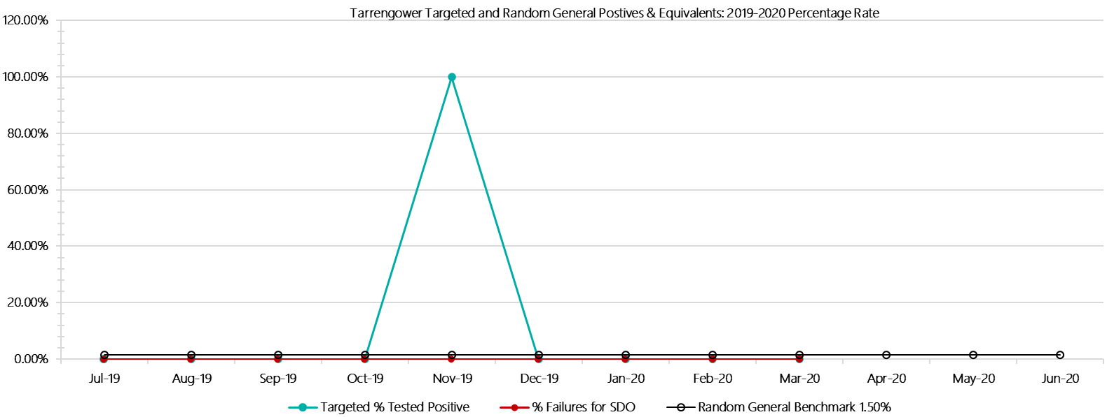

***Tarrengower Positive Test Results by Drug Type: 2019-2020***

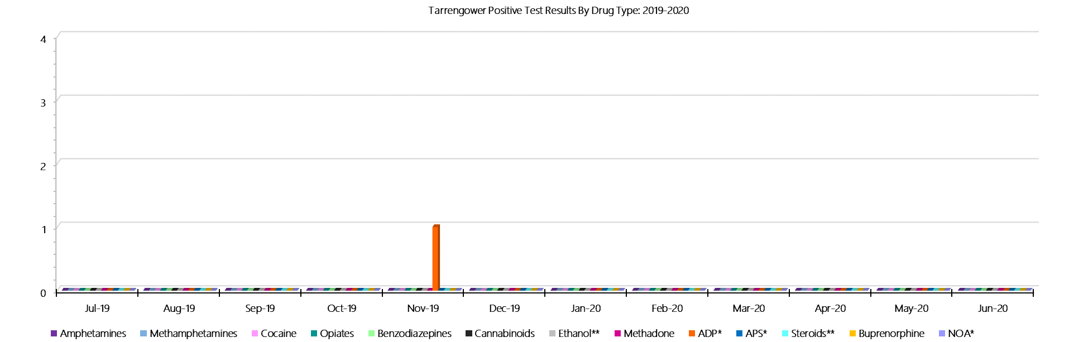

***Tarrengower Count of Visitor Seizures Finds: 2019-2020***

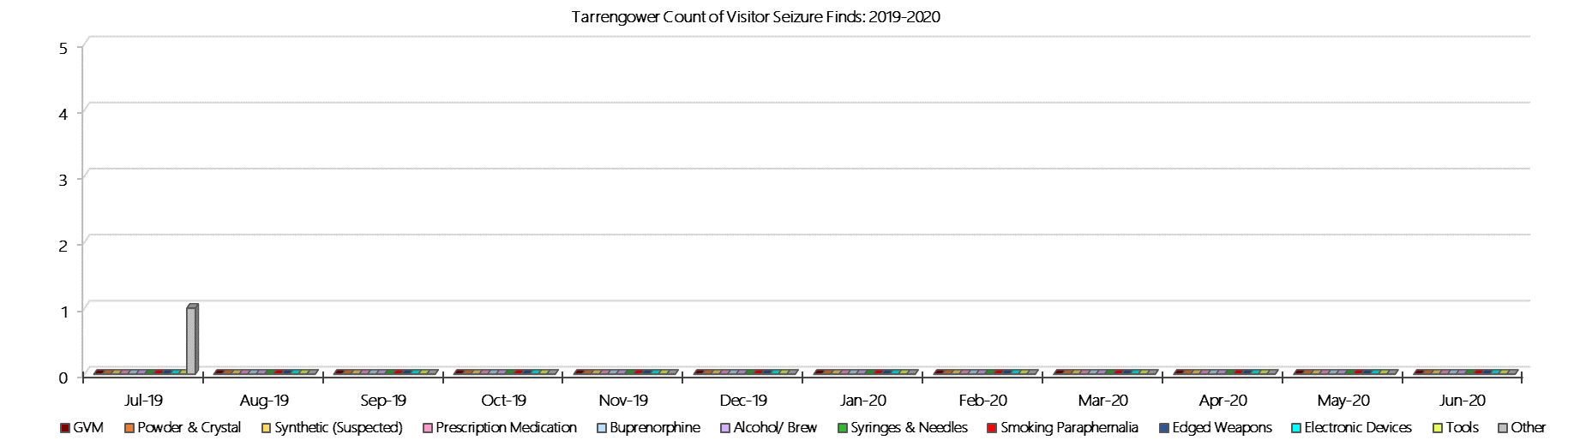

***Tarrengower Count of Prisoner Seizure Finds: 2019-2020***

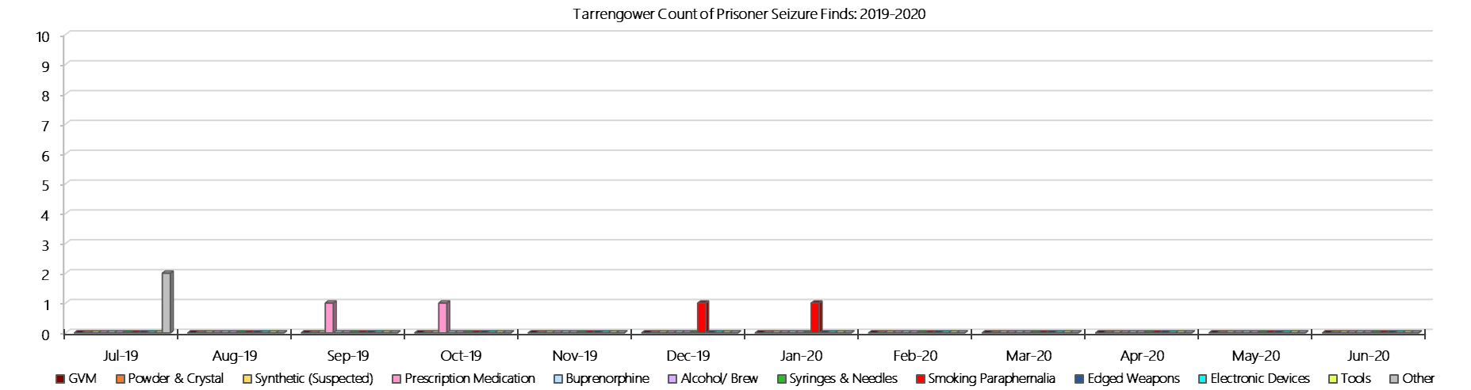

### **Judy Lazarus Transition Centre**

***Targeted and Random General Drug Test Results: 2019-2020***

|  |  |  |  |  |  |  |  |  |  |  |  |  |  |  |
| --- | --- | --- | --- | --- | --- | --- | --- | --- | --- | --- | --- | --- | --- | --- |
| **JLTC** | **Jul-19** | **Aug-19** | **Sep-19** | **Oct-19** | **Nov-19** | **Dec-19** | **Jan-20** | **Feb-20** | **Mar-20** | **Apr-20** | **May-20** | **Jun-20** | **Average** | ***Totals*** |
| **Effective Sample - Targeted** | **1** | **1** | **2** | **0** | **2** | **2** | **2** | **2** | **0** |  |  |  | **1** | ***12*** |
| **Targeted Positives** | **0** | **0** | **0** | **0** | **0** | **0** | **0** | **1** | **0** |  |  |  | **0** | ***1*** |
| **Refusal** | **0** | **0** | **0** | **0** | **0** | **0** | **0** | **0** | **0** |  |  |  | **0** | ***0*** |
| **Unable** | **0** | **0** | **0** | **0** | **0** | **0** | **0** | **0** | **0** |  |  |  | **0** | ***0*** |
| **Interfered** | **0** | **0** | **0** | **0** | **0** | **0** | **0** | **0** | **0** |  |  |  | **0** | ***0*** |
| **Adulterated** | **0** | **0** | **0** | **0** | **0** | **0** | **0** | **0** | **0** |  |  |  | **0** | ***0*** |
| **Targeted % Tested Positive** | **0.00%** | **0.00%** | **0.00%** | **#DIV/0!** | **0.00%** | **0.00%** | **0.00%** | **50.00%** | **#DIV/0!** | **#N/A** | **#N/A** | **#N/A** | **8.33%** | ***8.33%*** |
| **Awaiting / Pending Results** | **0** | **0** | **0** | **0** | **0** | **0** | **0** | **0** | **0** |  |  |  | **0** | ***0*** |
| **Targeted Residual** | **0** | **0** | **0** | **0** | **0** | **0** | **0** | **0** | **0** |  |  |  | **0** | ***0*** |
| **Random tests collected** | **4** | **4** | **5** | **4** | **4** | **5** | **4** | **4** | **5** |  |  |  | **4** | ***39*** |
| **Tested Positive** | **0** | **0** | **0** | **1** | **0** | **0** | **0** | **0** | **0** |  |  |  | **0** | ***1*** |
| **Refusal (guilty)** | **0** | **0** | **0** | **0** | **0** | **0** | **0** | **0** | **0** |  |  |  | **0** | ***0*** |
| **Unable (not guilty)** | **0** | **0** | **0** | **0** | **0** | **0** | **0** | **0** | **0** |  |  |  | **0** | ***0*** |
| **Unable (guilty)** | **0** | **0** | **0** | **0** | **0** | **0** | **0** | **0** | **0** |  |  |  | **0** | ***0*** |
| **Interfered (guilty)** | **0** | **0** | **0** | **0** | **0** | **0** | **0** | **0** | **0** |  |  |  | **0** | ***0*** |
| **No test (valid reason)** | **1** | **0** | **0** | **0** | **0** | **0** | **0** | **0** | **0** |  |  |  | **0** | ***1*** |
| **No test (no valid reason)** | **0** | **0** | **0** | **0** | **0** | **0** | **0** | **0** | **0** |  |  |  | **0** | ***0*** |
| **Adulterated** | **0** | **0** | **0** | **0** | **0** | **0** | **0** | **0** | **0** |  |  |  | **0** | ***0*** |
| **Awaiting / Pending Results** | **0** | **0** | **0** | **0** | **0** | **0** | **0** | **0** | **0** |  |  |  | **0** | ***0*** |
| **Random Residual *(PIMS URAR030)*** | **0** | **0** | **0** | **0** | **0** | **0** | **0** | **0** | **0** |  |  |  | ***0*** | ***0*** |
| **Effective Sample - Random General** | **4** | **4** | **5** | **4** | **4** | **5** | **4** | **4** | **5** |  |  |  | **4** | **39** |
| **% Tested positive** | **0.00%** | **0.00%** | **0.00%** | **25.00%** | **0.00%** | **0.00%** | **0.00%** | **0.00%** | **0.00%** |  |  |  | **2.78%** |  |
| **% Prisoner guilty, positive equivalents** | **0.00%** | **0.00%** | **0.00%** | **0.00%** | **0.00%** | **0.00%** | **0.00%** | **0.00%** | **0.00%** |  |  |  | **0.00%** |  |
| **% Total prisoner fails** | **0.00%** | **0.00%** | **0.00%** | **25.00%** | **0.00%** | **0.00%** | **0.00%** | **0.00%** | **0.00%** |  |  |  | **2.78%** |  |
| **% No test without valid reason** | **0.00%** | **0.00%** | **0.00%** | **0.00%** | **0.00%** | **0.00%** | **0.00%** | **0.00%** | **0.00%** |  |  |  | **0.00%** |  |
| ***Random General Benchmark 3.50%*** | ***3.50%*** | ***3.50%*** | ***3.50%*** | ***3.50%*** | ***3.50%*** | ***3.50%*** | ***3.50%*** | ***3.50%*** | ***3.50%*** | ***3.50%*** | ***3.50%*** | ***3.50%*** | ***YTD*** |  |
| **% Failures for SDO** | **0.00%** | **0.00%** | **0.00%** | **25.00%** | **0.00%** | **0.00%** | **0.00%** | **0.00%** | **0.00%** | **#N/A** | **#N/A** | **#N/A** | **2.56%** |  |

***JLTC - Drugs Identified Through Testing by Drug Type: 2019-2020***

|  |  |  |  |  |  |  |  |  |  |  |  |  |  |  |
| --- | --- | --- | --- | --- | --- | --- | --- | --- | --- | --- | --- | --- | --- | --- |
| **JLTC** | ***Amphetamines*** | ***Methamphetamines*** | ***Cocaine*** | ***Opiates*** | ***Benzodiazepines*** | ***Cannabinoids*** | ***Ethanol\*\**** | ***Methadone*** | ***ADP\**** | ***APS\**** | ***Steroids\*\**** | ***Buprenorphine*** | ***NOA\**** | **Total** |
| **Jul-19** | **0** | **0** | **0** | **0** | **0** | **0** | **0** | **0** | **0** | **0** | **0** | **0** | **0** | **0** |
| **Aug-19** | **0** | **0** | **0** | **0** | **0** | **0** | **0** | **0** | **0** | **0** | **0** | **0** | **0** | **0** |
| **Sep-19** | **0** | **0** | **0** | **0** | **0** | **0** | **0** | **0** | **0** | **0** | **0** | **0** | **0** | **0** |
| **Oct-19** | **1** | **1** | **1** | **0** | **0** | **0** | **0** | **0** | **0** | **0** | **0** | **1** | **0** | **4** |
| **Nov-19** | **0** | **0** | **0** | **0** | **0** | **0** | **0** | **0** | **0** | **0** | **0** | **0** | **0** | **0** |
| **Dec-19** | **0** | **0** | **0** | **0** | **0** | **0** | **0** | **0** | **0** | **0** | **0** | **1** | **0** | **1** |
| **Jan-20** | **0** | **0** | **0** | **0** | **0** | **0** | **0** | **0** | **0** | **0** | **0** | **0** | **0** | **0** |
| **Feb-20** | **0** | **0** | **0** | **1** | **0** | **0** | **0** | **0** | **0** | **0** | **0** | **0** | **0** | **1** |
| **Mar-20** | **0** | **0** | **0** | **0** | **0** | **0** | **0** | **0** | **0** | **0** | **0** | **0** | **0** | **0** |
| **Apr-20** |  |  |  |  |  |  |  |  |  |  |  |  |  |  |
| **May-20** |  |  |  |  |  |  |  |  |  |  |  |  |  |  |
| **Jun-20** |  |  |  |  |  |  |  |  |  |  |  |  |  |  |
| **JLTC YTD** | **1** | **1** | **1** | **1** | **0** | **0** | **0** | **0** | **0** | **0** | **0** | **2** | **0** | **6** |
| ***All Prisons YTD*** | ***133*** | ***224*** | ***2*** | ***35*** | ***30*** | ***30*** | ***20*** | ***32*** | ***49*** | ***13*** | ***0*** | ***1785*** | ***0*** | ***2353*** |
| ***JLTC % of Total*** | ***0.75%*** | ***0.45%*** | ***50.00%*** | ***2.86%*** | ***0.00%*** | ***0.00%*** | ***0.00%*** | ***0.00%*** | ***0.00%*** | ***0.00%*** | ***0.00%*** | ***0.11%*** | ***0.00%*** | ***0.25%*** |

***JLTC Seizures of Contraband: Visitors & Prisoners: 2019-2020***

|  |  |  |  |  |  |  |  |  |  |  |  |  |  |  |  |  |  |  |  |  |  |  |  |  |
| --- | --- | --- | --- | --- | --- | --- | --- | --- | --- | --- | --- | --- | --- | --- | --- | --- | --- | --- | --- | --- | --- | --- | --- | --- |
| **Visitors** | **GVM** | | **Powder  & Crystal** | | **Synthetic  (Suspected)** | | **Prescription  Medication** | | **Buprenorphine** | | **Alcohol &  Home Brew** | | **Syringes** | | **Smoking  Paraphernalia** | | **Edged  Weapons** | | **Electronic  Devices** | | **Tools** | | **Other** | |
| **JLTC** | **Finds** | **Gms** | **Finds** | **Gms** | **Finds** | **Gms** | **Finds** | **Qty** | **Finds** | **Qty** | **Finds** | **Ltrs** | **Finds** | **Qty** | **Finds** | **Qty** | **Finds** | **Qty** | **Finds** | **Qty** | **Finds** | **Qty** | **Finds** | **Qty** |
| **Jul-19** | **0** | **0.00** | **0** | **0.00** | **0** | **0.00** | **0** | **0.00** | **0** | **0.00** | **0** | **0.000** | **0** | **0** | **0** | **0** | **0** | **0** | **0** | **0** | **0** | **0** | **0** | **0** |
| **Aug-19** | **0** | **0.00** | **0** | **0.00** | **0** | **0.00** | **0** | **0.00** | **0** | **0.00** | **0** | **0.000** | **0** | **0** | **0** | **0** | **0** | **0** | **0** | **0** | **0** | **0** | **0** | **0** |
| **Sep-19** | **0** | **0.00** | **0** | **0.00** | **0** | **0.00** | **0** | **0.00** | **0** | **0.00** | **0** | **0.000** | **0** | **0** | **0** | **0** | **0** | **0** | **0** | **0** | **0** | **0** | **0** | **0** |
| **Oct-19** | **0** | **0.00** | **0** | **0.00** | **0** | **0.00** | **0** | **0.00** | **0** | **0.00** | **0** | **0.000** | **0** | **0** | **0** | **0** | **0** | **0** | **0** | **0** | **0** | **0** | **0** | **0** |
| **Nov-19** | **0** | **0.00** | **0** | **0.00** | **0** | **0.00** | **0** | **0.00** | **0** | **0.00** | **0** | **0.000** | **0** | **0** | **0** | **0** | **0** | **0** | **0** | **0** | **0** | **0** | **0** | **0** |
| **Dec-19** | **0** | **0** | **0** | **0** | **0** | **0** | **0** | **0** | **0** | **0** | **0** | **0** | **0** | **0** | **0** | **0** | **0** | **0** | **0** | **0** | **0** | **0** | **0** | **0** |
| **Jan-20** | **0** | **0.00** | **0** | **0.00** | **0** | **0.00** | **0** | **0.00** | **0** | **0.00** | **0** | **0.000** | **0** | **0** | **0** | **0** | **0** | **0** | **0** | **0** | **0** | **0** | **0** | **0** |
| **Feb-20** | **0** | **0.00** | **0** | **0.00** | **0** | **0.00** | **0** | **0.00** | **0** | **0.00** | **0** | **0.000** | **0** | **0** | **0** | **0** | **0** | **0** | **0** | **0** | **0** | **0** | **0** | **0** |
| **Mar-20** | **0** | **0.00** | **0** | **0.00** | **0** | **0.00** | **0** | **0.00** | **0** | **0.00** | **0** | **0.000** | **0** | **0** | **0** | **0** | **0** | **0** | **0** | **0** | **0** | **0** | **0** | **0** |
| **Apr-20** |  |  |  |  |  |  |  |  |  |  |  |  |  |  |  |  |  |  |  |  |  |  |  |  |
| **May-20** |  |  |  |  |  |  |  |  |  |  |  |  |  |  |  |  |  |  |  |  |  |  |  |  |
| **Jun-20** |  |  |  |  |  |  |  |  |  |  |  |  |  |  |  |  |  |  |  |  |  |  |  |  |
| **Total** | **0** | **0.00** | **0** | **0.00** | **0** | **0.00** | **0** | **0.00** | **0** | **0.00** | **0** | **0.000** | **0** | **0** | **0** | **0** | **0** | **0** | **0** | **0** | **0** | **0** | **0** | **0** |

|  |  |  |  |  |  |  |  |  |  |  |  |  |  |  |  |  |  |  |  |  |  |  |  |  |  |  |
| --- | --- | --- | --- | --- | --- | --- | --- | --- | --- | --- | --- | --- | --- | --- | --- | --- | --- | --- | --- | --- | --- | --- | --- | --- | --- | --- |
| **Prisoners** | **GVM** | | **Powder  & Crystal** | | **Synthetic  (Suspected)** | | **Prescription  Medication** | | | **Buprenorphine** | | **Alcohol &  Home Brew** | | **Syringes** | | **Smoking  Paraphernalia** | | | **Edged  Weapons** | | **Electronic  Devices** | | **Tools** | | **Other** | |
| **JLTC** | **Finds** | **Gms** | **Finds** | **Gms** | **Finds** | **Gms** | **Finds** | **Qty** | | **Finds** | **Qty** | **Finds** | **Ltrs** | **Finds** | **Qty** | **Finds** | **Qty** | | **Finds** | **Qty** | **Finds** | **Qty** | **Finds** | **Qty** | **Finds** | **Qty** |
| **Jul-19** | **0** | **0.00** | **0** | **0.00** | **0** | **0.00** | **1** | | **18.00** | **0** | **0.00** | **0** | **0.000** | **0** | **0** | **0** | | **0** | **0** | **0** | **0** | **0** | **0** | **0** | **0** | **0** |
| **Aug-19** | **0** | **0** | **0** | **0** | **0** | **0** | **1** | | **6** | **0** | **0** | **0** | **0** | **0** | **0** | **1** | | **4** | **0** | **0** | **0** | **0** | **0** | **0** | **0** | **0** |
| **Sep-19** | **0** | **0** | **0** | **0** | **0** | **0** | **0** | | **0** | **0** | **0** | **0** | **0** | **0** | **0** | **0** | | **0** | **0** | **0** | **0** | **0** | **0** | **0** | **0** | **0** |
| **Oct-19** | **0** | **0** | **0** | **0** | **0** | **0** | **0** | | **0** | **1** | **2** | **0** | **0** | **0** | **0** | **1** | | **2** | **0** | **0** | **0** | **0** | **1** | **2** | **1** | **1** |
| **Nov-19** | **0** | **0** | **0** | **0** | **0** | **0** | **0** | | **0** | **0** | **0** | **0** | **0** | **0** | **0** | **1** | | **1** | **0** | **0** | **0** | **0** | **0** | **0** | **1** | **1** |
| **Dec-19** | **0** | **0** | **0** | **0** | **0** | **0** | **0** | | **0** | **0** | **0** | **0** | **0** | **0** | **0** | **0** | | **0** | **0** | **0** | **0** | **0** | **0** | **0** | **0** | **0** |
| **Jan-20** | **0** | **0** | **0** | **0** | **0** | **0** | **0** | | **0** | **0** | **0** | **0** | **0** | **0** | **0** | **0** | | **0** | **0** | **0** | **0** | **0** | **0** | **0** | **0** | **0** |
| **Feb-20** | **0** | **0.00** | **0** | **0.00** | **0** | **0.00** | **0** | | **0.00** | **0** | **0.00** | **0** | **0.000** | **0** | **0** | **0** | | **0** | **0** | **0** | **0** | **0** | **0** | **0** | **0** | **0** |
| **Mar-20** | **0** | **0.00** | **0** | **0.00** | **0** | **0.00** | **0** | | **0.00** | **0** | **0.00** | **0** | **0.000** | **0** | **0** | **0** | | **0** | **0** | **0** | **0** | **0** | **0** | **0** | **0** | **0** |
| **Apr-20** |  |  |  |  |  |  |  | |  |  |  |  |  |  |  |  | |  |  |  |  |  |  |  |  |  |
| **May-20** |  |  |  |  |  |  |  | |  |  |  |  |  |  |  |  | |  |  |  |  |  |  |  |  |  |
| **Jun-20** |  |  |  |  |  |  |  | |  |  |  |  |  |  |  |  | |  |  |  |  |  |  |  |  |  |
| **Total** | **0** | **0.00** | **0** | **0.00** | **0** | **0.00** | **2** | | **24.00** | **1** | **2.00** | **0** | **0.000** | **0** | **0** | **3** | | **7** | **0** | **0** | **0** | **0** | **1** | **2** | **2** | **2** |

***JLTC Targeted and Random General Drug Test Positives & Equivalents: 2019-2020***

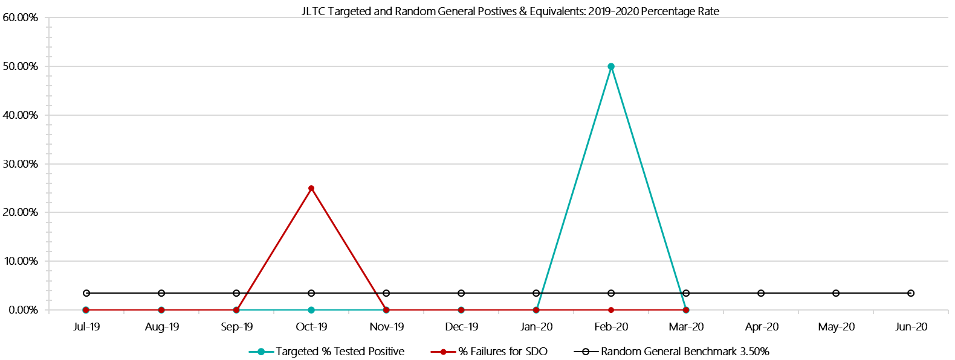

***JLTC Positive Test Results by Drug Type: 2019-2020***

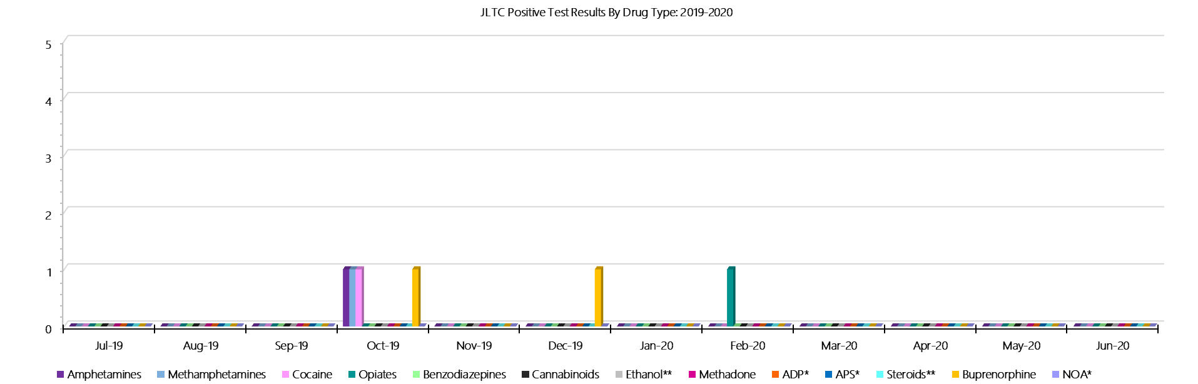

***JLTC Count of Visitor Seizures Finds: 2019-2020***

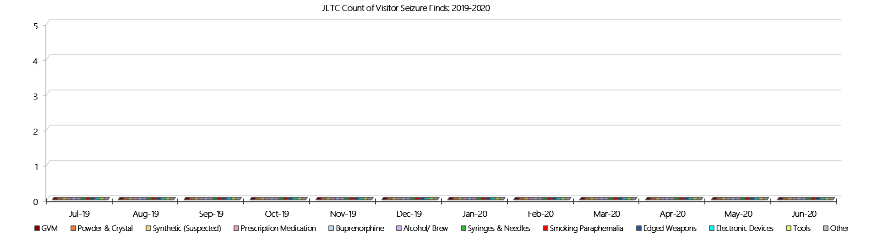

***JLTC Count of Prisoner Seizure Finds: 2019-2020***

**- PAGE LEFT BLANK INTENTIONALLY -**