**Report on Prohibited Drug Use and   
Contraband Seized in Victorian Prisons**

**2019 - 2020**

**Drugs in Victorian Prisons Report**

**January 2020**



Corrections Victoria

The System Performance Branch produces the Drugs in Victorian Prisons Report (DIVPR) each month to provide data pertaining to drug use – both illicit use and prescription misuse - and contraband seizures in Victorian prisons. The report is provided on a monthly basis, and is made available to selected stakeholders, such as the Assistant Commissioner Security and Intelligence Division, Deputy Commissioner Operations, General Manager Security and Emergency Services Group, General Manager Corrections Victoria Intelligence Unit, and Prison General Managers and Regional Directors. The report is designed to provide information for consideration of action, including the deployment of resources to detect and reduce drugs in Victorian prisons.

The DIVPR specifically compiles and presents data in the following areas:

* + - * drug test results for Random General and Targeted testing,
      * types of drugs identified through drug testing,
      * seizures of contraband from visitors and prisoners

The first section of the DIVPR provides a statewide overview of the above data, with the second section providing location specific data. In a bid to include details of all drug test results from the preceding month, compilation does not commence until after the 15th day of the following month. Information is provided by Prison Intelligence Units (seizures), the Drug Strategy Support Team (drug metabolite breakdowns), as well as the Monitoring, Standards and Reporting Unit (Random General – SDO8 data).

There has been an amendment to the seizure category of “Syringes”, which has been renamed to “Syringes & Needles”, to capture needles modified for drug use.

As part of the commitment to reducing the volume of strip searches in the women's prisons, Corrections Victoria has implemented a 12-month trial of saliva testing, which commenced in March 2019. The trial has replaced the majority of urine testing with an initial saliva test at Dame Phyllis Frost Centre and Tarrengower Prison. Due to the need for confirmatory testing, any prisoner returning a positive result on a saliva swab will be directed to complete a urine test.

As of February 2019, Corrections Victoria amended its data reporting process relating to the types of drugs detected within the prison system to more efficiently report on Methamphetamines. Whilst the number of Methamphetamine positives is accurate, the number of Amphetamine positives may be over represented. This is due to Methamphetamine positives coming from the drug 'ICE' and Amphetamines also being present in the majority of these positives due to the way the drug is manufactured and how it metabolises within the body.

**Table of Contents**

Statewide Overview 5

**Drug Test Results: 2019-2020** 5

**Graph of Targeted and Random General Drug Test Positives & Equivalents 2019-2020** 7

**Targeted and Random General Drug Test Positives & Equivalents: 2019-2020** 8

**Location Muster against Drug Tests Collected and % Positive** 9

Drugs Identified Through Drug Testing 10

**Positive Drug Test Results by Drug Type per Prison Location: January 2020** 10

**Graph of Positive Drug Test Results: Drug Type by Prison: January 2020** 11

**Year to Date Comparison - Current Financial Year and Previous Financial Years** 12

**Breakdown of Amphetamine & Opiate Drug Groups by Metabolite – 2019-2020** 13

**Positive by Location: YTD 2019-2020** 14

**Percentage Positive by Location: YTD 2019-2020** 15

**Visitors – January 2020** 16

**Graphs of Seizures of Contraband: Visitors – January 2020 & YTD 2019-2020** 19

**Graphs of Seizures of Contraband: Prisoners – January 2020 & YTD 2019-2020** 22

LOCATION SPECIFIC RESULTS 23

**Barwon Prison** 24

**Melbourne Assessment Prison** 29

**Metropolitan Remand Centre** 34

**Port Phillip Prison** 39

**Dame Phyllis Frost Centre** 44

**Fulham Correctional Centre** 49

**Hopkins Correctional Centre** 54

**Karreenga (annex of Marngoneet)** 59

**Marngoneet Correctional Centre** 64

**Loddon Prison** 69

**Middleton (annex of Loddon)** 74

**Ravenhall Correctional Centre** 79

**Beechworth Correctional Centre** 84

**Dhurringile Prison** 89

**Langi Kal Kal Prison** 94

**Tarrengower Prison** 99

**Judy Lazarus Transition Centre** 104

**Statewide Overview**

### **Drug Test Results: 2019-2020**

***Random General Positive Rate***

As at 26 February 2020, the number of Random General drug test samples collected in January was 875, of which 4.91% were positive.   
This is in comparison to the previous month, whereby 1,064 Random General tests were collected, of which 4.42% were positive.

* The following locations exceeded their Random General benchmark for the month of Janaury 2020:
  + - Langi Kal Kal Prison,
    - Metropolitan Remand Centre, and
    - Ravenhall Correctional Centre.
* The 2019-2020 Random General positive rate across all locations is 4.77%, with the following locations exceeding their benchmark for the year:
  + - Barwon Prison,
    - Loddon Prison, and
    - Metropolitan Remand Centre.

***Targeted Positive Rate***

The number of Targeted drug tests collected in January was 1,822 of which 11.09% were positive.

This is in comparison to the previous month, whereby 1,774 Targeted drug tests were collected, of which 12.80% were positive.

* The following locations had the highest Targeted positive rates for the month of January 2020:
  + - Barwon Prison,
    - Loddon Prison, and
    - Metropolitan Remand Centre.

The 2019-2020 Targeted positive rate for all locations 10.41%, with the following locations having the highest Targeted positive rates for the year:

* + - Barwon Prison,
    - Hopkins Correctional Centre, and
    - Metropolitan Remand Centre.

Targeted testing is used by intelligence officers to identify and intervene in use, and a high positive rate may therefore indicate well directed intelligence.

***Note:*** *The Commissioner defines a Random General positive as positives, refusals, and unables found guilty at a GMDH, as well as interfered and adulterated results. Random General data is provided by the Monitoring, Standards and Reporting Unit, with adjustments reflected in the following reporting month. January data provided 26 February 2020.   
Targeted and Positive Results by Drug Type are retrieved from PIMS by the System Performance Branch. January data provided 26 February 2020.*

|  |  |  |  |  |  |  |  |  |  |  |  |  |  |
| --- | --- | --- | --- | --- | --- | --- | --- | --- | --- | --- | --- | --- | --- |
| **TARGETED** | **Jul-19** | **Aug-19** | **Sep-19** | **Oct-19** | **Nov-19** | **Dec-19** | **Jan-20** | **Feb-20** | **Mar-20** | **Apr-20** | **May-20** | **Jun-20** | **YTD Av.** |
| **Barwon** | **14.77%** | **14.72%** | **16.04%** | **17.56%** | **14.56%** | **22.86%** | **15.20%** |  |  |  |  |  | **16.06%** |
| **MAP** | **7.06%** | **7.78%** | **6.35%** | **9.46%** | **5.63%** | **24.56%** | **4.41%** |  |  |  |  |  | **8.86%** |
| **MRC** | **8.70%** | **21.17%** | **11.26%** | **17.22%** | **15.30%** | **19.16%** | **17.22%** |  |  |  |  |  | **15.62%** |
| **PPP** | **9.97%** | **13.70%** | **16.41%** | **8.77%** | **13.23%** | **11.41%** | **14.19%** |  |  |  |  |  | **12.39%** |
| **DPFC** | **18.18%** | **4.44%** | **4.46%** | **12.00%** | **10.00%** | **15.67%** | **9.20%** |  |  |  |  |  | **10.25%** |
| **Fulham** | **9.82%** | **10.29%** | **6.37%** | **13.71%** | **10.36%** | **12.12%** | **14.08%** |  |  |  |  |  | **10.94%** |
| **Hopkins** | **13.64%** | **14.29%** | **0.00%** | **18.75%** | **29.03%** | **21.43%** | **11.11%** |  |  |  |  |  | **16.99%** |
| **Karreenga** | **11.36%** | **9.76%** | **13.04%** | **14.71%** | **12.50%** | **3.70%** | **6.06%** |  |  |  |  |  | **10.18%** |
| **Marngoneet** | **2.86%** | **4.62%** | **13.43%** | **22.02%** | **14.02%** | **24.00%** | **12.35%** |  |  |  |  |  | **13.88%** |
| **Loddon** | **10.98%** | **6.85%** | **16.67%** | **4.62%** | **11.86%** | **11.11%** | **15.15%** |  |  |  |  |  | **11.04%** |
| **Middleton** | **5.56%** | **13.95%** | **5.56%** | **6.12%** | **8.00%** | **5.88%** | **0.00%** |  |  |  |  |  | **6.31%** |
| **Ravenhall** | **5.60%** | **7.28%** | **6.25%** | **6.98%** | **9.25%** | **11.11%** | **9.45%** |  |  |  |  |  | **8.01%** |
| **Beechworth** | **0.00%** | **0.00%** | **2.63%** | **0.00%** | **0.00%** | **2.38%** | **0.00%** |  |  |  |  |  | **0.80%** |
| **Dhurringile** | **5.38%** | **2.22%** | **2.56%** | **2.59%** | **1.56%** | **0.83%** | **2.27%** |  |  |  |  |  | **2.62%** |
| **Langi Kal Kal** | **0.00%** | **0.00%** | **0.00%** | **0.00%** | **0.00%** | **0.00%** | **3.85%** |  |  |  |  |  | **0.67%** |
| **Tarrengower** | **0.00%** | **0.00%** | **0.00%** | **0.00%** | **100.00%** | **0.00%** | **0.00%** |  |  |  |  |  | **5.88%** |
| **JLTC** | **0.00%** | **0.00%** | **0.00%** | **0.00%** | **0.00%** | **0.00%** | **0.00%** |  |  |  |  |  | **0.00%** |
| **Targeted % Positive** | **8.34%** | **9.94%** | **9.04%** | **10.44%** | **11.23%** | **12.80%** | **11.09%** | **#N/A** | **#N/A** | **#N/A** | **#N/A** | **#N/A** | **10.41%** |
|  |  |  |  |  |  |  |  |  |  |  |  |  |  |
| **RANDOM - Benchmark** | **Jul-19** | **Aug-19** | **Sep-19** | **Oct-19** | **Nov-19** | **Dec-19** | **Jan-20** | **Feb-20** | **Mar-20** | **Apr-20** | **May-20** | **Jun-20** | **YTD** |
| **Barwon - 8.00%** | **13.56%** | **8.70%** | **8.33%** | **14.58%** | **4.17%** | **14.75%** | **6.00%** |  |  |  |  |  | **10.22%** |
| **MAP - 8.00%** | **3.33%** | **5.26%** | **6.25%** | **9.52%** | **0.00%** | **6.06%** | **0.00%** |  |  |  |  |  | **4.35%** |
| **MRC - 7.00%** | **14.29%** | **15.74%** | **7.94%** | **8.08%** | **11.76%** | **7.03%** | **16.04%** |  |  |  |  |  | **11.47%** |
| **PPP** | **6.25%** | **9.43%** | **6.56%** | **1.96%** | **9.62%** | **8.06%** | **6.00%** |  |  |  |  |  | **6.87%** |
| **DPFC - 7.25%** | **0.00%** | **0.00%** | **1.41%** | **3.39%** | **0.00%** | **0.00%** | **0.00%** |  |  |  |  |  | **0.67%** |
| **Fulham** | **0.00%** | **0.00%** | **2.70%** | **0.00%** | **8.33%** | **4.00%** | **6.25%** |  |  |  |  |  | **3.00%** |
| **Hopkins - 3.50%** | **1.87%** | **1.18%** | **3.64%** | **5.49%** | **2.20%** | **0.90%** | **2.13%** |  |  |  |  |  | **2.47%** |
| **Karreenga - 3.50%** | **4.55%** | **8.57%** | **0.00%** | **0.00%** | **0.00%** | **2.50%** | **3.13%** |  |  |  |  |  | **2.63%** |
| **Marngoneet - 6.50%** | **3.85%** | **7.81%** | **7.59%** | **11.48%** | **4.76%** | **5.26%** | **4.62%** |  |  |  |  |  | **6.38%** |
| **Loddon - 5.00%** | **8.33%** | **6.25%** | **10.00%** | **6.12%** | **6.38%** | **6.78%** | **0.00%** |  |  |  |  |  | **6.45%** |
| **Middleton - 4.00%** | **0.00%** | **3.13%** | **2.63%** | **0.00%** | **0.00%** | **0.00%** | **0.00%** |  |  |  |  |  | **0.86%** |
| **Ravenhall** | **5.14%** | **2.74%** | **3.37%** | **2.72%** | **6.43%** | **3.35%** | **6.21%** |  |  |  |  |  | **4.23%** |
| **Beechworth - 1.80%** | **0.00%** | **0.00%** | **0.00%** | **0.00%** | **0.00%** | **3.33%** | **0.00%** |  |  |  |  |  | **0.58%** |
| **Dhurringile - 3.50%** | **2.94%** | **0.00%** | **0.00%** | **3.57%** | **3.57%** | **5.56%** | **0.00%** |  |  |  |  |  | **2.19%** |
| **Langi Kal Kal - 1.50%** | **0.00%** | **0.00%** | **0.00%** | **0.00%** | **0.00%** | **0.00%** | **2.33%** |  |  |  |  |  | **0.29%** |
| **Tarrengower - 1.50%** | **0.00%** | **0.00%** | **0.00%** | **0.00%** | **0.00%** | **0.00%** | **0.00%** |  |  |  |  |  | **0.00%** |
| **JLTC - 3.50%** | **0.00%** | **0.00%** | **0.00%** | **25.00%** | **0.00%** | **0.00%** | **0.00%** |  |  |  |  |  | **3.33%** |
| **Random % Positive** | **5.03%** | **5.07%** | **4.39%** | **4.78%** | **4.90%** | **4.42%** | **4.91%** | **#N/A** | **#N/A** | **#N/A** | **#N/A** | **#N/A** |  |
| **Random YTD % Positive** | **5.03%** | **5.05%** | **4.82%** | **4.81%** | **4.83%** | **4.75%** | **4.77%** | **#N/A** | **#N/A** | **#N/A** | **#N/A** | **#N/A** | **4.77%** |
| ***Random Objective 5.00%*** | ***5.00%*** | ***5.00%*** | ***5.00%*** | ***5.00%*** | ***5.00%*** | ***5.00%*** | ***5.00%*** | ***5.00%*** | ***5.00%*** | ***5.00%*** | ***5.00%*** | ***5.00%*** |  |

***Graph of Targeted and Random General Drug Test Positives & Equivalents 2019-2020***

### 

### **Targeted and Random General Drug Test Positives & Equivalents: 2019-2020**

|  |  |  |  |  |  |  |  |  |  |  |  |  |  |  |
| --- | --- | --- | --- | --- | --- | --- | --- | --- | --- | --- | --- | --- | --- | --- |
| Corrections Victoria | Jul-19 | Aug-19 | Sep-19 | Oct-19 | Nov-19 | Dec-19 | Jan-20 | Feb-20 | Mar-20 | Apr-20 | May-20 | Jun-20 | YTD Average | YTD Totals |
| **Targeted - Tests Collected** | **1,857** | **1,780** | **1,714** | **1,915** | **1,798** | **1,774** | **1,817** |  |  |  |  |  | **1,808** | **12,655** |
| **Tested Positive** | **127** | **148** | **122** | **159** | **163** | **155** | **166** |  |  |  |  |  | **149** | **1,040** |
| **Refusal** | **13** | **12** | **20** | **15** | **20** | **29** | **17** |  |  |  |  |  | **18** | **126** |
| **Unable - Guilty** | **12** | **16** | **10** | **22** | **19** | **39** | **12** |  |  |  |  |  | **19** | **130** |
| **Interfered** | **1** | **0** | **0** | **0** | **0** | **3** | **1** |  |  |  |  |  | **1** | **5** |
| **Adulterated** | **2** | **1** | **3** | **4** | **0** | **1** | **6** |  |  |  |  |  | **2** | **17** |
| **Awaiting / Pending Results** | **1** | **0** | **0** | **0** | **0** | **0** | **5** |  |  |  |  |  | **1** | **6** |
| **Targeted - Effective Sample** | **1,858** | **1,780** | **1,714** | **1,915** | **1,798** | **1,774** | **1,822** |  |  |  |  |  | **1,809** | **12,661** |
| **Targeted % Positives and Equivalents** | **8.34%** | **9.94%** | **9.04%** | **10.44%** | **11.23%** | **12.80%** | **11.09%** | **#N/A** | **#N/A** | **#N/A** | **#N/A** | **#N/A** | **10.41%** | **10.41%** |
| **Random General - Tests Collected** | **1,056** | **857** | **1,054** | **852** | **852** | **1,054** | **867** |  |  |  |  |  | **942** | **6,592** |
| **Tested Positive** | **37** | **33** | **31** | **34** | **36** | **37** | **34** |  |  |  |  |  | **35** | **242** |
| **Refusal** | **7** | **4** | **5** | **2** | **3** | **2** | **2** |  |  |  |  |  | **4** | **25** |
| **Unable - Guilty** | **9** | **5** | **9** | **3** | **3** | **8** | **6** |  |  |  |  |  | **6** | **43** |
| **Interfered** | **0** | **0** | **0** | **0** | **0** | **0** | **0** |  |  |  |  |  | **0** | **0** |
| **No test - No Valid Reason** | **1** | **1** | **2** | **0** | **0** | **0** | **0** |  |  |  |  |  | **1** | **4** |
| **Adulterated** | **0** | **1** | **0** | **2** | **0** | **0** | **1** |  |  |  |  |  | **1** | **4** |
| **Awaiting / Pending Results** | **0** | **0** | **0** | **0** | **0** | **0** | **4** |  |  |  |  |  | **1** | **4** |
| **Random General - Effective Sample** | **1,073** | **867** | **1,070** | **857** | **858** | **1,064** | **875** |  |  |  |  |  | **952** | **6,664** |
| **SDO8 Positives & Equivalents** | **54** | **44** | **47** | **41** | **42** | **47** | **43** | **0** | **0** | **0** | **0** | **0** | **27** | **318** |
| **% Failures for SDO8 - Monthly** | **5.03%** | **5.07%** | **4.39%** | **4.78%** | **4.90%** | **4.42%** | **4.91%** | **#N/A** | **#N/A** | **#N/A** | **#N/A** | **#N/A** | **2.78%** |  |
| **% Failures for SDO8 - YTD** | **5.03%** | **5.05%** | **4.82%** | **4.81%** | **4.83%** | **4.75%** | **4.77%** | **#N/A** | **#N/A** | **#N/A** | **#N/A** | **#N/A** |  | **4.77%** |
| ***Random Objective 5.00%*** | ***5.00%*** | ***5.00%*** | ***5.00%*** | ***5.00%*** | ***5.00%*** | ***5.00%*** | ***5.00%*** | ***5.00%*** | ***5.00%*** | ***5.00%*** | ***5.00%*** | ***5.00%*** |  |  |

### **Location Muster against Drug Tests Collected and % Positive**

This data compares the number of Targeted and Random General tests collected and the percentage of the prison population tested for the month in comparison  
to the previous month.

It further provides the percentage of positives for both the Targeted and Random General urinalysis testing regimes.

|  |  |  |  |  |  |  |  |  |  |  |  |  |  |  |
| --- | --- | --- | --- | --- | --- | --- | --- | --- | --- | --- | --- | --- | --- | --- |
| **January 2020 - Location Muster Against Tests Collected  Targeted & Random General** | | | | | | | | | | **December 2019 - Location Muster Against Tests Collected  Targeted & Random General** | | | | |
|  |  | **Targeted** | | | | **Random General** | | | |  | **Targeted** | | **Random General** | |
| **Location** | **Average Monthly Muster** | **Targeted Tests Collected** | **% of Population** | **% Positive** | **No. of Tests YTD** | **Random General Tests Collected** | **% of Population** | **% Positive** | **No. of Tests YTD** | **Average Monthly Muster** | **Targeted Tests Collected** | **% Positive** | **Random General Tests Collected** | **% Positive** |
| **Barwon** | **403** | **125** | **31.02%** | **15.20%** | **847** | **48** | **11.91%** | **6.00%** | **360** | **403** | **70** | **22.86%** | **58** | **14.75%** |
| **MAP** | **229** | **68** | **29.69%** | **4.41%** | **508** | **25** | **10.92%** | **0.00%** | **178** | **249** | **57** | **24.56%** | **31** | **6.06%** |
| **MRC** | **903** | **151** | **16.72%** | **17.22%** | **1,101** | **105** | **11.63%** | **16.04%** | **783** | **871** | **167** | **19.16%** | **127** | **7.03%** |
| **PPP** | **1,039** | **303** | **29.16%** | **14.19%** | **2,083** | **50** | **4.81%** | **6.00%** | **391** | **976** | **263** | **11.41%** | **62** | **8.06%** |
| **DPFC** | **466** | **163** | **34.98%** | **9.20%** | **839** | **58** | **12.45%** | **0.00%** | **450** | **458** | **134** | **15.67%** | **68** | **0.00%** |
| **Fulham** | **872** | **206** | **23.62%** | **14.08%** | **1,426** | **63** | **7.22%** | **6.25%** | **464** | **834** | **198** | **12.12%** | **74** | **4.00%** |
| **Hopkins** | **772** | **36** | **4.66%** | **11.11%** | **153** | **93** | **12.05%** | **2.13%** | **686** | **752** | **28** | **21.43%** | **111** | **0.90%** |
| **Karreenga** | **259** | **33** | **12.74%** | **6.06%** | **226** | **31** | **11.97%** | **3.13%** | **262** | **268** | **27** | **3.70%** | **40** | **2.50%** |
| **Marngoneet** | **536** | **81** | **15.11%** | **12.35%** | **634** | **65** | **12.13%** | **4.62%** | **476** | **529** | **100** | **24.00%** | **76** | **5.26%** |
| **Loddon** | **401** | **66** | **16.46%** | **15.15%** | **489** | **49** | **12.22%** | **0.00%** | **371** | **392** | **72** | **11.11%** | **58** | **6.78%** |
| **Middleton** | **233** | **50** | **21.46%** | **0.00%** | **333** | **31** | **13.30%** | **0.00%** | **233** | **232** | **51** | **5.88%** | **36** | **0.00%** |
| **Ravenhall** | **1,230** | **402** | **32.68%** | **9.45%** | **2,872** | **144** | **11.71%** | **6.21%** | **1,102** | **1,212** | **414** | **11.11%** | **179** | **3.35%** |
| **Beechworth** | **111** | **21** | **18.92%** | **0.00%** | **249** | **12** | **10.81%** | **0.00%** | **170** | **196** | **42** | **2.38%** | **29** | **3.33%** |
| **Dhurringile** | **273** | **88** | **32.23%** | **2.27%** | **725** | **39** | **14.29%** | **0.00%** | **227** | **227** | **120** | **0.83%** | **35** | **5.56%** |
| **Langi Kal Kal** | **353** | **26** | **7.37%** | **3.85%** | **149** | **42** | **11.90%** | **2.33%** | **349** | **347** | **28** | **0.00%** | **55** | **0.00%** |
| **Tarrengower** | **58** | **1** | **1.72%** | **0.00%** | **17** | **8** | **13.79%** | **0.00%** | **60** | **58** | **1** | **0.00%** | **10** | **0.00%** |
| **JLTC** | **21** | **2** | **9.52%** | **0.00%** | **10** | **4** | **19.05%** | **0.00%** | **30** | **21** | **2** | **0.00%** | **5** | **0.00%** |
|  | **8,159** | **1,822** |  |  |  | **867** |  |  |  | **8,025** | **1,774** |  | **1,054** |  |

## **Drugs Identified Through Drug Testing**

### **Positive Drug Test Results by Drug Type per Prison Location: January 2020**

|  |  |  |  |  |  |  |  |  |  |  |  |  |  |  |
| --- | --- | --- | --- | --- | --- | --- | --- | --- | --- | --- | --- | --- | --- | --- |
| ***Jan-20*** | ***Amphetamines*** | ***Methamphetamines*** | ***Cocaine*** | ***Opiates*** | ***Benzodiazepines*** | ***Cannabinoids*** | ***Ethanol\*\**** | ***Methadone*** | ***ADP\**** | ***APS\**** | ***Steroids\*\**** | ***Buprenorphine*** | ***NOA\**** | **Total** |
| **Barwon** | **0** | **0** | **0** | **1** | **0** | **0** | **0** | **2** | **0** | **0** | **0** | **22** | **0** | **25** |
| **MAP** | **0** | **1** | **0** | **0** | **0** | **0** | **0** | **0** | **0** | **0** | **0** | **2** | **0** | **3** |
| **MRC** | **0** | **0** | **0** | **0** | **1** | **0** | **0** | **0** | **0** | **0** | **0** | **55** | **0** | **56** |
| **PPP** | **0** | **0** | **0** | **0** | **0** | **0** | **2** | **1** | **0** | **0** | **0** | **39** | **0** | **42** |
| **DPFC** | **1** | **2** | **1** | **5** | **2** | **0** | **0** | **0** | **1** | **0** | **0** | **0** | **0** | **12** |
| **Fulham** | **6** | **9** | **0** | **0** | **0** | **0** | **0** | **0** | **2** | **1** | **0** | **22** | **0** | **40** |
| **Hopkins** | **0** | **0** | **0** | **0** | **0** | **0** | **0** | **0** | **0** | **0** | **0** | **6** | **0** | **6** |
| **Karreenga** | **0** | **0** | **0** | **0** | **0** | **0** | **0** | **0** | **0** | **0** | **0** | **3** | **0** | **3** |
| **Marngoneet** | **0** | **0** | **0** | **0** | **0** | **0** | **0** | **0** | **0** | **0** | **0** | **24** | **0** | **24** |
| **Loddon** | **0** | **0** | **0** | **0** | **0** | **0** | **0** | **0** | **0** | **0** | **0** | **13** | **0** | **13** |
| **Middleton** | **0** | **0** | **0** | **0** | **0** | **0** | **0** | **0** | **0** | **0** | **0** | **0** | **0** | **0** |
| **Ravenhall** | **0** | **0** | **0** | **0** | **0** | **0** | **0** | **0** | **0** | **0** | **0** | **51** | **0** | **51** |
| **Beechworth** | **0** | **0** | **0** | **0** | **0** | **0** | **0** | **0** | **0** | **0** | **0** | **1** | **0** | **1** |
| **Dhurringile** | **0** | **0** | **0** | **0** | **0** | **0** | **0** | **0** | **0** | **0** | **0** | **2** | **0** | **2** |
| **Langi Kal Kal** | **0** | **0** | **0** | **0** | **0** | **0** | **0** | **0** | **0** | **0** | **0** | **1** | **0** | **1** |
| **Tarrengower** | **0** | **0** | **0** | **0** | **0** | **0** | **0** | **0** | **0** | **0** | **0** | **0** | **0** | **0** |
| **JLTC** | **0** | **0** | **0** | **0** | **0** | **0** | **0** | **0** | **0** | **0** | **0** | **0** | **0** | **0** |
| **Total** | **7** | **12** | **1** | **6** | **3** | **0** | **2** | **3** | **3** | **1** | **0** | **241** | **0** | **279** |
| **%** | **2.51** | **4.30** | **0.36** | **2.15** | **1.08** | **0.00** | **0.72** | **1.08** | **1.08** | **0.36** | **0.00** | **86.38** | **0.00** | **100.00** |
| ***PM Total*** | ***20*** | ***35*** | ***0*** | ***6*** | ***6*** | ***5*** | ***6*** | ***3*** | ***2*** | ***3*** | ***0*** | ***207*** | ***0*** | ***293*** |
| ***PM %*** | ***6.83*** | ***11.95*** | ***0.00*** | ***2.05*** | ***2.05*** | ***1.71*** | ***2.05*** | ***1.02*** | ***0.68*** | ***1.02*** | ***0.00*** | ***70.65*** | ***0.00*** | ***100.00*** |

***ADP*, APS* & NOA* medication only included on standard testing panel for particular private prisons – remaining prisons can request inclusion***

***Ethanol** & Steroids** – tested upon request***

### **Graph of Positive Drug Test Results: Drug Type by Prison: January 2020**

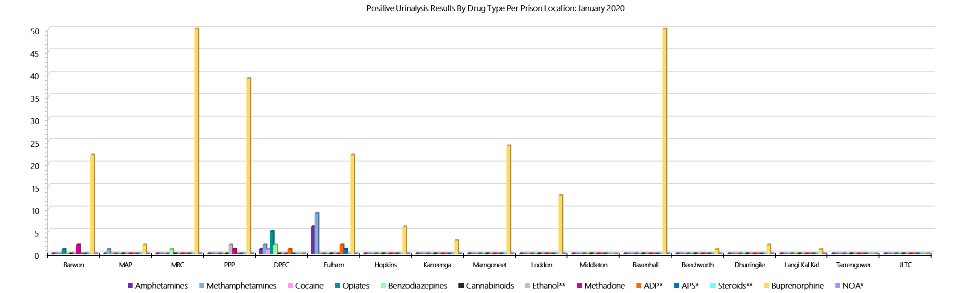

***ADP*, APS* & NOA* medication only included on standard testing panel for particular private prisons – remaining prisons can request inclusion***

***Ethanol** & Steroids** – tested upon request***

***Drugs Identified Through Drug Testing***

### **Year to Date Comparison - Current Financial Year and Previous Financial Years**

### 



***ADP*, APS* & NOA* medication only included on standard testing panel for particular private prisons – remaining prisons can request inclusion***

***Ethanol** & Steroids** – tested upon request***

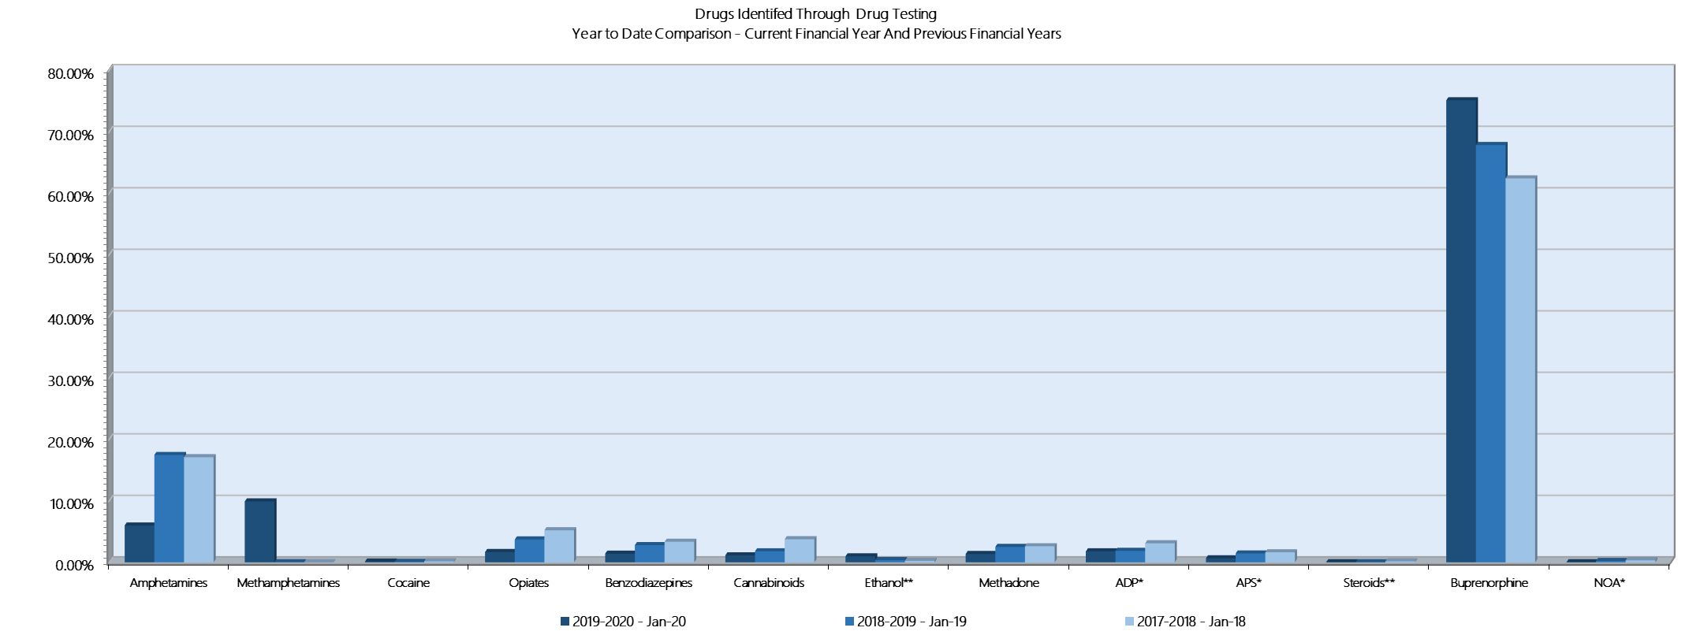

***Drugs Identified Through Testing***

### **Breakdown of Amphetamine & Opiate Drug Groups by Metabolite – 2019-2020**





*January data retrieved 26 February 2020. Results prepared in conjunction with Dorevitch pathology and in accordance with Australian testing methodology.*

***Drugs Identified Through Testing***

### **Positive by Location: YTD 2019-2020**

|  |  |  |  |  |  |  |  |  |  |  |  |  |  |  |
| --- | --- | --- | --- | --- | --- | --- | --- | --- | --- | --- | --- | --- | --- | --- |
| ***YTD - Jan-20*** | ***Amphetamines*** | ***Methamphetamines*** | ***Cocaine*** | ***Opiates*** | ***Benzodiazepines*** | ***Cannabinoids*** | ***Ethanol\*\**** | ***Methadone*** | ***ADP\**** | ***APS\**** | ***Steroids\*\**** | ***Buprenorphine*** | ***NOA\**** | **Total** |
| **Barwon** | **3** | **4** | **0** | **1** | **1** | **1** | **0** | **6** | **4** | **2** | **0** | **154** | **0** | **176** |
| **MAP** | **4** | **7** | **0** | **2** | **5** | **1** | **0** | **0** | **0** | **0** | **0** | **16** | **0** | **35** |
| **MRC** | **12** | **29** | **0** | **6** | **2** | **2** | **0** | **1** | **0** | **0** | **0** | **250** | **0** | **302** |
| **PPP** | **16** | **26** | **0** | **1** | **2** | **1** | **2** | **13** | **0** | **0** | **0** | **251** | **0** | **312** |
| **DPFC** | **22** | **31** | **1** | **12** | **3** | **1** | **0** | **0** | **2** | **1** | **0** | **17** | **0** | **90** |
| **Fulham** | **8** | **15** | **0** | **7** | **4** | **1** | **0** | **2** | **24** | **9** | **0** | **115** | **0** | **185** |
| **Hopkins** | **3** | **4** | **0** | **0** | **1** | **0** | **0** | **0** | **0** | **0** | **0** | **35** | **0** | **43** |
| **Karreenga** | **0** | **1** | **0** | **0** | **0** | **0** | **0** | **0** | **0** | **0** | **0** | **32** | **0** | **33** |
| **Marngoneet** | **10** | **14** | **0** | **0** | **2** | **3** | **10** | **2** | **1** | **0** | **0** | **149** | **0** | **191** |
| **Loddon** | **3** | **3** | **0** | **1** | **0** | **0** | **5** | **0** | **0** | **0** | **0** | **108** | **0** | **120** |
| **Middleton** | **3** | **4** | **0** | **0** | **0** | **1** | **0** | **0** | **0** | **0** | **0** | **27** | **0** | **35** |
| **Ravenhall** | **23** | **40** | **0** | **0** | **5** | **10** | **1** | **1** | **1** | **0** | **0** | **218** | **0** | **299** |
| **Beechworth** | **1** | **2** | **0** | **0** | **0** | **0** | **0** | **0** | **0** | **0** | **0** | **3** | **0** | **6** |
| **Dhurringile** | **2** | **3** | **0** | **1** | **1** | **0** | **0** | **0** | **0** | **0** | **0** | **18** | **0** | **25** |
| **Langi Kal Kal** | **0** | **0** | **0** | **0** | **0** | **0** | **0** | **0** | **0** | **0** | **0** | **2** | **0** | **2** |
| **Tarrengower** | **0** | **0** | **0** | **0** | **0** | **0** | **0** | **0** | **1** | **0** | **0** | **0** | **0** | **1** |
| **JLTC** | **1** | **1** | **1** | **0** | **0** | **0** | **0** | **0** | **0** | **0** | **0** | **2** | **0** | **5** |
| **Total** | **111** | **184** | **2** | **31** | **26** | **21** | **18** | **25** | **33** | **12** | **0** | **1397** | **0** | **1860** |
| **%** | **5.97** | **9.89** | **0.11** | **1.67** | **1.40** | **1.13** | **0.97** | **1.34** | **1.77** | **0.65** | **0.00** | **75.11** | **0.00** | **100.00** |
| ***PY Total*** | ***38*** | ***0*** | ***0*** | ***8*** | ***7*** | ***4*** | ***0*** | ***1*** | ***6*** | ***2*** | ***0*** | ***126*** | ***0*** | ***192*** |
| ***PY %*** | ***19.79*** | ***0.00*** | ***0.00*** | ***4.17*** | ***3.65*** | ***2.08*** | ***0.00*** | ***0.52*** | ***3.13*** | ***1.04*** | ***0.00*** | ***65.63*** | ***0.00*** | ***100.00*** |

***Drugs Identified Through Testing:***

### **Percentage Positive by Location: YTD 2019-2020**

|  |  |  |  |  |  |  |  |  |  |  |  |  |  |  |
| --- | --- | --- | --- | --- | --- | --- | --- | --- | --- | --- | --- | --- | --- | --- |
| **Drug Type Percentage Positive by Location - 2019-2020** | | | | | | | | | | | | | | |
| **Jan-20** | ***Amphetamines*** | ***Methamphetamines*** | ***Cocaine*** | ***Opiates*** | ***Benzodiazepines*** | ***Cannabinoids*** | ***Ethanol\*\**** | ***Methadone*** | ***ADP\**** | ***APS\**** | ***Steroids\*\**** | ***Buprenorphine*** | ***NOA\**** | **% of Total** |
| **Barwon** | **2.70%** | **2.17%** | **0.00%** | **3.23%** | **3.85%** | **4.76%** | **0.00%** | **24.00%** | **12.12%** | **16.67%** | **0.00%** | **11.02%** | **0.00%** | **9.46%** |
| **MAP** | **3.60%** | **3.80%** | **0.00%** | **6.45%** | **19.23%** | **4.76%** | **0.00%** | **0.00%** | **0.00%** | **0.00%** | **0.00%** | **1.15%** | **0.00%** | **1.88%** |
| **MRC** | **10.81%** | **15.76%** | **0.00%** | **19.35%** | **7.69%** | **9.52%** | **0.00%** | **4.00%** | **0.00%** | **0.00%** | **0.00%** | **17.90%** | **0.00%** | **16.24%** |
| **PPP** | **14.41%** | **14.13%** | **0.00%** | **3.23%** | **7.69%** | **4.76%** | **11.11%** | **52.00%** | **0.00%** | **0.00%** | **0.00%** | **17.97%** | **0.00%** | **16.77%** |
| **DPFC** | **19.82%** | **16.85%** | **50.00%** | **38.71%** | **11.54%** | **4.76%** | **0.00%** | **0.00%** | **6.06%** | **8.33%** | **0.00%** | **1.22%** | **0.00%** | **4.84%** |
| **Fulham** | **7.21%** | **8.15%** | **0.00%** | **22.58%** | **15.38%** | **4.76%** | **0.00%** | **8.00%** | **72.73%** | **75.00%** | **0.00%** | **8.23%** | **0.00%** | **9.95%** |
| **Hopkins** | **2.70%** | **2.17%** | **0.00%** | **0.00%** | **3.85%** | **0.00%** | **0.00%** | **0.00%** | **0.00%** | **0.00%** | **0.00%** | **2.51%** | **0.00%** | **2.31%** |
| **Karreenga** | **0.00%** | **0.54%** | **0.00%** | **0.00%** | **0.00%** | **0.00%** | **0.00%** | **0.00%** | **0.00%** | **0.00%** | **0.00%** | **2.29%** | **0.00%** | **1.77%** |
| **Marngoneet** | **9.01%** | **7.61%** | **0.00%** | **0.00%** | **7.69%** | **14.29%** | **55.56%** | **8.00%** | **3.03%** | **0.00%** | **0.00%** | **10.67%** | **0.00%** | **10.27%** |
| **Loddon** | **2.70%** | **1.63%** | **0.00%** | **3.23%** | **0.00%** | **0.00%** | **27.78%** | **0.00%** | **0.00%** | **0.00%** | **0.00%** | **7.73%** | **0.00%** | **6.45%** |
| **Middleton** | **2.70%** | **2.17%** | **0.00%** | **0.00%** | **0.00%** | **4.76%** | **0.00%** | **0.00%** | **0.00%** | **0.00%** | **0.00%** | **1.93%** | **0.00%** | **1.88%** |
| **Ravenhall** | **20.72%** | **21.74%** | **0.00%** | **0.00%** | **19.23%** | **47.62%** | **5.56%** | **4.00%** | **3.03%** | **0.00%** | **0.00%** | **15.60%** | **0.00%** | **16.08%** |
| **Beechworth** | **0.90%** | **1.09%** | **0.00%** | **0.00%** | **0.00%** | **0.00%** | **0.00%** | **0.00%** | **0.00%** | **0.00%** | **0.00%** | **0.21%** | **0.00%** | **0.32%** |
| **Dhurringile** | **1.80%** | **1.63%** | **0.00%** | **3.23%** | **3.85%** | **0.00%** | **0.00%** | **0.00%** | **0.00%** | **0.00%** | **0.00%** | **1.29%** | **0.00%** | **1.34%** |
| **Langi Kal Kal** | **0.00%** | **0.00%** | **0.00%** | **0.00%** | **0.00%** | **0.00%** | **0.00%** | **0.00%** | **0.00%** | **0.00%** | **0.00%** | **0.14%** | **0.00%** | **0.11%** |
| **Tarrengower** | **0.00%** | **0.00%** | **0.00%** | **0.00%** | **0.00%** | **0.00%** | **0.00%** | **0.00%** | **3.03%** | **0.00%** | **0.00%** | **0.00%** | **0.00%** | **0.05%** |
| **JLTC** | **0.90%** | **0.54%** | **50.00%** | **0.00%** | **0.00%** | **0.00%** | **0.00%** | **0.00%** | **0.00%** | **0.00%** | **0.00%** | **0.14%** | **0.00%** | **0.27%** |
| **All Prisons YTD** | **111** | **184** | **2** | **31** | **26** | **21** | **18** | **25** | **33** | **12** | **0** | **1397** | **0** | **1860** |
| ***% Positive*** | **5.97%** | **9.89%** | **0.11%** | **1.67%** | **1.40%** | **1.13%** | **0.97%** | **1.34%** | **1.77%** | **0.65%** | **0.00%** | **75.11%** | **0.00%** | **100.00%** |

***S*eizures of Contraband by Item Type**

### **Visitors – January 2020**

|  |  |  |  |  |  |  |  |  |  |  |  |  |  |  |  |  |  |  |  |  |  |  |  |  |
| --- | --- | --- | --- | --- | --- | --- | --- | --- | --- | --- | --- | --- | --- | --- | --- | --- | --- | --- | --- | --- | --- | --- | --- | --- |
| **Visitors** | **GVM** | | **Powder & Crystal** | | **Synthetic (Suspected)** | | **Prescription Medication** | | **Buprenorphine** | | **Alcohol & Home Brew** | | **Syringes & Needles** | | **Smoking Paraphernalia** | | **Edged Weapons** | | **Electronic Devices** | | **Tools** | | **Other** | |
| **Janaury 2020** | **Finds** | **Gms** | **Finds** | **Gms** | **Finds** | **Gms** | **Finds** | **Qty** | **Finds** | **Qty** | **Finds** | **Ltrs** | **Finds** | **Qty** | **Finds** | **Qty** | **Finds** | **Qty** | **Finds** | **Qty** | **Finds** | **Qty** | **Finds** | **Qty** |
| **Barwon** | **0** | **0.00** | **0** | **0.00** | **0** | **0.00** | **0** | **0.00** | **1** | **53.00** | **0** | **0.000** | **0** | **0** | **0** | **0** | **0** | **0** | **0** | **0** | **0** | **0** | **0** | **0** |
| **MAP** | **0** | **0.00** | **0** | **0.00** | **0** | **0.00** | **0** | **0.00** | **0** | **0.00** | **0** | **0.000** | **0** | **0** | **0** | **0** | **0** | **0** | **0** | **0** | **0** | **0** | **0** | **0** |
| **MRC** | **3** | **11.64** | **5** | **23.45** | **0** | **0.00** | **4** | **26.00** | **0** | **0.00** | **0** | **0.000** | **1** | **3** | **4** | **6** | **1** | **1** | **0** | **0** | **2** | **2** | **3** | **8** |
| **PPP** | **0** | **0.00** | **2** | **2.61** | **0** | **0.00** | **0** | **0.00** | **1** | **18.00** | **0** | **0.000** | **0** | **0** | **1** | **8** | **0** | **0** | **0** | **0** | **0** | **0** | **0** | **0** |
| **DPFC** | **0** | **0.00** | **0** | **0.00** | **0** | **0.00** | **1** | **4.00** | **0** | **0.00** | **0** | **0.000** | **0** | **0** | **0** | **0** | **0** | **0** | **0** | **0** | **0** | **0** | **0** | **0** |
| **Fulham** | **0** | **0.00** | **0** | **0.00** | **0** | **0.00** | **0** | **0.00** | **0** | **0.00** | **0** | **0.000** | **1** | **2** | **2** | **4** | **0** | **0** | **0** | **0** | **0** | **0** | **0** | **0** |
| **Hopkins** | **0** | **0.00** | **0** | **0.00** | **0** | **0.00** | **0** | **0.00** | **0** | **0.00** | **0** | **0.000** | **0** | **0** | **0** | **0** | **0** | **0** | **0** | **0** | **0** | **0** | **0** | **0** |
| **Karreenga** | **0** | **0.00** | **0** | **0.00** | **0** | **0.00** | **0** | **0.00** | **0** | **0.00** | **0** | **0.000** | **0** | **0** | **0** | **0** | **0** | **0** | **0** | **0** | **0** | **0** | **0** | **0** |
| **Marngoneet** | **0** | **0.00** | **0** | **0.00** | **0** | **0.00** | **0** | **0.00** | **0** | **0.00** | **0** | **0.000** | **0** | **0** | **0** | **0** | **0** | **0** | **0** | **0** | **0** | **0** | **0** | **0** |
| **Loddon** | **0** | **0.00** | **0** | **0.00** | **0** | **0.00** | **0** | **0.00** | **1** | **11.00** | **0** | **0.000** | **1** | **1** | **2** | **9** | **0** | **0** | **0** | **0** | **0** | **0** | **0** | **0** |
| **Middleton** | **0** | **0.00** | **0** | **0.00** | **0** | **0.00** | **0** | **0.00** | **0** | **0.00** | **0** | **0.000** | **0** | **0** | **0** | **0** | **0** | **0** | **0** | **0** | **0** | **0** | **0** | **0** |
| **Ravenhall** | **1** | **0.00** | **1** | **1.12** | **0** | **0.00** | **1** | **13.00** | **0** | **0.00** | **0** | **0.000** | **1** | **2** | **5** | **34** | **0** | **0** | **0** | **0** | **0** | **0** | **0** | **0** |
| **Beechworth** | **0** | **0.00** | **0** | **0.00** | **0** | **0.00** | **0** | **0.00** | **0** | **0.00** | **0** | **0.000** | **0** | **0** | **0** | **0** | **0** | **0** | **0** | **0** | **0** | **0** | **0** | **0** |
| **Dhurringile** | **0** | **0.00** | **0** | **0.00** | **0** | **0.00** | **0** | **0.00** | **0** | **0.00** | **0** | **0.000** | **0** | **0** | **0** | **0** | **0** | **0** | **0** | **0** | **0** | **0** | **0** | **0** |
| **Langi Kal Kal** | **0** | **0.00** | **0** | **0.00** | **0** | **0.00** | **0** | **0.00** | **0** | **0.00** | **0** | **0.000** | **0** | **0** | **0** | **0** | **0** | **0** | **0** | **0** | **0** | **0** | **0** | **0** |
| **Tarrengower** | **0** | **0.00** | **0** | **0.00** | **0** | **0.00** | **0** | **0.00** | **0** | **0.00** | **0** | **0.000** | **0** | **0** | **0** | **0** | **0** | **0** | **0** | **0** | **0** | **0** | **0** | **0** |
| **JLTC** | **0** | **0.00** | **0** | **0.00** | **0** | **0.00** | **0** | **0.00** | **0** | **0.00** | **0** | **0.000** | **0** | **0** | **0** | **0** | **0** | **0** | **0** | **0** | **0** | **0** | **0** | **0** |
| ***Current Month*** | **4** | **11.64** | **8** | **27.18** | **0** | **0.00** | **6** | **43.00** | **3** | **82.00** | **0** | **0.000** | **4** | **8** | **14** | **61** | **1** | **1** | **0** | **0** | **2** | **2** | **3** | **8** |
| ***Previous Month*** | ***6*** | ***11.99*** | ***7*** | ***10.23*** | ***0*** | ***0.00*** | ***2*** | ***8.00*** | ***1*** | ***8.00*** | ***0*** | ***0.000*** | ***2*** | ***3*** | ***7*** | ***12*** | ***2*** | ***2*** | ***0*** | ***0*** | ***1*** | ***1*** | ***4*** | ***19*** |

***Seizures of Contraband: Visitors - YTD 2019-2020***

|  |  |  |  |  |  |  |  |  |  |  |  |  |  |  |  |  |  |  |  |  |  |  |  |  |
| --- | --- | --- | --- | --- | --- | --- | --- | --- | --- | --- | --- | --- | --- | --- | --- | --- | --- | --- | --- | --- | --- | --- | --- | --- |
| **Visitors** | **GVM** | | **Powder & Crystal** | | **Synthetic (Suspected)** | | **Prescription Medication** | | **Buprenorphine** | | **Alcohol & Home Brew** | | **Syringes & Needles** | | **Smoking Paraphernalia** | | **Edged Weapons** | | **Electronic Devices** | | **Tools** | | **Other** | |
| **2019-2020** | **Finds** | **Gms** | **Finds** | **Gms** | **Finds** | **Gms** | **Finds** | **Qty** | **Finds** | **Qty** | **Finds** | **Ltrs** | **Finds** | **Qty** | **Finds** | **Qty** | **Finds** | **Qty** | **Finds** | **Qty** | **Finds** | **Qty** | **Finds** | **Qty** |
| **Barwon** | **2** | **17.40** | **2** | **3.10** | **0** | **0.00** | **1** | **3.00** | **1** | **53.00** | **0** | **0.000** | **2** | **4** | **2** | **3** | **0** | **0** | **0** | **0** | **0** | **0** | **0** | **0** |
| **MAP** | **0** | **0.00** | **0** | **0.00** | **0** | **0.00** | **0** | **0.00** | **0** | **0.00** | **0** | **0.000** | **0** | **0** | **0** | **0** | **0** | **0** | **0** | **0** | **0** | **0** | **0** | **0** |
| **MRC** | **9** | **20.43** | **16** | **44.37** | **0** | **0.00** | **7** | **43.00** | **3** | **4.10** | **1** | **0.660** | **4** | **18** | **16** | **27** | **8** | **21** | **1** | **1** | **8** | **13** | **13** | **28** |
| **PPP** | **1** | **22.00** | **4** | **23.04** | **0** | **0.00** | **1** | **2.00** | **5** | **270.00** | **0** | **0.000** | **4** | **12** | **4** | **15** | **1** | **1** | **0** | **0** | **0** | **0** | **0** | **0** |
| **DPFC** | **0** | **0.00** | **0** | **0.00** | **0** | **0.00** | **1** | **4.00** | **0** | **0.00** | **0** | **0.000** | **0** | **0** | **0** | **0** | **0** | **0** | **1** | **1** | **0** | **0** | **0** | **0** |
| **Fulham** | **0** | **0.00** | **0** | **0.00** | **0** | **0.00** | **0** | **0.00** | **0** | **0.00** | **0** | **0.000** | **2** | **3** | **9** | **18** | **0** | **0** | **0** | **0** | **0** | **0** | **3** | **11** |
| **Hopkins** | **1** | **1.12** | **2** | **1.89** | **0** | **0.00** | **0** | **0.00** | **0** | **0.00** | **0** | **0.000** | **0** | **0** | **2** | **2** | **0** | **0** | **0** | **0** | **0** | **0** | **0** | **0** |
| **Karreenga** | **0** | **0.00** | **1** | **1.20** | **0** | **0.00** | **0** | **0.00** | **0** | **0.00** | **0** | **0.000** | **0** | **0** | **1** | **1** | **0** | **0** | **0** | **0** | **0** | **0** | **0** | **0** |
| **Marngoneet** | **0** | **0.00** | **0** | **0.00** | **0** | **0.00** | **0** | **0.00** | **0** | **0.00** | **0** | **0.000** | **0** | **0** | **3** | **6** | **1** | **1** | **0** | **0** | **0** | **0** | **2** | **4** |
| **Loddon** | **1** | **1.00** | **1** | **1.30** | **0** | **0.00** | **0** | **0.00** | **3** | **100.50** | **0** | **0.000** | **1** | **1** | **5** | **45** | **0** | **0** | **0** | **0** | **0** | **0** | **0** | **0** |
| **Middleton** | **0** | **0.00** | **1** | **5.00** | **0** | **0.00** | **0** | **0.00** | **0** | **0.00** | **0** | **0.000** | **0** | **0** | **0** | **0** | **1** | **1** | **0** | **0** | **0** | **0** | **1** | **1** |
| **Ravenhall** | **15** | **96.25** | **23** | **44.12** | **0** | **0.00** | **9** | **61.00** | **3** | **20.00** | **0** | **0.000** | **6** | **11** | **26** | **76** | **5** | **5** | **1** | **1** | **3** | **17** | **3** | **31** |
| **Beechworth** | **0** | **0.00** | **0** | **0.00** | **0** | **0.00** | **0** | **0.00** | **0** | **0.00** | **0** | **0.000** | **0** | **0** | **0** | **0** | **0** | **0** | **0** | **0** | **0** | **0** | **0** | **0** |
| **Dhurringile** | **0** | **0.00** | **1** | **3.00** | **0** | **0.00** | **0** | **0.00** | **1** | **2.50** | **2** | **3.375** | **0** | **0** | **2** | **2** | **0** | **0** | **0** | **0** | **0** | **0** | **2** | **4** |
| **Langi Kal Kal** | **0** | **0.00** | **0** | **0.00** | **0** | **0.00** | **0** | **0.00** | **0** | **0.00** | **0** | **0.000** | **0** | **0** | **0** | **0** | **0** | **0** | **0** | **0** | **0** | **0** | **0** | **0** |
| **Tarrengower** | **0** | **0.00** | **0** | **0.00** | **0** | **0.00** | **0** | **0.00** | **0** | **0.00** | **0** | **0.000** | **0** | **0** | **0** | **0** | **0** | **0** | **0** | **0** | **0** | **0** | **1** | **1** |
| **JLTC** | **0** | **0.00** | **0** | **0.00** | **0** | **0.00** | **0** | **0.00** | **0** | **0.00** | **0** | **0.000** | **0** | **0** | **0** | **0** | **0** | **0** | **0** | **0** | **0** | **0** | **0** | **0** |
| **YTD: January 20** | **29** | **158.20** | **51** | **127.02** | **0** | **0.00** | **19** | **113.00** | **16** | **450.10** | **3** | **4.035** | **19** | **49** | **70** | **195** | **16** | **29** | **3** | **3** | **11** | **30** | **25** | **80** |
| ***YTD: January 20*** | ***20*** | ***33.56*** | ***24*** | ***86.58*** | ***1*** | ***8.70*** | ***12*** | ***59.50*** | ***13*** | ***320.10*** | ***3*** | ***14.200*** | ***18*** | ***89*** | ***47*** | ***95*** | ***11*** | ***12*** | ***7*** | ***10*** | ***6*** | ***9*** | ***41*** | ***273*** |

### **Graphs of Seizures of Contraband: Visitors – January 2020 & YTD 2019-2020**

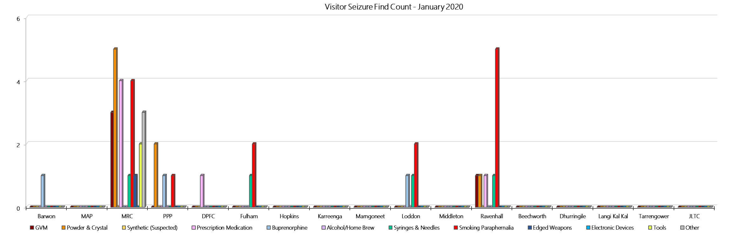

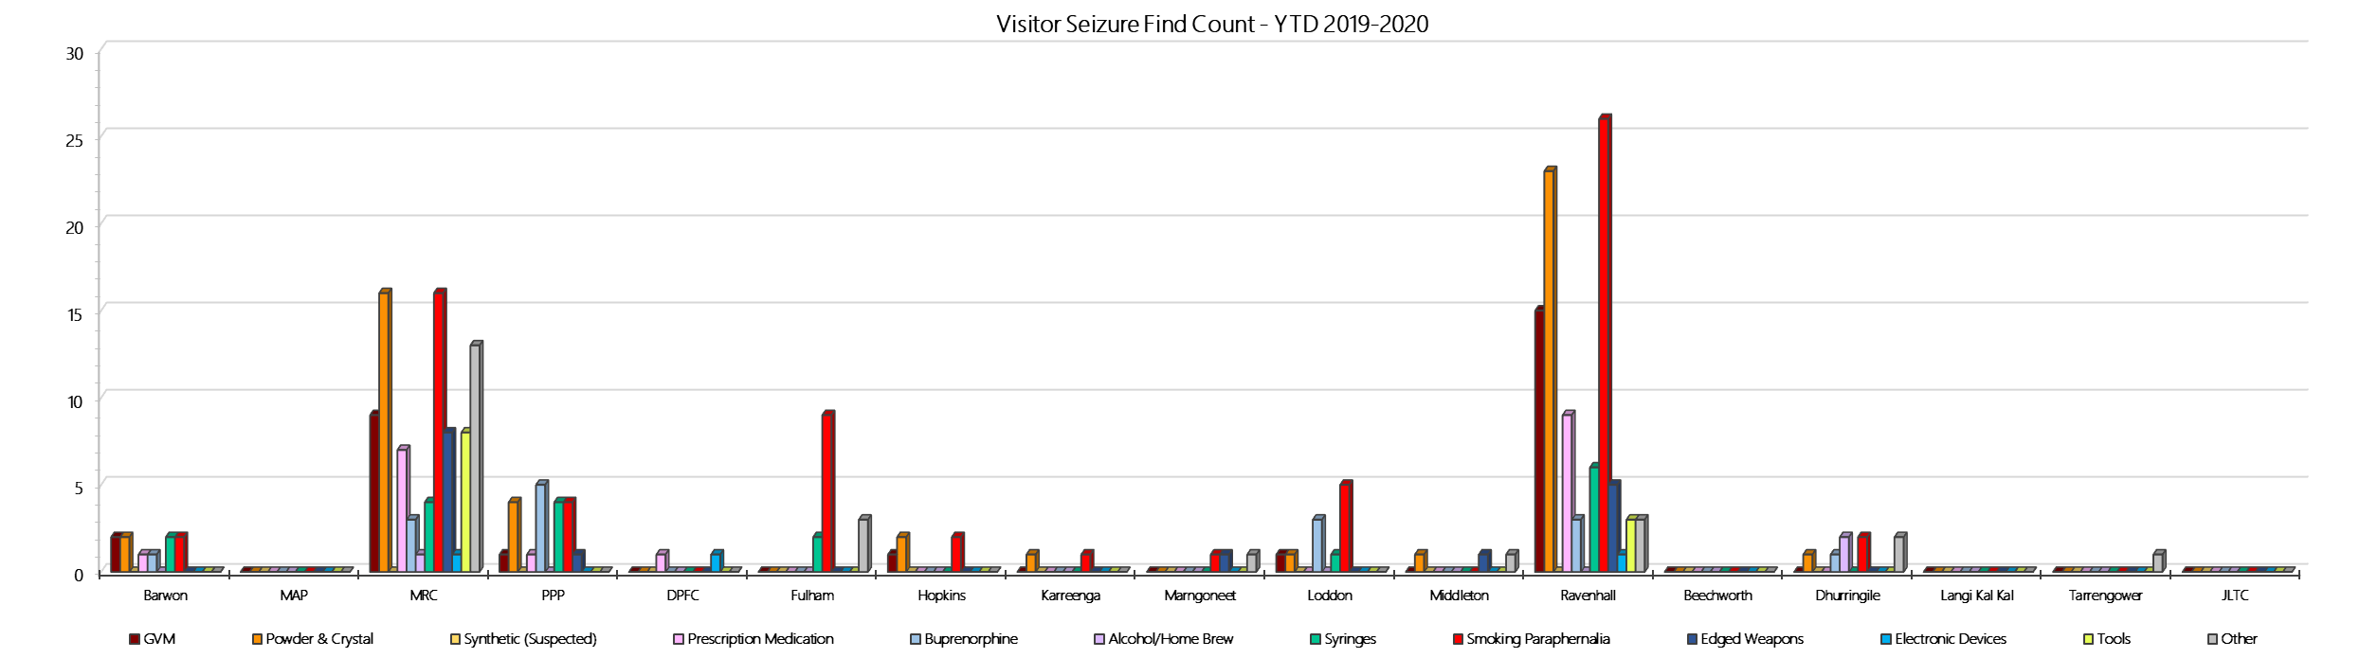

***Seizures of Contraband: Prisoners – January 2020***

|  |  |  |  |  |  |  |  |  |  |  |  |  |  |  |  |  |  |  |  |  |  |  |  |  |
| --- | --- | --- | --- | --- | --- | --- | --- | --- | --- | --- | --- | --- | --- | --- | --- | --- | --- | --- | --- | --- | --- | --- | --- | --- |
| **Prisoners** | **GVM** | | **Powder & Crystal** | | **Synthetic (Suspected)** | | **Prescription Medication** | | **Buprenorphine** | | **Alcohol & Home Brew** | | **Syringes & Needles** | | **Smoking Paraphernalia** | | **Edged Weapons** | | **Electronic Devices** | | **Tools** | | **Other** | |
| **January 20** | **Finds** | **Gms** | **Finds** | **Gms** | **Finds** | **Gms** | **Finds** | **Qty** | **Finds** | **Qty** | **Finds** | **Ltrs** | **Finds** | **Qty** | **Finds** | **Qty** | **Finds** | **Qty** | **Finds** | **Qty** | **Finds** | **Qty** | **Finds** | **Qty** |
| **Barwon** | **0** | **0.00** | **0** | **0.00** | **0** | **0.00** | **3** | **4.50** | **6** | **13.05** | **1** | **4.000** | **3** | **4** | **1** | **1** | **2** | **2** | **0** | **0** | **2** | **4** | **5** | **10** |
| **MAP** | **1** | **1.40** | **0** | **0.00** | **0** | **0.00** | **4** | **39.00** | **4** | **1.80** | **0** | **0.000** | **2** | **2** | **5** | **12** | **3** | **3** | **1** | **2** | **2** | **3** | **3** | **53** |
| **MRC** | **0** | **0.00** | **2** | **2.00** | **0** | **0.00** | **10** | **13.75** | **27** | **33.11** | **3** | **4.000** | **2** | **2** | **7** | **15** | **6** | **6** | **0** | **0** | **2** | **2** | **6** | **6** |
| **PPP** | **0** | **0.00** | **1** | **1.30** | **0** | **0.00** | **12** | **26.00** | **16** | **36.00** | **6** | **11.000** | **4** | **4** | **2** | **3** | **12** | **12** | **0** | **0** | **1** | **1** | **8** | **8** |
| **DPFC** | **0** | **0** | **3** | **35.2** | **0** | **0** | **0** | **0** | **0** | **0** | **0** | **0** | **1** | **1** | **2** | **2** | **0** | **0** | **0** | **0** | **0** | **0** | **4** | **4** |
| **Fulham** | **0** | **0** | **2** | **5.001** | **0** | **0** | **9** | **15** | **10** | **16.4** | **7** | **10.5** | **0** | **0** | **17** | **34** | **3** | **3** | **1** | **1** | **9** | **9** | **5** | **13** |
| **Hopkins** | **0** | **0.00** | **0** | **0.00** | **0** | **0.00** | **3** | **6.00** | **7** | **15.00** | **0** | **0.000** | **2** | **2** | **5** | **31** | **2** | **2** | **1** | **1** | **0** | **0** | **1** | **1** |
| **Karreenga** | **0** | **0.00** | **1** | **2.60** | **0** | **0.00** | **3** | **6.00** | **3** | **4.30** | **0** | **0.000** | **0** | **0** | **1** | **1** | **0** | **0** | **0** | **0** | **0** | **0** | **3** | **52** |
| **Marngoneet** | **0** | **0.00** | **0** | **0.00** | **0** | **0.00** | **3** | **41.00** | **4** | **1.00** | **1** | **0.800** | **1** | **1** | **0** | **0** | **1** | **1** | **0** | **0** | **0** | **0** | **5** | **6** |
| **Loddon** | **0** | **0.00** | **0** | **0.00** | **0** | **0.00** | **0** | **0.00** | **4** | **0.00** | **1** | **2.000** | **0** | **0** | **4** | **13** | **3** | **3** | **0** | **0** | **0** | **0** | **7** | **13** |
| **Middleton** | **0** | **0.00** | **0** | **0.00** | **0** | **0.00** | **0** | **0.00** | **0** | **0.00** | **1** | **1.000** | **0** | **0** | **0** | **0** | **0** | **0** | **0** | **0** | **1** | **1** | **0** | **0** |
| **Ravenhall** | **0** | **0.00** | **3** | **3.56** | **0** | **0.00** | **6** | **45.50** | **16** | **144.00** | **7** | **13.000** | **1** | **1** | **12** | **31** | **9** | **19** | **0** | **0** | **0** | **0** | **1** | **22.5** |
| **Beechworth** | **0** | **0.00** | **0** | **0.00** | **0** | **0.00** | **0** | **0.00** | **0** | **0.00** | **0** | **0.000** | **0** | **0** | **0** | **0** | **0** | **0** | **0** | **0** | **0** | **0** | **0** | **0** |
| **Dhurringile** | **0** | **0.00** | **1** | **2.00** | **0** | **0.00** | **1** | **2.00** | **0** | **0.00** | **0** | **0.000** | **0** | **0** | **3** | **20** | **0** | **0** | **0** | **0** | **0** | **0** | **0** | **0** |
| **Langi Kal Kal** | **0** | **0.00** | **0.00** | **0.00** | **0.00** | **0.00** | **0.00** | **0.00** | **1.00** | **8.00** | **0.00** | **0.00** | **0.00** | **0.00** | **1.00** | **17.00** | **0.00** | **0.00** | **0.00** | **0.00** | **0.00** | **0.00** | **4.00** | **11.00** |
| **Tarrengower** | **0** | **0.00** | **0.00** | **0.00** | **0.00** | **0.00** | **0.00** | **0.00** | **0.00** | **0.00** | **0.00** | **0.00** | **0.00** | **0.00** | **1.00** | **1.00** | **0.00** | **0.00** | **0.00** | **0.00** | **0.00** | **0.00** | **0.00** | **0.00** |
| **JLTC** | **0** | **0.00** | **0** | **0.00** | **0** | **0.00** | **0** | **0.00** | **0** | **0.00** | **0** | **0.000** | **0** | **0** | **0** | **0** | **0** | **0** | **0** | **0** | **0** | **0** | **0** | **0** |
| **Current Month** | **1** | **1.40** | **13** | **51.66** | **0** | **0.00** | **54** | **198.75** | **98** | **272.66** | **27** | **46.300** | **16** | **17** | **61** | **181** | **41** | **51** | **3** | **4** | **17** | **20** | **52** | **199.5** |
| ***Previous Month*** | ***4*** | ***15.38*** | ***9*** | ***18.51*** | ***0*** | ***0.00*** | ***46*** | ***338.60*** | ***71*** | ***328.95*** | ***45*** | ***120.250*** | ***18*** | ***34*** | ***59*** | ***143*** | ***57*** | ***74*** | ***9*** | ***13*** | ***33*** | ***88*** | ***48*** | ***103*** |

***Seizures of Contraband: Prisoners – YTD 2019-2020***

|  |  |  |  |  |  |  |  |  |  |  |  |  |  |  |  |  |  |  |  |  |  |  |  |  |
| --- | --- | --- | --- | --- | --- | --- | --- | --- | --- | --- | --- | --- | --- | --- | --- | --- | --- | --- | --- | --- | --- | --- | --- | --- |
| **Prisoners** | **GVM** | | **Powder & Crystal** | | **Synthetic (Suspected)** | | **Prescription Medication** | | **Buprenorphine** | | **Alcohol & Home Brew** | | **Syringes & Needles** | | **Smoking Paraphernalia** | | **Edged Weapons** | | **Electronic Devices** | | **Tools** | | **Other** | |
| **2019-2020** | **Finds** | **Gms** | **Finds** | **Gms** | **Finds** | **Gms** | **Finds** | **Qty** | **Finds** | **Qty** | **Finds** | **Ltrs** | **Finds** | **Qty** | **Finds** | **Qty** | **Finds** | **Qty** | **Finds** | **Qty** | **Finds** | **Qty** | **Finds** | **Qty** |
| **Barwon** | **1** | **0.10** | **7** | **19.10** | **0** | **0.00** | **29** | **117.75** | **48** | **69.85** | **32** | **96.500** | **11** | **12** | **15** | **35** | **61** | **108** | **2** | **3** | **16** | **36** | **28** | **65** |
| **MAP** | **8** | **38.80** | **5** | **1.27** | **0** | **0.00** | **20** | **113.75** | **24** | **117.60** | **1** | **0.500** | **13** | **16** | **21** | **38** | **7** | **8** | **7** | **8** | **9** | **10** | **17** | **111** |
| **MRC** | **5** | **3.00** | **15** | **38.38** | **1** | **0.50** | **71** | **284.25** | **112** | **137.59** | **26** | **96.500** | **24** | **29** | **61** | **117** | **66** | **78** | **5** | **8** | **47** | **117** | **84** | **108** |
| **PPP** | **0** | **0.00** | **4** | **7.30** | **0** | **0.00** | **47** | **135.00** | **90** | **438.25** | **19** | **43.500** | **20** | **33** | **19** | **29** | **90** | **110** | **3** | **2** | **23** | **44** | **85** | **130** |
| **DPFC** | **2** | **6.00** | **17** | **68.00** | **0** | **0.00** | **14** | **24.75** | **6** | **11.00** | **7** | **17.200** | **18** | **97** | **23** | **66** | **3** | **5** | **3** | **3** | **3** | **3** | **9** | **9** |
| **Fulham** | **1** | **0.20** | **5** | **6.51** | **0** | **0.00** | **56** | **112.25** | **55** | **53.70** | **23** | **30.800** | **8** | **11** | **171** | **407** | **34** | **42** | **12** | **16** | **59** | **130** | **48** | **63** |
| **Hopkins** | **0** | **0.00** | **0** | **0.00** | **0** | **0.00** | **5** | **11.50** | **22** | **33.00** | **0** | **0.000** | **9** | **9** | **25** | **75** | **9** | **9** | **2** | **2** | **3** | **7** | **4** | **4** |
| **Karreenga** | **0** | **0.00** | **3** | **6.50** | **0** | **0.00** | **16** | **73.00** | **13** | **6.90** | **4** | **12.000** | **5** | **5** | **6** | **9** | **7** | **9** | **0** | **0** | **2** | **2** | **15** | **82** |
| **Marngoneet** | **1** | **1.88** | **6** | **24.47** | **0** | **0.00** | **30** | **220.00** | **38** | **219.60** | **24** | **151.050** | **7** | **11** | **10** | **19** | **11** | **14** | **5** | **5** | **5** | **5** | **30** | **47** |
| **Loddon** | **1** | **7.20** | **2** | **5.00** | **0** | **0.00** | **5** | **69.00** | **27** | **180.90** | **12** | **32.000** | **1** | **1** | **21** | **39** | **18** | **20** | **3** | **3** | **2** | **7** | **12** | **37** |
| **Middleton** | **0** | **0.00** | **0** | **0.00** | **0** | **0.00** | **4** | **17.50** | **6** | **4.00** | **3** | **17.000** | **1** | **1** | **13** | **21** | **3** | **3** | **5** | **13** | **1** | **1** | **2** | **4** |
| **Ravenhall** | **1** | **3.76** | **7** | **6.58** | **0** | **0.00** | **61** | **555.25** | **58** | **232.30** | **44** | **87.220** | **13** | **16** | **83** | **435** | **110** | **190** | **4** | **4** | **41** | **139** | **51** | **142** |
| **Beechworth** | **0** | **0.00** | **0** | **0.00** | **0** | **0.00** | **1** | **24.00** | **0** | **0.00** | **0** | **0.000** | **0** | **0** | **3** | **5** | **0** | **0** | **1** | **1** | **1** | **1** | **6** | **10** |
| **Dhurringile** | **3** | **20.80** | **1** | **2.00** | **0** | **0.00** | **2** | **3.00** | **2** | **0.20** | **3** | **4.750** | **4** | **27** | **31** | **75** | **4** | **5** | **0** | **0** | **9** | **14** | **1** | **1** |
| **Langi Kal Kal** | **0** | **0.00** | **0** | **0.00** | **0** | **0.00** | **1** | **2.00** | **1** | **8.00** | **0** | **0.000** | **0** | **0** | **1** | **17** | **3** | **4** | **0** | **0** | **2** | **2** | **6** | **13** |
| **Tarrengower** | **0** | **0.00** | **0** | **0.00** | **0** | **0.00** | **2** | **5.00** | **0** | **0.00** | **0** | **0.000** | **0** | **0** | **2** | **2** | **0** | **0** | **0** | **0** | **0** | **0** | **2** | **1** |
| **JLTC** | **0** | **0.00** | **0** | **0.00** | **0** | **0.00** | **2** | **24.00** | **1** | **2.00** | **0** | **0.000** | **0** | **0** | **3** | **7** | **0** | **0** | **0** | **0** | **1** | **2** | **2** | **2** |
| **YTD: January 20** | **23** | **81.74** | **72** | **185.11** | **1** | **0.50** | **366** | **1792.00** | **503** | **1514.89** | **198** | **589.020** | **134** | **268** | **508** | **1,396** | **426** | **605** | **52** | **68** | **224** | **520** | **402** | **829** |
| ***YTD: January 20*** | ***33*** | ***179.03*** | ***98*** | ***357.85*** | ***6*** | ***27.60*** | ***556*** | ***2365.75*** | ***379*** | ***1013.15*** | ***168*** | ***477.970*** | ***171*** | ***232*** | ***677*** | ***1,964*** | ***402*** | ***548*** | ***78*** | ***142*** | ***353*** | ***648*** | ***510*** | ***1,028*** |

### **Graphs of Seizures of Contraband: Prisoners – January 2020 & YTD 2019-2020**

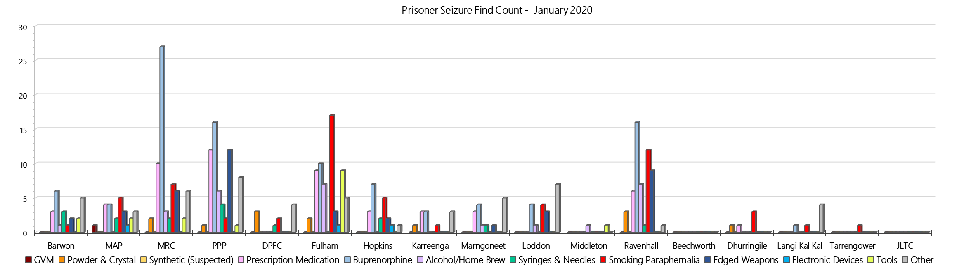

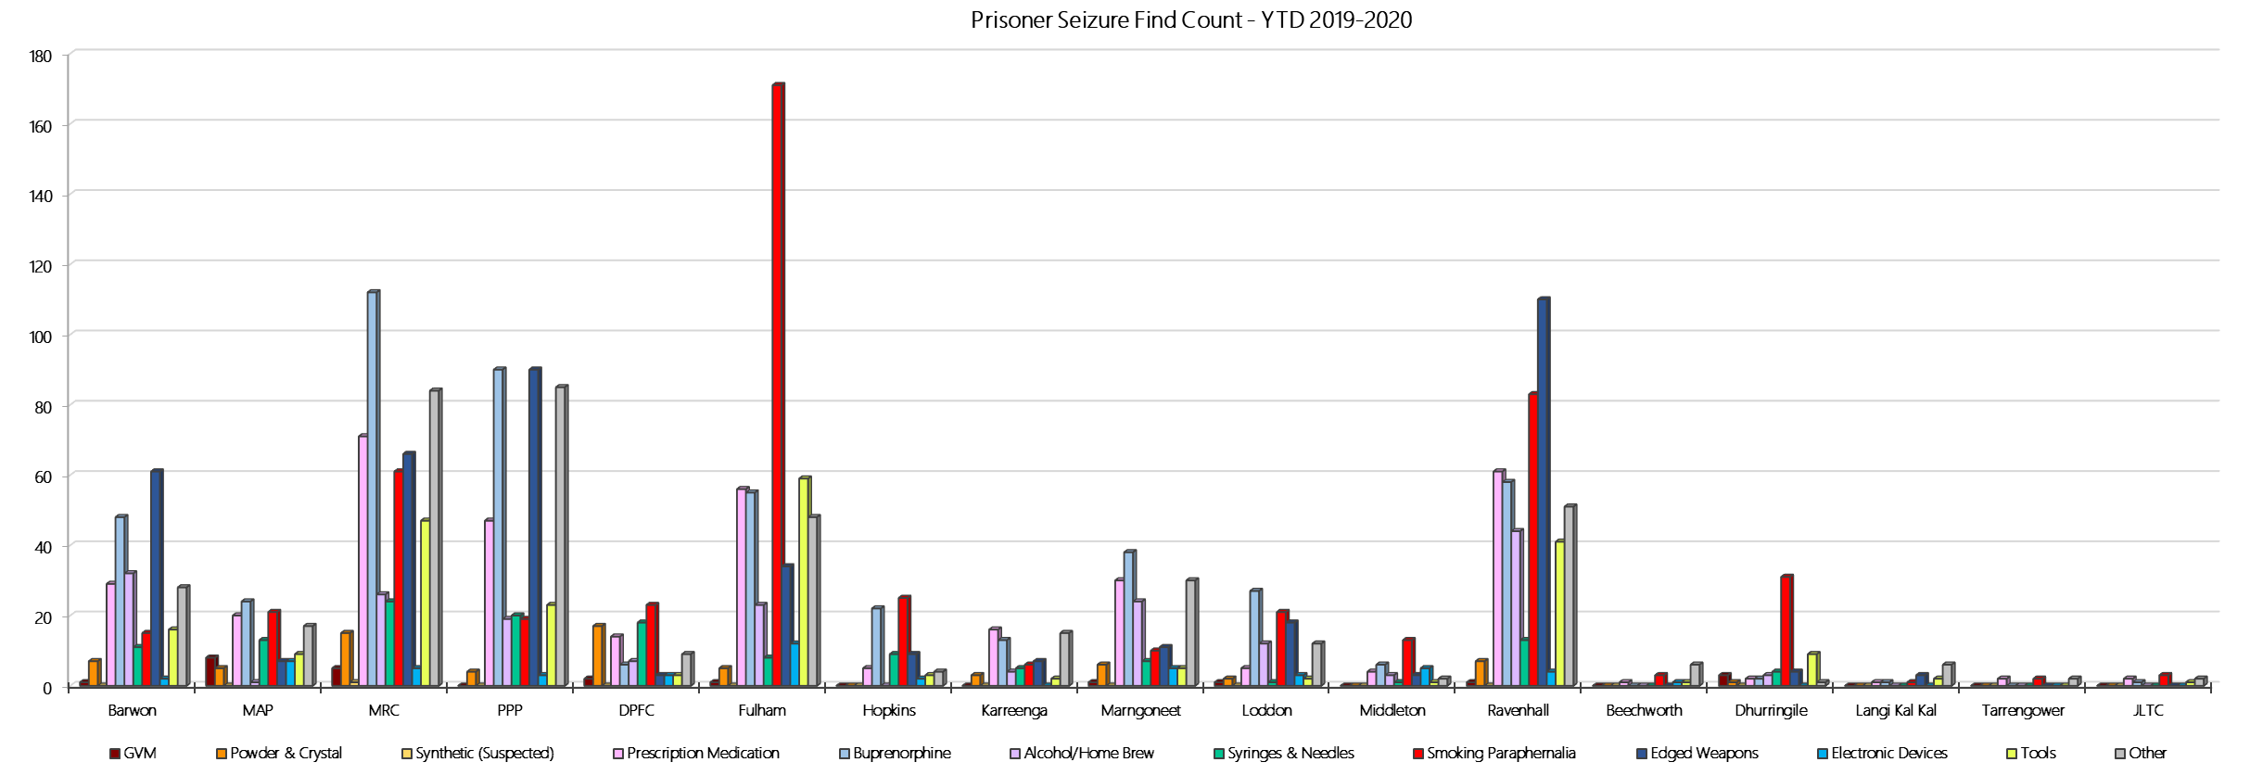

## **LOCATION SPECIFIC RESULTS**

### **Barwon Prison**

***Targeted and Random General Drug Test Results: 2019-2020***

|  |  |  |  |  |  |  |  |  |  |  |  |  |  |  |
| --- | --- | --- | --- | --- | --- | --- | --- | --- | --- | --- | --- | --- | --- | --- |
| **Barwon** | **Jul-19** | **Aug-19** | **Sep-19** | **Oct-19** | **Nov-19** | **Dec-19** | **Jan-20** | **Feb-20** | **Mar-20** | **Apr-20** | **May-20** | **Jun-20** | **Average** | ***Totals*** |
| **Effective Sample - Targeted** | **149** | **163** | **106** | **131** | **103** | **70** | **125** |  |  |  |  |  | **121** | ***847*** |
| **Targeted Positives** | **19** | **18** | **15** | **18** | **8** | **6** | **13** |  |  |  |  |  | **14** | ***97*** |
| **Refusal** | **0** | **4** | **2** | **2** | **7** | **8** | **4** |  |  |  |  |  | **4** | ***27*** |
| **Unable** | **2** | **2** | **0** | **1** | **0** | **0** | **2** |  |  |  |  |  | **1** | ***7*** |
| **Interfered** | **0** | **0** | **0** | **0** | **0** | **2** | **0** |  |  |  |  |  | **0** | ***2*** |
| **Adulterated** | **1** | **0** | **0** | **2** | **0** | **0** | **0** |  |  |  |  |  | **0** | ***3*** |
| **Targeted % Tested Positive** | **14.77%** | **14.72%** | **16.04%** | **17.56%** | **14.56%** | **22.86%** | **15.20%** | **#N/A** | **#N/A** | **#N/A** | **#N/A** | **#N/A** | **16.06%** | ***16.06%*** |
| **Awaiting / Pending Results** | **0** | **0** | **0** | **0** | **0** | **0** | **2** |  |  |  |  |  | **0** | ***2*** |
| **Targeted Residual** | **1** | **1** | **0** | **0** | **0** | **0** | **0** |  |  |  |  |  | **0** | ***2*** |
| **Random tests collected** | **54** | **45** | **59** | **48** | **48** | **58** | **48** |  |  |  |  |  | **51** | ***360*** |
| **Tested Positive** | **3** | **2** | **4** | **6** | **2** | **6** | **1** |  |  |  |  |  | **3** | ***24*** |
| **Refusal (guilty)** | **4** | **1** | **0** | **0** | **0** | **1** | **1** |  |  |  |  |  | **1** | ***7*** |
| **Unable (not guilty)** | **0** | **0** | **0** | **0** | **0** | **0** | **0** |  |  |  |  |  | **0** | ***0*** |
| **Unable (guilty)** | **0** | **0** | **1** | **0** | **0** | **2** | **1** |  |  |  |  |  | **1** | ***4*** |
| **Interfered (guilty)** | **0** | **0** | **0** | **0** | **0** | **0** | **0** |  |  |  |  |  | **0** | ***0*** |
| **No test (valid reason)** | **2** | **2** | **1** | **3** | **0** | **1** | **1** |  |  |  |  |  | **1** | ***10*** |
| **No test (no valid reason)** | **1** | **0** | **0** | **0** | **0** | **0** | **0** |  |  |  |  |  | **0** | ***1*** |
| **Adulterated** | **0** | **1** | **0** | **1** | **0** | **0** | **0** |  |  |  |  |  | **0** | ***2*** |
| **Awaiting / Pending Results** | **0** | **0** | **0** | **0** | **0** | **0** | **0** |  |  |  |  |  | **0** | ***0*** |
| **Random Residual *(PIMS URAR030)*** | **0** | **0** | **0** | **1** | **0** | **0** | **0** |  |  |  |  |  | ***0.142857*** | ***1*** |
| **Effective Sample - Random General** | **59** | **46** | **60** | **48** | **48** | **61** | **50** |  |  |  |  |  | **53** | **372** |
| **% Tested positive** | **5.08%** | **4.35%** | **6.67%** | **12.50%** | **4.17%** | **9.84%** | **2.00%** |  |  |  |  |  | **6.37%** |  |
| **% Prisoner guilty, positive equivalents** | **6.78%** | **4.35%** | **1.67%** | **2.08%** | **0.00%** | **4.92%** | **4.00%** |  |  |  |  |  | **3.40%** |  |
| **% Total prisoner fails** | **11.86%** | **6.52%** | **8.33%** | **12.50%** | **4.17%** | **14.75%** | **6.00%** |  |  |  |  |  | **9.16%** |  |
| **% No test without valid reason** | **1.69%** | **0.00%** | **0.00%** | **0.00%** | **0.00%** | **0.00%** | **0.00%** |  |  |  |  |  | **0.24%** |  |
| ***Random General Benchmark 8.00%*** | ***8.00%*** | ***8.00%*** | ***8.00%*** | ***8.00%*** | ***8.00%*** | ***8.00%*** | ***8.00%*** | ***8.00%*** | ***8.00%*** | ***8.00%*** | ***8.00%*** | ***8.00%*** | ***YTD*** |  |
| **% Failures for SDO** | **13.56%** | **8.70%** | **8.33%** | **14.58%** | **4.17%** | **14.75%** | **6.00%** | **#N/A** | **#N/A** | **#N/A** | **#N/A** | **#N/A** | **10.22%** |  |

***Barwon - Drugs Identified Through Testing by Drug Type: 2019-2020***

|  |  |  |  |  |  |  |  |  |  |  |  |  |  |  |
| --- | --- | --- | --- | --- | --- | --- | --- | --- | --- | --- | --- | --- | --- | --- |
| **Barwon** | ***Amphetamines*** | ***Methamphetamines*** | ***Cocaine*** | ***Opiates*** | ***Benzodiazepines*** | ***Cannabinoids*** | ***Ethanol\*\**** | ***Methadone*** | ***ADP\**** | ***APS\**** | ***Steroids\*\**** | ***Buprenorphine*** | ***NOA\**** | **Total** |
| **Jul-19** | **0** | **0** | **0** | **0** | **0** | **0** | **0** | **0** | **0** | **0** | **0** | **29** | **0** | **29** |
| **Aug-19** | **0** | **0** | **0** | **0** | **0** | **0** | **0** | **0** | **4** | **1** | **0** | **20** | **0** | **25** |
| **Sep-19** | **2** | **3** | **0** | **0** | **0** | **0** | **0** | **0** | **0** | **0** | **0** | **22** | **0** | **27** |
| **Oct-19** | **1** | **1** | **0** | **0** | **1** | **1** | **0** | **0** | **0** | **1** | **0** | **32** | **0** | **37** |
| **Nov-19** | **0** | **0** | **0** | **0** | **0** | **0** | **0** | **0** | **0** | **0** | **0** | **10** | **0** | **10** |
| **Dec-19** | **0** | **0** | **0** | **0** | **0** | **0** | **0** | **2** | **0** | **0** | **0** | **19** | **0** | **21** |
| **Jan-20** | **0** | **0** | **0** | **1** | **0** | **0** | **0** | **2** | **0** | **0** | **0** | **22** | **0** | **25** |
| **Feb-20** |  |  |  |  |  |  |  |  |  |  |  |  |  |  |
| **Mar-20** |  |  |  |  |  |  |  |  |  |  |  |  |  |  |
| **Apr-20** |  |  |  |  |  |  |  |  |  |  |  |  |  |  |
| **May-20** |  |  |  |  |  |  |  |  |  |  |  |  |  |  |
| **Jun-20** |  |  |  |  |  |  |  |  |  |  |  |  |  |  |
| **YTD** | **3** | **4** | **0** | **1** | **1** | **1** | **0** | **4** | **4** | **2** | **0** | **154** | **0** | **174** |
| ***All Prisons YTD*** | ***111*** | ***184*** | ***2*** | ***31*** | ***26*** | ***21*** | ***18*** | ***25*** | ***33*** | ***12*** | ***0*** | ***1397*** | ***0*** | ***1860*** |
| ***Barwon % of Total*** | ***2.70%*** | ***2.17%*** | ***0.00%*** | ***3.23%*** | ***3.85%*** | ***4.76%*** | ***0.00%*** | ***16.00%*** | ***12.12%*** | ***16.67%*** | ***0.00%*** | ***11.02%*** | ***0.00%*** | ***9.35%*** |

***Barwon Seizures of Contraband: Visitors & Prisoners: 2019-2020***

|  |  |  |  |  |  |  |  |  |  |  |  |  |  |  |  |  |  |  |  |  |  |  |  |  |
| --- | --- | --- | --- | --- | --- | --- | --- | --- | --- | --- | --- | --- | --- | --- | --- | --- | --- | --- | --- | --- | --- | --- | --- | --- |
| **Visitors** | **GVM** | | **Powder & Crystal** | | **Synthetic (Suspected)** | | **Prescription Medication** | | **Buprenorphine** | | **Alcohol/Home Brew** | | **Syringes & Needles** | | **Smoking Paraphernalia** | | **Edged Weapons** | | **Electronic Devices** | | **Tools** | | **Other** | |
| **Barwon** | **Finds** | **Gms** | **Finds** | **Gms** | **Finds** | **Gms** | **Finds** | **Qty** | **Finds** | **Qty** | **Finds** | **Ltrs** | **Finds** | **Qty** | **Finds** | **Qty** | **Finds** | **Qty** | **Finds** | **Qty** | **Finds** | **Qty** | **Finds** | **Qty** |
| **Jul-19** | **0** | **0.00** | **0** | **0.00** | **0** | **0.00** | **0** | **0.00** | **0** | **0.00** | **0** | **0.000** | **0** | **0** | **0** | **0** | **0** | **0** | **0** | **0** | **0** | **0** | **0** | **0** |
| **Aug-19** | **1** | **16.50** | **0** | **0.00** | **0** | **0.00** | **0** | **0.00** | **0** | **0.00** | **0** | **0.000** | **0** | **0** | **0** | **0** | **0** | **0** | **0** | **0** | **0** | **0** | **0** | **0** |
| **Sep-19** | **0** | **0.00** | **1** | **3.00** | **0** | **0.00** | **1** | **3.00** | **0** | **0.00** | **0** | **0.000** | **0** | **0** | **1** | **1** | **0** | **0** | **0** | **0** | **0** | **0** | **0** | **0** |
| **Oct-19** | **0** | **0.00** | **0** | **0.00** | **0** | **0.00** | **0** | **0.00** | **0** | **0.00** | **0** | **0.000** | **0** | **0** | **0** | **0** | **0** | **0** | **0** | **0** | **0** | **0** | **0** | **0** |
| **Nov-19** | **1** | **0.90** | **1** | **0.10** | **0** | **0.00** | **0** | **0.00** | **0** | **0.00** | **0** | **0.000** | **2** | **4** | **1** | **2** | **0** | **0** | **0** | **0** | **0** | **0** | **0** | **0** |
| **Dec-19** | **0** | **0.00** | **0** | **0.00** | **0** | **0.00** | **0** | **0.00** | **0** | **0.00** | **0** | **0.000** | **0** | **0** | **0** | **0** | **0** | **0** | **0** | **0** | **0** | **0** | **0** | **0** |
| **Jan-20** | **0** | **0.00** | **0** | **0.00** | **0** | **0.00** | **0** | **0.00** | **1** | **53.00** | **0** | **0.000** | **0** | **0** | **0** | **0** | **0** | **0** | **0** | **0** | **0** | **0** | **0** | **0** |
| **Feb-20** |  |  |  |  |  |  |  |  |  |  |  |  |  |  |  |  |  |  |  |  |  |  |  |  |
| **Mar-20** |  |  |  |  |  |  |  |  |  |  |  |  |  |  |  |  |  |  |  |  |  |  |  |  |
| **Apr-20** |  |  |  |  |  |  |  |  |  |  |  |  |  |  |  |  |  |  |  |  |  |  |  |  |
| **May-20** |  |  |  |  |  |  |  |  |  |  |  |  |  |  |  |  |  |  |  |  |  |  |  |  |
| **Jun-20** |  |  |  |  |  |  |  |  |  |  |  |  |  |  |  |  |  |  |  |  |  |  |  |  |
| **Total** | **2** | **17.40** | **2** | **3.10** | **0** | **0.00** | **1** | **3.00** | **1** | **53.00** | **0** | **0.000** | **2** | **4** | **2** | **3** | **0** | **0** | **0** | **0** | **0** | **0** | **0** | **0** |

|  |  |  |  |  |  |  |  |  |  |  |  |  |  |  |  |  |  |  |  |  |  |  |  |  |
| --- | --- | --- | --- | --- | --- | --- | --- | --- | --- | --- | --- | --- | --- | --- | --- | --- | --- | --- | --- | --- | --- | --- | --- | --- |
| **Prisoners** | **GVM** | | **Powder  & Crystal** | | **Synthetic  (Suspected)** | | **Prescription  Medication** | | **Buprenorphine** | | **Alcohol &  Home Brew** | | **Syringes & Needles** | | **Smoking  Paraphernalia** | | **Edged  Weapons** | | **Electronic  Devices** | | **Tools** | | **Other** | |
| **Barwon** | **Finds** | **Gms** | **Finds** | **Gms** | **Finds** | **Gms** | **Finds** | **Qty** | **Finds** | **Qty** | **Finds** | **Ltrs** | **Finds** | **Qty** | **Finds** | **Qty** | **Finds** | **Qty** | **Finds** | **Qty** | **Finds** | **Qty** | **Finds** | **Qty** |
| **Jul-19** | **0** | **0.00** | **1** | **11.80** | **0** | **0.00** | **2** | **7.50** | **5** | **12.90** | **0** | **0.000** | **1** | **1** | **0** | **0** | **11** | **13** | **0** | **0** | **2** | **4** | **3** | **4** |
| **Aug-19** | **0** | **0.00** | **1** | **1.40** | **0** | **0.00** | **6** | **31.25** | **11** | **10.90** | **13** | **35.250** | **2** | **2** | **1** | **3** | **6** | **11** | **0** | **0** | **2** | **3** | **1** | **1** |
| **Sep-19** | **0** | **0.00** | **0** | **0.00** | **0** | **0.00** | **2** | **2.90** | **8** | **15.00** | **4** | **22.000** | **0** | **0** | **1** | **1** | **12** | **27** | **1** | **1** | **3** | **4** | **6** | **9** |
| **Oct-19** | **0** | **0.00** | **3** | **0.60** | **0** | **0.00** | **6** | **31.00** | **8** | **9.00** | **2** | **5.000** | **1** | **1** | **7** | **10** | **13** | **24** | **1** | **2** | **2** | **4** | **4** | **25** |
| **Nov-19** | **0** | **0.00** | **2** | **5.30** | **0** | **0.00** | **4** | **26.50** | **4** | **4.50** | **6** | **12.500** | **1** | **1** | **3** | **18** | **6** | **13** | **0** | **0** | **2** | **2** | **5** | **7** |
| **Dec-19** | **1** | **0.10** | **0** | **0.00** | **0** | **0.00** | **6** | **14.10** | **6** | **4.50** | **6** | **17.750** | **3** | **3** | **2** | **2** | **11** | **18** | **0** | **0** | **3** | **15** | **4** | **9** |
| **Jan-20** | **0** | **0.00** | **0** | **0.00** | **0** | **0.00** | **3** | **4.50** | **6** | **13.05** | **1** | **4.000** | **3** | **4** | **1** | **1** | **2** | **2** | **0** | **0** | **2** | **4** | **5** | **10** |
| **Feb-20** |  |  |  |  |  |  |  |  |  |  |  |  |  |  |  |  |  |  |  |  |  |  |  |  |
| **Mar-20** |  |  |  |  |  |  |  |  |  |  |  |  |  |  |  |  |  |  |  |  |  |  |  |  |
| **Apr-20** |  |  |  |  |  |  |  |  |  |  |  |  |  |  |  |  |  |  |  |  |  |  |  |  |
| **May-20** |  |  |  |  |  |  |  |  |  |  |  |  |  |  |  |  |  |  |  |  |  |  |  |  |
| **Jun-20** |  |  |  |  |  |  |  |  |  |  |  |  |  |  |  |  |  |  |  |  |  |  |  |  |
| **Total** | **1** | **0.10** | **7** | **19.10** | **0** | **0.00** | **29** | **117.75** | **48** | **69.85** | **32** | **96.500** | **11** | **12** | **15** | **35** | **61** | **108** | **2** | **3** | **16** | **36** | **28** | **65** |

***Barwon Targeted and Random General Drug Test Positives & Equivalents: 2019-2020***

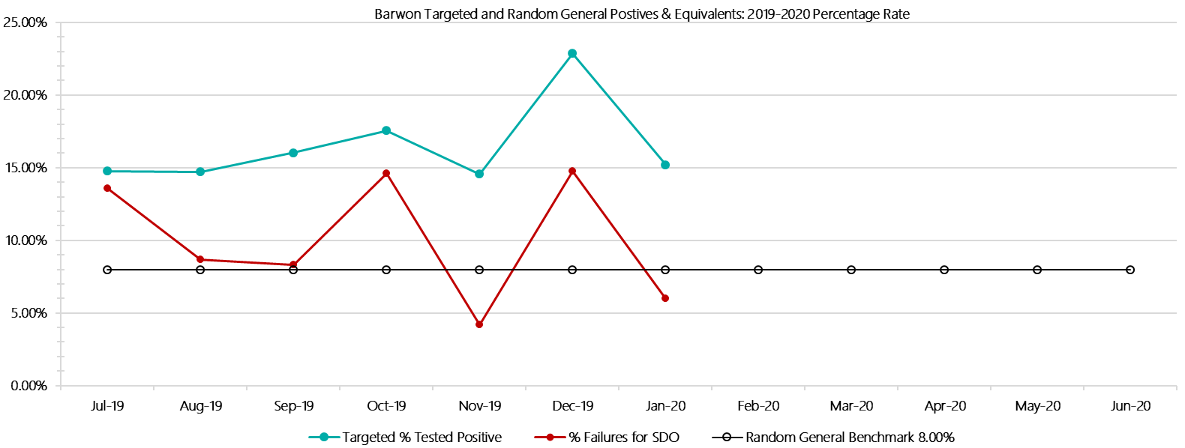

***Barwon Positive Drug Test Results by Drug Type: 2019-2020***

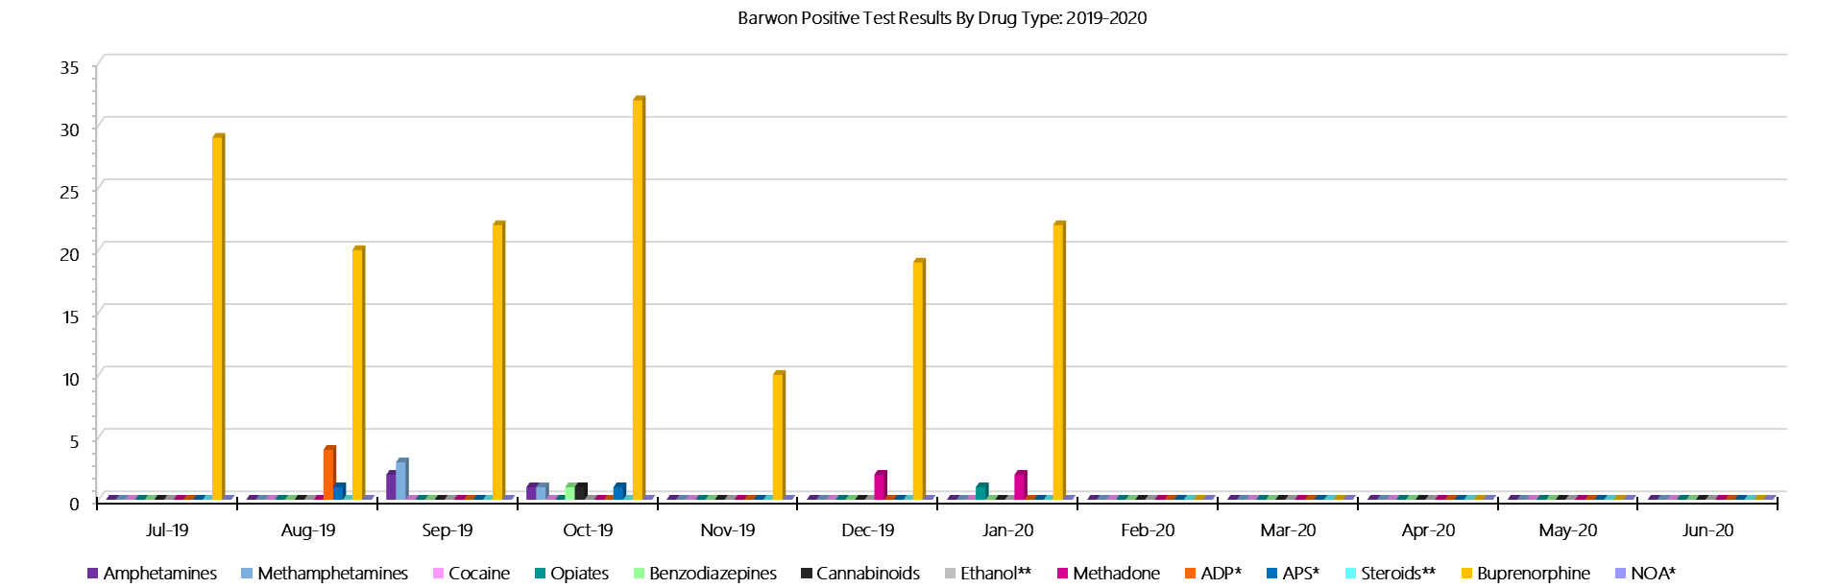

***Barwon Count of Visitor Seizures Finds: 2019-2020***

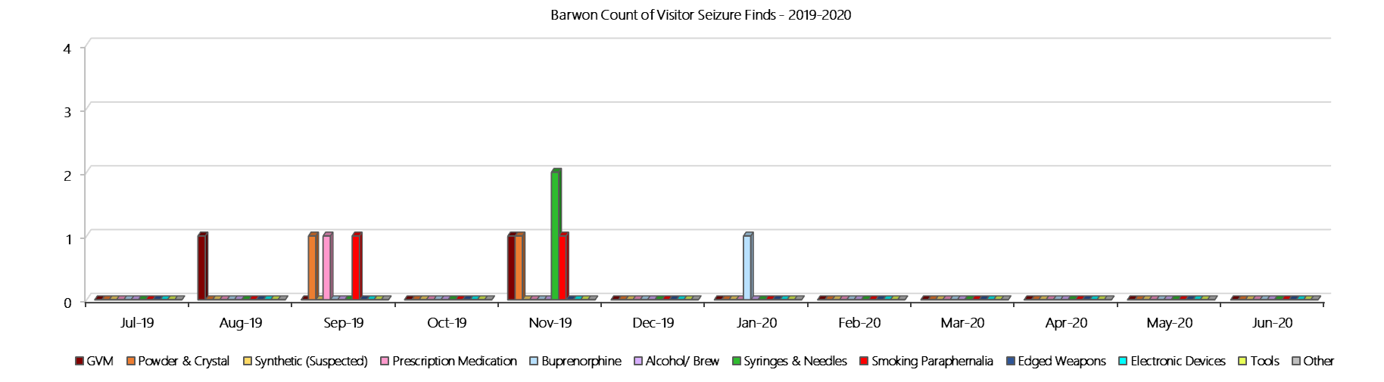

***Barwon Count of Prisoner Seizure Finds: 2019-2020***

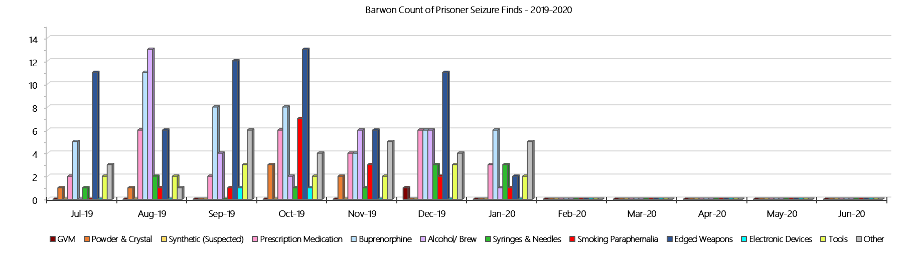

### **Melbourne Assessment Prison**

***Targeted and Random General Drug Test Results: 2019-2020***

|  |  |  |  |  |  |  |  |  |  |  |  |  |  |  |
| --- | --- | --- | --- | --- | --- | --- | --- | --- | --- | --- | --- | --- | --- | --- |
| **MAP** | **Jul-19** | **Aug-19** | **Sep-19** | **Oct-19** | **Nov-19** | **Dec-19** | **Jan-20** | **Feb-20** | **Mar-20** | **Apr-20** | **May-20** | **Jun-20** | **Average** | ***Totals*** |
| **Effective Sample - Targeted** | **85** | **90** | **63** | **74** | **71** | **57** | **68** |  |  |  |  |  | **73** | ***508*** |
| **Targeted Positives** | **3** | **4** | **2** | **4** | **2** | **7** | **3** |  |  |  |  |  | **4** | ***25*** |
| **Refusal** | **2** | **1** | **2** | **1** | **0** | **3** | **0** |  |  |  |  |  | **1** | ***9*** |
| **Unable** | **1** | **2** | **0** | **1** | **2** | **4** | **0** |  |  |  |  |  | **1** | ***10*** |
| **Interfered** | **0** | **0** | **0** | **0** | **0** | **0** | **0** |  |  |  |  |  | **0** | ***0*** |
| **Adulterated** | **0** | **0** | **0** | **1** | **0** | **0** | **0** |  |  |  |  |  | **0** | ***1*** |
| **Targeted % Tested Positive** | **7.06%** | **7.78%** | **6.35%** | **9.46%** | **5.63%** | **24.56%** | **4.41%** | **#N/A** | **#N/A** | **#N/A** | **#N/A** | **#N/A** | **8.86%** | ***8.86%*** |
| **Awaiting / Pending Results** | **0** | **0** | **0** | **0** | **0** | **0** | **0** |  |  |  |  |  | **0** | ***0*** |
| **Targeted Residual** | **0** | **0** | **0** | **0** | **0** | **0** | **0** |  |  |  |  |  | **0** | ***0*** |
| **Random tests collected** | **29** | **18** | **31** | **20** | **24** | **31** | **25** |  |  |  |  |  | **25** | ***178*** |
| **Tested Positive** | **0** | **0** | **1** | **1** | **0** | **0** | **0** |  |  |  |  |  | **0** | ***2*** |
| **Refusal (guilty)** | **0** | **1** | **1** | **1** | **0** | **1** | **0** |  |  |  |  |  | **1** | ***4*** |
| **Unable (not guilty)** | **0** | **0** | **0** | **0** | **0** | **0** | **0** |  |  |  |  |  | **0** | ***0*** |
| **Unable (guilty)** | **1** | **0** | **0** | **0** | **0** | **1** | **0** |  |  |  |  |  | **0** | ***2*** |
| **Interfered (guilty)** | **0** | **0** | **0** | **0** | **0** | **0** | **0** |  |  |  |  |  | **0** | ***0*** |
| **No test (valid reason)** | **5** | **9** | **4** | **7** | **8** | **9** | **5** |  |  |  |  |  | **7** | ***47*** |
| **No test (no valid reason)** | **0** | **0** | **0** | **0** | **0** | **0** | **0** |  |  |  |  |  | **0** | ***0*** |
| **Adulterated** | **0** | **0** | **0** | **0** | **0** | **0** | **0** |  |  |  |  |  | **0** | ***0*** |
| **Awaiting / Pending Results** | **0** | **0** | **0** | **0** | **0** | **0** | **0** |  |  |  |  |  | **0** | ***0*** |
| **Random Residual *(PIMS URAR030)*** | **0** | **0** | **1** | **0** | **0** | **0** | **0** |  |  |  |  |  | ***0.142857*** | ***1*** |
| **Effective Sample - Random General** | **30** | **19** | **32** | **21** | **24** | **33** | **25** |  |  |  |  |  | **26** | **184** |
| **% Tested positive** | **0.00%** | **0.00%** | **3.13%** | **4.76%** | **0.00%** | **0.00%** | **0.00%** |  |  |  |  |  | **1.13%** |  |
| **% Prisoner guilty, positive equivalents** | **3.33%** | **5.26%** | **3.13%** | **4.76%** | **0.00%** | **6.06%** | **0.00%** |  |  |  |  |  | **3.22%** |  |
| **% Total prisoner fails** | **3.33%** | **5.26%** | **6.25%** | **9.52%** | **0.00%** | **6.06%** | **0.00%** |  |  |  |  |  | **4.35%** |  |
| **% No test without valid reason** | **0.00%** | **0.00%** | **0.00%** | **0.00%** | **0.00%** | **0.00%** | **0.00%** |  |  |  |  |  | **0.00%** |  |
| ***Random General Benchmark 8.00%*** | ***8.00%*** | ***8.00%*** | ***8.00%*** | ***8.00%*** | ***8.00%*** | ***8.00%*** | ***8.00%*** | ***8.00%*** | ***8.00%*** | ***8.00%*** | ***8.00%*** | ***8.00%*** | ***YTD*** |  |
| **% Failures for SDO** | **3.33%** | **5.26%** | **6.25%** | **9.52%** | **0.00%** | **6.06%** | **0.00%** | **#N/A** | **#N/A** | **#N/A** | **#N/A** | **#N/A** | **4.35%** |  |

***Melbourne Assessment Prison - Drugs Identified Through Testing by Drug Type: 2019-2020***

|  |  |  |  |  |  |  |  |  |  |  |  |  |  |  |
| --- | --- | --- | --- | --- | --- | --- | --- | --- | --- | --- | --- | --- | --- | --- |
| **MAP** | ***Amphetamines*** | ***Methamphetamines*** | ***Cocaine*** | ***Opiates*** | ***Benzodiazepines*** | ***Cannabinoids*** | ***Ethanol\*\**** | ***Methadone*** | ***ADP\**** | ***APS\**** | ***Steroids\*\**** | ***Buprenorphine*** | ***NOA\**** | **Total** |
| **Jul-19** | **1** | **1** | **0** | **0** | **0** | **0** | **0** | **0** | **0** | **0** | **0** | **2** | **0** | **4** |
| **Aug-19** | **1** | **2** | **0** | **2** | **0** | **0** | **0** | **0** | **0** | **0** | **0** | **0** | **0** | **5** |
| **Sep-19** | **0** | **0** | **0** | **0** | **1** | **0** | **0** | **0** | **0** | **0** | **0** | **2** | **0** | **3** |
| **Oct-19** | **0** | **0** | **0** | **0** | **1** | **0** | **0** | **0** | **0** | **0** | **0** | **4** | **0** | **5** |
| **Nov-19** | **1** | **1** | **0** | **0** | **0** | **0** | **0** | **0** | **0** | **0** | **0** | **3** | **0** | **5** |
| **Dec-19** | **1** | **2** | **0** | **0** | **3** | **1** | **0** | **0** | **0** | **0** | **0** | **3** | **0** | **10** |
| **Jan-20** | **0** | **1** | **0** | **0** | **0** | **0** | **0** | **0** | **0** | **0** | **0** | **2** | **0** | **3** |
| **Feb-20** |  |  |  |  |  |  |  |  |  |  |  |  |  |  |
| **Mar-20** |  |  |  |  |  |  |  |  |  |  |  |  |  |  |
| **Apr-20** |  |  |  |  |  |  |  |  |  |  |  |  |  |  |
| **May-20** |  |  |  |  |  |  |  |  |  |  |  |  |  |  |
| **Jun-20** |  |  |  |  |  |  |  |  |  |  |  |  |  |  |
| **MAP YTD** | **4** | **7** | **0** | **2** | **5** | **1** | **0** | **0** | **0** | **0** | **0** | **16** | **0** | **35** |
| ***All Prisons YTD*** | ***111*** | ***184*** | ***2*** | ***31*** | ***26*** | ***21*** | ***18*** | ***25*** | ***33*** | ***12*** | ***0*** | ***1397*** | ***0*** | ***1860*** |
| ***MAP % of Total*** | ***3.60%*** | ***3.80%*** | ***0.00%*** | ***6.45%*** | ***19.23%*** | ***4.76%*** | ***0.00%*** | ***0.00%*** | ***0.00%*** | ***0.00%*** | ***0.00%*** | ***1.15%*** | ***0.00%*** | ***1.88%*** |

***Melbourne Assessment Prison Seizures of Contraband: Visitors & Prisoners: 2019-2020***

|  |  |  |  |  |  |  |  |  |  |  |  |  |  |  |  |  |  |  |  |  |  |  |  |  |
| --- | --- | --- | --- | --- | --- | --- | --- | --- | --- | --- | --- | --- | --- | --- | --- | --- | --- | --- | --- | --- | --- | --- | --- | --- |
| **Visitors** | **GVM** | | **Powder  & Crystal** | | **Synthetic  (Suspected)** | | **Prescription  Medication** | | **Buprenorphine** | | **Alcohol &  Home Brew** | | **Syringes & Needles** | | **Smoking  Paraphernalia** | | **Edged  Weapons** | | **Electronic  Devices** | | **Tools** | | **Other** | |
| **MAP** | **Finds** | **Gms** | **Finds** | **Gms** | **Finds** | **Gms** | **Finds** | **Qty** | **Finds** | **Qty** | **Finds** | **Ltrs** | **Finds** | **Qty** | **Finds** | **Qty** | **Finds** | **Qty** | **Finds** | **Qty** | **Finds** | **Qty** | **Finds** | **Qty** |
| **Jul-19** | **0** | **0.00** | **0** | **0.00** | **0** | **0.00** | **0** | **0.00** | **0** | **0.00** | **0** | **0.000** | **0** | **0** | **0** | **0** | **0** | **0** | **0** | **0** | **0** | **0** | **0** | **0** |
| **Aug-19** | **0** | **0.00** | **0** | **0.00** | **0** | **0.00** | **0** | **0.00** | **0** | **0.00** | **0** | **0.000** | **0** | **0** | **0** | **0** | **0** | **0** | **0** | **0** | **0** | **0** | **0** | **0** |
| **Sep-19** | **0** | **0.00** | **0** | **0.00** | **0** | **0.00** | **0** | **0.00** | **0** | **0.00** | **0** | **0.000** | **0** | **0** | **0** | **0** | **0** | **0** | **0** | **0** | **0** | **0** | **0** | **0** |
| **Oct-19** | **0** | **0.00** | **0** | **0.00** | **0** | **0.00** | **0** | **0.00** | **0** | **0.00** | **0** | **0.000** | **0** | **0** | **0** | **0** | **0** | **0** | **0** | **0** | **0** | **0** | **0** | **0** |
| **Nov-19** | **0** | **0.00** | **0** | **0.00** | **0** | **0.00** | **0** | **0.00** | **0** | **0.00** | **0** | **0.000** | **0** | **0** | **0** | **0** | **0** | **0** | **0** | **0** | **0** | **0** | **0** | **0** |
| **Dec-19** | **0** | **0.00** | **0** | **0.00** | **0** | **0.00** | **0** | **0.00** | **0** | **0.00** | **0** | **0.000** | **0** | **0** | **0** | **0** | **0** | **0** | **0** | **0** | **0** | **0** | **0** | **0** |
| **Jan-20** | **0** | **0.00** | **0** | **0.00** | **0** | **0.00** | **0** | **0.00** | **0** | **0.00** | **0** | **0.000** | **0** | **0** | **0** | **0** | **0** | **0** | **0** | **0** | **0** | **0** | **0** | **0** |
| **Feb-20** |  |  |  |  |  |  |  |  |  |  |  |  |  |  |  |  |  |  |  |  |  |  |  |  |
| **Mar-20** |  |  |  |  |  |  |  |  |  |  |  |  |  |  |  |  |  |  |  |  |  |  |  |  |
| **Apr-20** |  |  |  |  |  |  |  |  |  |  |  |  |  |  |  |  |  |  |  |  |  |  |  |  |
| **May-20** |  |  |  |  |  |  |  |  |  |  |  |  |  |  |  |  |  |  |  |  |  |  |  |  |
| **Jun-20** |  |  |  |  |  |  |  |  |  |  |  |  |  |  |  |  |  |  |  |  |  |  |  |  |
| **Total** | **0** | **0.00** | **0** | **0.00** | **0** | **0.00** | **0** | **0.00** | **0** | **0.00** | **0** | **0.000** | **0** | **0** | **0** | **0** | **0** | **0** | **0** | **0** | **0** | **0** | **0** | **0** |

|  |  |  |  |  |  |  |  |  |  |  |  |  |  |  |  |  |  |  |  |  |  |  |  |  |
| --- | --- | --- | --- | --- | --- | --- | --- | --- | --- | --- | --- | --- | --- | --- | --- | --- | --- | --- | --- | --- | --- | --- | --- | --- |
| **Prisoners** | **GVM** | | **Powder  & Crystal** | | **Synthetic  (Suspected)** | | **Prescription  Medication** | | **Buprenorphine** | | **Alcohol &  Home Brew** | | **Syringes & Needles** | | **Smoking  Paraphernalia** | | **Edged  Weapons** | | **Electronic  Devices** | | **Tools** | | **Other** | |
| **MAP** | **Finds** | **Gms** | **Finds** | **Gms** | **Finds** | **Gms** | **Finds** | **Qty** | **Finds** | **Qty** | **Finds** | **Ltrs** | **Finds** | **Qty** | **Finds** | **Qty** | **Finds** | **Qty** | **Finds** | **Qty** | **Finds** | **Qty** | **Finds** | **Qty** |
| **Jul-19** | **2** | **12.40** | **0** | **0.00** | **0** | **0.00** | **4** | **38.00** | **3** | **26.10** | **0** | **0.000** | **3** | **6** | **3** | **4** | **0** | **0** | **1** | **1** | **1** | **1** | **0** | **0** |
| **Aug-19** | **0** | **0.00** | **1** | **0.30** | **0** | **0.00** | **3** | **4.25** | **2** | **18.00** | **0** | **0.000** | **0** | **0** | **2** | **7** | **2** | **3** | **1** | **1** | **0** | **0** | **6** | **18** |
| **Sep-19** | **3** | **12.80** | **1** | **0.10** | **0** | **0.00** | **3** | **6.00** | **3** | **6.50** | **0** | **0.000** | **3** | **3** | **8** | **11** | **1** | **1** | **2** | **2** | **5** | **5** | **3** | **5** |
| **Oct-19** | **1** | **3.90** | **2** | **0.77** | **0** | **0.00** | **1** | **20.00** | **8** | **52.00** | **1** | **0.500** | **3** | **3** | **3** | **4** | **0** | **0** | **0** | **0** | **0** | **0** | **0** | **0** |
| **Nov-19** | **0** | **0.00** | **0** | **0.00** | **0** | **0.00** | **4** | **6.00** | **1** | **1.00** | **0** | **0.000** | **1** | **1** | **0** | **0** | **0** | **0** | **1** | **1** | **0** | **0** | **0** | **0** |
| **Dec-19** | **1** | **8.30** | **1** | **0.10** | **0** | **0.00** | **1** | **0.50** | **3** | **12.20** | **0** | **0.000** | **1** | **1** | **0** | **0** | **1** | **1** | **1** | **1** | **1** | **1** | **5** | **35** |
| **Jan-20** | **1** | **1.40** | **0** | **0.00** | **0** | **0.00** | **4** | **39.00** | **4** | **1.80** | **0** | **0.000** | **2** | **2** | **5** | **12** | **3** | **3** | **1** | **2** | **2** | **3** | **3** | **53** |
| **Feb-20** |  |  |  |  |  |  |  |  |  |  |  |  |  |  |  |  |  |  |  |  |  |  |  |  |
| **Mar-20** |  |  |  |  |  |  |  |  |  |  |  |  |  |  |  |  |  |  |  |  |  |  |  |  |
| **Apr-20** |  |  |  |  |  |  |  |  |  |  |  |  |  |  |  |  |  |  |  |  |  |  |  |  |
| **May-20** |  |  |  |  |  |  |  |  |  |  |  |  |  |  |  |  |  |  |  |  |  |  |  |  |
| **Jun-20** |  |  |  |  |  |  |  |  |  |  |  |  |  |  |  |  |  |  |  |  |  |  |  |  |
| **Total** | **8** | **38.80** | **5** | **1.27** | **0** | **0.00** | **20** | **113.75** | **24** | **117.60** | **1** | **0.500** | **13** | **16** | **21** | **38** | **7** | **8** | **7** | **8** | **9** | **10** | **17** | **111** |

***Melbourne Assessment Prison Targeted and Random General Urinalysis Positives & Equivalents: 2019-2020***

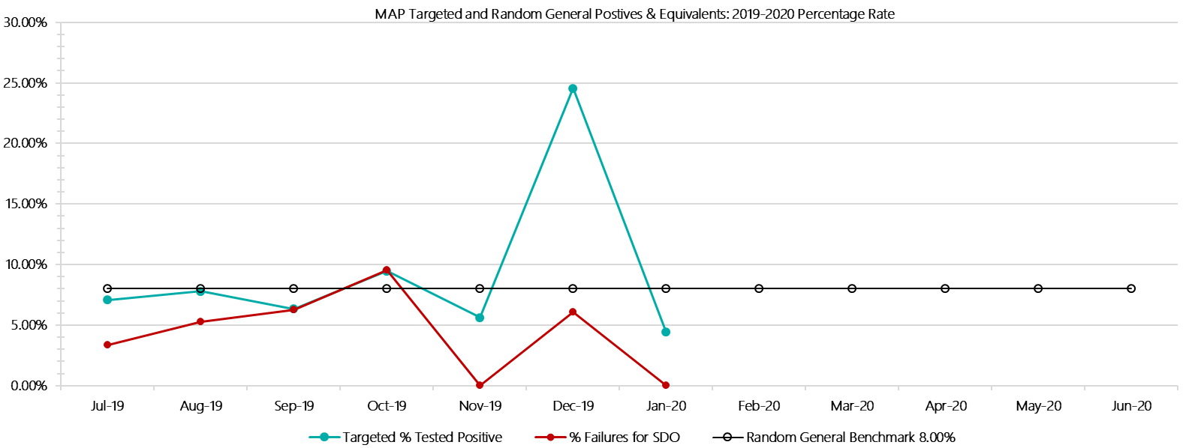

***Melbourne Assessment Prison Positive Test Results by Drug Type: 2019-2020***

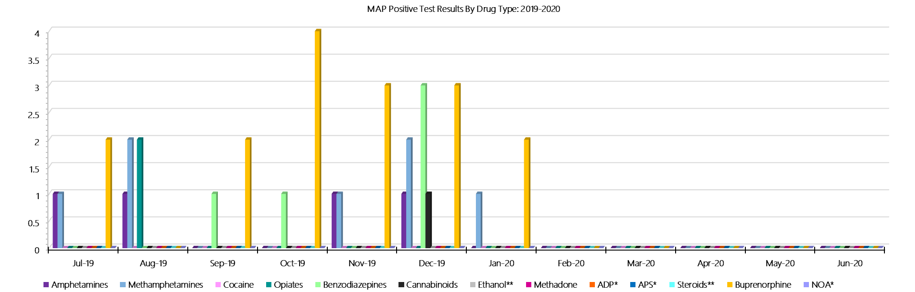

***Melbourne Assessment Prison Count of Visitor Seizures Finds: 2019-2020***

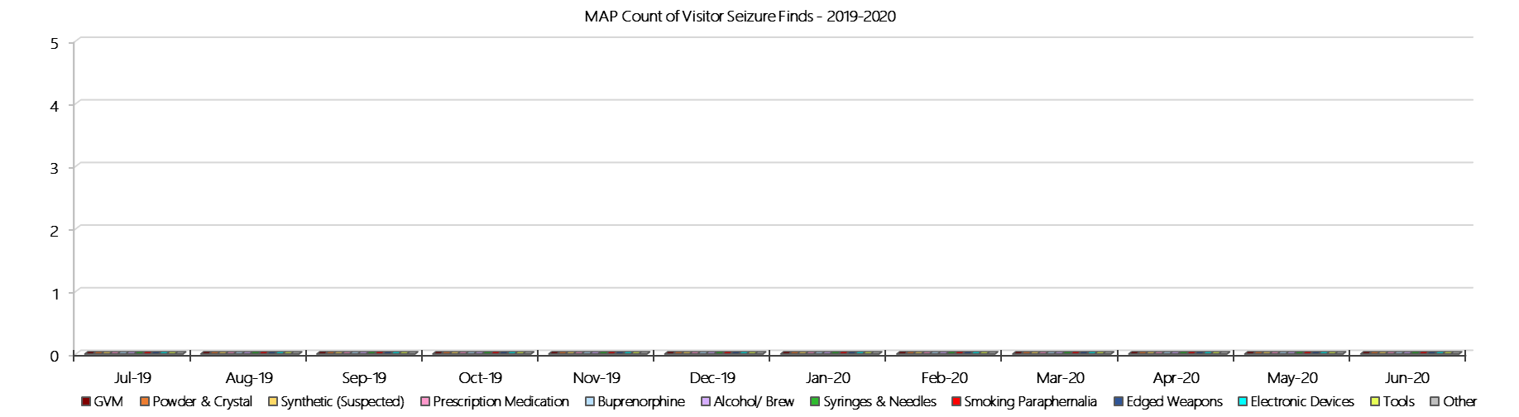

***Melbourne Assessment Prison Count of Prisoner Seizure Finds: 2019-2020***

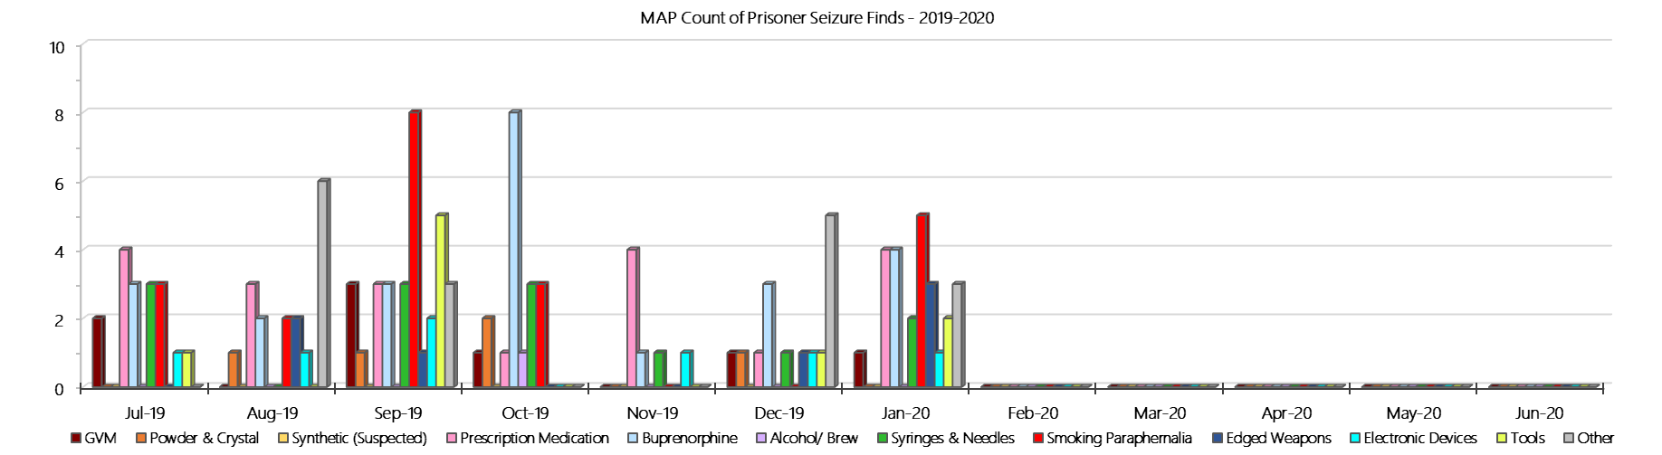

### **Metropolitan Remand Centre**

***Targeted and Random General Drug Test Results: 2019-2020***

|  |  |  |  |  |  |  |  |  |  |  |  |  |  |  |
| --- | --- | --- | --- | --- | --- | --- | --- | --- | --- | --- | --- | --- | --- | --- |
| **MRC** | **Jul-19** | **Aug-19** | **Sep-19** | **Oct-19** | **Nov-19** | **Dec-19** | **Jan-20** | **Feb-20** | **Mar-20** | **Apr-20** | **May-20** | **Jun-20** | **Average** | ***Totals*** |
| **Effective Sample - Targeted** | **161** | **137** | **151** | **151** | **183** | **167** | **151** |  |  |  |  |  | **157** | ***1101*** |
| **Targeted Positives** | **13** | **27** | **13** | **25** | **23** | **28** | **25** |  |  |  |  |  | **22** | ***154*** |
| **Refusal** | **0** | **1** | **4** | **0** | **2** | **2** | **1** |  |  |  |  |  | **1** | ***10*** |
| **Unable** | **1** | **1** | **0** | **1** | **3** | **2** | **0** |  |  |  |  |  | **1** | ***8*** |
| **Interfered** | **0** | **0** | **0** | **0** | **0** | **0** | **0** |  |  |  |  |  | **0** | ***0*** |
| **Adulterated** | **0** | **0** | **0** | **0** | **0** | **0** | **0** |  |  |  |  |  | **0** | ***0*** |
| **Targeted % Tested Positive** | **8.70%** | **21.17%** | **11.26%** | **17.22%** | **15.30%** | **19.16%** | **17.22%** | **#N/A** | **#N/A** | **#N/A** | **#N/A** | **#N/A** | **15.62%** | ***15.62%*** |
| **Awaiting / Pending Results** | **0** | **0** | **0** | **0** | **0** | **0** | **1** |  |  |  |  |  | **0** | ***1*** |
| **Targeted Residual** | **1** | **6** | **0** | **0** | **0** | **0** | **0** |  |  |  |  |  | **1** | ***7*** |
| **Random tests collected** | **128** | **104** | **124** | **97** | **98** | **127** | **105** |  |  |  |  |  | **112** | ***783*** |
| **Tested Positive** | **14** | **13** | **8** | **6** | **8** | **8** | **16** |  |  |  |  |  | **10** | ***73*** |
| **Refusal (guilty)** | **0** | **2** | **0** | **1** | **2** | **0** | **0** |  |  |  |  |  | **1** | ***5*** |
| **Unable (not guilty)** | **0** | **0** | **1** | **0** | **0** | **0** | **0** |  |  |  |  |  | **0** | ***1*** |
| **Unable (guilty)** | **5** | **1** | **2** | **1** | **2** | **1** | **1** |  |  |  |  |  | **2** | ***13*** |
| **Interfered (guilty)** | **0** | **0** | **0** | **0** | **0** | **0** | **0** |  |  |  |  |  | **0** | ***0*** |
| **No test (valid reason)** | **7** | **3** | **7** | **9** | **6** | **5** | **4** |  |  |  |  |  | **6** | ***41*** |
| **No test (no valid reason)** | **0** | **1** | **0** | **0** | **0** | **0** | **0** |  |  |  |  |  | **0** | ***1*** |
| **Adulterated** | **0** | **0** | **0** | **0** | **0** | **0** | **0** |  |  |  |  |  | **0** | ***0*** |
| **Awaiting / Pending Results** | **0** | **0** | **0** | **0** | **0** | **0** | **2** |  |  |  |  |  | **0** | ***2*** |
| **Random Residual *(PIMS URAR030)*** | **0** | **1** | **0** | **0** | **1** | **4** | **0** |  |  |  |  |  | ***0.857143*** | ***6*** |
| **Effective Sample - Random General** | **133** | **108** | **126** | **99** | **102** | **128** | **106** |  |  |  |  |  | **115** | **802** |
| **% Tested positive** | **10.53%** | **12.04%** | **6.35%** | **6.06%** | **7.84%** | **6.25%** | **15.09%** |  |  |  |  |  | **9.17%** |  |
| **% Prisoner guilty, positive equivalents** | **3.76%** | **2.78%** | **1.59%** | **2.02%** | **3.92%** | **0.78%** | **0.94%** |  |  |  |  |  | **2.26%** |  |
| **% Total prisoner fails** | **14.29%** | **14.81%** | **7.94%** | **8.08%** | **11.76%** | **7.03%** | **16.04%** |  |  |  |  |  | **11.42%** |  |
| **% No test without valid reason** | **0.00%** | **0.93%** | **0.00%** | **0.00%** | **0.00%** | **0.00%** | **0.00%** |  |  |  |  |  | **0.13%** |  |
| ***Random General Benchmark 7.00%*** | ***7.00%*** | ***7.00%*** | ***7.00%*** | ***7.00%*** | ***7.00%*** | ***7.00%*** | ***7.00%*** | ***7.00%*** | ***7.00%*** | ***7.00%*** | ***7.00%*** | ***7.00%*** | ***YTD*** |  |
| **% Failures for SDO** | **14.29%** | **15.74%** | **7.94%** | **8.08%** | **11.76%** | **7.03%** | **16.04%** | **#N/A** | **#N/A** | **#N/A** | **#N/A** | **#N/A** | **11.47%** |  |

***Metropolitan Remand Centre - Drugs Identified Through Testing by Drug Type: 2019-2020***

|  |  |  |  |  |  |  |  |  |  |  |  |  |  |  |
| --- | --- | --- | --- | --- | --- | --- | --- | --- | --- | --- | --- | --- | --- | --- |
| **MRC** | ***Amphetamines*** | ***Methamphetamines*** | ***Cocaine*** | ***Opiates*** | ***Benzodiazepines*** | ***Cannabinoids*** | ***Ethanol\*\**** | ***Methadone*** | ***ADP\**** | ***APS\**** | ***Steroids\*\**** | ***Buprenorphine*** | ***NOA\**** | **Total** |
| **Jul-19** | **1** | **6** | **0** | **2** | **0** | **0** | **0** | **0** | **0** | **0** | **0** | **27** | **0** | **36** |
| **Aug-19** | **2** | **5** | **0** | **1** | **1** | **1** | **0** | **0** | **0** | **0** | **0** | **44** | **0** | **54** |
| **Sep-19** | **2** | **2** | **0** | **0** | **0** | **0** | **0** | **0** | **0** | **0** | **0** | **25** | **0** | **29** |
| **Oct-19** | **3** | **6** | **0** | **1** | **0** | **0** | **0** | **1** | **0** | **0** | **0** | **32** | **0** | **43** |
| **Nov-19** | **0** | **3** | **0** | **2** | **0** | **1** | **0** | **0** | **0** | **0** | **0** | **30** | **0** | **36** |
| **Dec-19** | **4** | **7** | **0** | **0** | **0** | **0** | **0** | **0** | **0** | **0** | **0** | **37** | **0** | **48** |
| **Jan-20** | **0** | **0** | **0** | **0** | **1** | **0** | **0** | **0** | **0** | **0** | **0** | **55** | **0** | **56** |
| **Feb-20** |  |  |  |  |  |  |  |  |  |  |  |  |  |  |
| **Mar-20** |  |  |  |  |  |  |  |  |  |  |  |  |  |  |
| **Apr-20** |  |  |  |  |  |  |  |  |  |  |  |  |  |  |
| **May-20** |  |  |  |  |  |  |  |  |  |  |  |  |  |  |
| **Jun-20** |  |  |  |  |  |  |  |  |  |  |  |  |  |  |
| **MRC YTD** | **12** | **29** | **0** | **6** | **2** | **2** | **0** | **1** | **0** | **0** | **0** | **250** | **0** | **302** |
| ***All Prisons YTD*** | ***111*** | ***184*** | ***2*** | ***31*** | ***26*** | ***21*** | ***18*** | ***25*** | ***33*** | ***12*** | ***0*** | ***1397*** | ***0*** | ***1860*** |
| ***MRC % of Total*** | ***10.81%*** | ***15.76%*** | ***0.00%*** | ***19.35%*** | ***7.69%*** | ***9.52%*** | ***0.00%*** | ***4.00%*** | ***0.00%*** | ***0.00%*** | ***0.00%*** | ***17.90%*** | ***0.00%*** | ***16.24%*** |

***Metropolitan Remand Centre Seizures of Contraband: Visitors & Prisoners: 2019-2020***

|  |  |  |  |  |  |  |  |  |  |  |  |  |  |  |  |  |  |  |  |  |  |  |  |  |  |
| --- | --- | --- | --- | --- | --- | --- | --- | --- | --- | --- | --- | --- | --- | --- | --- | --- | --- | --- | --- | --- | --- | --- | --- | --- | --- |
| **Visitors** | **GVM** | | **Powder  & Crystal** | | **Synthetic  (Suspected)** | | **Prescription  Medication** | | **Buprenorphine** | | **Alcohol &  Home Brew** | | **Syringes & Needles** | | **Smoking  Paraphernalia** | | **Edged  Weapons** | | **Electronic  Devices** | | **Tools** | | **Other** | | |
| **MRC** | **Finds** | **Gms** | **Finds** | **Gms** | **Finds** | **Gms** | **Finds** | **Qty** | **Finds** | **Qty** | **Finds** | **Ltrs** | **Finds** | **Qty** | **Finds** | **Qty** | **Finds** | **Qty** | **Finds** | **Qty** | **Finds** | **Qty** | **Finds** | **Qty** |
| **Jul-19** | **0** | **0.00** | **1** | **1.00** | **0** | **0.00** | **1** | **3.00** | **2** | **3.10** | **0** | **0.000** | **2** | **11** | **4** | **5** | **1** | **3** | **0** | **0** | **2** | **3** | **4** | **7** | |
| **Aug-19** | **1** | **0.50** | **0** | **0.00** | **0** | **0.00** | **1** | **9.00** | **0** | **0.00** | **1** | **0.660** | **0** | **0** | **3** | **7** | **3** | **12** | **0** | **0** | **1** | **3** | **0** | **0** | |
| **Sep-19** | **1** | **0.01** | **0** | **0.00** | **0** | **0.00** | **0** | **0.00** | **0** | **0.00** | **0** | **0.000** | **0** | **0** | **0** | **0** | **0** | **0** | **0** | **0** | **0** | **0** | **1** | **5** | |
| **Oct-19** | **1** | **4.75** | **1** | **5.14** | **0** | **0.00** | **0** | **0.00** | **1** | **1.00** | **0** | **0.000** | **0** | **0** | **1** | **2** | **0** | **0** | **1** | **1** | **1** | **1** | **1** | **4** | |
| **Nov-19** | **0** | **0.00** | **8** | **9.78** | **0** | **0.00** | **0** | **0.00** | **0** | **0.00** | **0** | **0.000** | **1** | **4** | **3** | **4** | **3** | **5** | **0** | **0** | **2** | **4** | **2** | **2** | |
| **Dec-19** | **3** | **3.53** | **1** | **5.00** | **0** | **0.00** | **1** | **5.00** | **0** | **0.00** | **0** | **0.000** | **0** | **0** | **1** | **3** | **0** | **0** | **0** | **0** | **0** | **0** | **2** | **2** | |
| **Jan-20** | **3** | **11.64** | **5** | **23.45** | **0** | **0.00** | **4** | **26.00** | **0** | **0.00** | **0** | **0.000** | **1** | **3** | **4** | **6** | **1** | **1** | **0** | **0** | **2** | **2** | **3** | **8** | |
| **Feb-20** |  |  |  |  |  |  |  |  |  |  |  |  |  |  |  |  |  |  |  |  |  |  |  |  | |
| **Mar-20** |  |  |  |  |  |  |  |  |  |  |  |  |  |  |  |  |  |  |  |  |  |  |  |  | |
| **Apr-20** |  |  |  |  |  |  |  |  |  |  |  |  |  |  |  |  |  |  |  |  |  |  |  |  | |
| **May-20** |  |  |  |  |  |  |  |  |  |  |  |  |  |  |  |  |  |  |  |  |  |  |  |  | |
| **Jun-20** |  |  |  |  |  |  |  |  |  |  |  |  |  |  |  |  |  |  |  |  |  |  |  |  | |
| **Total** | **9** | **20.43** | **16** | **44.37** | **0** | **0.00** | **7** | **43.00** | **3** | **4.10** | **1** | **0.660** | **4** | **18** | **16** | **27** | **8** | **21** | **1** | **1** | **8** | **13** | **13** | **28** | |

|  |  |  |  |  |  |  |  |  |  |  |  |  |  |  |  |  |  |  |  |  |  |  |  |  |
| --- | --- | --- | --- | --- | --- | --- | --- | --- | --- | --- | --- | --- | --- | --- | --- | --- | --- | --- | --- | --- | --- | --- | --- | --- |
| **Prisoners** | **GVM** | | **Powder  & Crystal** | | **Synthetic  (Suspected)** | | **Prescription  Medication** | | **Buprenorphine** | | **Alcohol &  Home Brew** | | **Syringes & Needles** | | **Smoking  Paraphernalia** | | **Edged  Weapons** | | **Electronic  Devices** | | **Tools** | | **Other** | |
| **MRC** | **Finds** | **Gms** | **Finds** | **Gms** | **Finds** | **Gms** | **Finds** | **Qty** | **Finds** | **Qty** | **Finds** | **Ltrs** | **Finds** | **Qty** | **Finds** | **Qty** | **Finds** | **Qty** | **Finds** | **Qty** | **Finds** | **Qty** | **Finds** | **Qty** |
| **Jul-19** | **2** | **0.20** | **1** | **1.00** | **1** | **0.50** | **8** | **19.00** | **17** | **0.40** | **0** | **0.000** | **2** | **2** | **9** | **18** | **17** | **23** | **1** | **1** | **3** | **5** | **12** | **15** |
| **Aug-19** | **2** | **1.00** | **2** | **1.20** | **0** | **0.00** | **11** | **59.50** | **29** | **36.96** | **2** | **7.500** | **10** | **10** | **13** | **30** | **15** | **19** | **0** | **0** | **7** | **14** | **9** | **9** |
| **Sep-19** | **0** | **0.00** | **2** | **1.10** | **0** | **0.00** | **9** | **81.50** | **15** | **30.00** | **0** | **0.000** | **2** | **2** | **7** | **11** | **10** | **10** | **0** | **0** | **6** | **11** | **21** | **32** |
| **Oct-19** | **1** | **1.80** | **2** | **1.00** | **0** | **0.00** | **14** | **29.50** | **5** | **4.60** | **3** | **51.000** | **3** | **3** | **13** | **23** | **9** | **10** | **1** | **1** | **11** | **23** | **26** | **32** |
| **Nov-19** | **0** | **0.00** | **3** | **30.38** | **0** | **0.00** | **13** | **75.00** | **9** | **4.77** | **10** | **15.000** | **3** | **8** | **9** | **14** | **3** | **4** | **1** | **1** | **11** | **36** | **7** | **9** |
| **Dec-19** | **0** | **0.00** | **3** | **1.70** | **0** | **0.00** | **6** | **6.00** | **10** | **27.75** | **8** | **19.000** | **2** | **2** | **3** | **6** | **6** | **6** | **2** | **5** | **7** | **26** | **3** | **5** |
| **Jan-20** | **0** | **0.00** | **2** | **2.00** | **0** | **0.00** | **10** | **13.75** | **27** | **33.11** | **3** | **4.000** | **2** | **2** | **7** | **15** | **6** | **6** | **0** | **0** | **2** | **2** | **6** | **6** |
| **Feb-20** |  |  |  |  |  |  |  |  |  |  |  |  |  |  |  |  |  |  |  |  |  |  |  |  |
| **Mar-20** |  |  |  |  |  |  |  |  |  |  |  |  |  |  |  |  |  |  |  |  |  |  |  |  |
| **Apr-20** |  |  |  |  |  |  |  |  |  |  |  |  |  |  |  |  |  |  |  |  |  |  |  |  |
| **May-20** |  |  |  |  |  |  |  |  |  |  |  |  |  |  |  |  |  |  |  |  |  |  |  |  |
| **Jun-20** |  |  |  |  |  |  |  |  |  |  |  |  |  |  |  |  |  |  |  |  |  |  |  |  |
| **Total** | **5** | **3.00** | **15** | **38.38** | **1** | **0.50** | **71** | **284.25** | **112** | **137.59** | **26** | **96.500** | **24** | **29** | **61** | **117** | **66** | **78** | **5** | **8** | **47** | **117** | **84** | **108** |

***Metropolitan Remand Centre Targeted and Random General Drug Test Positives & Equivalents: 2019-2020  
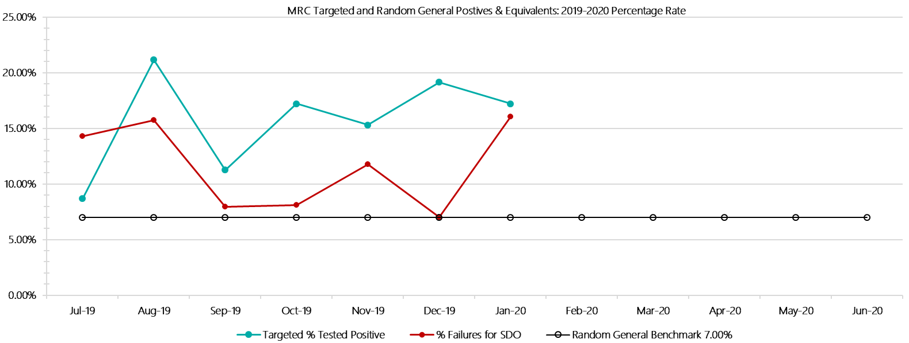***

***Metropolitan Remand Centre Positive Drug Test Results by Drug Type: 2019-2020***

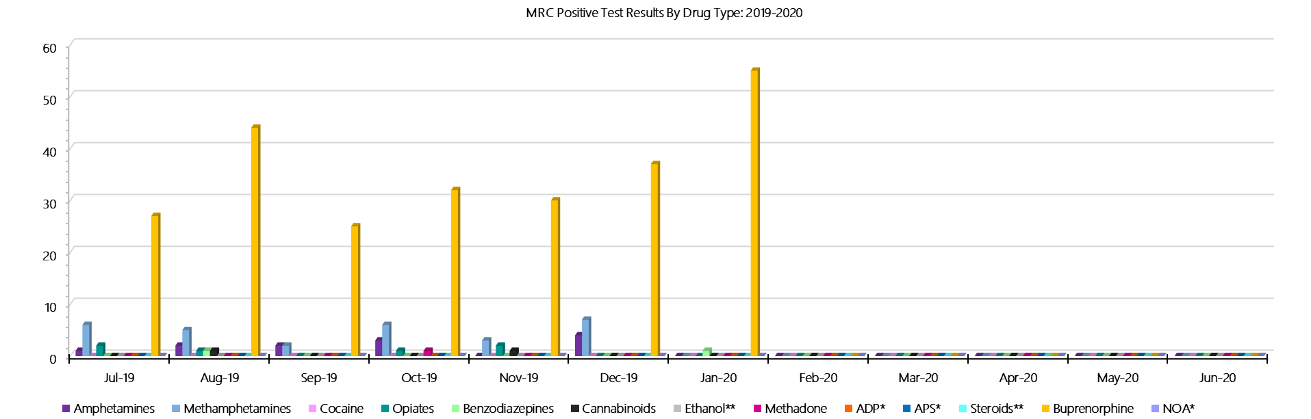

***Metropolitan Remand Centre Count of Visitor Seizures Finds: 2019-2020***

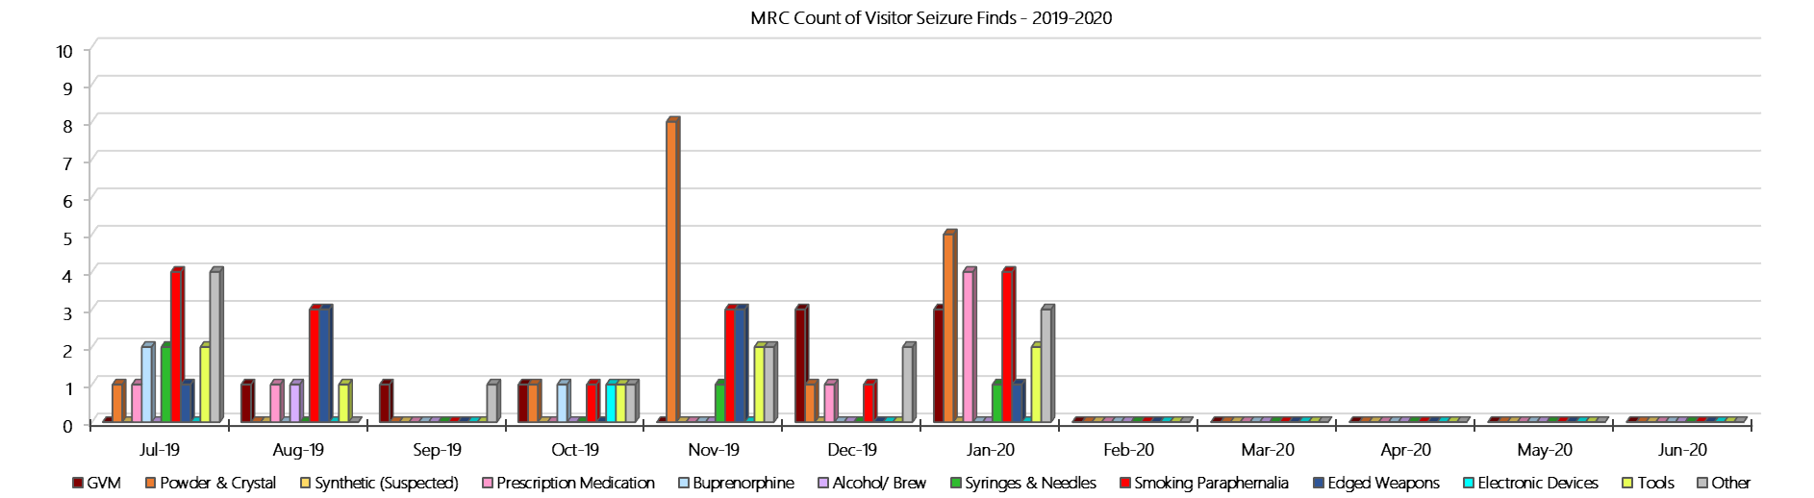

***Metropolitan Remand Centre Count of Prisoner Seizure Finds: 2019-2020***

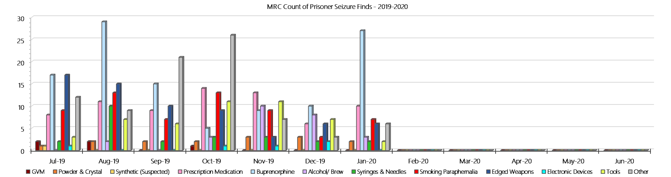

### **Port Phillip Prison**

***Targeted and Random General Drug Test Results: 2019-2020***

|  |  |  |  |  |  |  |  |  |  |  |  |  |  |  |
| --- | --- | --- | --- | --- | --- | --- | --- | --- | --- | --- | --- | --- | --- | --- |
| **Port Phillip Prison** | **Jul-19** | **Aug-19** | **Sep-19** | **Oct-19** | **Nov-19** | **Dec-19** | **Jan-20** | **Feb-19** | **Mar-20** | **Apr-20** | **May-20** | **Jun-20** | **Average** | ***Totals*** |
| **Effective Sample - Targeted** | **311** | **292** | **262** | **342** | **310** | **263** | **303** |  |  |  |  |  | **298** | ***2083*** |
| **Targeted Positives** | **28** | **34** | **33** | **21** | **35** | **20** | **31** |  |  |  |  |  | **29** | ***202*** |
| **Refusal** | **3** | **4** | **7** | **7** | **4** | **7** | **6** |  |  |  |  |  | **5** | ***38*** |
| **Unable** | **0** | **1** | **1** | **1** | **2** | **3** | **4** |  |  |  |  |  | **2** | ***12*** |
| **Interfered** | **0** | **0** | **0** | **0** | **0** | **0** | **0** |  |  |  |  |  | **0** | ***0*** |
| **Adulterated** | **0** | **1** | **2** | **1** | **0** | **0** | **2** |  |  |  |  |  | **1** | ***6*** |
| **Targeted % Tested Positive** | **9.97%** | **13.70%** | **16.41%** | **8.77%** | **13.23%** | **11.41%** | **14.19%** | **#N/A** | **#N/A** | **#N/A** | **#N/A** | **#N/A** | **12.39%** | ***12.39%*** |
| **Awaiting / Pending Results** | **1** | **0** | **0** | **0** | **0** | **0** | **0** |  |  |  |  |  | **0** | ***1*** |
| **Targeted Residual** | **4** | **1** | **4** | **1** | **1** | **1** | **0** |  |  |  |  |  | **2** | ***12*** |
| **Random tests collected** | **63** | **53** | **61** | **51** | **51** | **62** | **50** |  |  |  |  |  | **56** | ***391*** |
| **Tested Positive** | **3** | **5** | **4** | **1** | **4** | **5** | **3** |  |  |  |  |  | **4** | ***25*** |
| **Refusal (guilty)** | **1** | **0** | **0** | **0** | **0** | **0** | **0** |  |  |  |  |  | **0** | ***1*** |
| **Unable (not guilty)** | **1** | **1** | **1** | **0** | **0** | **0** | **0** |  |  |  |  |  | **0** | ***3*** |
| **Unable (guilty)** | **0** | **0** | **0** | **0** | **1** | **0** | **0** |  |  |  |  |  | **0** | ***1*** |
| **Interfered (guilty)** | **0** | **0** | **0** | **0** | **0** | **0** | **0** |  |  |  |  |  | **0** | ***0*** |
| **No test (valid reason)** | **3** | **1** | **3** | **1** | **0** | **3** | **4** |  |  |  |  |  | **2** | ***15*** |
| **No test (no valid reason)** | **0** | **0** | **0** | **0** | **0** | **0** | **0** |  |  |  |  |  | **0** | ***0*** |
| **Adulterated** | **0** | **0** | **0** | **0** | **0** | **0** | **0** |  |  |  |  |  | **0** | ***0*** |
| **Awaiting / Pending Results** | **0** | **0** | **0** | **0** | **0** | **0** | **0** |  |  |  |  |  | **0** | ***0*** |
| **Random Residual *(PIMS URAR030)*** | **0** | **0** | **0** | **0** | **1** | **0** | **0** |  |  |  |  |  | ***0.142857*** | ***1*** |
| **Effective Sample - Random General** | **64** | **53** | **61** | **51** | **52** | **62** | **50** |  |  |  |  |  | **56** | **393** |
| **% Tested positive** | **4.69%** | **9.43%** | **6.56%** | **1.96%** | **7.69%** | **8.06%** | **6.00%** |  |  |  |  |  | **6.34%** |  |
| **% Prisoner guilty, positive equivalents** | **1.56%** | **0.00%** | **0.00%** | **0.00%** | **1.92%** | **0.00%** | **0.00%** |  |  |  |  |  | **0.50%** |  |
| **% Total prisoner fails** | **6.25%** | **9.43%** | **6.56%** | **1.96%** | **9.62%** | **8.06%** | **6.00%** |  |  |  |  |  | **6.84%** |  |
| **% No test without valid reason** | **0.00%** | **0.00%** | **0.00%** | **0.00%** | **0.00%** | **0.00%** | **0.00%** |  |  |  |  |  | **0.00%** |  |
| **% Failures for SDO** | **6.25%** | **9.43%** | **6.56%** | **1.96%** | **9.62%** | **8.06%** | **6.00%** | **#N/A** | **#N/A** | **#N/A** | **#N/A** | **#N/A** | **6.87%** |  |

***Port Phillip Prison - Drugs Identified Through Testing by Drug Type: 2019-2020***

|  |  |  |  |  |  |  |  |  |  |  |  |  |  |  |
| --- | --- | --- | --- | --- | --- | --- | --- | --- | --- | --- | --- | --- | --- | --- |
| **PPP** | ***Amphetamines*** | ***Methamphetamines*** | ***Cocaine*** | ***Opiates*** | ***Benzodiazepines*** | ***Cannabinoids*** | ***Ethanol\*\**** | ***Methadone*** | ***ADP\**** | ***APS\**** | ***Steroids\*\**** | ***Buprenorphine*** | ***NOA\**** | **Total** |
| **Jul-19** | **2** | **2** | **0** | **0** | **0** | **0** | **0** | **5** | **0** | **0** | **0** | **36** | **0** | **45** |
| **Aug-19** | **4** | **5** | **0** | **0** | **0** | **0** | **0** | **4** | **0** | **0** | **0** | **39** | **0** | **52** |
| **Sep-19** | **6** | **11** | **0** | **0** | **0** | **0** | **0** | **2** | **0** | **0** | **0** | **39** | **0** | **58** |
| **Oct-19** | **0** | **1** | **0** | **0** | **0** | **0** | **0** | **0** | **0** | **0** | **0** | **26** | **0** | **27** |
| **Nov-19** | **1** | **2** | **0** | **1** | **1** | **0** | **0** | **0** | **0** | **0** | **0** | **40** | **0** | **45** |
| **Dec-19** | **3** | **5** | **0** | **0** | **1** | **1** | **0** | **1** | **0** | **0** | **0** | **32** | **0** | **43** |
| **Jan-20** | **0** | **0** | **0** | **0** | **0** | **0** | **2** | **1** | **0** | **0** | **0** | **39** | **0** | **42** |
| **Feb-20** |  |  |  |  |  |  |  |  |  |  |  |  |  |  |
| **Mar-20** |  |  |  |  |  |  |  |  |  |  |  |  |  |  |
| **Apr-20** |  |  |  |  |  |  |  |  |  |  |  |  |  |  |
| **May-20** |  |  |  |  |  |  |  |  |  |  |  |  |  |  |
| **Jun-20** |  |  |  |  |  |  |  |  |  |  |  |  |  |  |
| **PPP YTD** | **16** | **26** | **0** | **1** | **2** | **1** | **2** | **13** | **0** | **0** | **0** | **251** | **0** | **312** |
| ***All Prisons YTD*** | ***111*** | ***184*** | ***2*** | ***31*** | ***26*** | ***21*** | ***18*** | ***25*** | ***33*** | ***12*** | ***0*** | ***1397*** | ***0*** | ***1860*** |
| ***PPP % of Total*** | ***14.41%*** | ***14.13%*** | ***0.00%*** | ***3.23%*** | ***7.69%*** | ***4.76%*** | ***11.11%*** | ***52.00%*** | ***0.00%*** | ***0.00%*** | ***0.00%*** | ***17.97%*** | ***0.00%*** | ***16.77%*** |

***Port Phillip Prison Seizures of Contraband: Visitors & Prisoners: 2019-2020***

|  |  |  |  |  |  |  |  |  |  |  |  |  |  |  |  |  |  |  |  |  |  |  |  |  |  |
| --- | --- | --- | --- | --- | --- | --- | --- | --- | --- | --- | --- | --- | --- | --- | --- | --- | --- | --- | --- | --- | --- | --- | --- | --- | --- |
| **Visitors** | **GVM** | | **Powder  & Crystal** | | **Synthetic  (Suspected)** | | **Prescription  Medication** | | **Buprenorphine** | | **Alcohol &  Home Brew** | | **Syringes & Needles** | | **Smoking  Paraphernalia** | | **Edged  Weapons** | | **Electronic  Devices** | | **Tools** | | **Other** | | |
| **PPP** | **Finds** | **Gms** | **Finds** | **Gms** | **Finds** | **Gms** | **Finds** | **Qty** | **Finds** | **Qty** | **Finds** | **Ltrs** | **Finds** | **Qty** | **Finds** | **Qty** | **Finds** | **Qty** | **Finds** | **Qty** | **Finds** | **Qty** | **Finds** | **Qty** |
| **Jul-19** | **0** | **0.00** | **1** | **2.00** | **0** | **0.00** | **0** | **0.00** | **3** | **158.00** | **0** | **0.000** | **1** | **4** | **0** | **0** | **0** | **0** | **0** | **0** | **0** | **0** | **0** | **0** |
| **Aug-19** | **1** | **22.00** | **1** | **18.43** | **0** | **0.00** | **0** | **0.00** | **1** | **94.00** | **0** | **0.000** | **1** | **3** | **0** | **0** | **1** | **1** | **0** | **0** | **0** | **0** | **0** | **0** |
| **Sep-19** | **0** | **0.00** | **0** | **0.00** | **0** | **0.00** | **0** | **0.00** | **0** | **0.00** | **0** | **0.000** | **0** | **0** | **0** | **0** | **0** | **0** | **0** | **0** | **0** | **0** | **0** | **0** |
| **Oct-19** | **0** | **0.00** | **0** | **0.00** | **0** | **0.00** | **1** | **2.00** | **0** | **0.00** | **0** | **0.000** | **2** | **5** | **3** | **7** | **0** | **0** | **0** | **0** | **0** | **0** | **0** | **0** |
| **Nov-19** | **0** | **0.00** | **0** | **0.00** | **0** | **0.00** | **0** | **0.00** | **0** | **0.00** | **0** | **0.000** | **0** | **0** | **0** | **0** | **0** | **0** | **0** | **0** | **0** | **0** | **0** | **0** |
| **Dec-19** | **0** | **0.00** | **0** | **0.00** | **0** | **0.00** | **0** | **0.00** | **0** | **0.00** | **0** | **0.000** | **0** | **0** | **0** | **0** | **0** | **0** | **0** | **0** | **0** | **0** | **0** | **0** |
| **Jan-20** | **0** | **0.00** | **2** | **2.61** | **0** | **0.00** | **0** | **0.00** | **1** | **18.00** | **0** | **0.000** | **0** | **0** | **1** | **8** | **0** | **0** | **0** | **0** | **0** | **0** | **0** | **0** |
| **Feb-20** |  |  |  |  |  |  |  |  |  |  |  |  |  |  |  |  |  |  |  |  |  |  |  |  |
| **Mar-20** |  |  |  |  |  |  |  |  |  |  |  |  |  |  |  |  |  |  |  |  |  |  |  |  |
| **Apr-20** |  |  |  |  |  |  |  |  |  |  |  |  |  |  |  |  |  |  |  |  |  |  |  |  |
| **May-20** |  |  |  |  |  |  |  |  |  |  |  |  |  |  |  |  |  |  |  |  |  |  |  |  |
| **Jun-20** |  |  |  |  |  |  |  |  |  |  |  |  |  |  |  |  |  |  |  |  |  |  |  |  |
| **Total** | **1** | **22.00** | **4** | **23.04** | **0** | **0.00** | **1** | **2.00** | **5** | **270.00** | **0** | **0.000** | **4** | **12** | **4** | **15** | **1** | **1** | **0** | **0** | **0** | **0** | **0** | **0** |

|  |  |  |  |  |  |  |  |  |  |  |  |  |  |  |  |  |  |  |  |  |  |  |  |  |
| --- | --- | --- | --- | --- | --- | --- | --- | --- | --- | --- | --- | --- | --- | --- | --- | --- | --- | --- | --- | --- | --- | --- | --- | --- |
| **Prisoners** | **GVM** | | **Powder  & Crystal** | | **Synthetic  (Suspected)** | | **Prescription  Medication** | | **Buprenorphine** | | **Alcohol &  Home Brew** | | **Syringes & Needles** | | **Smoking  Paraphernalia** | | **Edged  Weapons** | | **Electronic  Devices** | | **Tools** | | **Other** | |
| **PPP** | **Finds** | **Gms** | **Finds** | **Gms** | **Finds** | **Gms** | **Finds** | **Qty** | **Finds** | **Qty** | **Finds** | **Ltrs** | **Finds** | **Qty** | **Finds** | **Qty** | **Finds** | **Qty** | **Finds** | **Qty** | **Finds** | **Qty** | **Finds** | **Qty** |
| **Jul-19** | **0** | **0.00** | **0** | **0.00** | **0** | **0.00** | **9** | **29.50** | **9** | **34.30** | **0** | **0.000** | **2** | **2** | **5** | **7** | **14** | **15** | **0** | **0** | **3** | **3** | **11** | **16** |
| **Aug-19** | **0** | **0.00** | **0** | **1.00** | **0** | **0.00** | **0** | **5.00** | **6** | **21.20** | **0** | **0.000** | **0** | **0** | **0** | **6** | **1** | **12** | **0** | **0** | **0** | **17** | **7** | **24** |
| **Sep-19** | **0** | **0.00** | **2** | **4.00** | **0** | **0.00** | **5** | **15.50** | **12** | **33.30** | **1** | **3.000** | **8** | **8** | **5** | **5** | **23** | **27** | **0** | **0** | **8** | **8** | **27** | **40** |
| **Oct-19** | **0** | **0.00** | **0** | **0.00** | **0** | **0.00** | **9** | **37.50** | **14** | **50.95** | **0** | **0.000** | **1** | **3** | **4** | **5** | **16** | **17** | **0** | **0** | **9** | **11** | **11** | **11** |
| **Nov-19** | **0** | **0.00** | **1** | **1.00** | **0** | **0.00** | **9** | **15.50** | **15** | **59.50** | **4** | **16.000** | **2** | **2** | **2** | **2** | **13** | **16** | **2** | **0** | **2** | **4** | **8** | **8** |
| **Dec-19** | **0** | **0.00** | **0** | **0.00** | **0** | **0.00** | **3** | **6.00** | **18** | **203.00** | **8** | **13.500** | **3** | **14** | **1** | **1** | **11** | **11** | **1** | **2** | **0** | **0** | **13** | **23** |
| **Jan-20** | **0** | **0.00** | **1** | **1.30** | **0** | **0.00** | **12** | **26.00** | **16** | **36.00** | **6** | **11.000** | **4** | **4** | **2** | **3** | **12** | **12** | **0** | **0** | **1** | **1** | **8** | **8** |
| **Feb-20** |  |  |  |  |  |  |  |  |  |  |  |  |  |  |  |  |  |  |  |  |  |  |  |  |
| **Mar-20** |  |  |  |  |  |  |  |  |  |  |  |  |  |  |  |  |  |  |  |  |  |  |  |  |
| **Apr-20** |  |  |  |  |  |  |  |  |  |  |  |  |  |  |  |  |  |  |  |  |  |  |  |  |
| **May-20** |  |  |  |  |  |  |  |  |  |  |  |  |  |  |  |  |  |  |  |  |  |  |  |  |
| **Jun-20** |  |  |  |  |  |  |  |  |  |  |  |  |  |  |  |  |  |  |  |  |  |  |  |  |
| **Total** | **0** | **0.00** | **4** | **7.30** | **0** | **0.00** | **47** | **135.00** | **90** | **438.25** | **19** | **43.500** | **20** | **33** | **19** | **29** | **90** | **110** | **3** | **2** | **23** | **44** | **85** | **130** |

***Port Phillip Prison Targeted and Random General Drug Test Positives & Equivalents: 2019-2020***

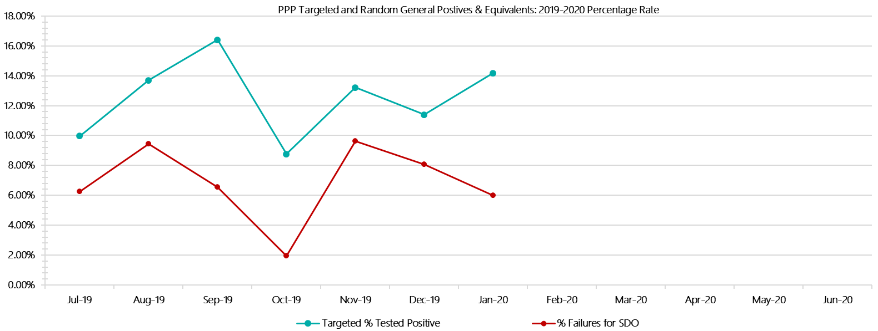

***Port Phillip Prison Positive Test Results by Drug Type: 2019-2020***

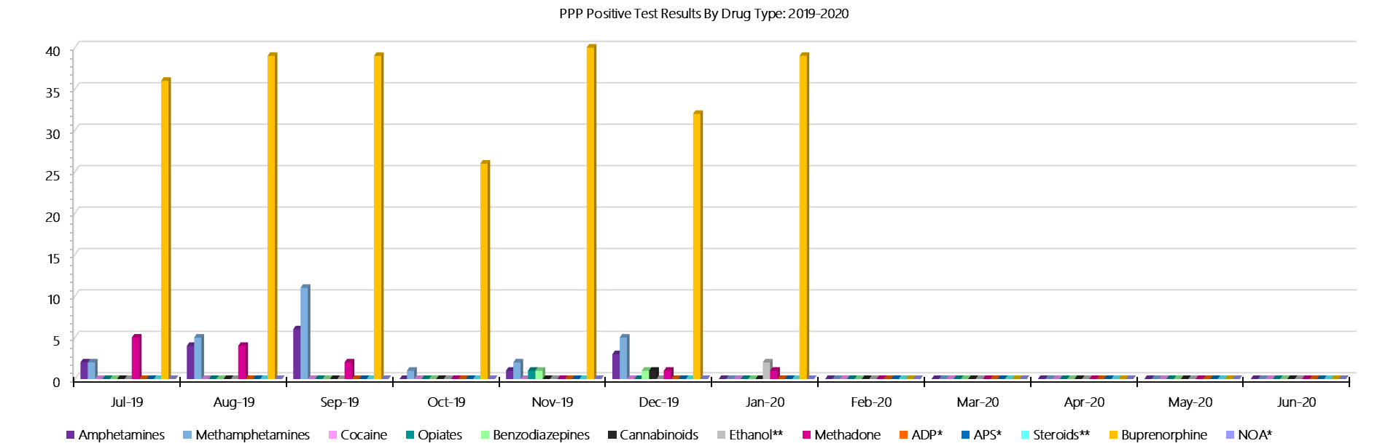

***Port Phillip Prison Count of Visitor Seizures Finds: 2019-2020***

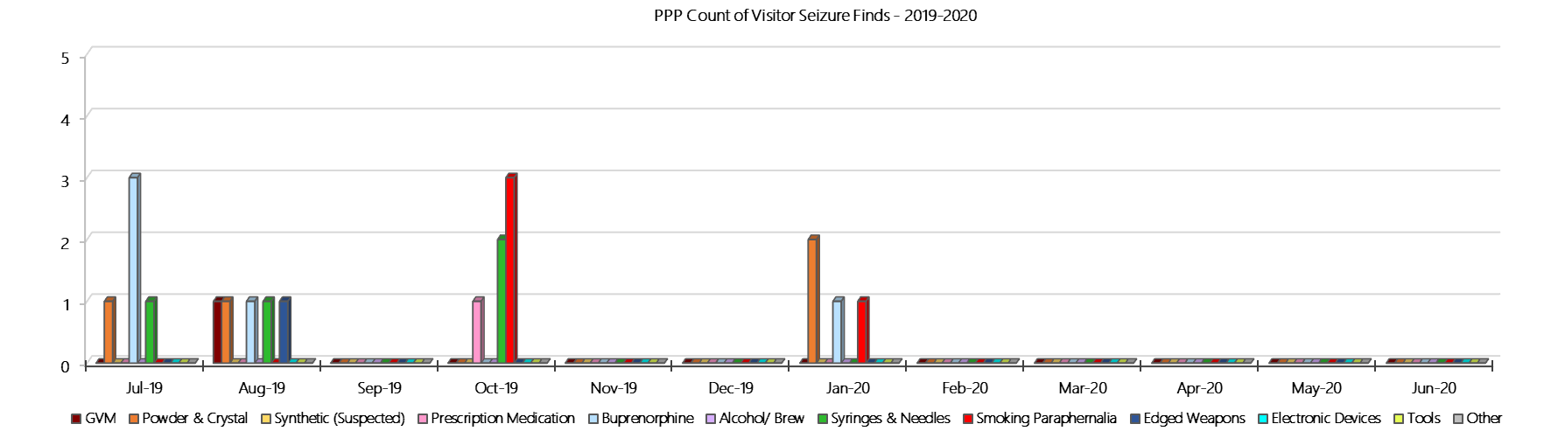

***Port Phillip Prison Count of Prisoner Seizure Finds: 2019-2020***

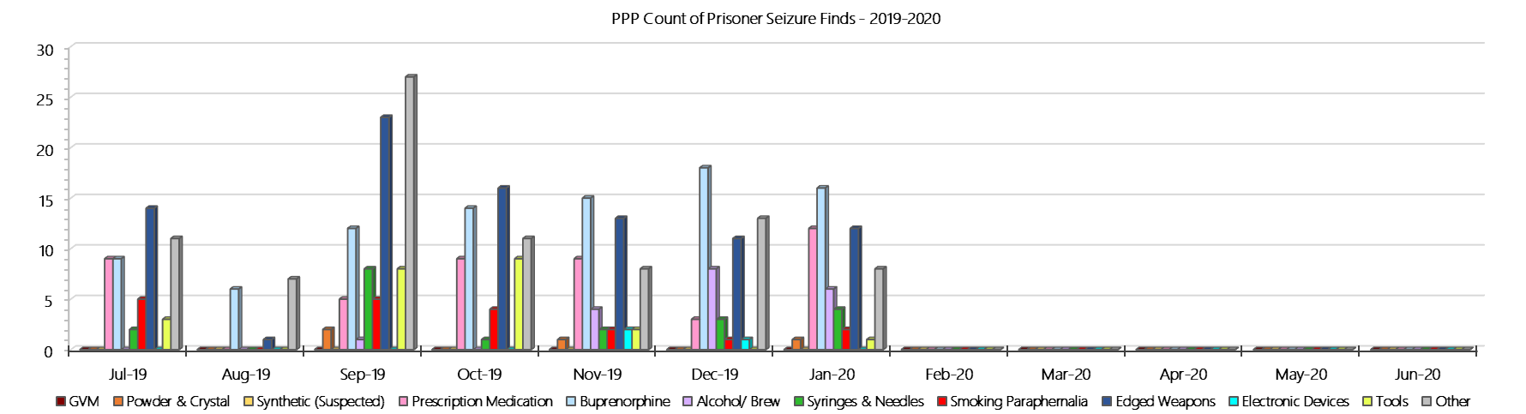

### **Dame Phyllis Frost Centre**

***Targeted and Random General Drug Test Results: 2019-2020***

|  |  |  |  |  |  |  |  |  |  |  |  |  |  |  |
| --- | --- | --- | --- | --- | --- | --- | --- | --- | --- | --- | --- | --- | --- | --- |
| **DPFC** | **Jul-19** | **Aug-19** | **Sep-19** | **Oct-19** | **Nov-19** | **Dec-19** | **Jan-20** | **Feb-20** | **Mar-20** | **Apr-20** | **May-20** | **Jun-20** | **Average** | ***Totals*** |
| **Effective Sample - Targeted** | **55** | **90** | **112** | **125** | **160** | **134** | **163** |  |  |  |  |  | **120** | ***839*** |
| **Targeted Positives** | **5** | **3** | **2** | **12** | **11** | **14** | **9** |  |  |  |  |  | **8** | ***56*** |
| **Refusal** | **3** | **1** | **2** | **1** | **3** | **6** | **4** |  |  |  |  |  | **3** | ***20*** |
| **Unable** | **2** | **0** | **1** | **2** | **2** | **1** | **1** |  |  |  |  |  | **1** | ***9*** |
| **Interfered** | **0** | **0** | **0** | **0** | **0** | **0** | **0** |  |  |  |  |  | **0** | ***0*** |
| **Adulterated** | **0** | **0** | **0** | **0** | **0** | **0** | **1** |  |  |  |  |  | **0** | ***1*** |
| **Targeted % Tested Positive** | **18.18%** | **4.44%** | **4.46%** | **12.00%** | **10.00%** | **15.67%** | **9.20%** | **#N/A** | **#N/A** | **#N/A** | **#N/A** | **#N/A** | **10.25%** | ***10.25%*** |
| **Awaiting / Pending Results** | **0** | **0** | **0** | **0** | **0** | **0** | **1** |  |  |  |  |  | **0** | ***1*** |
| **Targeted Residual** | **0** | **1** | **0** | **0** | **1** | **0** | **1** |  |  |  |  |  | **0** | ***3*** |
| **Random tests collected** | **77** | **60** | **70** | **59** | **58** | **68** | **58** |  |  |  |  |  | **64** | ***450*** |
| **Tested Positive** | **0** | **0** | **0** | **2** | **0** | **0** | **0** |  |  |  |  |  | **0** | ***2*** |
| **Refusal (guilty)** | **0** | **0** | **1** | **0** | **0** | **0** | **0** |  |  |  |  |  | **0** | ***1*** |
| **Unable (not guilty)** | **0** | **0** | **0** | **0** | **0** | **0** | **0** |  |  |  |  |  | **0** | ***0*** |
| **Unable (guilty)** | **0** | **0** | **0** | **0** | **0** | **0** | **0** |  |  |  |  |  | **0** | ***0*** |
| **Interfered (guilty)** | **0** | **0** | **0** | **0** | **0** | **0** | **0** |  |  |  |  |  | **0** | ***0*** |
| **No test (valid reason)** | **2** | **2** | **5** | **0** | **1** | **2** | **0** |  |  |  |  |  | **2** | ***12*** |
| **No test (no valid reason)** | **0** | **0** | **0** | **0** | **0** | **0** | **0** |  |  |  |  |  | **0** | ***0*** |
| **Adulterated** | **0** | **0** | **0** | **0** | **0** | **0** | **0** |  |  |  |  |  | **0** | ***0*** |
| **Awaiting / Pending Results** | **0** | **0** | **0** | **0** | **0** | **0** | **0** |  |  |  |  |  | **0** | ***0*** |
| **Random Residual *(PIMS URAR030)*** | **0** | **0** | **0** | **0** | **0** | **0** | **0** |  |  |  |  |  | ***0*** | ***0*** |
| **Effective Sample - Random General** | **77** | **60** | **71** | **59** | **58** | **68** | **58** |  |  |  |  |  | **64** | **451** |
| **% Tested positive** | **0.00%** | **0.00%** | **0.00%** | **3.39%** | **0.00%** | **0.00%** | **0.00%** |  |  |  |  |  | **0.48%** |  |
| **% Prisoner guilty, positive equivalents** | **0.00%** | **0.00%** | **1.41%** | **0.00%** | **0.00%** | **0.00%** | **0.00%** |  |  |  |  |  | **0.20%** |  |
| **% Total prisoner fails** | **0.00%** | **0.00%** | **1.41%** | **3.39%** | **0.00%** | **0.00%** | **0.00%** |  |  |  |  |  | **0.69%** |  |
| **% No test without valid reason** | **0.00%** | **0.00%** | **0.00%** | **0.00%** | **0.00%** | **0.00%** | **0.00%** |  |  |  |  |  | **0.00%** |  |
| ***Random General Benchmark 7.25%*** | ***7.25%*** | ***7.25%*** | ***7.25%*** | ***7.25%*** | ***7.25%*** | ***7.25%*** | ***7.25%*** | ***7.25%*** | ***7.25%*** | ***7.25%*** | ***7.25%*** | ***7.25%*** | ***YTD*** |  |
| **% Failures for SDO** | **0.00%** | **0.00%** | **1.41%** | **3.39%** | **0.00%** | **0.00%** | **0.00%** | **#N/A** | **#N/A** | **#N/A** | **#N/A** | **#N/A** | **0.67%** |  |

***Dame Phyllis Frost Centre - Drugs Identified Through Testing by Drug Type: 2019-2020***

|  |  |  |  |  |  |  |  |  |  |  |  |  |  |  |
| --- | --- | --- | --- | --- | --- | --- | --- | --- | --- | --- | --- | --- | --- | --- |
| **DPFC** | ***Amphetamines*** | ***Methamphetamines*** | ***Cocaine*** | ***Opiates*** | ***Benzodiazepines*** | ***Cannabinoids*** | ***Ethanol\*\**** | ***Methadone*** | ***ADP\**** | ***APS\**** | ***Steroids\*\**** | ***Buprenorphine*** | ***NOA\**** | **Total** |
| **Jul-19** | **4** | **4** | **0** | **0** | **0** | **0** | **0** | **0** | **0** | **0** | **0** | **3** | **0** | **11** |
| **Aug-19** | **2** | **2** | **0** | **0** | **0** | **0** | **0** | **0** | **0** | **0** | **0** | **2** | **0** | **6** |
| **Sep-19** | **0** | **0** | **0** | **1** | **0** | **1** | **0** | **0** | **0** | **0** | **0** | **0** | **0** | **2** |
| **Oct-19** | **8** | **13** | **0** | **0** | **0** | **0** | **0** | **0** | **0** | **1** | **0** | **1** | **0** | **23** |
| **Nov-19** | **3** | **4** | **0** | **0** | **0** | **0** | **0** | **0** | **1** | **0** | **0** | **7** | **0** | **15** |
| **Dec-19** | **4** | **6** | **0** | **6** | **1** | **0** | **0** | **0** | **0** | **0** | **0** | **4** | **0** | **21** |
| **Jan-20** | **1** | **2** | **1** | **5** | **2** | **0** | **0** | **0** | **1** | **0** | **0** | **0** | **0** | **12** |
| **Feb-20** |  |  |  |  |  |  |  |  |  |  |  |  |  |  |
| **Mar-20** |  |  |  |  |  |  |  |  |  |  |  |  |  |  |
| **Apr-20** |  |  |  |  |  |  |  |  |  |  |  |  |  |  |
| **May-20** |  |  |  |  |  |  |  |  |  |  |  |  |  |  |
| **Jun-20** |  |  |  |  |  |  |  |  |  |  |  |  |  |  |
| **DPFC YTD** | **22** | **31** | **1** | **12** | **3** | **1** | **0** | **0** | **2** | **1** | **0** | **17** | **0** | **90** |
| ***All Prisons YTD*** | ***111*** | ***184*** | ***2*** | ***31*** | ***26*** | ***21*** | ***18*** | ***25*** | ***33*** | ***12*** | ***0*** | ***1397*** | ***0*** | ***1860*** |
| ***DPFC % of Total*** | ***19.82%*** | ***16.85%*** | ***50.00%*** | ***38.71%*** | ***11.54%*** | ***4.76%*** | ***0.00%*** | ***0.00%*** | ***6.06%*** | ***8.33%*** | ***0.00%*** | ***1.22%*** | ***0.00%*** | ***4.84%*** |

***Dame Phyllis Frost Centre - Seizures of Contraband: Visitors & Prisoners: 2019-2020***

|  |  |  |  |  |  |  |  |  |  |  |  |  |  |  |  |  |  |  |  |  |  |  |  |  |  |  |
| --- | --- | --- | --- | --- | --- | --- | --- | --- | --- | --- | --- | --- | --- | --- | --- | --- | --- | --- | --- | --- | --- | --- | --- | --- | --- | --- |
| **Visitors** | **GVM** | | **Powder  & Crystal** | | **Synthetic  (Suspected)** | | **Prescription  Medication** | | **Buprenorphine** | | **Alcohol &  Home Brew** | | **Syringes & Needles** | | **Smoking  Paraphernalia** | | | **Edged  Weapons** | | **Electronic  Devices** | | **Tools** | | **Other** | | |
| **DPFC** | **Finds** | **Gms** | **Finds** | **Gms** | **Finds** | **Gms** | **Finds** | **Qty** | **Finds** | **Qty** | **Finds** | **Ltrs** | **Finds** | **Qty** | **Finds** | **Qty** | | **Finds** | **Qty** | **Finds** | **Qty** | **Finds** | **Qty** | **Finds** | **Qty** |
| **Jul-19** | **0** | **0.00** | **0** | **0.00** | **0** | **0.00** | **0** | **0.00** | **0** | **0.00** | **0** | **0.000** | **0** | **0** | **0** | | **0** | **0** | **0** | **0** | **0** | **0** | **0** | **0** | **0** |
| **Aug-19** | **0** | **0.00** | **0** | **0.00** | **0** | **0.00** | **0** | **0.00** | **0** | **0.00** | **0** | **0.000** | **0** | **0** | **0** | | **0** | **0** | **0** | **0** | **0** | **0** | **0** | **0** | **0** |
| **Sep-19** | **0** | **0.00** | **0** | **0.00** | **0** | **0.00** | **0** | **0.00** | **0** | **0.00** | **0** | **0.000** | **0** | **0** | **0** | | **0** | **0** | **0** | **0** | **0** | **0** | **0** | **0** | **0** |
| **Oct-19** | **0** | **0.00** | **0** | **0.00** | **0** | **0.00** | **0** | **0.00** | **0** | **0.00** | **0** | **0.000** | **0** | **0** | **0** | | **0** | **0** | **0** | **1** | **1** | **0** | **0** | **0** | **0** |
| **Nov-19** | **0** | **0.00** | **0** | **0.00** | **0** | **0.00** | **0** | **0.00** | **0** | **0.00** | **0** | **0.000** | **0** | **0** | **0** | | **0** | **0** | **0** | **0** | **0** | **0** | **0** | **0** | **0** |
| **Dec-19** | **0** | **0.00** | **0** | **0.00** | **0** | **0.00** | **0** | **0.00** | **0** | **0.00** | **0** | **0.000** | **0** | **0** | **0** | | **0** | **0** | **0** | **0** | **0** | **0** | **0** | **0** | **0** |
| **Jan-20** | **0** | **0.00** | **0** | **0.00** | **0** | **0.00** | **1** | **4.00** | **0** | **0.00** | **0** | **0.000** | **0** | **0** | **0** | | **0** | **0** | **0** | **0** | **0** | **0** | **0** | **0** | **0** |
| **Feb-20** |  |  |  |  |  |  |  |  |  |  |  |  |  |  |  | |  |  |  |  |  |  |  |  |  |
| **Mar-20** |  |  |  |  |  |  |  |  |  |  |  |  |  |  |  | |  |  |  |  |  |  |  |  |  |
| **Apr-20** |  |  |  |  |  |  |  |  |  |  |  |  |  |  |  | |  |  |  |  |  |  |  |  |  |
| **May-20** |  |  |  |  |  |  |  |  |  |  |  |  |  |  |  | |  |  |  |  |  |  |  |  |  |
| **Jun-20** |  |  |  |  |  |  |  |  |  |  |  |  |  |  |  | |  |  |  |  |  |  |  |  |  |
| **Total** | **0** | **0.00** | **0** | **0.00** | **0** | **0.00** | **1** | **4.00** | **0** | **0.00** | **0** | **0.000** | **0** | **0** | **0** | | **0** | **0** | **0** | **1** | **1** | **0** | **0** | **0** | **0** |

|  |  |  |  |  |  |  |  |  |  |  |  |  |  |  |  |  |  |  |  |  |  |  |  |  |  |
| --- | --- | --- | --- | --- | --- | --- | --- | --- | --- | --- | --- | --- | --- | --- | --- | --- | --- | --- | --- | --- | --- | --- | --- | --- | --- |
| **Prisoners** | **GVM** | | **Powder  & Crystal** | | **Synthetic  (Suspected)** | | **Prescription  Medication** | | **Buprenorphine** | | **Alcohol &  Home Brew** | | **Syringes & Needles** | | **Smoking  Paraphernalia** | | | **Edged  Weapons** | | **Electronic  Devices** | | **Tools** | | **Other** | |
| **DPFC** | **Finds** | **Gms** | **Finds** | **Gms** | **Finds** | **Gms** | **Finds** | **Qty** | **Finds** | **Qty** | **Finds** | **Ltrs** | **Finds** | **Qty** | **Finds** | **Qty** | | **Finds** | **Qty** | **Finds** | **Qty** | **Finds** | **Qty** | **Finds** | **Qty** |
| **Jul-19** | **0** | **0.00** | **1** | **2.10** | **0** | **0.00** | **2** | **7.00** | **1** | **1.00** | **1** | **1.000** | **2** | **31** | **3** | | **3** | **0** | **0** | **0** | **0** | **0** | **0** | **0** | **0** |
| **Aug-19** | **0** | **0.00** | **1** | **1.00** | **0** | **0.00** | **0** | **0.00** | **1** | **1.00** | **1** | **0.600** | **3** | **6** | **2** | | **6** | **1** | **1** | **1** | **1** | **0** | **0** | **3** | **3** |
| **Sep-19** | **1** | **0.90** | **2** | **0.30** | **0** | **0.00** | **5** | **11.50** | **2** | **7.00** | **1** | **1.000** | **8** | **55** | **2** | | **3** | **0** | **0** | **1** | **1** | **0** | **0** | **2** | **2** |
| **Oct-19** | **0** | **0.00** | **4** | **11.60** | **0** | **0.00** | **4** | **2.75** | **0** | **0.00** | **1** | **2.600** | **3** | **3** | **2** | | **2** | **0** | **0** | **1** | **1** | **0** | **0** | **0** | **0** |
| **Nov-19** | **0** | **0.00** | **2** | **1.10** | **0** | **0.00** | **2** | **1.50** | **1** | **1.00** | **1** | **10.000** | **1** | **1** | **6** | | **20** | **0** | **0** | **0** | **0** | **2** | **2** | **0** | **0** |
| **Dec-19** | **1** | **5.10** | **4** | **16.70** | **0** | **0.00** | **1** | **2.00** | **1** | **1.00** | **2** | **2.000** | **0** | **0** | **6** | | **30** | **2** | **4** | **0** | **0** | **1** | **1** | **0** | **0** |
| **Jan-20** | **0** | **0.00** | **3** | **35.20** | **0** | **0.00** | **0** | **0.00** | **0** | **0.00** | **0** | **0.000** | **1** | **1** | **2** | | **2** | **0** | **0** | **0** | **0** | **0** | **0** | **4** | **4** |
| **Feb-20** |  |  |  |  |  |  |  |  |  |  |  |  |  |  |  | |  |  |  |  |  |  |  |  |  |
| **Mar-20** |  |  |  |  |  |  |  |  |  |  |  |  |  |  |  | |  |  |  |  |  |  |  |  |  |
| **Apr-20** |  |  |  |  |  |  |  |  |  |  |  |  |  |  |  | |  |  |  |  |  |  |  |  |  |
| **May-20** |  |  |  |  |  |  |  |  |  |  |  |  |  |  |  | |  |  |  |  |  |  |  |  |  |
| **Jun-20** |  |  |  |  |  |  |  |  |  |  |  |  |  |  |  | |  |  |  |  |  |  |  |  |  |
| **Total** | **2** | **6.00** | **17** | **68.00** | **0** | **0.00** | **14** | **24.75** | **6** | **11.00** | **7** | **17.200** | **18** | **97** | **23** | | **66** | **3** | **5** | **3** | **3** | **3** | **3** | **9** | **9** |

***Dame Phyllis Frost Centre Targeted and Random General Drug Test Positives & Equivalents – 2019-2020***

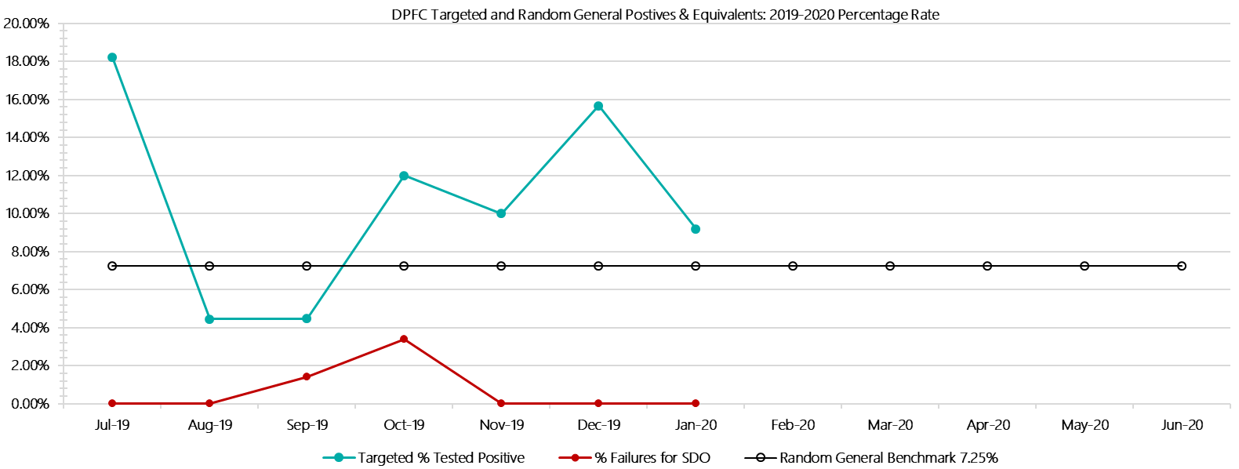

***Dame Phyllis Frost Centre Positive Test Results by Drug Type – 2019-2020  
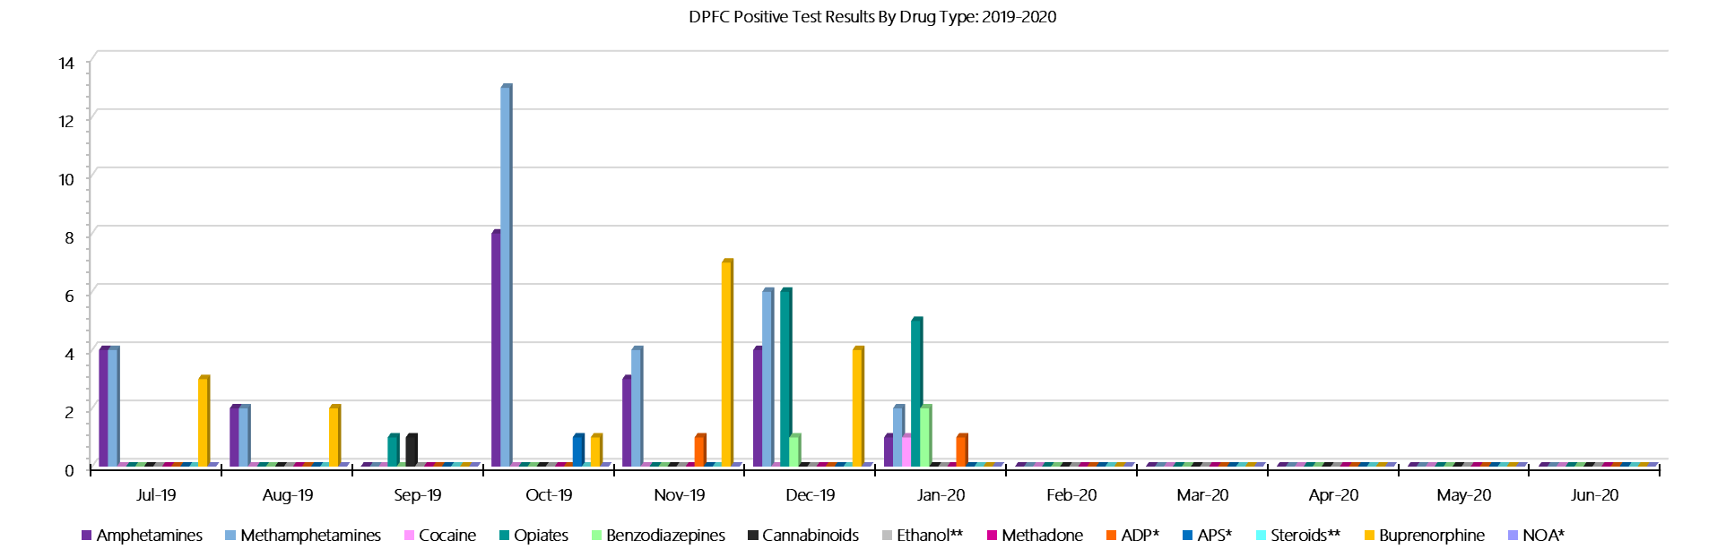***

***Dame Phyllis Frost Centre Count of Visitor Seizures Finds – 2019-2020***

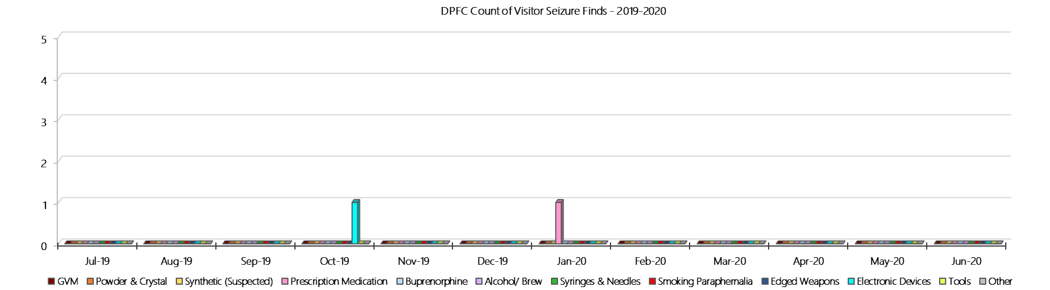

***DPFC Count of Prisoner Seizure Finds – 2019-2020***

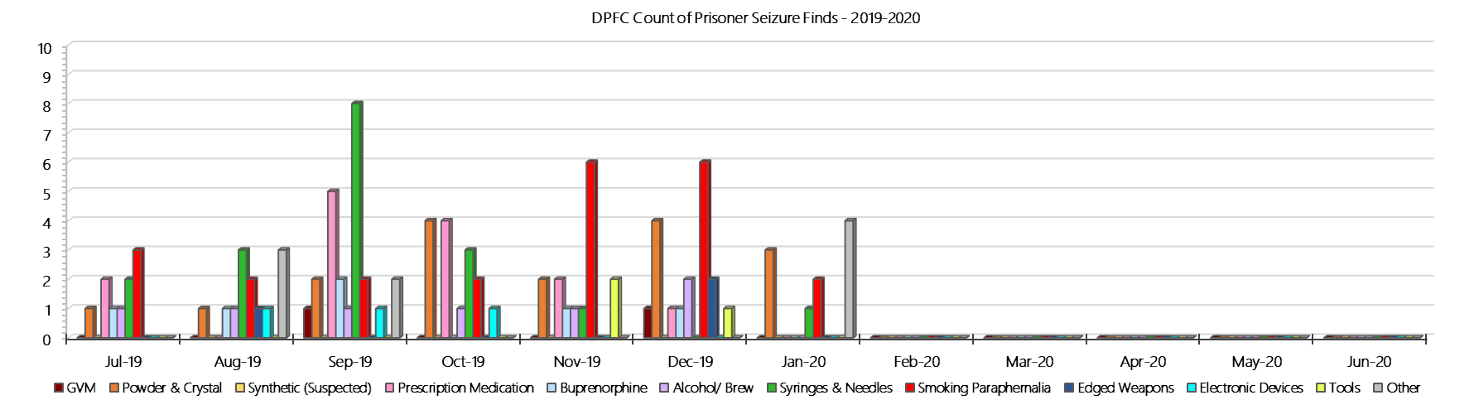

### **Fulham Correctional Centre**

***Targeted and Random General Drug Test Results: 2019-2020***

|  |  |  |  |  |  |  |  |  |  |  |  |  |  |  |
| --- | --- | --- | --- | --- | --- | --- | --- | --- | --- | --- | --- | --- | --- | --- |
| **Fulham** | **Jul-19** | **Aug-19** | **Sep-19** | **Oct-19** | **Nov-19** | **Dec-19** | **Jan-20** | **Feb-20** | **Mar-20** | **Apr-20** | **May-20** | **Jun-20** | **Average** | ***Totals*** |
| **Effective Sample - Targeted** | **224** | **204** | **204** | **197** | **193** | **198** | **206** |  |  |  |  |  | **204** | ***1426*** |
| **Targeted Positives** | **22** | **18** | **10** | **27** | **18** | **20** | **24** |  |  |  |  |  | **20** | ***139*** |
| **Refusal** | **0** | **0** | **0** | **0** | **0** | **0** | **1** |  |  |  |  |  | **0** | ***1*** |
| **Unable** | **0** | **3** | **3** | **0** | **2** | **4** | **2** |  |  |  |  |  | **2** | ***14*** |
| **Interfered** | **0** | **0** | **0** | **0** | **0** | **0** | **1** |  |  |  |  |  | **0** | ***1*** |
| **Adulterated** | **0** | **0** | **0** | **0** | **0** | **0** | **1** |  |  |  |  |  | **0** | ***1*** |
| **Targeted % Tested Positive** | **9.82%** | **10.29%** | **6.37%** | **13.71%** | **10.36%** | **12.12%** | **14.08%** | **#N/A** | **#N/A** | **#N/A** | **#N/A** | **#N/A** | **10.94%** | ***10.94%*** |
| **Awaiting / Pending Results** | **0** | **0** | **0** | **0** | **0** | **0** | **0** |  |  |  |  |  | **0** | ***0*** |
| **Targeted Residual** | **1** | **2** | **2** | **1** | **3** | **5** | **0** |  |  |  |  |  | **2** | ***14*** |
| **Random tests collected** | **76** | **61** | **73** | **57** | **60** | **74** | **63** |  |  |  |  |  | **66** | ***464*** |
| **Tested Positive** | **0** | **0** | **1** | **0** | **5** | **2** | **3** |  |  |  |  |  | **2** | ***11*** |
| **Refusal (guilty)** | **0** | **0** | **0** | **0** | **0** | **0** | **0** |  |  |  |  |  | **0** | ***0*** |
| **Unable (not guilty)** | **0** | **0** | **0** | **1** | **0** | **0** | **0** |  |  |  |  |  | **0** | ***1*** |
| **Unable (guilty)** | **0** | **0** | **1** | **0** | **0** | **1** | **1** |  |  |  |  |  | **0** | ***3*** |
| **Interfered (guilty)** | **0** | **0** | **0** | **0** | **0** | **0** | **0** |  |  |  |  |  | **0** | ***0*** |
| **No test (valid reason)** | **4** | **2** | **2** | **2** | **0** | **0** | **0** |  |  |  |  |  | **1** | ***10*** |
| **No test (no valid reason)** | **0** | **0** | **0** | **0** | **0** | **0** | **0** |  |  |  |  |  | **0** | ***0*** |
| **Adulterated** | **0** | **0** | **0** | **0** | **0** | **0** | **0** |  |  |  |  |  | **0** | ***0*** |
| **Awaiting / Pending Results** | **0** | **0** | **0** | **0** | **0** | **0** | **0** |  |  |  |  |  | **0** | ***0*** |
| **Random Residual *(PIMS URAR030)*** | **0** | **0** | **0** | **0** | **0** | **0** | **0** |  |  |  |  |  | ***0*** | ***0*** |
| **Effective Sample - Random General** | **76** | **61** | **74** | **57** | **60** | **75** | **64** |  |  |  |  |  | **67** | **467** |
| **% Tested positive** | **0.00%** | **0.00%** | **1.35%** | **0.00%** | **8.33%** | **2.67%** | **4.69%** |  |  |  |  |  | **2.43%** |  |
| **% Prisoner guilty, positive equivalents** | **0.00%** | **0.00%** | **1.35%** | **0.00%** | **0.00%** | **1.33%** | **1.56%** |  |  |  |  |  | **0.61%** |  |
| **% Total prisoner fails** | **0.00%** | **0.00%** | **2.70%** | **0.00%** | **8.33%** | **4.00%** | **6.25%** |  |  |  |  |  | **3.04%** |  |
| **% No test without valid reason** | **0.00%** | **0.00%** | **0.00%** | **0.00%** | **0.00%** | **0.00%** | **0.00%** |  |  |  |  |  | **0.00%** |  |
| **% Failures for SDO** | **0.00%** | **0.00%** | **2.70%** | **0.00%** | **8.33%** | **4.00%** | **6.25%** | **#N/A** | **#N/A** | **#N/A** | **#N/A** | **#N/A** | **3.00%** |  |

***Fulham - Drugs Identified Through Testing by Drug Type: 2019-2020***

|  |  |  |  |  |  |  |  |  |  |  |  |  |  |  |
| --- | --- | --- | --- | --- | --- | --- | --- | --- | --- | --- | --- | --- | --- | --- |
| **Fulham** | ***Amphetamines*** | ***Methamphetamines*** | ***Cocaine*** | ***Opiates*** | ***Benzodiazepines*** | ***Cannabinoids*** | ***Ethanol\*\**** | ***Methadone*** | ***ADP\**** | ***APS\**** | ***Steroids\*\**** | ***Buprenorphine*** | ***NOA\**** | **Total** |
| **Jul-19** | **0** | **0** | **0** | **2** | **0** | **1** | **0** | **1** | **3** | **1** | **0** | **17** | **0** | **25** |
| **Aug-19** | **2** | **3** | **0** | **0** | **0** | **0** | **0** | **0** | **6** | **2** | **0** | **11** | **0** | **24** |
| **Sep-19** | **0** | **0** | **0** | **3** | **1** | **0** | **0** | **0** | **1** | **0** | **0** | **6** | **0** | **11** |
| **Oct-19** | **0** | **0** | **0** | **0** | **1** | **0** | **0** | **1** | **5** | **2** | **0** | **24** | **0** | **33** |
| **Nov-19** | **0** | **0** | **0** | **2** | **2** | **0** | **0** | **0** | **5** | **0** | **0** | **20** | **0** | **29** |
| **Dec-19** | **0** | **3** | **0** | **0** | **0** | **0** | **0** | **0** | **2** | **3** | **0** | **15** | **0** | **23** |
| **Jan-20** | **6** | **9** | **0** | **0** | **0** | **0** | **0** | **0** | **2** | **1** | **0** | **22** | **0** | **40** |
| **Feb-20** |  |  |  |  |  |  |  |  |  |  |  |  |  |  |
| **Mar-20** |  |  |  |  |  |  |  |  |  |  |  |  |  |  |
| **Apr-20** |  |  |  |  |  |  |  |  |  |  |  |  |  |  |
| **May-20** |  |  |  |  |  |  |  |  |  |  |  |  |  |  |
| **Jun-20** |  |  |  |  |  |  |  |  |  |  |  |  |  |  |
| **Fuham YTD** | **8** | **15** | **0** | **7** | **4** | **1** | **0** | **2** | **24** | **9** | **0** | **115** | **0** | **185** |
| ***All Prisons YTD*** | ***111*** | ***184*** | ***2*** | ***31*** | ***26*** | ***21*** | ***18*** | ***25*** | ***33*** | ***12*** | ***0*** | ***1397*** | ***0*** | ***1860*** |
| ***Fulham % of Total*** | ***7.21%*** | ***8.15%*** | ***0.00%*** | ***22.58%*** | ***15.38%*** | ***4.76%*** | ***0.00%*** | ***8.00%*** | ***72.73%*** | ***75.00%*** | ***0.00%*** | ***8.23%*** | ***0.00%*** | ***9.95%*** |

***Fulham Seizures of Contraband: Visitors & Prisoners: 2019-2020***

|  |  |  |  |  |  |  |  |  |  |  |  |  |  |  |  |  |  |  |  |  |  |  |  |  |
| --- | --- | --- | --- | --- | --- | --- | --- | --- | --- | --- | --- | --- | --- | --- | --- | --- | --- | --- | --- | --- | --- | --- | --- | --- |
| **Visitors** | **GVM** | | **Powder  & Crystal** | | **Synthetic  (Suspected)** | | **Prescription  Medication** | | **Buprenorphine** | | **Alcohol &  Home Brew** | | **Syringes & Needles** | | **Smoking  Paraphernalia** | | **Edged  Weapons** | | **Electronic  Devices** | | **Tools** | | **Other** | |
| **Fulham** | **Finds** | **Gms** | **Finds** | **Gms** | **Finds** | **Gms** | **Finds** | **Qty** | **Finds** | **Qty** | **Finds** | **Ltrs** | **Finds** | **Qty** | **Finds** | **Qty** | **Finds** | **Qty** | **Finds** | **Qty** | **Finds** | **Qty** | **Finds** | **Qty** |
| **Jul-19** | **0** | **0.00** | **0** | **0.00** | **0** | **0.00** | **0** | **0.00** | **0** | **0.00** | **0** | **0.000** | **0** | **0** | **1** | **4** | **0** | **0** | **0** | **0** | **0** | **0** | **0** | **0** |
| **Aug-19** | **0** | **0** | **0** | **0** | **0** | **0** | **0** | **0** | **0** | **0** | **0** | **0** | **1** | **1** | **2** | **2** | **0** | **0** | **0** | **0** | **0** | **0** | **2** | **10** |
| **Sep-19** | **0** | **0.00** | **0** | **0.00** | **0** | **0.00** | **0** | **0.00** | **0** | **0.00** | **0** | **0.000** | **0** | **0** | **0** | **0** | **0** | **0** | **0** | **0** | **0** | **0** | **0** | **0** |
| **Oct-19** | **0** | **0.00** | **0** | **0.00** | **0** | **0.00** | **0** | **0.00** | **0** | **0.00** | **0** | **0.000** | **0** | **0** | **2** | **4** | **0** | **0** | **0** | **0** | **0** | **0** | **0** | **0** |
| **Nov-19** | **0** | **0.00** | **0** | **0.00** | **0** | **0.00** | **0** | **0.00** | **0** | **0.00** | **0** | **0.000** | **0** | **0** | **0** | **0** | **0** | **0** | **0** | **0** | **0** | **0** | **1** | **1** |
| **Dec-19** | **0** | **0.00** | **0** | **0.00** | **0** | **0.00** | **0** | **0.00** | **0** | **0.00** | **0** | **0.000** | **0** | **0** | **2** | **4** | **0** | **0** | **0** | **0** | **0** | **0** | **0** | **0** |
| **Jan-20** |  |  |  |  |  |  |  |  |  |  |  |  |  |  |  |  |  |  |  |  |  |  |  |  |
| **Feb-20** |  |  |  |  |  |  |  |  |  |  |  |  |  |  |  |  |  |  |  |  |  |  |  |  |
| **Mar-20** |  |  |  |  |  |  |  |  |  |  |  |  |  |  |  |  |  |  |  |  |  |  |  |  |
| **Apr-20** |  |  |  |  |  |  |  |  |  |  |  |  |  |  |  |  |  |  |  |  |  |  |  |  |
| **May-20** |  |  |  |  |  |  |  |  |  |  |  |  |  |  |  |  |  |  |  |  |  |  |  |  |
| **Jun-20** |  |  |  |  |  |  |  |  |  |  |  |  |  |  |  |  |  |  |  |  |  |  |  |  |
| **Total** | **0** | **0.00** | **0** | **0.00** | **0** | **0.00** | **0** | **0.00** | **0** | **0.00** | **0** | **0.000** | **1** | **1** | **7** | **14** | **0** | **0** | **0** | **0** | **0** | **0** | **3** | **11** |

|  |  |  |  |  |  |  |  |  |  |  |  |  |  |  |  |  |  |  |  |  |  |  |  |  |  |  |
| --- | --- | --- | --- | --- | --- | --- | --- | --- | --- | --- | --- | --- | --- | --- | --- | --- | --- | --- | --- | --- | --- | --- | --- | --- | --- | --- |
| **Prisoners** | **GVM** | | **Powder  & Crystal** | | **Synthetic  (Suspected)** | | **Prescription  Medication** | | **Buprenorphine** | | **Alcohol &  Home Brew** | | **Syringes & Needles** | | **Smoking  Paraphernalia** | | | **Edged  Weapons** | | **Electronic  Devices** | | **Tools** | | **Other** | | |
| **Fulham** | **Finds** | **Gms** | **Finds** | **Gms** | **Finds** | **Gms** | **Finds** | **Qty** | **Finds** | **Qty** | **Finds** | **Ltrs** | **Finds** | **Qty** | **Finds** | **Qty** | | **Finds** | **Qty** | **Finds** | **Qty** | **Finds** | **Qty** | **Finds** | **Qty** |
| **Jul-19** | **0** | **0.00** | **1** | **0.01** | **0** | **0.00** | **7** | **21.50** | **7** | **4.00** | **2** | **2.000** | **2** | **2** | **20** | | **103** | **2** | **3** | **3** | **3** | **3** | **4** | **6** | **7** |
| **Aug-19** | **0** | **0.00** | **2** | **1.50** | **0** | **0.00** | **6** | **6.00** | **4** | **20.80** | **3** | **3.600** | **1** | **1** | **20** | | **31** | **2** | **2** | **2** | **4** | **5** | **11** | **12** | **13** |
| **Sep-19** | **0** | **0.00** | **0** | **0.00** | **0** | **0.00** | **11** | **29.75** | **9** | **4.80** | **4** | **4.500** | **1** | **3** | **21** | | **31** | **12** | **16** | **1** | **3** | **5** | **20** | **1** | **1** |
| **Oct-19** | **1** | **0.20** | **0** | **0.00** | **0** | **0.00** | **6** | **12.00** | **5** | **3.30** | **2** | **1.200** | **1** | **1** | **30** | | **87** | **8** | **10** | **0** | **0** | **10** | **21** | **6** | **7** |
| **Nov-19** | **0** | **0.00** | **0** | **0.00** | **0** | **0.00** | **8** | **14.50** | **10** | **4.40** | **3** | **7.000** | **1** | **1** | **38** | | **63** | **5** | **6** | **2** | **2** | **14** | **34** | **7** | **7** |
| **Dec-19** | **0** | **0.00** | **0** | **0.00** | **0** | **0.00** | **9** | **13.50** | **10** | **0.00** | **2** | **2.000** | **2** | **3** | **25** | | **58** | **2** | **2** | **3** | **3** | **13** | **31** | **11** | **15** |
| **Jan-20** | **0** | **0.00** | **0** | **0.00** | **0** | **0.00** | **0** | **0.00** | **0** | **0.00** | **0** | **0.000** | **1** | **2** | **2** | | **4** | **0** | **0** | **0** | **0** | **0** | **0** | **0** | **0** |
| **Feb-20** |  |  |  |  |  |  |  |  |  |  |  |  |  |  |  | |  |  |  |  |  |  |  |  |  |
| **Mar-20** |  |  |  |  |  |  |  |  |  |  |  |  |  |  |  | |  |  |  |  |  |  |  |  |  |
| **Apr-20** |  |  |  |  |  |  |  |  |  |  |  |  |  |  |  | |  |  |  |  |  |  |  |  |  |
| **May-20** |  |  |  |  |  |  |  |  |  |  |  |  |  |  |  | |  |  |  |  |  |  |  |  |  |
| **Jun-20** |  |  |  |  |  |  |  |  |  |  |  |  |  |  |  | |  |  |  |  |  |  |  |  |  |
| **Total** | **0** | **0.00** | **0** | **0.00** | **0** | **0.00** | **0** | **0.00** | **0** | **0.00** | **0** | **0.000** | **2** | **3** | **9** | | **18** | **0** | **0** | **0** | **0** | **0** | **0** | **3** | **11** |

***Fulham Targeted and Random General Drug Test Positives & Equivalents: 2019-2020***

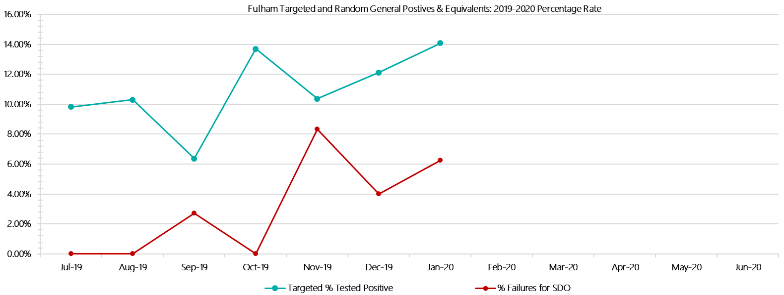

***Fulham Positive Test Results by Drug Type: 2019-2020***

**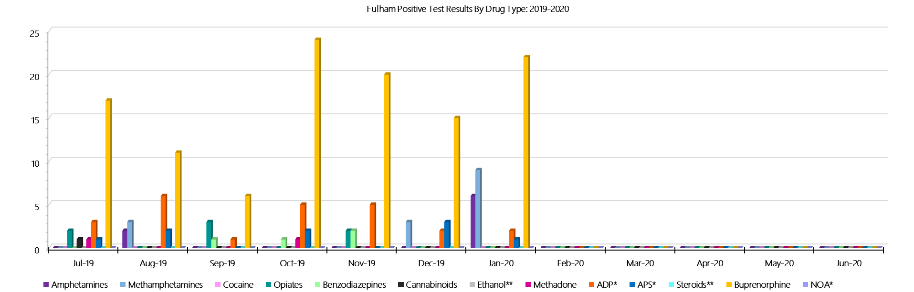*Fulham Count of Visitor Seizures Finds: 2019-2020***

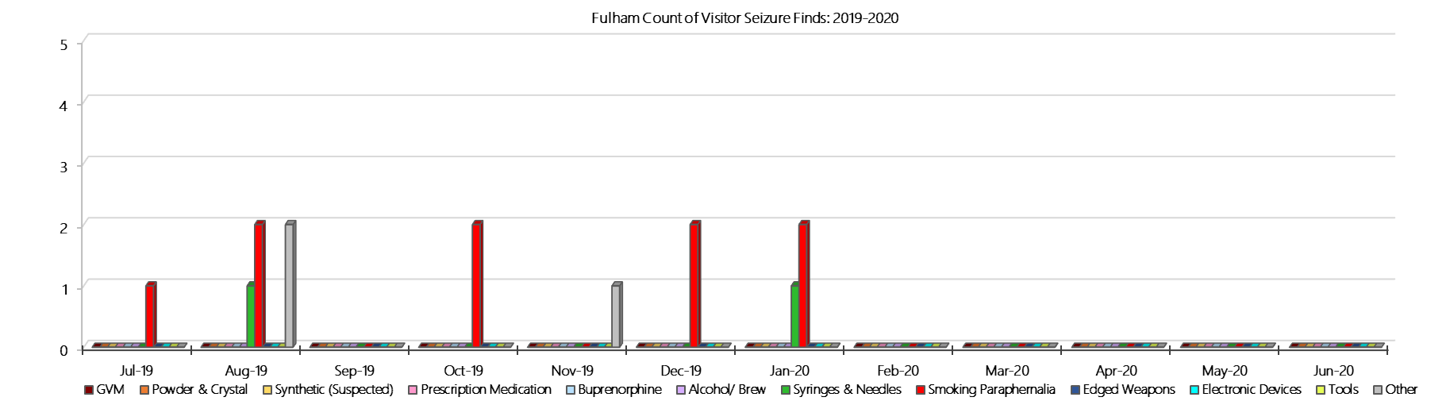

***Fulham Count of Prisoner Seizure Finds: 2019-2020***

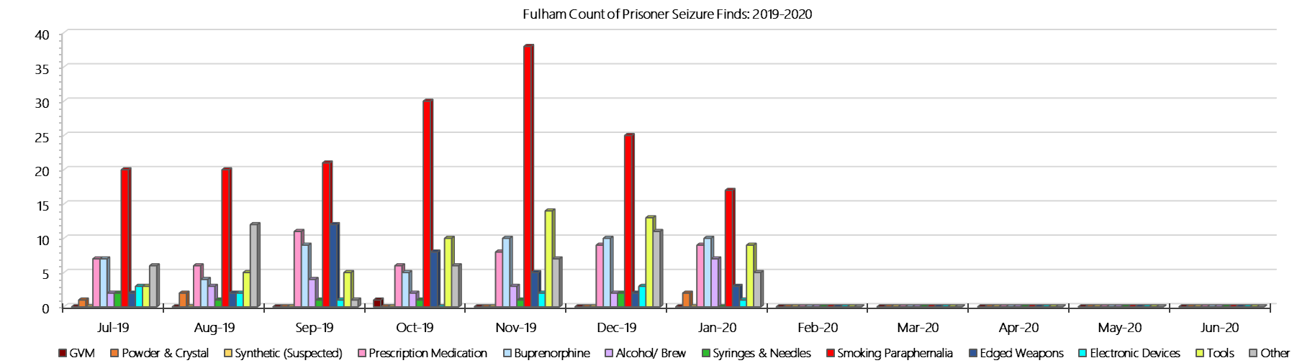

### **Hopkins Correctional Centre**

***Targeted and Random General Drug Test Results: 2019-2020***

|  |  |  |  |  |  |  |  |  |  |  |  |  |  |  |
| --- | --- | --- | --- | --- | --- | --- | --- | --- | --- | --- | --- | --- | --- | --- |
| **Hopkins** | **Jul-19** | **Aug-19** | **Sep-19** | **Oct-19** | **Nov-19** | **Dec-19** | **Jan-20** | **Feb-20** | **Mar-20** | **Apr-20** | **May-20** | **Jun-20** | **Average** | ***Totals*** |
| **Effective Sample - Targeted** | **22** | **7** | **13** | **16** | **31** | **28** | **36** |  |  |  |  |  | **22** | ***153*** |
| **Targeted Positives** | **2** | **1** | **0** | **2** | **6** | **4** | **4** |  |  |  |  |  | **3** | ***19*** |
| **Refusal** | **1** | **0** | **0** | **0** | **2** | **0** | **0** |  |  |  |  |  | **0** | ***3*** |
| **Unable** | **0** | **0** | **0** | **1** | **1** | **2** | **0** |  |  |  |  |  | **1** | ***4*** |
| **Interfered** | **0** | **0** | **0** | **0** | **0** | **0** | **0** |  |  |  |  |  | **0** | ***0*** |
| **Adulterated** | **0** | **0** | **0** | **0** | **0** | **0** | **0** |  |  |  |  |  | **0** | ***0*** |
| **Targeted % Tested Positive** | **13.64%** | **14.29%** | **0.00%** | **18.75%** | **29.03%** | **21.43%** | **11.11%** | **#N/A** | **#N/A** | **#N/A** | **#N/A** | **#N/A** | **16.99%** | ***16.99%*** |
| **Awaiting / Pending Results** | **0** | **0** | **0** | **0** | **0** | **0** | **0** |  |  |  |  |  | **0** | ***0*** |
| **Targeted Residual** | **0** | **0** | **0** | **0** | **0** | **1** | **0** |  |  |  |  |  | **0** | ***1*** |
| **Random tests collected** | **107** | **85** | **108** | **91** | **91** | **111** | **93** |  |  |  |  |  | **98** | ***686*** |
| **Tested Positive** | **2** | **1** | **2** | **5** | **2** | **1** | **1** |  |  |  |  |  | **2** | ***14*** |
| **Refusal (guilty)** | **0** | **0** | **0** | **0** | **0** | **0** | **0** |  |  |  |  |  | **0** | ***0*** |
| **Unable (not guilty)** | **0** | **0** | **0** | **1** | **1** | **0** | **0** |  |  |  |  |  | **0** | ***2*** |
| **Unable (guilty)** | **0** | **0** | **2** | **0** | **0** | **0** | **1** |  |  |  |  |  | **0** | ***3*** |
| **Interfered (guilty)** | **0** | **0** | **0** | **0** | **0** | **0** | **0** |  |  |  |  |  | **0** | ***0*** |
| **No test (valid reason)** | **0** | **0** | **0** | **0** | **1** | **4** | **0** |  |  |  |  |  | **1** | ***5*** |
| **No test (no valid reason)** | **0** | **0** | **0** | **0** | **0** | **0** | **0** |  |  |  |  |  | **0** | ***0*** |
| **Adulterated** | **0** | **0** | **0** | **0** | **0** | **0** | **0** |  |  |  |  |  | **0** | ***0*** |
| **Awaiting / Pending Results** | **0** | **0** | **0** | **0** | **0** | **0** | **1** |  |  |  |  |  | **0** | ***1*** |
| **Random Residual *(PIMS URAR030)*** | **0** | **0** | **0** | **0** | **0** | **0** | **0** |  |  |  |  |  | ***0*** | ***0*** |
| **Effective Sample - Random General** | **107** | **85** | **110** | **91** | **91** | **111** | **94** |  |  |  |  |  | **98** | **689** |
| **% Tested positive** | **1.87%** | **1.18%** | **1.82%** | **5.49%** | **2.20%** | **0.90%** | **1.06%** |  |  |  |  |  | **2.07%** |  |
| **% Prisoner guilty, positive equivalents** | **0.00%** | **0.00%** | **1.82%** | **0.00%** | **0.00%** | **0.00%** | **1.06%** |  |  |  |  |  | **0.41%** |  |
| **% Total prisoner fails** | **1.87%** | **1.18%** | **3.64%** | **5.49%** | **2.20%** | **0.90%** | **2.13%** |  |  |  |  |  | **2.49%** |  |
| **% No test without valid reason** | **0.00%** | **0.00%** | **0.00%** | **0.00%** | **0.00%** | **0.00%** | **0.00%** |  |  |  |  |  | **0.00%** |  |
| ***Random General Benchmark 3.50%*** | ***3.50%*** | ***3.50%*** | ***3.50%*** | ***3.50%*** | ***3.50%*** | ***3.50%*** | ***3.50%*** | ***3.50%*** | ***3.50%*** | ***3.50%*** | ***3.50%*** | ***3.50%*** | ***YTD*** |  |
| **% Failures for SDO** | **1.87%** | **1.18%** | **3.64%** | **5.49%** | **2.20%** | **0.90%** | **2.13%** | **#N/A** | **#N/A** | **#N/A** | **#N/A** | **#N/A** | **2.47%** |  |

***Hopkins - Drugs Identified Through Testing by Drug Type: 2019-2020***

|  |  |  |  |  |  |  |  |  |  |  |  |  |  |  |
| --- | --- | --- | --- | --- | --- | --- | --- | --- | --- | --- | --- | --- | --- | --- |
| **Hopkins** | ***Amphetamines*** | ***Methamphetamines*** | ***Cocaine*** | ***Opiates*** | ***Benzodiazepines*** | ***Cannabinoids*** | ***Ethanol\*\**** | ***Methadone*** | ***ADP\**** | ***APS\**** | ***Steroids\*\**** | ***Buprenorphine*** | ***NOA\**** | **Total** |
| **Jul-19** | **0** | **0** | **0** | **0** | **0** | **0** | **0** | **0** | **0** | **0** | **0** | **3** | **0** | **3** |
| **Aug-19** | **0** | **0** | **0** | **0** | **0** | **0** | **0** | **0** | **0** | **0** | **0** | **4** | **0** | **4** |
| **Sep-19** | **0** | **0** | **0** | **0** | **0** | **0** | **0** | **0** | **0** | **0** | **0** | **2** | **0** | **2** |
| **Oct-19** | **0** | **0** | **0** | **0** | **0** | **0** | **0** | **0** | **0** | **0** | **0** | **10** | **0** | **10** |
| **Nov-19** | **0** | **1** | **0** | **0** | **1** | **0** | **0** | **0** | **0** | **0** | **0** | **7** | **0** | **9** |
| **Dec-19** | **3** | **3** | **0** | **0** | **0** | **0** | **0** | **0** | **0** | **0** | **0** | **3** | **0** | **9** |
| **Jan-20** | **0** | **0** | **0** | **0** | **0** | **0** | **0** | **0** | **0** | **0** | **0** | **6** | **0** | **6** |
| **Feb-20** |  |  |  |  |  |  |  |  |  |  |  |  |  |  |
| **Mar-20** |  |  |  |  |  |  |  |  |  |  |  |  |  |  |
| **Apr-20** |  |  |  |  |  |  |  |  |  |  |  |  |  |  |
| **May-20** |  |  |  |  |  |  |  |  |  |  |  |  |  |  |
| **Jun-20** |  |  |  |  |  |  |  |  |  |  |  |  |  |  |
| **Hopkins YTD** | **3** | **4** | **0** | **0** | **1** | **0** | **0** | **0** | **0** | **0** | **0** | **35** | **0** | **43** |
| ***All Prisons YTD*** | ***111*** | ***184*** | ***2*** | ***31*** | ***26*** | ***21*** | ***18*** | ***25*** | ***33*** | ***12*** | ***0*** | ***1397*** | ***0*** | ***1860*** |
| ***Hopkins % of Total*** | ***2.70%*** | ***2.17%*** | ***0.00%*** | ***0.00%*** | ***3.85%*** | ***0.00%*** | ***0.00%*** | ***0.00%*** | ***0.00%*** | ***0.00%*** | ***0.00%*** | ***2.51%*** | ***0.00%*** | ***2.31%*** |

***Hopkins Seizures of Contraband: Visitors & Prisoners: 2019-2020***

|  |  |  |  |  |  |  |  |  |  |  |  |  |  |  |  |  |  |  |  |  |  |  |  |  |
| --- | --- | --- | --- | --- | --- | --- | --- | --- | --- | --- | --- | --- | --- | --- | --- | --- | --- | --- | --- | --- | --- | --- | --- | --- |
| **Visitors** | **GVM** | | **Powder  & Crystal** | | **Synthetic  (Suspected)** | | **Prescription  Medication** | | **Buprenorphine** | | **Alcohol &  Home Brew** | | **Syringes & Needles** | | **Smoking  Paraphernalia** | | **Edged  Weapons** | | **Electronic  Devices** | | **Tools** | | **Other** | |
| **Hopkins** | **Finds** | **Gms** | **Finds** | **Gms** | **Finds** | **Gms** | **Finds** | **Qty** | **Finds** | **Qty** | **Finds** | **Ltrs** | **Finds** | **Qty** | **Finds** | **Qty** | **Finds** | **Qty** | **Finds** | **Qty** | **Finds** | **Qty** | **Finds** | **Qty** |
| **Jul-19** | **0** | **0.00** | **0** | **0.00** | **0** | **0.00** | **0** | **0.00** | **0** | **0.00** | **0** | **0.000** | **0** | **0** | **0** | **0** | **0** | **0** | **0** | **0** | **0** | **0** | **0** | **0** |
| **Aug-19** | **0** | **0.00** | **0** | **0.00** | **0** | **0.00** | **0** | **0.00** | **0** | **0.00** | **0** | **0.000** | **0** | **0** | **0** | **0** | **0** | **0** | **0** | **0** | **0** | **0** | **0** | **0** |
| **Sep-19** | **1** | **1.12** | **0** | **0.00** | **0** | **0.00** | **0** | **0.00** | **0** | **0.00** | **0** | **0.000** | **0** | **0** | **0** | **0** | **0** | **0** | **0** | **0** | **0** | **0** | **0** | **0** |
| **Oct-19** | **0** | **0.00** | **1** | **1.20** | **0** | **0.00** | **0** | **0.00** | **0** | **0.00** | **0** | **0.000** | **0** | **0** | **1** | **1** | **0** | **0** | **0** | **0** | **0** | **0** | **0** | **0** |
| **Nov-19** | **0** | **0.00** | **0** | **0.00** | **0** | **0.00** | **0** | **0.00** | **0** | **0.00** | **0** | **0.000** | **0** | **0** | **0** | **0** | **0** | **0** | **0** | **0** | **0** | **0** | **0** | **0** |
| **Dec-19** | **0** | **0.00** | **1** | **0.69** | **0** | **0.00** | **0** | **0.00** | **0** | **0.00** | **0** | **0.000** | **0** | **0** | **1** | **1** | **0** | **0** | **0** | **0** | **0** | **0** | **0** | **0** |
| **Jan-20** | **0** | **0.00** | **0** | **0.00** | **0** | **0.00** | **0** | **0.00** | **0** | **0.00** | **0** | **0.000** | **0** | **0** | **0** | **0** | **0** | **0** | **0** | **0** | **0** | **0** | **0** | **0** |
| **Feb-20** |  |  |  |  |  |  |  |  |  |  |  |  |  |  |  |  |  |  |  |  |  |  |  |  |
| **Mar-20** |  |  |  |  |  |  |  |  |  |  |  |  |  |  |  |  |  |  |  |  |  |  |  |  |
| **Apr-20** |  |  |  |  |  |  |  |  |  |  |  |  |  |  |  |  |  |  |  |  |  |  |  |  |
| **May-20** |  |  |  |  |  |  |  |  |  |  |  |  |  |  |  |  |  |  |  |  |  |  |  |  |
| **Jun-20** |  |  |  |  |  |  |  |  |  |  |  |  |  |  |  |  |  |  |  |  |  |  |  |  |
| **Total** | **1** | **1.12** | **2** | **1.89** | **0** | **0.00** | **0** | **0.00** | **0** | **0.00** | **0** | **0.000** | **0** | **0** | **2** | **2** | **0** | **0** | **0** | **0** | **0** | **0** | **0** | **0** |

|  |  |  |  |  |  |  |  |  |  |  |  |  |  |  |  |  |  |  |  |  |  |  |  |  |  |
| --- | --- | --- | --- | --- | --- | --- | --- | --- | --- | --- | --- | --- | --- | --- | --- | --- | --- | --- | --- | --- | --- | --- | --- | --- | --- |
| **Prisoners** | **GVM** | | **Powder  & Crystal** | | **Synthetic  (Suspected)** | | **Prescription  Medication** | | **Buprenorphine** | | **Alcohol &  Home Brew** | | **Syringes & Needles** | | **Smoking  Paraphernalia** | | | **Edged  Weapons** | | **Electronic  Devices** | | **Tools** | | **Other** | |
| **Hopkins** | **Finds** | **Gms** | **Finds** | **Gms** | **Finds** | **Gms** | **Finds** | **Qty** | **Finds** | **Qty** | **Finds** | **Ltrs** | **Finds** | **Qty** | **Finds** | **Qty** | | **Finds** | **Qty** | **Finds** | **Qty** | **Finds** | **Qty** | **Finds** | **Qty** |
| **Jul-19** | **0** | **0.00** | **0** | **0.00** | **0** | **0.00** | **0** | **0.00** | **2** | **0.30** | **0** | **0.000** | **3** | **3** | **2** | | **10** | **0** | **0** | **0** | **0** | **0** | **0** | **1** | **1** |
| **Aug-19** | **0** | **0.00** | **0** | **0.00** | **0** | **0.00** | **0** | **0.00** | **9** | **17.00** | **0** | **0.000** | **1** | **1** | **9** | | **21** | **2** | **2** | **0** | **0** | **0** | **0** | **0** | **0** |
| **Sep-19** | **0** | **0.00** | **0** | **0.00** | **0** | **0.00** | **0** | **0.00** | **3** | **0.40** | **0** | **0.000** | **0** | **0** | **3** | | **3** | **2** | **2** | **0** | **0** | **0** | **0** | **0** | **0** |
| **Oct-19** | **0** | **0.00** | **0** | **0.00** | **0** | **0.00** | **0** | **0.00** | **1** | **0.30** | **0** | **0.000** | **0** | **0** | **3** | | **5** | **1** | **1** | **1** | **1** | **1** | **1** | **2** | **2** |
| **Nov-19** | **0** | **0.00** | **0** | **0.00** | **0** | **0.00** | **2** | **5.50** | **0** | **0.00** | **0** | **0.000** | **2** | **2** | **2** | | **4** | **1** | **1** | **0** | **0** | **2** | **6** | **0** | **0** |
| **Dec-19** | **0** | **0.00** | **0** | **0.00** | **0** | **0.00** | **0** | **0.00** | **0** | **0.00** | **0** | **0.000** | **1** | **1** | **1** | | **1** | **1** | **1** | **0** | **0** | **0** | **0** | **0** | **0** |
| **Jan-20** | **0** | **0.00** | **0** | **0.00** | **0** | **0.00** | **3** | **6.00** | **7** | **15.00** | **0** | **0.000** | **2** | **2** | **5** | | **31** | **2** | **2** | **1** | **1** | **0** | **0** | **1** | **1** |
| **Feb-20** |  |  |  |  |  |  |  |  |  |  |  |  |  |  |  | |  |  |  |  |  |  |  |  |  |
| **Mar-20** |  |  |  |  |  |  |  |  |  |  |  |  |  |  |  | |  |  |  |  |  |  |  |  |  |
| **Apr-20** |  |  |  |  |  |  |  |  |  |  |  |  |  |  |  | |  |  |  |  |  |  |  |  |  |
| **May-20** |  |  |  |  |  |  |  |  |  |  |  |  |  |  |  | |  |  |  |  |  |  |  |  |  |
| **Jun-20** |  |  |  |  |  |  |  |  |  |  |  |  |  |  |  | |  |  |  |  |  |  |  |  |  |
| **Total** | **0** | **0.00** | **0** | **0.00** | **0** | **0.00** | **5** | **11.50** | **22** | **33.00** | **0** | **0.000** | **9** | **9** | **25** | | **75** | **9** | **9** | **2** | **2** | **3** | **7** | **4** | **4** |

***Hopkins Targeted and Random General Drug Test Positives & Equivalents: 2019-2020***

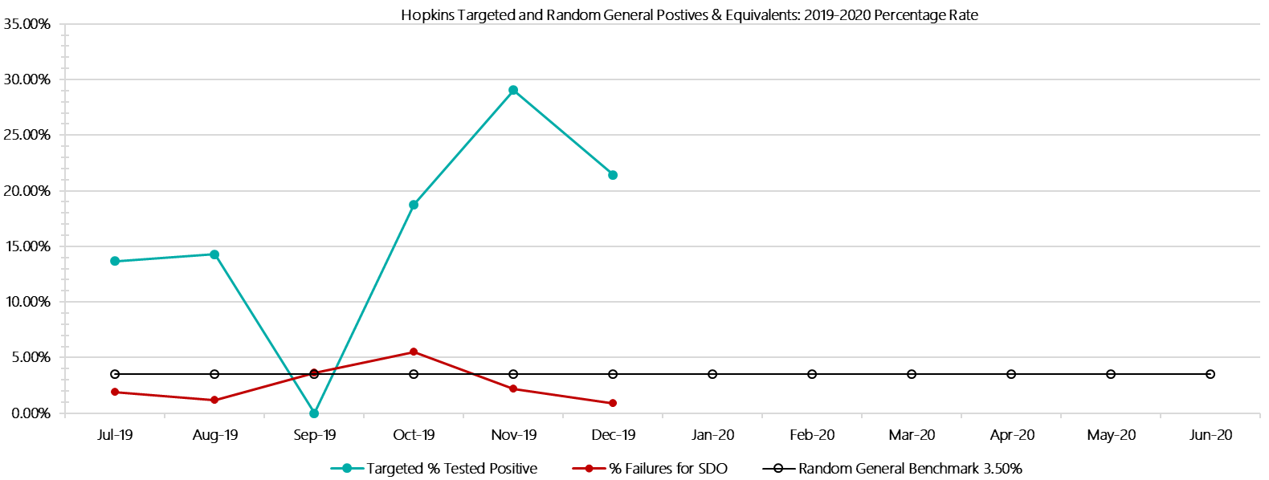

***Hopkins Positive Test Results by Drug Type: 2019-2020***

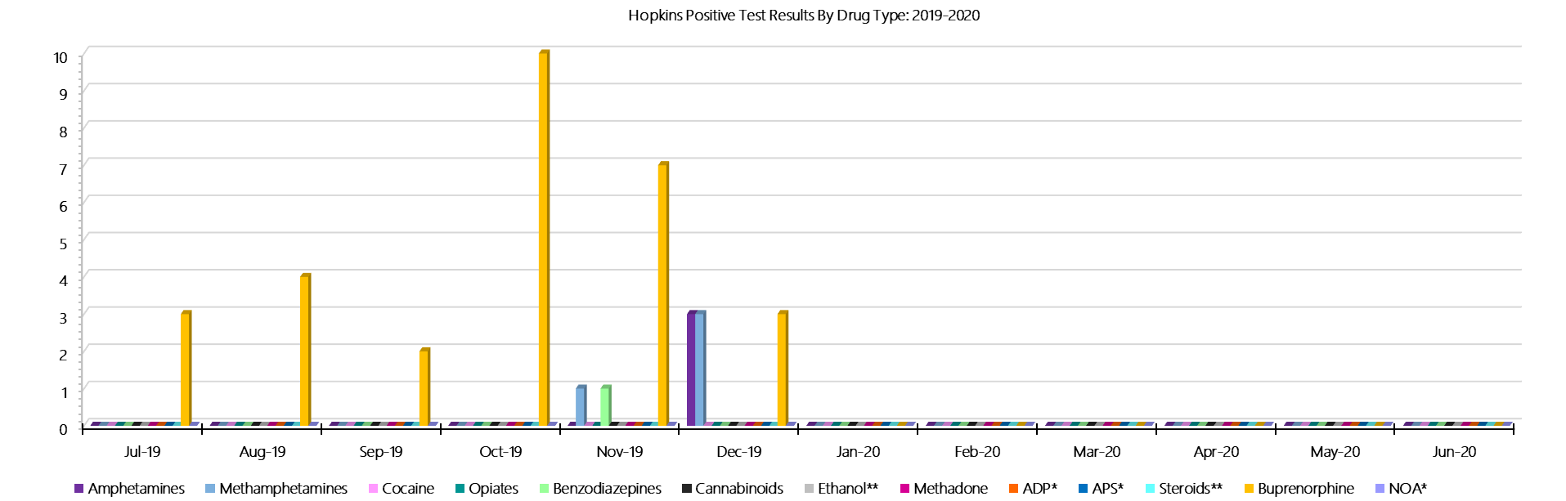

***Hopkins Count of Visitor Seizures Finds: 2019-2020***

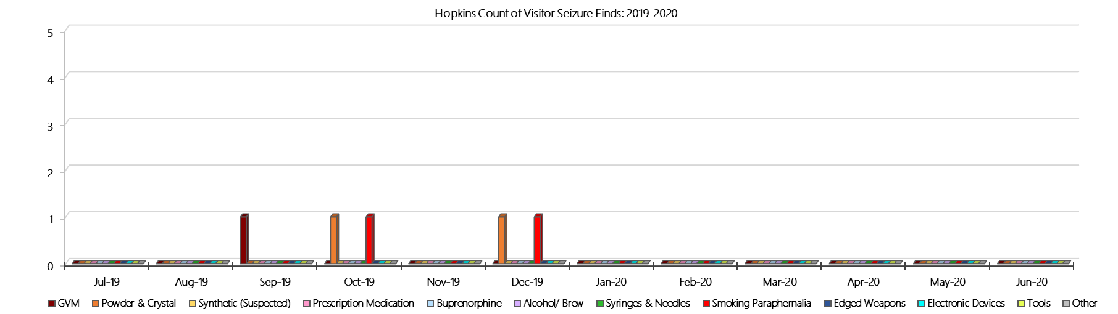

***Hopkins Count of Prisoner Seizure Finds: 2019-2020***

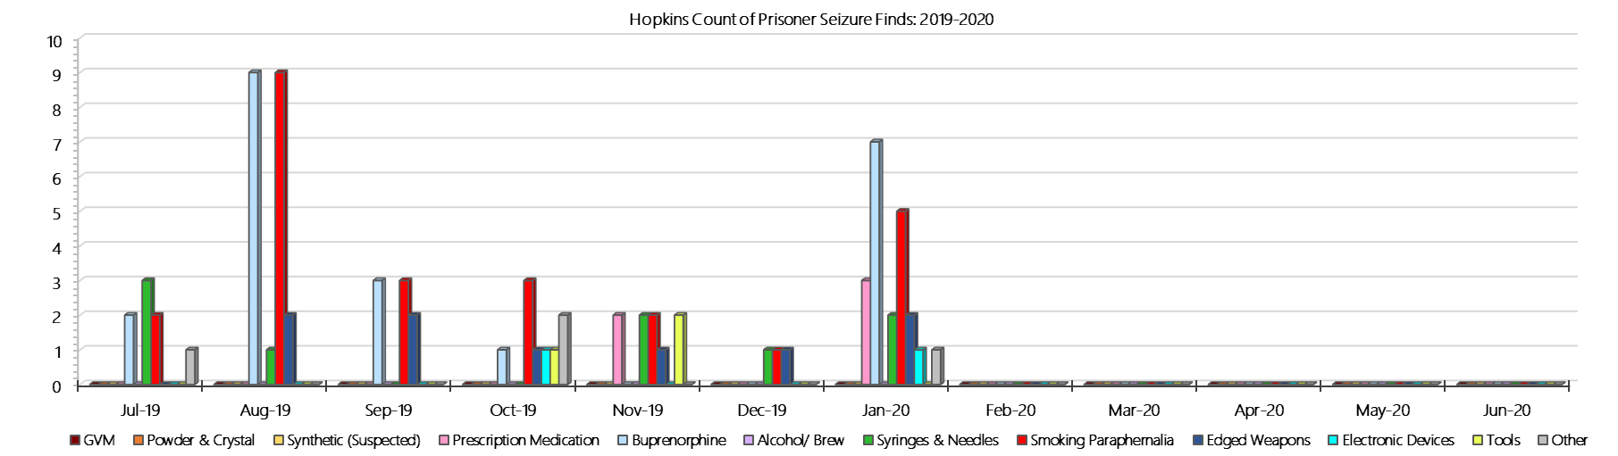

### **Karreenga (annex of Marngoneet)**

***Targeted and Random General Drug Test Results: 2019-2020***

|  |  |  |  |  |  |  |  |  |  |  |  |  |  |  |
| --- | --- | --- | --- | --- | --- | --- | --- | --- | --- | --- | --- | --- | --- | --- |
| **Karreenga** | **Jul-19** | **Aug-19** | **Sep-19** | **Oct-19** | **Nov-19** | **Dec-19** | **Jan-20** | **Feb-20** | **Mar-20** | **Apr-20** | **May-20** | **Jun-20** | **Average** | ***Totals*** |
| **Effective Sample - Targeted** | **44** | **41** | **23** | **34** | **24** | **27** | **33** |  |  |  |  |  | **32** | ***226*** |
| **Targeted Positives** | **4** | **3** | **3** | **3** | **3** | **0** | **0** |  |  |  |  |  | **2** | ***16*** |
| **Refusal** | **0** | **0** | **0** | **0** | **0** | **0** | **0** |  |  |  |  |  | **0** | ***0*** |
| **Unable** | **0** | **1** | **0** | **2** | **0** | **1** | **2** |  |  |  |  |  | **1** | ***6*** |
| **Interfered** | **1** | **0** | **0** | **0** | **0** | **0** | **0** |  |  |  |  |  | **0** | ***1*** |
| **Adulterated** | **0** | **0** | **0** | **0** | **0** | **0** | **0** |  |  |  |  |  | **0** | ***0*** |
| **Targeted % Tested Positive** | **11.36%** | **9.76%** | **13.04%** | **14.71%** | **12.50%** | **3.70%** | **6.06%** | **#N/A** | **#N/A** | **#N/A** | **#N/A** | **#N/A** | **10.18%** | ***10.18%*** |
| **Awaiting / Pending Results** | **0** | **0** | **0** | **0** | **0** | **0** | **1** |  |  |  |  |  | **0** | ***1*** |
| **Targeted Residual** | **0** | **1** | **0** | **0** | **0** | **0** | **0** |  |  |  |  |  | **0** | ***1*** |
| **Random tests collected** | **42** | **34** | **43** | **36** | **36** | **40** | **31** |  |  |  |  |  | **37** | ***262*** |
| **Tested Positive** | **0** | **2** | **0** | **0** | **0** | **1** | **0** |  |  |  |  |  | **0** | ***3*** |
| **Refusal (guilty)** | **0** | **0** | **0** | **0** | **0** | **0** | **0** |  |  |  |  |  | **0** | ***0*** |
| **Unable (not guilty)** | **0** | **0** | **0** | **0** | **0** | **0** | **0** |  |  |  |  |  | **0** | ***0*** |
| **Unable (guilty)** | **2** | **1** | **0** | **0** | **0** | **0** | **1** |  |  |  |  |  | **1** | ***4*** |
| **Interfered (guilty)** | **0** | **0** | **0** | **0** | **0** | **0** | **0** |  |  |  |  |  | **0** | ***0*** |
| **No test (valid reason)** | **1** | **1** | **2** | **0** | **0** | **3** | **0** |  |  |  |  |  | **1** | ***7*** |
| **No test (no valid reason)** | **0** | **0** | **0** | **0** | **0** | **0** | **0** |  |  |  |  |  | **0** | ***0*** |
| **Adulterated** | **0** | **0** | **0** | **0** | **0** | **0** | **0** |  |  |  |  |  | **0** | ***0*** |
| **Awaiting / Pending Results** | **0** | **0** | **0** | **0** | **0** | **0** | **0** |  |  |  |  |  | **0** | ***0*** |
| **Random Residual *(PIMS URAR030)*** | **0** | **0** | **0** | **0** | **0** | **0** | **0** |  |  |  |  |  | ***0*** | ***0*** |
| **Effective Sample - Random General** | **44** | **35** | **43** | **36** | **36** | **40** | **32** |  |  |  |  |  | **38** | **266** |
| **% Tested positive** | **0.00%** | **5.71%** | **0.00%** | **0.00%** | **0.00%** | **2.50%** | **0.00%** |  |  |  |  |  | **1.17%** |  |
| **% Prisoner guilty, positive equivalents** | **4.55%** | **2.86%** | **0.00%** | **0.00%** | **0.00%** | **0.00%** | **3.13%** |  |  |  |  |  | **1.50%** |  |
| **% Total prisoner fails** | **4.55%** | **8.57%** | **0.00%** | **0.00%** | **0.00%** | **2.50%** | **3.13%** |  |  |  |  |  | **2.68%** |  |
| **% No test without valid reason** | **0.00%** | **0.00%** | **0.00%** | **0.00%** | **0.00%** | **0.00%** | **0.00%** |  |  |  |  |  | **0.00%** |  |
| ***Random General Benchmark 3.50%*** | ***3.50%*** | ***3.50%*** | ***3.50%*** | ***3.50%*** | ***3.50%*** | ***3.50%*** | ***3.50%*** | ***3.50%*** | ***3.50%*** | ***3.50%*** | ***3.50%*** | ***3.50%*** | ***YTD*** |  |
| **% Failures for SDO** | **4.55%** | **8.57%** | **0.00%** | **0.00%** | **0.00%** | **2.50%** | **3.13%** | **#N/A** | **#N/A** | **#N/A** | **#N/A** | **#N/A** | **2.63%** |  |

***Karreenga - Drugs Identified Through Testing by Drug Type: 2019-2020***

|  |  |  |  |  |  |  |  |  |  |  |  |  |  |  |
| --- | --- | --- | --- | --- | --- | --- | --- | --- | --- | --- | --- | --- | --- | --- |
| **Karreenga** | ***Amphetamines*** | ***Methamphetamines*** | ***Cocaine*** | ***Opiates*** | ***Benzodiazepines*** | ***Cannabinoids*** | ***Ethanol\*\**** | ***Methadone*** | ***ADP\**** | ***APS\**** | ***Steroids\*\**** | ***Buprenorphine*** | ***NOA\**** | **Total** |
| **Jul-19** | **0** | **0** | **0** | **0** | **0** | **0** | **0** | **0** | **0** | **0** | **0** | **7** | **0** | **7** |
| **Aug-19** | **0** | **0** | **0** | **0** | **0** | **0** | **0** | **0** | **0** | **0** | **0** | **7** | **0** | **7** |
| **Sep-19** | **0** | **0** | **0** | **0** | **0** | **0** | **0** | **0** | **0** | **0** | **0** | **4** | **0** | **4** |
| **Oct-19** | **0** | **0** | **0** | **0** | **0** | **0** | **0** | **0** | **0** | **0** | **0** | **5** | **0** | **5** |
| **Nov-19** | **0** | **0** | **0** | **0** | **0** | **0** | **0** | **0** | **0** | **0** | **0** | **4** | **0** | **4** |
| **Dec-19** | **0** | **1** | **0** | **0** | **0** | **0** | **0** | **0** | **0** | **0** | **0** | **2** | **0** | **3** |
| **Jan-20** | **0** | **0** | **0** | **0** | **0** | **0** | **0** | **0** | **0** | **0** | **0** | **3** | **0** | **3** |
| **Feb-20** |  |  |  |  |  |  |  |  |  |  |  |  |  |  |
| **Mar-20** |  |  |  |  |  |  |  |  |  |  |  |  |  |  |
| **Apr-20** |  |  |  |  |  |  |  |  |  |  |  |  |  |  |
| **May-20** |  |  |  |  |  |  |  |  |  |  |  |  |  |  |
| **Jun-20** |  |  |  |  |  |  |  |  |  |  |  |  |  |  |
| **Karreenga YTD** | **0** | **1** | **0** | **0** | **0** | **0** | **0** | **0** | **0** | **0** | **0** | **32** | **0** | **33** |
| ***All Prisons YTD*** | ***111*** | ***184*** | ***2*** | ***31*** | ***26*** | ***21*** | ***18*** | ***25*** | ***33*** | ***12*** | ***0*** | ***1397*** | ***0*** | ***1860*** |
| ***Karreenga % of Total*** | ***0.00%*** | ***0.54%*** | ***0.00%*** | ***0.00%*** | ***0.00%*** | ***0.00%*** | ***0.00%*** | ***0.00%*** | ***0.00%*** | ***0.00%*** | ***0.00%*** | ***2.29%*** | ***0.00%*** | ***1.77%*** |

***Karreenga Seizures of Contraband: Visitors & Prisoners: 2019-2020***

|  |  |  |  |  |  |  |  |  |  |  |  |  |  |  |  |  |  |  |  |  |  |  |  |  |
| --- | --- | --- | --- | --- | --- | --- | --- | --- | --- | --- | --- | --- | --- | --- | --- | --- | --- | --- | --- | --- | --- | --- | --- | --- |
| **Visitors** | **GVM** | | **Powder  & Crystal** | | **Synthetic  (Suspected)** | | **Prescription  Medication** | | **Buprenorphine** | | **Alcohol &  Home Brew** | | **Syringes & Needles** | | **Smoking  Paraphernalia** | | **Edged  Weapons** | | **Electronic  Devices** | | **Tools** | | **Other** | |
| **Karreenga** | **Finds** | **Gms** | **Finds** | **Gms** | **Finds** | **Gms** | **Finds** | **Qty** | **Finds** | **Qty** | **Finds** | **Ltrs** | **Finds** | **Qty** | **Finds** | **Qty** | **Finds** | **Qty** | **Finds** | **Qty** | **Finds** | **Qty** | **Finds** | **Qty** |
| **Jul-19** | **0** | **0.00** | **0** | **0.00** | **0** | **0.00** | **0** | **0.00** | **0** | **0.00** | **0** | **0.000** | **0** | **0** | **0** | **0** | **0** | **0** | **0** | **0** | **0** | **0** | **0** | **0** |
| **Aug-19** | **0** | **0.00** | **0** | **0.00** | **0** | **0.00** | **0** | **0.00** | **0** | **0.00** | **0** | **0.000** | **0** | **0** | **0** | **0** | **0** | **0** | **0** | **0** | **0** | **0** | **0** | **0** |
| **Sep-19** | **0** | **0.00** | **0** | **0.00** | **0** | **0.00** | **0** | **0.00** | **0** | **0.00** | **0** | **0.000** | **0** | **0** | **0** | **0** | **0** | **0** | **0** | **0** | **0** | **0** | **0** | **0** |
| **Oct-19** | **0** | **0.00** | **1** | **1.20** | **0** | **0.00** | **0** | **0.00** | **0** | **0.00** | **0** | **0.000** | **0** | **0** | **1** | **1** | **0** | **0** | **0** | **0** | **0** | **0** | **0** | **0** |
| **Nov-19** | **0** | **0.00** | **0** | **0.00** | **0** | **0.00** | **0** | **0.00** | **0** | **0.00** | **0** | **0.000** | **0** | **0** | **0** | **0** | **0** | **0** | **0** | **0** | **0** | **0** | **0** | **0** |
| **Dec-19** | **0** | **0.00** | **0** | **0.00** | **0** | **0.00** | **0** | **0.00** | **0** | **0.00** | **0** | **0.000** | **0** | **0** | **0** | **0** | **0** | **0** | **0** | **0** | **0** | **0** | **0** | **0** |
| **Jan-20** | **0** | **0.00** | **0** | **0.00** | **0** | **0.00** | **0** | **0.00** | **0** | **0.00** | **0** | **0.000** | **0** | **0** | **0** | **0** | **0** | **0** | **0** | **0** | **0** | **0** | **0** | **0** |
| **Feb-20** |  |  |  |  |  |  |  |  |  |  |  |  |  |  |  |  |  |  |  |  |  |  |  |  |
| **Mar-20** |  |  |  |  |  |  |  |  |  |  |  |  |  |  |  |  |  |  |  |  |  |  |  |  |
| **Apr-20** |  |  |  |  |  |  |  |  |  |  |  |  |  |  |  |  |  |  |  |  |  |  |  |  |
| **May-20** |  |  |  |  |  |  |  |  |  |  |  |  |  |  |  |  |  |  |  |  |  |  |  |  |
| **Jun-20** |  |  |  |  |  |  |  |  |  |  |  |  |  |  |  |  |  |  |  |  |  |  |  |  |
| **Total** | **0** | **0.00** | **1** | **1.20** | **0** | **0.00** | **0** | **0.00** | **0** | **0.00** | **0** | **0.000** | **0** | **0** | **1** | **1** | **0** | **0** | **0** | **0** | **0** | **0** | **0** | **0** |

|  |  |  |  |  |  |  |  |  |  |  |  |  |  |  |  |  |  |  |  |  |  |  |  |  |  |
| --- | --- | --- | --- | --- | --- | --- | --- | --- | --- | --- | --- | --- | --- | --- | --- | --- | --- | --- | --- | --- | --- | --- | --- | --- | --- |
| **Prisoners** | **GVM** | | **Powder  & Crystal** | | **Synthetic  (Suspected)** | | **Prescription  Medication** | | **Buprenorphine** | | **Alcohol &  Home Brew** | | **Syringes & Needles** | | **Smoking  Paraphernalia** | | | **Edged  Weapons** | | **Electronic  Devices** | | **Tools** | | **Other** | |
| **Karreenga** | **Finds** | **Gms** | **Finds** | **Gms** | **Finds** | **Gms** | **Finds** | **Qty** | **Finds** | **Qty** | **Finds** | **Ltrs** | **Finds** | **Qty** | **Finds** | **Qty** | | **Finds** | **Qty** | **Finds** | **Qty** | **Finds** | **Qty** | **Finds** | **Qty** |
| **Jul-19** | **0** | **0.00** | **0** | **0.00** | **0** | **0.00** | **5** | **20.00** | **1** | **1.00** | **0** | **0.000** | **1** | **1** | **1** | | **1** | **0** | **0** | **0** | **0** | **0** | **0** | **5** | **15** |
| **Aug-19** | **0** | **0.00** | **1** | **0.10** | **0** | **0.00** | **1** | **1.00** | **1** | **0.10** | **0** | **0.000** | **1** | **1** | **2** | | **4** | **3** | **3** | **0** | **0** | **1** | **1** | **2** | **6** |
| **Sep-19** | **0** | **0.00** | **0** | **0.00** | **0** | **0.00** | **1** | **1.00** | **2** | **0.20** | **1** | **1.000** | **1** | **1** | **1** | | **2** | **0** | **0** | **0** | **0** | **0** | **0** | **1** | **1** |
| **Oct-19** | **0** | **0.00** | **0** | **0.00** | **0** | **0.00** | **1** | **27.00** | **3** | **1.00** | **1** | **5.000** | **0** | **0** | **0** | | **0** | **1** | **1** | **0** | **0** | **0** | **0** | **1** | **1** |
| **Nov-19** | **0** | **0.00** | **1** | **3.80** | **0** | **0.00** | **5** | **18.00** | **2** | **0.20** | **1** | **4.000** | **1** | **1** | **0** | | **0** | **1** | **1** | **0** | **0** | **0** | **0** | **2** | **6** |
| **Dec-19** | **0** | **0.00** | **0** | **0.00** | **0** | **0.00** | **0** | **0.00** | **1** | **0.10** | **1** | **2.000** | **1** | **1** | **1** | | **1** | **2** | **4** | **0** | **0** | **1** | **1** | **1** | **1** |
| **Jan-20** | **0** | **0.00** | **1** | **2.60** | **0** | **0.00** | **3** | **6.00** | **3** | **4.30** | **0** | **0.000** | **0** | **0** | **1** | | **1** | **0** | **0** | **0** | **0** | **0** | **0** | **3** | **52** |
| **Feb-20** |  |  |  |  |  |  |  |  |  |  |  |  |  |  |  | |  |  |  |  |  |  |  |  |  |
| **Mar-20** |  |  |  |  |  |  |  |  |  |  |  |  |  |  |  | |  |  |  |  |  |  |  |  |  |
| **Apr-20** |  |  |  |  |  |  |  |  |  |  |  |  |  |  |  | |  |  |  |  |  |  |  |  |  |
| **May-20** |  |  |  |  |  |  |  |  |  |  |  |  |  |  |  | |  |  |  |  |  |  |  |  |  |
| **Jun-20** |  |  |  |  |  |  |  |  |  |  |  |  |  |  |  | |  |  |  |  |  |  |  |  |  |
| **Total** | **0** | **0.00** | **3** | **6.50** | **0** | **0.00** | **16** | **73.00** | **13** | **6.90** | **4** | **12.000** | **5** | **5** | **6** | | **9** | **7** | **9** | **0** | **0** | **2** | **2** | **15** | **82** |

***Karreenga Targeted and Random General Drug Test Positives & Equivalents: 2019-2020***

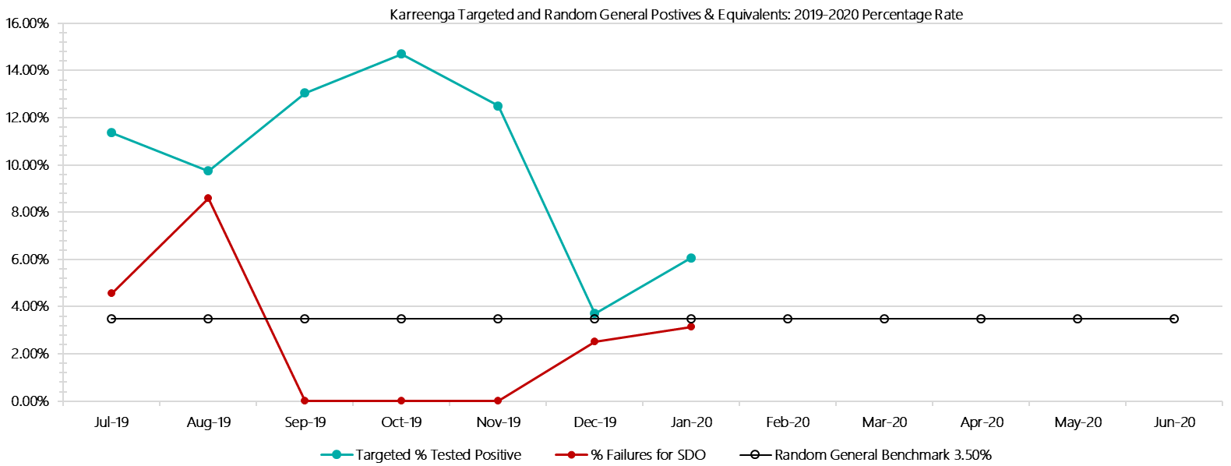

***Karreenga Positive Test Results by Drug Type: 2019-2020***

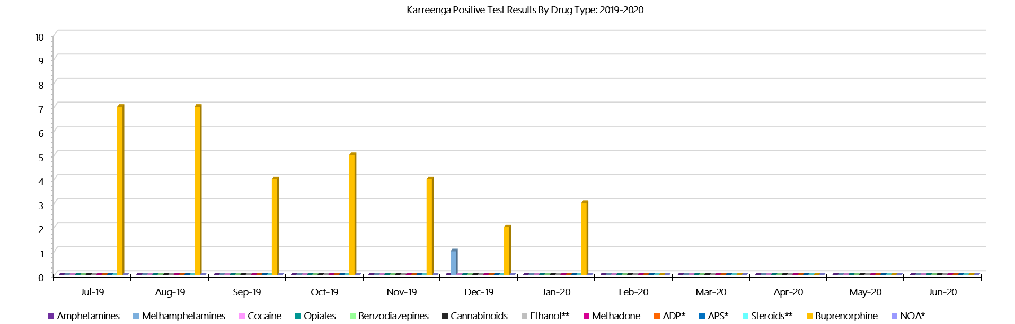

***Karreenga Count of Visitor Seizures Finds: 2019-2020***

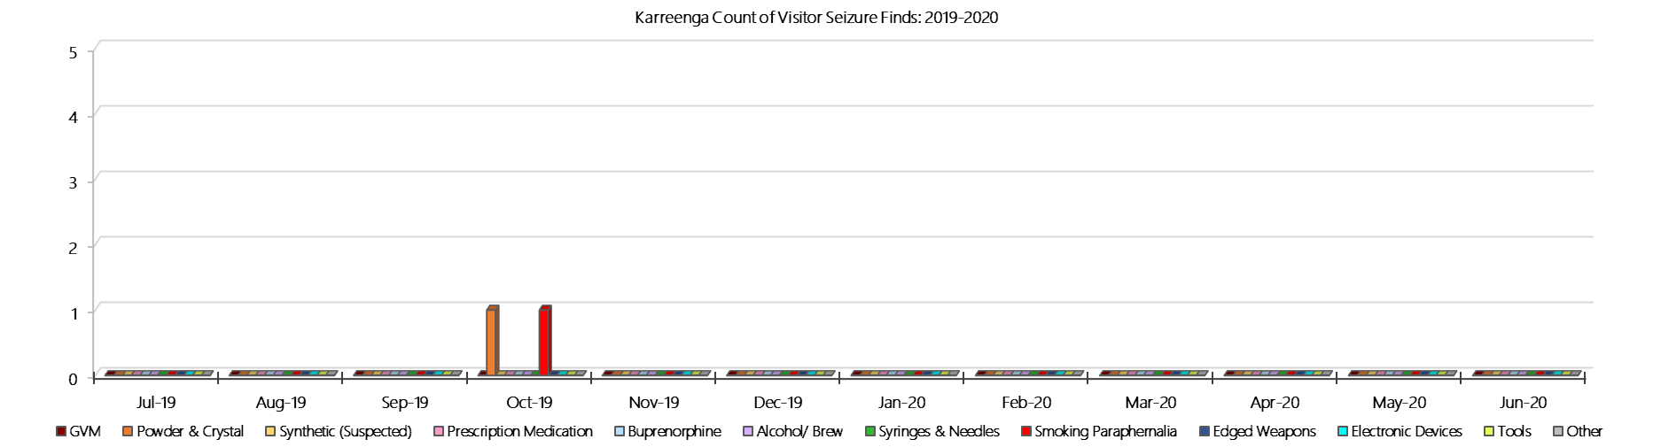

***Karreenga Count of Prisoner Seizure: 2019-2020***

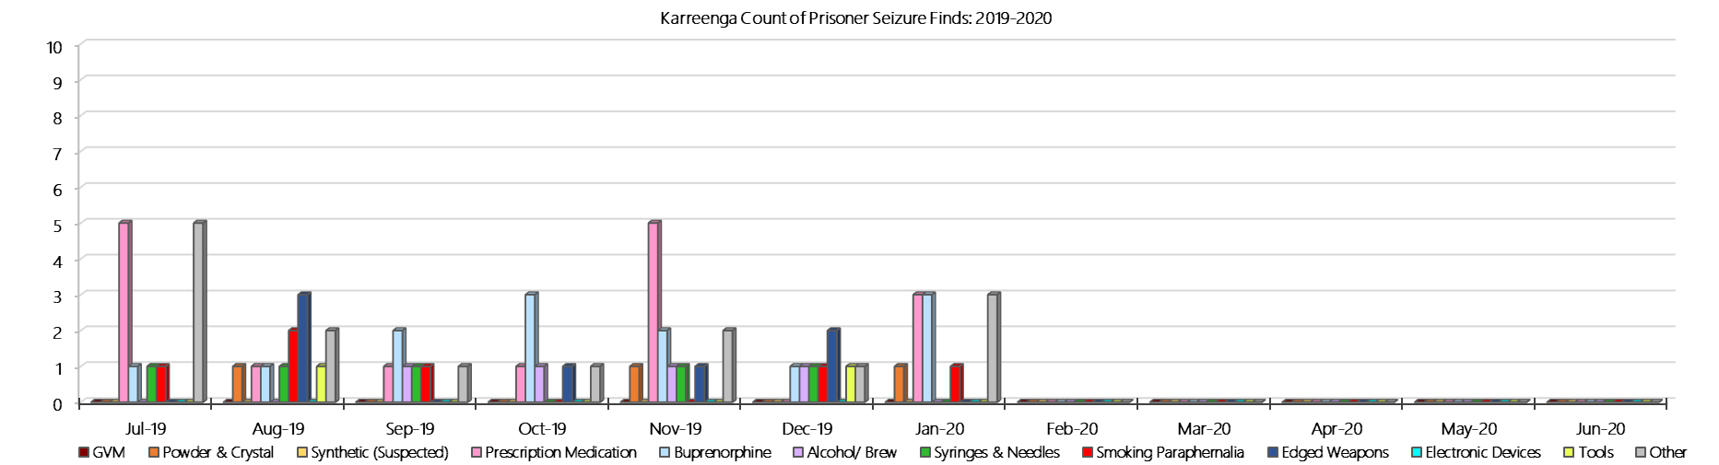

### **Marngoneet Correctional Centre**

***Targeted and Random General Drug Test Results: 2019-2020***

|  |  |  |  |  |  |  |  |  |  |  |  |  |  |  |
| --- | --- | --- | --- | --- | --- | --- | --- | --- | --- | --- | --- | --- | --- | --- |
| **Marngoneet** | **Jul-19** | **Aug-19** | **Sep-19** | **Oct-19** | **Nov-19** | **Dec-19** | **Jan-20** | **Feb-20** | **Mar-20** | **Apr-20** | **May-20** | **Jun-20** | **Average** | ***Totals*** |
| **Effective Sample - Targeted** | **105** | **65** | **67** | **109** | **107** | **100** | **81** |  |  |  |  |  | **91** | ***634*** |
| **Targeted Positives** | **1** | **2** | **9** | **19** | **12** | **17** | **10** |  |  |  |  |  | **10** | ***70*** |
| **Refusal** | **1** | **1** | **0** | **1** | **0** | **1** | **0** |  |  |  |  |  | **1** | ***4*** |
| **Unable** | **1** | **0** | **0** | **4** | **3** | **6** | **0** |  |  |  |  |  | **2** | ***14*** |
| **Interfered** | **0** | **0** | **0** | **0** | **0** | **0** | **0** |  |  |  |  |  | **0** | ***0*** |
| **Adulterated** | **0** | **0** | **0** | **0** | **0** | **0** | **0** |  |  |  |  |  | **0** | ***0*** |
| **Targeted % Tested Positive** | **2.86%** | **4.62%** | **13.43%** | **22.02%** | **14.02%** | **24.00%** | **12.35%** | **#N/A** | **#N/A** | **#N/A** | **#N/A** | **#N/A** | **13.88%** | ***13.88%*** |
| **Awaiting / Pending Results** | **0** | **0** | **0** | **0** | **0** | **0** | **0** |  |  |  |  |  | **0** | ***0*** |
| **Targeted Residual** | **0** | **1** | **0** | **0** | **0** | **2** | **0** |  |  |  |  |  | **0** | ***3*** |
| **Random tests collected** | **76** | **61** | **76** | **59** | **63** | **76** | **65** |  |  |  |  |  | **68** | ***476*** |
| **Tested Positive** | **1** | **2** | **3** | **4** | **3** | **4** | **3** |  |  |  |  |  | **3** | ***20*** |
| **Refusal (guilty)** | **1** | **0** | **1** | **0** | **0** | **0** | **0** |  |  |  |  |  | **0** | ***2*** |
| **Unable (not guilty)** | **0** | **0** | **0** | **0** | **0** | **0** | **0** |  |  |  |  |  | **0** | ***0*** |
| **Unable (guilty)** | **1** | **3** | **2** | **2** | **0** | **0** | **0** |  |  |  |  |  | **1** | ***8*** |
| **Interfered (guilty)** | **0** | **0** | **0** | **0** | **0** | **0** | **0** |  |  |  |  |  | **0** | ***0*** |
| **No test (valid reason)** | **2** | **1** | **1** | **2** | **1** | **4** | **1** |  |  |  |  |  | **2** | ***12*** |
| **No test (no valid reason)** | **0** | **0** | **0** | **0** | **0** | **0** | **0** |  |  |  |  |  | **0** | ***0*** |
| **Adulterated** | **0** | **0** | **0** | **1** | **0** | **0** | **0** |  |  |  |  |  | **0** | ***1*** |
| **Awaiting / Pending Results** | **0** | **0** | **0** | **0** | **0** | **0** | **0** |  |  |  |  |  | **0** | ***0*** |
| **Random Residual *(PIMS URAR030)*** | **0** | **0** | **1** | **0** | **0** | **0** | **0** |  |  |  |  |  | ***0.142857*** | ***1*** |
| **Effective Sample - Random General** | **78** | **64** | **79** | **61** | **63** | **76** | **65** |  |  |  |  |  | **69** | **486** |
| **% Tested positive** | **1.28%** | **3.13%** | **3.80%** | **6.56%** | **4.76%** | **5.26%** | **4.62%** |  |  |  |  |  | **4.20%** |  |
| **% Prisoner guilty, positive equivalents** | **2.56%** | **4.69%** | **3.80%** | **4.92%** | **0.00%** | **0.00%** | **0.00%** |  |  |  |  |  | **2.28%** |  |
| **% Total prisoner fails** | **3.85%** | **7.81%** | **7.59%** | **9.84%** | **4.76%** | **5.26%** | **4.62%** |  |  |  |  |  | **6.25%** |  |
| **% No test without valid reason** | **0.00%** | **0.00%** | **0.00%** | **0.00%** | **0.00%** | **0.00%** | **0.00%** |  |  |  |  |  | **0.00%** |  |
| ***Random General Benchmark 6.50%*** | ***6.50%*** | ***6.50%*** | ***6.50%*** | ***6.50%*** | ***6.50%*** | ***6.50%*** | ***6.50%*** | ***6.50%*** | ***6.50%*** | ***6.50%*** | ***6.50%*** | ***6.50%*** | ***YTD*** |  |
| **% Failures for SDO** | **3.85%** | **7.81%** | **7.59%** | **11.48%** | **4.76%** | **5.26%** | **4.62%** | **#N/A** | **#N/A** | **#N/A** | **#N/A** | **#N/A** | **6.38%** |  |

***Marngoneet - Drugs Identified Through Testing by Drug Type: 2019-2020***

|  |  |  |  |  |  |  |  |  |  |  |  |  |  |  |
| --- | --- | --- | --- | --- | --- | --- | --- | --- | --- | --- | --- | --- | --- | --- |
| **Marngoneet** | ***Amphetamines*** | ***Methamphetamines*** | ***Cocaine*** | ***Opiates*** | ***Benzodiazepines*** | ***Cannabinoids*** | ***Ethanol\*\**** | ***Methadone*** | ***ADP\**** | ***APS\**** | ***Steroids\*\**** | ***Buprenorphine*** | ***NOA\**** | **Total** |
| **Jul-19** | **0** | **1** | **0** | **0** | **0** | **1** | **2** | **0** | **0** | **0** | **0** | **6** | **0** | **10** |
| **Aug-19** | **0** | **0** | **0** | **0** | **0** | **1** | **0** | **1** | **0** | **0** | **0** | **15** | **0** | **17** |
| **Sep-19** | **4** | **5** | **0** | **0** | **0** | **0** | **2** | **0** | **0** | **0** | **0** | **18** | **0** | **29** |
| **Oct-19** | **4** | **6** | **0** | **0** | **0** | **0** | **0** | **0** | **1** | **0** | **0** | **31** | **0** | **42** |
| **Nov-19** | **1** | **1** | **0** | **0** | **2** | **0** | **6** | **6** | **0** | **0** | **0** | **23** | **0** | **39** |
| **Dec-19** | **1** | **1** | **0** | **0** | **0** | **1** | **0** | **0** | **0** | **0** | **0** | **32** | **0** | **35** |
| **Jan-20** | **0** | **0** | **0** | **0** | **0** | **0** | **0** | **0** | **0** | **0** | **0** | **24** | **0** | **24** |
| **Feb-20** |  |  |  |  |  |  |  |  |  |  |  |  |  |  |
| **Mar-20** |  |  |  |  |  |  |  |  |  |  |  |  |  |  |
| **Apr-20** |  |  |  |  |  |  |  |  |  |  |  |  |  |  |
| **May-20** |  |  |  |  |  |  |  |  |  |  |  |  |  |  |
| **Jun-20** |  |  |  |  |  |  |  |  |  |  |  |  |  |  |
| **Marngoneet YTD** | **10** | **14** | **0** | **0** | **2** | **3** | **10** | **7** | **1** | **0** | **0** | **149** | **0** | **196** |
| ***All Prisons YTD*** | ***111*** | ***184*** | ***2*** | ***31*** | ***26*** | ***21*** | ***18*** | ***25*** | ***33*** | ***12*** | ***0*** | ***1397*** | ***0*** | ***1860*** |
| ***Marngoneet % of Total*** | ***9.01%*** | ***7.61%*** | ***0.00%*** | ***0.00%*** | ***7.69%*** | ***14.29%*** | ***55.56%*** | ***28.00%*** | ***3.03%*** | ***0.00%*** | ***0.00%*** | ***10.67%*** | ***0.00%*** | ***10.54%*** |

***Marngoneet Seizures of Contraband: Visitors & Prisoners: 2019-2020***

|  |  |  |  |  |  |  |  |  |  |  |  |  |  |  |  |  |  |  |  |  |  |  |  |  |
| --- | --- | --- | --- | --- | --- | --- | --- | --- | --- | --- | --- | --- | --- | --- | --- | --- | --- | --- | --- | --- | --- | --- | --- | --- |
| **Visitors** | **GVM** | | **Powder  & Crystal** | | **Synthetic  (Suspected)** | | **Prescription  Medication** | | **Buprenorphine** | | **Alcohol &  Home Brew** | | **Syringes & Needles** | | **Smoking  Paraphernalia** | | **Edged  Weapons** | | **Electronic  Devices** | | **Tools** | | **Other** | |
| **MCC** | **Finds** | **Gms** | **Finds** | **Gms** | **Finds** | **Gms** | **Finds** | **Qty** | **Finds** | **Qty** | **Finds** | **Ltrs** | **Finds** | **Qty** | **Finds** | **Qty** | **Finds** | **Qty** | **Finds** | **Qty** | **Finds** | **Qty** | **Finds** | **Qty** |
| **Jul-19** | **0** | **0.00** | **0** | **0.00** | **0** | **0.00** | **0** | **0.00** | **0** | **0.00** | **0** | **0.000** | **0** | **0** | **1** | **1** | **0** | **0** | **0** | **0** | **0** | **0** | **1** | **2** |
| **Aug-19** | **0** | **0.00** | **0** | **0.00** | **0** | **0.00** | **0** | **0.00** | **0** | **0.00** | **0** | **0.000** | **0** | **0** | **0** | **0** | **0** | **0** | **0** | **0** | **0** | **0** | **0** | **0** |
| **Sep-19** | **0** | **0.00** | **0** | **0.00** | **0** | **0.00** | **0** | **0.00** | **0** | **0.00** | **0** | **0.000** | **0** | **0** | **0** | **0** | **0** | **0** | **0** | **0** | **0** | **0** | **0** | **0** |
| **Oct-19** | **0** | **0.00** | **0** | **0.00** | **0** | **0.00** | **0** | **0.00** | **0** | **0.00** | **0** | **0.000** | **0** | **0** | **0** | **0** | **0** | **0** | **0** | **0** | **0** | **0** | **0** | **0** |
| **Nov-19** | **0** | **0.00** | **0** | **0.00** | **0** | **0.00** | **0** | **0.00** | **0** | **0.00** | **0** | **0.000** | **0** | **0** | **1** | **3** | **0** | **0** | **0** | **0** | **0** | **0** | **0** | **0** |
| **Dec-19** | **0** | **0.00** | **0** | **0.00** | **0** | **0.00** | **0** | **0.00** | **0** | **0.00** | **0** | **0.000** | **0** | **0** | **1** | **2** | **1** | **1** | **0** | **0** | **0** | **0** | **1** | **2** |
| **Jan-20** | **0** | **0.00** | **0** | **0.00** | **0** | **0.00** | **0** | **0.00** | **0** | **0.00** | **0** | **0.000** | **0** | **0** | **0** | **0** | **0** | **0** | **0** | **0** | **0** | **0** | **0** | **0** |
| **Feb-20** |  |  |  |  |  |  |  |  |  |  |  |  |  |  |  |  |  |  |  |  |  |  |  |  |
| **Mar-20** |  |  |  |  |  |  |  |  |  |  |  |  |  |  |  |  |  |  |  |  |  |  |  |  |
| **Apr-20** |  |  |  |  |  |  |  |  |  |  |  |  |  |  |  |  |  |  |  |  |  |  |  |  |
| **May-20** |  |  |  |  |  |  |  |  |  |  |  |  |  |  |  |  |  |  |  |  |  |  |  |  |
| **Jun-20** |  |  |  |  |  |  |  |  |  |  |  |  |  |  |  |  |  |  |  |  |  |  |  |  |
| **Total** | **0** | **0.00** | **0** | **0.00** | **0** | **0.00** | **0** | **0.00** | **0** | **0.00** | **0** | **0.000** | **0** | **0** | **3** | **6** | **1** | **1** | **0** | **0** | **0** | **0** | **2** | **4** |

|  |  |  |  |  |  |  |  |  |  |  |  |  |  |  |  |  |  |  |  |  |  |  |  |  |  |
| --- | --- | --- | --- | --- | --- | --- | --- | --- | --- | --- | --- | --- | --- | --- | --- | --- | --- | --- | --- | --- | --- | --- | --- | --- | --- |
| **Prisoners** | **GVM** | | **Powder  & Crystal** | | **Synthetic  (Suspected)** | | **Prescription  Medication** | | **Buprenorphine** | | **Alcohol &  Home Brew** | | **Syringes & Needles** | | **Smoking  Paraphernalia** | | | **Edged  Weapons** | | **Electronic  Devices** | | **Tools** | | **Other** | |
| **MCC** | **Finds** | **Gms** | **Finds** | **Gms** | **Finds** | **Gms** | **Finds** | **Qty** | **Finds** | **Qty** | **Finds** | **Ltrs** | **Finds** | **Qty** | **Finds** | **Qty** | | **Finds** | **Qty** | **Finds** | **Qty** | **Finds** | **Qty** | **Finds** | **Qty** |
| **Jul-19** | **0** | **0.00** | **0** | **0.00** | **0** | **0.00** | **7** | **10.50** | **5** | **2.40** | **6** | **68.000** | **0** | **0** | **1** | | **1** | **1** | **1** | **2** | **2** | **0** | **0** | **6** | **11** |
| **Aug-19** | **0** | **0.00** | **0** | **0.00** | **0** | **0.00** | **2** | **2.50** | **5** | **11.10** | **4** | **12.000** | **1** | **1** | **2** | | **7** | **1** | **1** | **1** | **1** | **1** | **1** | **2** | **8** |
| **Sep-19** | **0** | **0.00** | **2** | **4.40** | **0** | **0.00** | **3** | **3.00** | **4** | **109.50** | **4** | **11.250** | **2** | **2** | **2** | | **5** | **2** | **2** | **1** | **1** | **0** | **0** | **3** | **3** |
| **Oct-19** | **0** | **0.00** | **3** | **20.06** | **0** | **0.00** | **6** | **137.50** | **8** | **42.10** | **5** | **47.000** | **1** | **2** | **0** | | **0** | **1** | **1** | **0** | **0** | **0** | **0** | **2** | **5** |
| **Nov-19** | **0** | **0.00** | **0** | **0.00** | **0** | **0.00** | **4** | **5.50** | **4** | **24.10** | **1** | **2.000** | **0** | **0** | **3** | | **4** | **1** | **2** | **1** | **1** | **3** | **3** | **7** | **7** |
| **Dec-19** | **1** | **1.88** | **1** | **0.01** | **0** | **0.00** | **5** | **20.00** | **8** | **29.40** | **3** | **10.000** | **2** | **5** | **2** | | **2** | **4** | **6** | **0** | **0** | **1** | **1** | **5** | **7** |
| **Jan-20** | **0** | **0.00** | **0** | **0.00** | **0** | **0.00** | **3** | **41.00** | **4** | **1.00** | **1** | **0.800** | **1** | **1** | **0** | | **0** | **1** | **1** | **0** | **0** | **0** | **0** | **5** | **6** |
| **Feb-20** |  |  |  |  |  |  |  |  |  |  |  |  |  |  |  | |  |  |  |  |  |  |  |  |  |
| **Mar-20** |  |  |  |  |  |  |  |  |  |  |  |  |  |  |  | |  |  |  |  |  |  |  |  |  |
| **Apr-20** |  |  |  |  |  |  |  |  |  |  |  |  |  |  |  | |  |  |  |  |  |  |  |  |  |
| **May-20** |  |  |  |  |  |  |  |  |  |  |  |  |  |  |  | |  |  |  |  |  |  |  |  |  |
| **Jun-20** |  |  |  |  |  |  |  |  |  |  |  |  |  |  |  | |  |  |  |  |  |  |  |  |  |
| **Total** | **1** | **1.88** | **6** | **24.47** | **0** | **0.00** | **30** | **220.00** | **38** | **219.60** | **24** | **151.050** | **7** | **11** | **10** | | **19** | **11** | **14** | **5** | **5** | **5** | **5** | **30** | **47** |

***Marngoneet Targeted and Random General Drug Test Positives & Equivalents: 2019-2020***

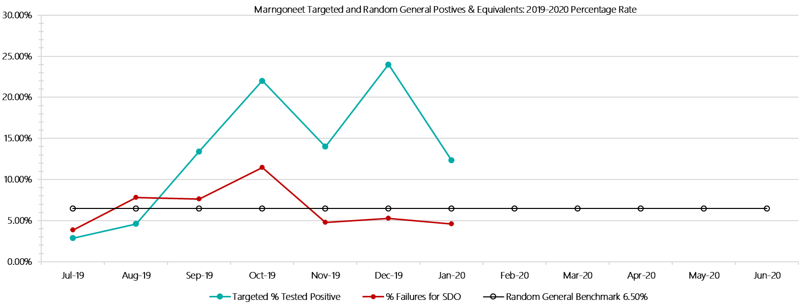

***Marngoneet Positive Test Results by Drug Type: 2019-2020***

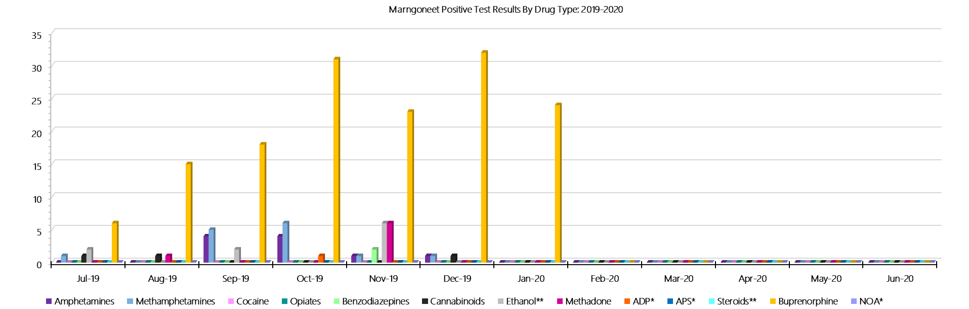

***Marngoneet Count of Visitor Seizures Finds: 2019-2020***

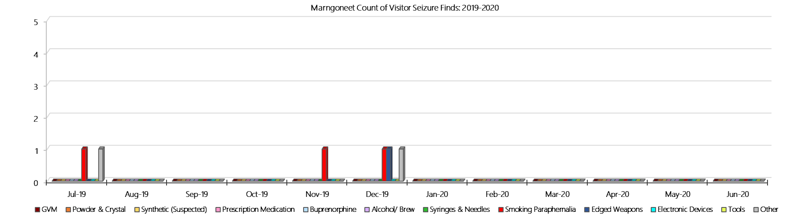

***Marngoneet Count of Prisoner Seizure Finds: 2019-2020***

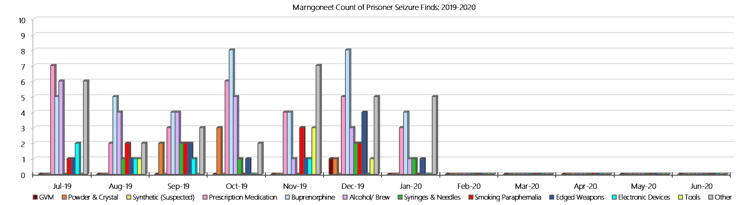

### **Loddon Prison**

***Targeted and Random General Drug Test Results: 2019-2020***

|  |  |  |  |  |  |  |  |  |  |  |  |  |  |  |
| --- | --- | --- | --- | --- | --- | --- | --- | --- | --- | --- | --- | --- | --- | --- |
| **Loddon** | **Jul-19** | **Aug-19** | **Sep-19** | **Oct-19** | **Nov-19** | **Dec-19** | **Jan-20** | **Feb-20** | **Mar-20** | **Apr-20** | **May-20** | **Jun-20** | **Average** | ***Totals*** |
| **Effective Sample - Targeted** | **82** | **73** | **72** | **65** | **59** | **72** | **66** |  |  |  |  |  | **70** | ***489*** |
| **Targeted Positives** | **8** | **5** | **12** | **3** | **6** | **6** | **10** |  |  |  |  |  | **7** | ***50*** |
| **Refusal** | **0** | **0** | **0** | **0** | **1** | **0** | **0** |  |  |  |  |  | **0** | ***1*** |
| **Unable** | **0** | **0** | **0** | **0** | **0** | **2** | **0** |  |  |  |  |  | **0** | ***2*** |
| **Interfered** | **0** | **0** | **0** | **0** | **0** | **0** | **0** |  |  |  |  |  | **0** | ***0*** |
| **Adulterated** | **1** | **0** | **0** | **0** | **0** | **0** | **0** |  |  |  |  |  | **0** | ***1*** |
| **Targeted % Tested Positive** | **10.98%** | **6.85%** | **16.67%** | **4.62%** | **11.86%** | **11.11%** | **15.15%** | **#N/A** | **#N/A** | **#N/A** | **#N/A** | **#N/A** | **11.04%** | ***11.04%*** |
| **Awaiting / Pending Results** | **0** | **0** | **0** | **0** | **0** | **0** | **0** |  |  |  |  |  | **0** | ***0*** |
| **Targeted Residual** | **6** | **4** | **2** | **0** | **0** | **1** | **0** |  |  |  |  |  | **2** | ***13*** |
| **Random tests collected** | **60** | **48** | **60** | **49** | **47** | **58** | **49** |  |  |  |  |  | **53** | ***371*** |
| **Tested Positive** | **5** | **3** | **6** | **3** | **3** | **3** | **0** |  |  |  |  |  | **3** | ***23*** |
| **Refusal (guilty)** | **0** | **0** | **0** | **0** | **0** | **0** | **0** |  |  |  |  |  | **0** | ***0*** |
| **Unable (not guilty)** | **0** | **0** | **0** | **0** | **0** | **0** | **0** |  |  |  |  |  | **0** | ***0*** |
| **Unable (guilty)** | **0** | **0** | **0** | **0** | **0** | **1** | **0** |  |  |  |  |  | **0** | ***1*** |
| **Interfered (guilty)** | **0** | **0** | **0** | **0** | **0** | **0** | **0** |  |  |  |  |  | **0** | ***0*** |
| **No test (valid reason)** | **2** | **0** | **2** | **0** | **1** | **1** | **2** |  |  |  |  |  | **1** | ***8*** |
| **No test (no valid reason)** | **0** | **0** | **0** | **0** | **0** | **0** | **0** |  |  |  |  |  | **0** | ***0*** |
| **Adulterated** | **0** | **0** | **0** | **0** | **0** | **0** | **0** |  |  |  |  |  | **0** | ***0*** |
| **Awaiting / Pending Results** | **0** | **0** | **0** | **0** | **0** | **0** | **0** |  |  |  |  |  | **0** | ***0*** |
| **Random Residual *(PIMS URAR030)*** | **0** | **0** | **0** | **0** | **0** | **0** | **0** |  |  |  |  |  | ***0*** | ***0*** |
| **Effective Sample - Random General** | **60** | **48** | **60** | **49** | **47** | **59** | **49** |  |  |  |  |  | **53** | **372** |
| **% Tested positive** | **8.33%** | **6.25%** | **10.00%** | **6.12%** | **6.38%** | **5.08%** | **0.00%** |  |  |  |  |  | **6.02%** |  |
| **% Prisoner guilty, positive equivalents** | **0.00%** | **0.00%** | **0.00%** | **0.00%** | **0.00%** | **1.69%** | **0.00%** |  |  |  |  |  | **0.24%** |  |
| **% Total prisoner fails** | **8.33%** | **6.25%** | **10.00%** | **6.12%** | **6.38%** | **6.78%** | **0.00%** |  |  |  |  |  | **6.27%** |  |
| **% No test without valid reason** | **0.00%** | **0.00%** | **0.00%** | **0.00%** | **0.00%** | **0.00%** | **0.00%** |  |  |  |  |  | **0.00%** |  |
| ***Random General Benchmark 5.00%*** | ***5.00%*** | ***5.00%*** | ***5.00%*** | ***5.00%*** | ***5.00%*** | ***5.00%*** | ***5.00%*** | ***5.00%*** | ***5.00%*** | ***5.00%*** | ***5.00%*** | ***5.00%*** | ***YTD*** |  |
| **% Failures for SDO** | **8.33%** | **6.25%** | **10.00%** | **6.12%** | **6.38%** | **6.78%** | **0.00%** | **#N/A** | **#N/A** | **#N/A** | **#N/A** | **#N/A** | **6.45%** |  |

***Loddon - Drugs Identified Through Testing by Drug Type: 2019-2020***

|  |  |  |  |  |  |  |  |  |  |  |  |  |  |  |
| --- | --- | --- | --- | --- | --- | --- | --- | --- | --- | --- | --- | --- | --- | --- |
| **Loddon** | ***Amphetamines*** | ***Methamphetamines*** | ***Cocaine*** | ***Opiates*** | ***Benzodiazepines*** | ***Cannabinoids*** | ***Ethanol\*\**** | ***Methadone*** | ***ADP\**** | ***APS\**** | ***Steroids\*\**** | ***Buprenorphine*** | ***NOA\**** | **Total** |
| **Jul-19** | **2** | **3** | **0** | **0** | **0** | **0** | **0** | **0** | **0** | **0** | **0** | **19** | **0** | **24** |
| **Aug-19** | **0** | **0** | **0** | **0** | **0** | **0** | **0** | **0** | **0** | **0** | **0** | **15** | **0** | **15** |
| **Sep-19** | **1** | **0** | **0** | **0** | **0** | **0** | **0** | **0** | **0** | **0** | **0** | **21** | **0** | **22** |
| **Oct-19** | **0** | **0** | **0** | **1** | **0** | **0** | **0** | **0** | **0** | **0** | **0** | **10** | **0** | **11** |
| **Nov-19** | **0** | **0** | **0** | **0** | **0** | **0** | **0** | **0** | **0** | **0** | **0** | **14** | **0** | **14** |
| **Dec-19** | **0** | **0** | **0** | **0** | **0** | **0** | **5** | **0** | **0** | **0** | **0** | **16** | **0** | **21** |
| **Jan-20** | **0** | **0** | **0** | **0** | **0** | **0** | **0** | **0** | **0** | **0** | **0** | **13** | **0** | **13** |
| **Feb-20** |  |  |  |  |  |  |  |  |  |  |  |  |  |  |
| **Mar-20** |  |  |  |  |  |  |  |  |  |  |  |  |  |  |
| **Apr-20** |  |  |  |  |  |  |  |  |  |  |  |  |  |  |
| **May-20** |  |  |  |  |  |  |  |  |  |  |  |  |  |  |
| **Jun-20** |  |  |  |  |  |  |  |  |  |  |  |  |  |  |
| **Loddon YTD** | **3** | **3** | **0** | **1** | **0** | **0** | **5** | **0** | **0** | **0** | **0** | **108** | **0** | **120** |
| ***All Prisons YTD*** | ***111*** | ***184*** | ***2*** | ***31*** | ***26*** | ***21*** | ***18*** | ***25*** | ***33*** | ***12*** | ***0*** | ***1397*** | ***0*** | ***1860*** |
| ***Loddon % of Total*** | ***2.70%*** | ***1.63%*** | ***0.00%*** | ***3.23%*** | ***0.00%*** | ***0.00%*** | ***27.78%*** | ***0.00%*** | ***0.00%*** | ***0.00%*** | ***0.00%*** | ***7.73%*** | ***0.00%*** | ***6.45%*** |

***Loddon Seizures of Contraband: Visitors & Prisoners: 2019-2020***

|  |  |  |  |  |  |  |  |  |  |  |  |  |  |  |  |  |  |  |  |  |  |  |  |  |  |  |
| --- | --- | --- | --- | --- | --- | --- | --- | --- | --- | --- | --- | --- | --- | --- | --- | --- | --- | --- | --- | --- | --- | --- | --- | --- | --- | --- |
| **Visitors** | **GVM** | | **Powder  & Crystal** | | **Synthetic  (Suspected)** | | **Prescription  Medication** | | **Buprenorphine** | | **Alcohol &  Home Brew** | | **Syringes & Needles** | | **Smoking  Paraphernalia** | | | **Edged  Weapons** | | **Electronic  Devices** | | **Tools** | | **Other** | | |
| **Loddon** | **Finds** | **Gms** | **Finds** | **Gms** | **Finds** | **Gms** | **Finds** | **Qty** | **Finds** | **Qty** | **Finds** | **Ltrs** | **Finds** | **Qty** | **Finds** | **Qty** | | **Finds** | **Qty** | **Finds** | **Qty** | **Finds** | **Qty** | **Finds** | **Qty** |
| **Jul-19** | **0** | **0.00** | **0** | **0.00** | **0** | **0.00** | **0** | **0.00** | **0** | **0.00** | **0** | **0.000** | **0** | **0** | **0** | | **0** | **0** | **0** | **0** | **0** | **0** | **0** | **0** | **0** |
| **Aug-19** | **0** | **0.00** | **0** | **0.00** | **0** | **0.00** | **0** | **0.00** | **0** | **0.00** | **0** | **0.000** | **0** | **0** | **0** | | **0** | **0** | **0** | **0** | **0** | **0** | **0** | **0** | **0** |
| **Sep-19** | **0** | **0.00** | **1** | **1.30** | **0** | **0.00** | **0** | **0.00** | **0** | **0.00** | **0** | **0.000** | **0** | **0** | **0** | | **0** | **0** | **0** | **0** | **0** | **0** | **0** | **0** | **0** |
| **Oct-19** | **0** | **0.00** | **0** | **0.00** | **0** | **0.00** | **0** | **0.00** | **0** | **0.00** | **0** | **0.000** | **0** | **0** | **1** | | **6** | **0** | **0** | **0** | **0** | **0** | **0** | **0** | **0** |
| **Nov-19** | **0** | **0.00** | **0** | **0.00** | **0** | **0.00** | **0** | **0.00** | **2** | **89.50** | **0** | **0.000** | **0** | **0** | **2** | | **30** | **0** | **0** | **0** | **0** | **0** | **0** | **0** | **0** |
| **Dec-19** | **1** | **1.00** | **0** | **0.00** | **0** | **0.00** | **0** | **0.00** | **0** | **0.00** | **0** | **0.000** | **0** | **0** | **0** | | **0** | **0** | **0** | **0** | **0** | **0** | **0** | **0** | **0** |
| **Jan-20** | **0** | **0.00** | **0** | **0.00** | **0** | **0.00** | **0** | **0.00** | **1** | **11.00** | **0** | **0.000** | **1** | **1** | **2** | | **9** | **0** | **0** | **0** | **0** | **0** | **0** | **0** | **0** |
| **Feb-20** |  |  |  |  |  |  |  |  |  |  |  |  |  |  |  | |  |  |  |  |  |  |  |  |  |
| **Mar-20** |  |  |  |  |  |  |  |  |  |  |  |  |  |  |  | |  |  |  |  |  |  |  |  |  |
| **Apr-20** |  |  |  |  |  |  |  |  |  |  |  |  |  |  |  | |  |  |  |  |  |  |  |  |  |
| **May-20** |  |  |  |  |  |  |  |  |  |  |  |  |  |  |  | |  |  |  |  |  |  |  |  |  |
| **Jun-20** |  |  |  |  |  |  |  |  |  |  |  |  |  |  |  | |  |  |  |  |  |  |  |  |  |
| **Total** | **1** | **1.00** | **1** | **1.30** | **0** | **0.00** | **0** | **0.00** | **3** | **100.50** | **0** | **0.000** | **1** | **1** | **5** | | **45** | **0** | **0** | **0** | **0** | **0** | **0** | **0** | **0** |

|  |  |  |  |  |  |  |  |  |  |  |  |  |  |  |  |  |  |  |  |  |  |  |  |  |  |  |
| --- | --- | --- | --- | --- | --- | --- | --- | --- | --- | --- | --- | --- | --- | --- | --- | --- | --- | --- | --- | --- | --- | --- | --- | --- | --- | --- |
| **Prisoners** | **GVM** | | **Powder  & Crystal** | | **Synthetic  (Suspected)** | | **Prescription  Medication** | | **Buprenorphine** | | **Alcohol &  Home Brew** | | **Syringes & Needles** | | **Smoking  Paraphernalia** | | | **Edged  Weapons** | | **Electronic  Devices** | | **Tools** | | **Other** | | |
| **Loddon** | **Finds** | **Gms** | **Finds** | **Gms** | **Finds** | **Gms** | **Finds** | **Qty** | **Finds** | **Qty** | **Finds** | **Ltrs** | **Finds** | **Qty** | **Finds** | **Qty** | | **Finds** | **Qty** | **Finds** | **Qty** | **Finds** | **Qty** | **Finds** | **Qty** |
| **Jul-19** | **0** | **0.00** | **0** | **0.00** | **0** | **0.00** | **2** | **39.00** | **8** | **9.60** | **0** | **0.000** | **0** | **0** | **3** | | **5** | **2** | **2** | **0** | **0** | **1** | **2** | **2** | **4** |
| **Aug-19** | **0** | **0.00** | **2** | **5.00** | **0** | **0.00** | **0** | **0.00** | **7** | **162.00** | **4** | **6.000** | **1** | **1** | **4** | | **4** | **0** | **0** | **1** | **1** | **1** | **5** | **2** | **19** |
| **Sep-19** | **1** | **7.20** | **0** | **0.00** | **0** | **0.00** | **1** | **1.00** | **3** | **9.30** | **1** | **2.000** | **0** | **0** | **5** | | **10** | **1** | **1** | **0** | **0** | **0** | **0** | **0** | **0** |
| **Oct-19** | **0** | **0.00** | **0** | **0.00** | **0** | **0.00** | **0** | **0.00** | **1** | **0.00** | **2** | **8.000** | **0** | **0** | **2** | | **2** | **3** | **4** | **1** | **1** | **0** | **0** | **0** | **0** |
| **Nov-19** | **0** | **0.00** | **0** | **0.00** | **0** | **0.00** | **1** | **28.00** | **2** | **0.00** | **1** | **8.000** | **0** | **0** | **1** | | **2** | **2** | **3** | **0** | **0** | **0** | **0** | **0** | **0** |
| **Dec-19** | **0** | **0.00** | **0** | **0.00** | **0** | **0.00** | **1** | **1.00** | **2** | **0.00** | **3** | **6.000** | **0** | **0** | **2** | | **3** | **7** | **7** | **1** | **1** | **0** | **0** | **1** | **1** |
| **Jan-20** | **0** | **0.00** | **0** | **0.00** | **0** | **0.00** | **0** | **0.00** | **4** | **0.00** | **1** | **2.000** | **0** | **0** | **4** | | **13** | **3** | **3** | **0** | **0** | **0** | **0** | **7** | **13** |
| **Feb-20** |  |  |  |  |  |  |  |  |  |  |  |  |  |  |  | |  |  |  |  |  |  |  |  |  |
| **Mar-20** |  |  |  |  |  |  |  |  |  |  |  |  |  |  |  | |  |  |  |  |  |  |  |  |  |
| **Apr-20** |  |  |  |  |  |  |  |  |  |  |  |  |  |  |  | |  |  |  |  |  |  |  |  |  |
| **May-20** |  |  |  |  |  |  |  |  |  |  |  |  |  |  |  | |  |  |  |  |  |  |  |  |  |
| **Jun-20** |  |  |  |  |  |  |  |  |  |  |  |  |  |  |  | |  |  |  |  |  |  |  |  |  |
| **Total** | **1** | **7.20** | **2** | **5.00** | **0** | **0.00** | **5** | **69.00** | **27** | **180.90** | **12** | **32.000** | **1** | **1** | **21** | | **39** | **18** | **20** | **3** | **3** | **2** | **7** | **12** | **37** |

***Loddon Targeted and Random General Drug Test Positives & Equivalents: 2019-2020***

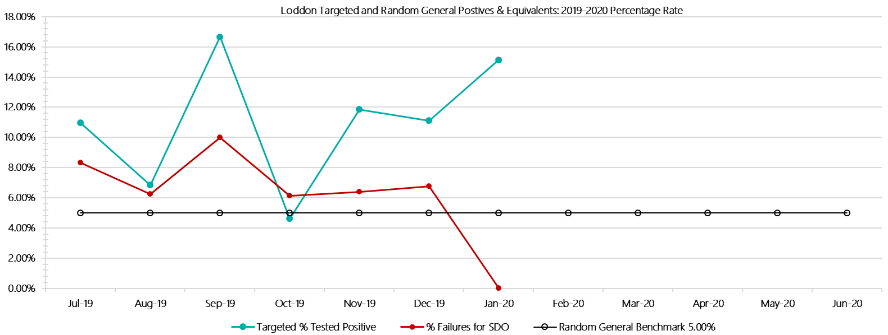

***Loddon Positive Test Results by Drug Type: 2019-2020***

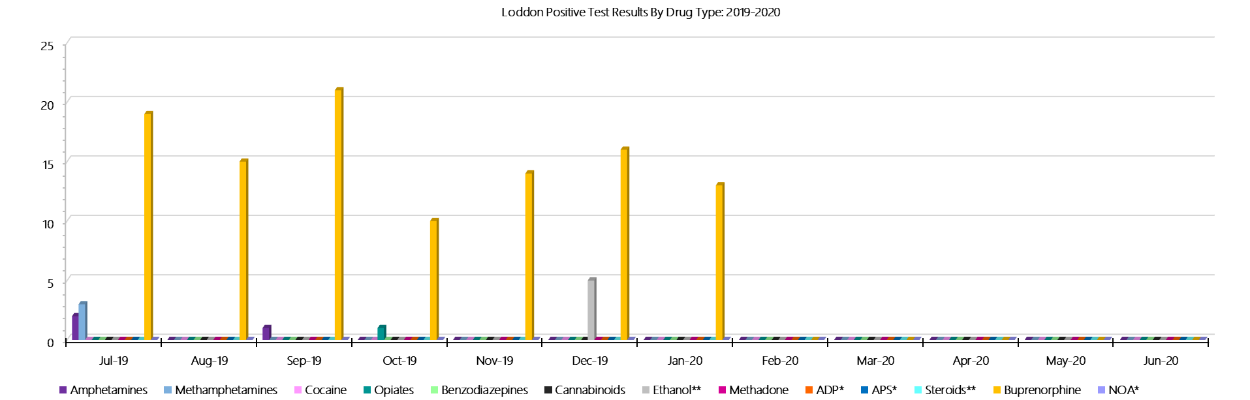

***Loddon Count of Visitor Seizures Finds: 2019-2020***

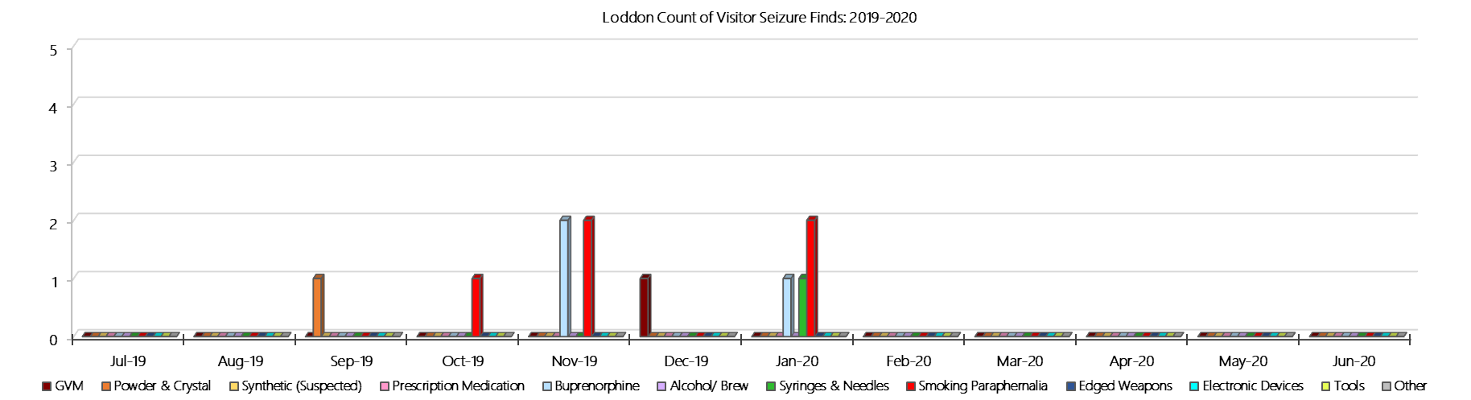

***Loddon Count of Prisoner Seizure Finds: 2019-2020***

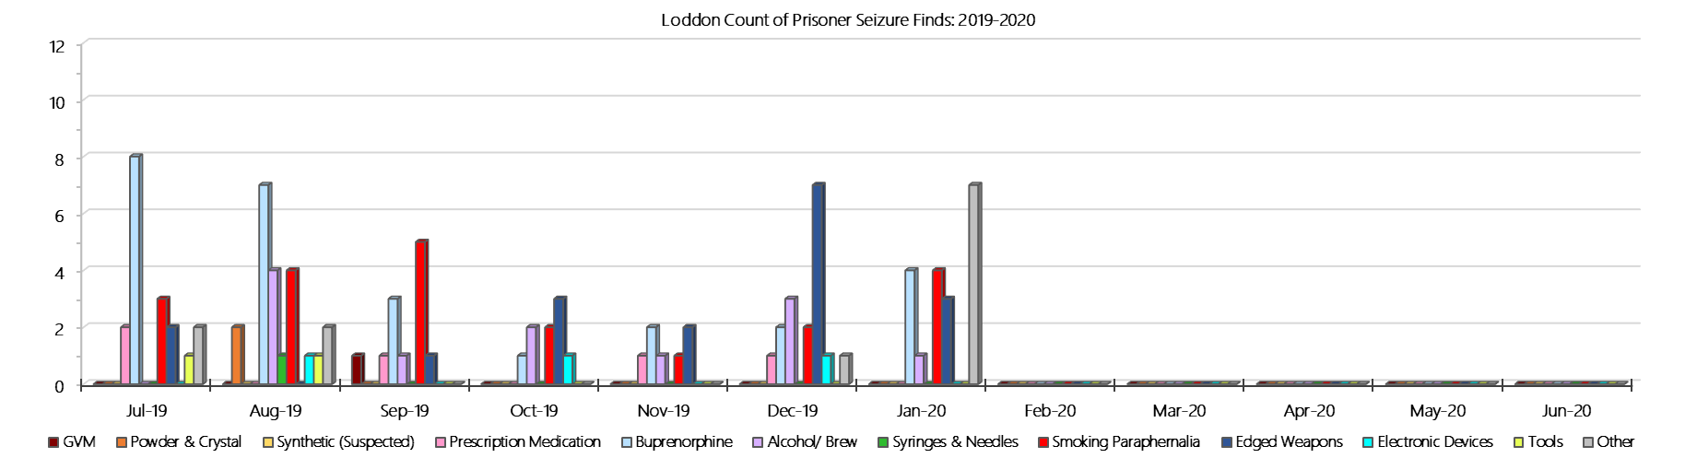

### **Middleton (annex of Loddon)**

***Targeted and Random General Drug Test Results: 2019-2020***

|  |  |  |  |  |  |  |  |  |  |  |  |  |  |  |
| --- | --- | --- | --- | --- | --- | --- | --- | --- | --- | --- | --- | --- | --- | --- |
| **Middleton** | **Jul-19** | **Aug-19** | **Sep-19** | **Oct-19** | **Nov-19** | **Dec-19** | **Jan-20** | **Feb-20** | **Mar-20** | **Apr-20** | **May-20** | **Jun-20** | **Average** | ***Totals*** |
| **Effective Sample - Targeted** | **36** | **43** | **54** | **49** | **50** | **51** | **50** |  |  |  |  |  | **48** | ***333*** |
| **Targeted Positives** | **2** | **5** | **3** | **2** | **4** | **2** | **0** |  |  |  |  |  | **3** | ***18*** |
| **Refusal** | **0** | **0** | **0** | **0** | **0** | **0** | **0** |  |  |  |  |  | **0** | ***0*** |
| **Unable** | **0** | **1** | **0** | **1** | **0** | **0** | **0** |  |  |  |  |  | **0** | ***2*** |
| **Interfered** | **0** | **0** | **0** | **0** | **0** | **1** | **0** |  |  |  |  |  | **0** | ***1*** |
| **Adulterated** | **0** | **0** | **0** | **0** | **0** | **0** | **0** |  |  |  |  |  | **0** | ***0*** |
| **Targeted % Tested Positive** | **5.56%** | **13.95%** | **5.56%** | **6.12%** | **8.00%** | **5.88%** | **0.00%** | **#N/A** | **#N/A** | **#N/A** | **#N/A** | **#N/A** | **6.31%** | ***6.31%*** |
| **Awaiting / Pending Results** | **0** | **0** | **0** | **0** | **0** | **0** | **0** |  |  |  |  |  | **0** | ***0*** |
| **Targeted Residual** | **0** | **0** | **0** | **1** | **0** | **0** | **0** |  |  |  |  |  | **0** | ***1*** |
| **Random tests collected** | **39** | **32** | **38** | **27** | **30** | **36** | **31** |  |  |  |  |  | **33** | ***233*** |
| **Tested Positive** | **0** | **1** | **1** | **0** | **0** | **0** | **0** |  |  |  |  |  | **0** | ***2*** |
| **Refusal (guilty)** | **0** | **0** | **0** | **0** | **0** | **0** | **0** |  |  |  |  |  | **0** | ***0*** |
| **Unable (not guilty)** | **0** | **0** | **0** | **0** | **0** | **0** | **0** |  |  |  |  |  | **0** | ***0*** |
| **Unable (guilty)** | **0** | **0** | **0** | **0** | **0** | **0** | **0** |  |  |  |  |  | **0** | ***0*** |
| **Interfered (guilty)** | **0** | **0** | **0** | **0** | **0** | **0** | **0** |  |  |  |  |  | **0** | ***0*** |
| **No test (valid reason)** | **1** | **0** | **2** | **1** | **0** | **1** | **0** |  |  |  |  |  | **1** | ***5*** |
| **No test (no valid reason)** | **0** | **0** | **0** | **0** | **0** | **0** | **0** |  |  |  |  |  | **0** | ***0*** |
| **Adulterated** | **0** | **0** | **0** | **0** | **0** | **0** | **0** |  |  |  |  |  | **0** | ***0*** |
| **Awaiting / Pending Results** | **0** | **0** | **0** | **0** | **0** | **0** | **0** |  |  |  |  |  | **0** | ***0*** |
| **Random Residual *(PIMS URAR030)*** | **0** | **0** | **0** | **0** | **0** | **0** | **0** |  |  |  |  |  | ***0*** | ***0*** |
| **Effective Sample - Random General** | **39** | **32** | **38** | **27** | **30** | **36** | **31** |  |  |  |  |  | **33** | **233** |
| **% Tested positive** | **0.00%** | **3.13%** | **2.63%** | **0.00%** | **0.00%** | **0.00%** | **0.00%** |  |  |  |  |  | **0.82%** |  |
| **% Prisoner guilty, positive equivalents** | **0.00%** | **0.00%** | **0.00%** | **0.00%** | **0.00%** | **0.00%** | **0.00%** |  |  |  |  |  | **0.00%** |  |
| **% Total prisoner fails** | **0.00%** | **3.13%** | **2.63%** | **0.00%** | **0.00%** | **0.00%** | **0.00%** |  |  |  |  |  | **0.82%** |  |
| **% No test without valid reason** | **0.00%** | **0.00%** | **0.00%** | **0.00%** | **0.00%** | **0.00%** | **0.00%** |  |  |  |  |  | **0.00%** |  |
| ***Random General Benchmark 4.00%*** | ***4.00%*** | ***4.00%*** | ***4.00%*** | ***4.00%*** | ***4.00%*** | ***4.00%*** | ***4.00%*** | ***4.00%*** | ***4.00%*** | ***4.00%*** | ***4.00%*** | ***4.00%*** | ***YTD*** |  |
| **% Failures for SDO** | **0.00%** | **3.13%** | **2.63%** | **0.00%** | **0.00%** | **0.00%** | **0.00%** | **#N/A** | **#N/A** | **#N/A** | **#N/A** | **#N/A** | **0.86%** |  |

***Middleton - Drugs Identified Through Testing by Drug Type: 2019-2020***

|  |  |  |  |  |  |  |  |  |  |  |  |  |  |  |  |
| --- | --- | --- | --- | --- | --- | --- | --- | --- | --- | --- | --- | --- | --- | --- | --- |
| **Middleton** | ***Amphetamines*** | | ***Methamphetamines*** | ***Cocaine*** | ***Opiates*** | ***Benzodiazepines*** | ***Cannabinoids*** | ***Ethanol\*\**** | ***Methadone*** | ***ADP\**** | ***APS\**** | ***Steroids\*\**** | ***Buprenorphine*** | ***NOA\**** | **Total** |
| **Jul-19** | **1** | | **2** | **0** | **0** | **0** | **0** | **0** | **0** | **0** | **0** | **0** | **3** | **0** | **6** |
| **Aug-19** | **2** | | **2** | **0** | **0** | **0** | **0** | **0** | **0** | **0** | **0** | **0** | **8** | **0** | **12** |
| **Sep-19** | **0** | | **0** | **0** | **0** | **0** | **0** | **0** | **0** | **0** | **0** | **0** | **6** | **0** | **6** |
| **Oct-19** | **0** | | **0** | **0** | **0** | **0** | **0** | **0** | **0** | **0** | **0** | **0** | **5** | **0** | **5** |
| **Nov-19** | **0** | | **0** | **0** | **0** | **0** | **1** | **0** | **0** | **0** | **0** | **0** | **3** | **0** | **4** |
| **Dec-19** | **0** | | **0** | **0** | **0** | **0** | **0** | **0** | **0** | **0** | **0** | **0** | **2** | **0** | **2** |
| **Jan-20** | **0** | | **0** | **0** | **0** | **0** | **0** | **0** | **0** | **0** | **0** | **0** | **0** | **0** | **0** |
| **Feb-20** |  | |  |  |  |  |  |  |  |  |  |  |  |  |  |
| **Mar-20** |  | |  |  |  |  |  |  |  |  |  |  |  |  |  |
| **Apr-20** |  | |  |  |  |  |  |  |  |  |  |  |  |  |  |
| **May-20** |  | |  |  |  |  |  |  |  |  |  |  |  |  |  |
| **Jun-20** |  | |  |  |  |  |  |  |  |  |  |  |  |  |  |
| **Middleton YTD** | | **3** | **4** | **0** | **0** | **0** | **1** | **0** | **0** | **0** | **0** | **0** | **27** | **0** | **35** |
| ***All Prisons YTD*** | | ***111*** | ***184*** | ***2*** | ***31*** | ***26*** | ***21*** | ***18*** | ***25*** | ***33*** | ***12*** | ***0*** | ***1397*** | ***0*** | ***1860*** |
| ***Middleton % of Total*** | | ***2.70%*** | ***2.17%*** | ***0.00%*** | ***0.00%*** | ***0.00%*** | ***4.76%*** | ***0.00%*** | ***0.00%*** | ***0.00%*** | ***0.00%*** | ***0.00%*** | ***1.93%*** | ***0.00%*** | ***1.88%*** |

***Middleton Seizures of Contraband: Visitors & Prisoners: 2019-2020***

|  |  |  |  |  |  |  |  |  |  |  |  |  |  |  |  |  |  |  |  |  |  |  |  |  |
| --- | --- | --- | --- | --- | --- | --- | --- | --- | --- | --- | --- | --- | --- | --- | --- | --- | --- | --- | --- | --- | --- | --- | --- | --- |
| **Visitors** | **GVM** | | **Powder  & Crystal** | | **Synthetic  (Suspected)** | | **Prescription  Medication** | | **Buprenorphine** | | **Alcohol &  Home Brew** | | **Syringes & Needles** | | **Smoking  Paraphernalia** | | **Edged  Weapons** | | **Electronic  Devices** | | **Tools** | | **Other** | |
| **Middleton** | **Finds** | **Gms** | **Finds** | **Gms** | **Finds** | **Gms** | **Finds** | **Qty** | **Finds** | **Qty** | **Finds** | **Ltrs** | **Finds** | **Qty** | **Finds** | **Qty** | **Finds** | **Qty** | **Finds** | **Qty** | **Finds** | **Qty** | **Finds** | **Qty** |
| **Jul-19** | **0** | **0.00** | **0** | **0.00** | **0** | **0.00** | **0** | **0.00** | **0** | **0.00** | **0** | **0.000** | **0** | **0** | **0** | **0** | **0** | **0** | **0** | **0** | **0** | **0** | **0** | **0** |
| **Aug-19** | **0** | **0.00** | **1** | **5.00** | **0** | **0.00** | **0** | **0.00** | **0** | **0.00** | **0** | **0.000** | **0** | **0** | **0** | **0** | **0** | **0** | **0** | **0** | **0** | **0** | **1** | **1** |
| **Sep-19** | **0** | **0.00** | **0** | **0.00** | **0** | **0.00** | **0** | **0.00** | **0** | **0.00** | **0** | **0.000** | **0** | **0** | **0** | **0** | **0** | **0** | **0** | **0** | **0** | **0** | **0** | **0** |
| **Oct-19** | **0** | **0.00** | **0** | **0.00** | **0** | **0.00** | **0** | **0.00** | **0** | **0.00** | **0** | **0.000** | **0** | **0** | **0** | **0** | **0** | **0** | **0** | **0** | **0** | **0** | **0** | **0** |
| **Nov-19** | **0** | **0.00** | **0** | **0.00** | **0** | **0.00** | **0** | **0.00** | **0** | **0.00** | **0** | **0.000** | **0** | **0** | **0** | **0** | **0** | **0** | **0** | **0** | **0** | **0** | **0** | **0** |
| **Dec-19** | **0** | **0.00** | **0** | **0.00** | **0** | **0.00** | **0** | **0.00** | **0** | **0.00** | **0** | **0.000** | **0** | **0** | **0** | **0** | **1** | **1** | **0** | **0** | **0** | **0** | **0** | **0** |
| **Jan-20** | **0** | **0.00** | **0** | **0.00** | **0** | **0.00** | **0** | **0.00** | **0** | **0.00** | **0** | **0.000** | **0** | **0** | **0** | **0** | **0** | **0** | **0** | **0** | **0** | **0** | **0** | **0** |
| **Feb-20** |  |  |  |  |  |  |  |  |  |  |  |  |  |  |  |  |  |  |  |  |  |  |  |  |
| **Mar-20** |  |  |  |  |  |  |  |  |  |  |  |  |  |  |  |  |  |  |  |  |  |  |  |  |
| **Apr-20** |  |  |  |  |  |  |  |  |  |  |  |  |  |  |  |  |  |  |  |  |  |  |  |  |
| **May-20** |  |  |  |  |  |  |  |  |  |  |  |  |  |  |  |  |  |  |  |  |  |  |  |  |
| **Jun-20** |  |  |  |  |  |  |  |  |  |  |  |  |  |  |  |  |  |  |  |  |  |  |  |  |
| **Total** | **0** | **0.00** | **1** | **5.00** | **0** | **0.00** | **0** | **0.00** | **0** | **0.00** | **0** | **0.000** | **0** | **0** | **0** | **0** | **1** | **1** | **0** | **0** | **0** | **0** | **1** | **1** |

|  |  |  |  |  |  |  |  |  |  |  |  |  |  |  |  |  |  |  |  |  |  |  |  |  |  |
| --- | --- | --- | --- | --- | --- | --- | --- | --- | --- | --- | --- | --- | --- | --- | --- | --- | --- | --- | --- | --- | --- | --- | --- | --- | --- |
| **Prisoners** | **GVM** | | **Powder  & Crystal** | | **Synthetic  (Suspected)** | | **Prescription  Medication** | | **Buprenorphine** | | **Alcohol &  Home Brew** | | **Syringes & Needles** | | **Smoking  Paraphernalia** | | | **Edged  Weapons** | | **Electronic  Devices** | | **Tools** | | **Other** | |
| **Middleton** | **Finds** | **Gms** | **Finds** | **Gms** | **Finds** | **Gms** | **Finds** | **Qty** | **Finds** | **Qty** | **Finds** | **Ltrs** | **Finds** | **Qty** | **Finds** | **Qty** | | **Finds** | **Qty** | **Finds** | **Qty** | **Finds** | **Qty** | **Finds** | **Qty** |
| **Jul-19** | **0** | **0.00** | **0** | **0.00** | **0** | **0.00** | **0** | **0.00** | **0** | **0.00** | **0** | **0.000** | **0** | **0** | **1** | | **1** | **1** | **1** | **1** | **1** | **0** | **0** | **0** | **0** |
| **Aug-19** | **0** | **0.00** | **0** | **0.00** | **0** | **0.00** | **0** | **0.00** | **3** | **4.00** | **0** | **0.000** | **0** | **0** | **2** | | **3** | **0** | **0** | **1** | **8** | **0** | **0** | **1** | **1** |
| **Sep-19** | **0** | **0.00** | **0** | **0.00** | **0** | **0.00** | **2** | **1.50** | **1** | **0.00** | **0** | **0.000** | **0** | **0** | **2** | | **3** | **0** | **0** | **1** | **2** | **0** | **0** | **0** | **0** |
| **Oct-19** | **0** | **0.00** | **0** | **0.00** | **0** | **0.00** | **0** | **0.00** | **1** | **0.00** | **0** | **0.000** | **0** | **0** | **2** | | **3** | **1** | **1** | **1** | **1** | **0** | **0** | **0** | **0** |
| **Nov-19** | **0** | **0.00** | **0** | **0.00** | **0** | **0.00** | **0** | **0.00** | **1** | **0.00** | **0** | **0.000** | **1** | **1** | **3** | | **8** | **1** | **1** | **0** | **0** | **0** | **0** | **0** | **0** |
| **Dec-19** | **0** | **0.00** | **0** | **0.00** | **0** | **0.00** | **2** | **16.00** | **0** | **0.00** | **2** | **16.000** | **0** | **0** | **3** | | **3** | **0** | **0** | **1** | **1** | **0** | **0** | **1** | **3** |
| **Jan-20** | **0** | **0.00** | **0** | **0.00** | **0** | **0.00** | **0** | **0.00** | **0** | **0.00** | **1** | **1.000** | **0** | **0** | **0** | | **0** | **0** | **0** | **0** | **0** | **1** | **1** | **0** | **0** |
| **Feb-20** |  |  |  |  |  |  |  |  |  |  |  |  |  |  |  | |  |  |  |  |  |  |  |  |  |
| **Mar-20** |  |  |  |  |  |  |  |  |  |  |  |  |  |  |  | |  |  |  |  |  |  |  |  |  |
| **Apr-20** |  |  |  |  |  |  |  |  |  |  |  |  |  |  |  | |  |  |  |  |  |  |  |  |  |
| **May-20** |  |  |  |  |  |  |  |  |  |  |  |  |  |  |  | |  |  |  |  |  |  |  |  |  |
| **Jun-20** |  |  |  |  |  |  |  |  |  |  |  |  |  |  |  | |  |  |  |  |  |  |  |  |  |
| **Total** | **0** | **0.00** | **0** | **0.00** | **0** | **0.00** | **4** | **17.50** | **6** | **4.00** | **3** | **17.000** | **1** | **1** | **13** | | **21** | **3** | **3** | **5** | **13** | **1** | **1** | **2** | **4** |

***Middleton Targeted and Random General Drug Test Positives & Equivalents: 2019-2020***

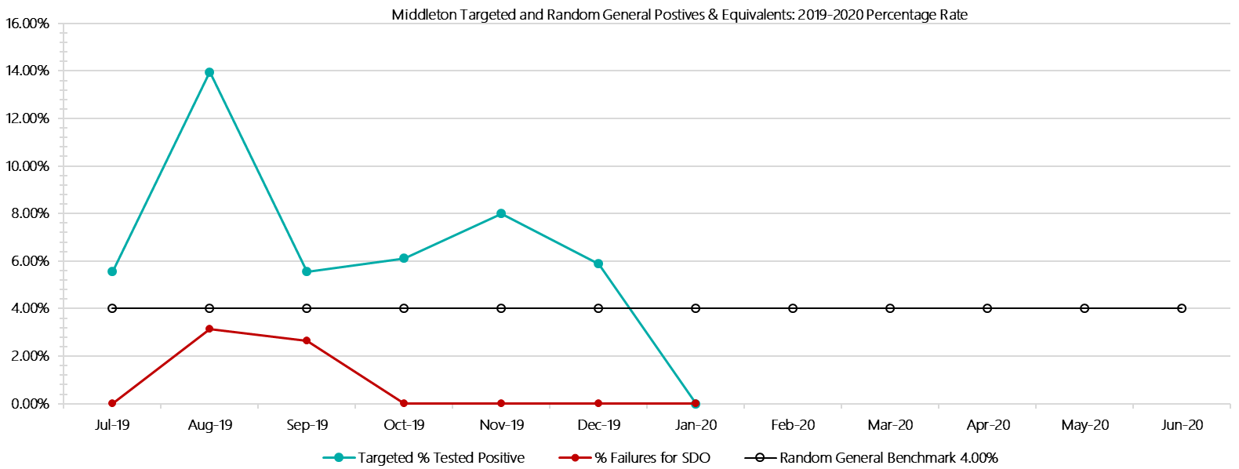

***Middleton Positive Test Results by Drug Type: 2019-2020***

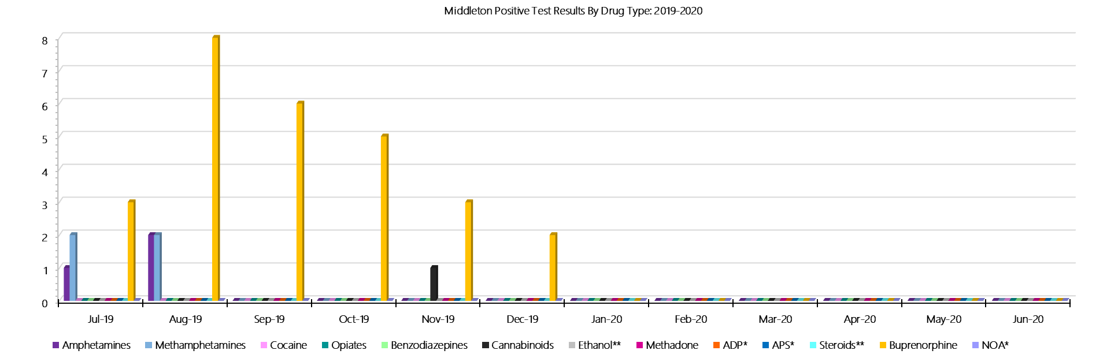

***Middleton Count of Visitor Seizures Finds: 2019-2020***

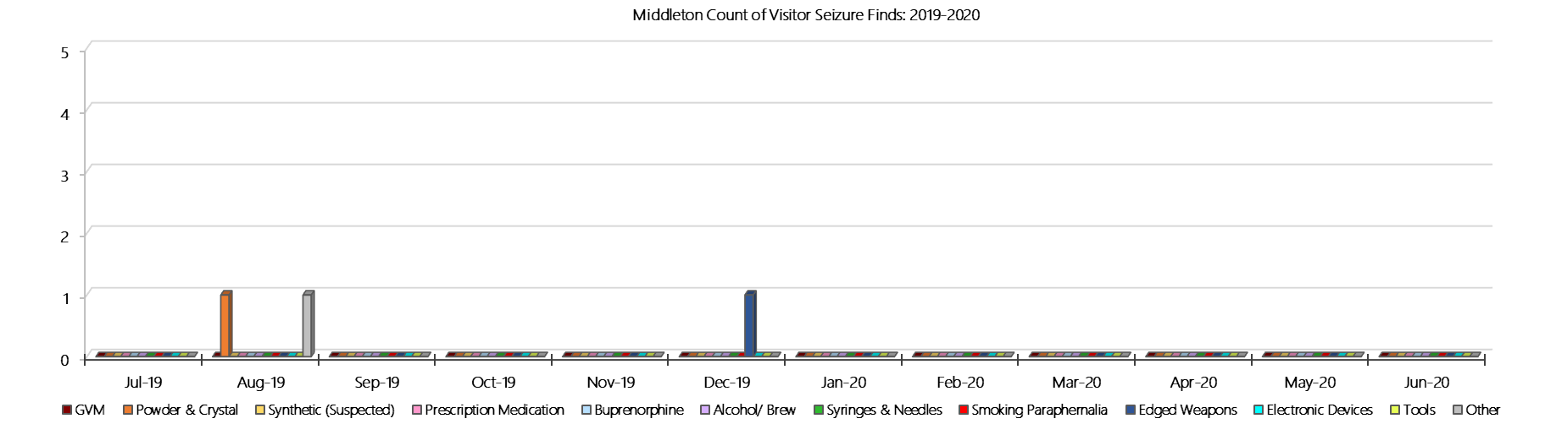

***Middleton Count of Prisoner Seizure Finds: 2019-2020***

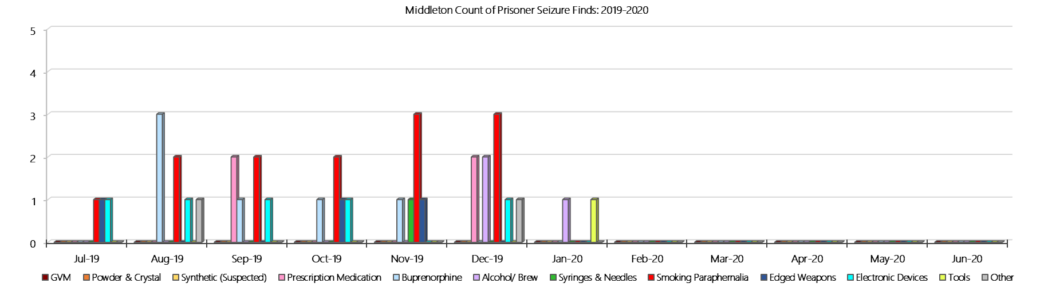

### **Ravenhall Correctional Centre**

***Targeted and Random General Drug Test Results: 2019-2020***

|  |  |  |  |  |  |  |  |  |  |  |  |  |  |  |
| --- | --- | --- | --- | --- | --- | --- | --- | --- | --- | --- | --- | --- | --- | --- |
| **Ravenhall** | **Jul-19** | **Aug-19** | **Sep-19** | **Oct-19** | **Nov-19** | **Dec-19** | **Jan-20** | **Feb-20** | **Mar-20** | **Apr-20** | **May-20** | **Jun-20** | **Average** | ***Totals*** |
| **Effective Sample - Targeted** | **375** | **426** | **400** | **444** | **411** | **414** | **402** |  |  |  |  |  | **410** | ***2872*** |
| **Targeted Positives** | **15** | **27** | **16** | **20** | **33** | **29** | **34** |  |  |  |  |  | **25** | ***174*** |
| **Refusal** | **1** | **0** | **3** | **3** | **1** | **2** | **1** |  |  |  |  |  | **2** | ***11*** |
| **Unable** | **5** | **4** | **5** | **8** | **4** | **14** | **1** |  |  |  |  |  | **6** | ***41*** |
| **Interfered** | **0** | **0** | **0** | **0** | **0** | **0** | **0** |  |  |  |  |  | **0** | ***0*** |
| **Adulterated** | **0** | **0** | **1** | **0** | **0** | **1** | **2** |  |  |  |  |  | **1** | ***4*** |
| **Targeted % Tested Positive** | **5.60%** | **7.28%** | **6.25%** | **6.98%** | **9.25%** | **11.11%** | **9.45%** | **#N/A** | **#N/A** | **#N/A** | **#N/A** | **#N/A** | **8.01%** | ***8.01%*** |
| **Awaiting / Pending Results** | **0** | **0** | **0** | **0** | **0** | **0** | **0** |  |  |  |  |  | **0** | ***0*** |
| **Targeted Residual** | **1** | **1** | **3** | **1** | **1** | **1** | **1** |  |  |  |  |  | **1** | ***9*** |
| **Random tests collected** | **174** | **146** | **173** | **147** | **139** | **179** | **144** |  |  |  |  |  | **157** | ***1102*** |
| **Tested Positive** | **8** | **4** | **1** | **4** | **8** | **6** | **7** |  |  |  |  |  | **5** | ***38*** |
| **Refusal (guilty)** | **1** | **0** | **2** | **0** | **1** | **0** | **0** |  |  |  |  |  | **1** | ***4*** |
| **Unable (not guilty)** | **0** | **0** | **0** | **0** | **0** | **0** | **0** |  |  |  |  |  | **0** | ***0*** |
| **Unable (guilty)** | **0** | **0** | **1** | **0** | **0** | **0** | **1** |  |  |  |  |  | **0** | ***2*** |
| **Interfered (guilty)** | **0** | **0** | **0** | **0** | **0** | **0** | **0** |  |  |  |  |  | **0** | ***0*** |
| **No test (valid reason)** | **7** | **2** | **5** | **1** | **7** | **5** | **4** |  |  |  |  |  | **4** | ***31*** |
| **No test (no valid reason)** | **0** | **0** | **2** | **0** | **0** | **0** | **0** |  |  |  |  |  | **0** | ***2*** |
| **Adulterated** | **0** | **0** | **0** | **0** | **0** | **0** | **1** |  |  |  |  |  | **0** | ***1*** |
| **Awaiting / Pending Results** | **0** | **0** | **0** | **0** | **0** | **0** | **0** |  |  |  |  |  | **0** | ***0*** |
| **Random Residual *(PIMS URAR030)*** | **0** | **0** | **0** | **1** | **1** | **0** | **1** |  |  |  |  |  | ***0.428571*** | ***3*** |
| **Effective Sample - Random General** | **175** | **146** | **178** | **147** | **140** | **179** | **145** |  |  |  |  |  | **159** | **1110** |
| **% Tested positive** | **4.57%** | **2.74%** | **0.56%** | **2.72%** | **5.71%** | **3.35%** | **4.83%** |  |  |  |  |  | **3.50%** |  |
| **% Prisoner guilty, positive equivalents** | **0.57%** | **0.00%** | **1.69%** | **0.00%** | **0.71%** | **0.00%** | **1.38%** |  |  |  |  |  | **0.62%** |  |
| **% Total prisoner fails** | **5.14%** | **2.74%** | **2.25%** | **2.72%** | **6.43%** | **3.35%** | **5.52%** |  |  |  |  |  | **4.02%** |  |
| **% No test without valid reason** | **0.00%** | **0.00%** | **1.12%** | **0.00%** | **0.00%** | **0.00%** | **0.00%** |  |  |  |  |  | **0.16%** |  |
| **% Failures for SDO** | **5.14%** | **2.74%** | **3.37%** | **2.72%** | **6.43%** | **3.35%** | **6.21%** | **#N/A** | **#N/A** | **#N/A** | **#N/A** | **#N/A** | **4.23%** |  |

***Ravenhall - Drugs Identified Through Testing by Drug Type: 2019-2020***

|  |  |  |  |  |  |  |  |  |  |  |  |  |  |  |  |
| --- | --- | --- | --- | --- | --- | --- | --- | --- | --- | --- | --- | --- | --- | --- | --- |
| **Ravenhall** | ***Amphetamines*** | | ***Methamphetamines*** | ***Cocaine*** | ***Opiates*** | ***Benzodiazepines*** | ***Cannabinoids*** | ***Ethanol\*\**** | ***Methadone*** | ***ADP\**** | ***APS\**** | ***Steroids\*\**** | ***Buprenorphine*** | ***NOA\**** | **Total** |
| **Jul-19** | **2** | | **5** | **0** | **0** | **0** | **1** | **0** | **0** | **0** | **0** | **0** | **28** | **0** | **36** |
| **Aug-19** | **2** | | **9** | **0** | **0** | **3** | **1** | **0** | **0** | **1** | **0** | **0** | **22** | **0** | **38** |
| **Sep-19** | **3** | | **3** | **0** | **0** | **1** | **2** | **0** | **0** | **0** | **0** | **0** | **16** | **0** | **25** |
| **Oct-19** | **7** | | **8** | **0** | **0** | **0** | **4** | **0** | **1** | **0** | **0** | **0** | **21** | **0** | **41** |
| **Nov-19** | **5** | | **8** | **0** | **0** | **0** | **0** | **0** | **0** | **0** | **0** | **0** | **43** | **0** | **56** |
| **Dec-19** | **4** | | **7** | **0** | **0** | **1** | **2** | **1** | **0** | **0** | **0** | **0** | **37** | **0** | **52** |
| **Jan-20** | **0** | | **0** | **0** | **0** | **0** | **0** | **0** | **0** | **0** | **0** | **0** | **51** | **0** | **51** |
| **Feb-20** |  | |  |  |  |  |  |  |  |  |  |  |  |  |  |
| **Mar-20** |  | |  |  |  |  |  |  |  |  |  |  |  |  |  |
| **Apr-20** |  | |  |  |  |  |  |  |  |  |  |  |  |  |  |
| **May-20** |  | |  |  |  |  |  |  |  |  |  |  |  |  |  |
| **Jun-20** |  | |  |  |  |  |  |  |  |  |  |  |  |  |  |
| **Ravenhall YTD** | | **23** | **40** | **0** | **0** | **5** | **10** | **1** | **1** | **1** | **0** | **0** | **218** | **0** | **299** |
| ***All Prisons YTD*** | | ***111*** | ***184*** | ***2*** | ***31*** | ***26*** | ***21*** | ***18*** | ***25*** | ***33*** | ***12*** | ***0*** | ***1397*** | ***0*** | ***1860*** |
| ***Ravenhall % of Total*** | | ***20.72%*** | ***21.74%*** | ***0.00%*** | ***0.00%*** | ***19.23%*** | ***47.62%*** | ***5.56%*** | ***4.00%*** | ***3.03%*** | ***0.00%*** | ***0.00%*** | ***15.60%*** | ***0.00%*** | ***16.08%*** |

***Ravenhall Seizures of Contraband: Visitors & Prisoners: 2019-2020***

|  |  |  |  |  |  |  |  |  |  |  |  |  |  |  |  |  |  |  |  |  |  |  |  |  |
| --- | --- | --- | --- | --- | --- | --- | --- | --- | --- | --- | --- | --- | --- | --- | --- | --- | --- | --- | --- | --- | --- | --- | --- | --- |
| **Visitors** | **GVM** | | **Powder  & Crystal** | | **Synthetic  (Suspected)** | | **Prescription  Medication** | | **Buprenorphine** | | **Alcohol &  Home Brew** | | **Syringes & Needles** | | **Smoking  Paraphernalia** | | **Edged  Weapons** | | **Electronic  Devices** | | **Tools** | | **Other** | |
| **Ravenhall** | **Find** | **Gms** | **Finds** | **Gms** | **Finds** | **Gms** | **Finds** | **Qty** | **Finds** | **Qty** | **Finds** | **Ltrs** | **Finds** | **Qty** | **Finds** | **Qty** | **Finds** | **Qty** | **Finds** | **Qty** | **Finds** | **Qty** | **Finds** | **Qty** |
| **Jul-19** | **2** | **22.09** | **2** | **2.62** | **0** | **0.00** | **2** | **8.00** | **1** | **5.00** | **0** | **0.000** | **0** | **0** | **3** | **12** | **2** | **2** | **0** | **0** | **1** | **6** | **0** | **0** |
| **Aug-19** | **2** | **6.50** | **3** | **25.81** | **0** | **0.00** | **3** | **30.00** | **0** | **0.00** | **0** | **0.000** | **1** | **1** | **5** | **8** | **1** | **1** | **0** | **0** | **1** | **10** | **1** | **1** |
| **Sep-19** | **3** | **10.00** | **6** | **7.45** | **0** | **0.00** | **2** | **7.00** | **1** | **7.00** | **0** | **0.000** | **1** | **3** | **5** | **12** | **1** | **1** | **1** | **1** | **0** | **0** | **1** | **15** |
| **Oct-19** | **2** | **35.40** | **3** | **1.84** | **0** | **0.00** | **0** | **0.00** | **0** | **0.00** | **0** | **0.000** | **1** | **2** | **1** | **1** | **1** | **1** | **0** | **0** | **0** | **0** | **0** | **0** |
| **Nov-19** | **3** | **14.80** | **3** | **0.74** | **0** | **0.00** | **0** | **0.00** | **0** | **0.00** | **0** | **0.000** | **0** | **0** | **5** | **7** | **0** | **0** | **0** | **0** | **0** | **0** | **0** | **0** |
| **Dec-19** | **2** | **7.46** | **5** | **4.54** | **0** | **0.00** | **1** | **3.00** | **1** | **8.00** | **0** | **0.000** | **2** | **3** | **2** | **2** | **0** | **0** | **0** | **0** | **1** | **1** | **1** | **15** |
| **Jan-20** | **1** | **0.00** | **1** | **1.12** | **0** | **0.00** | **1** | **13.00** | **0** | **0.00** | **0** | **0.000** | **1** | **2** | **5** | **34** | **0** | **0** | **0** | **0** | **0** | **0** | **0** | **0** |
| **Feb-20** |  |  |  |  |  |  |  |  |  |  |  |  |  |  |  |  |  |  |  |  |  |  |  |  |
| **Mar-20** |  |  |  |  |  |  |  |  |  |  |  |  |  |  |  |  |  |  |  |  |  |  |  |  |
| **Apr-20** |  |  |  |  |  |  |  |  |  |  |  |  |  |  |  |  |  |  |  |  |  |  |  |  |
| **May-20** |  |  |  |  |  |  |  |  |  |  |  |  |  |  |  |  |  |  |  |  |  |  |  |  |
| **Jun-20** |  |  |  |  |  |  |  |  |  |  |  |  |  |  |  |  |  |  |  |  |  |  |  |  |
| **Total** | **15** | **96.25** | **23** | **44.12** | **0** | **0.00** | **9** | **61.00** | **3** | **20.00** | **0** | **0.000** | **6** | **11** | **26** | **76** | **5** | **5** | **1** | **1** | **3** | **17** | **3** | **31** |

|  |  |  |  |  |  |  |  |  |  |  |  |  |  |  |  |  |  |  |  |  |  |  |  |  |  |  |
| --- | --- | --- | --- | --- | --- | --- | --- | --- | --- | --- | --- | --- | --- | --- | --- | --- | --- | --- | --- | --- | --- | --- | --- | --- | --- | --- |
| **Prisoners** | **GVM** | | **Powder  & Crystal** | | **Synthetic  (Suspected)** | | **Prescription  Medication** | | **Buprenorphine** | | **Alcohol &  Home Brew** | | **Syringes & Needles** | | **Smoking  Paraphernalia** | | | **Edged  Weapons** | | **Electronic  Devices** | | **Tools** | | **Other** | | |
| **Ravenhall** | **Finds** | **Gms** | **Finds** | **Gms** | **Finds** | **Gms** | **Finds** | **Qty** | **Finds** | **Qty** | **Finds** | **Ltrs** | **Finds** | **Qty** | **Finds** | **Qty** | | **Finds** | **Qty** | **Finds** | **Qty** | **Finds** | **Qty** | **Finds** | **Qty** |
| **Jul-19** | **1** | **3.76** | **0** | **0.00** | **0** | **0.00** | **15** | **192.00** | **11** | **15.00** | **1** | **1.000** | **0** | **0** | **12** | | **16** | **19** | **37** | **0** | **0** | **8** | **35** | **8** | **30** |
| **Aug-19** | **0** | **0.00** | **0** | **0.00** | **0** | **0.00** | **9** | **25.00** | **4** | **2.30** | **4** | **9.400** | **0** | **0** | **15** | | **47** | **11** | **27** | **1** | **1** | **6** | **13** | **8** | **26** |
| **Sep-19** | **0** | **0.00** | **2** | **3.00** | **0** | **0.00** | **8** | **25.00** | **7** | **11.00** | **11** | **20.500** | **4** | **4** | **14** | | **36** | **16** | **27** | **3** | **3** | **7** | **26** | **5** | **13** |
| **Oct-19** | **0** | **0.00** | **0** | **0.00** | **0** | **0.00** | **7** | **22.75** | **3** | **4.00** | **6** | **5.400** | **2** | **3** | **11** | | **47** | **18** | **26** | **0** | **0** | **12** | **50** | **14** | **29** |
| **Nov-19** | **0** | **0.00** | **2** | **0.02** | **0** | **0.00** | **6** | **11.50** | **5** | **5.00** | **5** | **5.920** | **3** | **4** | **11** | | **229** | **27** | **40** | **0** | **0** | **3** | **4** | **12** | **18** |
| **Dec-19** | **0** | **0.00** | **0** | **0.00** | **0** | **0.00** | **10** | **233.50** | **12** | **51.00** | **10** | **32.000** | **3** | **4** | **8** | | **29** | **10** | **14** | **0** | **0** | **5** | **11** | **3** | **3** |
| **Jan-20** | **0** | **0.00** | **3** | **3.56** | **0** | **0.00** | **6** | **45.50** | **16** | **144.00** | **7** | **13.000** | **1** | **1** | **12** | | **31** | **9** | **19** | **0** | **0** | **0** | **0** | **1** | **22.5** |
| **Feb-20** |  |  |  |  |  |  |  |  |  |  |  |  |  |  |  | |  |  |  |  |  |  |  |  |  |
| **Mar-20** |  |  |  |  |  |  |  |  |  |  |  |  |  |  |  | |  |  |  |  |  |  |  |  |  |
| **Apr-20** |  |  |  |  |  |  |  |  |  |  |  |  |  |  |  | |  |  |  |  |  |  |  |  |  |
| **May-20** |  |  |  |  |  |  |  |  |  |  |  |  |  |  |  | |  |  |  |  |  |  |  |  |  |
| **Jun-20** |  |  |  |  |  |  |  |  |  |  |  |  |  |  |  | |  |  |  |  |  |  |  |  |  |
| **Total** | **1** | **3.76** | **7** | **6.58** | **0** | **0.00** | **61** | **555.25** | **58** | **232.30** | **44** | **87.220** | **13** | **16** | **83** | | **435** | **110** | **190** | **4** | **4** | **41** | **139** | **51** | **141.5** |

***Ravenhall Targeted and Random General Drug Test Positives & Equivalents: 2019-2020***

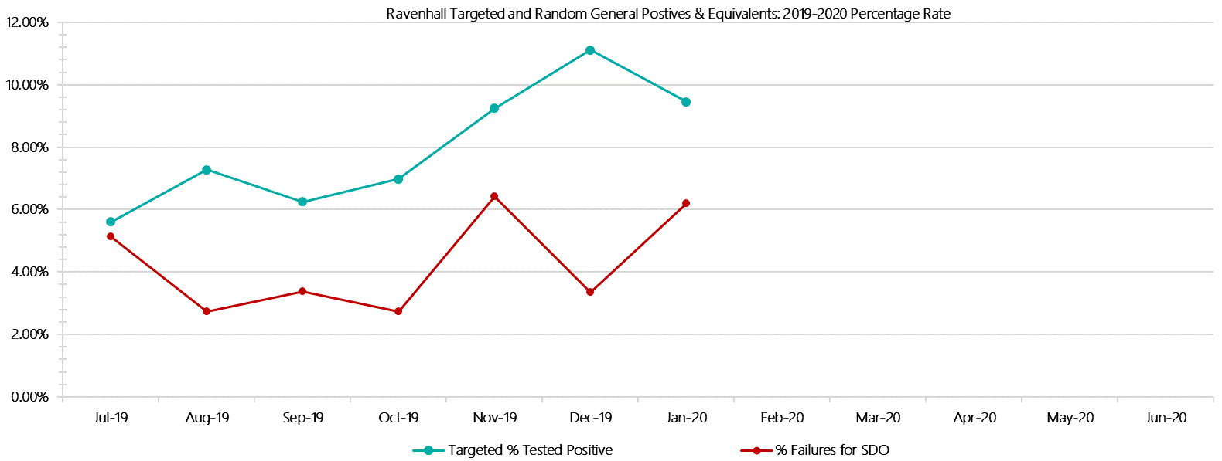

***Ravenhall Positive Test Results by Drug Type: 2019-2020***

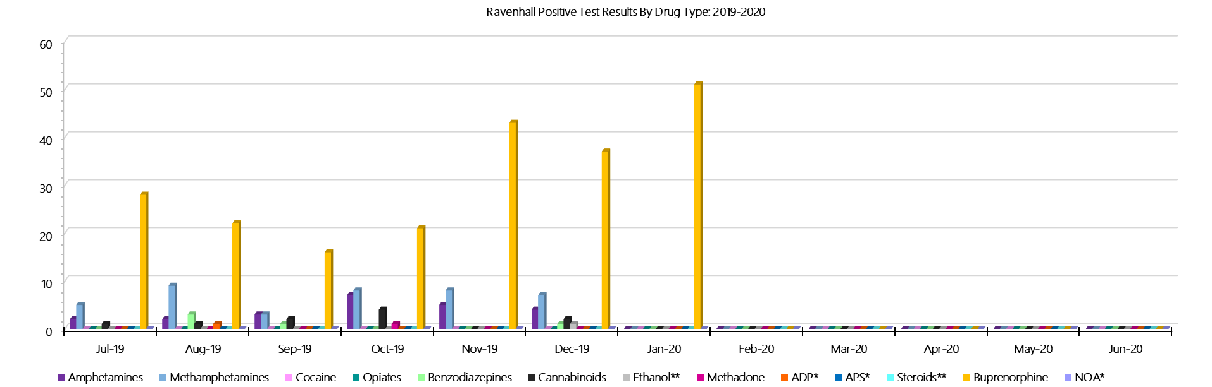

***Ravenhall Count of Visitor Seizures Finds: 2019-2020***

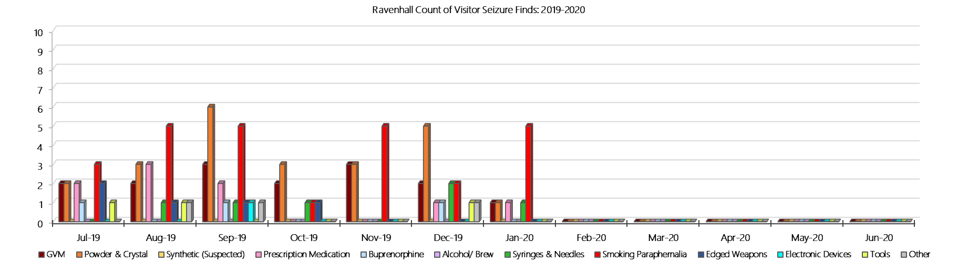

***Ravenhall Count of Prisoner Seizure Finds: 2019-2020***

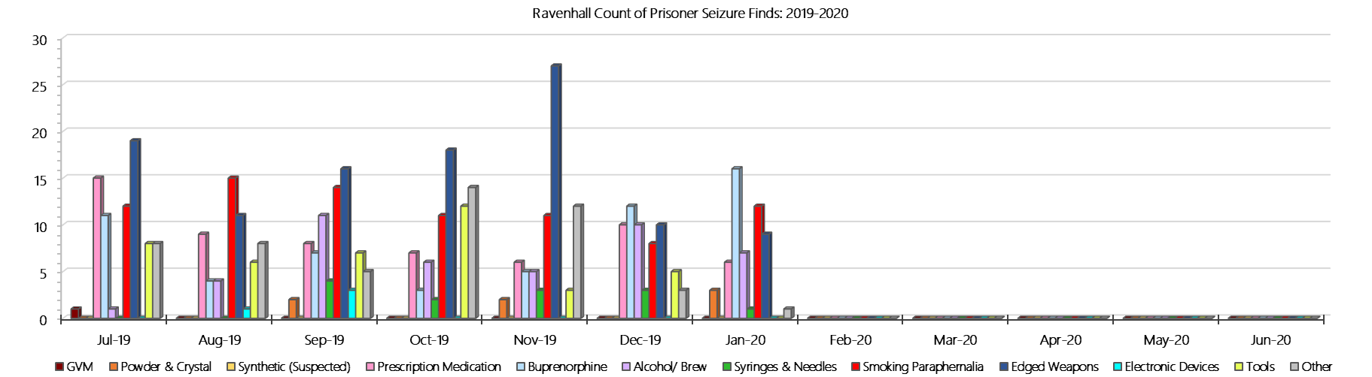

### **Beechworth Correctional Centre**

***Targeted and Random General Drug Test Results: 2019-2020***

|  |  |  |  |  |  |  |  |  |  |  |  |  |  |  |
| --- | --- | --- | --- | --- | --- | --- | --- | --- | --- | --- | --- | --- | --- | --- |
| **Beechworth** | **Jul-19** | **Aug-19** | **Sep-19** | **Oct-19** | **Nov-19** | **Dec-19** | **Jan-20** | **Feb-20** | **Mar-20** | **Apr-20** | **May-20** | **Jun-20** | **Average** | ***Totals*** |
| **Effective Sample - Targeted** | **43** | **35** | **38** | **50** | **20** | **42** | **21** |  |  |  |  |  | **36** | ***249*** |
| **Targeted Positives** | **0** | **0** | **1** | **0** | **0** | **1** | **0** |  |  |  |  |  | **0** | ***2*** |
| **Refusal** | **0** | **0** | **0** | **0** | **0** | **0** | **0** |  |  |  |  |  | **0** | ***0*** |
| **Unable** | **0** | **0** | **0** | **0** | **0** | **0** | **0** |  |  |  |  |  | **0** | ***0*** |
| **Interfered** | **0** | **0** | **0** | **0** | **0** | **0** | **0** |  |  |  |  |  | **0** | ***0*** |
| **Adulterated** | **0** | **0** | **0** | **0** | **0** | **0** | **0** |  |  |  |  |  | **0** | ***0*** |
| **Targeted % Tested Positive** | **0.00%** | **0.00%** | **2.63%** | **0.00%** | **0.00%** | **2.38%** | **0.00%** | **#N/A** | **#N/A** | **#N/A** | **#N/A** | **#N/A** | **0.80%** | ***0.80%*** |
| **Awaiting / Pending Results** | **0** | **0** | **0** | **0** | **0** | **0** | **0** |  |  |  |  |  | **0** | ***0*** |
| **Targeted Residual** | **0** | **0** | **0** | **0** | **0** | **0** | **0** |  |  |  |  |  | **0** | ***0*** |
| **Random tests collected** | **28** | **24** | **29** | **24** | **24** | **29** | **12** |  |  |  |  |  | **24** | ***170*** |
| **Tested Positive** | **0** | **0** | **0** | **0** | **0** | **0** | **0** |  |  |  |  |  | **0** | ***0*** |
| **Refusal (guilty)** | **0** | **0** | **0** | **0** | **0** | **0** | **0** |  |  |  |  |  | **0** | ***0*** |
| **Unable (not guilty)** | **0** | **0** | **0** | **0** | **0** | **0** | **0** |  |  |  |  |  | **0** | ***0*** |
| **Unable (guilty)** | **0** | **0** | **0** | **0** | **0** | **1** | **0** |  |  |  |  |  | **0** | ***1*** |
| **Interfered (guilty)** | **0** | **0** | **0** | **0** | **0** | **0** | **0** |  |  |  |  |  | **0** | ***0*** |
| **No test (valid reason)** | **0** | **0** | **0** | **0** | **0** | **0** | **0** |  |  |  |  |  | **0** | ***0*** |
| **No test (no valid reason)** | **0** | **0** | **0** | **0** | **0** | **0** | **0** |  |  |  |  |  | **0** | ***0*** |
| **Adulterated** | **0** | **0** | **0** | **0** | **0** | **0** | **0** |  |  |  |  |  | **0** | ***0*** |
| **Awaiting / Pending Results** | **0** | **0** | **0** | **0** | **0** | **0** | **0** |  |  |  |  |  | **0** | ***0*** |
| **Random Residual *(PIMS URAR030)*** | **0** | **0** | **0** | **0** | **0** | **0** | **0** |  |  |  |  |  | ***0*** | ***0*** |
| **Effective Sample - Random General** | **28** | **24** | **29** | **24** | **24** | **30** | **12** |  |  |  |  |  | **24** | **171** |
| **% Tested positive** | **0.00%** | **0.00%** | **0.00%** | **0.00%** | **0.00%** | **0.00%** | **0.00%** |  |  |  |  |  | **0.00%** |  |
| **% Prisoner guilty, positive equivalents** | **0.00%** | **0.00%** | **0.00%** | **0.00%** | **0.00%** | **3.33%** | **0.00%** |  |  |  |  |  | **0.48%** |  |
| **% Total prisoner fails** | **0.00%** | **0.00%** | **0.00%** | **0.00%** | **0.00%** | **3.33%** | **0.00%** |  |  |  |  |  | **0.48%** |  |
| **% No test without valid reason** | **0.00%** | **0.00%** | **0.00%** | **0.00%** | **0.00%** | **0.00%** | **0.00%** |  |  |  |  |  | **0.00%** |  |
| ***Random General Benchmark 1.80%*** | ***1.80%*** | ***1.80%*** | ***1.80%*** | ***1.80%*** | ***1.80%*** | ***1.80%*** | ***1.80%*** | ***1.80%*** | ***1.80%*** | ***1.80%*** | ***1.80%*** | ***1.80%*** | ***YTD*** |  |
| **% Failures for SDO** | **0.00%** | **0.00%** | **0.00%** | **0.00%** | **0.00%** | **3.33%** | **0.00%** | **#N/A** | **#N/A** | **#N/A** | **#N/A** | **#N/A** | **0.58%** |  |

***Beechworth - Drugs Identified Through Testing by Drug Type: 2019-2020***

|  |  |  |  |  |  |  |  |  |  |  |  |  |  |  |
| --- | --- | --- | --- | --- | --- | --- | --- | --- | --- | --- | --- | --- | --- | --- |
| **Beechworth** | ***Amphetamines*** | ***Methamphetamines*** | ***Cocaine*** | ***Opiates*** | ***Benzodiazepines*** | ***Cannabinoids*** | ***Ethanol\*\**** | ***Methadone*** | ***ADP\**** | ***APS\**** | ***Steroids\*\**** | ***Buprenorphine*** | ***NOA\**** | **Total** |
| **Jul-19** | **0** | **0** | **0** | **0** | **0** | **0** | **0** | **0** | **0** | **0** | **0** | **0** | **0** | **0** |
| **Aug-19** | **0** | **1** | **0** | **0** | **0** | **0** | **0** | **0** | **0** | **0** | **0** | **0** | **0** | **1** |
| **Sep-19** | **1** | **1** | **0** | **0** | **0** | **0** | **0** | **0** | **0** | **0** | **0** | **1** | **0** | **3** |
| **Oct-19** | **0** | **0** | **0** | **0** | **0** | **0** | **0** | **0** | **0** | **0** | **0** | **0** | **0** | **0** |
| **Nov-19** | **0** | **0** | **0** | **0** | **0** | **0** | **0** | **0** | **0** | **0** | **0** | **0** | **0** | **0** |
| **Dec-19** | **0** | **0** | **0** | **0** | **0** | **0** | **0** | **0** | **0** | **0** | **0** | **1** | **0** | **1** |
| **Jan-20** | **0** | **0** | **0** | **0** | **0** | **0** | **0** | **0** | **0** | **0** | **0** | **1** | **0** | **1** |
| **Feb-20** |  |  |  |  |  |  |  |  |  |  |  |  |  |  |
| **Mar-20** |  |  |  |  |  |  |  |  |  |  |  |  |  |  |
| **Apr-20** |  |  |  |  |  |  |  |  |  |  |  |  |  |  |
| **May-20** |  |  |  |  |  |  |  |  |  |  |  |  |  |  |
| **Jun-20** |  |  |  |  |  |  |  |  |  |  |  |  |  |  |
| **BeechworthYTD** | **1** | **2** | **0** | **0** | **0** | **0** | **0** | **0** | **0** | **0** | **0** | **3** | **0** | **6** |
| ***All Prisons YTD*** | ***111*** | ***184*** | ***2*** | ***31*** | ***26*** | ***21*** | ***18*** | ***25*** | ***33*** | ***12*** | ***0*** | ***1397*** | ***0*** | ***1860*** |
| ***Beechworth % of Total*** | ***0.90%*** | ***1.09%*** | ***0.00%*** | ***0.00%*** | ***0.00%*** | ***0.00%*** | ***0.00%*** | ***0.00%*** | ***0.00%*** | ***0.00%*** | ***0.00%*** | ***0.21%*** | ***0.00%*** | ***0.32%*** |

***Beechworth Seizures of Contraband: Visitors & Prisoners: 2019-2020***

|  |  |  |  |  |  |  |  |  |  |  |  |  |  |  |  |  |  |  |  |  |  |  |  |  |  |
| --- | --- | --- | --- | --- | --- | --- | --- | --- | --- | --- | --- | --- | --- | --- | --- | --- | --- | --- | --- | --- | --- | --- | --- | --- | --- |
| **Visitors** | **GVM** | | **Powder  & Crystal** | | **Synthetic  (Suspected)** | | **Prescription  Medication** | | **Buprenorphine** | | **Alcohol &  Home Brew** | | **Syringes & Needles** | | **Smoking  Paraphernalia** | | **Edged  Weapons** | | **Electronic  Devices** | | **Tools** | | **Other** | | |
| **BCC** | **Finds** | **Gms** | **Finds** | **Gms** | **Finds** | **Gms** | **Finds** | **Qty** | **Finds** | **Qty** | **Finds** | **Ltrs** | **Finds** | **Qty** | **Finds** | **Qty** | **Finds** | **Qty** | **Finds** | **Qty** | **Finds** | **Qty** | **Finds** | **Qty** |
| **Jul-19** | **0** | **0.00** | **0** | **0.00** | **0** | **0.00** | **0** | **0.00** | **0** | **0.00** | **0** | **0.000** | **0** | **0** | **0** | **0** | **0** | **0** | **0** | **0** | **0** | **0** | **0** | **0** |
| **Aug-19** | **0** | **0.00** | **0** | **0.00** | **0** | **0.00** | **0** | **0.00** | **0** | **0.00** | **0** | **0.000** | **0** | **0** | **0** | **0** | **0** | **0** | **0** | **0** | **0** | **0** | **0** | **0** |
| **Sep-19** | **0** | **0.00** | **0** | **0.00** | **0** | **0.00** | **0** | **0.00** | **0** | **0.00** | **0** | **0.000** | **0** | **0** | **0** | **0** | **0** | **0** | **0** | **0** | **0** | **0** | **0** | **0** |
| **Oct-19** | **0** | **0.00** | **0** | **0.00** | **0** | **0.00** | **0** | **0.00** | **0** | **0.00** | **0** | **0.000** | **0** | **0** | **0** | **0** | **0** | **0** | **0** | **0** | **0** | **0** | **0** | **0** |
| **Nov-19** | **0** | **0.00** | **0** | **0.00** | **0** | **0.00** | **0** | **0.00** | **0** | **0.00** | **0** | **0.000** | **0** | **0** | **0** | **0** | **0** | **0** | **0** | **0** | **0** | **0** | **0** | **0** |
| **Dec-19** | **0** | **0.00** | **0** | **0.00** | **0** | **0.00** | **0** | **0.00** | **0** | **0.00** | **0** | **0.000** | **0** | **0** | **0** | **0** | **0** | **0** | **0** | **0** | **0** | **0** | **0** | **0** |
| **Jan-20** | **0** | **0.00** | **0** | **0.00** | **0** | **0.00** | **0** | **0.00** | **0** | **0.00** | **0** | **0.000** | **0** | **0** | **0** | **0** | **0** | **0** | **0** | **0** | **0** | **0** | **0** | **0** |
| **Feb-20** |  |  |  |  |  |  |  |  |  |  |  |  |  |  |  |  |  |  |  |  |  |  |  |  |
| **Mar-20** |  |  |  |  |  |  |  |  |  |  |  |  |  |  |  |  |  |  |  |  |  |  |  |  |
| **Apr-20** |  |  |  |  |  |  |  |  |  |  |  |  |  |  |  |  |  |  |  |  |  |  |  |  |
| **May-20** |  |  |  |  |  |  |  |  |  |  |  |  |  |  |  |  |  |  |  |  |  |  |  |  |
| **Jun-20** |  |  |  |  |  |  |  |  |  |  |  |  |  |  |  |  |  |  |  |  |  |  |  |  |
| **Total** | **0** | **0.00** | **0** | **0.00** | **0** | **0.00** | **0** | **0.00** | **0** | **0.00** | **0** | **0.000** | **0** | **0** | **0** | **0** | **0** | **0** | **0** | **0** | **0** | **0** | **0** | **0** |

|  |  |  |  |  |  |  |  |  |  |  |  |  |  |  |  |  |  |  |  |  |  |  |  |  |  |
| --- | --- | --- | --- | --- | --- | --- | --- | --- | --- | --- | --- | --- | --- | --- | --- | --- | --- | --- | --- | --- | --- | --- | --- | --- | --- |
| **Prisoners** | **GVM** | | **Powder  & Crystal** | | **Synthetic  (Suspected)** | | **Prescription  Medication** | | **Buprenorphine** | | **Alcohol &  Home Brew** | | **Syringes & Needles** | | **Smoking  Paraphernalia** | | | **Edged  Weapons** | | **Electronic  Devices** | | **Tools** | | **Other** | |
| **BCC** | **Finds** | **Gms** | **Finds** | **Gms** | **Finds** | **Gms** | **Finds** | **Qty** | **Finds** | **Qty** | **Finds** | **Ltrs** | **Finds** | **Qty** | **Finds** | **Qty** | | **Finds** | **Qty** | **Finds** | **Qty** | **Finds** | **Qty** | **Finds** | **Qty** |
| **Jul-19** | **0** | **0.00** | **0** | **0.00** | **0** | **0.00** | **0** | **0.00** | **0** | **0.00** | **0** | **0.000** | **0** | **0** | **0** | | **0** | **0** | **0** | **0** | **0** | **0** | **0** | **2** | **6** |
| **Aug-19** | **0** | **0.00** | **0** | **0.00** | **0** | **0.00** | **0** | **0.00** | **0** | **0.00** | **0** | **0.000** | **0** | **0** | **1** | | **2** | **0** | **0** | **1** | **1** | **0** | **0** | **0** | **0** |
| **Sep-19** | **0** | **0.00** | **0** | **0.00** | **0** | **0.00** | **0** | **0.00** | **0** | **0.00** | **0** | **0.000** | **0** | **0** | **0** | | **0** | **0** | **0** | **0** | **0** | **0** | **0** | **0** | **0** |
| **Oct-19** | **0** | **0.00** | **0** | **0.00** | **0** | **0.00** | **0** | **0.00** | **0** | **0.00** | **0** | **0.000** | **0** | **0** | **2** | | **3** | **0** | **0** | **0** | **0** | **1** | **1** | **0** | **0** |
| **Nov-19** | **0** | **0.00** | **0** | **0.00** | **0** | **0.00** | **0** | **0.00** | **0** | **0.00** | **0** | **0.000** | **0** | **0** | **0** | | **0** | **0** | **0** | **0** | **0** | **0** | **0** | **3** | **3** |
| **Dec-19** | **0** | **0.00** | **0** | **0.00** | **0** | **0.00** | **1** | **24.00** | **0** | **0.00** | **0** | **0.000** | **0** | **0** | **0** | | **0** | **0** | **0** | **0** | **0** | **0** | **0** | **1** | **1** |
| **Jan-20** | **0** | **0.00** | **0** | **0.00** | **0** | **0.00** | **0** | **0.00** | **0** | **0.00** | **0** | **0.000** | **0** | **0** | **0** | | **0** | **0** | **0** | **0** | **0** | **0** | **0** | **0** | **0** |
| **Feb-20** |  |  |  |  |  |  |  |  |  |  |  |  |  |  |  | |  |  |  |  |  |  |  |  |  |
| **Mar-20** |  |  |  |  |  |  |  |  |  |  |  |  |  |  |  | |  |  |  |  |  |  |  |  |  |
| **Apr-20** |  |  |  |  |  |  |  |  |  |  |  |  |  |  |  | |  |  |  |  |  |  |  |  |  |
| **May-20** |  |  |  |  |  |  |  |  |  |  |  |  |  |  |  | |  |  |  |  |  |  |  |  |  |
| **Jun-20** |  |  |  |  |  |  |  |  |  |  |  |  |  |  |  | |  |  |  |  |  |  |  |  |  |
| **Total** | **0** | **0.00** | **0** | **0.00** | **0** | **0.00** | **1** | **24.00** | **0** | **0** | **0** | **0.000** | **0** | **0** | **3** | | **5** | **0** | **0** | **1** | **1** | **1** | **1** | **6** | **10** |

***Beechworth Targeted and Random General Drug Test Positives & Equivalents: 2019-2020***

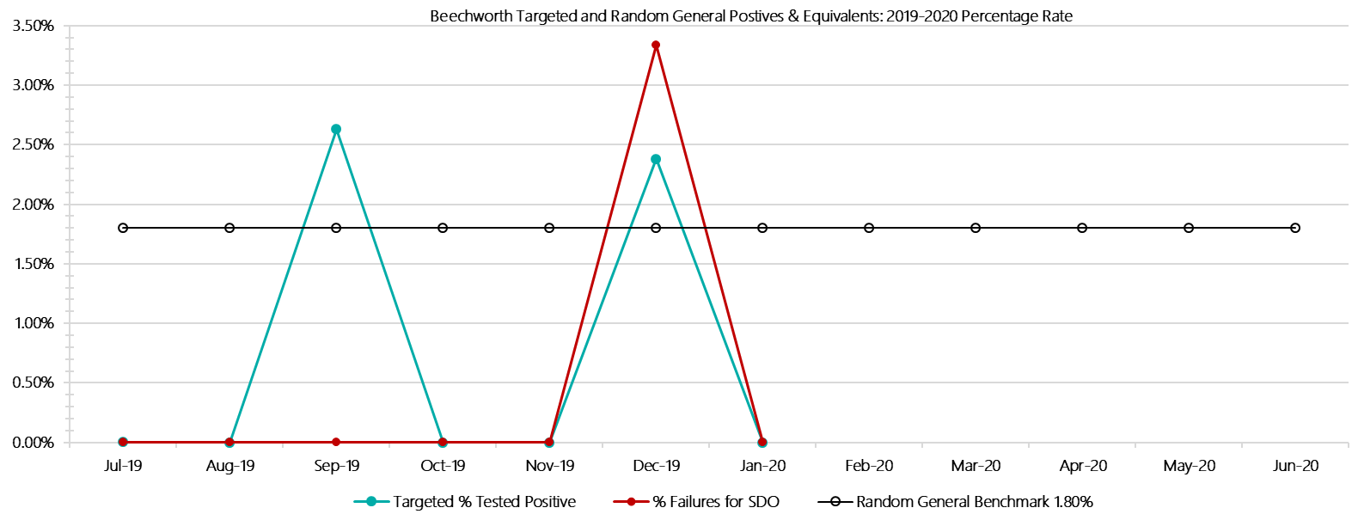

***Beechworth Positive Test Results by Drug Type: 2019-2020***

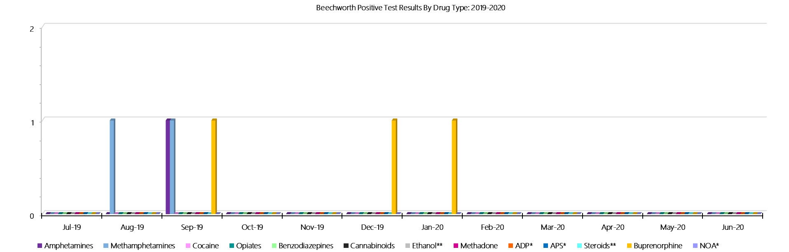

***Beechworth Count of Visitor Seizures Finds: 2019-2020***

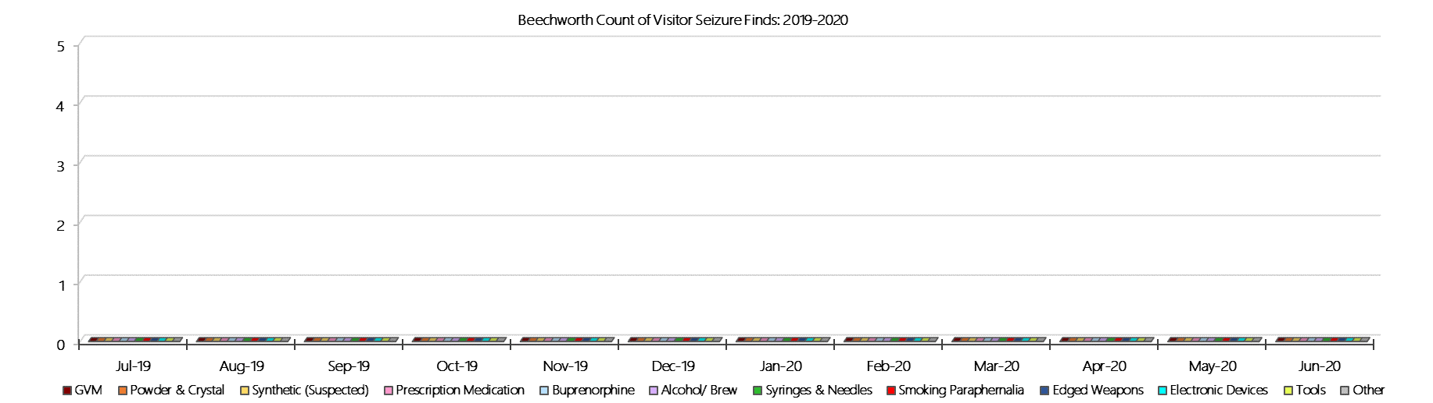

***Beechworth Count of Prisoner Seizure Finds: 2019-2020***

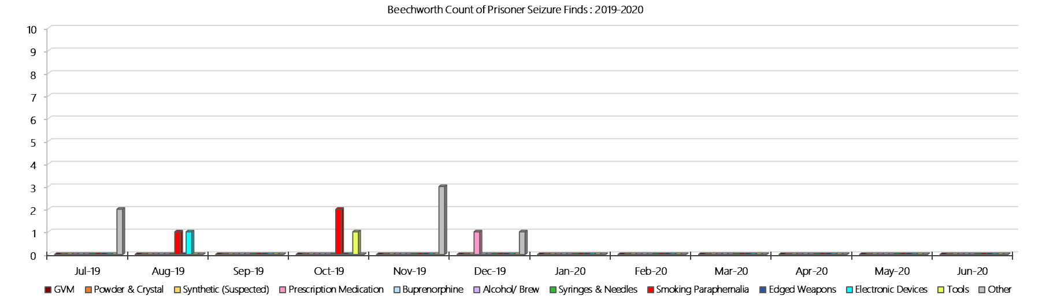

### **Dhurringile Prison**

***Targeted and Random General Drug Test Results: 2019-2020***

|  |  |  |  |  |  |  |  |  |  |  |  |  |  |  |
| --- | --- | --- | --- | --- | --- | --- | --- | --- | --- | --- | --- | --- | --- | --- |
| **Dhurringile** | **Jul-19** | **Aug-19** | **Sep-19** | **Oct-19** | **Nov-19** | **Dec-19** | **Jan-20** | **Feb-20** | **Mar-20** | **Apr-20** | **May-20** | **Jun-20** | **Average** | ***Totals*** |
| **Effective Sample - Targeted** | **130** | **90** | **117** | **116** | **64** | **120** | **88** |  |  |  |  |  | **104** | ***725*** |
| **Targeted Positives** | **5** | **1** | **3** | **3** | **1** | **1** | **2** |  |  |  |  |  | **2** | ***16*** |
| **Refusal** | **2** | **0** | **0** | **0** | **0** | **0** | **0** |  |  |  |  |  | **0** | ***2*** |
| **Unable** | **0** | **1** | **0** | **0** | **0** | **0** | **0** |  |  |  |  |  | **0** | ***1*** |
| **Interfered** | **0** | **0** | **0** | **0** | **0** | **0** | **0** |  |  |  |  |  | **0** | ***0*** |
| **Adulterated** | **0** | **0** | **0** | **0** | **0** | **0** | **0** |  |  |  |  |  | **0** | ***0*** |
| **Targeted % Tested Positive** | **5.38%** | **2.22%** | **2.56%** | **2.59%** | **1.56%** | **0.83%** | **2.27%** | **#N/A** | **#N/A** | **#N/A** | **#N/A** | **#N/A** | **2.62%** | ***2.62%*** |
| **Awaiting / Pending Results** | **0** | **0** | **0** | **0** | **0** | **0** | **0** |  |  |  |  |  | **0** | ***0*** |
| **Targeted Residual** | **1** | **0** | **1** | **0** | **0** | **0** | **0** |  |  |  |  |  | **0** | ***2*** |
| **Random tests collected** | **34** | **28** | **35** | **28** | **28** | **35** | **39** |  |  |  |  |  | **32** | ***227*** |
| **Tested Positive** | **1** | **0** | **0** | **1** | **1** | **1** | **0** |  |  |  |  |  | **1** | ***4*** |
| **Refusal (guilty)** | **0** | **0** | **0** | **0** | **0** | **0** | **0** |  |  |  |  |  | **0** | ***0*** |
| **Unable (not guilty)** | **0** | **0** | **0** | **0** | **0** | **0** | **0** |  |  |  |  |  | **0** | ***0*** |
| **Unable (guilty)** | **0** | **0** | **0** | **0** | **0** | **1** | **0** |  |  |  |  |  | **0** | ***1*** |
| **Interfered (guilty)** | **0** | **0** | **0** | **0** | **0** | **0** | **0** |  |  |  |  |  | **0** | ***0*** |
| **No test (valid reason)** | **0** | **0** | **0** | **0** | **0** | **0** | **0** |  |  |  |  |  | **0** | ***0*** |
| **No test (no valid reason)** | **0** | **0** | **0** | **0** | **0** | **0** | **0** |  |  |  |  |  | **0** | ***0*** |
| **Adulterated** | **0** | **0** | **0** | **0** | **0** | **0** | **0** |  |  |  |  |  | **0** | ***0*** |
| **Awaiting / Pending Results** | **0** | **0** | **0** | **0** | **0** | **0** | **0** |  |  |  |  |  | **0** | ***0*** |
| **Random Residual *(PIMS URAR030)*** | **0** | **0** | **0** | **0** | **0** | **0** | **0** |  |  |  |  |  | ***0*** | ***0*** |
| **Effective Sample - Random General** | **34** | **28** | **35** | **28** | **28** | **36** | **39** |  |  |  |  |  | **33** | **228** |
| **% Tested positive** | **2.94%** | **0.00%** | **0.00%** | **3.57%** | **3.57%** | **2.78%** | **0.00%** |  |  |  |  |  | **1.84%** |  |
| **% Prisoner guilty, positive equivalents** | **0.00%** | **0.00%** | **0.00%** | **0.00%** | **0.00%** | **2.78%** | **0.00%** |  |  |  |  |  | **0.40%** |  |
| **% Total prisoner fails** | **2.94%** | **0.00%** | **0.00%** | **3.57%** | **3.57%** | **5.56%** | **0.00%** |  |  |  |  |  | **2.23%** |  |
| **% No test without valid reason** | **0.00%** | **0.00%** | **0.00%** | **0.00%** | **0.00%** | **0.00%** | **0.00%** |  |  |  |  |  | **0.00%** |  |
| ***Random General Benchmark 3.50%*** | ***3.50%*** | ***3.50%*** | ***3.50%*** | ***3.50%*** | ***3.50%*** | ***3.50%*** | ***3.50%*** | ***3.50%*** | ***3.50%*** | ***3.50%*** | ***3.50%*** | ***3.50%*** | ***YTD*** |  |
| **% Failures for SDO** | **2.94%** | **0.00%** | **0.00%** | **3.57%** | **3.57%** | **5.56%** | **0.00%** | **#N/A** | **#N/A** | **#N/A** | **#N/A** | **#N/A** | **2.19%** |  |

***Dhurringile - Drugs Identified Through Testing by Drug Type: 2019-2020***

|  |  |  |  |  |  |  |  |  |  |  |  |  |  |  |
| --- | --- | --- | --- | --- | --- | --- | --- | --- | --- | --- | --- | --- | --- | --- |
| **Dhurringile** | ***Amphetamines*** | ***Methamphetamines*** | ***Cocaine*** | ***Opiates*** | ***Benzodiazepines*** | ***Cannabinoids*** | ***Ethanol\*\**** | ***Methadone*** | ***ADP\**** | ***APS\**** | ***Steroids\*\**** | ***Buprenorphine*** | ***NOA\**** | **Total** |
| **Jul-19** | **2** | **3** | **0** | **1** | **0** | **0** | **0** | **0** | **0** | **0** | **0** | **3** | **0** | **9** |
| **Aug-19** | **0** | **0** | **0** | **0** | **0** | **0** | **0** | **0** | **0** | **0** | **0** | **1** | **0** | **1** |
| **Sep-19** | **0** | **0** | **0** | **0** | **0** | **0** | **0** | **0** | **0** | **0** | **0** | **3** | **0** | **3** |
| **Oct-19** | **0** | **0** | **0** | **0** | **1** | **0** | **0** | **0** | **0** | **0** | **0** | **3** | **0** | **4** |
| **Nov-19** | **0** | **0** | **0** | **0** | **0** | **0** | **0** | **0** | **0** | **0** | **0** | **3** | **0** | **3** |
| **Dec-19** | **0** | **0** | **0** | **0** | **0** | **0** | **0** | **0** | **0** | **0** | **0** | **3** | **0** | **3** |
| **Jan-20** | **0** | **0** | **0** | **0** | **0** | **0** | **0** | **0** | **0** | **0** | **0** | **2** | **0** | **2** |
| **Feb-20** |  |  |  |  |  |  |  |  |  |  |  |  |  |  |
| **Mar-20** |  |  |  |  |  |  |  |  |  |  |  |  |  |  |
| **Apr-20** |  |  |  |  |  |  |  |  |  |  |  |  |  |  |
| **May-20** |  |  |  |  |  |  |  |  |  |  |  |  |  |  |
| **Jun-20** |  |  |  |  |  |  |  |  |  |  |  |  |  |  |
| **Dhurringile YTD** | **2** | **3** | **0** | **1** | **1** | **0** | **0** | **0** | **0** | **0** | **0** | **18** | **0** | **25** |
| ***All Prisons YTD*** | ***111*** | ***184*** | ***2*** | ***31*** | ***26*** | ***21*** | ***18*** | ***25*** | ***33*** | ***12*** | ***0*** | ***1397*** | ***0*** | ***1860*** |
| ***Dhurringile % of Total*** | ***1.80%*** | ***1.63%*** | ***0.00%*** | ***3.23%*** | ***3.85%*** | ***0.00%*** | ***0.00%*** | ***0.00%*** | ***0.00%*** | ***0.00%*** | ***0.00%*** | ***1.29%*** | ***0.00%*** | ***1.34%*** |

***Dhurringile Seizures of Contraband: Visitors & Prisoners: 2019-2020***

|  |  |  |  |  |  |  |  |  |  |  |  |  |  |  |  |  |  |  |  |  |  |  |  |  |  |
| --- | --- | --- | --- | --- | --- | --- | --- | --- | --- | --- | --- | --- | --- | --- | --- | --- | --- | --- | --- | --- | --- | --- | --- | --- | --- |
| **Visitors** | **GVM** | | **Powder  & Crystal** | | **Synthetic  (Suspected)** | | **Prescription  Medication** | | **Buprenorphine** | | **Alcohol &  Home Brew** | | **Syringes & Needles** | | **Smoking  Paraphernalia** | | **Edged  Weapons** | | **Electronic  Devices** | | **Tools** | | **Other** | | |
| **D’gile** | **Finds** | **Gms** | **Finds** | **Gms** | **Finds** | **Gms** | **Finds** | **Qty** | **Finds** | **Qty** | **Finds** | **Ltrs** | **Finds** | **Qty** | **Finds** | **Qty** | **Finds** | **Qty** | **Finds** | **Qty** | **Finds** | **Qty** | **Finds** | **Qty** |
| **Jul-19** | **0** | **0.00** | **0** | **0.00** | **0** | **0.00** | **0** | **0.00** | **0** | **0.00** | **0** | **0.000** | **0** | **0** | **0** | **0** | **0** | **0** | **0** | **0** | **0** | **0** | **0** | **0** |
| **Aug-19** | **0** | **0.00** | **0** | **0.00** | **0** | **0.00** | **0** | **0.00** | **0** | **0.00** | **0** | **0.000** | **0** | **0** | **0** | **0** | **0** | **0** | **0** | **0** | **0** | **0** | **0** | **0** |
| **Sep-19** | **0** | **0.00** | **0** | **0.00** | **0** | **0.00** | **0** | **0.00** | **0** | **0.00** | **0** | **0.000** | **0** | **0** | **0** | **0** | **0** | **0** | **0** | **0** | **0** | **0** | **0** | **0** |
| **Oct-19** | **0** | **0.00** | **0** | **0.00** | **0** | **0.00** | **0** | **0.00** | **1** | **2.50** | **0** | **0.000** | **0** | **0** | **1** | **1** | **0** | **0** | **0** | **0** | **0** | **0** | **0** | **0** |
| **Nov-19** | **0** | **0.00** | **1** | **3.00** | **0** | **0.00** | **0** | **0.00** | **0** | **0.00** | **2** | **3.375** | **0** | **0** | **1** | **1** | **0** | **0** | **0** | **0** | **0** | **0** | **2** | **4** |
| **Dec-19** | **0** | **0.00** | **0** | **0.00** | **0** | **0.00** | **0** | **0.00** | **0** | **0.00** | **0** | **0.000** | **0** | **0** | **0** | **0** | **0** | **0** | **0** | **0** | **0** | **0** | **0** | **0** |
| **Jan-20** | **0** | **0.00** | **0** | **0.00** | **0** | **0.00** | **0** | **0.00** | **0** | **0.00** | **0** | **0.000** | **0** | **0** | **0** | **0** | **0** | **0** | **0** | **0** | **0** | **0** | **0** | **0** |
| **Feb-20** |  |  |  |  |  |  |  |  |  |  |  |  |  |  |  |  |  |  |  |  |  |  |  |  |
| **Mar-20** |  |  |  |  |  |  |  |  |  |  |  |  |  |  |  |  |  |  |  |  |  |  |  |  |
| **Apr-20** |  |  |  |  |  |  |  |  |  |  |  |  |  |  |  |  |  |  |  |  |  |  |  |  |
| **May-20** |  |  |  |  |  |  |  |  |  |  |  |  |  |  |  |  |  |  |  |  |  |  |  |  |
| **Jun-20** |  |  |  |  |  |  |  |  |  |  |  |  |  |  |  |  |  |  |  |  |  |  |  |  |
| **Total** | **0** | **0.00** | **1** | **3.00** | **0** | **0.00** | **0** | **0.00** | **1** | **2.50** | **2** | **3.375** | **0** | **0** | **2** | **2** | **0** | **0** | **0** | **0** | **0** | **0** | **2** | **4** |

|  |  |  |  |  |  |  |  |  |  |  |  |  |  |  |  |  |  |  |  |  |  |  |  |  |  |
| --- | --- | --- | --- | --- | --- | --- | --- | --- | --- | --- | --- | --- | --- | --- | --- | --- | --- | --- | --- | --- | --- | --- | --- | --- | --- |
| **Prisoners** | **GVM** | | **Powder  & Crystal** | | **Synthetic  (Suspected)** | | **Prescription  Medication** | | **Buprenorphine** | | **Alcohol &  Home Brew** | | **Syringes & Needles** | | **Smoking  Paraphernalia** | | | **Edged  Weapons** | | **Electronic  Devices** | | **Tools** | | **Other** | |
| **D’gile** | **Finds** | **Gms** | **Finds** | **Gms** | **Finds** | **Gms** | **Finds** | **Qty** | **Finds** | **Qty** | **Finds** | **Ltrs** | **Finds** | **Qty** | **Finds** | **Qty** | | **Finds** | **Qty** | **Finds** | **Qty** | **Finds** | **Qty** | **Finds** | **Qty** |
| **Jul-19** | **0** | **0.00** | **0** | **0.00** | **0** | **0.00** | **0** | **0.00** | **0** | **0.00** | **1** | **3.000** | **3** | **3** | **4** | | **8** | **1** | **1** | **0** | **0** | **1** | **4** | **1** | **1** |
| **Aug-19** | **0** | **0.00** | **0** | **0.00** | **0** | **0.00** | **0** | **0.00** | **0** | **0.00** | **0** | **0.000** | **0** | **0** | **4** | | **14** | **0** | **0** | **0** | **0** | **0** | **0** | **0** | **0** |
| **Sep-19** | **0** | **0.00** | **0** | **0.00** | **0** | **0.00** | **0** | **0.00** | **1** | **0.10** | **1** | **0.750** | **0** | **0** | **3** | | **4** | **2** | **2** | **0** | **0** | **1** | **1** | **0** | **0** |
| **Oct-19** | **1** | **18.70** | **0** | **0.00** | **0** | **0.00** | **1** | **1.00** | **1** | **0.10** | **1** | **1.000** | **1** | **24** | **5** | | **6** | **0** | **0** | **0** | **0** | **4** | **4** | **0** | **0** |
| **Nov-19** | **2** | **2.10** | **0** | **0.00** | **0** | **0.00** | **0** | **0.00** | **0** | **0.00** | **0** | **0.000** | **0** | **0** | **8** | | **17** | **1** | **2** | **0** | **0** | **2** | **4** | **0** | **0** |
| **Dec-19** | **0** | **0.00** | **0** | **0.00** | **0** | **0.00** | **0** | **0.00** | **0** | **0.00** | **0** | **0.000** | **0** | **0** | **4** | | **6** | **0** | **0** | **0** | **0** | **1** | **1** | **0** | **0** |
| **Jan-20** | **0** | **0.00** | **1** | **2.00** | **0** | **0.00** | **1** | **2.00** | **0** | **0.00** | **0** | **0.000** | **0** | **0** | **3** | | **20** | **0** | **0** | **0** | **0** | **0** | **0** | **0** | **0** |
| **Feb-20** |  |  |  |  |  |  |  |  |  |  |  |  |  |  |  | |  |  |  |  |  |  |  |  |  |
| **Mar-20** |  |  |  |  |  |  |  |  |  |  |  |  |  |  |  | |  |  |  |  |  |  |  |  |  |
| **Apr-20** |  |  |  |  |  |  |  |  |  |  |  |  |  |  |  | |  |  |  |  |  |  |  |  |  |
| **May-20** |  |  |  |  |  |  |  |  |  |  |  |  |  |  |  | |  |  |  |  |  |  |  |  |  |
| **Jun-20** |  |  |  |  |  |  |  |  |  |  |  |  |  |  |  | |  |  |  |  |  |  |  |  |  |
| **Total** | **3** | **20.80** | **1** | **2.00** | **0** | **0.00** | **2** | **3.00** | **2** | **0.20** | **3** | **4.750** | **4** | **27** | **31** | | **75** | **4** | **5** | **0** | **0** | **9** | **14** | **1** | **1** |

***Dhurringile Targeted and Random General Drug Test Positives & Equivalents: 2019-2020***

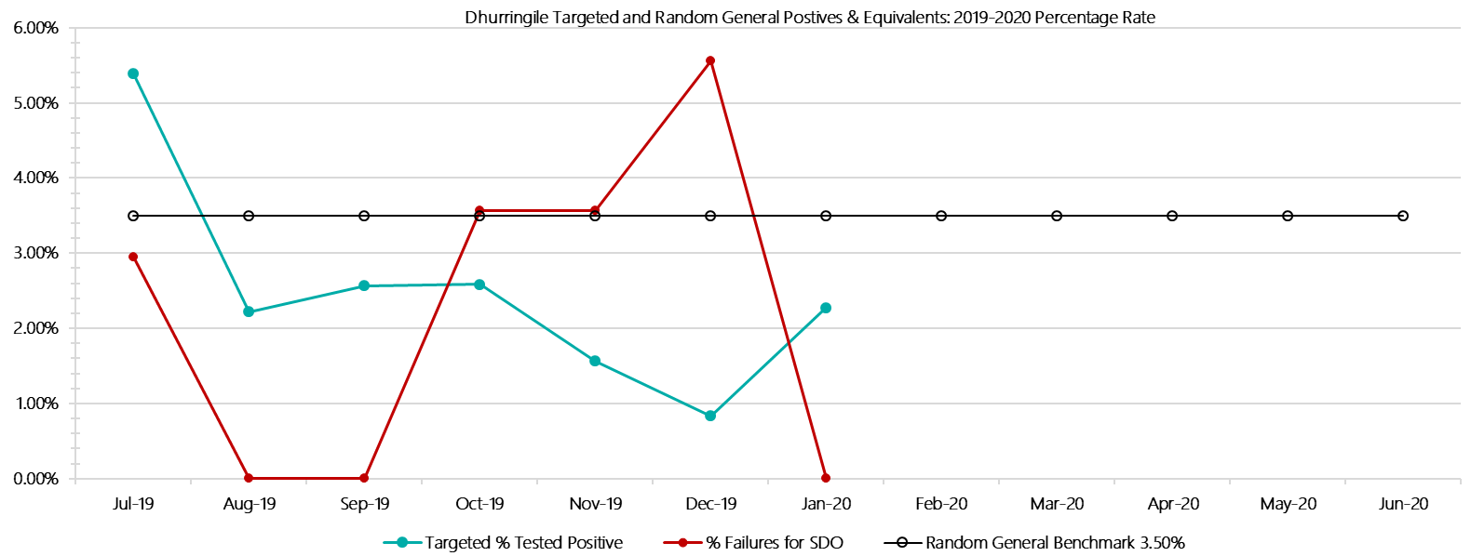

***Dhurringile Positive Test Results by Drug Type: 2019-2020***

**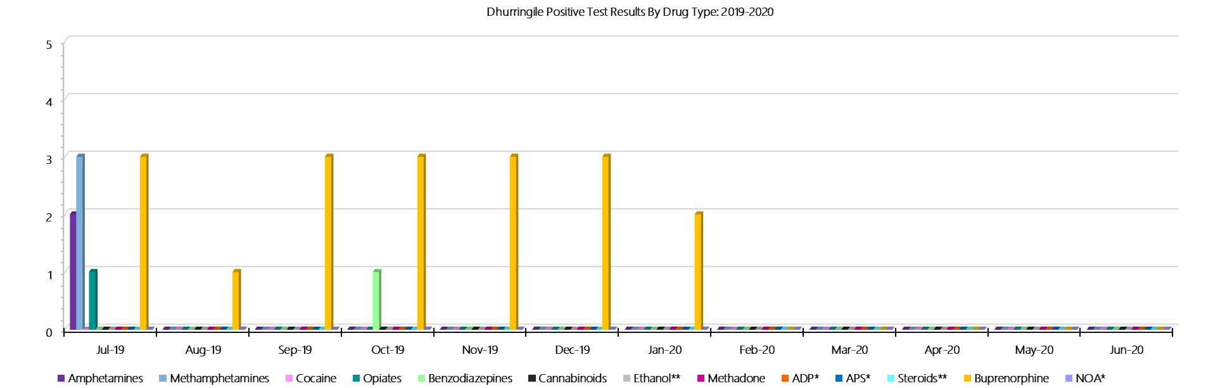*Dhurringile Count of Visitor Seizures Finds: 2019-2020***

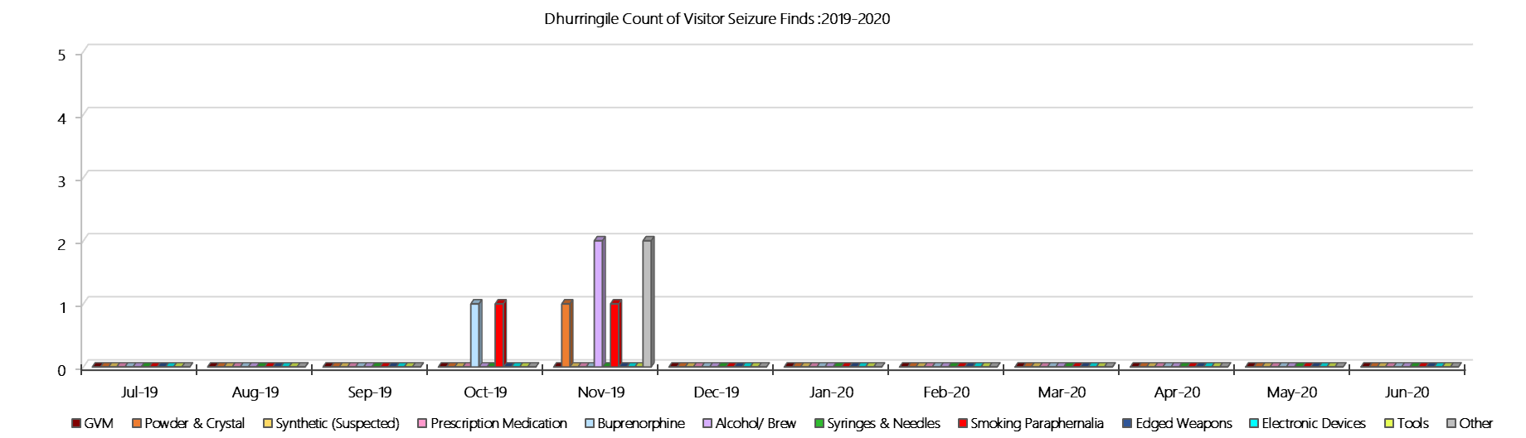

***Dhurringile Count of Prisoner Seizure Finds: 2019-2020***

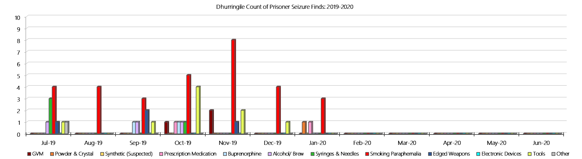

### **Langi Kal Kal Prison**

***Targeted and Random General Drug Test Results: 2019-2020***

|  |  |  |  |  |  |  |  |  |  |  |  |  |  |  |
| --- | --- | --- | --- | --- | --- | --- | --- | --- | --- | --- | --- | --- | --- | --- |
| **Langi Kal Kal** | **Jul-19** | **Aug-19** | **Sep-19** | **Oct-19** | **Nov-19** | **Dec-19** | **Jan-20** | **Feb-20** | **Mar-20** | **Apr-20** | **May-20** | **Jun-20** | **Average** | ***Totals*** |
| **Effective Sample - Targeted** | **28** | **20** | **27** | **11** | **9** | **28** | **26** |  |  |  |  |  | **21** | ***149*** |
| **Targeted Positives** | **0** | **0** | **0** | **0** | **0** | **0** | **1** |  |  |  |  |  | **0** | ***1*** |
| **Refusal** | **0** | **0** | **0** | **0** | **0** | **0** | **0** |  |  |  |  |  | **0** | ***0*** |
| **Unable** | **0** | **0** | **0** | **0** | **0** | **0** | **0** |  |  |  |  |  | **0** | ***0*** |
| **Interfered** | **0** | **0** | **0** | **0** | **0** | **0** | **0** |  |  |  |  |  | **0** | ***0*** |
| **Adulterated** | **0** | **0** | **0** | **0** | **0** | **0** | **0** |  |  |  |  |  | **0** | ***0*** |
| **Targeted % Tested Positive** | **0.00%** | **0.00%** | **0.00%** | **0.00%** | **0.00%** | **0.00%** | **3.85%** | **#N/A** | **#N/A** | **#N/A** | **#N/A** | **#N/A** | **0.67%** | ***0.67%*** |
| **Awaiting / Pending Results** | **0** | **0** | **0** | **0** | **0** | **0** | **0** |  |  |  |  |  | **0** | ***0*** |
| **Targeted Residual** | **0** | **0** | **0** | **0** | **0** | **0** | **0** |  |  |  |  |  | **0** | ***0*** |
| **Random tests collected** | **55** | **46** | **59** | **48** | **44** | **55** | **42** |  |  |  |  |  | **50** | ***349*** |
| **Tested Positive** | **0** | **0** | **0** | **0** | **0** | **0** | **0** |  |  |  |  |  | **0** | ***0*** |
| **Refusal (guilty)** | **0** | **0** | **0** | **0** | **0** | **0** | **1** |  |  |  |  |  | **0** | ***1*** |
| **Unable (not guilty)** | **0** | **0** | **0** | **0** | **0** | **0** | **0** |  |  |  |  |  | **0** | ***0*** |
| **Unable (guilty)** | **0** | **0** | **0** | **0** | **0** | **0** | **0** |  |  |  |  |  | **0** | ***0*** |
| **Interfered (guilty)** | **0** | **0** | **0** | **0** | **0** | **0** | **0** |  |  |  |  |  | **0** | ***0*** |
| **No test (valid reason)** | **0** | **0** | **1** | **0** | **0** | **0** | **0** |  |  |  |  |  | **0** | ***1*** |
| **No test (no valid reason)** | **0** | **0** | **0** | **0** | **0** | **0** | **0** |  |  |  |  |  | **0** | ***0*** |
| **Adulterated** | **0** | **0** | **0** | **0** | **0** | **0** | **0** |  |  |  |  |  | **0** | ***0*** |
| **Awaiting / Pending Results** | **0** | **0** | **0** | **0** | **0** | **0** | **1** |  |  |  |  |  | **0** | ***1*** |
| **Random Residual *(PIMS URAR030)*** | **0** | **0** | **0** | **0** | **0** | **0** | **0** |  |  |  |  |  | ***0*** | ***0*** |
| **Effective Sample - Random General** | **55** | **46** | **59** | **48** | **44** | **55** | **43** |  |  |  |  |  | **50** | **350** |
| **% Tested positive** | **0.00%** | **0.00%** | **0.00%** | **0.00%** | **0.00%** | **0.00%** | **0.00%** |  |  |  |  |  | **0.00%** |  |
| **% Prisoner guilty, positive equivalents** | **0.00%** | **0.00%** | **0.00%** | **0.00%** | **0.00%** | **0.00%** | **2.33%** |  |  |  |  |  | **0.33%** |  |
| **% Total prisoner fails** | **0.00%** | **0.00%** | **0.00%** | **0.00%** | **0.00%** | **0.00%** | **2.33%** |  |  |  |  |  | **0.33%** |  |
| **% No test without valid reason** | **0.00%** | **0.00%** | **0.00%** | **0.00%** | **0.00%** | **0.00%** | **0.00%** |  |  |  |  |  | **0.00%** |  |
| ***Random General Benchmark 1.50%*** | ***1.50%*** | ***1.50%*** | ***1.50%*** | ***1.50%*** | ***1.50%*** | ***1.50%*** | ***1.50%*** | ***1.50%*** | ***1.50%*** | ***1.50%*** | ***1.50%*** | ***1.50%*** | ***YTD*** |  |
| **% Failures for SDO** | **0.00%** | **0.00%** | **0.00%** | **0.00%** | **0.00%** | **0.00%** | **2.33%** | **#N/A** | **#N/A** | **#N/A** | **#N/A** | **#N/A** | **0.29%** |  |

***Langi Kal Kal - Drugs Identified Through Testing by Drug Type: 2019-2020***

|  |  |  |  |  |  |  |  |  |  |  |  |  |  |  |
| --- | --- | --- | --- | --- | --- | --- | --- | --- | --- | --- | --- | --- | --- | --- |
| **Langi Kal Kal** | ***Amphetamines*** | ***Methamphetamines*** | ***Cocaine*** | ***Opiates*** | ***Benzodiazepines*** | ***Cannabinoids*** | ***Ethanol\*\**** | ***Methadone*** | ***ADP\**** | ***APS\**** | ***Steroids\*\**** | ***Buprenorphine*** | ***NOA\**** | **Total** |
| **Jul-19** | **0** | **0** | **0** | **0** | **0** | **0** | **0** | **0** | **0** | **0** | **0** | **0** | **0** | **0** |
| **Aug-19** | **0** | **0** | **0** | **0** | **0** | **0** | **0** | **0** | **0** | **0** | **0** | **0** | **0** | **0** |
| **Sep-19** | **0** | **0** | **0** | **0** | **0** | **0** | **0** | **0** | **0** | **0** | **0** | **1** | **0** | **1** |
| **Oct-19** | **0** | **0** | **0** | **0** | **0** | **0** | **0** | **0** | **0** | **0** | **0** | **0** | **0** | **0** |
| **Nov-19** | **0** | **0** | **0** | **0** | **0** | **0** | **0** | **0** | **0** | **0** | **0** | **0** | **0** | **0** |
| **Dec-19** | **0** | **0** | **0** | **0** | **0** | **0** | **0** | **0** | **0** | **0** | **0** | **0** | **0** | **0** |
| **Jan-20** | **0** | **0** | **0** | **0** | **0** | **0** | **0** | **0** | **0** | **0** | **0** | **1** | **0** | **1** |
| **Feb-20** |  |  |  |  |  |  |  |  |  |  |  |  |  |  |
| **Mar-20** |  |  |  |  |  |  |  |  |  |  |  |  |  |  |
| **Apr-20** |  |  |  |  |  |  |  |  |  |  |  |  |  |  |
| **May-20** |  |  |  |  |  |  |  |  |  |  |  |  |  |  |
| **Jun-20** |  |  |  |  |  |  |  |  |  |  |  |  |  |  |
| **Langi Kal Kal YTD** | **0** | **0** | **0** | **0** | **0** | **0** | **0** | **0** | **0** | **0** | **0** | **2** | **0** | **2** |
| ***All Prisons YTD*** | ***111*** | ***184*** | ***2*** | ***31*** | ***26*** | ***21*** | ***18*** | ***25*** | ***33*** | ***12*** | ***0*** | ***1397*** | ***0*** | ***1860*** |
| ***Langi Kal Kal % of Total*** | ***0.00%*** | ***0.00%*** | ***0.00%*** | ***0.00%*** | ***0.00%*** | ***0.00%*** | ***0.00%*** | ***0.00%*** | ***0.00%*** | ***0.00%*** | ***0.00%*** | ***0.14%*** | ***0.00%*** | ***0.11%*** |

***Langi Kal Kal Seizures of Contraband: Visitors & Prisoners: 2019-2020***

|  |  |  |  |  |  |  |  |  |  |  |  |  |  |  |  |  |  |  |  |  |  |  |  |  |
| --- | --- | --- | --- | --- | --- | --- | --- | --- | --- | --- | --- | --- | --- | --- | --- | --- | --- | --- | --- | --- | --- | --- | --- | --- |
| **Visitors** | **GVM** | | **Powder  & Crystal** | | **Synthetic  (Suspected)** | | **Prescription  Medication** | | **Buprenorphine** | | **Alcohol &  Home Brew** | | **Syringes & Needles** | | **Smoking  Paraphernalia** | | **Edged  Weapons** | | **Electronic  Devices** | | **Tools** | | **Other** | |
| **LKK** | **Finds** | **Gms** | **Finds** | **Gms** | **Finds** | **Gms** | **Finds** | **Qty** | **Finds** | **Qty** | **Finds** | **Ltrs** | **Finds** | **Qty** | **Finds** | **Qty** | **Finds** | **Qty** | **Finds** | **Qty** | **Finds** | **Qty** | **Finds** | **Qty** |
| **Jul-19** | **0** | **0.00** | **0** | **0.00** | **0** | **0.00** | **0** | **0.00** | **0** | **0.00** | **0** | **0.000** | **0** | **0** | **0** | **0** | **0** | **0** | **0** | **0** | **0** | **0** | **0** | **0** |
| **Aug-19** | **0** | **0.00** | **0** | **0.00** | **0** | **0.00** | **0** | **0.00** | **0** | **0.00** | **0** | **0.000** | **0** | **0** | **0** | **0** | **0** | **0** | **0** | **0** | **0** | **0** | **0** | **0** |
| **Sep-19** | **0** | **0.00** | **0** | **0.00** | **0** | **0.00** | **0** | **0.00** | **0** | **0.00** | **0** | **0.000** | **0** | **0** | **0** | **0** | **0** | **0** | **0** | **0** | **0** | **0** | **0** | **0** |
| **Oct-19** | **0** | **0.00** | **0** | **0.00** | **0** | **0.00** | **0** | **0.00** | **0** | **0.00** | **0** | **0.000** | **0** | **0** | **0** | **0** | **0** | **0** | **0** | **0** | **0** | **0** | **0** | **0** |
| **Nov-19** | **0** | **0.00** | **0** | **0.00** | **0** | **0.00** | **0** | **0.00** | **0** | **0.00** | **0** | **0.000** | **0** | **0** | **0** | **0** | **0** | **0** | **0** | **0** | **0** | **0** | **0** | **0** |
| **Dec-19** | **0** | **0.00** | **0** | **0.00** | **0** | **0.00** | **0** | **0.00** | **0** | **0.00** | **0** | **0.000** | **0** | **0** | **0** | **0** | **0** | **0** | **0** | **0** | **0** | **0** | **0** | **0** |
| **Jan-20** | **0** | **0.00** | **0** | **0.00** | **0** | **0.00** | **0** | **0.00** | **0** | **0.00** | **0** | **0.000** | **0** | **0** | **0** | **0** | **0** | **0** | **0** | **0** | **0** | **0** | **0** | **0** |
| **Feb-20** |  |  |  |  |  |  |  |  |  |  |  |  |  |  |  |  |  |  |  |  |  |  |  |  |
| **Mar-20** |  |  |  |  |  |  |  |  |  |  |  |  |  |  |  |  |  |  |  |  |  |  |  |  |
| **Apr-20** |  |  |  |  |  |  |  |  |  |  |  |  |  |  |  |  |  |  |  |  |  |  |  |  |
| **May-20** |  |  |  |  |  |  |  |  |  |  |  |  |  |  |  |  |  |  |  |  |  |  |  |  |
| **Jun-20** |  |  |  |  |  |  |  |  |  |  |  |  |  |  |  |  |  |  |  |  |  |  |  |  |
| **Total** | **0** | **0.00** | **0** | **0.00** | **0** | **0.00** | **0** | **0.00** | **0** | **0.00** | **0** | **0.000** | **0** | **0** | **0** | **0** | **0** | **0** | **0** | **0** | **0** | **0** | **0** | **0** |

|  |  |  |  |  |  |  |  |  |  |  |  |  |  |  |  |  |  |  |  |  |  |  |  |  |  |
| --- | --- | --- | --- | --- | --- | --- | --- | --- | --- | --- | --- | --- | --- | --- | --- | --- | --- | --- | --- | --- | --- | --- | --- | --- | --- |
| **Prisoners** | **GVM** | | **Powder  & Crystal** | | **Synthetic  (Suspected)** | | **Prescription  Medication** | | **Buprenorphine** | | **Alcohol &  Home Brew** | | **Syringes & Needles** | | **Smoking  Paraphernalia** | | | **Edged  Weapons** | | **Electronic  Devices** | | **Tools** | | **Other** | |
| **LKK** | **Finds** | **Gms** | **Finds** | **Gms** | **Finds** | **Gms** | **Finds** | **Qty** | **Finds** | **Qty** | **Finds** | **Ltrs** | **Finds** | **Qty** | **Finds** | **Qty** | | **Finds** | **Qty** | **Finds** | **Qty** | **Finds** | **Qty** | **Finds** | **Qty** |
| **Jul-19** | **0** | **0.00** | **0** | **0.00** | **0** | **0.00** | **0** | **0.00** | **0** | **0.00** | **0** | **0.000** | **0** | **0** | **0** | | **0** | **1** | **2** | **0** | **0** | **1** | **1** | **1** | **1** |
| **Aug-19** | **0** | **0.00** | **0** | **0.00** | **0** | **0.00** | **0** | **0.00** | **0** | **0.00** | **0** | **0.000** | **0** | **0** | **0** | | **0** | **0** | **0** | **0** | **0** | **0** | **0** | **0** | **0** |
| **Sep-19** | **0** | **0.00** | **0** | **0.00** | **0** | **0.00** | **0** | **0.00** | **0** | **0.00** | **0** | **0.000** | **0** | **0** | **0** | | **0** | **0** | **0** | **0** | **0** | **0** | **0** | **1** | **1** |
| **Oct-19** | **0** | **0.00** | **0** | **0.00** | **0** | **0.00** | **0** | **0.00** | **0** | **0.00** | **0** | **0.000** | **0** | **0** | **0** | | **0** | **1** | **1** | **0** | **0** | **0** | **0** | **0** | **0** |
| **Nov-19** | **0** | **0.00** | **0** | **0.00** | **0** | **0.00** | **0** | **0.00** | **0** | **0.00** | **0** | **0.000** | **0** | **0** | **0** | | **0** | **1** | **1** | **0** | **0** | **1** | **1** | **0** | **0** |
| **Dec-19** | **0** | **0.00** | **0** | **0.00** | **0** | **0.00** | **1** | **2.00** | **0** | **0.00** | **0** | **0.000** | **0** | **0** | **0** | | **0** | **0** | **0** | **0** | **0** | **0** | **0** | **0** | **0** |
| **Jan-20** | **0** | **0.00** | **0** | **0.00** | **0** | **0.00** | **0** | **0.00** | **1** | **8.00** | **0** | **0.000** | **0** | **0** | **1** | | **17** | **0** | **0** | **0** | **0** | **0** | **0** | **4** | **11** |
| **Feb-20** |  |  |  |  |  |  |  |  |  |  |  |  |  |  |  | |  |  |  |  |  |  |  |  |  |
| **Mar-20** |  |  |  |  |  |  |  |  |  |  |  |  |  |  |  | |  |  |  |  |  |  |  |  |  |
| **Apr-20** |  |  |  |  |  |  |  |  |  |  |  |  |  |  |  | |  |  |  |  |  |  |  |  |  |
| **May-20** |  |  |  |  |  |  |  |  |  |  |  |  |  |  |  | |  |  |  |  |  |  |  |  |  |
| **Jun-20** |  |  |  |  |  |  |  |  |  |  |  |  |  |  |  | |  |  |  |  |  |  |  |  |  |
| **Total** | **0** | **0.00** | **0** | **0.00** | **0** | **0.00** | **1** | **2.00** | **1** | **8.00** | **0** | **0.000** | **0** | **0** | **1** | | **17** | **3** | **4** | **0** | **0** | **2** | **2** | **6** | **13** |

***Langi Kal Kal Targeted and Random General Drug Test Positives & Equivalents: 2019-2020***

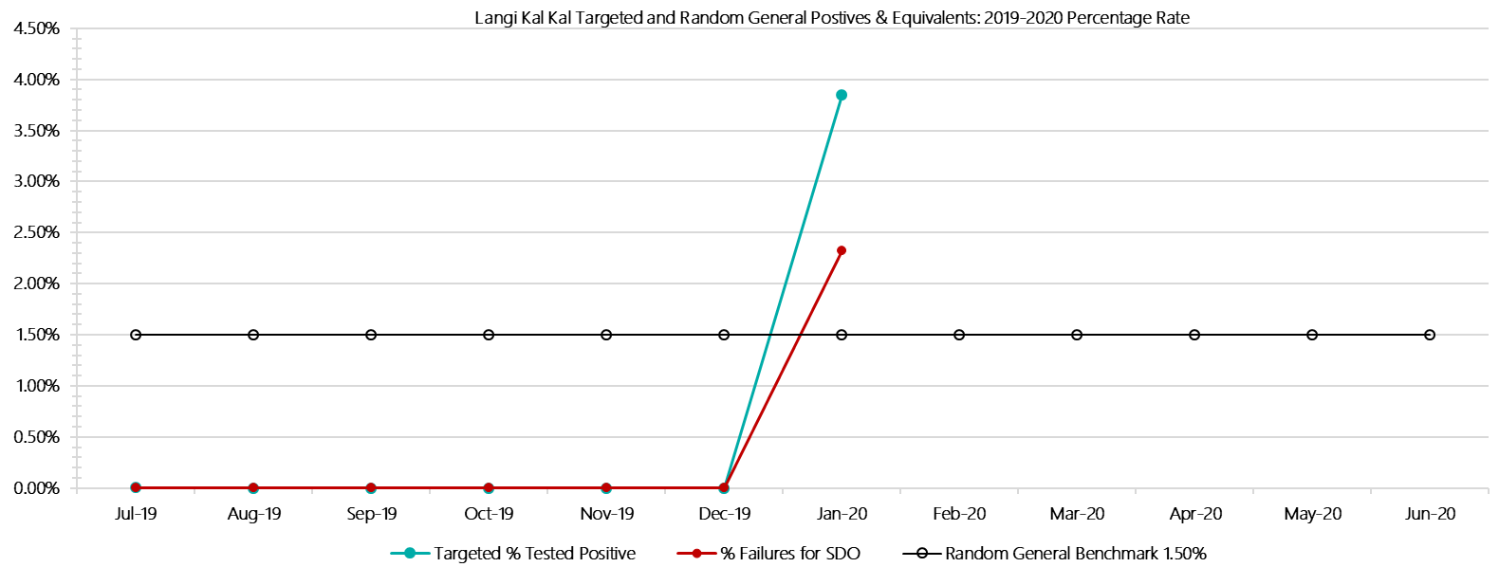

***Langi Kal Kal Positive Test Results by Drug Type: 2019-2020***

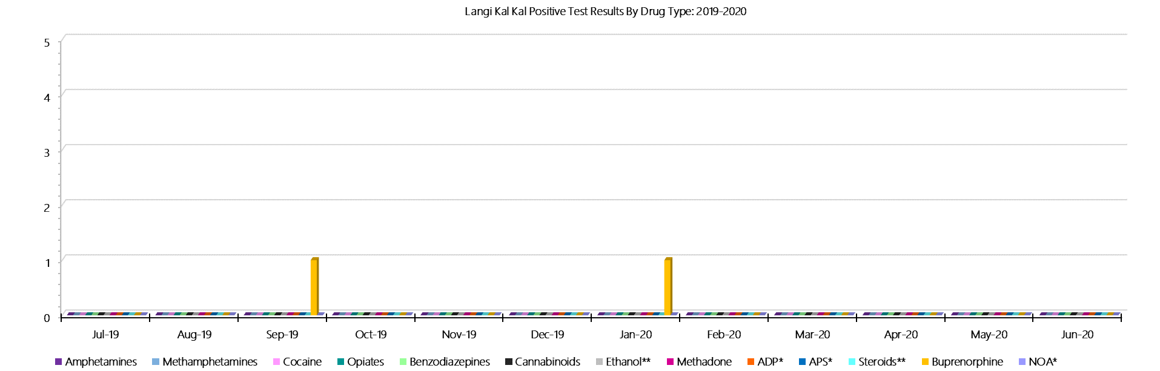

***Langi Kal Kal Count of Visitor Seizures Finds: 2019-2020***

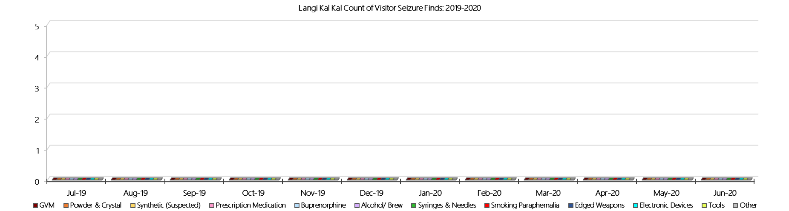

***Langi Kal Kal Count of Prisoner Seizure Finds: 2019-2020***

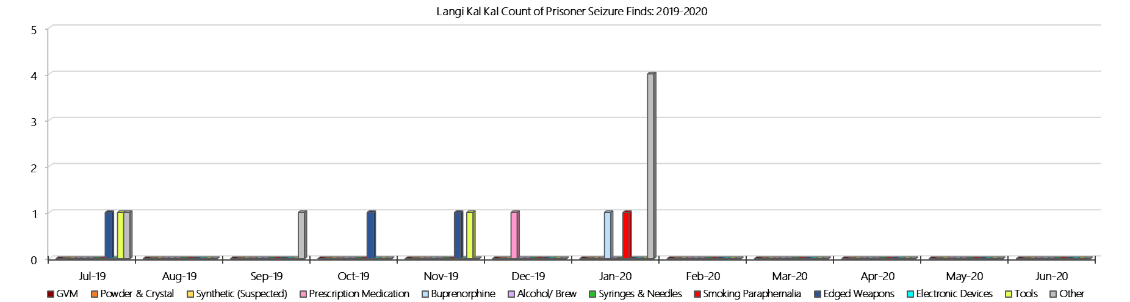

### **Tarrengower Prison**

***Targeted and Random General Drug Test Results: 2018-2019***

|  |  |  |  |  |  |  |  |  |  |  |  |  |  |  |
| --- | --- | --- | --- | --- | --- | --- | --- | --- | --- | --- | --- | --- | --- | --- |
| **Tarrengower** | **Jul-19** | **Aug-19** | **Sep-19** | **Oct-19** | **Nov-19** | **Dec-19** | **Jan-20** | **Feb-20** | **Mar-20** | **Apr-20** | **May-20** | **Jun-20** | **Average** | ***Totals*** |
| **Effective Sample - Targeted** | **7** | **3** | **3** | **1** | **1** | **1** | **1** |  |  |  |  |  | **2** | ***17*** |
| **Targeted Positives** | **0** | **0** | **0** | **0** | **1** | **0** | **0** |  |  |  |  |  | **0** | ***1*** |
| **Refusal** | **0** | **0** | **0** | **0** | **0** | **0** | **0** |  |  |  |  |  | **0** | ***0*** |
| **Unable** | **0** | **0** | **0** | **0** | **0** | **0** | **0** |  |  |  |  |  | **0** | ***0*** |
| **Interfered** | **0** | **0** | **0** | **0** | **0** | **0** | **0** |  |  |  |  |  | **0** | ***0*** |
| **Adulterated** | **0** | **0** | **0** | **0** | **0** | **0** | **0** |  |  |  |  |  | **0** | ***0*** |
| **Targeted % Tested Positive** | **0.00%** | **0.00%** | **0.00%** | **0.00%** | **100.00%** | **0.00%** | **0.00%** | **#N/A** | **#N/A** | **#N/A** | **#N/A** | **#N/A** | **5.88%** | ***5.88%*** |
| **Awaiting / Pending Results** | **0** | **0** | **0** | **0** | **0** | **0** | **0** |  |  |  |  |  | **0** | ***0*** |
| **Targeted Residual** | **0** | **0** | **0** | **0** | **0** | **0** | **0** |  |  |  |  |  | **0** | ***0*** |
| **Random tests collected** | **10** | **8** | **10** | **7** | **7** | **10** | **8** |  |  |  |  |  | **9** | ***60*** |
| **Tested Positive** | **0** | **0** | **0** | **0** | **0** | **0** | **0** |  |  |  |  |  | **0** | ***0*** |
| **Refusal (guilty)** | **0** | **0** | **0** | **0** | **0** | **0** | **0** |  |  |  |  |  | **0** | ***0*** |
| **Unable (not guilty)** | **0** | **0** | **0** | **0** | **0** | **0** | **0** |  |  |  |  |  | **0** | ***0*** |
| **Unable (guilty)** | **0** | **0** | **0** | **0** | **0** | **0** | **0** |  |  |  |  |  | **0** | ***0*** |
| **Interfered (guilty)** | **0** | **0** | **0** | **0** | **0** | **0** | **0** |  |  |  |  |  | **0** | ***0*** |
| **No test (valid reason)** | **0** | **0** | **0** | **1** | **1** | **0** | **0** |  |  |  |  |  | **0** | ***2*** |
| **No test (no valid reason)** | **0** | **0** | **0** | **0** | **0** | **0** | **0** |  |  |  |  |  | **0** | ***0*** |
| **Adulterated** | **0** | **0** | **0** | **0** | **0** | **0** | **0** |  |  |  |  |  | **0** | ***0*** |
| **Awaiting / Pending Results** | **0** | **0** | **0** | **0** | **0** | **0** | **0** |  |  |  |  |  | **0** | ***0*** |
| **Random Residual *(PIMS URAR030)*** | **0** | **0** | **0** | **0** | **0** | **0** | **0** |  |  |  |  |  | ***0*** | ***0*** |
| **Effective Sample - Random General** | **10** | **8** | **10** | **7** | **7** | **10** | **8** |  |  |  |  |  | **9** | **60** |
| **% Tested positive** | **0.00%** | **0.00%** | **0.00%** | **0.00%** | **0.00%** | **0.00%** | **0.00%** |  |  |  |  |  | **0.00%** |  |
| **% Prisoner guilty, positive equivalents** | **0.00%** | **0.00%** | **0.00%** | **0.00%** | **0.00%** | **0.00%** | **0.00%** |  |  |  |  |  | **0.00%** |  |
| **% Total prisoner fails** | **0.00%** | **0.00%** | **0.00%** | **0.00%** | **0.00%** | **0.00%** | **0.00%** |  |  |  |  |  | **0.00%** |  |
| **% No test without valid reason** | **0.00%** | **0.00%** | **0.00%** | **0.00%** | **0.00%** | **0.00%** | **0.00%** |  |  |  |  |  | **0.00%** |  |
| ***Random General Benchmark 1.50%*** | ***1.50%*** | ***1.50%*** | ***1.50%*** | ***1.50%*** | ***1.50%*** | ***1.50%*** | ***1.50%*** | ***1.50%*** | ***1.50%*** | ***1.50%*** | ***1.50%*** | ***1.50%*** | ***YTD*** |  |
| **% Failures for SDO** | **0.00%** | **0.00%** | **0.00%** | **0.00%** | **0.00%** | **0.00%** | **0.00%** | **#N/A** | **#N/A** | **#N/A** | **#N/A** | **#N/A** | **0.00%** |  |

***Tarrengower - Drugs Identified Through Testing by Drug Type: 2019-2020***

|  |  |  |  |  |  |  |  |  |  |  |  |  |  |  |
| --- | --- | --- | --- | --- | --- | --- | --- | --- | --- | --- | --- | --- | --- | --- |
| **Tarrengower** | ***Amphetamines*** | ***Methamphetamines*** | ***Cocaine*** | ***Opiates*** | ***Benzodiazepines*** | ***Cannabinoids*** | ***Ethanol\*\**** | ***Methadone*** | ***ADP\**** | ***APS\**** | ***Steroids\*\**** | ***Buprenorphine*** | ***NOA\**** | **Total** |
| **Jul-19** | **0** | **0** | **0** | **0** | **0** | **0** | **0** | **0** | **0** | **0** | **0** | **0** | **0** | **0** |
| **Aug-19** | **0** | **0** | **0** | **0** | **0** | **0** | **0** | **0** | **0** | **0** | **0** | **0** | **0** | **0** |
| **Sep-19** | **0** | **0** | **0** | **0** | **0** | **0** | **0** | **0** | **0** | **0** | **0** | **0** | **0** | **0** |
| **Oct-19** | **0** | **0** | **0** | **0** | **0** | **0** | **0** | **0** | **0** | **0** | **0** | **0** | **0** | **0** |
| **Nov-19** | **0** | **0** | **0** | **0** | **0** | **0** | **0** | **0** | **1** | **0** | **0** | **0** | **0** | **1** |
| **Dec-19** | **0** | **0** | **0** | **0** | **0** | **0** | **0** | **0** | **0** | **0** | **0** | **0** | **0** | **0** |
| **Jan-20** | **0** | **0** | **0** | **0** | **0** | **0** | **0** | **0** | **0** | **0** | **0** | **0** | **0** | **0** |
| **Feb-20** |  |  |  |  |  |  |  |  |  |  |  |  |  |  |
| **Mar-20** |  |  |  |  |  |  |  |  |  |  |  |  |  |  |
| **Apr-20** |  |  |  |  |  |  |  |  |  |  |  |  |  |  |
| **May-20** |  |  |  |  |  |  |  |  |  |  |  |  |  |  |
| **Jun-20** |  |  |  |  |  |  |  |  |  |  |  |  |  |  |
| **Tarrengower YTD** | **0** | **0** | **0** | **0** | **0** | **0** | **0** | **0** | **1** | **0** | **0** | **0** | **0** | **1** |
| ***All Prisons YTD*** | ***111*** | ***184*** | ***2*** | ***31*** | ***26*** | ***21*** | ***18*** | ***25*** | ***33*** | ***12*** | ***0*** | ***1397*** | ***0*** | ***1860*** |
| ***Tarrengower % of Total*** | ***0.00%*** | ***0.00%*** | ***0.00%*** | ***0.00%*** | ***0.00%*** | ***0.00%*** | ***0.00%*** | ***0.00%*** | ***3.03%*** | ***0.00%*** | ***0.00%*** | ***0.00%*** | ***0.00%*** | ***0.05%*** |

***Tarrengower Seizures of Contraband: Visitors & Prisoners: 2019-2020***

|  |  |  |  |  |  |  |  |  |  |  |  |  |  |  |  |  |  |  |  |  |  |  |  |  |
| --- | --- | --- | --- | --- | --- | --- | --- | --- | --- | --- | --- | --- | --- | --- | --- | --- | --- | --- | --- | --- | --- | --- | --- | --- |
| **Visitors** | **GVM** | | **Powder  & Crystal** | | **Synthetic  (Suspected)** | | **Prescription  Medication** | | **Buprenorphine** | | **Alcohol &  Home Brew** | | **Syringes** | | **Smoking  Paraphernalia** | | **Edged  Weapons** | | **Electronic  Devices** | | **Tools** | | **Other** | |
| **T’gower** | **Finds** | **Gms** | **Finds** | **Gms** | **Finds** | **Gms** | **Finds** | **Qty** | **Finds** | **Qty** | **Finds** | **Ltrs** | **Finds** | **Qty** | **Finds** | **Qty** | **Finds** | **Qty** | **Finds** | **Qty** | **Finds** | **Qty** | **Finds** | **Qty** |
| **Jul-19** | **0** | **0.00** | **0** | **0.00** | **0** | **0.00** | **0** | **0.00** | **0** | **0.00** | **0** | **0.000** | **0** | **0** | **0** | **0** | **0** | **0** | **0** | **0** | **0** | **0** | **1** | **1** |
| **Aug-19** | **0** | **0.00** | **0** | **0.00** | **0** | **0.00** | **0** | **0.00** | **0** | **0.00** | **0** | **0.000** | **0** | **0** | **0** | **0** | **0** | **0** | **0** | **0** | **0** | **0** | **0** | **0** |
| **Sep-19** | **0** | **0.00** | **0** | **0.00** | **0** | **0.00** | **0** | **0.00** | **0** | **0.00** | **0** | **0.000** | **0** | **0** | **0** | **0** | **0** | **0** | **0** | **0** | **0** | **0** | **0** | **0** |
| **Oct-19** | **0** | **0.00** | **0** | **0.00** | **0** | **0.00** | **0** | **0.00** | **0** | **0.00** | **0** | **0.000** | **0** | **0** | **0** | **0** | **0** | **0** | **0** | **0** | **0** | **0** | **0** | **0** |
| **Nov-19** | **0** | **0.00** | **0** | **0.00** | **0** | **0.00** | **0** | **0.00** | **0** | **0.00** | **0** | **0.000** | **0** | **0** | **0** | **0** | **0** | **0** | **0** | **0** | **0** | **0** | **0** | **0** |
| **Dec-19** | **0** | **0.00** | **0** | **0.00** | **0** | **0.00** | **0** | **0.00** | **0** | **0.00** | **0** | **0.000** | **0** | **0** | **0** | **0** | **0** | **0** | **0** | **0** | **0** | **0** | **0** | **0** |
| **Jan-20** | **0** | **0.00** | **0** | **0.00** | **0** | **0.00** | **0** | **0.00** | **0** | **0.00** | **0** | **0.000** | **0** | **0** | **0** | **0** | **0** | **0** | **0** | **0** | **0** | **0** | **0** | **0** |
| **Feb-20** |  |  |  |  |  |  |  |  |  |  |  |  |  |  |  |  |  |  |  |  |  |  |  |  |
| **Mar-20** |  |  |  |  |  |  |  |  |  |  |  |  |  |  |  |  |  |  |  |  |  |  |  |  |
| **Apr-20** |  |  |  |  |  |  |  |  |  |  |  |  |  |  |  |  |  |  |  |  |  |  |  |  |
| **May-20** |  |  |  |  |  |  |  |  |  |  |  |  |  |  |  |  |  |  |  |  |  |  |  |  |
| **Jun-20** |  |  |  |  |  |  |  |  |  |  |  |  |  |  |  |  |  |  |  |  |  |  |  |  |
| **Total** | **0** | **0.00** | **0** | **0.00** | **0** | **0.00** | **0** | **0.00** | **0** | **0.00** | **0** | **0.000** | **0** | **0** | **0** | **0** | **0** | **0** | **0** | **0** | **0** | **0** | **1** | **1** |

|  |  |  |  |  |  |  |  |  |  |  |  |  |  |  |  |  |  |  |  |  |  |  |  |  |  |
| --- | --- | --- | --- | --- | --- | --- | --- | --- | --- | --- | --- | --- | --- | --- | --- | --- | --- | --- | --- | --- | --- | --- | --- | --- | --- |
| **Prisoners** | **GVM** | | **Powder  & Crystal** | | **Synthetic  (Suspected)** | | **Prescription  Medication** | | **Buprenorphine** | | **Alcohol &  Home Brew** | | **Syringes** | | **Smoking  Paraphernalia** | | | **Edged  Weapons** | | **Electronic  Devices** | | **Tools** | | **Other** | |
| **T’gower** | **Finds** | **Gms** | **Finds** | **Gms** | **Finds** | **Gms** | **Finds** | **Qty** | **Finds** | **Qty** | **Finds** | **Ltrs** | **Finds** | **Qty** | **Finds** | **Qty** | | **Finds** | **Qty** | **Finds** | **Qty** | **Finds** | **Qty** | **Finds** | **Qty** |
| **Jul-19** | **0** | **0.00** | **0** | **0.00** | **0** | **0.00** | **0** | **0.00** | **0** | **0.00** | **0** | **0.000** | **0** | **0** | **0** | | **0** | **0** | **0** | **0** | **0** | **0** | **0** | **2** | **1.1** |
| **Aug-19** | **0** | **0.00** | **0** | **0.00** | **0** | **0.00** | **0** | **0.00** | **0** | **0.00** | **0** | **0.000** | **0** | **0** | **0** | | **0** | **0** | **0** | **0** | **0** | **0** | **0** | **0** | **0** |
| **Sep-19** | **0** | **0.00** | **0** | **0.00** | **0** | **0.00** | **1** | **2.00** | **0** | **0.00** | **0** | **0.000** | **0** | **0** | **0** | | **0** | **0** | **0** | **0** | **0** | **0** | **0** | **0** | **0** |
| **Oct-19** | **0** | **0.00** | **0** | **0.00** | **0** | **0.00** | **1** | **3.00** | **0** | **0.00** | **0** | **0.000** | **0** | **0** | **0** | | **0** | **0** | **0** | **0** | **0** | **0** | **0** | **0** | **0** |
| **Nov-19** | **0** | **0.00** | **0** | **0.00** | **0** | **0.00** | **0** | **0.00** | **0** | **0.00** | **0** | **0.000** | **0** | **0** | **0** | | **0** | **0** | **0** | **0** | **0** | **0** | **0** | **0** | **0** |
| **Dec-19** | **0** | **0.00** | **0** | **0.00** | **0** | **0.00** | **0** | **0.00** | **0** | **0.00** | **0** | **0.000** | **0** | **0** | **1** | | **1** | **0** | **0** | **0** | **0** | **0** | **0** | **0** | **0** |
| **Jan-20** | **0** | **0.00** | **0** | **0.00** | **0** | **0.00** | **0** | **0.00** | **0** | **0.00** | **0** | **0.000** | **0** | **0** | **1** | | **1** | **0** | **0** | **0** | **0** | **0** | **0** | **0** | **0** |
| **Feb-20** |  |  |  |  |  |  |  |  |  |  |  |  |  |  |  | |  |  |  |  |  |  |  |  |  |
| **Mar-20** |  |  |  |  |  |  |  |  |  |  |  |  |  |  |  | |  |  |  |  |  |  |  |  |  |
| **Apr-20** |  |  |  |  |  |  |  |  |  |  |  |  |  |  |  | |  |  |  |  |  |  |  |  |  |
| **May-20** |  |  |  |  |  |  |  |  |  |  |  |  |  |  |  | |  |  |  |  |  |  |  |  |  |
| **Jun-20** |  |  |  |  |  |  |  |  |  |  |  |  |  |  |  | |  |  |  |  |  |  |  |  |  |
| **Total** | **0** | **0.00** | **0** | **0.00** | **0** | **0.00** | **2** | **5.00** | **0** | **0.00** | **0** | **0.000** | **0** | **0** | **2** | | **2** | **0** | **0** | **0** | **0** | **0** | **0** | **2** | **1.1** |

***Tarrengower Targeted and Random General Drug Test Positives & Equivalents: 2019-2020***

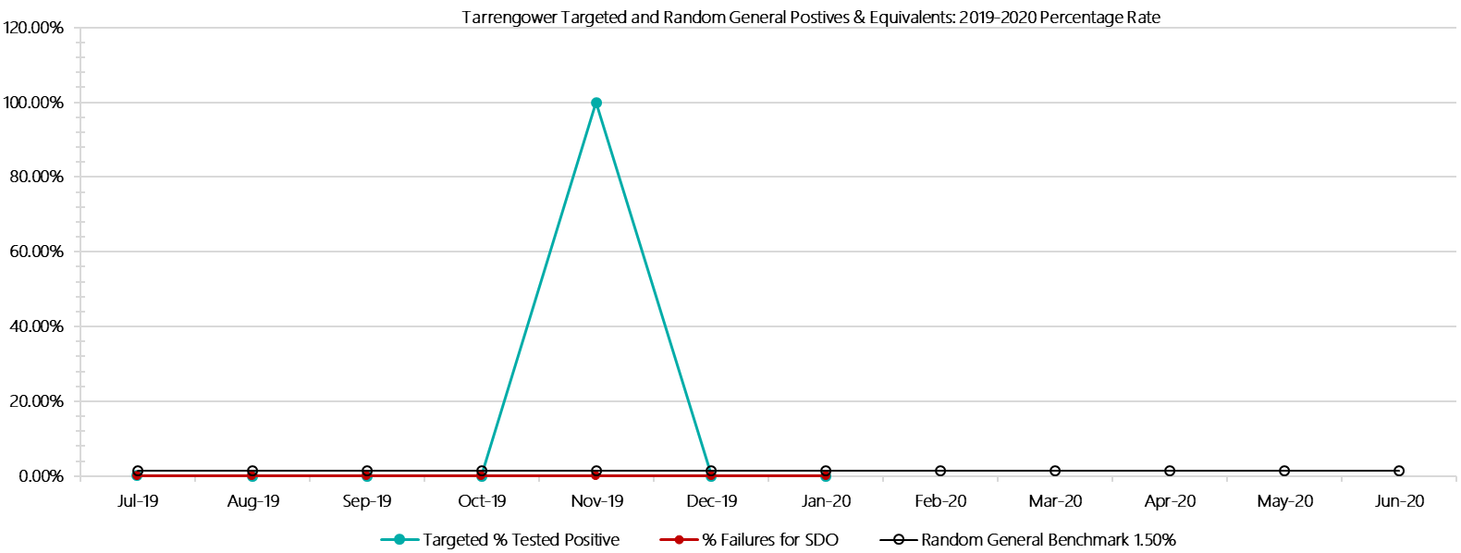

***Tarrengower Positive Test Results by Drug Type: 2019-2020***

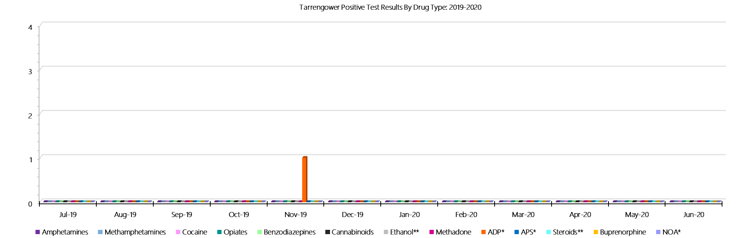

***Tarrengower Count of Visitor Seizures Finds: 2019-2020***

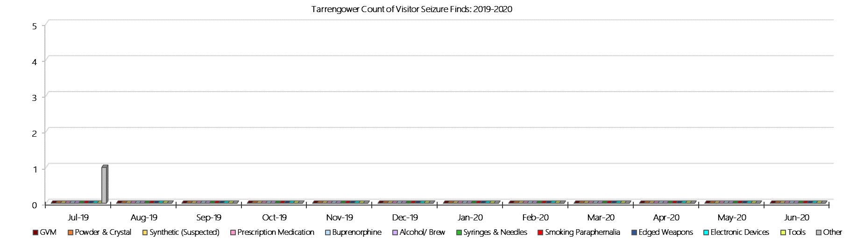

***Tarrengower Count of Prisoner Seizure Finds: 2019-2020***

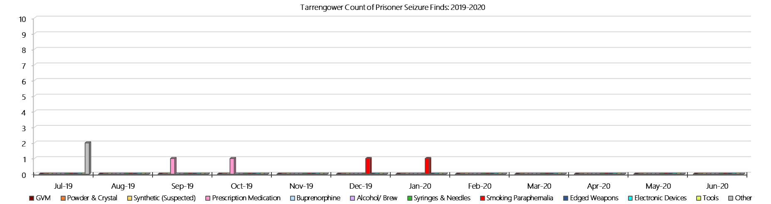

### **Judy Lazarus Transition Centre**

***Targeted and Random General Drug Test Results: 2019-2020***

|  |  |  |  |  |  |  |  |  |  |  |  |  |  |  |
| --- | --- | --- | --- | --- | --- | --- | --- | --- | --- | --- | --- | --- | --- | --- |
| **JLTC** | **Jul-19** | **Aug-19** | **Sep-19** | **Oct-19** | **Nov-19** | **Dec-19** | **Jan-20** | **Feb-20** | **Mar-20** | **Apr-20** | **May-20** | **Jun-20** | **Average** | ***Totals*** |
| **Effective Sample - Targeted** | **1** | **1** | **2** | **0** | **2** | **2** | **2** |  |  |  |  |  | **1** | ***10*** |
| **Targeted Positives** | **0** | **0** | **0** | **0** | **0** | **0** | **0** |  |  |  |  |  | **0** | ***0*** |
| **Refusal** | **0** | **0** | **0** | **0** | **0** | **0** | **0** |  |  |  |  |  | **0** | ***0*** |
| **Unable** | **0** | **0** | **0** | **0** | **0** | **0** | **0** |  |  |  |  |  | **0** | ***0*** |
| **Interfered** | **0** | **0** | **0** | **0** | **0** | **0** | **0** |  |  |  |  |  | **0** | ***0*** |
| **Adulterated** | **0** | **0** | **0** | **0** | **0** | **0** | **0** |  |  |  |  |  | **0** | ***0*** |
| **Targeted % Tested Positive** | **0.00%** | **0.00%** | **0.00%** | **#DIV/0!** | **0.00%** | **0.00%** | **0.00%** | **#N/A** | **#N/A** | **#N/A** | **#N/A** | **#N/A** | **0.00%** | ***0.00%*** |
| **Awaiting / Pending Results** | **0** | **0** | **0** | **0** | **0** | **0** | **0** |  |  |  |  |  | **0** | ***0*** |
| **Targeted Residual** | **0** | **0** | **0** | **0** | **0** | **0** | **0** |  |  |  |  |  | **0** | ***0*** |
| **Random tests collected** | **4** | **4** | **5** | **4** | **4** | **5** | **4** |  |  |  |  |  | **4** | ***30*** |
| **Tested Positive** | **0** | **0** | **0** | **1** | **0** | **0** | **0** |  |  |  |  |  | **0** | ***1*** |
| **Refusal (guilty)** | **0** | **0** | **0** | **0** | **0** | **0** | **0** |  |  |  |  |  | **0** | ***0*** |
| **Unable (not guilty)** | **0** | **0** | **0** | **0** | **0** | **0** | **0** |  |  |  |  |  | **0** | ***0*** |
| **Unable (guilty)** | **0** | **0** | **0** | **0** | **0** | **0** | **0** |  |  |  |  |  | **0** | ***0*** |
| **Interfered (guilty)** | **0** | **0** | **0** | **0** | **0** | **0** | **0** |  |  |  |  |  | **0** | ***0*** |
| **No test (valid reason)** | **1** | **0** | **0** | **0** | **0** | **0** | **0** |  |  |  |  |  | **0** | ***1*** |
| **No test (no valid reason)** | **0** | **0** | **0** | **0** | **0** | **0** | **0** |  |  |  |  |  | **0** | ***0*** |
| **Adulterated** | **0** | **0** | **0** | **0** | **0** | **0** | **0** |  |  |  |  |  | **0** | ***0*** |
| **Awaiting / Pending Results** | **0** | **0** | **0** | **0** | **0** | **0** | **0** |  |  |  |  |  | **0** | ***0*** |
| **Random Residual *(PIMS URAR030)*** | **0** | **0** | **0** | **0** | **0** | **0** | **0** |  |  |  |  |  | ***0*** | ***0*** |
| **Effective Sample - Random General** | **4** | **4** | **5** | **4** | **4** | **5** | **4** |  |  |  |  |  | **4** | **30** |
| **% Tested positive** | **0.00%** | **0.00%** | **0.00%** | **25.00%** | **0.00%** | **0.00%** | **0.00%** |  |  |  |  |  | **3.57%** |  |
| **% Prisoner guilty, positive equivalents** | **0.00%** | **0.00%** | **0.00%** | **0.00%** | **0.00%** | **0.00%** | **0.00%** |  |  |  |  |  | **0.00%** |  |
| **% Total prisoner fails** | **0.00%** | **0.00%** | **0.00%** | **25.00%** | **0.00%** | **0.00%** | **0.00%** |  |  |  |  |  | **3.57%** |  |
| **% No test without valid reason** | **0.00%** | **0.00%** | **0.00%** | **0.00%** | **0.00%** | **0.00%** | **0.00%** |  |  |  |  |  | **0.00%** |  |
| ***Random General Benchmark 3.50%*** | ***3.50%*** | ***3.50%*** | ***3.50%*** | ***3.50%*** | ***3.50%*** | ***3.50%*** | ***3.50%*** | ***3.50%*** | ***3.50%*** | ***3.50%*** | ***3.50%*** | ***3.50%*** | ***YTD*** |  |
| **% Failures for SDO** | **0.00%** | **0.00%** | **0.00%** | **25.00%** | **0.00%** | **0.00%** | **0.00%** | **#N/A** | **#N/A** | **#N/A** | **#N/A** | **#N/A** | **3.33%** |  |

***JLTC - Drugs Identified Through Testing by Drug Type: 2019-2020***

|  |  |  |  |  |  |  |  |  |  |  |  |  |  |  |
| --- | --- | --- | --- | --- | --- | --- | --- | --- | --- | --- | --- | --- | --- | --- |
| **JLTC** | ***Amphetamines*** | ***Methamphetamines*** | ***Cocaine*** | ***Opiates*** | ***Benzodiazepines*** | ***Cannabinoids*** | ***Ethanol\*\**** | ***Methadone*** | ***ADP\**** | ***APS\**** | ***Steroids\*\**** | ***Buprenorphine*** | ***NOA\**** | **Total** |
| **Jul-19** | **0** | **0** | **0** | **0** | **0** | **0** | **0** | **0** | **0** | **0** | **0** | **0** | **0** | **0** |
| **Aug-19** | **0** | **0** | **0** | **0** | **0** | **0** | **0** | **0** | **0** | **0** | **0** | **0** | **0** | **0** |
| **Sep-19** | **0** | **0** | **0** | **0** | **0** | **0** | **0** | **0** | **0** | **0** | **0** | **0** | **0** | **0** |
| **Oct-19** | **1** | **1** | **1** | **0** | **0** | **0** | **0** | **0** | **0** | **0** | **0** | **1** | **0** | **4** |
| **Nov-19** | **0** | **0** | **0** | **0** | **0** | **0** | **0** | **0** | **0** | **0** | **0** | **0** | **0** | **0** |
| **Dec-19** | **0** | **0** | **0** | **0** | **0** | **0** | **0** | **0** | **0** | **0** | **0** | **1** | **0** | **1** |
| **Jan-20** | **0** | **0** | **0** | **0** | **0** | **0** | **0** | **0** | **0** | **0** | **0** | **0** | **0** | **0** |
| **Feb-20** |  |  |  |  |  |  |  |  |  |  |  |  |  |  |
| **Mar-20** |  |  |  |  |  |  |  |  |  |  |  |  |  |  |
| **Apr-20** |  |  |  |  |  |  |  |  |  |  |  |  |  |  |
| **May-20** |  |  |  |  |  |  |  |  |  |  |  |  |  |  |
| **Jun-20** |  |  |  |  |  |  |  |  |  |  |  |  |  |  |
| **JLTC YTD** | **1** | **1** | **1** | **0** | **0** | **0** | **0** | **0** | **0** | **0** | **0** | **2** | **0** | **5** |
| ***All Prisons YTD*** | ***111*** | ***184*** | ***2*** | ***31*** | ***26*** | ***21*** | ***18*** | ***25*** | ***33*** | ***12*** | ***0*** | ***1397*** | ***0*** | ***1860*** |
| ***JLTC % of Total*** | ***0.90%*** | ***0.54%*** | ***50.00%*** | ***0.00%*** | ***0.00%*** | ***0.00%*** | ***0.00%*** | ***0.00%*** | ***0.00%*** | ***0.00%*** | ***0.00%*** | ***0.14%*** | ***0.00%*** | ***0.27%*** |

***JLTC Seizures of Contraband: Visitors & Prisoners: 2019-2020***

|  |  |  |  |  |  |  |  |  |  |  |  |  |  |  |  |  |  |  |  |  |  |  |  |  |
| --- | --- | --- | --- | --- | --- | --- | --- | --- | --- | --- | --- | --- | --- | --- | --- | --- | --- | --- | --- | --- | --- | --- | --- | --- |
| **Visitors** | **GVM** | | **Powder  & Crystal** | | **Synthetic  (Suspected)** | | **Prescription  Medication** | | **Buprenorphine** | | **Alcohol &  Home Brew** | | **Syringes** | | **Smoking  Paraphernalia** | | **Edged  Weapons** | | **Electronic  Devices** | | **Tools** | | **Other** | |
| **JLTC** | **Finds** | **Gms** | **Finds** | **Gms** | **Finds** | **Gms** | **Finds** | **Qty** | **Finds** | **Qty** | **Finds** | **Ltrs** | **Finds** | **Qty** | **Finds** | **Qty** | **Finds** | **Qty** | **Finds** | **Qty** | **Finds** | **Qty** | **Finds** | **Qty** |
| **Jul-19** | **0** | **0.00** | **0** | **0.00** | **0** | **0.00** | **0** | **0.00** | **0** | **0.00** | **0** | **0.000** | **0** | **0** | **0** | **0** | **0** | **0** | **0** | **0** | **0** | **0** | **0** | **0** |
| **Aug-19** | **0** | **0.00** | **0** | **0.00** | **0** | **0.00** | **0** | **0.00** | **0** | **0.00** | **0** | **0.000** | **0** | **0** | **0** | **0** | **0** | **0** | **0** | **0** | **0** | **0** | **0** | **0** |
| **Sep-19** | **0** | **0.00** | **0** | **0.00** | **0** | **0.00** | **0** | **0.00** | **0** | **0.00** | **0** | **0.000** | **0** | **0** | **0** | **0** | **0** | **0** | **0** | **0** | **0** | **0** | **0** | **0** |
| **Oct-19** | **0** | **0.00** | **0** | **0.00** | **0** | **0.00** | **0** | **0.00** | **0** | **0.00** | **0** | **0.000** | **0** | **0** | **0** | **0** | **0** | **0** | **0** | **0** | **0** | **0** | **0** | **0** |
| **Nov-19** | **0** | **0.00** | **0** | **0.00** | **0** | **0.00** | **0** | **0.00** | **0** | **0.00** | **0** | **0.000** | **0** | **0** | **0** | **0** | **0** | **0** | **0** | **0** | **0** | **0** | **0** | **0** |
| **Dec-19** | **0** | **0** | **0** | **0** | **0** | **0** | **0** | **0** | **0** | **0** | **0** | **0** | **0** | **0** | **0** | **0** | **0** | **0** | **0** | **0** | **0** | **0** | **0** | **0** |
| **Jan-20** | **0** | **0.00** | **0** | **0.00** | **0** | **0.00** | **0** | **0.00** | **0** | **0.00** | **0** | **0.000** | **0** | **0** | **0** | **0** | **0** | **0** | **0** | **0** | **0** | **0** | **0** | **0** |
| **Feb-20** |  |  |  |  |  |  |  |  |  |  |  |  |  |  |  |  |  |  |  |  |  |  |  |  |
| **Mar-20** |  |  |  |  |  |  |  |  |  |  |  |  |  |  |  |  |  |  |  |  |  |  |  |  |
| **Apr-20** |  |  |  |  |  |  |  |  |  |  |  |  |  |  |  |  |  |  |  |  |  |  |  |  |
| **May-20** |  |  |  |  |  |  |  |  |  |  |  |  |  |  |  |  |  |  |  |  |  |  |  |  |
| **Jun-20** |  |  |  |  |  |  |  |  |  |  |  |  |  |  |  |  |  |  |  |  |  |  |  |  |
| **Total** | **0** | **0.00** | **0** | **0.00** | **0** | **0.00** | **0** | **0.00** | **0** | **0.00** | **0** | **0.000** | **0** | **0** | **0** | **0** | **0** | **0** | **0** | **0** | **0** | **0** | **0** | **0** |

|  |  |  |  |  |  |  |  |  |  |  |  |  |  |  |  |  |  |  |  |  |  |  |  |  |  |  |
| --- | --- | --- | --- | --- | --- | --- | --- | --- | --- | --- | --- | --- | --- | --- | --- | --- | --- | --- | --- | --- | --- | --- | --- | --- | --- | --- |
| **Prisoners** | **GVM** | | **Powder  & Crystal** | | **Synthetic  (Suspected)** | | **Prescription  Medication** | | | **Buprenorphine** | | **Alcohol &  Home Brew** | | **Syringes** | | **Smoking  Paraphernalia** | | | **Edged  Weapons** | | **Electronic  Devices** | | **Tools** | | **Other** | |
| **JLTC** | **Finds** | **Gms** | **Finds** | **Gms** | **Finds** | **Gms** | **Finds** | **Qty** | | **Finds** | **Qty** | **Finds** | **Ltrs** | **Finds** | **Qty** | **Finds** | **Qty** | | **Finds** | **Qty** | **Finds** | **Qty** | **Finds** | **Qty** | **Finds** | **Qty** |
| **Jul-19** | **0** | **0.00** | **0** | **0.00** | **0** | **0.00** | **1** | | **18.00** | **0** | **0.00** | **0** | **0.000** | **0** | **0** | **0** | | **0** | **0** | **0** | **0** | **0** | **0** | **0** | **0** | **0** |
| **Aug-19** | **0** | **0** | **0** | **0** | **0** | **0** | **1** | | **6** | **0** | **0** | **0** | **0** | **0** | **0** | **1** | | **4** | **0** | **0** | **0** | **0** | **0** | **0** | **0** | **0** |
| **Sep-19** | **0** | **0** | **0** | **0** | **0** | **0** | **0** | | **0** | **0** | **0** | **0** | **0** | **0** | **0** | **0** | | **0** | **0** | **0** | **0** | **0** | **0** | **0** | **0** | **0** |
| **Oct-19** | **0** | **0** | **0** | **0** | **0** | **0** | **0** | | **0** | **1** | **2** | **0** | **0** | **0** | **0** | **1** | | **2** | **0** | **0** | **0** | **0** | **1** | **2** | **1** | **1** |
| **Nov-19** | **0** | **0** | **0** | **0** | **0** | **0** | **0** | | **0** | **0** | **0** | **0** | **0** | **0** | **0** | **1** | | **1** | **0** | **0** | **0** | **0** | **0** | **0** | **1** | **1** |
| **Dec-19** | **0** | **0** | **0** | **0** | **0** | **0** | **0** | | **0** | **0** | **0** | **0** | **0** | **0** | **0** | **0** | | **0** | **0** | **0** | **0** | **0** | **0** | **0** | **0** | **0** |
| **Jan-20** | **0** | **0** | **0** | **0** | **0** | **0** | **0** | | **0** | **0** | **0** | **0** | **0** | **0** | **0** | **0** | | **0** | **0** | **0** | **0** | **0** | **0** | **0** | **0** | **0** |
| **Feb-20** |  |  |  |  |  |  |  | |  |  |  |  |  |  |  |  | |  |  |  |  |  |  |  |  |  |
| **Mar-20** |  |  |  |  |  |  |  | |  |  |  |  |  |  |  |  | |  |  |  |  |  |  |  |  |  |
| **Apr-20** |  |  |  |  |  |  |  | |  |  |  |  |  |  |  |  | |  |  |  |  |  |  |  |  |  |
| **May-20** |  |  |  |  |  |  |  | |  |  |  |  |  |  |  |  | |  |  |  |  |  |  |  |  |  |
| **Jun-20** |  |  |  |  |  |  |  | |  |  |  |  |  |  |  |  | |  |  |  |  |  |  |  |  |  |
| **Total** | **0** | **0.00** | **0** | **0.00** | **0** | **0.00** | **2** | | **24.00** | **1** | **2.00** | **0** | **0.000** | **0** | **0** | **3** | | **7** | **0** | **0** | **0** | **0** | **1** | **2** | **2** | **2** |

***JLTC Targeted and Random General Drug Test Positives & Equivalents: 2019-2020***

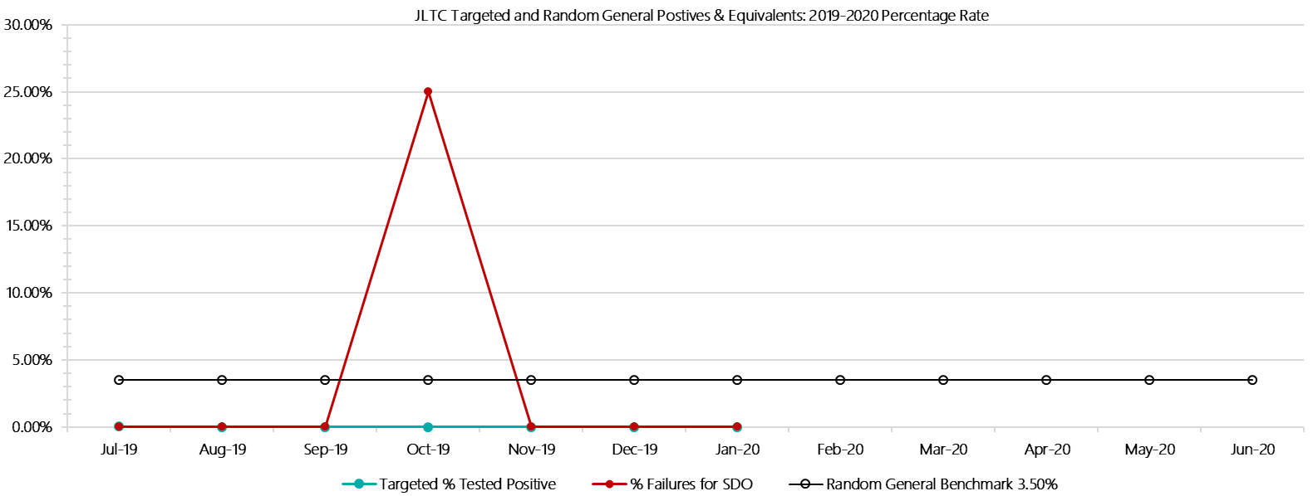

***JLTC Positive Test Results by Drug Type: 2019-2020***

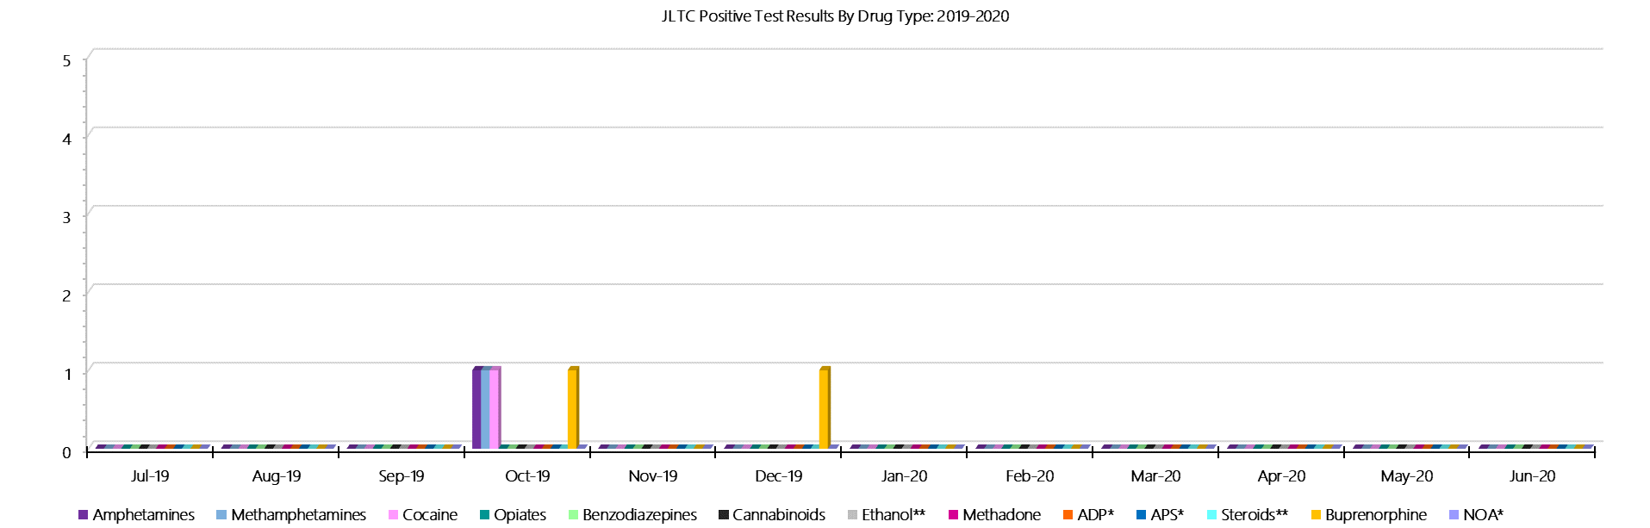

***JLTC Count of Visitor Seizures Finds: 2019-2020***

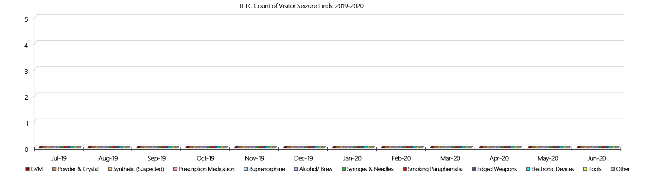

***JLTC Count of Prisoner Seizure Finds: 2019-2020***

**- PAGE LEFT BLANK INTENTIONALLY -**