Prison Recreation
Section |  | 3. Programs and Industry
CR Number | 3.3.1 | Current Issue Date | November 2020
Legislation & Policy |  | Corrections Act 1986  Charter of Human Rights and Responsibilities Act 2006
Standard |  | Programs and Reintegration Services – Fitness, Sport and Recreation
Attachments |  | Procurement Process Flowchart
Forms |  | Approved Risk Assessment Matrix
- PURPOSE
To define the requirements relating to recreation in prisons, with specific regard to:
  - the procurement and risk assessments to be undertaken when new recreational equipment is purchased by prisons;
  - quarterly risk assessments of existing recreational equipment; and
  - staff participation in recreational activities with prisoners.
- REQUIREMENT
General Managers must ensure that:
  - a Recreation Officer qualified in risk-assessment (responsible officer) is responsible for coordinating the acquisition, distribution, maintenance, storage, and modification of all recreational equipment;
  - staff do not participate in any recreational activities with prisoners that distract or prevent them from performing the functions of their role;
  - staff must give proper consideration to human rights and afford prisoners the opportunity to engage in meaningful recreation that supports their physical and mental health and wellbeing and limits any indirect harm.
- CONTEXT
Processes are required to ensure that recreational equipment is appropriately procured, maintained and managed and that there are appropriate protocols in place relating to staff involvement in recreational activities.
- INSTRUCTION
  - Management of Recreational Equipment
    - Prisoners are to be afforded the opportunity to participate in a range of activities to support their physical and mental health.
    - General Managers are required to risk assess recreational equipment that is procured, to reduce or eliminate the likelihood of particular items, including free-standing and detachable equipment being used as weapons in prisons.
    - It will be the responsibility of the Recreation Officer to coordinate the approval of equipment and maintain records of requests, approvals, audits, inventory and maintenance.
    - Refresher training must be provided to Recreation Officers every twelve months. The General Manager will determine how this training will be delivered.
  - Recreation Equipment Approval Process
    - All recreational equipment is required to undergo the approval process summarised in the Procurement Process Flowchart. This includes passive and consumable items:
- passive items are defined as items such as board games and puzzles; and
- recreational equipment ‘consumables’ are defined as items that present no or minimal risk, e.g. tennis balls, pool cue tips, pool cue chalk, table tennis balls and shuttlecocks.
    - The objective of the approval process is to ensure that the equipment requested is suitable for the environment. Suitability is determined during the risk assessment stage of the approval process and by ensuring that the relevant parties are involved in the decision-making process. Procurement Process Flowchart.
    - Each item of recreational equipment will undergo a 2-stage risk assessment:
- a security risk assessment; and
- an occupational health and safety risk assessment.
    - Where possible, strategies will be implemented to reduce and/or manage risk, for example, by modifying equipment, increasing auditing or considering a different level of staff supervision. The item will not be approved if the risk is assessed as unsuitable for the environment.
    - Prior to submitting a request, staff must take into consideration:
- the location of the equipment;
- the level of supervision required or available;
- the suitability for the environment; and
- the prisoner group utilising the equipment.
For all equipment requests, excluding consumable and passive items, staff must seek the approval of the responsible officer, prior to submitting the form to Recreation who will process the request.
    - General Managers should utilise their local Security and Emergency Management Planning Committee (or equivalent authorising committee) which should include an Occupational Health and Safety Representative, to conduct the risk assessments. The Committee may recommend that the Prison Executive/Leadership Team/Committee consider a request for a new item.
    - Any variation to the above process must be approved by the prison General Manager.
  - Approved Recreation Equipment Master List
    - Each prison is to maintain an Approved Standard Equipment Master List. Every item on the list is to have undergone the approval process outlined in the Procurement Process Flowchart.
    - When a request for equipment not on the Approved Standard Master List is received, the responsible (Recreation) Officer is to request that an off-site inspection and risk assessment be carried out on the proposed equipment. The risk assessment must be carried out by a person trained to assess and quantify risk.
  - Safe Operating Procedures
    - Once an item is approved a Safe Operating Procedure (SOP) is developed for all recreational items except passive equipment and consumable items.
    - Each piece of equipment will be delivered with a SOP attached. If the SOP cannot be attached to the item, it will be displayed nearby or made readily available to all users.
  - High Security and Management Units
Recreational equipment and activities available to prisoners located in high security and management units must be guided by the profile and suitability of the unit.
  - Equipment Maintenance and Modifications
Recreation Officers are responsible for coordinating the servicing, repair and modification of all recreational equipment. Recreational equipment that is modified for any purpose must be re-assessed for risk prior to being returned into service.
  - Service and Repairs
    - If an item requires servicing or repairs, the unit staff must contact the responsible officer to report the faulty or damaged equipment.
    - Requests must be actioned by a qualified gym maintenance contractor, maintenance, or recreation officers. Upon receipt of the request, Recreation Officers will determine who should action the request and commence the process. The decision is based on the type of request, skill, experience, risk and tools required.
  - Equipment Audits
    - To ensure that all equipment is accounted for and that occupational health and safety and security risks are managed on an ongoing basis, recreational equipment is subject to three types of audits:
- Unit/area staff must undertake fortnightly audits;
- Recreation Officers must undertake monthly safety and security audits; and
- Recreation Officers must undertake quarterly inventory audits.

    - Auditing is conducted to ensure that:
- equipment is intact, in particular any parts that have been secured by a bolt or weld;
- all items are accounted for;
- items remain within the areas they have been allocated to; and
- equipment has not been altered or modified.
  - Inventory of Recreational Equipment
    - All recreational equipment, other than the consumable and passive items, are to be recorded in a Recreation Master Inventory Database. This includes the items located in units, designated recreation areas and recreation storerooms.
    - Recreation Officers must conduct a quarterly prison-wide inventory audit of all recreational equipment completed by the 15th day of March, June, September and December.
    - Recreation Officers must submit an audit report to the General Manager. Audit reports must be presented at prison executive meetings and minuted.
    - Units are responsible for inspecting recreational equipment during daily unit search and inspections.
  - Occupational Health and Safety (OH&S)
    - The Department of Justice & Community Safety (DJCS) provides risk assessment training to staff. OH&S representatives must undertake risk assessments as required.
    - All newly received prisoners must be provided with information on OH&S in relation to using recreational equipment. Safety posters must be displayed where recreational equipment is situated and safe operating procedures attached to each item of equipment. Unit staff must notify a Recreation Officer when a poster becomes detached or is unable to be located.
    - To ensure that all recreational areas are safe, all staff are responsible for reporting damaged equipment to a responsible officer immediately. Damaged or faulty equipment must be withdrawn from use or secured.
  - Disposal of Recreational Equipment
Any items that are considered unserviceable, obsolete or surplus must be returned to Recreation Department and deleted from the Recreation Master Inventory Database noting the reason for the deletion.
  - Approved Risk Assessment Matrix
The Approved Risk Assessment Matrix reflects the format for the Approved Risk Assessment Matrix. To ensure consistency with risk assessment methodology across prisons, the excel version of this matrix is to be used when conducting initial or modification risk assessments.
  - Staff Involvement in Recreational Activities
    - Selected staff nominated by the prison General Manager, such as recreation staff, will be required to take responsibility for the development and implementation of fitness, sport and recreation activities at the prison, and will as part of that role necessarily engage in such activities with prisoners.
    - Where recreational activities between staff and prisoners may be appropriate, particularly at lower security levels, the General Manager must approve all requests for recreational activities between staff and prisoners.
    - Staff on duty must not to participate in any recreational activities, sport or games – either with prisoners or amongst themselves – that distract or prevent them from performing the essential functions of their role, particularly custodial functions.
    - Prison staff, other than recreational officers performing their ordinary duties, must not participate in recreational activities with prisoners unless:
- the staffing complement permits such activities;
- security and safety issues are not compromised, with particular consideration in high security and management units; and
- the General Manager has granted approval.
4.14 Contact Sports
    - Contact sports are sports that require the physical contact between players. Some sports such as sparring, boxing and mixed martial arts are scored on impact on an opponent, while others, such as football and rugby require the tackling of players. While all of these sports are full-contact, as there is a risk in prisons that prisoners will use the sport or activity to deliberately inflict harm/injuries to other prisoners, consideration is to be given to the appropriate supervision by recreation staff.
    - If the sport can be undertaken with no deliberate contact to the face and head, such as football, prisoners can participate in the sport. Activities that include full-contact to the face and head, such as boxing and sparring, will not be permitted. Prisoners are however permitted to use boxing punching bags and speed bags.
4.15 Local Procedures
Prison General Managers are to develop Local Operating Procedures/Operating Instructions which comply with the requirements of this policy. Local procedures must contain schedules or checklists necessary for the effective management of this Requirement.

Larissa Strong
Acting Commissioner

Information below this point is administrative supporting detail
only and not subject to Commissioner’s review or approval.

Acronyms
DJCS | Department of Justice & Community Safety
OH&S | Occupational Health and Safety
SOP | Safe Operating Procedure

Definitions
Nil

Associated Commissioner’s Requirements
Nil

Document Detail
Title: | Prison Recreation
Owner: | Manager, Operations Directorate

Version Control
Version | Date | Description
V4 | Nov-20 | Update
V3 | Jul-20 | Update
V2 | Oct-15 | Update
V1 | Aug-14 | Amalgamation of Recreational Equipment, Procurement and Risk Assessments + Staff Involvement in Recreational Activities

Approved Risk Assessment Matrix

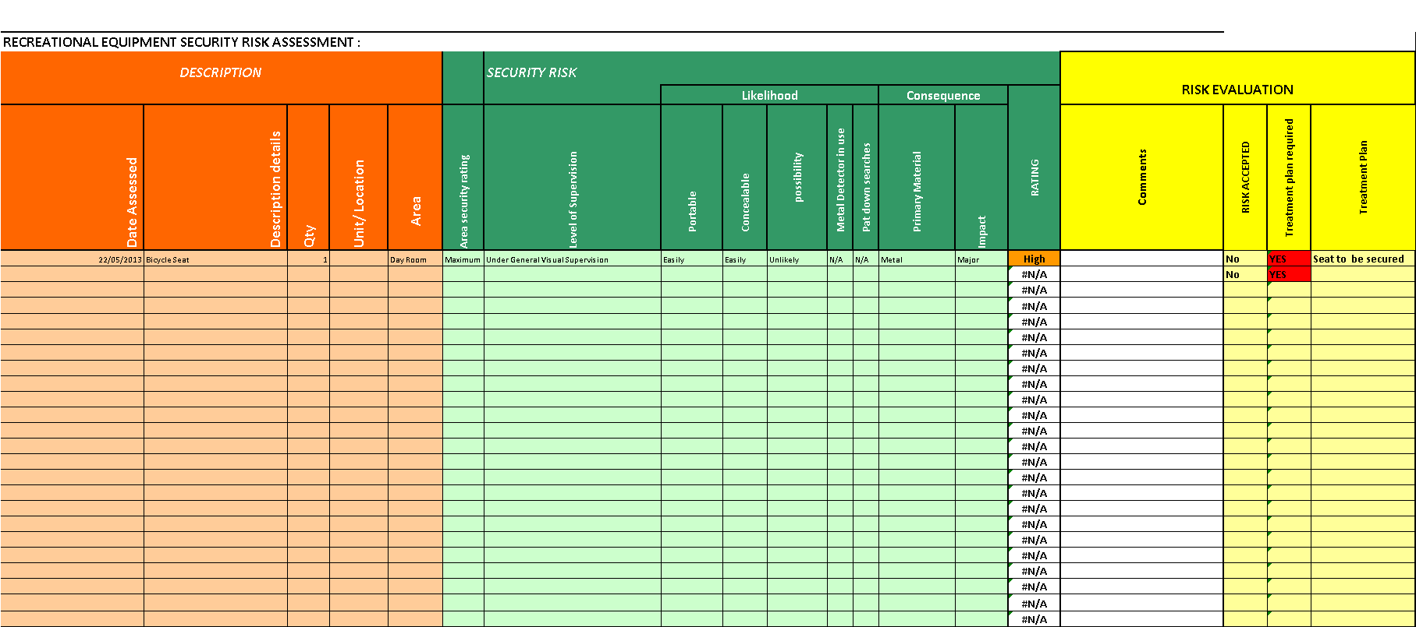
Procurement Process Flowchart

A proposal is received by the responsible officer to procure recreational equipment.
Approval to proceed is sought from a member of the Prison Executive.

The responsible officer completes an initial assessment to ensure the request is reasonable. If so, the formal approval process commences.

IS THE ITEM ON THE APPROVED STANDARD MASTER INVENTORY LIST?

NO
YES

The responsible officer contacts a member of the Prison Executive and advises that a request has been submitted. Arrangements are made to inspect the equipment (offsite) with a trained risk assessor and OH&S representative in readiness for presentation at the next authorising committee meeting.

No further approval required

The authorising committee considers the information and make a recommendation or non-recommendation and identify modifications/strategies to reduce risk to ensure that the item is suitable for the location.
A Recreation Officer attends the meeting.

The authorising committee record the recommendation and discussion in the minutes.
Recreation record the information on the Recreation Services Request .Form

The recommendation is forwarded to the Prison Executive for determination.

The Prison Executive approve/not approve the request. The risk assessments and authorising committee recommendation will influence the decision.
Recreation is notified of the outcome.

If approved, Recreation order the equipment.
MODIFICATIONS – Where modifications have been undertaken, Recreation will request, via a Prison Executive representative, that the authorising committee inspect the item to ensure that the modifications are as requested.
SAFE OPERATING PROCEDURES – Where applicable, a Safe operating Procedure will be developed, taking into account the risk assessments.
If equipment is not approved, Recreation notify the unit of the outcome.

Each piece of equipment will be delivered with a Safe Operating Procedure which must be displayed adjacent to the equipment and be available to supervising staff. The Recreation Officers induct the equipment into the unit or recreation centre.
The item is added to the Recreation Master Inventory.

