Universal Serial Bus (USB) Storage Devices for Prisoners
Section |  | 2. Prisoner Management
CR Number | 2.1.4 | Current Issue Date | August 2020
Legislation & Policy |  | Corrections Act 1986  Copyright Act 1968  Copyright Amendment Act 1968  Copyright Amendment (Digital Agenda) Act 2000  Charter of Human Rights and Responsibilities Act 2006  Corrections Regulations 2019  Correctional Standards for Men’s Prisons in Victoria  Standards for the Management of Women Prisoners in Victoria
Standard |  | Prisoner Administration Services - Prisoner Property
Attachments |  | Attachment 1 - Approved USB Storage Device Specifications  Attachment 2 - USB Storage Device Offence Guidelines
Forms |  | Form 1 - Application to Purchase Corrections Victoria Approved USB Storage Device  Form 2 - Prisoner’s USB Storage Device Agreement
- PURPOSE
To provide instructions relating to the purchase and use of Universal Serial Bus (USB) storage devices by prisoners.
- REQUIREMENT
All prisons will maintain operating procedures to manage prisoner USB storage devices, including guidelines and processes for:
- purchasing;
- in-cell retention;
- storage; and
- transfer.
- CONTEXT
In prisons where a prisoner network learning systems or internal drive network supports the secure storage of this information on a network drive, it will generally be unnecessary to place such information on a USB storage device other than, for some prisoners, at the point of transfer to another location.
- INSTRUCTION
  - General Guidelines
    - Portable USB storage devices in prisons must be controlled and monitored.
    - The opportunity to purchase a USB storage device will be extended to prisoners who require electronic file portability, not just those who have been approved to own an ‘in-cell’ computer. This may include prisoners who are required to make use of shared computer facilities, such as those in units, prisoner libraries, education centres or resource areas, to complete coursework related to education courses or treatment programs or to prepare correspondence or documents for internal or external purposes (e.g. letters to external agencies, completion of documents that are required for identification purposes) and to prepare for legal matters.
    - Prisoners will only be granted access to a USB storage device if approved by the prison General Manager.
    - Specifications for the approved device(s) are listed in Attachment 1 Approved USB Storage Device Specifications.
    - The USB storage device will be subject to random auditing to determine any unauthorised access or the storage of non-approved software, programs and other unauthorised material.
    - Applications to purchase an approved USB storage device must be made to the General Manager using Form 1 Application to Purchase a Corrections Victoria Approved USB Storage Device and Form 2 Prisoner USB Storage Device Agreement.
    - The General Manager will include consideration of whether the good order and security of the prison will be threatened by permitting a prisoner access to a USB.
    - General Managers must consider if there are more suitable and appropriate forms of secure storage of information (prisoner network learning system or internal network drives) and the capacity of the prison to monitor and audit the number of USBs.
  - Requirement and Eligibility Criteria
    - The purchase of an ‘in-cell’ computer requires that prisoners demonstrate that an ‘in-cell’ computer is ‘necessary’ (as outlined in the Commissioner’s Requirement – Prisoner Computers). Approval to purchase a USB storage device similarly relies upon the prisoner demonstrating that access to a USB is ‘necessary’.
    - A prisoner must demonstrate that the USB storage device is necessary:
- to the prisoner’s ability to prepare for trial or appeal;
- to assist the prisoner complete essential course work as part of their participation in approved education or treatment programs; or
- for the prisoner to safely retain electronic copies of important personal documents, particularly in circumstances where:
  - the prisoner routinely accesses and relies on shared computer facilities,
  - voluminous hard copy documentation would be a potential fire risk,
  - the quantum of documents are not manageable in the prisoner’s property, or
  - the security or privacy of sensitive documents would be significantly compromised if the documents were to be retained in hard copy (e.g. in a shared cell).
    - An application for the purchase of USB storage device will not be supported in the event that a prisoner is unable to demonstrate the existence of at least one of these elements.
  - Conditions of Use
Prisoners must adhere to the following conditions of use:
- All software and files stored on the USB must be appropriately licensed and not in breach of any provisions of the Copyright Act 1968 or Copyright Amendment (Digital Agenda) Act 2000.
- Games, music files, and images (other than those directly relating to a prisoner’s own court case or an approved education or treatment program) must not to be stored on the USB.
- The USB must not be used to transfer any data, software or files between prisoners’ in-cell or prisoner-accessed computers without the General Manager’s permission. Permission will not be granted unless the prisoner is able to provide sufficient evidence to demonstrate the need to utilise the USB in this way.
- The USB must not be used to store any encryption, virtual drive or enabling software (including partitioning and ghosting software). Approval must be obtained from the General Manager prior to transferring the USB to a person or organisation in the community. This will only be approved if there is a legal, educational or significant personal need for information to be transferred on such a device.
- Prisoners must immediately report the theft or removal of a USB from their cell or person, or may otherwise be assumed to have loaned the device if found in another prisoner’s possession.
- Prisoners must produce assigned USBs for examination, audit and testing. Any material found on the USB that contravenes these requirements will result in:
  - the device will be immediately seized,
  - offending documents, files (except legal files), or programs will be deleted, and
  - the USB will be stored in the prisoner’s property and marked ‘not to be re-issued without the prison General Manager’s approval’. Subject to the nature of the offence, prisoners will lose access to the device and will not be able to purchase another device for a specified period of time in accordance with Attachment 2 Universal Storage Device Offence Guidelines.
  - Purchasing – Procurement Process
    - Corrections Victoria will be responsible for the purchase of all authorised USB storage devices and individual locations are required to purchase these devices for on-sale to prisoners.
    - The General Manager, Judy Lazarus Transition Centre (JLTC) may approve an alternative commercially available USB in order to minimise any potential issues that may arise from a prisoner using the Corrections Victoria authorised USB on a leave program. The non-Corrections Victoria USB is not permitted to be in the possession of a prisoner in the event of transfer from the JLTC to a prison.
  - Purchasing – Prisoner Purchase
    - Form 1 An Application to Purchase a Corrections Victoria Approved USB Storage Device and Form 2 Prisoner USB Storage Device Agreement must be completed by all parties prior to purchase.
    - Purchases will be conducted via Special Spend or similar canteen or shop processes.
    - A prisoner may ordinarily purchase (and retain in cell) one USB storage device. The General Manager may in exceptional circumstances grant access to a second USB.
  - Security
The following processes and requirements must be applied across all locations:
- The following must be displayed on the outer casing of the device;
  - the internal serial number, and
  - the prisoner’s first name, surname and CRN;
- a record of all devices must be retained at the respective location, including details identifying the prisoner (first name, surname, CRN) and the serial number of the device;
- a security label, as applied to optical media disks, will be fixed to the outer casing;
- the device must be listed as a separate item on the prisoner’s E*Justice Property record. The entry is to be made as follows:

Computer – Accessories
Details: Corrections Victoria Approved USB Storage Device,
Capacity: 128MB, Serial Number: XXXXXXXXX

- the device will be audited on a random basis at least once per calendar year subject to operational considerations.
  - Guidelines for Use
    - The following guidelines must be adhered to:
- the device must be secured in the prisoner’s accommodation, except when it is necessary to be transported for approved purposes. When the device is required to be transported, it must remain in the prisoner’s possession;
- prisoners may only use the device with their own personal computer or shared resource computers; and
- the General Manager must arrange for prisoners’ continued need for a USB to be reviewed at least annually.
    - At any time a prisoner ceases to meet the Eligibility Criteria for continued use of the device, it must be placed in their personal property tub in the Property Store, and marked ‘Not to Be Issued’.
    - In the event that an offence is proven at a General Manager’s Disciplinary Hearing relating to breaches of this Commissioner’s Requirement, the penalties that may be applied are detailed in Attachment 2 - USB Storage Device Offence Guidelines.
    - In addition to the range of actions that may be taken in response to prisoners breaching the conditions and guidelines relating to the use of the USB, disciplinary action may be taken against prisoners for copying, sharing or distributing sensitive or legal material without appropriate approval.

Larissa Strong
Acting Commissioner

Information below this point is administrative supporting detail
only and not subject to Commissioner’s review or approval.

Acronyms
JLTC | Judy Lazarus Transition Centre
USB | Universal Serial Bus

Definitions
USB | A USB Storage device is a computer peripheral that provides a means for electronic file portability.

Associated Commissioner’s Requirements
2.1.1 - Prisoner Property
2.1.2 - Prisoner Computers

Document Detail
Title: | Universal Serial Bus (USB) Storage Devices for Prisoners
Owner: | Assistant Commissioner, Security & Intelligence Division

Version Control
Version | Date | Description
V4 | Aug-20 | Update
V3 | Aug-15 | Update
V2 | Aug-14 | Update
V1 | Apr-14 | First Issue

Attachment 1
APPROVED USB STORAGE DEVICE SPECIFICATIONS
The use of a USB storage device for prisoner use has been approved by Corrections Victoria. This device will be available for prisoners to purchase.
The approved device will:

- Have a storage capacity approved by Corrections Victoria
Approved capacity is 128MB
- Be of a physical size approved by Corrections Victoria
Approved size specification is that of a Credit Card, 85mm x 55mm x 3mm
- Have an enclosed internal electronic storage component
Approved internal storage component situated between the sides of the casing
- Have approved distinctive artwork applied to the outer casing of the device
Approved Artwork

“CORRECTIONS VICTORIA”
will be displayed using Pantone colour 286C (Royal Blue)

“APPROVED USB DEVICE PERMITTED FOR USE BY PRISONERS”
will be displayed using Pantone colour 185C (Bright Red)

The reverse side of the device casing will remain blank to allow the addition of the security label, marking for the serial number and any other identifying information as required.

- Have an approved ‘warning’ installed as part of the USB storage device software that opens on every occasion that the device is opened on a computer

Approved Warning

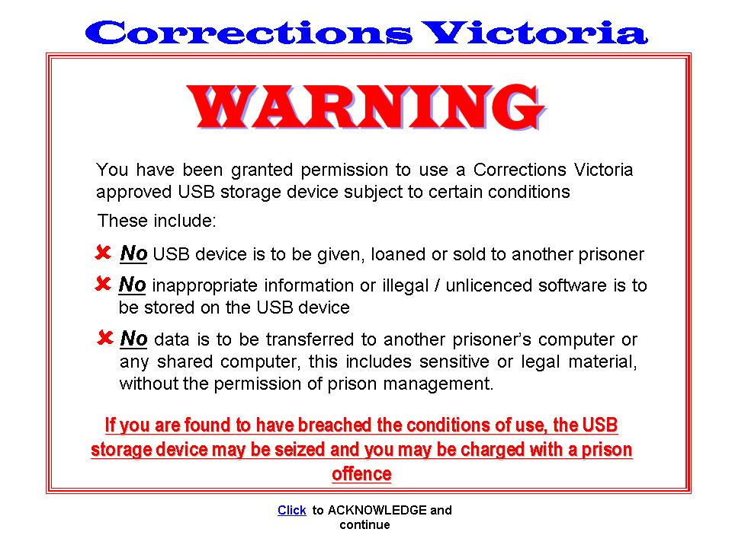

Attachment 2
USB STORAGE DEVICE OFFENCE GUIDELINES

Where an offence is proven at a General Manager’s Disciplinary Hearing of breaches of prison offences relating to Commissioner’s Requirement – Universal Serial Bus (USB) Storage Devices for Prisoners, recommendations for the severity of a breach of this Commissioner’s Requirement are suggested as follows:
Unauthorised Music / Video and Image Files
Breaches of copyright are determined as any action, where a prisoner has copied or allowed to be copied any music CD/DVD or tape, in any format that they do not own and have obtained illegally and subject to the Copyright Act 1968 and Copyright Amendment (Digital Agenda) Act 2000
Recommendation
- That the prisoner loses access to the device for a period of no less than six (6) months.
- That the music and/or associated music/video files in question, be removed from the device by an appropriately authorised staff member.
Unauthorised Sharing of Electronic Data or Information
Personal or non-sensitive documents belonging to another prisoner have been found to be stored on a prisoner’s USB storage device. These documents include personal or private letters, education material or other material that is not deemed to be of a legal or sensitive nature which has been identified as belonging to another prisoner.
Recommendation
- That the prisoner loses access to the device for a period of not less than six (6) months
- That the relevant files be removed from the device by an appropriately authorised staff member.
Unauthorised Access to Sensitive or Legal Material
Legal and sensitive documents belonging to another prisoner have been found to be stored on a prisoner’s USB storage device. These documents include written statements of another prisoner pertaining to a criminal or civil matter, witness statements, health information or records, etc.
Recommendation
- That the prisoner loses access to a device for the remainder of his/her sentence.
- The device will be forfeited via the usual seizure processes.

Inappropriate Visual Images
Any image files found to contain inappropriate visual images including, naked bodies, exposed genitalia, acts of violence, racist material, drug related paraphernalia, motorcycle gang branding.
Recommendation
- That the prisoner loses access to a device for the remainder of his/her sentence.
- The device will be forfeited via the usual seizure processes.

Note: any sanctions must consider the individual’s circumstances and the impact on their human rights, particular the prisoner’s right to a fair hearing (s24) and rights in criminal proceedings (s25).

Form 1
APPLICATION TO PURCHASE CORRECTIONS VICTORIA APPROVED
USB STORAGE DEVICE

Last Name: | Given Name: | CRN:
I, request permission to purchase a USB Storage Device as approved by Corrections Victoria for prisoner use
The reason for my application is
Legal
Education
Treatment Program
Important Personal Documentation
Second USB Storage Device (exceptional circumstances)

Describe the reason why electronic file portability is necessary:
__________________________________________________________________________
__________________________________________________________________________
__________________________________________________________________________
__________________________________________________________________________
__________________________________________________________________________
__________________________________________________________________________
__________________________________________________________________________
__________________________________________________________________________
____________________________________________________________________________________________________________________________________________________
__________________________________________________________________________
__________________________________________________________________________

I understand that Corrections Victoria, or its representative, will act with all due care and responsibility in the supply of an approved USB storage device, and will be exempt from any liability should the device fail to operate due to a manufacturer’s fault or misuse.

Signed: ____________________________________________ Date __ / __ / 20__

Official Use Only
Accommodation Supervisor: _________________________________ Date ___ / __ / 20__

Local IT Coordinator Notified: _________________________________ Date ___ / __ / 20__

General Comments: _______________________________________________________________________________
_______________________________________________________________________________

The following approvals and signatures are required.
Prison General Manager or approved delegate: ______________________ Date ___ / __ / 20__

If Major Offender, Endorsement by: ______________________________ Date ___ / __ / 20__

If not approved by any person or group listed, detail reason for application refusal?
_______________________________________________________________________________

_______________________________________________________________________________

_______________________________________________________________________________

Attach additional information if required.

PRISONER’S USB STORAGE DEVICE AGREEMENT

I, ___________________________________________CRN: ______________ understand that:
Given name and surname

- Australian copyright laws can expose me to claims for civil damages and fines up to $50,000, together with a jail term or unauthorised duplication of software, music and movie files.
- A USB storage device approved by Corrections Victoria is the only USB storage device that is able to be purchased by me and to be in my possession whilst in custody.
- No games, music files, images or videos (other than those directly related to an approved education or treatment program), or pornographic files or software are to be stored on the USB storage device.
- An authorised staff member will audit the USB storage device on an irregular basis.
- I am not permitted to transfer data, software or information to any other prisoner or, while in custody, any person in the community, without the approval of the General Manager.
- I am not permitted to distribute sensitive electronic or legal material to other prisoners without the approval of the General Manager.
- I will not use the USB storage device owned by me with another prisoner’s computer without the approval of the General Manager.
- Failure to comply with the guidelines as stipulated in Commissioner’s Requirement – Universal Serial Bus (USB) Storage Devices for Prisoner’s or local operating procedures, and any subsequent instructions regarding USB storage devices may result in the General Manager withdrawing access to the USB storage device at any time.
- The USB storage device must be secured in my accommodation at all times, except when it is necessary to transport files for authorised purposes and must remain in my possession at all times during such periods.
- I will report the loss or theft of the USB storage device as soon as I become aware of it.
- I understand that my access to the USB storage device may cease when the criteria for which I was approved to have the device is no longer applicable or that it may be reviewed due to inappropriate behaviour.
- Additional conditions (if applicable): __________________________________________________________________________________________________________________________________________________________________________
- I have read and understood the terms and conditions as outlined above, which detail the requirements relating to my access to a Corrections Victoria approved USB storage device, and will comply with these terms and conditions and with any additional policy, requirement or local instructions that may be issued from time to time.

Prisoner’s Signature: ___________________________________ Date ___ / __ / 20__

General Manager’s Signature: ______________________ Date ___ / __ / 20__

