Parole Application Process
Section |  | 2. Prisoner Management
CR Number | 2.6.1 | Current Issue Date | November 2020
Legislation & Policy |  | Corrections Act 1986  Corrections Regulations 2019  Charter of Human Rights and Responsibilities Act 2006  Parole Coordination Function - Operating Guidelines
Standard |  | Prisoner Management
Attachments |  | Parole application process flow for state prisoners
Forms |  | Parole Application form  Parole Application form - Commonwealth Prisoners  Case Management Review Committee - Parole Application Report  Brief - Review of Satisfactory Behaviour for Parole Applications  Full - Review of Satisfactory Behaviour for Parole Suitability Assessments
- PURPOSE
To set out the parole application requirements for public and private prisons.
- REQUIREMENT
Prisoners are required to make an application to the Adult Parole Board (APB) to be considered for parole. All sentenced prisoners with a non-parole period are eligible to apply for parole. All prisons are required to facilitate the parole application process for eligible prisoners.
- GUIDING PRINCIPLE
  - The Corrections Act 1986 Section 73A requires that “The Board must give paramount consideration to the safety and protection of the community in determining whether to make or vary a parole order, cancel a prisoner’s parole or revoke the cancellation of parole.”
  - The APB considers prisoners who demonstrate their motivation for parole by making an application.
  - Section 21 of the Charter of Human Rights and Responsibilities Act 2006 protects a person’s right to liberty and security of person and prescribes that a person must not be subjected to arbitrary detention. As such, the parole application process must occur in a timely manner and not prevent or delay the APB’s consideration of a prisoner for parole. Consideration should also be given to prisoners with special needs or vulnerabilities (i.e. prisoners with an intellectual or cognitive impairment, or prisoners from a Culturally and Linguistically Diverse background etc) who may require support or assistance in applying for parole, as such obstacles should not preclude a prisoner from being considered for parole.
  - Prisoners serving sentences for Commonwealth offences are not required to apply for parole, however, should be strongly encouraged to apply to maintain consistency for prisoners and to allow for vital information to be gathered for the parole assessment. Federal prisoners are to complete the Parole Application form – Commonwealth Prisoners, and applications will be submitted to the Commonwealth Attorney General’s Department (CAGD) via the Parole Central Unit. Unless specified, the parole application process for federal prisoners is consistent with state processes.
- CONTEXT
Corrections Victoria acknowledges the importance of a well-managed and coordinated parole application process underpinned by quality prisoner case management, to maximise community safety.
- INSTRUCTION
  - Parole Application Process
The General Manager must ensure that:
    - there is an identified key contact point within the prison for matters related to parole and the parole application process;
    - information about parole and the parole application process is readily available to prisoners;
    - Parole Application Workflow System (PAWS) is monitored for prisoners who are at the recommended time to commence the parole application process. The following guidelines apply to the recommended timing for commencement of the parole application process:
  - in general, prisoners will be guided to complete applications from 12 months before their earliest eligibility dates;
  - prisoners serving 10 years or more may be guided to apply for parole up to three years before their earliest eligibility dates, in consultation with the Sentence Management Division;
  - prisoners who have had parole cancelled may apply immediately, however should be encouraged to consider the circumstances of their cancellation and efforts to address the reasons for their cancellation when making an application for re-parole;
  - prisoners who have been transferred from Youth Justice and do not have earliest eligibility dates, may be guided to apply at any time, appropriate to rehabilitation progress; and
  - prisoners with shorter sentences should be guided to complete applications at an appropriate time, taking into account timelines for a Parole Suitability Assessment and pre-release planning (e.g. a prisoner with a six-month non parole period may be guided to complete an application at the commencement of their sentence) notwithstanding that treatment may need to be completed prior to the APB being prepared to grant parole.
    - the Assessment and Transition Coordinator (ATC) or delegate advises the prisoner’s case worker, as soon as possible, that the prisoner is at the recommended time to commence the parole application process, including completion and submission of the Parole Application form, and the date that the Parole Application Case Management Review Committee (CMRC) will consider the application. (At Ravenhall Correctional Centre, the role of the ATC will be performed by Reintegration Officers.);
    - the prisoner’s case worker completes the relevant sections of the Case Management Review Committee – Parole Application Report. For Serious Violent offenders and Sex Offenders (SVoSOs) the case worker also completes the Brief - Review of Satisfactory Behaviour for Parole Applications. These documents, together with the prisoner’s Parole Application, are provided to the ATC or equivalent, for the information of the Parole Application CMRC, within 14 days of the case worker being notified by the ATC or equivalent, that the prisoner is at the recommended time to commence the parole application process;
    - prisoners are scheduled onto a Parole Application CMRC meeting at an appropriate time to allow submission of applications to the relevant authority (APB or CAGD via PCU) within 30 calendar days of the prisoner reaching the recommended time to commence the parole application process;
    - prisoners are guided to submit parole applications at an appropriate time and advised of the possible implications of applying too early, where they have declined to participate in recommended programs or have demonstrated poor behaviour. In guiding a prisoner to submit the parole application, case workers should assist prisoners who may have difficulty completing the application form due to cognitive impairment, language difficulties or other similar issues. In addition, a case manager should provide assistance with the process, if requested by a prisoner;
    - prisoners who have not applied or have declined to apply for parole are to attend a Parole Application CMRC, to discuss the reason for declining and whether these factors could be addressed through supports available at the prison or referrals to external agencies;
    - the proposed release address of each prisoner who applies for parole (if available) is checked prior to the Parole Applications CMRC meeting to allow discussion with the prisoner at the meeting;
    - Parole Application CMRCs must be chaired by Operations Managers or private provider equivalent and are not delegable;
    - Parole Application CMRC panels should comprise of the ATC or equivalent, representatives of industries, education, clinical services, programs and/or staff with knowledge and expertise relevant to the prisoner’s parole application and should perform the following functions:
- ensure any other relevant completion reports from programs, education or employment are present;
- review the application documents and other relevant materials on the prisoner’s IMF;
- confirm with the prisoner the parole application process and criteria including any identified requirements such as program participation, satisfactory behaviour and suitable accommodation;
- engage prisoners in discussion about preparation for release (for example, what has worked in the past, what have been the challenges, what preparations are being made, including for example proposed release address) noting that their Earliest Eligibility Date (EED) is an eligibility date only and not a guaranteed release date;
- motivate the prisoner to engage in, and continue with, the process of behaviour change;
- evaluate the prisoner’s progress against the requirements for parole;
- if the prisoner is a SVoSO, advise the prisoner of the function of the Brief - Review of Satisfactory Behaviour for Parole Applications and the reporting obligations to the APB or CAGD;
- complete the remaining sections of the Case Management Review Committee – Parole Application Report if the prisoner is a SVoSO, including whether the committee considers the prisoner has met threshold by demonstrating satisfactory behaviour and completion of programs and willingness to engage in assessments and recommended programs;
- ensure the prisoner’s parole application and Case Management Review Committee – Parole Application Report is submitted to the relevant authority on E*Justice;
- review the appropriateness of the Sentence and Local Plan based on the information reviewed, for example, current risk of reoffending assessment tool (LSI:R-SV or LS/RNR) and any incidents in which the prisoner has been involved;
- provide advice to the APB of a prisoner’s intent NOT to apply for parole; and
- ensure the case worker is informed of the CMRC recommendations and any requirements to work with the prisoner on updating and progressing their Local Plan.
    - Parole Application CMRC meeting outcomes are accurately recorded in PIMS/PAWS with any necessary notes, including if a prisoner has declined to apply for parole. In the event that a SVoSO prisoner has not met the threshold to proceed to a Parole Suitability Assessment, comments must be included in the Case Management Review Committee – Parole Application Report ;
    - The Parole Application and Case Management Review Committee – Parole Application Report is submitted to the relevant authority within 30 calendar days of the prisoner reaching the recommended time for initiation of the parole application process;
    - the relevant authority is advised of those prisoners who decline to apply for parole, although federal prisoners will still be required to undertake a Parole Suitability Assessment;
    - prisoners are advised of the outcome of their parole application and that Community Correctional Services (CCS) will make contact when required;
    - a point of contact within the prison is identified for CCS Parole Officers completing the Parole Suitability Assessment;
    - in the case of SVoSOs, prison case workers complete the Full - Review of Satisfactory Behaviour for Parole Suitability Assessments and provide to the CCS Parole Officer when requested;
    - where the APB has previously denied parole and a prisoner may be re-applying, the prisoner should be encouraged to consider the reasons for being denied and whether there has been significant change in these circumstances before making another application.

Larissa Strong
Acting Commissioner

Information below this point is administrative supporting detail
only and not subject to Commissioner’s review or approval.

Acronyms
APB | Adult Parole Board
ATC | Assessment and Transition Coordinator
CAGD | Commonwealth Attorney General’s Department
CCS | Community Correctional Services
CMRC | Case Management Review Committee
EED | Earliest Eligibility Date
IMF | Individual Management File
PAWS | Parole Application Workflow System
PCU | Parole Central Unit
PCW | Prison Case Worker
PIMS | Prisoner Information Management System
SVoSO | Serious Violent offender or Sex Offender

Definitions
Nil

Associated Commissioner’s Requirements
3.1.1 – Transitional Support and Preparation for Release

Document Detail
Title: | Parole Application Process
Owner: | Deputy Commissioner, Custodial Operations

Version Control
Version | Date | Description
V6 | Nov-20 | Update
V5 | Dec-18 | Update
V4 | Nov-17 | Update
V3 | Apr-17 | Update
V2 | Mar-16 | Update
V1 | Mar-15 | First Issue

Parole application form

To: The Adult Parole Board of Victoria

Via: The Case Management Review Committee

I wish to apply for parole.

My parole has been cancelled and I wish to apply for re-parole.

PERSONAL DETAILS
Name: |  | Date of Birth: |  | / | /

CRN: |  | JAID:

Current Location: |  | Case Manager:

PROPOSED PAROLE ADDRESS DETAILS

Proposed Address:

Primary contact details for proposed address:
Name: |  | Phone number:

DOB: |  | Relationship:

Details of proposed co-residents
Name: |  | DOB: |  | Relationship:
Name: |  | DOB: |  | Relationship:
Name: |  | DOB: |  | Relationship:
Name: |  | DOB: |  | Relationship:

Please note any adult co-residents residing at the proposed address will be contacted by Corrections Victoria. This is to assist in the assessment of this property, in the overall assessment for Parole. Please notify the Assessment and Transition Coordinator (ATC) at the prison, if the address being proposed changes at any time.

There are no co-residents at this property; I will be residing alone.

I have no accommodation to propose.
FURTHER INFORMATION (if required)

You may provide information for the Adult Parole Board’s consideration.

Note: You do not need to list the programs you have completed as the Board will receive this information. The Board will not respond to questions. Any questions about parole should be directed to your case manager.

Signature: |  | Date: |  | / | /

Parole application form for Commonwealth Prisoners only

To: The Commonwealth Attorney-General’s Department

Via: The Case Management Review Committee

I wish to apply for parole.

My parole has been revoked and I wish to apply for re-parole.

PERSONAL DETAILS
Name: |  | Date of Birth: |  | / | /

CRN: |  | JAID:

Current Location: |  | Case Manager:

PROPOSED PAROLE ADDRESS DETAILS

Proposed Address:

Primary contact details for proposed address:
Name: |  | Phone number:

DOB: |  | Relationship:

Details of proposed co-residents
Name: |  | DOB: |  | Relationship:
Name: |  | DOB: |  | Relationship:
Name: |  | DOB: |  | Relationship:
Name: |  | DOB: |  | Relationship:

Please note any adult co-residents residing at the proposed address will be contacted by Corrections Victoria. This is to assist in the assessment of this property, in the overall assessment for Parole. Please notify the Assessment and Transition Coordinator (ATC) at the prison, if the address being proposed changes at any time.

There are no co-residents at this property; I will be residing alone.

I have no accommodation to propose.
FURTHER INFORMATION (if required)

You may provide information for the Commonwealth Attorney-General’s Department for their consideration.

Note: You do not need to list the programs you have completed as the Commonwealth Attorney-General’s Department will receive this information. The Commonwealth Attorney-General’s Department will not respond to questions. Any questions about parole should be directed to your case manager.

Signature: |  | Date: |  | / | /

Case Management Review Committee
Parole Application Report

To: Adult Parole Board of Victoria / Commonwealth Attorney‐General’s Department
(Delete the option that is not applicable)
Copy to be placed on the prisoner IMF
SECTION 1
PART A – TO BE COMPLETED BY PRISON CASE WORKER FOR ALL PRISONERS WHO HAVE COMPLETED AN APPLICATION FOR PAROLE

- – PRISONER DETAILS

Name: …………………………………………………….. Date of Birth: ……/……/…….

Current location: ……………………………… CRN:……………JAID:…….. ………..…

Security classification………………………….

Please tick all boxes below that apply to the prisoner:
□ Registered Intellectual Disability □ Aboriginal or Torres Strait Islander
□ Major Offender □ Special Category Prisoner1
□ Serious Violent or Sex Offender □ Commonwealth Offender

- – SENTENCE INFORMATION

Sentence: …………(aggregate)……………(minimum) EED:…………… EDD:……………
Any outstanding court matters? □ Yes □ No

If Yes, provide details……………………………………………………………………………….

- – RISK OF RE‐OFFENDING
General risk of re‐offending (LS/RNR or VISAT): □ High □ Medium □ Low
(circle/indicate tool)
Serious Violent Offender : □ (tick if applicable) Risk Level : …………Tool:…………Date:……
Sex Offender: □ (tick if applicable) Risk Level : ………….Tool:…………Date:……

- – VICTORIAN PAROLE HISTORY

Number of previous times released on parole……………………………………………………...

Number of times parole cancelled…………………………………………………………………..

PART B – TO BE COMPLETED FOR SERIOUS VIOLENT OR SEX OFFENDERS ONLY BY PRISON CASE WORKER

- – TREATMENT INFORMATION

Prisoner has participated in all RECOMMENDED treatment (tick one box only)
□ Yes ‐ completed
□ Yes ‐ scheduled or in progress (est. completion date:..………………………………………)
□ No (reason:……………………………………………………………………………………….)
□ Not applicable – assessment did not recommend a treatment program

- – REVIEW OF SATISFACTORY BEHAVIOUR
Review of Satisfactory Behaviour attached? □ Yes □ No

ENDORSEMENT OF SECTION 1

Case Worker signature :…………………………………………………. Date:………………

Print name:…………………………………..………………

SECTION 2
TO BE COMPLETED BY PAROLE COORDINATOR (refer to CCS Catchment list)

7 – CCS LOCATION TO COMPLETE PAROLE SUITABILITY ASSESSMENT
Proposed release address validated □ Yes □ No

CCS location closest to proposed address (or if no address, closest CCS location to the prison):

………………………………………………………………………………………………………….

ENDORSEMENT OF SECTION 2
Parole Coordinator Signature:………………………………………………… Date:…………………………………….
Print name:………………………………………………………………………..
SECTION 3
TO BE COMPLETED FOR SERIOUS VIOLENT OR SEX OFFENDERS ONLY BY CMRC CHAIR

8 – CMRC ADVICE TO ADULT PAROLE BOARD / COMMONWEALTH ATTORNEY-GENERAL’S DEPARTMENT
Using the Satisfactory Behaviour Guide, the CMRC considers the prisoner’s recent institutional behaviour as:

□ Satisfactory □ Of some concern □ Of major concern

………………………………………………………………………………………………………………………………………………………………….
………………………………………………………………………………………………………………………………………………………………….
………………………………………………………………………………………………………………………………………………………………….
………………………………………………………………………………………………………………………………………………………………….
Overall, the CMRC considers the prisoner has met the threshold for progression to parole planning towards their earliest eligible date
□ Yes □ No

SECTION 4
TO BE COMPLETED BY CMRC CHAIR

9 – CMRC CHAIR ENDORSEMENT

The CMRC Chair endorses the content of this report

CMRC Chair (or delegate) signature:………………………………………………………. Date:……………………………………….

Print name:…………………………………………………………………………………………….

Corrections Victoria
TO BE COMPLETED FOR SVoSO Prisoners ONLY OFFICIAL - Sensitive

BRIEF ‐ Review of Satisfactory Behaviour for Parole Applications

To be completed by the Prison caseworker for submission with the Prisoner’s Application to the Parole
Coordinator.

Date Prison Location
Prisoner Name:
CRN: JAID:

Instructions:
For each of the four areas below, provide brief comments on the prisoner’s behaviour based on available evidence and in line with the instructions. In doing so, consider the prisoner’s behaviour during the second half of his or her sentence – or, over a reasonable period if the second half of the sentence is not a useful guide (e.g. too short or too long to allow helpful observations to be made).
In determining what information is relevant, it is important to understand the context in which the prisoner is living (for example, the prisoner’s security status or regime may have an impact on the prisoner’s opportunity for pro social behaviour and rehabilitative opportunities). The nature of any other factors influencing them, such as mental disorder, intellectual disability and/or Acquired Brain Injury may also be important, as well as other important personal and social factors (e.g. gender, culture, ethnicity). These other factors should not excuse poor behaviour but should be considered as factors that may require management.
Consider the gravity and frequency of the behaviour, as well as any mitigating factors that may be of relevance to the Case
Management Review Committee (CMRC) in determining the endorsement of the CMRC Report submitted to the Adult Parole
Board. Once each area has been completed, a brief summary of the prisoner’s overall behaviour should be provided.
The information will be considered by the CMRC in its completion of the Parole Application Report for the Adult Parole Board. It is intended to assist the CMRC to make a determination about the prisoner’s recent institutional behaviour.
The outcome of the CMRC Report is to be recorded on PIMS (in the CMRC minutes) and a copy of the CMRC Report and the Brief Review of Satisfactory Behaviour placed on the Individual Management File.
1. Violent behaviour:
INFORMATION SOURCES
- Review and consider involvement in incidents recorded on PIMS. Is there evidence of significant assaults or verbal aggression, property damage, or use of weapons?
- Consider prison officers’ reports for evidence of aggressive/sexually aggressive behaviour (threatening, intimidating behaviour or verbal aggression, standover).
CASE WORKER COMMENTS
…………………………………………………………………………………………………………………………… ……………………………………………………………………………………………………………………………
……………………………………………………………………………………………………………………………
……………………………………………………………………………………………………………………………
2. Involvement in substance abuse or like behaviour:
INFORMATION SOURCES
- Review and consider available information reports and databases, such as PIMS for evidence of incidents of positive drug screens, refusal to undertake random urine screening, or possession of drug using equipment.
- Consider any available information sources to confirm whether there has been any involvement in alcohol or other drug activity, to what degree, and the type of substance use detected.
CASE WORKER COMMENTS
……………………………………………………………………………………………………………………………………………………………………………………………….. ………………………………………………………………………………………………………………………………………………………………………………………………..
………………………………………………………………………………………………………………………………………………………………………………………………..
………………………………………………………………………………………………………………………………………………………………………………………………..
3. Attitude to employment, education and/or rehabilitation:
INFORMATION SOURCES
- Consider evidence of a positive attitude and commitment to employment, education and/or rehabilitation
- Consider reports from OBP, education and industry and other staff regarding attendance, engagement and participation.
CASE WORKER COMMENTS
……………………………………………………………………………………………………………………………………………………………………………………………… ………………………………………………………………………………………………………………………………………………………………………………………………
………………………………………………………………………………………………………………………………………………………………………………………………
………………………………………………………………………………………………………………………………………………………………………………………………
4. Response to supervision and direction:
INFORMATION SOURCES
- Review and consider involvement in incidents recorded on PIMS . Has the prisoner complied with instruction?
Is there evidence for disregard for prison rules? Does the prisoner respond well to direction?
- What is the nature of the prisoner’s relationships with the case manager and unit staff?
- CMRC to ascertain advice from staff regarding the prisoner’s relationships with other prisoners.
CASE WORKER COMMENTS
………………………………………………………………………………………………………………………………………………………………………………………………...………………………………………………………………………………………………………………………………………………………………………………………………
………………………………………………………………………………………………………………………………………………………………………………………………
………………………………………………………………………………………………………………………………………………………………………………………………
SUMMARY (include evidence based information only):
Provide any further comments summarising the prisoner’s behaviour overall.
………………………………………………………………………………………………………………………………………………………………………………………………..………………………………………………………………………………………………………………………………………………………………………………………………
……………………………………………………………………………………………………………………………………………………………………………………………….
………………………………………………………………………………………………………………………………………………………………………………………………
………………………………………………………………………………………………………………………………………………………………………………………………..………………………………………………………………………………………………………………………………………………………………………………………………
………………………………………………………………………………………………………………………………………………………………………………………………

CASEWORKER:…………………………………………………….. (name)……………………………………………………………….(signature)

Corrections Victoria
TO BE COMPLETED FOR SVoSO Prisoners ONLY

FULL ‐ Review of Satisfactory Behaviour for Parole Suitability Assessments
To be completed by the Prison caseworker for submission to the Parole Coordinator for CCS.

Date Prison Location
Prisoner Name:
CRN: JAID:
Instructions:

For each statement below, place a mark on the continuum to identify how you would rate the prisoner’s behaviour. This does not have t0 be an exact number but rather your impression from the information you have considered. In doing so, consider the prisoner’s behaviour during the second half of his or her sentence – or, over a reasonable period if the second half of the sentence is not a useful guide (e.g. too short or too long to allow helpful observations to be made). Use this information to assess whether the prisoner’s behaviour overall is satisfactory or unsatisfactory.

In determining what information is relevant, it is important to understand the context in which the prisoner is living (for example, the prisoner’s security status or regime may have an impact on the prisoner’s opportunity for pro social behaviour and rehabilitative opportunities). The nature of any other factors influencing them, such as mental disorder, intellectual disability and/or Acquired Brain Injury may also be important, as well as other important personal and social factors (e.g. gender, culture, ethnicity). These factors should not excuse poor behaviour however should be considered as factors that require management. Consider the gravity and frequency of the behaviour as well as any mitigating factors that may be of relevance.

For each risk factor, place a cross (×) at the place on the line that best reflects the prisoner’s behaviour.

Once each area has been completed, you are required to make a judgement about whether the prisoner’s behaviour is satisfactory. It can reasonably be assumed that the more the continuums are marked on the positive side (the green end of the continuum) the more the person’s behaviour can be considered satisfactory. However, there may be serious concerns about a person’s antisocial (unsatisfactory) behaviour on one particular scale (e.g. repeated acts of significant aggression during institutionalisation) that might indicate that the person’s behaviour is unsatisfactory. It is your assessment of overall behaviour.

To make this overall assessment, consider each identified area and make a final assessment on balance as to whether you consider the person’s behaviour is satisfactory or unsatisfactory. The assessment will be considered by Community Correctional Services staff completing the Parole Suitability Assessment Report and will form part of the information presented to the Adult Parole Board about the prisoner’s suitability for release on parole.
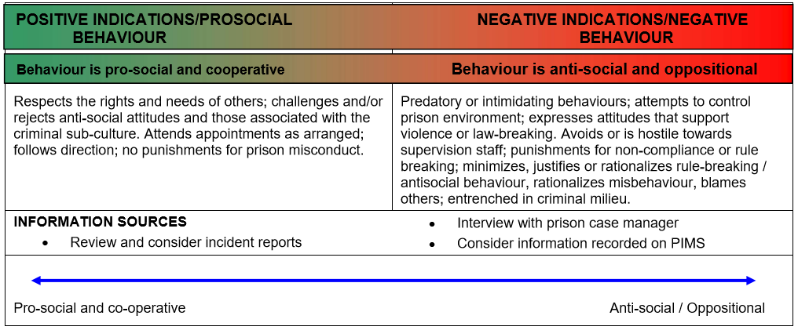

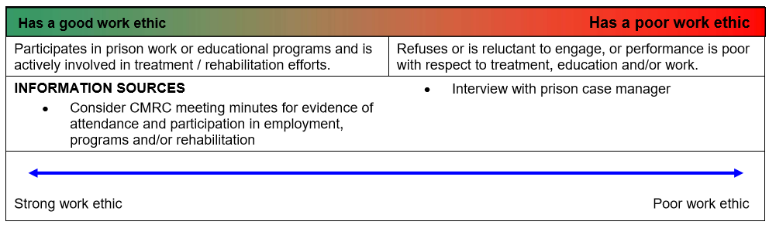

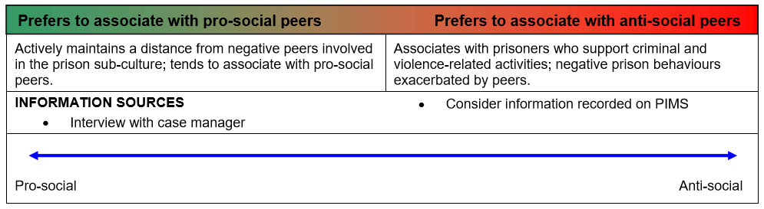

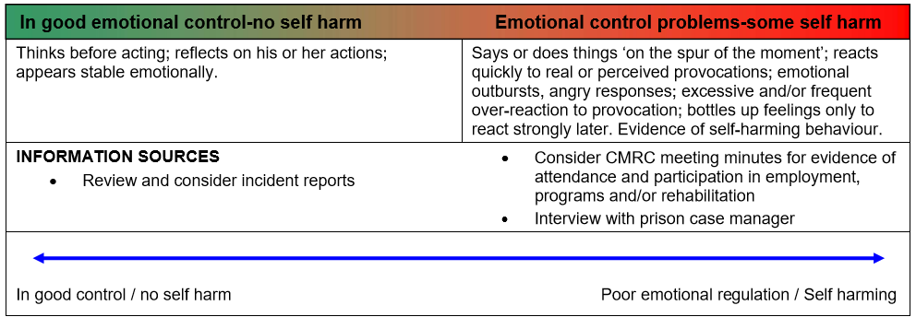
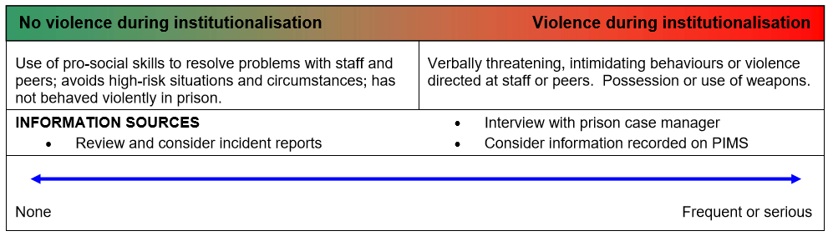

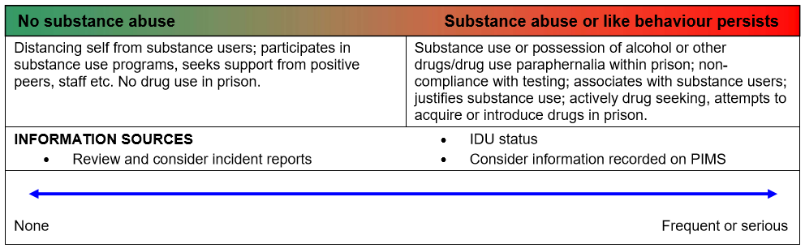

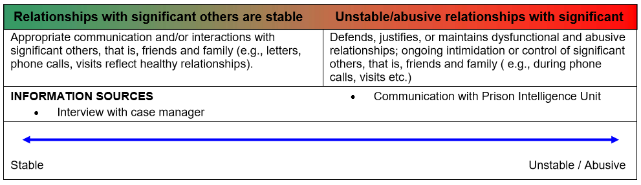

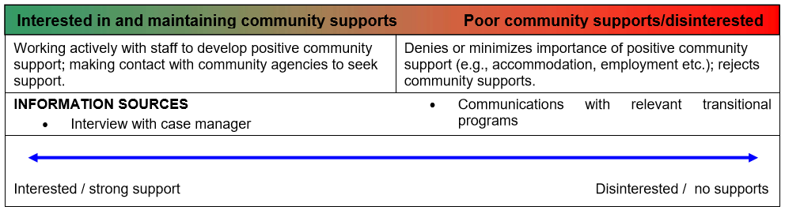

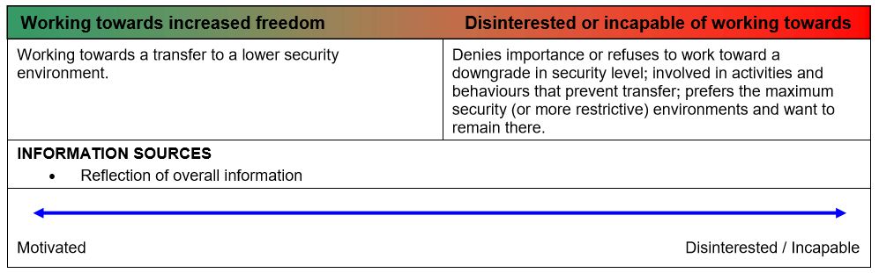
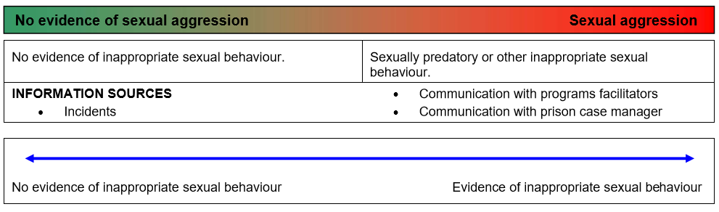

FINAL BEHAVIOUR RATING (CIRCLE THE APPROPRIATE LABEL):

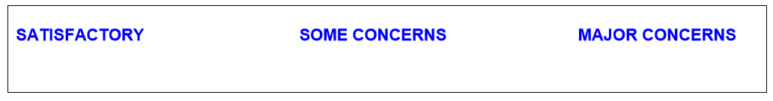

Caseworker: (Name) (Signature)

SUMMARY (include evidence-based information only):
Provide any further comments summarising the prisoner’s behaviour overall.
……………………………………………………………………………………………………………………………………………
……………………………………………………………………………………………………………………………………………
……………………………………………………………………………………………………………………………………………
……………………………………………………………………………………………………………………………………………
……………………………………………………………………………………………………………………………………………
……………………………………………………………………………………………………………………………………………

The Satisfactory Behaviour Guide (SBG) was developed for Corrections Victoria by Michael Daffern, Kylie Thomson, James Ogloff and Tamara Sweller (Daffern, Thomson, Ogloff & Sweller, 2014). Several items and definitions are drawn from the Violence Risk Scale (Wong & Gordon, 2000) and the Offense Analogue and Offense Reduction Rating Guide (Gordon & Wong, 2009).

The APB may progress SVoSO prisoners to Parole Suitability Assessment if behaviour has been satisfactory and prisoners are willing to be assessed for programs (not necessarily having completed programs at this stage).
1 Definition as outlined in the Sentence Management Manual Section AC8

